High-affinity agonism at the P2X₇ receptor is mediated by three residues outside the orthosteric pocket

Authors: Adam C. Okenª, Nicolas E. Lisiª, Ipsita Krishnamurthyª, Alanna E. McCarthy^{b}, Michael H. Godseyª, Arthur Glasfeldª, and Steven E. Mansoor^{a,b*}
Affiliations:
- Department of Chemical Physiology & Biochemistry, Oregon Health & Science University, Portland, Oregon 97239, USA.
- Division of Cardiovascular Medicine, Knight Cardiovascular Institute, Oregon Health & Science University, Portland, Oregon 97239, USA.

* To whom correspondence should be addressed: mansoors@ohsu.edu

This PDF file includes:
Supplementary Figures 1 to 9
Supplementary Table 1 and 2

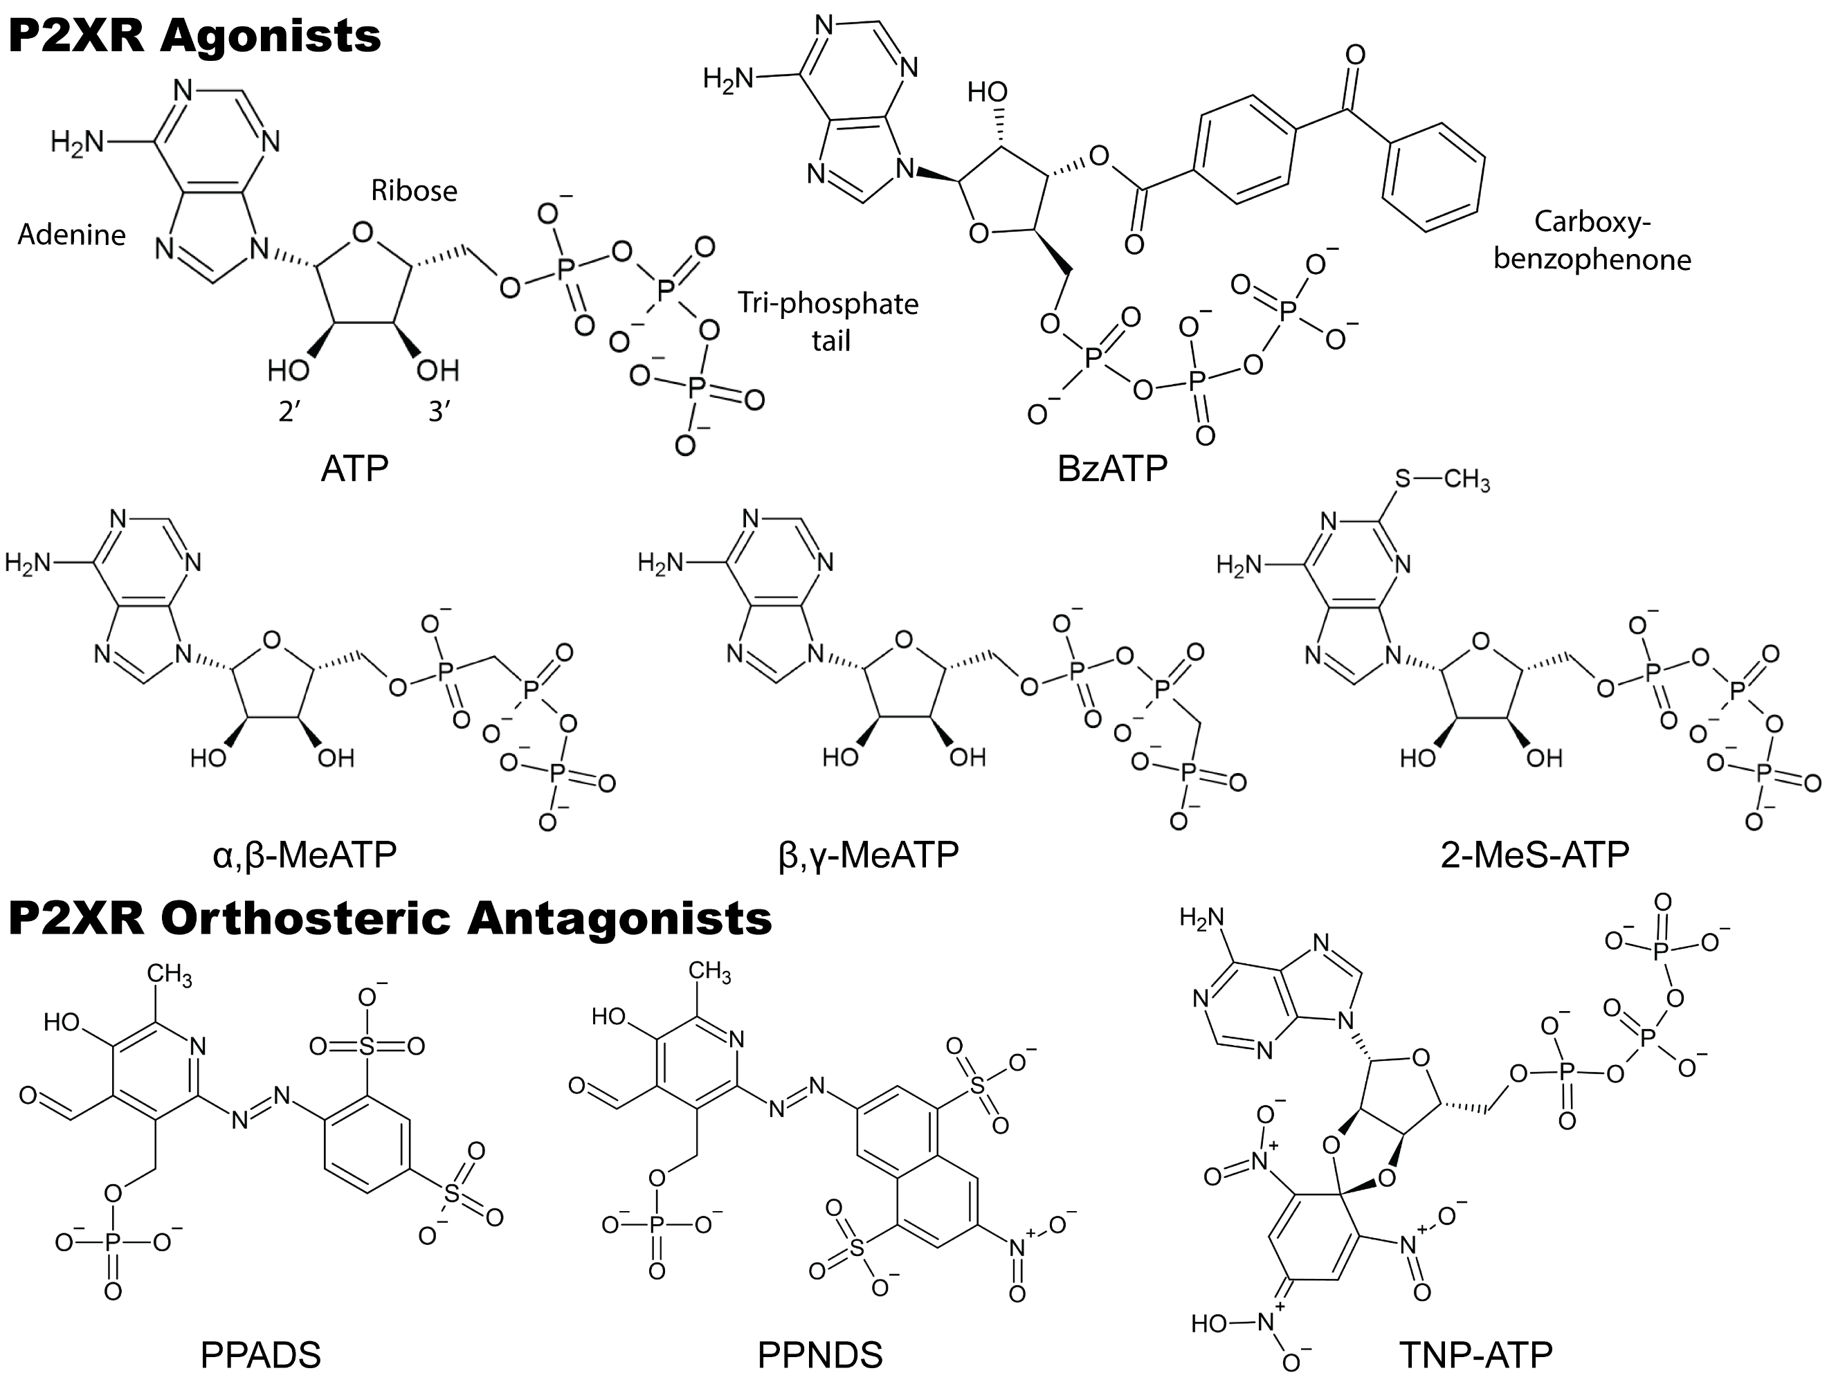

Supplementary Fig. 1: Chemical structures and functional group names of P2XR agonists and orthosteric antagonists. The structural basis for each of the above orthosteric antagonists has been previously described^{1,2}.

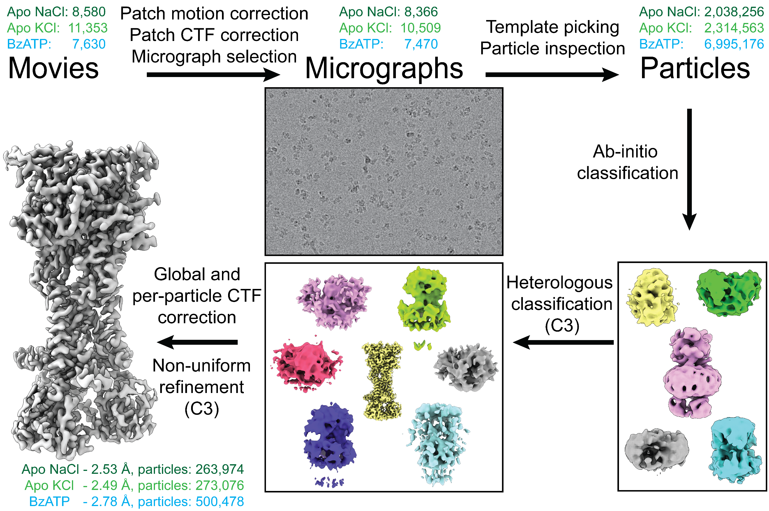
Supplementary Fig. 2: General cryo-EM processing pipeline for rP2X₇ reconstructions. After high-throughput data acquisition, movies were binned during patch motion correction, patch CTF correction performed, and usable micrographs selected in CryoSPARC³. Accepted micrographs were template picked using 2D templates generated from a low resolution rP2X₇ map. Particles from the template picker were subsequently inspected and extracted for further processing. Skipping 2D classification, extracted particles were sent directly to iterative 3D classification using ab-initio jobs to generate initial maps and then heterogenous classification to homogenize particle stacks in CryoSPARC. Classifications were conducted using C3 symmetry. After a final particle stack was determined, particles were extracted at the physical pixel size, CTF correction was performed at both the global and per-particle levels, and finally refined using CryoSPARC’s non-uniform refinement with C3 symmetry. The number of initial movies, accepted movies, initial template picked particles, and final particles for the apo NaCl (dark green), apo KCl (light green), and BzATP-bound (blue) data processing are provided here and in Supplementary Table 1.

Supplementary Fig. 3: Local resolution, Fourier shell correlation (FSC) plots, and map fits for all rP2X₇ datasets. Resolution stated is at an FSC = 0.143. All local resolution plots range between 1.5 Å (blue) and 3.5 Å (red). Representative regions (TM1, TM2, β₋₁, β₀, β₁₄, α₁₄, and GDP) from the apo NaCl (green), apo KCl (green), and the BzATP-bound (blue) structures shown within their respective electron densities (blue mesh) highlighting the strong map-to-model fit⁴.

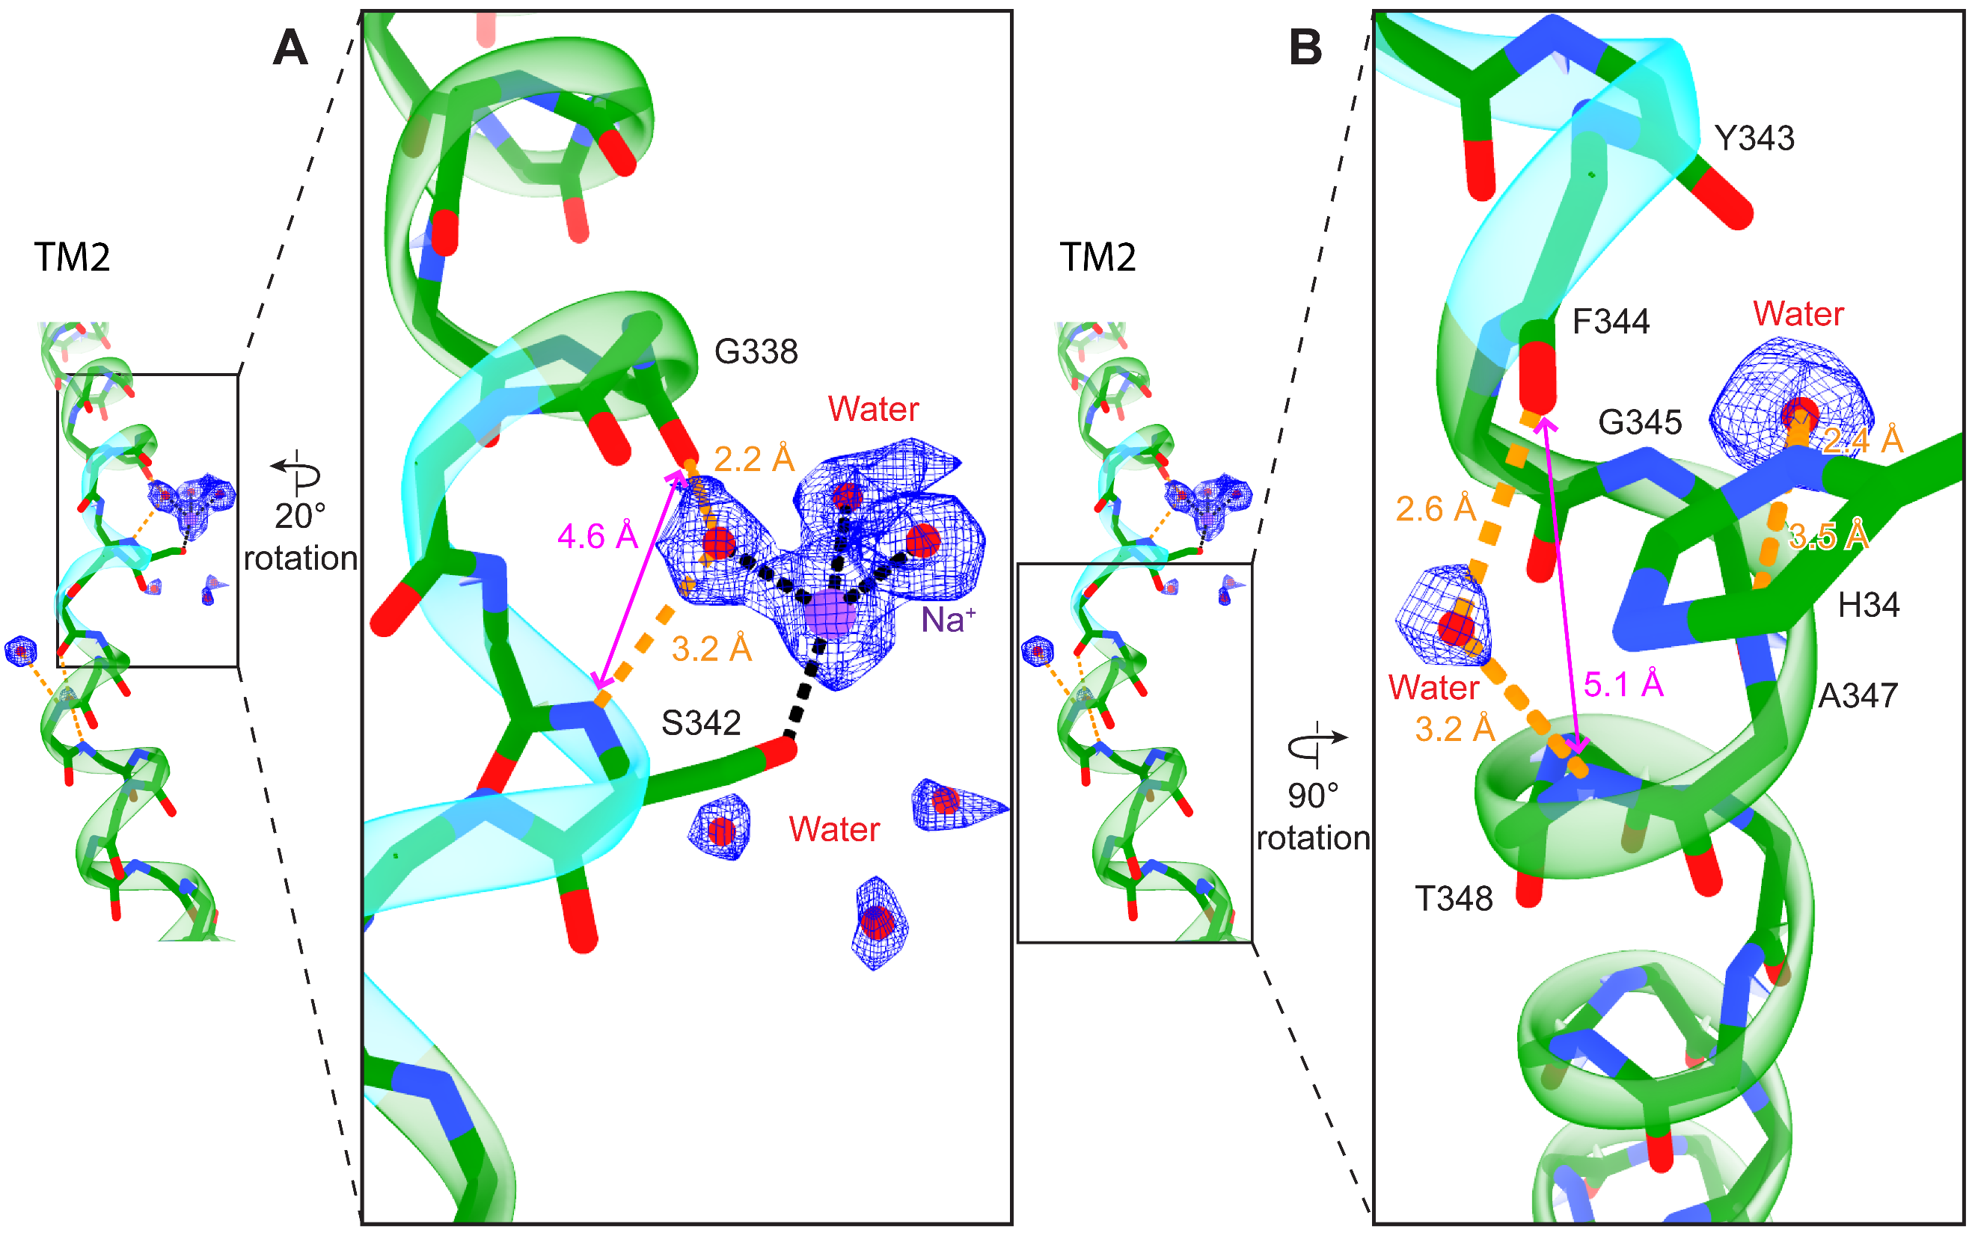Supplementary Fig. 4: Ordered waters affect the helical topology of the TM2 helix of rP2X₇. (A and B) Magnified view of Fig. 1D highlighting the initiation (A) and termination (B) of a short 3₁₀-helix in each symmetry-related TM2 by three different sets of symmetry-related ordered water molecules (red spheres) that disrupt standard alpha helical backbone hydrogen bonding patterns. Electron density for the water molecules (red spheres) and Na⁺ ion (purple sphere) is shown in blue mesh. (A) The short 3₁₀-helix (cyan ribbon) is initiated by a set of symmetry-related ordered water molecules within the pore and above the gate that interact with the Na⁺ ion and stabilize a kink in TM2 by interacting with the backbone carbonyl of G338 (2.2 Å) and the backbone nitrogen of S342 (3.2 Å). The magenta line highlights an unreasonably long n:n+4 backbone hydrogen bonding distance (4.6 Å) that would be expected for a standard alpha helix. This set of ordered water molecules mediates the loss of this interaction. (B) The short 3₁₀-helix is terminated by two additional sets of symmetry-related ordered water molecules below the gate and within the transmembrane domain that stabilize another kink. The first set of symmetry-related waters below the gate interact with the imidazole ring of H34 on TM1 and the backbone nitrogen of A347. This set of waters does not coordinate to the backbone carbonyls of either Y343 (due to an inappropriate H-bonding distance, 3.8 Å) or F344 (due to an inappropriate H-bonding angle). The second set of symmetry-related waters below the gate interact with the backbone carbonyl of F344 (2.6 Å) and the backbone nitrogen of T348 (3.2 Å). The magenta line highlights an unreasonably long n:n+4 backbone hydrogen bonding distance (5.1 Å) between F344 and T348 that would be expected for a standard alpha helix. This second set of ordered water molecules mediates the loss of this interaction.

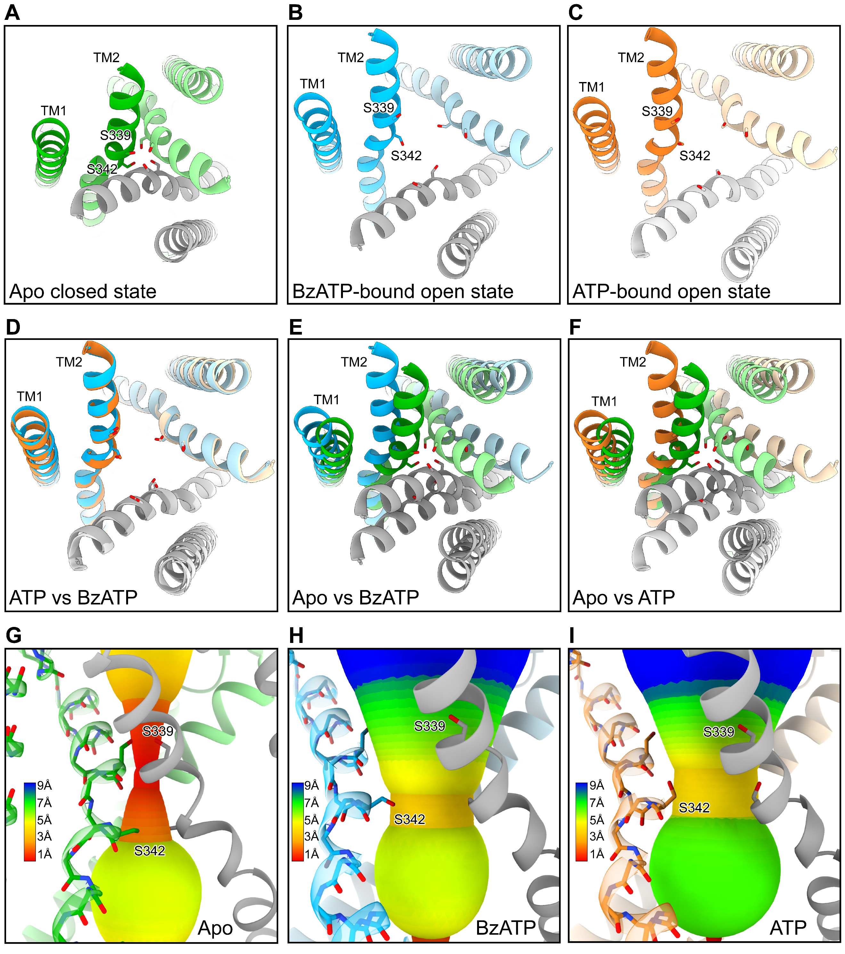Supplementary Fig. 5: Comparison of the rP2X₇ pore in the apo closed, BzATP-bound open, and ATP-bound open states. (A-C) View of the pore found in the apo closed (shades of green), BzATP-bound open (shades of blue), and the ATP-bound open (shades of orange) states visualized looking down the pore from the extracellular surface. This view highlights the closed pore of rP2X₇ with the side chains of residues S339 and S342 occluding the potential flow of ions as well as the similarities of the open pore in both agonist-bound structures (PDB 6U9W)⁴. Of note, in the open state structures, residue S342 points into the center of the pore, comprising the narrowest constriction of the open pore. This residue likely mediates interactions with cations as they pass through the open pore. (D-F) Superimposed comparison of the pore between ATP-bound and BzATP-bound (D), apo and BzATP-bound (E), and apo and ATP-bound (F) structures highlighting the differences in the TM helices between open and closed states. (G-I) Visualization of the pore radius, as calculated by the program MOLE, for the apo closed (G), BzATP-bound open (H), and ATP-bound open (I) states⁵. (A-I) All side chains in TM1 and TM2 are hidden except for the side chains of S339 and S342, the two residues that define the narrowest region of the pore in each state.

Supplementary Fig. 6: Interactions between BzATP and three key residues R125, Q143, and I214 in rP2X₇. (A-B) Magnified view of Fig. 3C focusing on movements and interactions of residue I214. (A) View highlighting a small hydrophobic pocket between I214, L287, F288, and BzATP. (B) View highlighting the 1.1 Å movement of I214 towards BzATP between the BzATP-bound (blue and dark grey) and the ATP-bound (orange and light grey) structures (PDB code: 6U9W)⁴. The inward movement and rotamer change of I214 creates new hydrophobic interactions with F288 and the ribose of BzATP. (C) Rotated view from panel A highlighting the interactions between the guanidino group of R125 and BzATP. The guanidino group of R125 forms five new hydrogen bonds with BzATP, each ranging from 2.7-3.5 Å: two with the β/γ phosphates on the phosphate tail, one with the 3’ hydroxy on the ribose, and two with the carboxyl group on the carboxybenzophenone moiety of BzATP. Additionally, the side chain of R125 forms cation-π interactions with the benzoyl ester portion of the carboxybenzophenone moiety. (D) A different rotation of panel A highlighting the interactions between the amide group of Q143 and BzATP. The side chain of Q143 interacts with the 2’-hydroxyl on the ribose (distances of 2.9 - 3.1 Å). Additionally, the sidechain oxygen of Q143 forms a strong hydrogen bond with the guanidino group of R125 which, as a result of the structural change described, is only 2.5 Å away. (E) Zoomed out view of panel A showing BzATP and its corresponding electron density (blue mesh). (F) A 120º rotation of panel E highlighting another view of BzATP and its corresponding electron density (blue mesh).

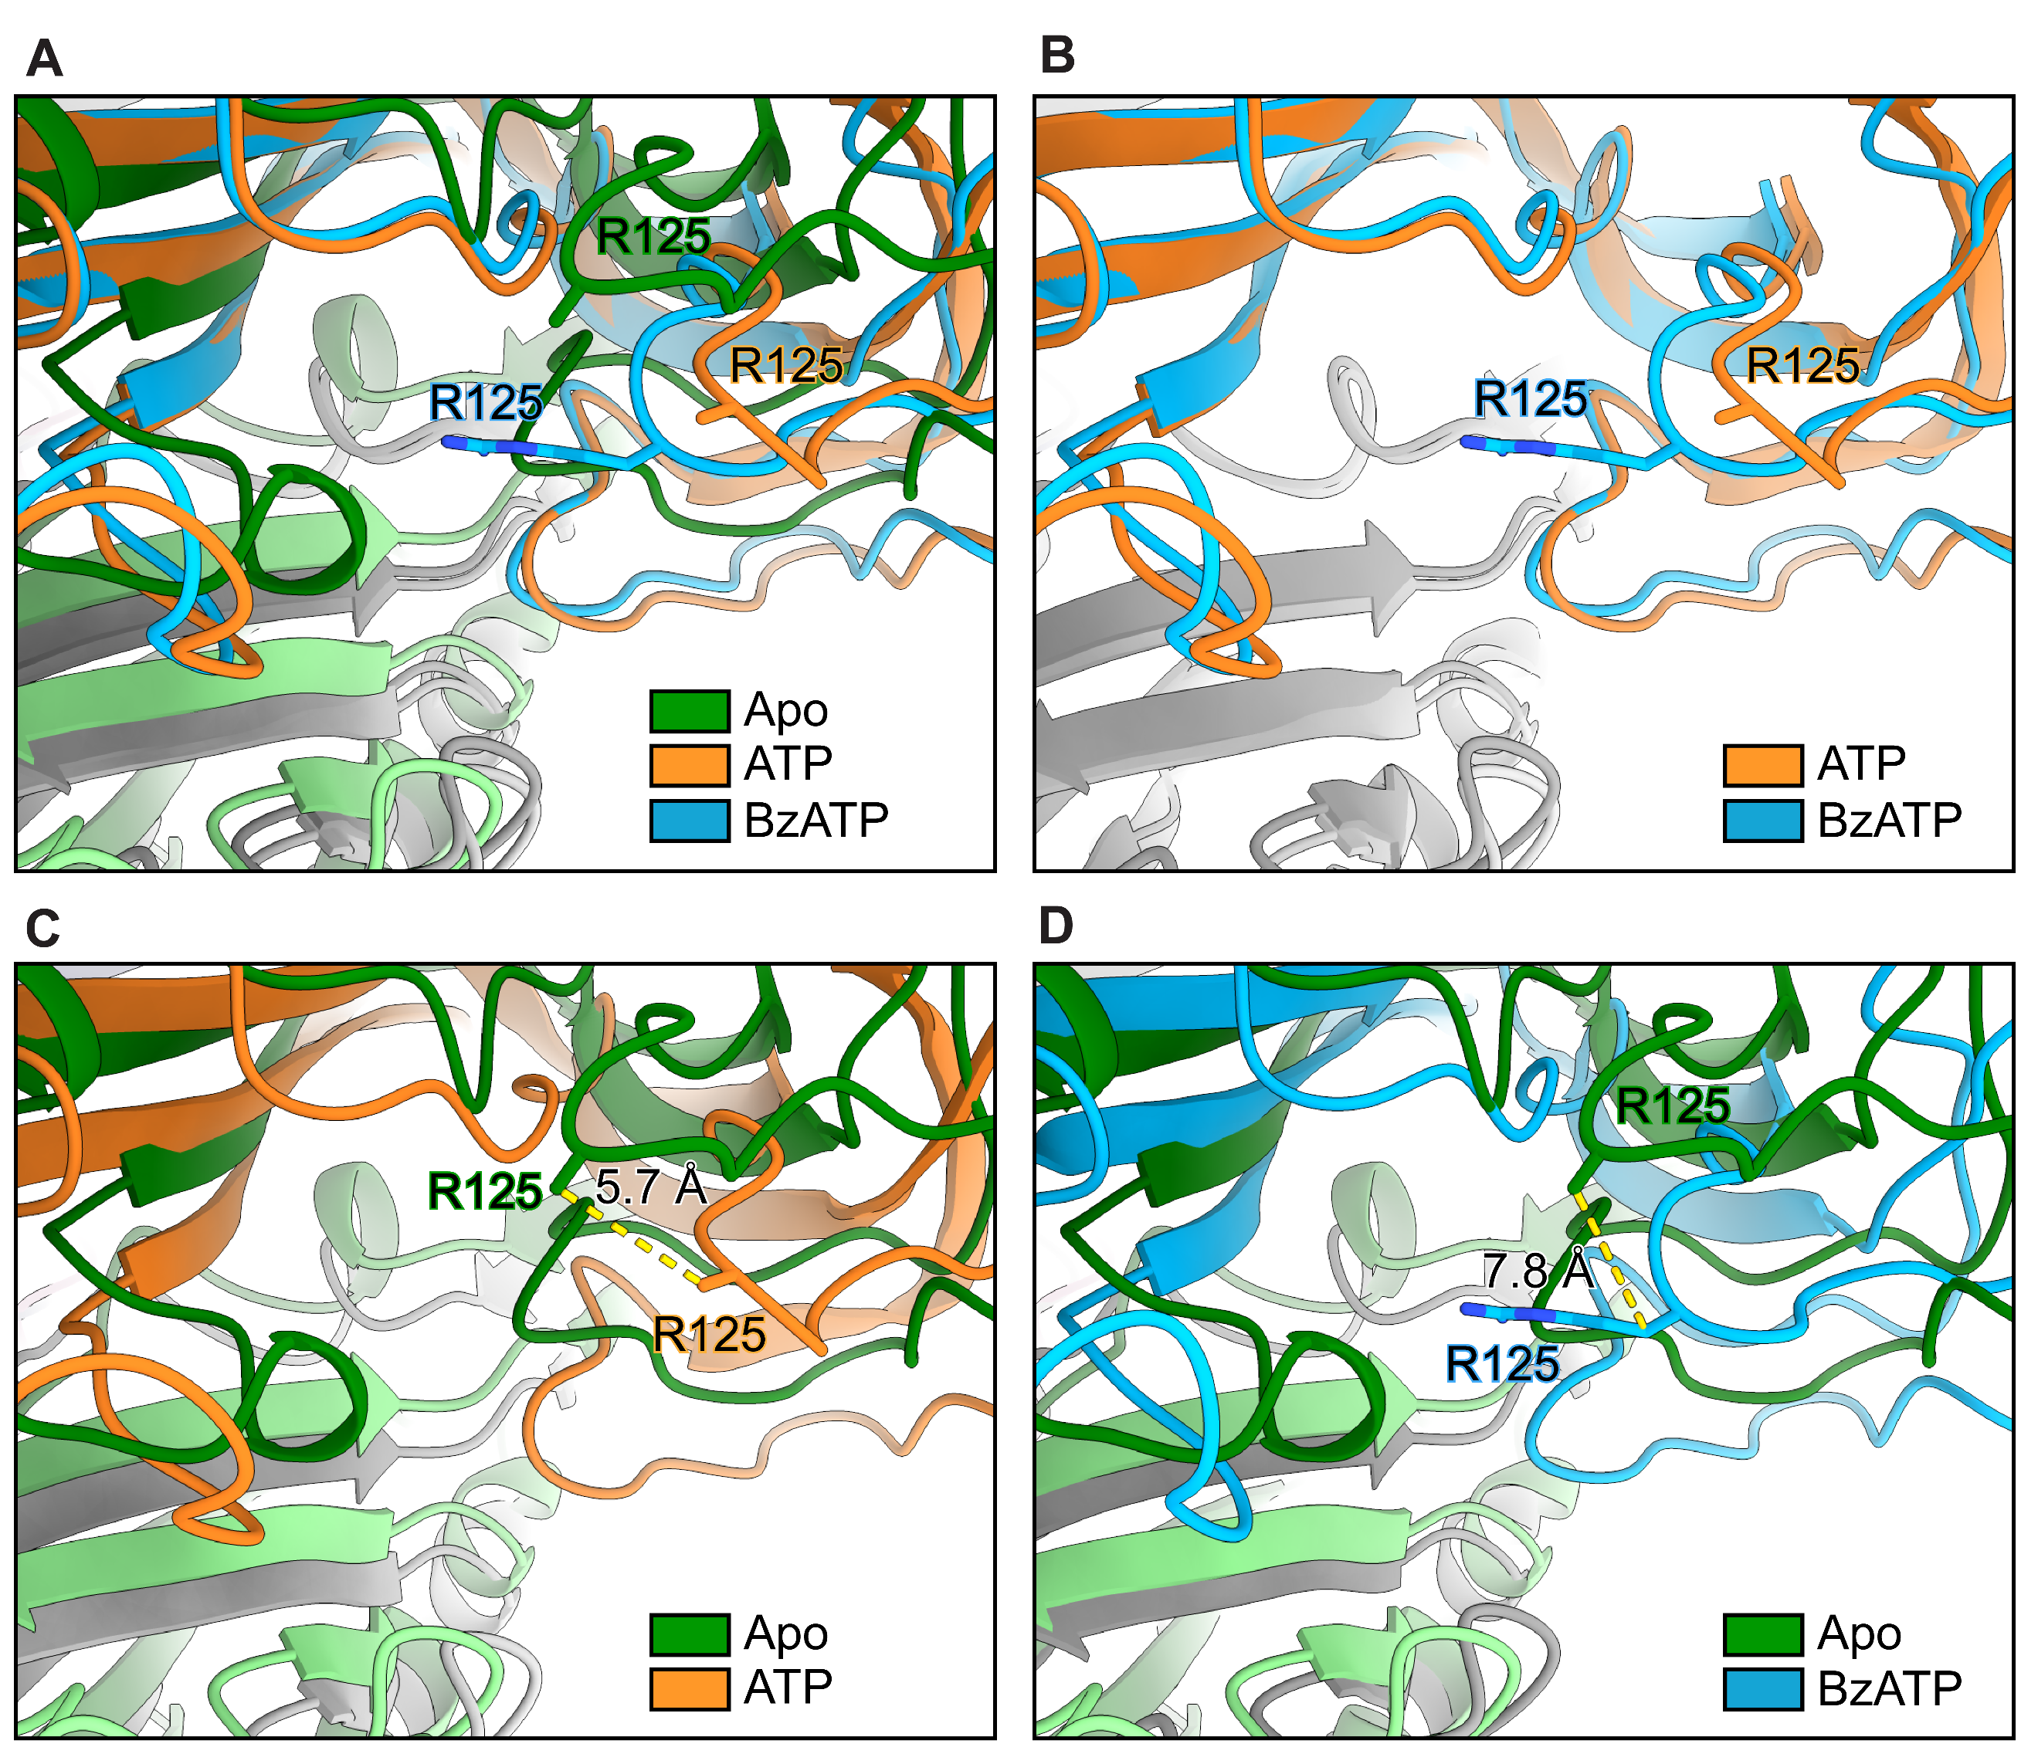
Supplementary Fig. 7: Comparison between the position of residue R125 in the apo closed, ATP-bound open, and BzATP-bound open states. (A-D) Zoomed-out view of Fig. 3C focusing on the location and movement of R125 across different states. (A) Comparison of residue R125 across the apo closed (shades of green), ATP-bound open (orange and light gray, PDB code: 6U9W), and BzATP-bound open (blue and dark grey) states⁴. In the apo closed and ATP-bound open state structures, the side chains of R125 lack any density in the cryo-EM maps and are stubbed at the Cβ carbon. In contrast, in the BzATP-bound open state structure, the electron density for the side chain of R125 is very well defined. (B-D) Superimposed comparison of the position of residue R125 between ATP-bound and BzATP-bound (B), apo and ATP-bound (C), and apo and BzATP-bound (D) structures. The distance between Cβ carbons on the R125 side chain between the apo and ATP-bound structures is 5.7 Å (C) compared to the apo and BzATP-bound structures which is 7.8 Å (D).

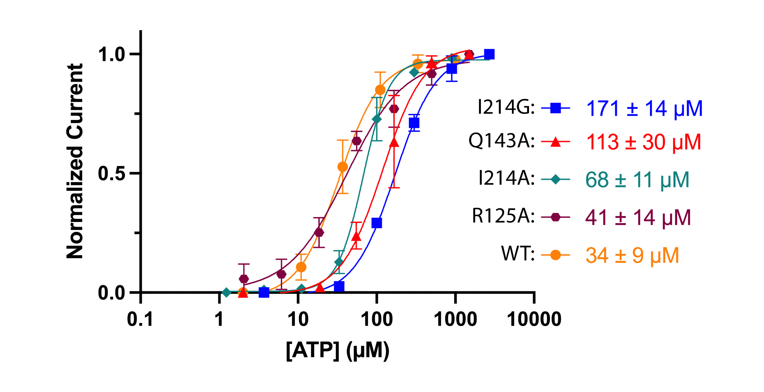
Supplementary Fig. 8: Apparent affinities of wild-type and mutant rP2X₇ activation by ATP. Dose-response curves (EC₅₀) for wild-type as well as the three single mutants (R125A, Q143A, and I214A) activation by ATP. These traces highlight similar apparent affinities of R125A, Q143A, and I214A mutants to ATP. Additionally, the apparent affinity (EC₅₀) of the glycine mutant, I214G, found in mouse P2X₇ is significantly decreased relative to either the I214A mutant or wild-type receptor.

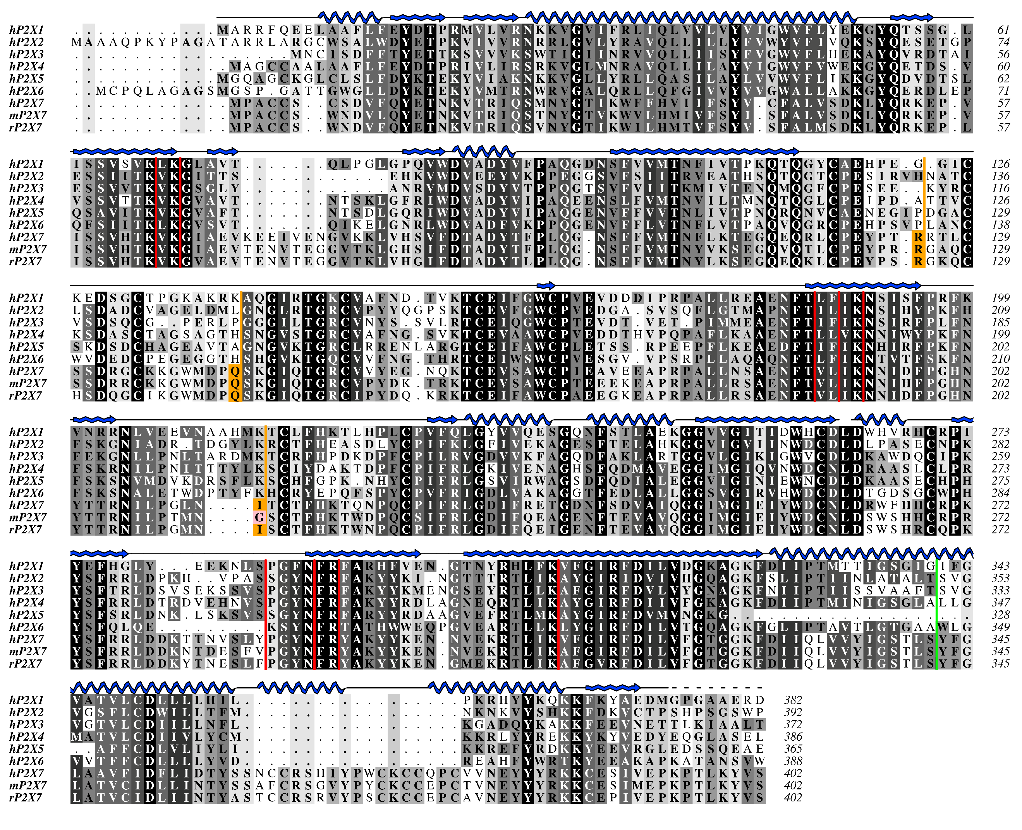
Supplementary Fig. 9: Sequence alignment of selected P2XR subtypes. Protein sequence alignment of the seven human P2XR subtypes along with mouse and rat P2X₇. Amino acids are shown in grayscale by level of sequence conservation as calculated by Alscript (black denotes full sequence conservation and white denotes no sequence conservation)⁶. Right justified red columns indicate residues that coordinate ATP across all P2XR subtypes. Right justified orange columns indicate the position of residues in rP2X₇ known to interact with the carboxybenzophenone moiety of BzATP, aligned to the analogous residues in other P2XR subtypes. The right justified green column indicates the position of the pore constriction in rP2X₇ (S342). The sequence alignment was generated in Clustal Omega and the figure was created within Aline^{7,8}. Sequences were obtained from UniProt with accession numbers P51575, Q9UBL9, P56373, Q99571, Q93086, O15547, Q99572, Q9Z1M0, Q64663 for hP2X₁-hP2X₇, mP2X₇, and rP2X₇, respectively.

Supplementary Table 1: Cryo-EM collection, refinement, and validation statistics
 | Apo rP2X₇  NaCl  (EMD-41570)  (PDB: 8TR5) | Apo rP2X₇  KCl  (EMD-42976)  (PDB: 8V4S) | BzATP rP2X₇  (EMD-41581)  (PDB: 8TRJ)
Data collection and processing
Magnification (kx) | 130 | 130 | 130
Voltage (kV) | 300 | 300 | 300
Electron exposure (e–/Å²) | 42 | 45 | 40
Movie frames | 50 | 50 | 50
Defocus range (μm) | -0.8 to –1.4 | -0.9 to -1.4 | -0.8 to –2.2
Pixel size (Å)  Physical (super-res) | 0.648 (0.324) | 0.648 (0.324) | 0.648 (0.324)
Symmetry imposed | C3 | C3 | C3
Initial micrographs (no.) | 8,580 | 11,353 | 7,630
Final micrographs used (no.) | 8,366 | 10,509 | 7,470
Initial particle images (no.) | 2,038,256 | 2,314,563 | 6,995,176
Final particle images (no.) | 263,974 | 273,076 | 500,478
Map resolution (Å)  FSC threshold | 2.53  (0.143) | 2.49  (0.143) | 2.78  (0.143)
Map resolution range (Å) | 1.7 to 31 | 1.6 to 9.1 | 1.6 to 12
Refinement
Initial model used (PDB code) | 6U9V | 6U9V | 6U9W
Model resolution  FSC threshold | 2.50  (0.143) | 2.46  (0.143) | 2.74  (0.143)
Map sharpening B factor (Å²) | 80.5 | 81.5 | 107.8
Model composition
Non-hydrogen atoms | 13,855 | 13857 | 14,037
Protein Residues | 1656 | 1653 | 1674
Ligands | 22 | 18 | 24
Waters | 204 | 231 | 135
B factors (Å²)
Protein | 30/108/ 62.1 | 3.25/123/60.4 | 6.48/74.4/33.4
Ligand | 50.2/76.5/61.9 | 39.8/109/59.4 | 15.1/92.2/28.3
Nucleotide | 57.1/57.1/57.1 | 66.7/85.1/71.8 | 49.4/49.4/49.4
Water | 30/73.27/48.9 | 0.34/22.0/13.0 | 4.87/35.2/13.5
R.m.s. deviations
Bond lengths (Å) | 0.009 (0) | 0.004 (0) | 0.007 (0)
Bond angles (°) | 0.656 (0) | 0.948(0) | 0.688 (0)
Validation
MolProbity score | 1.26 | 1.20 | 1.45
Clash score | 4.99 | 3.88 | 4.56
Poor rotamers (%) | 0 | 0 | 0
Ramachandran plot
Favored (%) | 98.26 | 97.88 | 96.64
Allowed (%) | 1.74 | 2.12 | 3.36
Disallowed (%) | 0 | 0 | 0

Supplementary Table 2: ΔΔG calculations of wild-type and mutant rP2X₇ performed in Rosetta using the all-atom scoring function reported in Rosetta Energy Units⁹
The scoring function uses a linear combination of energies of interaction, empirical potentials, and statistical potentials to approximate the energetics of biomolecules. Positive values suggest destabilizing energetics and negative values suggest stabilizing forces.
Mutation(s) | Energy Score | ΔΔG
WT | 16363 | 0
R125A | 16332 | 31
Q143A | 16344 | 19
I214A | 16373 | -10
R125A/Q143A | 16313 | 50
R125A/I214A | 16338 | 25
Q143A/I214A | 16350 | 13
R125A/Q143A/I214A | 16319 | 44

References
1. Sheng, D. et al. Structural insights into the orthosteric inhibition of P2X receptors by non-ATP-analog antagonists. (eLife Sciences Publications, Ltd, 2023).
2. Kasuya, G. et al. Structural insights into the competitive inhibition of the ATP-gated P2X receptor channel. Nat Commun 8, 876 (2017).
3. Punjani, A., Rubinstein, J.L., Fleet, D.J. & Brubaker, M.A. cryoSPARC: algorithms for rapid unsupervised cryo-EM structure determination. Nat Methods 14, 290-296 (2017).
4. McCarthy, A.E., Yoshioka, C. & Mansoor, S.E. Full-Length P2X(7) Structures Reveal How Palmitoylation Prevents Channel Desensitization. Cell 179, 659-670 e13 (2019).
5. Berka, K. et al. MOLEonline 2.0: interactive web-based analysis of biomacromolecular channels. Nucleic Acids Research 40, W222-W227 (2012).
6. Barton, G.J. ALSCRIPT: a tool to format multiple sequence alignments. Protein Engineering, Design and Selection 6, 37-40 (1993).
7. Bond, C.S. & Schuttelkopf, A.W. ALINE: a WYSIWYG protein-sequence alignment editor for publication-quality alignments. Acta Crystallogr D Biol Crystallogr 65, 510-2 (2009).
8. Sievers, F. & Higgins, D.G. Clustal Omega for making accurate alignments of many protein sequences. Protein Sci 27, 135-145 (2018).
9. Alford, R.F. et al. The Rosetta All-Atom Energy Function for Macromolecular Modeling and Design. J Chem Theory Comput 13, 3031-3048 (2017).

