Supplementary Information
Simultaneously activating molecular oxygen and surface lattice oxygen on Pt/TiO₂ for low-temperature CO oxidation
Tengfei Zhang ^{1,9}, Peng Zheng ^{2,9}, Jiajian Gao ³, Xiaolong Liu ^{1,*}, Yongjun Ji ^{4,*}, Junbo Tian ¹, Yang Zou ¹, Zhiyi Sun ⁵, Qiao Hu ⁶, Guokang Chen ⁶, Wenxing Chen ^{5,*}, Xi Liu ^{6,*}, Ziyi Zhong ⁷, Guangwen Xu ^{2,8}, Tingyu Zhu ^{1,*}, and Fabing Su ^{1,8,*}
¹ Institute of Process Engineering, Chinese Academy of Sciences, Beijing 100190, China
² Key Laboratory on Resources Chemicals and Materials of Ministry of Education, Shenyang University of Chemical Technology, Shenyang, 110142, China
³ Institute of Sustainability for Chemicals, Energy and Environment (ISCE²), Agency for Science, Technology, and Research (A*STAR), 1 Pesek Road, Jurong Island, Singapore 627833, Republic of Singapore
⁴ School of Light Industry, Beijing Technology and Business University, Beijing 100048, China
⁵ Energy & Catalysis Center, School of Materials Science and Engineering, Beijing Institute of Technology, Beijing 100081, China
⁶ School of Chemistry and Chemical Engineering, in situ Center for Physical Sciences, Shanghai Jiao Tong University, Shanghai 200240, People’s Republic of China
⁷ Department of Chemical Engineering, and Guangdong Provincial Key Laboratory of Materials and Technologies for Energy Conversion (MATEC), Guangdong Technion Israel Institute of Technology (GTIIT), 241 Daxue Road, Shantou, 515063, China
⁸ Institute of Industrial Chemistry and Energy Technology, Shenyang University of Chemical Technology, Shenyang, 110142, China
⁹ These authors contributed equally: Tengfei Zhang and Peng Zheng.
* liuxl@ipe.ac.cn, yjji@btbu.edu.cn, wxchen@bit.edu.cn, liuxi@sjtu.edu.cn, tyzhu@ipe.ac.cn, and fbsu@ipe.ac.cn.
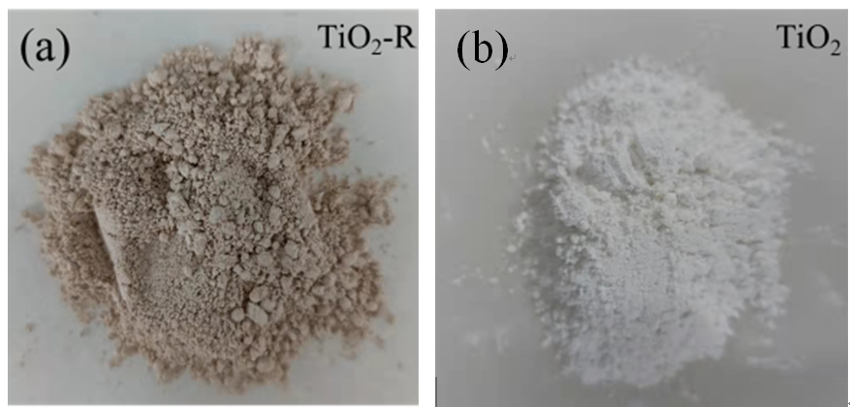
Supplementary Fig. 1 | Photos of (a) TiO₂-R and (b) TiO₂.

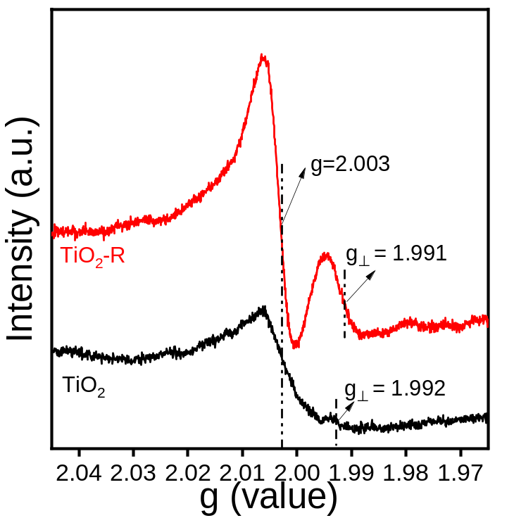
Supplementary Fig. 2 | EPR spectra of TiO₂ and TiO₂-R.
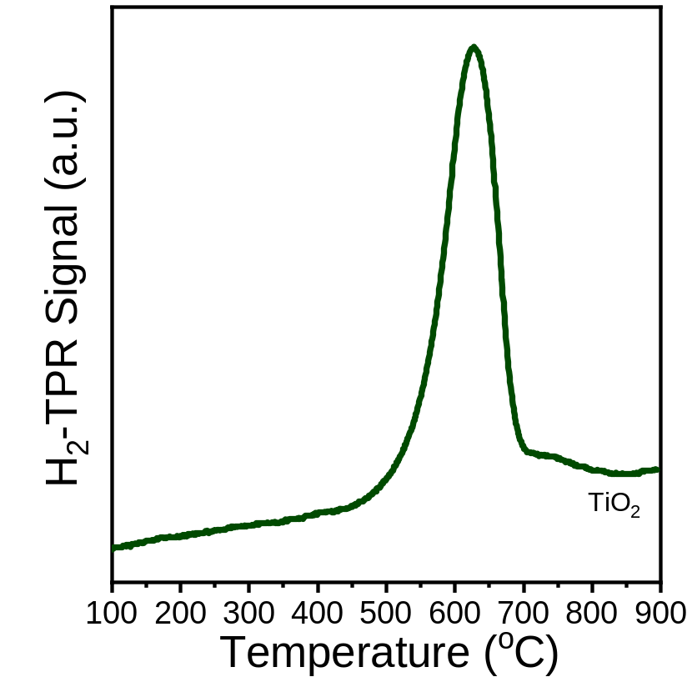
Supplementary Fig. 3 | H₂-TPR curve of TiO₂.
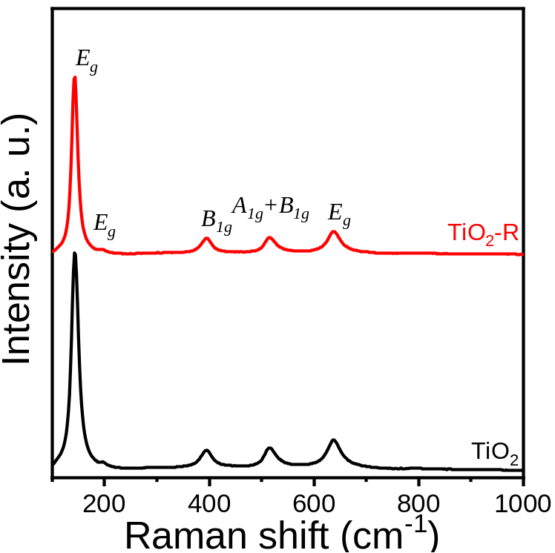
Supplementary Fig. 4 | Raman spectra of TiO₂ and TiO₂-R.

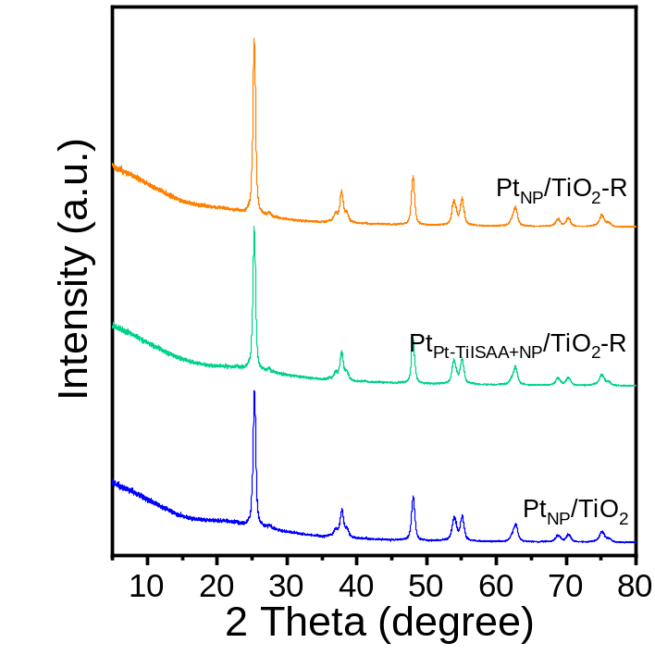
Supplementary Fig. 5 | XRD patterns of all the catalysts.

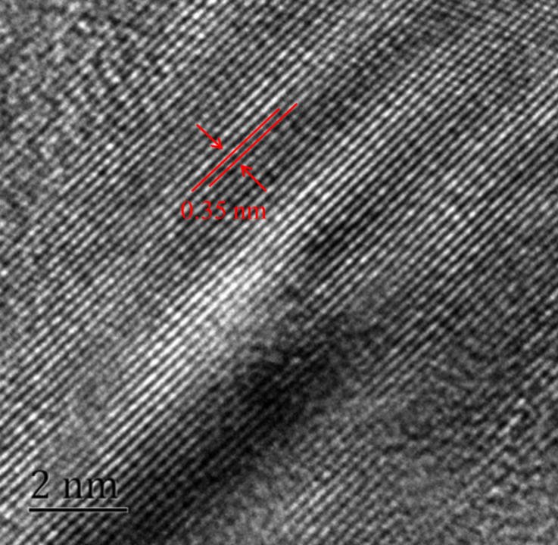
Supplementary Fig. 6 | HRTEM image of Pt_{NP}/TiO₂-R.

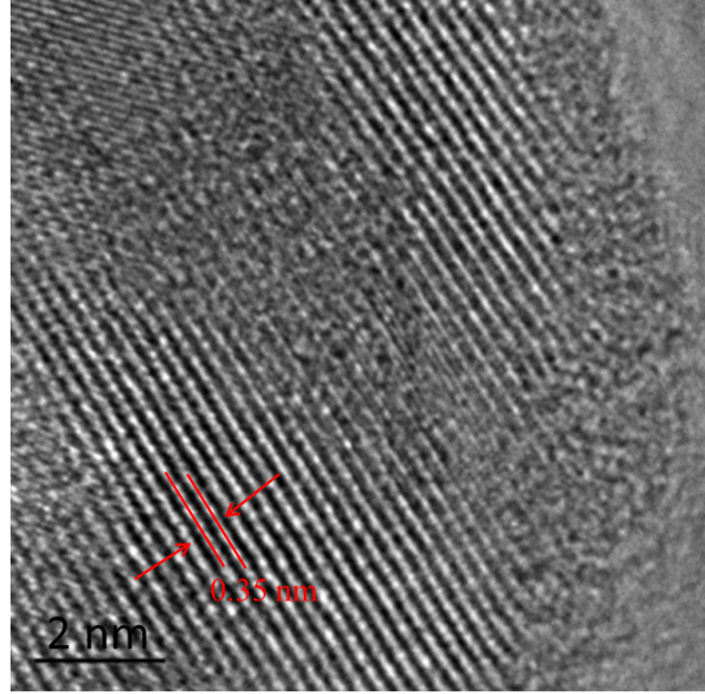
Supplementary Fig. 7 | HRTEM image of Pt_{Pt-TiISAA+NP}/TiO₂-R.
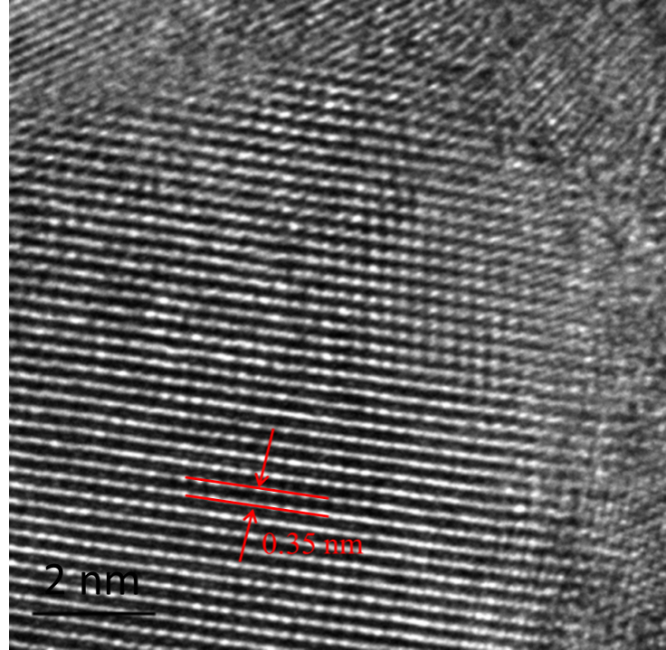
Supplementary Fig. 8 | HRTEM image of Pt_{NP}/TiO₂.

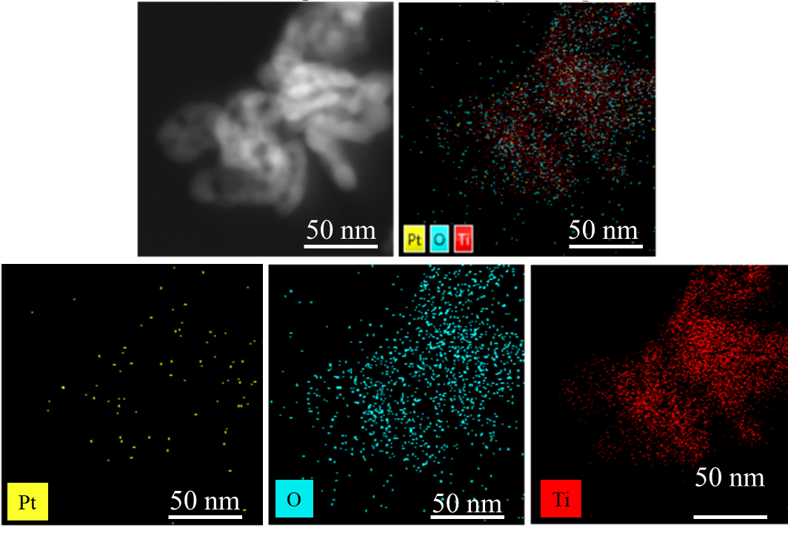
Supplementary Fig. 9 | HAADF-STEM image and the corresponding EDS element mappings of Pt_{NP}/TiO₂-R.
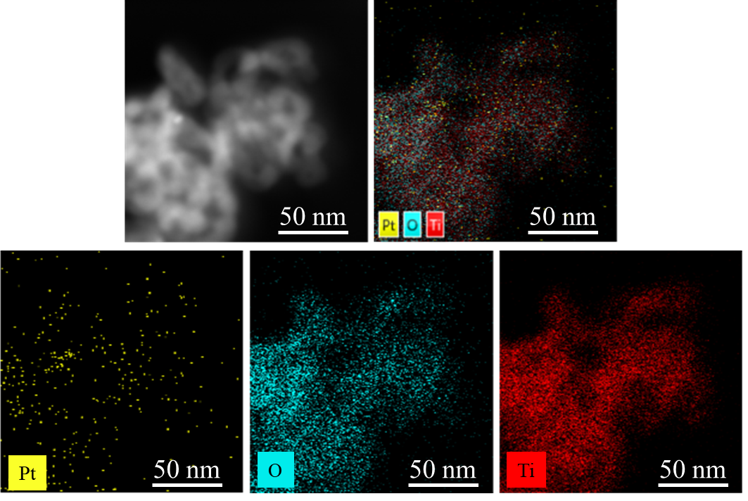
Supplementary Fig. 10 | HAADF-STEM image and the corresponding EDS element mappings of Pt_{Pt-TiISAA+NP}/TiO₂-R.
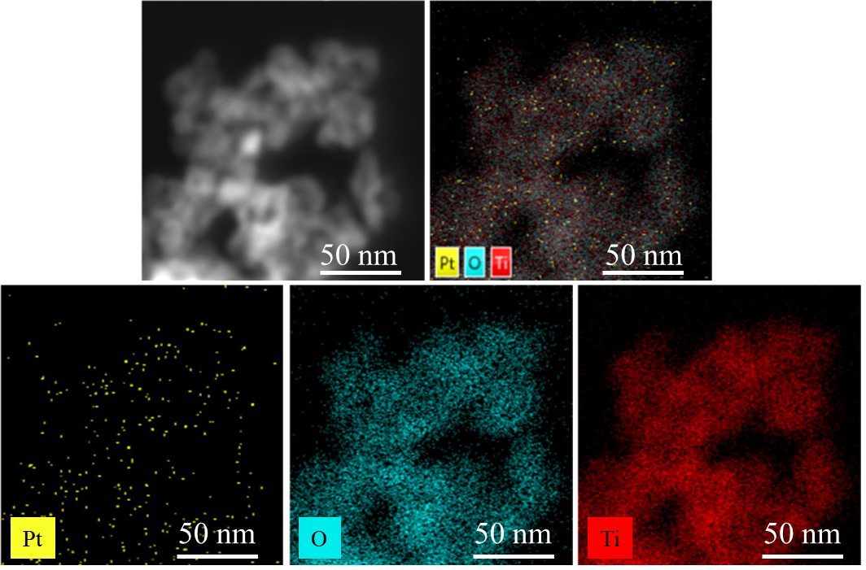
Supplementary Fig. 11 | HAADF-STEM image and the corresponding EDS element mappings of Pt_{NP}/TiO₂.
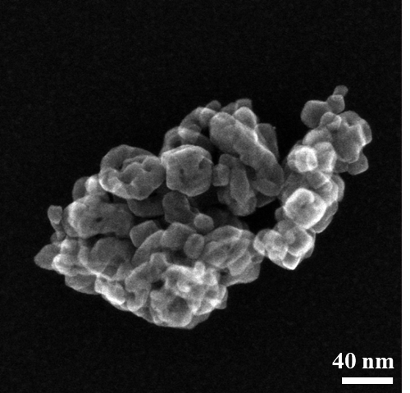
Supplementary Fig. 12 | Scanning transmission electron microscope-secondary electron image of Pt_{NP}/TiO₂-R.
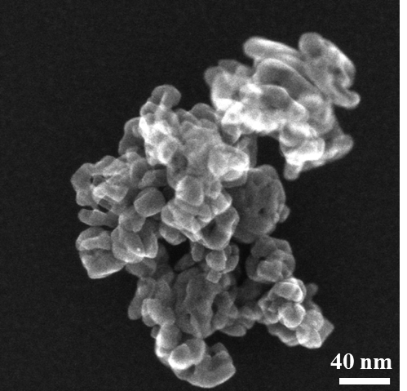
Supplementary Fig. 13 | Scanning transmission electron microscope-secondary electron image of Pt_{Pt-TiISAA+NP}/TiO₂-R.
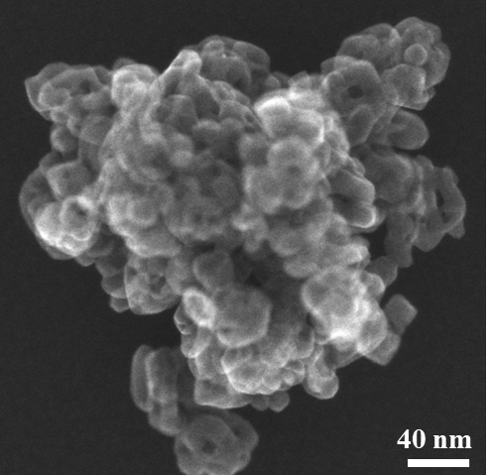
Supplementary Fig. 14 | Scanning transmission electron microscope-secondary electron image of Pt_{NP}/TiO₂.
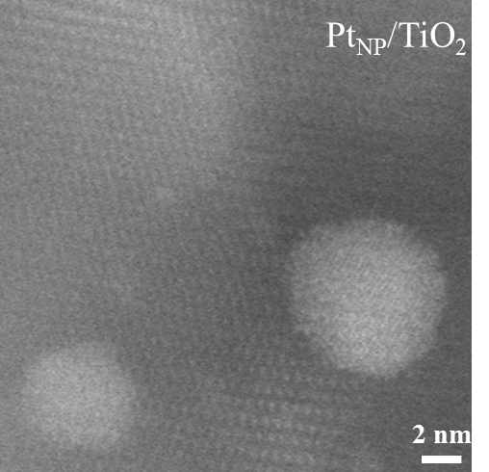
Supplementary Fig. 15 | AC-HAADF-STEM image of Pt_{NP}/TiO₂.

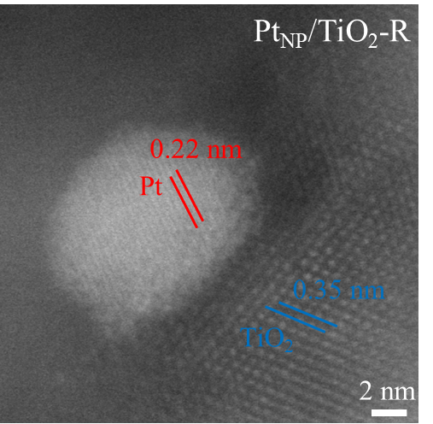
Supplementary Fig. 16 | AC-HAADF-STEM image of Pt_{NP}/TiO₂-R.
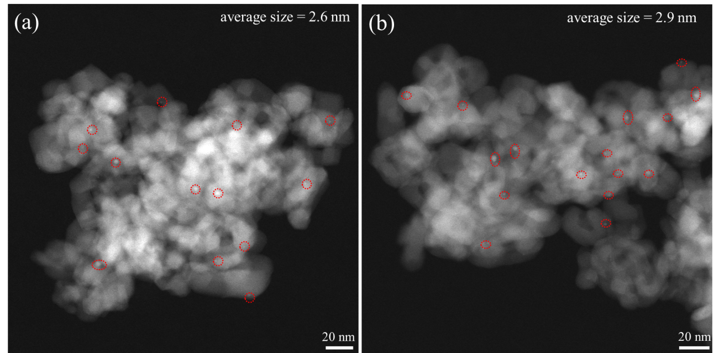
Supplementary Fig. 17 | AC-HAADF-STEM images of (a) Pt_{NP}/TiO₂-R and (b) Pt_{NP}/TiO₂.

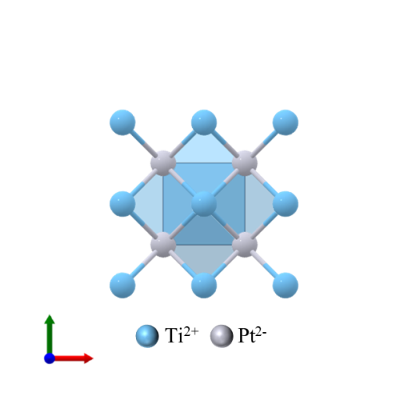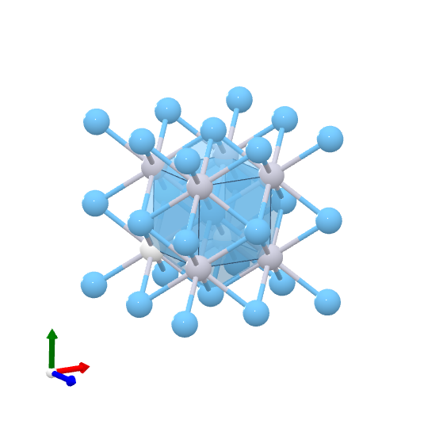
Supplementary Fig. 18 | Schematic diagram of Pd–Ti crystal structure.
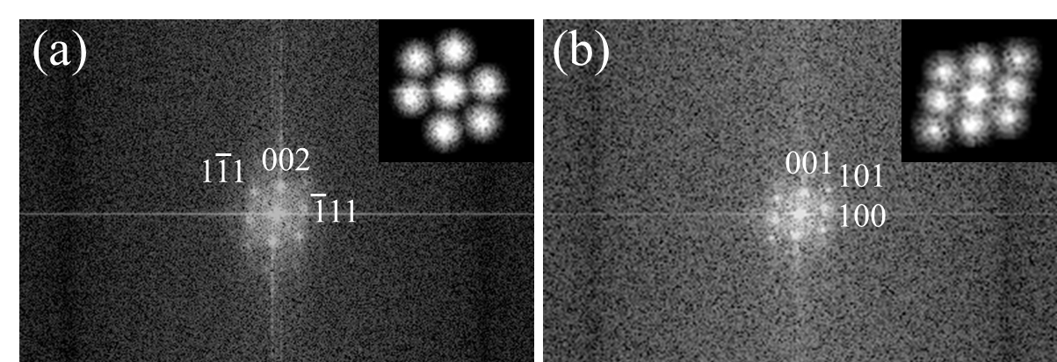
Supplementary Fig. 19 | Corresponding FFT patterns for the region d (a) and region e (b) in Fig. 1b.
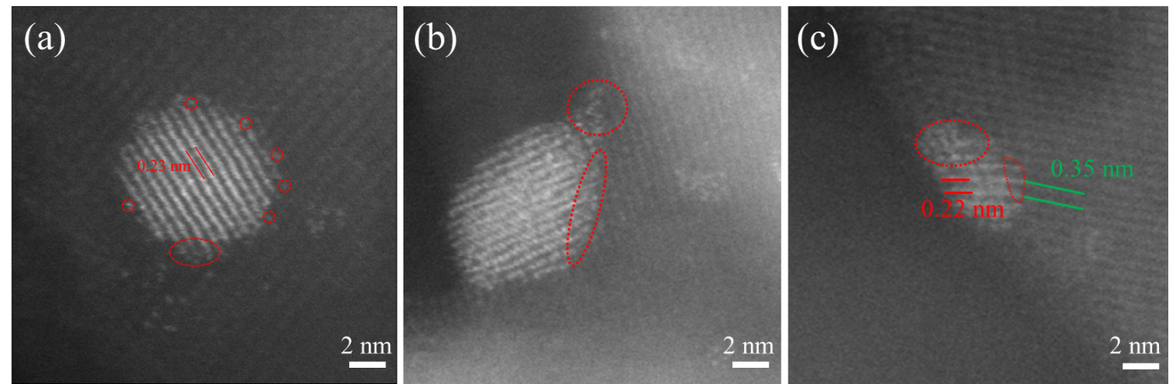
Supplementary Fig. 20 | (a)–(c) Representative AC-HAADF-STEM images of Pt_{Pt-TiISAA+NP/}TiO₂-R.
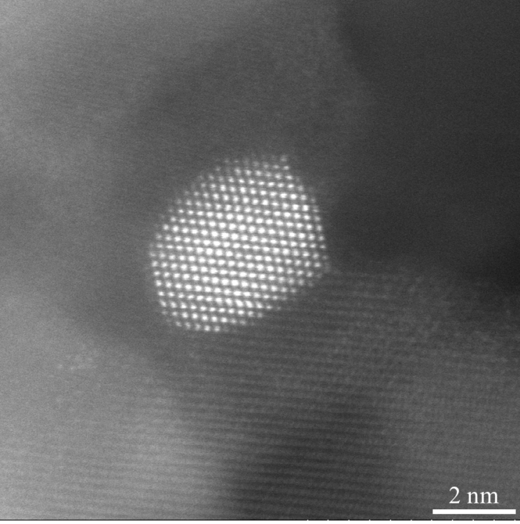
Supplementary Fig. 21 | AC-HAADF-STEM image of Pt_{NP}/TiO₂-H₂.

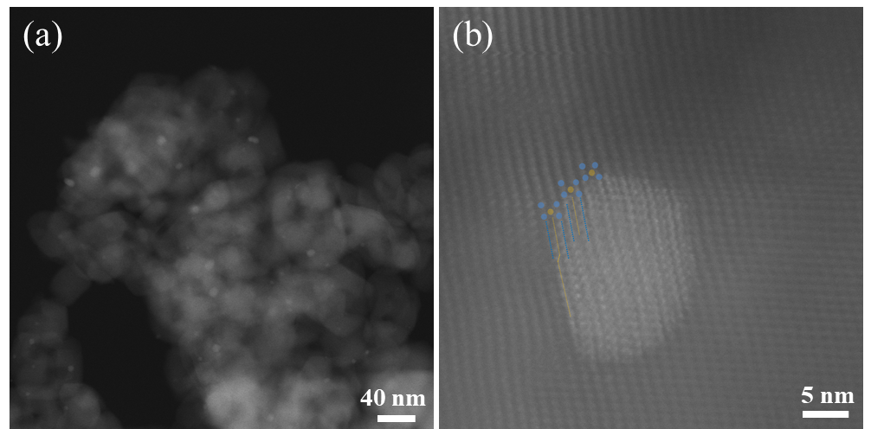
Supplementary Fig. 22 | (a) and (b) AC-HAADF-STEM images of 0.5 wt%Pt_{Pt-TiISAA+NP}/TiO₂-R.

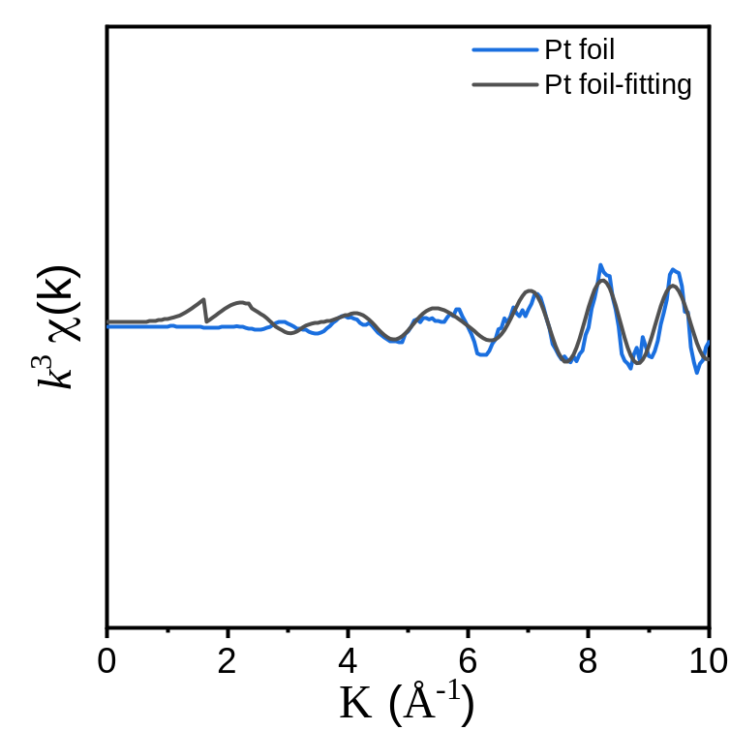
Supplementary Fig. 23 | k space EXAFS spectra of Pt foil.
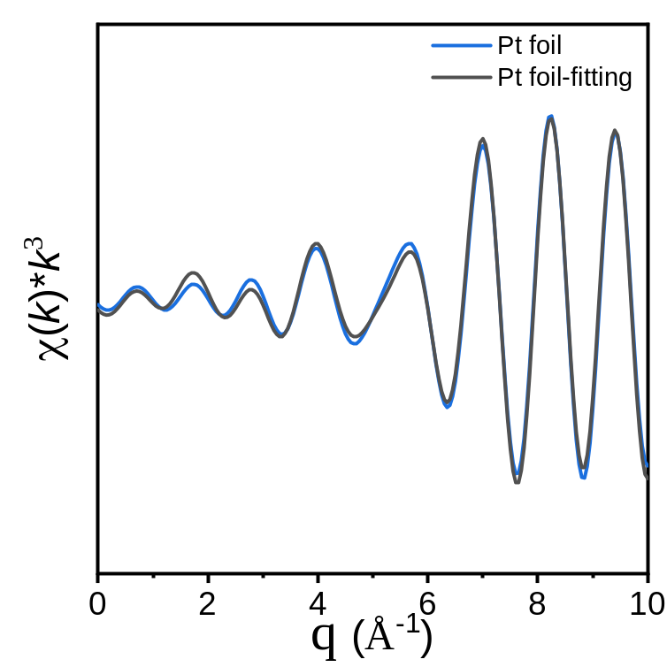
Supplementary Fig. 24 | q space EXAFS spectra of Pt foil.
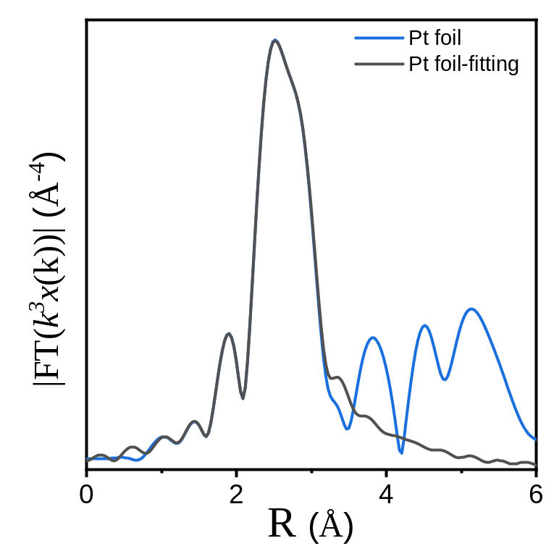
Supplementary Fig. 25 | R space EXAFS spectra of Pt foil.
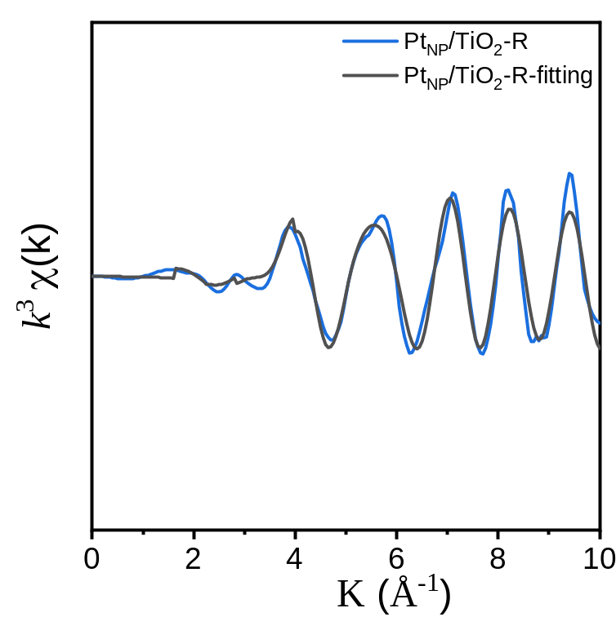
Supplementary Fig. 26 | k space EXAFS spectra of Pt_{NP}/TiO₂-R.
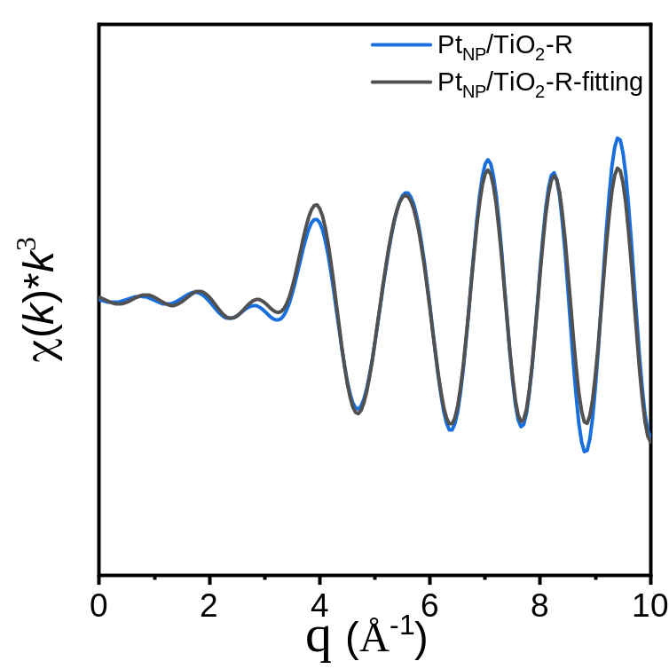
Supplementary Fig. 27 | q space EXAFS spectra of Pt_{NP}/TiO₂-R.
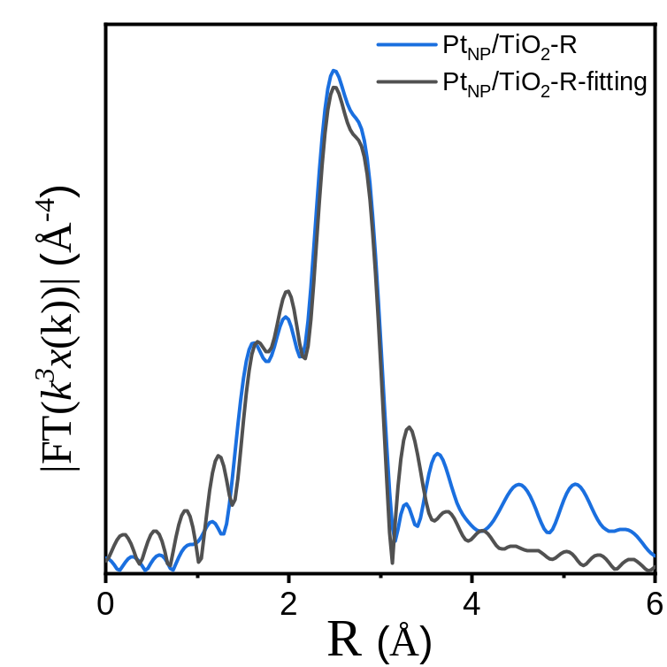
Supplementary Fig. 28 | R space EXAFS spectra of Pt_{NP}/TiO₂-R.
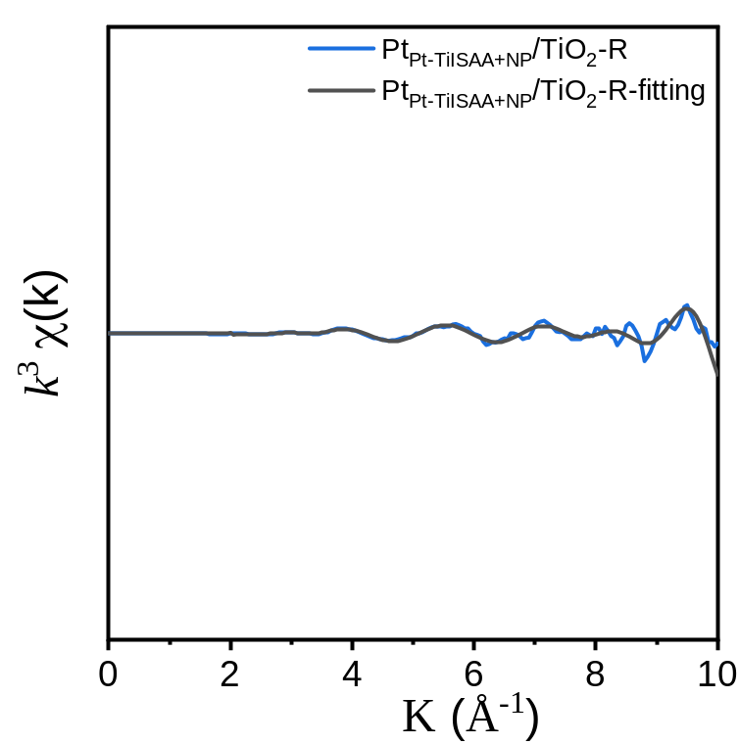
Supplementary Fig. 29 | k space EXAFS spectra of Pt_{Pt-TiISAA+NP}/TiO₂-R.
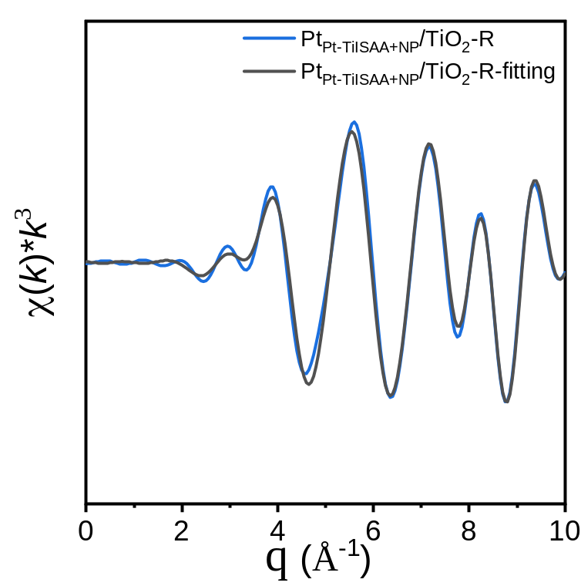
Supplementary Fig. 30 | q space EXAFS spectra of Pt_{Pt-TiISAA+NP}/TiO₂-R.
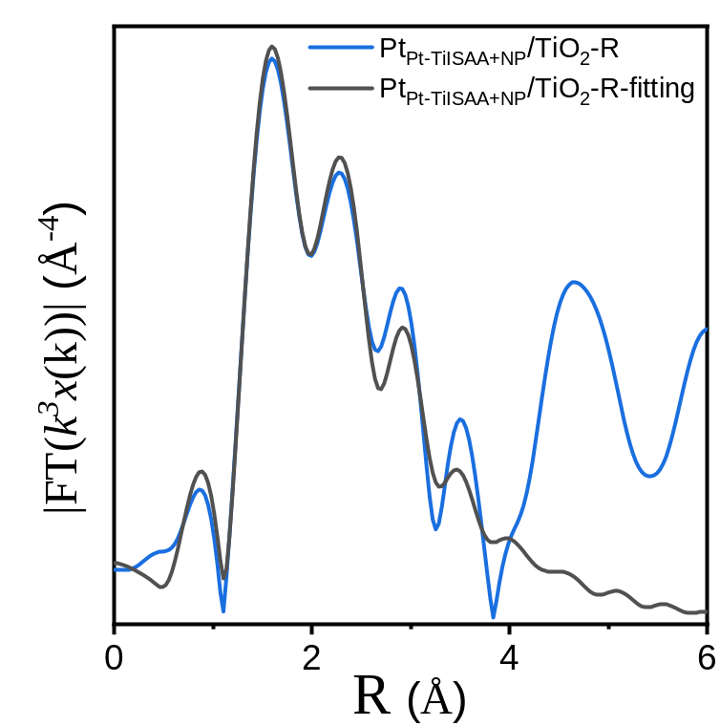
Supplementary Fig. 31 | R space EXAFS spectra of Pt_{Pt-TiISAA+NP}/TiO₂-R.
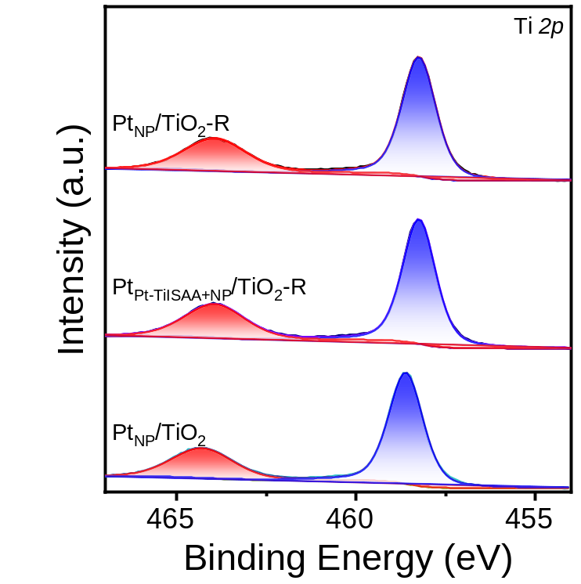
Supplementary Fig. 32 | Ti 2p XPS spectra of all the catalysts.
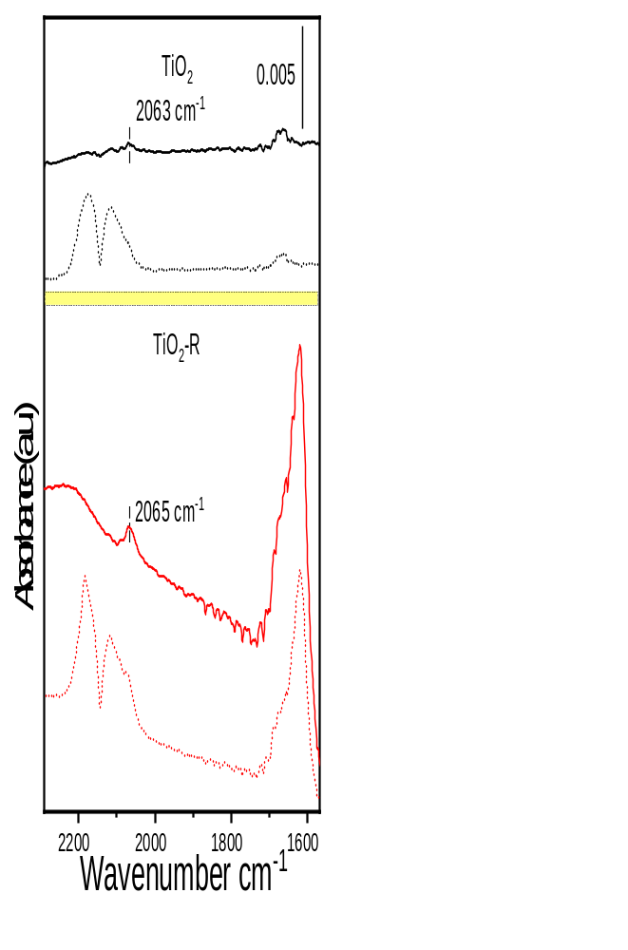
Supplementary Fig. 33 | In situ DRIFTS spectra of the CO adsorption for TiO₂ and TiO₂-R supports.

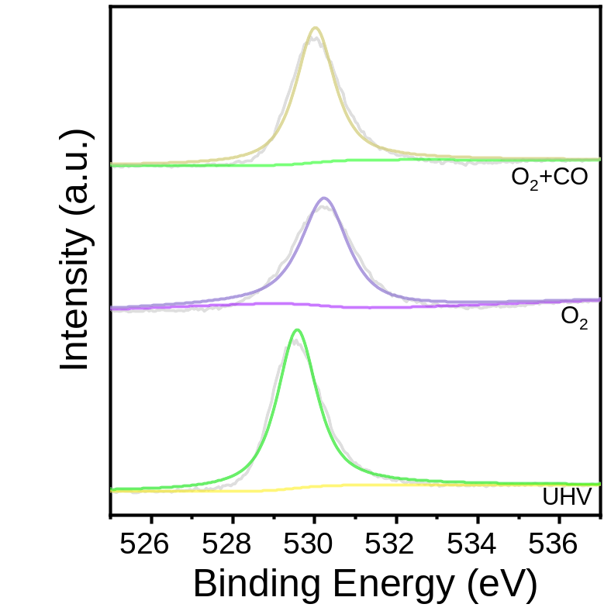
Supplementary Fig. 34 | In situ NAP-XPS of O 1s spectra from Pt_{Pt-TiISAA+NP}/TiO₂-R at 150 °C.
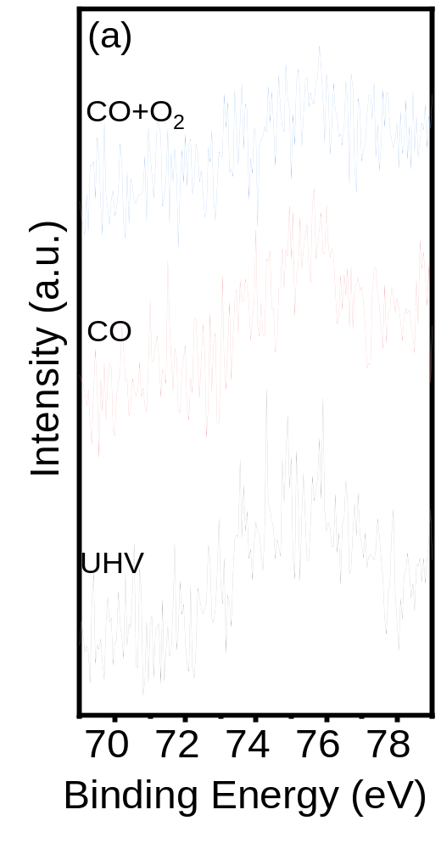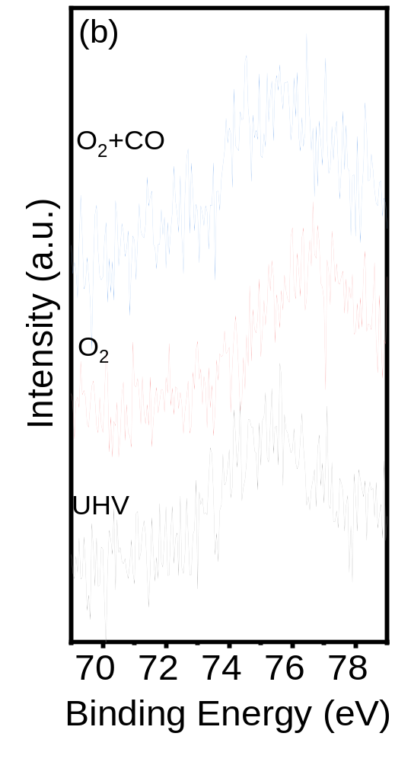
Supplementary Fig. 35 | In situ NAP-XPS of Pt 4f spectra obtained from Pt_{Pt-TiISAA+NP}/TiO₂-R at 150 °C.

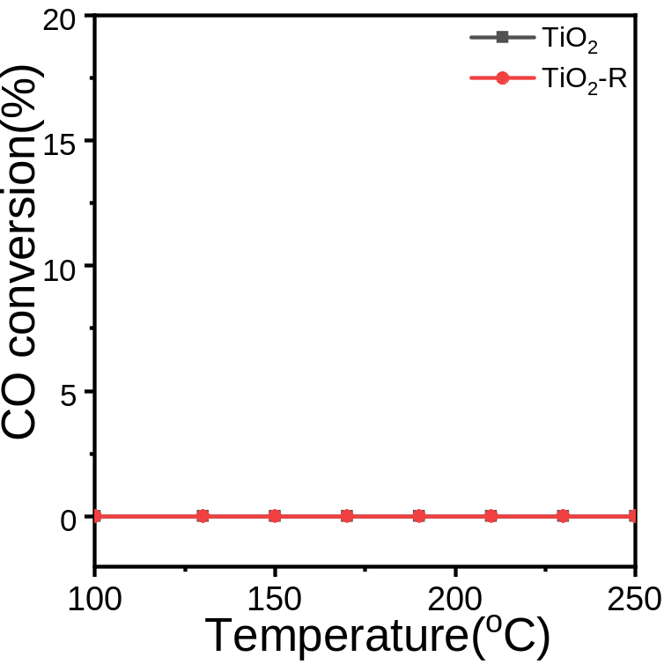
Supplementary Fig. 36 | CO conversion of TiO₂ and TiO₂-R supports as a functional of reaction temperature. (Reaction conditions: 0.4 g of Cat., 1 vol% CO, 16 vol% O₂ mix balanced with N₂; v = 400 mL min⁻¹, GHSV = 60000 mL g⁻¹ h⁻¹)
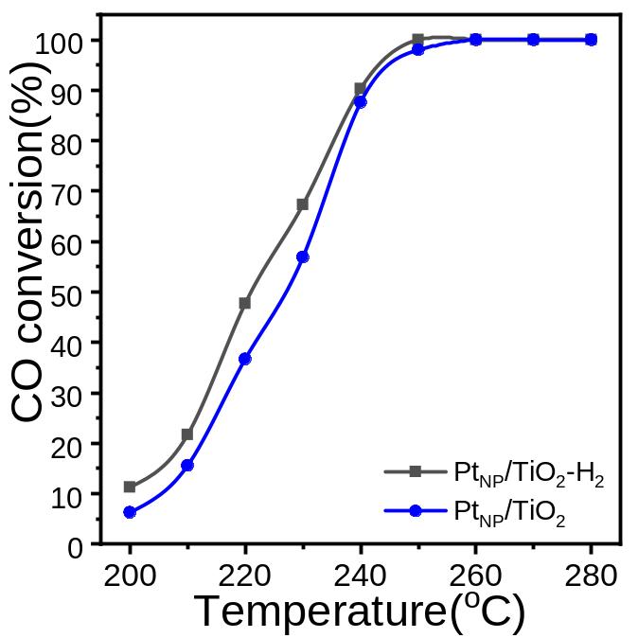
Supplementary Fig. 37 | CO conversion as a function of reaction temperature over Pt_{NP}/TiO₂-H₂ and Pt_{NP}/TiO₂. (Reaction conditions: 0.4 g of Cat., a gas mix containing 1 vol% CO and 16 vol% O₂ balanced with N₂.)

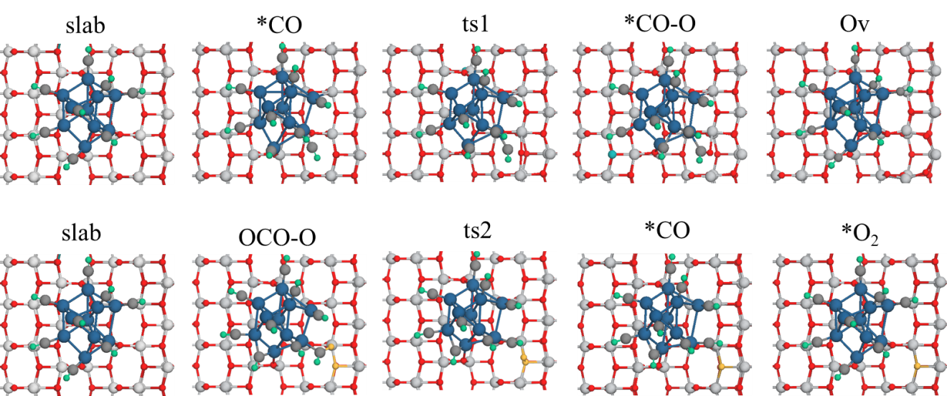
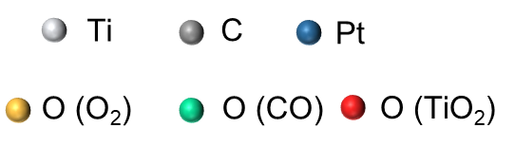
Supplementary Fig. 38 | Intermediates and transition states for Pt_{NP}/TiO₂.
Supplementary Table 1. Structural parameters extracted from the Pt L₃-edge EXAFS fitting. (S₀²=0.85)
sample | Scattering pair | CN | R(Å) | σ²(10⁻³Å²) | ΔE₀(eV) | R factor
Pt_{NP}/TiO₂-R | Pt-O | 1.1 | 1.98 | 4.5 | 2.0 | 0.008
Pt_{NP}/TiO₂-R | Pt-Pt | 8.3 | 2.72 | 5.7 | 2.0 | 0.008
Pt_{Pt-TiISAA+NP}/TiO₂-R | Pt-O | 1.3 | 1.97 | 5.8 | 1.5 | 0.006
Pt_{Pt-TiISAA+NP}/TiO₂-R | Pt-Ti | 5.6 | 2.57 | 6.7 | 1.5 | 0.006
Pt_{Pt-TiISAA+NP}/TiO₂-R | Pt-Pt | 3.8 | 2.75 | 5.6 | 1.5 | 0.006
S₀² is the amplitude reduction factor; CN is the coordination number; R is interatomic distance (the bond length between central atoms and surrounding coordination atoms); σ² is Debye-Waller factor (a measure of thermal and static disorder in absorber-scatterer distances); ΔE₀ is edge-energy shift (the difference between the zero kinetic energy value of the sample and that of the theoretical model). R factor is used to value the goodness of the fitting.
Error bounds that characterize the structural parameters obtained by EXAFS spectroscopy were estimated as N ± 20%; R ± 1%; σ² ± 20%; ΔE₀ ± 20%.

Supplementary Table 2. T₅₀, T₁₀₀, and turnover frequencies (TOFs) of some typical catalysts reported in the literature.
Catalyst | Metal loading  (wt%) | Reaction condition | Temp. (°C) | TOF_{Pt}  (s^{–1}) | Space Velocity (mL/(g_{cat}.h)) | T₅₀ (°C) | T₁₀₀ (°C) | Ref.
Pt_{Pt-TiISAA+NP}/TiO₂-R | 0.15 | 1.0 vol% CO, 16.0 vol% O₂ | 80 | 11.59 | 60,000 | ~88 | ~120
  This work
Pt_{Pt-TiISAA+NP}/TiO₂-R | 0.15 | 1.0 vol% CO, 4.0 vol% O₂ | 80 | 5.94 | 60,000 | ~106 | ~140
  This work
Pt NP/TiO₂ | 1.00 | 0.1 vol% CO, 5.0 vol% O₂ | 115 | 0.01 | 60,000 | ~78 | ~120 | ¹
Pt/CNT-600 | 1.00 | 1.0 vol% CO, 20.0 vol% O₂ | 100 | 0.05 | 60,000 | 120 | 140 | ²
Pt_{n}/CeCu | 1.77 | 1.0 vol% CO, 10.0 vol% O₂ | 80 | 0.26 | 120,000 | ~34 | ~40 | ³
Pt₁/CeO_{x}-TiO₂ | 0.25 | 1.0 vol% CO, 4.0 vol% O₂ | 200 | 0.09 | 60,000 | ~170 | 190 | ⁴
Pt/Sn_{0.2}Ti_{0.8}O₂ | 0.50 | 1.0 vol% CO, 1.0 vol% O₂ | 100 | 0.30 | 60,000 | 75 | 120 | ⁵
Pt₁/CeO₂ | 1.00 | 0.4 vol% CO, 10.0 vol% O₂ | n.a | n.a | 200,000 | ~140 | ~148 | ⁶
Pt/CeO₂ | 17.00 | 10.0 vol% CO, 5.0 vol% O₂ | 285 | 1.05 | ~ | ~270 | ~310 | ⁷
Pt/CeO₂ | 1.00 | 1.0 vol% CO, 1.0 vol% O₂ | n.a | n.a | 400,000 | ~180 | ~250 | ⁸
Pt-O-Pt/CeO₂ | 0.27 | 0.1 vol% CO, 5.0 vol% O₂ | 150 | 1.97 | 2,400,000 | ~120 | ~170 | ⁹
Pt/m-Al₂O₃ | 0.20 | 2.5 vol% CO, 2.5 vol% O₂ | 200 | 0.02 | 24,000 | ~260 | ~300 | ¹⁰
Au-SA/Def-TiO₂ | 0.30 | 1.0 vol% CO, 16.0 vol% O₂ | n.a | n.a | 30,000 | ~100 | ~120 | ¹¹

Supplementary References
1. Hojo H, Gondo M, Yoshizaki S, Einaga H. Atomic and electronic structure of Pt/TiO₂ catalysts and their relationship to catalytic activity. Nano Lett. 22, 145-150 (2022).
2. Chen W, et al. Molecular-level insights into the electronic effects in platinum-catalyzed carbon monoxide oxidation. Nat. Commun. 12, 6888 (2021).
3. Liu X, et al. Activation of subnanometric Pt on Cu-modified CeO₂ via redox-coupled atomic layer deposition for CO oxidation. Nat. Commun. 11, 4240 (2020).
4. Yoo M, et al. A tailored oxide interface creates dense Pt single-atom catalysts with high catalytic activity. Energy Environ. Sci. 13, 1231-1239 (2020).
5. Chen J, et al. Reverse oxygen spillover triggered by CO adsorption on Sn-doped Pt/TiO₂ for low-temperature CO oxidation. Nat. Commun.14, 3477 (2023).
6. Nie L, et al. Activation of surface lattice oxygen in single-atom Pt/CeO₂ for low-temperature CO oxidation. Science 358, 1419-1423 (2017).
7. Vincent JL, Crozier PA. Atomic level fluxional behavior and activity of CeO₂-supported Pt catalysts for CO oxidation. Nat. Commun. 12, 5789 (2021).
8. Tan W, et al. Fine-tuned local coordination environment of Pt single atoms on ceria controls catalytic reactivity. Nat. Commun. 13, 7070 (2022).
9. Wang H, et al. Surpassing the single-atom catalytic activity limit through paired Pt-O-Pt ensemble built from isolated Pt₁ atoms. Nat. Commun. 10, 3808 (2019).
10. Zhang Z, et al. Thermally stable single atom Pt/m-Al₂O₃ for selective hydrogenation and CO oxidation. Na.t Commun.8, 16100 (2017).
11. Wan J, et al. Defect effects on TiO₂ nanosheets: Stabilizing single atomic site Au and promoting catalytic properties. Adv. Mater. 30, 1705369 (2018).

