Supplementary Information

Promoting the OH Cycle on an Activated Dynamic Interface for Electrocatalytic Ammonia Synthesis

Jiabao Lv ^{1,2}, Ang Cao ^{1,3}, Yunhao Zhong ¹, Qingyang Lin ¹, Xiaodong Li ¹, Hao Bin Wu ⁴*, Jianhua Yan ¹*, Angjian Wu ^{1,2}*
¹ State Key Laboratory of Clean Energy Utilization, Zhejiang University, Hangzhou, 310027, P. R. China
² Baima Lake Laboratory, Hangzhou, 310053, P. R. China
³ Department of Physics, Technical University of Denmark, Kongens Lyngby 2800, Denmark
⁴ State Key Laboratory of Silicon Materials, School of Materials Science and Engineering, Zhejiang University, Hangzhou 310027, P. R. China
* Correspondence to: wuaj@zju.edu.cn; hbwu@zju.edu.cn; yanjh@zju.edu.cn

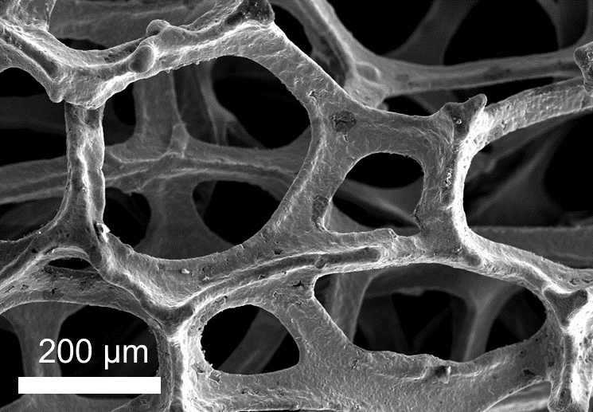
Supplementary Fig. 1 | Microscopic surface morphology Cu foam by SEM. (scale bar: 200 μm)

Supplementary Fig. 2 | Cu 2p XPS spectra of Ni(OH)₂@Cu and Ni(OH)₂/Ni@CF. The Cu species of the catalyst remains at metallic Cu⁰ before and after the electrochemical reaction.
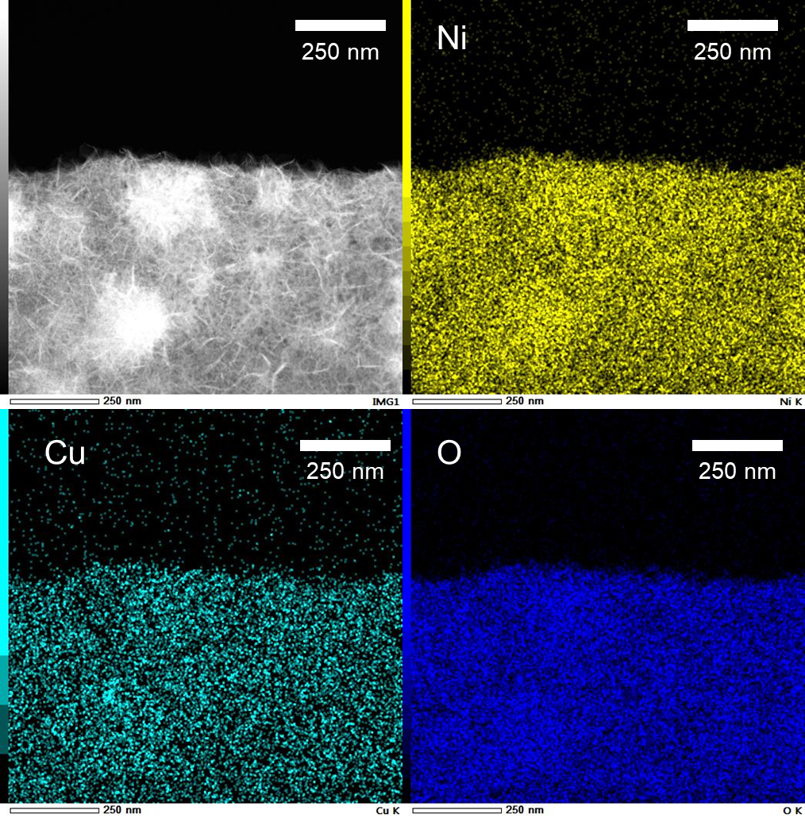
Supplementary Fig. 3 | EDX mapping of surface Cu, Ni, and O on Ni(OH)₂@CF. The yellow, green, and blue represented the Ni, Cu, and O species.

Supplementary Fig. 4 | XRD pattern of Ni(OH)₂@CF (before electrocatalysis). The Ni(OH)₂@CF was consist of Ni(OH)₂ and Cu species.

Supplementary Fig. 5 | XPS spectra of the stripped catalyst. (a) Cu 2p spectra. (b) Cu LMM spectra. No Cu species was stripped from the catalyst.

Supplementary Fig. 6 | XRD pattern of Ni(OH)₂/Ni@CF (after electrocatalysis). The Ni(OH)₂/Ni@CF was consist of Ni, Ni(OH)₂, and Cu species.

Supplementary Fig. 7 | XAS Fitting result for the Ni K edge of Ni(OH)₂@CF. (a) The k3-weighted extended EXAFS spectra. (b) The χ(R) space extended EXAFS spectra. The red line represented the fitting spectra.

Supplementary Fig. 8 | XAS Fitting result for the Ni K edge of Ni(OH)₂/Ni@CF (a) The k3-weighted extended EXAFS spectra. (b) tThe χ(R) space extended EXAFS spectra. The blue line represented the fitting spectra.

Supplementary Fig. 9 |. Corresponding Fourier transformed spectra. The Ni(OH)₂/Ni@CF displayed dominant metallic Ni-Ni bond.

Supplementary Fig. 10 |. Average Ni valence state determination in using the Ni K-edge energy shift of the reference of Ni foil and Ni(OH)₂. By using the valence of Ni in Ni foil and Ni(OH)₂ foil at 0.4 normalized absorption as the standard, we established the linear relationship between the valence state and k-edge energy of Ni. The valence of Ni in Ni(OH)₂/Ni@CF and Ni(OH)₂@CF was calculated using this linear relationship. The nominal valence states of Ni in Ni(OH)₂/Ni@CF and Ni(OH)₂@CF were determined to be +0.35 and +1.99, respectively.
Supplementary Fig. 11 | Raw data of in situ electrochemical Raman spectra of Ni(OH)₂/Ni@CF from 0 to -0.9 V vs. RHE (without iR compensation) in the electrolyte with 0.1 M KNO₃ + 1 M KOH. The above data was corresponding to the contour plot in Figure 2a.

Supplementary Fig. 12 | Supplementary results of D₂O labelled DEMS test. (a) Schematic diagram of the DEMS test. Signals obtained by DEMS during NO₃RR. (b) m/z=17, (c) m/z=18. (d) m/z=19, (e) m/z=20. In situ DEMS measurements was performed with H/D isotope labeling. The catalyst was firstly labeled via electrocatalysis in the electrolyte with H₂O and D₂O as the solvent, respectively (step 1). Secondly, NO₃RR was performed in the electrolyte with H₂O as the solvent after thoroughly washing of prepared catalyst. The generated gas during the reaction was measured using DEMS. Due to the exchange between the lattice OH in the catalyst and OD in solution during the first step, Ni(OD)₂/Ni@CF catalyst containing OD species was created. Thus, NH_{x}D_{3-x} signals (m/z=18, 19, 20) was observed.

Supplementary Fig. 13 | Supplementary results of H₂O labelled DEMS test. (a) Schematic diagram of the DEMS test. Signals obtained by DEMS during NO₃RR. (b) m/z=17, (c) m/z=18. No NH_{x}D_{3-x} signals (m/z=18, 19, 20) was observed, indicating that no contaminated electrolyte was present.

Supplementary Fig. 14 | The semi-quantitative FTIR results of the D₂O and H₂O ratio in different operating conditions. Ni(OD)₂@CF electrocatalyst was prepared by using D₂O instead of H₂O as solvent during electrodeposition. After performing NO₃RR on Ni(OD)₂@CF, the composition of electrolyte was detected by ATR-FTIR (Thermo Scientific Nicolet iS20), with a range from 1000 to 4000 cm⁻¹. After the operation, the catalyst was promptly immersed in H₂O, thoroughly rinsed, and subjected to re-testing to ascertain the electrolyte composition. Subsequently, the catalyst underwent immersion in D₂O, followed by meticulous washing, before proceeding to electrocatalytic experimentation to evaluate the electrolyte composition. The above process was repeated to ensure the reproducibility.

Supplementary Fig. 15 | ATR-FTIR spectrum of the electrolyte corresponding to experiment Ⅰ to Ⅴ in Supplementary Fig. 14. (a) Corresponding to Ⅰ. (b) Corresponding to Ⅱ. (c) Corresponding to Ⅱ. (d) Corresponding to Ⅳ. (e) Corresponding to Ⅴ. The attribution of the FTIR peaks have been marked in the figures. The D/H ratios in Supplementary Fig. 14 were calculated by A₁/A₂.

Supplementary Fig. 16 | Raman spectra of standard D₂O, H₂O, and a mixed sample of D₂O and H₂O.

Supplementary Fig. 17 | Raman spectra of the electrolyte after tracking using deuterium isotopes. According to the Raman spectra of standard D₂O, H₂O, and a mixed sample of D₂O and H₂O, the peak located at ~2582.6 cm⁻¹ was attributed to the D₂O species.

Supplementary Fig. 18 | Free energy diagram of nitrate reduction reaction process on Ni(OH)₂/Ni and Ni(OH)₂.

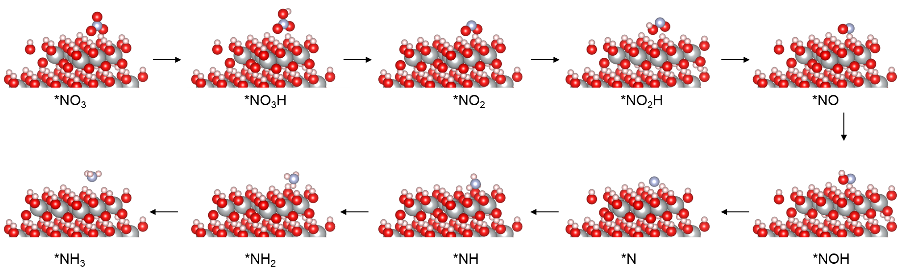
Supplementary Fig. 19 | Models after structural relaxation on Ni(OH)₂ during nitrate reduction reaction process.

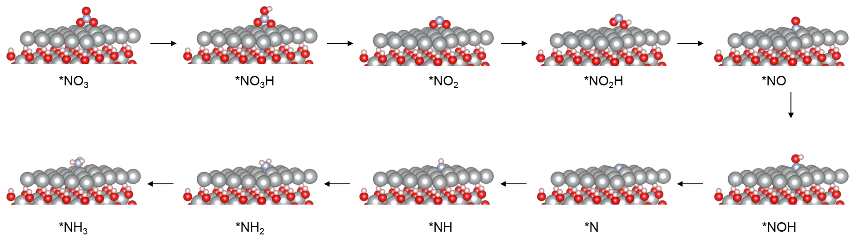
Supplementary Fig. 20 | Models after structural relaxation on Ni(OH)₂/Ni during nitrate reduction reaction process.

Supplementary Fig. 21 | COHP of the bond between O atom of nitrate and catalyst surface on Ni(OH)₂ and Ni(OH)₂/Ni.

Supplementary Fig. 22 | Structure model of Ni(OH)₂/Ni.

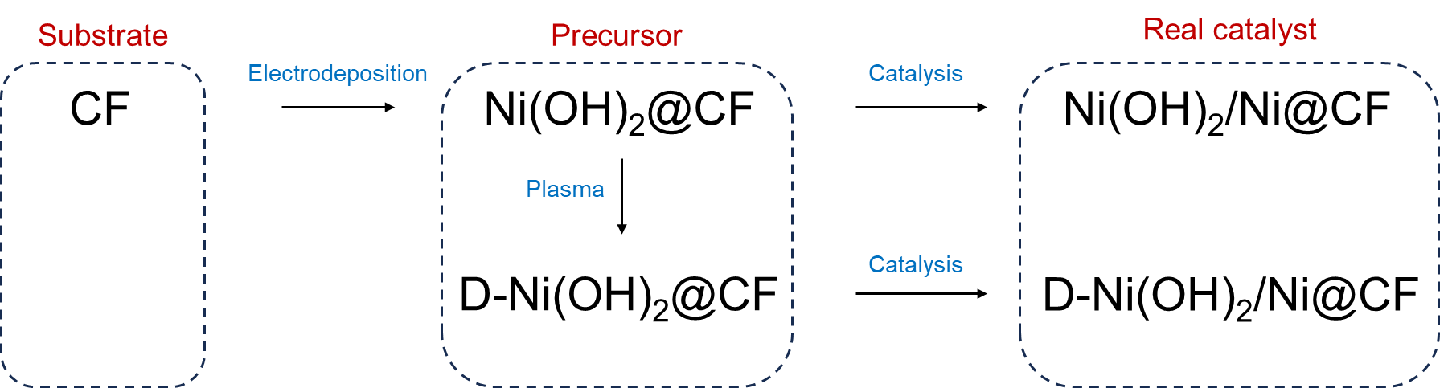
Supplementary Fig. 23 | Schematic diagram of the catalyst preparation process.

Supplementary Fig. 24 | XRD pattern of D-Ni(OH)₂/Ni@CF. The D-Ni(OH)₂/Ni@CF was consist of Ni, Ni(OH)₂, and Cu species.

Supplementary Fig. 25 | Cu 2p XPS spectra of D-Ni(OH)₂/Ni@Cu. The valence state in D-Ni(OH)₂/Ni@CF maintained metallic Cu⁰.

Supplementary Fig. 26 | Ni 2p XPS spectra of Ni(OH)₂@CF, D₁₀₀-Ni(OH)₂@CF, D₂₀₀-Ni(OH)₂@CF, and D₃₀₀-Ni(OH)₂@CF, respectively (100, 200, 300 represented the power of NTP. We measured the peak positions, and the increasing offset (0.15 eV→0.24 eV→0.32 eV) indicated the reduction in surface Ni-OH species.
Supplementary Fig. 27 | Ni⁰/Ni²⁺ ratio obtained by XPS peak area. The area was calculated based on Fig. S26.

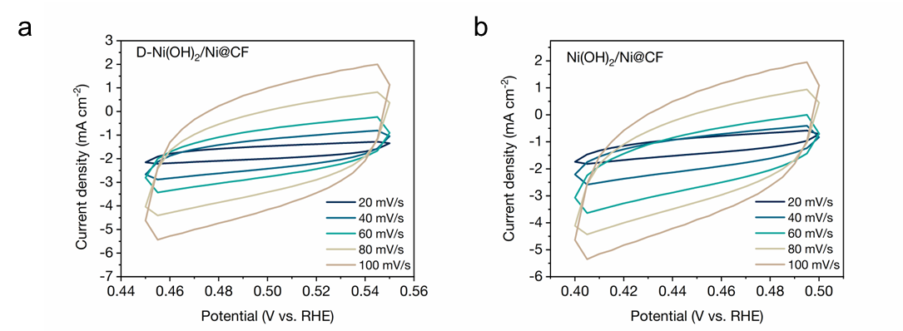
Supplementary Fig. 28 | CV curves immediately after catalyst preparation in the non-faradaic area with different scan rates (20 mV/s, 40 mV/s, 60 mV/s, 80 mV/s, and 100 mV/s) of (a) D-Ni(OH)₂/Ni@CF and (b) Ni(OH)₂/Ni@CF.

Supplementary Fig. 29 | The double layer capacitance (Cdl) of Ni(OH)₂/Ni@CF and D-Ni(OH)₂/Ni@CF. The ECSA was measured immediately after catalyst preparation calculated by CV curves.

Supplementary Fig. 30 | Polarization curves measured by linear sweep voltammetry (LSV) from 0.2 to -0.4 V vs. RHE (without iR compensation) of D-Ni(OH)₂/Ni@CF and Ni(OH)₂/Ni@CF in the electrolyte without nitrate.

Supplementary Fig. 31 | EIS with a frequency range from 0.01 Hz to 100 kHz on different catalysts at open circuit voltage.

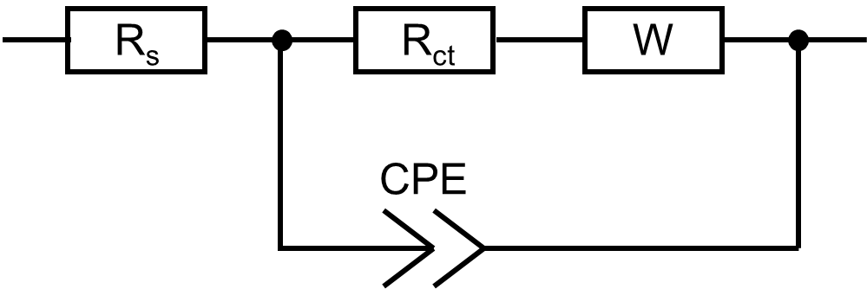
Supplementary Fig. 32 | EIS fitting circuit. R_{ct} represented the resistance of charge transfer, R_{s} represented the resistance of electrolyte solution, CPE represented the constant phase element, W represented the Warburg impedance.

Supplementary Fig. 33 | The double layer capacitance (Cdl) of CF, Ni(OH)₂/Ni@CF and D-Ni(OH)₂/Ni@CF. The ECSA calculated by CV curves was measured after series of electrochemical measurements.

Supplementary Fig. 34 | CV curves in the non-faradaic area with different scan rates (20 mV/s, 40 mV/s, 60 mV/s, 80 mV/s, and 100 mV/s) of (a) D-Ni(OH)₂/Ni@CF. (b) Ni(OH)₂/Ni@CF. (c) CF.
Supplementary Fig. 35 | Raw data of in situ electrochemical Raman spectra at -0.8 V vs. RHE of (a) D-Ni(OH)₂/Ni@CF and (b) Ni(OH)₂/Ni@CF with a time scale of 0~30 min. The above data was corresponding to the contour plot in Figure 4.

Supplementary Fig. 36 | Quasi in-situ EPR spectra of collected electrolyte from NO₃RR using D-Ni(OH)₂/Ni@CF and Ni(OH)₂/Ni@CF as electrocatalysts at -0.8 V vs. RHE in 1 M KOH. The DMPO-OH signal was detected without the addition of nitrate.

Supplementary Fig. 37 | FE of D-Ni(OH)₂/Ni@CF in H₂O and D₂O solutions. Only sight decreased of FE occurred on the D-Ni(OH)₂/Ni@CF in D₂O solutions.

Supplementary Fig. 38 | 1H NMR spectrum of ¹⁵NH₄⁺ in the electrolyte when ¹⁵KNO₃ was used as the nitrogen source. The typical double and triple peaks were assigned to the ¹⁵NH₄⁺ and ¹⁴NH₄⁺ species. Maleic acid was used as internal calibration

Supplementary Fig. 39 | Comparison of NH₃ production rate and FE obtained by UV and IC methods. The difference was within 5%.

Supplementary Fig. 40 | Standard concentration-absorbance calibration curves of NH₃ (UV method). The calibration curve shows good linearity.

Supplementary Fig. 41 | Standard calibration curves of NH₃ (IC method). The calibration curve shows good linearity.

Supplementary Fig. 42 | NH₃ production rate and FE of Cu foam (CF) at the potential range from 0.0 to -1.0 V vs. RHE (without iR compensation) (error bars: standard deviations of 3 independent measurements, center value: average of the 3 independent measurements).

Supplementary Fig. 43 | XRD patterns of (a) Ni(OH)₂@CF, (b) Ni(OH)₂/Ni_{7:3}@CF, (c) Ni(OH)₂/Ni_{5:5}@CF, (d) Ni(OH)₂/Ni_{3:7}@CF, and (e) Ni@CF. A series of Ni(OH)₂/Ni catalysts with different ratios were prepared by adjusting the parameters during electrodeposition. To be specific, cyclic voltammetry electrodeposition for 6 cycles (0.1 mV/s) in the range of -1~0.5 V vs. RHE was performed, followed by 600 s potentiostatic electrodeposition at -1.1, -1.2, -1.3, -1.4, -1.5 V vs. Ag/AgCl for Ni(OH)₂@CF, Ni(OH)₂/Ni_{7:3}@CF, Ni(OH)₂/Ni_{5:5}@CF, Ni(OH)₂/Ni_{3:7}@CF and Ni@CF, respectively.

Supplementary Fig. 44 | XPS Ni 2p spectra of (a) Ni(OH)₂@CF, (b) Ni(OH)₂/Ni_{7:3}@CF, (c) Ni(OH)₂/Ni_{5:5}@CF, (d) Ni(OH)₂/Ni_{3:7}@CF, and (e) Ni@CF.

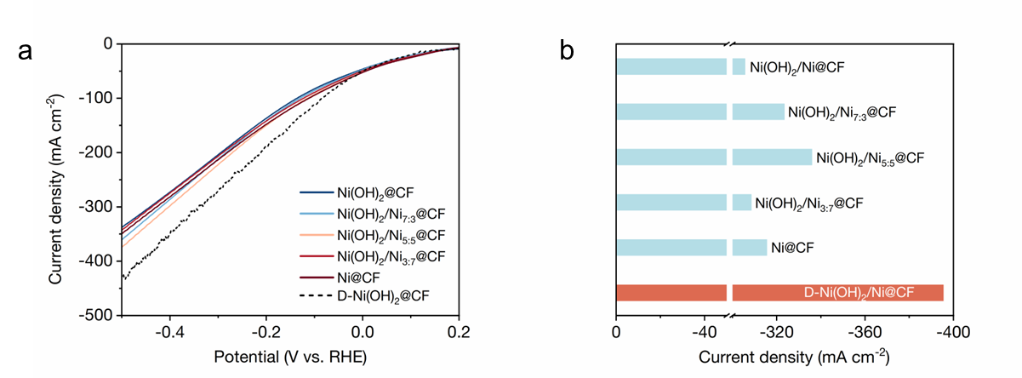
Supplementary Fig. 45 | Electrocatalytic performance of different doping ratios of Ni(OH)₂ and Ni. (a) Polarization curves from 0.2 to -0.5 V vs. RHE (without iR compensation) on Ni(OH)₂@CF, Ni(OH)₂/Ni_{7:3}@CF, Ni(OH)₂/Ni_{5:5}@CF, Ni(OH)₂/Ni_{3:7}@CF, Ni@CF, and D-Ni(OH)₂@CF catalysts. (b) Corresponding current density at -0.5 V vs. RHE. By increasing the metallic Ni phase in Ni(OH)²/Ni heterogeneous structure, the current density initially raised and then declined, demonstrating a volcano trend. Thus, a proper regulation of the Ni(OH)₂/Ni structure indeed enhanced the electrocatalytic performance to a certain extent. However, employing such strategy reached a maximum current density of only -335.9 mA cm⁻² on Ni(OH)₂/Ni_{5:5}@CF, significantly lower than -395.8 mA cm⁻² achieved through activation of the OH cycle on D- Ni(OH)₂/Ni@CF.

Supplementary Fig. 46 | FE of NH₃ synthesis at -0.6 V vs. RHE (without iR compensation) on Ni(OH)₂@CF, Ni(OH)₂/Ni_{7:3}@CF, Ni(OH)₂/Ni_{5:5}@CF, Ni(OH)₂/Ni_{3:7}@CF, Ni@CF, and D-Ni(OH)₂@CF catalysts. It was difficult to increase the selectivity to that of D-Ni(OH)₂/Ni@CF (FE=~100%) by only adjusting the Ni(OH)₂/Ni structure (FE=50%-70%), which also implied the increase activity might be also originated from the defects and the enhanced OH cycle not only the effect of catalyst structure.

Supplementary Fig. 47 | Polarization curves from 0.2 to -0.7 V vs. RHE (without iR compensation) of D-Ni(OH)₂/Ni@CF at different NO₃⁻ concentrations (500 to 10000 ppm)

Supplementary Fig. 48 | XPS Ni 2p spectra of D-Ni(OH)₂/Ni@CF after reaction.

Table S1. ICP-OES results of the surface catalyst after electrocatalysis (ND: not detected).
Element | C₀ (mg/L)
Ni | 6.641
Cu | ND
Co | ND
Fe | ND

Table S2. Fitting parameters at the Ni K-edge of Ni(OH)₂@CF and Ni(OH)₂/Ni@CF.
Sample ª | Path | N ^{b} | R ^{c}  (Å) | σ² ^{d}  (× 10⁻³ Å) | ΔE  (eV) | R factor
Ni(OH)₂@CF | Ni-O | 5.4±0.6 | 2.06±0.01 | 9.8±1.7 | -3.4±0.9 | 0.017
Ni(OH)₂@CF | Ni-Ni (in Ni(OH)₂) | 4.4±0.7 | 3.11±0.01 | 6.7±1.2 | -3.4±0.9 | 0.017
Ni(OH)₂/Ni@CF | Ni-O | 1.9±1.1 | 2.04±0.03 | 8.6±1.5 | 8.3±2.3 | 0.013
Ni(OH)₂/Ni@CF | Ni-Ni | 3.5±1.2 | 2.43±0.01 | 6.2±2.5 | 8.3±2.3 | 0.013
Ni(OH)₂/Ni@CF | Ni-Ni (in Ni(OH)₂) | 1.6±2.8 | 3.09±0.04 | 7.2±1.3 | 8.3±2.3 | 0.013
ª S⁰ was fixed as 1.0. ^{b} N is the coordination number. ^{c} is the distance between absorber and backscatter atoms. ^{d} σ² is the Debye-Waller factor. R-factor is residual factor.

Table S3. Free energy diagram during NO₃RR
Reaction Coordinate | Free energy
Reaction Coordinate | Ni | Ni(OH)₂
*NO₃ | 0 | 0
*NO₃H | 0.52 | 0.95
*NO₂ | -1.84 | -1.31
*NO₂H | -1.37 | -0.96
*NO | -4.36 | -1.75
*NOH | -3.91 | -0.35
*N | -5.57 | 0.06
*NH | -6.13 | -3.03
*NH₂ | -5.62 | -4.12
*NH₃ | -6.31 | -4.79

Table S4. Positron Lifetimes and Relative Intensities with Their Deviations of D-Ni(OH)₂/Ni@CF and Ni(OH)₂/Ni@CF
 | Ni(OH)₂/Ni@CF | D-Ni(OH)₂/Ni@CF
τ₁ (ns) | 0.128268 | 0.113783
Error | 0.002836 | 0.002742
I₁ (%) | 59.640274 | 53.262021
Error | 1.520672 | 1.200634
τ₂ (ns) | 0.27297 | 0.234848
Error | 0.005712 | 0.00257
I₂ (%) | 38.303682 | 44.363655
Error | 1.533103 | 1.206147
τ₃ (ns) | 2.002239 | 1.976285
Error | 0.045586 | 0.028551
I₃ (%) | 2.056044 | 2.374324
Error | 0.075788 | 0.063131

Table S5. Comparison of the NH₃ synthesis performance with state-of-the-art Ni-based catalysts.
 | Potential |  | FE  (%) | NH₃ yield  (mg h⁻¹ cm⁻²) |  | Stability |  | Electrolyte
Ni₁Fe₁ ^{[1]} | -0.75 (vs. SCE) |  | 74.8 | 3.672 |  | 7 cycles |  | 0.1 M K₂SO₄ + 200 ppm KNO₃
Fe/Ni₂P ^{[2]} | -0.4 (vs. RHE) |  | 95.4 | 4.17 |  | 6 cycles, 11 h |  | 0.2 M K₂SO₄ + 50mM KNO₃
NiPr-TPA-COF ^{[3]} | -1.45 (vs. SCE) |  | >80 | 2.5 |  | 10 cycles |  | 0.5 M K₂SO₄+ 0.1 M KNO₃
Cu₅₀Ni₅₀ ^{[4]} | -0.15 (vs. RHE) |  | 99 | ~170 mA cm⁻² |  | 12 h, 6 cycles |  | 1 M KOH + 0.1 M KNO₃
NiCoP/NF-₂₀ ^{[5]} | / |  | ~57.7 | 0.07528 |  | 6 cycles, 30 h |  | 0.05 M Na₂SO₄ + 50 ppm NaNO₃
CFP-Cu₁Ni₁ ^{[6]} | -0.22 (vs. RHE) |  | 95.7 | 3.06986 |  | 5 h, 10 cycles |  | 0.5 M Na₂SO₄+ 0.1 M KNO₃
Ni₁Cu-SAA ^{[7]} | -0.55 (vs. RHE) |  | ~100 | 5.5539 |  | ~9 h (32,000 s) |  | 0.5 M K₂SO₄ + 200 ppm KNO₃
Ni-MOF ^{[8]} | -1.4 (vs. SCE) |  | 96.4 | 0.11013 |  | 8 cycles |  | 0.1 M Na₂SO₄ + 70 ppm NaNO₃
Ni₂P ^{[9]} | -0.3 (vs. RHE) |  | ~90 | 20.287 |  | 35 h |  | 1 M NaOH + 0.1 M NaNO₂
Ni₃Co₆S₈ ^{[10]} | -0.4 (vs. RHE) |  | 85.3 | 2.3884 |  | 6 cycles |  | 1 M KOH +50 ppm KNO₃
Ni₂P/NF ^{[11]} | -0.3 (vs. RHE) |  | 90.2 | 2.6922 |  | 6 cycles |  | 0.1 M PBS +200 ppm NaNO₂
BCN@Ni ^{[12]} | -0.5 (vs. RHE) |  | 91.15 | 2.3202 |  | 20 h, 10 cycle |  | 0.1 M KOH + 0.1 M KNO₃
NTP-Cu₅₀Ni₅₀ ^{[13]} | -0.47 (vs. RHE) |  | ~100 | ~6 |  | / |  | 1 M KOH + 0.1 M KNO₃
P-NiFe₂O₄ ^{[14]} | -0.35 (vs. RHE) |  | 85.34 | 22.30354 |  | 16 cycles, 8 h |  | 1 M KOH + 0.1 M KNO₂
C-NiWO₄/NF ^{[15]} | -0.4 (vs. RHE) |  | 97.6 | 10.97436 |  | 6 cycles |  | 0.1 M NaOH + 0.1 M NaNO₂
This work | -0.2 (vs. RHE) |  | 97.65 | 14.11 |  | 50 cycles, 50 h |  | 1 M KOH + 0.1 M KNO₃
This work | -0.8 (vs. RHE) |  | 98.99 | 47.85

Supplementary Discussion 1. DMPO-OH signal in EPR test.
The formation of DMPO-OH species might be originated from the nucleophilic addition of DMPO by active H₂O (Fig. S49). This process following the Forrester-Hepburn mechanism (F-H mechanism) ^{[16-17]}, and has been observed in diverse transition metal systems including Cu^{2+ [18]}, Fe³⁺ ^{[19],} and Ti⁴⁺ ^{[20]}, etc. In our system, we have reported that the dynamic adsorption of OH on the Ni active site during the OH cycle could effectively activate interfacial H₂O dissociation. Thus, the H₂O activated during the OH cycle could be severed as the nucleophile and facilitated the formation of DMPO-OH specie, coupling with the electron transfer with Ni²⁺ → Ni⁰, thus completed the F-H process.
Supplementary Fig. 49 | Schematic diagram of the understanding of DMPO-OH in this research.

Supplementary Discussion 2. Techno-economic assessment.
To explore the potential of NO₃RR, we built a more elaborate TEA model of NO₃RR process inspired by previous studies in electrolyzers and electrocatalysis ^{[21-23]}. The potential distributed NH₃ yield was assumed at a scale of 1 t d⁻¹. The cost of this process mainly consisted of capital cost and operational cost. To consider the effect of stability and activity of the catalyst on the cost of electrolyzer, we assumed that the catalyst could operate for 500 h with the average FE of 85%, and investigated its effect on the NH₃ production cost (e.g variation of FE from 43% to 100%). The lifetime of the whole nitrate electrolysis system was assumed of 20 years. The electrolyzer operation parameters were based on the performance of our prepared catalyst (Table S6). Without considering ohmic losses etc, the cell voltage V in our experiment was set as 1.23-(-0.8) = 2.03 V. An operation of 7000 hours per year for the electrochemical system was set. The electricity was assumed to be 0.03 $/kWh ^{[21]}. To achieve 1 t d⁻¹ capacity, the needed total electrolyzer area which is normally contributed by multiple electrolyzer stacks was calculated as follows ^{[21]}:
A_{ele} = (yield × n_{NH3} × F) / (j × Average FE) (1)
Where yield represented the designed annual NH₃ production (1 t d⁻¹), n_{NH3} represented the number of electron transfers (8 for NO₃RR), F represented Faraday constant (96,485 C mol⁻¹). The cost of the electrolyzers was mainly composed of cathode material (e.g Ni & Cu), anode metarial (Pt), ion exchange membranes, bipolar plates, end plates and tie rods. Each component's replacement time and cost parameters were listed (Table S7). The current market metal price was also considered for catalysts used for cathode and anode materials ^{[21]}. For catalysts, the replacement cost (C_{re}) was calculated as follows ^{[21]}:
C_{re,i} = P_{m} × LM × A_{ele} (2)
Where P_{m} represented the current market metal price, LM represented the loading mass per unit area. The cost of bipolar plates, end plates or tie rods ($/kW) was estimated ^{[24]}, where reference electrolyzer operated at V_{ref} (1.9 V) and j_{ref} (2 A cm⁻²). The cost was calculated as follows based on DOE ^{[25]}:
Cost ($ m⁻²) = Cost ($ kW⁻¹) × V_{ref} × j_{ref} (3)
Based on calculated results above, the capital cost of electrolyzers in its 20-year lifetime was calculated as follows:
C_{ele} = $\sum_{i}{C_{re,i}×n_{i}}$ (4)
Where C_{re,i} represented the replacement cost of i ($, i = catalysts, membrane, plates or tie rods), n_{i} represented the replacement time of i in 20 years. The electrolyzer cost per kW (C_{ele per kW}) considering material replacement was calculated as 1071 $ kW⁻¹.
The annual NH₃ yield (yield_{NH3}) was calculated to be 291.7 t yr⁻¹ and the annual anode O₂ yield (yield_{O2}) was calculated to be 1,098 t yr⁻¹ ^{[21]}. The electrolyzer electricity cost (C_{ee}) under 0.03 $ kWh⁻¹ was calculated to be 263,562 $ yr⁻¹. Other costs (BoP, maintenance, etc) were estimated based on other literatures and listed in Table S8. The nitrate electrolysis system cost to produce 1 t NH₃ (C_{ammonia}) was calculated by total capital cost (C_{cap,tot}) and annual operational (C_{op,tot}) as follows:
C_{ammonia} = (C_{cap,tot} + C_{op,tot} × 20) / ( yield × 20 ) = 1,487 $ t_{NH3}⁻¹ (5)
The total revenue (R_{tot}) was calculated as follows ^{[22]}:
R_{tot} = (P_{ammonia} × yield_{NH3} + P_{oxygen} × yield_{O2}) / yield_{NH3} = 1,156 $ t_{NH3}⁻¹ (6)
Where P_{ammonia} represented the market price of ammonia (290 $ t⁻¹) ^{[26]}, P_{oxygen} represented the market price of oxygen (230 $ t⁻¹) ^{[27]}. Sensitivity analysis was performed by varying different parameters of ±50%, including electricity, cell performance and the designed NH₃ yield etc (Operation time and FE only vary of -50 %, cell voltage only vary of +50 %).

Table S6. Electrolyzer operation parameters
 | Values | Units | Ref. & Notes
Designed ammonia yield, yield | 1,000 | kg d⁻¹ | Assumed
Current density, j | ~0.6 | A cm⁻² | Experimental  Assumed
Average FE | 85 | % | Experimental  Assumed
Cathode potential | -0.8 | V | Experimental
Catalyst duration, t | 500 | h | Assumed
Electrolyzer area needed, A_{ele} | 1,030,426 | cm² | Equation (1)
Operation time | 7000 | h yr⁻¹ | Assumed

Table S7. Parameters and costs for the electrolyzer.
Component | Replacement time | Cost parameters
Ni | Based on operational time | 20430 $ t^{-1 [28]}  63 g m⁻² from experiment
Cu | Based on operational time | 3.815 $ lbs^{-1 [28]}  550 g m⁻² from experiment
Pt | Assumed 1 time per 2 yrs | 974 $/tr.oz ^{[28]}  7 g m^{-2 [23]}
Membrane | 1 time per 2 yrs ^{[29]} | 750 $ m⁻² ^{[29]}
Bipolar plate |  | 535 $ m^{-2 [24, 25]}
End plate | 1 time per 7 yrs ^{[24]} | 16 $ m^{-2 [24, 25]}
Tie rods |  | 16 $ m^{-2 [24, 25]}
Operational time: (7000 h) / (500 h) yr⁻¹. Separating the cathode does not damage the membrane due to the CF substrate)

Table S8. Cost components for the nitrate electrolysis system.
 | Values | Units | Ref. & Notes
Capital cost
C_{ele} | 1,344,768 |  | This study
C_{cap, BOP} | 860,652 | $ | 64 % of C_{ele} ^{[21]}
C_{cap, tot} | 2,205,420
Operational cost
C_{chem} | 0 |  | Waste water ^{[22]}
C_{ee} | 263,562 |  | Electrolyzer electricity
C_{op, PS} | 26,356 | $ yr⁻¹ | 10 % of C_{ee} ^{[22]}
C_{m} | 33,619 |  | 2.5 % of C_{ele} ^{[21]}
C_{op, tot} | 323,537

According to the stability test of D-Ni(OH)₂/Ni@CF, A slight decline in the average FE was observed from the initial 24 hours to entire 50-hour interval (Fig. S50). The average FE of 1-50 cycles was 97.26%, dropping about 1.5% compared to 1-24 cycles (98.72%), which showed a potential for 500-hour operation.
Supplementary Fig. 50 | Average FE of 1-24 h and 1-50 h.
Supplementary Fig. 51 | Sensitivity analysis of NO₃RR process.

Supplementary Fig. 52 | pH value of the electrolyte. Error bars: standard deviations of 3 independent measurements, center value: average of the 3 independent measurements.
Supplementary Fig. 53 | Schematic of the electrolytic cell. (a) Electrolytic cell for in situ Raman test. (b) Electrolytic cell for in situ FTIR test. For in situ Raman electrolytic cell, Pt wire and Ag/AgCl electrode were served as the counter electrode and reference electrode, respectively, and the catalyst was employed as the working electrode. For in situ FTIR electrolytic cell, Pt wire and Ag/AgCl electrode were utilized as the counter and reference electrodes, respectively. The catalyst was stripped from the CF and processed into an ink for deposition onto the working electrode.

Supplementary Fig. 54 | CV curves for reference electrode (Ag/AgCl) calibration in 1 M KOH solution. Inset: local amplification at the zero mA cm⁻² area. The current>0 represented the HOR, and the current<0 represented the HER. The potential of the reference electrode was corrected by averaging the intersection point with zero current density, which was calculated to be -1.02.

Supplementary Fig. 55 | Resistance of the electrochemical cell in between RE and WE during the constant potential test. Error bars: standard deviations of 3 independent measurements, center value: average of the 3 independent measurements.

Reference
[1] X. Wu et al. Amorphous nickel-iron hydroxide nanosheets for effective electroreduction of nitrate to ammonia. Inorg. Chem. Front. 10, 666-674 (2023).
[2] R. Zhang et al. Efficient Ammonia Electrosynthesis and Energy Conversion through a Zn-Nitrate Battery by Iron Doping Engineered Nickel Phosphide Catalyst. Adv. Energy Mater. 12, 2103872 (2022).
[3] F. Lv et al. Near-unity electrochemical conversion of nitrate to ammonia on crystalline nickel porphyrin-based covalent organic frameworks. Energy Environ. Sci. 16, 201-209 (2023).
[4] Y. Wang et al. Enhanced nitrate-to-ammonia activity on copper–nickel alloys via tuning of intermediate adsorption. J. Am. Chem. Soc. 142, 5702-5708 (2020).
[5] J. Wang, et al. Electrodeposited NiCoP on nickel foam as a self-supported cathode for highly selective electrochemical reduction of nitrate to ammonia. Sep. Purif. Technol. 320, 124155 (2023).
[6] Z. Zhang et al. Electro-triggered Joule heating method to synthesize single-phase CuNi nano-alloy catalyst for efficient electrocatalytic nitrate reduction toward ammonia. Nano Res. 16, 6632-6641 (2023).
[7] J. Cai et al. Electrocatalytic nitrate-to-ammonia conversion with~ 100% Faradaic efficiency via single-atom alloying. Appl. Catal. B. 316, 121683 (2022).
[8] F. Pan et al. Revealing the activity origin of ultrathin nickel metal–organic framework nanosheet catalysts for selective electrochemical nitrate reduction to ammonia: Experimental and density functional theory investigations. J. Colloid Interface Sci. 638, 26-38 (2023).
[9] X. Yang, et al. Electrochemical ammonia synthesis from nitrite assisted by in situ generated hydrogen atoms on a nickel phosphide catalyst. Chem. Commun. 57, 7176-7179 (2021).
[10] W. Tao, et al. Engineering sulfur vacancies optimization in Ni3Co6S8 nanospheres toward extraordinarily efficient nitrate electroreduction to ammonia. Appl. Catal. B. 324, 122193 (2023).
[11] G. Wen et al. Ni2P nanosheet array for high-efficiency electrohydrogenation of nitrite to ammonia at ambient conditions. J. Colloid Interface Sci. 606, 1055-1063 (2022).
[12] X. Zhao et al. Simultaneous anchoring of Ni nanoparticles and single-atom Ni on BCN matrix promotes efficient conversion of nitrate in water into high-value-added ammonia. Chem. Eng. J. 433, 133190 (2022).
[13] Y. Zhou et al. Ar-plasma enhanced copper-nickel alloy catalysis for ammonia synthesis. Waste Disposal & Sustainable Energy. 4, 149-155 (2022).
[14] T. Zhao et al. Self-supported P-doped NiFe2O4 micro-sheet arrays for the efficient conversion of nitrite to ammonia. J. Colloid Interface Sci. 650, 143-150 (2023).
[15] H. Qiu et al. NiWO 4 nanoparticles with oxygen vacancies: high-efficiency electrosynthesis of ammonia with selective reduction of nitrite. Inorg. Chem. Front. 10, 3909-3915 (2023).
[16] A.R. Forrester, et al. Spin traps. A cautionary note. J. Chem. Soc. C. 701-703 (1971).
[17] E. Braxton, et al. Electron paramagnetic resonance for the detection of electrochemically generated hydroxyl radicals: issues associated with electrochemical oxidation of the spin trap. ACS Meas. Sci. Au. 3, 21-31 (2023).
[18] P. M Hanna, et al. When are metal ion-dependent hydroxyl and alkoxyl radical adducts of 5,5-dimethyl-1-pyrroline N-oxide artifacts? Arch. Biochem. Biophys. 296, 640-644 (1992).
[19] K. Makino et al. Cautionary note for DMPO spin trapping in the presence of iron ion. Biochemistry. 172, 1073-1080 (1990).
[20] Y. Miura et al. Formation of the DMPO-OH adduct from Ti (IV) and DMPO in aqueous solution-the first ESR evidence. Inorg. Chim. Acta. 234, 169-171 (1995).
[21] H. Shin, et al. Techno-economic assessment of low-temperature carbon dioxide electrolysis. Nature Sustain. 4, 911-919 (2021).
[22] K. Fan, et al. Active hydrogen boosts electrochemical nitrate reduction to ammonia. Nat Common. 13, 7958 (2022).
[23] A. Mayyas, et al. National Renewable Energy Laboratory (NREL), https://www.nrel.gov/docs/fy19osti/72740.pdf.
[24] A. Badgett, et al. National Renewable Energy Laboratory (NREL), 2024, https://www.nrel.gov/docs/fy24osti/87625.pdf.
[25] D. Peterson, et al. DOE hydrogen and fuel cells program record 19009: Hydrogen production cost from PEM electrolysis-2019, US Department of Energy, 2020, https://www.hydrogen.energy.gov/pdfs/19009_h2_production_cost_pem_electrolysis_2019.pdf.
[26] ChemAnalyst, Ammonia price trend and forecast, https://www.chemanalyst.com/Pricing-data/ammonia-37.
[27] ChemAnalyst, Oxygen price trend and forecast, https://www.chemanalyst.com/Pricing-data/oxygen-1575.
[28] Trading Economics, https://tradingeconomics.com.
[29] A. Iizuka, et al. Carbon dioxide recovery from carbonate solutions using bipolar membrane electrodialysis. Sep. Purif. Technol. 101, 49-59 (2012).

