Supplementary Information

Targeting Fatty Acid Oxidation Enhances Response to HER2-targeted Therapy
Nandi et al.

Supplementary Figures 1-12
Supplementary Tables 1-4

Supplementary Figures

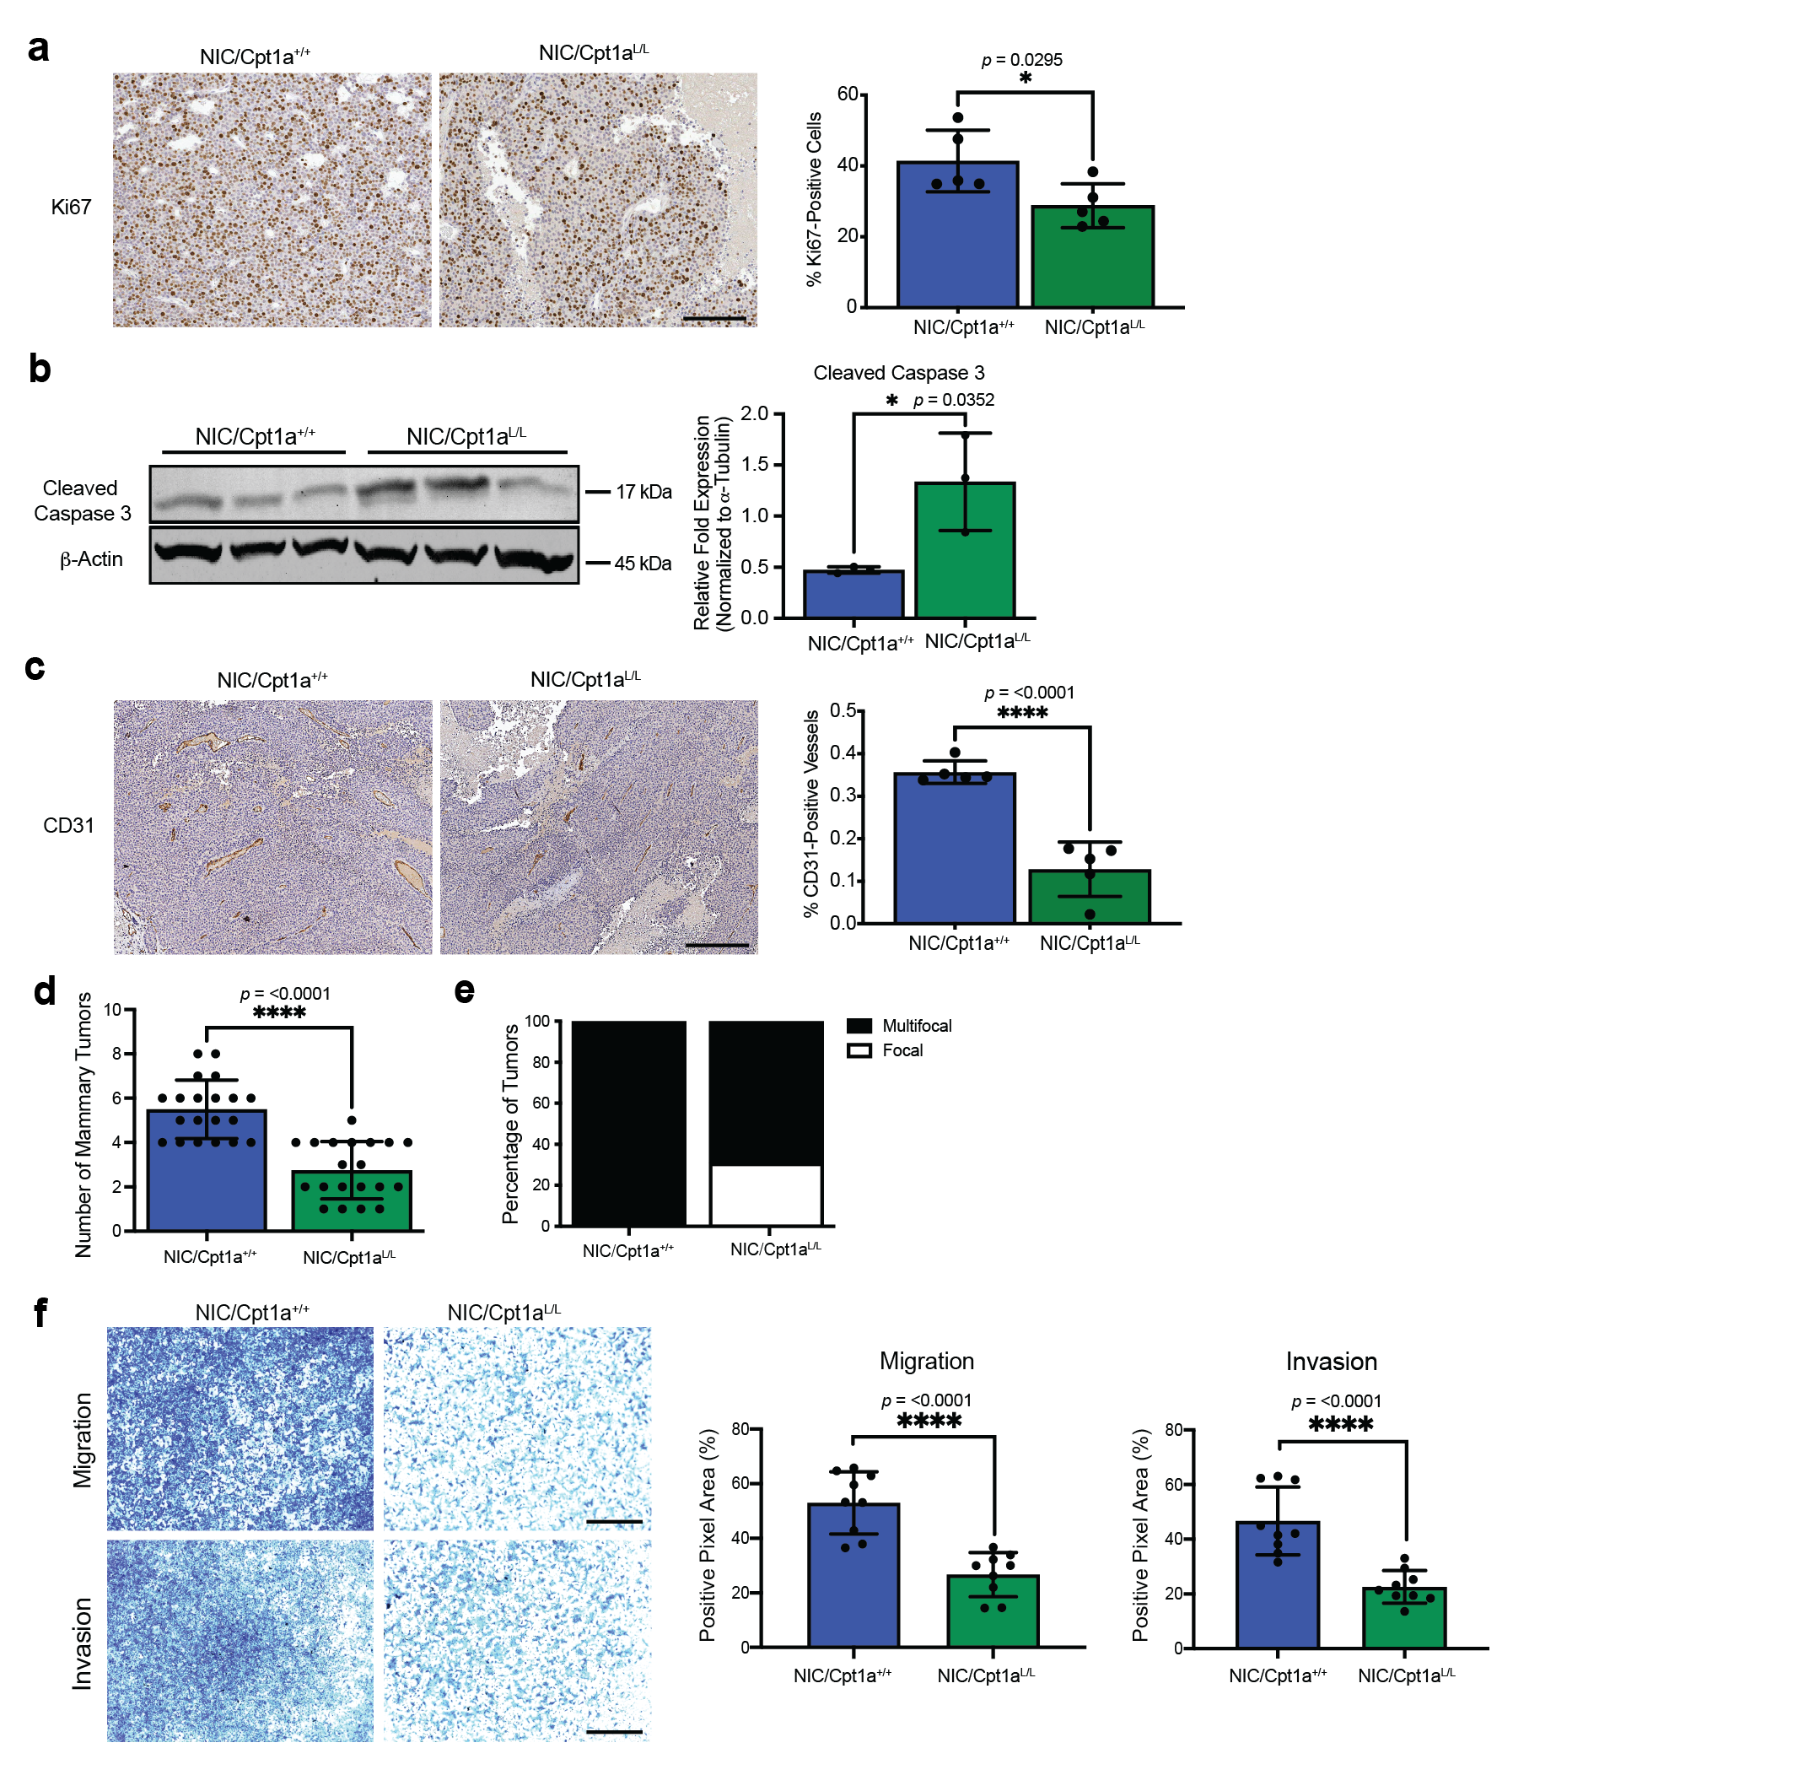Supplementary Figure 1: Cpt1a-deficient NIC Tumors are Necrotic and Exhibit Decreased Blood Vessel Diameter
a, Control and Cpt1a-deficient tumors were stained for Ki67, a proliferation marker, expression by immunohistochemistry (IHC). Left panel - Representative images. Scale bar represents 100 µm. Right panel - Quantification of the percentage of Ki67-positive nuclei in tumors. n = 5 mice per genotype (minimum 10,000 total nuclei analyzed per mouse). *p < 0.05; unpaired, two-tailed Student’s t-test. b, Lysates of NIC/Cpt1a^{+/+} and NIC/Cpt1a^{L/L} cells were immunoblotted with the indicated antibodies. Representative immunoblots and quantification (fluorescent immunoblotting – LiCOR Odyssey) of Cleaved Caspase 3 expression are shown. 3 independent cell lines were analyzed per genotype. *p < 0.05; unpaired, two-tailed Student’s t-test. c, Tumors as in (a) were stained for stained for CD31, a marker of endothelial cells, by IHC. Left panel - Representative images. Scale bar represents 100 µm. Right panel - Quantification of the percentage of CD31-positive vessels in tumors. n = 5 mice per genotype (minimum 10,000 total nuclei analyzed per mouse). ****p < 0.0001; unpaired, two-tailed Student’s t-test. d-e, Quantification of the total number of mammary tumors per mouse (d) and percentage of focal and multifocal tumors, for each genotype. n = 20 mice per genotype - ****p < 0.0001; unpaired, two-tailed Student’s t-test. f, Left panel –Representative images of cell migration and invasion (Boyden chamber) assays. Scale bar represents 1000 μm. Right Panel – quantification (positive pixel area) of cell migration and invasion (n = 3 cell lines per genotype in triplicate – ****p < 0.0001; unpaired, two-tailed Student’s t-test). All error bars are expressed as mean values ± SD. Source data are provided as a Source Data file.

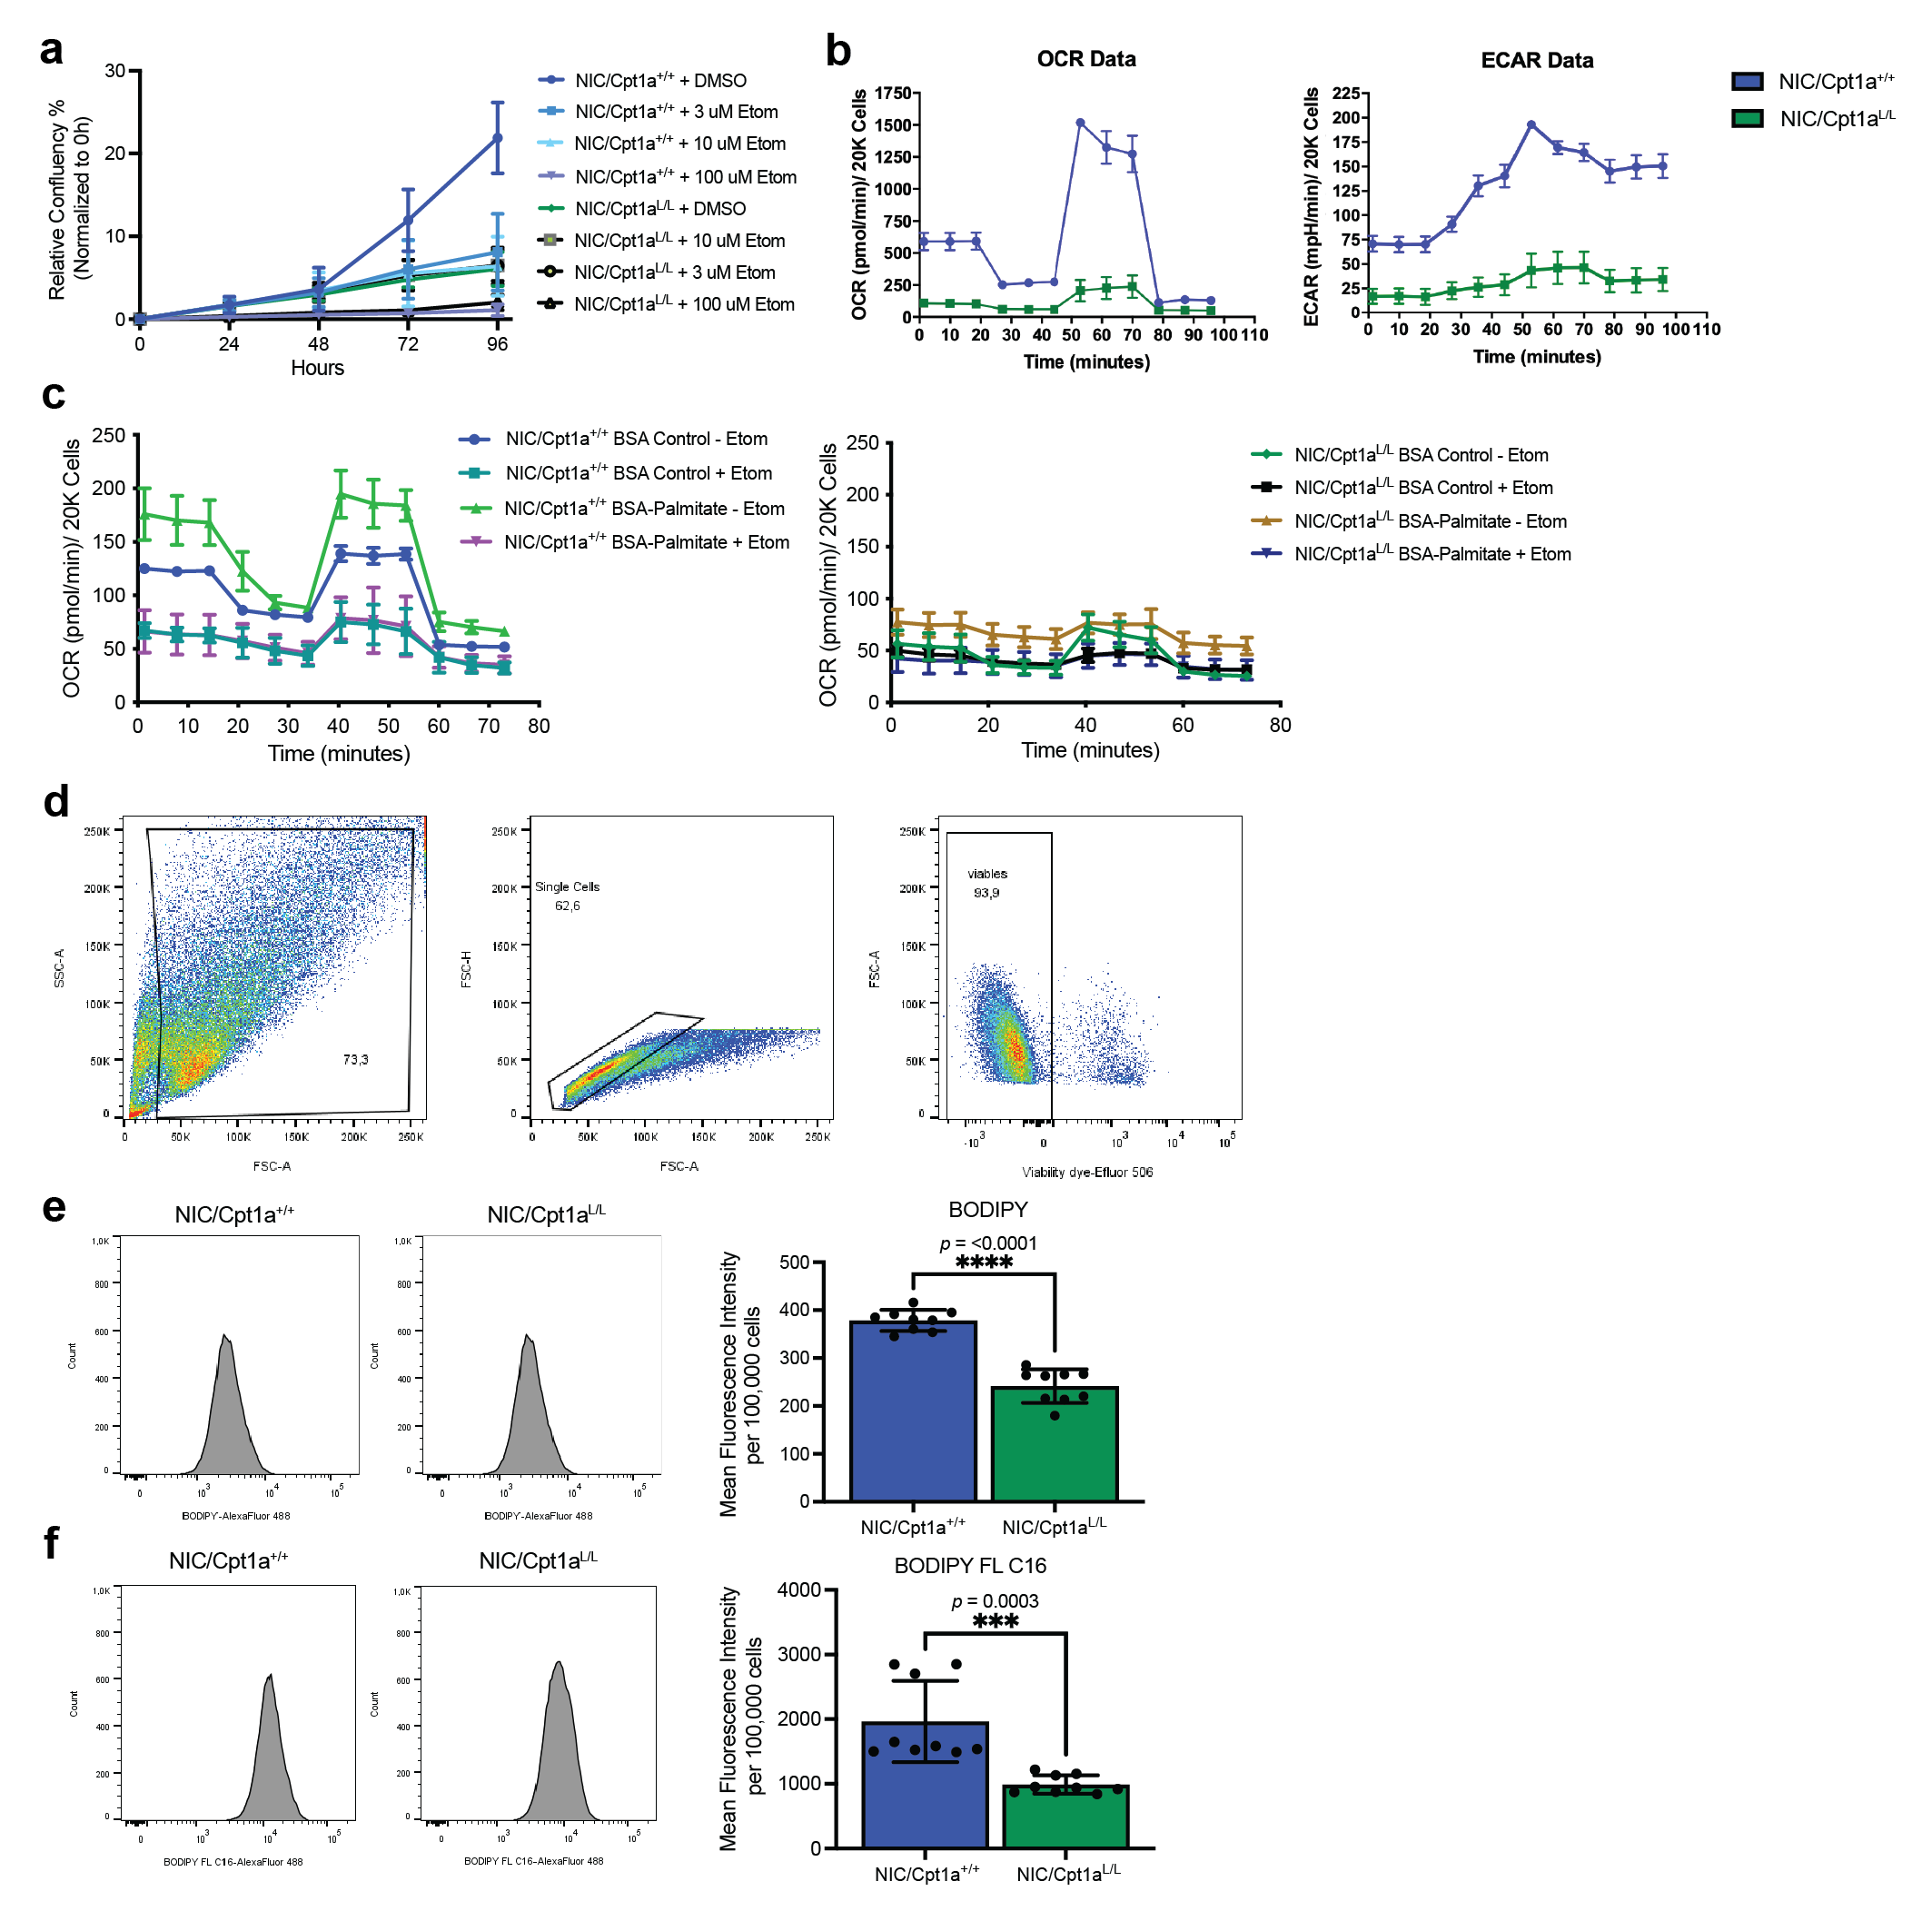Supplementary Figure 2: Deletion of Cpt1a impairs OXPHOS, glycolysis and utilization of exogenous fatty acids for FAO.
a, Growth curves from the proliferation assay Figure 2b. b, Left panel - Basal, maximal (FCCP), ATP-synthesis coupled (Oligomycin A), and non-mitochondrial (rotenone/ antimycin A) oxygen consumption rates (OCRs) of NIC/Cpt1a^{+/+} and NIC/Cpt1a^{L/L} cells. Representative of n = 3 cell lines. Right panel - pH changes per minute in the cell culture medium measured simultaneously with OCR, Representative of n = 3 cell lines per genotype. c, Left panel - Basal, maximal (FCCP), ATP-synthesis coupled (Oligomycin A), and non-mitochondrial (rotenone/ antimycin A) OCRs of NIC/Cpt1a^{+/+} and NIC/ Cpt1a^{L/L} cells in the presence of bovine serum albumin (BSA)-control or palmitate and in the presence or absence of Etomoxir (Etom). Representative of n = 3 cell lines. Right panel - pH changes per minute in the cell culture medium from cells as 2f measured simultaneously with OCR, Representative of n = 3 cell lines per genotype. d, Representative gating strategy for flow cytometry analysis of (e-f) assessing BODIPY 493/503 and BODIPY FL C16 (Alexa Fluor 488) in viable (eFluor 506-positive) NIC/Cpt1a^{+/+} and NIC/Cpt1a^{L/L} cells. e-f, Representative histograms (Left panel) and mean fluorescence intensity (MFI) (Right panel) of BODIPY 493/503 (d) and BODIPY FL C16 (e) incorporation in NIC/ Cpt1a^{+/+} and NIC/ Cpt1a^{L/L} cells. n = 3 cell lines per genotype analyzed in triplicate -***p< 0.001, ****p < 0.0001; unpaired, two-tailed Student’s t-test. All error bars are expressed as mean values ± SD. Source data are provided as a Source Data file.

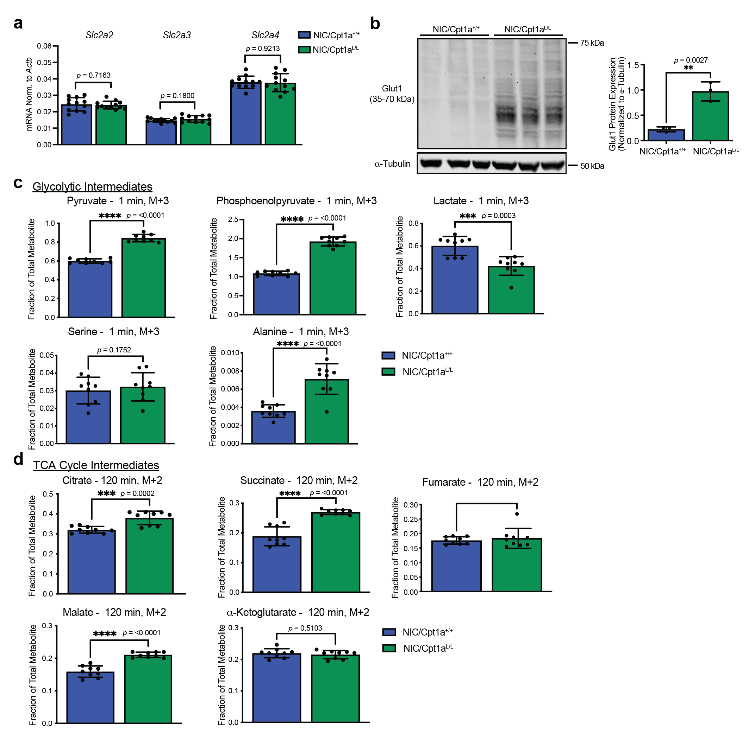Supplementary Figure 3: U-¹³C-glucose labeling shows loss of Cpt1a drives synthesis of TCA cycle intermediates from glucose
a, QRT-PCR analysis of Glut2 (Slc2a2), Glut3 (Slc2a3) and Glut4 (Slc2a4) in NIC/Cpt1a^{+/+} and NIC/Cpt1a^{L/L} cells. Expression was normalized to that of Actb. n = 4 cell lines per genotype in triplicate - ***p< 0.001, ****p < 0.0001; unpaired, two-tailed Student’s t-test. b, NIC/Cpt1a^{+/+} and NIC/Cpt1a^{L/L} lysates were immunoblotted with the indicated antibodies. Representative immunoblots and quantification (fluorescent immunoblotting – LiCOR Odyssey) of Glut1 expression are shown. 3 independent cell lines were analyzed per genotype in triplicate. **p < 0.01; unpaired, two-tailed Student’s t-test. c-d, Fractional ion abundance of Glycolytic (Pyruvate, Phosphoenolpyruvate, Lactate, Serine and Alanine) and TCA Cycle (Citrate, Succinate, Fumarate, Malate and a-KG) intermediates following a pulse with U-¹³C-glucose at the indicated time points of NIC/Cpt1a^{+/+} and NIC/Cpt1a^{L/L} cells. n = 3 per genotype, analyzed in triplicate - ***p < 0.001, ****p < 0.0001; unpaired, two-tailed Student’s t-test. All error bars are expressed as mean values ± SD. Source data are provided as a Source Data file.

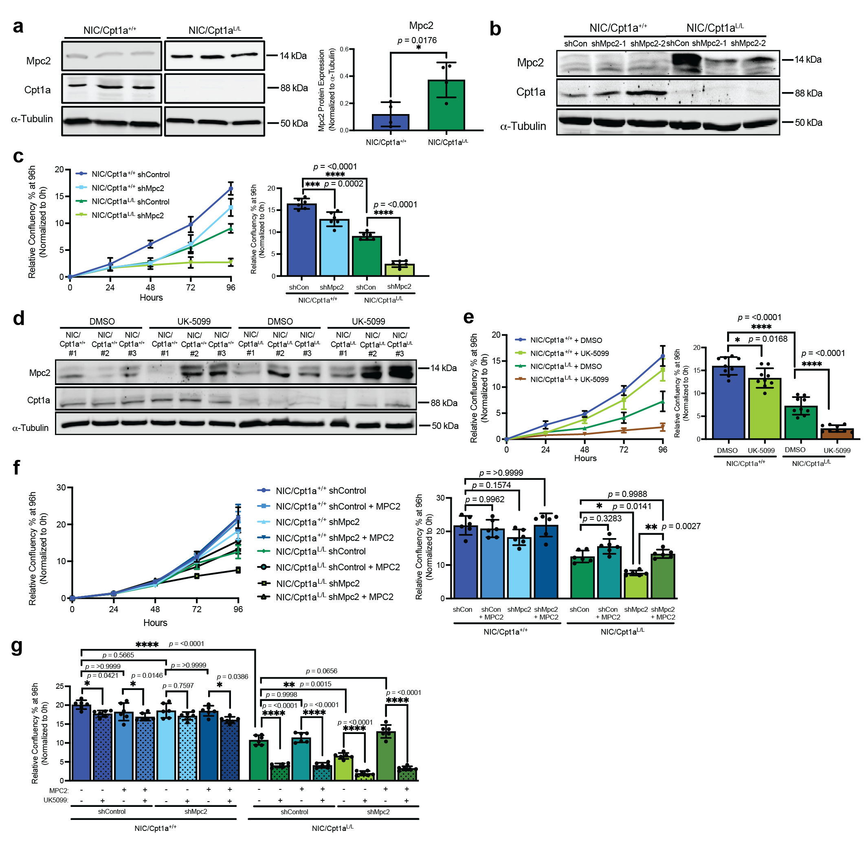Supplementary Figure 4: Ablation of Cpt1a confers dependence on pyruvate transport into the mitochondria.
a, NIC/Cpt1a^{+/+} and NIC/Cpt1a^{L/L} lysates were immunoblotted with the indicated antibodies. Representative immunoblots (Left panel) and quantification (fluorescent immunoblotting – LiCOR Odyssey) (Right panel) of Mpc2 expression are shown. 4 independent cell lines were analyzed per genotype. *p < 0.05; unpaired, two-tailed Student’s t-test. b, NIC/Cpt1a^{+/+} and NIC/Cpt1a^{L/L} cells stably expressing short hairpin RNAs (shRNAs) against luciferase (control - shCon) or Mpc2 (Brp44) were transduced in vitro and immunoblotted with the indicated antibodies. c, Proliferation was assessed from cells as in (b) using an imaging-based assay to monitor cell confluency in real time. Left panel – growth curves. Right panel – endpoint analysis of cell growth at 96h. Data were normalized to confluency at t=0. n = 2 cell lines in triplicate - ***p < 0.001, ****p < 0.0001; unpaired, two-tailed Student’s t-test. d, Lysates of NIC/Cpt1a^{+/+} and NIC/Cpt1a^{L/L} cells were immunoblotted with the indicated antibodies. Mitochondrial pyruvate carrier (MPC) inhibitor, UK5099, was used at 10μM. e, NIC cells were treated with 10μM UK5099, or DMSO as a control. Proliferation was assessed by Incucyte® to measure cell confluency in real time. Growth curves (left panel) correspond to endpoint data at 96 hours (right panel). n = 3 per genotype, analyzed in triplicate - *p < 0.05 and ****p < 0.0001; one-way ANOVA with Tukey’s post-hoc test. f, Left panel - Proliferation assay of NIC/Cpt1a^{+/+} and NIC/Cpt1a^{L/L} shControl and shMpc2 cells stably transduced with human MPC2 constructs, resistant to targeting my shMpc2, assessed by Incucyte®. Right panel – Percentage relative confluency of cells at 96 hours, normalized to t=0. (n=3 cell lines) (*p < 0.05, **p < 0.05; one-way ANOVA with Tukey’s post-hoc test). g, Growth curve (left panel) and end-point proliferation data (right panel) of NIC shControl and shMpc2 cells stably transduced with human MPC2 and treated with UK5099 (10μM) at 96 hours, normalized to t=0. (n=3 cell lines) (**p < 0.01, ****p < 0.0001; one-way ANOVA with Tukey’s post-hoc test). All error bars are expressed as mean values ± SD. Source data are provided as a Source Data file.

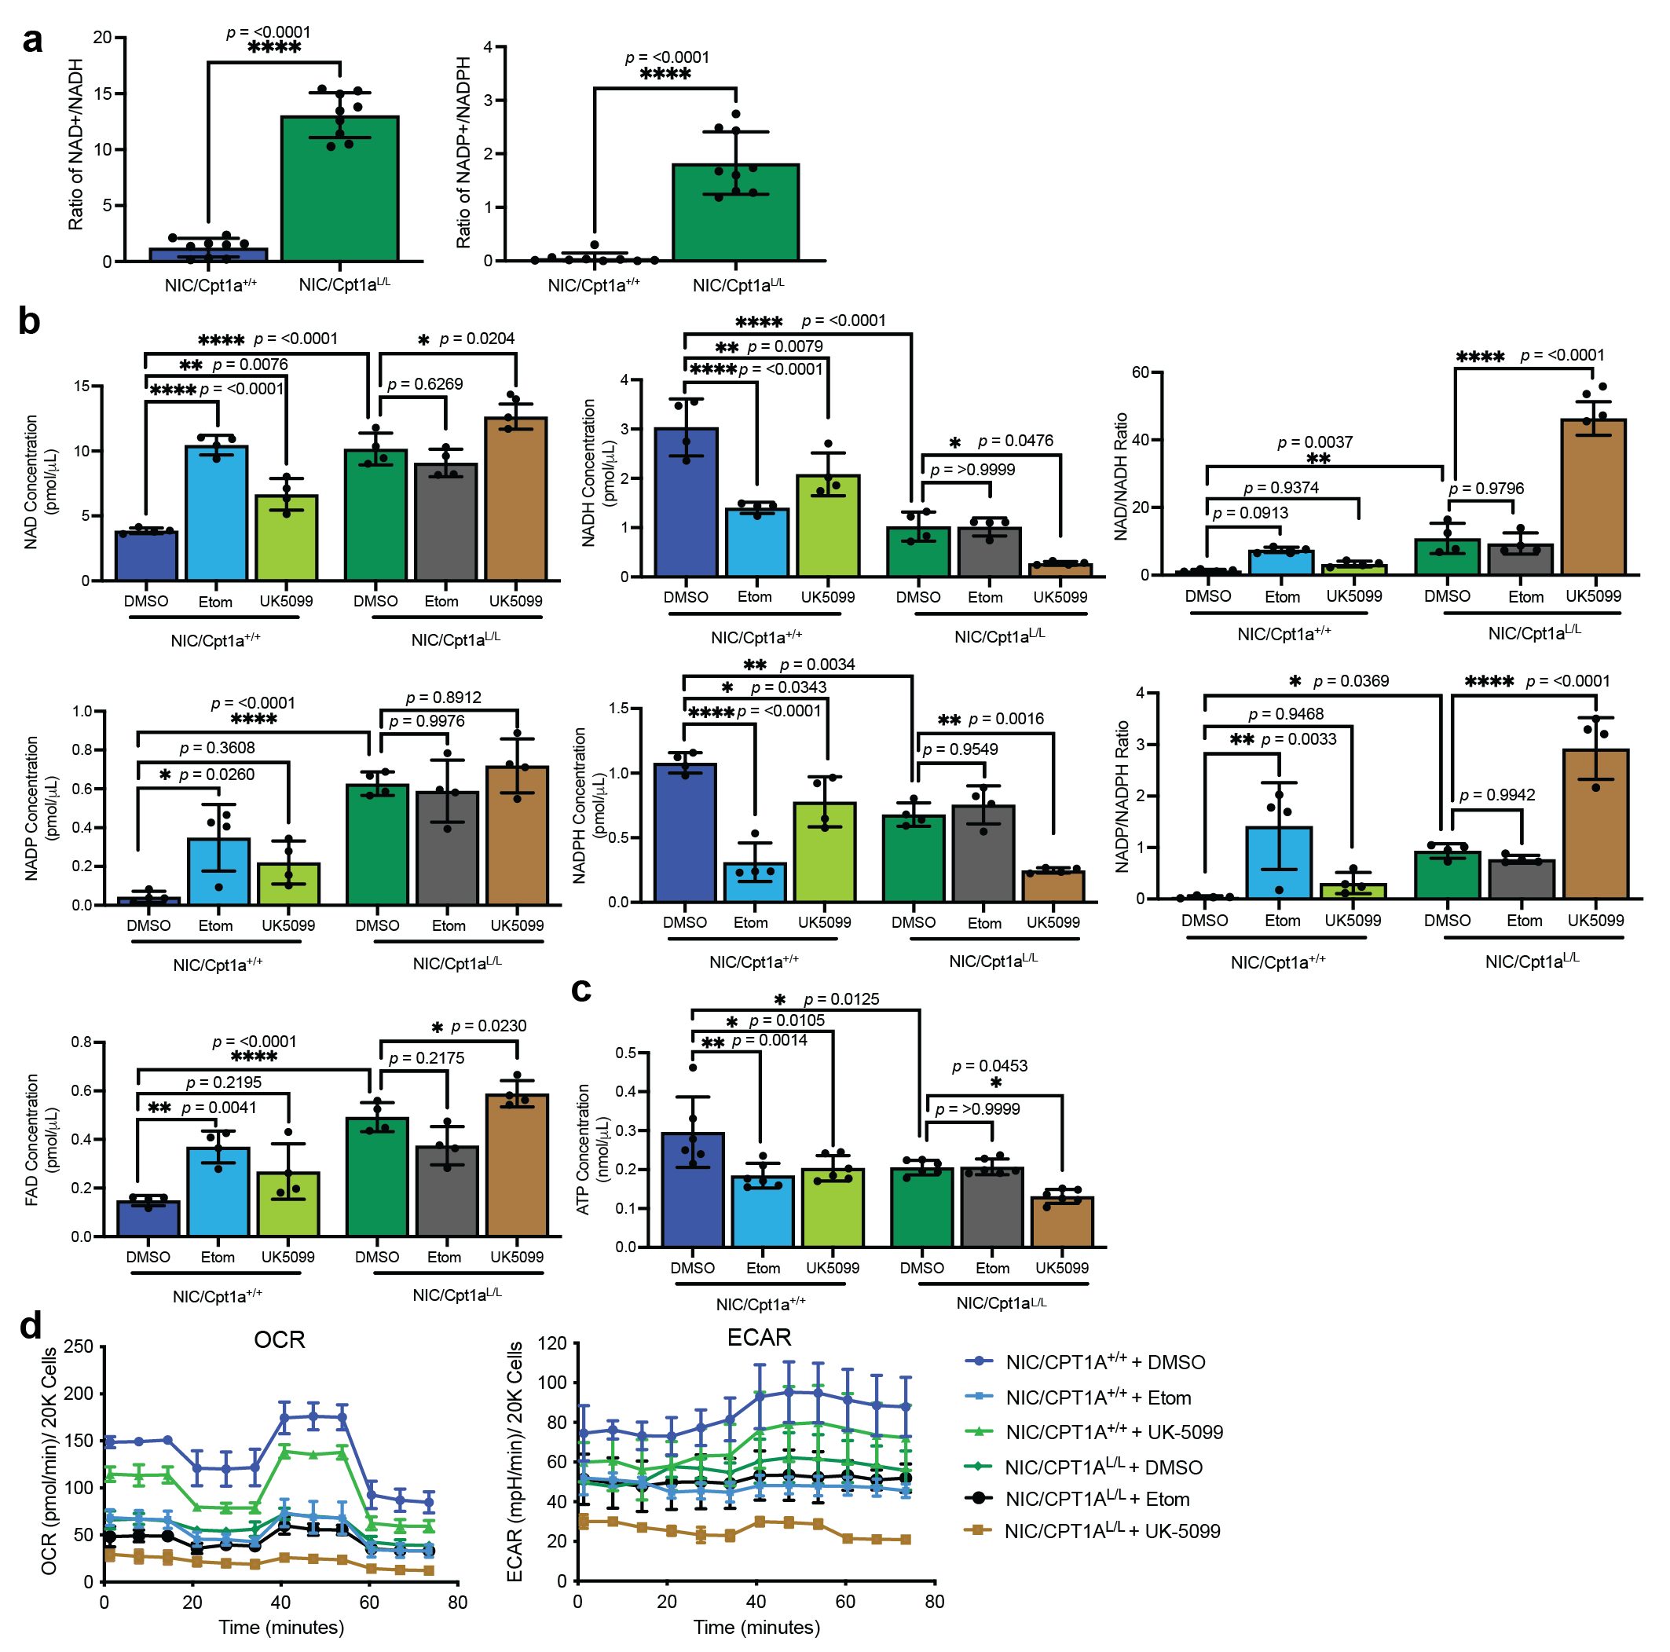Supplementary Figure 5: Acetyl CoA from FAs drives TCA flux in wild-type ErbB2+ breast cancer cells while Cpt1a-deficient cells are dependent on pyruvate.
a, Ratio of NAD/NADH (left) and NADP/NADPH (right) in NIC/Cpt1a^{+/+} and NIC/Cpt1a^{L/L} cells. n = 4 per genotype, analyzed in triplicate - *p < 0.05, **p < 0.01; unpaired, two-tailed Student’s t-test. b, Relative abundance of oxidized (nicotinamide adenine dinucleotide - NAD⁺, nicotinamide adenine dinucleotide phosphate - NADP⁺, and flavin adenine dinucleotide - FAD) and reduced (NADH and NADPH) forms of electron carriers in NIC/Cpt1a^{+/+} and NIC/Cpt1a^{L/L} cells treated with 3μM Etomoxir (Etom), 10 μM MPC inhibitor, UK-5099, or DMSO as a control. n = 2 per genotype, analyzed in duplicate - *p < 0.05, **p < 0.01, ***p < 0.001, ****p < 0.0001; one-way ANOVA with Tukey’s post-hoc test. c, Relative ATP concentration in NIC/Cpt1a^{+/+} and NIC/Cpt1a^{L/L} cells treated with DMSO, Etomoxir and UK-5099. n = 3 per genotype, analyzed in triplicate -*p < 0.05, **p < 0.001; one-way ANOVA with Tukey’s post-hoc test. d, Left panel - Basal, maximal (FCCP), ATP-synthesis coupled (Oligomycin A), and non-mitochondrial (rotenone/ antimycin A) oxygen consumption rates (OCRs) of NIC/Cpt1a^{+/+} and NIC/Cpt1a^{L/L} cells treated with DMSO, Etomoxir and UK-5099. Representative of n = 3 cell lines. Right panel - pH changes per minute in the cell culture medium measured simultaneously with OCR, Representative of n = 3 cell lines per genotype. All error bars are expressed as mean values ± SD. Source data are provided as a Source Data file.
Supplementary Figure 6: Cpt1a deletion induces oxidative stress and elevates Nrf2 expression.
a, Hierarchical clustering analysis of Nrf2 target gene expression (up-regulated (red) and down-regulated (blue)) in cell lines derived from NIC/Cpt1a^{L/L} tumors compared to NIC/Cpt1a^{+/+} controls (n = 2 or 4 per genotype, analyzed in duplicate). b, Nrf2 mRNA levels in cell lines as in (a) were determined using QRT-PCR and normalized to Actb. n = 4 per genotype, analyzed in triplicate - ****p < 0.0001; unpaired, two-tailed Student’s t-test. Error bars are expressed as mean values ± SD. Source data are provided as a Source Data file.
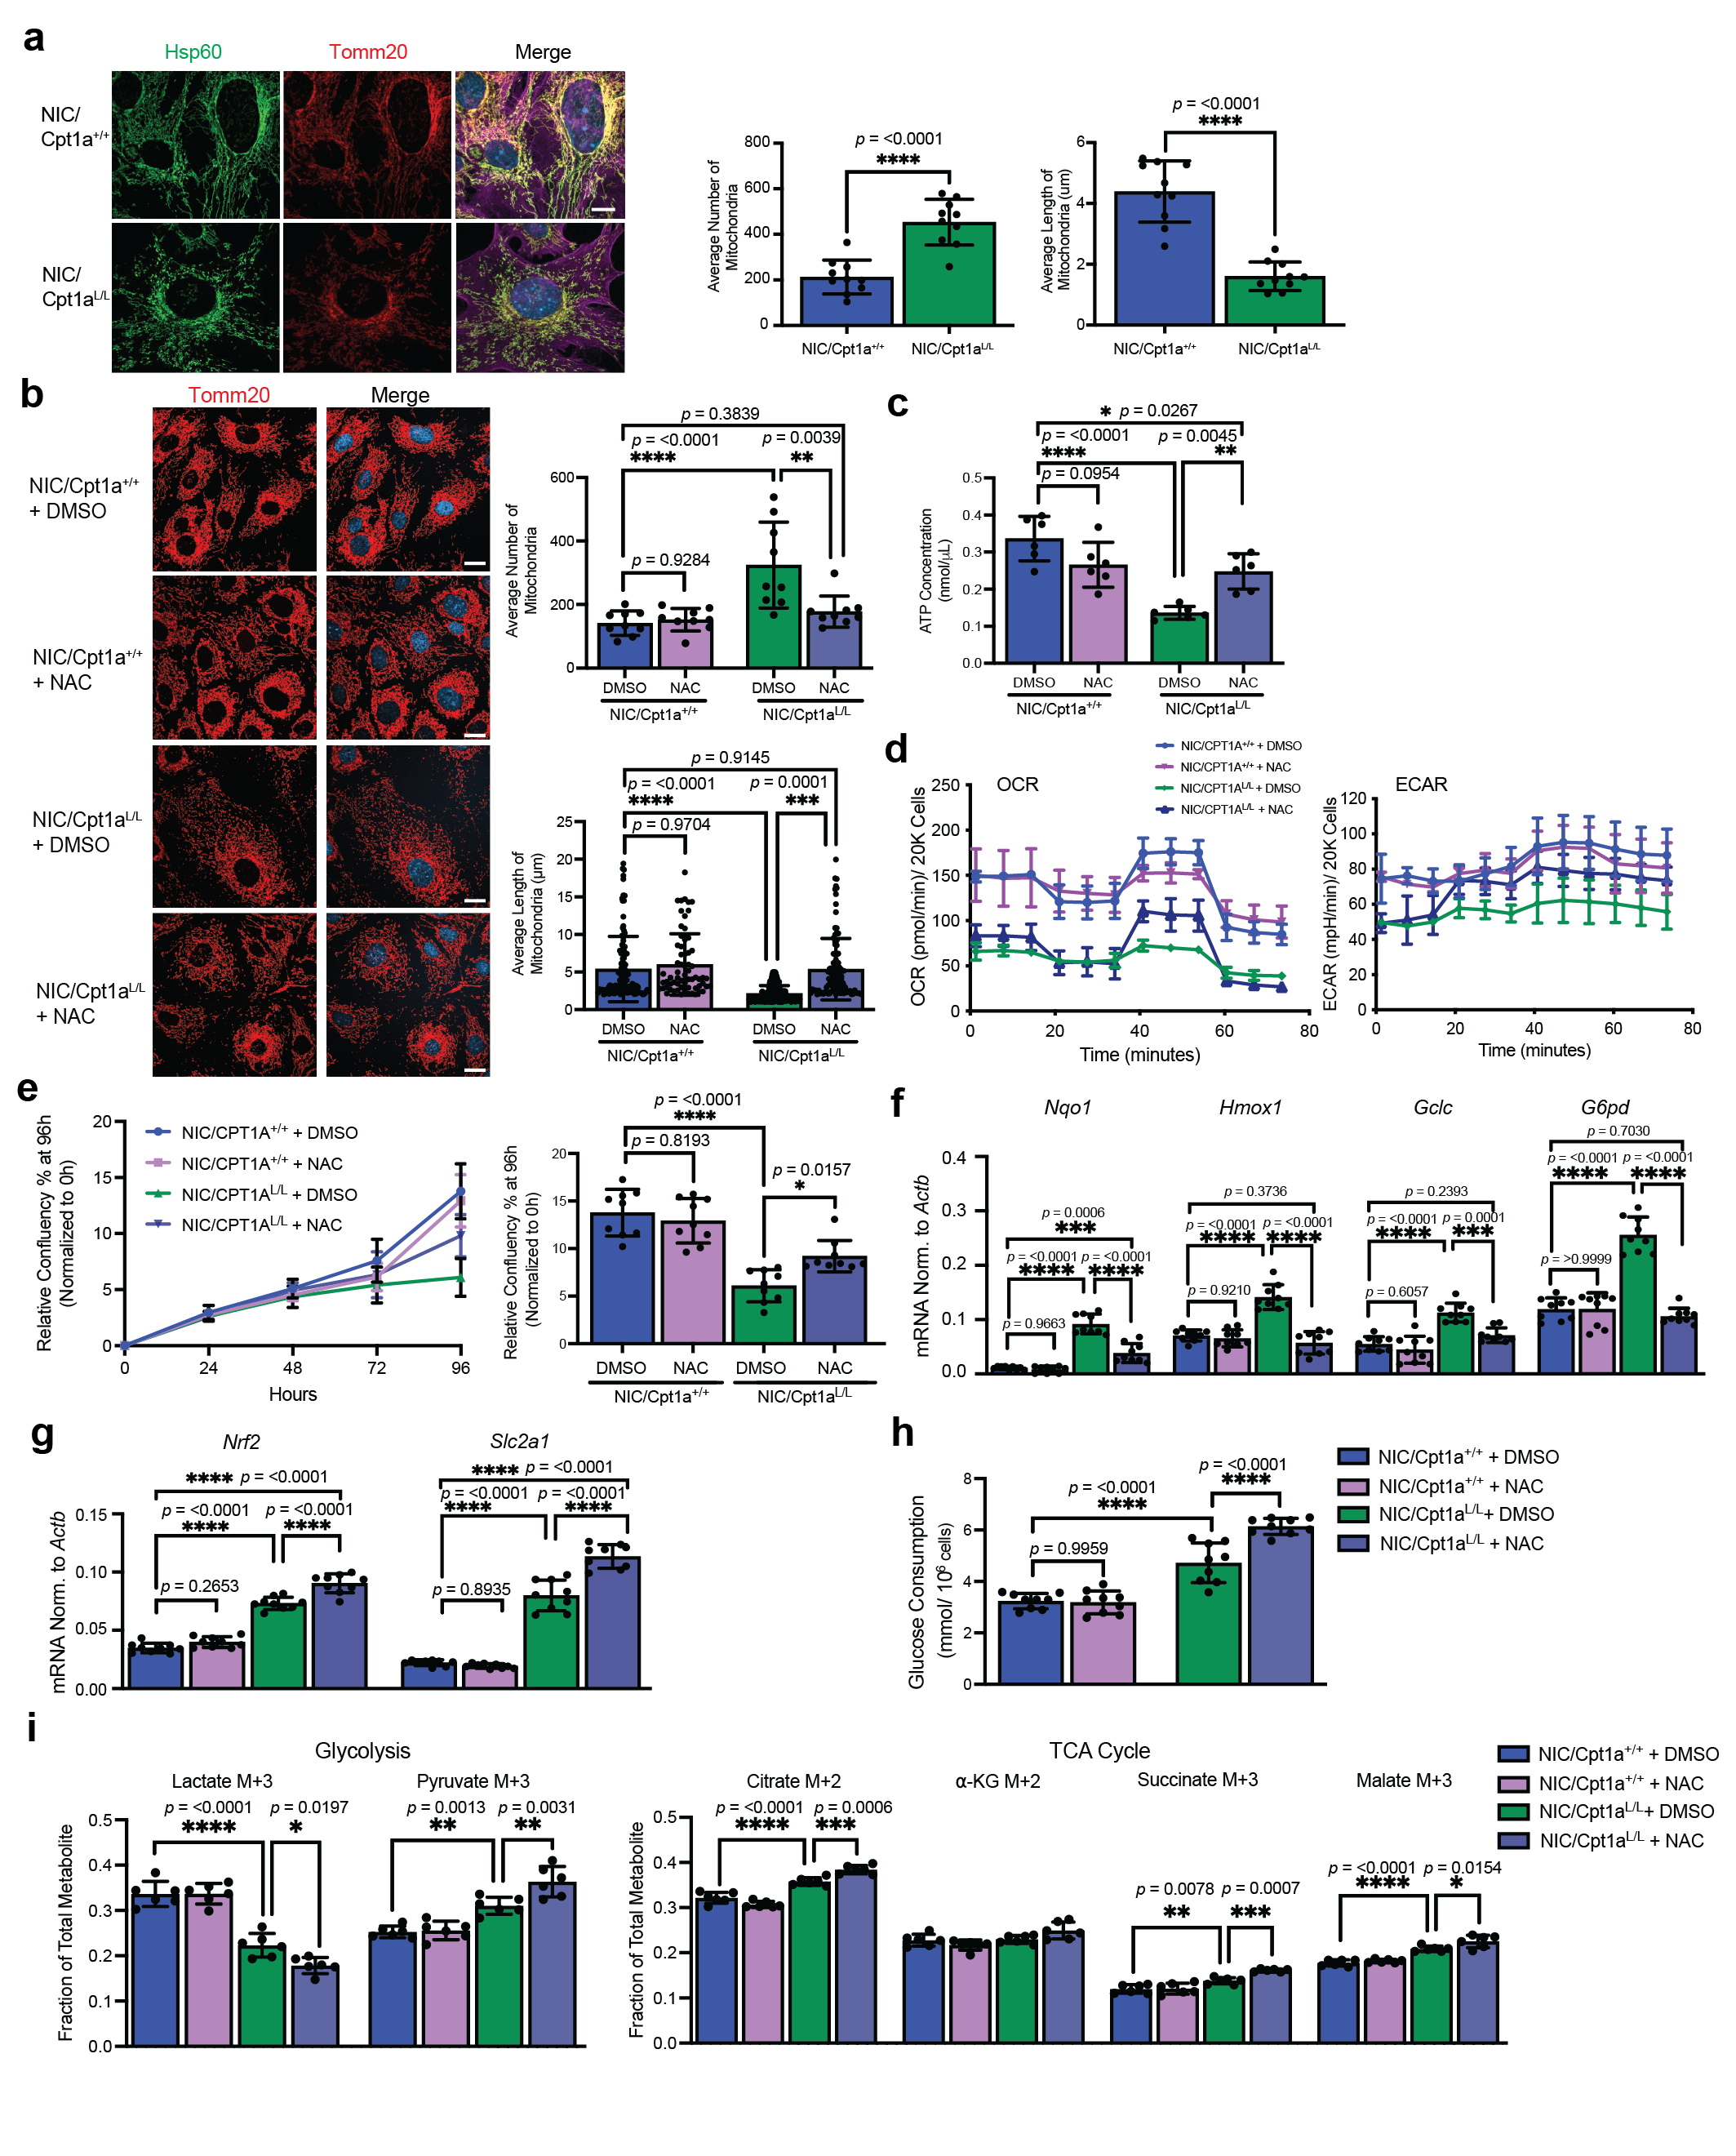Supplementary Figure 7: Loss of Cpt1a disrupts mitochondrial fusion and function which can be reversed by ROS inhibition.
a, Left panel – Representative images of NIC/Cpt1a^{+/+} and NIC/Cpt1a^{L/L} cells stained with antibodies against Hsp60 and Tomm20. Scale bar represents 10 μm. Right Panel – Number and average length of mitochondria were measured by co-localization of Hsp60 and Tomm20 with ImageJ. n = 3 per genotype, analyzed in triplicate -****p < 0.0001; unpaired, two-tailed Student’s t-test. b, Left panel - NIC cells treated with 5M N-acetyl cysteine (NAC), were stained for Tomm20. Scale bar represents 10 μm. Right Panel – Tomm20 staining analysis as in (a). n = 3 cell lines per genotype in triplicate – **p < 0.01, ***p < 0.001, ****p < 0.0001; one-way ANOVA with Tukey’s post-hoc test. c, ATP concentration in NIC cells following treatment with 5M NAC. n = 2 cell lines per genotype in triplicate – *p < 0.05, **p < 0.01, ****p < 0.0001; one-way ANOVA with Tukey’s post-hoc test. d, Basal, maximal (FCCP), ATP-synthesis coupled (Oligomycin A), and non-mitochondrial (rotenone/antimycin A) oxygen consumption rate (OCR – left panel) and extracellular acidification rate (ECAR - right panel) of NIC cells treated with 5M NAC. Representative of n = 3 cell lines in triplicate. e, Left panel - Proliferation assay of cells as in (b-d). Right panel – Confluency at 96 hours, normalized to t=0. n=3 cell lines in triplicate - *p < 0.05 and ****p < 0.0001; one-way ANOVA with Tukey’s post-hoc test. f-g, QRT-PCR analysis of Nrf2 target genes (f) and Nrf2 and Glut1 (g) expression in NIC cells treated with 5M NAC. Gene expression was normalized to Actb. n = 3 cell lines per genotype in triplicate - ***p< 0.001, ****p < 0.0001; unpaired, two-tailed Student’s t-test. h, Glucose consumption of NIC cells treated with NAC or DMSO. n = 3 cell lines per genotype in triplicate – ****p < 0.0001; one-way ANOVA with Tukey’s post-hoc test. i, Fractional ion abundance of glycolytic and TCA cycle intermediates of U-¹³C-glucose-labeled NIC cells treated with 5M NAC or DMSO. n = 2 per genotype, analyzed in triplicate - *p < 0.05, **p < 0.01, ***p < 0.001, ****p < 0.0001; one-way ANOVA with Tukey’s post hoc-test. All error bars are expressed as mean values ± SD. Source data are provided as a Source Data file.
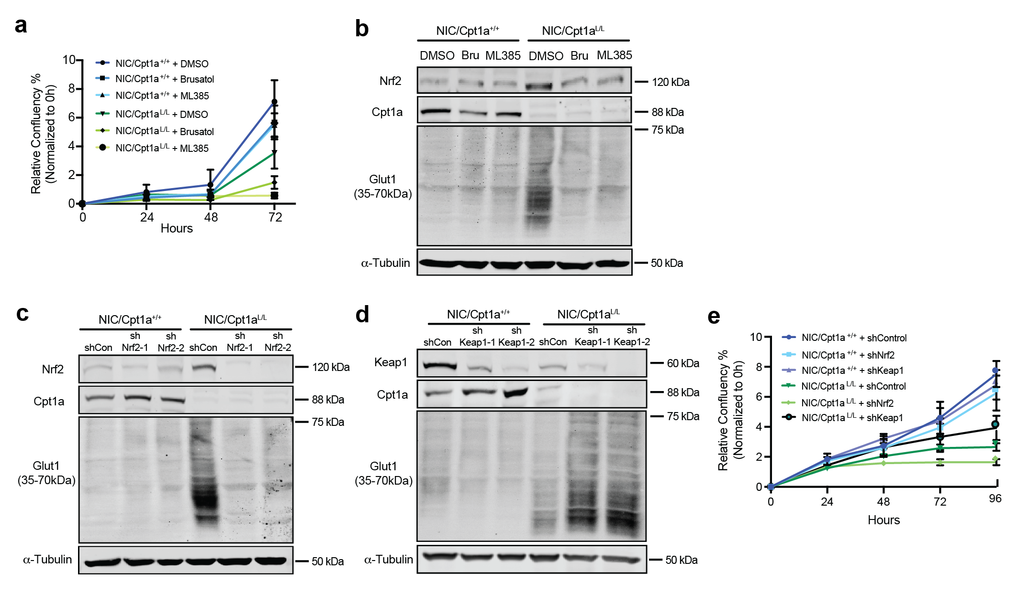
Supplementary Figure 8: Nrf2 inhibition and genetic ablation blocks proliferation and glucose consumption of Cpt1a-deficient HER2+ breast cancer cells.
a, NIC cells were treated with Nrf2 inhibitors (Brusatol and ML 385), or DMSO and proliferation was assessed in real time. Growth curves correspond to endpoint data shown in Figure 5a. b, Lysates of NIC/Cpt1a^{+/+} and NIC/Cpt1a^{L/L} cells were treated with Brusatol (100 nM), ML385 (2 μM) or DMSO and immunoblotted with the indicated antibodies. c-d, NIC cells stably expressing shRNAs against Nrf2, Keap1, or control (luciferase) were immunoblotted with the indicated antibodies e, Proliferation assay of NIC cells stably expressing shRNAs against Nrf2, Keap1, or control (luciferase), corresponding to the cells in Fig. 5f. All error bars are expressed as mean values ± SD. Source data are provided as a Source Data file.

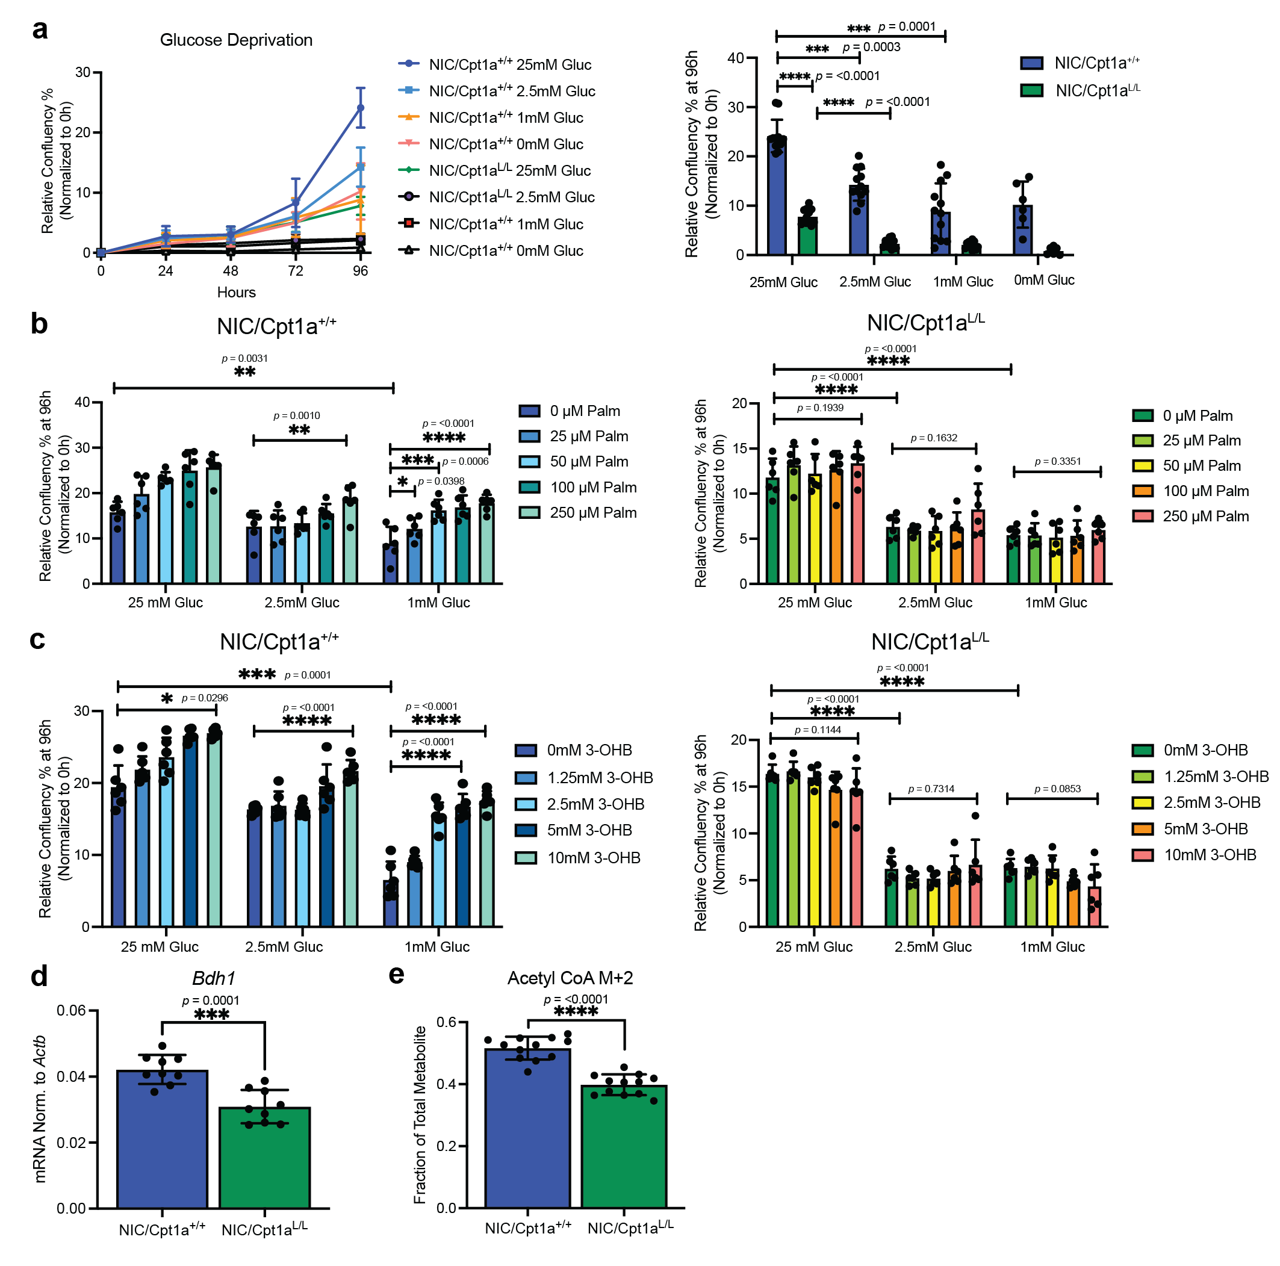Supplementary Figure 9: Proliferation of Cpt1a-deficient cells is impaired in high-lipid or high-ketone, low-glucose conditions in vitro
a, Proliferation of NIC/Cpt1a^{+/+} and NIC/Cpt1a^{L/L} cells at the indicated glucose concentrations using an imaging-based assay to monitor cell confluency in real time. Left panel – growth curves. Right panel – endpoint analysis of cell growth at 96h. n = 2 cell lines in triplicate - ***p < 0.001, ****p < 0.0001; unpaired, two-tailed Student’s t-test. b-c, Proliferation of NIC cells supplemented with Palmitate (b) or Ketone (3-OHB, c) under varying glucose concentrations for 96 hours. Endpoint analysis after 96h of imaging is shown. Data were normalized to confluency at t=0. n = 3 cell lines per genotype in triplicate – *p < 0.05, **p < 0.01, ***p < 0.001, ****p < 0.0001; one-way ANOVA with Tukey’s post-hoc test. d, QRT-PCR analysis of 3-betahydroxybutyrate dehydrogenase 1 (Bdh1) in NIC/ Cpt1a^{+/+} and NIC/ Cpt1a^{L/L} cells. Expression was normalized to Actb. n = 3 cell lines per genotype in triplicate - ***p< 0.001, unpaired, two-tailed Student’s t-test. e, Fractional ion abundance of Acetyl CoA (M+2) in NIC/ Cpt1a^{+/+} and NIC/ Cpt1a^{L/L} cells following a 2 hour pulse with U-¹³C-glucose. n = 3 per genotype, analyzed in triplicate - ***p < 0.001; unpaired, two-tailed Student’s t-test. All error bars are expressed as mean values ± SD. Source data are provided as a Source Data file.

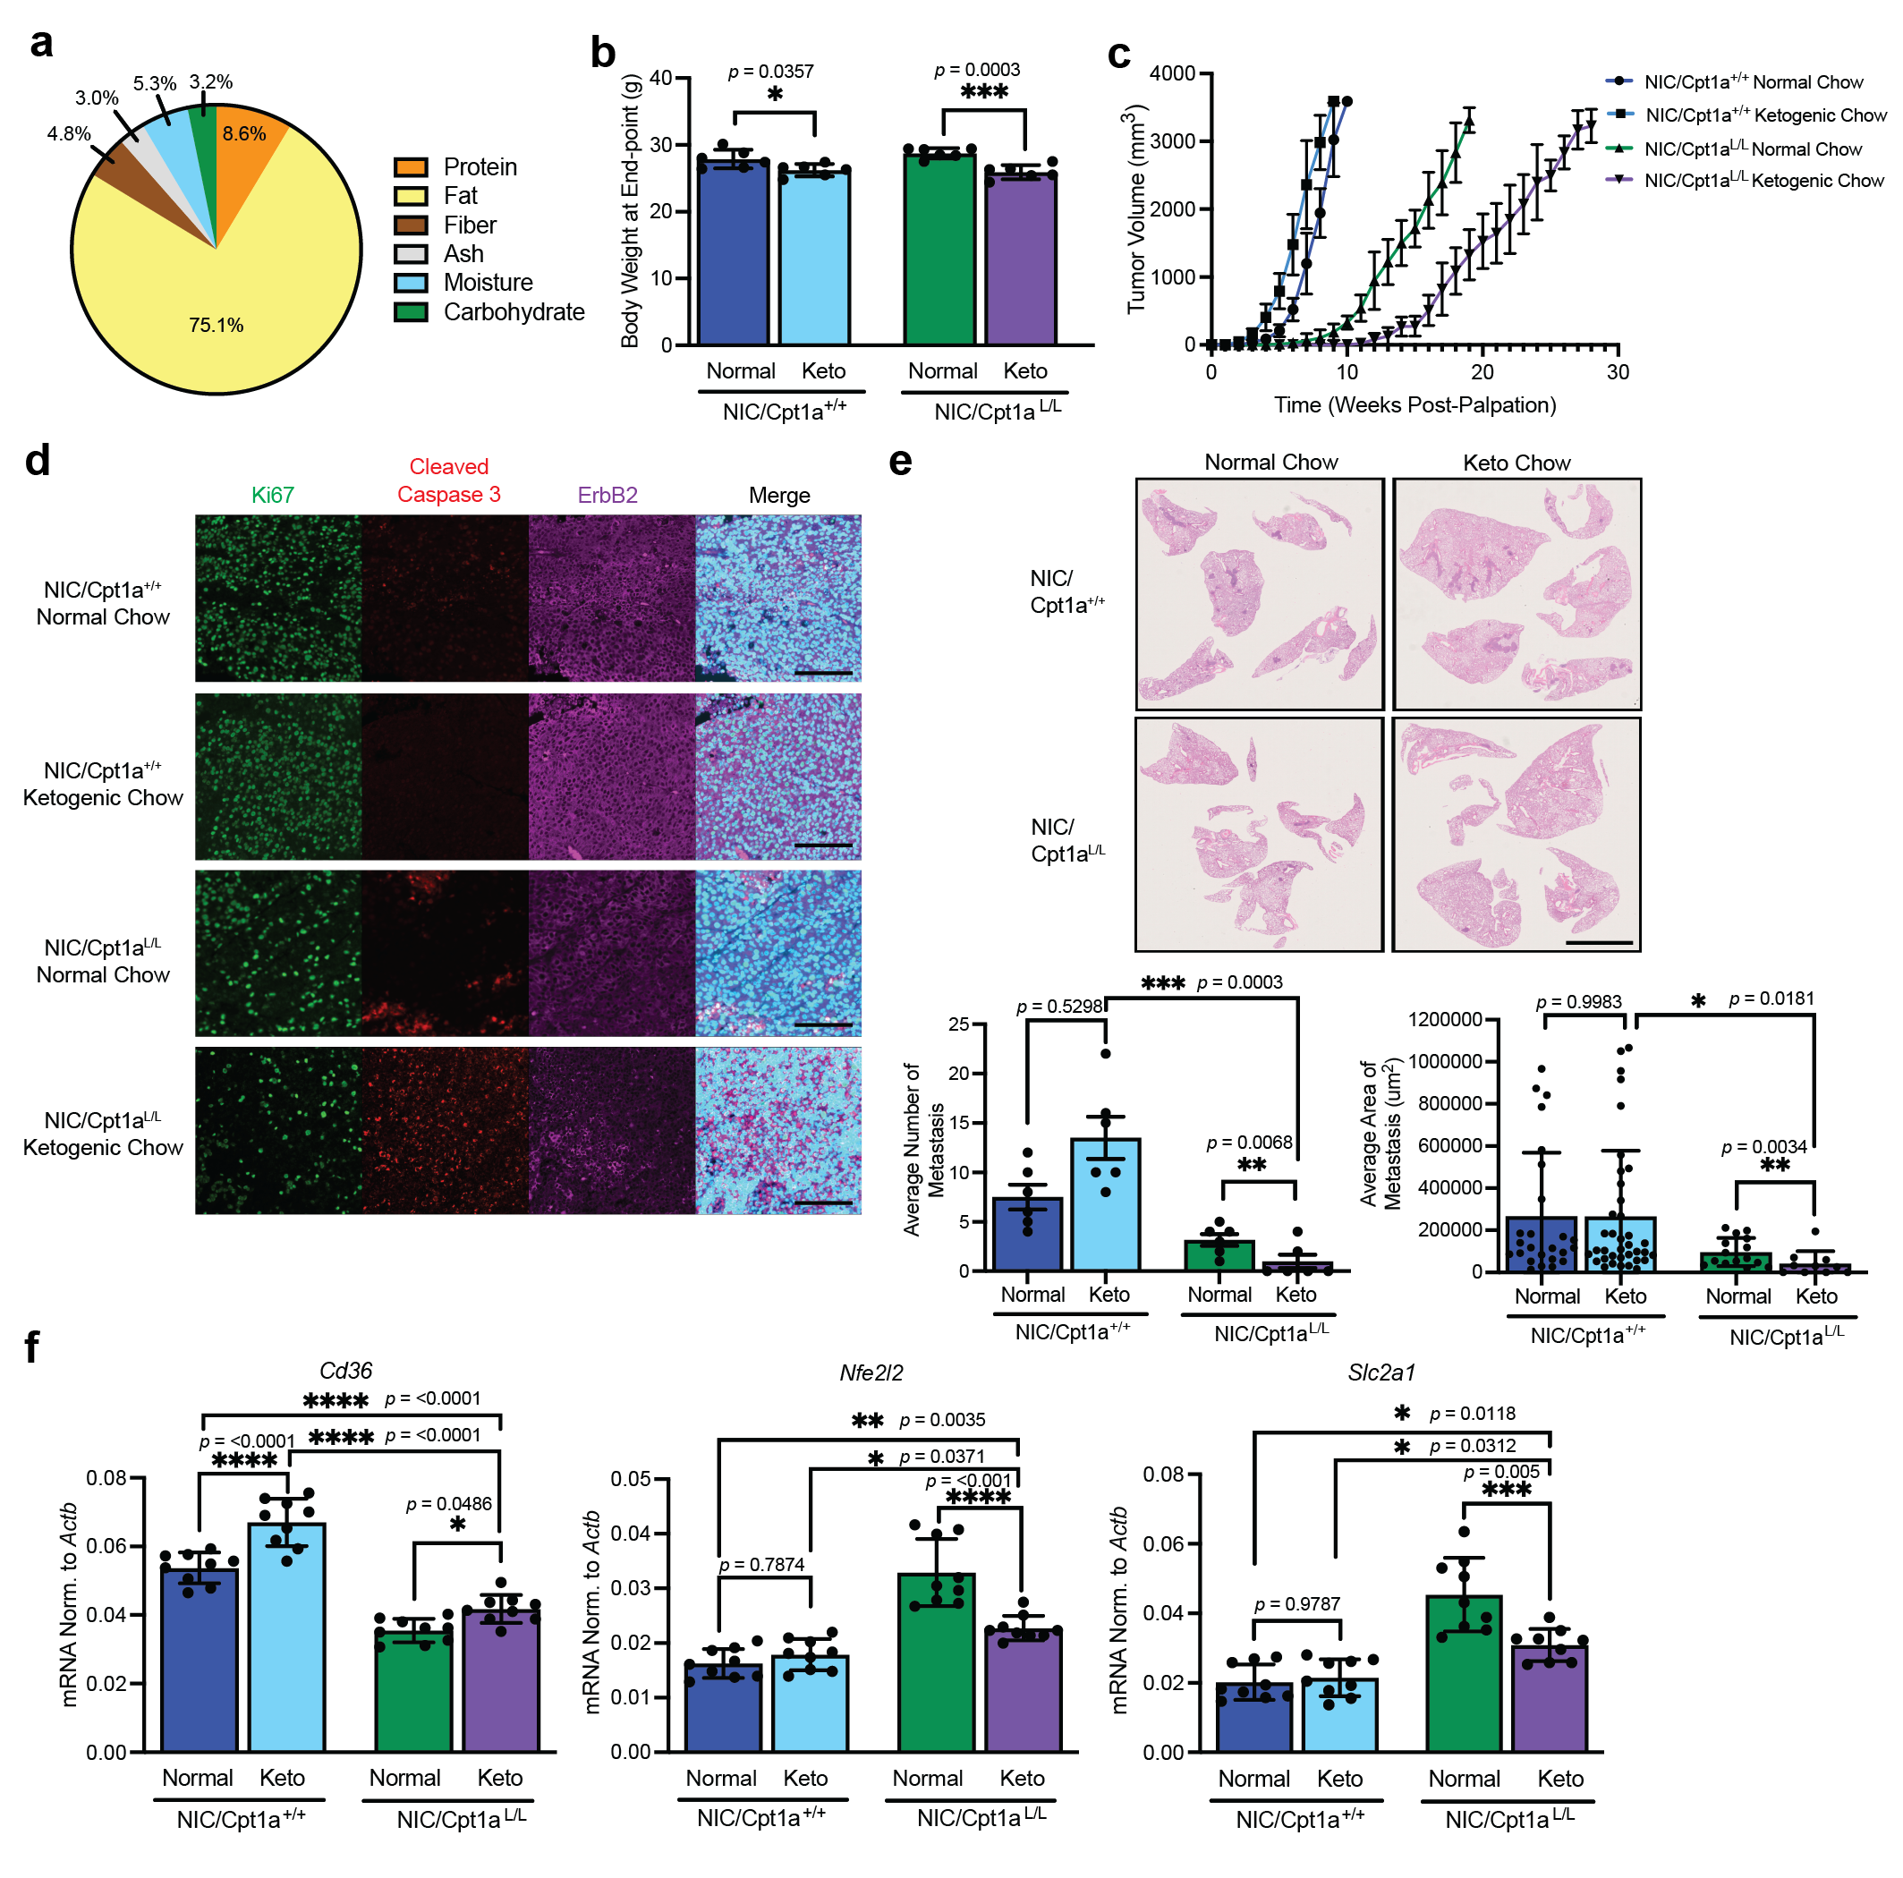Supplementary Figure 10: Loss of Cpt in combination with the ketogenic diet decreases tumor growth and metastasis.
a, Ingredient composition of normal chow and ketogenic diet chow fed to female FVB/N for 15 weeks. b, Mouse body weight was measured to ensure mice achieved ketosis. n = 6 per group, ****p < 0.0001; one-way ANOVA with Tukey’s post-hoc test. c, Tumor burden was determined by weekly caliper measurements till all mice reached end-point. n = 6 mice per treatment group. d, End-stage tumors from FVB/N mice bearing orthotopic allografts of NIC/Cpt1a^{+/+} and NIC/Cpt1a^{L/L} cells fed with normal or ketogenic chow were immunostained using the indicated antibodies and DAPI. Images are representative of 6 mice per treatment group. Scale bar: 100 μm. e, Top panel – representative H&E images of lungs from mice as in (A). Scale bar: 5 mm. Bottom panels – average number and total area of lung metastases. n = 6 per treatment group, *p < 0.05, **p < 0.01 and ***p < 0.001; one-way ANOVA with Tukey’s post-hoc test. f, QRT-PCR analysis of Cd36, Nrf2 and Glut1 gene expression in tumors samples as in (a). Gene expression was normalized to that of Actb. n = 6 per treatment group. *p < 0.05, **p < 0.01, ***p < 0.001, and ****p < 0.0001, by one-way ANOVA with Tukey’s post hoc test. All error bars are expressed as mean values ± SD. Source data are provided as a Source Data file.

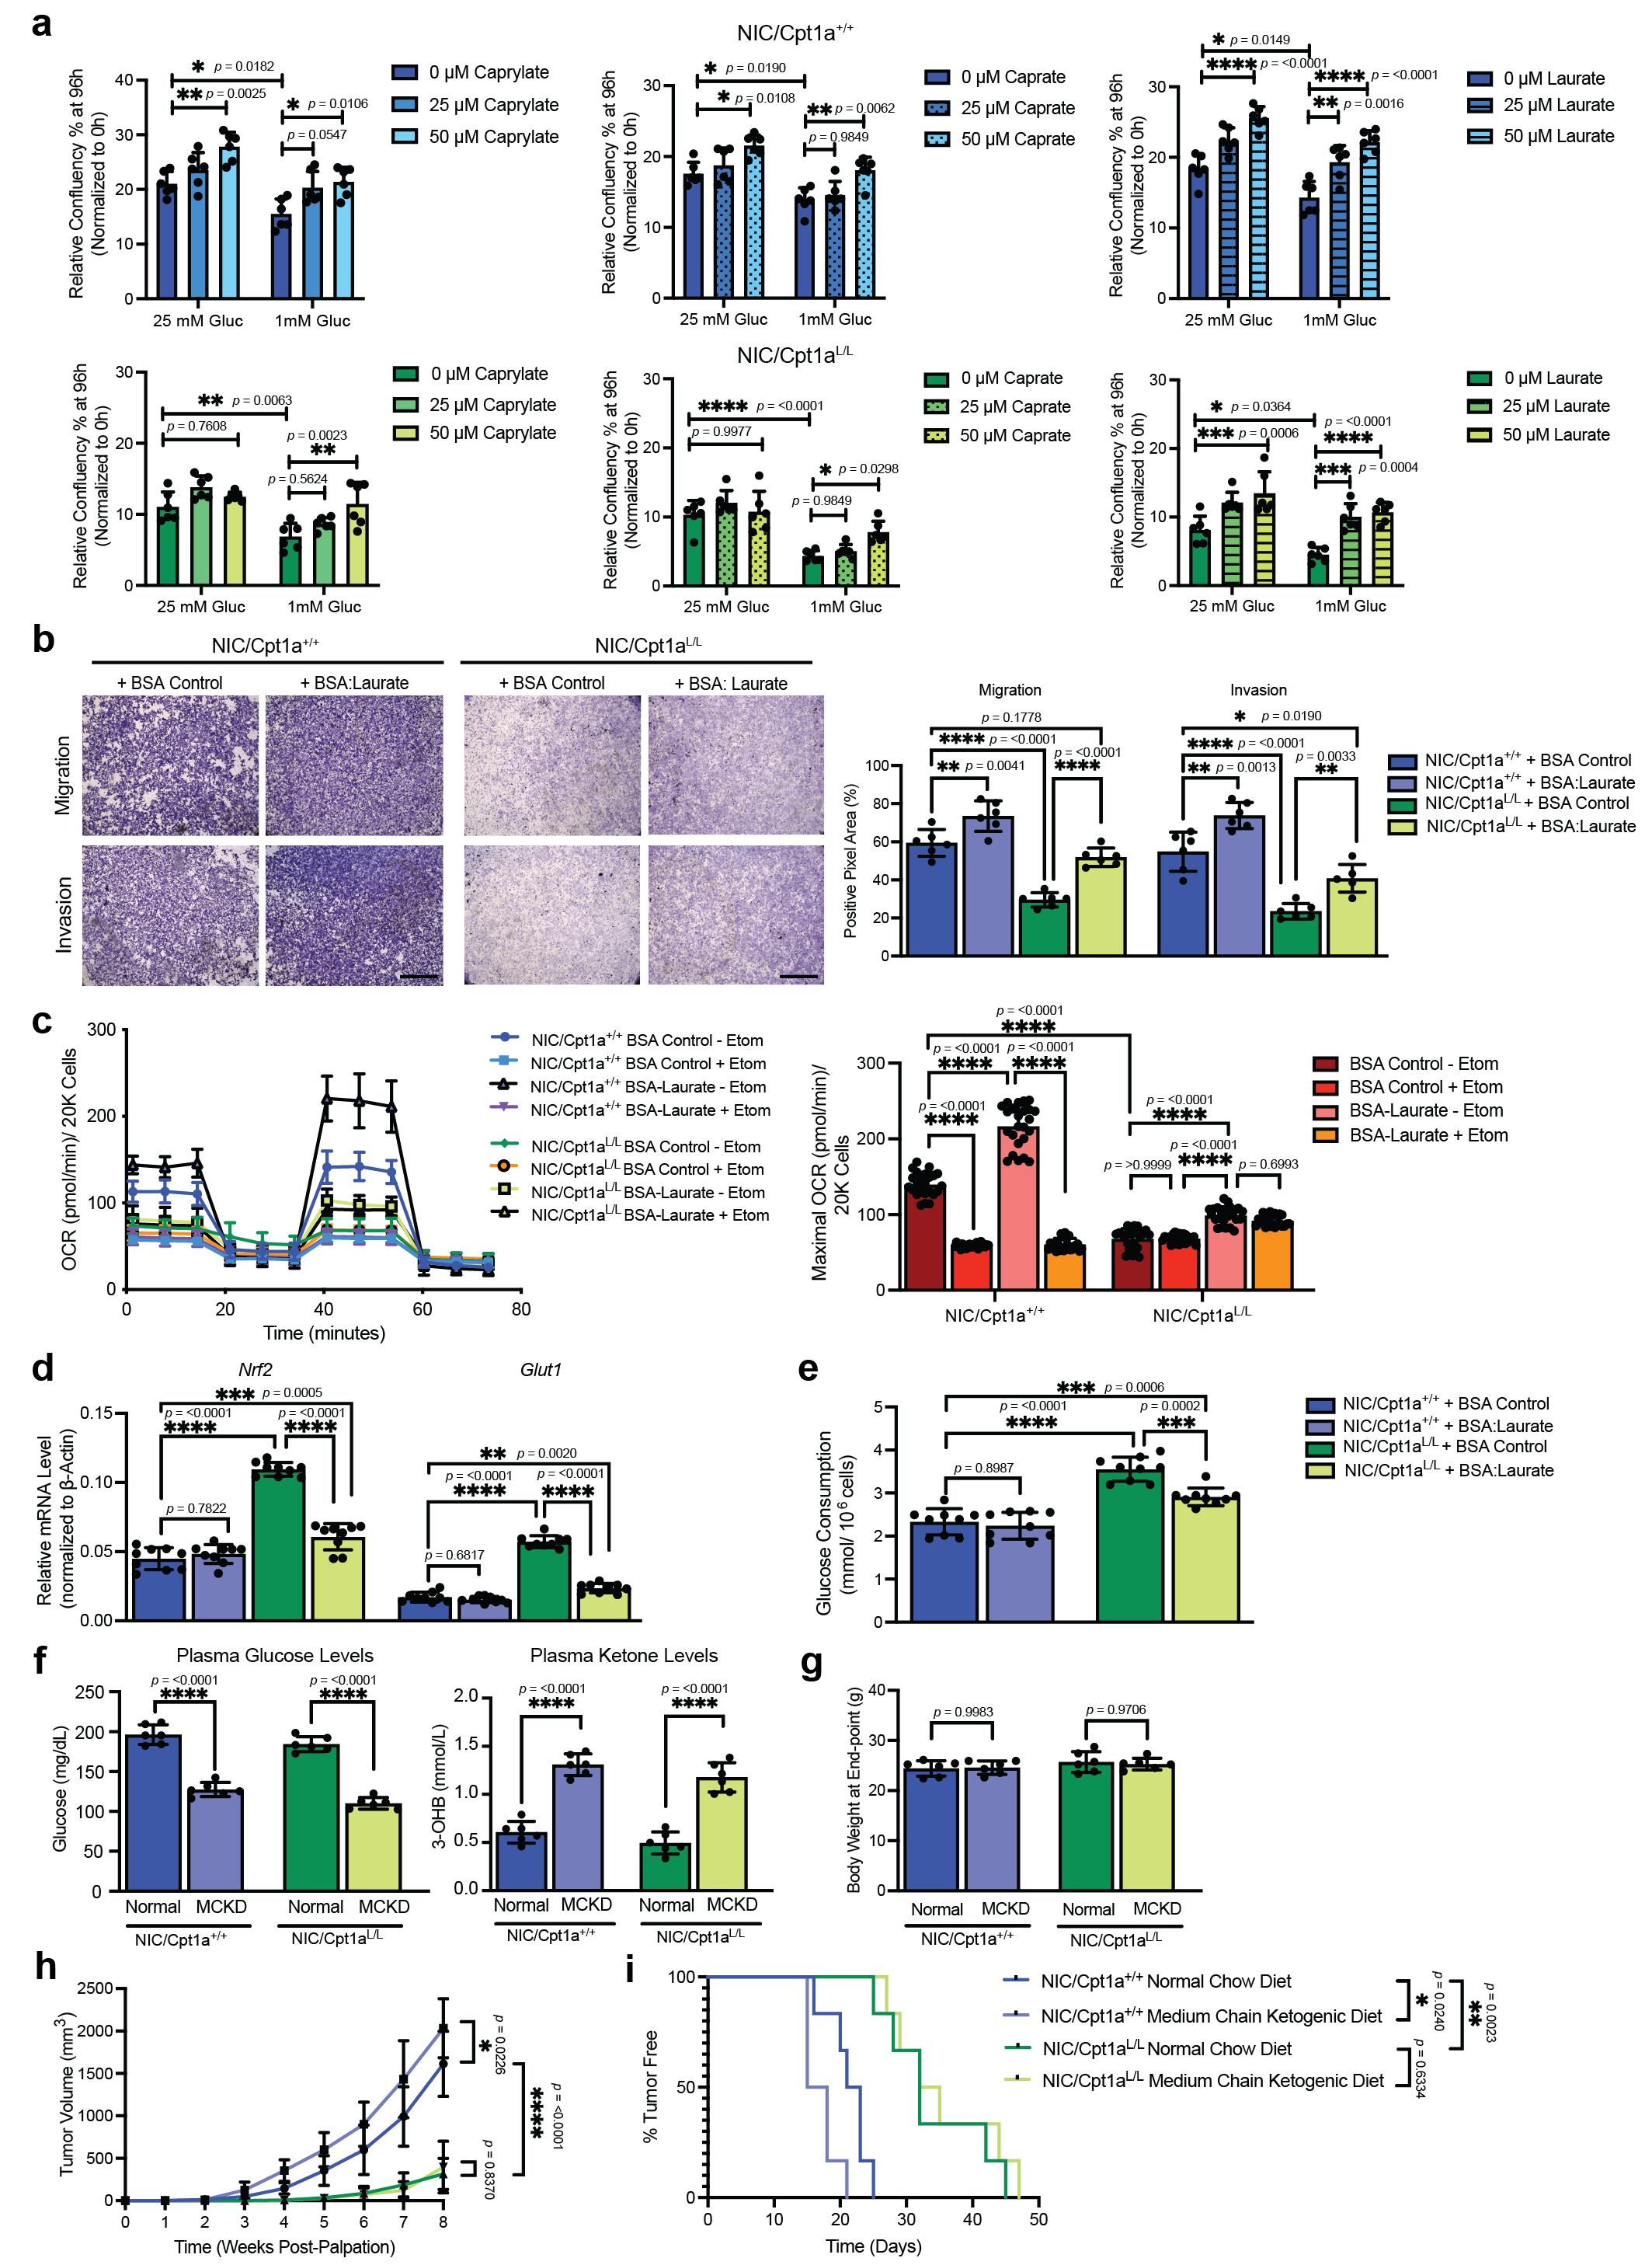Supplementary Figure 11: Supplementation with medium-chain fatty acids partially rescues proliferation and respiration of Cpt1a-deficient NIC cells in vitro.
a, Proliferation assessed on Cpt1a-proficient (top panels) and -deficient (bottom panels) NIC cells supplemented with caprylate (C8:0), caprate (C10:0) and laurate (C12:0) under varying glucose concentrations for 96 hours. Data normalized to confluency at t=0. n = 2 cell lines per genotype in triplicate – *p < 0.05, **p < 0.01, ***p < 0.001, ****p < 0.0001; one-way ANOVA with Tukey’s post-hoc test. b, Left panel – Representative images of cell migration and invasion (Boyden chamber) assays of NIC cells supplemented with 50 μM BSA-Laurate or BSA control. Scale bar represents 1000 μm. Right Panel – quantification (positive pixel area) of migration and invasion (n = 3 cell lines per genotype in triplicate – *p < 0.05, **p < 0.01, ****p < 0.0001; one-way ANOVA with Tukey’s post-hoc test). c, Left panel - Basal, maximal (FCCP), ATP-synthesis coupled (Oligomycin A), and non-mitochondrial (rotenone/ antimycin A) oxygen consumption rates (OCRs) of NIC cells with BSA-control or Laurate, and in the presence or absence of 10μM Etomoxir (Etom). Right panel - Quantification of maximal OCR. n = 2 cell lines in quadruplicate - ****p < 0.0001; one-way ANOVA with Tukey’s post-hoc test. d-e, QRT-PCR analysis of Nrf2 and Glut1 gene expression (d) and Glucose consumption (e) of cells as in (b-c) treated with 50 μM BSA-Laurate or BSA. n = 3 cell lines per genotype in triplicate – **p < 0.01, ***p < 0.001, ****p < 0.0001; one-way ANOVA with Tukey’s post-hoc test. f, Medium-chain ketogenic diet (MCKD) orthotopic xenotransplant study using two independent NIC/Cpt1a^{+/+} and NIC/Cpt1a^{L/L} cell lines. Plasma glucose and ketone levels were assessed. n = 6 mice per group, ****p < 0.0001; one-way ANOVA with Tukey’s post-hoc test. g, Mouse body weight at tumor end-point. n = 6 mice per treatment group; one-way ANOVA with Tukey’s post-hoc test. h, Tumor burden determined by weekly caliper measurements. n = 6 mice per treatment group, *p < 0.05, ****p < 0.0001; one-way ANOVA with Tukey’s post-hoc test. i, Kaplan-Meier survival analysis. n = 6 mice per treatment group, *p < 0.05, **p < 0.01; log rank test. All error bars are expressed as mean values ± SD. Source data are provided as a Source Data file.

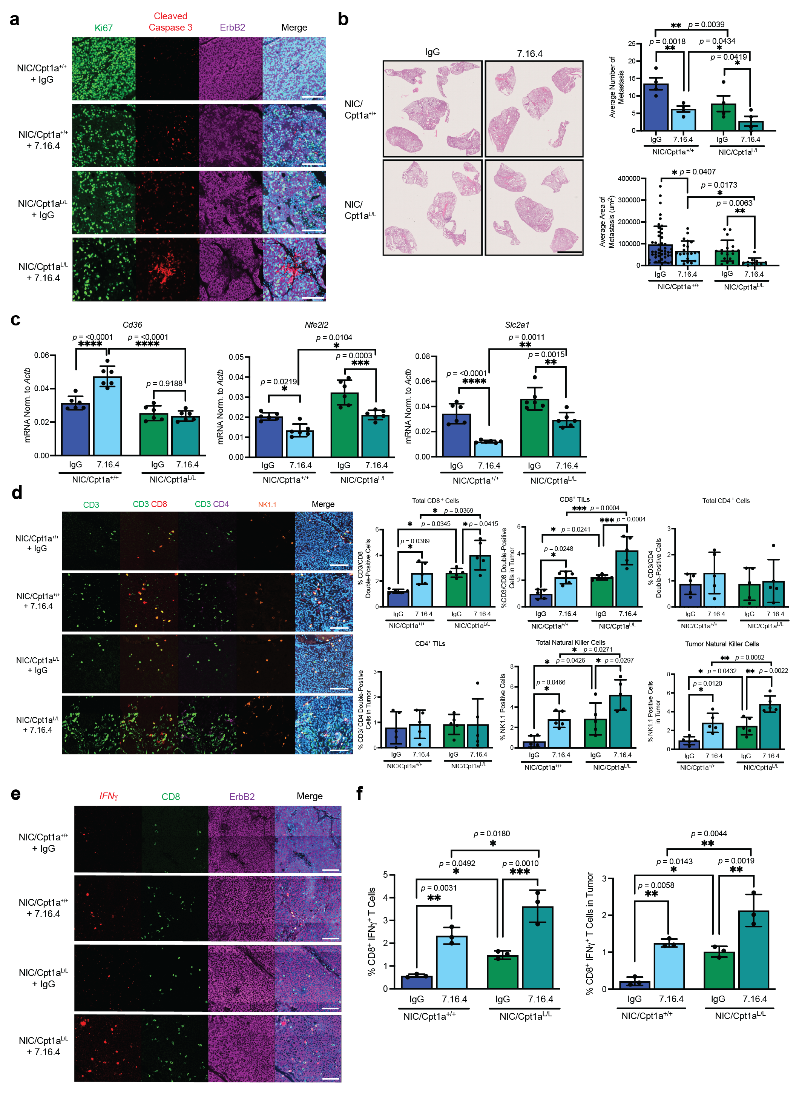Supplementary Figure 12: CPT1A deletion enhances the effects of ErbB2 monoclonal antibody therapy to dampen tumor progression in ErbB2+ breast cancer cells.
a, End-stage tumors from immunocompetent mice bearing orthotopic allografts of NIC/ Cpt1a^{+/+} and NIC/ Cpt1a^{L/L} cells treated with IgG (control Ab) and 7.16.4 Ab were immunostained using the indicated antibodies and DAPI. Images are representative of 6 mice per treatment group. Scale bar: 100 μm. b, Left panel – representative H&E images of lungs from mice as in (a). Right panels – average number and total area of lung metastases. n = 10 per treatment group, *p < 0.05 and **p < 0.01; one-way ANOVA with Tukey’s post-hoc test. c, QRT-PCR analysis of Cd36, Nrf2 and Glut1 gene expression in tumors samples as in (A). Gene expression was normalized to that of Actb. n = 6 per treatment group. *p < 0.05, **p < 0.01, ***p< 0.001, and ****p < 0.0001, by one-way ANOVA with Tukey’s post hoc test. d, Left panel - End-stage tumors from mice bearing orthotopic allografts of NIC/ Cpt1a^{+/+} and NIC/ Cpt1a^{L/L} cells treated with IgG and 7.16.4 Ab were immunostained using the indicated markers of immune cells and DAPI. Images are representative of 5 mice per treatment group. Scale bar: 100 μm. Right panel - Quantification of CD3⁺/CD8⁺ (total and tumor), CD3⁺/CD4⁺ (total and tumor), and NK1.1 (total and tumor) by HALO Analysis. *p < 0.05, **p < 0.01, ***p < 0.001; one-way ANOVA with Tukey’s post hoc-test. e, RNA FISH staining against IFNγ (red dots) combined with immunofluorescence staining for CD8, ErbB2 and DAPI on tumor tissue from NIC/ Cpt1a^{+/+} and NIC/ Cpt1a^{L/L} mice treated with IgG and 7.16.4 Ab. Images are representative of 3 mice per treatment group. Scale bar: 100 μm. f, Quantification of total CD8⁺ IFNγ⁺ cells (IFNγ-secreting cytotoxic T cells) (left panel) and tumor-infiltrating CD8⁺ IFNγ⁺ (CD8⁺ IFNγ⁺ ErbB2⁺) (right panel) in NIC/ Cpt1a^{+/+} and NIC/ Cpt1a^{L/L} tumors after treatment with IgG and 7.16.4 Ab. n = 3 per treatment group, *p < 0.05, **p < 0.01 and ***p < 0.001; one-way ANOVA with Tukey’s post-hoc test. All error bars are expressed as mean values ± SD. Source data are provided as a Source Data file.

Supplementary Tables

Supplementary Table S1: Genotyping Primers

Gene | Sequences | Species
Neu Genotyping Forward Primer | 5’-TTCCGGAACCCACATCAGGCC-3’ | Mouse
Neu Genotyping Reverse Primer | 5’-GTTTCCTGCAGCAGCCTACGC-3’ | Mouse
Cre Genotyping Forward Primer | 5’-TGCTCTGTCCGTTTGCCG-3’ | Mouse
Cre Genotyping Reverse Primer | 5’-ACTGTGTCCAGACCAGGC-3’ | Mouse
Flox Cpt1a Genotyping Forward Primer | 5’-TGAAGGTGCTGCTCTCCTACCATGG-3’ | Mouse
Flox Cpt1a Genotyping Reverse Primer | 5’-CATGGTGCCTTGGCCTTAAGGTC-3’ | Mouse

Supplementary Table S2: Dietary Composition of Normal and Ketogenic Diets

 | Normal Chow | LCKD | MCKD
Product Number | Teklad, 2920X | Bioserv, F3666 | Bioserv, F10595
Macronutrient
Protein | 19.4 % | 8.6 % | 8.6 %
Fat | 6.5 % | 75.1 % | 75.1 %
Carbohydrate | 47.0 % | 3.2 % | 3.2 %
Crude Fiber | 2.7 % | 4.8 % | 4.8 %
Ash | 5.1 % | 3.0 % | 3.0 %
Caloric Profile
Calories from Protein | 24.0 % | 4.7 % | 4.7 %
Calories from Fat | 16.0 % | 93.3 % | 93.3 %
Calories from Carbohydrate | 60.0 % | 1.8 % | 1.8 %
Energy Density | 3.10 kcal/g | 7.24 kcal/g | 7.24 kcal/g
Fatty Acids (% of Total Fatty Acids)
C18:2ω6 Linoleic | 2.6 % | 10.3 % | 3.3 %
C18:3ω3 Linolenic | 0.3 % | 0.6 % | 0.3 %
Total Saturated | 0.8 % | 27.3 % | 63.1 %
Total Monounsaturated | 1.1 % | 25.9 % | 5.0 %
Total Polyunsaturated | 2.9 % | 11.0 % | 3.5 %

Supplementary Table S3: Primary and Secondary Antibodies

Antibody | Source | Catalog # | Dilution
β-Actin | Millipore | A5441 | IB: 1/2000
CD206/ MRC1 | Cell Signaling | 24595 | IF: 1/400
CD3-epsilon | Cell Signaling | 99940 | IF: 1/200
CD36 | Novus Biologicals | NB400-144 | IF: 1/200
CD4 | Cell Signaling | 25229 | IF: 1/200
CD8-alpha | Cell Signaling | 98941 | IF: 1/200
CD31 (PECAM-1) | Cell Signaling | 77699 | IF: 1/200
Cleaved Caspase 3 | Cell Signaling | 9661 | IF: 1/200
CPT1A | Proteintech | 15184-1-AP | IF: 1/500  IB: 1/1000
ErbB2 | DAKO | A0485 | IF: 1/200
ErbB2/ c-Neu (Ab3) | Millipore | OP15L | IF: 1/100
F4/80 | Cell Signaling | 70076 | IF: 1/200
Glut1 | Cell Signaling | 73015 | IF: 1/200  IB: 1/1000
Hsp60 | Fisher Scientific | MA5-15836 | IF: 1/100
Keap1 | Proteintech | 10503-2-AP | IB: 1/1000
Ki67 | Cell Signaling | 12202 | IF: 1/200
Mpc2 | Cell Signaling | 46141 | IB: 1/1000
NK1.1/ CD161 | Cell Signaling | 39197 | IF: 1/200
Nrf2 | Cell Signaling | 12721 | IF: 1/200  IB: 1/1000
p-Stat1 (Y701) | Cell Signaling | 9167 | IF: 1/200
Tomm20 | Santa Cruz | sc-11415 | IF: 1/200
α-Tubulin | Cell Signaling | 3873 | IB: 1/2000
Vinculin | Chemicon | MAB3574 | IB: 1/5000
Alexa Fluor 488 Goat anti-Mouse | Fisher Scientific | A32723 | IF: 1/1000
Alexa Fluor 555 Goat anti-Rabbit | Fisher Scientific | A32732 | IF: 1/1000
Alexa Fluor 647 Phalloidin | Fisher Scientific | A22287 | IF: 1/1000
IRDye 800CW Donkey anti-Rabbit | Li-COR Biosciences | 925-32213 | IB: 1/10000
IRDye 680RD Donkey anti-Mouse | Li-COR Biosciences | 926-68073 | IB: 1/10000

Supplementary Table S4: Mouse quantitative RT-PCR primer sequences

Gene | Sequences | Species
Nfe2l2 qPCR Forward Primer | 5’-TCTTGGAGTAAGTCGAGAAGTGT-3’ | Mouse
Nfe2l2 qPCR Reverse Primer | 5’-GTTGAAACTGAGCGAAAAAGGC-3’ | Mouse
Slc2a1 qPCR Forward Primer | 5’-CAGTTCGGCTATAACACTGGTG-3’ | Mouse
Slc2a1 qPCR Reverse Primer | 5’-GCCCCCGACAGAGAAGATG-3’ | Mouse
Slc2a2 qPCR Forward Primer | 5’-TCAGAAGACAAGATCACCGGA-3’ | Mouse
Slc2a2 qPCR Reverse Primer | 5’-GCTGGTGTGACTGTAAGTGGG-3’ | Mouse
Slc2a3 qPCR Forward Primer | 5’-ATGGGGACAACGAAGGTGAC-3’ | Mouse
Slc2a3 qPCR Reverse Primer | 5’-GTCTCAGGTGCATTGATGACTC-3’ | Mouse
Slc2a4 qPCR Forward Primer | 5’GTGACTGGAACACTGGTCCTA-3’ | Mouse
Slc2a4 qPCR Reverse Primer | 5’-CCAGCCACGTTGCATTGTAG-3’ | Mouse
Cd36 qPCR Forward Primer | 5’-ATGGGCTGTGATCGGAACTG-3’ | Mouse
Cd36 qPCR Reverse Primer | 5’-GTCTTCCCAATAAGCATGTCTCC-3’ | Mouse
Bdh1 qPCR Forward Primer | 5’- ACAAGACACACGCTGTTGTTT-3’ | Mouse
Bdh1 qPCR Reverse Primer | 5’- CTCTTCAAGCTGTCCAGTTC-3’ | Mouse
Nqo1 qPCR Forward Primer | 5’-AGGATGGGAGGTACTCGAATC-3’ | Mouse
Nqo1 qPCR Reverse Primer | 5’-AGGCGTCCTTCCTTATATGCTA-3' | Mouse
G6pd qPCR Forward Primer | 5’-CACAGTGGACGACATCCGAAA-3’ | Mouse
G6pd qPCR Reverse Primer | 5’-AGCTACATAGGAATTACGGGCAA-3’ | Mouse
Hmox1 qPCR Forward Primer | 5’-AAGCCGAGAATGCTGAGTTCA-3' | Mouse
Hmox1 qPCR Reverse Primer | 5’-GCCGTGTAGATATGGTACAAGGA-3’ | Mouse
Gclc qPCR Forward Primer | 5’-GGGGTGACGAGGTGGAGTA-3’ | Mouse
Gclc qPCR Reverse Primer | 5’- GTTGGGGTTTGTCCTCTCCC-3’ | Mouse
Actb qPCR Forward Primer | 5’- TCCATCATGAAGTGTGACGT-3’ | Mouse
Actb qPCR Reverse Primer | 5’- GAGCAATGATCTTGATCTTCAT-3’ | Mouse

