Supplementary Information

Cryo-EM structure of Alzheimer’s disease tau filaments with PET ligand MK-6240

Peter Kunach^{1,2}, Jaime Vaquer-Alicea², Matthew S. Smith^{3,4}, Jim Monistrol², Robert Hopewell⁶, Luc Moquin⁶, Joseph Therriault¹, Cecile Tissot¹, Nesrine Rahmouni¹, Gassan Massarweh⁶, Jean-Paul Soucy⁶, Marie-Christine Guiot^{1,6}, Brian K. Shoichet³, Pedro Rosa-Neto^{1,*}, Marc I. Diamond^{2,*}, and Sarah H. Shahmoradian^{2,*}

¹Department of Neurology, McGill University, Montreal, Quebec, Canada
²Center for Alzheimer’s and Neurodegenerative Diseases, Peter O’Donnell Jr. Brain Institute, Dallas, TX, United States
³Department of Pharmaceutical Chemistry, UCSF, San Francisco, CA, United States
⁴Program of Biophysics, UCSF, San Francisco, CA, United States
⁶Montreal Neurological Institute, Montreal, Quebec, Canada

*Co-Corresponding Authors

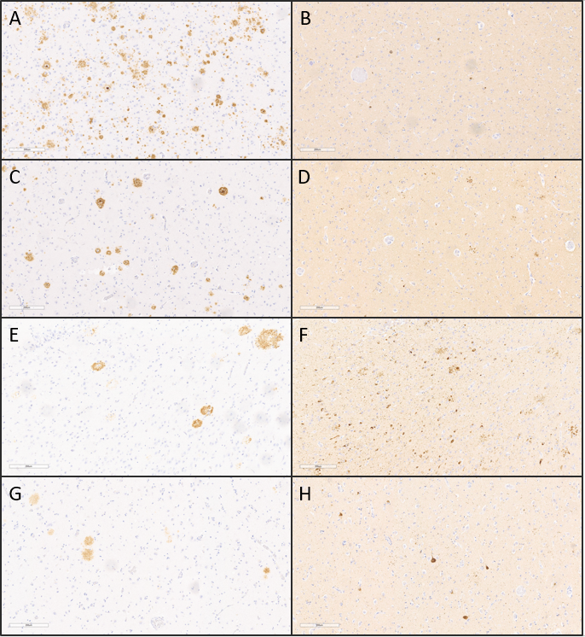
Supplementary Figure 1: Tau and Amyloid Staining in Alzheimer's Disease Patient Utilized as Source of Tau Filaments.
(A) Immunohistochemical staining of sections derived from the Parietal cortex (A and B), Medial temporal cortex (C and D), Hippocampus (E and F), and Amygdala (G and H) employing the 1-40/42 anti-amyloid antibody (A, C, E, and G) and AT8 (B, D, F, H). Nuclei were counterstained. Scale bars: 200 µm.

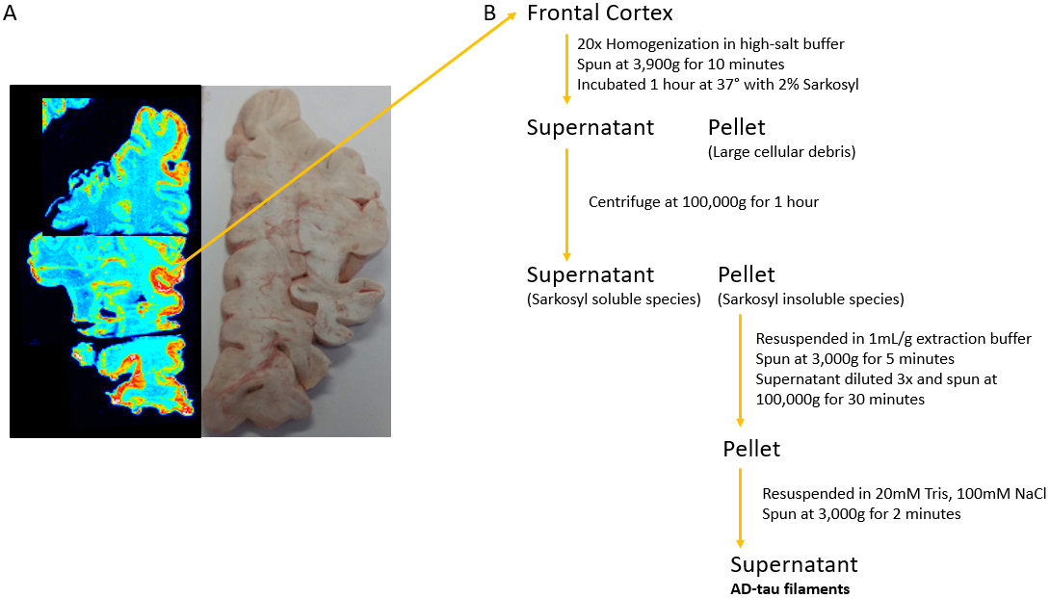
Supplementary Figure 2: Schematic of Tissue-Guided Autoradiography and Homogenization.
(A) Autoradiograph of post-mortem brain tissue from a neuropathologically confirmed Alzheimer's disease (AD) patient, labeled with [18F] MK-6240. Color code denotes regions of robust [18F] MK-6240 binding in red and areas of low binding in blue. Grey matter regions with notable [18F] MK-6240 binding was isolated and homogenized for the extraction of sarkosyl-insoluble fractions. (B) Schematic representation outlining the sequential steps involved in the purification of AD-tau filaments.

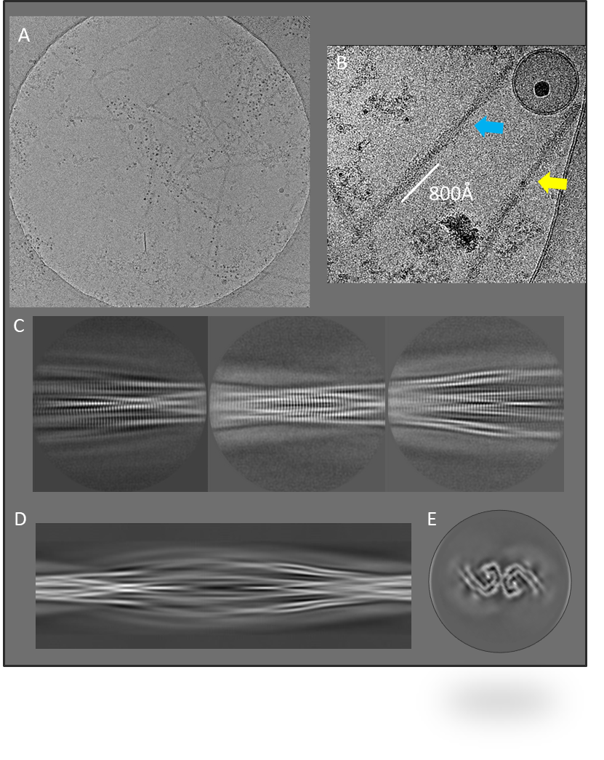
Supplementary Figure 3: Micrograph Assessment for Data Collection Preparation.
(A) Depiction of a representative view of the cryo-EM grid utilized for data collection. (B) Illustration of representative micrographs showcasing paired helical filaments (PHFs) in blue, accompanied by a lesser occurrence of straight filaments (SFs) in yellow. A cross-over distance of 800 Å was observed for PHFs, guiding the initial model generation. (C) Three representative 2D class averages that were used for generating the initial model. (D) The sinogram depicting 360° of rotation along the helical axis. (E) The cross-section of the inimodel used for subsequent refinements.

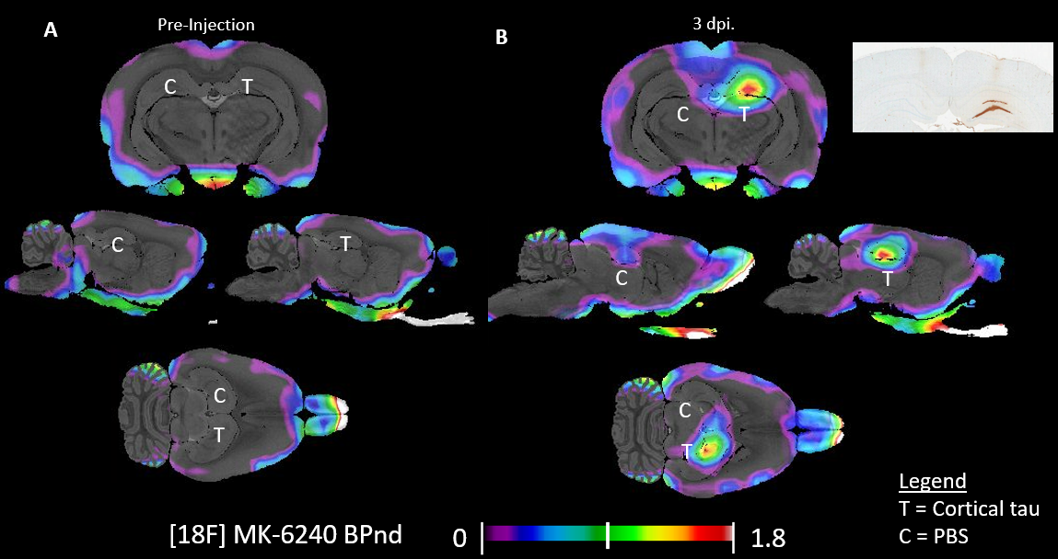
Supplementary Figure 4: Pilot Inoculation Utilizing Sarkosyl-Insoluble Tau Filaments Extracted from Alzheimer's Disease Patient Brain.
Overlay of parametric maps on structure the rat MRI summarizing (A) the pre-injection [18F] MK-6240 BPND (n=1) and (B) the post-injection [18F] MK-6240 BPND, accompanied by (C) its respective post-mortem immunohistochemistry (IHC) evidencing AT8 positivity (n=1). The left hemisphere of the dorsal hippocampus received a control injection of PBS, while the right hemisphere was injected with sarkosyl-insoluble tau species extracted from human AD patient brain material.

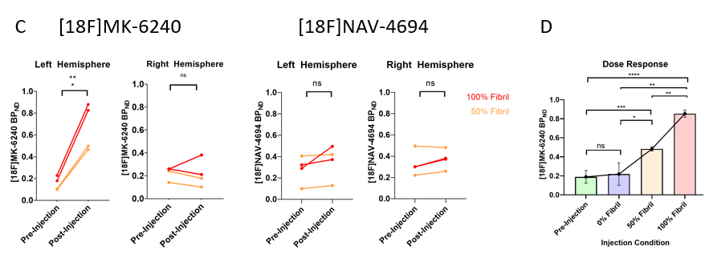
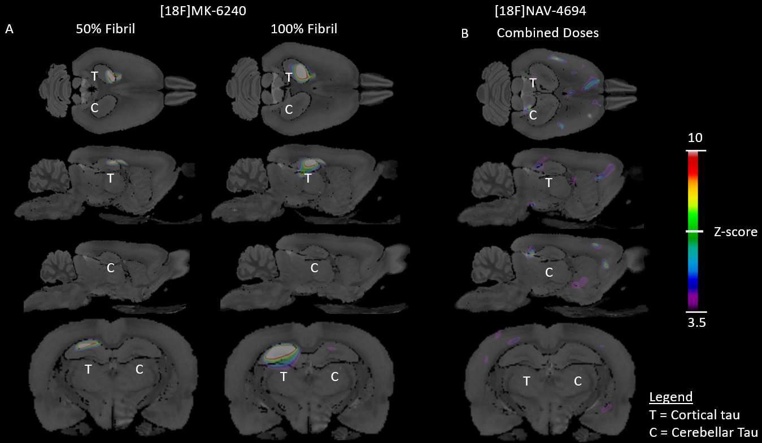
Supplementary Figure 5: Sarkosyl-Insoluble Brain Material Quantification from Alzheimer's Disease Patient Brain in Living Rats using PET.
Overlay of parametric maps on structure the rat MRI summarizing (A) Comparison of [18F] MK6240 z-score maps between baseline scans and post-injection scans in animals subjected to 50% Fibril dose (n=2) and 100% Fibril dose (n=2) AD tau fibril injections (Left Hemisphere), along with cerebellar cortex extraction control (Right Hemisphere). (B) [18F] NAV4694 z-score map comparison between baseline scans and post-injection scans in all animals injected with AD tau fibrils (n=4) (Left Hemisphere), juxtaposed with cerebellar cortex extraction control (Right Hemisphere). Overlaid on the Waxholm Space Atlas MRI. Brain maps were derived for [18F] MK6240 (tau-PET) and [18F] NAV-6494 (Aβ-PET) employing the formula [(Post-injection Average BP_{ND}) - (Baseline BP_{ND} Average) / (Baseline BP_{ND} Standard Deviation)]. This voxel-wise analysis was adjusted for multiple comparisons using the RFT method, yielding an adjusted threshold of p < 0.05. Post-injection BP_{ND} Maps exhibit significant deviations from baseline, with z-scores ≥ 3.5. (C/D) Graphical representation displaying mean BP_{ND} values originating from the dorsal hippocampi.

Supplementary Table 1
Cryo-EM data collection, refinement, and validation statistics
Data Collection | +MK-6240 AD PHF | -MK-6240 AD PHF
Electron Microscope Type | Titan Krios | Titan Krios
Nominal Magnification | 105,000x | 105,000x
Voltage (kV) | 300 | 300
Detector | Gatan K3 w/ Bioquantum Energy Filter | Gatan K3 w/ Bioquantum Energy Filter
Electron Exposure (e⁻/ Å²) | 62 | 60
Defocus Range (µm) | -1.0 to -2.4 µm | -1.0 to -1.8 µm
Super-resolution Pixel Size (Å) | 0.415 | 0.415
Reconstruction
Total number of micrographs | 8,037 | 12,477
Number of usable micrographs | 3,976 | 3,842
Particles after Extraction | 1,533,788 | 1,033,374
Particles after 2D Classification | 408,700 | 413,684
Particles after 3D Classification | 32,986 | 165,401
Map Resolution (Å; FSC=0.143) | 2.31 | 3.08
Helical Rise (Å) | 2.38 | 2.38
Helical Twist (degrees) | 179.46 | 179.46
Symmetry Imposed | 2₁ | 2₁
Refinement
Initial model used (PDB code) | N/A | 5o3l
Model resolution FSC 0.5 (Å) | 3.10 | 2.92
Map sharpening B factor (Å²) | -33.04 | -65.83
Model composition
Non-hydrogen atoms | 7236 | 7165
Protein residues | 450 | 462
Ligands | 6 | 0
B Factors (Å²)
Protein | 73.16 | 72.84
Ligand | 0 | N/A
R.m.s. deviations
Bond lengths (Å) | 0.012 | 0.010
Bond angles (degrees) | 1.946 | 1.931
Validation
MolProbity score | 1.05 | 0.98
Clashscore | 0.42 | 0
Poor rotamers (%) | 0 | 0
Ramachandran plot
Favored (%) | 94.06 | 92.22
Allowed (%) | 5.94 | 7.78
Disallowed (%) | 0 | 0

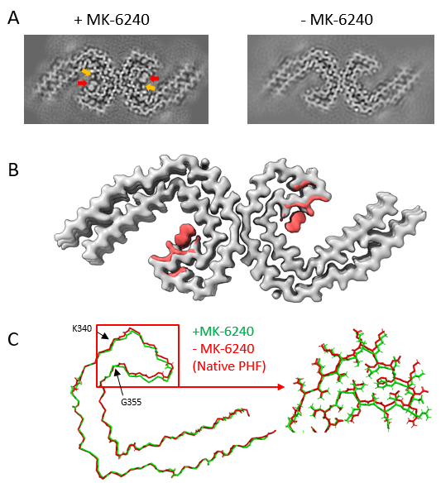
Supplementary Figure 6: Structural Alterations and Maps Illustrating Mainchain and Sidechain Rearrangement upon MK-6240 Binding.
(A) Projected cross-section of a single rung extracted from the final post-processed map. Cryo-EM map depicts the architecture of Alzheimer's disease (AD) paired helical filaments (PHFs) incubated with MK-6240 (left) (Unambiguous site is highlighted by a red arrow, second potential site is highlighted by an orange arrow), and without MK-6240 (DMSO vehicle control, right). Cross-section corresponds to six images, representing one rung of the filament. Sigma contrast value = 7.5. (B) Cryo-EM map of AD tau PHFs without MK-6240 (DMSO Control, grey) with the difference map derived from the MK-6240-bound structure (salmon), highlighting the most prominent differences, and emphasizing amino acids involved in sidechain rearrangements. (C) Overlaid atomic models displaying mainchains from native AD PHF (red) and +MK-6240 AD PHF (green). On the left, a mainchain translation originating at K340 and terminating at G355 is observable. The right section presents a magnified view from within the red rectangle on the left, illustrating distinct mainchain and sidechain configurations.

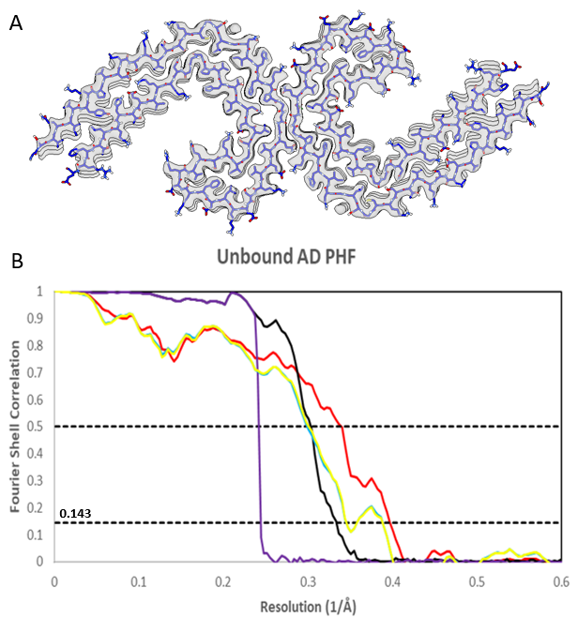
Supplementary Figure 7: Cryo-EM Map and atomic model of unbound AD PHF structure.
(A) Cryo-EM density (white) is juxtaposed with the atomic model of the unbound tau fold (blue). (B) Graph illustrating Fourier Shell Correlation (FSC) curves for the Cryo-EM maps of the AD-PHF with MK-6240 (Black). Additionally, FSC curves are presented for the refined atomic model against the post-processed map utilized for atomic model generation (Red), for the refined atomic model from one half-map to itself (Blue), for the refined atomic model from the first half-map to the second (Yellow), and for phase randomized curves of the two independently refined half-maps (Purple).

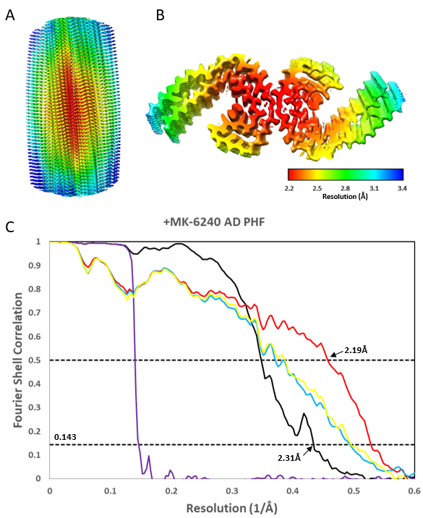
Supplementary Figure 8: Cryo-EM Map with Local Resolution and Model Resolution Assessment.
(A/B) Cryo-EM map depicting Alzheimer's disease (AD) paired helical filaments (PHF) with MK-6240, illustrating a side-view of the filament (A) and a cross-sectional view representing 20% of the filament (B). Local resolution is represented using color coding (in Å), where warmer colors indicate regions of high resolution and cooler colors indicate areas of lower resolution. (C) Graph illustrating Fourier Shell Correlation (FSC) curves for the Cryo-EM maps of the AD-PHF with MK-6240 (Black). Additionally, FSC curves are presented for the refined atomic model against the post-processed map utilized for atomic model generation (Red), for the refined atomic model from one half-map to itself (Blue), for the refined atomic model from the first half-map to the second (Yellow), and for phase randomized curves of the two independently refined half-maps (Purple).

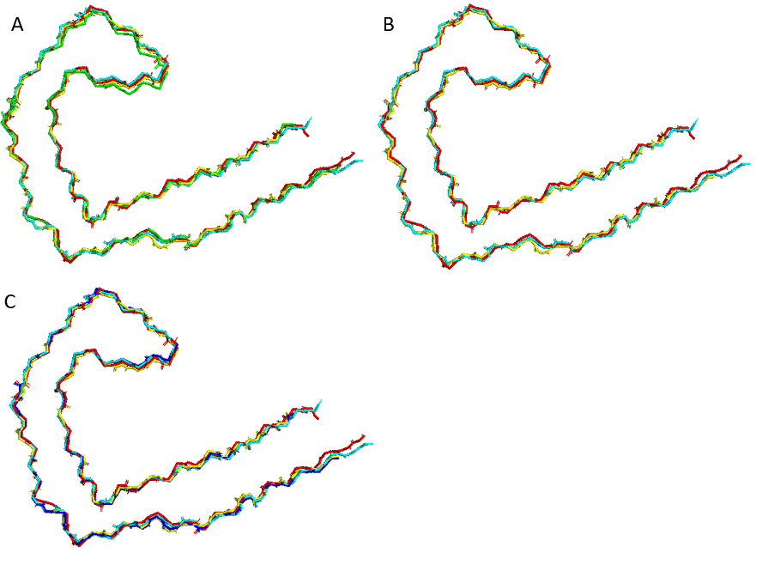
Supplementary Figure 9: Atomic Model Comparison for RMSD Calculations
(A) Overlaid atomic models from +MK-6240 AD PHF (green). unbound AD PHF (red), 5o3l (yellow), and 6HRE (baby blue). (B) Overlaid atomic models from unbound AD PHF (red), 503L (yellow), and 6HRE (baby blue). (C) Overlaid atomic models from +GTP-1 AD PHF (dark blue). unbound AD PHF (red), 503L (yellow), and 6HRE (baby blue).

