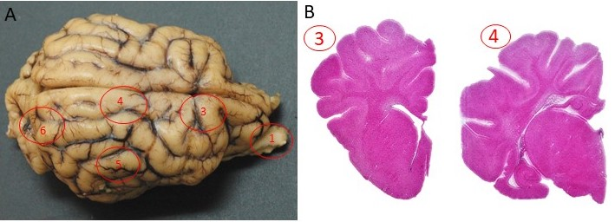
Supp. Figure 1: Examples of sampling sites marked on the brain (A) and corresponding cross sections (B) processed for histology.
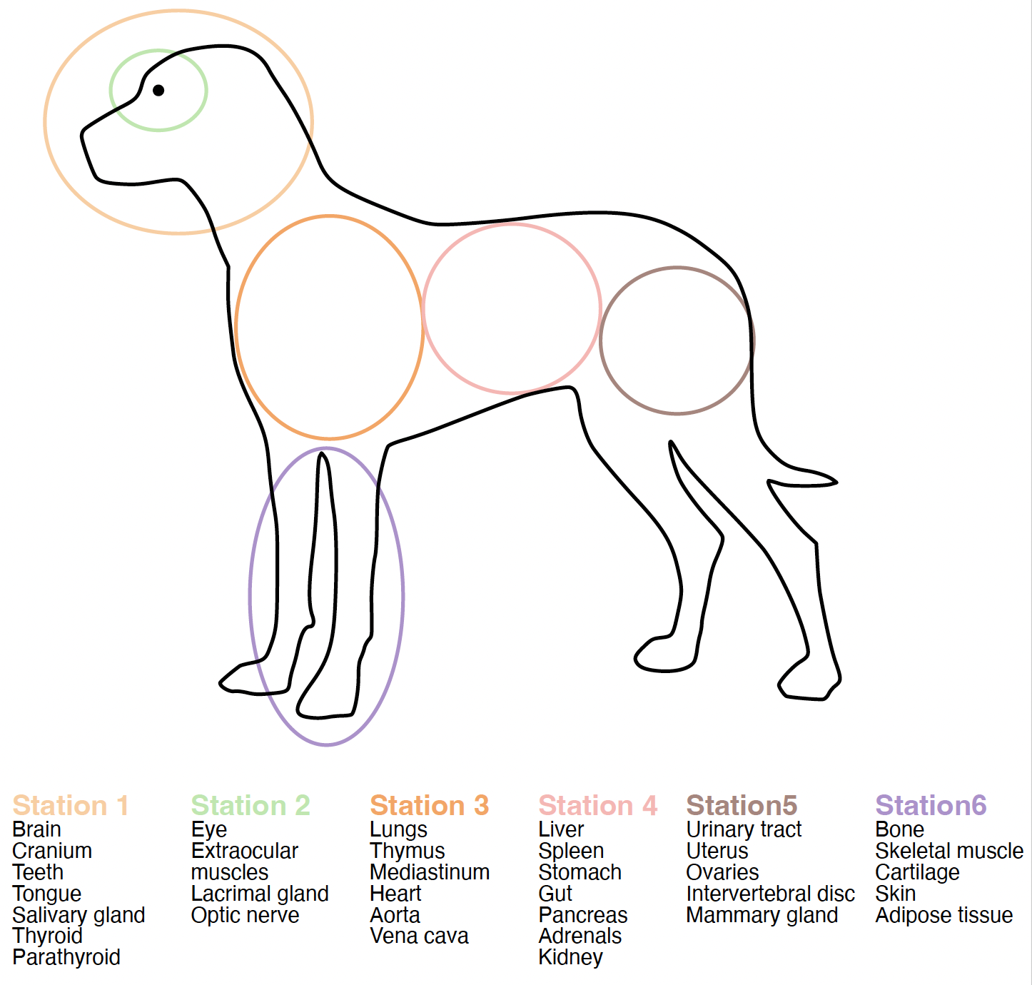
Supp. Figure 2: Overview of the organization of stations during sample collection.

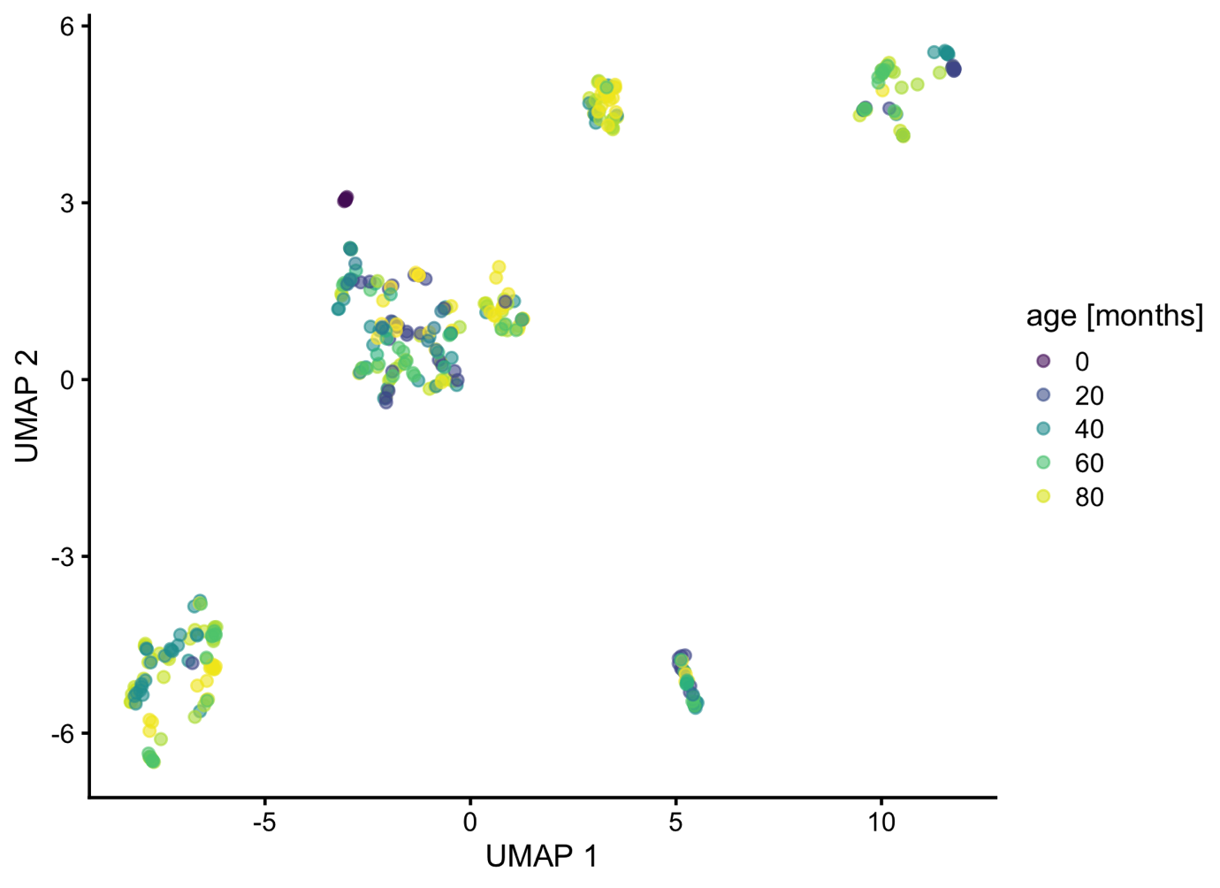
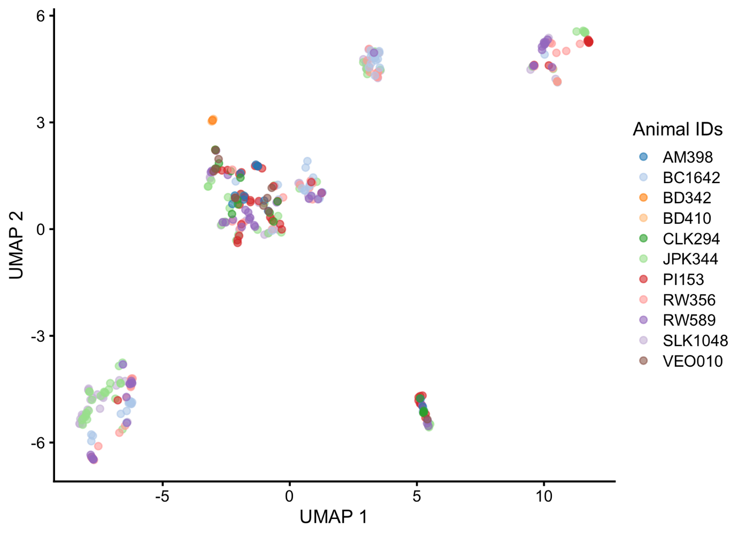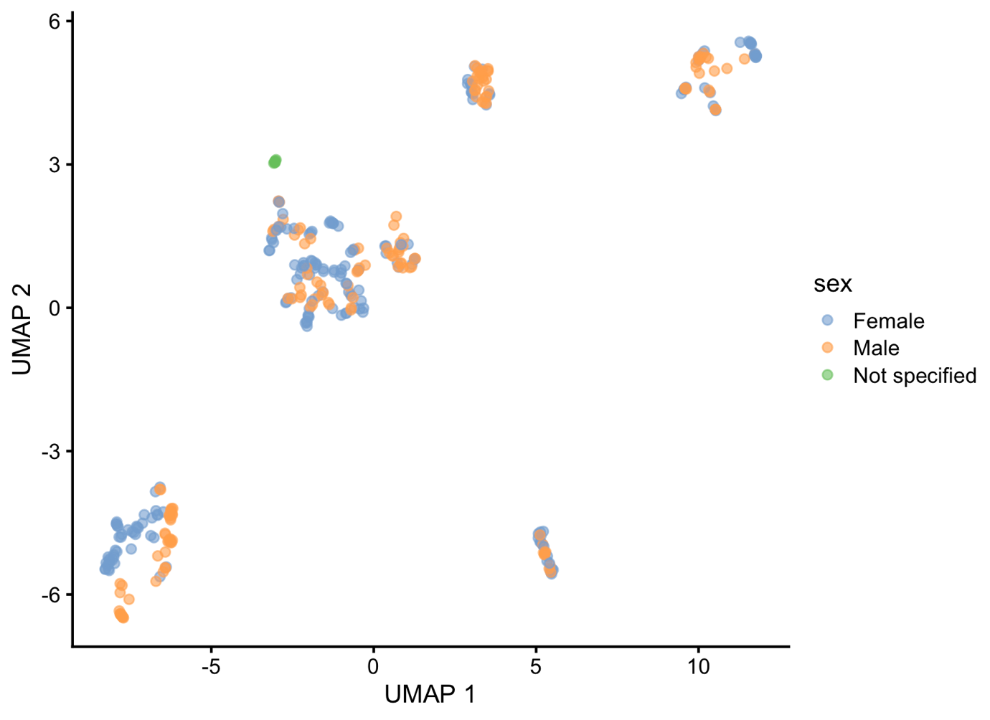
Supp. Figure 3: Data QC: UMAP plot of expression profiles in robust promoter set, colored based on age, sex and breed.
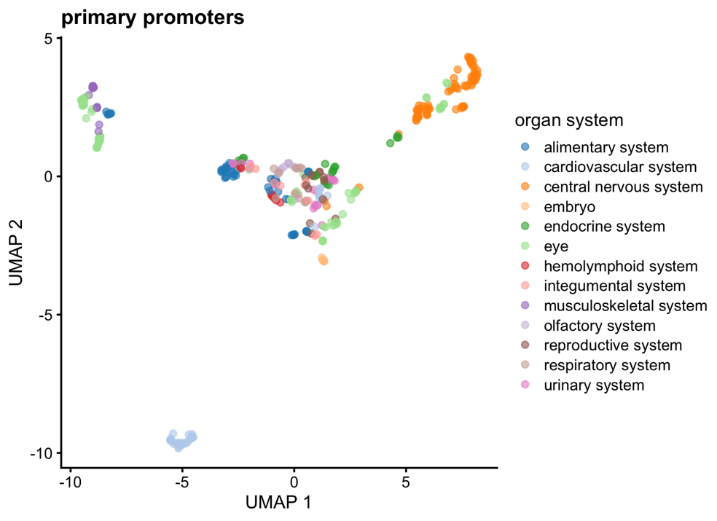
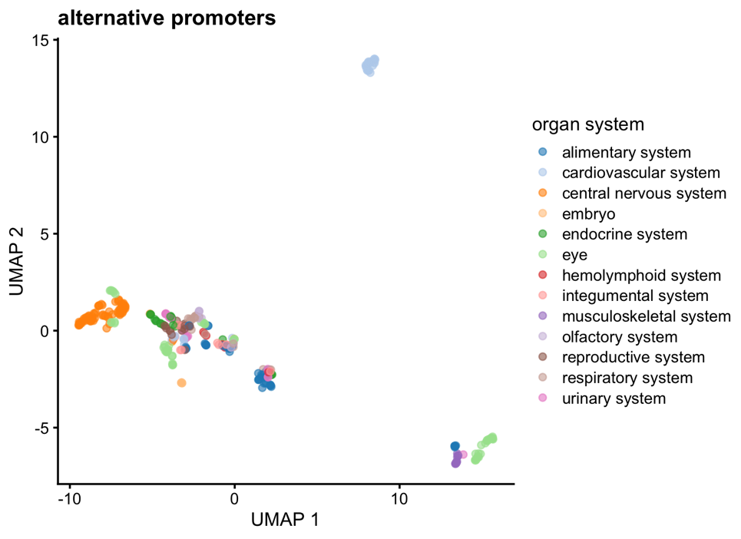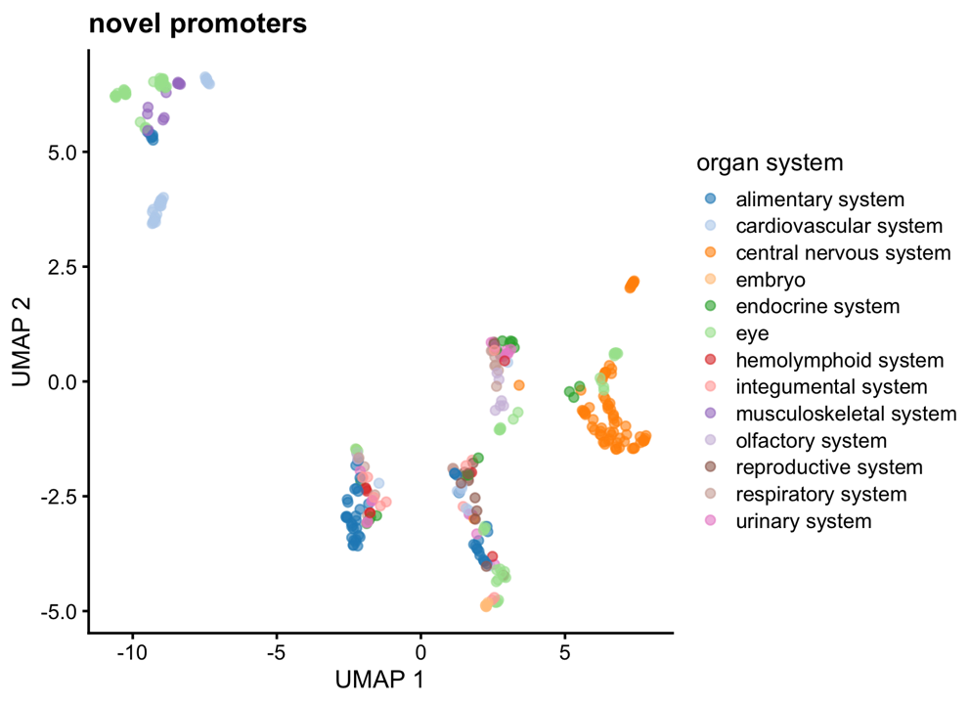
Supp. Figure 4: UMAP plot of expression profiles of the different promoter types in the robust promoter set, colored based on organ system.

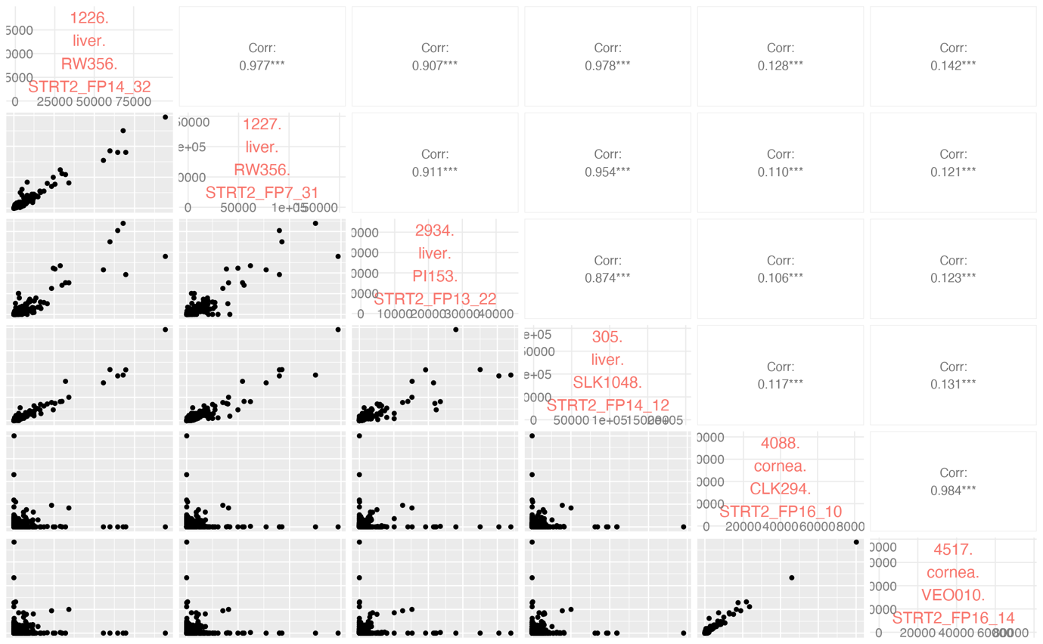
Supp. Figure 5: Data QC: Correlation matrix between a subset of samples.
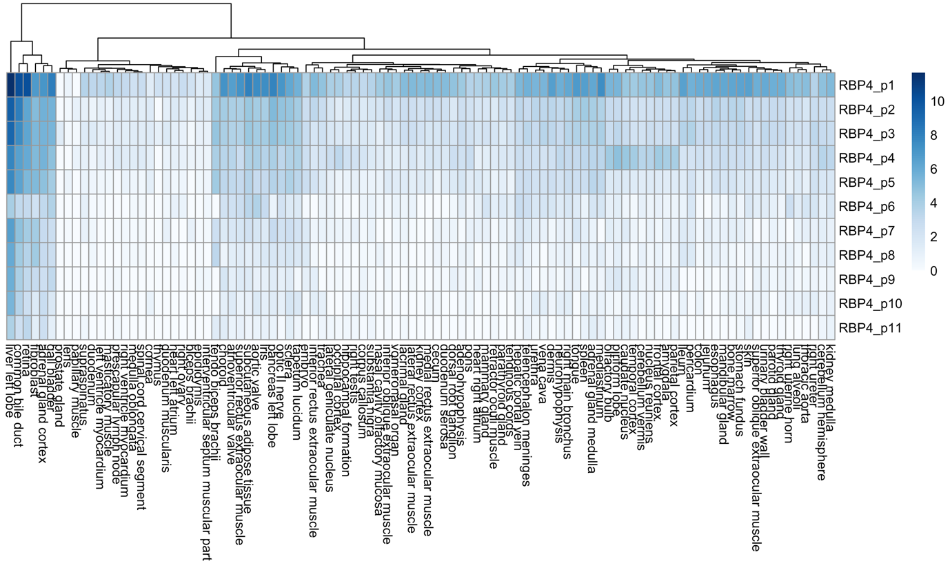
Supp. Figure 6: Mean expression per tissue of primary and alternative promoters of RBP4.

