Supplementary Information
Spatial Proteomics of Single Cells and Organelles on Tissue Slides Using Filter-Aided Expansion Proteomics
Zhen Dong^{1,2,3#}, Wenhao Jiang^{1,2,3#}, Chunlong Wu^{1,2,3}, Ting Chen⁴, Jiayi Chen^{1,2,3}, Xuan Ding^{1,2,3}, Shu Zheng⁴, Kiryl D. Piatkevich^{2,3,5}*, Yi Zhu^{1,2,3}*, Tiannan Guo^{1,2,3}*
¹School of Medicine, Westlake University, Hangzhou, Zhejiang Province, China.
²Westlake Center for Intelligent Proteomics, Westlake Laboratory of Life Sciences and Biomedicine, Hangzhou, Zhejiang Province, China.
³Research Center for Industries of the Future, School of Life Sciences, Westlake University, Hangzhou, Zhejiang Province, China.
⁴Cancer Institute (Key Laboratory of Cancer Prevention and Intervention, China National Ministry of Education), The Second Affiliated Hospital, School of Medicine, Zhejiang University, Hangzhou, Zhejiang Province, China.
⁵School of Life Sciences, Westlake University, Hangzhou, Zhejiang Province, China.

#These authors contributed equally.
*Corresponding authors: kiryl.piatkevich@westlake.edu.cn; zhuyi@westlake.edu.cn; guotiannan@westlake.edu.cn

SUPPLEMENTARY INFORMATION
Supplementary Figure 1. Maintaining proteome coverage while accelerating timeline in ProteomEx for mouse liver tissue.
Supplementary Figure 2. Isotropic analysis of mouse kidney slide sample expansion using FAXP under autoclave (121ºC, 1.5 h).
Supplementary Figure 3. Performance of reduction and alkylation at different stages using mouse brain tissue-hydrogel composites.
Supplementary Figure 4. Performance of different enzyme digestion conditions using mouse brain tissue-hydrogel composites.
Supplementary Figure 5. Comparison analysis between conventional in-gel digestion and filter-aided in-gel digestion.
Supplementary Figure 6. Bright field images show a single nucleus cut from a mouse liver formalin-fixed paraffin-embedded (FFPE) slide using laser capture microdissection, with separate images from FFPE tissue (a) and hydrogel-embedded tissue (b).
Supplementary Figure 7. Quality control filtering of single nuclear and single-cell proteomics data.
Supplementary Figure 8. Proteomics comparison between mononuclear and binuclear cells in mouse liver.
Supplementary Figure 9. Quality control evaluation and identification results of colorectal cancer samples.
Supplementary Figure 10. Progression analysis of colorectal cancer proteome expression.
Supplementary Figure 11. Optimization of gel-making conditions and liquid chromatography (LC) gradients.
Supplementary Table 1. Optimizations of gel-making conditions.
Supplementary Table 2. Optimizations of reduction and alkylation steps as well as in-gel proteolytic digestion.
Supplementary Table 3. Sample collection of CRC tissue-hydrogel composites from three patients.
Supplementary Table 4. Chemical composition of reagents and buffers for FAXP.
Supplementary Table 5. Main chemicals, reagents, consumables, and instruments used for FAXP and their corresponding suppliers and catalog numbers.
Supplementary Table 6. MS settings for diaPASEF.
Supplementary Note 1. Critical steps and troubleshooting in FAXP and MS procedures.
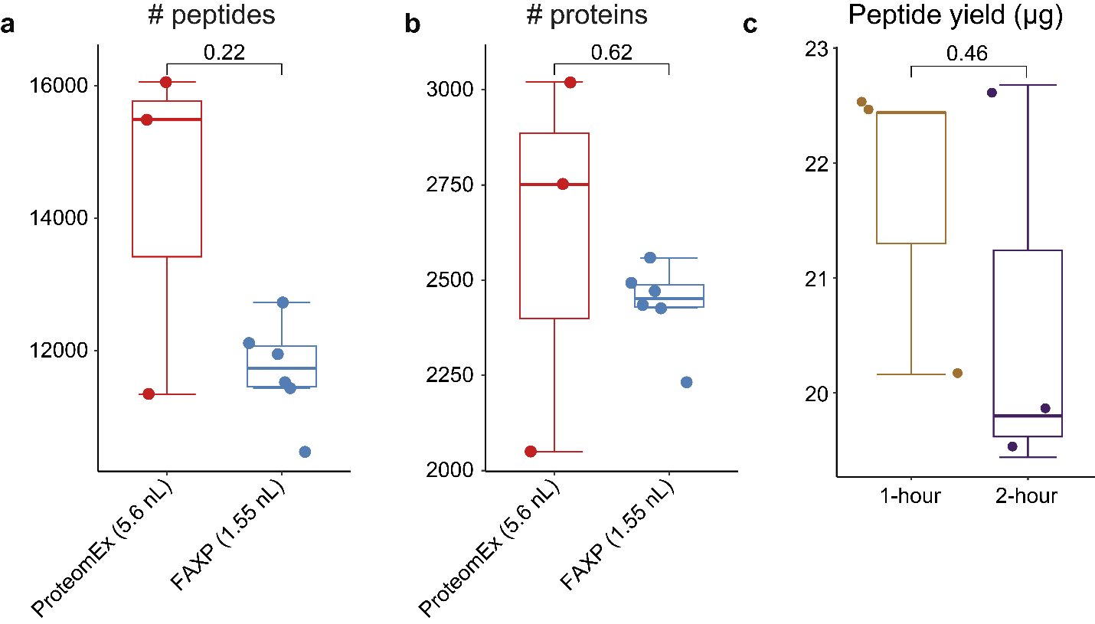
Supplementary Figure 1. Maintaining proteome coverage while accelerating timeline in ProteomEx for mouse liver tissue. (a) Peptide and (b) protein identifications from mouse liver samples compared between two workflows: ProteomEx (5.6 nL in red; effective LC gradient time: 80 minutes) and the current FAXP approach (1.55 nL in blue; effective LC gradient time: 50 minutes). Data obtained from timsTOF Pro ddaPASEF mode, with ProteomEx data sourced from the original study¹ (n = 3) and FAXP data comprising six technical replicates from mouse liver tissue-hydrogel composites. (c) Peptide yield comparison from mouse liver tissues anchored for 1 hour in gold versus 2 hours in purple (n = 3), using six consecutive 10-micron thick sections. P-values are estimated by Welch’s t-test (two-sided). As to data presentation, center lines show the medians; box limits indicate the 25th and 75th percentiles; whiskers extend to the most extreme data points within 1.5 times the IQR. Data are presented as dots and points beyond whiskers are outliers. Source data are provided as a Source Data file.
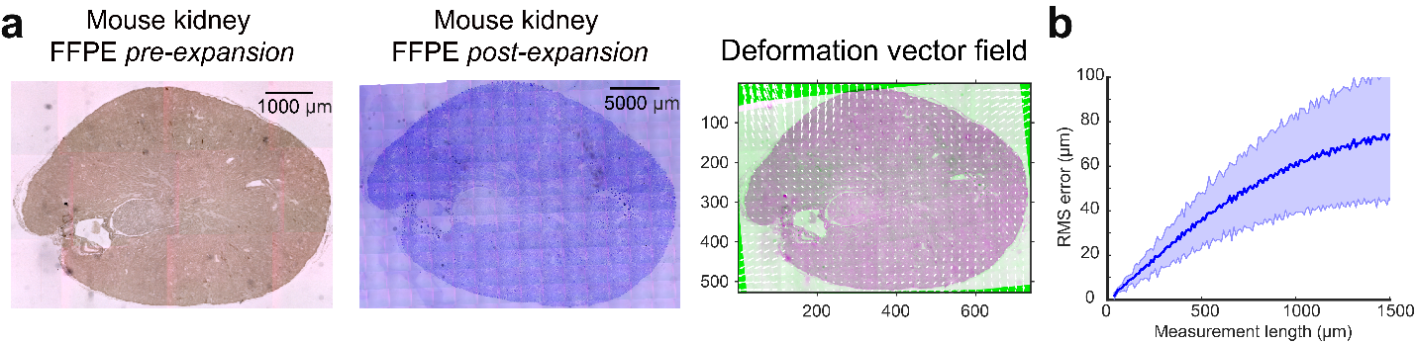
Supplementary Figure 2. Isotropic analysis of mouse kidney slide sample expansion using FAXP under autoclave (121ºC, 1.5 h). (a) Bright-field images depicting mouse kidney formalin-fixed paraffin-embedded (FFPE) tissue slides (n = 3) before (left panel) and after (middle panel; Coomassie-stained) expansion, alongside an overlay (right panel) displaying the pre-expansion image in magenta pseudo-color and the registered post-expansion image in green pseudo-color. Deformation vectors are indicated by white arrows. (b) Comparison of root-mean-square (RMS) measurement length error between pre-expansion and post-expansion images of kidney slides (n = 3); as exemplified in panel (a).

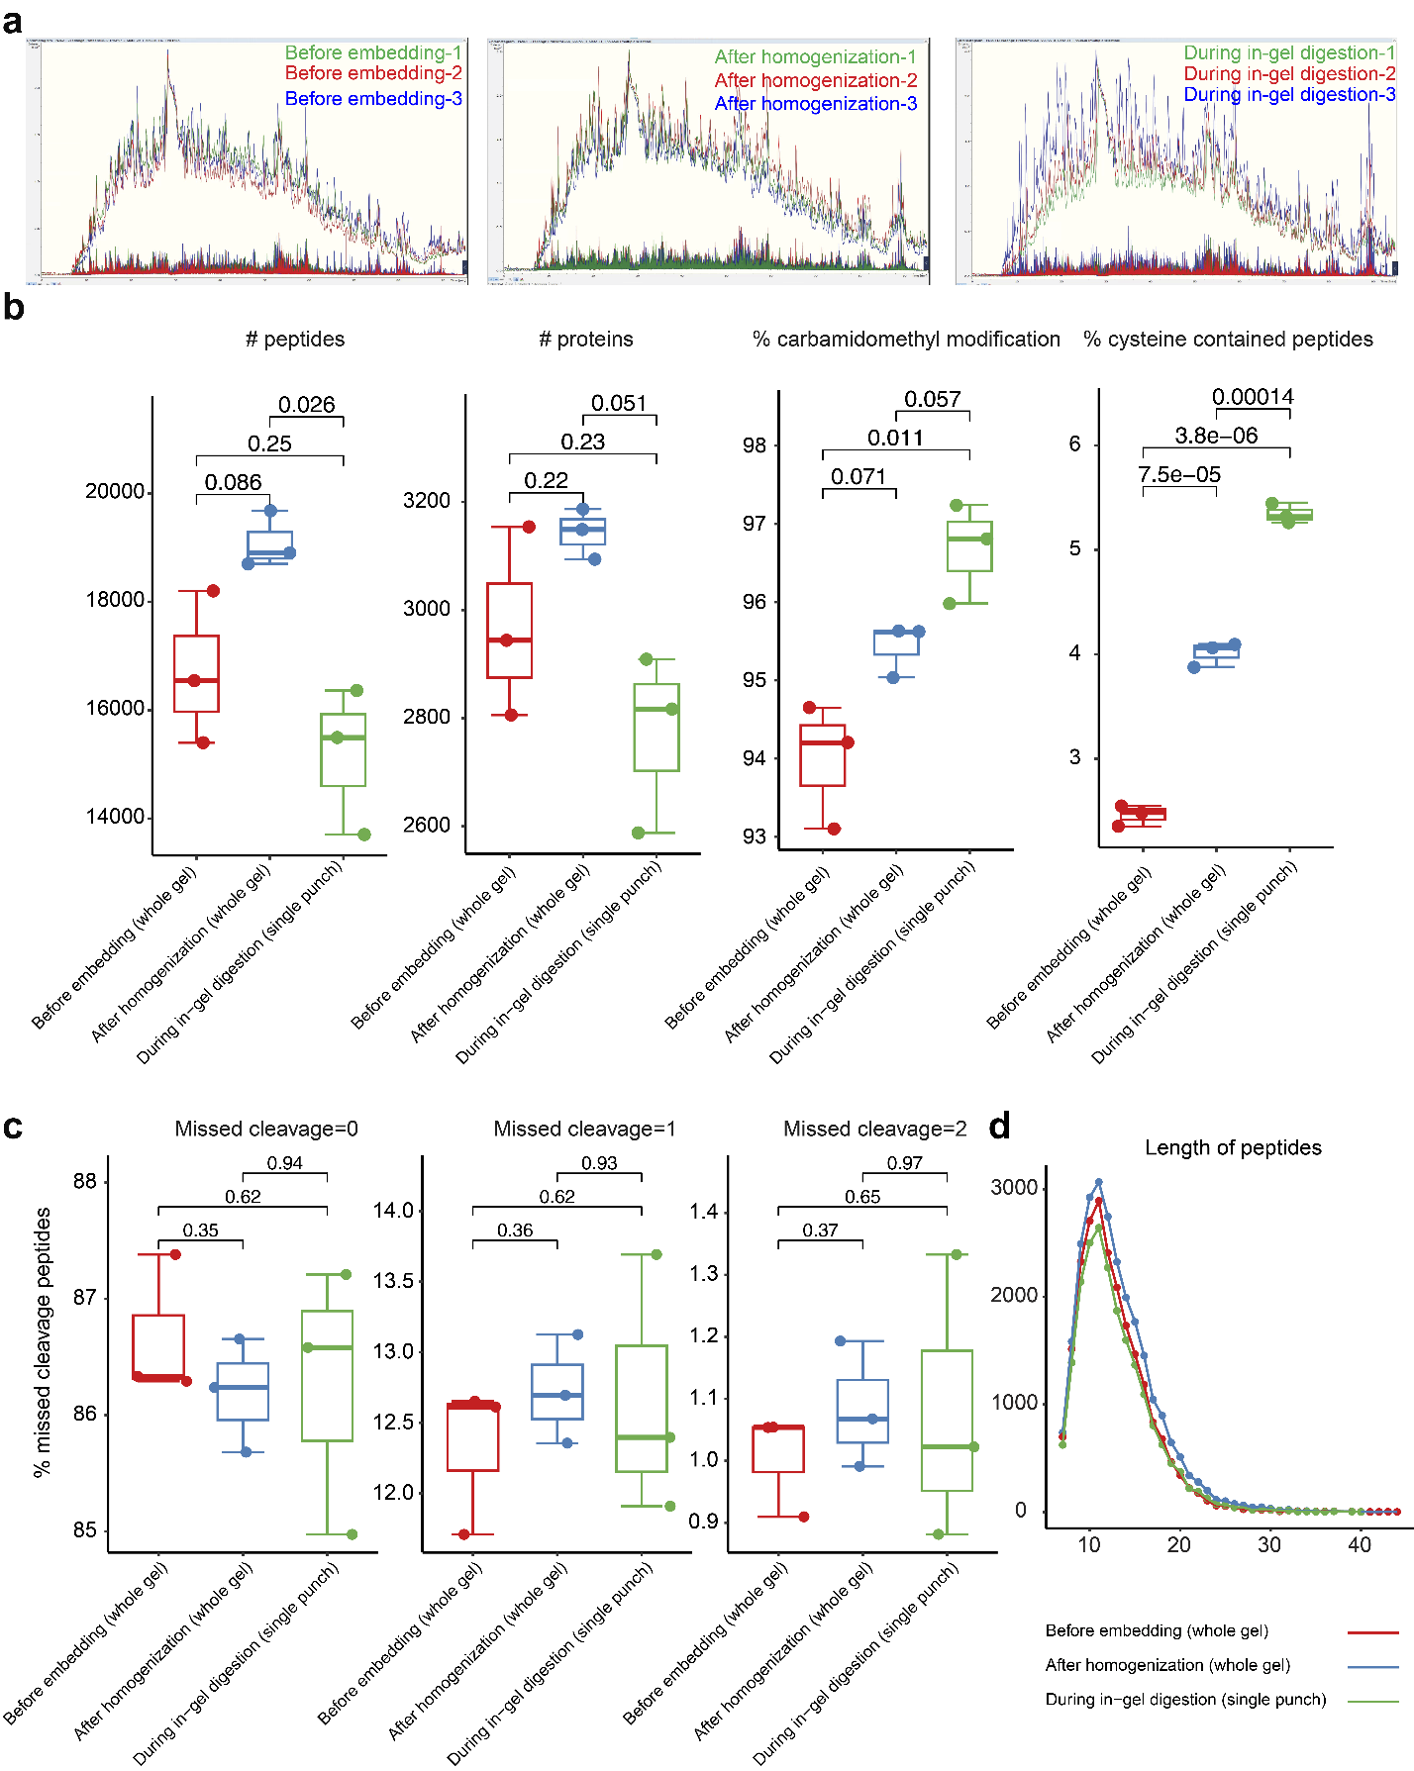
Supplementary Figure 3. Performance of reduction and alkylation at different stages using mouse brain tissue-hydrogel composites. (a) MS1 and MS2 spectra of peptides at different stages of reduction and alkylation, including “Before embedding (whole gel)”, “After homogenization (whole gel)”, and “During in-gel digestion (single punch)” (n = 3). Each color represents a different replicate: replicate 1 (green), replicate 2 (red), and replicate 3 (blue). Comparison of MS1 and MS2 chromatograms, displaying LC retention time for equivalent peptide amounts (3-mm punches) on timsTOF Pro (80-minute effective LC gradient). (b) Comparative proteomic outcomes across the three reduction and alkylation stages (n = 3), showing the number of identified peptides and proteins, percentages of carbamidomethyl modifications, and percentages of cysteine-contained peptides. Conditions are color-coded as follows: "Before embedding (whole gel)" (red), "After homogenization (whole gel)" (blue), and "During in-gel digestion (single punch)" (green). (c) Missed cleavage rates observed in identified peptides among the three stages (n = 3). (d) Peptide length distribution displayed through a curve plot across the three stages. Related information is available in Supplementary Table 2. P-values are estimated by Welch’s t-test (two-sided). For all boxplots, center lines show the medians; box limits indicate the 25th and 75th percentiles; whiskers extend to the most extreme data points within 1.5 times the IQR. Data are presented as dots and points beyond whiskers are outliers. Source data are provided as a Source Data file.
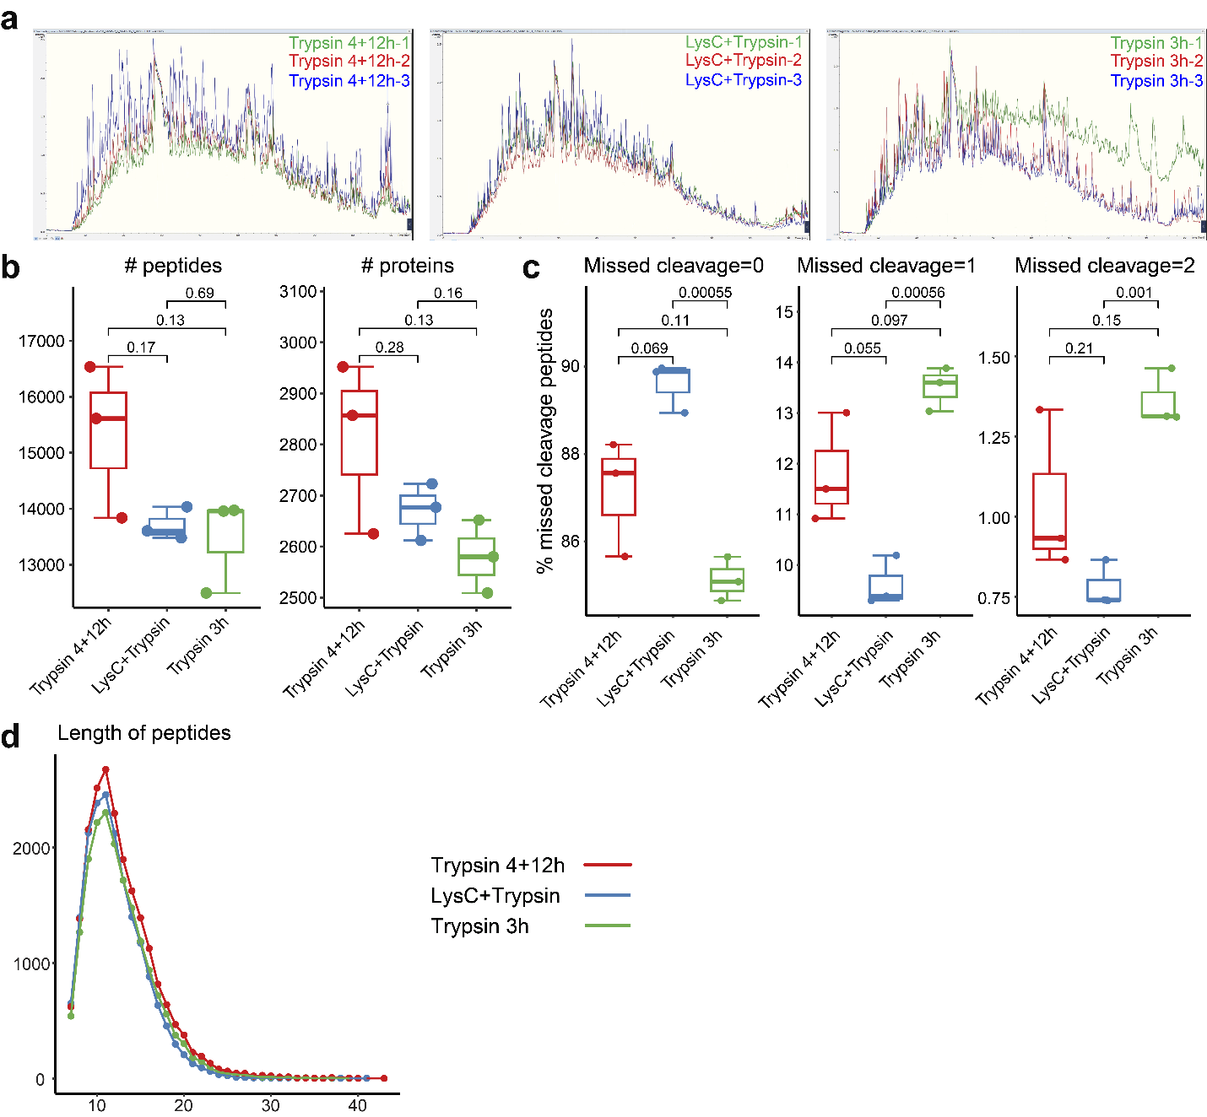
Supplementary Figure 4. Performance of different enzyme digestion conditions using mouse brain tissue-hydrogel composites. (a) MS1 and MS2 spectra illustrating peptides under varied enzyme digestion conditions (n = 3). Each color represents a different replicate: replicate 1 (green), replicate 2 (red), and replicate 3 (blue). Comparative MS1 and MS2 chromatograms displaying LC retention times for similar sample amounts (3-mm punches) analyzed on timsTOF Pro (80-minute effective LC gradient). (b) Quantification of identified peptides and proteins across the three enzyme digestion conditions (n = 3): Trypsin 4+12h (red), LysC+Trypsin (blue), and Trypsin 3h (green). (c) Comparison of missed cleavage rates observed in identified peptides among the three conditions (n = 3). (d) Visualization of peptide length distributions across the three conditions using a curve plot. Related information is available in Supplementary Table 2. P-values are estimated by Welch’s t-test (two-sided). For all boxplots, center lines show the medians; box limits indicate the 25th and 75th percentiles; whiskers extend to the most extreme data points within 1.5 times the IQR. Data are presented as dots and points beyond whiskers are outliers. Source data are provided as a Source Data file.
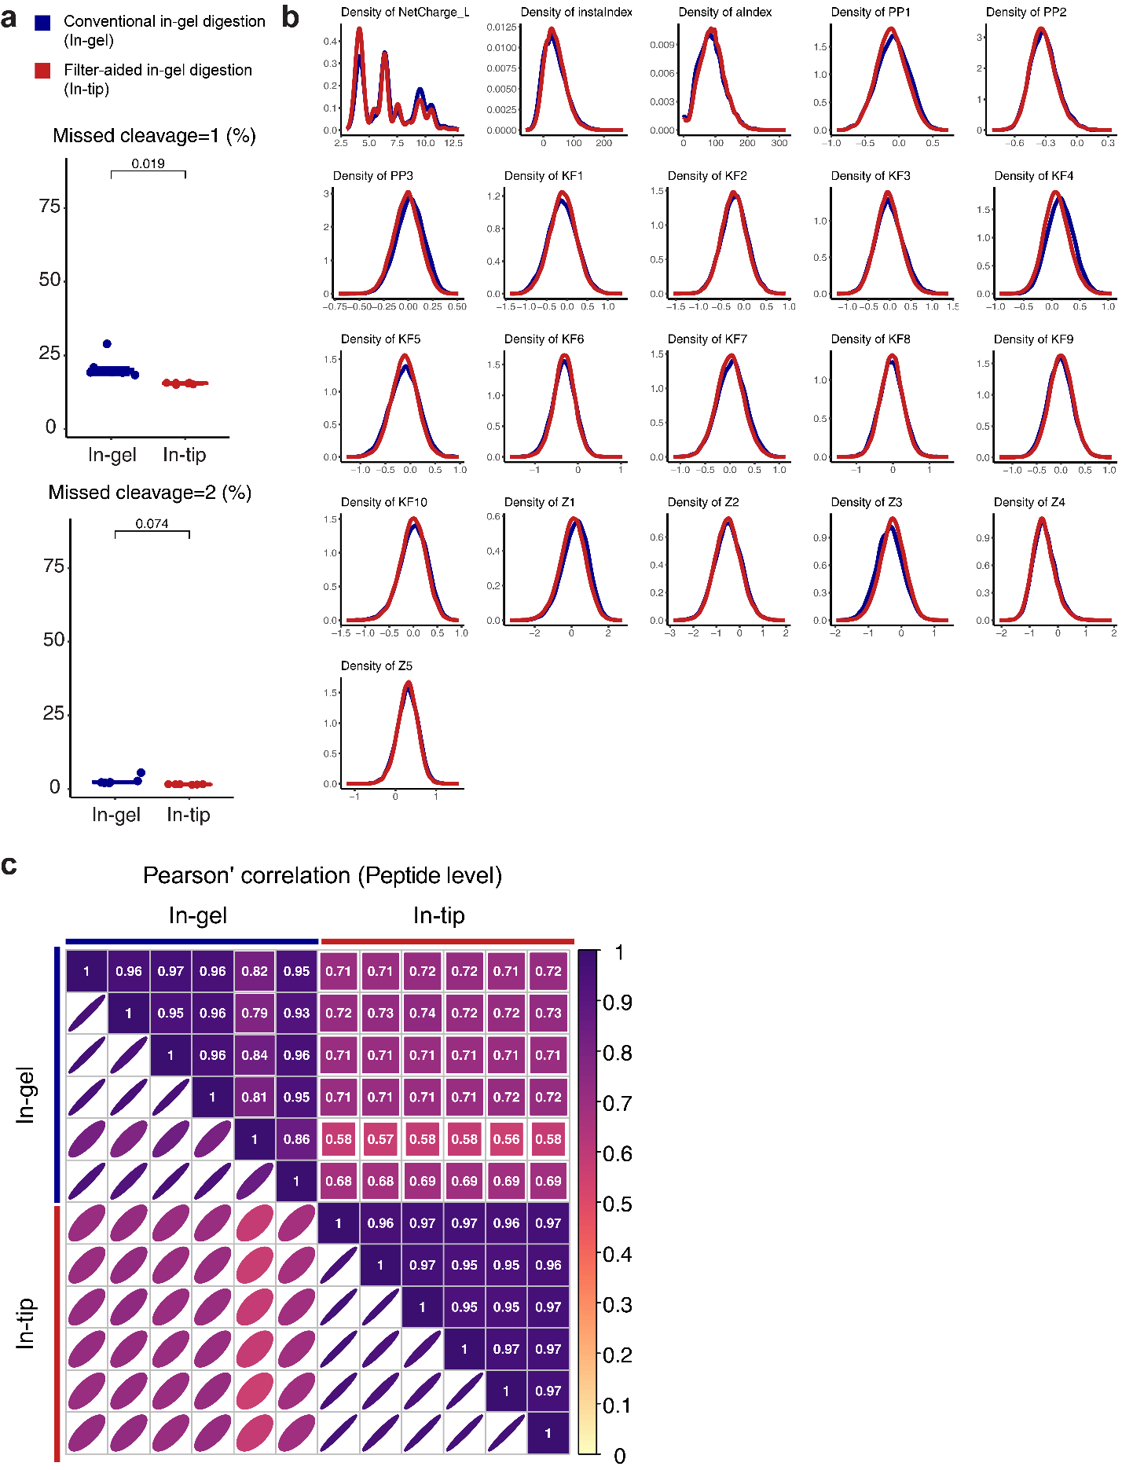
Supplementary Figure 5. Comparison analysis between conventional in-gel digestion and filter-aided in-gel digestion. (a) Percentage of identified peptides with one and two missed cleavage sites using in-gel (blue) and in-tip (red) digestions. P-values are estimated by Welch’s t-test (two-sided). For all boxplots, center lines show the medians; box limits indicate the 25th and 75th percentiles; whiskers extend to the most extreme data points within 1.5 times the IQR. Data are presented as dots and points beyond whiskers are outliers. (b) Density distribution curves of physiochemical properties for identified peptides in both digestion methods. (c) Pearson’s correlation analysis for peptide quantification between in-gel and in-tip digestions. Source data are provided as a Source Data file.
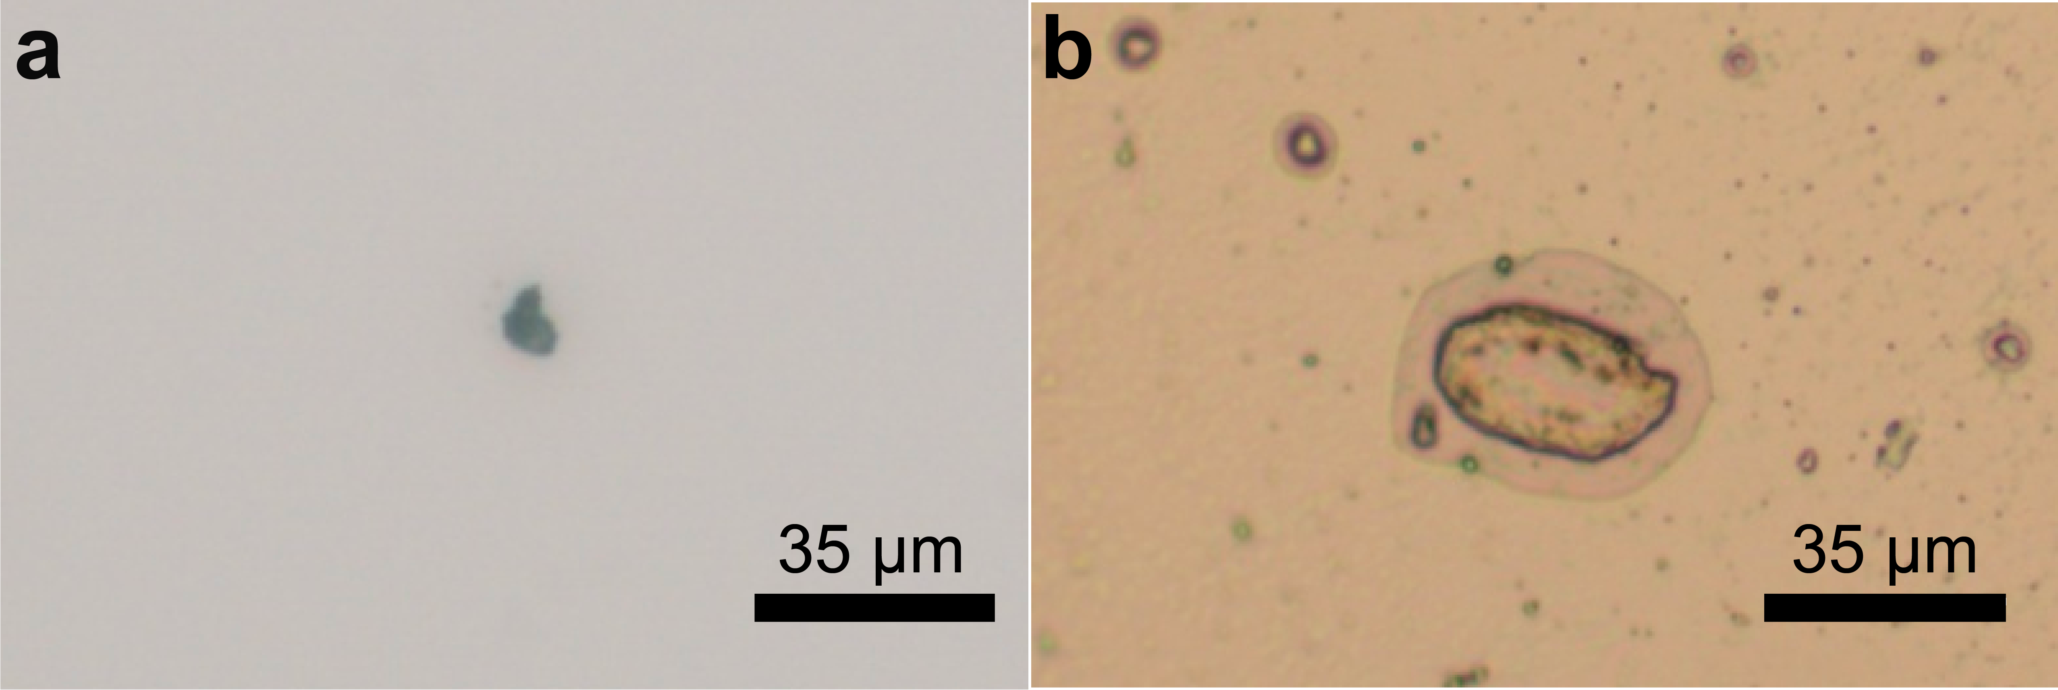
Supplementary Figure 6. Bright field images show a single nucleus cut from a mouse liver formalin-fixed paraffin-embedded (FFPE) slide using laser capture microdissection, with separate images from FFPE tissue (a) and hydrogel-embedded tissue (b). Scale bars are provided.
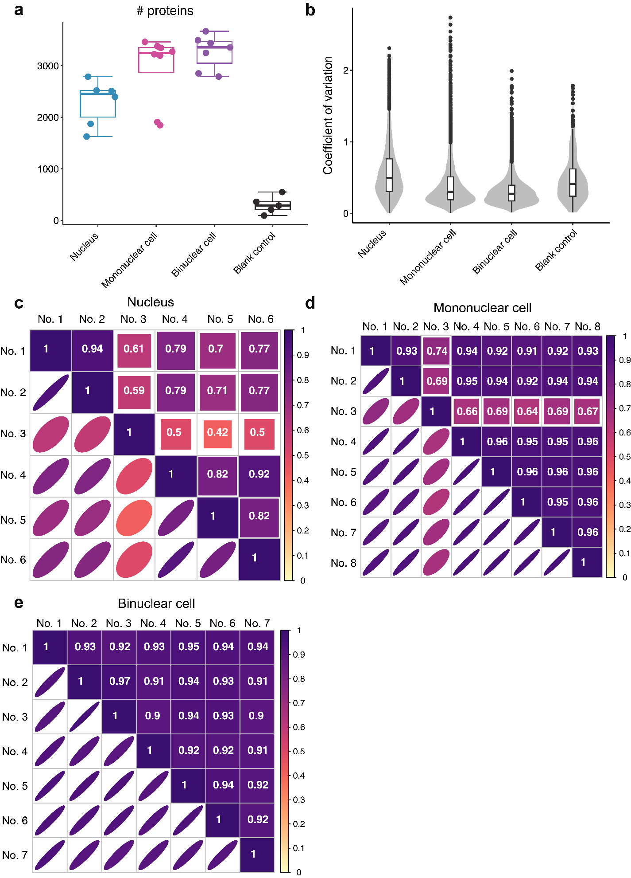
Supplementary Figure 7. Quality control filtering of single nuclear and single-cell proteomics data. (a) Identification of proteins in mouse liver nucleus (n = 6; blue), mononuclear cells (n = 8; pink), binuclear cells (n = 7; purple), and blank controls (n = 5; black). (b) Coefficient of variation for the identified proteins across all samples in (a). (c-e) Pearson’s correlation analysis of individual samples from the nucleus (c), mononuclear cells (d), and binuclear cells (e). For all boxplots, center lines show the medians; box limits indicate the 25th and 75th percentiles; whiskers extend to the most extreme data points within 1.5 times the IQR. Data are presented as dots and points beyond whiskers are outliers. Source data are provided as a Source Data file.
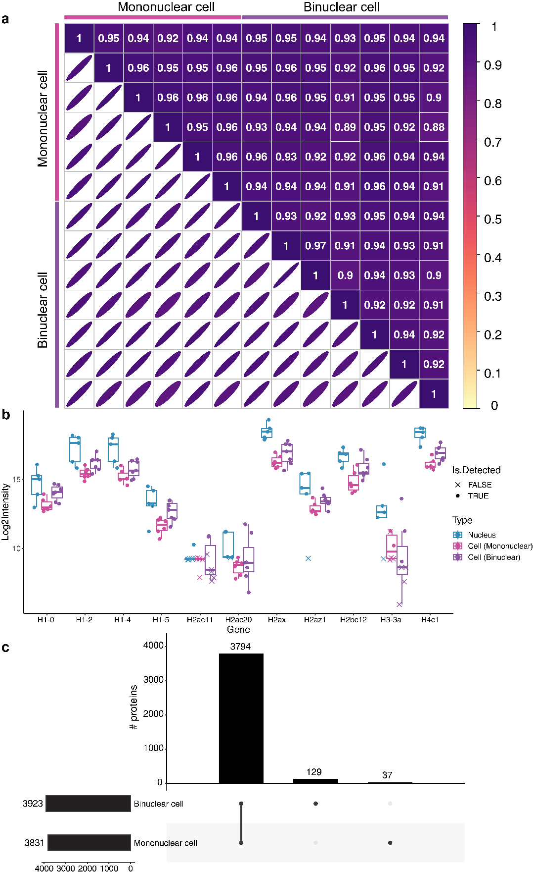
Supplementary Figure 8. Proteomics comparison between mononuclear and binuclear cells in mouse liver. (a) Heatmap depicting Pearson’s correlations for protein quantification between each sample pair from single mononuclear (n = 6) and binuclear (n = 7) cells. (b) Distribution of histones across the nucleus (n = 5; blue), mononuclear cells (n = 6; pink), and binuclear cells (n = 7; purple). Dots representing quantified proteins, whereas crosses indicating proteins that were not detected and subsequently imputed. (c) Upset plot illustrating the overlap of identified proteins between mononuclear and binuclear cells. Source data are provided as a Source Data file.
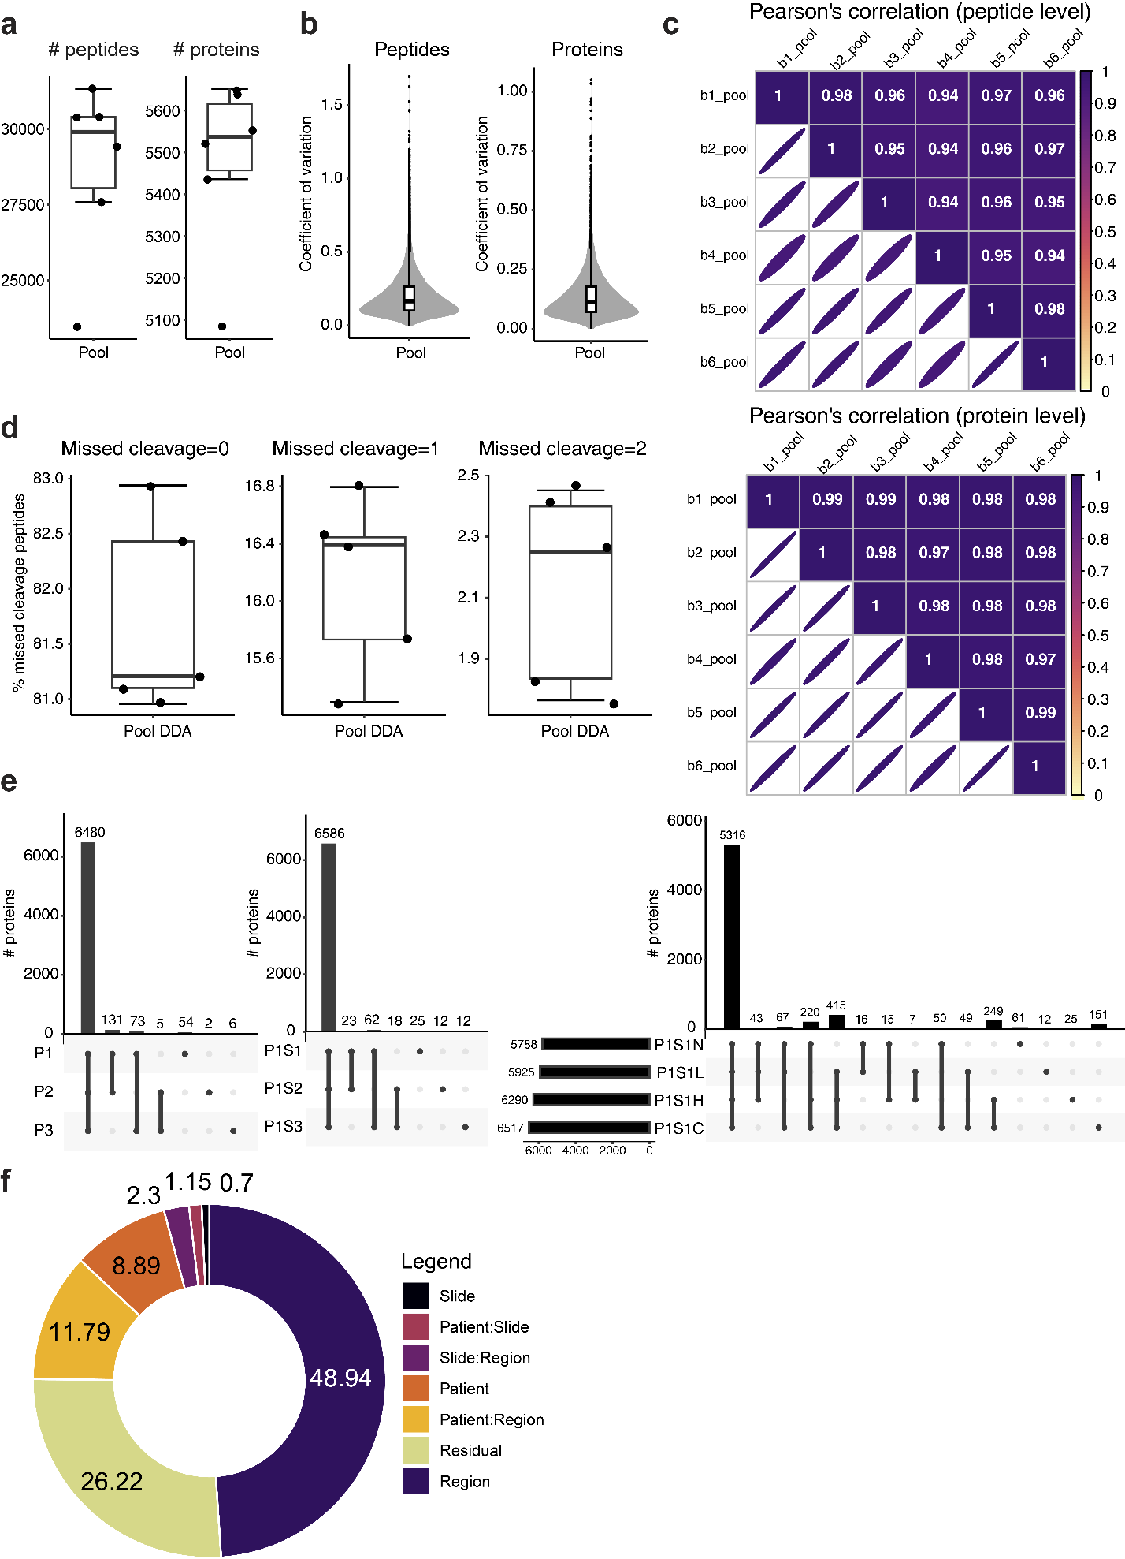
Supplementary Figure 9. Quality control evaluation and identification results of colorectal cancer samples. (a) Number of identified peptides and proteins from pooled samples analyzed through DIA-MS (n = 6). (b) Coefficient of variation of the global peptides and proteins for all the pooled samples. (c) Pearson’s correlations of peptides and proteins quantification for all pooled samples from each batch. (d) Missed cleavage rates of pooled samples analyzed through DDA-MS (n = 5). (e) Upset plots for different patients (left panel), consecutive slides of patient No.1 (middle panel), and different subtypes of patient No.1 (right panel). (f) Pie chart showing the variance contribution from the top three principal variance components identified by PVCA. For all boxplots, center lines show the medians; box limits indicate the 25th and 75th percentiles; whiskers extend to the most extreme data points within 1.5 times the IQR. Data are presented as dots and points beyond whiskers are outliers. Source data are provided as a Source Data file.
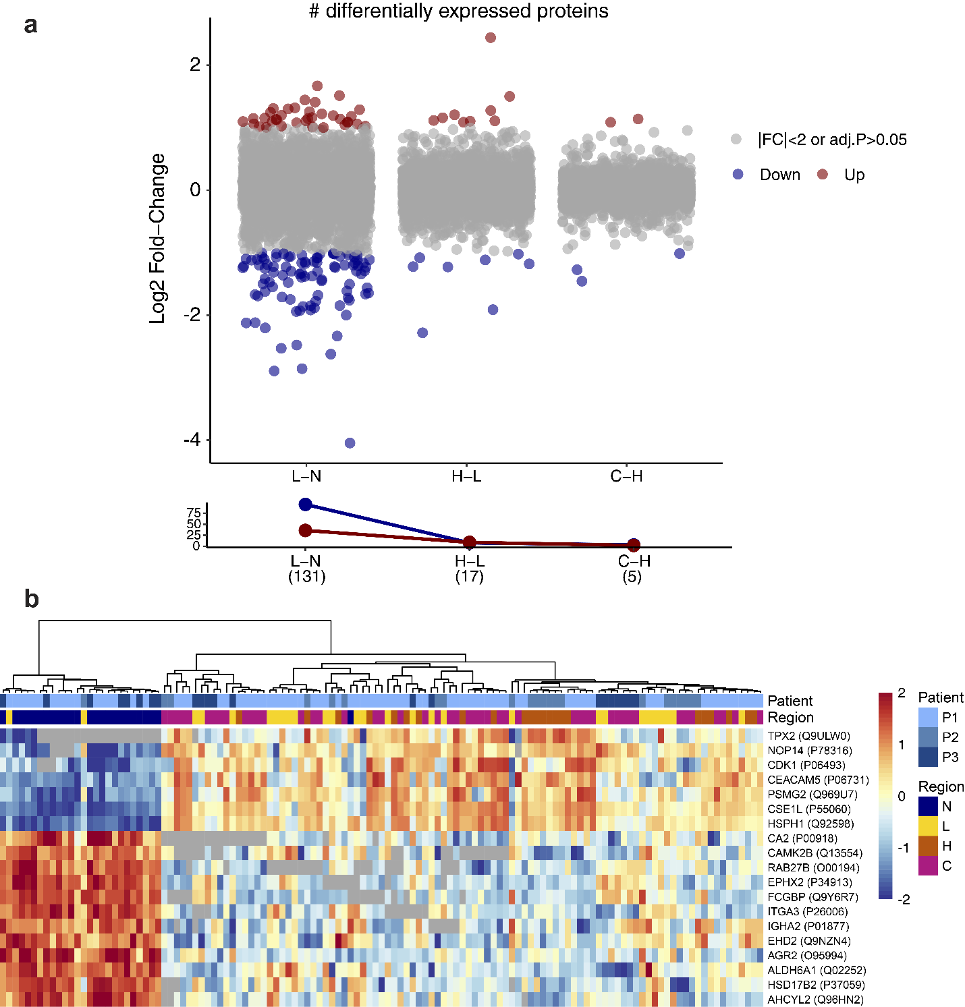
Supplementary Figure 10. Progression analysis of colorectal cancer proteome expression. (a) Differential protein expression analysis showing up-regulated (red) and down-regulated (blue) proteins from comparisons between stages of more malignant compared to less malignant changes (N: Normal, L: Low-grade dysplasia, H: High-grade dysplasia, C: Carcinoma), with the line chart showing the number of differentially expressed proteins (DEPs). Statistical analysis was performed using Welch's t-test (two-sided), with Benjamini-Hochberg (BH) adjustment for multiple comparisons. (b) Heatmap showing the significant DEPs from comparisons between stages of more malignant compared to less malignant changes, color-coded by patient IDs and regions (N: blue, L: yellow, H: orange, C: magenta). Protein abundance is displayed as z-scores. Source data are provided as a Source Data file.
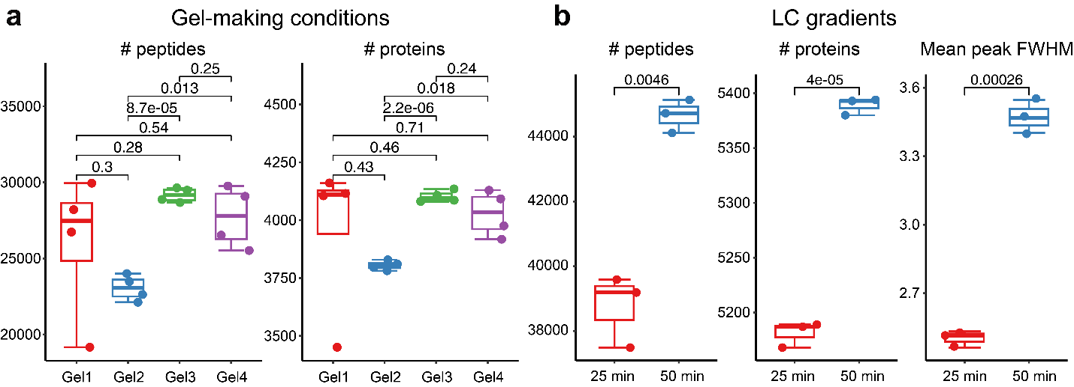
Supplementary Figure 11. Optimization of gel-making conditions and liquid chromatography (LC) gradients. (a) Optimization of four gel preparation conditions (Gel1: red, Gel2: blue, Gel3: green, Gel4: purple) detailed in Supplementary Table 1, including variations in gel compositions, homogenization buffers, and autoclave conditions (n = 4). (b) Liquid chromatography optimization employing effective linear gradients of 25 minutes (red) and 50 minutes (blue) (n = 3), presenting the number of identified peptides and proteins alongside the mean peak full width at half maximum (FWHM). P-values are estimated by Welch’s t-test (two-sided). For all boxplots, center lines show the medians; box limits indicate the 25th and 75th percentiles; whiskers extend to the most extreme data points within 1.5 times the IQR. Data are presented as dots and points beyond whiskers are outliers. Source data are provided as a Source Data file.
Supplementary Table 1. Optimizations of gel-making conditions.
Gel No. | Anchoring time | Hydrogel composition  (SMA:PAE) | SDS concentration in homogenization buffer | Homogenization condition
Gel 1 | 1 h | 71:1 | 20% | 105°C, 1 h  (0.02-0.025 MPa)
Gel 2 | 1 h | 156:1 | 20% | 105°C, 1 h  (0.02-0.025 MPa)
Gel 3 | 1 h | 71:1 | 5.8% | 110°C, 1 h  (0.045 MPa)
Gel 4 | 1 h | 71:1 | 10% | 110°C, 1 h  (0.045 MPa)

Supplementary Table 2. Optimizations of reduction and alkylation steps as well as in-gel proteolytic digestion.
Gel No. | Reduction and alkylation steps | Enzyme digestion
1 | Before embedding (whole gel) | Trypsin 12.5 ng/µL (4 h) +  Trypsin 12.5 ng/µL (overnight)
2 | After homogenization (whole gel) | Trypsin 12.5 ng/µL (4 h) +  Trypsin 12.5 ng/µL (overnight)
3 | During in-gel digestion (single punch) | Trypsin 12.5 ng/µL (4 h) +  Trypsin 12.5 ng/µL (overnight)
3 | During in-gel digestion (single punch) | Lys-C 6.25 ng/µL (4 h) +  Trypsin 12.5 ng/µL (overnight)
3 | During in-gel digestion (single punch) | Trypsin 12.5 ng/µL (3 h)
Note that these optimizations are carried using mouse brain slices under the ProteomEx workflow.

Supplementary Table 3. Sample collection of CRC tissue-hydrogel composites from three patients.
Regions | Normal | Low-grade dysplasia | High-grade dysplasia | Carcinoma
Patient 1 (n=3) | 6 | 5 | 6 | 11
Patient 2 (n=1) | - | 8 | 8 | 8
Patient 3 (n=1) | 8 | 8 | - | 8

Supplementary Table 4. Chemical composition of reagents and buffers for FAXP.
Purpose | Solution name | Solution formula | Storage temperature
Protein anchoring | NSA stock | Dissolve 100 mg of NSA in the anhydrous DMSO to make the final volume at 10 mL. | Store at 4℃
Protein anchoring | Protein anchoring buffer | Mix 25 mL 0.2 M MES stock solution with 25 mL ddH₂O to make the final volume at 50 mL and test if the pH is at 6.0.² | Store at 4℃
Protein anchoring | Protein anchoring solution | 2 μL NSA stock solution with 198 μL protein anchoring buffer. | Freshly prepared
Protein anchoring | Anchoring termination buffer | Mix 2 mL 0.5 M MOPS stock solution with 8 mL ddH₂O to make the final volume at 10 mL and test if the pH is at 7.0. | Store at 4℃
Gelation | PAE stock solution | Dissolve 1.15 g PAE in the tetrahydrofuran (THF) to make the final volume at 10 mL and avoid light. | Store at 4℃
Gelation | Monomer solution stock | 10 mL, pH 6.5;  3.137 g N,N-dimethylacrylamide  (DMAA) (~3 mL);  0.8624 g Sodium methacrylate (SMA);  269.5 μL Pentaerythritol allyl ether (PAE stock solution);  ddH2O 4.380 mL;  10% HCl 350 μL | Store at 4℃
Gelation | APS stock | Dissolve 0.1 g APS in ddH₂O to make the final volume at 1 mL. | Freshly prepared
Gelation | TEMED stock | Dissolve 0.1 g TEMED (about 0.129 mL) in ddH₂O (0.871) to make the final volume at 1 mL. | Store at 4℃
Gelation | Activated monomer solution | 1 mL - pH 6.5;  900 μL Monomer solution stock;  30 μL APS stock;  20 μL TEMED stock;  50 μL ddH₂O | Freshly prepared
Homogenization | Protein denaturation buffer | 200 mL - pH 7.0;  10 mL Tris, 1 M, pH 8;  40 g, SDS;  1.8612 g, EDTA-Na₂·2H₂O;  8 mL, NaCl, 5 M | Store at RT
Reduction and alkylation | 20 mM TCEP solution | Dissolve 0.1433 g TCEP in 1× PBS (pH 7.4) to make the final volume at 25 mL. | Freshly prepared
Reduction and alkylation | 45 mM TCEP solution | Dissolve 0.3225 g TCEP in 1× PBS (pH 7.4) to make the final volume at 25 mL. | Freshly prepared
Reduction and alkylation | 10 mM DTT solution | Dissolve 0.03856 g DTT in 1× PBS (pH 7.4) to make the final volume at 25 mL. | Freshly prepared
Reduction and alkylation | 20 mM DTT solution | Dissolve 0.07712 g DTT in 1× PBS (pH 7.4) to make the final volume at 25 mL. | Freshly prepared
Reduction and alkylation | 55 mM IAA solution | Dissolve 0.25432 g IAA in 1× PBS (pH 7.4) to make the final volume at 25 mL. | Freshly prepared
Reduction and alkylation | 100 mM IAA solution | Dissolve 0.4624 g IAA in 1× PBS (pH 7.4) to make the final volume at 25 mL. | Freshly prepared
Coomassie blue staining | Coomassie Blue solution | Mix R-250 with ddH₂O to a final density of 1 mg/mL. | Store at RT
Enzymatic digestion | 80% ACN | Mix 8 mL ACN with 2 mL ddH₂O to make the final volume at 10 mL. | Store at RT
Enzymatic digestion | 100 mM ABB | Dissolve 79.06 mg ABB in the ddH₂O to make the final volume at 10 mL. | Store at RT
Enzymatic digestion | 50 mM ABB | Mix 1 mL of 100 mM ABB with 1 mL of ddH₂O to make final volume at 2 mL. | Store at RT
Enzymatic digestion | 50% ACN/50% 100 mM ABB | Mix 10 mL of 100 mM ABB with 10 mL of ACN to make final volume at 20 mL. | Store at RT
Enzymatic digestion | 50% ACN/50% ddH₂O | Mix 10 mL of ACN with 10 mL of ddH₂O to make final volume at 20 mL. | Store at RT
Enzymatic digestion | Trypsin stock solution | Add 200 μL of 0.1% HAc (pH = 3) to 100 μg trypsin, aliquot into 50 μL/vial. | Store at -20℃
Enzymatic digestion | Digestion buffer 1 | Mix 0.5 mL of ACN with 4.5 mL of 50 mM ABB to make the final volume at 5 mL. | Freshly prepared
Enzymatic digestion | Digestion buffer 2 | Mix 0.1 mL of 100 mM ABB with 0.9 mL of ddH₂O to make final the volume at 1 mL. | Freshly prepared
Enzymatic digestion | Working solution for in-tip digestion | Add 5 μL trypsin stock solution to 195 μL of digestion buffer 1. Need to test the pH by stripes, which should be around 8-9. | Freshly prepared
Enzymatic digestion | Working solution for in-gel digestion | Add 5 μL trypsin stock solution to 195 μL of digestion buffer 1. Need to test the pH by stripes, which should be around 8-9. | Freshly prepared
Peptide extraction | Solvent buffer A – in-tip digestion | Mix 2 μL ACN with 10 μL Trifluoroacetic acid (TFA) and 9.8 mL ddH₂O to make the final volume at 10 mL. | Store at RT
Peptide extraction | Solvent buffer B – in-tip digestion | Mix 7 mL ACN with 10 μL TFA and 3 mL ddH₂O to make the final volume at 10 mL. | Store at RT
Peptide extraction | Solvent buffer A – in-gel digestion | 25 mM ABB solution; | Store at RT
Peptide extraction | Solvent buffer B – in-gel digestion | 40 mL;  20 mL ACN;  1 mL formic acid (FA);  Add 19 mL ddH₂O to 40 mL; | Store at RT
Peptide extraction | Solvent buffer C – in-gel digestion | 100% ACN; | Store at RT
Desalting | Activation buffer | 100% Methanol; | Store at RT
Desalting | Equilibration buffer A | 10 mL;  8 mL ACN;  10 μL TFA;  Add ddH₂O to 10 mL | Store at RT
Desalting | Equilibration buffer/washing buffer | 10 mL;  0.2 mL ACN;  10 μL TFA;  Add ddH₂O to 10 mL; | Store at RT
Desalting | Elution buffer | 10 mL;  4 mL ACN;  10 μL TFA;  Add ddH₂O to 10 mL; | Store at RT
Loading for MS acquisition | MS buffer | 10 mL;  0.2 mL ACN;  10 μL FA;  Add ddH₂O to 10 mL; | Store at 4℃

Supplementary Table 5. Main chemicals, reagents, consumables, and instruments used for FAXP and their corresponding suppliers and catalog numbers.
 | Name | Supplier | Catalog number
Reagents
H&E staining | Hematoxylin and eosin staining solution | Shanghai Yuanye | R20570-2*100ml
H&E staining | Differentiation solution (acid alcohol; 1%) | Shanghai Yuanye | R20778-500ml
H&E staining | Scott's solution | Shanghai Yuanye | R20596-500ml
H&E staining | Neutral balsam | Macklin | N861409-25ml
Protein anchoring | N-succinimidyl acrylate (NSA) | TCI | S0814
Protein anchoring | DMSO | Sigma-Aldrich | D5879-100ML
Protein anchoring | MOPS, 0.5M, pH 7.0 | Macklin | M885700
Protein anchoring | MES, 0.2M, pH 6.0 | Macklin | M885671
Gelation | Pentaerythritol allyl ether (PAE) | Sigma-Aldrich | 251720-100G
Gelation | Tetrahydrofuran (THF), HPLC | Macklin | T818769-500ml
Gelation | N, N-dimethylacrylamide (DMAA) | Sigma-Aldrich | 274135-500ML
Gelation | Sodium methacrylate (SMA) | Sigma-Aldrich | 408212-50G
Gelation | Ammonium persulfate (APS) | Sigma-Aldrich | A3678
Gelation | N, N,N′, N′-Tetramethylethylenediamine (TEMED, density 0.775 g/mL) | Sigma-Aldrich | T7024
Homogenization | Sodium dodecyl sulfate (SDS) | Macklin | S817790-500g
Homogenization | EDTA-Na₂·2H₂O | Sigma-Aldrich | E4884-100g
Homogenization | Tris base | Sigma-Aldrich | T6791-500G
Homogenization | NaCl | Sigma-Aldrich | S9888-500G
Reduction and alkylation | Tris(2-carboxyethyl)phosphine (TCEP) | Adamas Reagent | 61820E
Reduction and alkylation | Dithiothreitol (DTT) | Thermo Fisher | R0861
Reduction and alkylation | Iodoacetamide (IAA) | Sigma-Aldrich | I6125-25G
Staining | Brilliant blue R-250 | BBI | A610037-025
Staining | ASGR1 polyclonal antibody | Proteintech | 11739-1-AP-50UL
Staining | Goat anti-rabbit IgG H&L (Alexa Fluor® 555) preadsorbed | Abcam | ab150086-500ug
Enzymatic digestion and peptide elution | Formic acid (FA) | Thermo Fisher | A117-50
Enzymatic digestion and peptide elution | Methanol | General-reagent | G75851B
Enzymatic digestion and peptide elution | Lys-C | Hualishi | HLS LYS001C-50μg
Enzymatic digestion and peptide elution | Trypsin | Hualishi | HLS TRY001C-100μg
Enzymatic digestion and peptide elution | Ammonium bicarbonate (ABB) | Sigma-Aldrich | A6141-1kg
Enzymatic digestion and peptide elution | Acetonitrile (ACN) | General-reagent | G80988B
Enzymatic digestion and peptide elution | Acetonitrile (ACN) | Thermo Fisher | A955-4
Enzymatic digestion and peptide elution | MS grade water | Thermo Fisher | W6-4
Enzymatic digestion and peptide elution | Trifluoroacetic acid (TFA) | Adamas Reagent | 81548K
Enzymatic digestion and peptide elution | n-Dodecyl β-D-maltoside (DDM) | Aladdin | N475300-250mg
Consumables
 | 200 μm in thickness × 1.5 mm in diameter glass chamber | Customized
 | Single Specimen | No. 1.5 Coverslip | 98mm X 67mm Viewing Area | Uncoated | MatTek | P384G-1.5-10872-C
 | 6 cm diameter petri dish | NEST | 705001
 | 9 cm diameter petri dish | NEST | 752004
 | 1.5 ml EP tube | Axygen | MCT-150-C
 | Empore C18 47mm Extraction Disks | 3M | 66883-U
 | Low protein binding tubes, 1.5 mL | Thermo Fisher | 90410
 | QSP standard tips | Thermo Fisher | TLR102-Q

Instruments
 | Nikon CSU-W1 SoRa confocal microscope | Nikon | CSU-W1 SoRa
 | Fluorescence Stereo Zoom Microscope | ZEISS | Axio Zoom.V16
 | Vacuum drying oven | Shanghai YiHeng | DZF-6032
 | Autoclave | TOMY | SX-700

Supplementary Table 6. MS settings for diaPASEF.
ExpType | Repetitions | KA | m1 | m2 | CEA | KB | m3 | m4 | CEB | Steps
MS1 | 1 | - | - | - | - | - | - | - | - | -
PASEF | 1 | 0.703 | 384 | 412 | -1 | 1.119 | 909 | -1 | -1 | 4
PASEF | 1 | 0.717 | 409 | 437 | -1 | 1.133 | 934 | -1 | -1 | 4
PASEF | 1 | 0.731 | 434 | 462 | -1 | 1.147 | 959 | -1 | -1 | 4
PASEF | 1 | 0.745 | 459 | 487 | -1 | 1.161 | 984 | -1 | -1 | 4
PASEF | 1 | 0.759 | 484 | 512 | -1 | 1.175 | 1009 | -1 | -1 | 4
PASEF | 1 | 0.774 | 509 | 537 | -1 | 1.189 | 1034 | -1 | -1 | 4
PASEF | 1 | 0.788 | 534 | 562 | -1 | 1.203 | 1059 | -1 | -1 | 4
PASEF | 1 | 0.797 | 384 | 412 | -1 | 1.213 | 909 | -1 | -1 | 4
PASEF | 1 | 0.811 | 409 | 437 | -1 | 1.227 | 934 | -1 | -1 | 4
PASEF | 1 | 0.825 | 434 | 462 | -1 | 1.241 | 959 | -1 | -1 | 4
PASEF | 1 | 0.839 | 459 | 487 | -1 | 1.255 | 984 | -1 | -1 | 4
PASEF | 1 | 0.853 | 484 | 512 | -1 | 1.269 | 1009 | -1 | -1 | 4
PASEF | 1 | 0.867 | 509 | 537 | -1 | 1.283 | 1034 | -1 | -1 | 4
PASEF | 1 | 0.881 | 534 | 562 | -1 | 1.297 | 1059 | -1 | -1 | 4

Supplementary Note 1. Critical steps and troubleshooting in FAXP and MS procedures.
- Tissue expansion
- For tissue-hydrogel composite break after expansion, ensure that the reagents and protocols are consistent. If issues persist, consider the sample quality. For instance, liver tissue from mice may not expand properly if the tissue is not fresh or has undergone excessive dehydration. The solution is to harvest liver tissue from mice with normal liver morphology and strictly control the fixation and dehydration times. Once paraffin embedding conditions are stabilized, the tissue should expand without fracturing.
- For tissue-hydrogel anchor and pre-gelation: During incubation, place tissue samples in a humidified chamber to prevent drying out.
- Anchor termination buffer wash: Monitor the sample for any detachment from the slide. If detachment occurs, flatten the sample or consider re-incubating with a fresh sample.
- Monomer solution incubation: Ensure tissue sections are completely air-dried in a fume hood before adding the monomer solution.
- Post-incubation handling: After incubating at 4°C overnight, transfer to an anaerobic environment. Cover the tissue sections with a coverslip and secure the sandwich structure with clamps.
- Homogenization buffer incubation: Before moving to autoclave or oven, remove the coverslip, place the sample face up, and add homogenization buffer so that the liquid level is at least 0.5 cm above the sample.
- Post-homogenization handling: If the sample does not detach from the glass slide after homogenization, incubate in 1× PBS at 37°C for 30 minutes to facilitate detachment.
- Staining
- Be mindful of the denaturation temperature for nuclear staining, as excessive heat can cause DNA fragmentation. Additionally, using the buffer recommended by the manufacturer is critical for obtaining reliable results.
- Hydrogel drying onto LCM membrane
- To address shrinkage, treat the LCM membrane with poly-L-lysine to ensure tight adherence of the hydrogel. If water evaporates too quickly, it can cause deformation before the gel adheres to the membrane. Adding salt can slow down evaporation, and controlling the temperature can help manage evaporation rates.
- Optimization of LCM cutting conditions
- Consistently cutting expanded hydrogel samples using the LCM can be challenging due to environmental factors. If desired cuts are not achieved, adjust the laser power and speed, with optimal results typically at a speed parameter around 10 (parameter in Leica LMD 7). If reproducibility issues arise on subsequent days, high humidity may be causing the hydrogel to reabsorb water and slightly expand, affecting precision. To address this, store samples with fresh desiccants to maintain a dry environment, which is critical for consistent cutting.
- Sample preparation for MS:
- Assembly of FAXP Tip and Rehydration During Enzymatic Digestion: Ensure the membrane is securely attached to the end of the FAXP tips and that samples are kept hydrated throughout the enzymatic digestion process to prevent drying.
- Desalting is unnecessary for the FAXP workflow, particularly for minute samples. This approach simplifies the process and maximizes peptide yield.
- n-Dodecyl β-D-maltoside (DDM) for Enhanced Enzymatic Performance: Using DDM improves enzymatic performance and peptide recovery, resulting in more effective digestion and higher peptide yield.
- MS acquisition:
- Data-independent acquisition (DIA) is ideal due to its broad and quantitative coverage. Establishing a library based on experimental needs is preferable, but if that is not possible, library-free mode is also a viable alternative.
Supplementary References
1 Li, L. et al. Spatially resolved proteomics via tissue expansion. Nature Communications 13, 7242 (2022). https://doi.org/10.1038/s41467-022-34824-2
2 Tillberg, P. W. et al. Protein-retention expansion microscopy of cells and tissues labeled using standard fluorescent proteins and antibodies. Nature Biotechnology 34, 987-+ (2016). https://doi.org/10.1038/nbt.3625

