Supplementary Materials for

Metabolomic and genomic prediction of common diseases in 700,217 participants in three national biobanks

Nightingale Health Biobank Collaborative Group

Corresponding author: jeffrey.barrett@nightingalehealth.com

The PDF file includes:

Figs. S1 to S18

Other Supplementary Materials for this manuscript include the following:

Supplementary Data 1-10

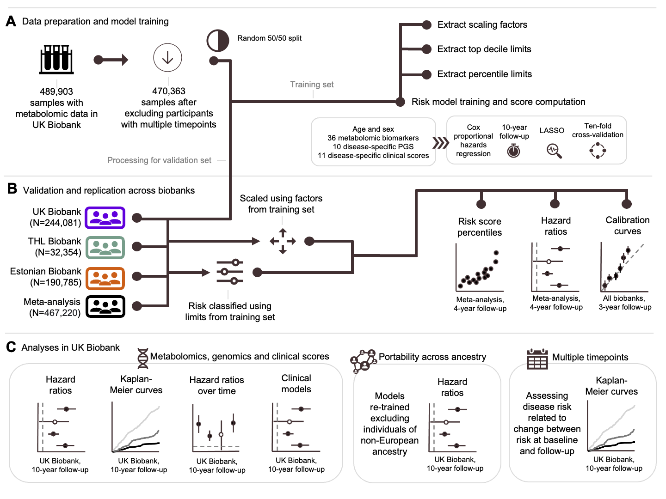
Fig. S1. Study design. (A) The data and analyses used to build our metabolomic risk scores in half of the UK Biobank. (B) The data and analyses used to validate, replicate, and calibrate our metabolomic risk scores. (C) The data and analyses used for detailed investigations in UK Biobank.

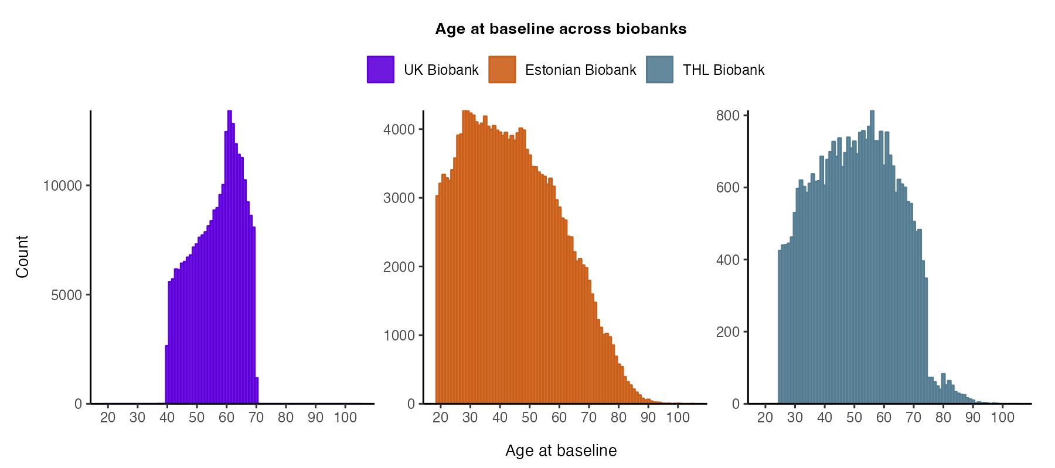
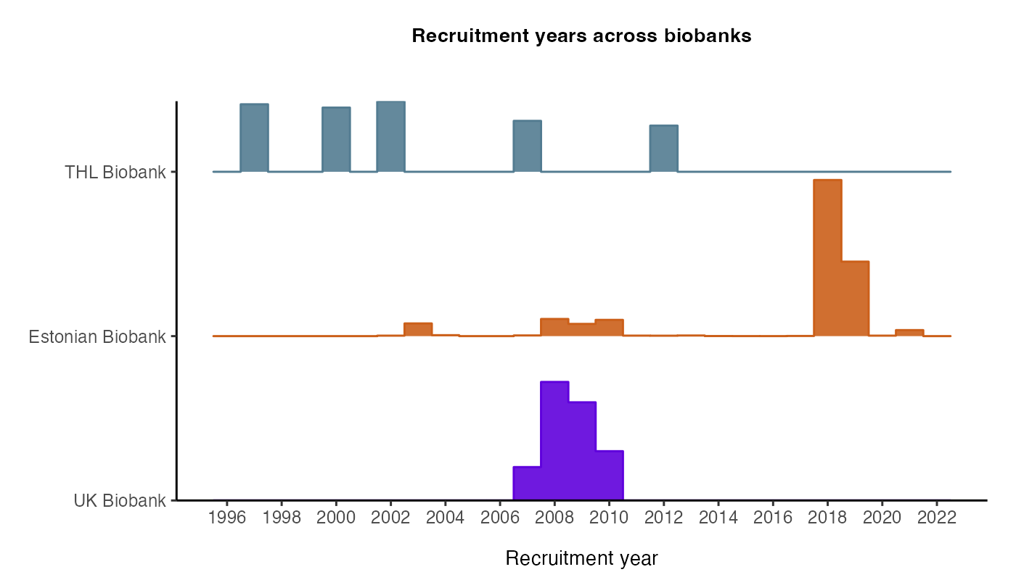

Fig. S2. Age and recruitment in the three biobanks. Note the recent recruitment of a large fraction of Estonian Biobank dictates the maximum follow-up for meta-analysis.

Fig. S3. Coefficients in 12 metabolomic scores. Each column is a disease score, and each row is the coefficient for that feature. Empty cells mean the feature was not selected.

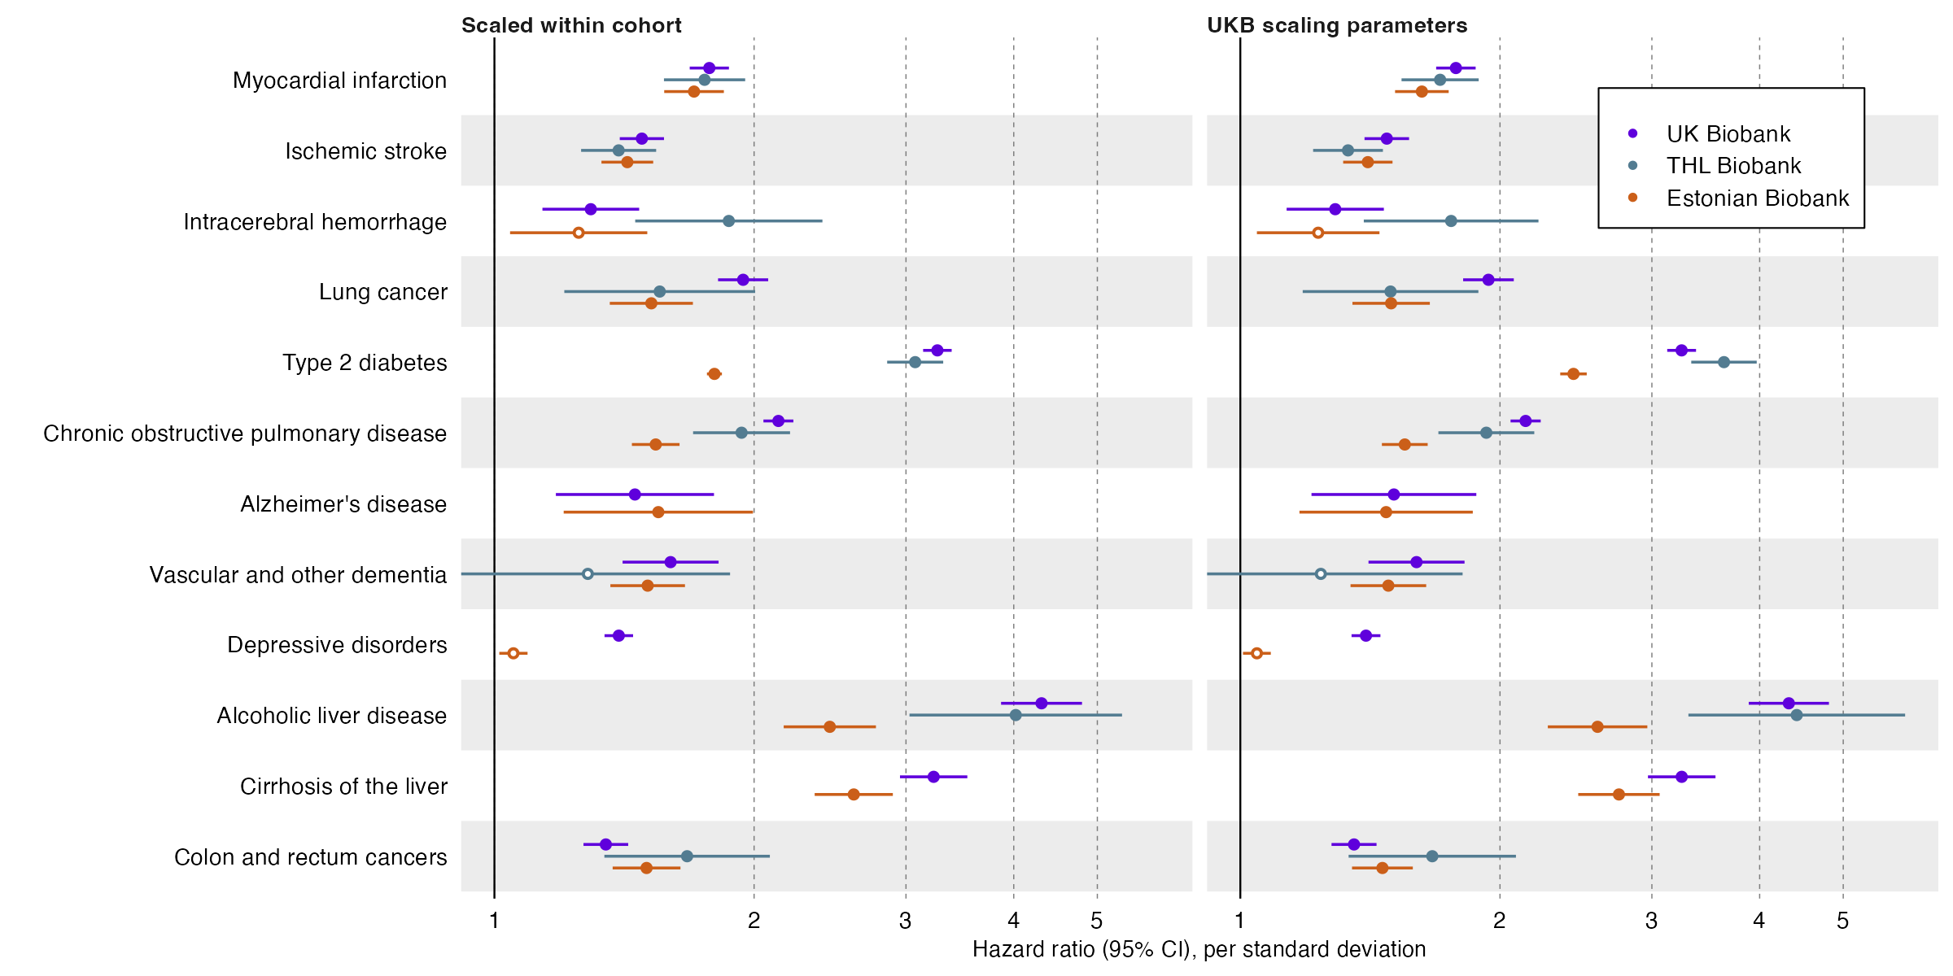

Fig. S4. Performance of metabolomic scores when scaling within cohort or using scaling parameters from UK Biobank training data. Hazard ratios are estimated over 4 years of follow-up. Horizontal error bars denote 95% confidence intervals. Closed circles denote p-value < 0.05/12 and open circles p-value >0.05/12.

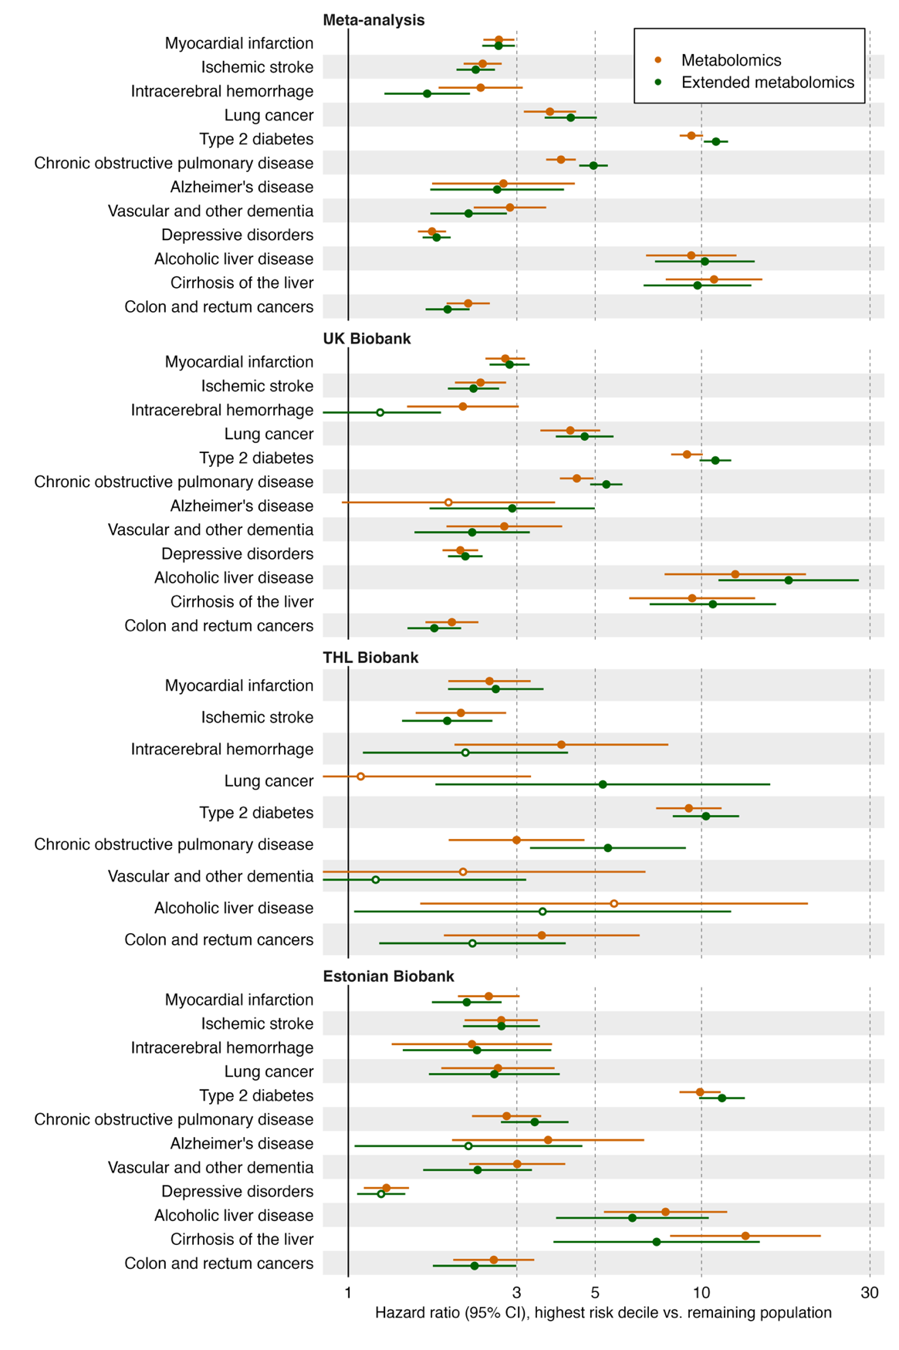

Fig. S5. Comparison of scores using 36 validated vs 249 extended biomarkers. HR are estimated over 4 years of follow-up. Horizontal error bars denote 95% confidence intervals. Closed estimate circles denote p-value <0.05/12 and open circles p-value >0.05/12.

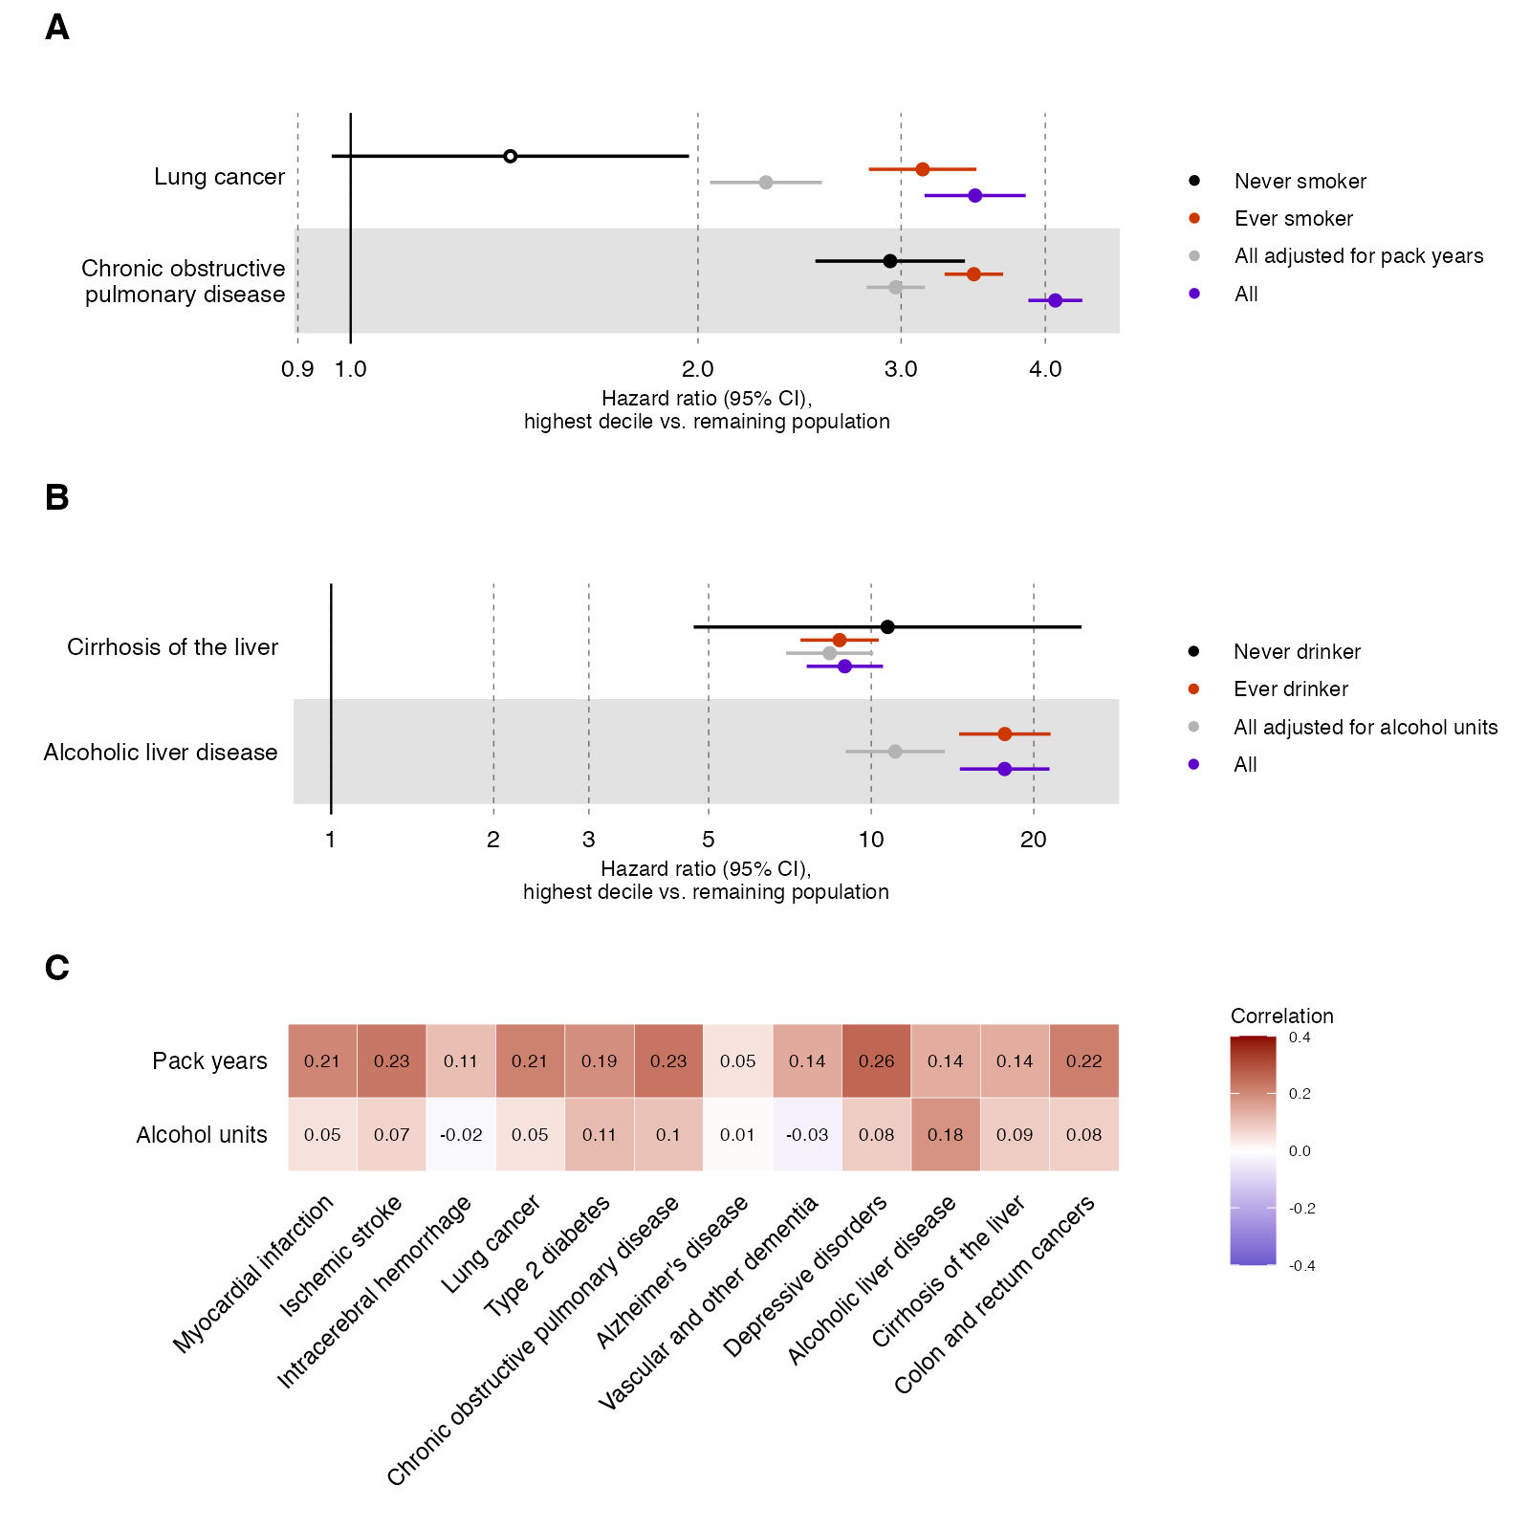

Fig. S6. Relationship between the lung cancer and COPD scores and smoking, and the liver scores and alcohol use. (A) Comparison of HR between ever and never smokers, and adjusted for pack years of smoking. HR are estimated over 10 years of follow-up. Horizontal error bars denote 95% confidence intervals. Closed estimate circles denote p-value <0.05/12 and open circles p-value >0.05/12. (B) Comparison of HR between ever and never drinkers, and adjusted for daily alcohol units. (C) Correlations between all metabolomic disease scores, pack years and alcohol units.

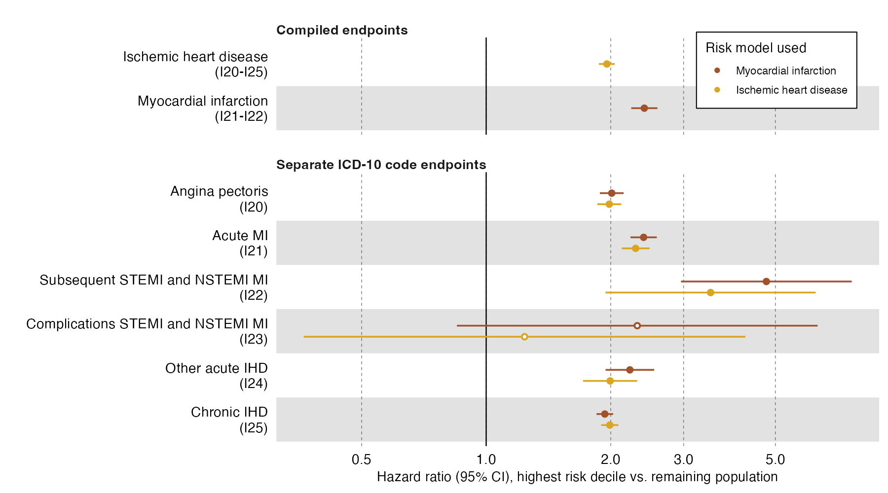

Fig S7. Performance of myocardial infarction and ischemic heart disease scores across ICD-10 codes. Testing scores against joint disease endpoints of myocardial infarction (ICD-10 codes I21-I22) and ischemic heart disease (ICD-10 codes I20-I25), as well as the individual ICD-10 codes. HR are estimated over 10 years of follow-up. Horizontal error bars denote 95% confidence intervals. Closed circles denote p-value <0.05/12 and open circles p-value >0.05/12.

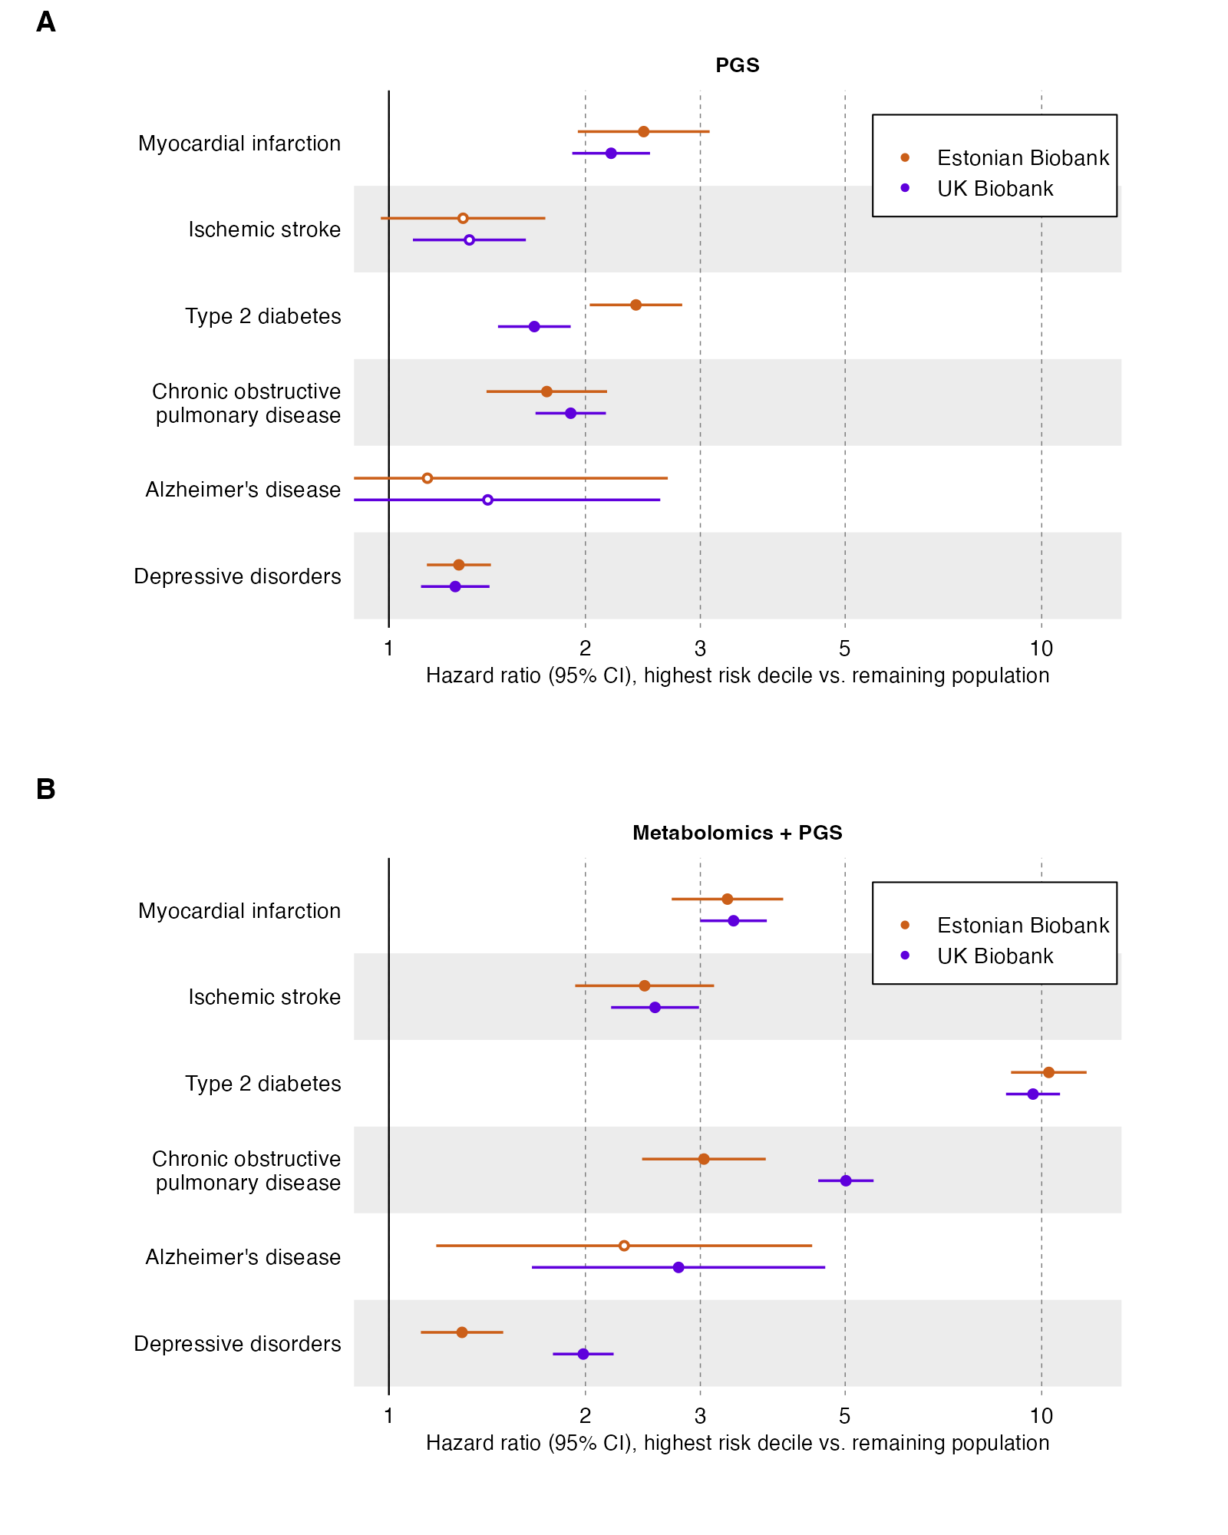

Fig. S8. Performance of PGS in Estonian Biobank and UK Biobank with 4 years of follow-up. Horizontal error bars denote 95% confidence intervals. Closed estimate circles denote p-value < 0.05/12 and open circles p-value >0.05/12.

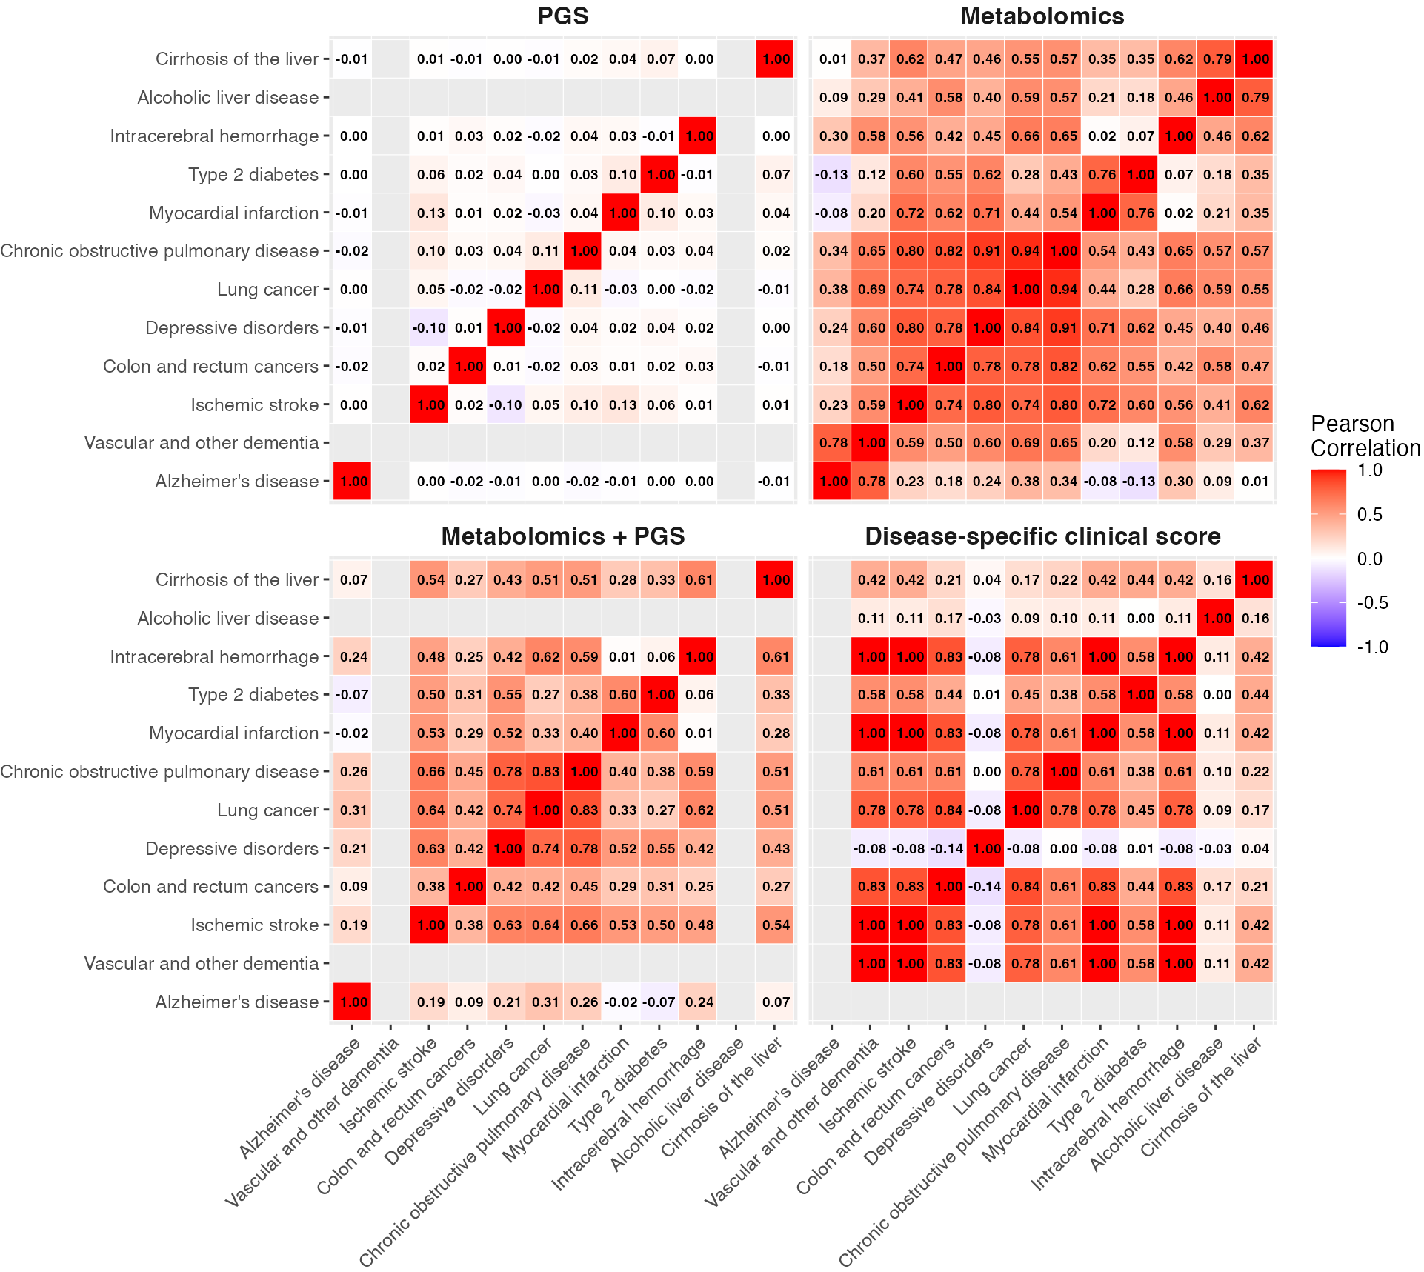

Fig. S9. Correlations of risk scores between diseases. Metabolomics matrix is clustered using unweighted pair group method with arithmetic mean. PGS, Metabolomics + PGS and disease-specific clinical score matrices are shown in the same order as Metabolomics matrix. PGS for alcoholic liver disease and vascular dementia, and a clinical score for Alzheimer’s disease are missing.

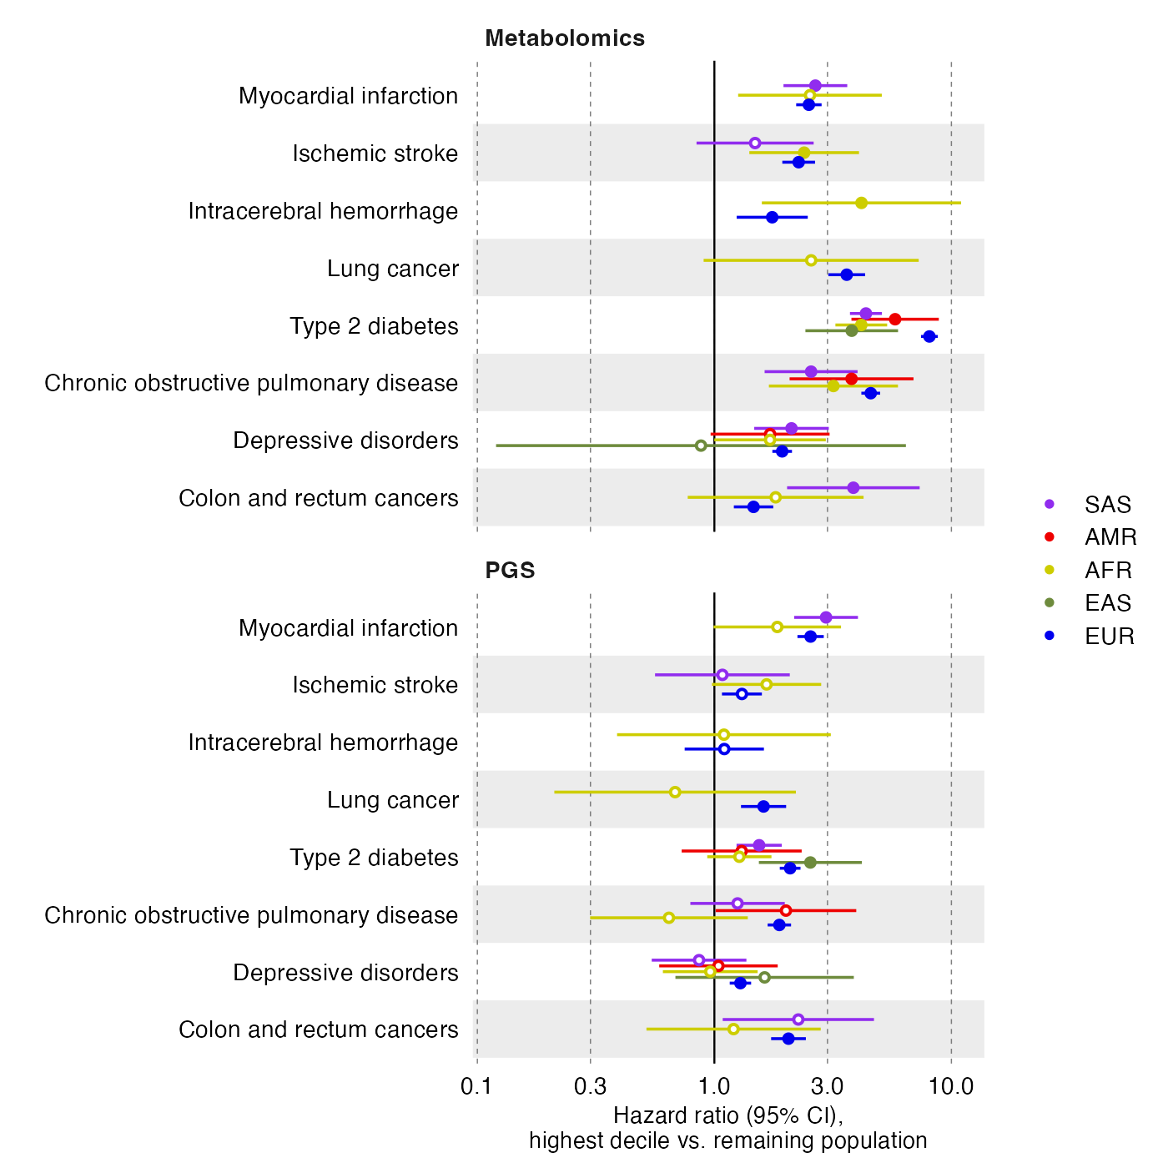

Fig. S10. Performance of metabolomic score and PGS across ancestries. HR are estimated over 10 years of follow-up. Horizontal error bars denote 95% confidence intervals. Closed estimate circles denote p-value <0.05/12 and open circles p-value >0.05/12. AFR = African, AMR = Admixed American, EAS = East Asian, EUR = European, and SAS = South Asian ancestry.

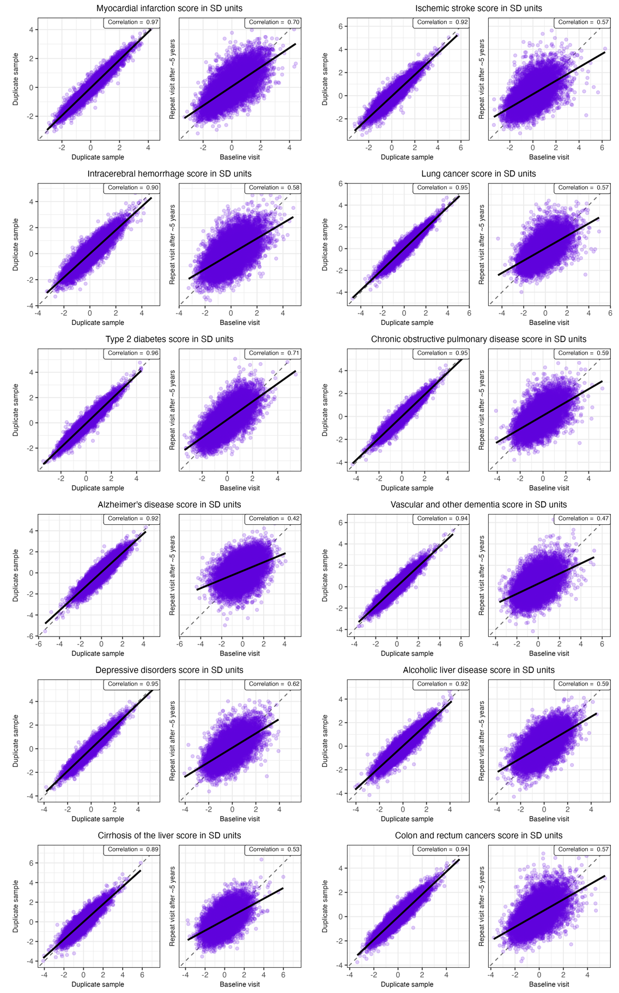

Fig. S11. Correlations of metabolomic scores between duplicate measurements, and baseline and repeat visit after five years. Black solid line denotes linear regression line. Dashed line denotes the diagonal.

Fig. S12. Performance of clinical and multi-omics scores over 4 years of follow-up. Hazard ratios of a simple model with clinical variables compared to those variables plus the best ‘omic data (either just metabolomics or metabolomics plus PGS from Figure 2). Vertical lines represent 95% confidence intervals. Closed estimate circles denote p-value <0.05/12 and open circles p-value >0.05/12.

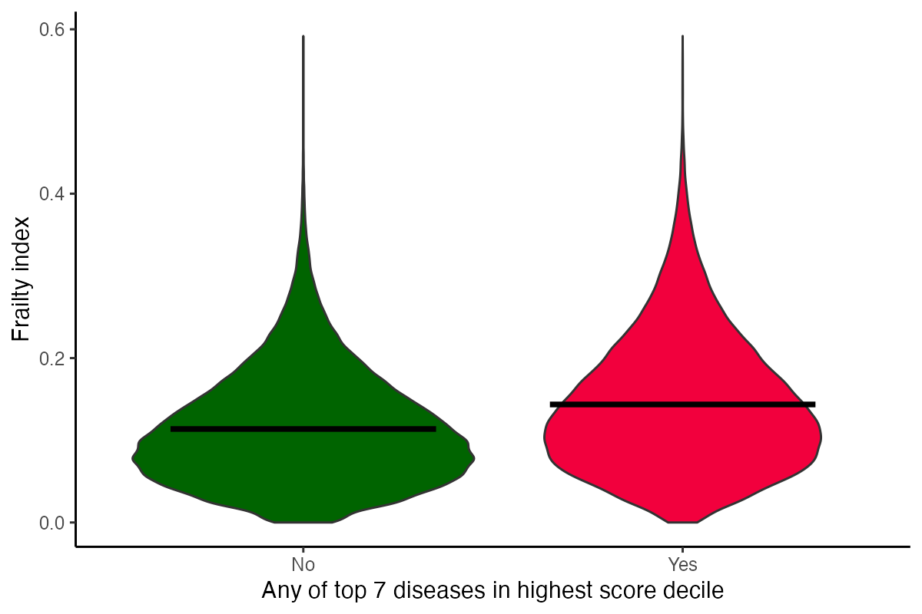

Fig. S13. Distributions of frailty index between individuals with low and high metabolomic risk. Horizontal lined denote mean frailty indices.

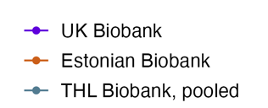
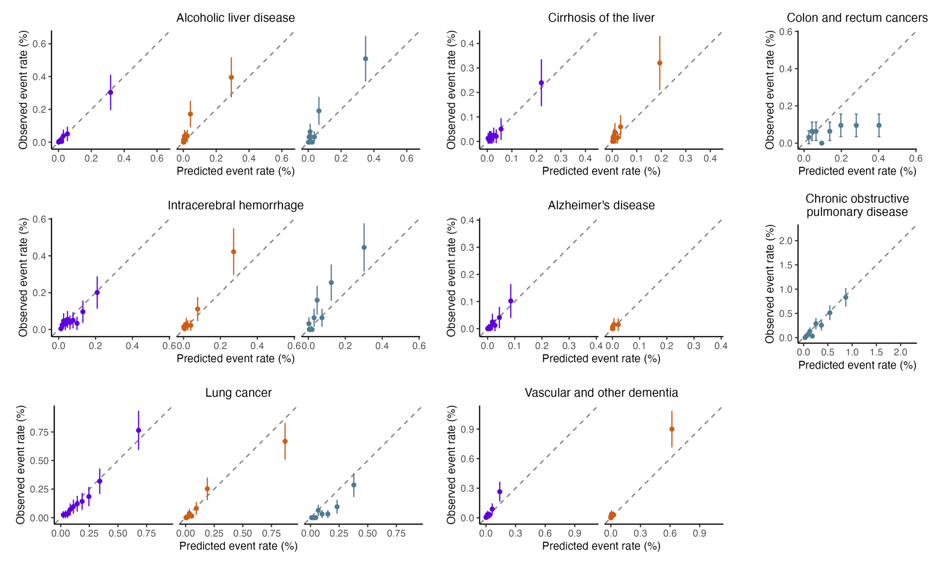

Fig. S14. Model calibration for diseases and cohorts where number of events < 200. For each disease outcome, the calibration of three-year observed event rates are shown by 10 equally sized deciles of absolute predicted risk. Vertical lines represent 95% confidence intervals.

Fig. S15. Performance of the scores within testing set (+) and individuals excluded from the analysis (circles) due to extreme biomarker values. HR are estimated over 10 years of follow-up. Horizontal error bars denote 95% confidence intervals.

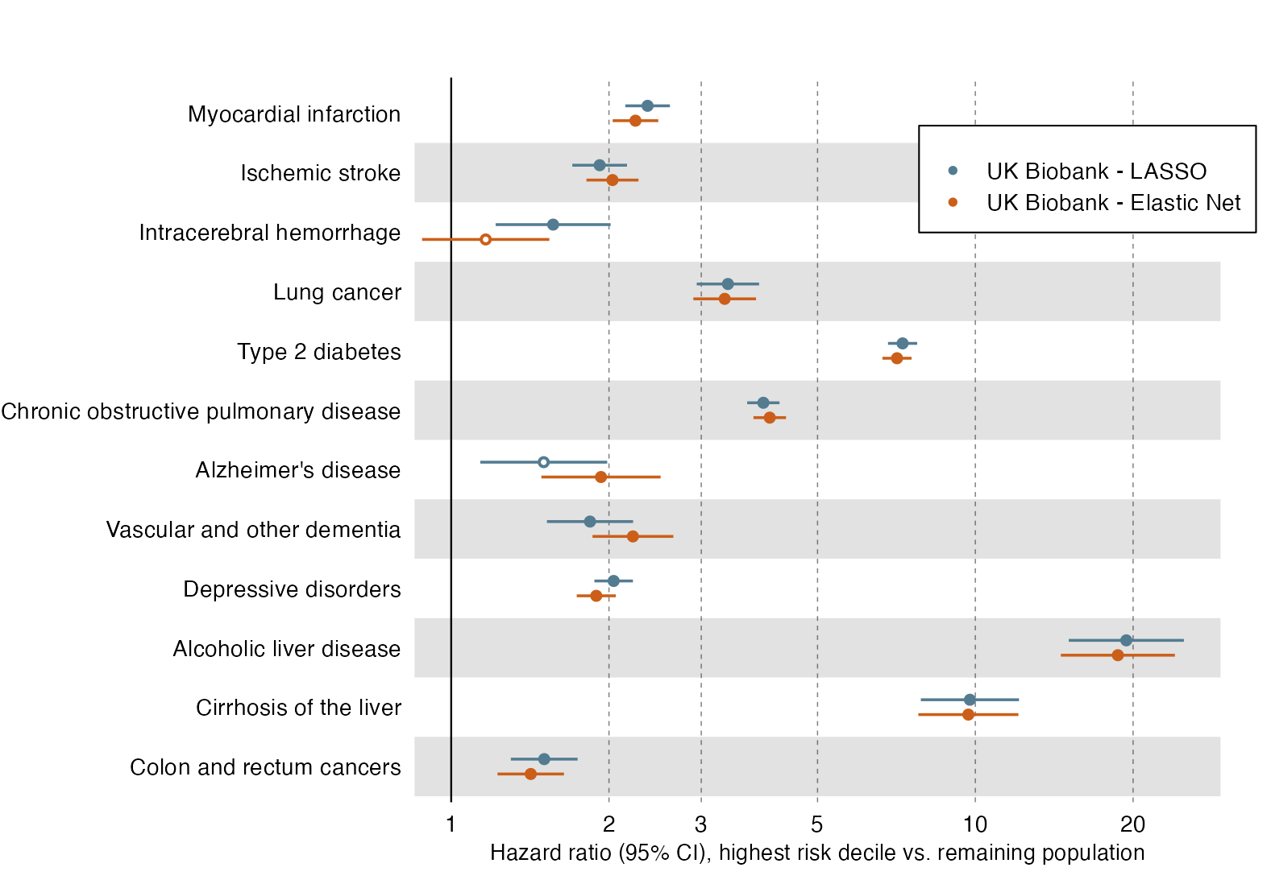
Fig. S16. Performance of metabolomic scores trained using LASSO and Elastic Net. HR are estimated over 10 years of follow-up. Models were trained and tested in about half of the available UK Biobank data. Horizontal error bars denote 95% confidence intervals. Closed estimate circles denote p-value <0.05/12.

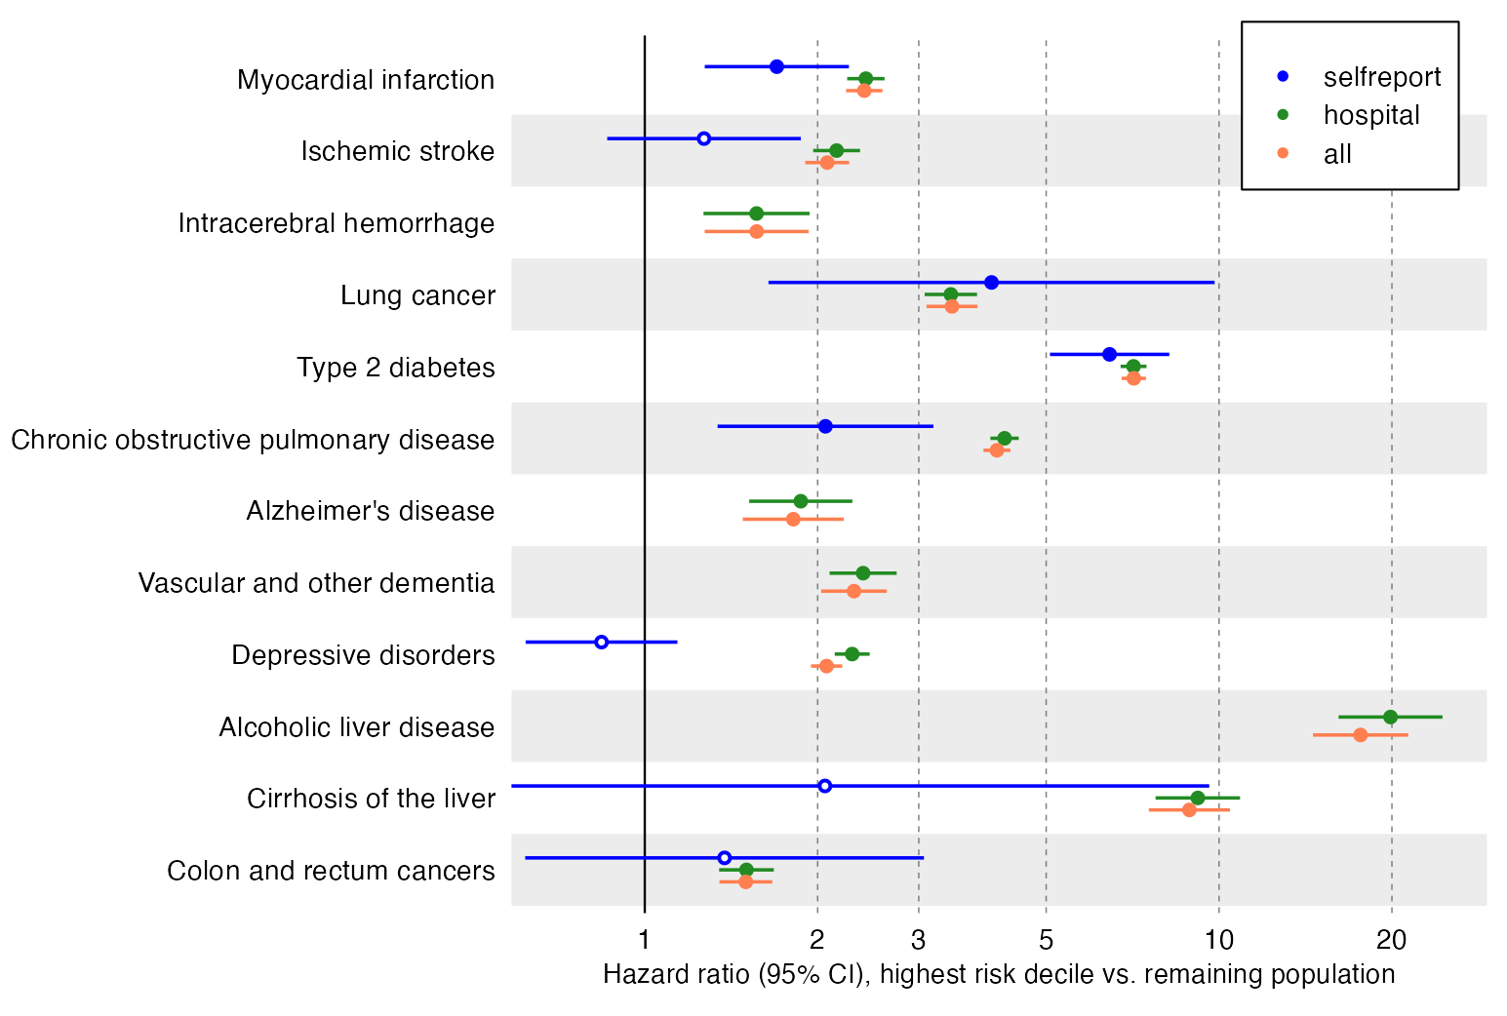Fig. S17. Performance of metabolomic scores predicting different sources of incident disease diagnoses in UK Biobank. HR are estimated over 10 years of follow-up. Horizontal error bars denote 95% confidence intervals. Closed estimate circles denote p-value <0.05/12 and open circles p-value >0.05/12.

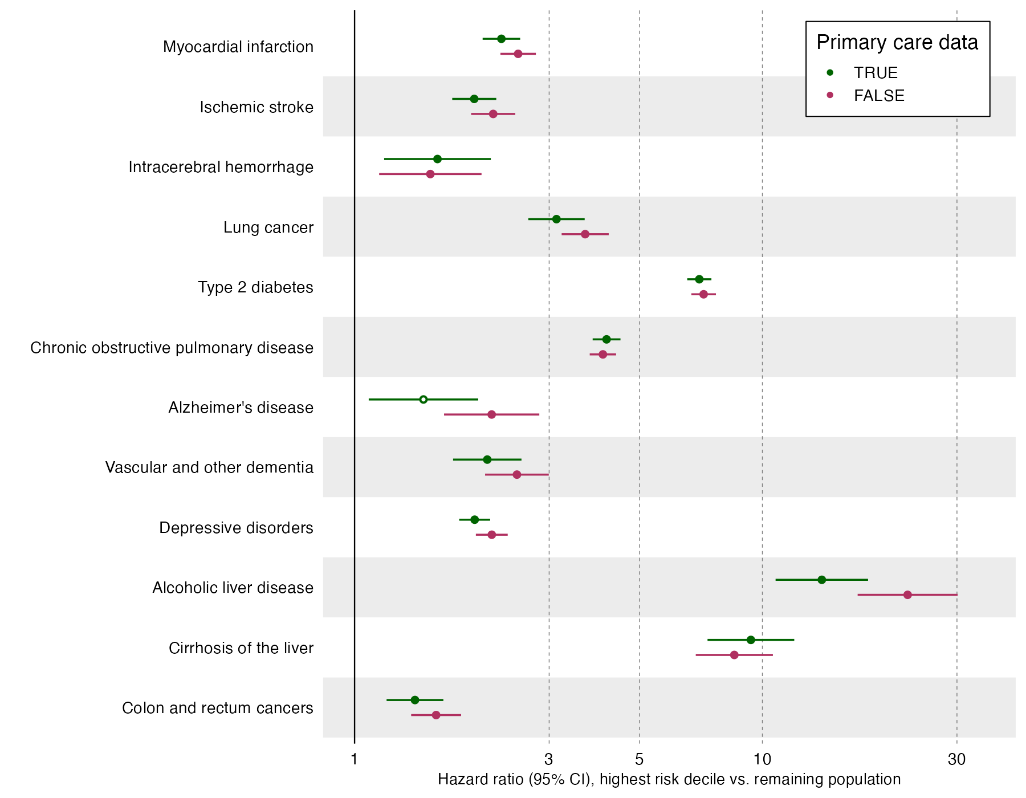

Fig. S18. Performance of metabolomic scores predicting individuals with and without primary care data available in UK Biobank. HR are estimated over 10 years of follow-up. Horizontal error bars denote 95% confidence intervals. Closed estimate circles denote p-value <0.05/12 and open circles p-value >0.05/12.

 | FINRISK 1997 | HEALTH 2000 | FINRISK 2002 | FINRISK 2007 | FINRISK 2012
Number of participants | 7282 | 6924 | 7636 | 5516 | 4996
Age at blood sample (median, [IQR]) | 48.0 [38.0-59.0] | 53.0 [42.0-65.0] | 48.0 [37.0-58.0] | 52.0 [40.0-63.0] | 53.0 [40.0-64.0]
Females (%) | 50.6 | 55.1 | 55.3 | 53.0 | 51.9
Body mass index  (kg/m^2, median, [IQR]) | 26.0 [23.5-28.9] | 26.4 [23.7-29.5] | 26.2 [23.5-29.3] | 26.4 [23.7-29.6] | 26.3 [23.7-29.7]
Smoking prevalence (current, %) | 34.6 | 39.0 | 37.5 | 31.0 | 28.9
Cholesterol lowering medication (%) | 4.7 | 7.5 | 9.3 | 16.7 | 18.7
Follow-up time  (median, [IQR]) | 18.8 [18.8-18.9] | 15.1 [14.9-15.2] | 13.8 [13.8-13.9] | 8.9 [8.8-8.9] | 3.8 [3.8-3.9]
Recruitment period | 1997 | 2000 | 2002 | 2007 | 2012

Table S1. Epidemiological characteristics of THL Biobank cohorts.

Metabolomic score | UK Biobank, test (%) | THL Biobank (%) | Estonian Biobank (%)
Myocardial infarction | 9.9 | 10.5 | 8.2
Ischemic stroke | 9.9 | 14.2 | 4.0
Intracerebral hemorrhage | 9.9 | 9.6 | 8.0
Lung cancer | 9.7 | 17.4 | 7.2
Type 2 diabetes | 10.0 | 6.1 | 7.7
Chronic obstructive pulmonary disease | 9.7 | 9.3 | 4.5
Alzheimer's disease | 9.8 | - | 11.8
Vascular and other dementia | 9.9 | 17.8 | 8.8
Depressive disorders | 9.7 | - | 5.9
Alcoholic liver disease | 10.0 | 13.2 | 12.1
Cirrhosis of the liver | 9.9 | 11.2 | 7.3
Colon and rectum cancers | 10.0 | 11.3 | 7.7

Table S4. Prevalence of individuals at high metabolomic risk in biobanks. Threshold for belonging into high-risk group was defined as the top decile of the metabolomic score in the training set of UK Biobank. Alzheimer’s disease and Depressive disorders in THL were not considered due to the lack of endpoint data.

Disease | HR per SD | 95% CI | P-value | N | N cases
Myocardial infarction | 1.00 | (0.97, 1.03) | 8.9e-01 | 254,969 | 4,627
Ischemic stroke | 1.02 | (0.98, 1.05) | 3.5e-01 | 257,347 | 3,413
Intracerebral hemorrhage | 0.99 | (0.93, 1.07) | 8.8e-01 | 260,768 | 914
Lung cancer | 1.01 | (0.97, 1.05) | 6.3e-01 | 260,874 | 2,212
Type 2 diabetes | 0.93 | (0.92, 0.95) | 0.0e+00 | 247,465 | 8,216
Chronic obstructive pulmonary disease | 1.01 | (0.98, 1.03) | 5.6e-01 | 256,123 | 7,114
Alzheimer's disease | 0.99 | (0.92, 1.06) | 7.5e-01 | 261,126 | 934
Depressive disorders | 0.98 | (0.96, 1.00) | 8.0e-02 | 239,107 | 7,878
Cirrhosis of the liver | 1.01 | (0.96, 1.07) | 6.7e-01 | 260,762 | 748
Colon and rectum cancers | 0.97 | (0.94, 1.01) | 1.2e-01 | 259,642 | 2,981

Table S6. Estimates for interaction between metabolomic and polygenic scores. Estimates are shown for interaction term `metabolic score * PGS`. HR = Hazard Ratio. SD = Standard deviation, CI = Confidence interval, N = Total number of samples, N cases = Number of cases within samples.

Biomarker | Correlation |  | Biomarker | Correlation
Alanine | 0.25 |  | Histidine | 0.35
Albumin | 0.30 |  | Isoleucine | 0.20
ApoA1 | 0.67 |  | Leucine | 0.28
ApoB | 0.61 |  | MUFA | 0.56
ApoB/ApoA1 | 0.67 |  | MUFA % | 0.67
Clinical LDL-C | 0.58 |  | Phenylalanine | 0.35
Creatinine | 0.66 |  | PUFA | 0.58
DHA | 0.59 |  | PUFA % | 0.61
DHA % | 0.56 |  | PUFA/MUFA | 0.65
Omega-3 | 0.62 |  | SFA | 0.52
Omega-3 % | 0.60 |  | SFA % | 0.47
Omega-6 | 0.56 |  | Total BCAA | 0.30
Omega-6 % | 0.62 |  | Total-C | 0.60
Omega-6/Omega-3 | 0.62 |  | Total triglycerides | 0.61
Glucose-Lactate | 0.39 |  | Total fatty acids | 0.55
Glycine | 0.67 |  | Tyrosine | 0.32
Glycoprotein acetyls | 0.54 |  | Valine | 0.35
HDL-C | 0.77 |  | VLDL-C | 0.61

Table S7. Individual biomarker correlations between baseline and repeat visits 5 years apart. Includes the 36 validated biomarkers that were also used in model training.

 | Cohort | Low risk group mean (SD) or N [%] | High risk group mean (SD) or N [%] | Difference in mean (95% CI) or OR [95% CI] | P-value
Frailty index | UKB | 0.11 (0.07) | 0.14 (0.08) | 0.03 (0.03 - 0.03) | < 2.2e-16
Current smoking | Meta-analysis |  |  | 1.85 (1.81 - 1.88) | < 2.2e-16
Current smoking | UKB | 13131 [7.82] | 11543 [16.42] | 2.32 [2.25 - 2.38] | < 2.2e-16
Current smoking | THL | 3249 [29.61] | 2748 [43.13] | 1.8 [1.69 - 1.92] | 1.1e-72
Current smoking | EBB | 15854 [16.26] | 7184 [23.29] | 1.56 [1.52 - 1.61] | 6.9e-173
BMI (kg/m2) | Meta-analysis |  |  | 2.26 (2.23 - 2.3) | < 2.2e-16
BMI (kg/m2) | UKB | 26.59 (4.11) | 29.16 (5.58) | 2.57 (2.53 - 2.62) | < 2.2e-16
BMI (kg/m2) | THL | 26.28 (4.1) | 27.97 (5.38) | 1.7 (1.58 - 1.81) | 1.7e-181
BMI (kg/m2) | EBB | 25.38 (4.58) | 27.22 (6.03) | 1.83 (1.77 - 1.90) | < 2.2e-16
Systolic blood pressure (mmHg) | Meta-analysis |  |  | 4.59 (4.43 - 4.75) | < 2.2e-16
Systolic blood pressure (mmHg) | UKB | 136.44 (18.34) | 141.02 (18.83) | 4.58 (4.41 - 4.75) | < 2.2e-16
Systolic blood pressure (mmHg) | THL | 135.06 (19.86) | 139.78 (21.68) | 4.73 (4.24 - 5.21) | 1.3e-80
Total cholesterol (mmol/l) | Meta-analysis |  |  | -0.04 (-0.05 - -0.03) | 1.9e-14
Total cholesterol (mmol/l) | UKB | 5.72 (1.06) | 5.65 (1.28) | -0.07 (-0.08 - -0.06) | 1e-34
Total cholesterol (mmol/l) | THL | 5.5 (0.99) | 5.62 (1.21) | 0.13 (0.1 - 0.15) | 2.4e-21
HDL cholesterol (mmol/l) | Meta-analysis |  |  | -0.13 (-0.14 - -0.13) | < 2.2e-16
HDL cholesterol (mmol/l) | UKB | 1.5 (0.35) | 1.35 (0.43) | -0.14 (-0.15 - -0.14) | < 2.2e-16
HDL cholesterol (mmol/l) | THL | 1.46 (0.35) | 1.39 (0.44) | -0.08 (-0.08 - -0.07) | 8.9e-55
Waist circumference (cm) | Meta-analysis |  |  | 6.6 (6.49 - 6.7) | < 2.2e-16
Waist circumference (cm) | UKB | 88.02 (12.2) | 94.93 (14.7) | 6.91 (6.79 - 7.04) | < 2.2e-16
Waist circumference (cm) | THL | 89.15 (12.59) | 93.45 (15.11) | 4.31 (3.97 - 4.64) | 4.2e-137
Hip circumference (cm) | Meta-analysis |  |  | 3.69 (3.61 - 3.77) | < 2.2e-16
Hip circumference (cm) | UKB | 102.17 (8.09) | 105.94 (10.83) | 3.76 (3.67 - 3.85) | < 2.2e-16
Hip circumference (cm) | THL | 99.54 (8.08) | 102.76 (10.55) | 3.23 (3 - 3.46) | 1.6e-163
Age (years) | Meta-analysis |  |  | 1.75 (1.69 - 1.82) | < 2.2e-16
Age (years) | UKB | 56.12 (8.08) | 57.49 (7.98) | 1.37 (1.3 - 1.44) | 2.5e-317
Age (years) | THL | 49.19 (13.4) | 52.7 (14.66) | 3.51 (3.18 - 3.84) | 5.5e-97
Age (years) | EBB | 42.43 (14.74) | 46.16 (17.00) | 3.73 (3.55 - 3.91) | < 2.2e-16
Male sex | Meta-analysis |  |  | 0.86 (0.85 - 0.88) | < 2.2e-16
Male sex | UKB | 76421 [45.32] | 32974 [46.61] | 1.05 [1.03 - 1.07] | 7.9e-09
Male sex | THL | 10639 [50.43] | 4375 [39.51] | 0.64 [0.61 - 0.67] | 1.4e-77
Male sex | EBB | 45201 [34.51] | 12167 [28.73] | 0.76 [0.75 - 0.78] | 4e-107
Statin use | Meta-analysis |  |  | 1.69 (1.66 - 1.73) | < 2.2e-16
Statin use | UKB | 24689 [14.64] | 16819 [23.77] | 1.82 [1.78 - 1.86] | < 2.2e-16
Statin use | THL | 1774 [10.58] | 960 [10.78] | 1.02 [0.94 - 1.11] | 0.64
Statin use | EBB | 8296 [6.33] | 4492 [10.61] | 1.75 [1.69 - 1.82] | 9.8e-188

Table S9. Clinical characteristics between individuals with low and high metabolomic risk score. Low risk group includes individuals whose metabolomic risk is not in the highest decile for any of the 7 scores considered. High risk group includes individuals who has at least one of the 7 metabolic risks in the highest decile. SD = standard deviation. CI = Confidence interval.

