Supplementary Information

Intermediate-regulated dynamic restructuring at Ag-Cu biphasic interface enables selective CO₂ electroreduction to C₂₊ fuels
Xinyang Gao^{1#}, Yongjun Jiang^{2#}, Jiyuan Liu^{3#}, Guoshuai Shi¹, Chunlei Yang¹, Qinshang Xu¹, Yuanqing Yun¹, Yuluo Shen¹, Mingwei Chang¹, Chenyuan Zhu¹, Tingyu Lu¹, Yin Wang¹, Guanchen Du¹, Shuzhou Li^{3*}, Sheng Dai^{2*} and Liming Zhang^{1*}
¹Department of Chemistry, iChEM (Collaborative Innovation Center of Chemistry for Energy Materials), Shanghai Key Laboratory of Molecular Catalysis and Innovative Materials, Fudan University, Shanghai 200438, China
²Key Laboratory for Advanced Materials and Joint International Research Laboratory of Precision Chemistry and Molecular Engineering, Feringa Nobel Prize Scientist Joint Research Center, School of Chemistry and Molecular Engineering, East China University of Science and Technology, Shanghai 200237, China
³School of Materials Science and Engineering, Nanyang Technological University, Singapore 639798, Singapore
#Those authors contribute equally.
*Corresponding authors: zhanglm@fudan.edu.cn; shengdai@ecust.edu.cn; lisz@ntu.edu.sg

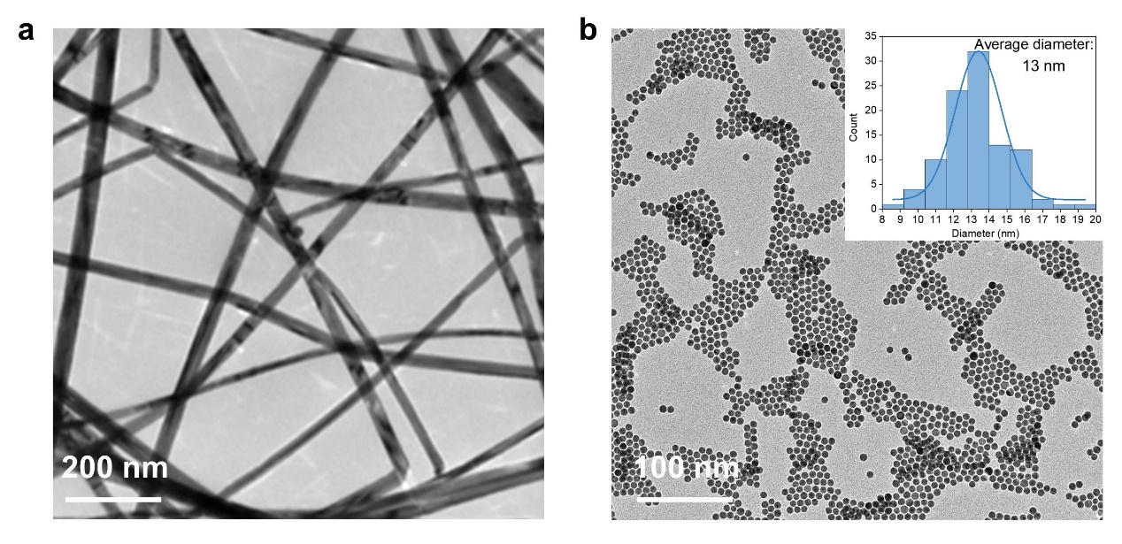
Supplemental Figures
Supplementary Figure 1 Low-magnification TEM images of (a) Cu NWs and (b) Ag NPs.

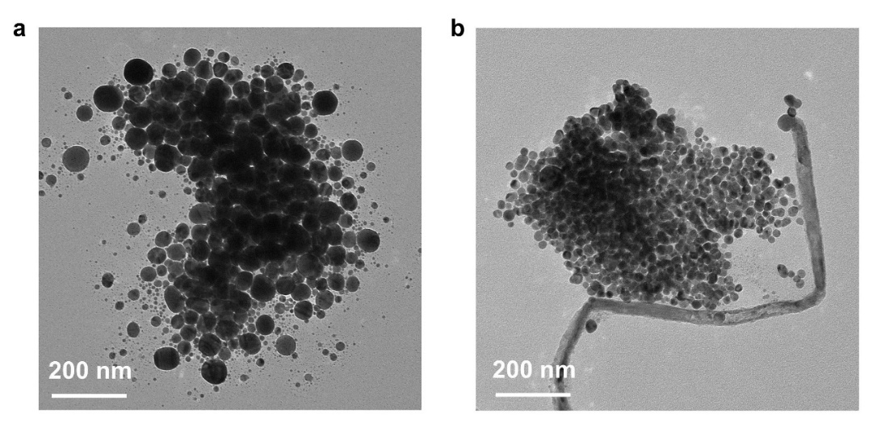
Supplementary Figure 2 TEM images of (a) bipy-functionalized Ag NPs and (b) assembled Ag-Cu with Ag surface functionalized.

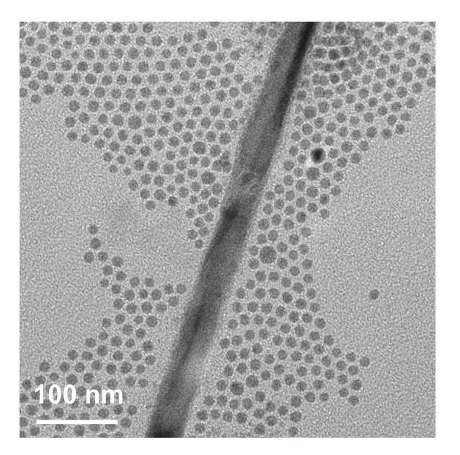
Supplementary Figure 3 A typical TEM image of a mixture of Ag NPs and Cu NW without bipy-functionalization.

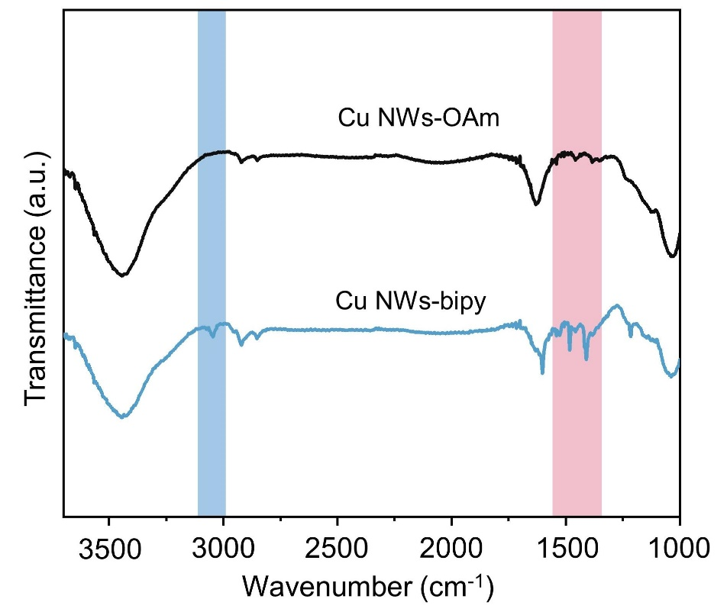

Supplementary Figure 4 IR spectra of OAm-functionalized Cu NWs (as-synthesized Cu-NW with the oleylamine surfactant) and bipy-functionalized Cu NWs (Cu NWs-bipy).

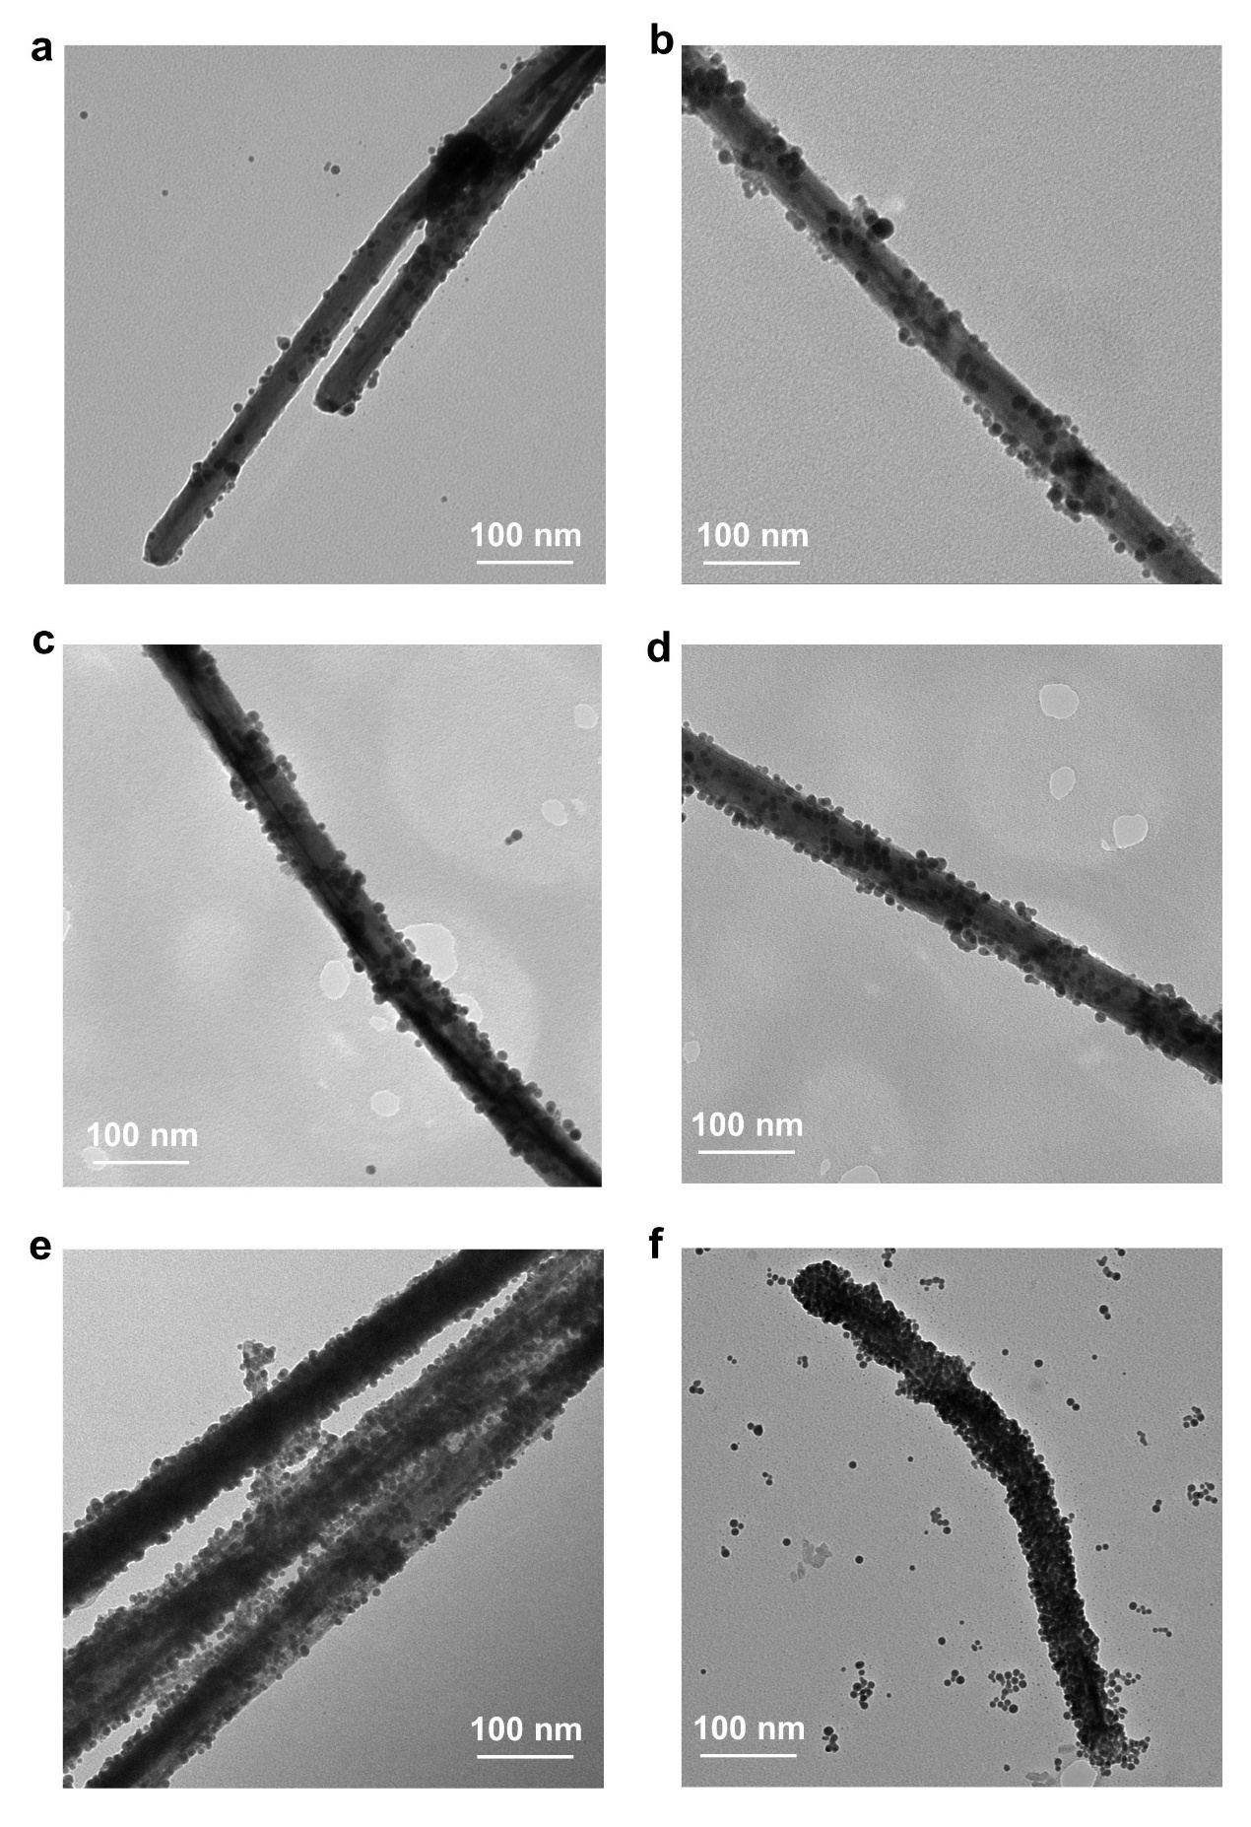Supplementary Figure 5 Low-magnified TEM images of (a) Ag_{0.15}-Cu_{0.85}, (b) Ag_{0.25}-Cu_{0.75}, (c) Ag_{0.33}-Cu_{0.67}, (d) Ag_{0.5}-Cu_{0.5}, (e) Ag_{0.75}-Cu_{0.25}, and (f) Ag_{0.85}-Cu_{0.15}.

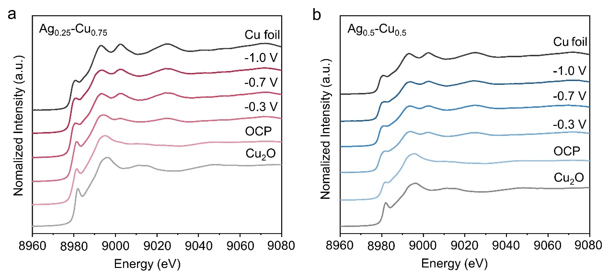
Supplementary Figure 6 Operando XAS characterizations. The Cu K-edge XANES spectra of (a) Ag_{0.25}-Cu_{0.75} and (b) Ag_{0.5}-Cu_{0.5} at OCP and various negative potentials (vs. RHE) in CO₂-saturated 0.1 M KHCO₃. Cu₂O and Cu foil were used as references.

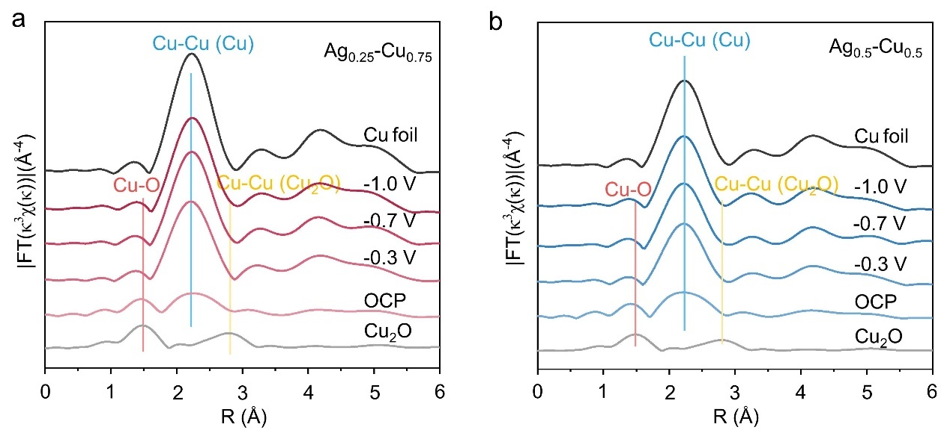
Supplementary Figure 7 Operando XAS characterizations. FT k³-weighted EXAFS spectra of (a) Ag_{0.25}-Cu_{0.75} and (b) Ag_{0.5}-Cu_{0.5} at OCP and various negative potentials (vs. RHE). Cu₂O and Cu foil were used as references.

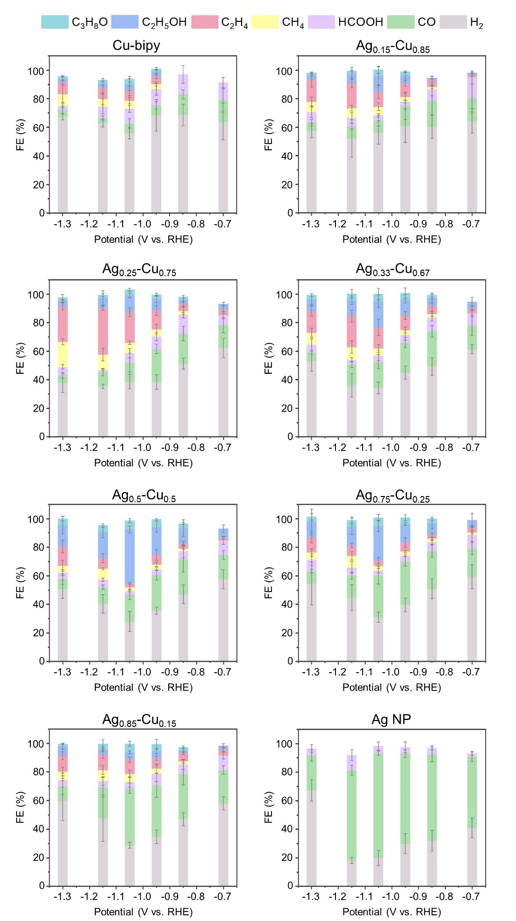
Supplementary Figure 8 Potential-dependent Faradaic efficiencies of multiple products on Cu-bipy, Ag and variable Ag_{x}-Cu_{y} electrodes, the potential is with 100% iR correction. The error bars along Y axis correspond to one standard deviation of triplicate measurements.

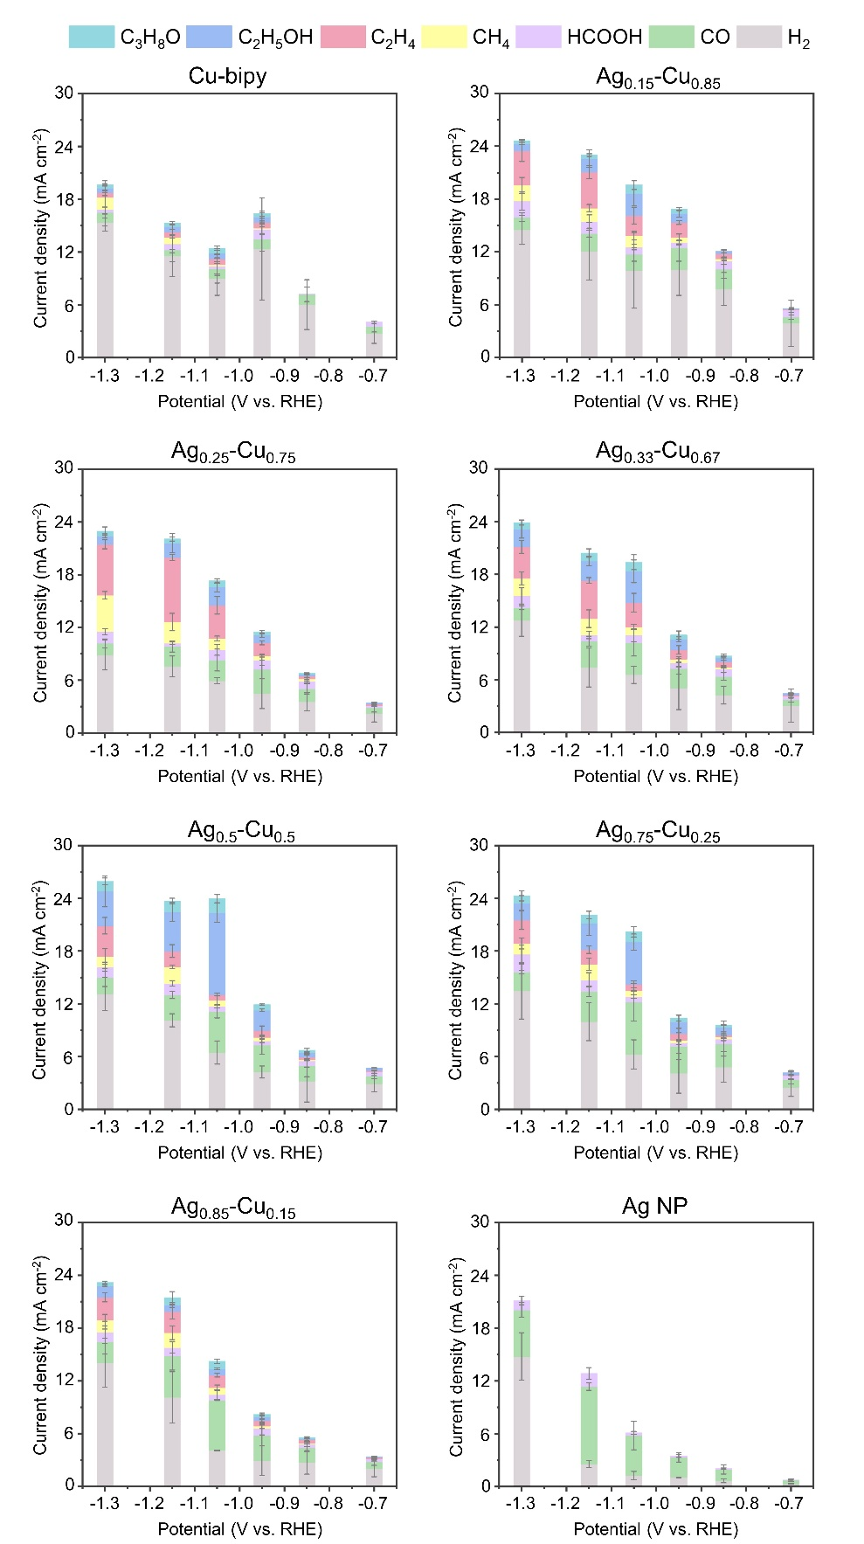

Supplementary Figure 9 Potential-dependent partial current densities of multiple products on Cu-bipy, Ag and variable Ag_{x}-Cu_{y} electrodes, the potential is with 100% iR correction. The error bars along Y axis correspond to one standard deviation of triplicate measurements.

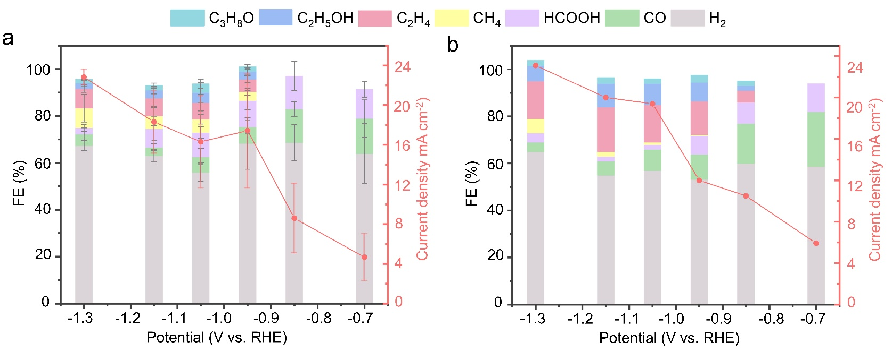

Supplementary Figure 10 The product distribution and current density of CO₂R at different potentials on Cu NWs with (a) and without (b) bipy-functionalization, the potential is with 100% iR correction.

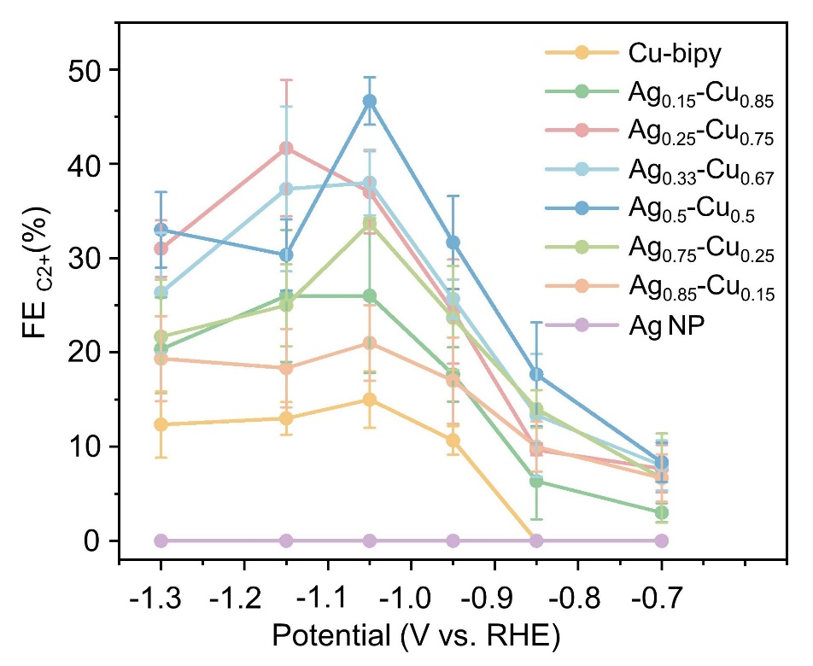

Supplementary Figure 11 FE of C₂₊ products on Cu-bipy, Ag, and variable Ag_{x}-Cu_{y} electrodes, the potential is with 100% iR correction. The error bars along Y axis correspond to one standard deviation of triplicate measurements.

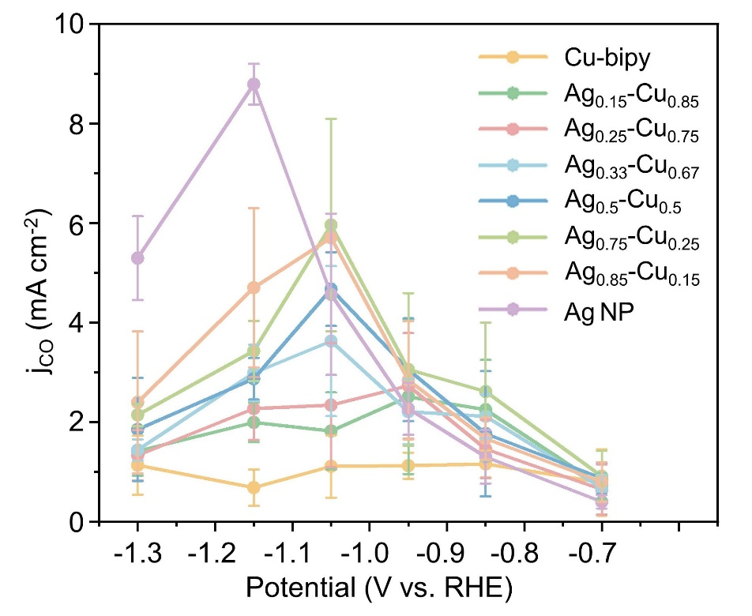
Supplementary Figure 12 The partial current density of CO as a function of applied potentials on Cu-bipy, Ag, and variable Ag_{x}-Cu_{y} electrodes, the potential is with 100% iR correction. The error bars along Y axis correspond to one standard deviation of triplicate measurements.

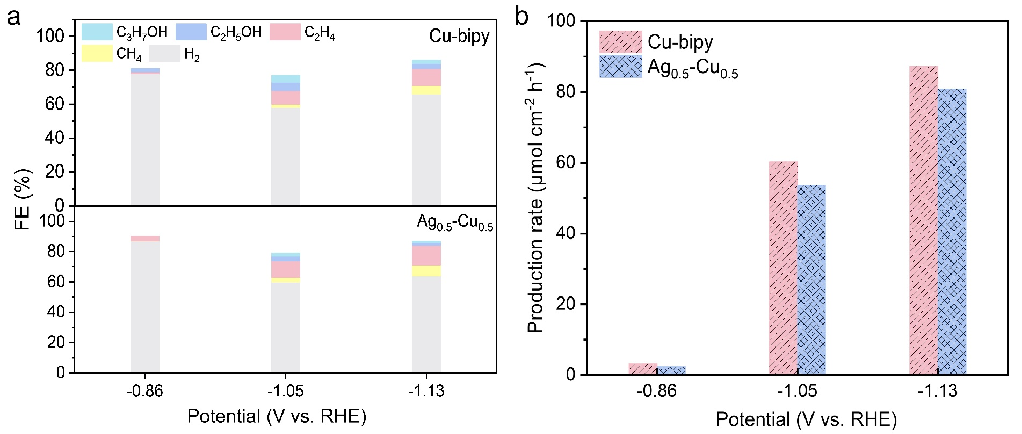

Supplementary Figure 13 The FE (a) and production rate (b) of C₂₊ fuels on Ag_{0.5}-Cu_{0.5} and Cu-bipy in electrochemical CO reduction under different potentials, the potential is with 100% iR correction.

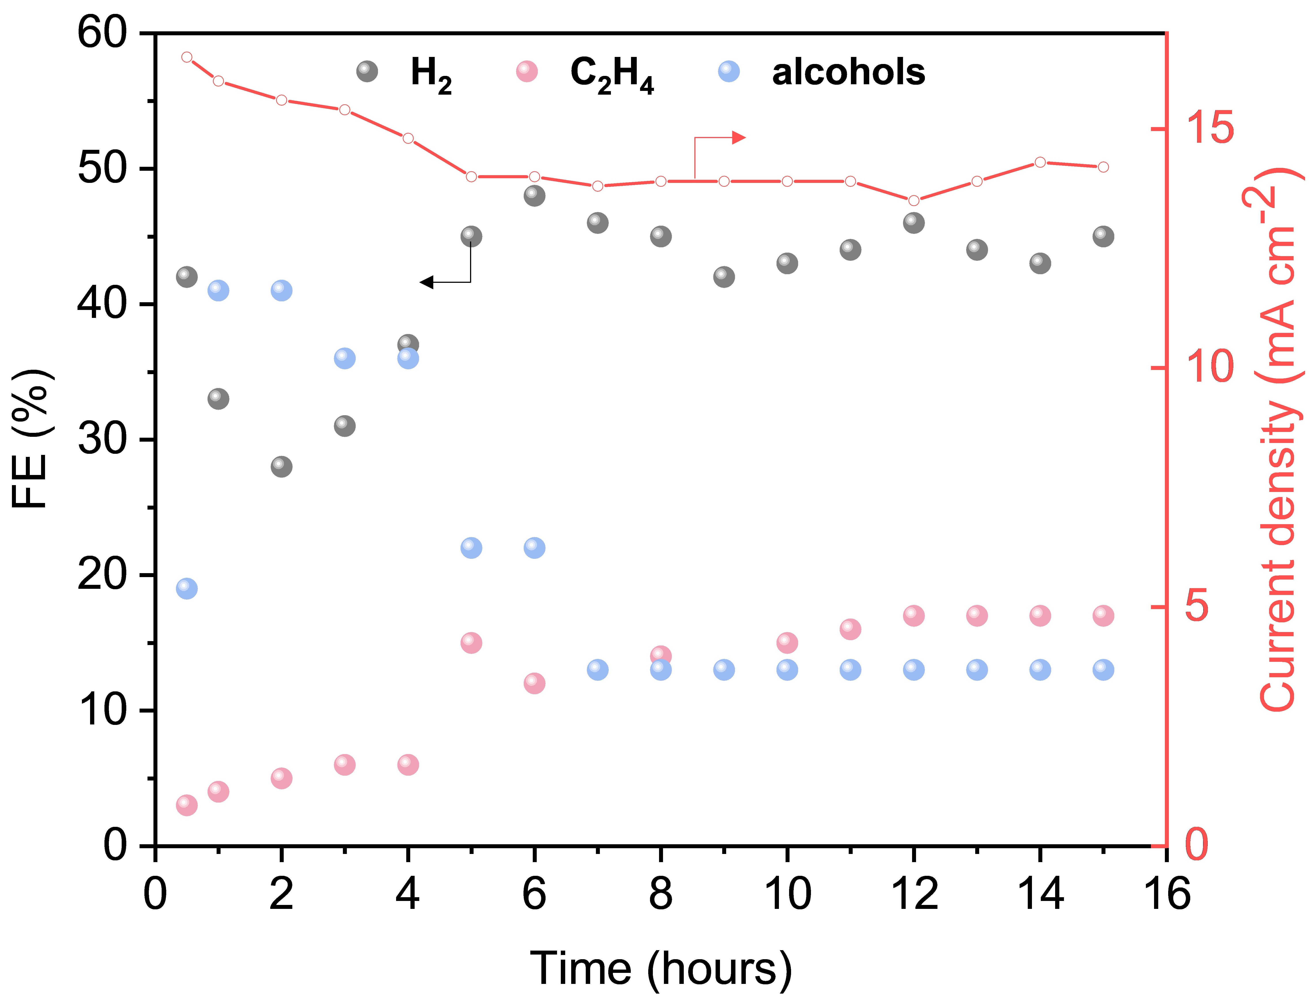

Supplementary Figure 14 The current density and product distribution evaluation during 15 h CO₂ electrolysis catalyzed by Ag_{0.5}-Cu_{0.5} at -1.05 V (vs. RHE, with a 100% iR correction)

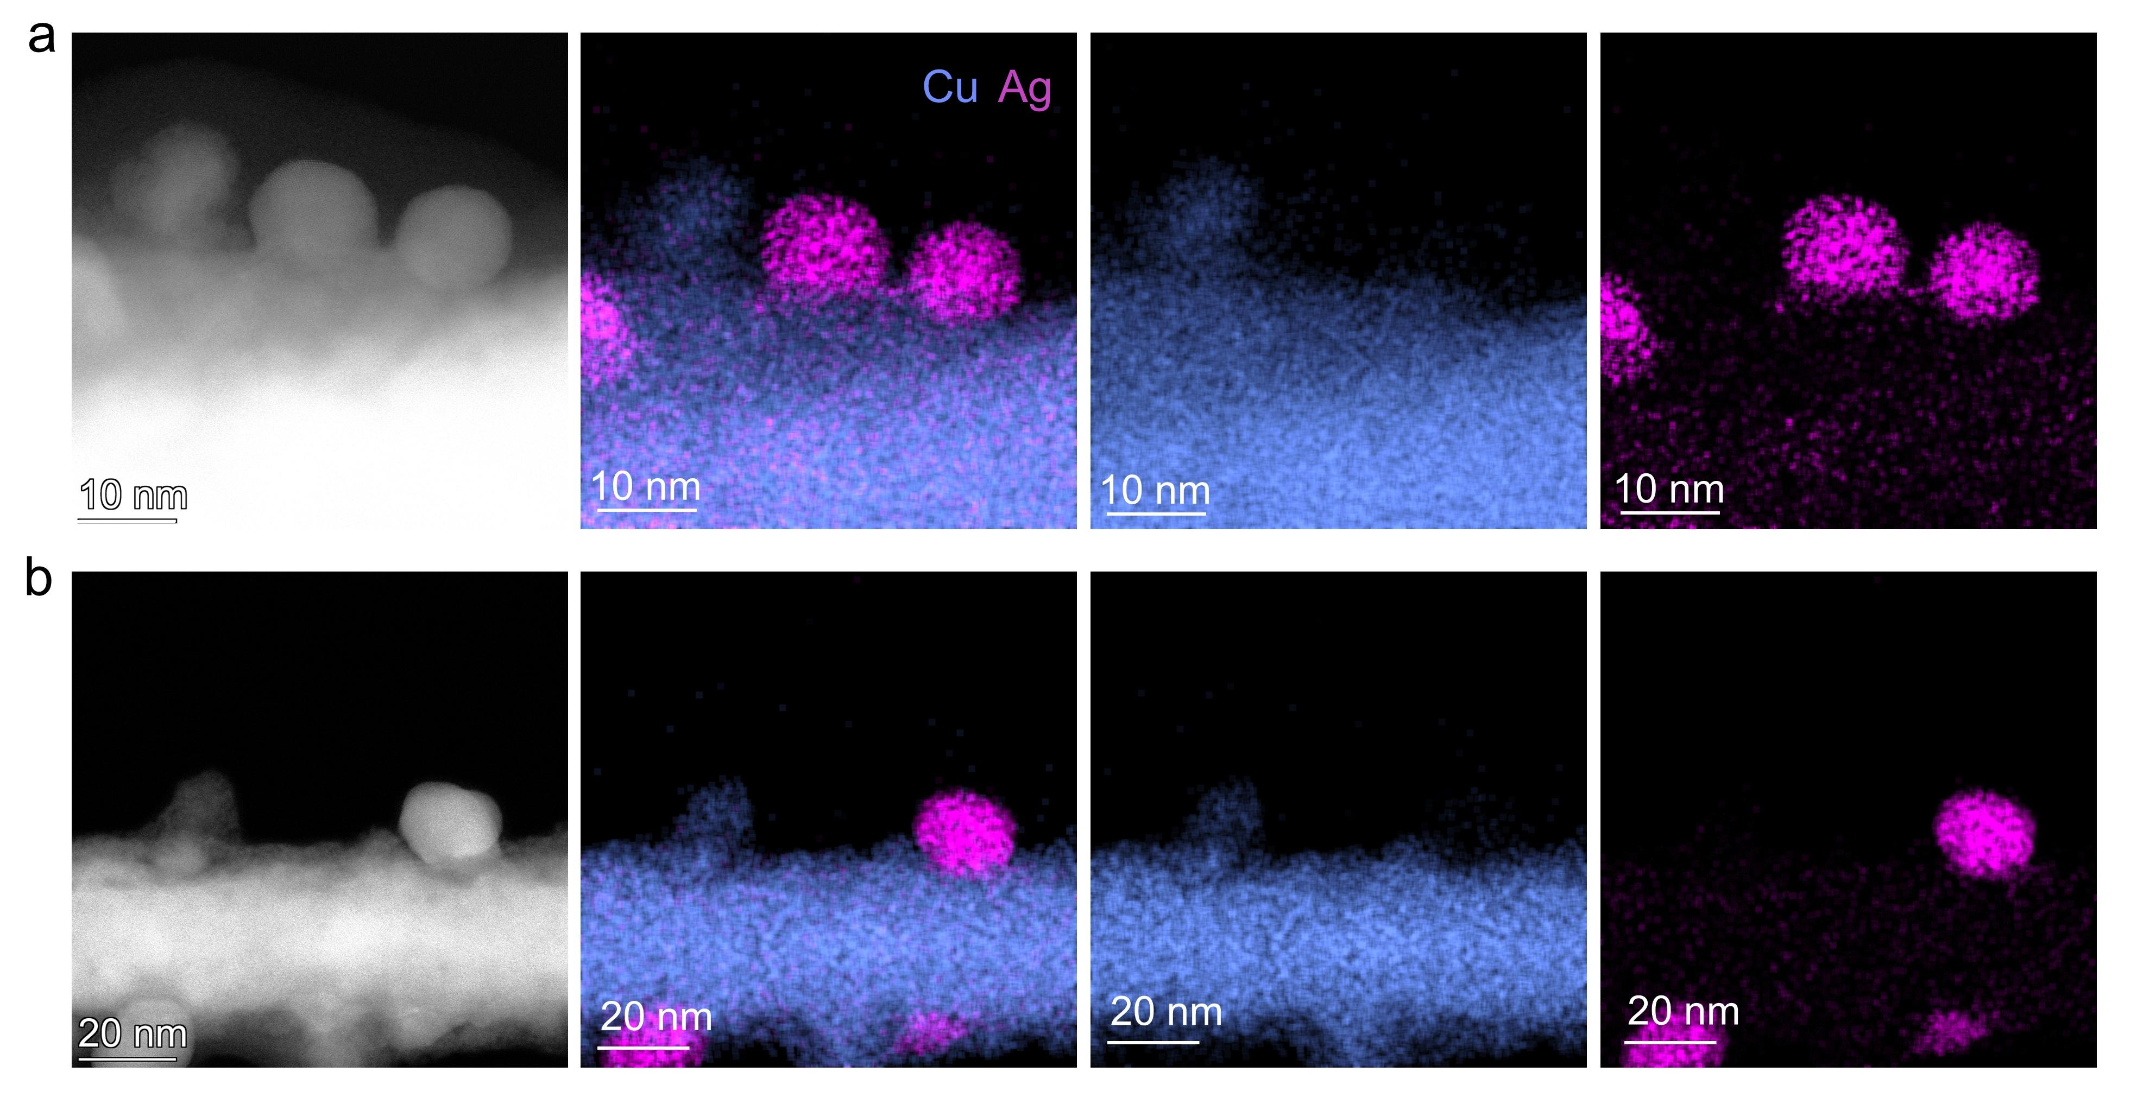
Supplementary Figure 15 The HAADF-STEM images and corresponding EDS elemental maps showing the reconstructed nanostructures on Ag_{0.25}-Cu_{0.75}.

Supplementary Figure 16 The HAADF-STEM images and corresponding EDS elemental maps showing the reconstructed core-shell nanostructure on Ag_{0.5}-Cu_{0.5}.

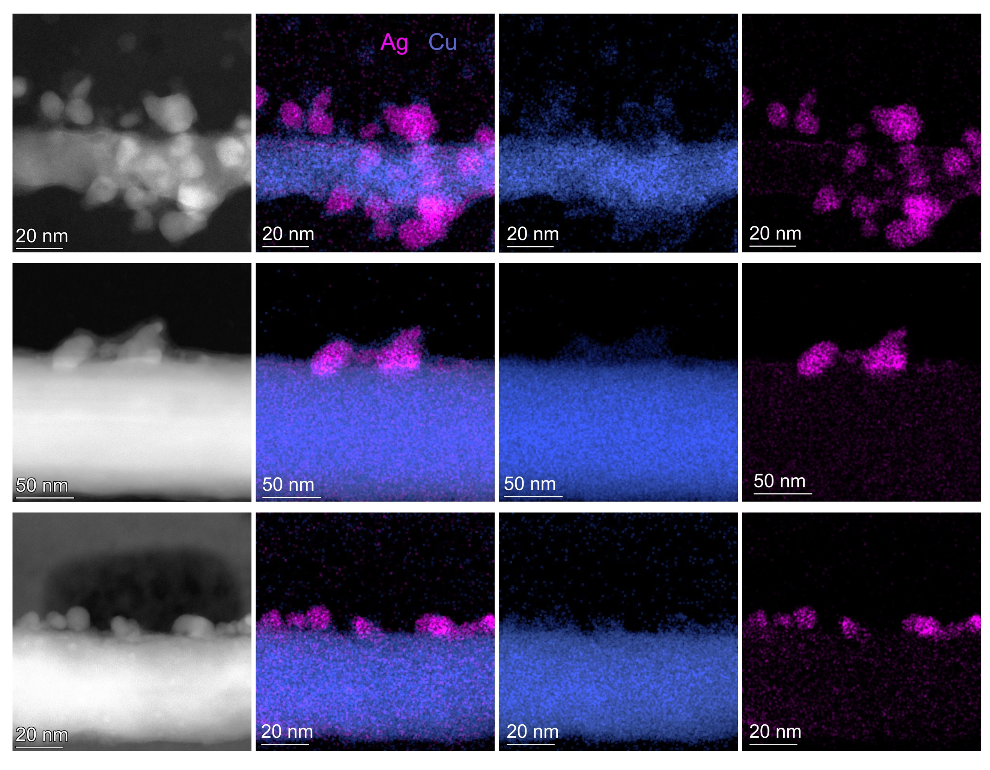

Supplementary Figure 17 The HAADF-STEM image and corresponding EDS elemental maps of Ag_{0.5}-Cu_{0.5} in a flow cell at -1.05 V vs. RHE.

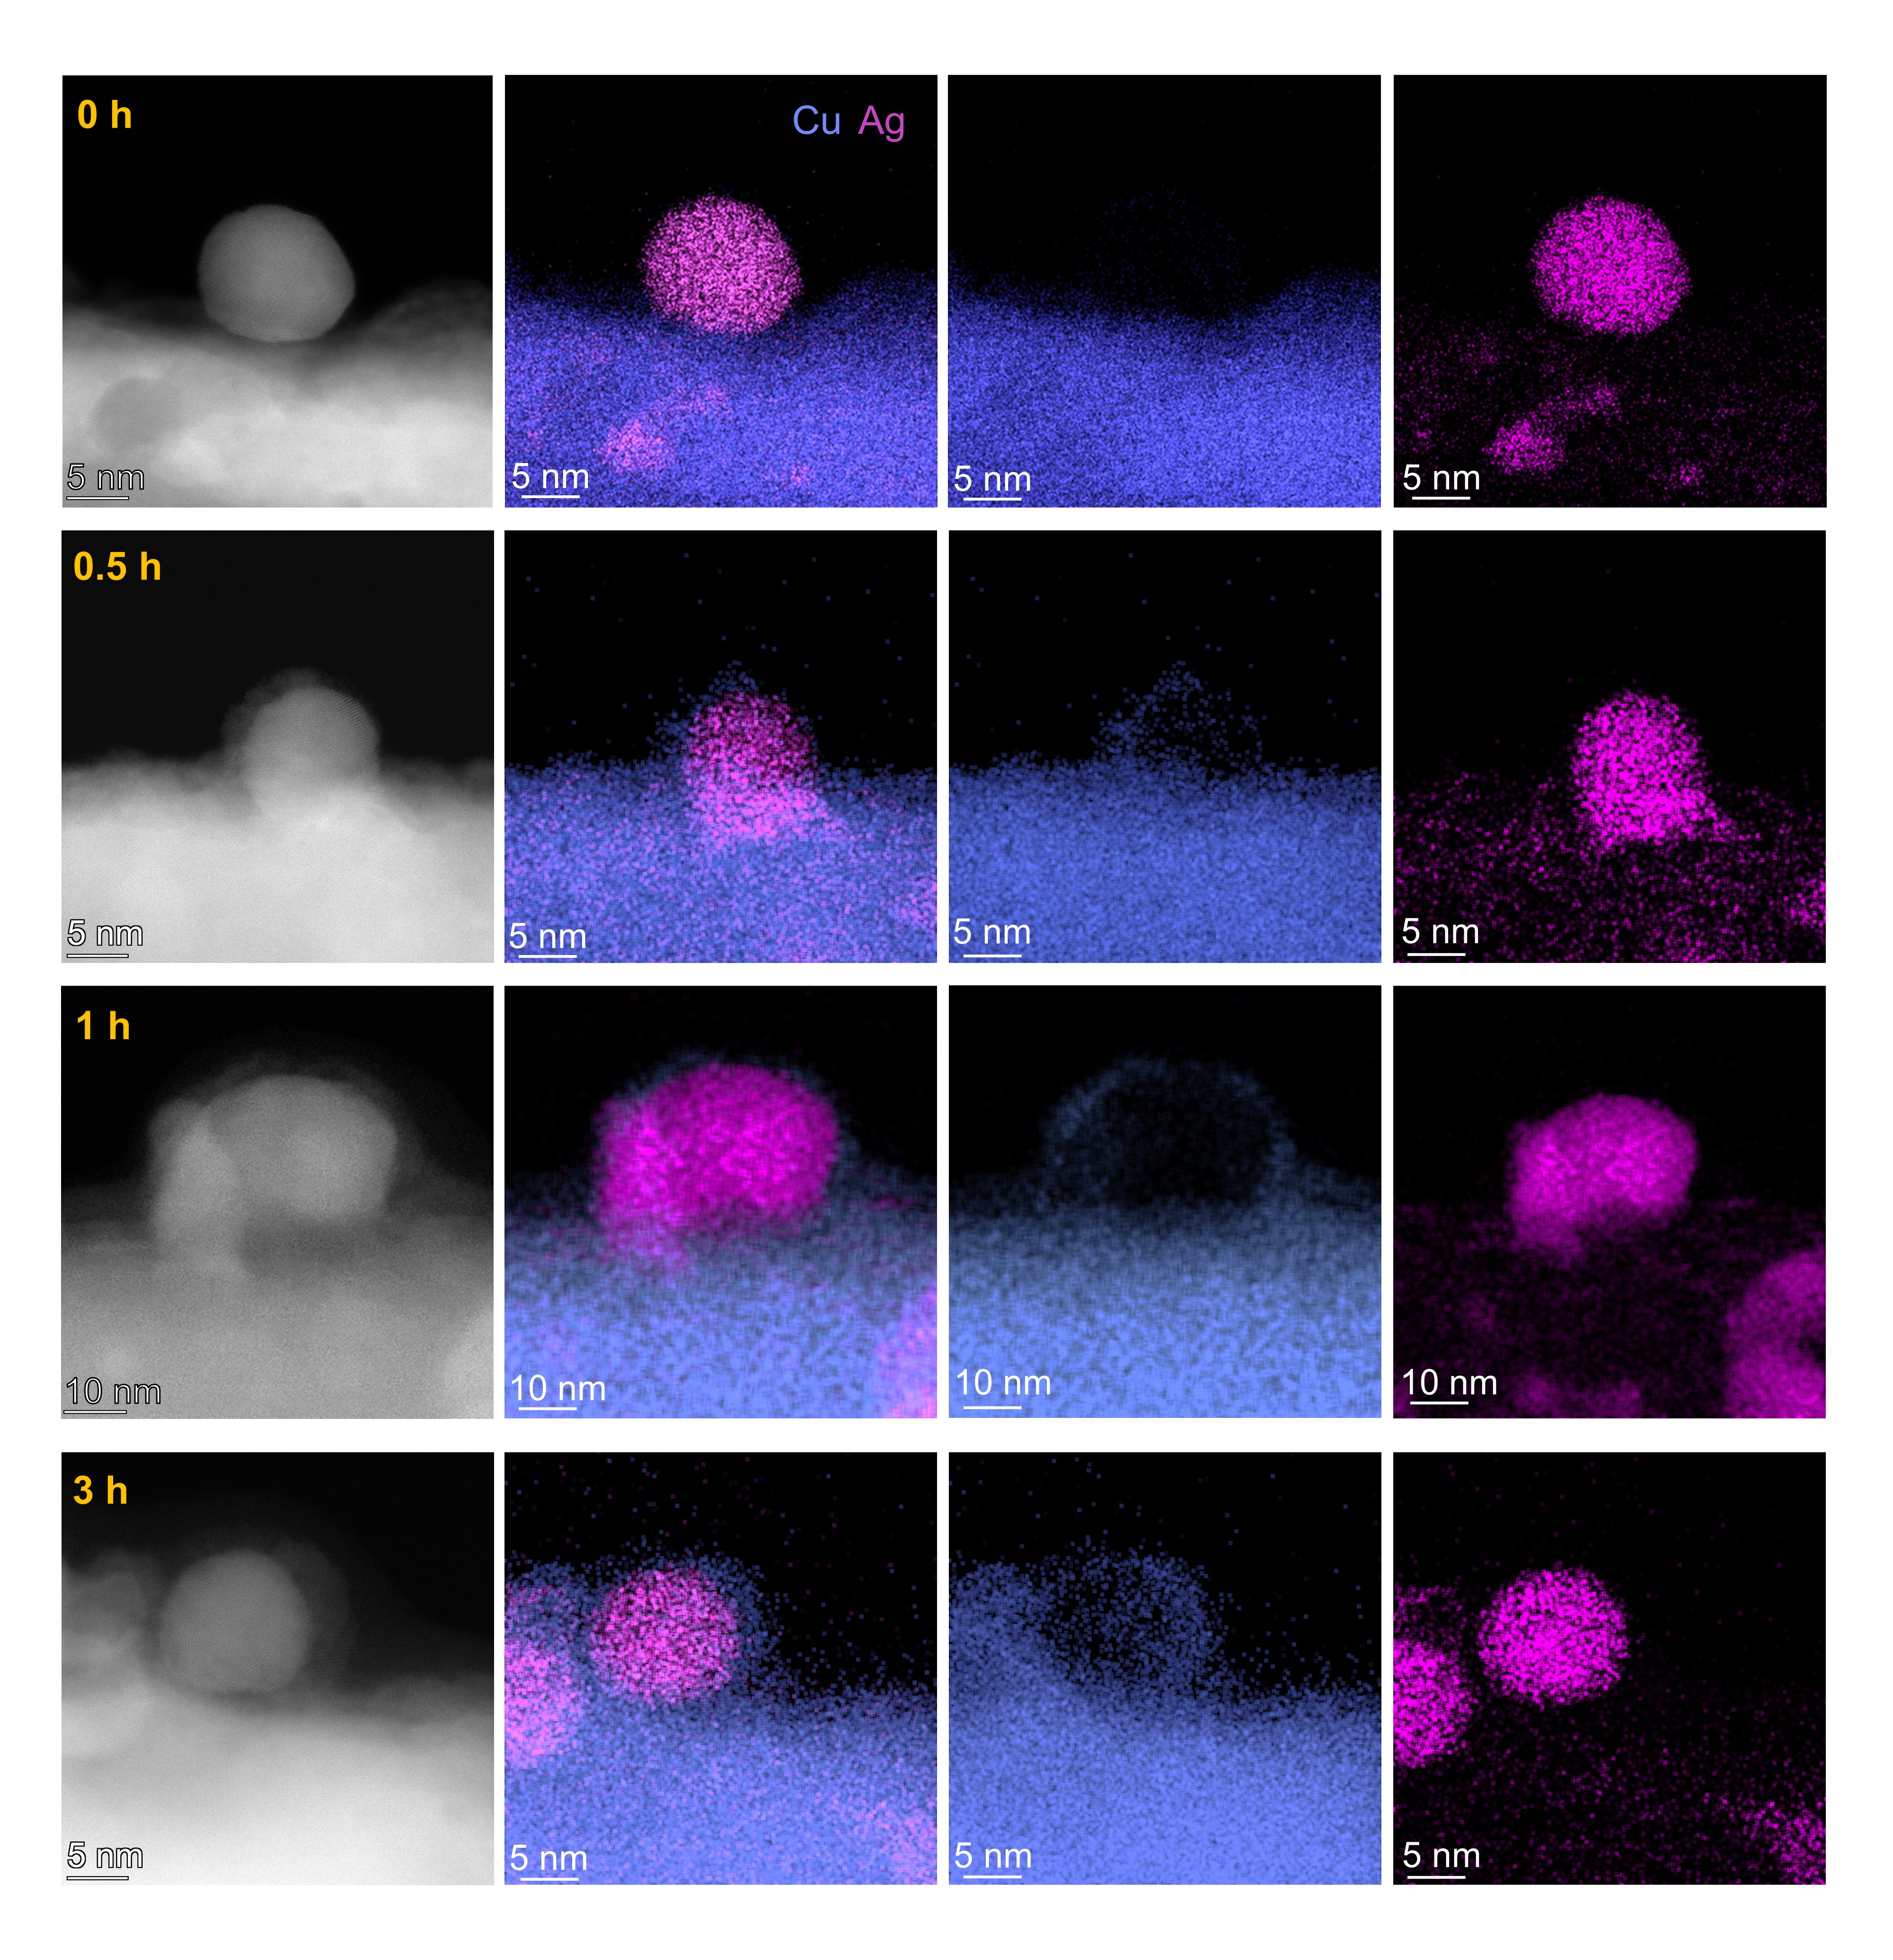
Supplementary Figure 18 The HAADF-STEM images and corresponding EDS elemental maps of Ag_{0.5}-Cu_{0.5} after 0, 0.5, 1, and 3 h CO₂ electrolysis.

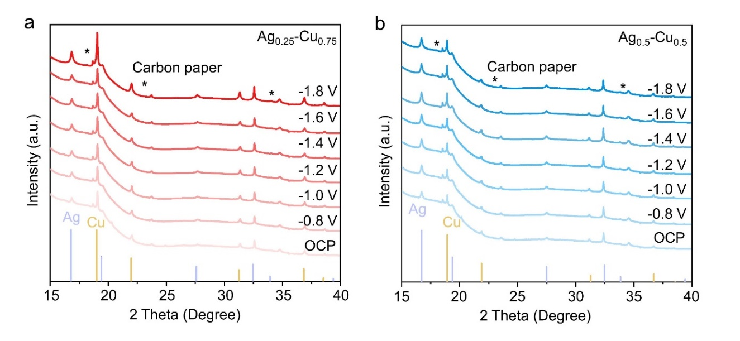
Supplementary Figure 19 Operando XRD patterns of (a) Ag_{0.25}-Cu_{0.75} and (b) Ag_{0.5}-Cu_{0.5} at OCP and negative bias between -0.8 and -1.8 V vs. RHE in CO₂-saturated 0.1 M KHCO₃. The peaks marked with * were from the carbon paper support. Two sets of characteristic peaks attributed to the fcc lattice of pure Ag (PDF-04-0783) and Cu (PDF-04-0836) were shown below.

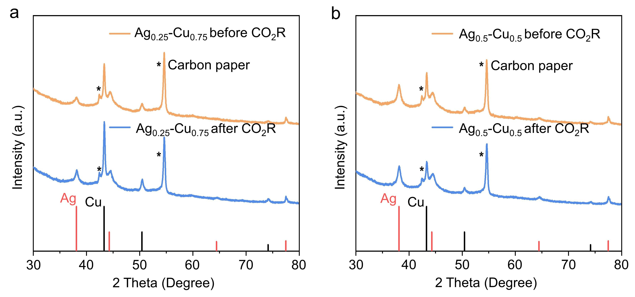Supplementary Figure 20 ex-situ XRD patterns of (a) Ag_{0.25}-Cu_{0.75} and (b) Ag_{0.5}-Cu_{0.5} before and after electrolysis. The post-electrolysis samples were prepared after conducting CO₂R at -1.05 V vs. RHE for 1 hour. The peaks marked with * were from the carbon paper support. Two sets of characteristic peaks attributed to the fcc lattice of pure Ag (PDF-04-0783) and Cu (PDF-04-0836) were shown below.

Supplementary Figure 21 The HAADF-STEM image and corresponding EDS elemental maps of Ag_{0.5}-Cu_{0.5} after one hour electrolysis in gas mixtures with different ratios of Ar and CO₂.

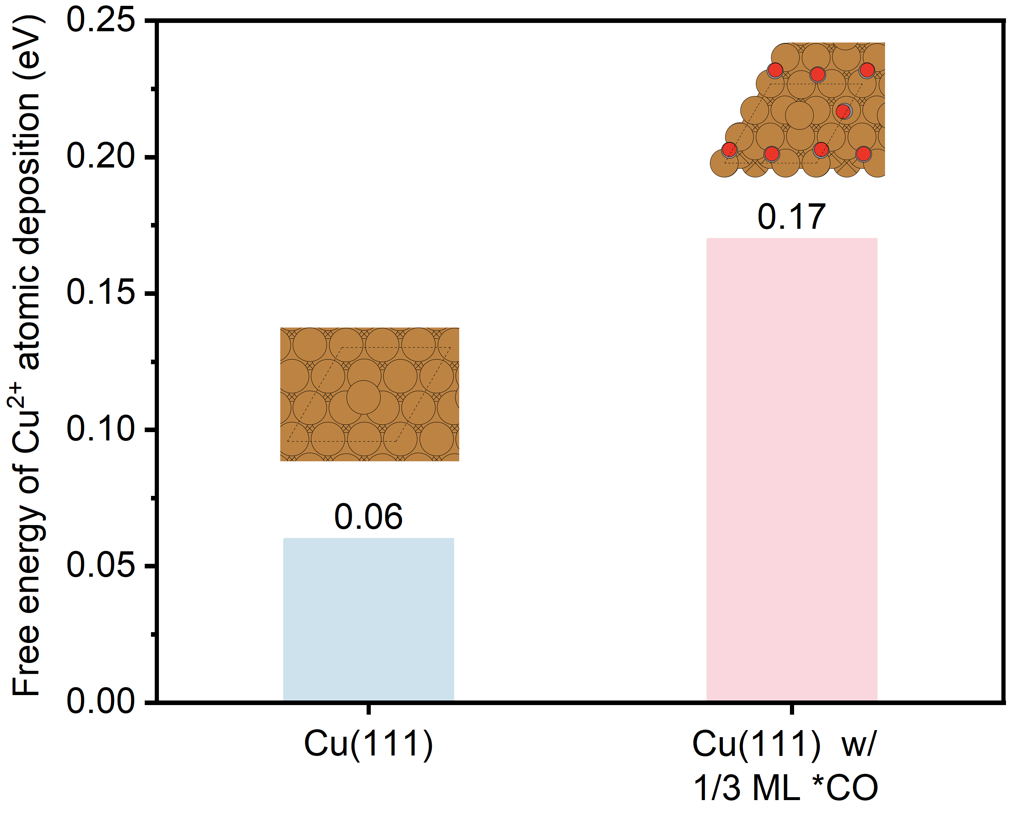

Supplementary Figure 22 The free energy evolution of Cu ion deposition on Cu(111) and Cu(111) with 1/3 ML *CO.

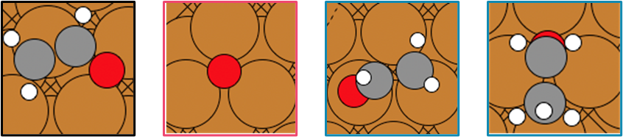

Supplementary Figure 23 Illustration of the key intermediates on Cu(111). The brown, grey, white and red circles represent for Cu, C, H, and O atoms, respectively.

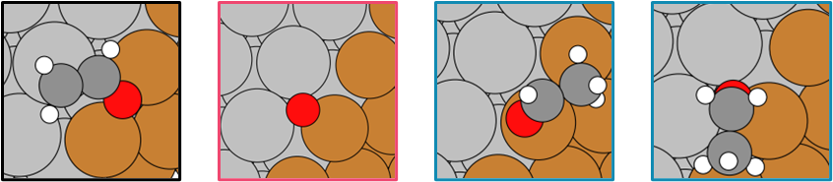

Supplementary Figure 24 Illustration of the key intermediates on Ag/Cu interface. The brown, silver, grey, white and red circles represent for Cu, Ag, C, H, and O atoms, respectively.

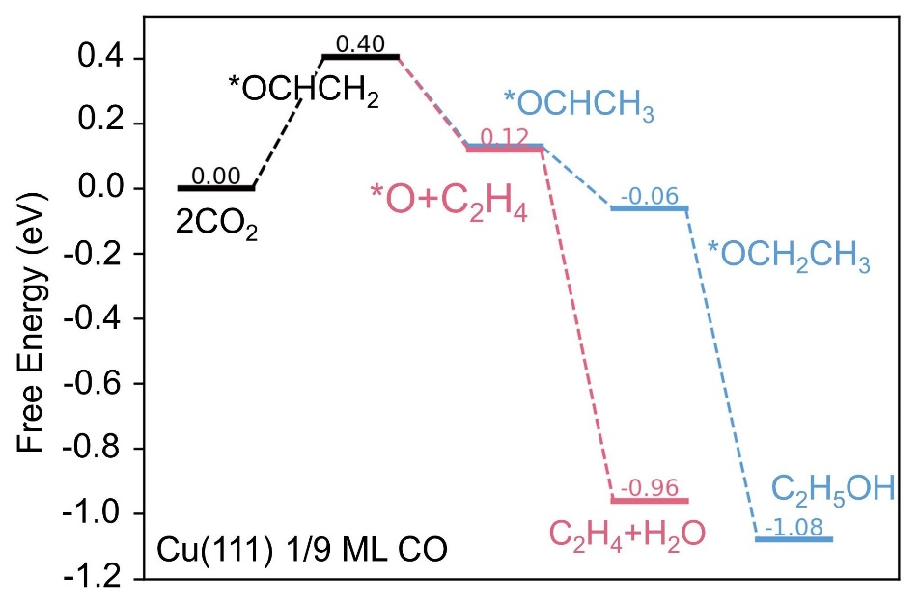

Supplementary Figure 25 The reaction profiles of the C₂H₄ (red) and C₂H₅OH pathway (blue) on Cu(111) with 1/9 ML *CO coverage.

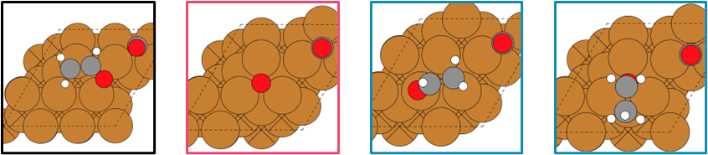

Supplementary Figure 26 Illustration of the key intermediates on Cu(111) with 1/9 ML *CO coverage.

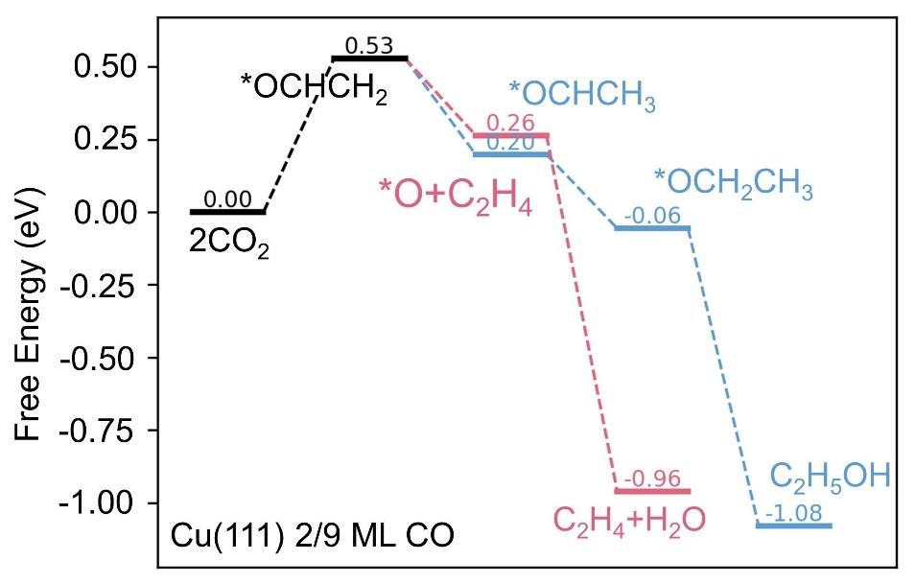

Supplementary Figure 27 The reaction profile of C₂H₄ (red) and C₂H₅OH pathway (blue) on Cu(111) with 2/9 ML *CO coverage.

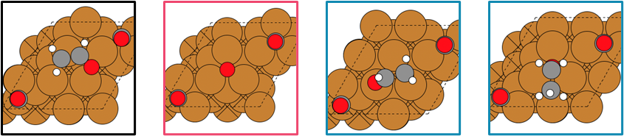

Supplementary Figure 28 Illustration of the key intermediates on Cu(111) with 2/9 ML *CO coverage.
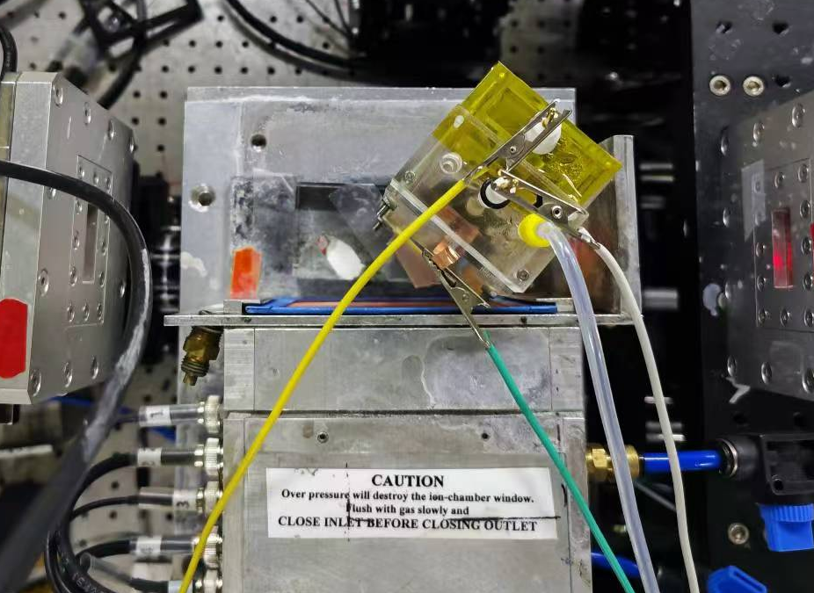
Supplementary Figure 29 The set up of operando XAS.

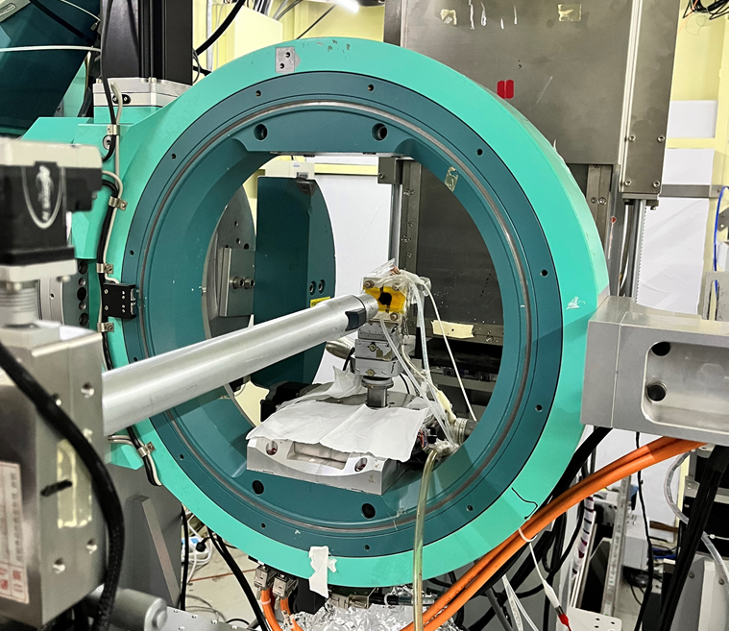
Supplementary Figure 30 The set up of operando XRD.

Supplemental Tables

Supplementary Table 1 Comparison of the CO₂R performances in various
Ag-Cu bimetallic structures

Catalyst | Electrolyte |  | Potential (V vs. RHE) | FE_{major prod.} (%)* | Current density (mA cm⁻²)* | Refs
AgCu-50 |  | 0.1 M KHCO₃ | -0.6 | CO (60) | 5 | 1
Ag_{1.01%}-CuO |  | 0.1 M KHCO₃ | -0.7 | CO (91.2) | 10.5 | 2
snp AgCu |  | 0.1 M KHCO₃ | -0.91 | CO (97.5) | 25 | 3
Cu₆₈Ag₃₂ |  | 0.5 M KHCO₃ | -1.17 | CH₄ (60) | 42 | 4
Cu/Ag 3 nm |  | 0.1 M KHCO₃ | -1.2 | CH₄ (65.3) | 6.48 | 5
Cu₉Ag₁NWs |  | 0.1 M KHCO₃ | -1.17 | CH₄ (72) | 3 | 6
Ag@Cu₂O-6.4 NCs |  | 1 M KOH | -1.2 | CH₄ (74) | 251 | 7
CuAg-30 |  | 0.1 M KHCO₃ | -1.7 | C₂H₄ (25) | 20 | 8
Ag@Cu-20 |  | 0.1 M KHCO₃ | -1.06 | C₂H₄ (28.6) | 3.4 | 9
Ag@CuO_{x}-32 |  | 0.1 M KHCO₃ | -1.06 | C₂H₄ (31.55) | 20 | 10
Cu@Ag-2 NPs |  | 1 M KOH | -1.1 | C₂H₄ (32.2) | 65 | 11
Ag₁-Cu_{1.1} NDs |  | 0.1 M KHCO₃ | -1.1 | C₂H₄ (36) | 0.7 | 12
Ag@Cu Np |  | 0.5 M KHCO₃ | -1.2 | C₂H₄ (41.3) | 20 | 13
Ag/Cu |  | 0.1 M KHCO₃ | -1.1 | C₂H₄ (42) | 5.9 | 14
CuAg NW |  | 0.1 M KHCO₃ | -1.05 | C₂H₄ (52) | 35 | 15
Ag₆₅-Cu₃₅ JNS-100 |  | 0.1 M KHCO₃ | -1.2 | C₂H₄ (54) | 5 | 16
CuAg-wire (6%Ag) |  | 1 M KOH | -0.7 | C₂H₄ (60) + C₂H₅OH (25) | 310.8 | 17
OD-Ag₁₅Cu₈₅ |  | 0.5 M KHCO₃ | -1 | C₂H₅OH (33.7) | 26 | 18
Ag-Cu₂O_{PB} |  | 0.2 M KCl | -1.2 | C₂H₅OH (34) | 2.5 | 19
supersaturated Ag–Cu |  | MEA | -3.2 | C₂H₅OH (40.4) | 120 | 20
Ag0.14/Cu0.86 |  | 1 M KOH | -0.67 | C₂H₅OH (41) | 250 | 21
AgCu SANP |  | 1 M KOH | -0.65 | C₂H₅OH (45) | 720 | 22
(Cu)₂, (Ag)₃ |  | 0.5 M KHCO₃ | -1.33 | CH₃COOH (21.2) | 0.85 | 23
5-Ag/Cu₂O |  | 0.1 M KHCO₃ | -1 | C₂₊ liquids (30) | 10 | 24
Cu₃Ag₁ |  | 0.5 M KHCO₃ | -0.95 | C₂₊ alcohols (63) | 40 | 25

* The values of current densities and faraday efficiencies were either provided in literature or extracted from the corresponding figures.

Supplementary Table 2 The Cu and Ag contents determined by ICP-OES

Ag_{x}-Cu_{y} | Mass percentage of Cu  in the heterostructure (wt%) | Mass percentage of Ag  in the heterostructure (wt%)
Ag_{0.15}-Cu_{0.85} | 81.29 | 17.89
Ag_{0.25}-Cu_{0.75} | 69.12 | 28.25
Ag_{0.33}-Cu_{0.67} | 62.19 | 34.18
Ag_{0.5}-Cu_{0.5} | 52.36 | 45.85
Ag_{0.75}-Cu_{0.25} | 38.30 | 58.22
Ag_{0.85}-Cu_{0.15} | 16.48 | 82.00

Supplementary Table 3 ICP-OES analysis of Cu ions in electrolyte after different CO₂R reaction time under -1.05 V vs. RHE

Electrolyte | Reaction time | Cu content (μg L⁻¹)
0.1M KHCO₃ | OCV | 71.7
0.1M KHCO₃ | 0.5 h | 936.1
0.1M KHCO₃ | 1 h | 1640.8

References
1. Kottakkat, T. et al. Electrodeposited AgCu foam catalysts for enhanced reduction of CO₂ to CO. ACS Appl. Mater. Interf. 11, 14734-14744 (2019).
2. Zhang, W., Zhu, N., Ding, L., Hu, Y. & Wu, Z. Efficacious CO₂ adsorption and activation on Ag nanoparticles/CuO mesoporous nanosheets heterostructure for CO₂ electroreduction to CO. Inorg. Chem. 60, 19356-19364 (2021).
3. Wang, H. et al. Surface restructuring in AgCu single-atom alloy catalyst and self-enhanced selectivity toward CO₂ reduction. Electrochim. Acta 426, 140774 (2022).
4. Chang, C.J. et al. Dynamic reoxidation/reduction-driven atomic interdiffusion for highly selective CO₂ reduction toward methane. J. Am. Chem. Soc. 142, 12119-12132 (2020).
5. Dong, W. J. et al. Tailoring electronic structure of bifunctional Cu/Ag layered electrocatalysts for selective CO₂ reduction to CO and CH₄. Nano Energy 78, 105168 (2020).
6. Choi, C. et al. Intimate atomic Cu-Ag interfaces for high CO₂RR selectivity towards CH₄ at low over potential. Nano Res. 14, 3497-3501 (2021).
7. Xiong, L. et al. Geometric modulation of local CO flux in Ag@Cu₂O nanoreactors for steering the CO₂RR pathway toward high‐efficacy methane production. Adv. Mater. 33, 2101741 (2021).
8. Yang, Y. et al. Insight into the formation and transfer process of the first intermediate of CO₂ reduction over Ag-decorated dendritic Cu. Chem. Eur. J 26, 4080-4089 (2020).
9. Chang, Z., Huo, S., Zhang, W., Fang, J. & Wang, H. The tunable and highly selective reduction products on Ag@Cu bimetallic catalysts toward CO₂ electrochemical reduction reaction. J. Phys. Chem. C 121, 11368-11379 (2017).
10. Chang, C. J. et al. Quantitatively unraveling the redox shuttle of spontaneous oxidation/electroreduction of CuO_{x} on silver nanowires using in situ X-ray absorption spectroscopy. ACS Cent. Sci. 5, 1998-2009 (2019).
11. Zhang, S. et al. Electrochemical reduction of CO₂ toward C₂ valuables on Cu@Ag core-shell tandem catalyst with tunable shell thickness. Small 17, 2102293 (2021).
12. Huang, J., Mensi, M., Oveisi, E., Mantella, V. & Buonsanti, R. Structural sensitivities in bimetallic catalysts for electrochemical CO₂ reduction revealed by Ag-Cu nanodimers. J. Am. Chem. Soc. 141, 2490-2499 (2019).
13. Hou, L. et al. Ag nanoparticle embedded Cu nanoporous hybrid arrays for the selective electrocatalytic reduction of CO₂ towards ethylene. Inorg. Chem. Front. 7, 2097-2106 (2020).
14. Wang, J. et al. Silver/copper interface for relay electroreduction of carbon dioxide to ethylene. ACS Appl. Mater. Interf. 11, 2763-2767 (2019).
15. Gao, J. et al. Selective C-C coupling in carbon dioxide electroreduction via efficient spillover of intermediates as supported by operando Raman spectroscopy. J. Am. Chem. Soc. 141, 18704-18714 (2019).
16. Ma, Y. et al. Confined growth of silver–copper Janus nanostructures with {100} facets for highly selective tandem electrocatalytic carbon dioxide reduction. Adv. Mater. 34, 2110607 (2022).
17. Hoang, T. T. H. et al. Nanoporous copper-silver alloys by additive-controlled electrodeposition for the selective electroreduction of CO₂ to ethylene and ethanol. J. Am. Chem. Soc. 140, 5791-5797 (2018).
18. Dutta, A. et al. Activation of bimetallic AgCu foam electrocatalysts for ethanol formation from CO₂ by selective Cu oxidation/reduction. Nano Energy 68, 104331 (2020).
19. Lee, S., Park, G. & Lee, J. Importance of Ag-Cu Biphasic boundaries for selective electrochemical reduction of CO₂ to ethanol. ACS Catal. 7, 8594-8604 (2017).
20. Kim, J. Y. et al. Selective hydrocarbon or oxygenate production in CO₂ electroreduction over metallurgical alloy catalysts. Nat. Synth. 3, 452–465 (2024).
21. Li, Y. C. et al. Binding site diversity promotes CO₂ electroreduction to ethanol. J. Am. Chem. Soc. 141, 8584-8591 (2019).
22. Du, C. et al. Cascade electrocatalysis via AgCu single-atom alloy and Ag nanoparticles in CO₂ electroreduction toward multicarbon products. Nat. Commun. 14, 6142 (2023).
23. Wang, Y. et al. CO₂ reduction to acetate in mixtures of ultrasmall (Cu)_{n},(Ag)_{m} bimetallic nanoparticles. Proc. Natl. Acad. Sci. U.S.A 115, 278-283 (2018).
24. Herzog, A. et al. Operando investigation of Ag-decorated Cu₂O nanocube catalysts with enhanced CO₂ electroreduction toward liquid products. Angew Chem. Int. Ed. 60, 7426-7435 (2021).
25. Lv, X. et al. Electron-deficient Cu sites on Cu₃Ag₁ catalyst promoting CO₂ electroreduction to alcohols. Adv. Energy Mater. 10, 2001987 (2020).

