Supplementary Information

Ion suppression correction and normalization for non-targeted metabolomics
(Mahmud et al.)

Corresponding Author
Philip L. Lorenzi, The University of Texas MD Anderson Cancer Center, 7435 Fannin Street, Room 2SCR3.3029, Unit 0950, Houston, TX 77054. Phone: 713-792-9999. Email: PLLorenzi@mdanderson.org.

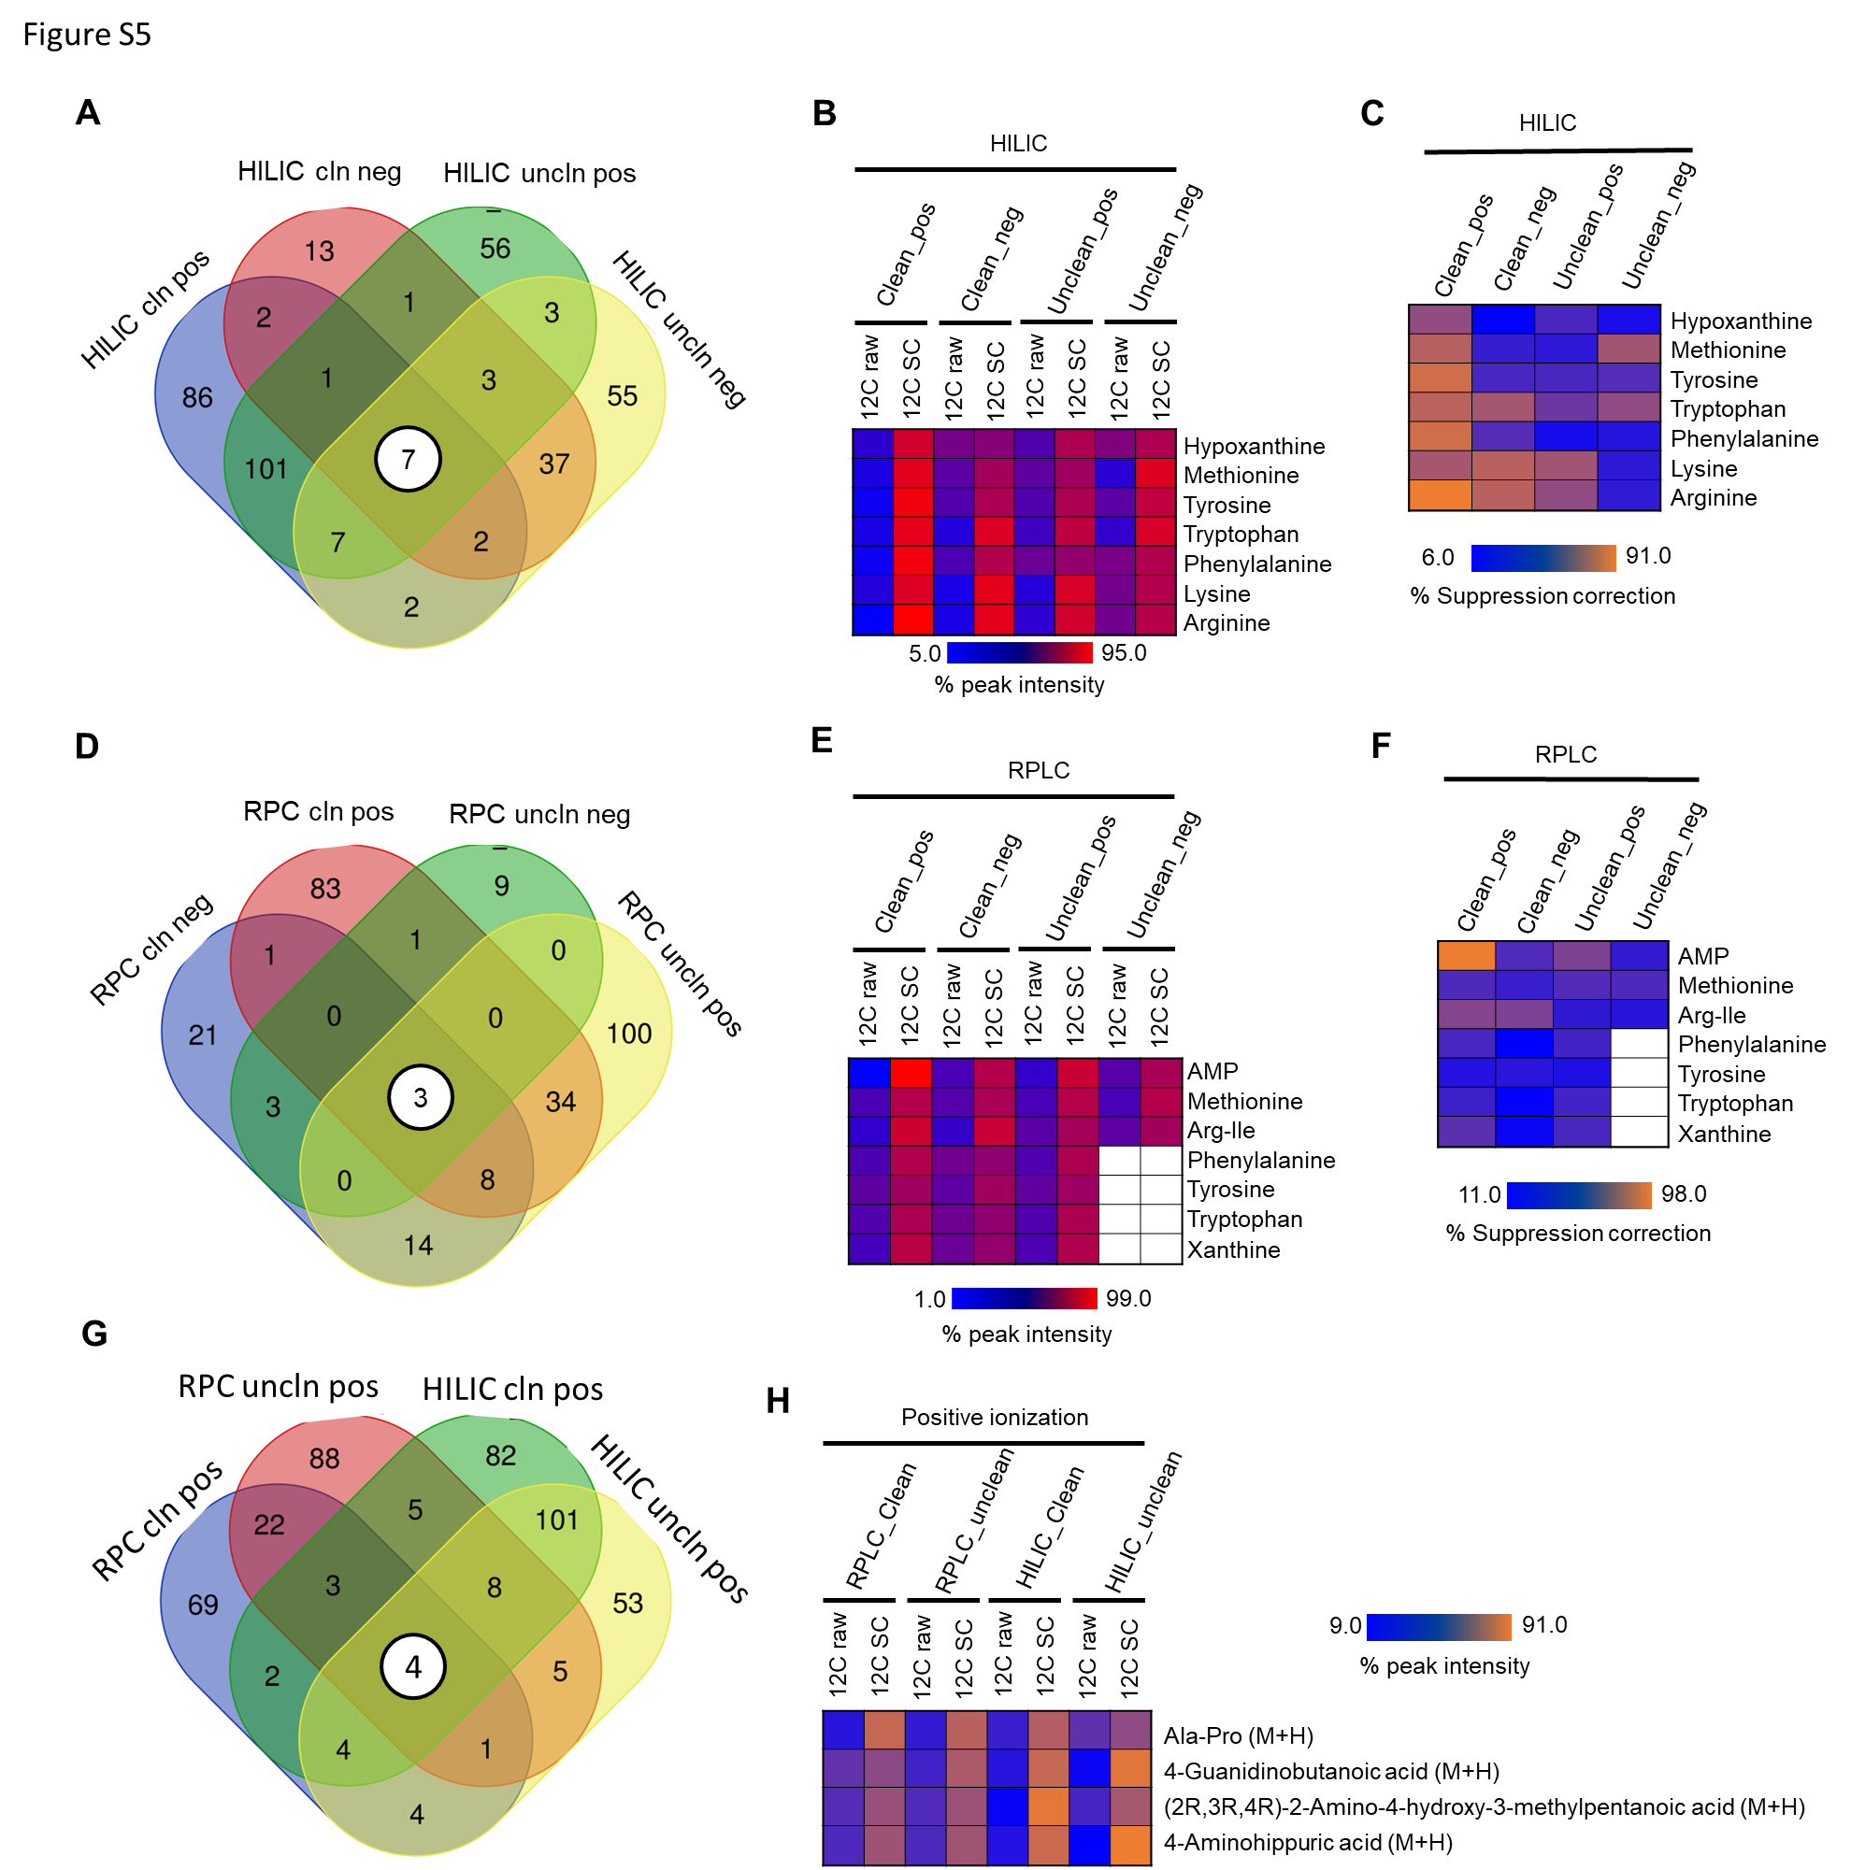
Supplementary Fig. 1 | Assessment of IROA Workflow in ion suppression correction across chromatography. (a) Commonly annotated 7 metabolites in different HILIC methods. (b) Raw MSTUS-12C and suppression-corrected 12C peak intensity for 7 metabolites that were commonly identified by HILIC. (c) Percent suppression correction among different HILIC methods by IROA Workflow. (d) Commonly annotated 3 metabolites in different RPLC methods. (e) Raw MSTUS-12C and suppression-corrected 12C peak intensity for 7 metabolites that were commonly identified by RPC. (f) Percent suppression correction among different RPC methods by IROA Workflow. (g) Commonly annotated 4 metabolites in RPLC and HILIC positive ion modes. (h) Raw MSTUS-12C and suppression-corrected 12C peak intensity for 4 metabolites that were commonly identified by both RPLC and HILIC chromatography in positive ion mode.

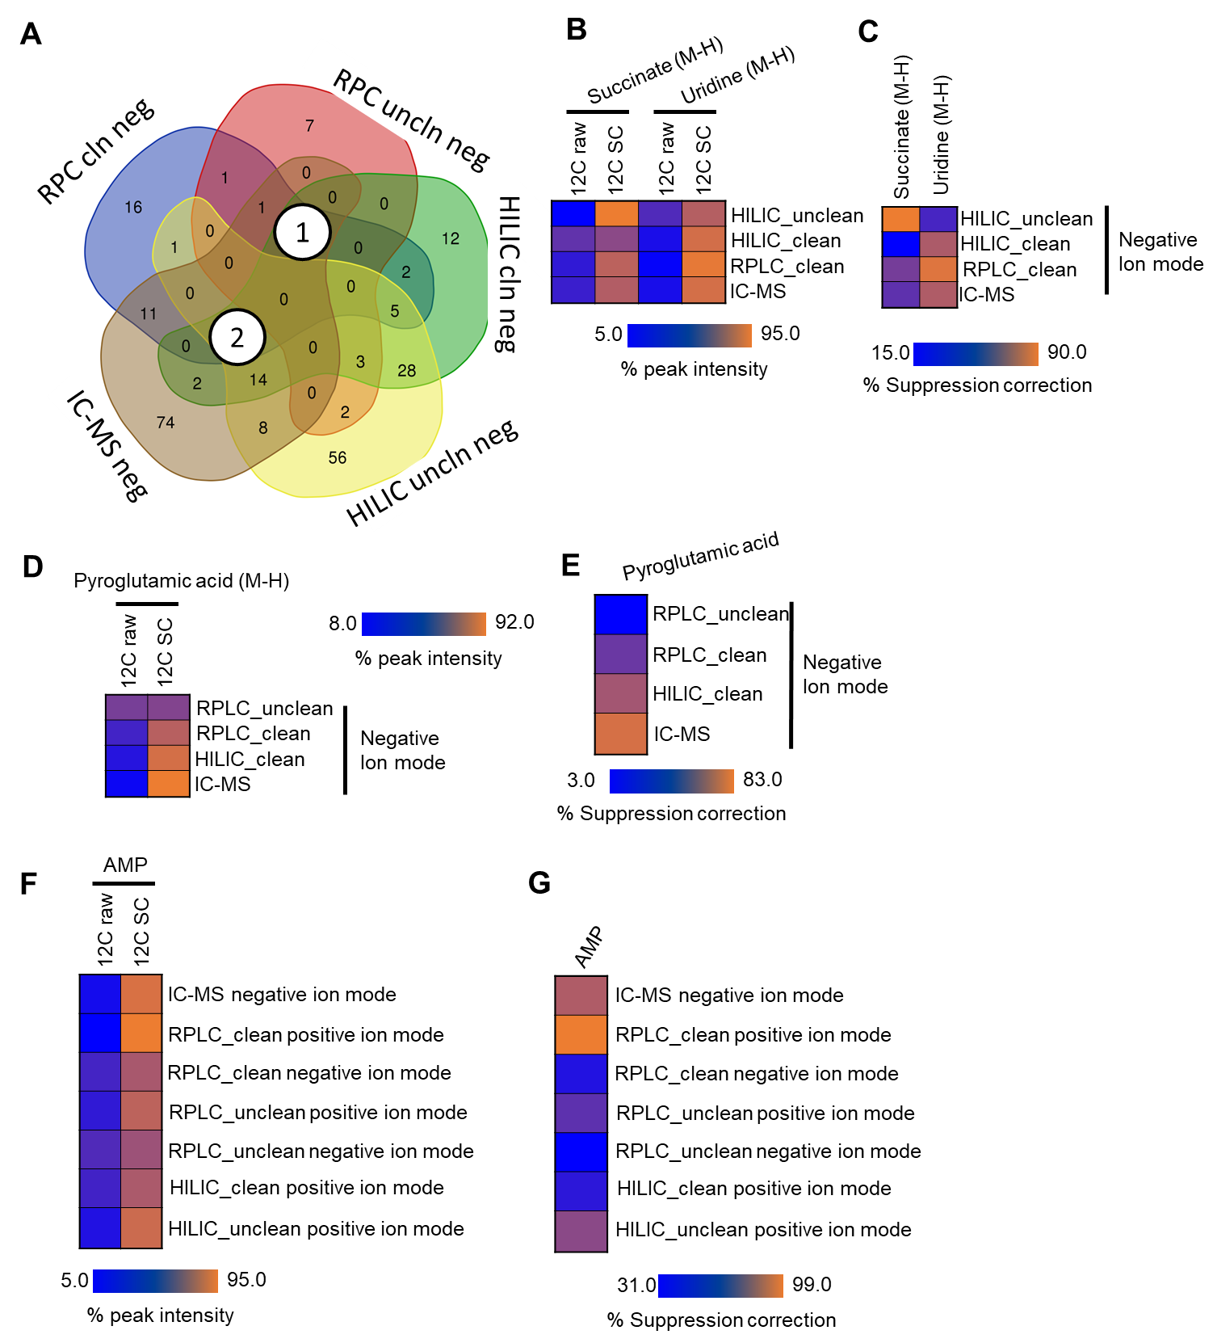
Supplementary Fig. 2 | Assessment of IROA Workflow in ion suppression correction across ion modes of different chromatography. (a) Commonly annotated metabolites in different ion mode of RPLC, HILIC, and ICMS. (b) Raw MSTUS-12C and suppression-corrected 12C peak intensity for succinate and uridine that were commonly identified by different chromatography. (c) Percent suppression correction among different chromatography modes by IROA Workflow. (d) Raw MSTUS-12C and suppression-corrected 12C peak intensity for pyroglutamic acid that was commonly identified by different chromatography. (e) Percent suppression correction of pyroglutamic acid among IC-MS, RPLC, and HILIC negative. (f) Raw MSTUS-12C and suppression-corrected 12C peak intensity for AMP that was commonly identified by different chromatography. (g) Percent suppression correction of AMP among IC-MS, RPLC, and HILIC methods.

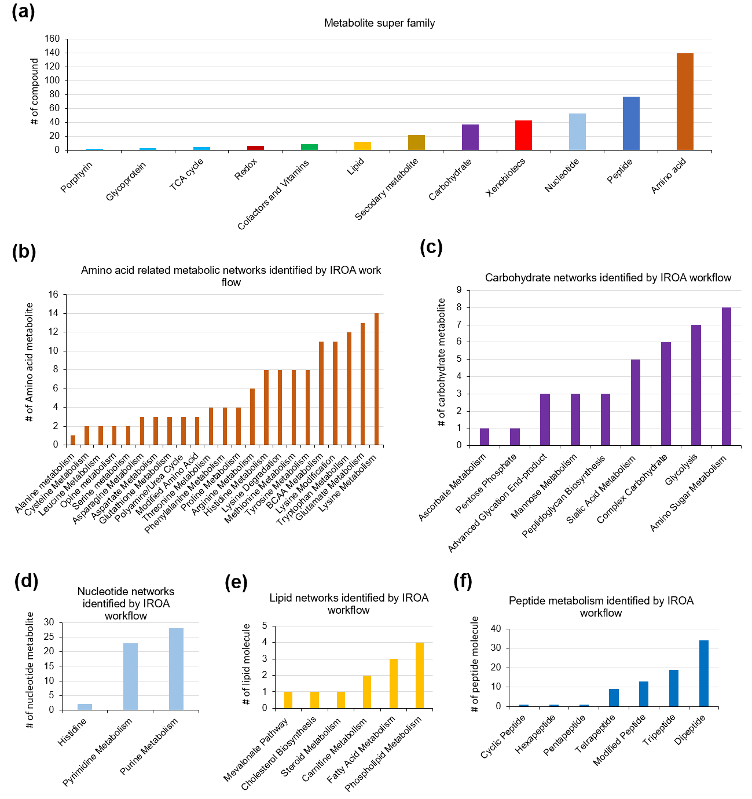
Supplementary Fig. 3 | Metabolite identified by IROA workflow. (a) Metabolite super family identified by IROA workflow. (b) Amino acid sub pathway identified by IROA workflow. (c) Carbohydrate related sub pathway identified by IROA workflow. (d) Nucleotide related sub pathway identified by IROA workflow. (e) Lipid related sub pathway identified by IROA workflow. (f) Peptide related metabolism identified by IROA workflow.

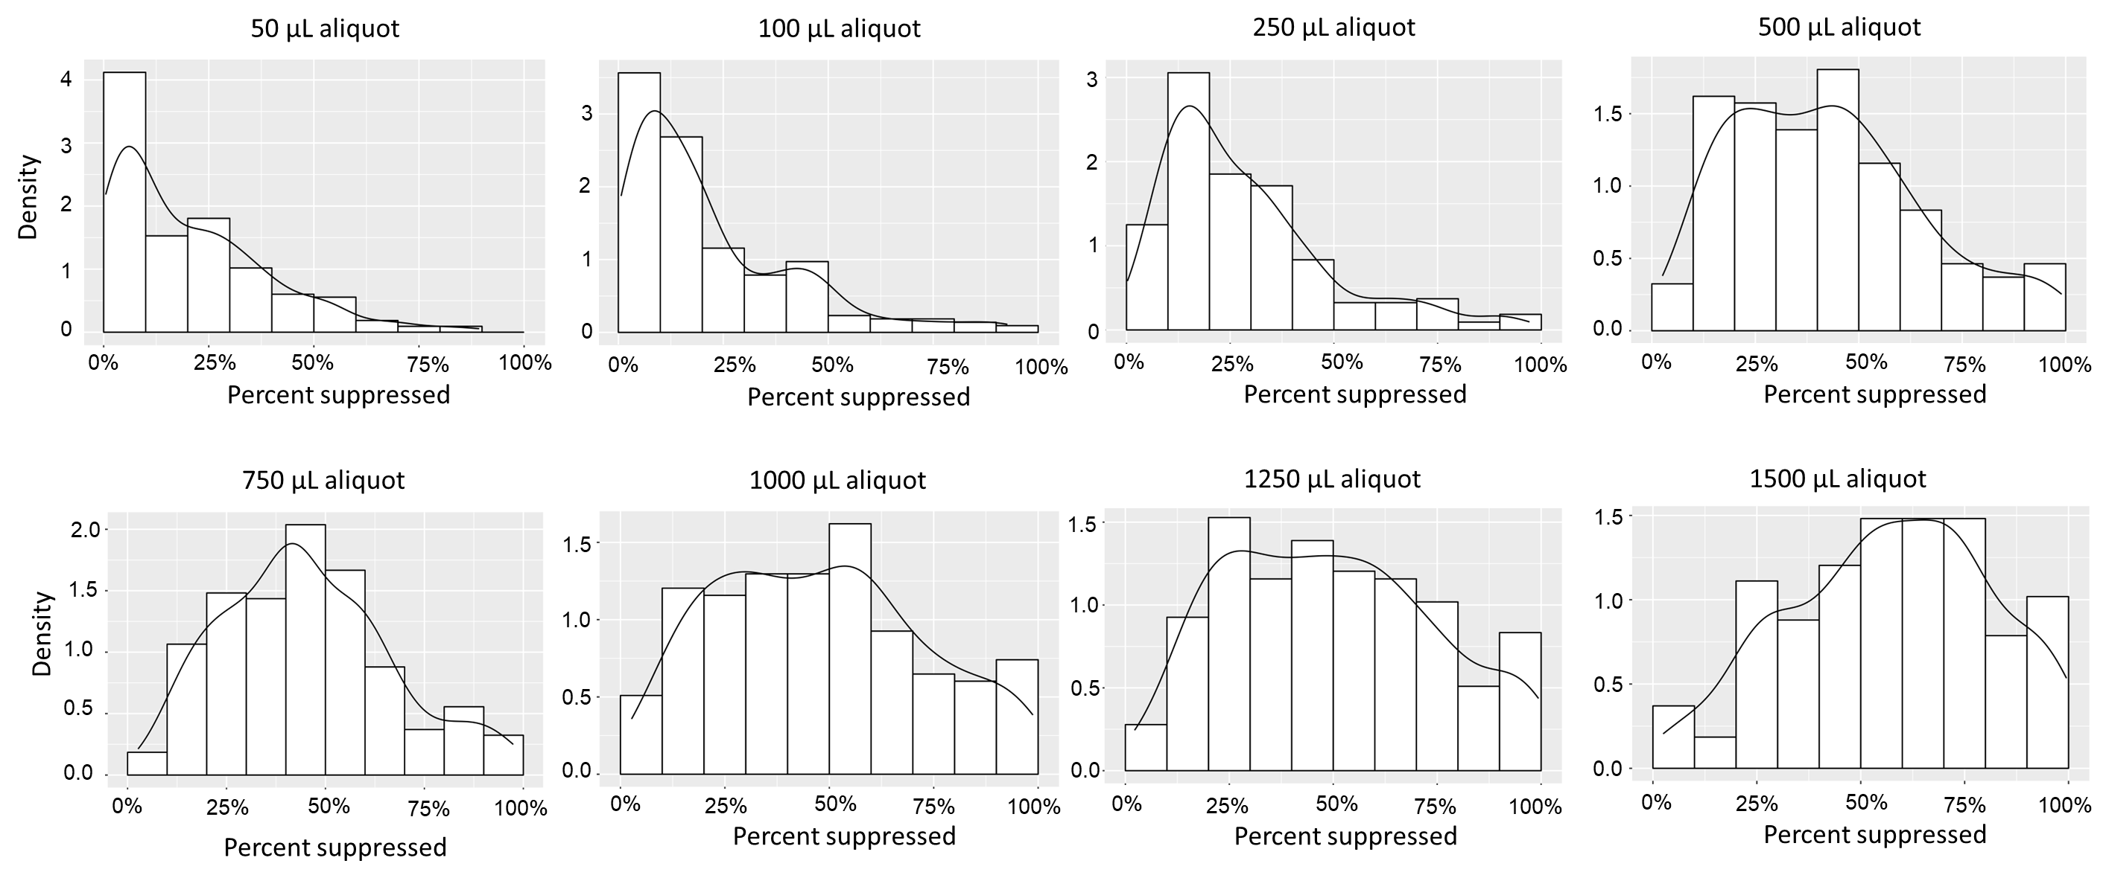
Supplementary Fig. 4 | Distribution of suppression level seen in different aliquots.

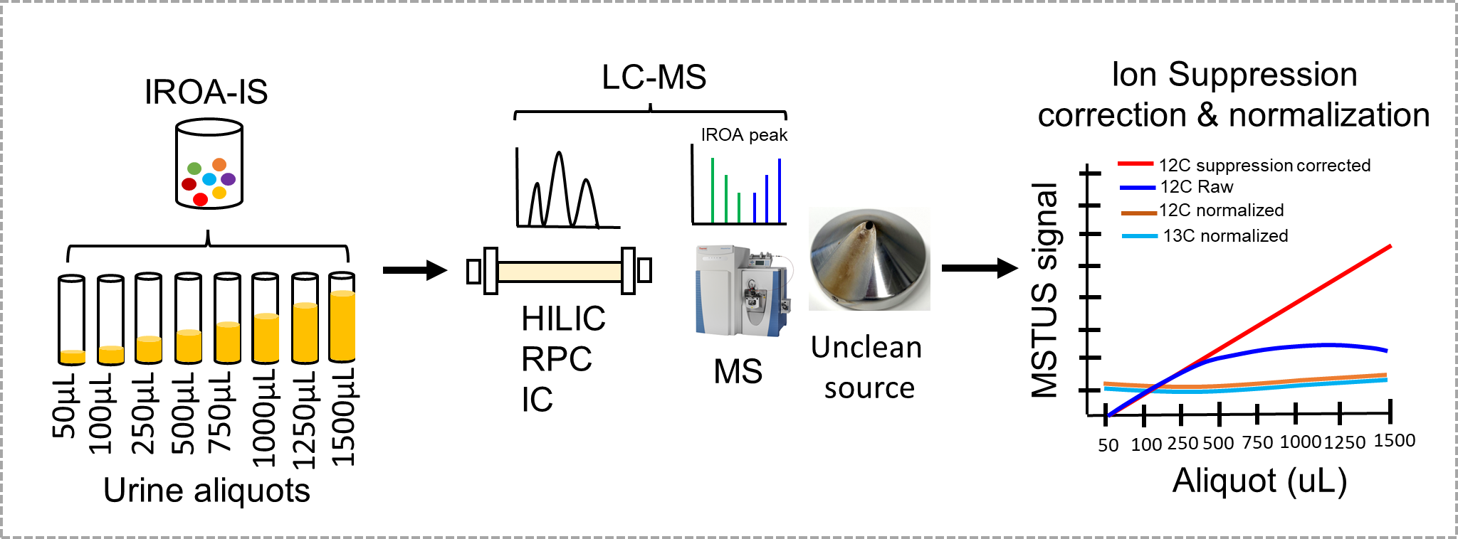
Supplementary Fig. 5 | Ion suppression correction by IROA Workflow in urine metabolomics across RPLC uncleaned system with positive and negative ion modes.

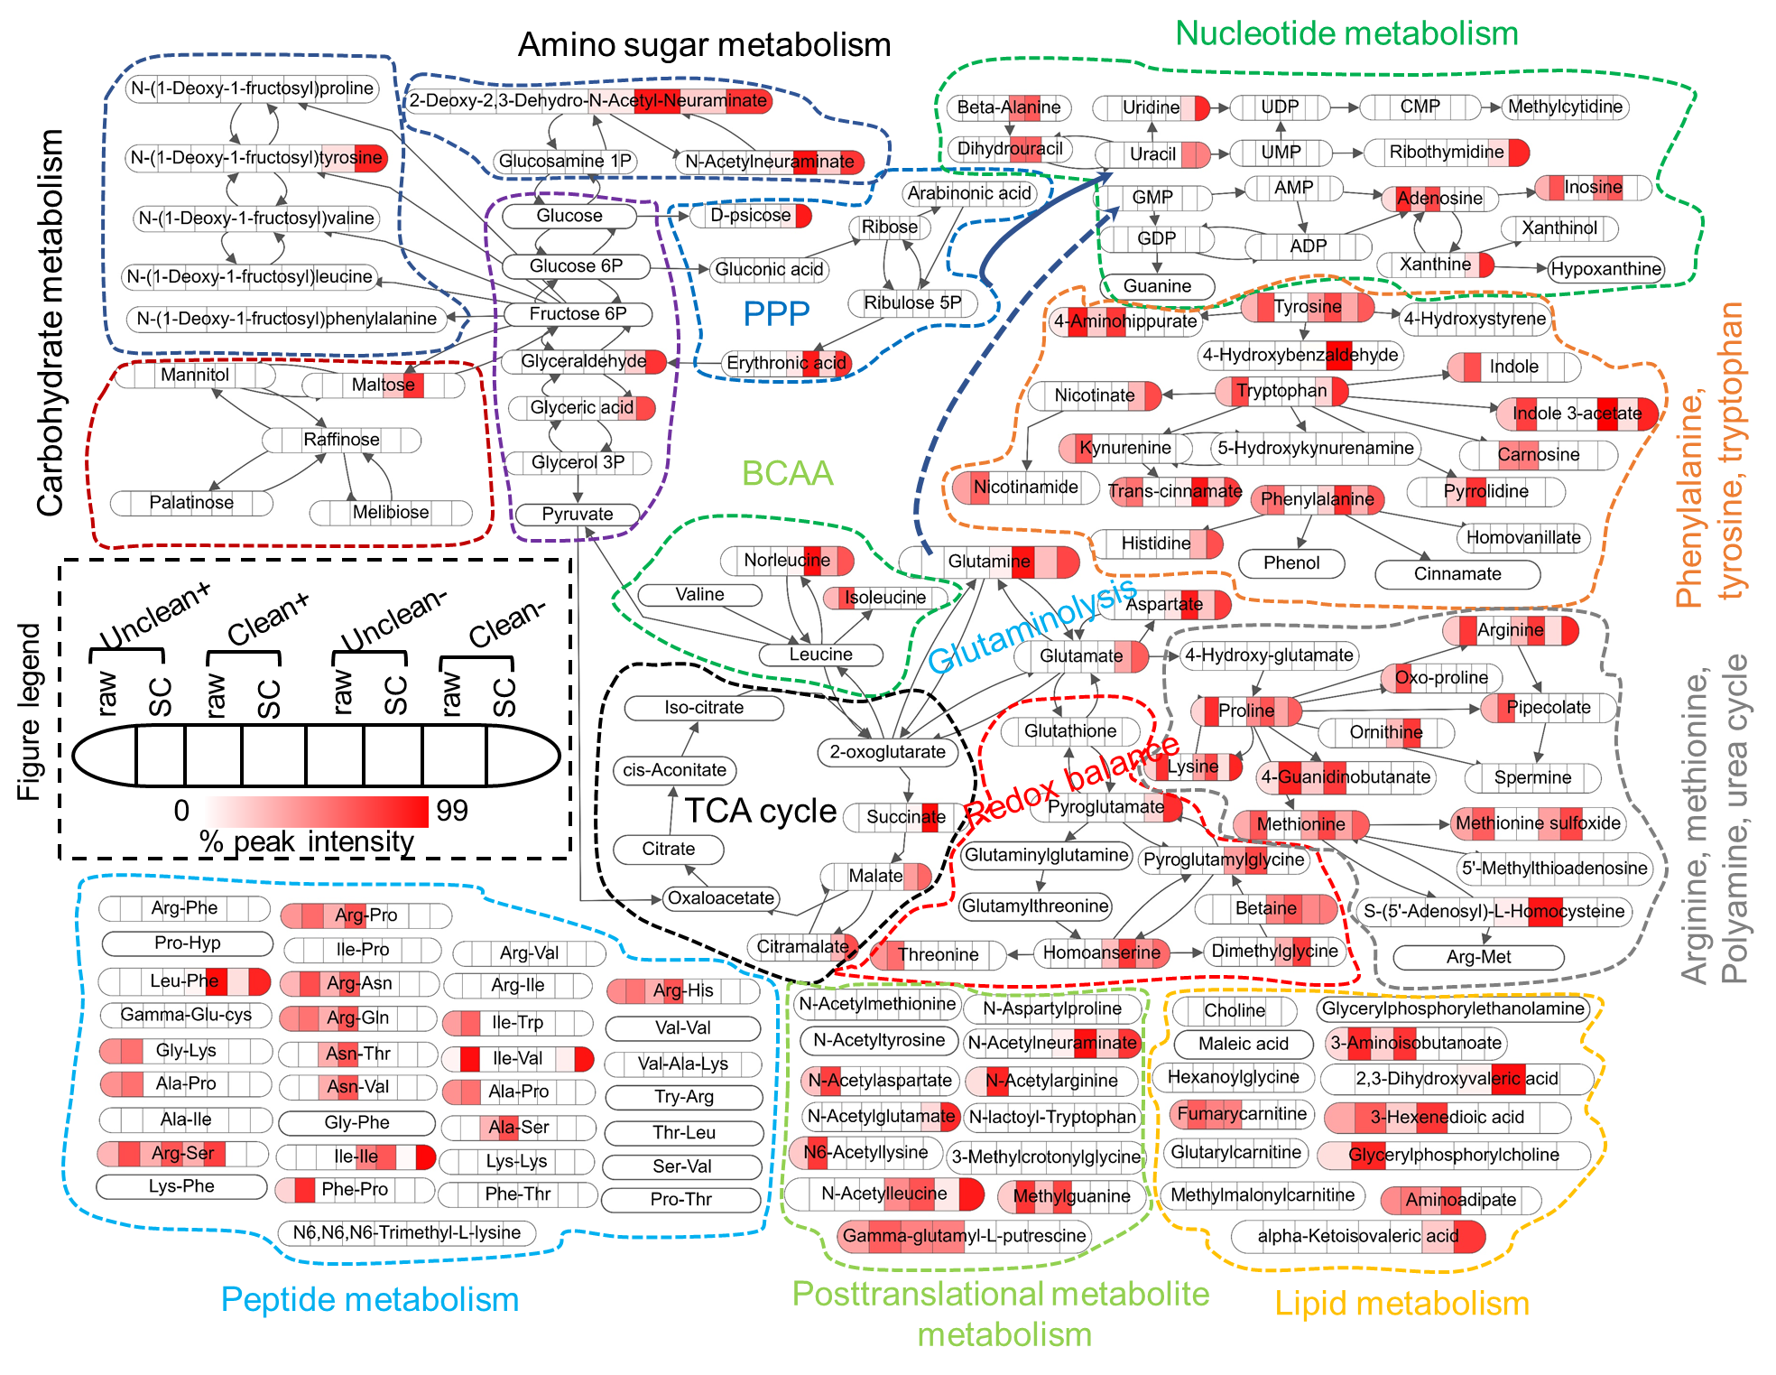
Supplementary Fig. 6 | The IROA Workflow correct and recover peak intensities of global metabolic pathways analyzed by different HILIC chromatography. Shown are metabolic pathways before (12C raw) and after ion suppression correction (12C suppression corrected) across different HILIC-based analytical methods and experimental conditions. Raw = 12C raw; SC= 12C suppression corrected; Uncleaned+ = Uncleaned positive ion mode; clean+ = clean positive ion mode; uncleaned- = uncleaned negative ion mode; cleaned- = cleaned negative ion mode. Data were drawn in SBGN (system biology graphical notation), Process Description (PD) and Activity Flow (AF) languages or Simple Interaction Format (SIF). Metabolites are color-coded based on the percent peak intensity.

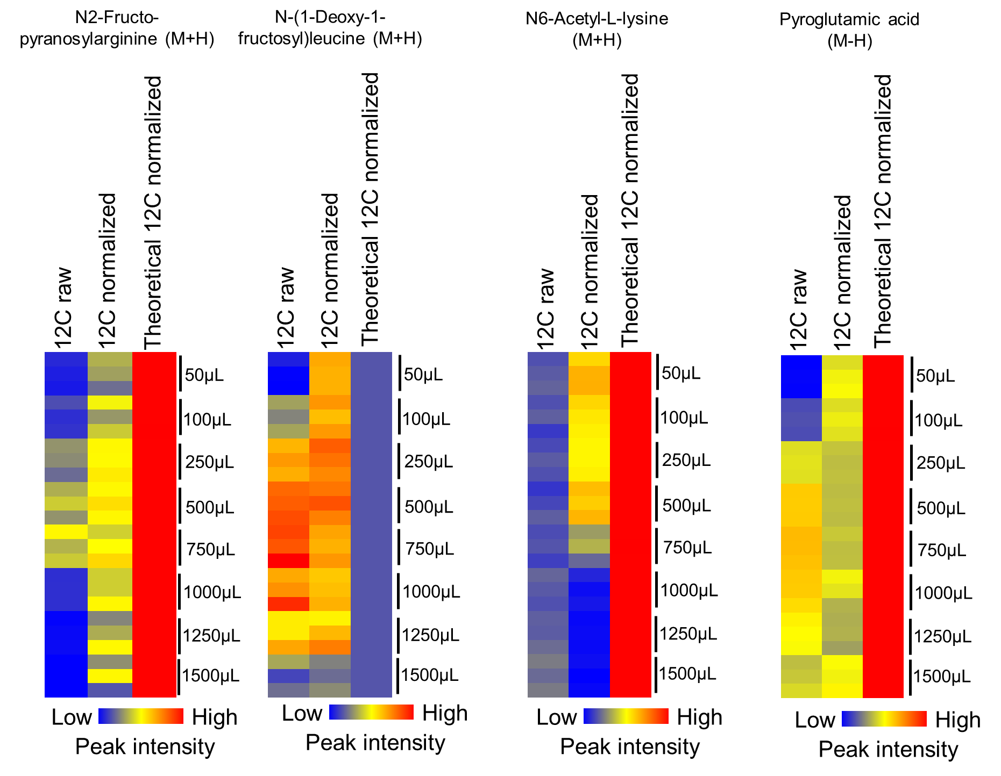
Supplementary Fig. 7 | Normalization Factor (NF) benefits metabolites that are not present in the IROA-IS. The application of the Normalization Factor (NF) to compounds that are not suppression corrected will normalize them but cannot correct for the ion suppression they have suffered. The normalized value is closer to the expected normalized value in all the analytes shown. Example analytes are shown from HILIC clean positive and negative mode data.

