An Optoelectrochemical Synapse based on the Single-component N-type Mixed Conductor
Yazhou Wang^{1#}, Wentao Shan^{1#}, Hanrui Li², Yizhou Zhong¹, Shofarul Wustoni¹, Johana Uribe¹, Tianrui Chang¹, Valentina E. Musteata³, Wan Yue⁴, Haifeng Ling⁵, Nazek El‐Atab², Sahika Inal¹*

¹ Organic Bioelectronics Laboratory, Biological and Environmental Science and Engineering Division, King Abdullah University of Science and Technology (KAUST), Thuwal 23955-6900, Saudi Arabia.
² Smart, Advanced Memory Devices and Applications (SAMA) Laboratory, Computer Electrical Mathematical Science and Engineering Division, King Abdullah University of Science and Technology (KAUST), Thuwal, 23955-6900, Saudi Arabia
³Imaging and Characterization Core Lab, King Abdullah University of Science and Technology (KAUST), Thuwal 23955-6900, Saudi Arabia
⁴School of Materials Science and Engineering, State Key Laboratory of Optoelectronic Materials and Technologies, Key Laboratory for Polymeric Composite and Functional Materials of Ministry of Education, Guangzhou Key Laboratory of Flexible Electronic Materials and Wearable Devices, Sun Yat-sen University, Guangzhou 510275, China.
⁵State Key Laboratory of Organic Electronics and Information Displays & Institute of Advanced Materials (IAM), Nanjing University of Posts & Telecommunications (NJUPT), Nanjing 210023, China

Email: sahika.inal@kaust.edu.sa

Section 1. Synthetic Procedures
Synthesis of monomers
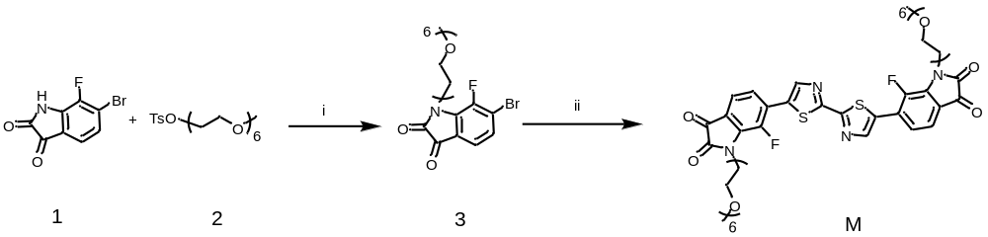
Fig. S1. Synthetic route to M. Reaction conditions: i) K₂CO₃, tetrabutylammonium bromide, DMF, RT; ii) Pd₂(dba)₃, P(o-tol)₃, toluene, reflux. Compound 1 and bis(trimethylstannyl)-bithiazole was purchased from Bide Pharmatech Co., Ltd., 2 and 3 was synthesized according to the literature¹.

Synthesis of M: 3 (200 mg, 0.384 mmol, 2.0 equiv.), bis(trimethylstannyl)-bithiazole (94.77 mg, 0.192 mmol, 1.0 equiv.), Pd₂(dba)₃ (8.78 mg, 9.6 x 10⁻³ mmol, 0.05 equiv.), and P(o-tol)₃ (17.56 mg) were added to a microwave vial. The tube was sealed and flushed with argon. Degassed toluene (5.0 mL) was added, and the mixture was further degassed for 5 mins. The reaction was then heated to 110 ℃ for 12 h. Toluene was removed under vacuum. The residue was purified by silica gel column chromatography to give 100.93 mg (50 %) M as a red-brown liquid.
¹H NMR (400 MHz, CDCl₃) δ 8.39 (s, 2H), 7.52 (d, J = 7.8 Hz, 2H), 7.41 (dd, J = 7.8, 5.5 Hz, 2H), 4.19 (t, J = 5.5 Hz, 4H), 3.83 (t, J = 5.2 Hz, 4H), 3.71 – 3.48 (m, 40H), 3.37 (s, 6H). ¹³C NMR (151 MHz, CDCl3, 300K) δ 181.36, 162.33, 158.35, 147.09, 144.88, 143.80, 138.48, 133.51, 129.33, 123.97, 123.42, 121.66, 119.62, 71.93, 68.21, 59.02, 42.08, 31.44, 30.20, 29.70, 29.32. HRMS (ESI): m/z: calculated for C₄₈H₆₀F₂N₄O₁₆S₂: 1051.3447 ([M+H]⁺⁾ found:1051.3501.
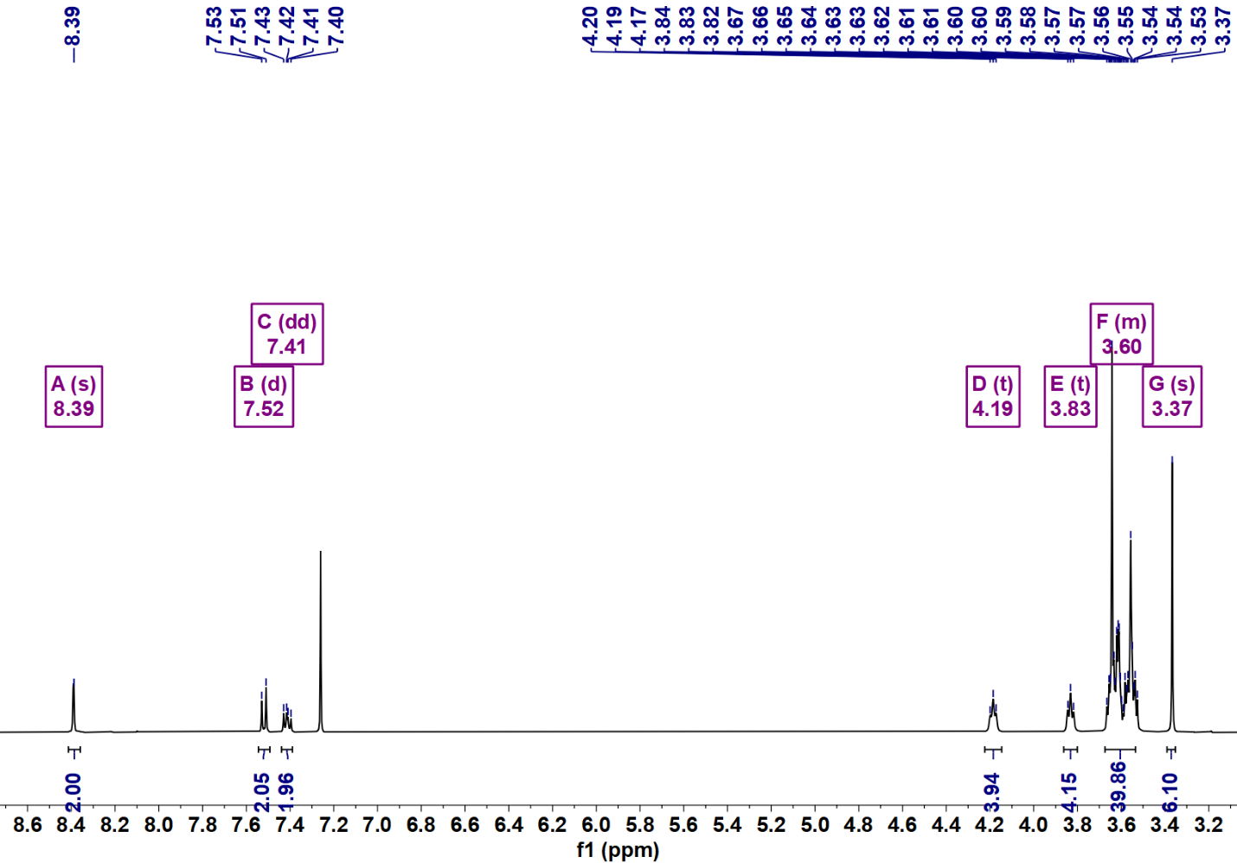
Fig. S2. ¹H NMR of M in CDCl₃ at 300 K.
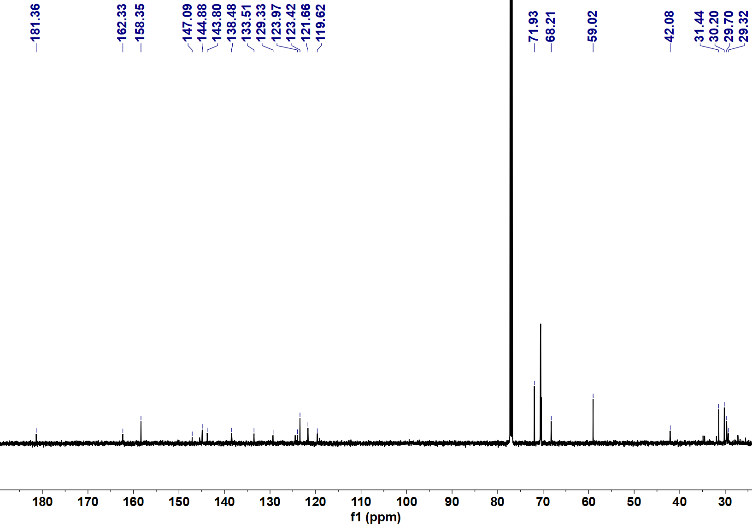
Fig. S3. ¹³C NMR of M in CDCl₃ at 300 K.
Polymer Synthesis
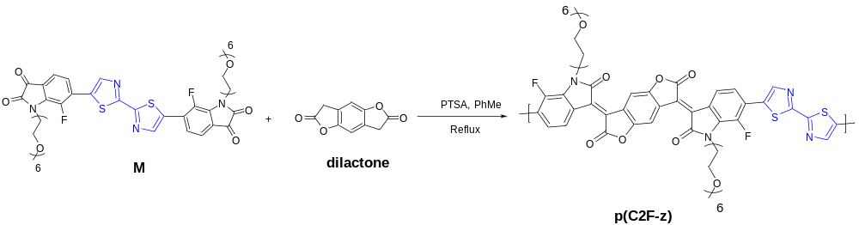
Fig. S4. Synthetic route of polymer p(C-gTBTT). Reaction conditions: p-toluenesulfonic acid (PTSA), toluene, reflux. 3,7-dihydrobenzo[1,2-b:4,5-b']difuran-2,6-dione (dilactone) was synthesized according to the literature.²
Synthesis of p(C2F-z): M (33.06 mg, 0.0315 mmol, 1.0 equiv.), dilactone (5.99 mg, 0.0315 mmol, 1.0 equiv.), and P-toluenesulfonic acid monohydrate (1.79 mg, 0.009 mmol, 0.3 equiv.) were added to a microwave vial. The tube was sealed, flushed with argon, and then degassed toluene (1.0 mL) was added. The tube was stirred at 110 ℃ for 12 h. After cooling to room temperature, the polymer was precipitated into around 100 mL methanol, and filtered through a Soxhlet thimble. The polymer was extracted using Soxhlet apparatus with methanol, acetone, hexane and chloroform. The chloroform fraction was concentrated and precipitated into methanol. The precipitates were filtered and dried under vacuum to afford p(C2F-z) as a black solid (22.82 mg，60 %), ¹H NMR (1,1,2,2-tetrachloroethane-d₂, 393K, 500 MHz), δ (ppm)：9.30-7.95(broad), 7.71-6.82 (broad), 5.00-2.69 (m). GPC shows Mn of 97.0 kDa with PD of 1.49.
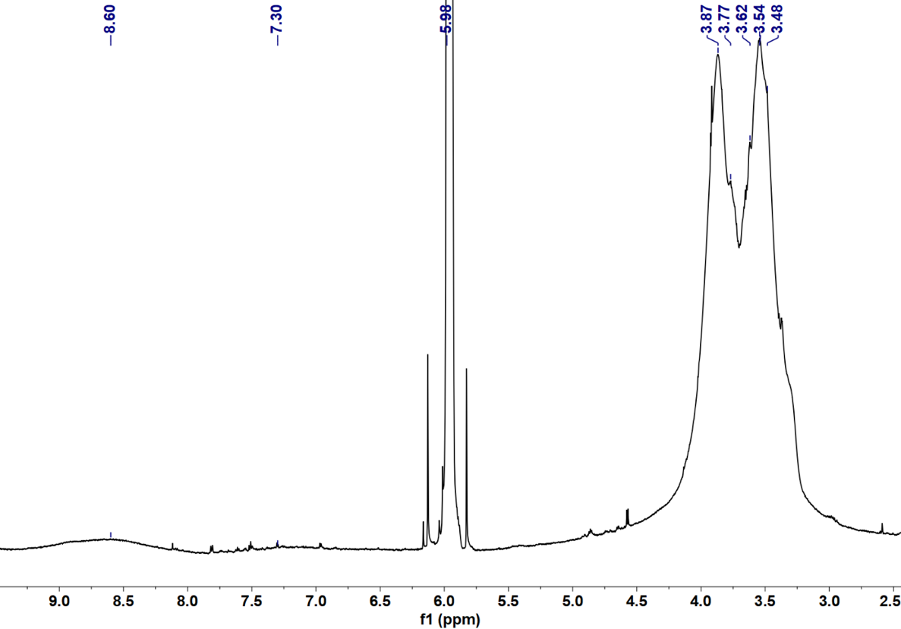
Fig. S5. ¹H NMR of p(C2F-z) in tetrachloroethane-d₂ at 393 K.
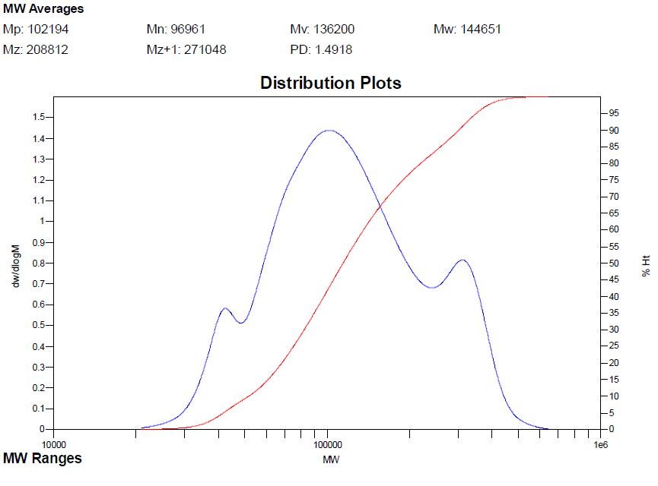
Fig. S6. GPC data recorded for the polymer p(C2F-z)
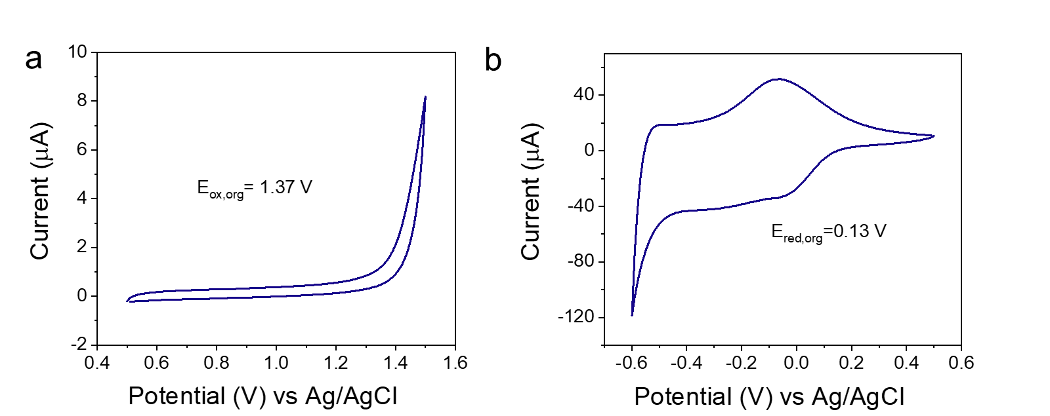
Fig. S7. Cyclic voltammetry curves showing the a) oxidation and b) reduction of p(C2F-z) using 0.1 M tetrabutylammonium phosphate in acetonitrile recorded at a scan rate of 100 mV/s. LUMO and HOMO levels were calculated according to the equation: LUMO = - (4.8 + E_{red,org} vs. Fc/Fc⁺ ) and HOMO = -(4.8 + E_{red,org} vs. Fc/Fc⁺). The E_{red,org} and E_{ox,org} represent the reduction potential onset and oxidation potential onset. The E_{red,org} and E_{ox,org} are 0.13 V and 1.37 eV, respectively. The onset of Fc/Fc⁺ reduction peak is 0.44 V. The obtained LUMO level of the film is 4.49 eV, and the HOMO is 5.73 eV. The optical band gap (E_{ox, org}) is 1.24 eV according to the equation: E_{g}=LUMO-HOMO.

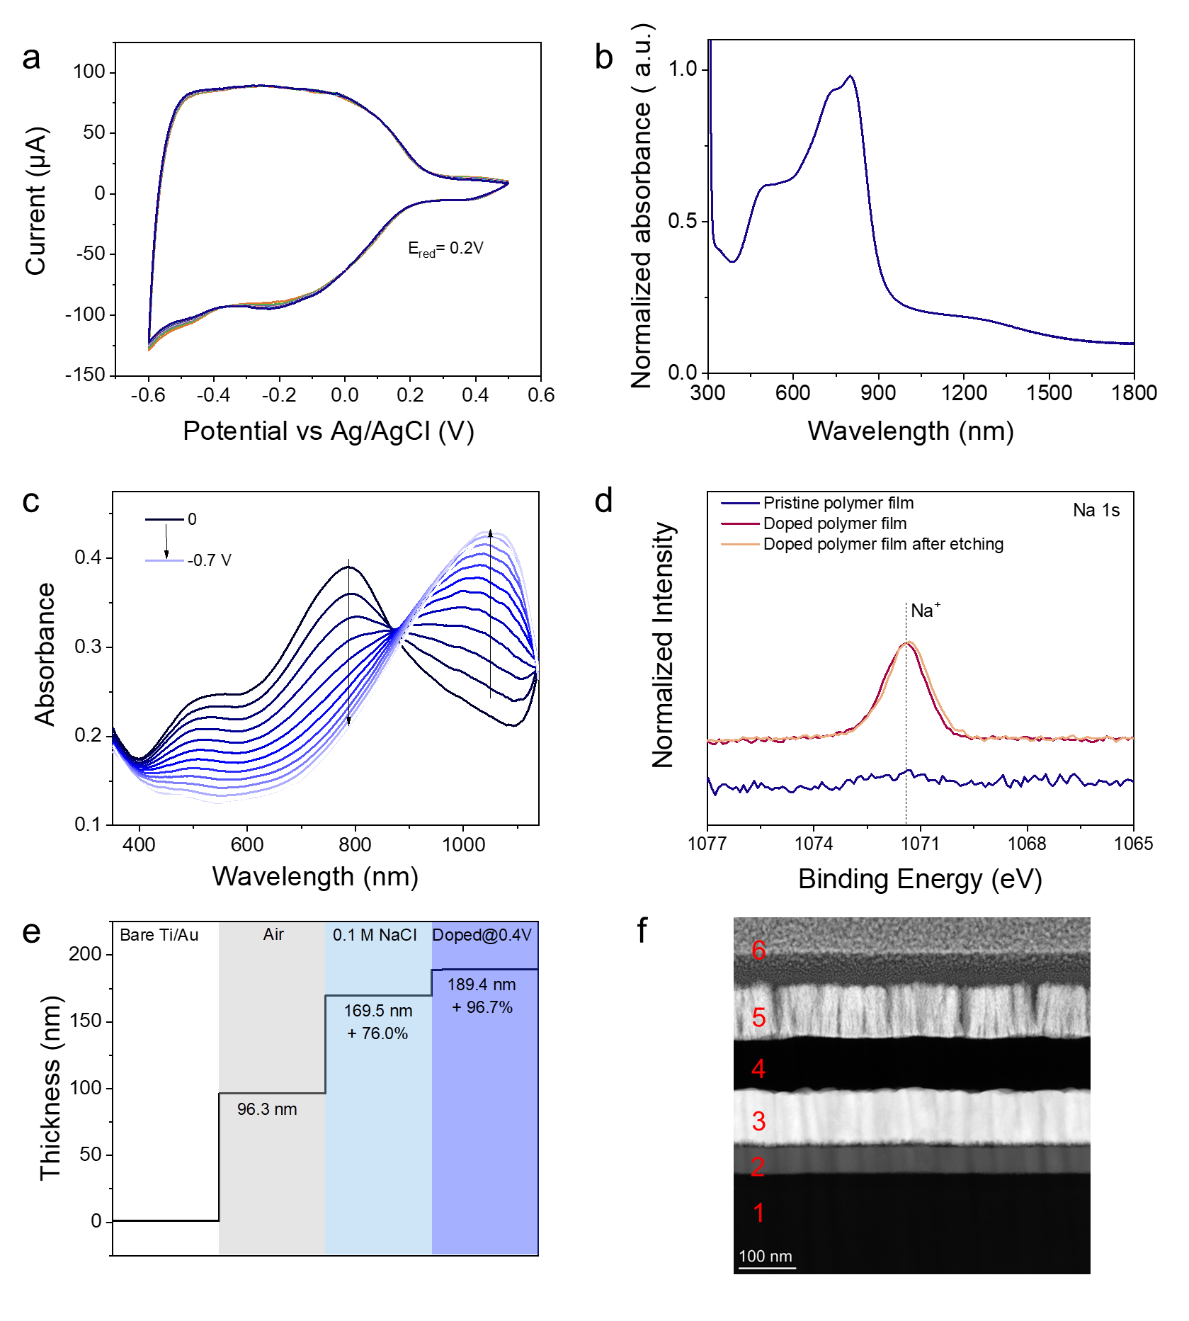
Fig. S8. a) CV curve of the polymer film coated on an ITO substrate recorded in aqueous 0.1 M NaCl. The reduction onset is ca. 0.20 V. b) UV–VIS–NIR absorption spectrum of the film in the dry state, with absorbance values normalized to the maximum absorption intensity at 802 nm. The spectrum exhibits a dual-band profile, featuring a high energy band ranging from 400 to 640 nm and a low energy band spanning from 640 to 1100 nm. The low energy band displays both asymmetric main peaks and accompanying shoulders. c) UV–VIS–NIR absorption spectra of the film acquired by immersing it in 0.1 M electrolyte and applying doping voltages using an Ag/AgCl reference electrode. The undoped state of p(C2F-z) manifests the distinctive absorption features typically observed in lactone-based materials, i.e., two peaks at ca. 522 nm and 786 nm. These peaks correspond to the π-π* transition and the intramolecular charge transfer (ICT), respectively. Polarizing the film with increasingly negative voltages leads to a gradual decrease in the absorption intensity of these peaks. Concurrently, a new feature becomes apparent at around 1050 nm, attributed to polaronic species. d) The XPS spectra of Na 1s of the pristine film, the film doped in NaCl solution, and the doped film after etching. Na⁺ is found in the film only upon doping. By performing XPS etching analysis, we further monitored how far the cations penetrated and distributed in the polymer film during doping. After etching the surface for 4 min, we observed a similar intensity of Na⁺ compared to the outer surface of the film. e) The film thickness change when it is first exposed to NaCl and then under the electrochemical doping, monitored using eQCM-D. The polymer film experienced an 76.0% increase of its initial thickness when exposed to the electrolyte. Doped at -0.4 V, the film swelled more, up to 96.7% due to the ingress of ions and water molecules. f) A cross-sectional scanning transmission electron microscopy image of a p(C2F-z) film on the gold electrode. 1: glass substrate; 2: ITO layer: 3: gold layer; 4: polymer film; 5: Pt sputter-coated layer; 6: Pt FIB-coated layer. The image indicates a relatively smooth and uniform polymer film with a thickness of around 80-90 nm.

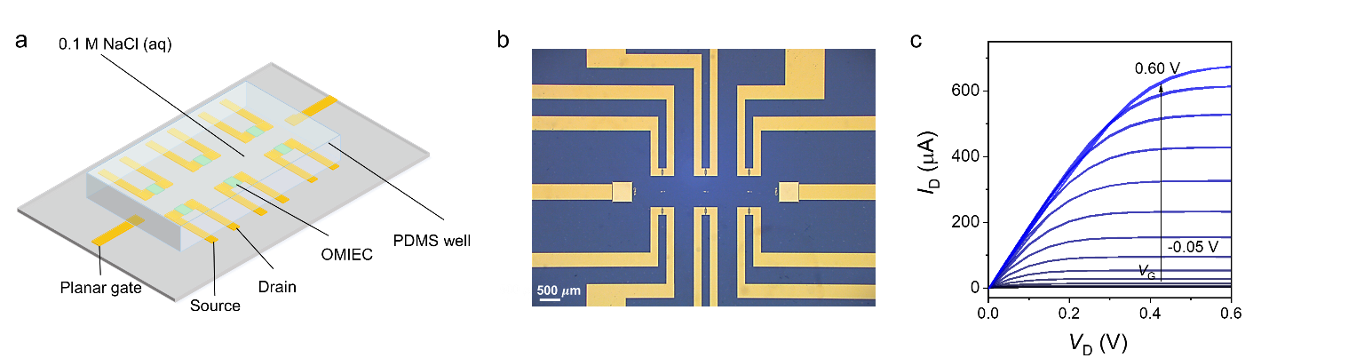
Fig. S9. a) Schematic representation of OECTs with six channels and two lateral gate electrodes, b) the microscope image of OECT device, c) the output (I_{D}–V_{D}) characteristics of p(C2F-z) OECT.
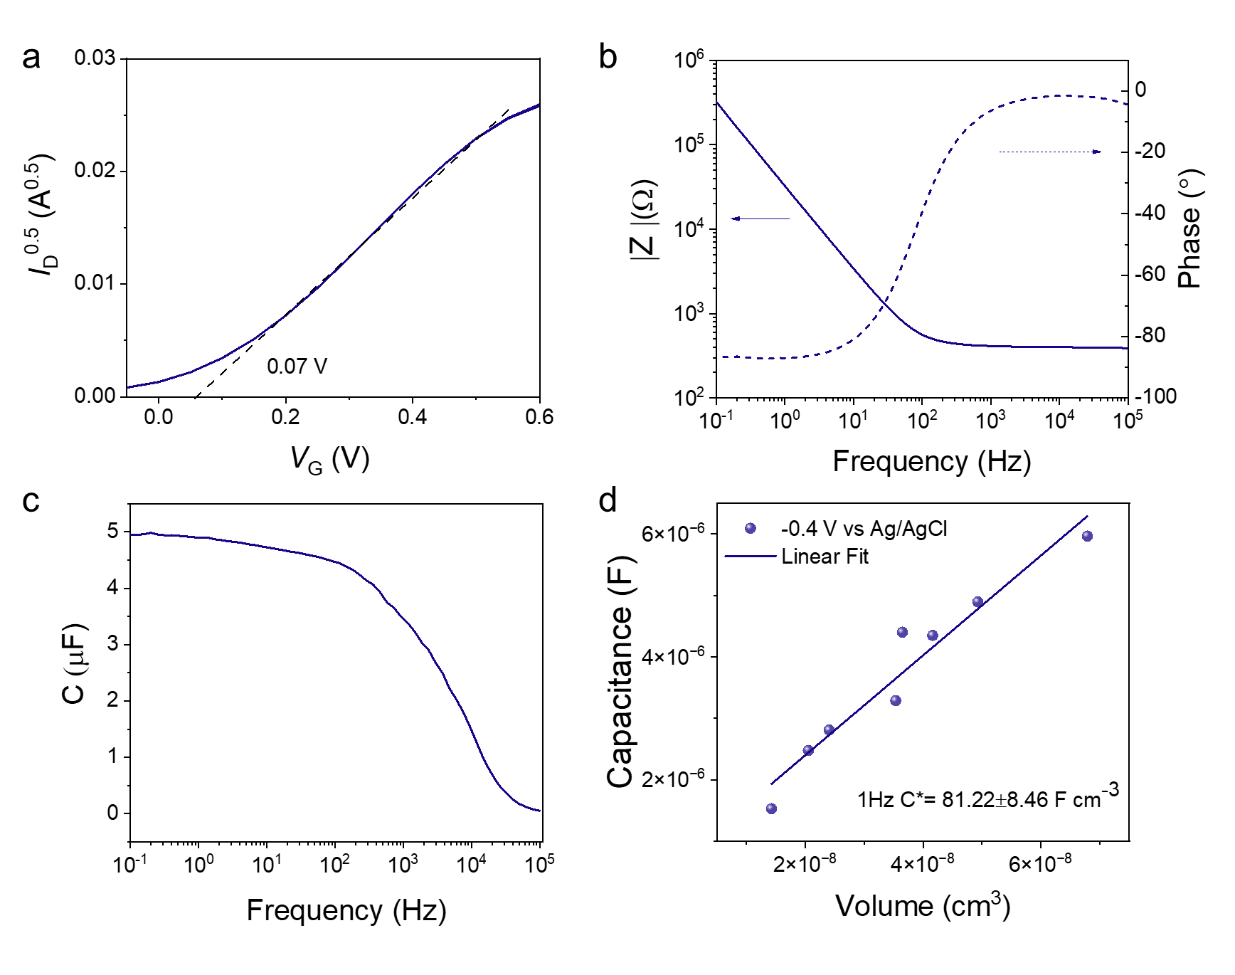
Fig. S10. a) I_{D}^{0.5} versus V_{G} curves showing the linear fit to extract the V_{TH} values. b) Bode plot (|Z| vs. frequency, and phase vs. frequency) and c) effective capacitance spectrum of an electrochemically doped p(C2F-z) film. The data were recorded at an offset bias (V_{offset}) of -0.4 V vs. Ag/AgCl. d) The effective volumetric capacitance of p(C2F-z). Values were reported at f = 1 Hz and C* was calculated from the linear fit.

Table S1. Summary of device performance metrics and materials transport properties.
Polymer | g_{m,norm}ª  (s cm⁻¹) | d  (nm) | V_{TH}^{b}  (V) | $μ$C*^{c}  (F V⁻¹ cm⁻¹ s⁻¹) | C*^{d}  (F cm⁻³) | $μ$^{e}  (cm² V⁻¹ s⁻¹) |  | $τ$_{ON}  $$(μs)$$ | $τ$_{OFF}  ($μ$s)
p(C2F-z) | 25.94 ± 4.38 | 79 ± 15 | 0.07 | 84.65 ± 8.34 | 81.22 ± 8.46 |  | 1.04 | 365± 23 | 71 ± 8
ª calculated according to g_{m,norm} = g_{m} W⁻¹ L d⁻¹; ^{b} determined by extrapolating the linear regime of the I_{D}^{1/2}~V_{G} plot; ^{c} extracted from the slope of the linear fit to g_{m} vs. (Wd/L)(V_{TH} - V_{G}) plot; ^{d} extracted from the electrochemical impedance spectra; ^{e} calculated from the $μ$C* using the C*. All OECTs were operated in a 0.1 M NaCl aqueous solution in ambient conditions using Ag/AgCl gate. Average values were calculated from 5 operational channels.

Table S2. Comparison of the performance of the OECTs developed in this work and the other n-type OECTs
Polymer | g_{m}  (S/cm) | $μ$C*  (F V⁻¹ cm⁻¹ s⁻¹) | $$μ$$  (cm² V⁻¹ s⁻¹) | V_{TH}  (V) | $τ$_{ON}  (ms) | ref
2DPP-OD-TEG | 0.73 | 7 | 0.048 | 0.89 | NA | 3
p(N-T) | 0.72 | 4.3 | 0.059 | 0.25 | NA | 4
p(C-T) | 0.80 | 6.7 | 0.069 | 0.43 | NA | 4
P(gPzDPP-CT2) | 0.43 | 1.72 | 0.019 | 0.32 | 3.0 | 5
f-BTI2TEG-FT | 4.6 | 15.20 | 0.034 | 0.68 | 272 | 6
BBL₁₅₂ | 11.1 | 25.9 | 0.040 | 0.15 | 0.38 | 7
P(g7NC10N) | 0.370 | 1.83 | 0.012 | 0.3 | NA | 8
f-BTI2g-TVTCN | 12.8 | 41.3 | 0.240 | 0.68 | 68 | 9
P(gTDPP2FT) | 15.34 | 54.8 | 0.350 | 0.64 | 1.75 | 10
gNDI-V | 0.42 | 2.31 | 0.014 | 0.30 | 2.90 | 11
gAIID-2FT | 0.941 | 4.09 | 0.049 | 0.45 | 58.5 | 12
p(C-V) | 1.81 | 14.89 | 0.090 | 0.17 | 1.201 | 1
p(C2F-V) | 25.67 | 107.56 | 0.912 | 0.02 | 0.336 | 1
f-BTI2g-SVSCN | 46.7 | 146.2 | 0.350 | 0.7 | 7.3 | 13
f-BseI2g-SVSCN | 69.7 | 187.6 | 0.360 | 0.68 | 5.1 | 13
PANDA | 14.7 | 39.6 | 0.219 | 0.44 | 2.34 | 14
PANDA2 | 19.2 | 51.4 | 0.261 | 0.47 | 1.00 | 14
P(PyV) | NA | 112 | 0.230 | 0.5 | 14.2 | 15
p(C2F-z) | 25.94 | 84.65 | 1.040 | 0.07 | 0.365 | This work
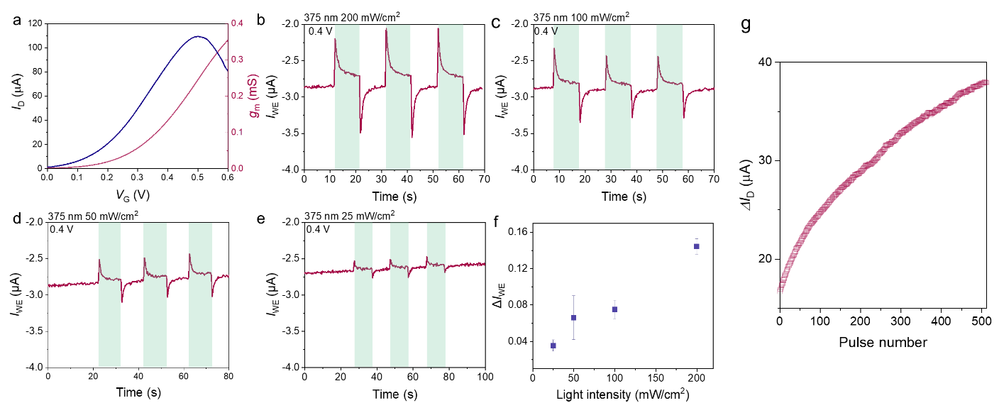
Fig. S11. a) The transfer characteristics of Au gated p(C2F-z) OECT measured in the dark and the corresponding g_{m} vs. V_{G}. V_{D}= 0.6 V. The current response of p(C2F-z) thin film coated on ITO when illuminated with a 375 nm LED at an intensity of b) 200 mW cm⁻², c) 100 mW cm⁻², d) 50 mW cm⁻², and e) 25 mW cm⁻². During the light exposure, the film was electrochemically held at a doping voltage of 0.4 V vs. Ag/AgCl. f) The current change as a function of light intensity. The current change value is derived from the average of three current readings according to Fig. S11b-d. g) The device current change as a function of pulse number. The current was modulated with 512 light pulses (200 mW cm⁻², the pulse width t_{p} = 0.1 s, the pulse interval ∆t = 0.05 s)
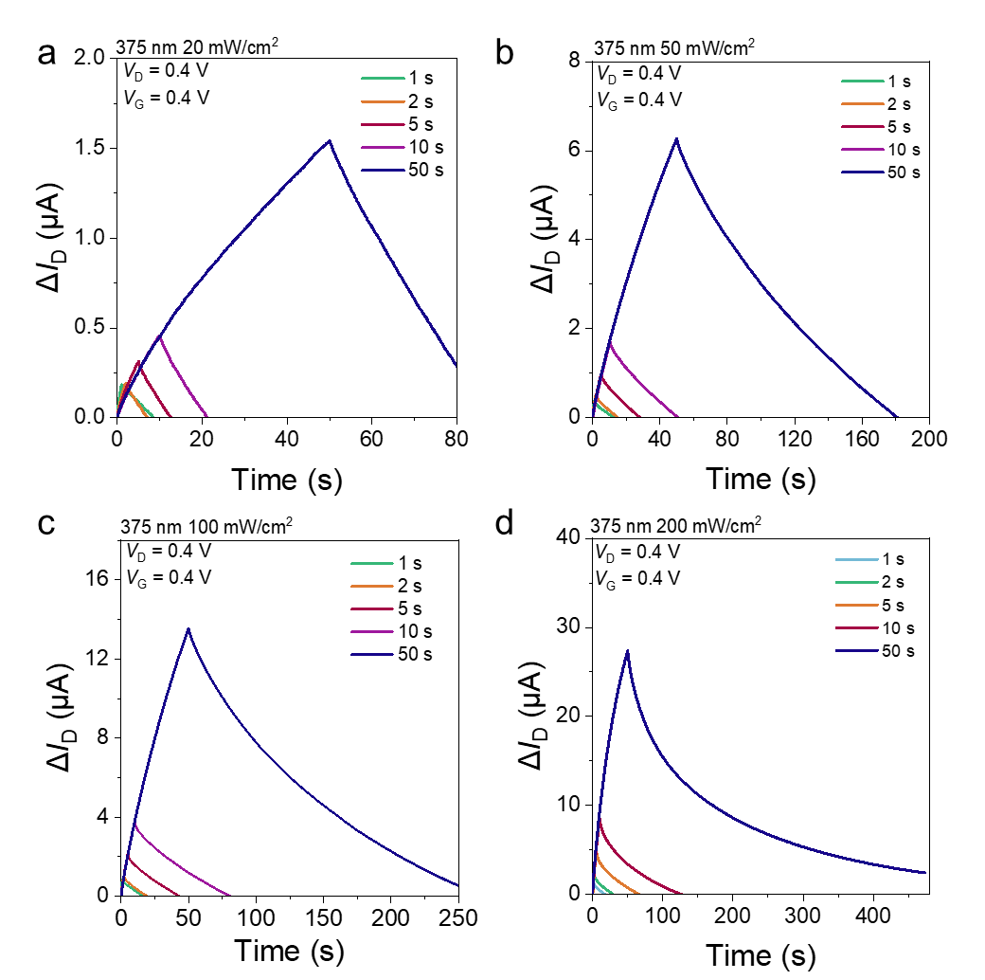
Fig. S12. The photonic response with various illumination times ranging from 1 s to 50 s under an intensity of a) 20 mW cm⁻², b) 50 mW cm⁻², c) 100 mW cm⁻², d) 200 mW cm⁻². V_{D} = V_{G} = 0.4 V.

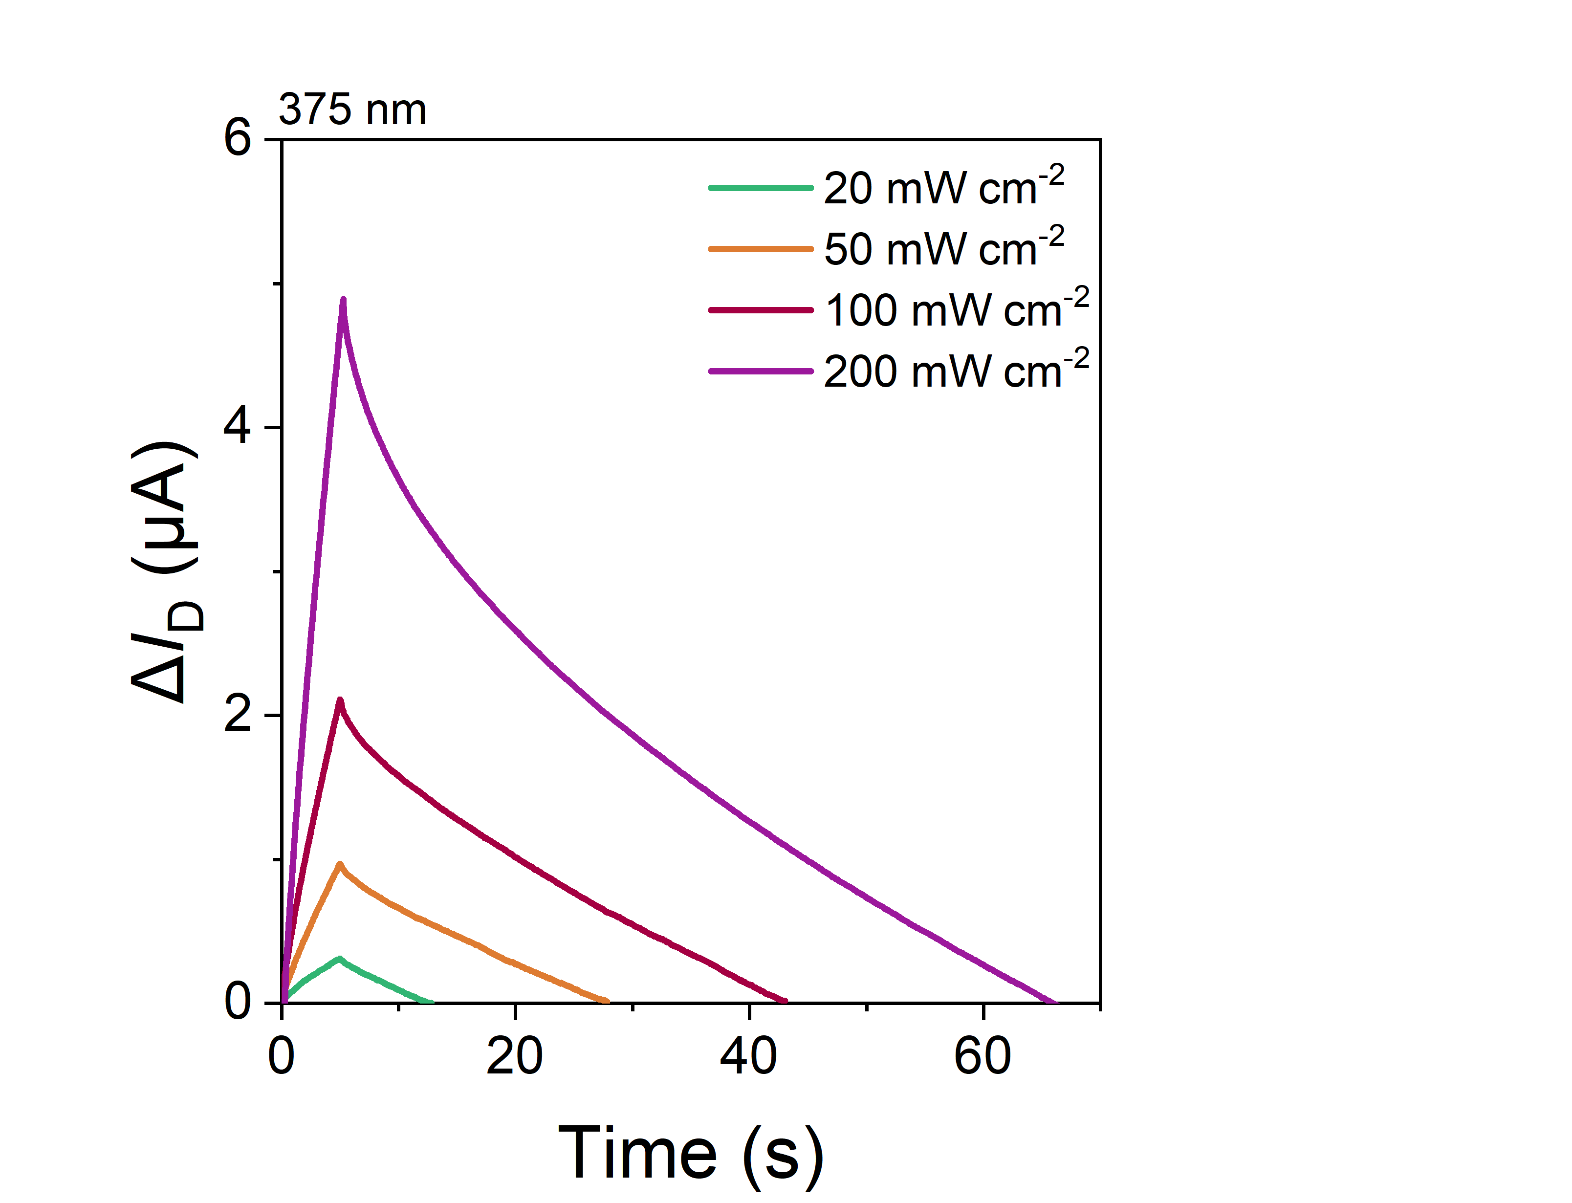
Fig. S13. The photonic response with illumination time of 5 s under different light intensities. V_{D} = V_{G} = 0.4 V.
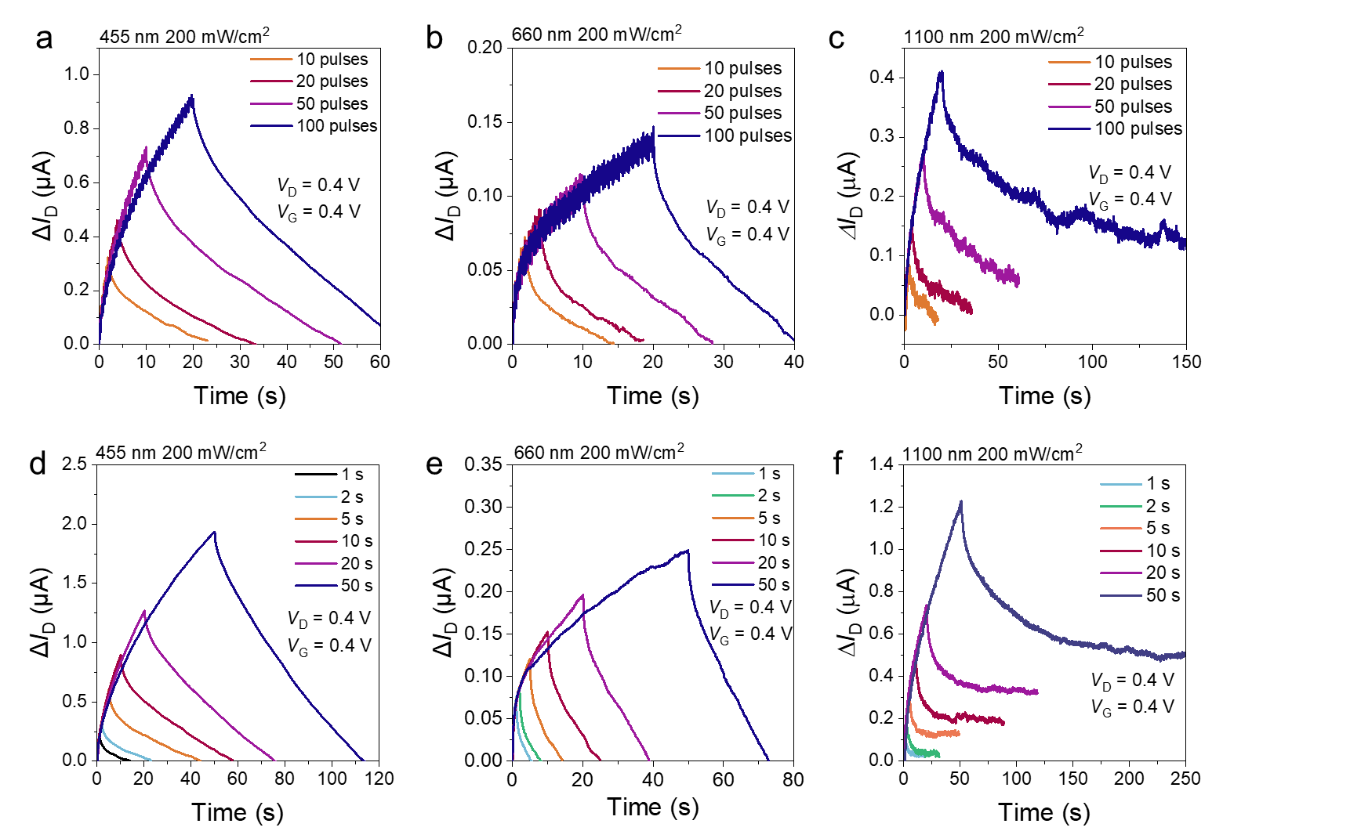
Fig. S14. The device response to various light pulse numbers a-c) and duration time d-f). The light source in a) and d) is at 455 nm; in b) and e) is at 660 nm, and c) and f) is at 1100 nm. V_{D} = V_{G} = 0.4 V.
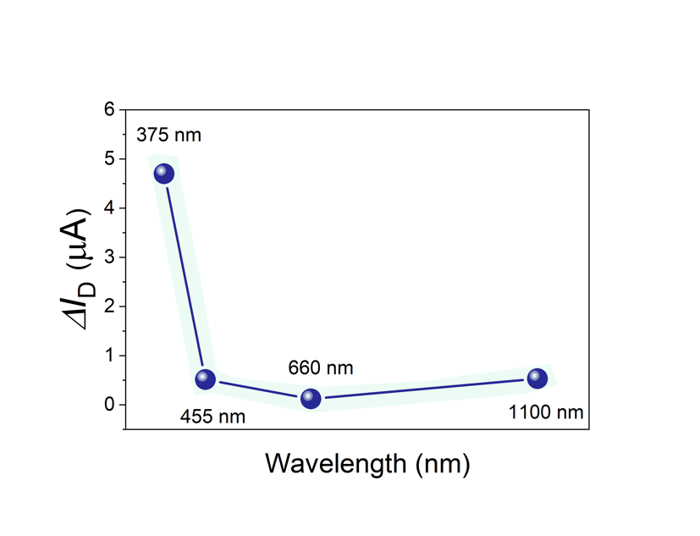
Fig. S15. The channel current change as a function of the wavelength of the light source. The illumination length is 5s and its intensity is 200 mW cm⁻². V_{D} = V_{G} = 0.4 V.
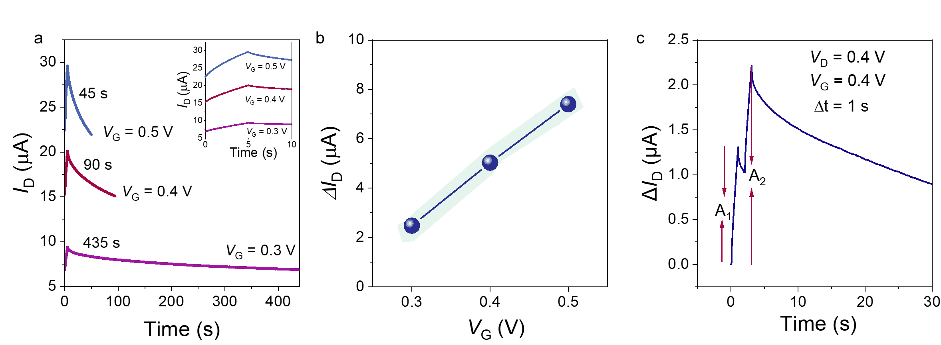
Fig. S16. a) The device current-time profile recorded at different gate voltages as a light source at 375 nm with an intensity of 200 mW cm⁻² is switched on for 5 s. V_{D} = 0.4 V. The inset demonstrates a zoomed in profile of the first 10 seconds. The recovery time of the current is noted as 45 s, 90 s, and 435 s for V_{G} 0.5, 0.4, and 0.3 V, respectively. b) The photonic current obtained at different gate voltages. c) PPF profile obtained at t_{p}=1 s, V_{D} = V_{G} = 0.4 V.
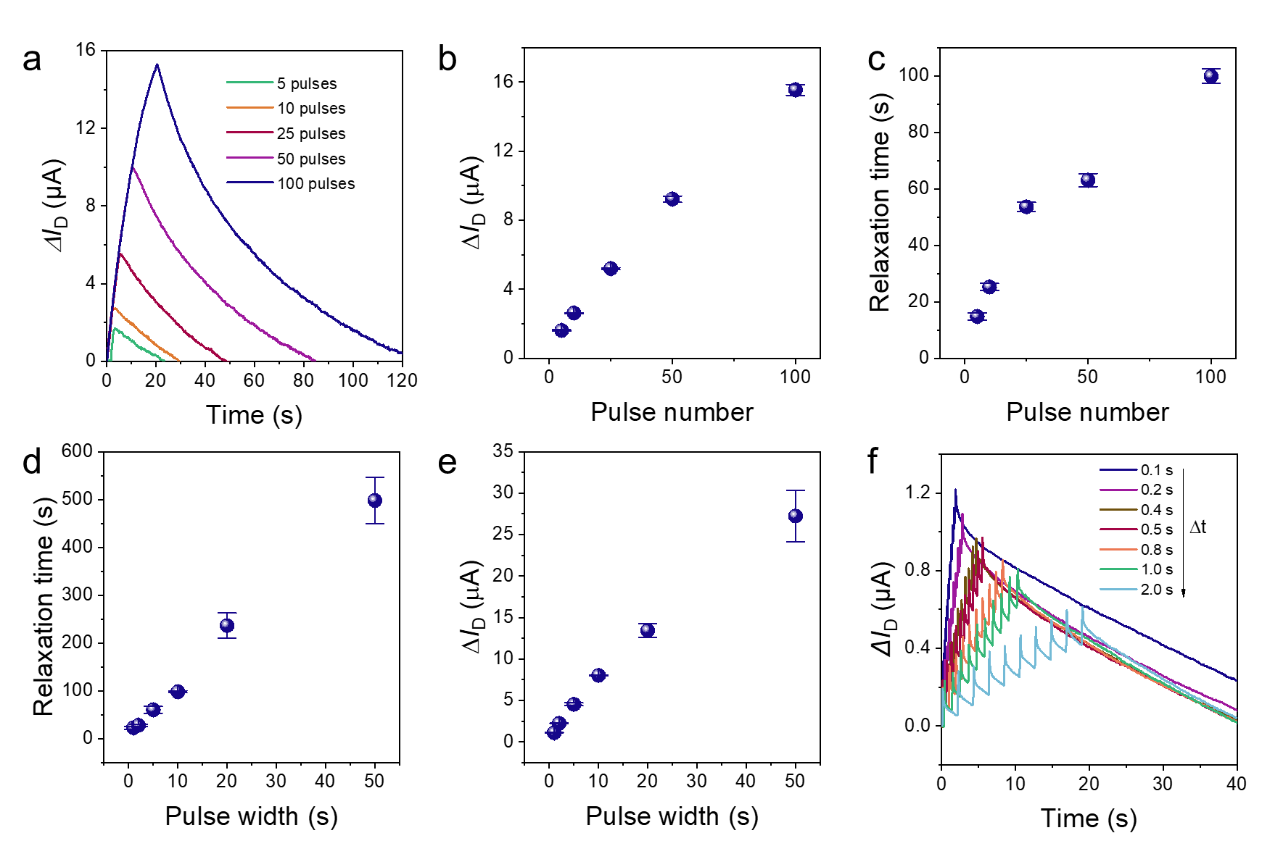
Fig. S17. a) The photonic current-time profile in response to various light pulse numbers (200 mW cm⁻², t_{p} = 0.1 s, ∆t = 0.1 s). b) the photonic current as a function of pulse number, c) the current relaxation time as a function of pulse number. d) the current relaxation time as a function of pulse width and e) the photonic current as a function of pulse width. f) The photonic current-time profile in response to various pulse intervals (200 mW cm⁻², t_{p} = 0.1 s) In all plots, the error bars represent data from four measurements.
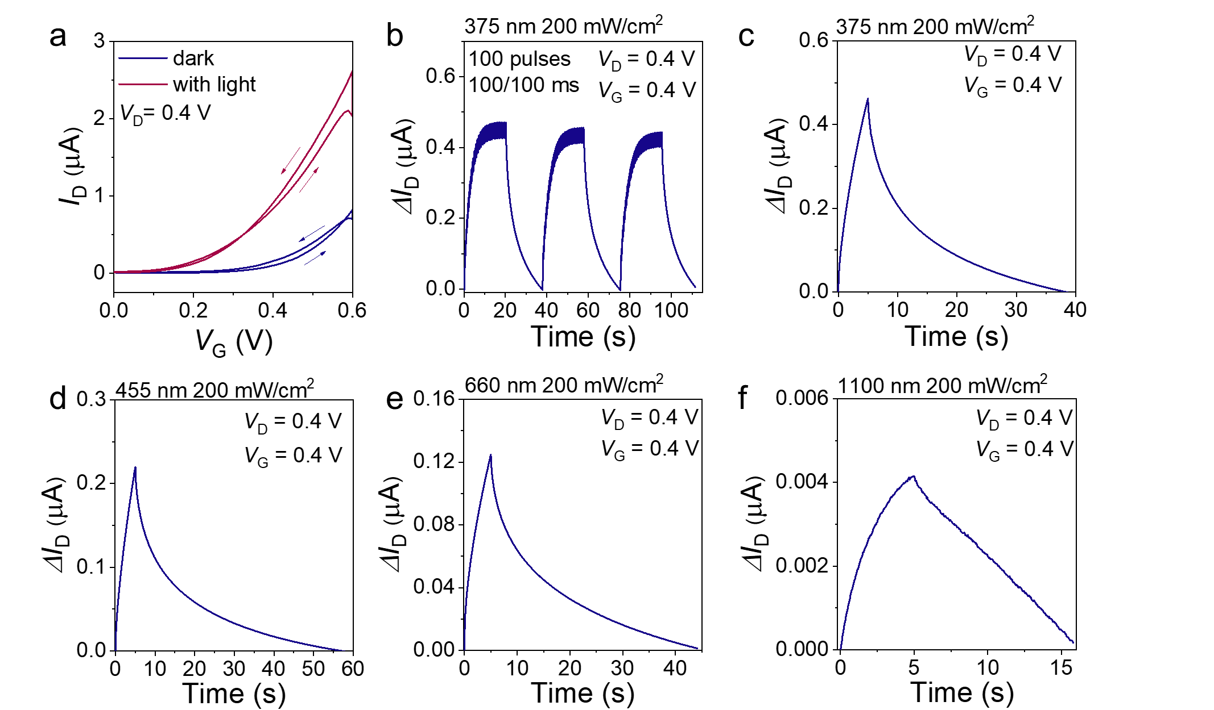
Fig. S18. a) The transfer characteristics of BBL-based OECT before and after light illumination using gold as the gate electrode. The light intensity is 200 mW cm⁻². b) The device current was written by 100 light pulses (200 mW cm⁻², the pulse width t_{p} = 0.1 s, the pulse interval ∆t = 0.1 s). The photonic current upon illumination for 5 s with a light intensity of 200 mW cm⁻²: c) 375 nm, d) 455 nm, e) 660 nm and f) 1100 nm.
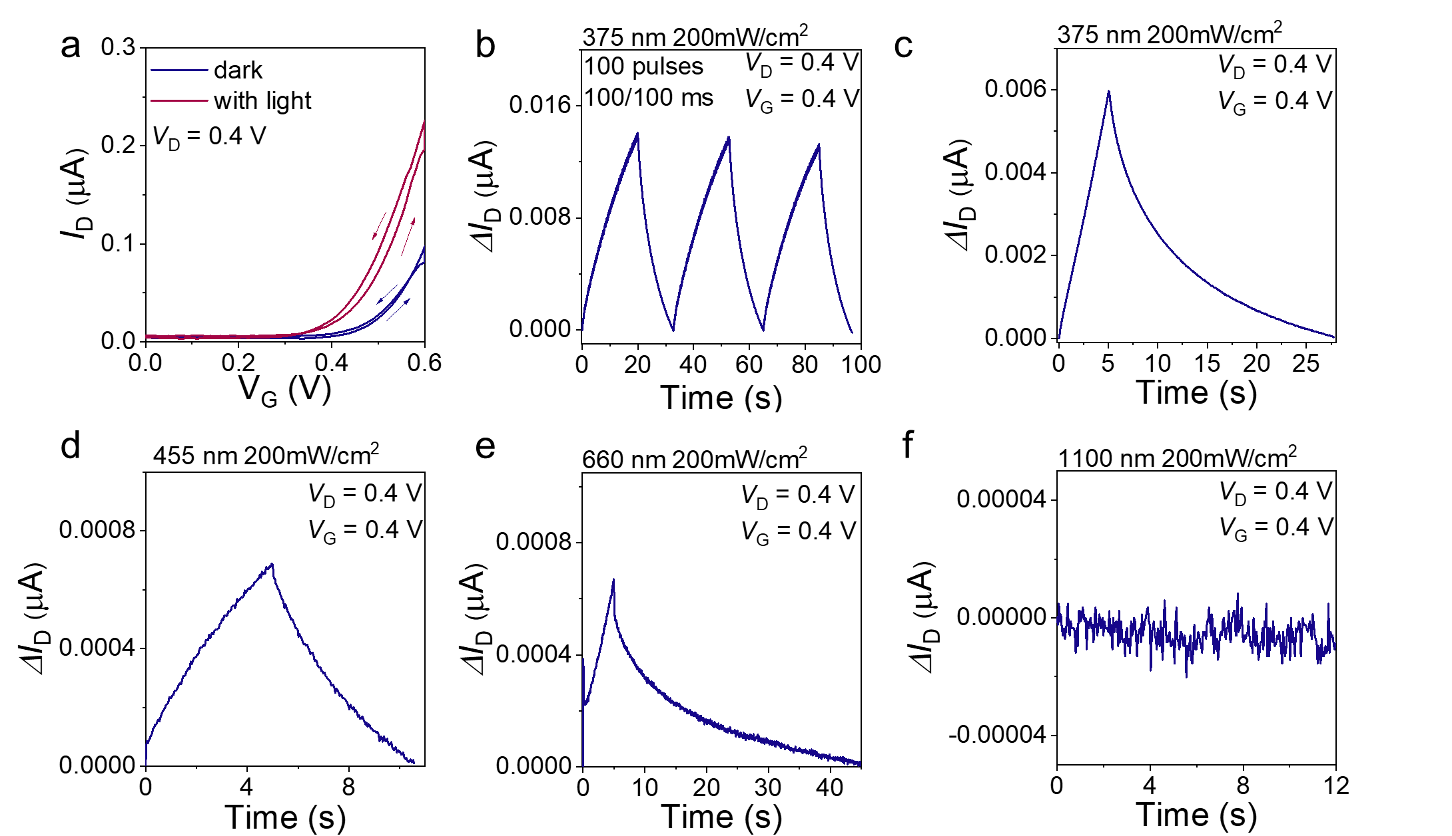
Fig. S19. a) The transfer characteristics of p(C₆NDI-T)-based OECT before and after light illumination using gold as the gate electrode. The light intensity is 200 mW cm⁻². b) The device current was written by 100 light pulses (200 mW cm⁻², the pulse width t_{p} = 0.1 s, the pulse interval ∆t = 0.1 s). The photonic current upon illumination for 5 s with a light intensity of 200 mW cm⁻²: c) 375 nm, d) 455 nm, e) 660 nm and f) 1100 nm.

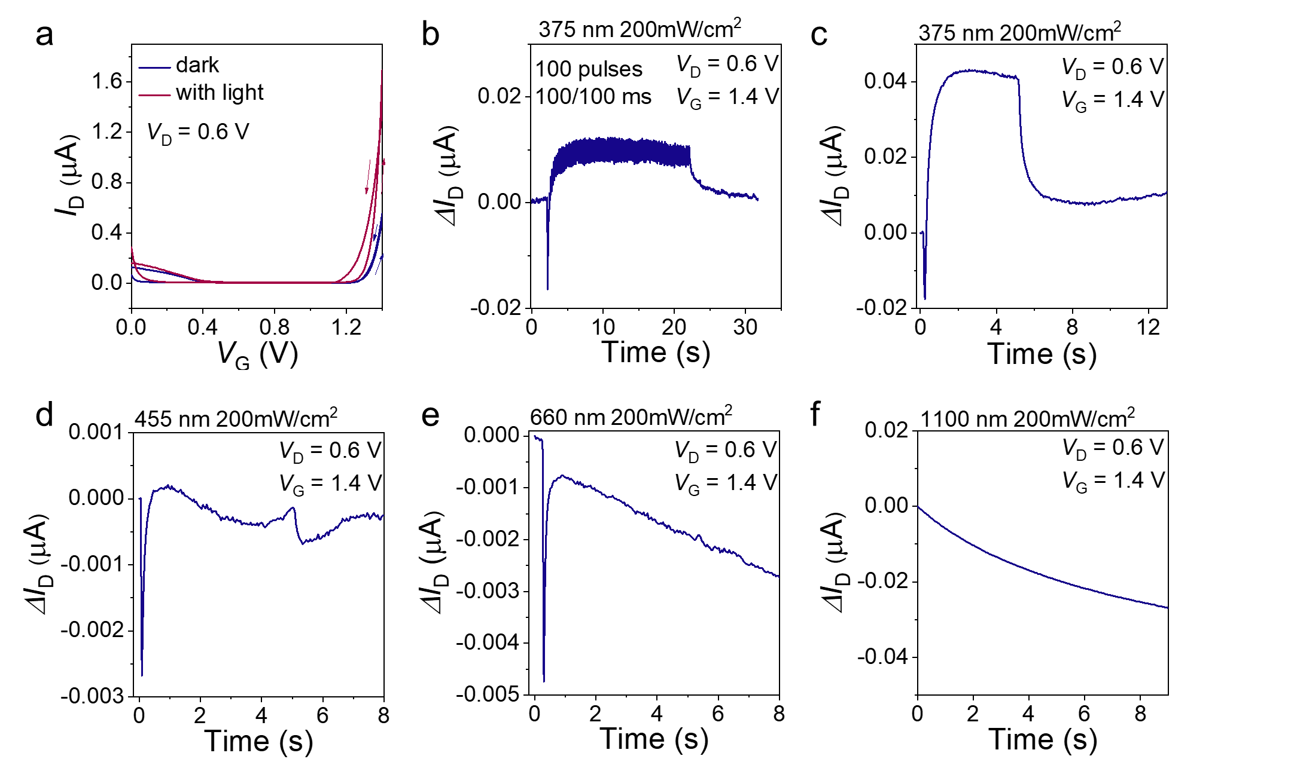
Fig. S20. a) The transfer characteristics of f-BTI2TEG-FT-based OECT before and after light illumination using gold as the gate electrode. The light intensity is 200 mW cm⁻². b) The device current was written by 100 light pulses (200 mW cm⁻², the pulse width t_{p} = 0.1 s, the pulse interval ∆t = 0.1 s). The photonic current upon illumination for 5 s with a light intensity of 200 mW cm⁻²: c) 375 nm, d) 455 nm, e) 660 nm and f) 1100 nm.

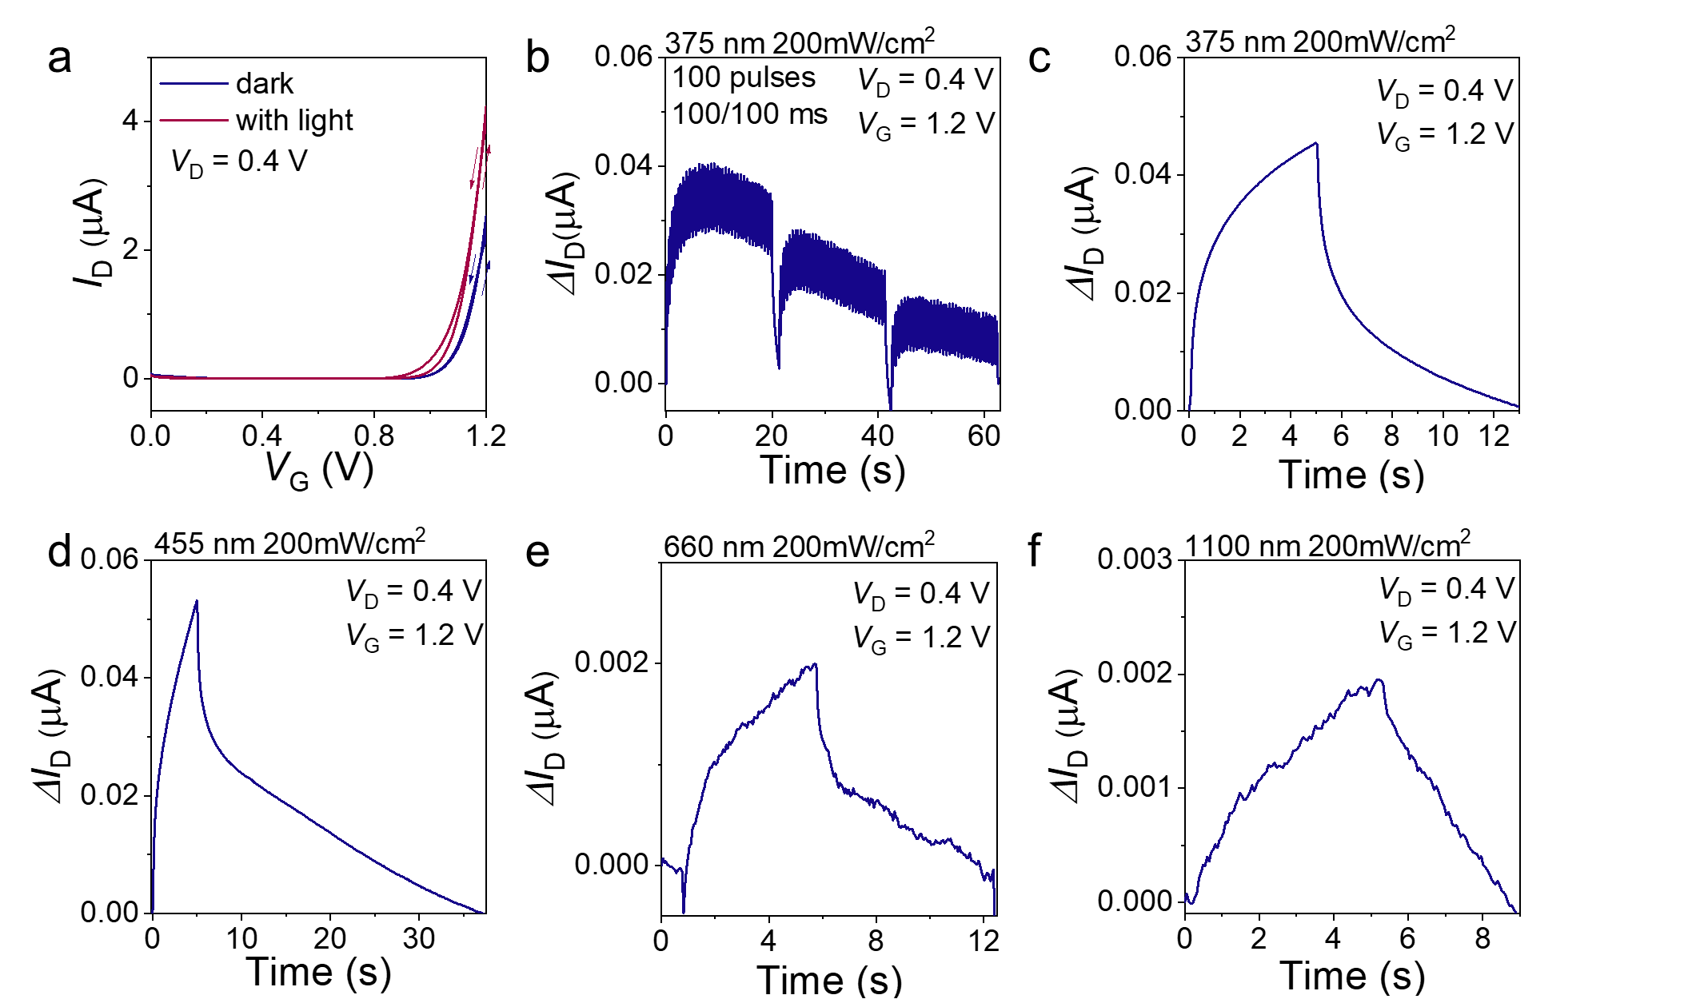
Fig. S21. a) The transfer characteristics of gAIID-2FT-based OECT before and after light illumination using gold as the gate electrode. The light intensity is 200 mW cm⁻². b) The device current was written by 100 light pulses (200 mW cm⁻², the pulse width t_{p} = 0.1 s, the pulse interval ∆t = 0.1 s). The photonic current upon illumination for 5 s with a light intensity of 200 mW cm⁻²: c) 375 nm, d) 455 nm, e) 660 nm and f) 1100 nm.

Table S3. The threshold voltage and photocurrents of other n-type OECTs under UV, VIS and NIR illumination. The light pulse was applied for 5s at an intensity of 200 mW cm⁻².
Polymer | V_{TH}ª  (V) | $∆$I_{UV}^{b}  ($μ$A) | $∆I$_{VIS,1}^{c}  ($μ$A) | $∆I$_{VIS,2}^{d}  ($μ$A) | $∆I$_{NIR}^{e}  ($μ$A)
BBL | 0.33 | 0.46 | 0.22 | 0.125 | 0.0042
p(C₆NDI-T) | 0.41 | 0.0060 | 6.86x10⁻⁴ | 6.7x10⁻⁴ | No response
f-BTI2TEG-FT | 1.26 | 0.042 | No response | No response | No response
gAIID-2FT | 1.02 | 0.046 | 0.053 | 0.002 | 0.002
p(C2F-z) | 0.13 | 4.7 | 0.51 | 0.12 | 0.53
ªdetermined by extrapolating the linear regime of the I_{D}^{1/2}~V_{G} plot and tested in the darkness. ^{b}375 nm, ^{c}455 ^{d}660 nm and ^{e}1100 nm. All devices had a geometry of W/L=100 $μ$m/10 $μ$m and operated in 0.1 M NaCl electrolyte with an Au gate electrode.

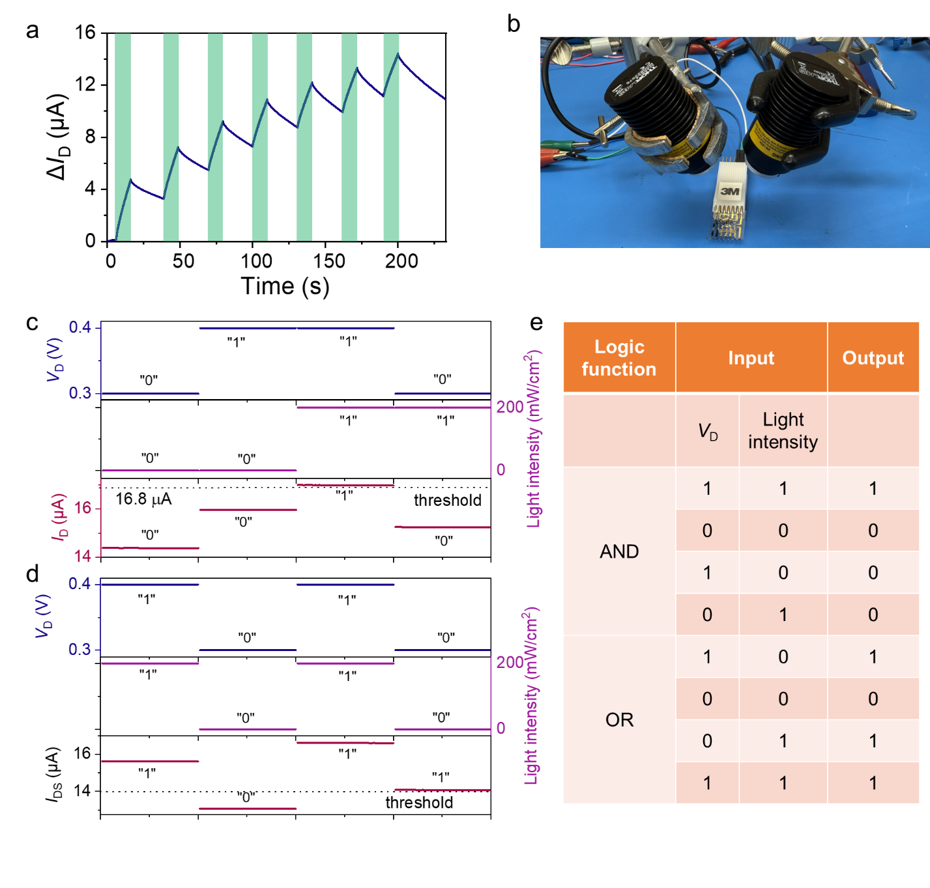
Fig. S22. a) The learning-forgetting-relearning protocol repeated seven times. The green highlighted area (50 pulses) represents the period under the light (200 mW cm⁻², $λ$=375 nm). b) The setup evaluating optical logic functions of the optoelectrochemical synapse. c) AND d) OR regulated by dual stimuli (electrical and optical). The current obtained by manipulating the input light intensity and drain voltage. The high V_{D} (0.4 V) represents the “1” and the low V_{D} (0.3 V) represents the “0” while the 375 nm light with an intensity of 200 mW cm⁻² and the darkness represents the “1” and “0”, respectively. e) The truth table of AND/OR logic function.
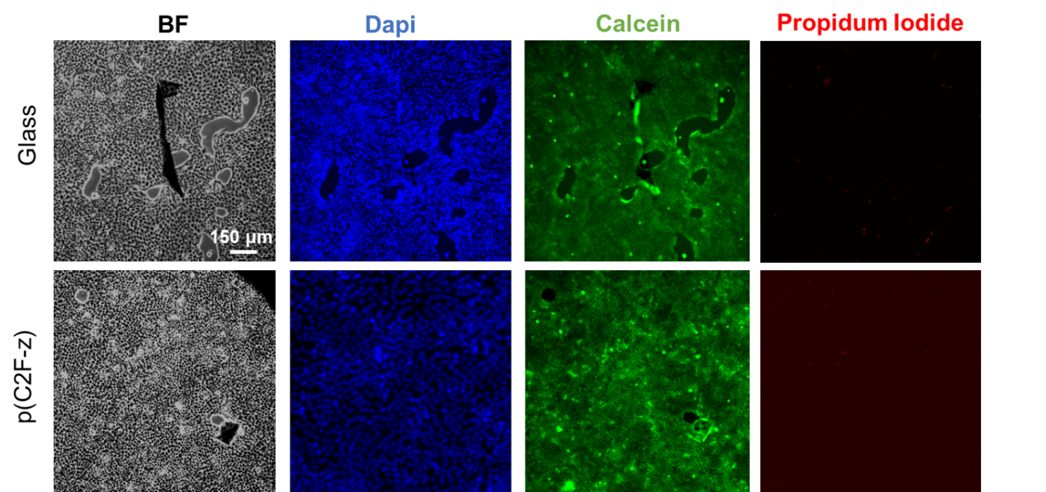
Fig. S23. Cytotoxicity of the p(C2F-v) polymer on polymer coating. A live and dead assay was performed on MDCKII cells cultured for 48 hours on polymer-coated glass and regular glass used as a control. The first column shows cells in a bright field, the second column displays cell nuclei (Dapi), the third column shows live cells (Calcein AM), and the fourth column shows dead cells (Propidium Iodide). The cell viability on polymer films is very similar to that of cells on glass and is close to 100%.
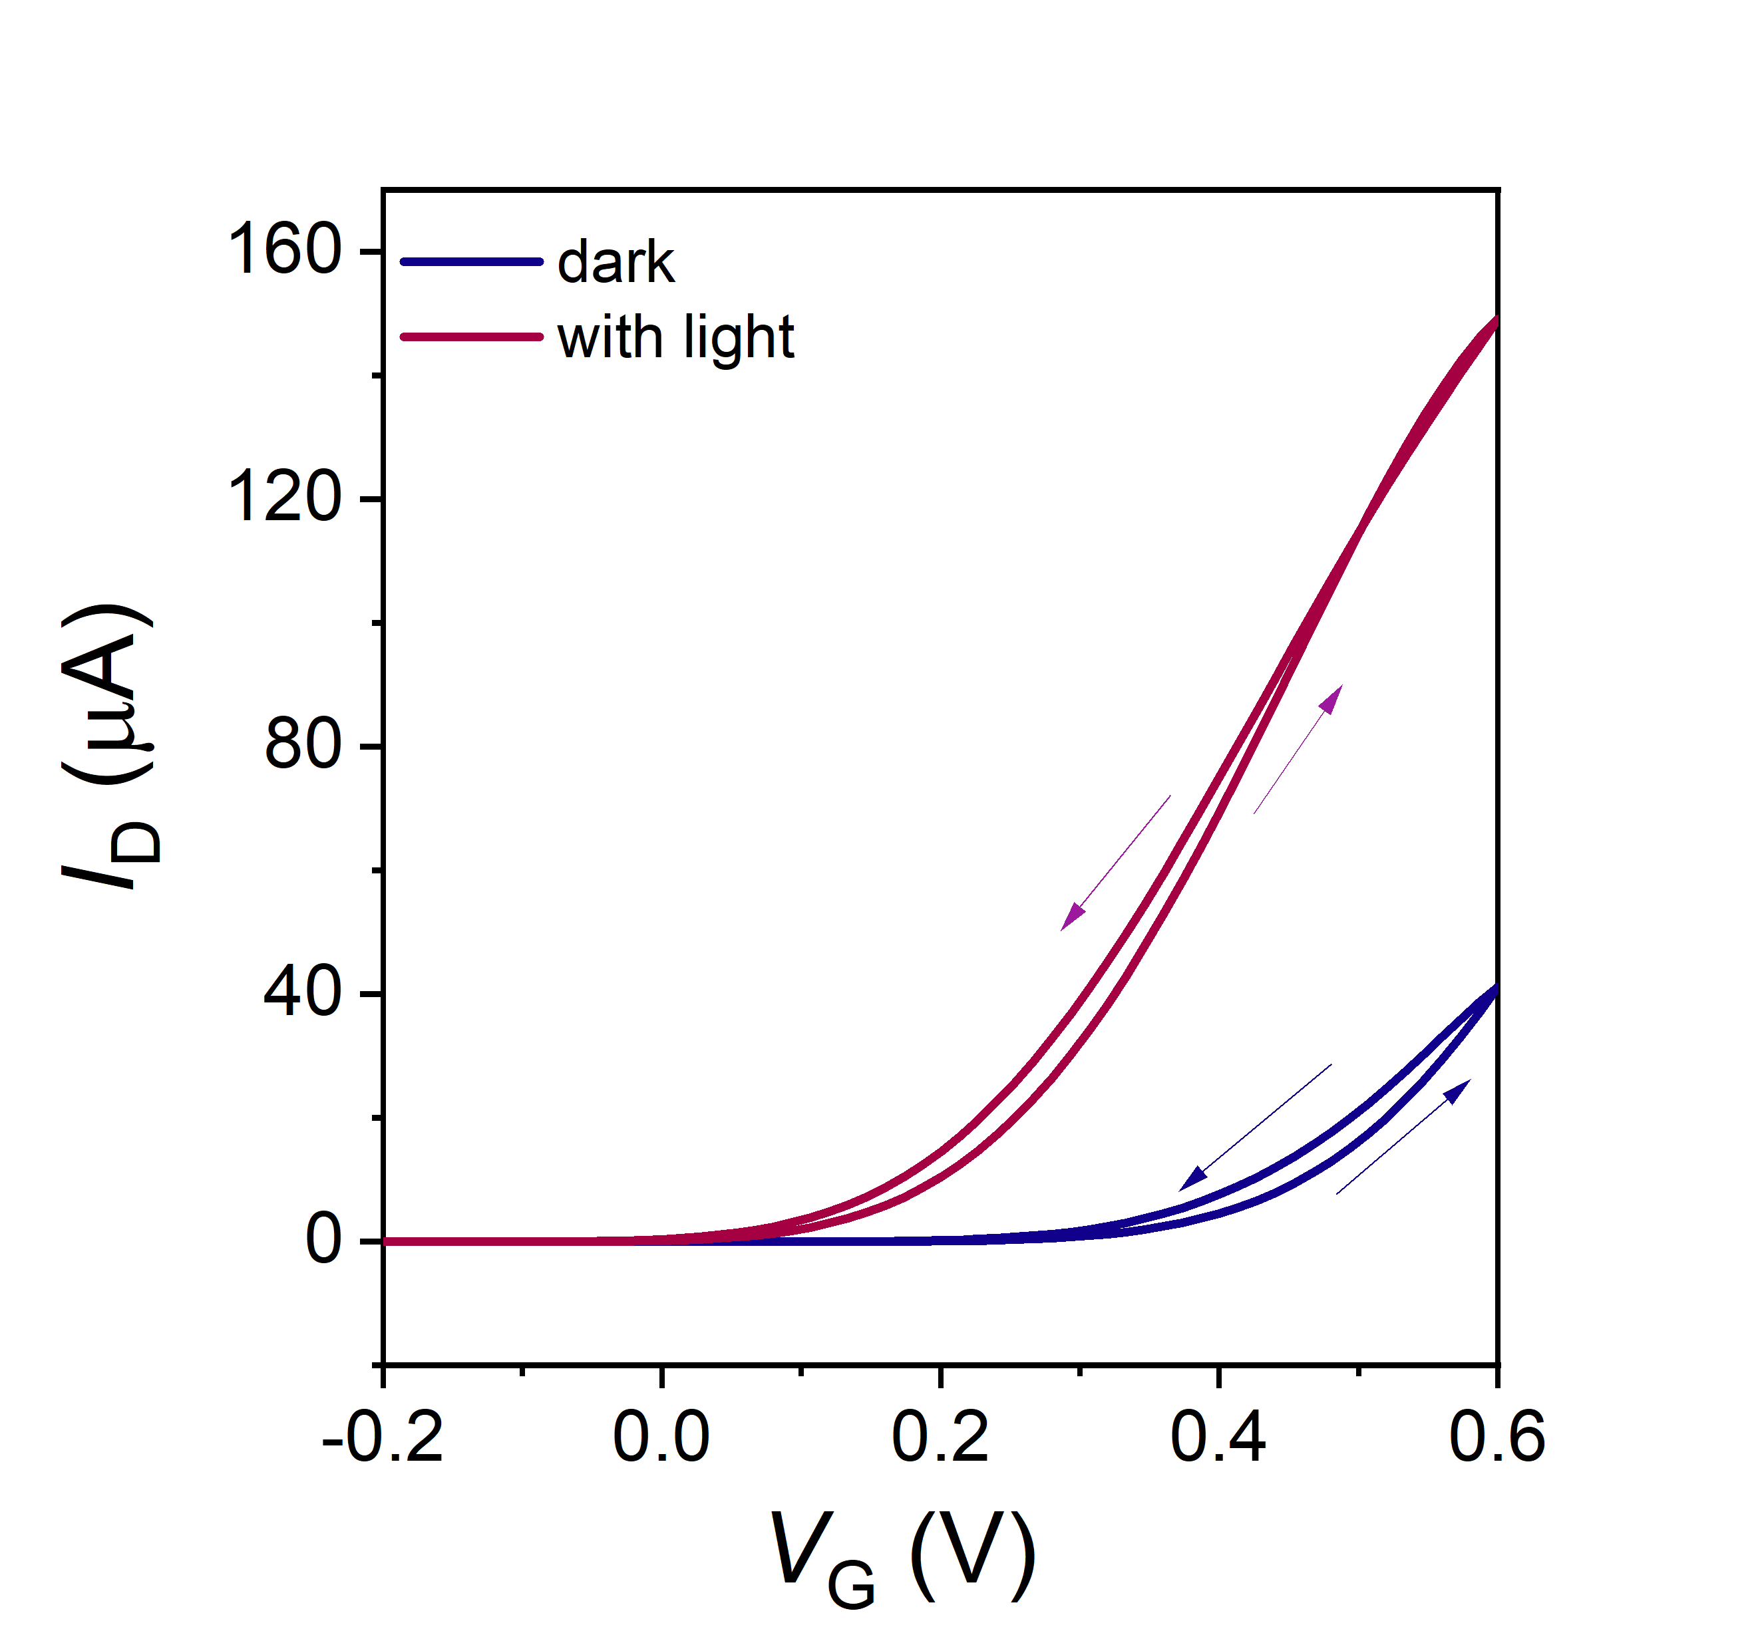
Fig. S24. The transfer characteristics of flexible OECTs before and after illuminating the device for 1 min. The light at 375 nm had an intensity of 200 mW cm⁻² and the device was operated using a hydrogel.

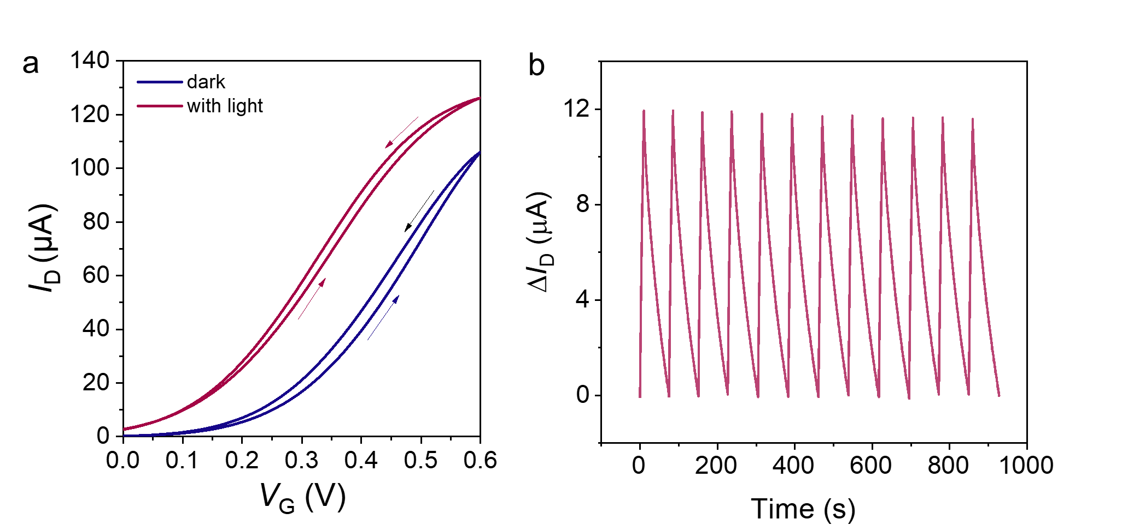
Fig. S25. a) The transfer characteristics of flexible OECTs before and after illuminating the device for 1 min. The light at 375 nm had an intensity of 200 mW cm⁻² and the device operated in 0.1 M NaCl. b) The operating stability of the flexible synaptic device. 100 light pulses with 0.1 s width and 0.1 s pulse interval were applied with a resting period of 65 seconds.
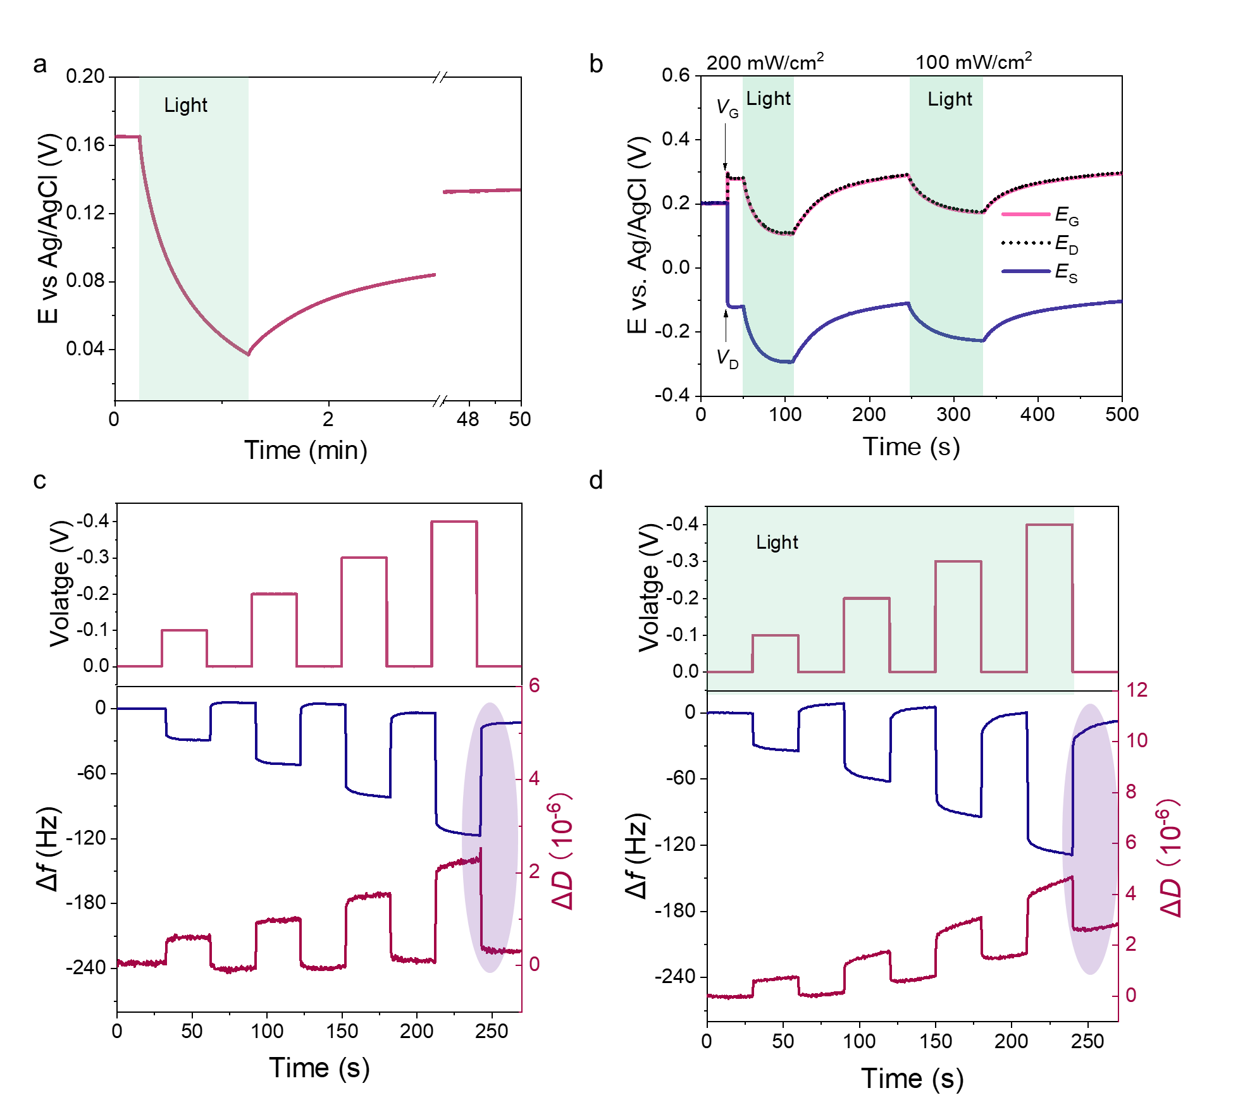
Fig. S26. a) The change in the OCP of the film measured in 0.1 M NaCl with respect to Ag/AgCl reference electrode. The LED (100 mW cm⁻²) was switched on at t=0.24 min until t=1.24 min. b) The OCP change of the OECT terminals during light exposure measured. E_{G}, E_{D}, E_{S} are electrochemical potentials of the device terminals during operation. V_{D} = 0.4 V and V_{G} = 0.4 V were applied at t = 30 s, the LED (200 mW cm⁻²) was switched on at t = 50 s for 50 s, and the LED was switched off at 109 s. The LED (100 mW cm⁻²) was switched on again at t=245 s until t=335 s. The QCM-D profile of the film c) during electrochemical doping and d) during electrochemical and light-based doping. The voltages were applied to the film with respect to Ag/AgCl, varying from -0.1 V to -0.4 V and at each voltage step returning to 0 V. The light intensity was 200 mW cm⁻². Light exposure caused an increase in $∆$f by 20.7%, 18.7%, 11.9%, 8.6% at -0.1 V, -0.2 V, -0.3 V, -0.4 V vs Ag/AgCl, respectively.

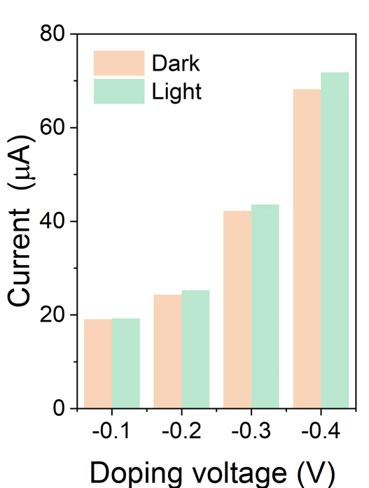

Fig. S27. The current change under doping potentials of -0.1 V, -0.2 V, -0.3 V, and -0.4 V vs. Ag/AgCl in the dark and under illumination.

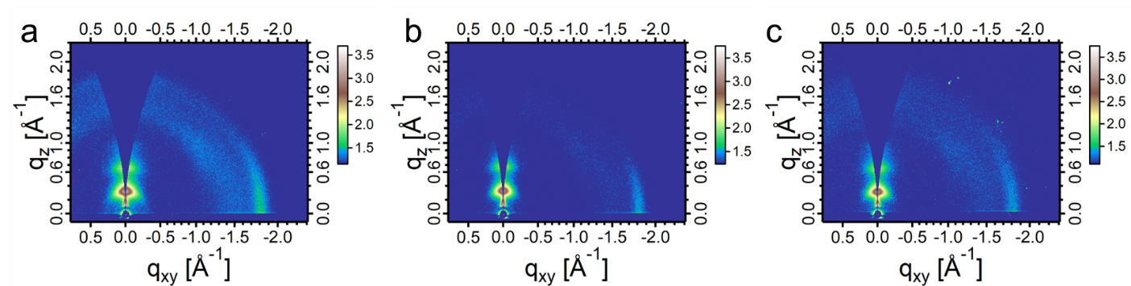
Fig. S28. Ex situ 2D grazing-incidence wide-angle X-ray scattering patterns of p(C2F-z) films in a) pristine, b) electrochemically-doped, and c) light-doped state. The film was doped at -0.4 V vs. Ag/AgCl for two minutes, followed by nitrogen drying, and a round of GIWAXS analysis. The film was exposed to light while being electrochemical doped at -0.4 V vs. Ag/AgCl for two minutes, dried under nitrogen, and subjected to a final round of GIWAXS analysis.

Table S4. Summary of GIWAXS peak parameters.
 | q₍₀₁₀₎  (Å⁻¹) | d₍₀₁₀₎  (Å) | q₍₁₀₀₎  (Å⁻¹) | d₍₁₀₀₎  (Å)
pristine | 1.804 | 3.481 | 0.322 | 19.503
e-doped | 1.811 | 3.468 | 0.329 | 19.088
light-doped | 1.808 | 3.474 | 0.315 | 19.937
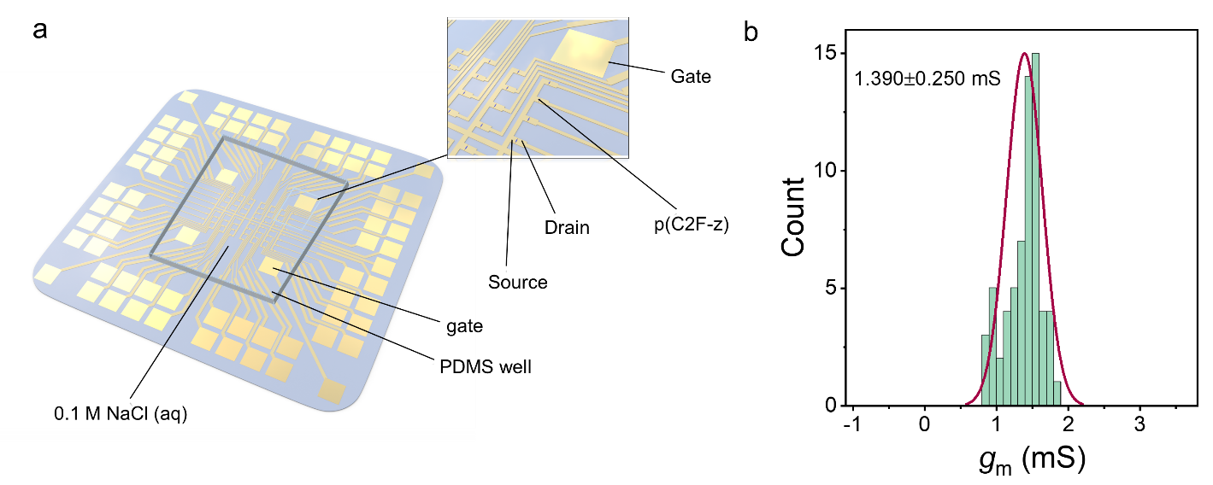
Fig. S29. a) The schematic of the 8x8 synaptic array. The inset is a zoomed-in view of a part of the device. b) Statistical distribution histogram of transconductance of 64 devices.

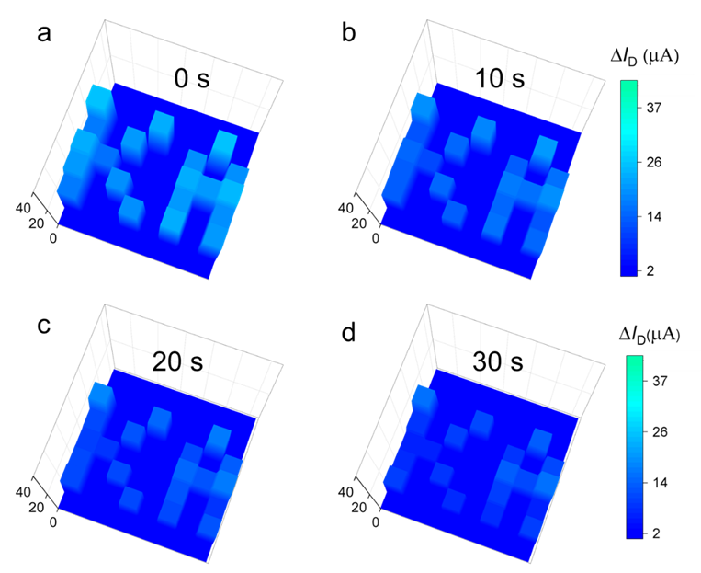
Fig. S30. The current change map of the array recorded a) immediately, b) 10 s, c) 20 s, d) 30 s after the light was switched off.

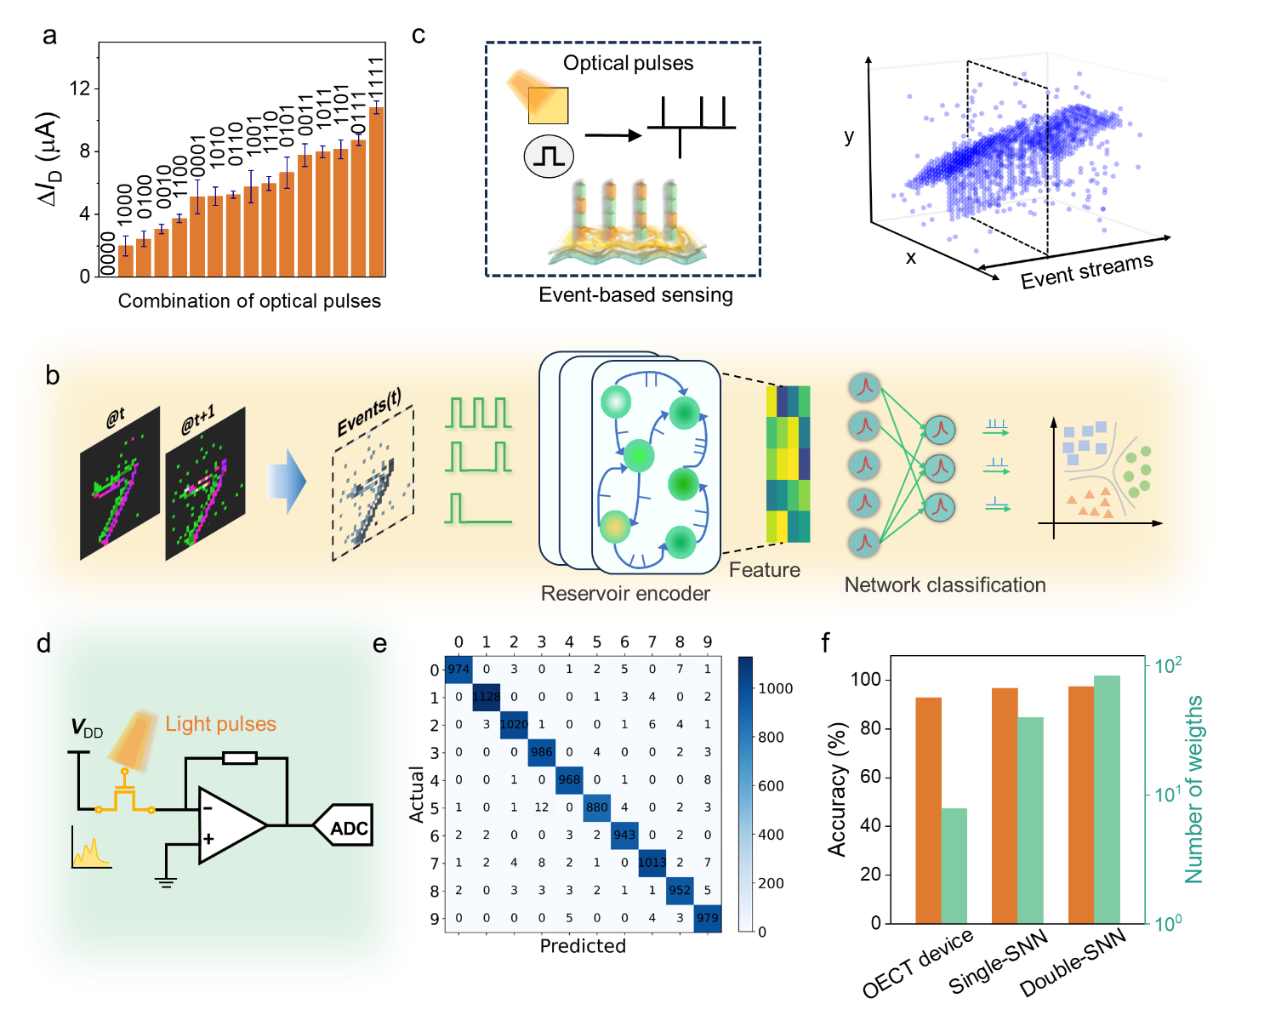
Fig. S31. Event-based reservoir computing task a) Experimental read-current responses generated by sixteen 4-bit optical pulse trains ranging from (0000) to (1111). Each data point is the average of 5 repeated tests. b) Schematic representation of event-driven image processing framework, where features are extracted after the reservoir layer and fed into an SNN for classification. c) Illustration of event-based sensing with our device and spatiotemporal view of event-driven data. d) The circuit diagram performs as the reservoir node. e) The confusion matrix obtained after training. f) Comparison of the accuracy and number of weights of our optoelectronic reservoir-computing system using organic optoelectrochemical synapse, a single-layer SNN, and a double-layer SNN.

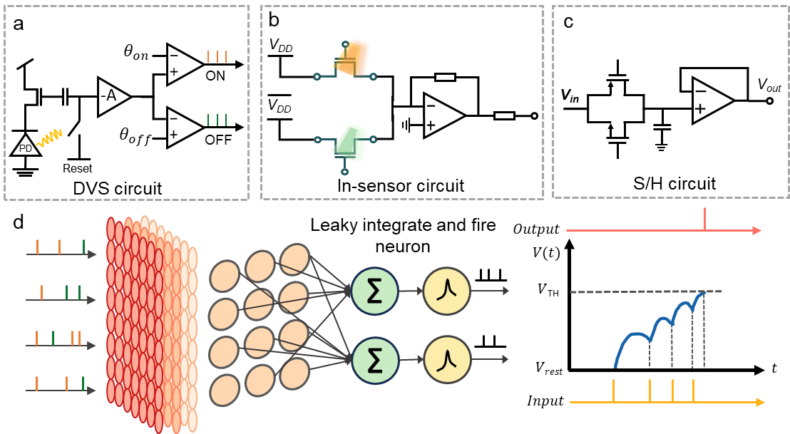
Fig. S32. a) The circuit diagram of DVS sensor. b) The circuit diagram of in-sensor computing, which performs as the reservoir node. c) The circuit diagram of the sample-and-hold (S/H) circuit. d) The schematic of our design to realize an in-sensor spiking neural network.

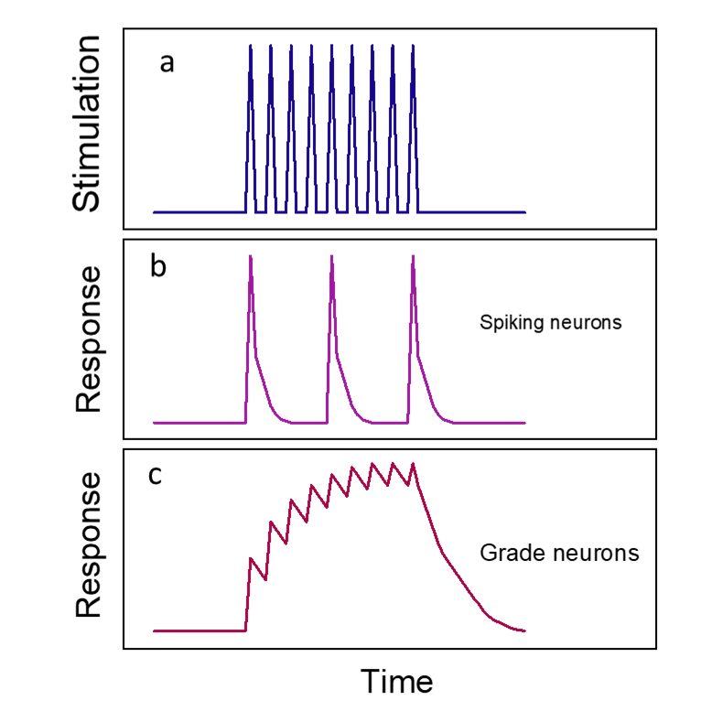
Fig. S33. The response of the spiking and the graded neurons to the same input. a) The electrical stimulation as a function of time. The response of b) spiking neurons and c) graded neurons.

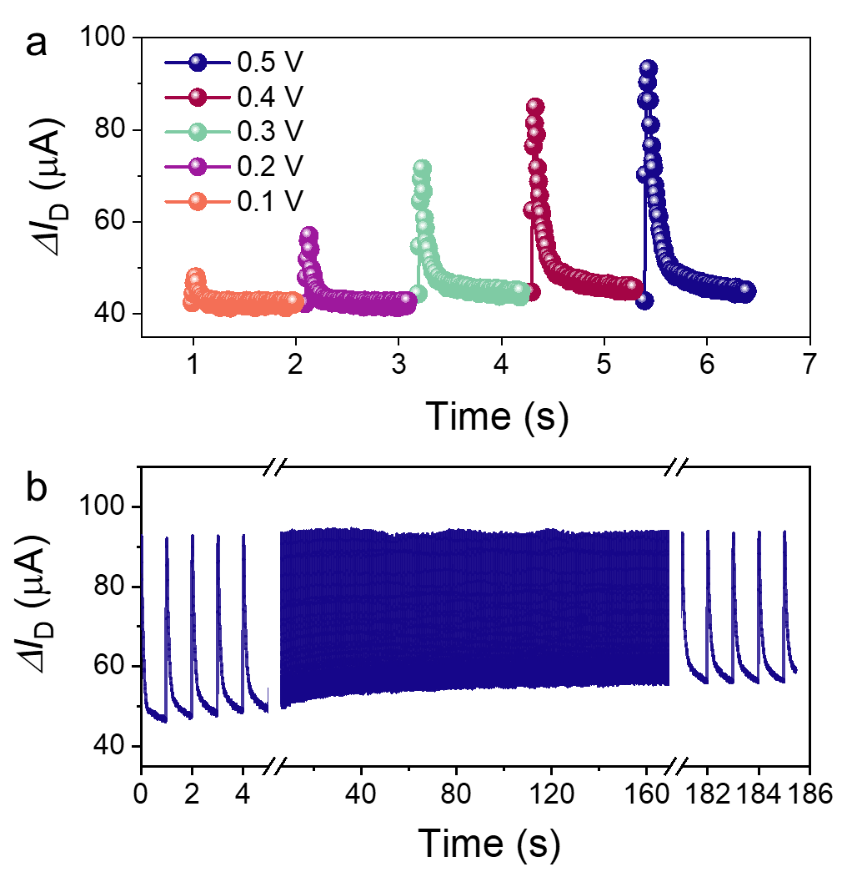
Fig. S34. a) The I_{D}-time profile when the device is addressed with four consecutive gate voltage pulses with increasing magnitudes, width of 5 ms and interval of 5 ms. With an increase in gate voltage, both the current and the time required to reach the initial current increase. b) The operating stability of the device. We conducted 185 tests and each test involved the application of the four consecutive V_{G} = 0.5 V pulses with a width of 5 ms and interval of 5 ms, and a resting period of 0.95 s in between each pulse.

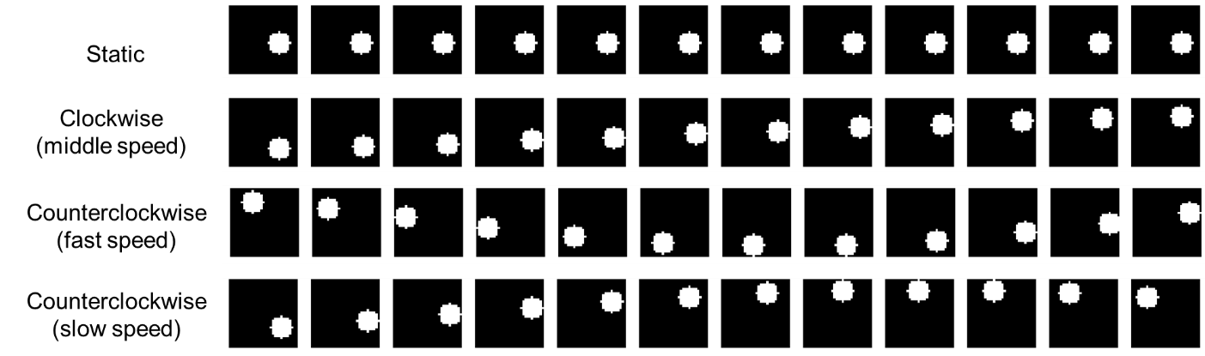
Fig. S35. The sample video representation for four classes of motion with different directions and speeds. Each row shows the movement of the ball as a function of time.

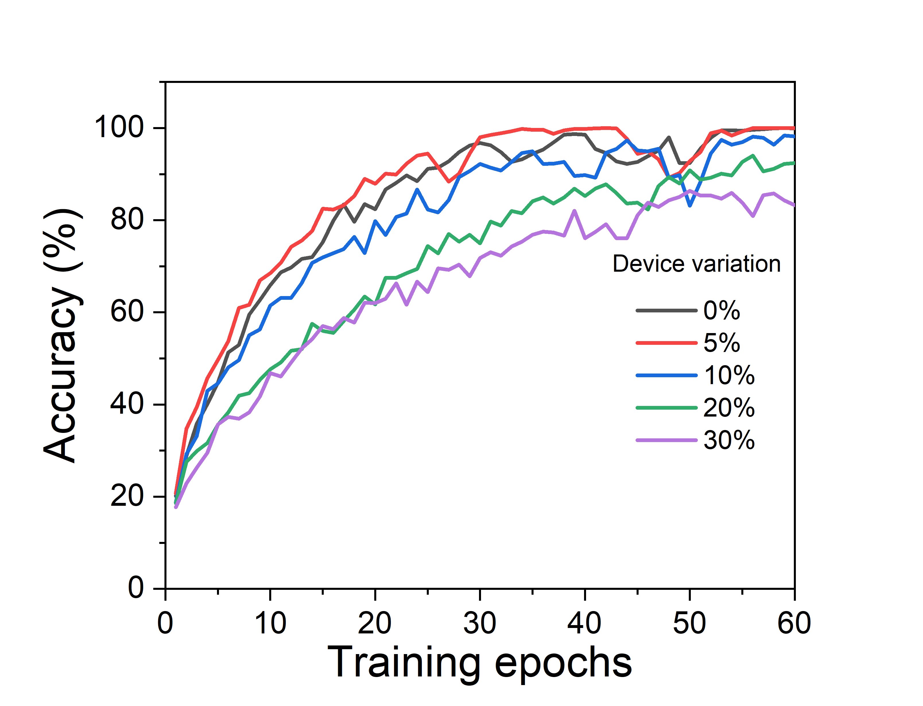
Fig. S36. The impact of device-to-device performance variation on the recognition accuracy.

Supplementary Note 1. The effect of V_{G} on the current recovery after the light pulse
To quantify the memory capability, we recorded the current change over time post-light pulse (Fig. S16a). As the gate voltage increases, the time required for the current to return to its initial value decreases from 45 s (V_{G} = 0.5 V) to 90 s (V_{G} = 0.4 V) and further to 435 s (V_{G} = 0.3 V). Once the light is off, the separated charge carriers generated by light need to travel to the corresponding contacts, and their motion is affected by interactions with electrolyte ions inside the film.¹⁶ Different gate voltages can influence the rate and extent of ion migration within the device. Higher gate voltages can increase the speed of ion migration as the stronger electric field drives ions more effectively, improving the speed of the recovery process.¹⁷ We postulate that varying gate voltages lead to different levels of interference of the separated charges and electrolyte ions, resulting in distinct recovery times.
Supplementary Note 2. The OECT synaptic array characterization
We used PDMS as a reservoir to contain 0.1 M NaCl solution. The electrolyte is in contact the channels and the large gold electrodes that serve as the gates exclusively, while the source, drain, and gate lines are shielded with Pa-C insulating layer, fabricated following the same fabrication process as for single devices. During current recording, a common gate electrode was employed, and we recorded the current of each transistor one after the after. In between each measurement, the Au electrode’s electrochemical potential was monitored to avoid polarization, which may otherwise affect the next measurement.
Supplementary Note 3. Event-based reservoir computing task
In our design, computations are performed directly with sensory devices in the analog domain. Fig. S32a shows the circuit of the DVS, which can monitor changes in pixel circuit brightness using a photodiode. The change in light intensity (ΔP) is encoded as the amplitude of electronic spikes. The in-sensor circuit, depicted in Fig. S32b, integrates both sensing and computing functions. It can detect sequential light pulses with dynamic properties and incorporates two devices capable of handling both positive and negative encoded values. The sample-and-hold (S/H) circuit, shown in Fig. S32c, is designed to capture and maintain a voltage level over time. By freezing the analog value at a specific moment, the S/H circuit allows for periodic reading and further processing by digital systems. Fig. S32d presents the in-sensor spiking neural network, where the sensor array extracts essential information and helps interpret the information.
Supplementary Note 4. Multispectral sensing for full-color image processing
In color image processing, the selected color image was first sampled into the R, G, and B components. Since the device exhibits a wavelength-dependent current response, the image processing result based on the device characteristics is the sum of the responses to light of different wavelengths. The equation used in the simulation is as follows:
$$f_{X}\left(X\right)=a×X^{b}+c$$
$$f_{output}=f_{R}\left(R\right)+f_{G}\left(G\right)+f_{B}\left(B\right)$$
where $X$ represents the grayscale value of each channel, $a$ is the weight associated with the corresponding photocurrent response, and $b$ and $c$ represent the exponential term and bias, respectively.
Supplementary Note 5. Graded neurons
Flying insects possess an agile visual system that enables them to perceive motion with great acuity, as quantified by their flicker fusion frequency. For instance, Drosophila, a type of flying insect, has a flicker fusion frequency of 100 Hz, which is four times faster than that of humans. The compact vision system of flying insects minimizes the distance for signal transmission between the retina and the brain. This proximity allows graded neurons to efficiently encode temporal information upon receiving electrical signals from the photoreceptors. The insect visual system comprises non-spiking graded neurons, exemplified by the lamina in flying insects, which demonstrate a significantly higher information transmission rate compared to the spiking neurons (Fig. S33b) found in the human visual system. These graded neurons, such as the lamina in flying insects, exhibit multi-level responses, in contrast to the spiking behavior (Fig. S33b) observed in other neurons. Their responses depend on the intensity of sequential stimuli, demonstrating temporal summation characteristics without a refractory period. The non-spiking graded characteristics of lamina neurons (Fig. S33c) facilitate the efficient encoding of spatiotemporal information associated with moving objects at the sensory terminals.
Supplementary Note 6. Motion detection with the bioinspired vision sensor
For the ball movement detection tasks, we developed a customized video dataset using OpenCV. Each video frame was configured to dimensions of 32$×$32 pixels, with the ball's radius fixed at 5 pixels, and a frame rate of 30 frames per second. To enhance dataset diversity, the ball was randomly positioned at the start of each sequence and assigned velocities of 0, 1, 3, and 5 m/s. The dataset includes two rotation directions: clockwise and counterclockwise, with each class comprising 60 samples. The dataset was split into training and test sets at a ratio of 4:1. A sample video frame representation is shown in Fig. S35.
The feature map extracted from temporal frames was converted into electrical current values by the bio-inspired sensor (Fig. 7c). This feature map, represented as discrete action events across temporal frames, encodes essential spatial and temporal patterns. Each pixel value in the temporal frame corresponds to a specific current value. These feature maps were used as inputs to a neural network for classification. The network's final layer consisted of seven output neurons, representing seven classes of ball movement: high, medium, and low speeds for both clockwise and counterclockwise rotations, as well as a static state. The class with the highest neuron value was selected as the predicted result.
For comparison, we trained the feature maps generated by a conventional sensor array, where individual frames captured at fixed intervals were used as input. These feature maps were fed into the neural network, as illustrated in Fig. 7d, and the network was trained using backpropagation to optimize weights and minimize prediction errors. The difference in accuracy between the conventional and bio-inspired sensors is attributed to the latter’s ability to integrate both spatial and temporal data, which provides a richer representation of motion.
The device’s ability to capture spatiotemporal dynamics was further demonstrated using real-world video data, such as the movement of a mosquito (Fig. 7g). A video of the mosquito was recorded at a fixed frequency, and its movement velocity was estimated based on time intervals. Adjusting the video frame rate allowed us to simulate varying motion speeds; for example, increasing the frequency by a factor of 10 simulated a tenfold increase in perceived motion speed. The bio-inspired sensor encoded this motion information into spatiotemporal frames, breaking the video into sequences that captured both the spatial position and temporal evolution of the mosquito’s movement. The feature map illustrates the sensor’s ability to distinguish between fast and slow motions by encoding the temporal dynamics of objects. This example underscores the sensor's effectiveness in capturing and interpreting dynamic information for motion detection and classification tasks.

References
1. Wang, Y. et al. Acceptor Functionalization via Green Chemistry EnablesHigh-Performance n-Type Organic ElectrochemicalTransistors for Biosensing, Memory Applications. Advanced Functional Materials 34, 2304103 (2023).
2. Lei, T., Dou, J.-H., Cao, X.-Y., Wang, J.-Y. & Pei, J. Electron-deficient poly (p-phenylene vinylene) provides electron mobility over 1 cm2 V–1 s–1 under ambient conditions. Journal of the American Chemical Society 135, 12168-12171 (2013).
3. Samuel, J.J., Garudapalli, A., Mohapatra, A.A., Gangadharappa, C., Patil, S. & Aetukuri, N.P.B. Single‐Component CMOS‐Like Logic using Diketopyrrolopyrrole‐Based Ambipolar Organic Electrochemical Transistors. Advanced Functional Materials 31 (2021).
4. Wang, Y. et al. Green Synthesis of Lactone‐Based Conjugated Polymers for n‐Type Organic Electrochemical Transistors. Advanced Functional Materials 32, 2111439 (2022).
5. Shi, J. et al. Revealing the Role of Polaron Distribution on the Performance of n-Type Organic Electrochemical Transistors. Chemistry of Materials 34, 864-872 (2022).
6. Feng, K. et al. Fused Bithiophene Imide Dimer-Based n-Type Polymers for High-Performance Organic Electrochemical Transistors. Angew Chem Int Ed Engl 60, 24198-24205 (2021).
7. Wu, H.Y. et al. Influence of Molecular Weight on the Organic Electrochemical Transistor Performance of Ladder-Type Conjugated Polymers. Adv Mater 34, e2106235 (2022).
8. Marks, A. et al. Synthetic Nuances to Maximize n-Type Organic Electrochemical Transistor and Thermoelectric Performance in Fused Lactam Polymers. J Am Chem Soc 144, 4642-4656 (2022).
9. Feng, K. et al. Cyano-Functionalized n-Type Polymer with High Electron Mobility for High-Performance Organic Electrochemical Transistors. Adv Mater 34, e2201340 (2022).
10. Li, P., Shi, J., Lei, Y., Huang, Z. & Lei, T. Switching p-type to high-performance n-type organic electrochemical transistors via doped state engineering. Nat Commun 13, 5970 (2022).
11. Chen, J. et al. Backbone coplanarity manipulation via hydrogen bonding to boost the n-type performance of polymeric mixed conductors operating in aqueous electrolyte. Mater Horiz 10, 607-618 (2023).
12. Wang, Y. et al. n-Type Organic Electrochemical Transistors with High Transconductance and Stability. Chemistry of Materials 35, 405-415 (2023).
13. Wu, W. et al. Selenophene Substitution Enabled High-Performance n-Type Polymeric Mixed Ionic-Electronic Conductors for Organic Electrochemical Transistors and Glucose Sensors. Adv Mater 36, e2310503 (2024).
14. Huang, Z. et al. Azonia-Naphthalene: A Cationic Hydrophilic Building Block for Stable N-Type Organic Mixed Ionic-Electronic Conductors. Angew Ch0em Int Ed Engl 63, e202313260 (2024).
15. Li, P. et al. N-type semiconducting hydrogel. Science 384, 30 (2024).
16. Chen, K. et al. Organic optoelectronic synapse based on photon-modulated electrochemical doping. Nature Photonics 17, 629-637 (2023).
17. Paudel, P.R., Skowrons, M., Dahal, D., Radha Krishnan, R.K. & Lüssem, B. The Transient Response of Organic Electrochemical Transistors. Advanced Theory and Simulations 5 (2022).

