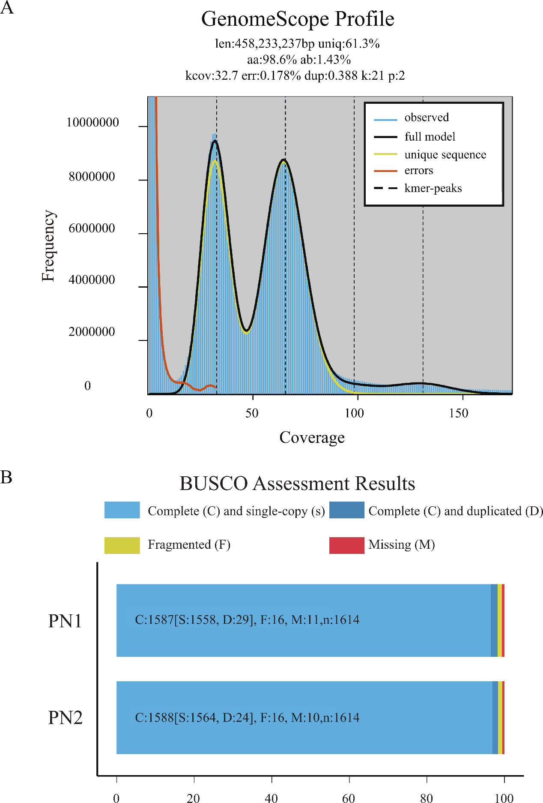
SUPPLEMENTAL FIGURES
Supplementary Figure 1. Heterozygosity of Pinot Noir assessed using K-mer analysis and BUSCO. (A) The heterozygosity and size of PN were predicted using a k-mer of 21, with varying horizontal coordinates representing different coverage levels. (B) The results of gene integrity testing were obtained from the embryophyte_odb10 database via BUSCO.
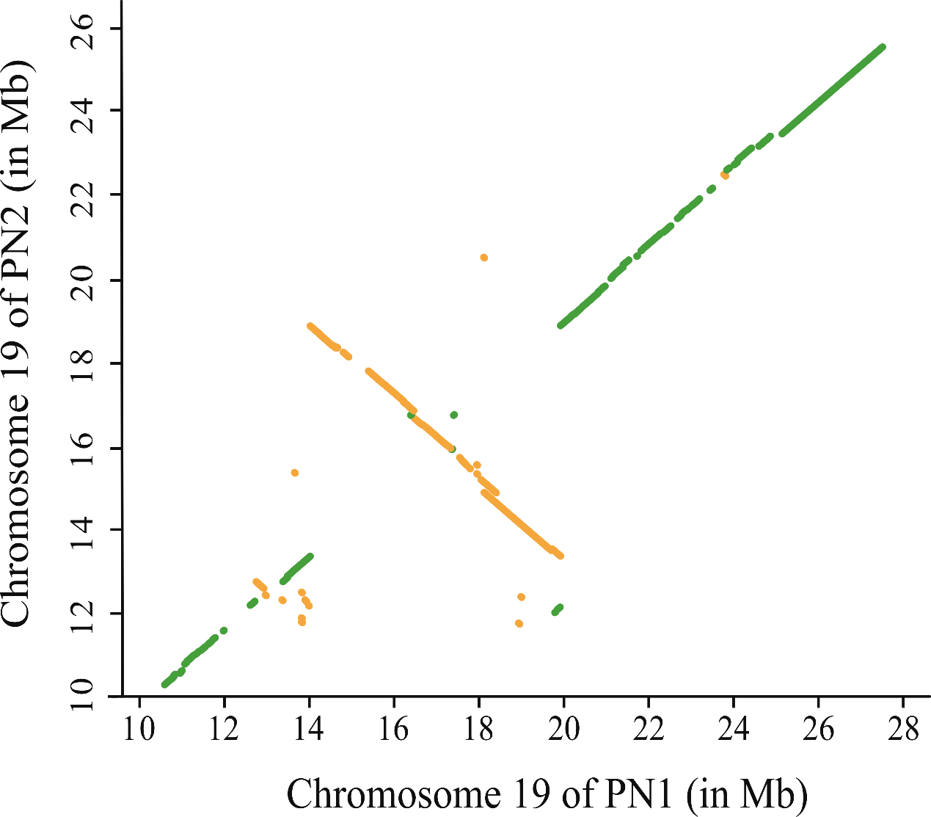
Supplementary Figure 2. Mummer diagram of the inversion between PN1 and PN2 on chromosome 19.

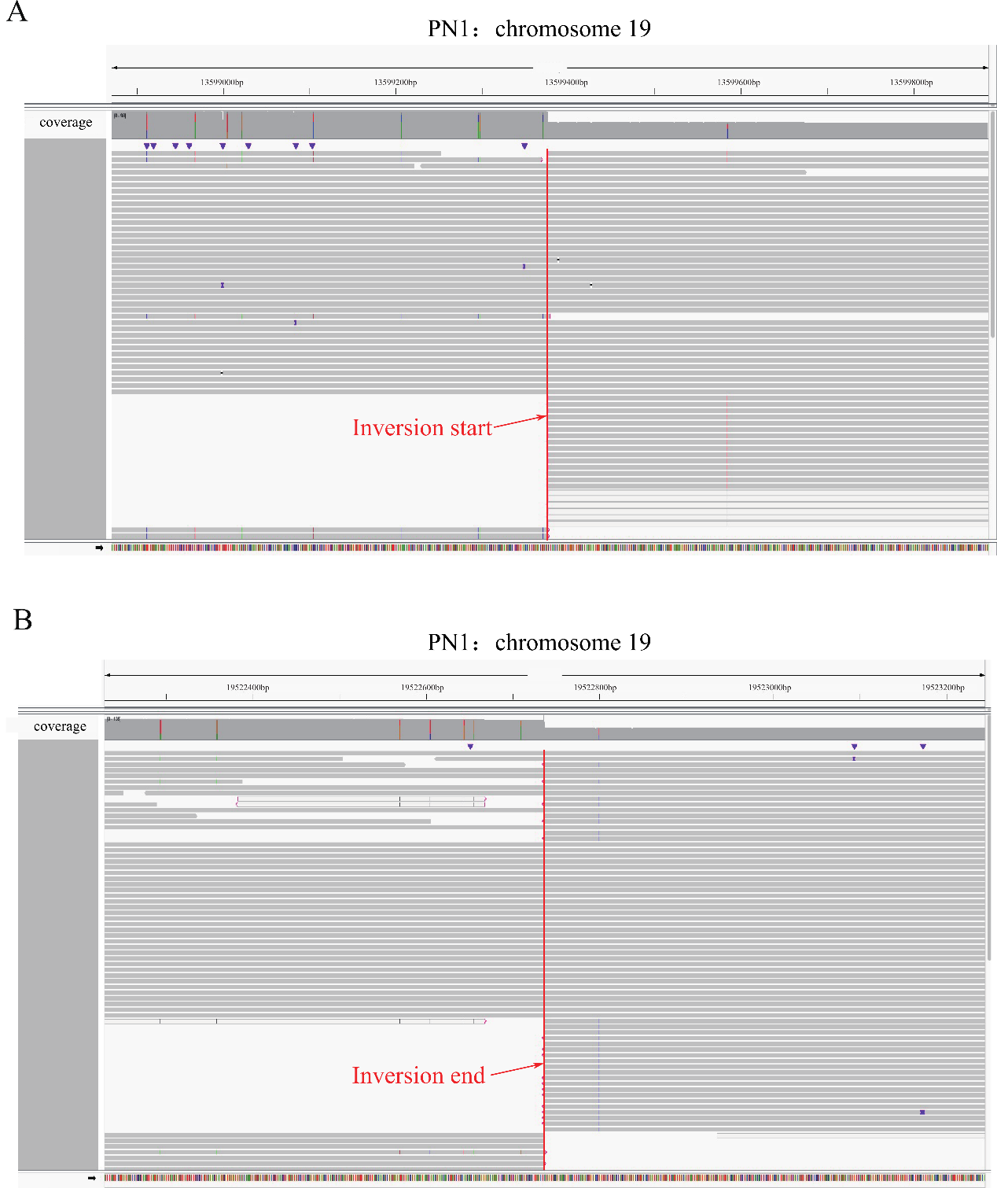
Supplementary Figure 3. IGV visualization for inversion verification. The IGV screenshots show the inverted breakpoints of PN1: (A) the start breakpoint and (B) the end breakpoint. The red vertical lines indicate the locations of these breakpoints.

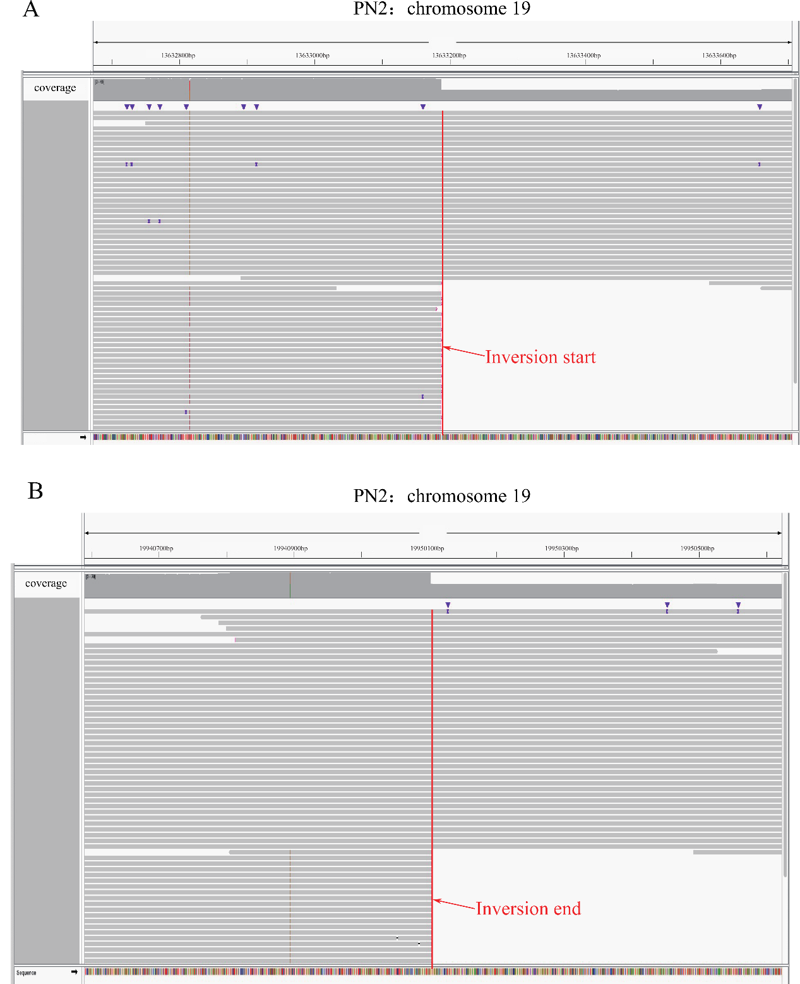
Supplementary Figure 4. IGV visualization for inversion verification. The IGV screenshots show the inverted breakpoints of PN2: (A) the start breakpoint and (B) the end breakpoint. The red vertical lines indicate the locations of these breakpoints.

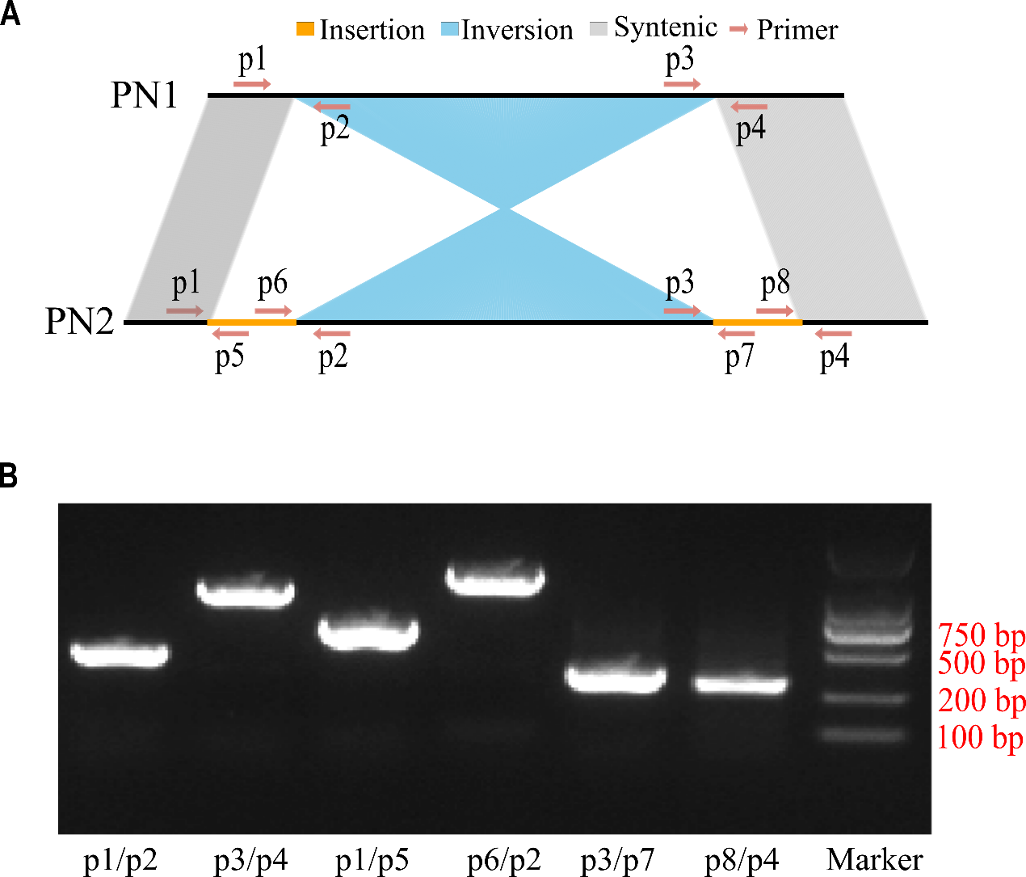
Supplementary Figure 5. Schematic of inversion on Chr19 and verification by PCR. (A) An inversion with two insertions at the flanks on Chr19. The primers used for verification are shown with arrows. (B) The PCR results using the primers shown in A. Source data are provided as a Source Data file.

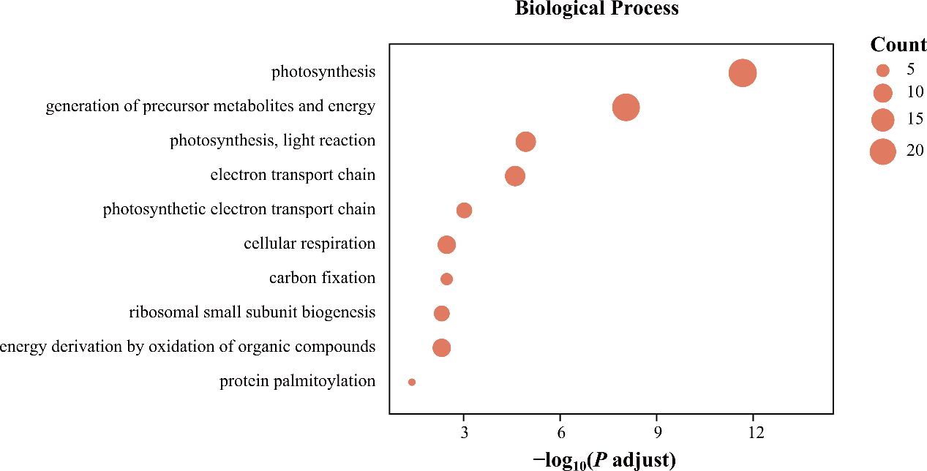
Supplementary Figure 6. GO term enrichment of the top 1% of genes in the f_{d} analysis for EU and PN in the biological process.

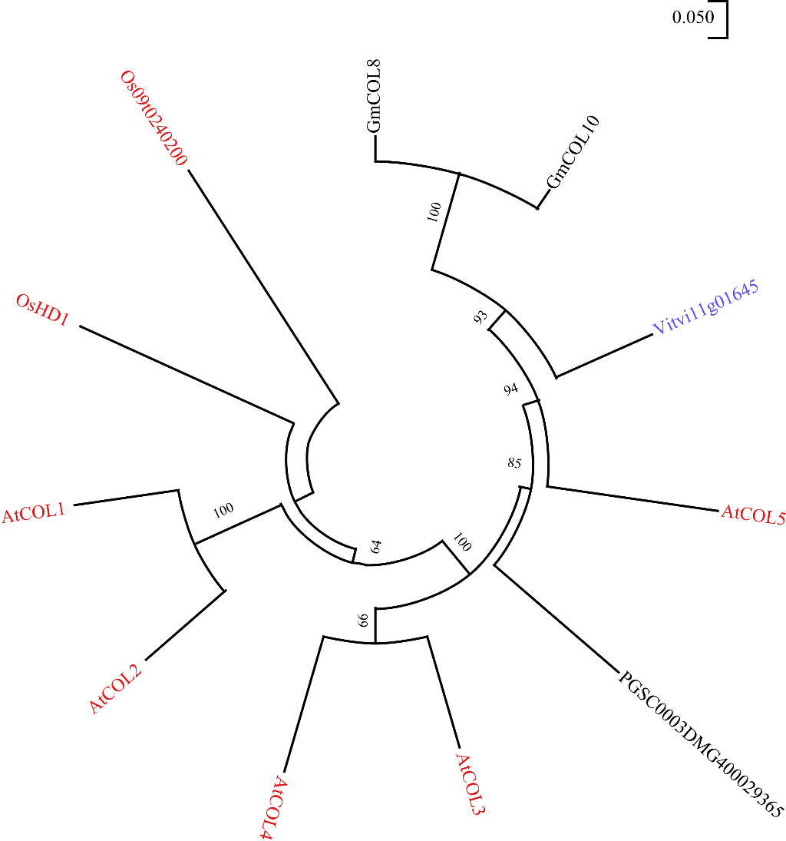
Supplementary Figure 7. Phylogenetic trees of the COL5 gene. Genes found in grapes are represented in blue, those identified and functionally validated in other plant species are in red, and unvalidated genes are in black. At: Arabidopsis thaliana; GLYMA, Gm: Glycine max; Os: Oryza sativa; Vitvi: Vitis vinifera; PGSC: Solanum tuberosum.

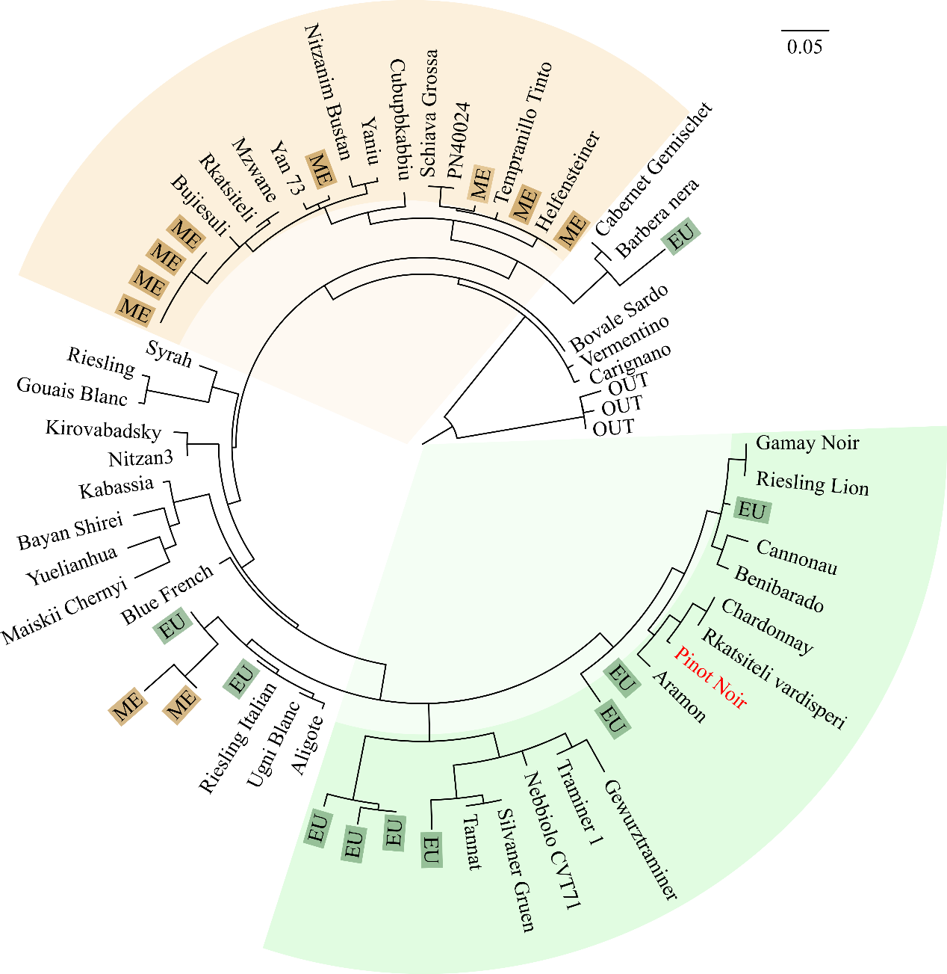
Supplementary Figure 8. Phylogenetic tree of 20 wild grapes and 44 wine grapes in the 20 kb region where COL5 is located. ME wild grapes are represented with a brown background, while EU wild grapes are shown with a green background. Pinot Noir is highlighted in red.

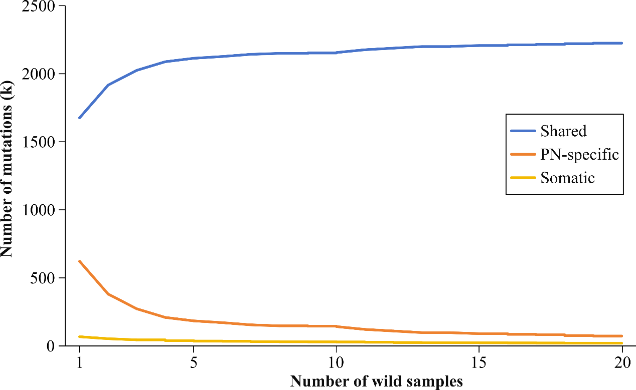
Supplementary Figure 9. Effects of the number of wild grapes used on mutation detection. The blue line indicates the number of mutations shared by PN and wild grapes; the orange line indicates the number of PN-specific mutations; and the yellow line indicates the number of predicted somatic mutations.

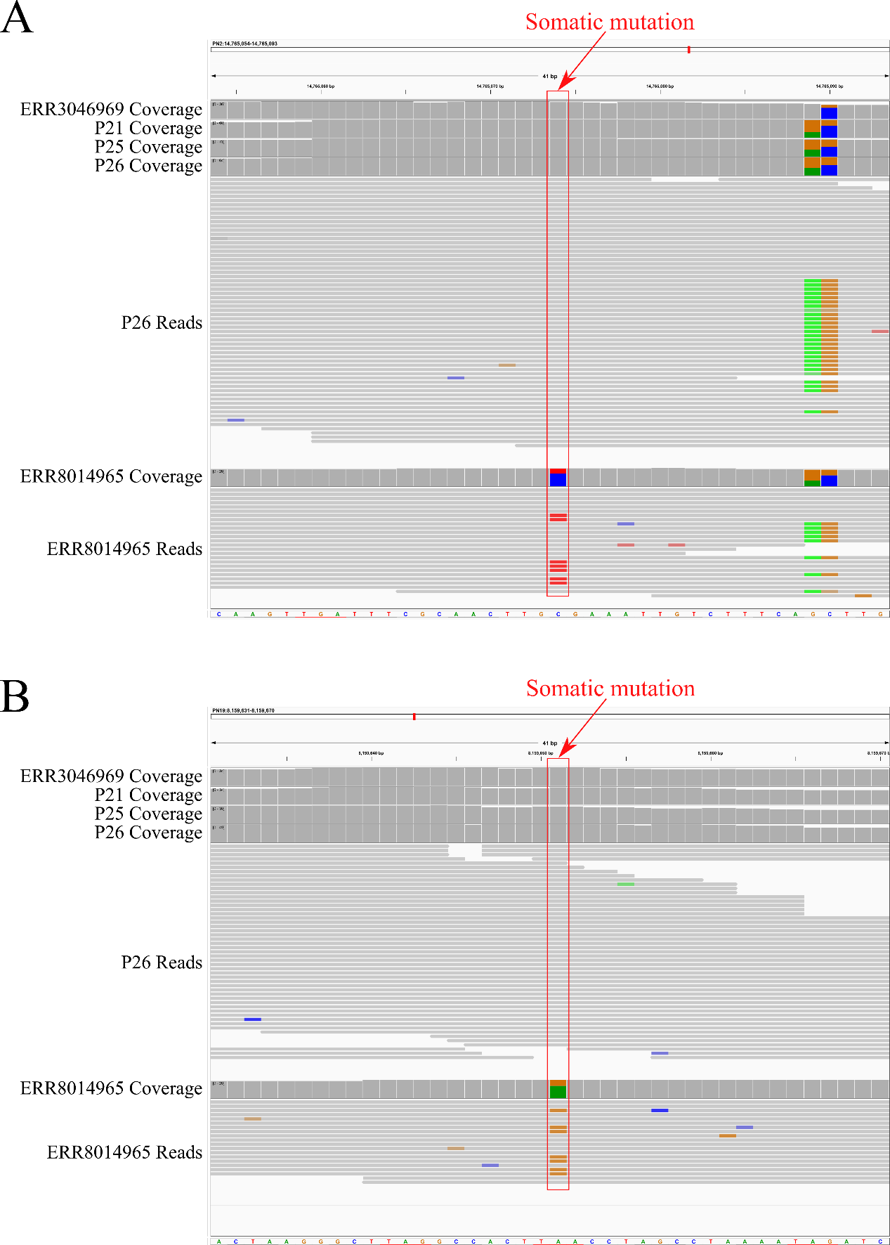
Supplementary Figure 10. IGV visualization to examine identified somatic mutations. Subfigures (A) and (B) represent two different somatic mutation sites. In each subfigure, the coverage of reads that match and differ from the reference genome of five PN clones is shown, along with detailed reads for one sample without somatic mutation and one sample with somatic mutation.
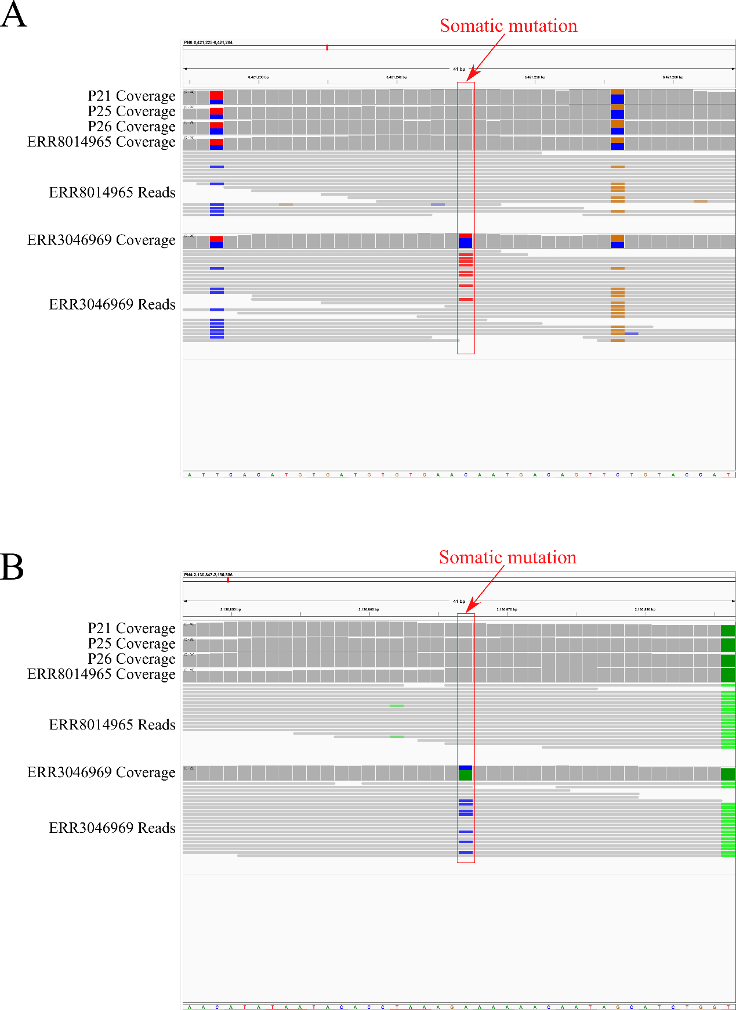
Supplementary Figure 11. IGV visualization to examine identified somatic mutations. Subfigures (A) and (B) represent two different somatic mutation sites. In each subfigure, the coverage of reads that match and differ from the reference genome of five PN clones is shown, along with detailed reads for one sample without somatic mutation and one sample with somatic mutation.
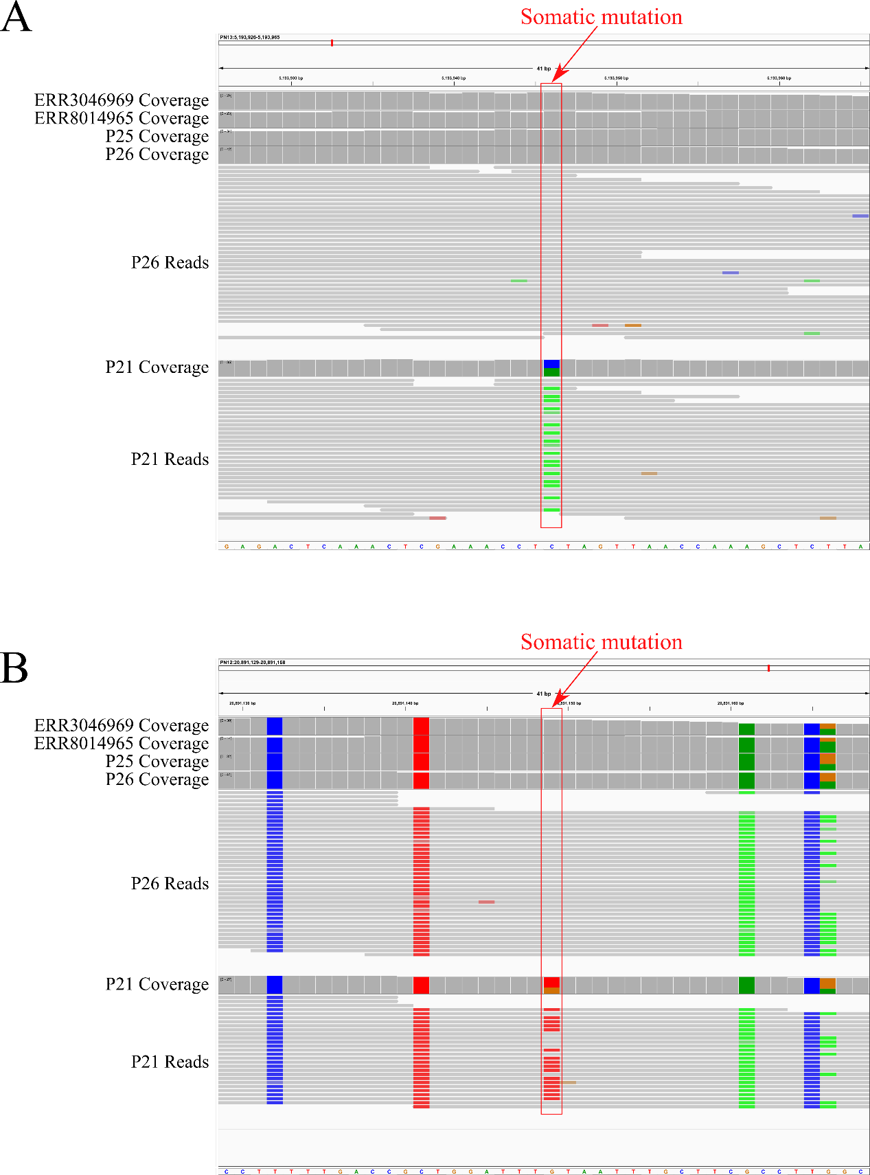
Supplementary Figure 12. IGV visualization to examine identified somatic mutations. Subfigures (A) and (B) represent two different somatic mutation sites. In each subfigure, the coverage of reads that match and differ from the reference genome of five PN clones is shown, along with detailed reads for one sample without somatic mutation and one sample with somatic mutation.

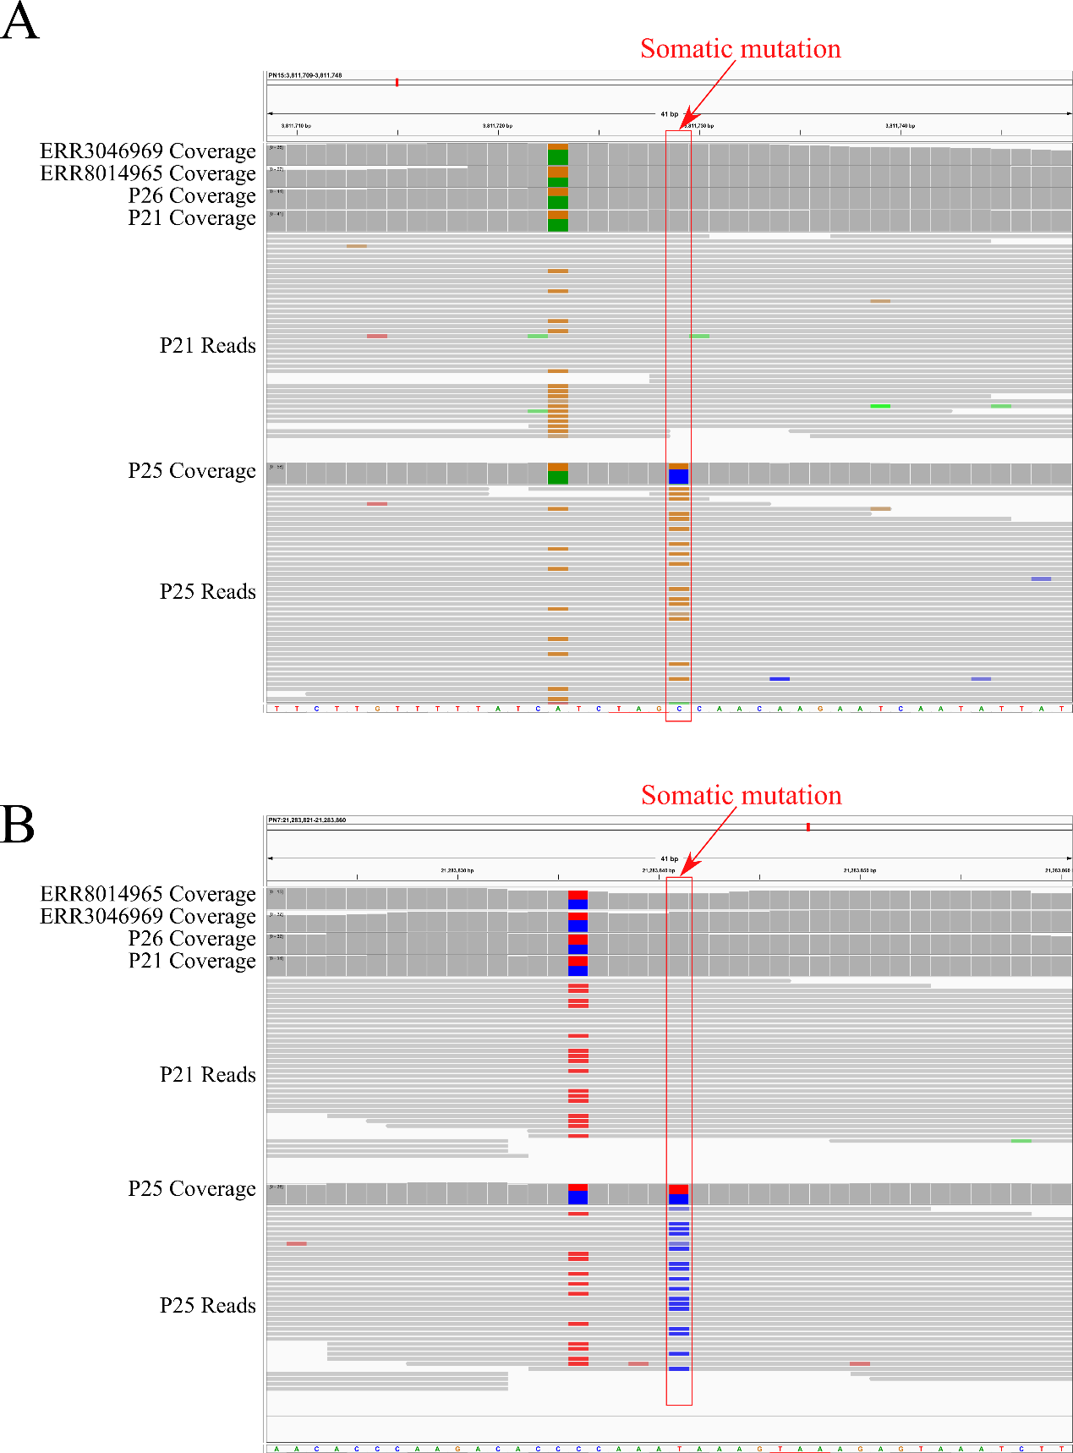
Supplementary Figure 13. IGV visualization to examine identified somatic mutations. Subfigures (A) and (B) represent two different somatic mutation sites. In each subfigure, the coverage of reads that match and differ from the reference genome of five PN clones is shown, along with detailed reads for one sample without somatic mutation and one sample with somatic mutation.

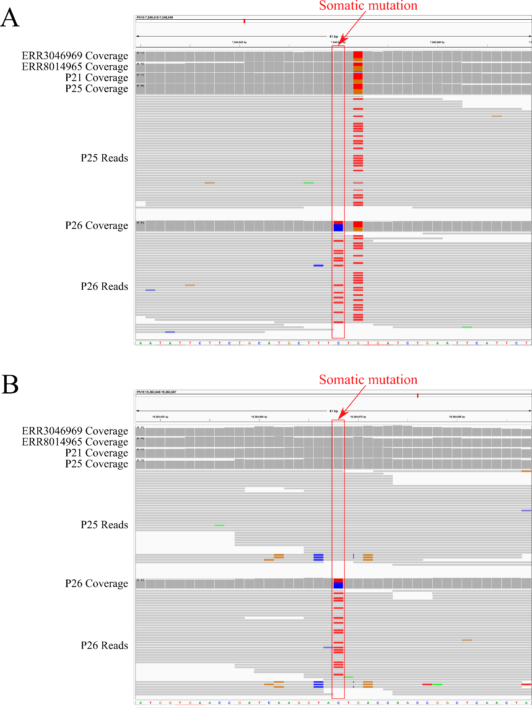
Supplementary Figure 14. IGV visualization to examine identified somatic mutations. Subfigures (A) and (B) represent two different somatic mutation sites. In each subfigure, the coverage of reads that match and differ from the reference genome of five PN clones is shown, along with detailed reads for one sample without somatic mutation and one sample with somatic mutation.

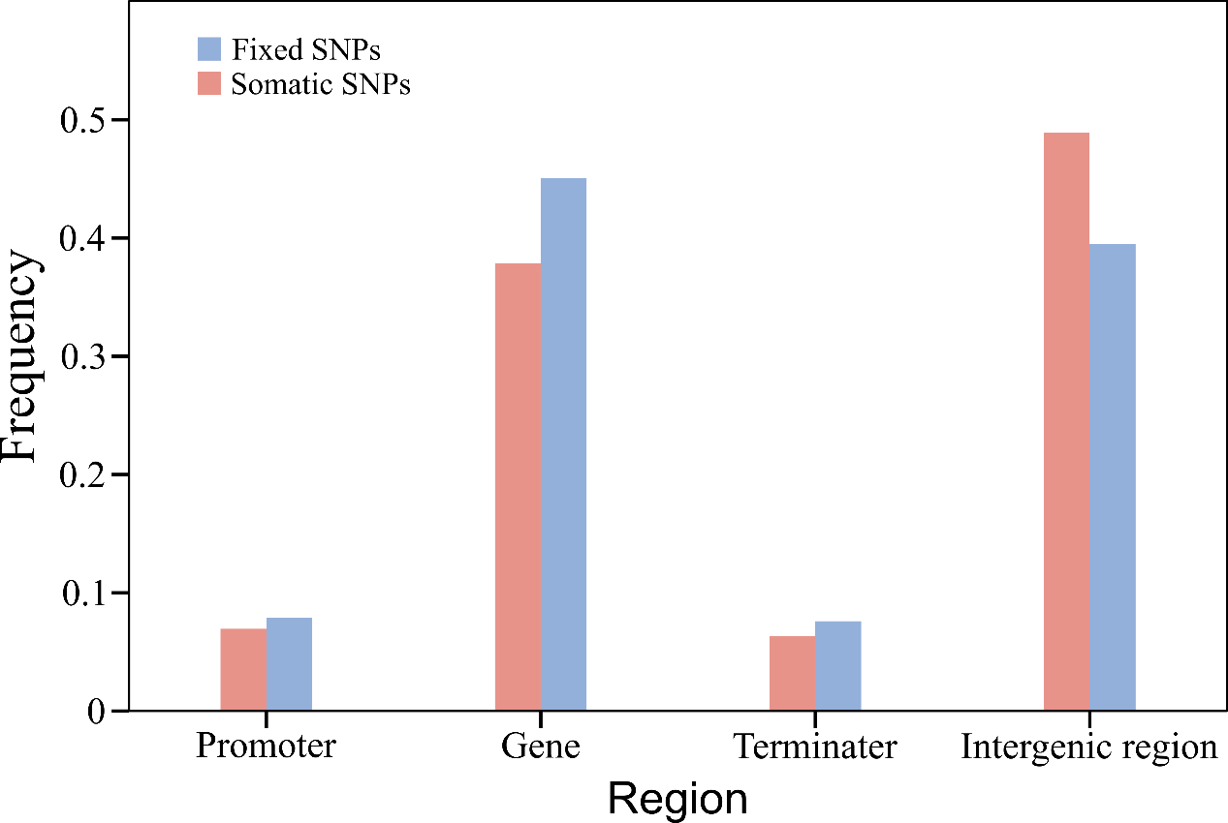
Supplementary Figure 15. The distribution of PN-specific SNPs across the genome. Blue represents fixed SNPs, and red represents putative somatic mutations.

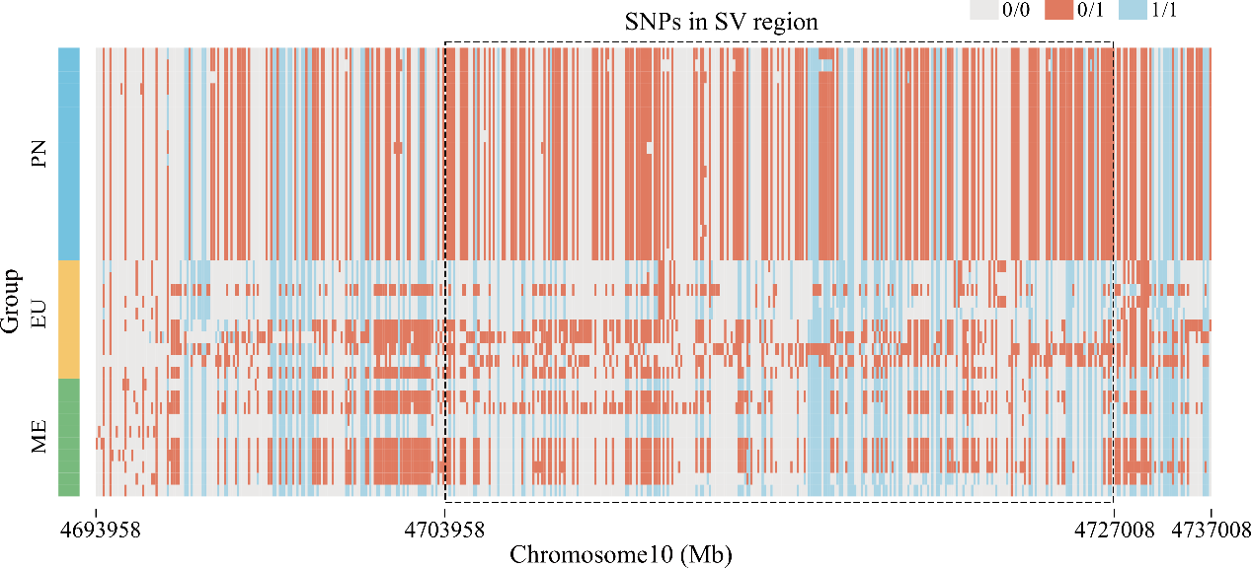
Supplementary Figure 16. Genotypes of the SNPs on the SV located on chromosome 10. The dashed line shows the range of SV.

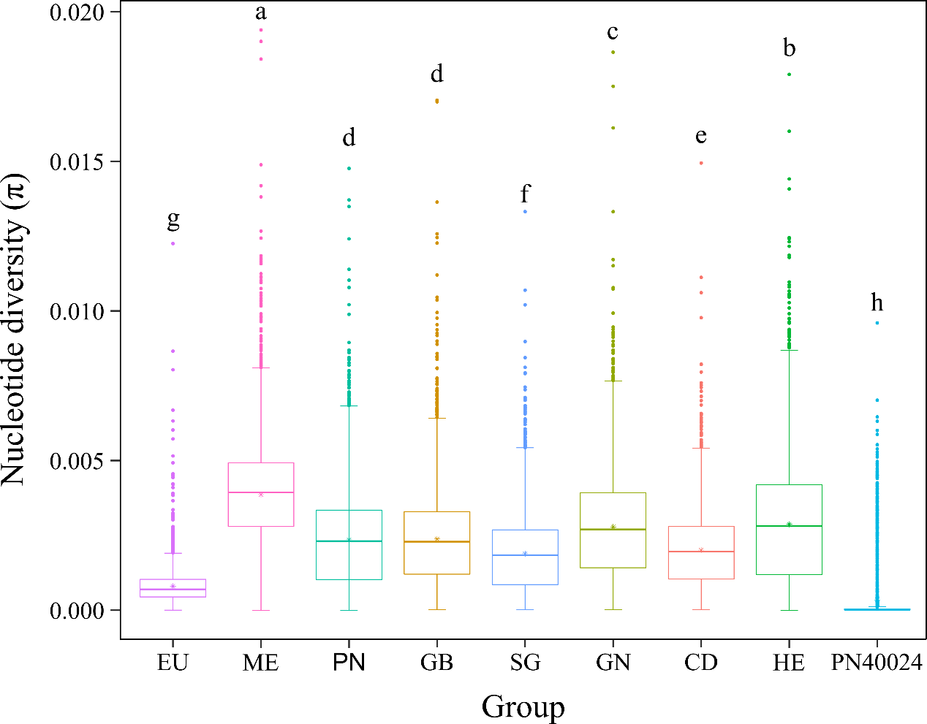
Supplementary Figure 17. The nucleotide diversity (π) value for each group. The sample sizes for each group, from left to right, are as follows: 4783, 4787, 4782, 4779, 4782, 4773, 4777, 4742, and 2027. The two-sided Least Significant Difference (LSD) test was used for statistical analysis to compare each group; groups sharing the same letter are not significantly different (P < 0.05). Source data are provided as a Source Data file.
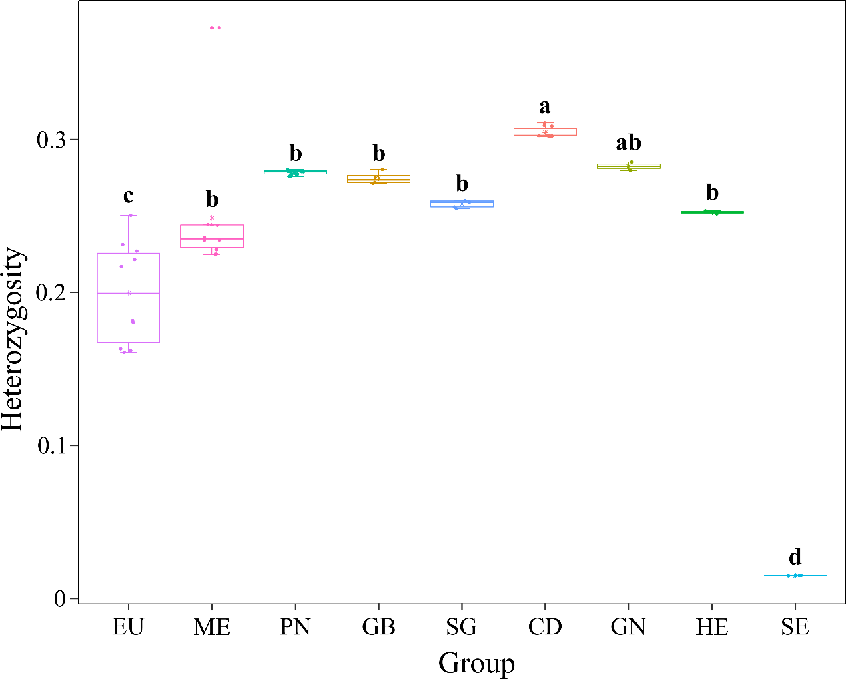
Supplementary Figure 18. Heterozygosity of the nine populations. The number of heterozygous sites in each sample was divided by the total number of SNPs to calculate the heterozygosity of each sample. The sample sizes for each group, from left to right, are as follows: 10, 10, 18, 4, 5, 10, 2, 2, and 4. The two-sided LSD test was used for statistical analysis to compare each group; groups sharing the same letter are not significantly different (P < 0.05). Source data are provided as a Source Data file.

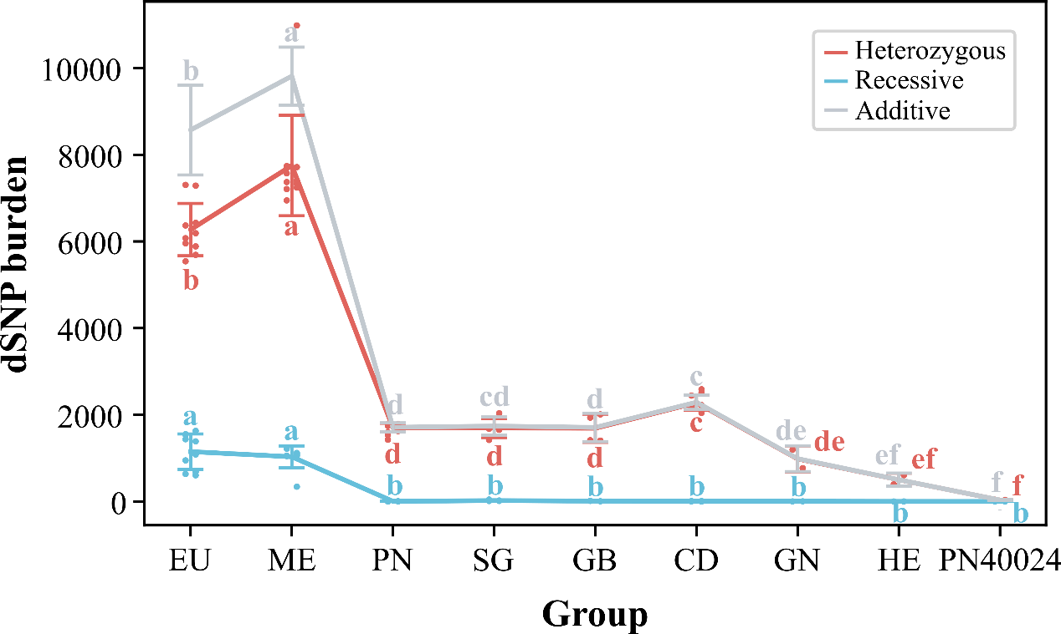
Supplementary Figure 19. The genetic burden of d SNPs unshared within each group. The dots indicate individuals. The sample sizes for each group, from left to right, are as follows: 10, 10, 18, 5, 4, 10, 2, 2, and 4. All data are presented as mean ± SD for each group. The two-sided LSD test was used for statistical analysis to compare each group; groups sharing the same letter are not significantly different (P < 0.05).

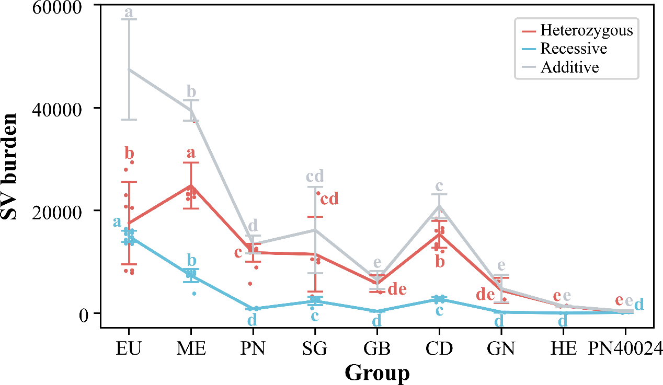
Supplementary Figure 20. The genetic burden of SVs unshared within each group. The dots indicate individuals. The sample sizes for each group, from left to right, are as follows: 10, 10, 18, 5, 4, 10, 2, 2, and 4. All data are presented as mean ± SD for each group. The two-sided LSD test was used for statistical analysis to compare each group; groups sharing the same letter are not significantly different (P < 0.05).

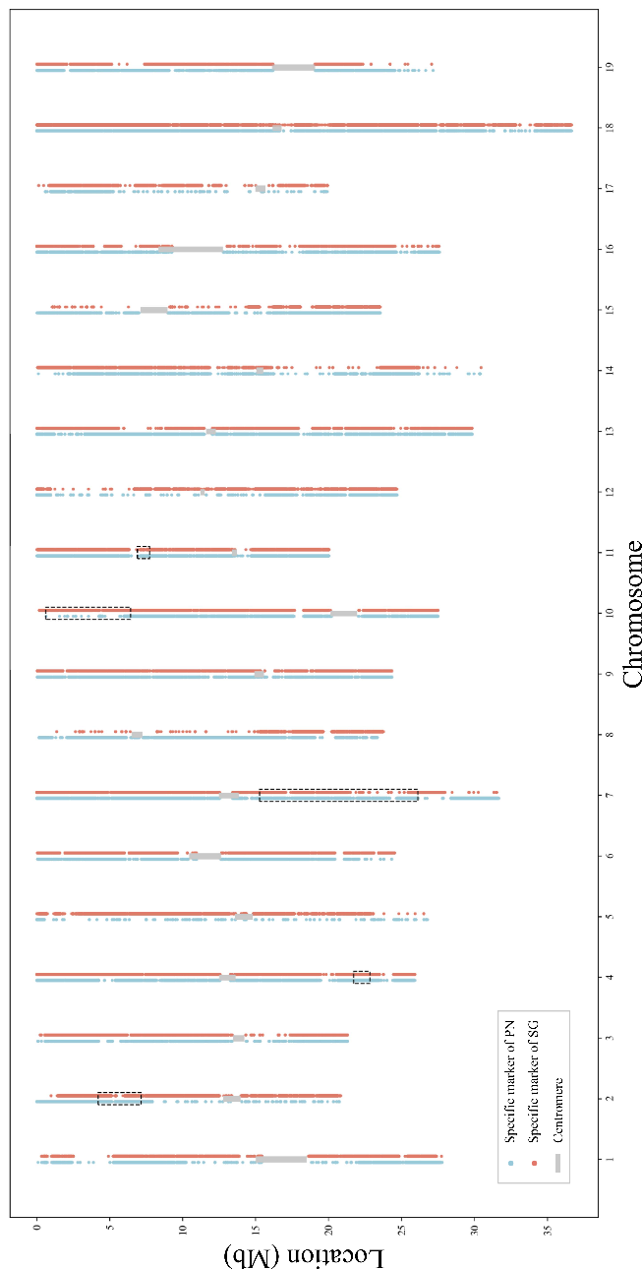
Supplementary Figure 21. The distribution of PN- or SG-specific markers on HE. The black box indicates the heterozygous region on PN40024.

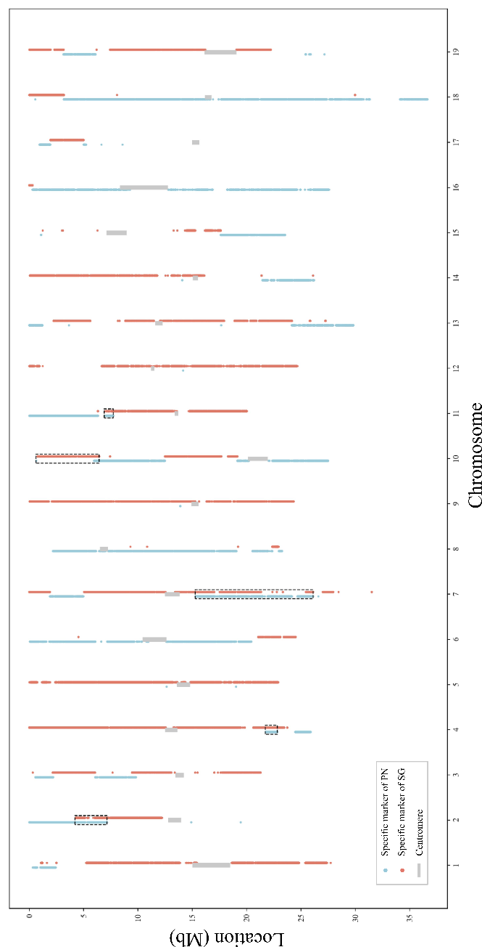
Supplementary Figure 22. The distribution of PN- or SG-specific markers on PN40024. The black box indicates the heterozygous region on PN40024.
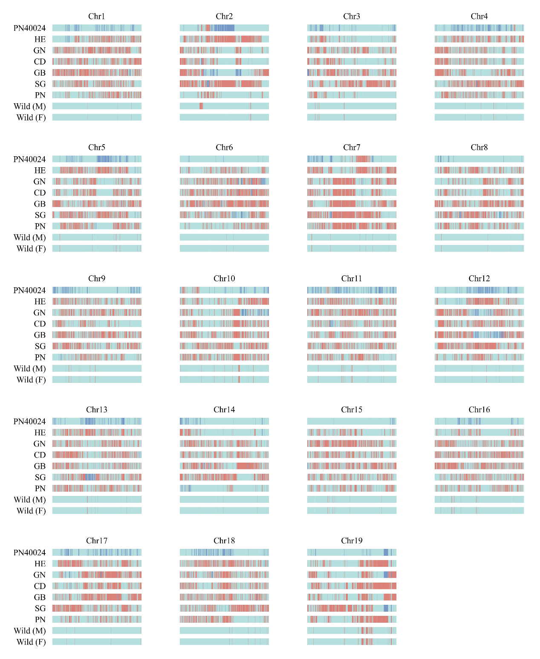
Supplementary Figure 23. The genotype of conserved sites on each chromosome in different cultivars. The light cyan lines indicate the genotype of 0/0; the red lines indicate the genotype of 0/1; the dark blue lines indicate the genotype of 1/1.

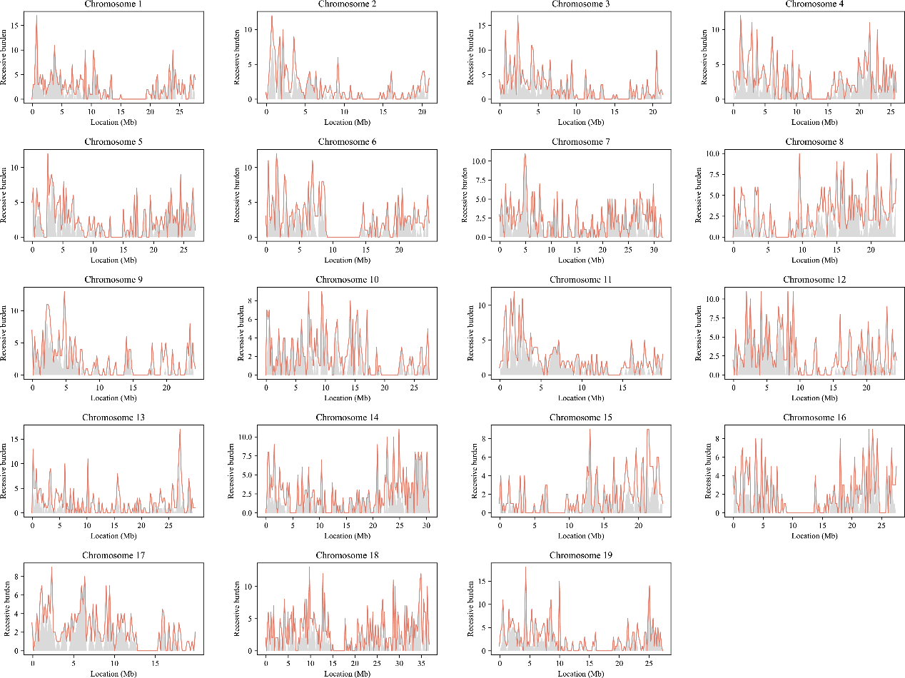
Supplementary Figure 24. The recessive burden from deleterious SNPs on HE and PN40024 genomes.

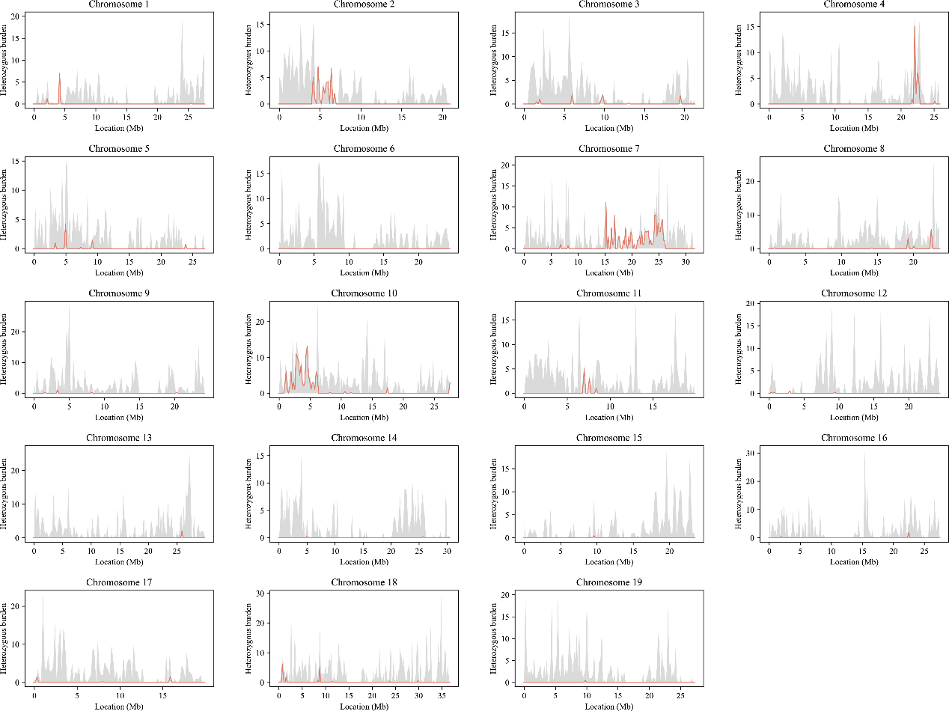
Supplementary Figure 25. The heterozygous burden from deleterious SNPs on HE and PN40024 genomes.

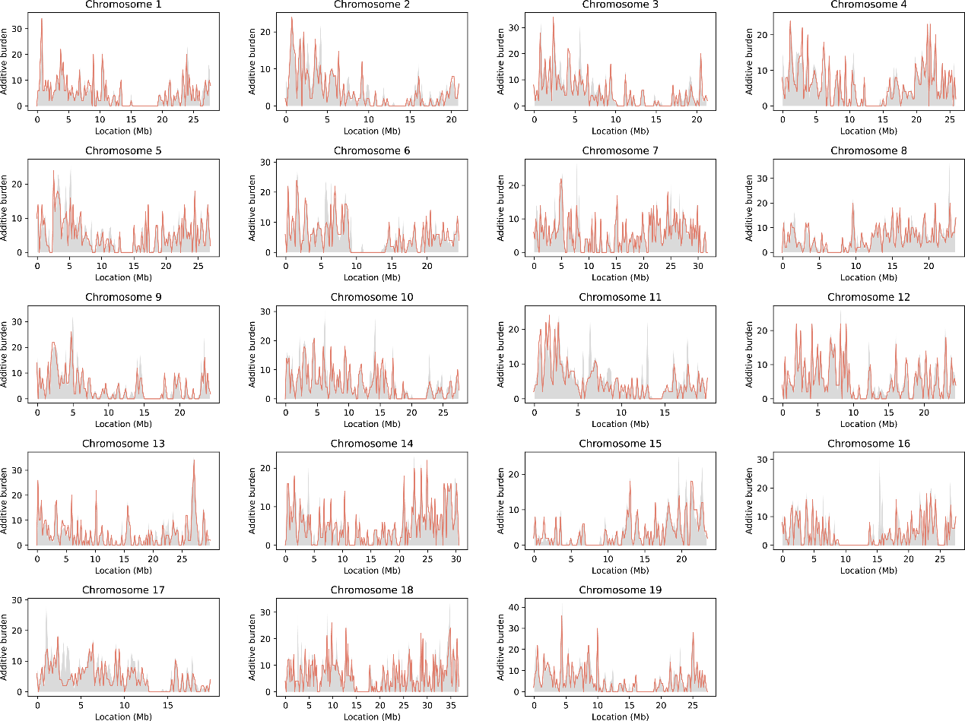
Supplementary Figure 26. The additive burden from deleterious SNPs on HE and PN40024 genomes.

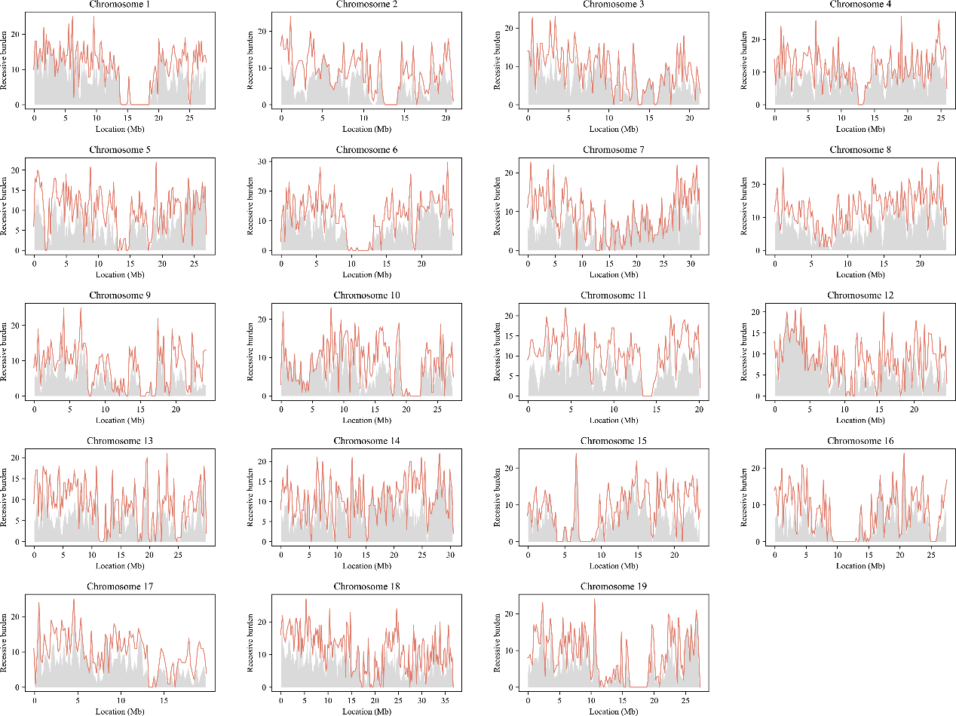
Supplementary Figure 27. The recessive burden of SVs on HE and PN40024 genomes.

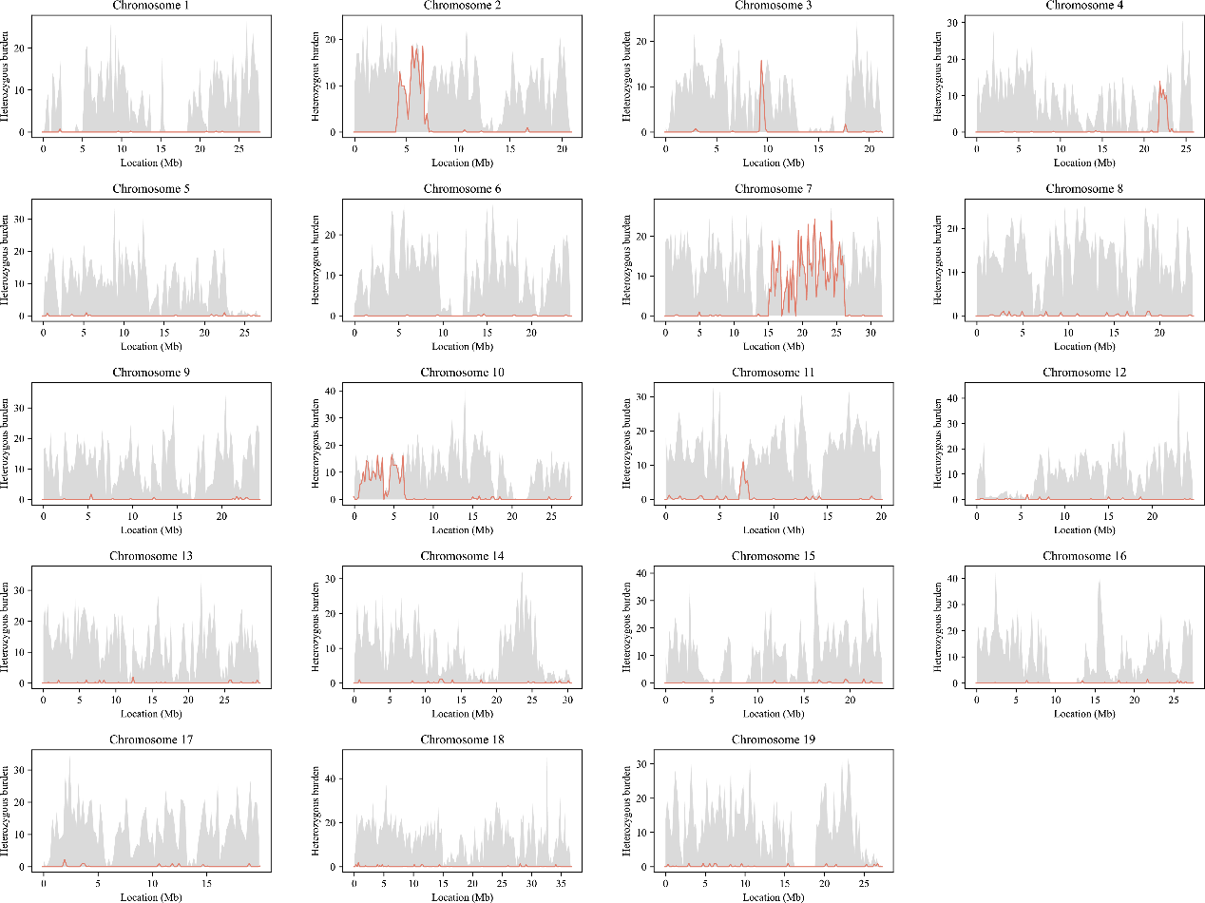
Supplementary Figure 28. The heterozygous burden of SVs on HE and PN40024 genomes.

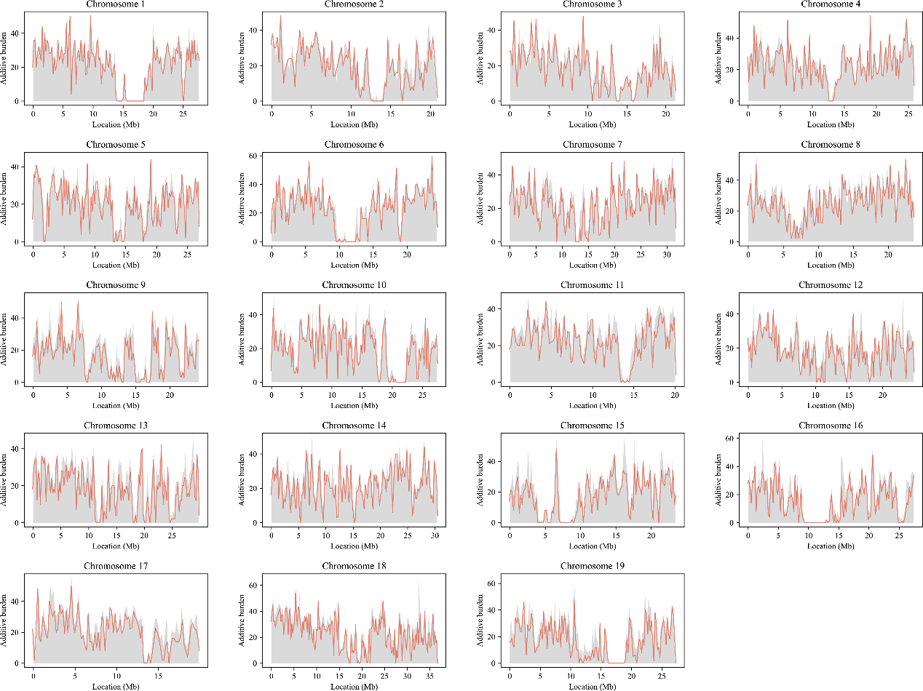
Supplementary Figure 29. The additive burden of SVs on HE and PN40024 genomes.

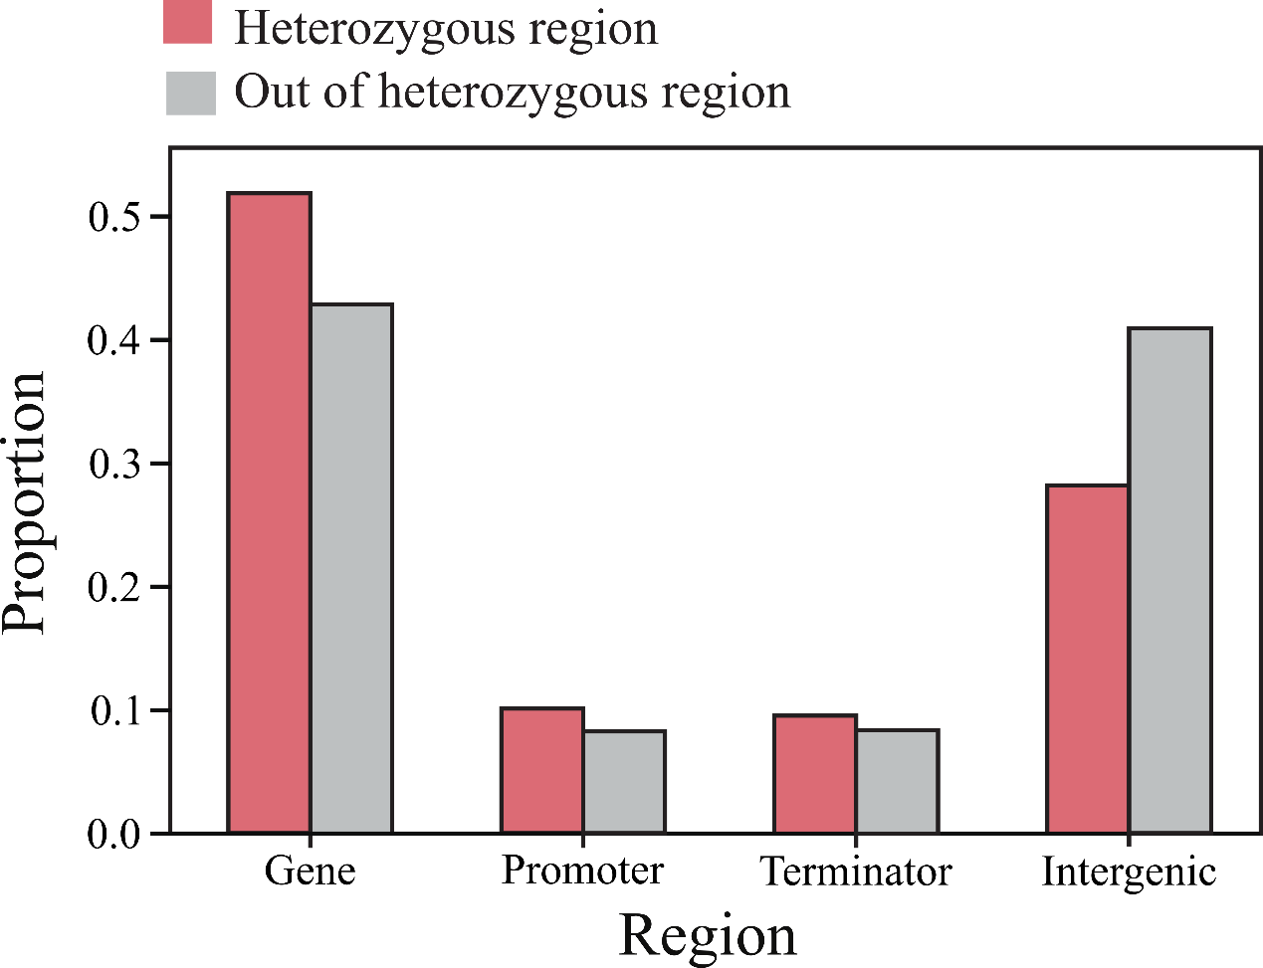
Supplementary Figure 30. The distribution of SNPs of HE in heterozygous blocks and outside of heterozygous blocks.
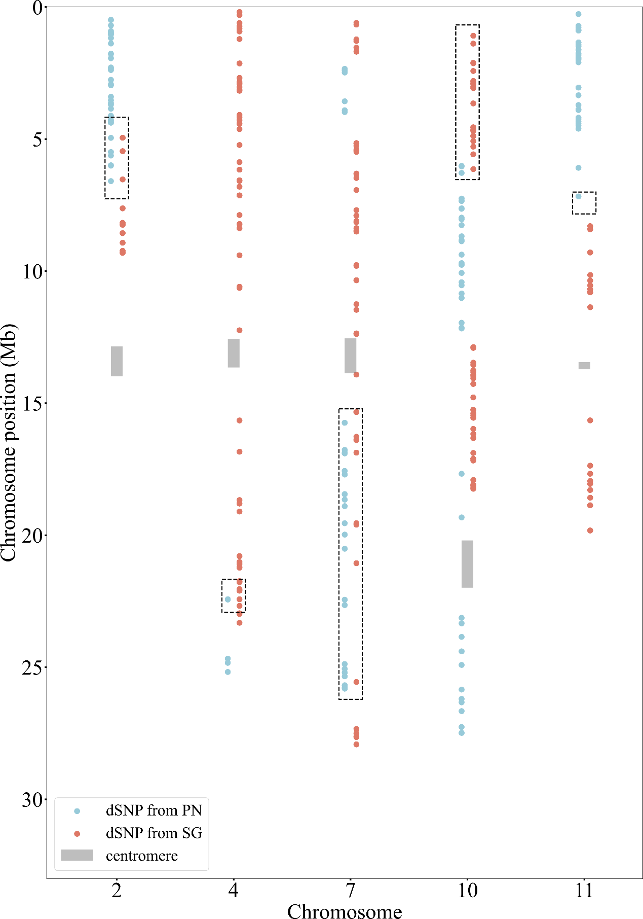
Supplementary Figure 31. The distribution of dSNPs originating from PN and SG on PN40024 in the heterozygous regions of Chromosomes 2, 4, 7, 10, and 11.

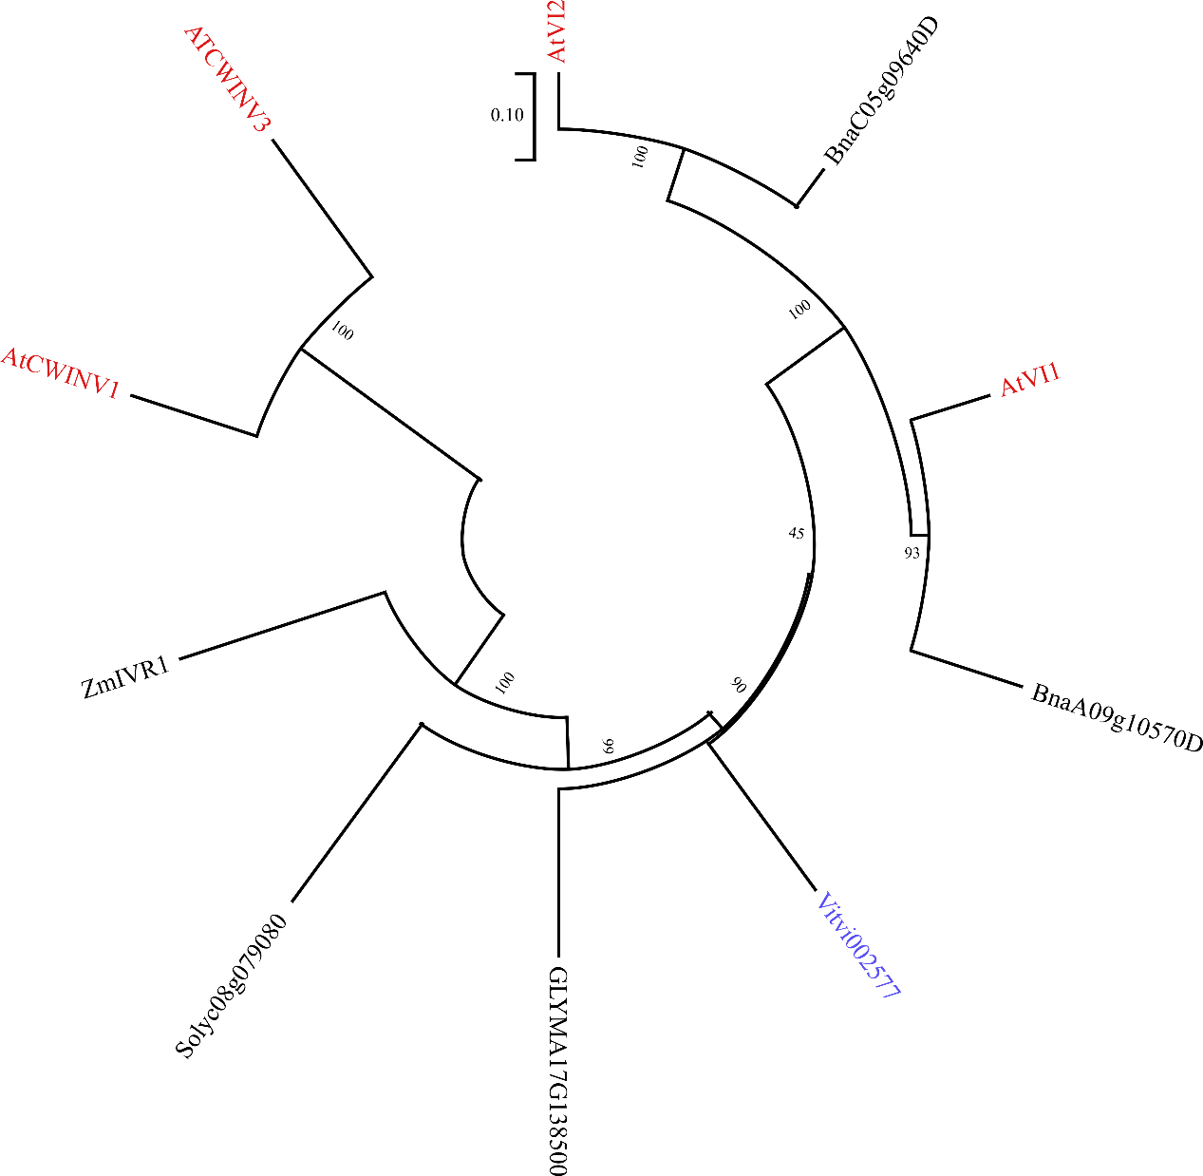
Supplementary Figure 32. Phylogenetic trees of the VI2 gene. Genes found in grapes are represented in blue, those found and functionally validated in other plant species are in red, and unvalidated genes are in black. Abbreviations: At: Arabidopsis thaliana; GLYMA: Glycine max; Vitvi: Vitis vinifera; Solyc: Solanum lycopersicum; Bna: Brassica napus; Zm: Zea mays.

SUPPLEMENTAL TABLES

Supplementary Table 1. Genomic features of Pinot Noir assemblies.
Assembly | PN1 | PN2
Number of contigs (gaps) | 461 | 342
Cumulative size (bp) | 520,445,349 | 509,742,976
N50 (bp) | 23,598,695 | 24,190,395
L50 | 10 | 9
Longest contig (bp) | 36,890,491 | 35,700,716
Number of chromosomes | 19 | 19
Cumulative size (bp) | 496,430,306 | 489,778,950
N50 (bp) | 26,294,478 | 25,184,442
L50 | 9 | 9
Longest (bp) | 36,890,491 | 37,419,935
Complete BUSCO (N = 1,614) | 1,587（98.3%） | 1,588（98.4%）
Telomeres | 35/38 | 35/38
Centromere | 19/19 | 19/19
The number of gene | 37,038 | 37,350
Repeat content (%) | 66.64% | 66.21%

Supplementary Table 2. Primers used for the verification of inversions on Chr19.
Combination | Forward primer | Reverse primer | Expected product length (bp)
p1/p2 | TCCGACTATGTGAAAGGCCC | CGGGTTTGTCACCTGCTTTG | 425
p3/p4 | CCGGCGTAAAATCTGAGAAG | TCAAGGTGGCTCACAAGTG | 1044
p1/p5 | TCCGACTATGTGAAAGGCCC | CCTATGCATAAGCCGTGGGT | 670
p6/p3 | TGTCTCTCACTTCTCCCTCT | CCGGCGTAAAATCTGAGAAG | 1359
p2/p7 | CGGGTTTGTCACCTGCTTTG | CCCGACATGTCCTCATATGG | 369
p8/p4 | TCAACCGGTTCAGCACTATG | TCAAGGTGGCTCACAAGTG | 285

Supplementary Table 3. The number of SV types specific to PN and the number associated with TE.
 | DEL | BND | DUP | INV | All
All | 361 | 178 | 55 | 11 | 605
Relate to TE | 348 | 117 | 53 | 11 | 529

Supplementary Table 4. The range of heterozygous blocks.
Chromosome | 2 | 4 | 7 | 10 | 11 | 16
Start (bp) | 4,270,039 | 21,770,266 | 15,315,086 | 678,030 | 6,950,463 | 12,997,815
End (bp) | 7,167,418 | 22,821,760 | 26,110,944 | 6,437,427 | 7,731,974 | 13,655,510

