Supplemental information

Benefits of equilibrium between microbiota- and host-derived ligands of the aryl hydrocarbon receptor after stroke in aged male mice

Pedram Peesh^{1,2,5}, Maria P. Blasco-Conesa¹, Ahmad El Hamamy¹, Romeesa Khan¹, Gary Guzman¹, Parisa Honarpisheh¹, Eric C. Mohan¹, Grant W. Goodman¹, Justin N. Nguyen¹, Anik Banerjee^{1,2}, Bryce E. West¹, Kyung Ae Ko¹, Janelle Korf^{1,2}, Chunfeng Tan¹, Huihui Fan¹, Gabriela Delevati Colpo¹, Hilda Ahnstedt¹, Lucy Couture¹, Solji Roh¹, Julia K. Kofler³, Jose F. Moruno Manchon¹, Michael Maniskas¹, Jaroslaw Aronowski¹, Rodney M. Ritzel¹, Juneyoung Lee¹, Jun Li¹, Robert M. Bryan⁴, Anjali Chauhan¹, Venugopal R Venna¹, Louise D. McCullough*¹ and Bhanu P. Ganesh*^{1,2}
*Co-corresponding/co-senior authors
¹Department of Neurology, The University of Texas McGovern Medical School, Houston, TX.
²The University of Texas MD Anderson UTHealth Graduate School of Biomedical Sciences, Houston, TX.
³Department of Pathology, University of Pittsburgh School of Medicine, Pittsburgh, PA
⁴Baylor College of Medicine, Department of Anesthesiology, Houston, TX
⁵Department of Neurosurgery, The University of Texas McGovern Medical School, Houston, TX.

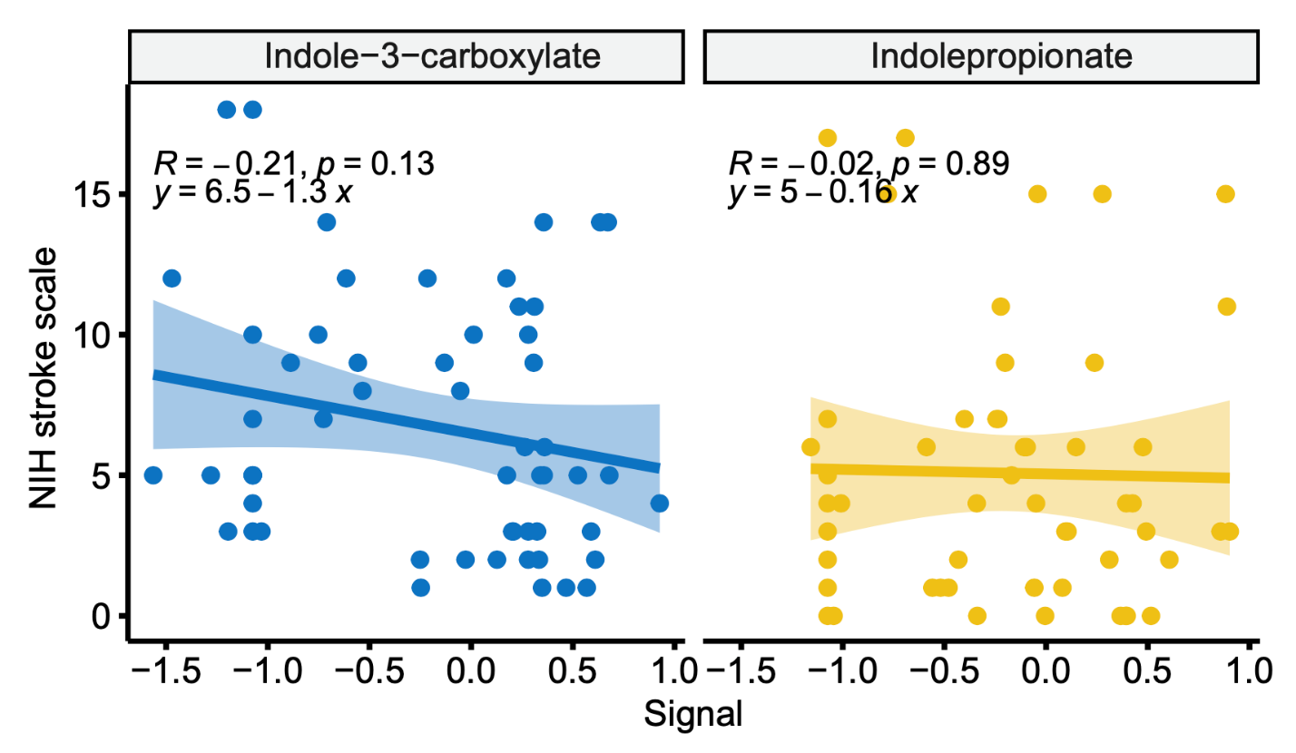

Supplementary Figure S1. Correlational analysis of plasma concentration of microbiota-derived indole-based ligands of AHR with NIH Stroke Scale (NIHSS) in human patients.

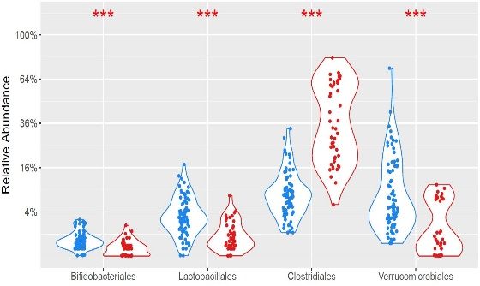
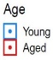
Supplementary Figure S2. 16S rRNA gene sequencing analysis data as order-level relative abundance analysis of gut microbiota shows significant decreases in Bifidobacteriales, Lactobacillales, and Verrucomicrobiales populations in aged mice vs young mice. This indicates that indole-producing species decrease with aging in the gut. (Mann-Whitney test, median. P<0.0001). Each dot represents a biological replicate.

Supplementary Figure S3. RT-qPCR analysis of HMC3 cells treated with Kyn, IC, or IP, shows activation of AHR as measured by the downstream target gene Cyp1b1. Treatment with Kyn increases expression of Cyp1b1 as compared to indole treatment.

Supplementary Figure S4. RT-qPCR analysis of HMC3 cells after oxygen-glucose deprivation and reperfusion (OGD), treated with Kyn or IC/IP cocktail post-OGD, shows activation of inflammatory cytokines post-OGD, and decreased expression after treatment with a Kyn and indole cocktail.

Supplementary Figure S5. (A) Metabolomic analysis of brain samples after treatment with indole-3-carboxaldehyde and indole-3-propionate. As expected, concentrations of indole-based ligands were significantly increased in the brain samples from indoles-treated GF mice compared to controls. (B) Metabolomic analysis of plasma samples from germ-free (GF) and wild-type (WT) mice, showing indole-3-carboxaldehyde and indole-3-propionate levels. Concentrations of indoles were significantly increased in the plasma samples from indole-treated GF mice compared to the vehicle group. No significant differences were found in indole-3-carboxaldehyde and indole-3-propionate levels in WT animals before and after indole treatment, however, the total concentration of detected indoles increased in treated WT animals compared to WT controls.

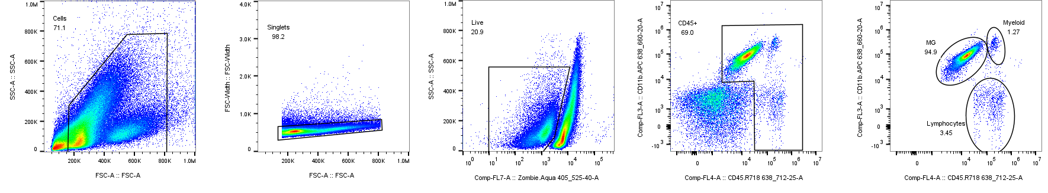
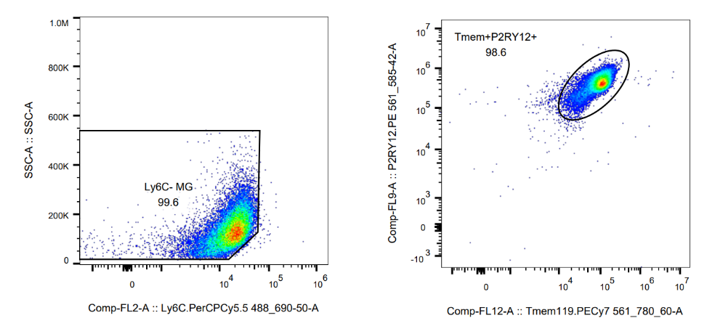

Supplemental Figure S6. No less than 100,000 events were recorded for each sample/tissue. Cell type-matched fluorescence minus one (FMO) and unstained controls were used as gating strategies. Briefly, the bivatiat plots of forward scatter versus side scatter were used to select for particle size and granularity. Subsequently, forward scatter area versus length was used to identify and exclude the blood particles. Next gait was to select for viable cells using Zombie Aqua staining, negatively stained particles were selected as live singlet cells. Following the selection of the live cells, a plot of CD45 versus CD11b was used to select the classical gates of the myeloid populations in the brain. Intermediate staining of CD45 versus high staining of CD11b was determined as the microglia population, confirmed by double positive staining of P2RY12 and TMEM119. Additionally, microglia gait was confirmed to be negative for staining of Ly6C to exclude monocytic contaminations. High levels of CD45 staining along with high CD11b staining was identified as infiltrating myeloid cells a population comprised of monocytes, macrophages, dendritic cells. Lastly, on the same plot of CD45 versus CD11b, the CD45 high population with low CD11b staining was identified as an initial gait for the lymphocytes. B and T lymphocytes were subsequently identified from the initial lymphocyte gate using CD19 and CD3 pan markers, respectively.
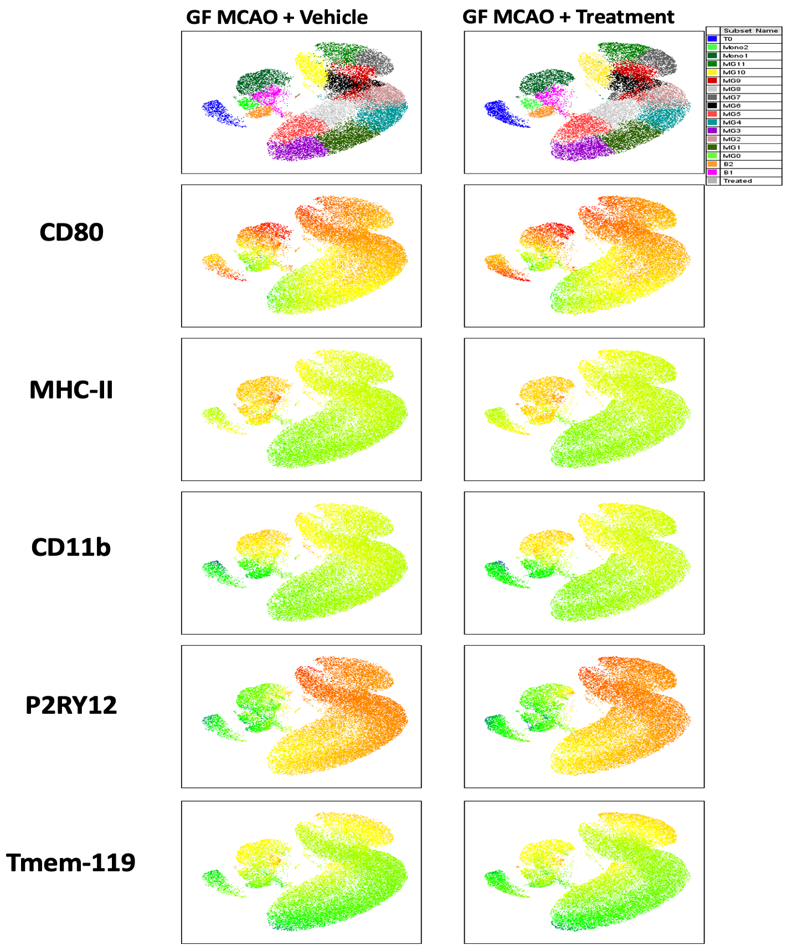
Supplementary Figure S7. Surface expression of CD80, MHC-II, CD11b, P2RY12, and Tmem119 superimposed on the brain phenographs of GF stroke mice treated with indoles compared to the GF vehicle group.
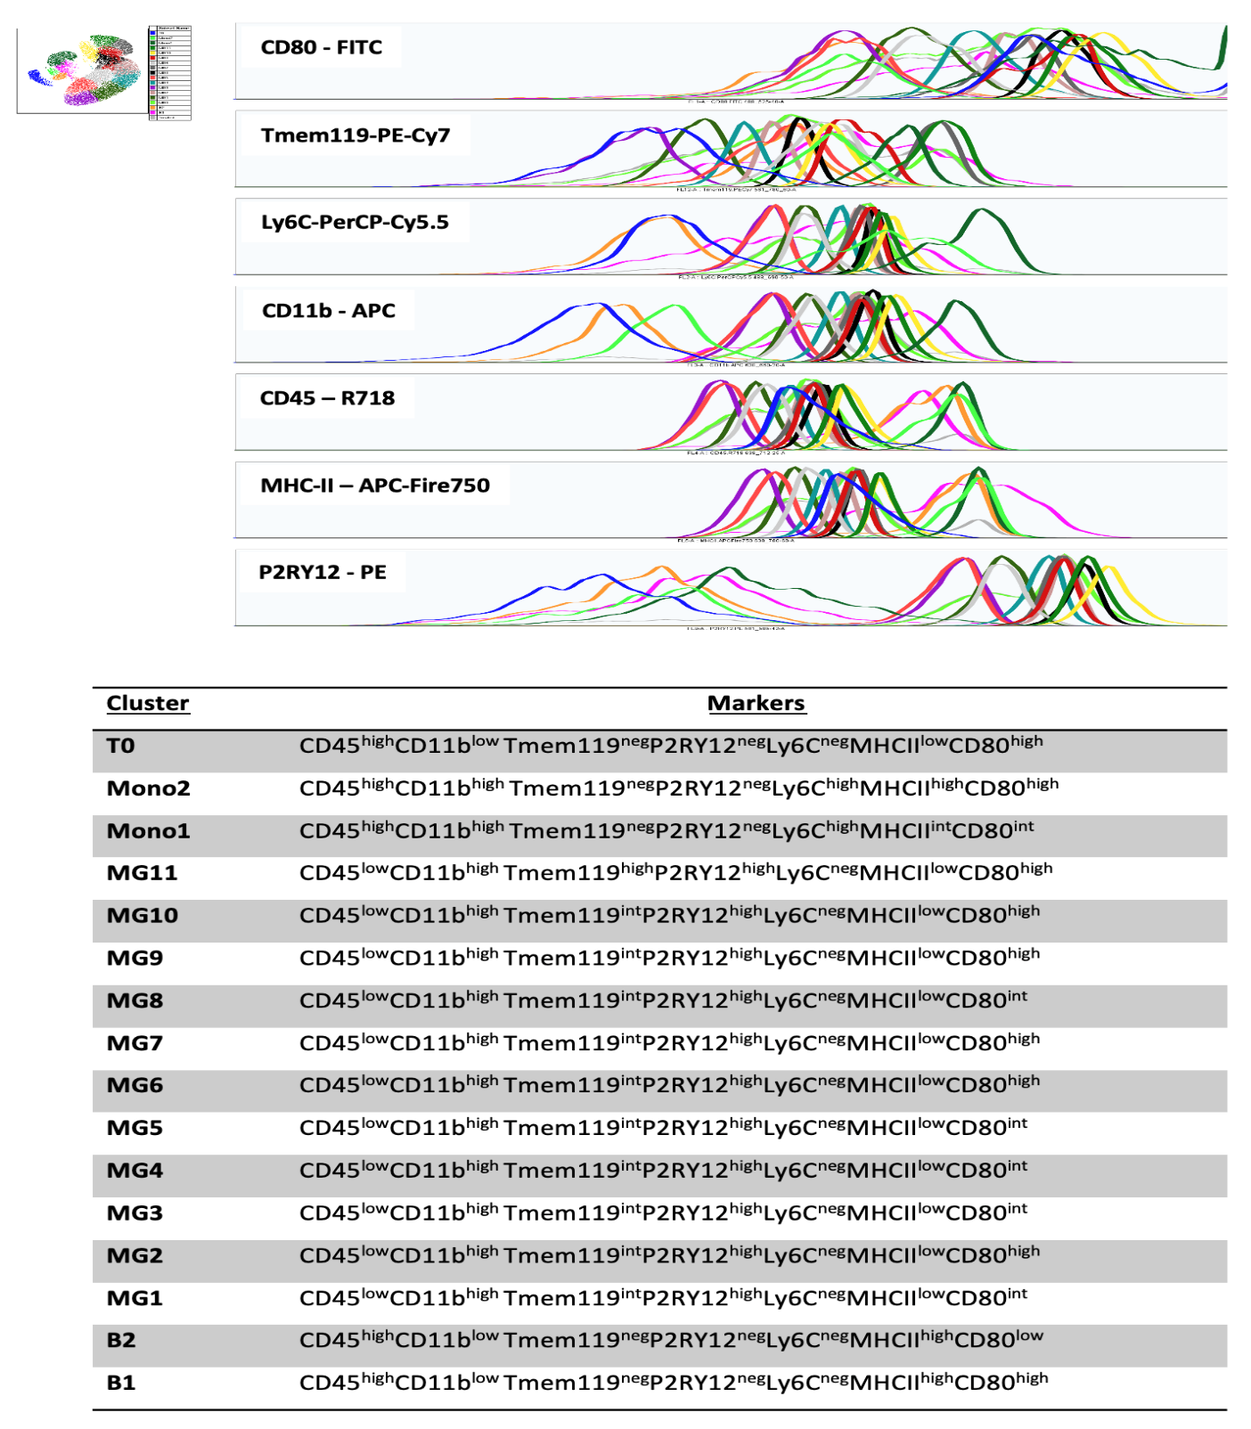
Supplementary Figure S8. Surface phenotype of seven markers (fluorescence intensity and tabular format) used to identify different immune population in the clusters detected by the unsupervised phonograph algorithm.

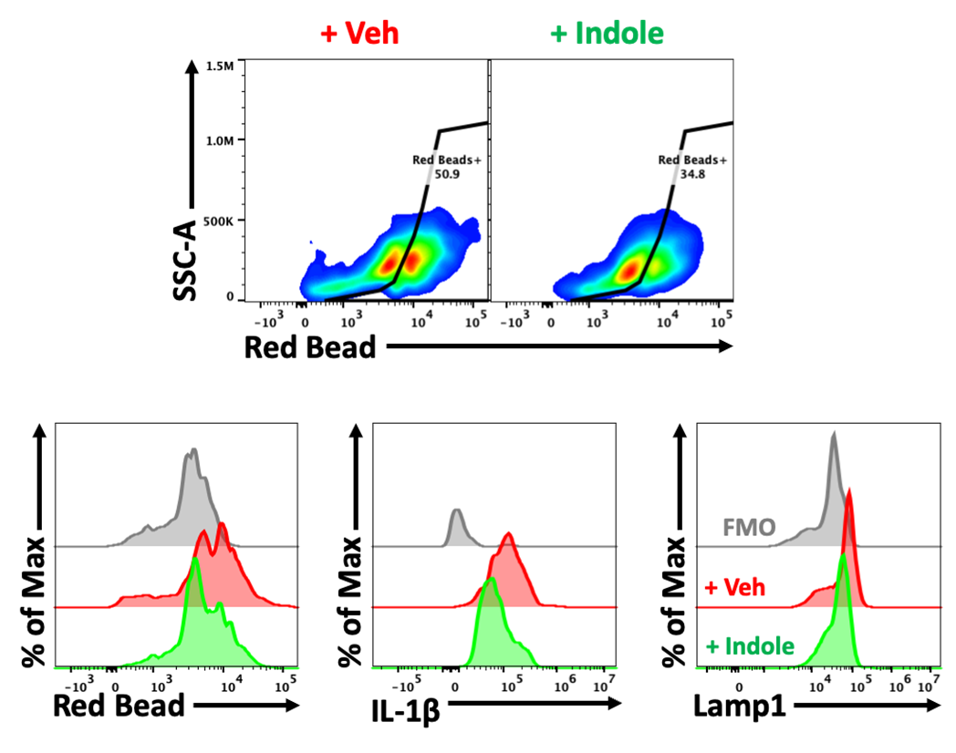
Supplementary Figure S9.
Sorted microglia from germ free male mice treated with indoles or vehicle prior to stroke at 3 hours and 8 hours. Mean fluorescence intensity of vehicle-treated microglia compared to indole-treated microglia with elevated red bead engulfment, IL-1β and LAMP1.

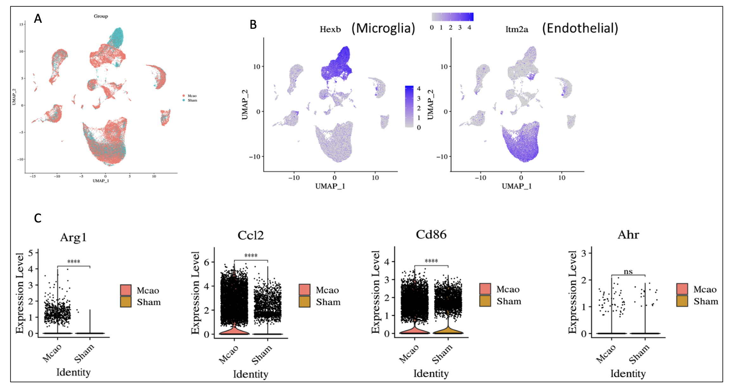

Supplementary Figure S10. AHR and related pathway genes are upregulated in MCAO microglia. (A) UMAP showing integrated cell clustering across MCAO and Sham samples. (B) Microglia and endothelial cell markers are shown in the UMAPs. (C) Violin plots showing significant up-regulation of AHR related genes when comparing MCAO to Sham using microglia. Significance level: * p-value ≤ 0.05; ** p-value ≤ 0.01; *** p-value≤ 0.001; **** p-value ≤ 0.0001.

Supplementary Table S1 – Population and clinical characteristics of stroke and control cohorts for postmortem brain samples
Case # (Human brains) | Age range (years) | Sex | Postmortem (h) | Cohort | Stroke location
Control 1 | 61-79 | M | 5 | Control
Control 2 | 61-79 | M | 6 | Control
Control 3 | 61-79 | M | 12 | Control
Control 4 | 80-99 | M | 5 | Control
Control 5 | 80-99 | M | 20 | Control
Control 6 | 61-79 | M | 13 | Control
Control 7 | 80-99 | F | 7.5 | Control
Control 8 | 80-99 | F | 12 | Control
Control 9 | 80-99 | F | 5 | Control
Control 10 | 61-79 | F | 9 | Control
Stroke (Acute phase) 1 | 61-79 | M | 5 | Stroke | R posterior parietal
Stroke (Acute phase) 2 | 80-99 | M | 24 | Stroke | NA
Stroke (Acute phase) 3 | 61-79 | M | n/a | Stroke | NA
Stroke (Acute phase) 4 | 61-79 | F | 11 | Stroke | NA
Stroke (Acute phase) 5 | 80-99 | F | 13 | Stroke | NA
Stroke (Acute phase) 6 | 80-99 | F | 8 | Stroke | L inferior occipital
Stroke (Acute phase) 7 | 61-79 | F | 2 | Stroke | R medial occipital
Stroke (Acute phase) 8 | 80-99 | F | 24 | Stroke | Occipital
Stroke (Acute phase) 9 | 80-99 | F | 3 | Stroke | L MCA
Stroke (Acute phase) 10 | 40-59 | M |  | Stroke | R frontal watershed
Stroke (Acute phase) 11 | 80-99 | M |  | Stroke | R medial occipital
Stroke (Acute phase) 11 | 80-99 | M |  | Stroke | R lateral occipital cortex
Stroke (Acute-Subacute phase) 1 | 61-79 | M |  | Stroke | R frontal watershed
Stroke (Acute-Subacute phase) 2 | 80-99 | M |  | Stroke | R lateral occipital cortex
Stroke (Subacute Phase) 1 | 80-99 | M | 11 | Stroke | R inferior occipital
Stroke (Subacute Phase) 2 | 61-79 | M | 4 | Stroke | NA
Stroke (Subacute Phase) 3 | 80-99 | M | 7 | Stroke | NA
Stroke (Subacute Phase) 4 | 80-99 | M | 4 | Stroke | NA
Stroke (Subacute Phase) 5 | 80-99 | F | 17 | Stroke | Periamygdala
Stroke (Subacute Phase) 6 | 80-99 | F | 0 | Stroke | L medial occipital
Stroke (Subacute Phase) 7 | 61-79 | F | 4 | Stroke | NA
Stroke (Subacute Phase) 8 | 80-99 | F | 9 | Stroke | L medial occipital
Stroke (Subacute Phase) 9 | 80-99 | F | 4 | Stroke | L cingulate gyrus
Stroke (Subacute Phase) 10 | 61-79 | F | 3 | Stroke | L cingulate gyrus
Stroke (Subacute-Chronic phase) | 61-79 | M |  | Stroke | R superior parietal
Stroke (Subacute-Chronic phase) | 61-79 | F |  | Stroke | L putamen
Stroke (Chronic phase) | 61-79 | F |  | Stroke | L medial frontal gyrus
Stroke (Chronic phase) | 61-79 | F |  | Stroke | L temporal tip WM
Stroke (Chronic phase) | 61-79 | F |  | Stroke | L caudate head

MCA (middle cerebral artery); WM (white matter)

Supplementary Table S2 – Population and clinical characteristics of stroke and control cohorts for plasma samples
 | Stroke (n=60) | Controls (n=64) | p value
Demographics characteristics
Sex, Female, n (%) | 22 (36.6%) | 21 (32.8%) | 0.70ª
Age, mean± SD, y | 62.38 ±13.24 | 58.29 ±14.88 | 0.25^{b}
Race, ethnicity n (%) |  |  | 0.43^{c}
White/Caucasian | 33 (55%) | 42 (65.6%)
Black/ African American | 15 (25%) | 8 (12.5%)
Asian | 3 (5%) | 2 (3.1%)
Other | 9 (15%) | 12 (18.7%)
Hispanic (Other/White) | 15 (25%) | 14 (21.8%)
Smoking (past or currently) | 25 (41.6%) | 8 (12.5%) | 0.0003ª
Missing |  | 5 (7.8%)
Medical history, n (%) |  |  | 0.76^{c}
Hypertension | 53 (88.3%) | 34 (53.1%)
Missing |  | 3 (4.68%)
Diabetes | 30 (50%) | 13 (20.3%)
Missing |  | 4 (6.2%)
Hypercholesterolemia | 38 (63.3%) | 23 (35.9%)
Missing |  | 4 (6.2%)
Atrial fibrillation | 13 (21.6%) | 9 (14%)
Missing |  | 4 (6.2%)
SD, standard deviation
ªFisher’s exact test
^{b}Mann-Whitney/Wilcoxon test
^{c} Chi-square test
p represents the significance of the comparison between Stroke and control groups. Significant differences (unadjusted p < 0.05) are bolded.

