Supplementary Information

Compression of sickspan by interventions that steepen the survival curve
Yifan Yang¹, Avi Mayo¹, Tomer Levy¹, Naveh Raz¹, Ben Shenhar¹, Dan Jarosz², Uri Alon¹

Table of contents

Supplementary Information
S1. Effect of SR model parameters on longevity and sickspan 2
S2. Tables of mouse, fly and nematode control and intervention cohorts with longitudinal healthspan data 3
S3. Effect of steepness on mice sickspan is robust to the definition of sickspan threshold 6
S4. Alternative definitions of steepness 7
S5. Accounting for batch effects and environmental heterogeneity in C. elegans 9
S6. Several interventions in the ITP database significantly change the steepness of survival curves 10
S7. Male mice have shorter lifespan, shallower survival curves and more steepening interventions 12
S8. Intervention experiments independent of ITP introduce additional classes of steepening interventions and agree with those in the ITP database 13
S9. Antioxidants NDGA and GTE increase steepness 15
S10. Most rapamycin experiments shows approximate scaling except at old ages 16
S11. Rapamycin and acarbose interact additively to extend mouse lifespan and steepness 17
S12. In vivo reprogramming shows approximate scaling in preliminary experimental data 18

S1. Effect of SR model parameters on longevity and sickspan
Here instead of lifespan on the axis as in Fig. 1e, Fig. 2 cd, we plot the log magnitude of parameter change on the x axis. Baseline parameters are for mice ³². Similar effects are seen for other baseline parameter choices including human and invertebrate model parameters.

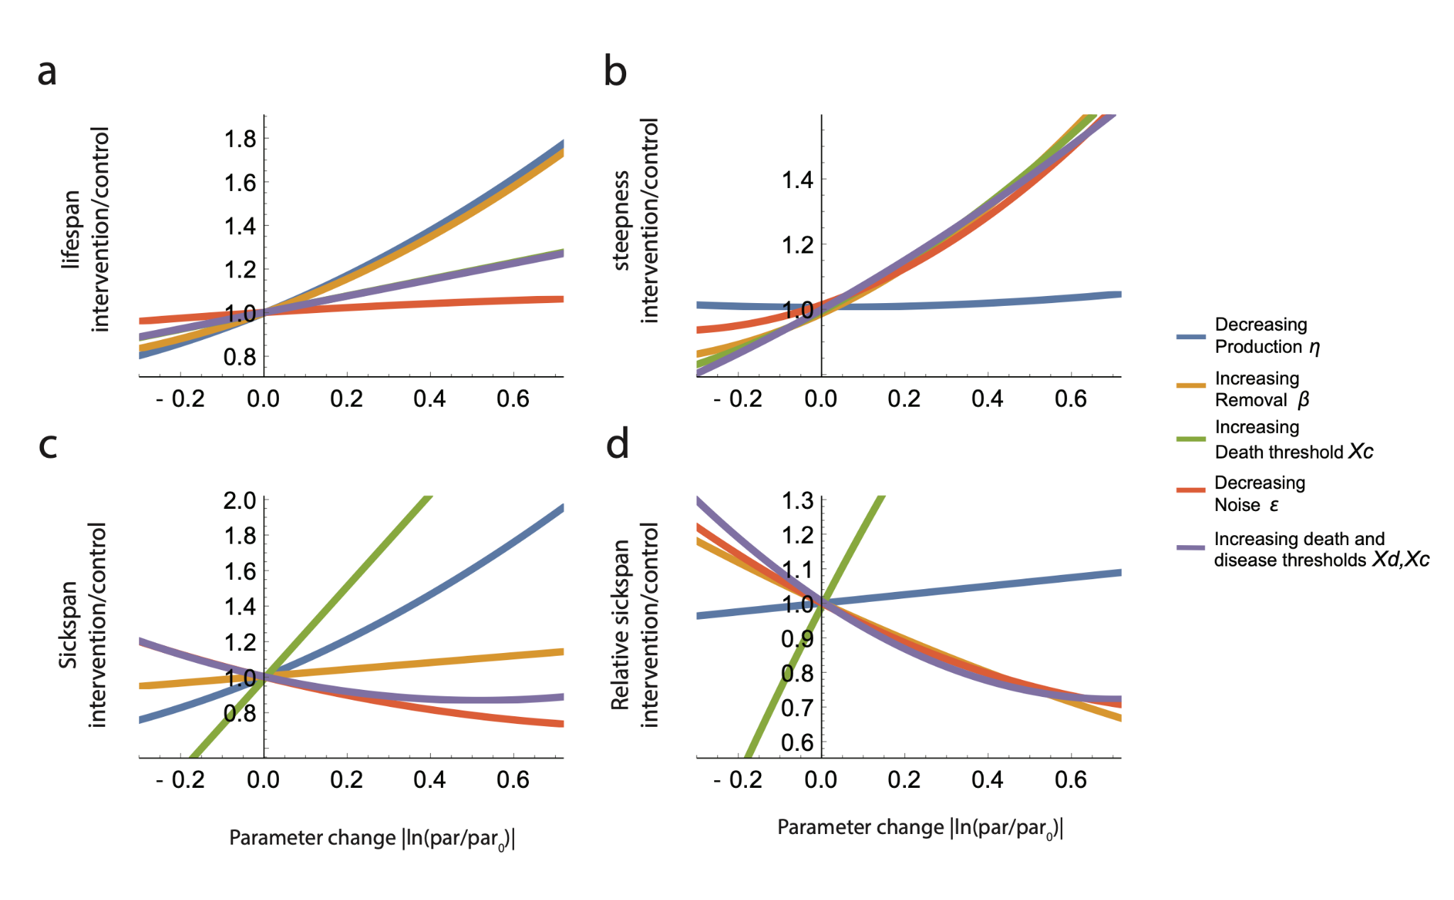
Supplementary Figure 1. Effect of SR model parameter variation on longevity, steepness and sickspan. a-d, Lifespan (a), steepness (b), absolute sickspan (c) and relative sickspan (d) are plotted against magnitude of parameter changes in the direction indicated by the legend. Simulations are the same as in Fig. 2b-d. Parameters are shown relative to the baseline parameter set (see Methods, η=6.6✕10⁻⁶/day², β=0.15 /day, κ=0.5, ε=0.16 /day, Xd=12, Xc=17).

S2. Tables of mouse, fly and nematode control and intervention cohorts with longitudinal healthspan data

In all cases (Supp. Table 1-4), sickspan is defined according to the original paper criteria. The criterion for each paper is briefly summarized in the table captions.

strain | sex | diet | N | longevity (weeks) | longevity S.E. (weeks) | steepness | steepness S.E. | sickspan (weeks) | sickspan S.E. (weeks) | relative sickspan | relative sickspan S.E.
C57BL/6J | f | AL | 15 | 131 | 3 | 17.4 | 4.1 | 4.6 | 1.1 | 3.5% | 0.8%
C57BL/6J | m | AL | 28 | 135 | 4 | 9.6 | 1.6 | 14.0 | 2.1 | 10.0% | 1.3%
J:DO | f | AL | 26 | 155 | 3 | 13.6 | 2.4 | 9.2 | 1.5 | 5.8% | 0.9%
J:DO | f | CR20 | 56 | 172 | 3 | 9.4 | 0.9 | 15.6 | 1.6 | 8.8% | 0.8%
J:DO | f | CR40 | 79 | 184 | 3 | 8.2 | 0.5 | 24.3 | 2.0 | 12.7% | 0.9%
J:DO | f | IF1 | 34 | 154 | 2 | 15.5 | 2.3 | 8.5 | 1.0 | 5.4% | 0.6%
J:DO | f | IF2 | 51 | 161 | 2 | 12.7 | 1.2 | 8.2 | 0.9 | 5.0% | 0.5%

Supplementary Table 1. Longevity, steepness and sickspans of mouse cohorts under dietary longevity interventions
(caloric restriction and intermittent fasting) in two strains from Luciano et al ⁴². Sickspan was defined using mouse frailty index. In this table, female J:DO is the control cohort. Comparing steepness and relative sickspan of all other cohorts to those of female J:DO generates the intervention/control steepness and relative sickspan shown in Fig. 3a.

Group | Sex | N survival | N sickspan | longevity (days) | longevity S.E. (days) | steepness | steepness S.E. | sickspan (days) | sickspan S.E.
Oregon (control) | female | 115 | 105 | 65.1 | 0.7 | 10.9 | 1.4 | 0.81 | 0.14
Lausanne | female | 93 | 83 | 36.1 | 1.1 | 4.5 | 0.4 | 1.73 | 0.22
Protein restriction (PR) | female | 122 | 112 | 83.7 | 1.3 | 8.6 | 1.1 | 0.87 | 0.11
Curcumin | female | 95 | 85 | 69.1 | 1.1 | 7.1 | 0.6 | 1.69 | 0.21
Superfruit | female | 88 | 79 | 72.1 | 1.4 | 6.5 | 0.5 | 1.34 | 0.24
PR+Cur | female | 94 | 82 | 76.1 | 1.1 | 8.8 | 1.0 | 1.61 | 0.24
PR+SF | female | 119 | 109 | 77.4 | 1.0 | 9.0 | 0.8 | 1.49 | 0.24
Oregon (control) | male | 109 | 94 | 72.7 | 1.2 | 7.6 | 0.4 | 1.13 | 0.18
Lausanne | male | 98 | 90 | 51.6 | 1.0 | 5.9 | 0.4 | 1.41 | 0.16
Protein restriction (PR) | male | 113 | 102 | 84.3 | 1.2 | 8.6 | 1.1 | 0.57 | 0.08
Curcumin | male | 87 | 79 | 85.0 | 1.7 | 6.4 | 0.7 | 1.69 | 0.25
Superfruit | male | 110 | 101 | 85.8 | 1.8 | 6.1 | 0.6 | 1.06 | 0.14
PR+Cur | male | 104 | 97 | 82.5 | 1.2 | 8.8 | 0.9 | 0.86 | 0.11
PR+SF | male | 99 | 87 | 84.0 | 1.4 | 8.9 | 1.7 | 0.57 | 0.08

Supplementary Table 2. Longevity, steepness and sickspans of D. melanogaster cohorts under nutritional longevity interventions in two strains (Lausanne and Oregon). Sickspan was defined by deficits in climbing, jumping and flying in response to a mechanical challenge. Fig. 3b is generated using Oregon male and female cohort controls for all other male and female cohorts respectively. The table is generated from raw data provided by the original authors from Gaitanidis et al ⁴⁰.

Group | Longevity (days) | Steepness intervention/control | Steepness intervention/control C.V. | Sickspan (days) | Sickspan lower C.I. (days) | Sickspan upper C.I. (days) | relative sickspan intervention/control | relative sickspan intervention/control lower C.I. | relative sickspan intervention/control upper C.I.
N2 (wild type) | 31.2 | 100% | 4% | 21.4 | 10.7 | 24.7 | 100.0% | 49.8% | 115.6%
daf2(e1368) | 42.6 | 143% | 4% | 15.4 | 10.7 | 18.4 | 52.6% | 36.5% | 62.9%
daf2(e1370) | 44.4 | 131% | 4% | 24.7 | 15.8 | 27.0 | 81.0% | 51.8% | 88.7%
eat2(ad1116) | 31.9 | 108% | 4% | 14.2 | 9.7 | 18.9 | 64.7% | 44.5% | 86.3%
glp1(e2141) | 34.7 | 162% | 5% | 7.9 | 6.1 | 8.8 | 33.3% | 25.6% | 36.9%

Supplementary Table 3. Longevity, steepness and sickspan of longevity mutants in C. elegans where sickspan was defined by loss of muscle power measured by piezoelectric challenge. Data digitized from Statzer et al ²⁶.

experiment | Intervention type | Intervention description | Control group genotype | Control group food | Control group temperature | Steepness intervention/control | Steepness intervention/control C.V. | relative sickspan intervention/control | relative sickspan intervention/control C.V.
oswal_daf2 | Genotype | daf2(e1368) | QZ0(WT) | live OP50 | 25 | 133% | 5% | 81% | 3%
oswal_eat2_1 | Nutrition | Bacterial Deprivation | QZ0(WT) | live OP50 | 20 | 140% | 4% | 100% | 4%
oswal_eat2_1 | Genotype | eat2(ad1116) | QZ0(WT) | live OP50 | 20 | 137% | 4% | 111% | 4%
oswal_eat2_2 | Nutrition | UV NEC937 | QZ0(WT) | live OP50 | 20 | 71% | 4% | 158% | 3%
oswal_eat2_2 | Genotype | eat2(ad1116) | QZ0(WT) | live OP50 | 20 | 75% | 5% | 131% | 3%
oswal_glp1 | Genotype | glp1(e2141) | QZ0(WT) | live OP50 | 20 | 113% | 8% | 50% | 7%
oswal_nuo6 | Genotype | nuo6(qm200) | QZ0(WT) | UV NEC937 | 20 | 136% | 12% | 95% | 6%
oswal_temp | Temperature | 25C | QZ0(WT) | UV NEC937 | 20 | 85% | 3% | 140% | 2%
statzer_sterile | Genotype | glp1(e2141) | spe9(hc88);rrf3(b26) | L4440 | 20 | 144% | 4% | 114% | 4%
statzer_main | Genotype | daf2(e1368) | N2(WT) | heat-killed OP50 | 15 | 131% | 4% | 106% | 4%
statzer_main | Genotype | daf2(e1370) | N2(WT) | heat-killed OP50 | 15 | 108% | 4% | 90% | 5%
statzer_main | Genotype | eat2(ad1116) | N2(WT) | heat-killed OP50 | 15 | 161% | 5% | 78% | 5%
statzer_main | Genotype | glp1(e2141) | N2(WT) | heat-killed OP50 | 15 | 131% | 6% | 88% | 5%

Supplementary Table 4. Genetic, dietary and environmental longevity interventions in C. elegans, where sickspan was measured by secession of spontaneous movements. Data from Stazer et al ²⁶ and Oswal et al ⁴¹.

S3. Effect of steepness on mice sickspan is robust to the definition of sickspan threshold

In Fig. 3a we used the original author's definition of sickspan as the time when an individual mouse exceeded 3 health deficits. Here we test the effect of changing this threshold to 4 or 5 deficits. Supp. Fig. 2a shows the raw data and these three thresholds (dashed lines at 3.5,4.5,5.5 since data is discrete).
We find that for all thresholds, relative sickspan drops with steepness of the survival curve (Supp. Fig. 2b).

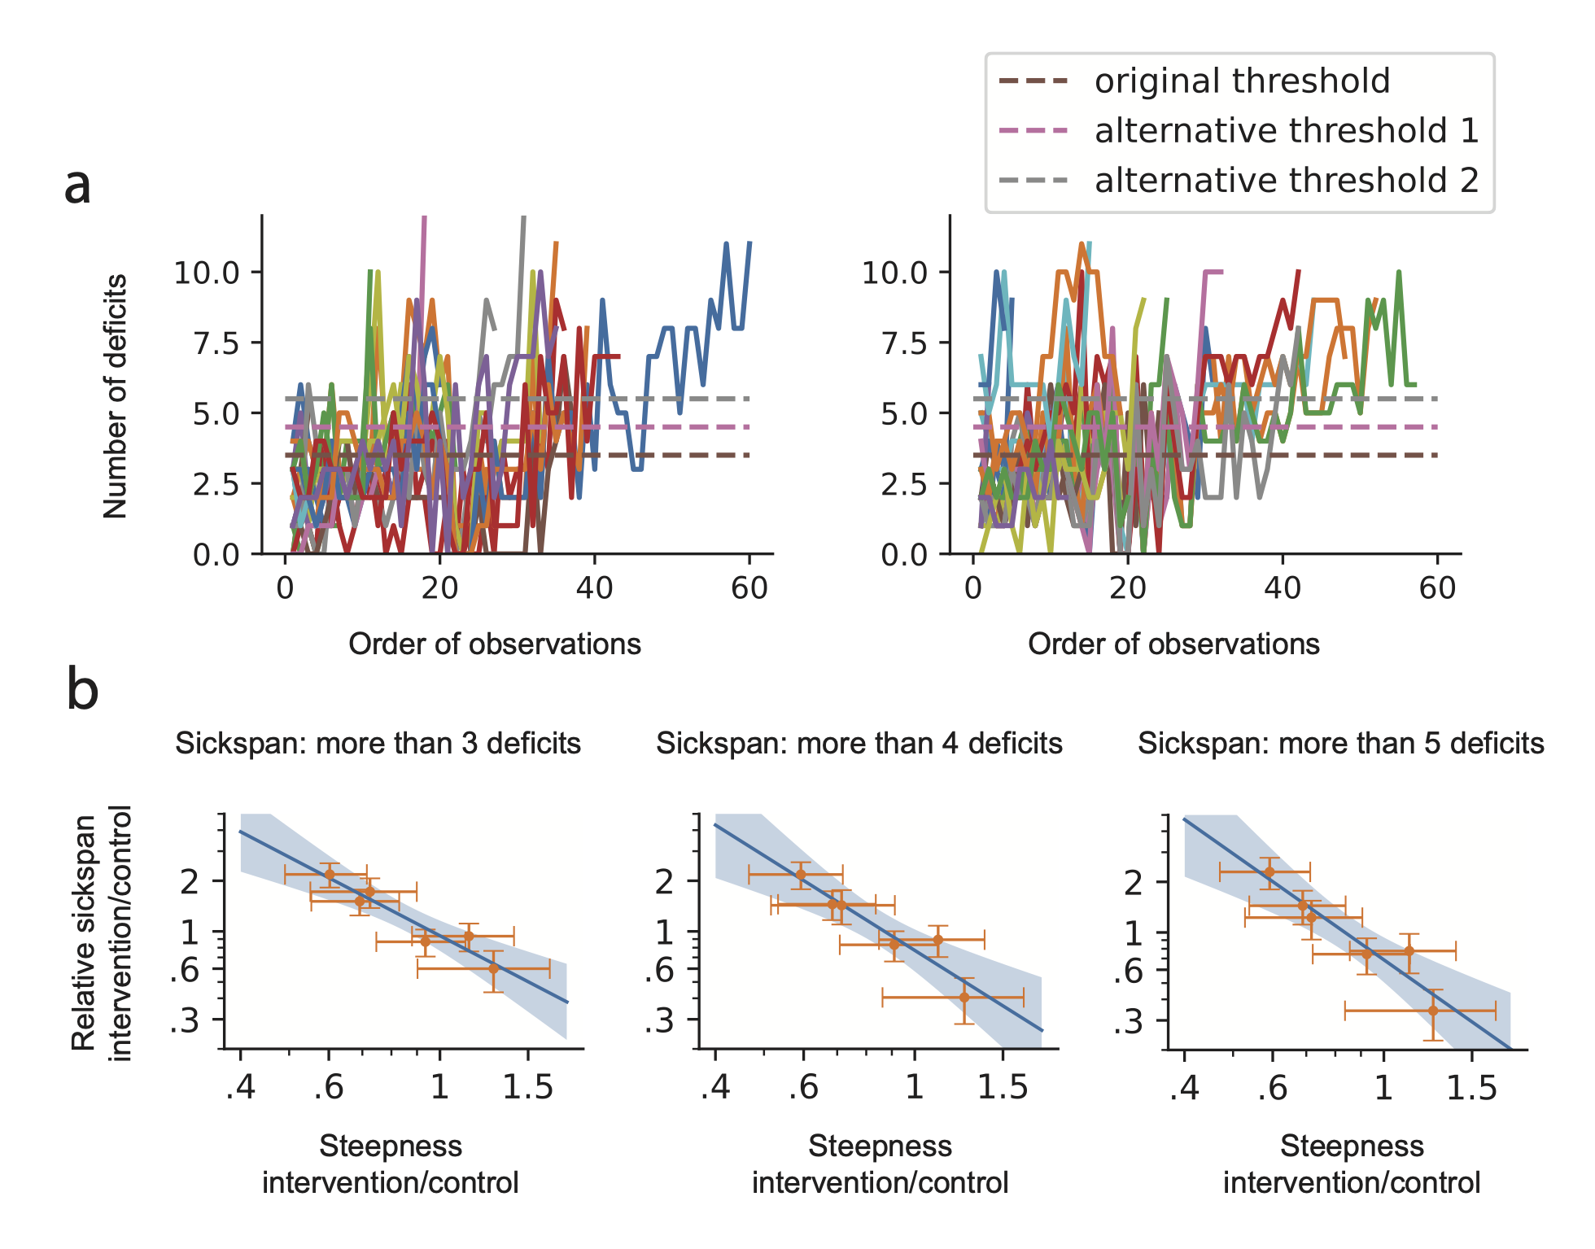

Supplementary Figure 2. Relative sickspan in Luciano et al drops with steepness of survival curve for three different sickspan definitions, namely thresholds of above 3,4 or 5 deficits. a, typical trajectories of mice from Luciano et al ⁴², C57BL/6J (left) and J:DO (right). Dashed lines indicate 3.5, 4.5, and 5.5 thresholds, since the number of deficits is integer, this corresponds to exceeding 3, 4 or 5 deficits. b, Analysis of relative sickspan versus survival curve steepness as in Fig. 3, for the thresholds of 3, 4, 5 deficits.

S4. Alternative definitions of steepness

Steepness is a dimensionless quantity that roughly captures the relative homogeneity in lifespan. We can calculate steepness by dividing the average lifespan, measured as the median or the mean, by the dispersion of lifespan. Thus, depending on the exact choice of statistics measuring the average and dispersion of lifespan, there can be many definitions of steepness.

In order to evaluate whether the negative correlation between steepness and relative sickspan is robust to these alternative definitions of steepness, we calculated 4 alternative steepness definitions for mice, flies, worms (strength and movement) using the same data as those in Fig. 3, and plotted against relative sickspan in Supplementary Figure 3.

The overall negative correlation between relative sickspan and steepness is robust to alternative definitions of steepness (Supp. Fig. 3).

The main factors causing the minor differences in results between alternative steepness definitions are two: 1) statistical power; 2) sensitivity to early life deaths that are by definition not caused by aging. Some steepness definitions, such as median/interquartile-range (IQR) and inverse coefficient of variance (iCV) trimmed on both sides, are insensitive to early extrinsic deaths, but have reduced statistical power and thus wider confidence intervals. While another steepness definition, the iCV without trimming, has higher statistical power but is sensitive to early extrinsic deaths, particularly in flies where there are significant variations among intervention groups in early survivals. The left-trimmed iCV strikes a compromise between statistical power and robustness to early deaths and is thus chosen in the main text and Fig. 3.
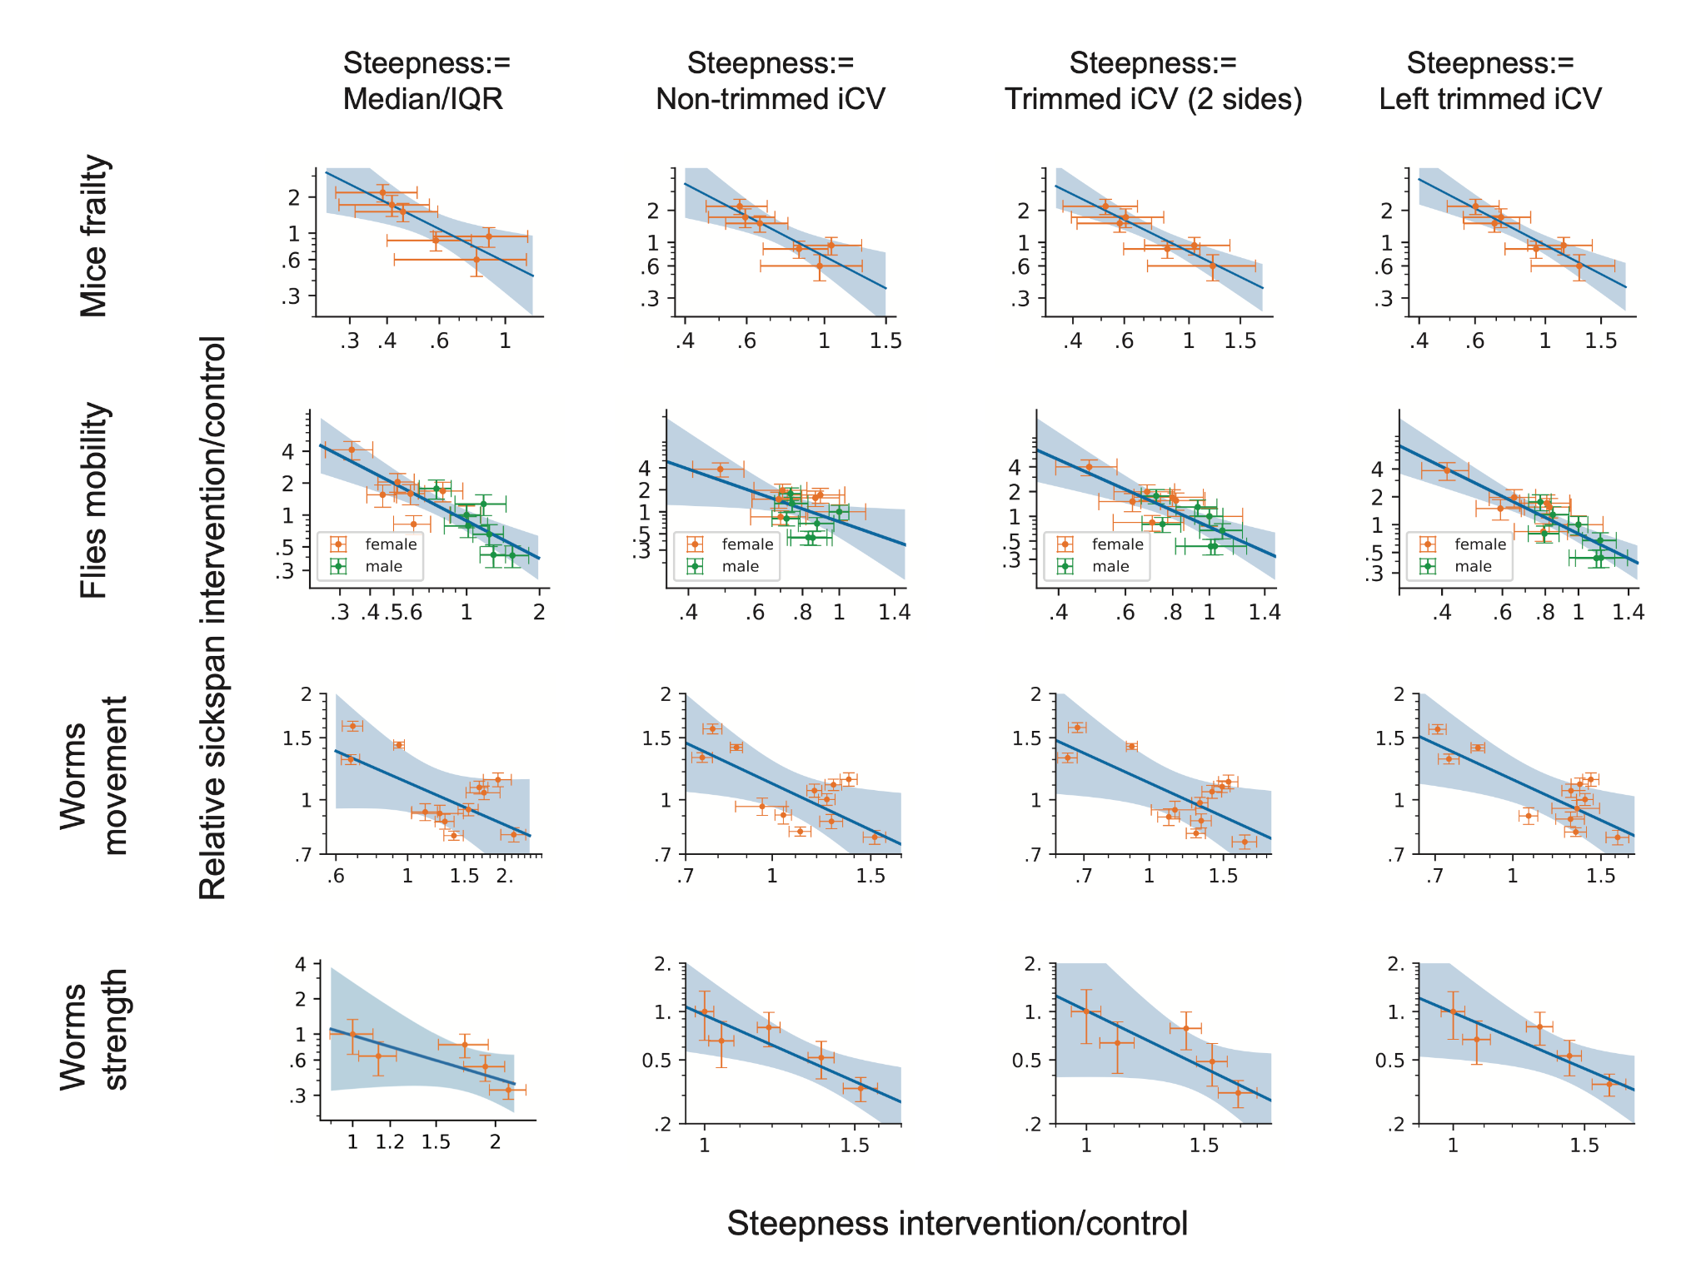

Supplementary Figure 3. The negative correlation between relative sickspan and steepness is robust to the definition of steepness. Relative sickspan of mice, flies, worms as defined by movement and worms as defined by strength, is plotted versus relative steepness of survival curve, according to 4 alternative definitions. Data is the same as those in Fig. 3. IQR stands for interquartile range; iCV stands for inverse coefficient of variance and is defined as the mean divided by standard deviation. Trimming is done to all events, death or censorship, and is always by 10% each side as per standard definition.

S5. Accounting for batch effects and environmental heterogeneity in C. elegans

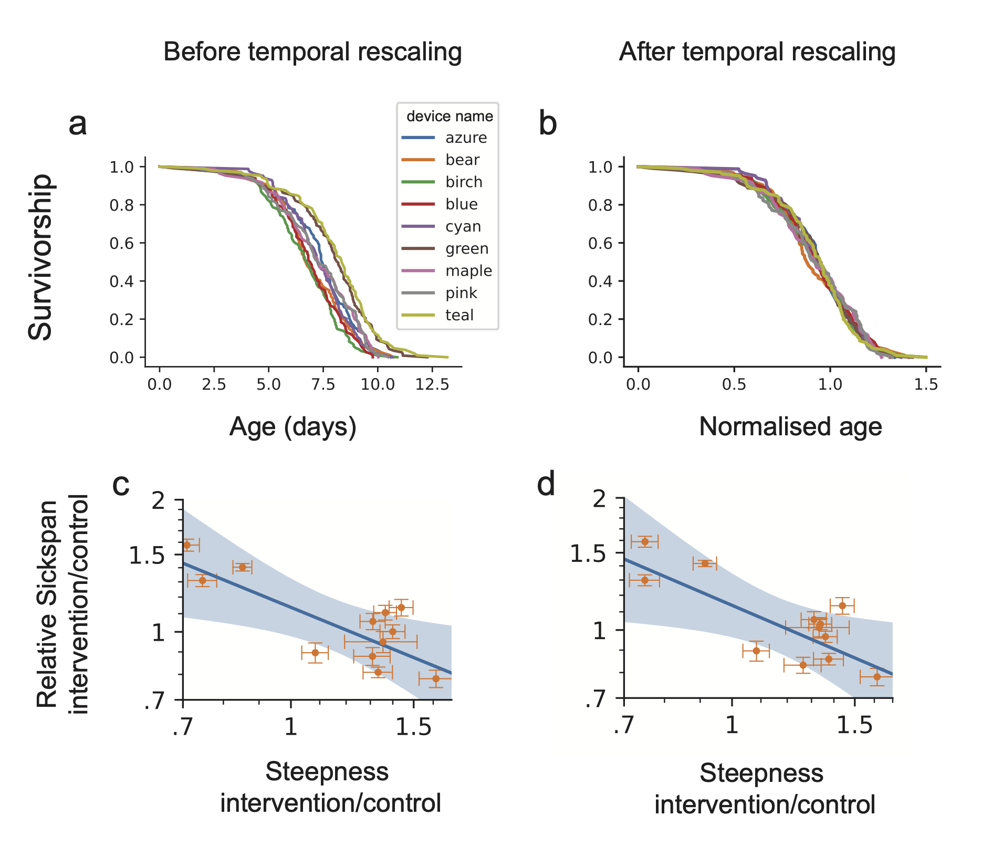

Supplementary Figure 4. The negative correlation between relative sickspan and steepness persists before or after temporal rescaling that removes batch effects. a, survival curves of wildtype worm cohorts (QZ0, feeding on live OP50 at 25 degrees) in individual devices within the same experiment from Oswal et al ⁴¹. b, These survival curves scales temporally after their age is normalised by the average lifespan. Temporal rescaling is done by the accelerated failure time (AFT) model. c-d, Relative sickspan plotted against steepness of all worms cohorts analysed from Stazer et al ²⁶ and Oswal et al ⁴¹. Steepness is calculated without temporal rescaling in (c) and with temporal rescaling via AFT in (d) whenever batch information is provided.

S6. Several interventions in the ITP database significantly change the steepness of survival curves

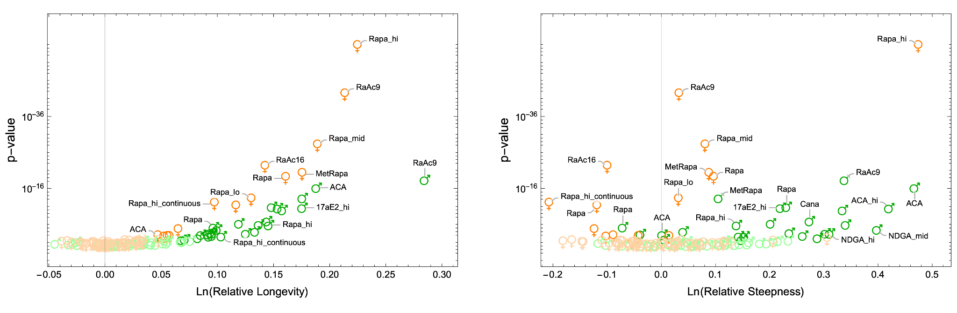
Supplementary Figure 5. Volcano plots of ITP interventions. On y-axis, p-values of the chi-square test described in Methods (H0: treated and control groups have the same steepness and longevity) are plotted separately against effect sizes of (left) longevity and (right) steepness. All calculations are the same as in Figure 4a. Green and orange symbols indicate females and males respectively. Solid and faint symbols indicate, respectively, significant and insignificant interventions for α=0.05 with Benjamini-Hochberg corrections.

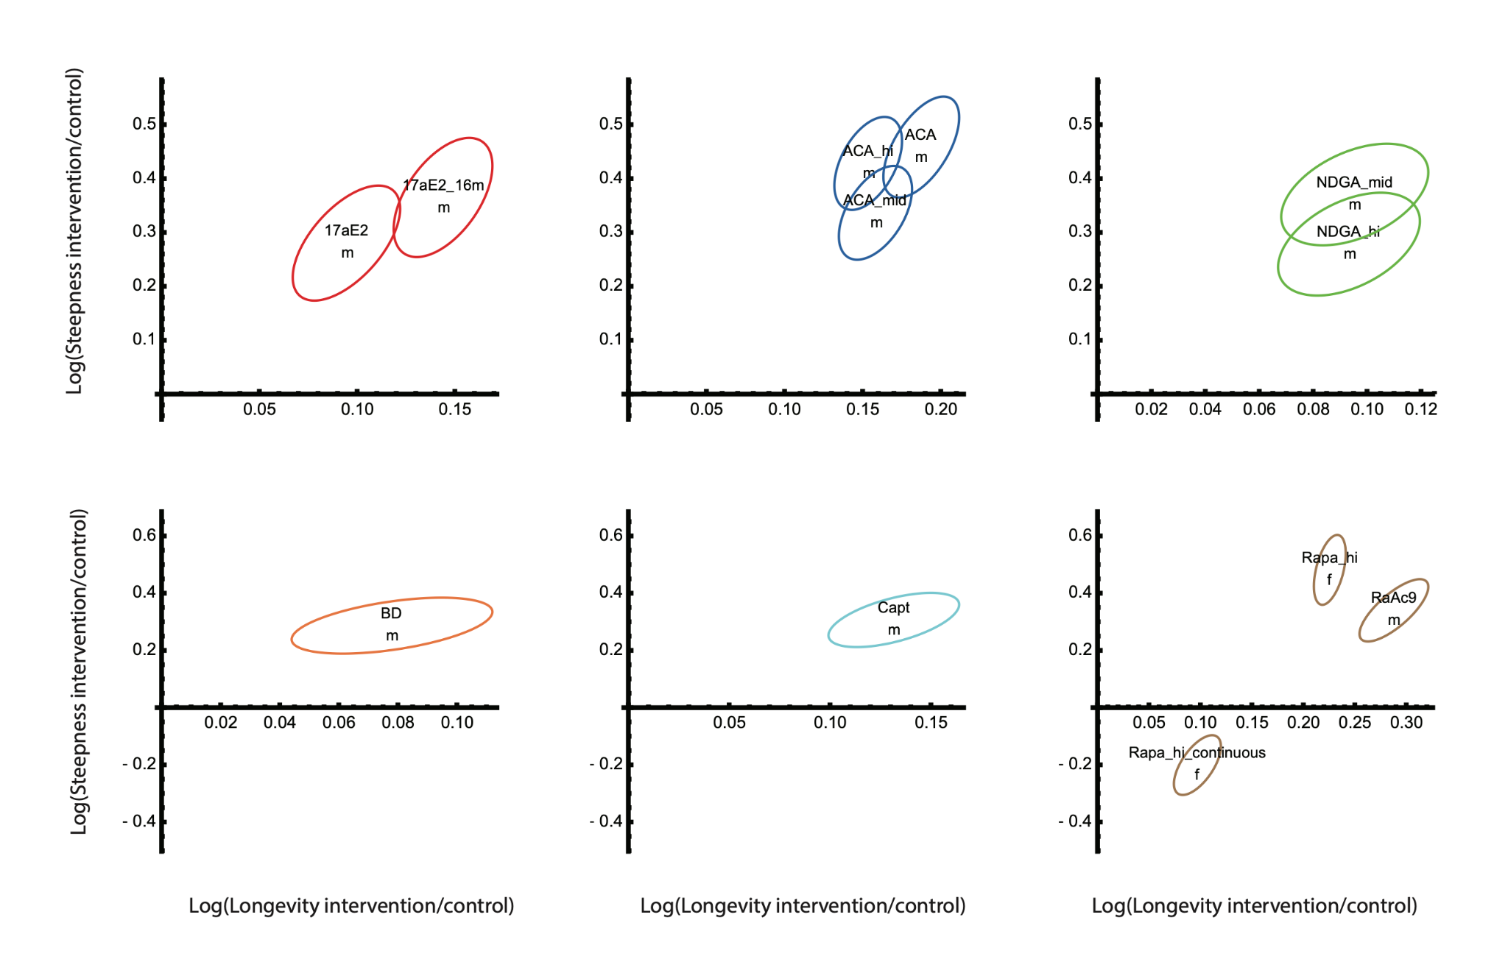

Supplementary Figure 6. Confidence Intervals of non-scaling interventions in the ITP database. The ellipsoids indicate means and covariances of interventions’ effect on longevity and steepness. For each pair of treated and cohort cohorts, the means and covariances of log(longevity) and log(steepness) of control μ_{c}=(ln(L_{c}), ln(S_{c})) and intervention cohort μ_{i}=(ln(L_{i}), ln(S_{i})) are estimated by bootstrapping 200 times with returns the right-censored death times. The mean and covariance of an intervention, μ_{i} - μ_{c} were modeled by multivariate normal distribution N_{i}(μ_{i}-μ_{c}, σ_{i}+σ_{c}), visualized as the ellipsoids. Shown are intervention experiments found to have significant effects (Hotelling’s T-square test) and also non-scaling from AFT+KS test (Methods), grouped by mechanism of action (Fig. 4a).

Supplementary Data 1. Statistics of all interventions in the ITP shown in Fig. 4a and Supp. Fig. 5. Relative longevity, relative steepness, quartile test p-value and AFT+KS test statistic and p-value of all interventions in the ITP.

S7. Male mice have shorter lifespan, shallower survival curves and more steepening interventions
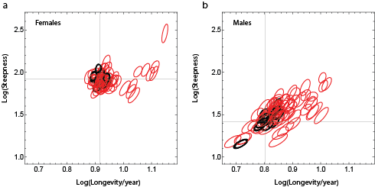
Supplementary Figure 7. Absolute longevity and steepness of all interventions and their control groups in the ITP database. Red and black ellipsoids indicate means and covariances of treated and control cohorts respectively. For each cohort (control or treated), the means and covariances were estimated by bootstrapping death times with returns 200 times. The crosshairs in each panel indicate the mean longevity and steepness of all female and male control cohorts. The ellipsoids are drawn without labeling the interventions in order to visualize the absolute longevity and steepness of all the female (a) and male (b) cohorts in the dataset.

S8. Intervention experiments independent of ITP introduce additional classes of steepening interventions and agree with those in the ITP database
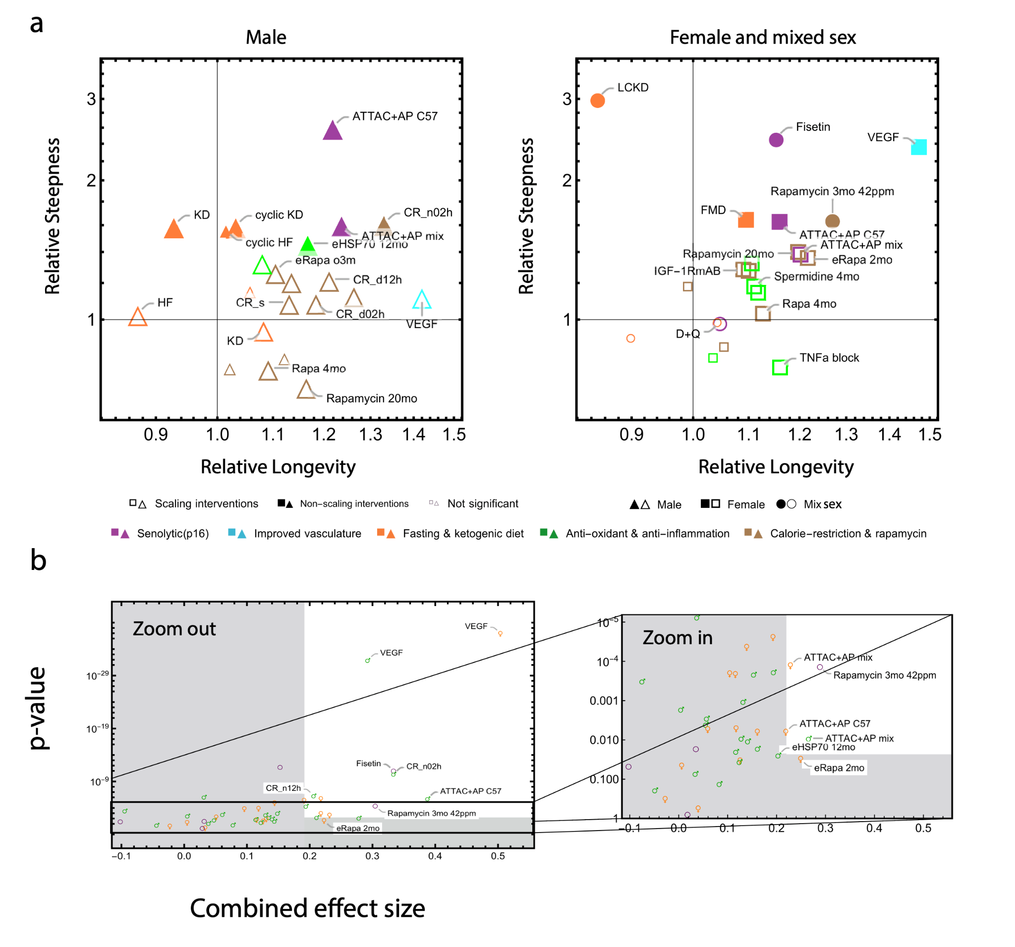
Supplementary Figure 8. Longevity and steepness effects of Intervention outside of ITP. a, Longevity and steepness relative to control in interventions reported in 32 publications independent of the NIA ITP (Supp. Data 2). Similar to Fig. 4a-b, triangle, square and circle symbols denote interventions for male, female and mixed sex mice cohorts respectively. Small symbols indicate interventions whose effects are not statistically significant (quartile test, α=0.05 with Benjamini-Hochberg correction). Filled and empty symbols indicate scaling and non-scaling interventions respectively. Labeling indicates treated cohorts that are significantly different from control in either longevity or steepness (quartile test), or in survival curves shape (AFT+KS test, results not shown). b, Volcano plots of the interventions presented in (a). On y-axis, p-values as described in Methods are plotted against, on x-axis, the combined effect sizes of longevity and steepness according to the following heuristic formula: 0.75*ln(L_{i}/L_{c})+0.25*ln(S_{i}/S_{c}). Right panel is the zoom-in version of the left panel. Green, orange and purple symbols indicate male, female and mixed sex cohorts, respectively. The gray regions show a threshold in effect size (0.2) is combined with a threshold in p-value (α=0.05 with Benjamini-Hochberg correction).

Supplementary Data 2. Statistics of all analyzed interventions outside of the ITP shown in Fig. 4b and Supp. Fig. 8. Sample sizes, AFT+KS test statistic, p-value of all analyzed interventions outside of the ITP.

S9. Antioxidants NDGA and GTE increase steepness

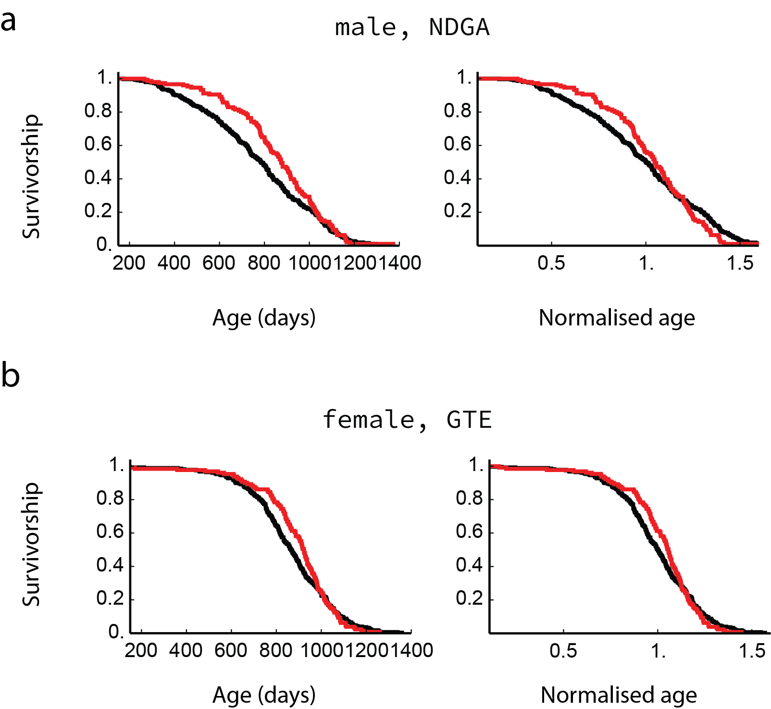
Supplementary Figure 9. Survival curves and scaled survival curves for selected antioxidant supplements that steepens the survival curves. a, NDGA (2500 ppm) in male mice starting at age of 9 months ⁵⁷ (AFT+KS scaling test p=0.033) and b, GTE (2000 ppm) in female mice starting at age of 4 months ⁵⁶ (AFT+KS scaling test p=0.023).

S10. Most rapamycin experiments shows approximate scaling except at old ages

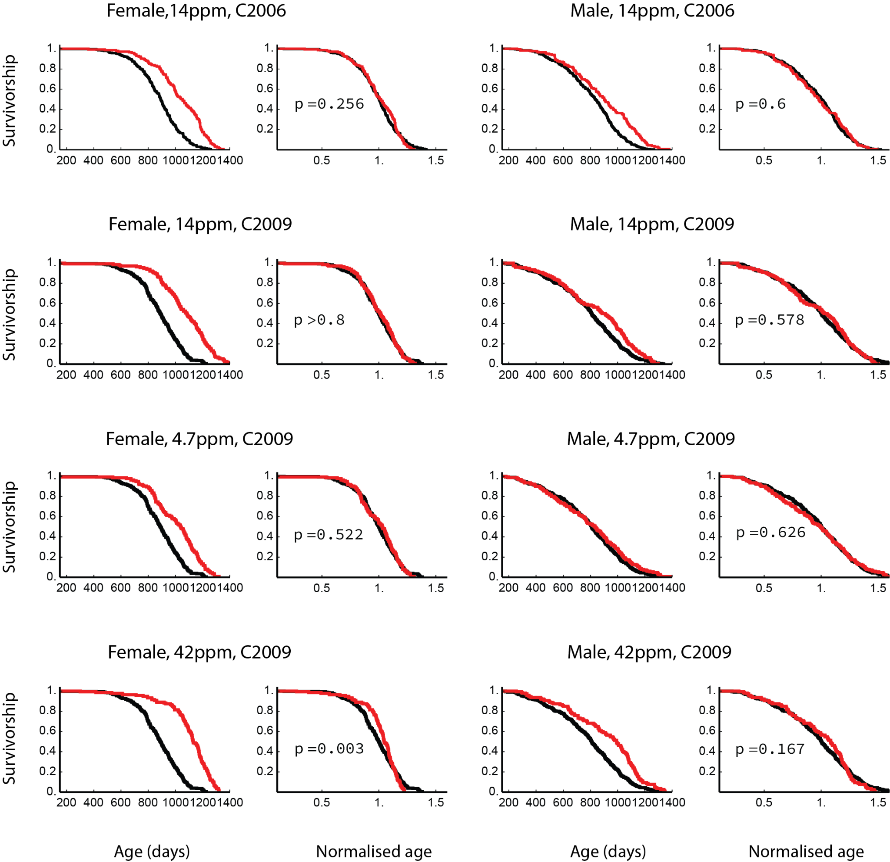
Supplementary Figure 10. Survival curves and scaled survival curves for rapamycin ^{83,84} of female and male mice in the ITP dataset ⁵⁰. Rapamycin was at dose 42, 14 (twice) and 4.7 ppm starting from the age of 9 months. AFT+KS scaling test p-values are shown.

S11. Rapamycin and acarbose interact additively to extend mouse lifespan and steepness
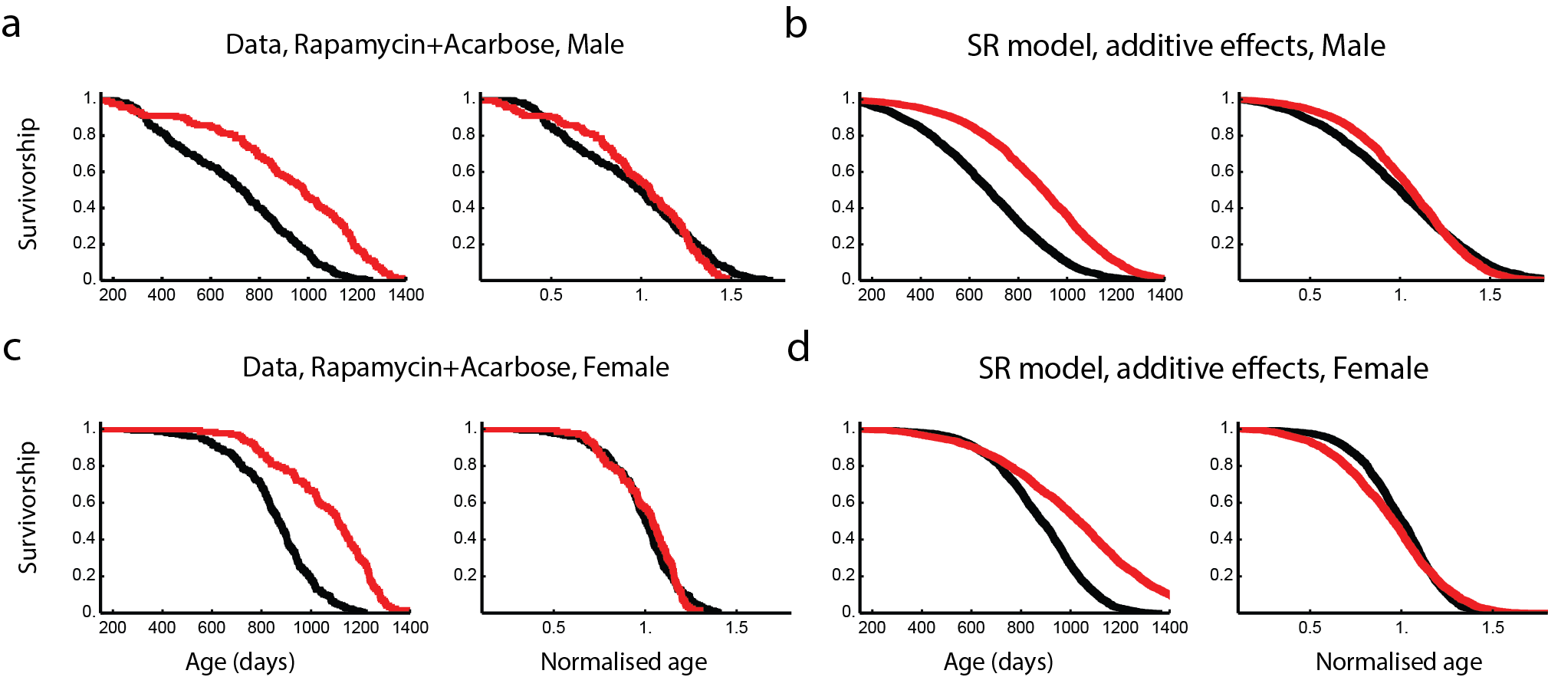
Supplementary Figure 11. Rapamycin and acarbose affect the survival curves independently (non-epistatic) in mice. a,c, Survival curves and scaled survival curves of male and female mice treated by rapamycin+acarbose at 14.7ppm+1000ppm starting from the age of 9 months (red) and controls (black). Data from ITP C2017 cohorts. b,d, Simulated survival curves of the SR model and assuming the effects of the drugs are independent - fold changes of parameters are added together to arrive at the model parameters. Fold changes of SR model parameters η and β induced by the two drugs were estimated by matching the experimental longevity and steepness. Data used are rapamycin at 14ppm starting from the age of 9 months (C2006), and acarbose at 1000ppm starting from the age of 8 months (C2013). In all SR model simulations, Xc is set to 23.2 and ε is adjusted to 0.69 so that the simulations show longevity and steepness typical of experimental control cohorts. κ is kept the same as in reference ³².

S12. In vivo reprogramming shows approximate scaling in preliminary experimental data

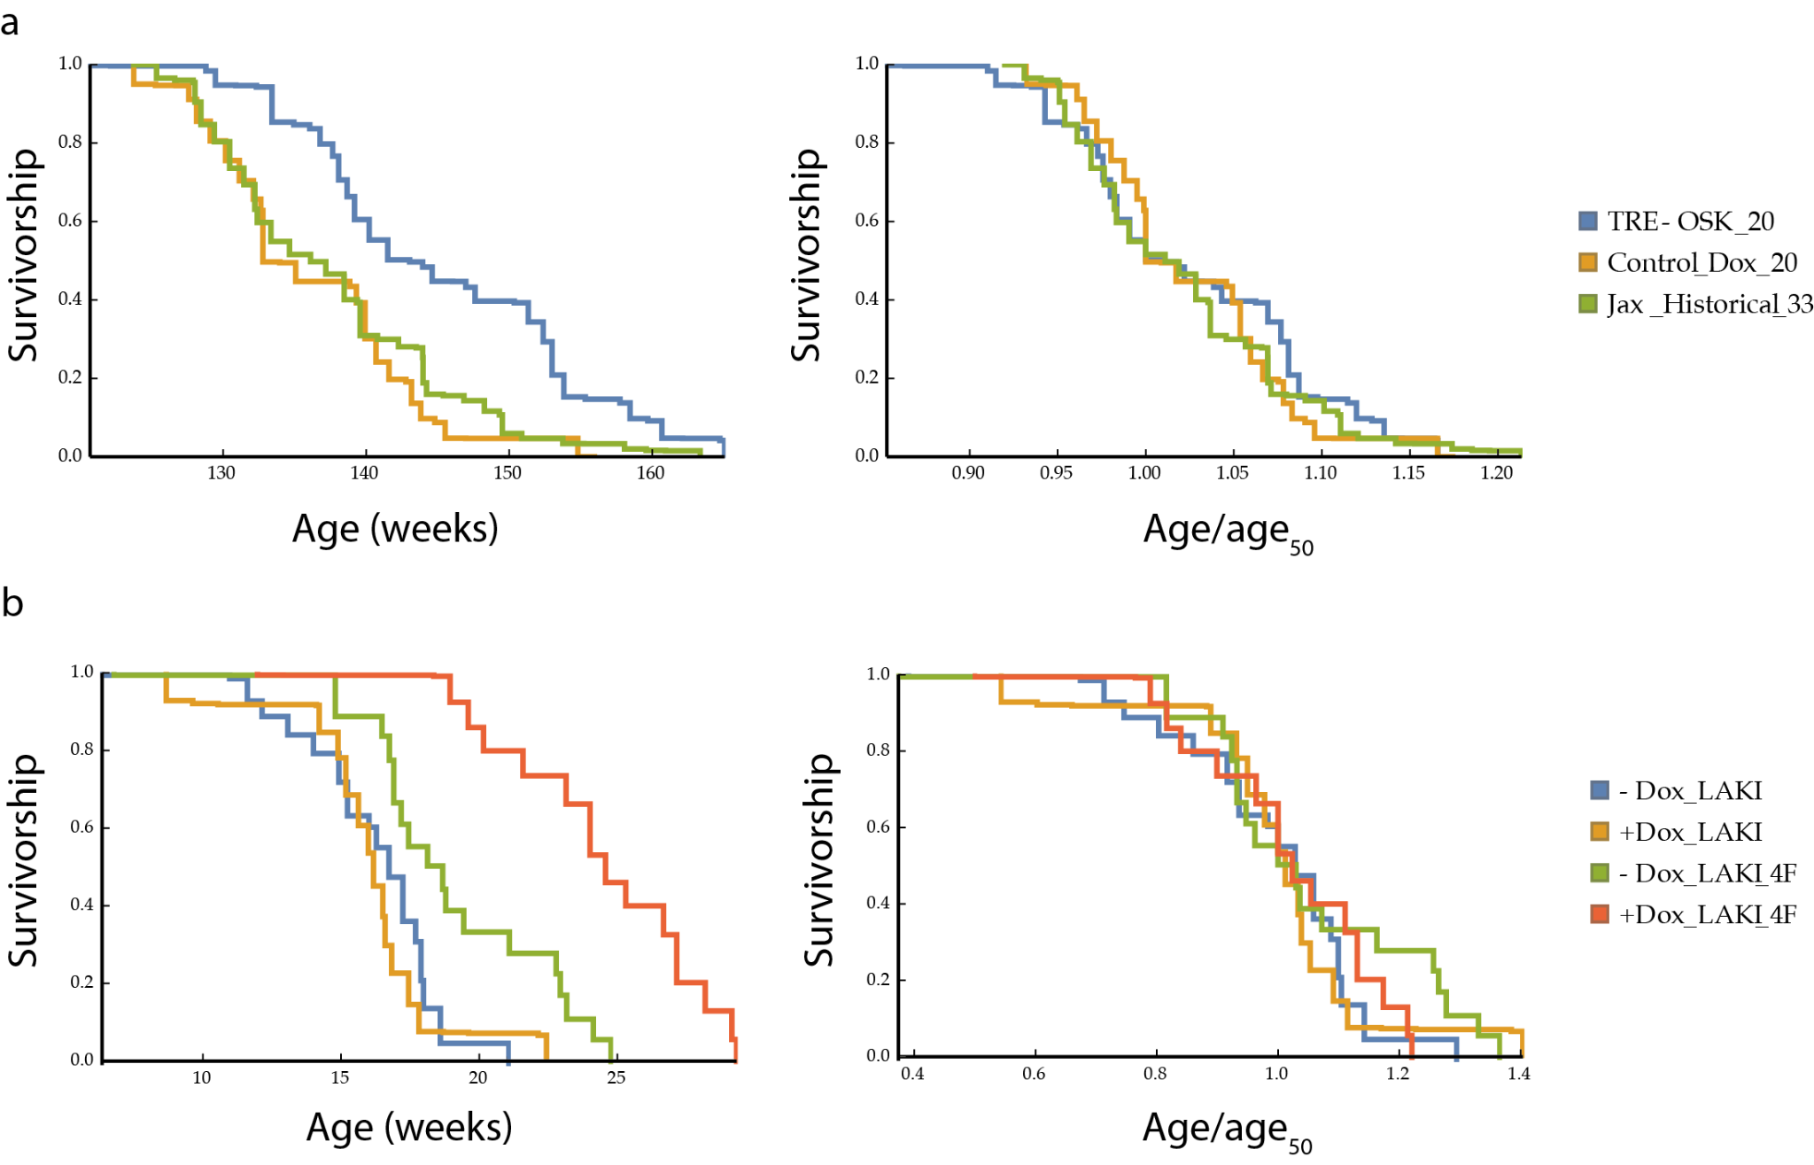
Supplementary Figure 12. In vivo partial reprogramming survival curves and scaled survival curves. a, Data from reference ²⁴, injection is at week 124. b, Data from reference ²³.

