Supplementary methods
- Modeling of Marangoni propulsion of the edible aquatic robot
The physical model (Fig. S1A) is comprised of two parts: 1) a fluidic actuator model that relates gas generation and fuel supply rate to locomotion duration; 2) a dynamic model based on force balance to estimate locomotion speed (Fig. S1B). Related parameter symbols are listed in the Appendix, table S3.
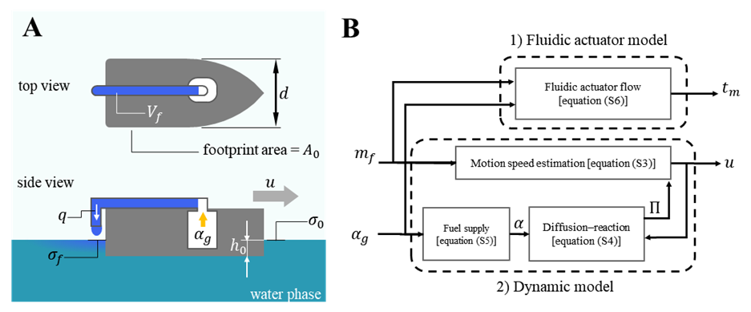
Fig. S1. Physical model of edible aquatic robot. (A) Illustration of geometry and mechanism related parameters, where $V_{f}$ is the fuel reservoir volume, $d$ is he width of the device, ${ A}_{0}$ is the footprint area of the device, $q$ is the fuel flow rate by volume, $α_{g}$ is the CO₂ gas generation rate by moles, $u$ is the motion speed, $h_{0}$ is the submerged depth of the device, $σ_{0}$ is the surface tension of pure water, $σ_{f}$ is the surface tension of the fuel-water mixture behind the device. (B) Diagram of the model’s main structure of inputs ($α_{g}$, $m_{f}$) and outputs ($u$, $t_{m}$), where $m_{f}$ is the amount of fuel by mass, $t_{m}$ is the motion duration, $α$ is the fuel supply rate to water surface in moles, $Π$ is the surface tension pressure induced by the difference between $σ_{f}$ and $σ_{0}$.
The force balance in vertical direction between gravity and buoyancy force¹ gives:
$mg=ρ_{0}gA_{0}h_{0}$ (S1)
The force balance in horizontal direction, considering the driving force and water drag force¹ and acceleration, yields:
$m\frac{d^{2}x}{dt^{2}}=F_{s}- \frac{1}{2}c_{d}ρ_{0}dh_{0}{(\frac{dx}{dt})}^{2}$ (S2)
Where $m$, $d$, $A_{0}$, $h_{0}$, $c_{d}$ correspond to the mass, width, footprint area, submerged depth and drag coefficient of the robot, $ρ_{0}$ is the density of water, $F_{s}$ (the surface tension driving force) equals $d(σ_{0}-σ_{f})$ where $σ_{0}$ and $σ_{f}$ refer to the surface tension of pure water and water-surfactant mixture, respectively. This is a commonly used approximation for the motion of centimeter-scale surface-tension-driven objects^{2,3}. For simplicity, we assume a constant speed $u$ of the robot ($\frac{dx}{dt}=u$, $\frac{d^{2}x}{dt^{2}}=0$), such that:
$u=\sqrt{\frac{2A_{0}(σ_{0}-σ_{f})}{c_{d}∙m}}$ (S3)
Note that the surface tension value $σ_{f}$ (as depicted in Fig. S1A) depends on the surface concentration of the fuel right behind the robot. Here we adapt the one-dimensional diffusion-reaction based model derived by Suematsu et al². to describe the dependence of surface pressure value $Π$ on $α$ (the supply rate of fuel to the water surface):
$Π= σ_{0}-σ_{f}=\frac{RTα}{d\sqrt{u^{2}+4kD}}$ (S4)
where $R$ and $T$ are the gas constant and temperature in Kelvin, respectively. Increasing $α$ raises the surface pressure $σ_{0}-σ_{f}$ , thereby increasing the motion velocity $u$ of the robot, as described by equation (S3). The relation holds until the water surface becomes saturated, indicating that the surface concentration of the fuel has reached its solubility limit, and $σ_{f}$ reaches its minimal value. The fuel dissipation rate ($k$) and the effective diffusion rate ($D$) are parameters that depend on the specific type of fuel used and are estimated experimentally in Section S4. $α$ can be obtained using the fuel supply model:
$α=η∙α_{q}=η∙\frac{q.ρ_{f}}{M_{f}}=η∙\frac{α_{g}RT}{P_{0}}∙\frac{ρ_{f}}{M_{f}}$ (S5)
Where $α_{q}$ is the total fuel supply rate to water surface, water body and air phase, $q$ is the corresponding flow rate of fuel by volume, and $η$ is the fuel supply efficiency to the water surface. This accounts for the fact that only a portion of the dispensed fuel reaches the water surface and contributes to the propulsion. $ρ_{f}$ and $M_{f}$ are density and molar mass of the liquid fuel, respectively, enabling the conversion between fuel flow rate by moles and by volume. $R$, $T$ and $P_{0}$ represent the gas constant, temperature in Kelvin, and standard atmospheric pressure, respectively, and are used to relate gas generation rates by moles and volume. Assuming the gas generation rate by volume equals the fuel flow rate by volume, the fuel flow rate can be derived from $α_{g}$ (the gas generation rate by moles) which is determined by the rate of the CO₂ gas generation reaction.
Motion duration time $t_{m}$ can be derived by:
$t_{m}=\frac{V_{f}}{q}=\frac{V_{f}P_{0}}{α_{g}RT}= \frac{m_{f}P_{0}}{{ρ_{f}α}_{g}RT}$ (S6)
Where $m_{f}$, $V_{f}$, are the mass and volume of the fuel. The model provides a principle based on which the structure properties and design specifications can be chosen to meet the requirements, mainly the speed requirement proposed in the “Design and modeling” subsection of the main text. It also allows for prediction of the motion performance of the aquatic robot, which will be addressed in Section S5 and S6 of supplementary methods.
- Evaluation of the drag coefficient
CFD simulation was performed using flow simulation toolkit in SolidWorks 2020 with the built-in settings of pure water as the fluid media. Three flat-bottom body shapes were simulated and compared (Fig. S2A), with the streamlined boat shape exhibiting the lowest drag coefficient. While larger aquatic vehicles often adopt V-shaped or rounded bottoms to optimize hull structure, literature suggests that flat-bottom hulls offer comparable drag and tilting stability, particularly at smaller scales⁴. Therefore, this study maintains a simple flat-bottom design without exploring more complex configurations.
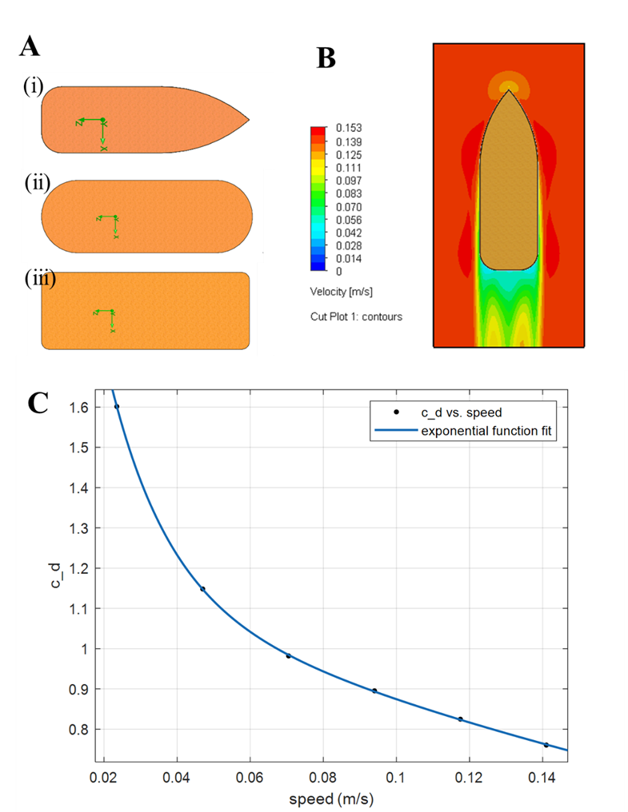
Fig. S2. Illustration of the CFD simulation procedure of body structures. (A) i), ii), iii) shows streamline shape, slot shape and rectangular shape, respectively. Each shape has the same footprint area $A_{0}$ (600 mm²), width $d$ (15 mm) and height $h$ (4 mm). (B) Water flow profile around the boat-shaped body in simulation. (C) Fitted curve of the drag coefficient $c_{d}$ as a function of the flow speed around the boat-shaped body.
Flow along the length of the body was supplied in simulation (Fig. S2B), drag coefficient was calculated based on the drag force $F_{d}$ given by simulation:
$c_{d}=\frac{2F_{d}}{ρ_{0}dhu^{2}}$ (S7)
At $u$ = 0.141 m/s (which corresponds to 3 body lengths per second), the streamlined boat shape has the lowest $F_{d}$ = 4.54×10⁻⁴ N compared to the other two shapes (4.63×10⁻⁴ N for slot shape, 6.25×10⁻⁴ N for rectangular shape), which corresponds to a drag coefficient $c_{d}$ = 0.76, Raynolds number $Re$ = 564. With $u$ = 0.0235 m/s, $c_{d}$ = 1.60 and $Re$ = 94 for the boat-shaped body. 4 extra data points of the drag coefficient between the lower and higher speed values were also obtained from the simulation and used to generate an estimated fitting of the function (Fig. S2C), where $c_{d}=a_{1}e^{b_{1}u}+a_{2}e^{b_{2}u}$, $a_{1}$ =0.0128, $b_{1}$ = -2.7180, $a_{2}$ = 0.9218, $b_{2}$ = -0.1430.
- Toxicity index derivation
The toxicity index is defined as:
$I_{toxic}=\frac{1}{R_{N}∙NOEC} or \frac{1}{R_{E}∙EC50}$ (S8)
Where “half maximal effective concentration (EC50)” and “no observed effect concentration (NOEC)” are important metrics used in ecotoxicology to assess the impact of substances on aquatic species. $R_{N}$ and $R_{E}$ are corresponding assessment factors which will be explained later.
EC50 refers to the concentration of a substance at which 50% of the maximal effect is observed. It is a measure of the potency of a substance, indicating the concentration required to produce a significant effect in 50% of the test organisms. A lower EC50 value indicates a more toxic substance. NOEC is the highest concentration of a substance at which no observable adverse effects are detected on the test organisms compared to a control group, which is a stricter and therefore safer metric for evaluation. The NOEC is always smaller than EC50, given the same test conditions and procedure.
The EC50 and NOEC data can be tested at different time scales with different aquatic species. To make the comparison as convincing as possible, here the 48h (hours) EC50 (acute toxicity, immobilization) data for Daphnia magna was selected as the benchmark to compare due to the most toxicity experiment data available. However, there are still some surfactants that have no available 48h EC50 data. For these surfactants, the 21d (days) NOEC data (chronic toxicity, reproductivity) was used instead. For all the surfactants considered, their toxicity data are presented in Table S1.
Table S1. Ecotoxicity data for selected surfactants
Chemical | Toxicity data type (Daphnia magna) | Value [mg/L]
Ethanol⁵ | 48h EC50 | 12340
Propylene glycol⁶ | 48h EC50 | 43500
Methyl hexanoate⁷ | 48h EC50 | 40
3-Methyl-1-butanol⁸ | 48h EC50 | 255
L-Menthol⁹ | 48h EC50 | 26.6
mono-rhamnolipids¹⁰ | 48h EC50 | 30
Polyvinyl alcohol (PVA)¹¹ | 21d NOEC | 1
Polyethylene glycol 300^{[11]} | 21d NOEC | 1
Polysorbate 80^{[12]} | 21d NOEC | 10
Lecithin (various phospholipids)¹³ | Not available | -
In practice¹⁴, assessment factors can be used to relate NOEC and EC50, which have different ecotoxicity meanings and are not directly comparable. Here we chose assessment factors $R_{N}=$ 1 and $R_{E}=$ $\frac{1}{1234}$ for 21d NOEC and 48h EC50 data respectively, based on the toxicity data of ethanol (Table S2) and assume the same assessment factors also apply to other substances in Table S1.
Chemical | Toxicity data type (Daphnia magna) | Value [mg/L]
Ethanol⁵ | 48h EC50 | 12340
Ethanol⁵ | 21d NOEC | 10
Table S2. Ecotoxicity data used to estimate $R_{N}$ and $R_{E}$

- Analysis of the rotary test data
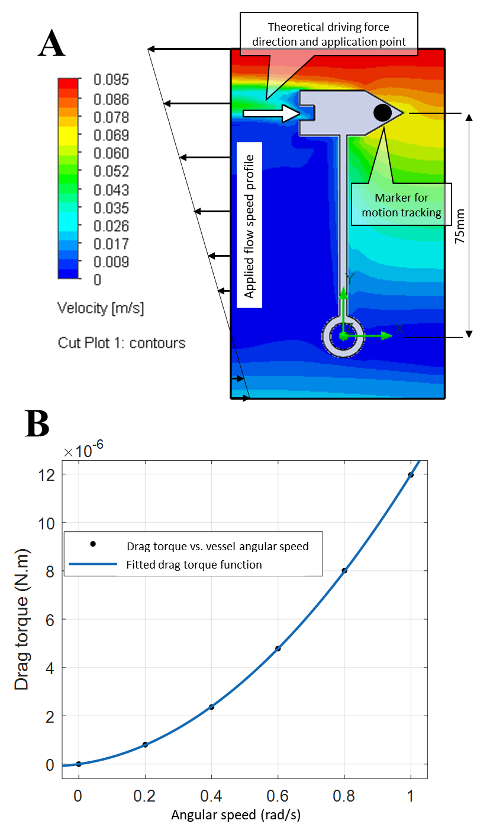
Fig. S3. Analysis of the rotary test. (A) Illustration of the CFD simulation of the rotary vehicle. (B) Fitted curve of the drag torque as a function of the angular speed of the rotary vessel in simulation.
The drag applied to the rotary vehicle was obtained by CFD simulation (Fig. S3A), with the height of the 3d model set to double the theoretical submerge depth $h_{0}$ = 2.23 mm derived from the mass and footprint area of the vehicle (mirror images assumption) to account for the water-air interface effect. The applied flow profile increases linearly from zero from the rotary center to a terminal speed at the edge of the system, emulating the rotary motion. The drag torque data was extracted from the simulation and divided by 2 to acquire the actual drag torque $T_{d}$, as a function of the angular speed $ω$ of the rotary motion estimated by 6 data points with angular speed from 0 to 1 rad/s. The function was approximated to be $T_{d} = p_{2}ω^{2}+p_{1}ω+p_{0}$, where $p_{0}$, $p_{1}$, $p_{2}$ equals -2.14 × 10⁻¹⁰, 1.95 × 10⁻⁶, 1.00×10⁻⁵, respectively. Assuming constant speed rotary motion, the driving force $F_{s}$, assumed to be applied to the vessel at radius $r_{s}$ = 75 mm, balances the drag torque $T_{d}$, giving:
$F_{s}=T_{d}∙r_{s}$ (S9)
In the actual experiment, however, the driving force and drag force are not identical because of acceleration. Using the measured data of the marker’s speed $u$ (at a slightly larger radius $r_{m}$ = 76.2 mm) and the tangential acceleration rate $a_{m}$, the total energy needed for motion can be estimated by:
$\int_{0}^{t_{m}}{F_{s}∙u_{s}∙dt}= \int_{0}^{t_{m}}{(T_{d}∙r_{s}+\frac{I∙a_{m}}{r_{s}r_{m}})(\frac{r_{s}}{r_{m}})u_{m}∙dt}$ (S10)
Where $m$ is the mass of the test vehicle including the mass of fuel (assumed to be constant) that equals to 1.49 g, $I$ is the moment of inertia which was estimated to be 6.00×10⁻¹² kg∙m² from the 3d model, $u_{m}$ is the measured tangential speed of the marker on the test vessel, and the speed of the vessel at $r_{s}$ = 75 mm, $u_{s}=$ $u_{m}∙r_{s}/r_{m}$ due to the small radius difference between the marker and the theoretical application point of the driving force. Plug in the data for propylene glycol and ethanol motion test respectively, the equation gives a total motion energy of 1.07 × 10⁻⁴ J for propylene glycol and 1.94 × 10⁻⁴ J for ethanol. When comparing with the same amount of ethanol, propylene glycol provides less motion energy, but exhibits much less toxicity to aquatic species, thus was selected as the fuel of the device, as quantitatively stated in the main text.
Parameters $η$, $k$ and $D$ are essential parameters to predict the performance of an aquatic robot, which are related to the type of fuel and can be estimated by rotary motion experiment. Here, the product $kD$ is considered as a whole, the correlation between $η$ and $kD$ can be derived based on equations S4 and S5 in Section S1, such that:
$η= \frac{\int_{0}^{t_{m}}{α}∙dt}{n_{f}}$ (S11)
Where $n_{f}$ = 3.94 × 10⁻³ mol for the test with propylene glycol, and:
$α= \frac{F_{s}\sqrt{{u_{s}}^{2}+4kD}}{RT}$ (S12)
The dependence of $η$ on $kD$ can be defined numerically (Fig. S4). Without measurement, the value of $kD$ is estimated in the range greater than 0 but not exceeding 3.47×10⁶ m²∙s⁻², which corresponds to $η$ ranging from 1.10×10⁻⁵ to the maximum theoretical value of 1.
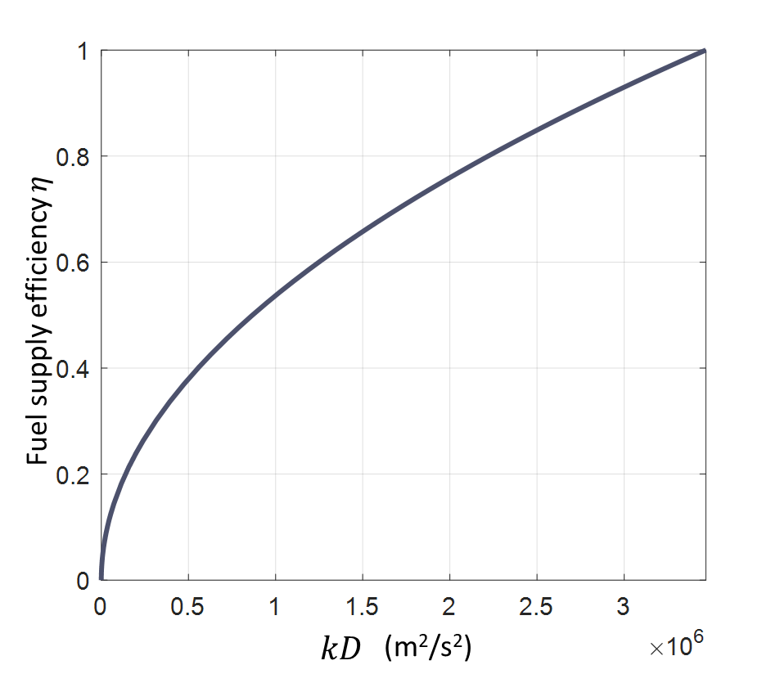
Fig. S4. Numerical function plot of $η(kD)$. This relationship is assumed to apply to not only the rotary motion test vehicle, but also the edible aquatic robot.
- Fluidic actuator design and fuel flow estimation
To guarantee uniform and smooth expulsion of the fuel in the reservoir, the reservoir needs to have a cross-section width scale that ensures the dominating effect of surface tension rather than gravity. This relationship is governed by the dimensionless parameter Bond number¹⁵:
$B_{o}= \frac{ρ_{f}gw^{2}}{γ_{f}}$ (S13)
Where $ρ_{f}$ is the density of fuel, $g$ is gravity constant, $w$ is the channel width (reference length scale in this case), and $γ_{f}$ is the surface tension of pure propylene glycol in this case. To enable a uniform and smooth flow of liquid, bond number is expected to be smaller than 1, which requires $w$ to be smaller than 1.9 mm. Meanwhile, it is also desired to maximize the fuel capacity of the reservoir while ensuring even distribution of the fuel in the area to reduce any imbalance caused by the fuel mass. After systematically considering all these requirements, the reservoir channel width was eventually selected to be 1.8 mm, and the pattern of the channels is designed to be a waving pattern surrounding the reaction chamber in the center.
To achieve the target speed between 0.0235 m/s to 0.141 m/s, assuming constant speed and straight motion path, the required driving force can be derived based on equation S2 in Section S1:
$F_{s}= \frac{1}{2}c_{d}ρ_{0}dh_{0}u^{2}$ (S14)
Where $c_{d}$ could range from 0.76 to 1.60, depending on the speed and corresponding Reynolds number (refer to Section S1). $h_{0}$ (the submerged depth) can be estimated by the geometry and mass of the device. Corresponding total fuel supply rate:
$α_{q}=\frac{F_{s}\sqrt{u^{2}+4kD}}{RTη}$ (S15)
Flow rate:
$q= \frac{α_{q}∙M_{f}}{ρ_{f}}$ (S16)
With $kD$ ranges from 0 to the maximum value (3.47×10⁶ m²∙s⁻²), required flow rate $q$ ranges from 1.04 µl/s to 1.82 µl/s for lower speed target 0.0235 m/s, and ranges from 31.09 µl/s to 107.10 µl/s for higher speed target 0.141 m/s. Therefore, the final required flow rate $q$ was set between 1.82 µl/s and 31.09 µl/s, which would in theory guarantee the speed of the aquatic robot lies between the desired values.
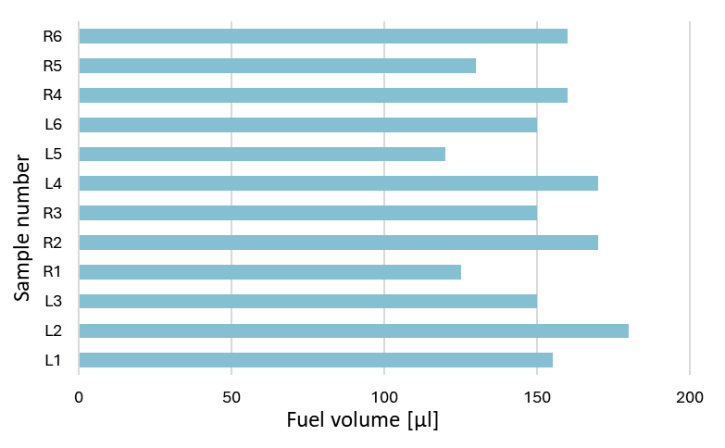
Fig. S5. Reservoir volume of the fluidic actuators.
From literature¹⁶, with each 1 mol of (192.12 g) citric acid and 3 mol (252.02 g) of sodium bicarbonate, the average gas generation rate can range from 0.097 L/s to 0.580 L/s at room temperature (297K), depending on the concentration of the chemicals in the reaction system. The selected combination of 10 mg (5.21 × 10⁻⁵ mol) of citric acid and 10 mg (11.90 × 10⁻⁵ mol) of sodium bicarbonate includes an extra 1.24×10⁻⁵ mol of citric acid as a buffer to ensure the complete exhaustion of sodium bicarbonate. The final amount of sodium citrate is 10.24 mg, which is within the proposed limit of 1% of the total feed mass. The reaction theoretically generates gas at a rate (assumed to be the same as the fuel flow rate) of 3.84 µl/s to 23.02 µl/s based on the literature, which lies perfectly between the desired flow rate derived based on target lower and higher speeds (1.82 µl/s and 31.09 µl/s) established earlier in this section, although the actual gas generation rate may differ due to the small extra amount of citric acid and potential measurement errors. The fluidic actuators have a theoretical volume of 195 µl. Assuming constant gas generation speed and ignoring the dynamic air compressing process, the fuel flow duration can be estimated to be between 8.47 seconds and 50.82 seconds. However, from preliminary tests, it is observed that due to rapid water absorption and reduced fuel reservoir volume during fabrication procedure (Fig. S5), the expulsion speed converges to over 20 µl/s, which often results in an expulsion duration from 5 to 10 seconds, limiting prolonged motion which might be required for future applications. Therefore, ethylcellulose, which is known as a hydrophobic edible and biocompatible polymer, is added and mixed with the reagents in powdered form. Here we assume that, with the addition of varying amounts of ethylcellulose, the flow rate could range from as low as 1.95 µl/s to the theoretical maximum value 23.02 µl/s, although in the actual experiments, only two different amounts (10 mg and 20 mg) were tested.
- Nutritional profile calculation
The edible aquatic robot has two main parts: the boat-shaped body and the fluidic actuator.
The boat-shaped body, formed by the edible binder (gelatin) and ground commercial fish feed pellet in mass ratio of 1:2, has an average mass of 0.48 g. The commercial fish feed is known to have 31% crude protein, 8% lipids, 52% carbohydrates, 2% fiber and 4.7% ash by mass. Therefore, for each single boat-shaped body sample, the nutritional composition can be calculated as: 0.16 g protein from the edible binder, 0.099 g protein from the ground feed pellet, 0.026 g lipids, 0.167 g carbohydrate and 0.029 g other compounds including ash and fiber.
The fluidic layer, excluding the fuel, gas generation chemicals and the permeable bottom, has an average mass of 0.60 g. Assuming zero moisture, because the ratio between gelatin and glycerol used to create the fluidic actuator is 4:1, each fluidic actuator should contain 0.48 g gelatin, with the rest mass taken by glycerol which is not considered part of the nutrition value of the device.
These values were used for calculating the nutritional profile of the edible aquatic robot as shown in Fig.4c of the main text.
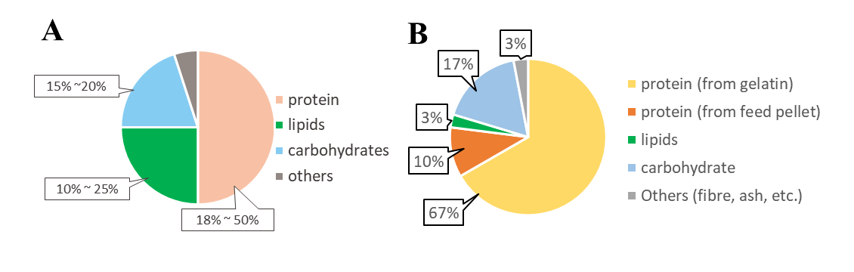
Fig. S6. Nutritional profile evaluation and comparison. (A) An instance of commercial feed pellet nutrition profile based on the literature; (B) Nutritional profile of the edible robot evaluated according to the material composition of the boat-shaped body and the fluidic actuator.
- Water surface saturations analysis
To estimate whether the dispense of fuel (propylene glycol) would significantly affect the surface tension of water and thus reduce the edible aquatic robots’ propulsion ability in possible multiple devices scenario, pedant drop test (Krüss DSA-30) was performed with propylene glycol in water solution samples of different concentrations (Fig. S7). Since each aquatic robot contains approximately 150µl of fuel, and the test container has a water volume of 67.6L, each robot would leave an equivalent concentration 2.22 × 10⁻⁶ (v/v) of propylene glycol in water.
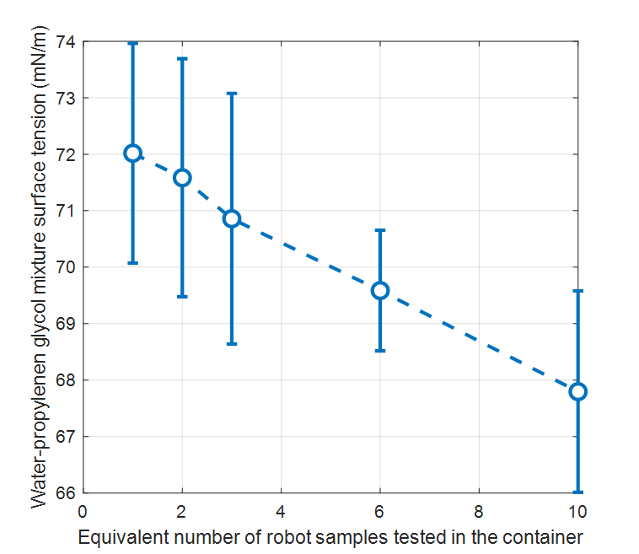
Fig. S7. Relation between increased propylene glycol concentration and the change of water surface tension, measured by the corresponding equivalent number of edible aquatic robot tested. Error bars represent standard deviation.
From the result, it is observed that after testing 3 aquatic edible robot samples in the container, the surface tension of water is reduced by 2.67% compared to the theoretical value of pure water (72.8 mN/m) at 20ºC, which would result in a 2.67% decrease in the driving force of the robot, while after 10 tests, the reduction became 6.87%, according to the physical model (equation S3). This information could guide the choice of limit on robot numbers in potential future swarm application scenarios.
- Edible aquatic robot speed estimation and analysis
Given the total fuel supply rate $α_{q}$ and fuel supply efficiency $η$, based on the model equation S3 and S4 in Section S1, we have:
$\frac{u^{2}c_{d}∙m}{2A_{0}}=\frac{RTα_{q}η}{d\sqrt{u^{2}+4kD}}$ (S17)
Where $u$ can be solved directly. Since $η$ is dependent on $kD$ (Fig. S3, see Section S4), scanning $kD$ from 0 to maximum value (3.47×10⁶, derived in Section S3), and scanning $α_{q}$ from 2.65×10⁻⁵ to 3.13×10⁻⁴ (which correspond to predicted fuel flow rate $q$ from 1.95 µl/s to 23.02 µl/s, obtained in Section S5) gives an estimation of $u$ from 0.023 m/s to 0.111m/s, where smaller fuel flow rates correspond to lower speed value, but longer motion duration (main text Fig. 4F). Although the fuel volume contained by each robot has a range of 120 µl to 180 µl, the predicted duration predicted to be from 8.47 to 100 seconds, which corresponds to the range of fuel flow rate based on the nominal value of 195 µl.
The model prediction was made under simplified condition by assuming straight trajectory, constant fuel flow rate and constant motion speed of the aquatic robot, in the real experiments, the device exhibited much more random trajectory (Fig. S8), and the motion speed also varied significantly (Fig. S9, S10).
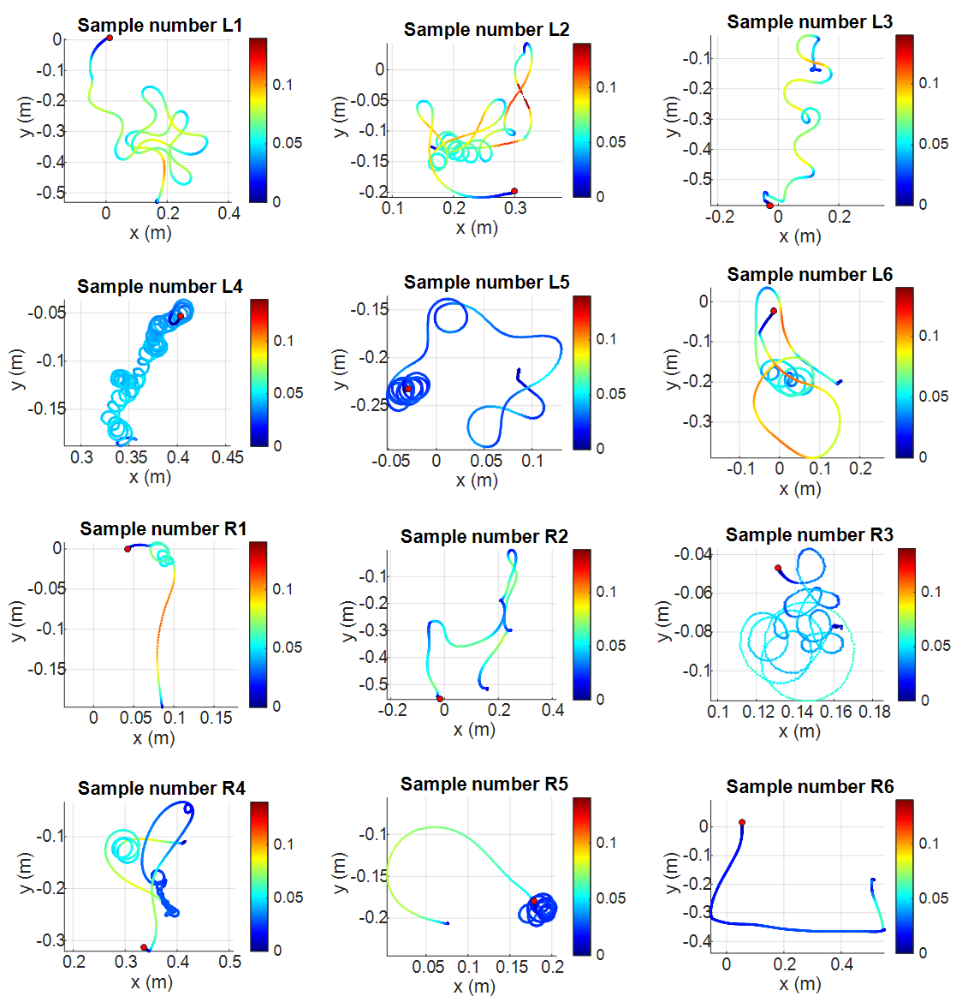
Fig. S8. Center motion trajectory of reported edible aquatic robot samples. Color bars represent center motion speed in m/s, red circular marks denote end points of the trajectories.
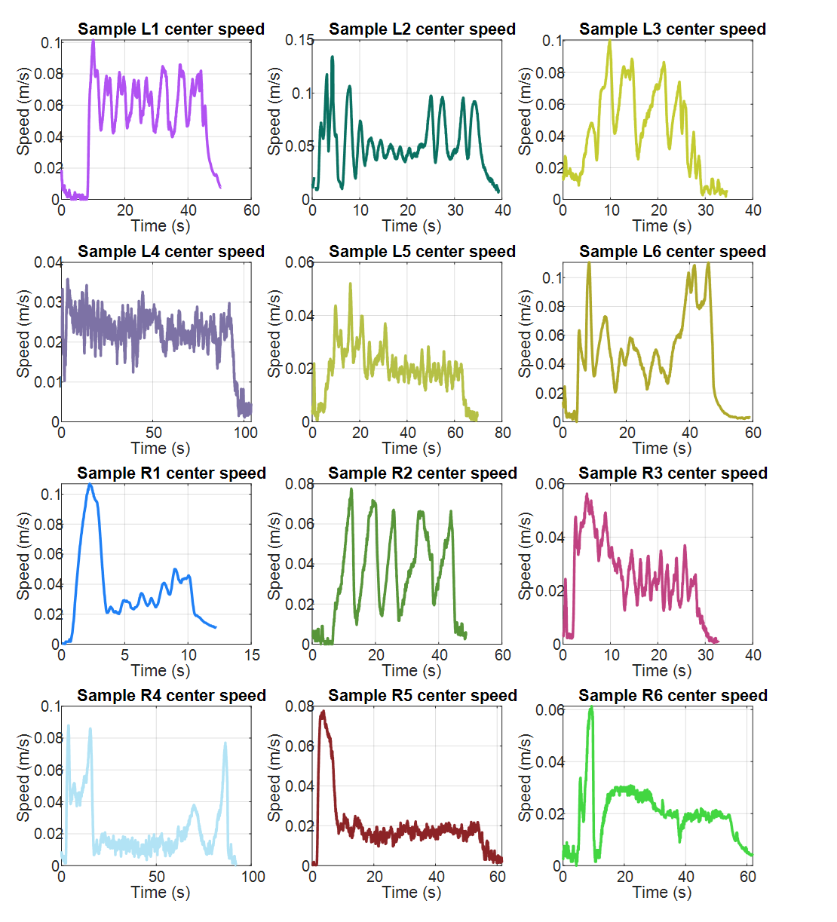
Fig. S9. Center motion speed of reported edible aquatic robot samples
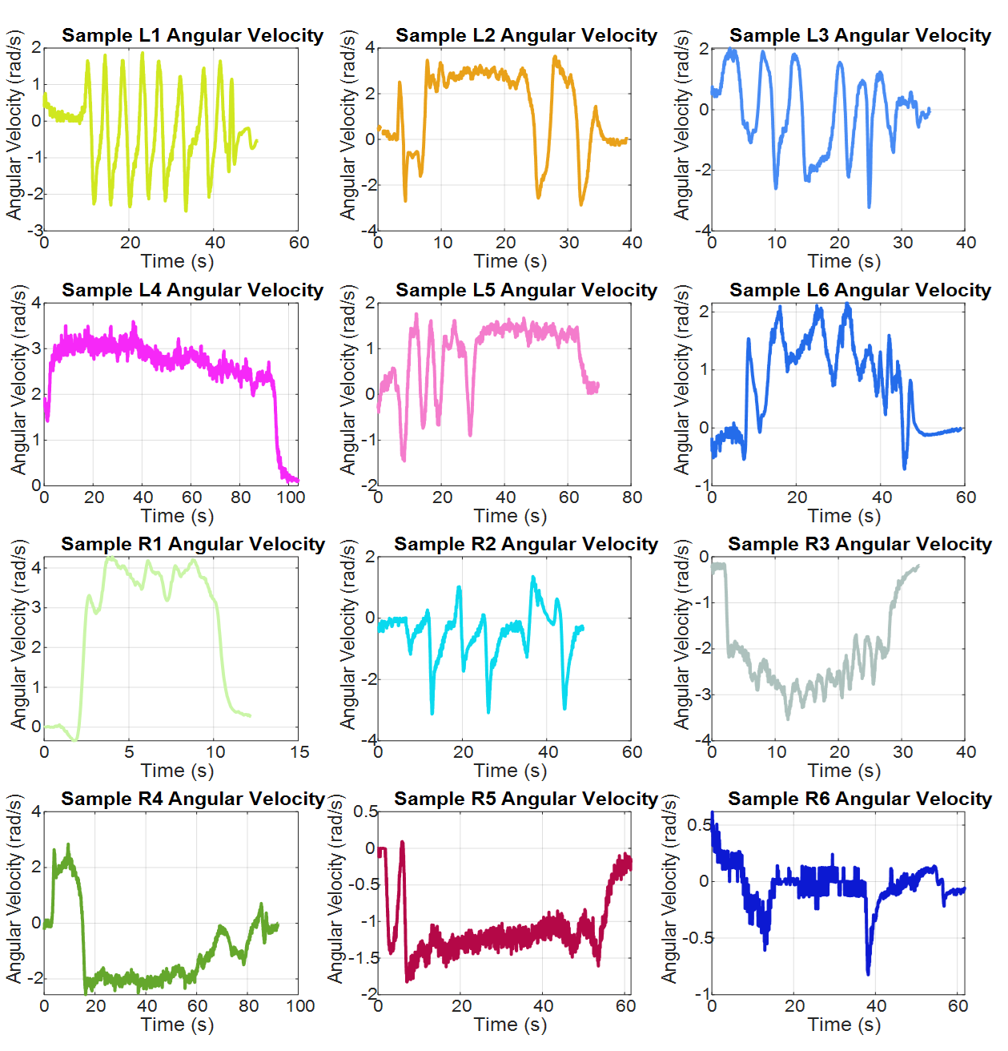
Fig. S10. Angular speed of reported edible aquatic robot samples
All trajectory and speed data were derived from the position data of the two visual tracking markers (Fig. S11) at a time interval of 0.033 seconds. To take both the linear and angular speed of the device into consideration, we define the reference speed $u_{r}$(Fig. S11) as the speed used for evaluation. $u_{0}$ represents the linear speed of the center, $ω$ represents the angular velocity (both extracted from the colored markers motion tracking data), and $l_{m}$ represents the distance between the colored markers. The reference speed is defined as:
$u_{r}=\sqrt{u_{0}^{2}+{(ω∙\frac{l_{m}}{2})}^{2}}$ (S18)
In data analysis, a 10% maximum speed threshold was used to define the start and end of the locomotion period.
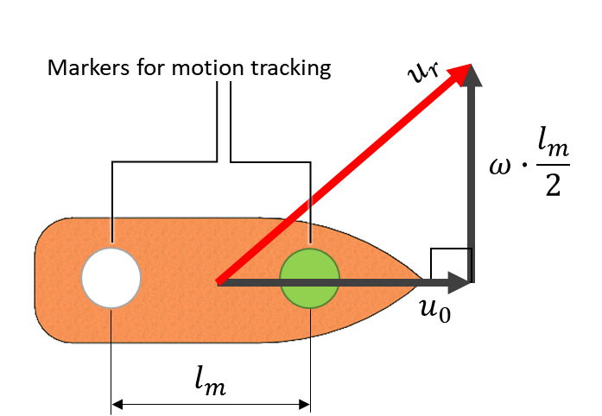
Fig. S11. Definition of the device’s reference speed $u_{r}$.

Appendix
Table S3. Parameters Notation
Notation | Parameter | Value | Unit
$$m_{0}$$ | robot mass without fuel | 1.27 in average | [g]
$$m_{f}$$ | fuel mass | 0.16 in average | [g]
$$m$$ | sum of $m_{0}$ and $m_{f}$ | 1.43 in average | [g]
$$g$$ | gravity acceleration | 9.81 | [m s⁻²]
$$ρ_{0}$$ | pure water density | 10³ | [kg m⁻³]
$$A_{0}$$ | robot bottom footprint area | 6×10⁻⁴ in theory | [m²]
$$h_{0}$$ | robot submerge depth | 2.38×10⁻³ in average | [m]
$$h$$ | floating boat shaped body height | 4×10⁻³ in theory | [m]
$$d$$ | robot feed width | 0.015 | [m]
$$L$$ | robot length | 0.047 | [m]
$$l_{m}$$ | distance between visual tracking markers | 0.025 | [m]
$$F_{s}$$ | driving force | - | [N]
$$u$$ | motion velocity | - | [m s⁻¹]
$$c_{d}$$ | drag coefficient | - | -
$$Π$$ | surface pressure | - | [N m⁻¹]
$$σ_{0}$$ | pure water surface tension | 72.0×10⁻³ at 297 K | [N m⁻¹]
$$σ_{f}$$ | fuel-affected surface tension | - | [N m⁻¹]
$$σ_{min}$$ | minimal surface tension of water-surfactant mixture | - | [N m⁻¹]
$$R$$ | gas constant | 8.31 | [J mol⁻¹ K⁻¹]
$$T$$ | absolute temperature | 297 | [K]
$$α$$ | fuel supply rate from fluidic actuator to water surface | - | [mol s⁻¹]
$$α_{q}$$ | total fuel supply rate from fluidic actuator | - | [mol s⁻¹]
$$η$$ | efficiency of fuel supply | - | -
$$k$$ | fuel dissipation rate (dissolution and evaporation from surface) | - | [s⁻¹]
$$D$$ | effective diffusion rate considering the effect of Marangoni flow | - | [m² s⁻¹]
$$q$$ | fuel flow rate from fluidic actuator to water surface | - | [m³ s⁻¹]
$$ρ_{f}$$ | fuel density | 1.04×10³ for propylene glycol | [kg m⁻³]
$$M_{f}$$ | molar mass of fuel | 76.09 for propylene glycol | [g mol⁻¹]
$$V_{f}$$ | fuel volume | - | [m³]
$$n_{f}$$ | fuel molar number | - | [mol]
$$P_{0}$$ | standard atmosphere pressure | 101.3×10³ | [Pa]
$$α_{g}$$ | gas generation rate | - | [mol s⁻¹]

Supplementary references
1. White, F. M. Fluid Mechanics. (McGraw-Hill, 2011).
2. Suematsu, N. J., Sasaki, T., Nakata, S. & Kitahata, H. Quantitative Estimation of the Parameters for Self-Motion Driven by Difference in Surface Tension. Langmuir 30, 8101–8108 (2014).
3. Burton, L. J., Cheng, N. & Bush, J. W. M. The Cocktail Boat. Integrative and Comparative Biology 54, 969–973 (2014).
4. Lutfi, M. A. et al. Leisure Boat Concept Design: Study on the Influence of Hull Form and Dimension to Increase Hydrodynamic Performance. IJMERR 13, 139–161 (2024).
5. OECD (Organisation for Economic Co-operation and Development). Screening Information Dataset (SIDS) Initial Assessment Report for Ethanol (CAS No. 64-17-5). https://hpvchemicals.oecd.org/ui/handler.axd?id=2602cc56-d998-4e67-bd78-5454ef3f8f9a (accessed: May 2025).
6. OECD (Organisation for Economic Co-operation and Development). Screening Information Dataset (SIDS) Initial Assessment Report for 1,2-Dihydroxypropane (CAS No. 57-55-6). https://hpvchemicals.oecd.org/ui/handler.axd?id=8ff27582-80e7-472a-8e86-f57aea93ffff (accessed: May 2025).
7. European Chemicals Agency (ECHA). Methyl hexanoate registration dossier. https://chem.echa.europa.eu/100.003.115/ (accessed: May 2025).
8. European Chemicals Agency (ECHA). 3-methylbutan-1-ol registration dossier. https://chem.echa.europa.eu/100.004.213/ (accessed: May 2025)
9. European Chemicals Agency (ECHA). L-menthol registration dossier. https://chem.echa.europa.eu/100.016.992/ (accessed: May 2025).
10. Johann, S. et al. Mechanism-specific and whole-organism ecotoxicity of mono-rhamnolipids. Science of The Total Environment 548–549, 155–163 (2016).
11. Mondellini, S. et al. Beyond microplastics: Water soluble synthetic polymers exert sublethal adverse effects in the freshwater cladoceran Daphnia magna. Science of The Total Environment 847, 157608 (2022).
12. European Chemicals Agency (ECHA). Dehydrated sorbitol, C18 (unsaturated) fatty acid esters, ethoxylated registration dossier. https://chem.echa.europa.eu/100.252.233/ (accessed: May 2025).
13. European Chemicals Agency (ECHA). Phosphatidylcholines, soya, hydrogenated registration dossier. https://chem.echa.europa.eu/100.096.816/ (accessed: May 2025).
14. European Chemicals Agency (ECHA). Guidance on information requirements and chemical safety assessment: Chapter R.10: Characterisation of dose [concentration]-response for environment. https://echa.europa.eu/documents/10162/13632/information_requirements_r10_en.pdf/bb902be7-a503-4ab7-9036-d866b8ddce69 (accessed: May 2025).
15. Squires, T. M. & Quake, S. R. Microfluidics: Fluid physics at the nanoliter scale. Rev. Mod. Phys. 77, 977–1026 (2005).
16. Okui, M., Nagura, Y., Iikawa, S., Yamada, Y. & Nakamura, T. A pneumatic power source using a sodium bicarbonate and citric acid reaction with pressure booster for use in mobile devices. in 2017 IEEE/RSJ International Conference on Intelligent Robots and Systems (IROS) 1040–1045 (IEEE, Vancouver, BC, 2017). doi:10.1109/IROS.2017.8202272.

