Supporting Information for
Rising Military Spending Jeopardizes Climate Targets
Wenjie Dong^{1*†}, Qi Ran^{1†}, Fei Liu¹, Rong Deng¹, Jie Yang¹, Kaixi Wang¹, Xinyue Wang¹, Duofan Zheng¹, Chenhao Li¹, Wenjun Liang¹, Jieming Chou², Wenping Yuan³, Deliang Chen⁴
¹ School of Atmospheric Sciences Sun Yat-Sen University, Key Laboratory of Tropical Atmosphere-Ocean System Ministry of Education, and Southern Marine Science and Engineering Guangdong Laboratory, Zhuhai 519082, China.
² Institute of Disaster Risk Science, Faculty of Geographical Science, Beijing Normal University,
Beijing 100875, China.
³ Institute of Carbon Neutrality, Sino-French Institute for Earth System Science, College of Urban and Environmental Sciences, Peking University, Beijing 100871, China.
⁴ Department of Earth System Science, Tsinghua University, Beijing 100084, China.
* Correspondence to: Wenjie Dong (dongwj3@mail.sysu.edu.cn)
† These authors contributed equally: Wenjie Dong, Qi Ran.

Contents of this file
Supplementary Figures 1 to 12
Supplementary Tables 1 to 4

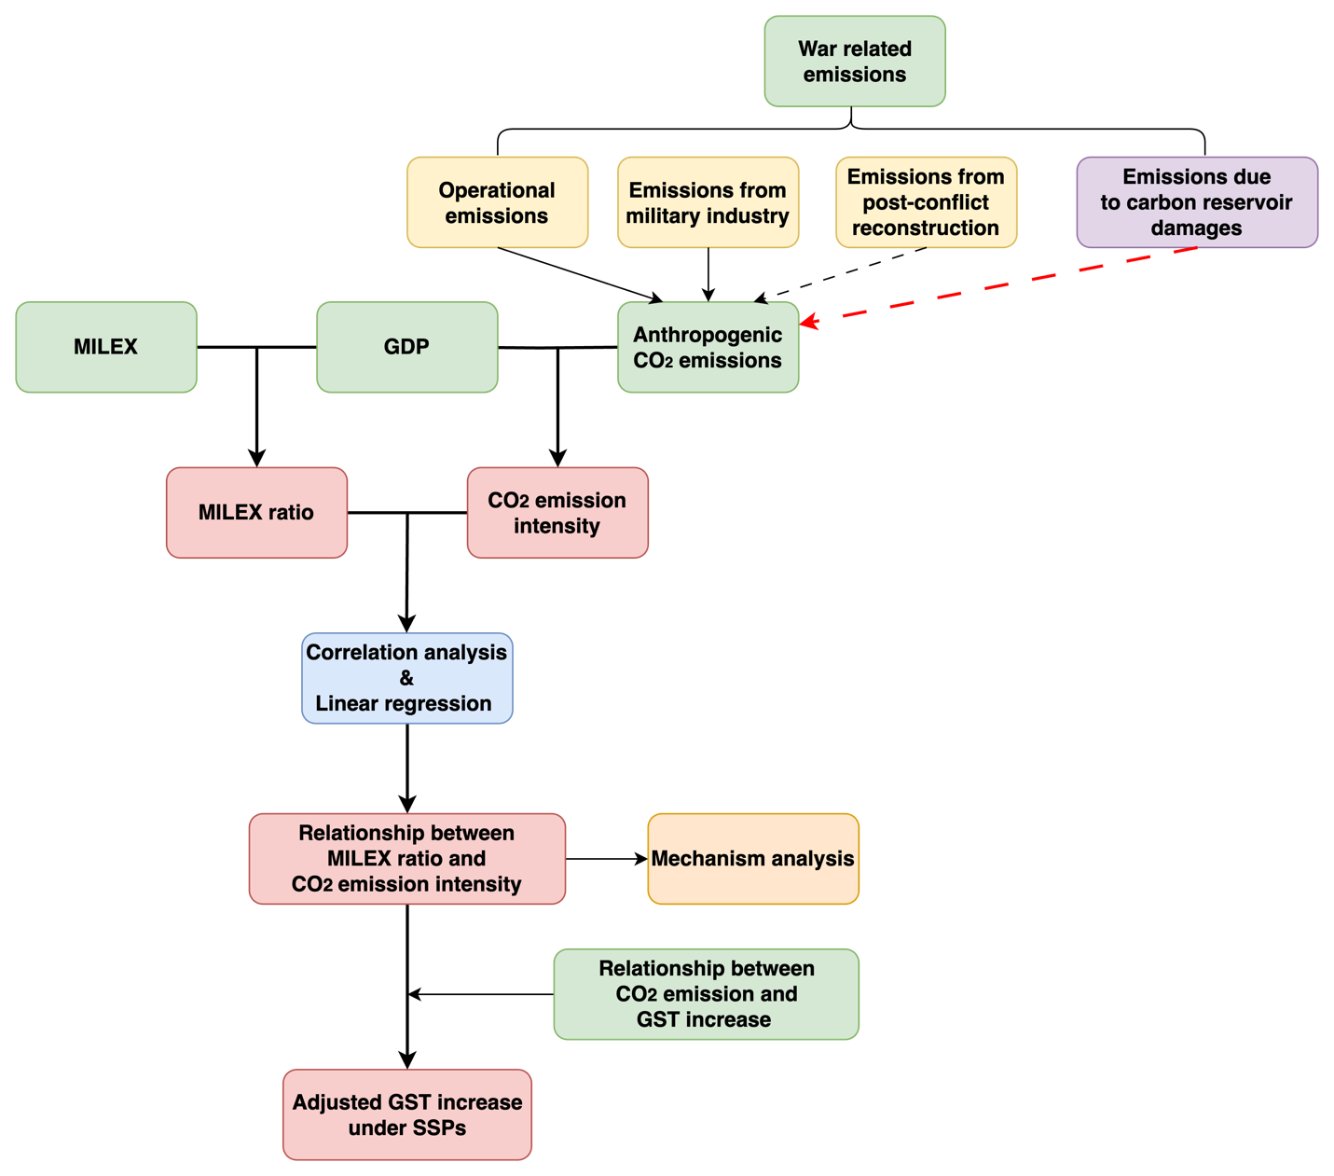
Supplementary Fig. 1. Research framework of this study.

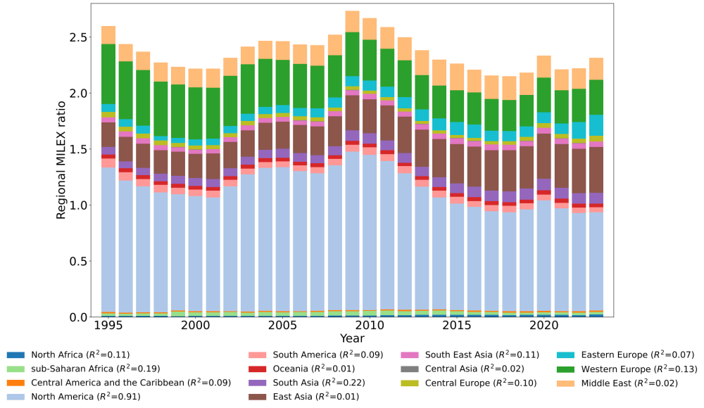
Supplementary Fig. 2. The contribution of different regions to global military expenditure (MILEX) ratio from 1995 to 2023. The bar charts, each in a different color, represent the ratio of regional military expenditure to global GDP. R², the coefficient of determination, indicates the proportion of the variation in the global MILEX ratio that is predictable from the regional MILEX ratio (regional MILEX/regional GDP).

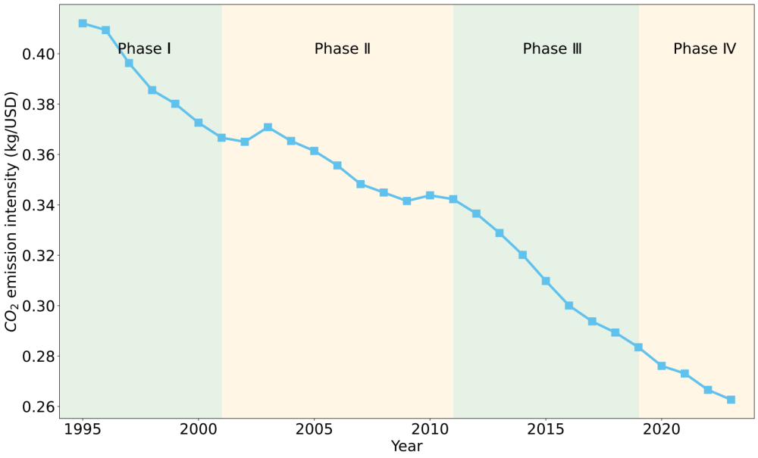
Supplementary Fig. 3. Time series of global CO₂ emission intensity (kg/USD in constant 2017 of purchasing power parity) between 1995 and 2023. The study period is divided into four phases, showcasing a relatively peaceful phase (highlighted with a light-green background) and a phase of frequent regional wars (marked with a light-orange background).

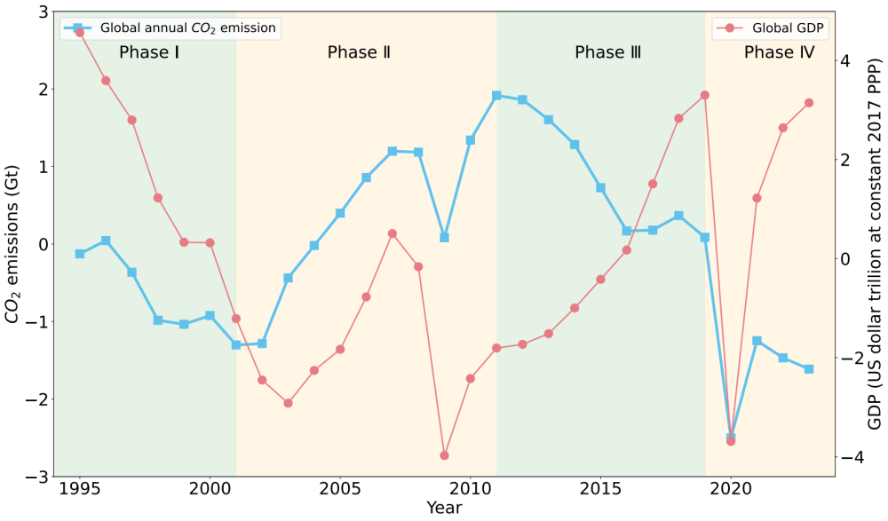
Supplementary Fig. 4(a) Detrended global annual CO₂ emissions (Gt) and detrended global GDP (US dollar trillion at constant 2017 PPP) from 1995 to 2023. The study period is divided into four phases, showcasing a relatively peaceful phase (highlighted with a light-green background) and a phase of frequent regional wars (marked with a light-orange background).

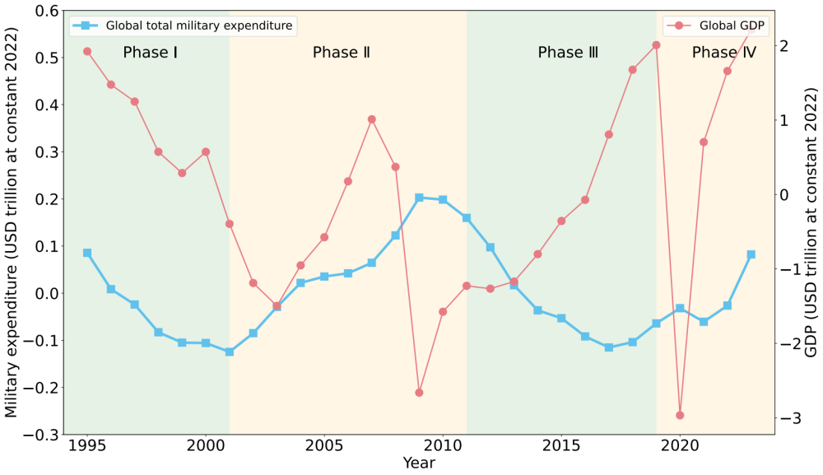
Supplementary Fig. 4(b) Detrended global military expenditure (US dollar trillion at constant 2022) and detrended global GDP (US dollar trillion at constant 2022) from 1995 to 2023. The study period is divided into four phases, showcasing a relatively peaceful phase (highlighted with a light-green background) and a phase of frequent regional wars (marked with a light-orange background).

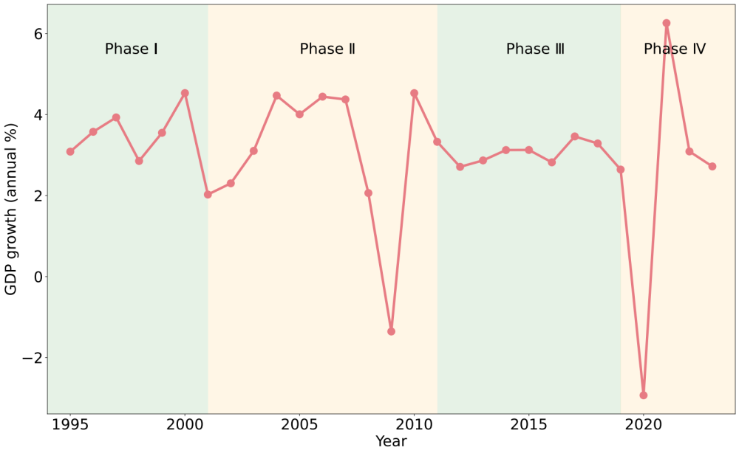
Supplementary Fig. 5. GDP growth (annual %) from 1995 to 2023. Data is provided by World Bank^{[1]}. The study period is divided into four phases, showcasing a relatively peaceful phase (highlighted with a light-green background) and a phase of frequent regional wars (marked with a light-orange background).

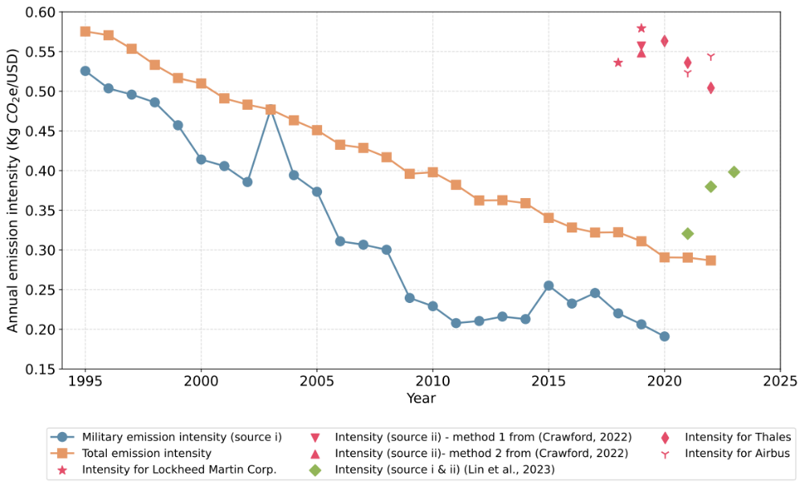
Supplementary Fig. 6. Emission intensities across various military sectors and the national total for the United States. Blue circles represent the carbon emission intensity (kg CO₂-equivalent/USD in constant 2015 prices) of U.S. military bases and operations (source i) during 1995–2020, calculated as Department of Defense emissions^{[2]} divided by national defense outlays for operation, maintenance, and military construction^{[3]}. Pink triangles indicate military industry emission intensity (source ii, 2019), estimated using military-industrial emissions provided by Crawford^{[2]} and the national defense outlays for procurement^{[3]}. Green diamonds show combined military sources (sources i and ii) during 2021–2023. U.S. total emission intensity is depicted by orange squares, estimated using the military-related carbon footprint data from Lin et al.^{[4]} and corresponding defense outlays. For comparison, emission intensities of major defense contractors are included: Lockheed Martin Corporation^{[2]} (pink stars), the top-ranked U.S. arms dealer, along with European arms manufacturers Thales (pink diamonds) and Airbus^{[4]} (pink Y-symbols).

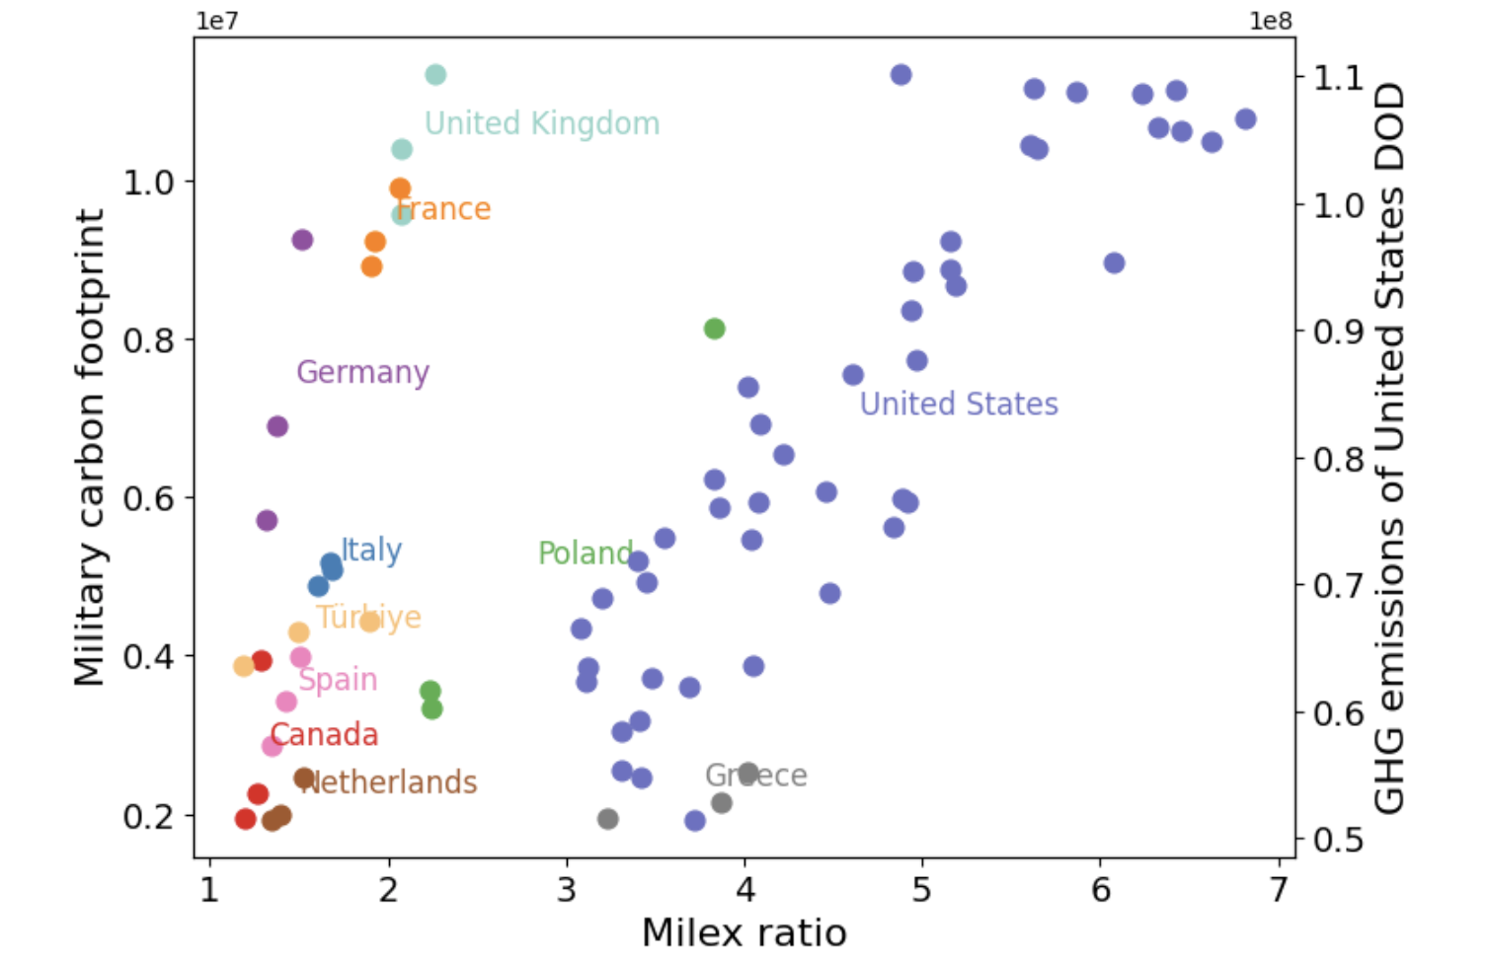
Supplementary Fig. 7. Scatter plot of military expenditure ratios and military carbon footprint (tons CO₂e) of some NATO members from 2021 to 2023. The military carbon footprints for European NATO members from 2021 to 2023 are computed based on the formula provided by Lin et al.^{[4]}. The military-related carbon emissions for the United States are only from the Department of Defense (DOD)^{[2]}, and cover the period from 1975 to 2020.
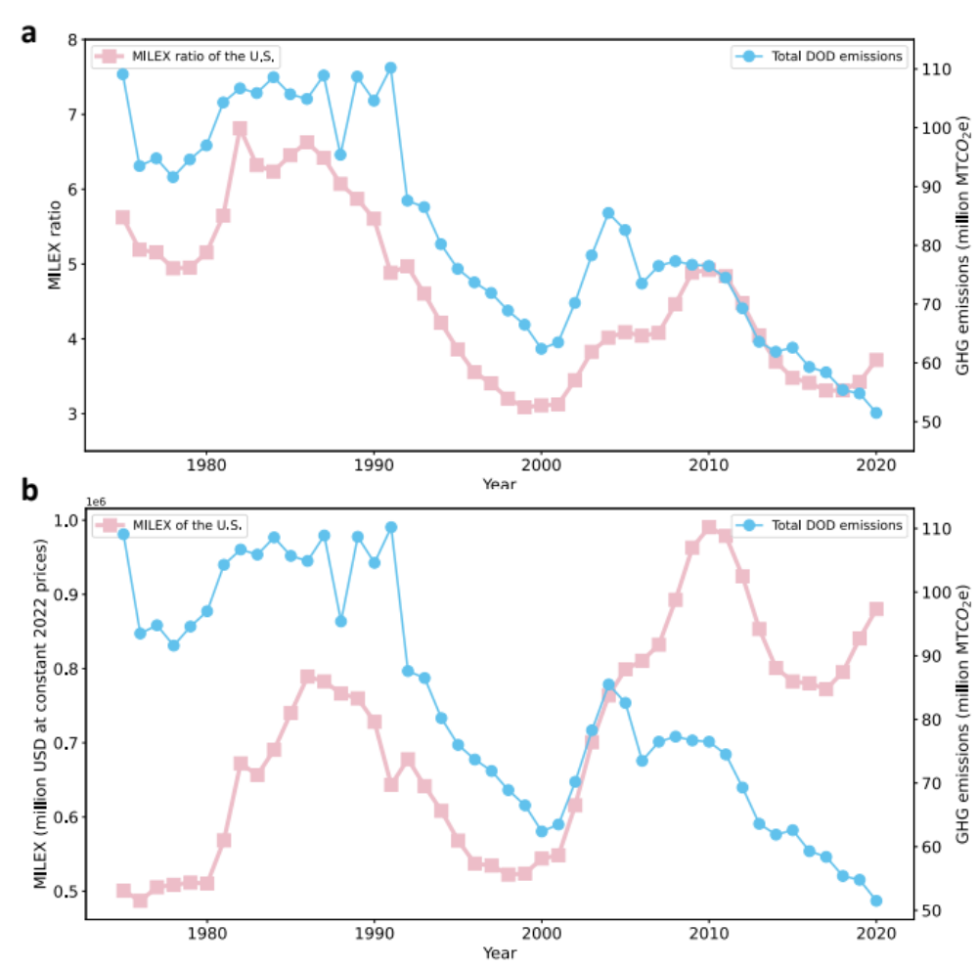
Supplementary Fig. 8. The relationship between the United States DOD emissions and national military expenditures (ratios). a, The time series of U.S. military expenditure (MILEX) ratio (pink line) and total DOD emissions^{[2]} (blue line) from 1975 to 2020. b, The time series of U.S. MILEX (pink line) and total DOD emissions (blue line).

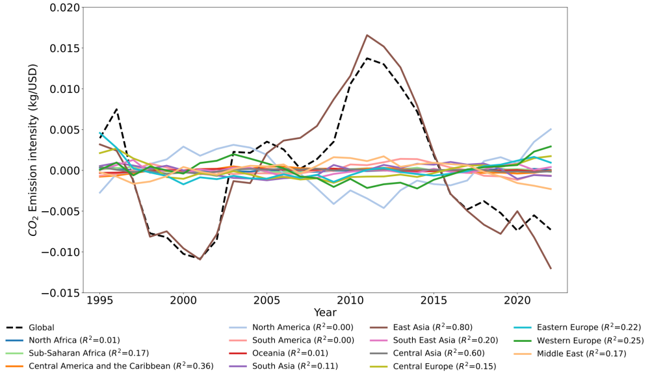
Supplementary Fig. 9. The contribution of different regions to global total emission intensity from 1995 to 2022. The colored lines represent the ratio of regional CO₂ emissions to global GDP. R², the coefficient of determination, indicates the proportion of the variation in the global CO₂ emission intensity that is predictable from the regional CO₂ emission intensity (regional CO₂ emissions/regional GDP).

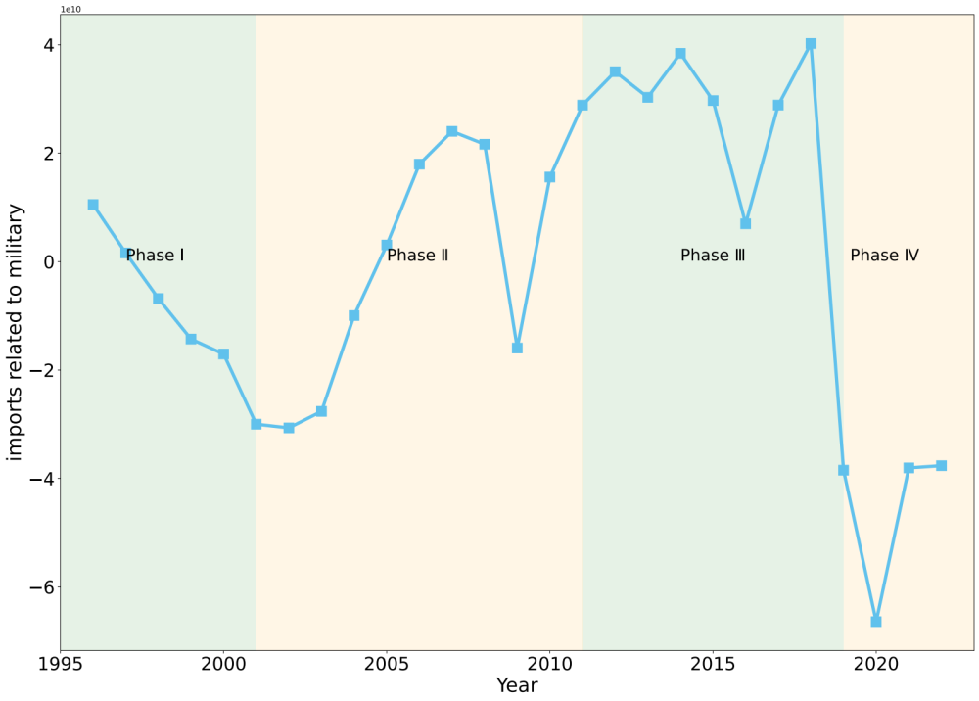
Supplementary Fig. 10. The United States military-related imports (USD) from China between 1995 and 2022 (after detrending). Data is provided by WTO STATS (https://stats.wto.org). The study period is divided into four phases, showcasing a relatively peaceful phase (highlighted with a light-green background) and a phase of frequent regional wars (marked with a light-orange background).

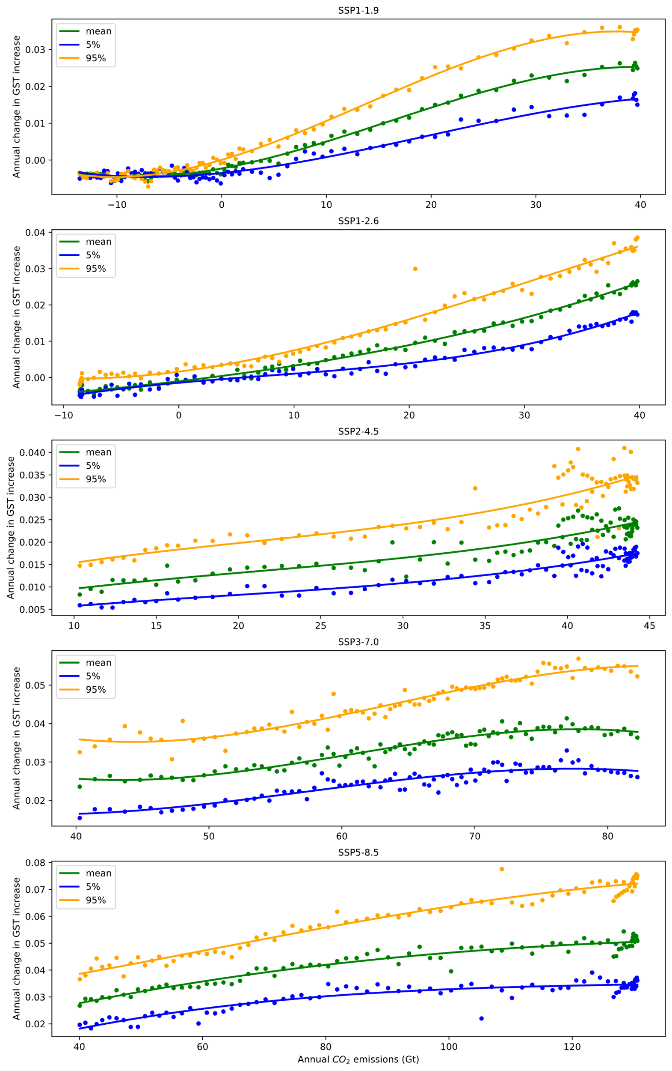
Supplementary Fig. 11. Scatter plots of annual variation in GST change relative to 1850–1900 and annual CO₂ emissions for the five SSP scenarios. Green, blue, and orange dots correspond to the mean GST variations and 5% and 95% confidence intervals of GST changes. Colored lines display the polynomial fitting of their relationship.

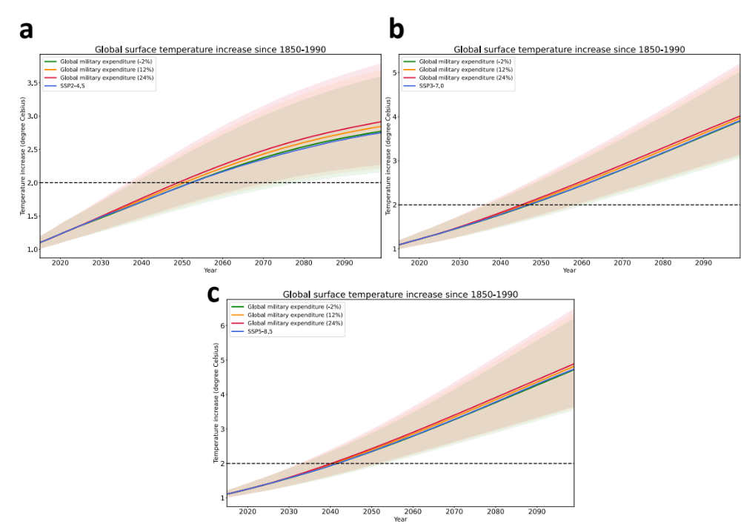
Supplementary Fig. 12. Projections of global surface temperature (GST) increase in baseline SSPs and sensitivity scenarios with varied global tensions. a, b, c, Projected changes in GST relative to the 1850–1900 mean under the SSP2-4.5 (a), SSP3-7.0 (b) and SSP5-8.5 (c) baselines (blue lines), as well as sensitivity scenarios with varying global military expenditure ratios: -2% (green lines), +12% (orange lines), and +24% (red lines) compared to baseline. The shaded areas represent 95% confidence intervals for each scenario.

Supplementary Table 1. Lagged Pearson’s correlation coefficients between detrended CO₂ emission intensity and global MILEX ratio. “Lag” indicates the number of years lagged. Here, we consider only the possible effect of the MILEX ratio on CO₂ emission intensity, and therefore, only the lagged correlation of CO₂ intensity with respect to the MILEX ratio is calculated. The correlation coefficients in bold pass the Student’s t-test at 0.1 significance level (lag = 0, 1, 2) or 0.05 significance level (lag = 1). Effective degrees of freedom are used for the significance test.
Lag (year) | 0 | 1 | 2 | 3 | 4 | 5
Correlation coefficient | 0.71 | 0.84 | 0.76 | 0.59 | 0.42 | 0.22

Supplementary Table 2. Sources of military related CO₂ emissions mapped to different categories of military expenditure^{[5]}.
Military Expenditure Category | Sources of CO₂ Emissions
Personnel expenditures | N/A
Operations and maintenance expenditures | Source i
Procurement expenditures | Source ii (military industry, including the production of vehicles, weapons, and equipment)
Military research and development | Source i and ii
Military infrastructure spending, including military bases | Source i
Military aid | Source i from funded foreign bases/operations  Source ii from provided weapons/equipment  Source iii (post-conflict reconstruction)
Not directly mapped | Source iv (destruction of carbon reservoirs)

Supplementary Table 3. CO₂ emissions from source iv (destruction of carbon reservoirs) during different wars estimated by Michaelowa et al.^{[6]} and de Klerk et al.^{[7]}
War or conflict | Period | CO₂ emissions (million t) | Details
World War II | 1943 | 36–215^{[6]} | Entire German cities were bombed.
Vietnam War | 1961–1971 | 300^{[6]} | 0.5 million hectares of tropical forest and mangroves in southern Vietnam were destroyed.
the Gulf War | 1991 | 320^{[6]} | Iraq set fire to 751 oil wells in Kuwait.
The Russo-Ukrainian War | February 2022- 23 February 2023 | 32.2 (CO₂ equivalent) ^{[7]} | Fires caused extensive forest destruction;  North Stream 1 & 2 pipelines sabotaged, releasing large quantities of natural gas.
Nuclear  war | future | 1.8–14^{[6]} (per city) | N/A

Supplementary Table 4. Changes in GST increase (℃) relative to 1850–1900 when different global MILEX ratio is considered in the SSP scenarios. “−x%” or “+x%” represents the global MILEX ratio decreases or increases by x% compared with the baseline. “2050” and “2099” mean the difference in the GST increase between the baseline SSPs and the sensitivity scenarios in the year 2050 or 2099.
 | −2% |  | +5% |  | +12%
 | 2050 | 2099 | 2050 | 2099 | 2050 | 2099
SSP1-1.9 | −0.01 | −0.02 | 0.03 | 0.04 | 0.07 | 0.12
 | −2% |  | +12% |  | +24%
SSP1-2.6 | −0.01 | −0.02 | 0.06 | 0.13 | 0.13 | 0.28
SSP2-4.5 | 0.00 | 0.02 | 0.04 | 0.1 | 0.08 | 0.17
SSP3-7.0 | −0.01 | −0.01 | 0.03 | 0.05 | 0.07 | 0.1
SSP5-8.5 | 0.00 | −0.01 | 0.04 | 0.09 | 0.08 | 0.16

Supplementary References
1. World Bank, GDP growth (annual %). 2024. https://data.worldbank.org/indicator/NY.GDP.MKTP.KD.ZG
2. Crawford, N.C, The Pentagon, Climate Change, and War: Charting the Rise and Fall of U.S. Military Emissions. 2022. The MIT Press. https://doi.org/10.7551/mitpress/14617.001.0001
3. Office of the Under Secretary of Defense (Comptroller). (2022). National Defense Budget Estimates for FY 2023. U.S. Department of Defense. https://comptroller.defense.gov/Portals/45/Documents/defbudget/FY2023/FY23_Green_Book.pdf
4. Lin, H.C., Buxton, N., Akkerman, M., Burton, D., de Vries, W. (October 2023), Climate crossfire: how NATO’s 2% military spending targets contribute to climate breakdown, Transnational Institute http://www.tni.org/climatecrossfire
5. Stockholm International Peace Research Institute (SIPRI). SIPRI Military Expenditure Database (2023). https://doi.org/10.55163/CQGC9685.
6. Michaelowa, A., Koch, T., Charro, D. et al., Military and conflict-related emissions: kyoto to glasgow and beyond. 2022, Perspectives Climate Group: Freiburg, Germany.
7. de Klerk, L., Shlapak, M., Shmurak, A. et al., Climate Damage caused by Russia’s war in Ukraine. 2023.

