Caspase-11 drives macrophage hyperinflammation in models of Polg-related mitochondrial disease

Supplementary Information

Jordyn J. VanPortfliet^{1,2}, Yuanjiu Lei^{2,3}, Muthumeena Ramanathan¹, Camila Guerra Martinez², Jessica Wong¹, Tim J. Stodola¹, Brian R. Hoffmann¹, Kathryn Pflug⁴, Raquel Sitcheran⁴, Stephen C. Kneeland¹, Stephen A. Murray¹, Peter. J. McGuire⁵, Carolyn L. Cannon², A. Phillip West^{1,2,*}

¹The Jackson Laboratory, Bar Harbor, Maine 04609, USA

²Department of Microbial Pathogenesis and Immunology, College of Medicine, Texas A&M University, Bryan, Texas 77807, USA

³Department of Pathology, Yale School of Medicine, New Haven, CT 06520, USA

⁴Department of Cell Biology and Genetics, College of Medicine, Texas A&M University, Bryan, Texas 77807, USA

⁵Metabolism, Infection and Immunity Section, National Human Genome Research Institute, National Institutes of Health, Bethesda, Maryland, 20892, USA

* Correspondence to: phillip.west@jax.org

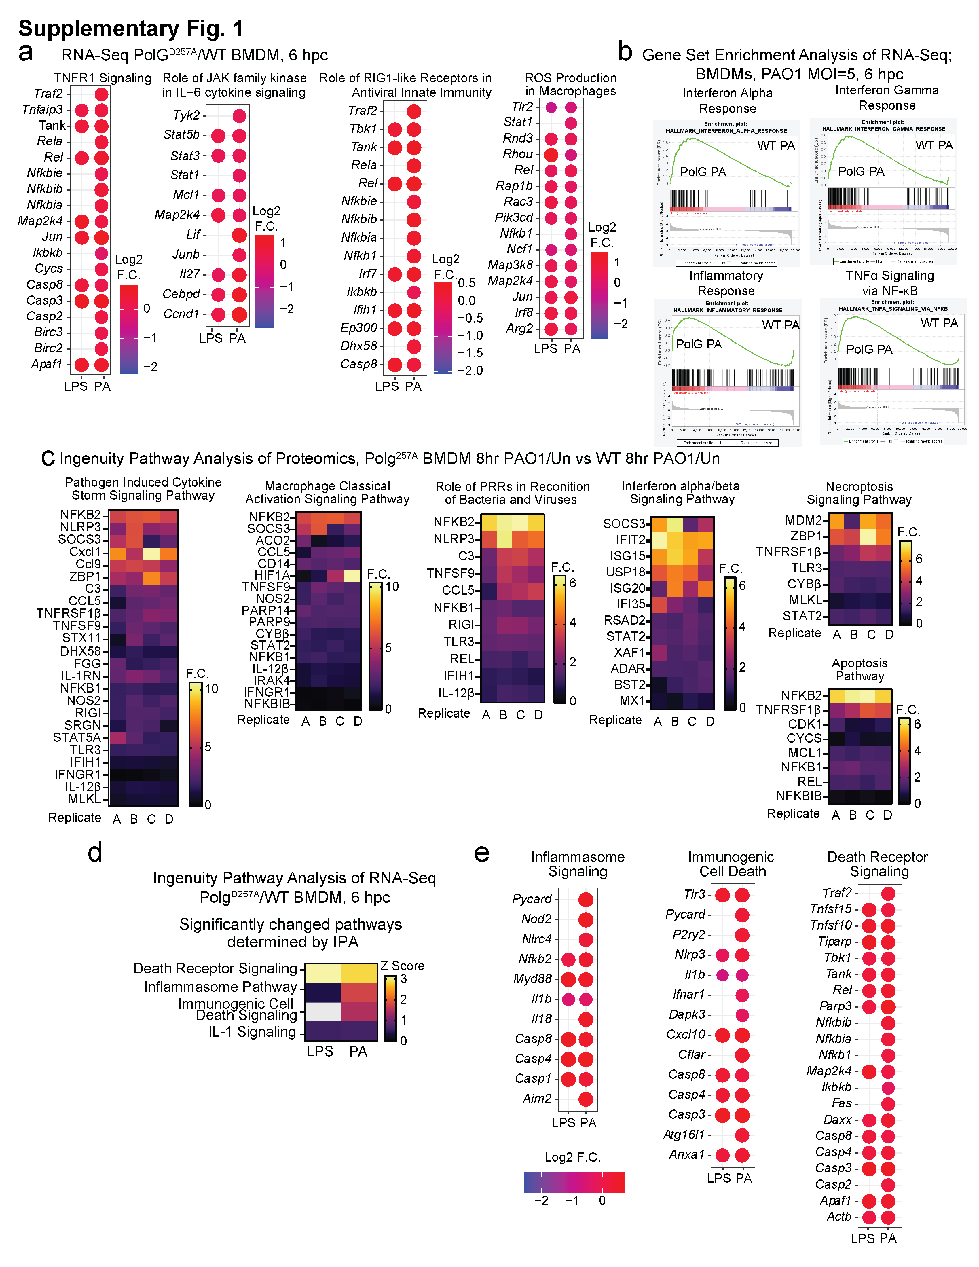
Supplementary Figures

Supplementary Fig. 1: Polg^{D257A} macrophages exhibit elevated IFN-I and pro-inflammatory gene expression when challenged with LPS or PAO1.
(a) Log² fold changes of representative genes in IPA pathways from (Fig. 1b) in Polg^{D257A} BMDMs compared to WT after challenge with LPS or PAO1. N=3 biological replicates/genotype/condition.
(b) Gene Set Enrichment (GSEA) pathways of RNA-seq data in WT ang Polg ^{D257A} BMDMs after challenge with PAO1. Heatmaps represent fold changes of each group relative to WT PAO1 challenged BMDMs. N=3 biological replicates/genotype/condition.
(c) Ingenuity pathway analysis of proteomics from Polg^{D257A} (PAO1, 8hpc/Un)/WT (PAO1, 8 hpc/Un) BMDM proteins in upregulated pathways from Fig 1g. N=4 biological replicates
(d) Ingenuity Pathway Analysis (IPA) of RNA-seq from bone marrow-derived macrophages (BMDMs) showing Z-scores of pathways related to cell death signaling in Polg^{D257A} mutant BMDMs compared to wild-type (WT) after LPS or PAO1 challenge. N=3 biological replicates/genotype/condition.
(e) Log² fold changes of representative genes in IPA pathways from (d) in Polg^{D257A} BMDMs compared to WT after LPS or PAO1.
Source data are provided as a Source Data file.

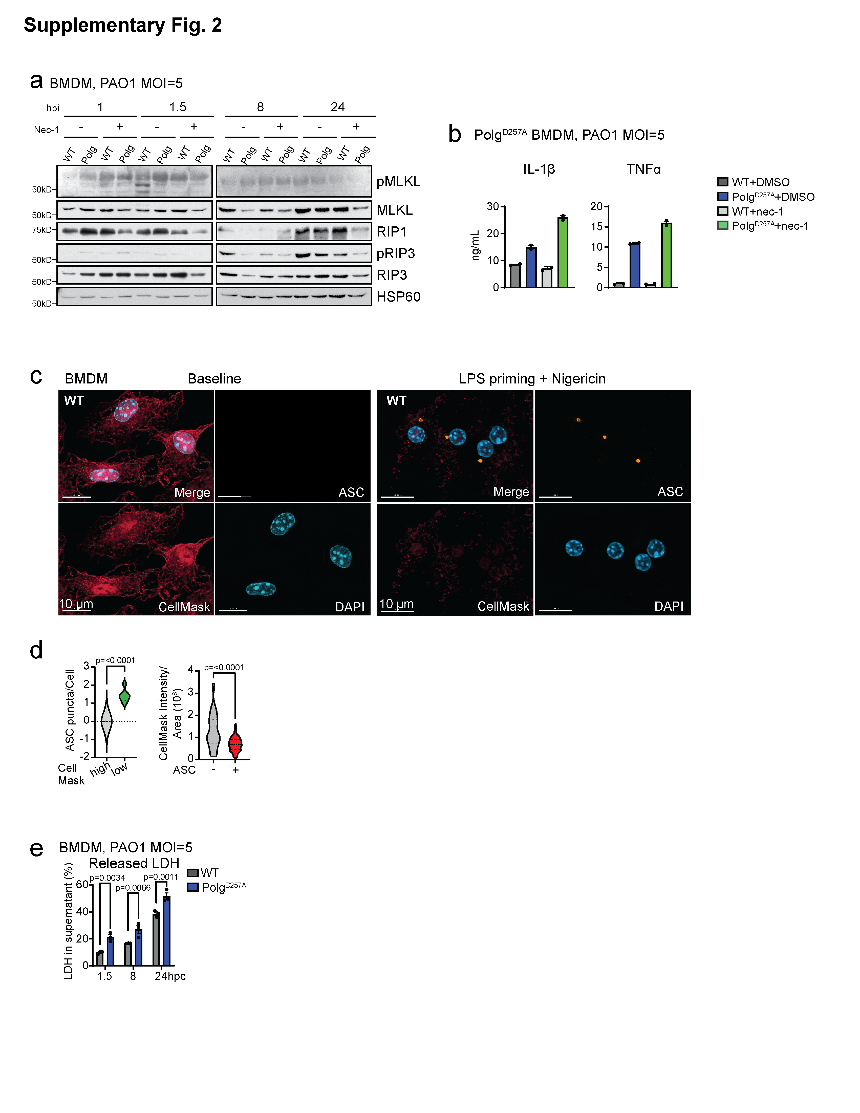
Supplementary Fig. 2: Polg^{D257A} macrophages exhibit increased inflammatory cell death when exposed to PAO1.
(a) Western blot of BMDM protein lysates after nec-1 priming plus PAO1 for protein involved in necroptosis.
(b) ELISA analysis of inflammatory cytokines in BMDM supernatant after PAO1 or PAO1 plus necroptosis inhibitors. N= 2 biological replicates/genotype/condition/timepoint.
(c) Representative IF of BMDMs unchallenged or primed with LPS for 4 hours and stimulated with nigericin for 1 hour to activate the NLRP3 inflammasome. Cells are stained with DAPI to mark the nucleus, CellMask to mark total cell volume, and anti-ASC antibody to mark puncta.
(d) Number of ASC puncta per cell in cells with high and low CellMask staining in (a) IF. N= 7 images/condition.
(e) Percent LDH released from BMDMs during PAO1 challenge. N=3 biological replicates/genotype/timepoint.
Statistics: (d) Two-Sided Students t-test (e) Two-way ANOVA. Error bars represent SEM. Source data are provided as a Source Data file.

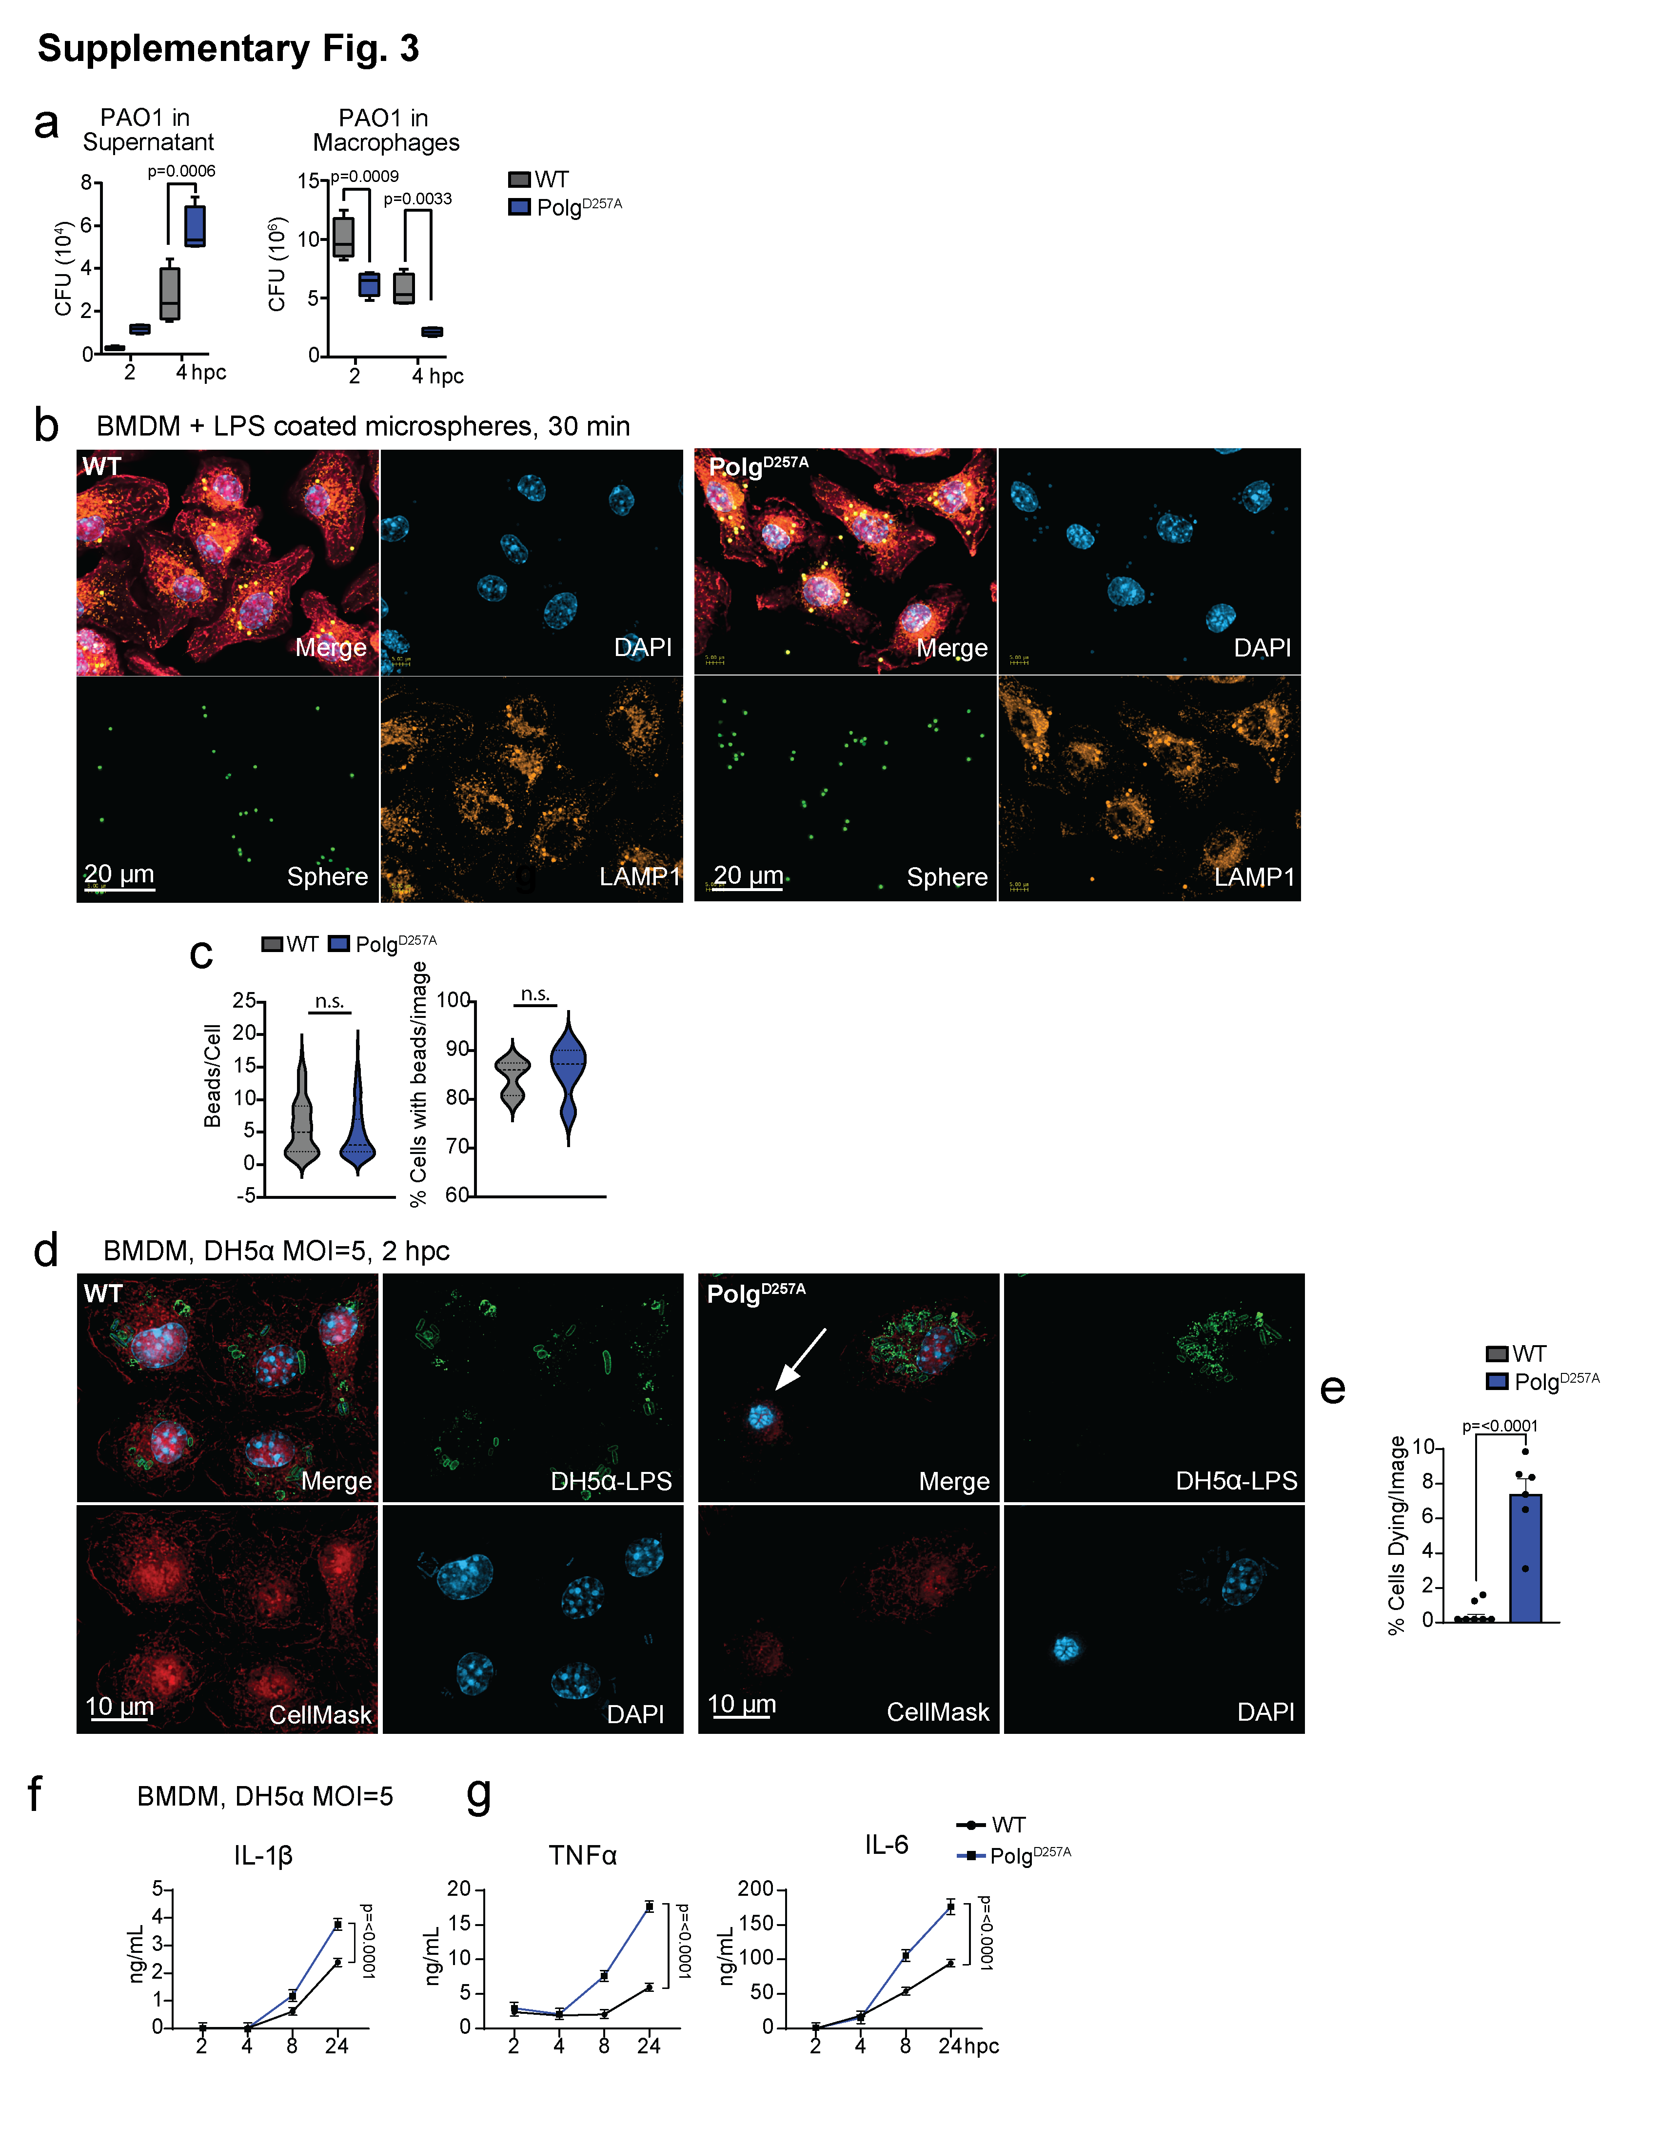
=
Supplementary Fig. 3: Hyperinflammation and impaired anti-bacterial responses in Polg^{D257A} macrophages are not caused by a deficiency of phagocytosis.
(a) PAO1 colony forming units obtained from BMDM supernatant or detergent lysates 2 and 4 hours post challenge (hpc). N=4 biological replicates/genotype/timepoint.
(b) Representative IF of BMDMs phagocytosing LPS coated, fluorescent microspheres. Cells were stained with DAPI to mark the nucleus, CellMask to label the cell volume, and anti-LAMP1 to mark phagolysosomes.
(c) Beads per cell quantified from (e) IF. N= 100 cells/genotype.
(d) Percent BMDMs dying after challenge with DH5α (e) IF. N=7 IF images/genotype.
(e) Representative IF of BMDMs stained with DAPI to mark the nucleus, CellMask to mark the total cell volume, and anti-LPS to mark DH5α bacteria. White arrows highlight dying cells characterized by condensed nuclei and loss of CellMask staining.
(f) ELISA analysis of IL-1β in BMDM supernatants after challenge with Escherichia coli strain DH5α. N= 4 biological replicates/genotype/timepoint.
(g) ELISA analysis of inflammatory cytokines in BMDM supernatants after challenge with Escherichia coli strain DH5α. N= 4 biological replicates/genotype/timepoint.
Statistics: (c & d) Two-Sided Students t-test (a, f & g) Two-way ANOVA. Error bars represent SEM. Source data are provided as a Source Data file.

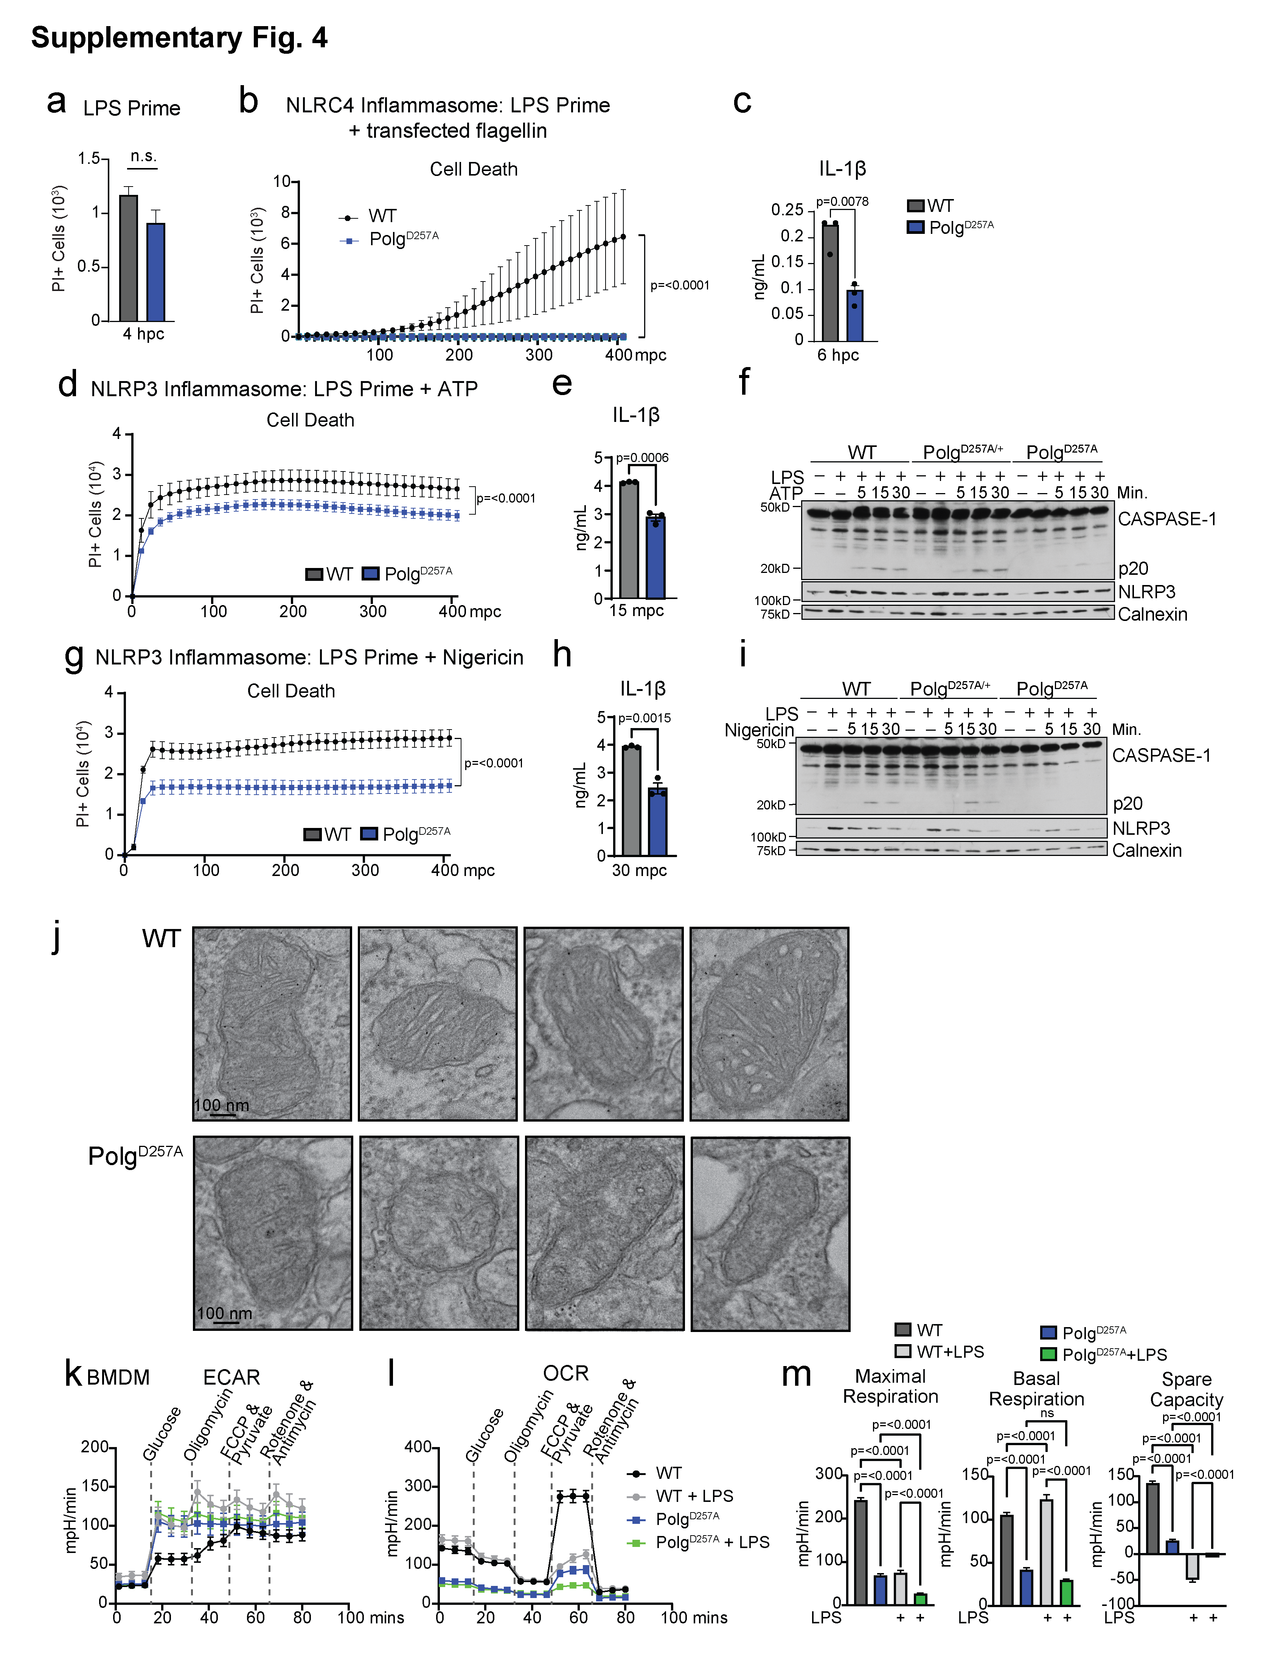
Supplementary Fig. 4: OXPHOS impairment and alterations to canonical inflammasome activity in Polg^{D257A} macrophages.
(a) Cytation5 imaging quantification of PI positive cells in BMDMs after LPS priming for 4 hours. N= 21 replicates/genotype.
(b) Cytation5 imaging quantification of PI positive cells in BMDMs after LPS priming plus PA-flagellin transfection. N= 5 biological replicates/genotype.
(c) ELISA analysis of IL-1β in BMDM supernatant after LPS priming plus PA-flagellin transfection. N= 3 biological replicates.
(d) Cytation5 imaging quantification of PI positive cells in BMDMs after LPS priming plus ATP. N= 6 biological replicates/genotype.
(e) ELISA analysis of IL-1β in BMDM supernatant after LPS priming plus ATP. N= 2 biological replicates.
(f) Western blot of BMDM protein lysates after LPS priming plus ATP.
(g) Cytation5 imaging quantification of PI positive cells in BMDMs after LPS priming plus nigericin. N= 6 biological replicates/genotype.
(h) ELISA analysis of IL-1β in BMDM supernatant after LPS priming plus nigericin. N= 2 biological replicates.
(i) Western blot of BMDM protein lysates after LPS priming plus nigericin.
(j) Representative TEM images of mitochondria from BMDMs.
(k) & (l) Seahorse analysis of BMDMs unchallenged or treated with overnight LPS. Extracellular acidification rate (ECAR) (k) and oxygen consumption rate (OCR) (l) are plotted. N=12 replicates/genotype.
(m) Quantification of Seahorse OCR measurements. N=12 replicates/genotype.
Statistics: (b, d, & g) Two-Way ANOVA (m) One-Way ANOVA (a, c, e, & h) Two-Sided Students t-test. Error bars represent SEM. Source data are provided as a Source Data file.

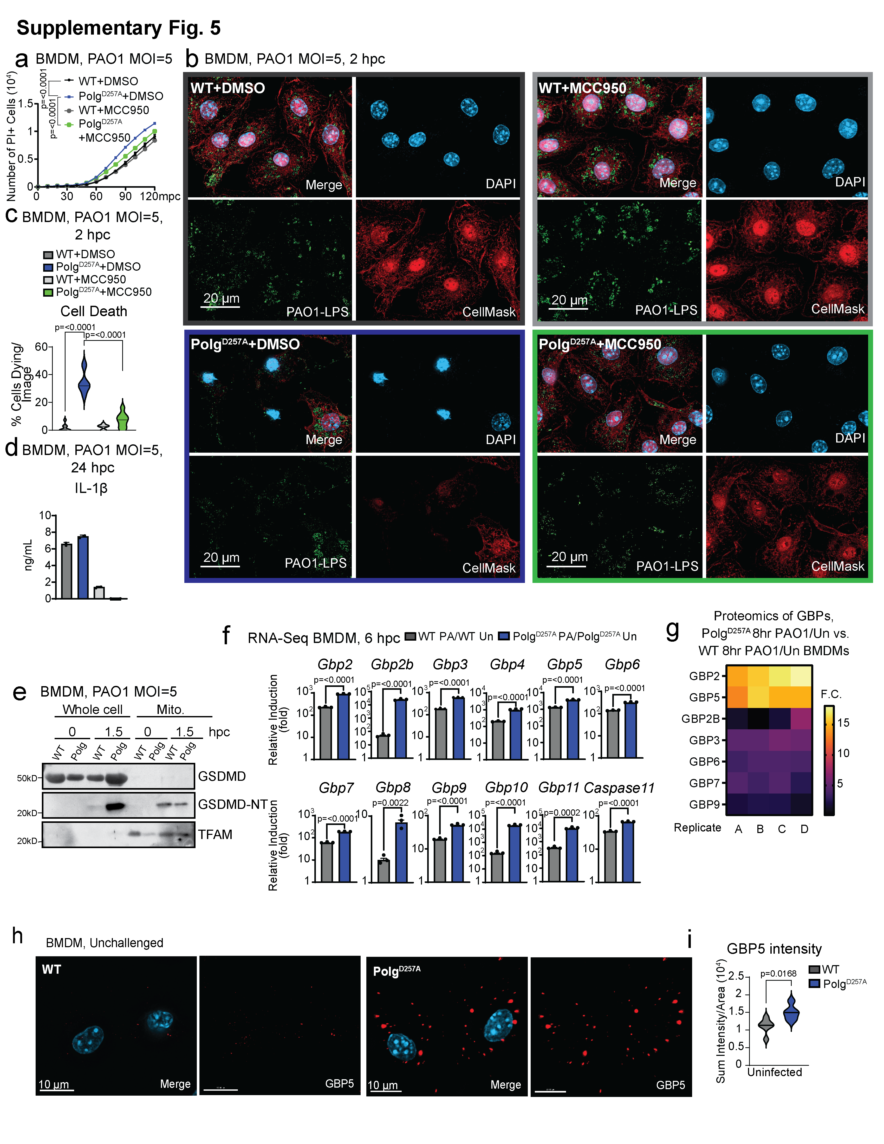
Supplementary Fig. 5: The NLRP3 inflammasome is downstream of caspase-11 activation in Polg^{D257A} macrophages.
(a) Cytation5 imaging quantification of PI positive cells in BMDMs with PAO1 or PAO1 plus MCC950. N= 6 biological replicates/genotype/timepoint.
(c) Percent BMDMs dying after PAO1 and PAO1 plus NLRP3 inhibitor, MCC950, from (b) representative IF. N=8-9 IF images/genotype/condition.
(d) ELISA analysis of pyroptotic cytokines in BMDM supernatant after PAO1 or PAO1 plus NLRP3 inhibitor, MCC950. N= 2 biological replicates/genotype/condition.
(e) Western blot of GSDMD localization during PAO1 challenge.
(f) RNA-seq from BMDMs showing induction of Gbps and Caspase-11 RNA 6 hpc with PAO1. N=3 biological replicates/genotype/condition.
(g) GBP expression in Polg^{D257A} (8hr PAO1/Un)/WT (8hr PAO1/Un) BMDMs by proteomics. N=4 biological replicates/genotype/condition.
(h) Representative IF of unchallenged BMDMs stained with DAPI to mark the nucleus and anti-GBP5 antibody.
(i) Sum intensity of GBP5 per cell area in resting BMDMs in (h) IF. N=5-6 images/genotype
Statistics: (f & i) Two-Sided Student’s t-test (c) One-way ANOVA (a) Two-way ANOVA. Error bars represent SEM. Source data are provided as a Source Data file.

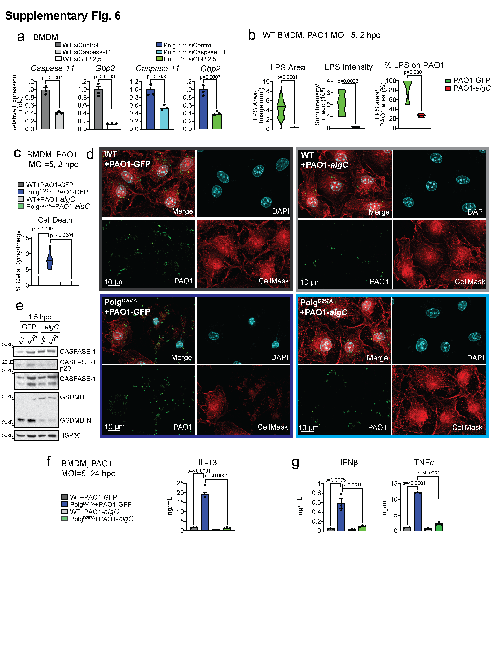
Supplemental Fig. 6: A PAO1 algC mutant displays decreased levels of LPS and does not robustly engage the caspase-11 inflammasome or induce potentiated cell death and inflammation in Polg^{D257A} macrophages.
(a) qRT-PCR quantification of siRNA knock down efficiency in BMDMs. N=3 technical replicates/genotype.
(b) Quantification of LPS associated with PAO1 and total LPS staining in BMDMs after PAO1 or PAO1- algC challenge by IF. N=6-7 IF images/genotype/condition.
(c) Percent BMDMs dying after PAO1 and PAO1- algC from (d) representative IF. N=10 IF images/genotype/condition.
(e) Western blotting of proteins involved in pyroptosis in BMDMs after PAO1 or PAO1- algC challenge.
(f) ELISA analysis of IL-1 cytokines in BMDM supernatant after PAO1 or PAO1-algC. N= 3 biological replicates/genotype/condition.
(g) ELISA analysis of proinflammatory cytokines in BMDM supernatant after PAO1 or PAO1- algC. N= 3 biological replicates/genotype/condition.
Statistics: (a & b) Two-Sided Student’s t-test (c, f, & g) One-way ANOVA. Error bars represent SEM. Source data are provided as a Source Data file.

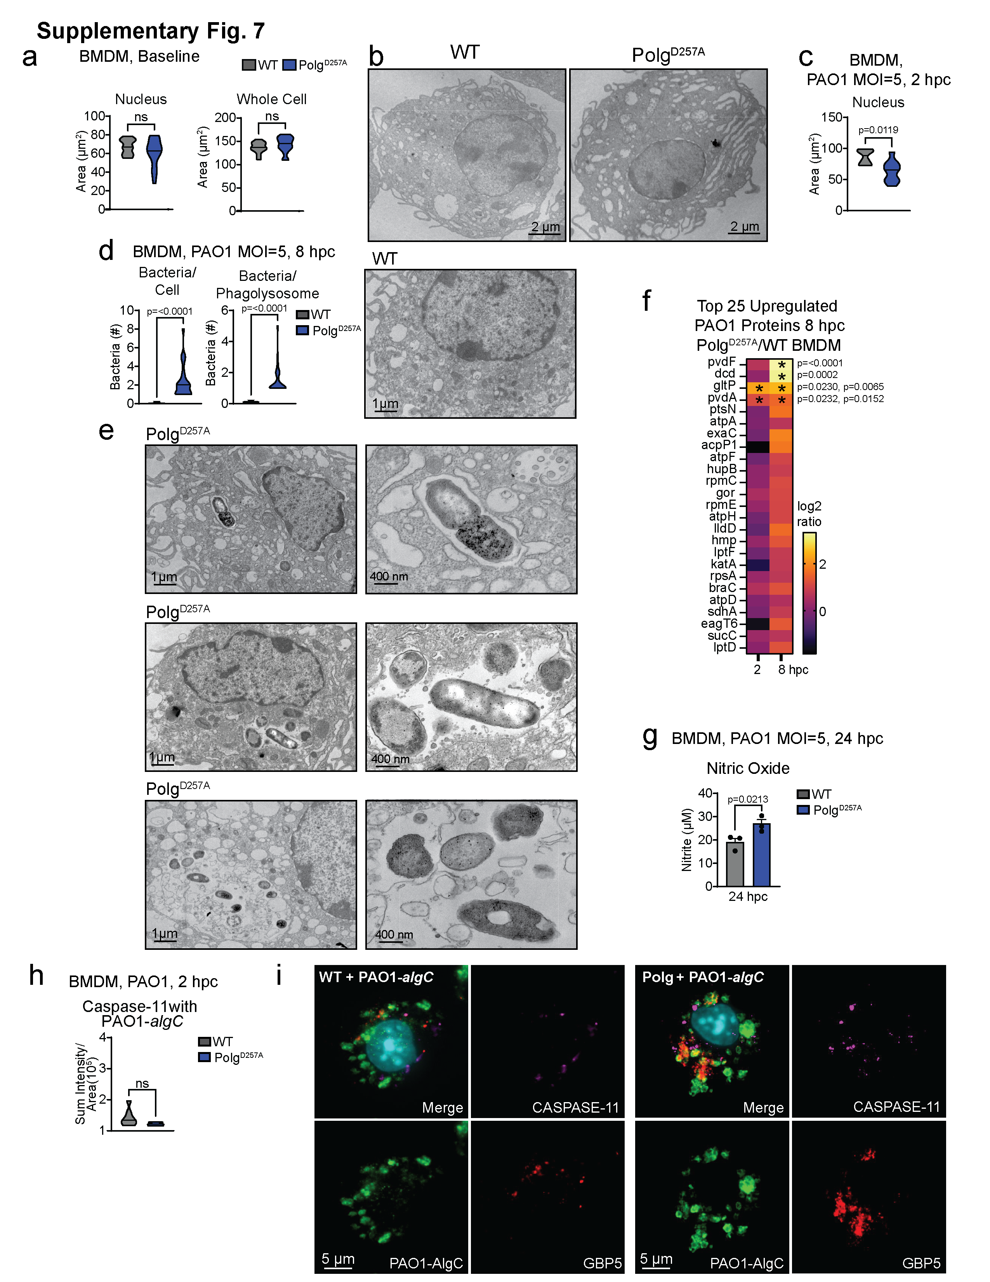
Supplemental Fig. 7: Polg^{D257A} macrophages contain more PAO1 and PAO1 proteins at late timepoints after challenge.
(a) Quantitation of nucleus and cellular area of BMDMs from (b) TEM images of BMDMs at rest. N= 14-15 images/condition.
(c) Quantitation of nuclear area of BMDMs from (Fig. 6b) TEM images. N= 9 images/condition.
(d) Quantification of bacteria in BMDMs and their lysosomes 8 hours after PAO1 by (e) TEM. N=15-20 cells/genotype.
(f) Proteomic analysis of PAO1 proteins in Polg^{D257A} homozygous mutant BMDMs compared to WT 8 hours after PAO1 challenge. N=4 biological replicates/genotype/condition.
(g) Quantification of nitric oxide in BMDMs 24 hpc with PAO1. N=3 biological replicates/genotype.
(h) Quantification of capase-11 associated with PAO1-GFP or PAO1-algC mutant from representative IF images (i). N=6 IF images/genotype/condition.
Statistics: (a, c, d, g, & h) Two-Sided Students t-test. Error bars represent SEM. Source data are provided as a Source Data file.

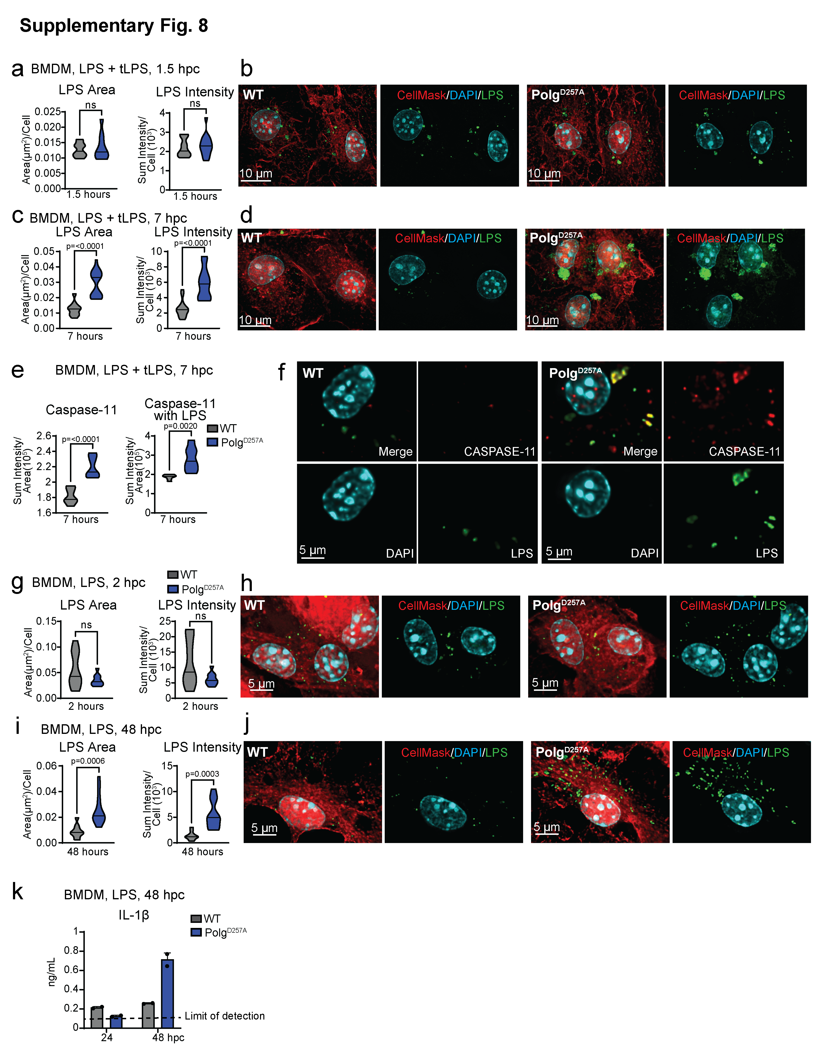
Supplemental Fig. 8: Polg^{D257A} macrophages contain higher levels of intracellular LPS that more strongly localizes with caspase-11 at late timepoints.
(a) Quantification of LPS per cell in BMDMs after 4 hours LPS priming then 1.5 hours LPS transfection from (b) IF. N=10-11 IF images/genotype/condition.
(c) Quantification of LPS per cell in BMDMs after 4 hours LPS priming then 7 hours LPS transfection from (d) IF. N=10-12 IF images/genotype/condition.
(e) Quantification of caspase-11 intensity and caspase-11 associated with LPS in BMDMs after 4 hours LPS priming then 7 hours LPS transfection from (f) IF. N=7 IF images/genotype/condition.
(g) Quantification of LPS per cell in BMDMs 2 hours post LPS challenge from (h) IF. N=8-9 IF images/genotype/condition.
(i) Quantification of LPS per cell in BMDMs 48 hours post LPS challenge from (j) IF. N=10 IF images/genotype/condition.
(k) ELISA analysis of IL-1β in BMDM supernatant after LPS. N= 2 biological replicates/genotype/timepoint.
Statistics: (a, c, e, & g) Two-Sided Students t-test. Error bars represent SEM. Source data are provided as a Source Data file.

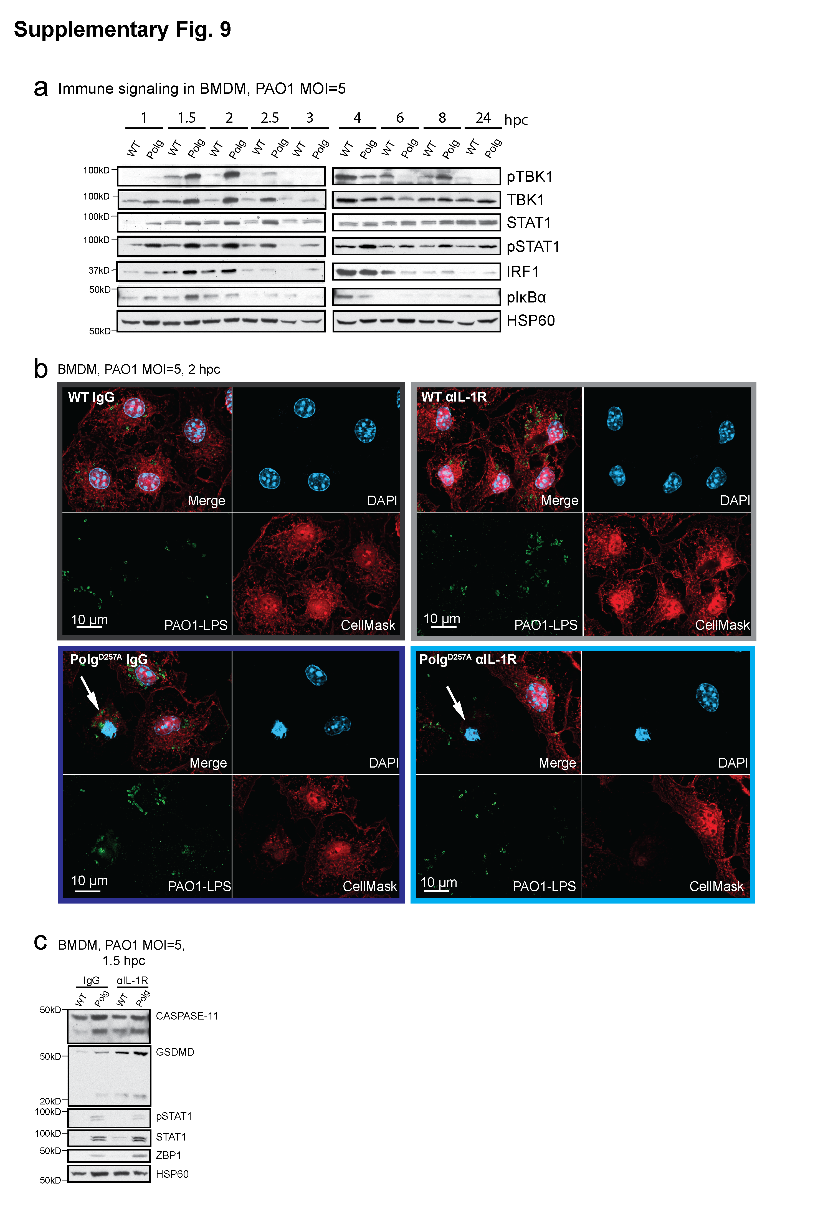

Supplementary Fig. 9: PAO1 challenged Polg^{D257A} BMDMs exhibit enhanced NF-κB signaling but acutely blocking the IL-1R does not impair caspase-11-dependent cell death.
(a) Western blot of signaling in BMDMs during a PAO1 time course. Representative blots from N=3 experiments.
(b) Representative images of cell death quantitation in Fig. 5f. Representative images from N=3 experiments.
(c) Western blot analysis of lysates from BMDMs challenged with PAO1 and PAO1 plus anti-IL-1R blockade 1.5 hpc. Representative blots from N=3 experiments.
Source data are provided as a Source Data file.

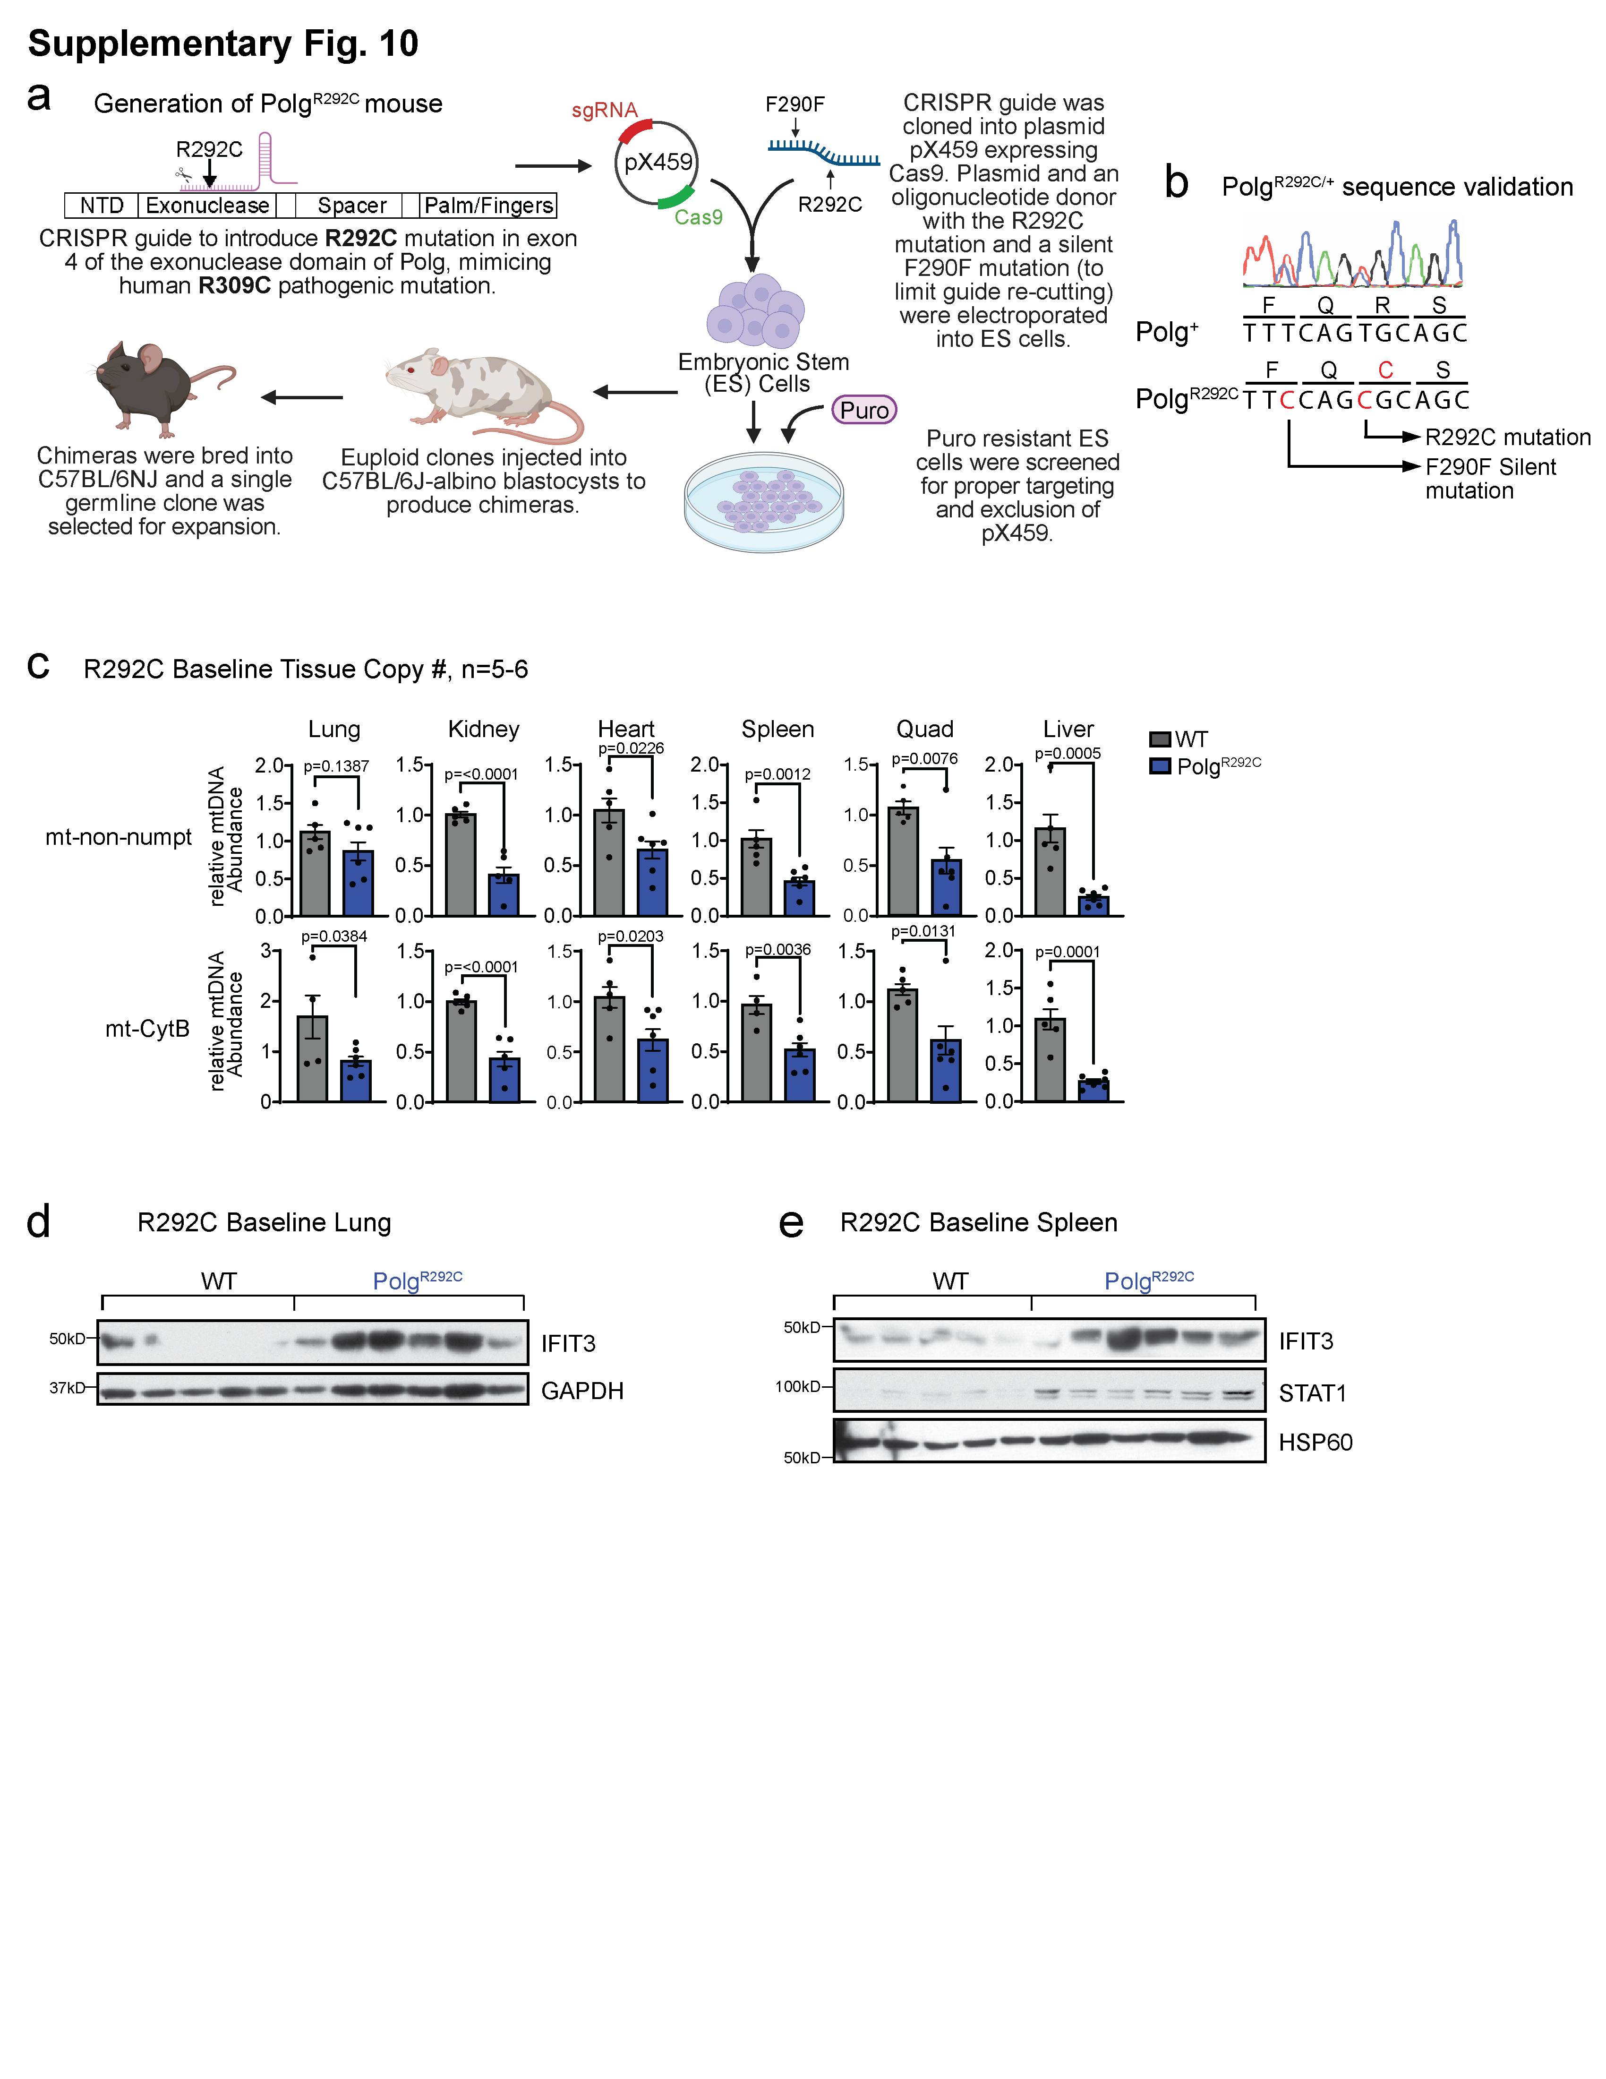

Supplemental Fig. 10: Mice incorporating a deleterious patient mutation (Polg^{R292C}) exhibit mtDNA depletion and elevated IFN-I responses.
(a) Generation of the Polg^{R292C} mouse. Created in BioRender. Vanportfliet, J. (2025) https://BioRender.com/jdv8m3w.
(b) Chromatograph from Sanger sequencing of DNA from heterozygous Polg^{R292C} mouse verifying germline incorporation of mutation.
(c) qPCR analysis of mtDNA abundance in tissues. N= 4-6 mice/genotype.
(d) Western blot analysis of ISG, IFIT3, in lung lysates from Polg^{R292C} mice.
(e) Western blot analysis of ISGs in spleen lysates from Polg^{R292C} mice.
Statistics: (c) Two-Sided Student’s t-test. Error bars represent SEM. Source data are provided as a Source Data file.

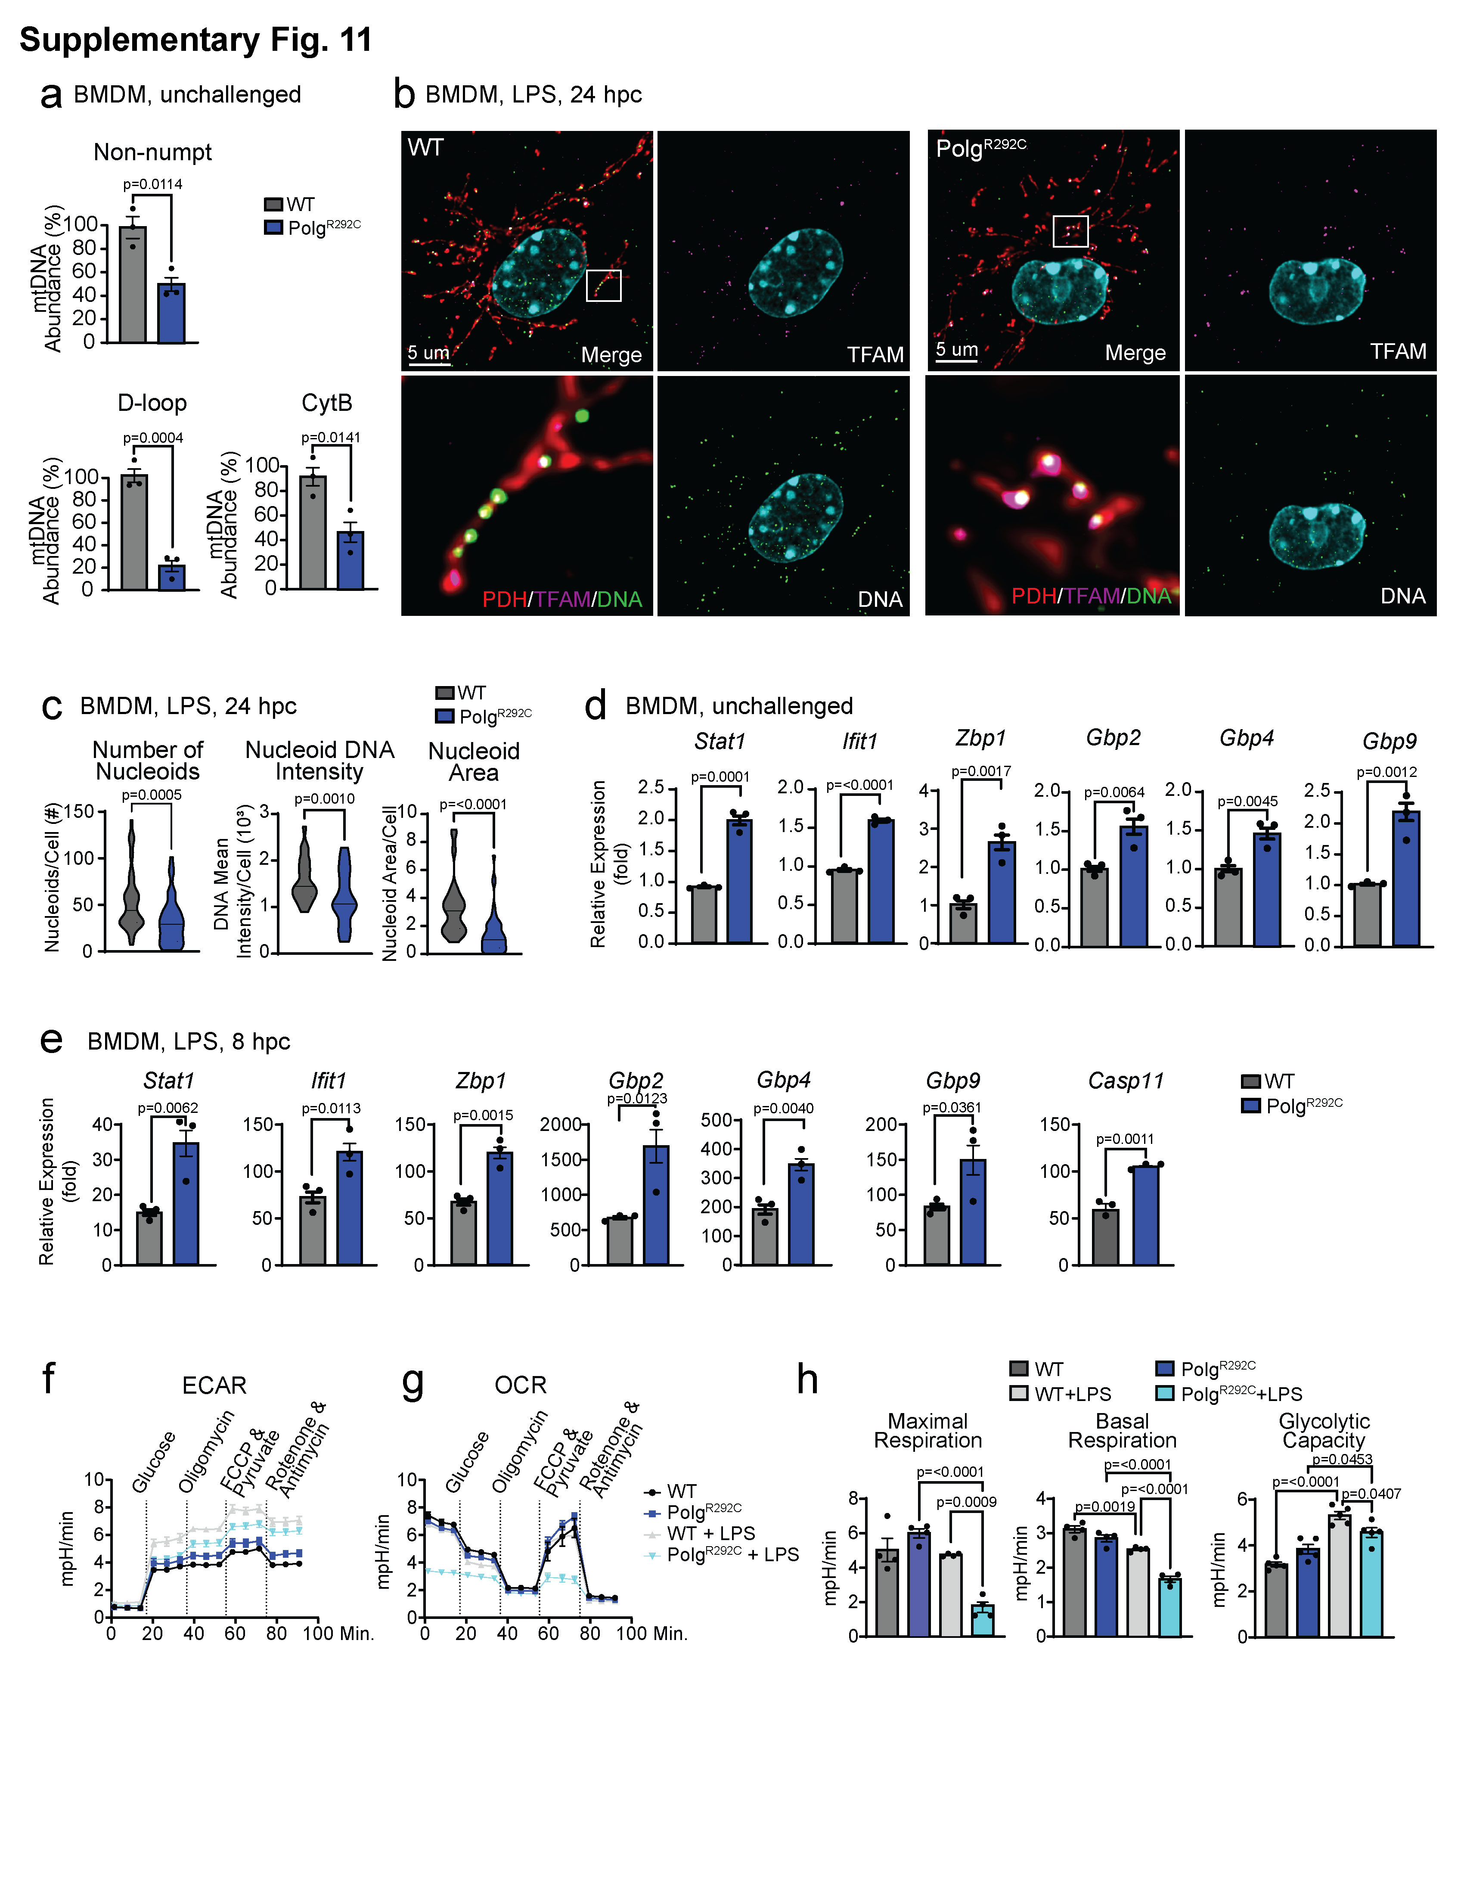
Supplemental Fig. 11: Macrophages incorporating the Polg^{R292C} variant exhibit mtDNA depletion, elevated IFN-I responses, and altered metabolism.
(a) qPCR analysis of mtDNA abundance in BMDMs. N= 3 technical triplicates/genotype.
(b) Representative IF of nucleoids in BMDMs stained with anti-PDH antibody to label mitochondria, anti-DNA antibody to label nucleoids, and anti-TFAM antibody.
(c) Quantification of nucleoids per cell, mean intensity of DNA signal per nucleoid, and nucleoid area per cell from BMDMs in (b) IF. N=40-50 cells/genotype
(d) qRT-PCR analysis of ISGs in unchallenged Polg^{R292C} BMDMs. N=3 biological replicates, 3 technical replicates/genotype.
(e) qRT-PCR analysis of ISGs in Polg^{R292C} BMDMs 8 hours post challenge (hpc) with LPS. N= 3 technical replicates/genotype.
(f) & (g) Seahorse analysis of BMDMs unchallenged or treated with overnight LPS. Extracellular acidification rate (ECAR) (f) and oxygen consumption rate (OCR) (g) are plotted. N= 5-6 technical replicates.
(h) Quantification of Seahorse OCR measurements. N= 4-5 technical replicates.
Statistics: (a, c, d, & e) Two-Sided Students t-test (h) One-Way ANOVA. Error bars represent SEM. Source data are provided as a Source Data file.

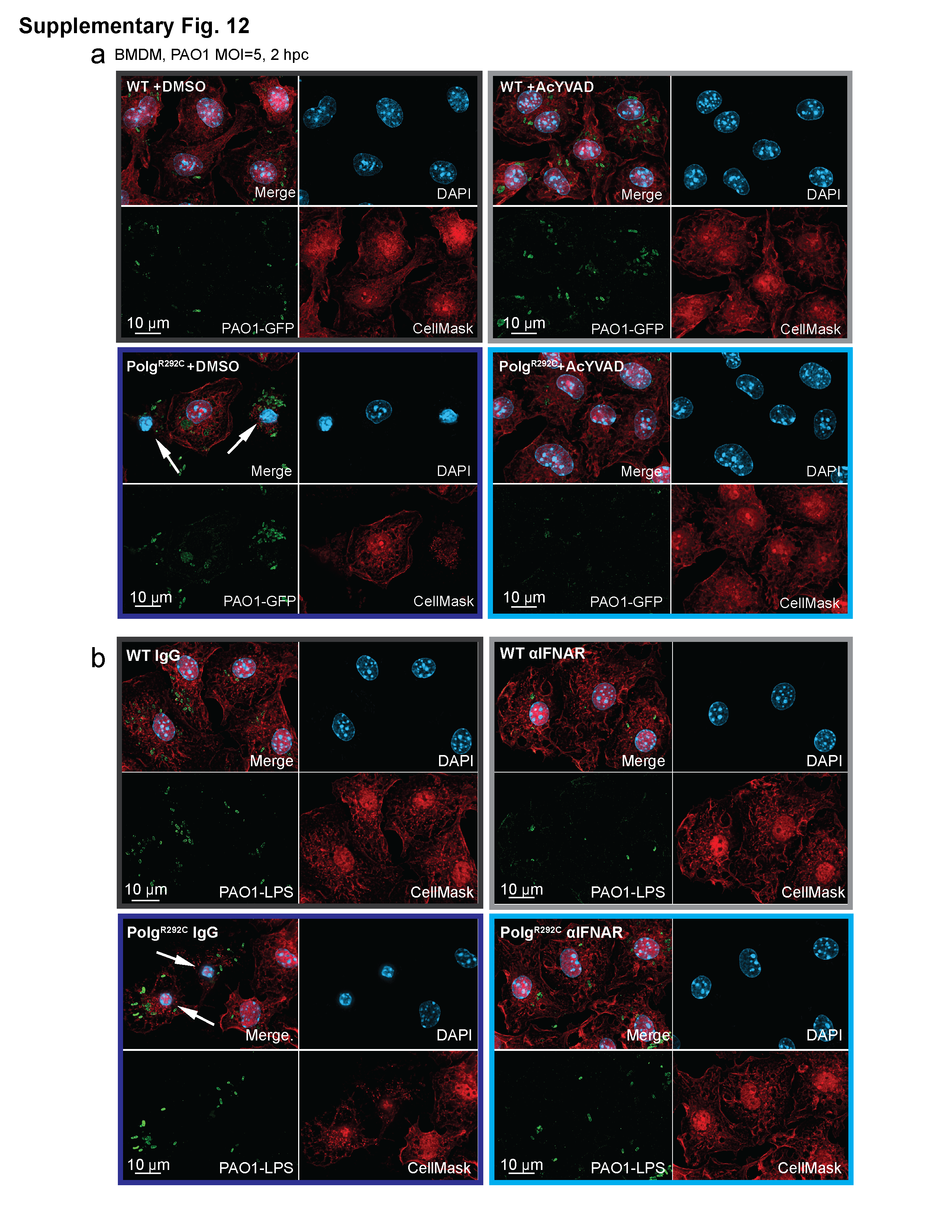
Supplemental Fig. 12: AcYVAD and anti-IFNAR blockade reduces cell death in Polg^{R292C} macrophages.
(a) Representative IF of dying cells characterized by condensed nuclei and loss of cell mask staining (white arrows) after PAO1 and PAO1 plus caspase-1/11 inhibitor, AcYVAD, quantified in Fig. 6c. Representative images from N=3 experiments.
(b) Representative IF of dying cells characterized by condensed nuclei and loss of cell mask staining (white arrows) after PAO1 and PAO1 plus anti-IFNAR blockade quantified in Fig. 6f. Representative images from N=3 experiments.

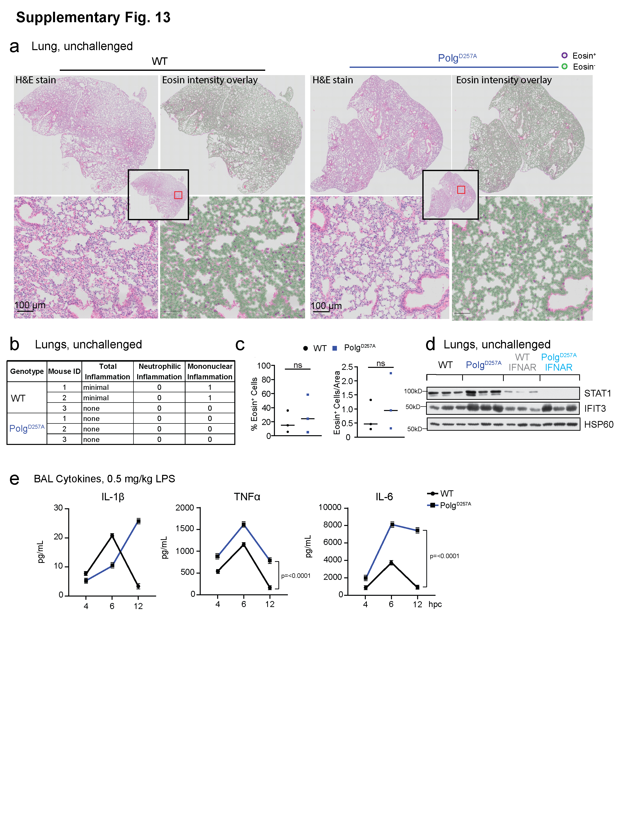
Supplementary Fig. 13: Polg mutant mice exhibit elevated IFN-I and inflammatory responses to LPS, but do not exhibit basal differences in lung morphology or immune cell abundance.
(a) Representative histology images of hematoxylin and eosin (H&E) staining of WT and Polg^{D257A} lungs, with an overlay of eosin positive cells using QuPath software. Representative images from N=3 mice/genotype.
(b) Pathology assessment of unchallenged lungs. N=3 mice/genotype
(c) QuPath analysis of eosin⁺ cells in the lungs from (c). N=3 mice/genotype
(d) Protein expression of ISGs in unchallenged WT and Polg^{D257A} lungs homogenates.
(e) ELISA analysis of inflammatory cytokines in bronchioalveolar lavage of LPS challenged WT and Polg^{D257A} lungs. N=2 mice/genotype/timepoint.
Statistics: (c) Two-Sided Students t-test (e) Two-Way ANOVA. Error bars represent SEM. Source data are provided as a Source Data file.

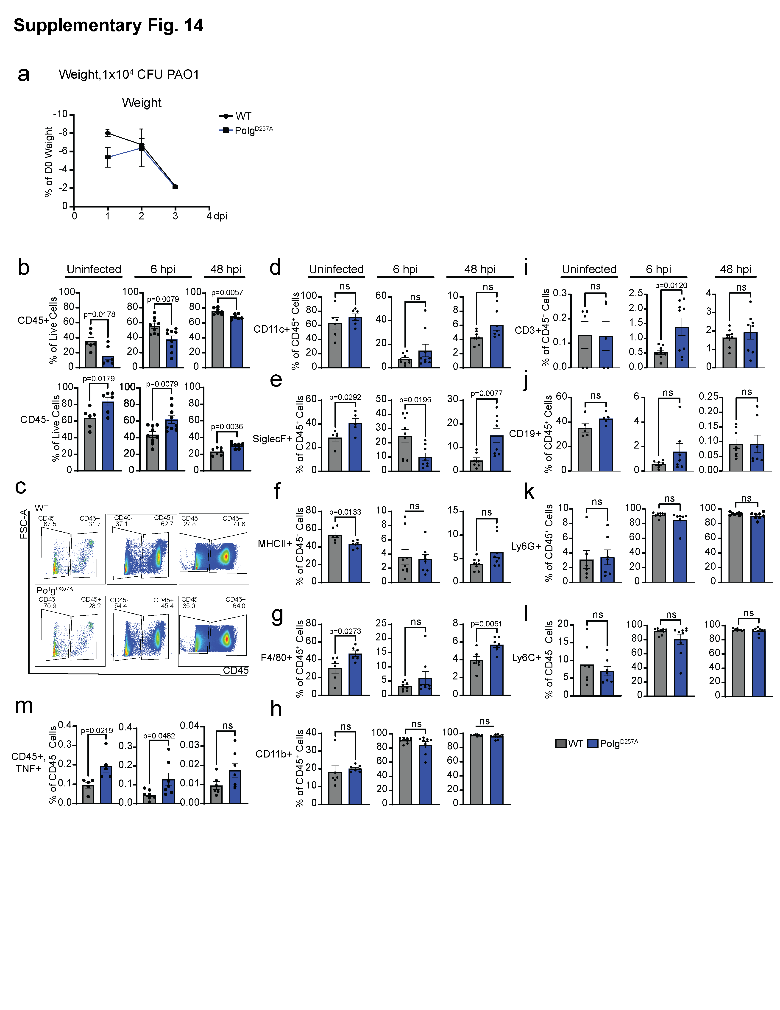
Supplementary Fig. 14: Intratracheal instillation of PAO1 alters immune cell composition in Polg^{D257A} mouse lungs.
(a) Weight change in WT and Polg^{D257A} mice after infection with 1x10⁴ PAO1. N=4 mice/genotype.
(b) CD45 expression on cells from bronchioalveolar lavage (BAL) from uninfected and PAO1 infected WT and Polg^{D257A} mice. N=5-9 mice/genotype/timepoint.
(c) Gates used to quantify CD45 expression in (b).
(d) Percent of CD45⁺ cells expressing CD11c from the BAL of uninfected and PAO1 infected lungs. N=5-9 mice/genotype/timepoint.
(e) Percent of CD45⁺ cells expressing SiglecF from the BAL of uninfected and PAO1 infected lungs. N=5-9 mice/genotype/timepoint.
(f) Percent of CD45⁺ cells expressing MHCII from the BAL of uninfected and PAO1 infected lungs. N=5-9 mice/genotype/timepoint.
(g) Percent of CD45⁺ cells expressing F4/80 from the BAL of uninfected and PAO1 infected lungs. N=5-9 mice/genotype/timepoint.
(h) Percent of CD45⁺ cells expressing CD11b from the BAL of uninfected and PAO1 infected lungs. N=5-9 mice/genotype/timepoint.
(i) Percent of CD45⁺, CD11b⁻ cells expressing CD3 from the BAL of uninfected and PAO1 infected lungs. N=5-9 mice/genotype/timepoint.
(j) Percent of CD45⁺, CD11b⁻ cells expressing CD19 from the BAL of uninfected and PAO1 infected lungs. N=5-9 mice/genotype/timepoint
(k) Percent of CD45⁺ expressing Ly6G from the BAL of uninfected and PAO1 infected lungs. N=5-9 mice/genotype/timepoint.
(l) Percent of CD45⁺ cells expressing Ly6C from the BAL of uninfected and PAO1 infected lungs. N=5-9 mice/genotype/timepoint.
(m) CD45⁺ cells with cell associated TNFα expression from BAL of uninfected and PAO1 infected lungs. N=5-9 mice/genotype/timepoint.
Statistics: (b, & d-m) Two-Sided Students t-test. Error bars represent SEM. Source data are provided as a Source Data file.

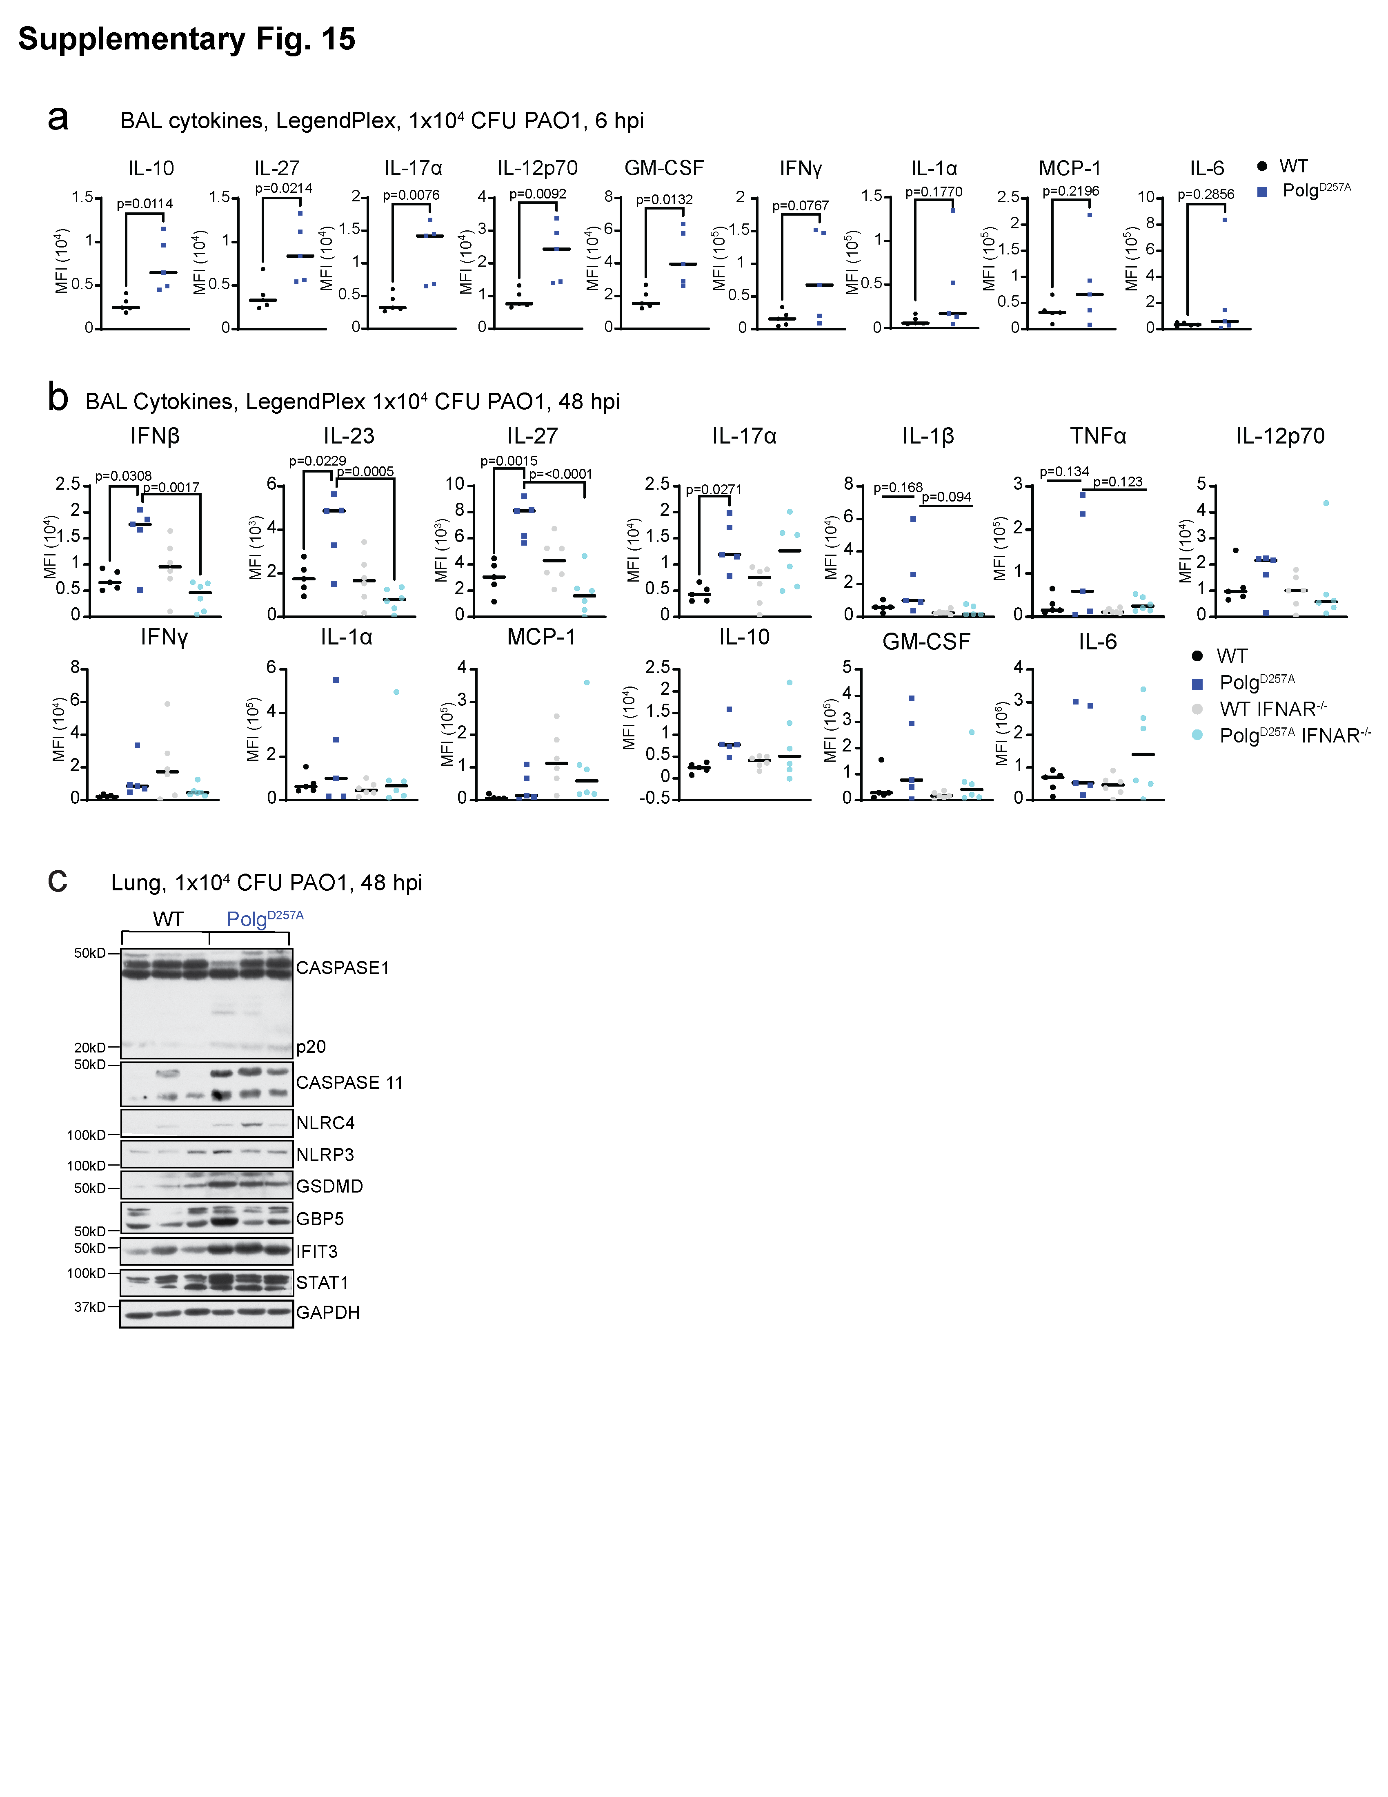
Supplementary Fig. 15: A non-lethal dose of PAO1 induces hyperinflammation and activation of pyroptosis in the lungs of Polg^{D257A} mice.
(a) LegendPlex pro-inflammatory cytokine analysis of bronchial alveolar lavage (BAL) 6 hours post infection (hpi) with 1x10⁴ colony forming units (CFU) of PAO1. N=5 mice/genotype
(b) LegendPlex pro-inflammatory cytokine analysis of bronchioalveolar lavage (BAL) from WT, Polg^{D257A}, WT IFNAR^{-/-}, and Polg^{D257A} IFNAR^{-/-} lungs infected with 1x10⁴ PAO1 for 48 hours. All undefined comparisons are not significant. N=5-6 mice/genotype.
(c) Western blot of ISGs and proteins involved in pyroptosis from homogenized lung tissue from mice infected with 1x10⁴ PAO1 for 48 hours.
Statistics: (a) Two-Sided Students t-test (b) One-way ANOVA. Error bars represent SEM. Source data are provided as a Source Data file.

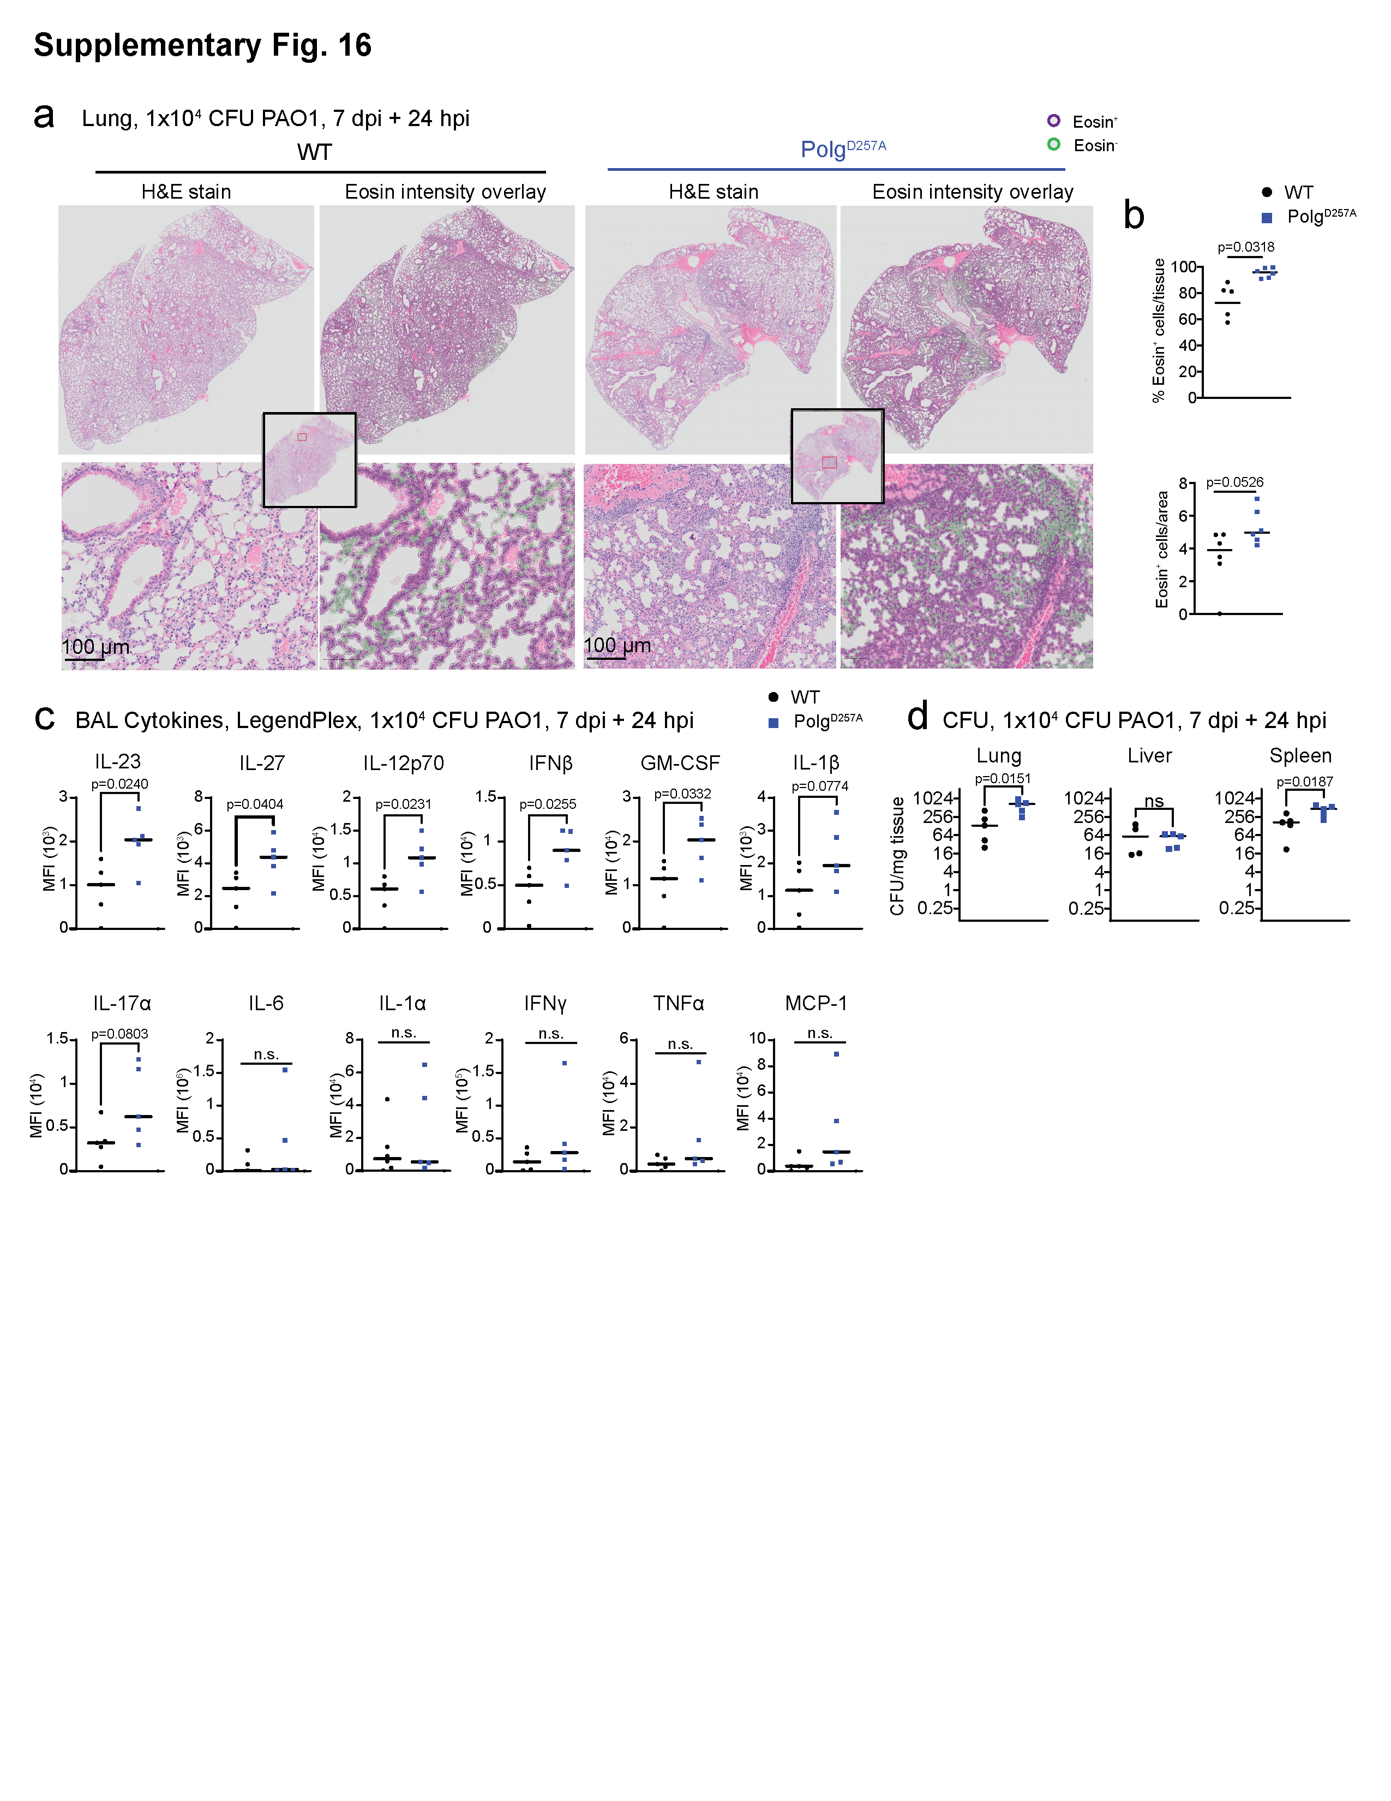
Supplementary Fig. 16: Polg^{D257A} mice exhibit hyperinflammation in response to infection and reinfection with PAO1.
(a) Representative histology images of hematoxylin and eosin (H&E) staining of WT and Polg^{D257A} lungs after initial infection with 1x10⁴ PAO1, followed by 7 days rest, then reinfection with 1x10⁴ PAO1. Overlay of eosin positive cells was done using QuPath software.
(b) QuPath analysis of eosin⁺ cells in the lung from (a) histology. N=6 mice/genotype.
(c) LegendPlex pro-inflammatory cytokine analysis of BAL from WT and Polg^{D257A} lungs after initial infection with 1x10⁴ PAO1, followed by 7 days rest, then reinfection with 1x10⁴ PAO1. N=5 mice/genotype.
(d) Colony counts from homogenized tissue after initial infection with 1x10⁴ PAO1, followed by 7 days rest, then reinfection with 1x10⁴ PAO1. N=5 mice/genotype.
Statistics: (b, c, & d) Two-Sided Students t-test. Error bars represent SEM. Source data are provided as a Source Data file.

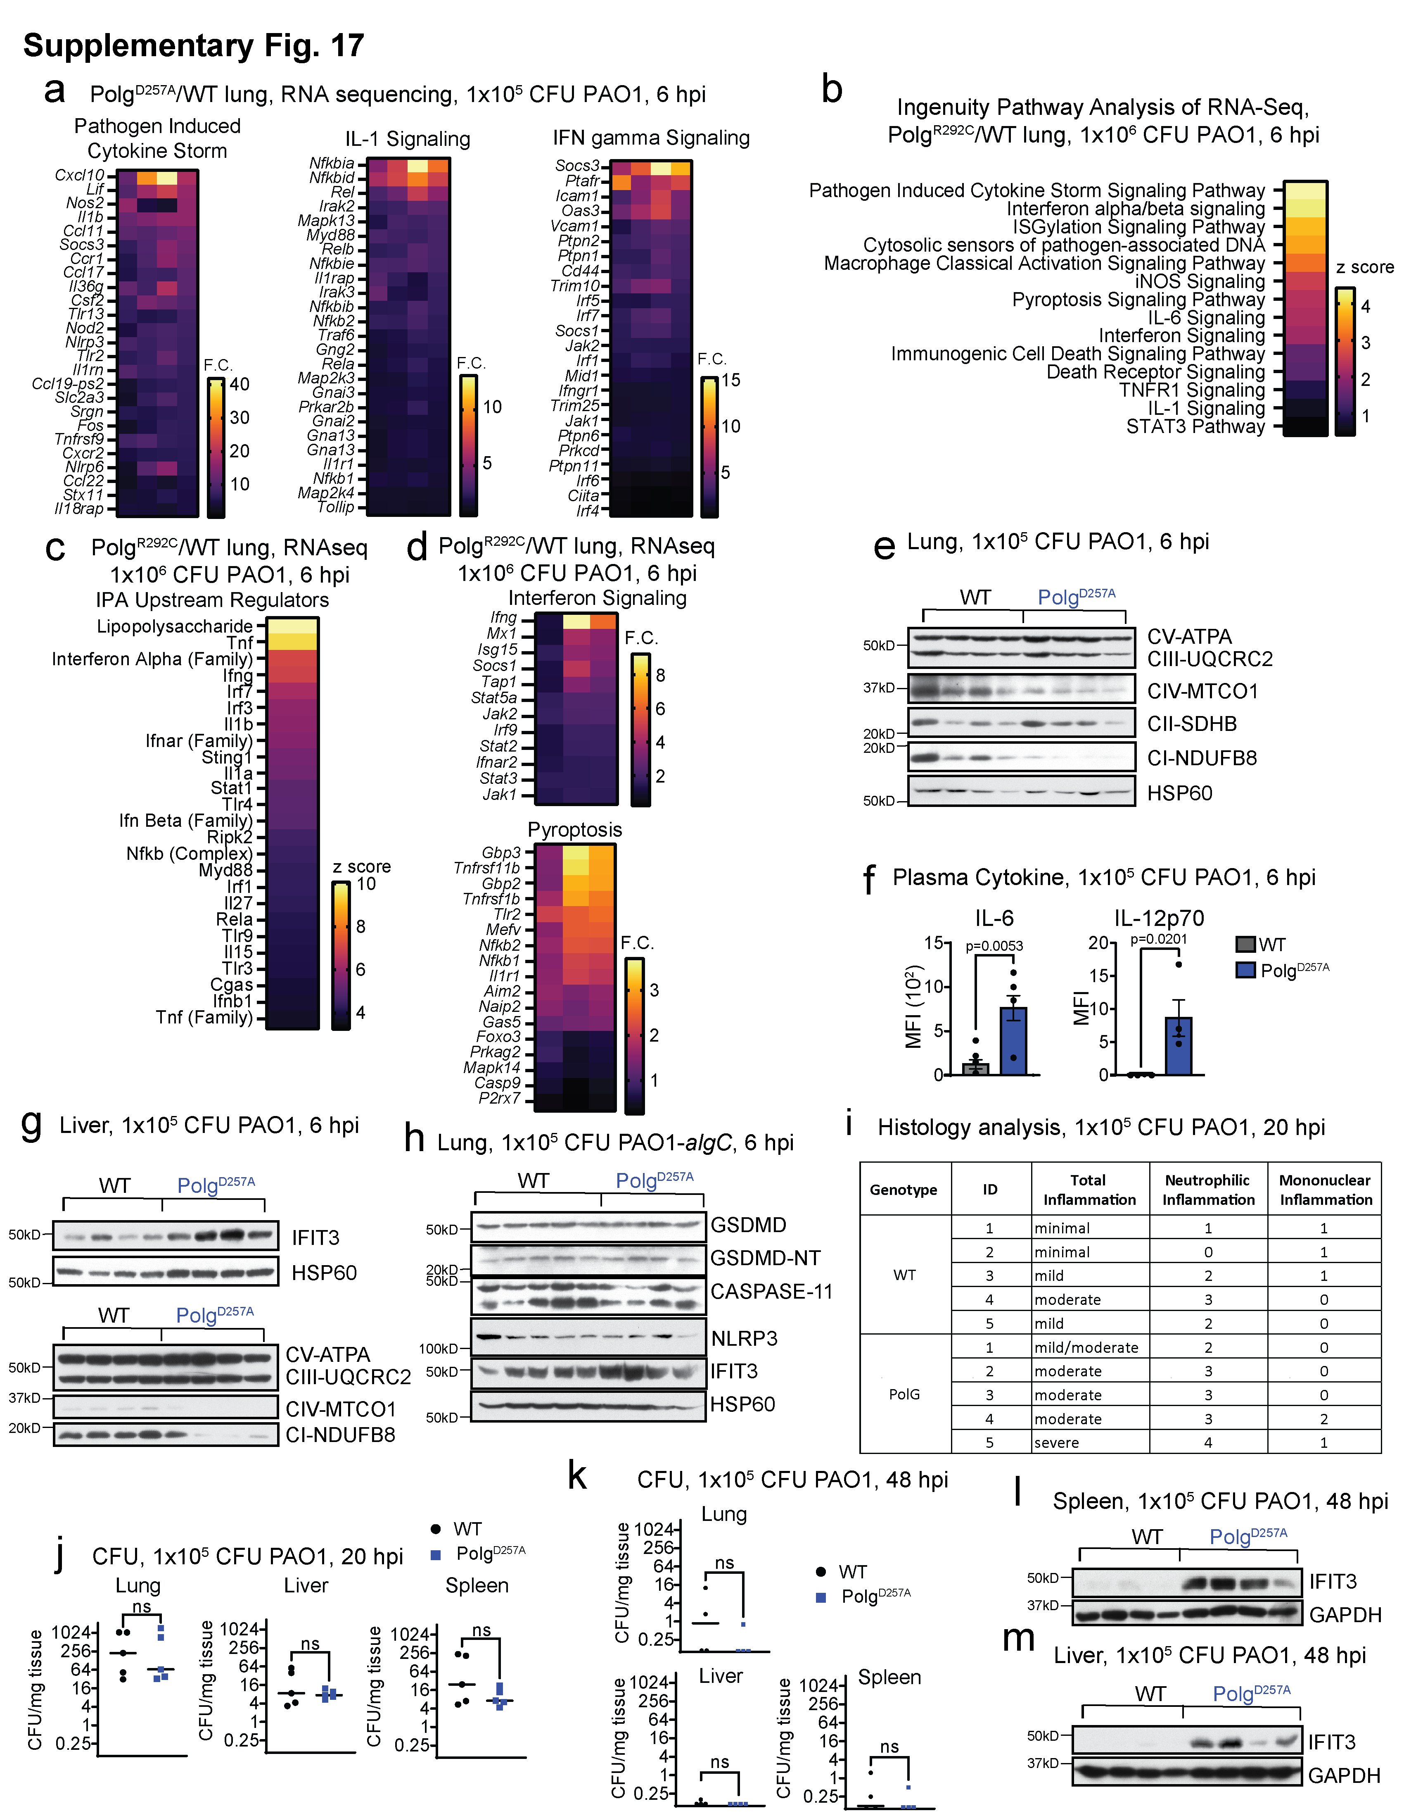

Supplementary Fig. 17: Polg mutant mice exhibit increased IFN-I, pyroptotic cell death, and pro-inflammatory responses after challenge with PAO1.
(a) Fold changes of representative genes in IPA pathways from Fig. 7b in Polg^{D257A} lungs compared to WT after LPS or PAO1.
(b) Ingenuity Pathway Analysis (IPA) of RNAseq from lungs showing Z-scores of pathways in Polg^{R292C} lungs compared to WT after PAO1 challenge. N=3 biological replicates/genotype/condition.
(c) IPA Upstream Regulator analysis showing Z-scores in Polg^{R292C} lung compared to WT after PAO1 challenge.
(d) Log² fold changes of representative genes in IPA pathways from (b) in Polg^{R292C} lungs compared to WT after PAO1.
(e) Western blot of proteins involved in oxidative phosphorylation in the lung 6 hours post infection (hpi) with 1x10⁵ colony forming units (CFU) of PAO1.
(f) LegendPlex of circulating pro-inflammatory cytokine in the plasma 6 hpi with 1x10⁵ CFU of PAO1. N=4 mice/genotype
(g) Western blot of ISG and proteins involved in oxidative phosphorylation in the liver 6 hpi with 1x10⁵ CFU of PAO1.
(h) Western blot of ISG and proteins involved in pyroptosis in the lung 6 hours post infection with 1x10⁵ CFU of PAO1-algC.
(i) Summary of pathologist scoring of H&E stained lungs infected with 1x10⁵ CFU PAO1 at 20 hpi. N=5 mice/genotype.
(j) Colony counts from homogenized tissue infected with 1x10⁵ CFU PAO1 at 20 hpi. N=5 mice/genotype.
(k) Colony counts from homogenized tissue infected with 1x10⁵ CFU PAO1 at 48 hpi. N=4 mice/genotype.
(l) Western blot of ISGs from homogenized liver and (m) spleen from mice infected with 1x10⁵ CFU PAO1 at 48 hpi.
Statistics: (f, j, & k) Two-Sided Students t-test. Error bars represent SEM. Source data are provided as a Source Data file.
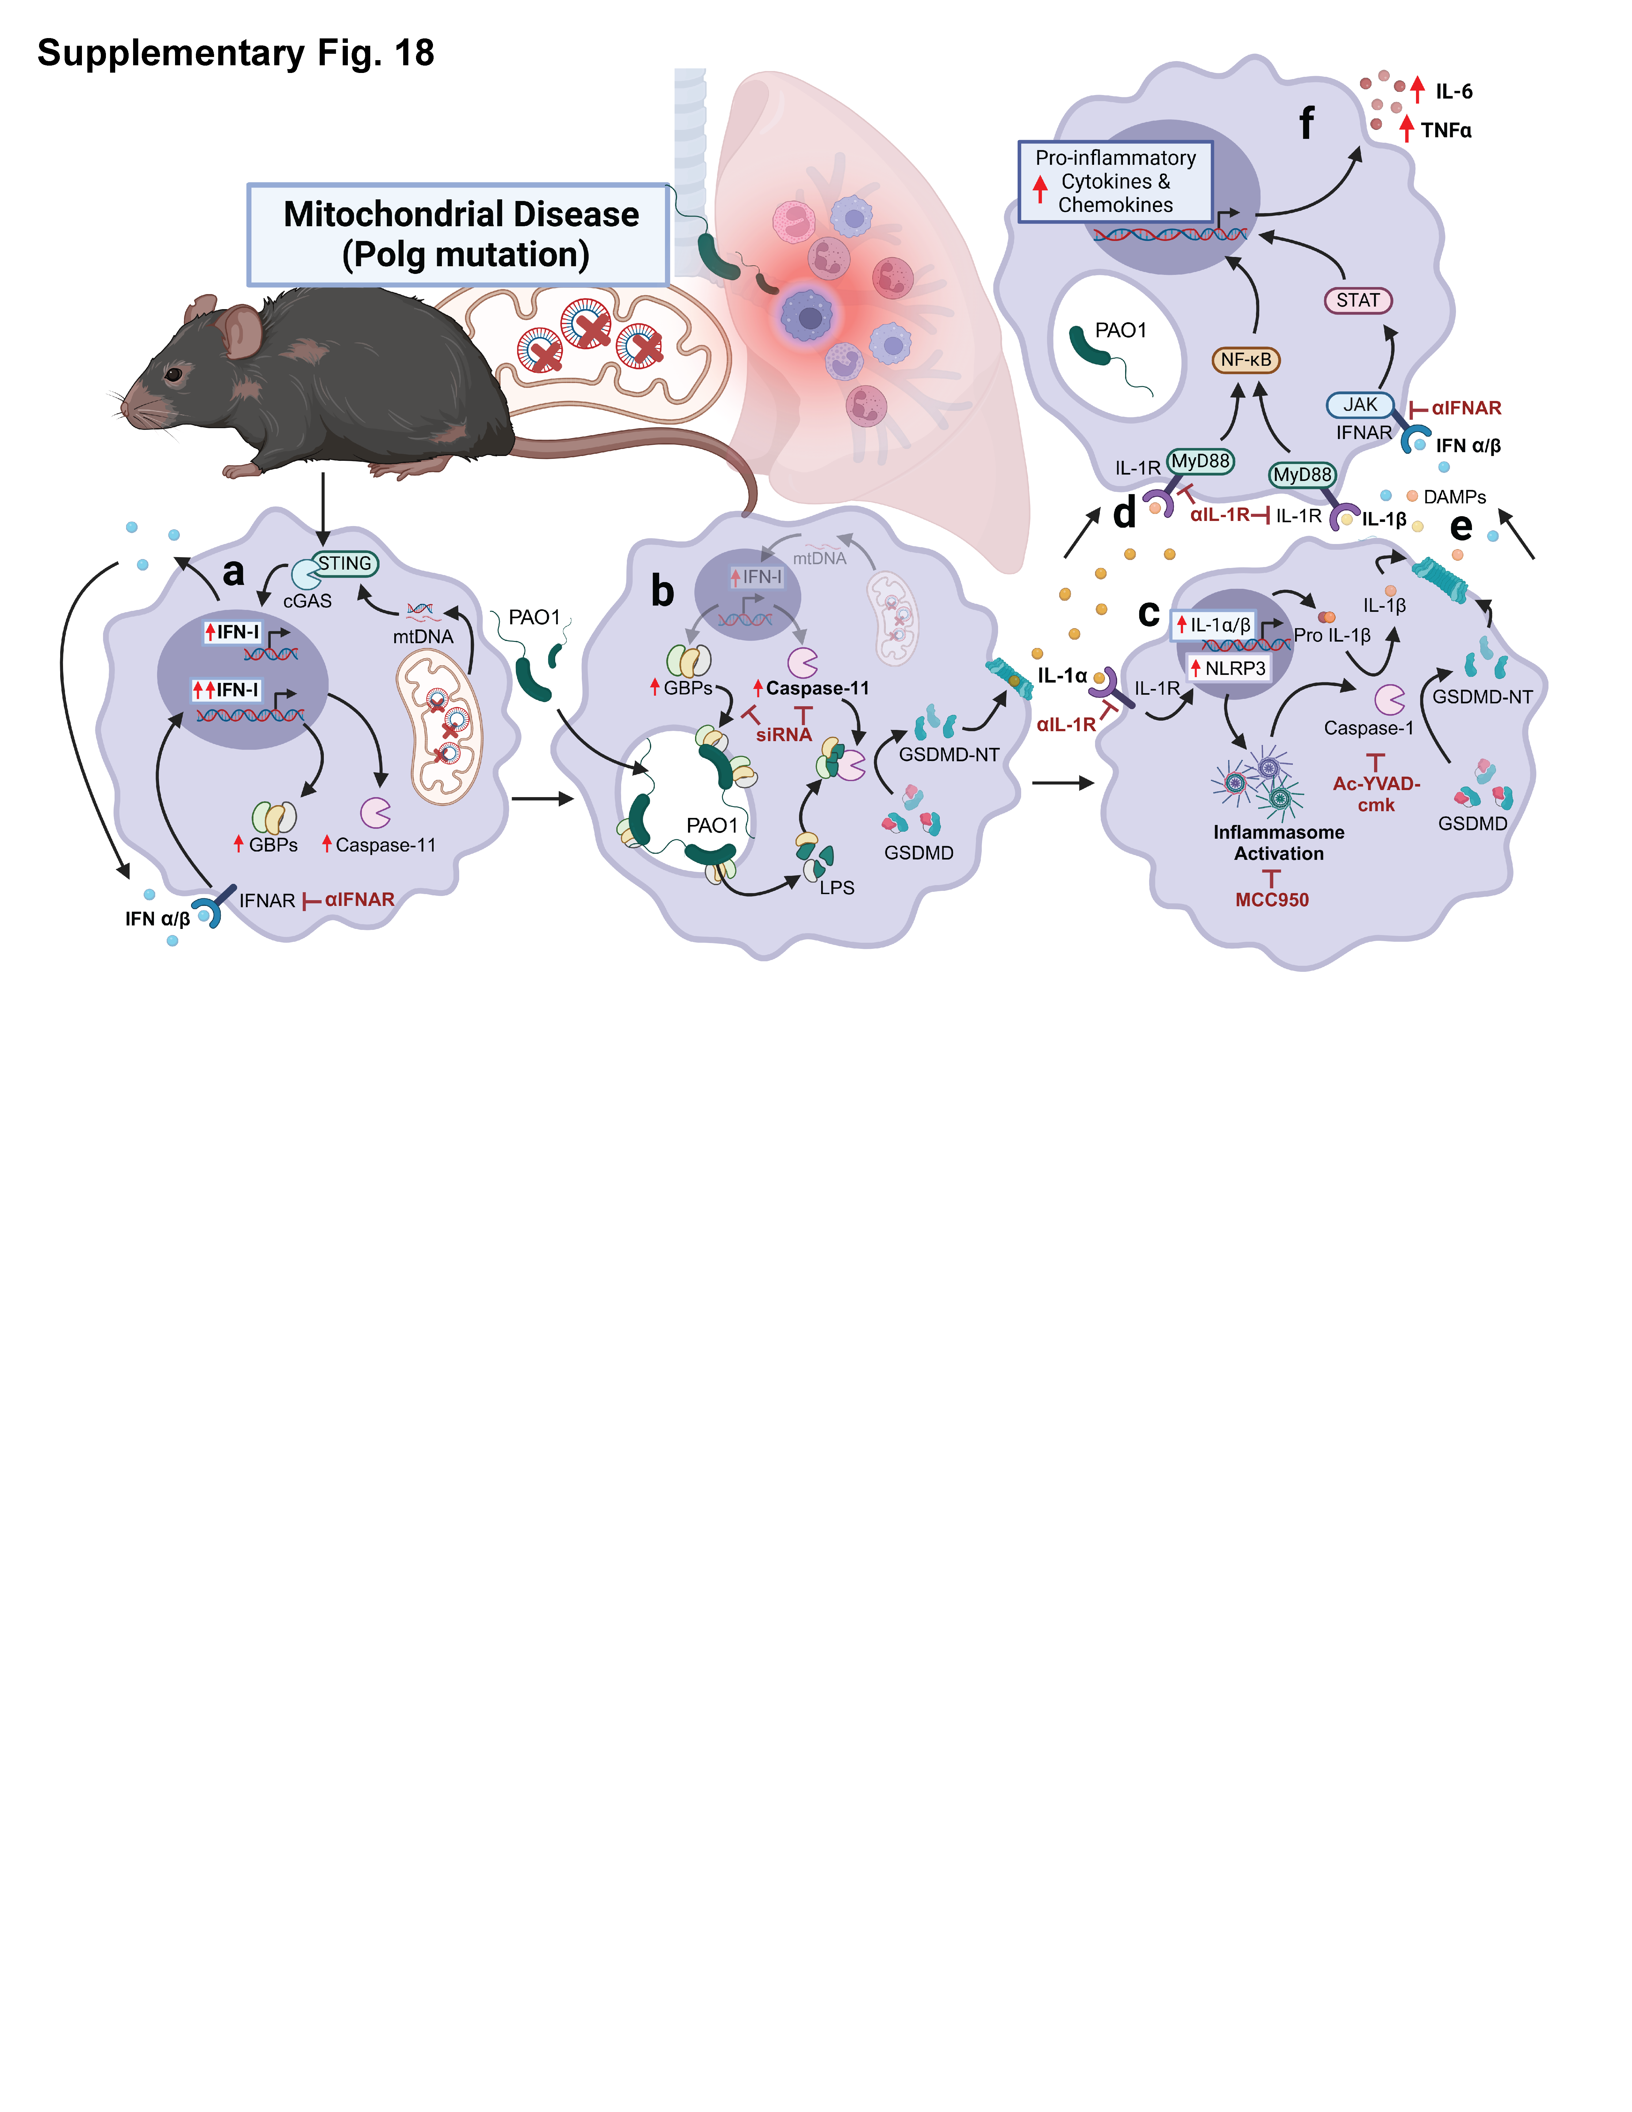
Supplementary Fig. 18: Elevated IFN-I primes macrophages for caspase-11 inflammasome activation and drives hyperinflammatory phenotypes, resulting in lung injury in models of Polg-related MtD.
Mitochondrial DNA instability in exonuclease-deficient Polg mutant mice triggers chronic IFN-I signaling that enhances expression of caspase-11, GBPs, and other ISGs (a). Inhibitors and genetic approaches (maroon arrows) revealed that GBPs accumulate on bacteria and augment activation of the caspase-11 non-canonical inflammasome, resulting in pyroptosis and the GSDMD-dependent release of IL-1α (b). IL-1α signals through the IL-1R to further upregulate the expression of inflammasome mediators including NLRP3 and pro-IL-1β (c), leading to the release of mature IL-1β (d) and DAMPs (e) that feed forward to sustain and enhance IFN-I and IL-1R signaling, elevating release of other pro-inflammatory cytokines such as TNFα and IL-6 (f). Elevated rates of pyroptotic cell death and hyperinflammation in the lung of Polg mutant mice contribute to acute lung injury and systemic inflammation resulting in decreased survival after infection. Created in BioRender. Vanportfliet, J. (2025) https://BioRender.com/949guk7.
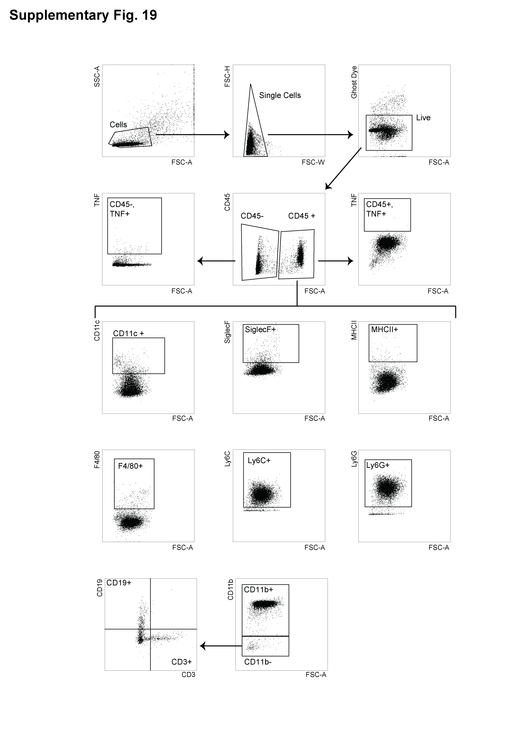
Supplementary Fig. 19: Gating strategy for flow cytometry analysis.
Supplementary Tables

Protein | Company | Catalog | Dilution
ASC | Cell Signaling Technology | 67824 | 1:5,000
CASPASE-1 | Adipogen | AG-20B0042-C100 | 1:1,000
CASPASE-11 | Cell Signaling Technology | 14340 | 1:1,000
GAPDH | ProteinTech | 60004-1-Ig | 1:5,000
GBP5 | Cell Signaling Technology | 67798 | 1:1,000
GSDMD | Abcam | ab209845 | 1:1,000
GSDME | Cell Signaling Technology | 88874S | 1:1,000
HSP60 | Santa Cruz Biotechnology | Sc-1052 | 1:5,000
IFIT3 | Ganes Sen, Cleveland Clinic | N/A | 1:5,000
IL-1β | Cell Signaling Technology | 12242 | 1:1,000
IRF1 | Cell Signaling Technology | 8478 | 1:1,000
IRG1 | Cell Signaling Technology | 17805 | 1:1,000
NLRC4 | Abcam | Ab201792 | 1:1,000
NLRP3 | Cell Signaling Technology | 15101 | 1:1,000
OXPHOS | Abcam | ab110413 | 1:5,000
pSTAT1 | Cell Signaling Technology | 7649 | 1:1,000
pTBK1 | Cell Signaling Technology | 5483 | 1:1,000
pIκΒα | Cell Signaling Technology | 2859 | 1:1,000
TBK1 | Cell Signaling Technology | 3504 | 1:1,000
STAT1 | Cell Signaling Technology | 9172 | 1:5,000
ZBP1 | Adipogen | AG-20B-0010 | 1:5,000

Supplementary Table 1: Western blot antibodies

Protein | Catalog (Binding) | Diltuion (Binding) | Catalog (Detection) | Dilution (Detection)
TNFα | 506302 | 250X | 506312 | 600X
IL-1β | 503514 | 640X | 515801 | 200X
IL-6 | 504502 | 200X | 504602 | 500X
IL-1α | 503208 | 250X | 512503 | 500X
IFNβ | 519202 | 250X | 508105 | 500X

Supplementary Table 2: ELISA antibodies (Biolegend)

Gene | F Primer 5’ 3’ | R Primer 5’ 3’
Cxcl10 | CCAAGTGCTGCCGTCATTTTC | GGCTCGCAGGGATGATTTCAA
Ifit1 | CAAGGCAGGTTTCTGAGGAG | GACCTGGTCACCATCAGCAT
Casp11 | TGTCATCTCTTTGATATATTCCTGAAG | CAAGGTTGCCCGATCAAT
Gbp2 | CAGCATAGGAACCATCAACCA | TCTACCCCACTCTGGTCA
Gbp4 | CAGGCTCTACATGGACATGAGG | TGCCTGCAAGATGGAACTCTCG
Gbp9 | TCGTGGCTATTGTTGGATTG | GGTCTGAGACTGCACAGTGGG
Rpl37 | CATCCTTTGGTAAGCGTCGCA | TGGCACTCCAGTTATACTTCCT
Stat1 | CGCGCATGCAACTGGCATATAACT | ATGCTTCCGTTCCCACGTAGACTT
Zbp1 | TCAAAGGGTGAAGACATGACAGAC | GTGGGTGGCTTCAGAGCTT
Ifit3 | TTCCCAGCAGCACAGAAAC | AAATTCCAGGTGAAATGGCA
Gbp3 | GGAAATCCTACCTCATGAATCG | TCCAGATACCCTTGGTTTCG

Supplementary Table 3: Primer sequences for qRT-PCR analysis

Protein | Company | Catalog | Diltuion
CASPASE-11 | Cell Signaling Technology | 14340 | 1:100
GFP | Thermo Fisher Scientific | NC9777966 | 1:600
LPS | Thermo Fisher Scientific | PA173178 | 1:100
PAO1 | Thermo Fisher Scientific | PA173116 | 1:100
GBP5 | Cell Signaling Technology | 67798 | 1:100
TFAM | Proteintech | 23996-1-AP | 1:800
PDH | Abcam | Ab110333 | 1:200
DNA | Sigma Millipore | CBL186 | 1:200
ASC | Cell Signaling Technology | 67824 | 1:600

Supplementary Table 4: Immunofluorescence microscopy antibodies

Gene | F Primer 5’ 3’ | R Primer 5’ 3’
mt-Non-numpt | CTAGAAACCCCGAAACCAA | CCAGCTATCACCAAGCTCGT
Mt-D-loop | AATCTACCATCCTCCGTGAAACC | TCAGTTTAGCTACCCCCAAGTTTAA
Mt-Cytb | GCTTTCCACTTCATCTTACCATTTA | TGTTGGGTTGTTTGATCCTG
nuc Tert | CTAGCTCATGTGTCAAGACCCTCTT | GCCAGCACGTTTCTCTCGTT

Supplementary Table 5: Primers for mtDNA copy number analysis by qPCR

Antigen | Fluorophore | Laser | Company | Catalog/ Ref # | Dilution
CD45 | BUV395 | UV2 | BD | 564279 | 1:200
Ly6C | BV650 | V11 | BioLegend | 128049 | 1:200
MHCII | BV711 | V13 | BioLegend | 107643 | 1:200
CD19 | BV605 | V10 | BioLegend | 115539 | 1:200
CD3 | APC-fire810 | R8 | BioLegend | 100267 | 1:200
F4/80 | VF450 | V3 | TONBO Biosciences | 75-4801-U025 | 1:200
PA01 | FITC | B2
CD11c | PE-Cy5 | YG5 | TONBO Biosciences | 55-0114-U100 | 1:200
TNF | PE-Cy7 | YG9 | Biolegend | 506324 | 1:200
Ly6G | PE | YG1 | TONBO Biosciences | 50-1276-U100 | 1:200
Siglec-F | APC | R1 | Biolegend | 155508 | 1:200
CD11b (M1/70) | APC-Cy7 | R7 | TONBO Biosciences | 25-0112-U100 | 1:200
CD326 | PE/Dazzel 594 | YG3 | Biolegend | 118235 | 1:200
Viability | Ghost Dye 710 | R4 | TONBO Biosciences | 13-0871-T100 | 1:1,000

Supplementary Table 6: Flow cytometry antibody panel

