Supplementary Information

Machine learning-assisted high-throughput prediction and experimental validation of high-responsivity extreme ultraviolet detectors

R. A. W. Ayyubi¹, Mei Xian Low², Salar Salimi³, Majid Khorsandi⁴, M. Mosarof Hossain⁵, Hurriyat Arooj⁶, Shoaib Masood¹, M. Husnain Zeb⁷, Nasir Mahmood⁸, Qiaoliang Bao⁹, Sumeet Walia², Babar Shabbir ^{4,8}*

¹Department of Physics, University of Illinois at Chicago, Chicago, Illinois 60607, USA
²School of Engineering, RMIT University, Melbourne, Victoria 3001, Australia
³Radiation Application Department, Shahid Beheshti University, Tehran, 1983969411, Iran
⁴Department of Nuclear, Plasma and Radiological Engineering, University of Illinois at Urbana–Champaign, Urbana, IL 61801 USA
⁵Department of Neuroscience, School of Translational Medicine, Monash University, Melbourne, Victoria, Australia
⁶Department of Physics and Applied Mathematics, Pakistan Institute of Engineering and Applied Sciences, Islamabad 45650, Pakistan
⁷Department of Electrical and Computer Engineering, Concordia University, 1455 Boul. de Maisonneuve Ouest, Montréal, Quebec, H3G 1M8 Canada
⁸School of Science, RMIT University, Victoria 3001, Australia
⁹Institute of Energy Materials Science (IEMS), University of Shanghai for Science and Technology, Shanghai, 200093 China
*Corresponding address: Dr. Babar Shabbir (babar.shabbir@rmit.edu.au)

Supplementary Notes
Supplementary Note 1: Workflow for training and testing machine learning models  for predictive analysis | 3
Supplementary Note 2: Training dataset | 4
Supplementary Note 3: Feature selection using Pearson correlation coefficient and  correlation heatmap analysis | 6
Supplementary Note 4: Comparative analysis of machine learning models for prediction and performance evaluation | 10
Supplementary Note 5: Optimization of Device Thickness for Enhanced α-MoO₃ Responsivity at 13.5 nm | 15
Supplementary Note 6: Factors contributing to minor discrepancies between predicted and experimental values | 16
Supplementary Note 7: Limitations and future directions of the machine learning predictive framework | 17
Supplementary Note 8: Attenuation characteristics of the α-MoO₃ device in EUV range | 19
Supplementary Note 9: Characteristics of α-MoO₃ based detector | 21
Supplementary Note 10: Performance of α-MoO₃ based detector | 25
Supplementary Note 11: Detectivity and EQE of α-MoO₃ based detector | 28
Supplementary Note 12: Raman Spectra of ReS₂ device | 31
Supplementary Note 13: Performance of ReS₂ detector | 32
Supplementary References | 33

Supplementary Note 1: Workflow for training and testing machine learning models for predictive analysis
Supplementary Figure 1 illustrates the comprehensive workflow for machine learning-based analysis, encompassing four key stages: Data Aggregation, Feature Engineering, Model Appraisal, and Model Application. The process begins with data aggregation from experiments, theoretical studies, publications, and data repositories such as Materials Project API. This is followed by feature engineering, which involves dimensionality reduction, combination, and iterative refinement to ensure a robust representation of the dataset. The next phase, model appraisal, focuses on algorithm selection, optimization, and validation to identify the most effective predictive model. Finally, the selected model is deployed for inference and outcome generation in the model application phase, ensuring practical utility and integration into real-world scenarios.

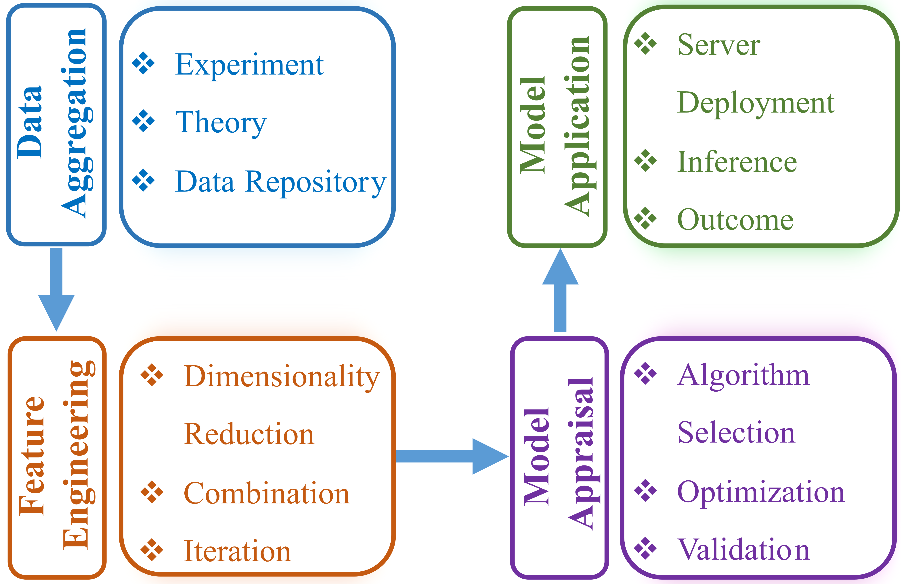
Supplementary Figure 1: Schematic representation of the four main stages in the model development process: Each step outlines critical actions and transformations essential to enhance model accuracy and predictive capabilities.

Supplementary Note 2: Training dataset
The dataset used in this study consists of 1927 samples, each characterized by 23 distinct input features and a target variable, responsivity, primarily aggregated from 29 experimental research articles centered on the fabrication of photodetectors.^{[1–27]} Additional features were sourced from the periodic table, the Materials Project database, the NIST database, and theoretical studies.^{[28–35]} This dataset encapsulates comprehensive information on both the active layer and substrate materials for each fabricated photodetector, encompassing the feature attributes listed in Supplementary Table 1.
Supplementary Table 1. Names, detailed descriptions, and sources of features used for responsivity prediction. Features marked with an asterisk (*) were excluded following correlation analysis.
Feature Number | Feature Name | Feature Description | Source
1 | AL(Z) | The summation of atomic numbers for all constituent elements within a single formula unit of the material (active layer) | Periodic Table
2 | Avg_Z | AL(Z) divided by the total number of atoms present in a single formula unit of the material (active layer) | Periodic Table
3 | AL(Z_sq)* | Square of AL(Z) | Periodic Table
4 | AL(A)* | The summation of atomic masses for all constituent elements within a single formula unit of the material (active layer) | Periodic Table
5 | AL_Mob(cm^2/Vs) | The experimental mobility of the active layer expressed in units of $cm^{2}/Vs$ | Publications
6 | AL_Den(g/cm^3) | The density of the active layer expressed in units of $g/cm^{3}$ | Materials Project
7 | Avg_Val_e | The sum of valence electrons for all constituent elements in a single formula unit of the material (active layer), divided by the total number of atoms in that formula unit. | Periodic Table
8 | AL_Eg(eV) | Experimental band gap of the active layer measured in units of eV | Publications
9 | AL_Th_Eg(eV) | Theoretical band gap of the active layer measured in units of eV | Publications/Materials Project
10 | S_Eg(eV) | Experimental band gap of the substrate measured in units of eV | Publications
11 | S_Th_Eg(eV)* | Theoretical bandgap of the substrate measured in units of eV | Materials Project
12 | Thickness(nm) | Thickness of the active layer measured in units of nm | Tunable Parameter
13 | E(eV) | The energy of the incident radiation on the active layer, measured in units of electron volts (eV) | Tunable Parameter
14 | Wave_L(nm) | The wavelength of the incident radiation on the active layer, measured in units of nanometers (nm) | Tunable Parameter
15 | P_Int(um/cm2) | The power intensity of the incident radiation on the active layer, measured in units of $μm/cm^{2}$ | Tunable Parameter
16 | Bias | The bias voltage applied across the device, measured in units of volts | Tunable Parameter
17 | Res(A/W)  (Target Variable) | Experimental responsivity of the active layer measured in units of A/W | Publications
18 | PIN | Device architecture: p-i-n (PIN) | Publications
19 | NIP | Device architecture: n-i-p (NIP) | Publications
20 | FET | Device architecture: Field effect transistor (FET) | Publications
21 | SBD | Device architecture: Schottky barrier diode (SBD) | Publications
22 | NN | Device architecture: n–n heterojunction (NN) | Publications
23 | Ohmic | Device architecture: Ohmic contact-based structure | Publications
24 | PN | Device architecture: p–n junction (PN) | Publications

Supplementary Note 3: Feature selection using Pearson correlation coefficient and correlation heatmap analysis
The Pearson correlation coefficient is a widely used statistical measure for feature selection in machine learning and statistical analysis. It quantifies the strength and direction of the linear relationship between two variables, typically represented by X (independent variable or feature) and Y (dependent variable or target). In the context of feature selection, the objective is to identify features that demonstrate a significant correlation with the target variable, while simultaneously minimizing inter-feature correlation to reduce redundancy. This approach is advantageous because:
- It assesses how strongly each feature is linearly associated with the target variable.
- It identifies pairs of features with high correlation, which may indicate multicollinearity and redundancy, thereby helping to streamline the feature set by removing less informative features.
The Pearson correlation coefficient, $r_{X},_{Y}$, between two variables X and Y is defined as:
$$r_{X},_{Y}=\frac{\sum_{i=1}^{n}{(X_{i}-\overline{X})(Y_{i}-\overline{Y})}}{\sqrt{\sum_{i=1}^{n}{{\left(X_{i}-\overline{X}\right)}^{2}}}.\sqrt{\sum_{i=1}^{n}{{\left(Y_{i}-\overline{Y}\right)}^{2}}}}$$
Where $X_{i}$ and $Y_{i}$​ represent individual sample values for $X$ and $Y$, respectively; $\overline{X}$ and $\overline{Y}$ are the mean values of $X$and $Y$; and $n$ is the number of observations.
A threshold of $\left|r\right|>0.9$ was applied to exclude features exhibiting high inter-feature correlation, as such correlations suggest overlapping information that can introduce multicollinearity. The correlation coefficients of all features, both with one another and with the target variable (responsivity), are displayed in the correlation heatmap matrix shown in Supplementary Figure 2. Following the application of the threshold, features demonstrating a strong correlation with the target variable (responsivity) and low inter-feature correlation were retained, as illustrated in Supplementary Figure 3.
Retaining features that are highly correlated with the target variable while maintaining low inter-feature correlations enhances the diversity of predictive information integrated into the machine learning models, thereby improving model robustness and interpretability.
Note: During the Pearson correlation analysis, the device architecture categories including PIN, NIP, FET, SBD, NN, Ohmic, and PN were intentionally not included in the feature elimination process. As these seven columns represent mutually exclusive classes of device architectures, retaining all of them is essential to ensure that the model can make predictions across the full spectrum of device types. From a machine learning perspective, preserving the complete set of class-defining features is crucial for maintaining the model's capacity to generalize across all architecture categories. Removing any of these device architectures (variables) due to high pairwise correlation could lead to biased or incomplete learning, ultimately compromising both predictive performance and the interpretability of the results. This is because eliminating a class-defining variable for a given material would result in that material being incorrectly assigned to another device architecture, leading to misclassification and inaccurate model outputs.

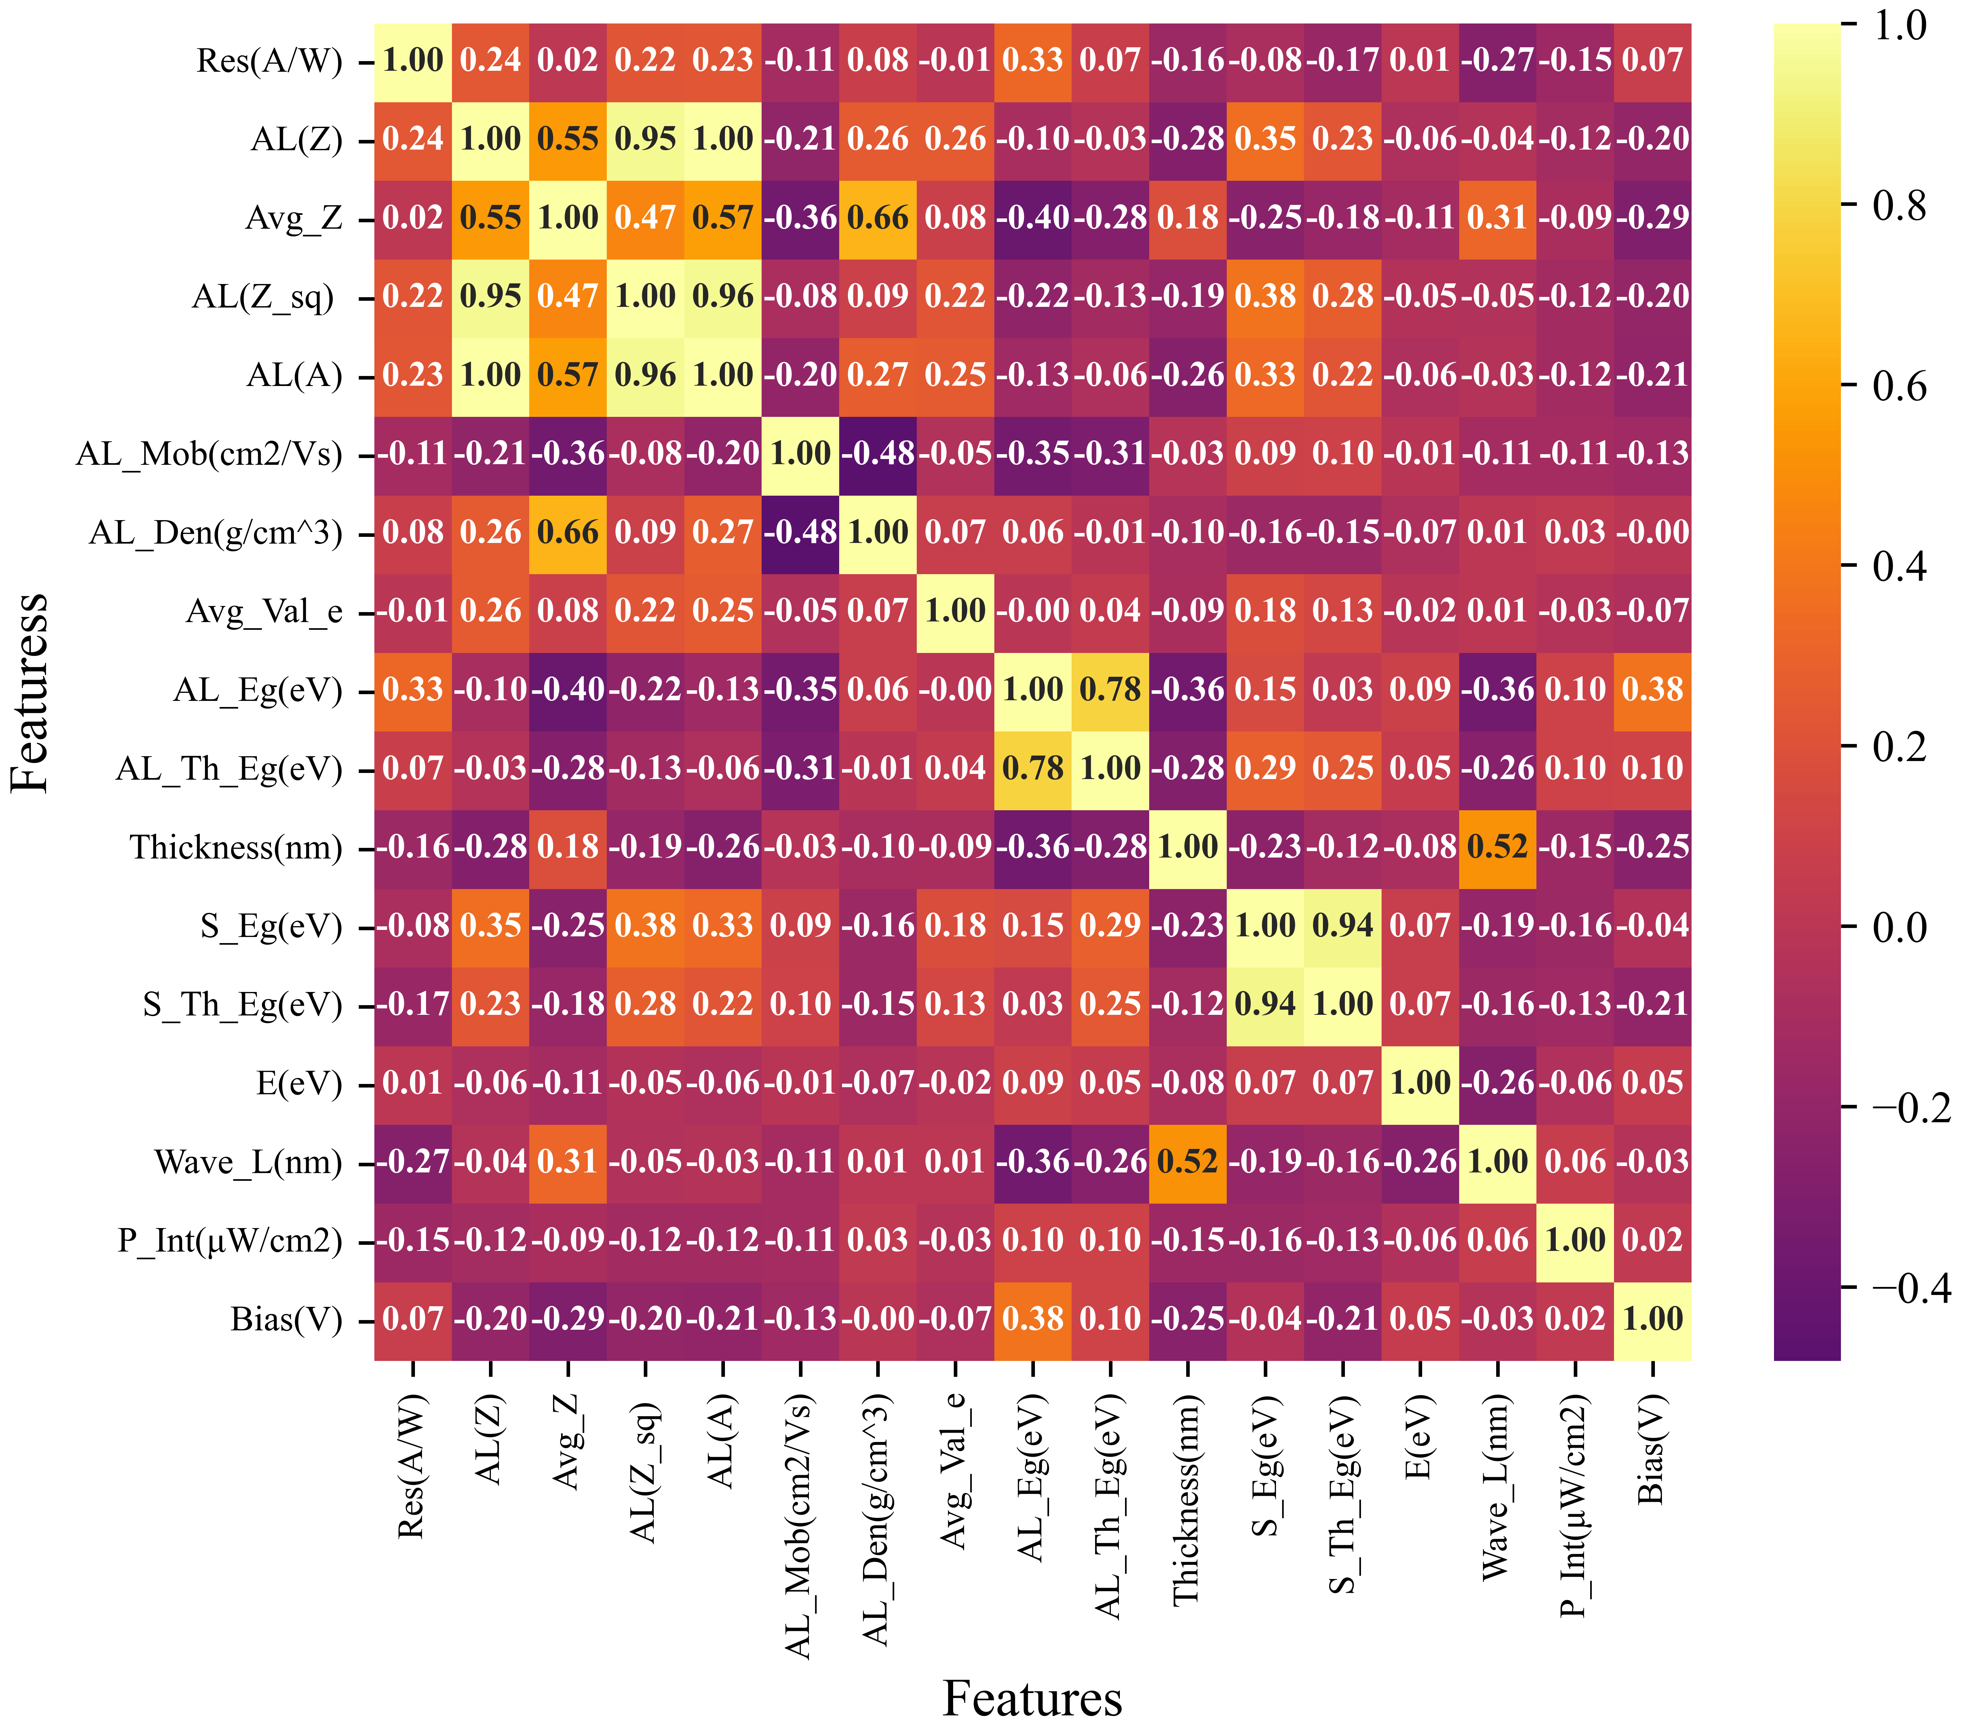
Supplementary Figure 2: Correlation heatmap matrix before correlation analysis: Depicting the correlations of all initial features with each other and with the target variable, responsivity (A/W), before the removal of redundant features.

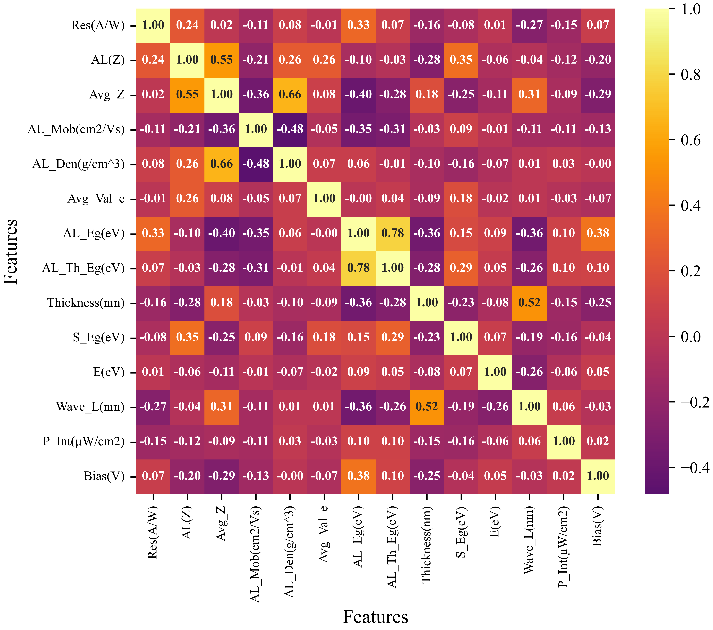
Supplementary Figure 3: Correlation heatmap matrix after correlation analysis: Displaying the top-performing features for predicting the target variable, responsivity (A/W), after excluding redundant features. A Pearson correlation coefficient threshold of ±0.9 is applied for feature selection and to optimize model performance.

Supplementary Note 4: Comparative analysis of machine learning models for prediction and performance evaluation
Machine Learning Models:
We applied the following seven machine learning regression models in our study, with brief descriptions provided below.
1-Extra Trees: Extra Trees is an ensemble learning technique that constructs multiple decision trees in a highly randomized manner. Unlike Random Forests, Extra Trees selects cut points at random and uses the
entire dataset (rather than bootstrap samples) for training. This approach can lead to reduced variance and often results in a faster training process.
2-SGBoost (Stochastic Gradient Boosting): SGBoost is a variation of gradient boosting that incorporates stochastic elements by randomly subsampling the data before training each base learner. This stochastic approach helps in reducing overfitting and can lead to better generalization, especially in large and complex datasets. It balances the bias-variance tradeoff more effectively than standard gradient boosting.
3-Random Forest Regression: Random Forest Regression is an ensemble learning method that builds multiple decision trees during training and outputs the mean prediction of the individual trees. It reduces overfitting by averaging multiple decision trees trained on various subsets of the data, thereby enhancing prediction accuracy and robustness.
4-CatBoost: CatBoost is a gradient boosting algorithm that handles categorical features natively and efficiently without requiring extensive preprocessing. It is designed to be less prone to overfitting and provides high accuracy and speed, particularly in datasets with categorical variables. CatBoost's key innovations include ordered boosting and categorical feature support, making it competitive with other gradient boosting methods.
5-Decision Trees: A Decision Tree is a non-parametric supervised learning method used for classification and regression. It splits the data into subsets based on the most significant attribute at each node, forming a tree structure. The goal is to create a model that predicts the value of a target variable by learning simple decision rules inferred from the data features.
6-XGBoost (Extreme Gradient Boosting): XGBoost is an advanced implementation of gradient boosting that is designed to be highly efficient, flexible, and portable. It utilizes decision trees as base learners and iteratively improves predictions by minimizing a loss function. XGBoost includes optimizations such as regularization and parallel processing, which make it faster and more accurate compared to traditional gradient boosting methods.
7-LightGBM (Light Gradient Boosting Machine): LightGBM is a gradient boosting framework that uses tree-based learning algorithms, optimized for speed and memory efficiency. It achieves faster training times and lower memory usage by using a leaf-wise tree growth strategy and histogram-based decision trees. LightGBM is particularly well-suited for large datasets and can handle large numbers of features with high accuracy.
Each model was trained and evaluated on the dataset using standard regression metrics like Mean Squared Error (MSE), Mean Absolute Error (MAE), and R² Score. Additionally, cross-validation was performed to assess the models’ generalization performance. Feature standard scaling was also applied to meet the specific requirements of each model. Model sensitivity analysis was conducted to identify the most influential features in the models’ predictions. These regression algorithms provide a comprehensive exploration of different modeling techniques, aiming to identify the most accurate and reliable approach to predict photodetector responsivity effectively.

Supplementary Table 2: Comparative performance analysis of seven machine learning regression models based on performance metrics including Root Mean Squared Error (RMSE), Mean Absolute Error (MAE), and Coefficient of Determination (R²) values for both training and testing data sets, providing a comprehensive assessment of each model. Furthermore, the predicted responsivity (A/W) values generated by all seven models for a 168 nm thick α-MoO₃ active layer device in the EUV region (at 13.5 nm or 91.85 eV), operating under a 1 mV bias voltage, are displayed in the rightmost column.

Method | Training RMSE | Training MAE | Training R² | Test RMSE | Test MAE | Test R²
Extra Trees | $$0.022$$ | $$0.003$$ | $$1.0000$$ | $$0.2725$$ | $$0.0728$$ | $$0.99995$$
SGBoost | $$0.001$$ | $$0.001$$ | $$1.0000$$ | $$0.9463$$ | $$0.2949$$ | $$0.99941$$
Random Forest | $$0.885$$ | $$0.195$$ | $$0.9995$$ | $$1.0784$$ | $$0.3350$$ | $$0.99924$$
Decision Tree | $$0.135$$ | $$0.016$$ | $$0.9999$$ | $$1.5694$$ | $$0.5520$$ | $$0.99838$$
CatBoost | $$0.449$$ | $$0.212$$ | $$0.9998$$ | $$1.6179$$ | $$0.5966$$ | $$0.99828$$
XGBoost | $$1.202$$ | $$0.317$$ | $$0.9990$$ | $$2.1370$$ | $$0.7710$$ | $$0.99701$$
LightGBM | $$1.380$$ | $$0.516$$ | $$0.9987$$ | $$3.0165$$ | $$1.1874$$ | $$0.99405$$

Supplementary Figure 4: The comparative performance of various machine learning models: presented in descending order based on performance and illustrated through plots of actual (experimental) versus predicted responsivity for previously unseen data, alongside the respective feature importances of each model. (a) and (b) depict the SGBoost regression model, (c) and (d) illustrate the Random Forest model, and (e) and (f) show the Decision tree model. Insets detail the associated performance metrics, including Root Mean Squared Error (RMSE), Mean Absolute Error (MAE), and R² values, providing a comprehensive assessment of each model's predictive efficacy.

Supplementary Figure 5: The comparative performance of various machine learning models: presented in descending order based on performance and illustrated through plots of actual (experimental) versus predicted responsivity for previously unseen data, alongside the respective feature importances of each model. (a) and (b) depict the CatBoost model, (c) and (d) illustrate the XGBoost model, and (e) and (f) show the LightGBM regression model. Insets detail the associated performance metrics, including Root Mean Squared Error (RMSE), Mean Absolute Error (MAE), and R² values, providing a comprehensive assessment of each model's predictive efficacy.

Supplementary Note 5: Optimization of Device Thickness for Enhanced α-MoO₃ Responsivity at 13.5 nm
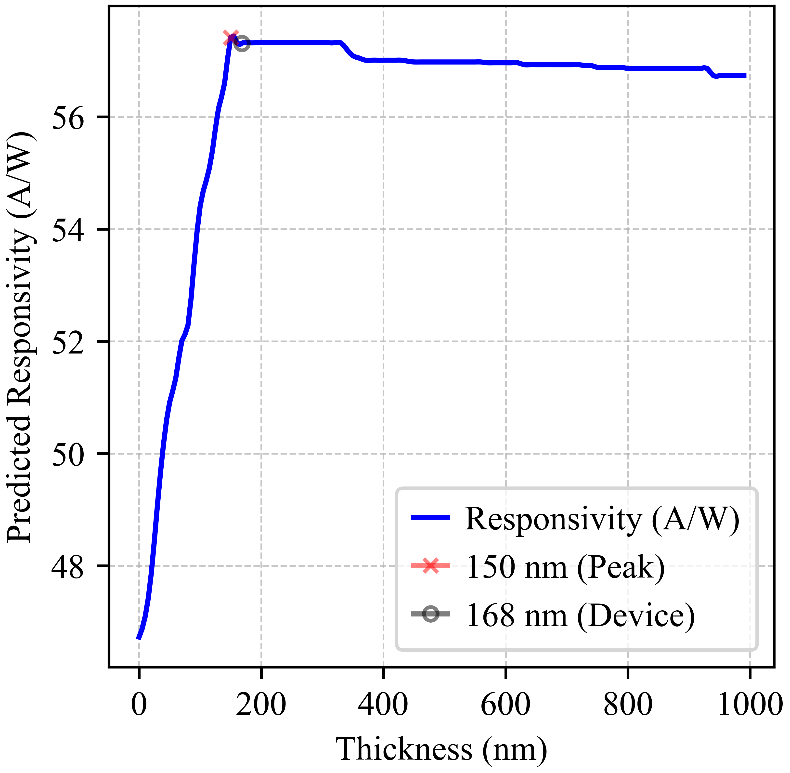
After identifying the optimal material for sensing within the EUV range, the subsequent challenge involved optimizing the thickness of the active layer to maximize responsivity at 13.5 nm (or 91.85 eV). Since the machine learning (ML) model training dataset includes active layer thickness as a crucial input feature, one that significantly influences the target variable, responsivity, the same ML model (in this case, the Extreme Gradient Tree Regressor, or ETR, identified as the most effective model) was utilized to predict device responsivity across a range of thicknesses. By plotting responsivity as a function of active layer thickness, we identified the optimal thickness range while maintaining other experimental variables, such as bias voltage, power intensity, and EUV wavelength, constant. The model predicted the highest responsivity for an active layer thickness of 150 nm, as illustrated in Supplementary Figure 6.
Supplementary Figure 6: Optimization of α-MoO₃ Device Thickness: The thickness of the active layer of α-MoO₃ was simulated over a range from 0 to 1000 nm in the EUV region (at 13.5 nm or 91.85 eV), operating under a 1 mV bias voltage. The highest responsivity (57.42 A/W) was predicted for an active layer thickness of 150 nm. The analysis revealed that the maximum predicted responsivity of 57.42$A/W±2.2 \%$ was achieved within optimal thickness range of $150 nm to 320 nm$. The fabricated device has an actual thickness of 168 nm, which lies in the optimal region. The cross and dot signs represent the predicted peak responsivity value and the predicted responsivity value for the 168 nm-thick device in this study, respectively.

Supplementary Note 6: Factors contributing to minor discrepancies between predicted and experimental values
In this work, two materials have been experimentally tested for their responsivity in the extreme ultraviolet (EUV) range after their responsivities were predicted using the Extra Trees Regressor (ETR) model. Supplementary Table 3 presents a detailed comparison between the predicted and experimental responsivity values for Ohmic-type device architectures, along with the corresponding percentage errors. The observed discrepancies are minor, with percentage errors $≤ 4\%$, indicating that the model performs well overall.
Supplementary Table 3: Comparison of predicted and experimental responsivity values for $α$-$MoO_{3}$ and $ReS_{2}$: The predicted values correspond to $168 nm$ thick active layers operating at a wavelength of $13.5 nm (91.85 eV)$ under a bias voltage of $1 mV$.
Material | Predicted Value | Experimental Value | Percentage Error
$$α-MoO_{3}$$ | 57.4 | 59.8 | 4.01 %
$$ReS_{2}$$ | 20.9 | 20.4 | 2.45 %

In any machine learning endeavor, the quality and scope of the dataset are paramount. Our initial dataset was compiled from experimental data drawn exclusively from 29 published studies, which, while valuable, could benefit from expansion. Increasing the predictive power of our model would require the inclusion of a more extensive and diverse dataset, encompassing a broader range of experimental conditions. Additionally, variations in material properties, such as mobility and bandgap, necessitated the use of averaged values due to discrepancies reported across different sources. Theoretical parameters, including bandgaps derived from Density Functional Theory (DFT) calculations available in databases such as the Materials Project, inherently diverge from experimental values due to methodological assumptions and approximations intrinsic to DFT. These discrepancies introduce deviations in model predictions, even when employing high-performance machine learning models.

Supplementary Note 7: Limitations and future directions of the machine learning predictive framework
Currently, there exists a significantly smaller number of studies focused on the responsivity of photodetectors in the EUV region compared to the UV and visible spectral ranges. Although a few of these EUV-specific studies have been incorporated into the training dataset, their representation remains limited. With the ongoing progress in EUV photodetector research, the availability of more experimental studies will allow for the expansion of the dataset in this spectral domain. Incorporating such data would enable the model to better capture and learn the distinct optical and electronic behaviors of materials under EUV illumination, thereby improving its predictive accuracy specifically for EUV-responsive devices.
Moreover, the current dataset is categorized into seven distinct device architecture classes: PIN, NIP, PN, Ohmic, Schottky, NN, and FET. At present, the dataset is more heavily populated with devices corresponding to PN, Ohmic, and Schottky diodes, while other classes such as NIP, PIN, FET, and NN are underrepresented. Supplementary Figure 7 shows the model predictions for all seven types of device architectures. However, due to the limited amount of training data corresponding to the PIN, NIP, FET, and NN categories, the model's predictive power is less reliable for these device types. In contrast, the relatively large number of samples available for PN, Ohmic, and Schottky device architectures allows the model to produce more accurate and trustworthy predictions for these classes. Notably, the model's predicted responsivity values for Ohmic-type devices have been experimentally validated, further supporting its robustness in these well-represented categories. Expanding the dataset by incorporating additional materials and devices from the underrepresented classes would not only improve class balance but also enhance the model’s predictive capability across all device architectures. Class-wise diversification is thus a critical step toward more robust and generalizable prediction outcomes. As the model is capable of making predictions across all seven device architectures, we welcome and encourage future efforts aimed at expanding the dataset to make the model increasingly robust and efficient.
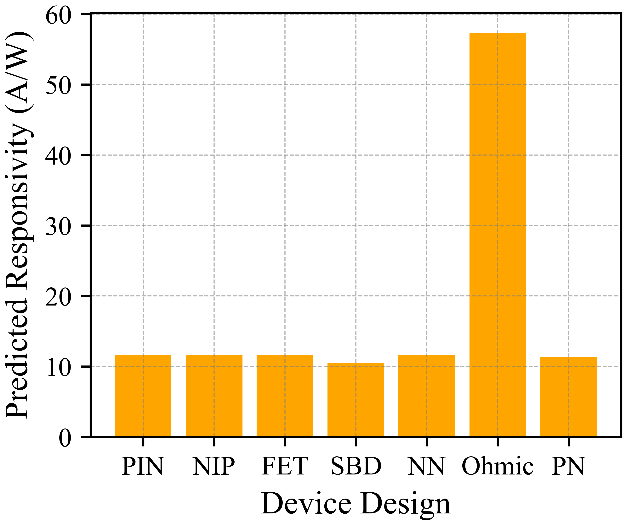
Supplementary Figure 7: Predicted responsivity values generated by the Extra Trees Regressor (ETR) model for seven distinct device architectures: The predictions correspond to a $168 nm$ thick $α$-$MoO_{3}$ active layer operating at a wavelength of $13.5 nm (91.85 eV)$ under a bias voltage of $1 mV$.

Supplementary Note 8: Attenuation characteristics of the α-MoO₃ device in EUV range
To evaluate the potential of α-MoO₃ as an EUV detector, the attenuation coefficients of α-MoO₃ and silicon were calculated using the National Institute of Standards and Technology (NIST) photon cross-section database, facilitating a comparative performance analysis in the EUV photon range (Supplementary Figure 8). The attenuation coefficient measures the extent to which incident radiation flux diminishes as it traverses a material. At the typical photon energy used in EUV lithography patterning (i.e., 92 eV or 13.5 nm), the attenuation coefficient of α-MoO₃ is approximately an order of magnitude higher than that of silicon (Supplementary Figure 8(a)), suggesting that α-MoO₃ is capable of detecting EUV radiation with significantly reduced material thickness. Containing high Z element ($Z^{Mo}=42 \&{ Z}^{Si}=14)$, this layered structure of α-MoO₃ supports a high density of $4.69g/{{cm}^{3}}$ than Si ($D^{Si}=2.69g/{{cm}^{3})}$, rendering it an efficient attenuator of EUV radiation.
To illustrate EUV radiation penetration in α-MoO₃, the average photon range was calculated, which is inversely related to the attenuation rate (Supplementary Figure 8(b)). For 13.5 nm EUV photons, the average range was determined to be 70 nm in α-MoO₃, demonstrating the average distance travelled in a material before interaction. This distinct attenuation characteristic is also reflected in the half-value layer (HVL) of 50 nm for 92 eV (or 13.5nm) EUV radiation, denoting the thickness of α-MoO₃ required to reduce radiation by half, computed as HVL = 0.693 × Average Range. α-MoO₃’s attenuation coefficient decreases sharply at higher photon energies, enhancing EUV penetration.
This efficiency is further elucidated by comparing their attenuation efficiencies which can be used to determine the material’s thickness for percentage attenuation; for instance, a 290 nm thick α-MoO₃ layer attenuates over 99% of 13.5 nm EUV photons, while silicon achieves only ~35% attenuation at this thickness (Supplementary Figure 8(c)). While thinner materials enhance carrier extraction, thicker materials necessitate higher EUV exposures and bias voltages, and an increased active material thickness can also detrimentally affect image resolution. These distinctive characteristics make α-MoO₃ a promising material for efficient EUV radiation detection.

Supplementary Figure 8: Attenuation Characteristics (a) Attenuation curves of α-MoO₃ and Silicon, indicating a significantly higher attenuation coefficient of α-MoO₃ compared to Silicon at 13.5 nm radiations by an order of a magnitude, thus an attenuation result of Silicon can easily be achieved using a relatively much lower thickness of α-MoO₃ and along with high resolution. (b) Theoretically derived Half Value Layer ‘HVL’ and average photon range ‘APR’ values of α-MoO₃ as a function of EUV photon energies. The HVL and APR of α-MoO₃ for 92 eV (or 13.5 nm) energy is 50 nm and 70 nm respectively, suggesting strong potential use of α-MoO₃ for EUV sensing and detection. (c) Attenuation efficiencies as a function of the material’s thickness are presented for 13.5 nm radiations. This shows a 290 nm thick α-MoO₃ and Silicon can attenuate the same EUV radiation energy by 99% and 35% respectively.

Supplementary Note 9: Characteristics of α-MoO₃ based detector

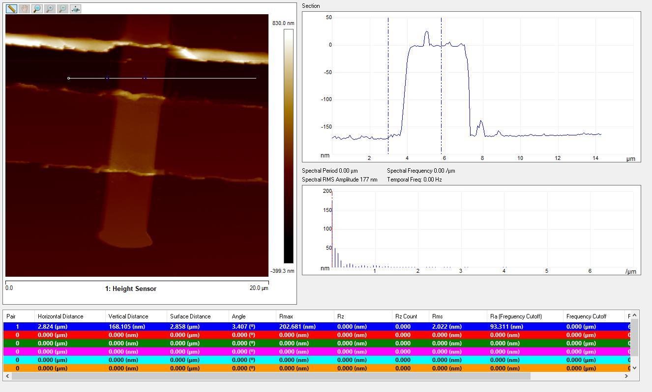
Supplementary Figure 9: AFM details of the α-MoO₃ Device: α-MoO₃ with thickness of ~168nm is exfoliated and transferred on Si/SiO₂ substrate.

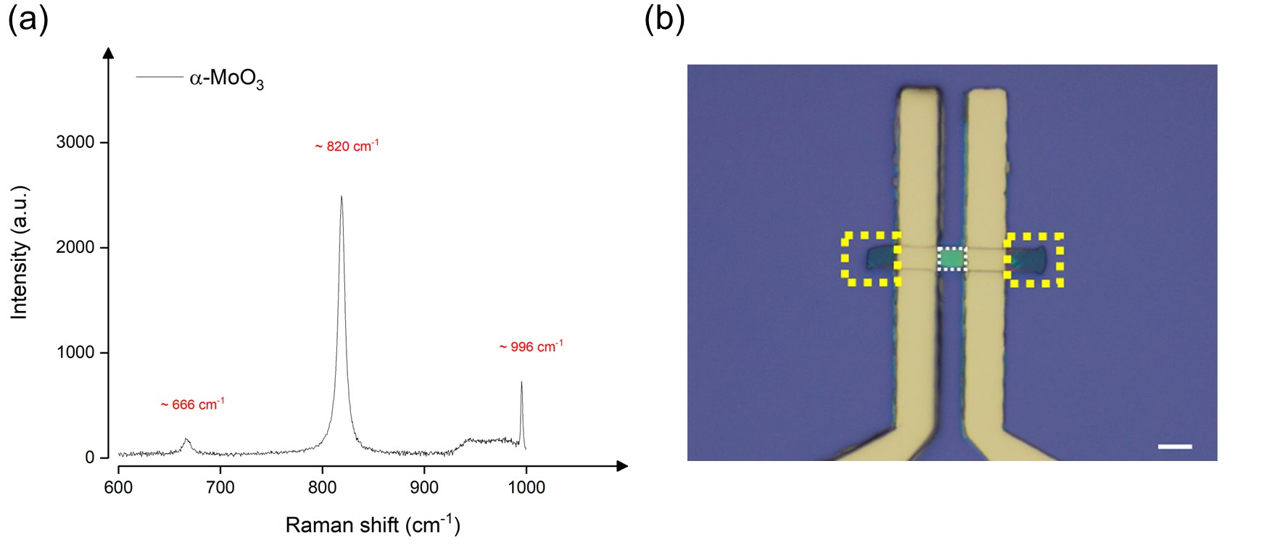
Supplementary Figure 10: Material/Device Characteristics: (a) Typical Raman Spectra of α-MoO₃, shows characteristic peaks at ~666 cm⁻¹, 820 cm⁻¹ and 996 cm⁻¹.^{[36]} The Raman spectrum of the α-MoO₃ flake was recorded using a 2.33 eV excitation laser with a power of 1.5 mW, while maintaining the temperature at 25º C. (b) Actual photo of a device. Scale bar shows 5 microns. We used area between the electrodes for the calculation of responsivity as areas showcased in yellow boxes doesn’t contribute to the transport properties. Also, area under gold is not considered because EUV cannot penetrate through the gold due to its high density and thickness.

The photodetector under study has a lateral metal–semiconductor–metal (MSM) architecture based on α-$MoO₃$ as the active layer, with parallel top electrodes separated by around 3 μm gap. In such devices, photocurrent generation and extraction are governed by two fundamental charge transport mechanisms: drift (field-driven transport) and diffusion (concentration-driven transport).
In device geometry, the lateral electric field induced by the applied bias is confined to the region between the source and drain electrodes. This localization designates Region-I (see Supplementary Figure 11) is the electrically active zone, where photo-generated carriers experience a drift force and are efficiently swept toward the electrodes before undergoing recombination. In contrast, Regions-II and III exhibit negligible field strength, and hence do not support significant drift-driven transport.
Although the entire device surface is illuminated, charge carriers generated outside the gap (in Regions-II and III) do not contribute appreciably to the measured photocurrent. In these field-free zones, carrier transport relies solely on diffusion, which is a much slower and recombination-prone process compared to drift. This behavior is well-described by the exponential carrier collection probability:
$$P\left(x\right)∝e^{-\frac{x}{L_{D}}}$$
where $L_{D}$ is diffusion length for photogenerated charge carrier and $x$ is the distance from electrode. This probability of carriers reaching the electrodes decreases rapidly and the likelihood of carriers generated in Regions-II and III reaching the electrodes is exponentially suppressed. Therefore, their contribution to the photocurrent is effectively negligible.
Further this approach aligns with established analytical modeling and experimental validations, using the following relation for photoresponsivity in lateral MSM photodetectors:^{[37,38]}
$$R\left(l\right)=\frac{C}{l}\left(1-e^{-\frac{l}{L_{D}}}\right),$$
here, $l$ is the inter-electrodes gap, $L_{D}$is diffusion length and $C$ is a constant that depends on the material’s photogeneration rate and the device width. This model explicitly assumes that only carriers generated within the electrode gap contribute to the photocurrent. Including optically illuminated regions outside the drift-active zone would lead to an artificially reduced responsivity and a misrepresentation of device performance.
Also, 2D Laplace equation have been solved numerically under appropriate boundary conditions using finite-difference relaxation methods (FDM). As shown in Supplementary Figure 11, the resulting electric field distribution clearly demonstrates that the field is strong and nearly uniform within Region-I and rapidly decays outside the electrode gap (Regions-II and III), indicating minimal drift forces on photo-generated carriers in those regions.
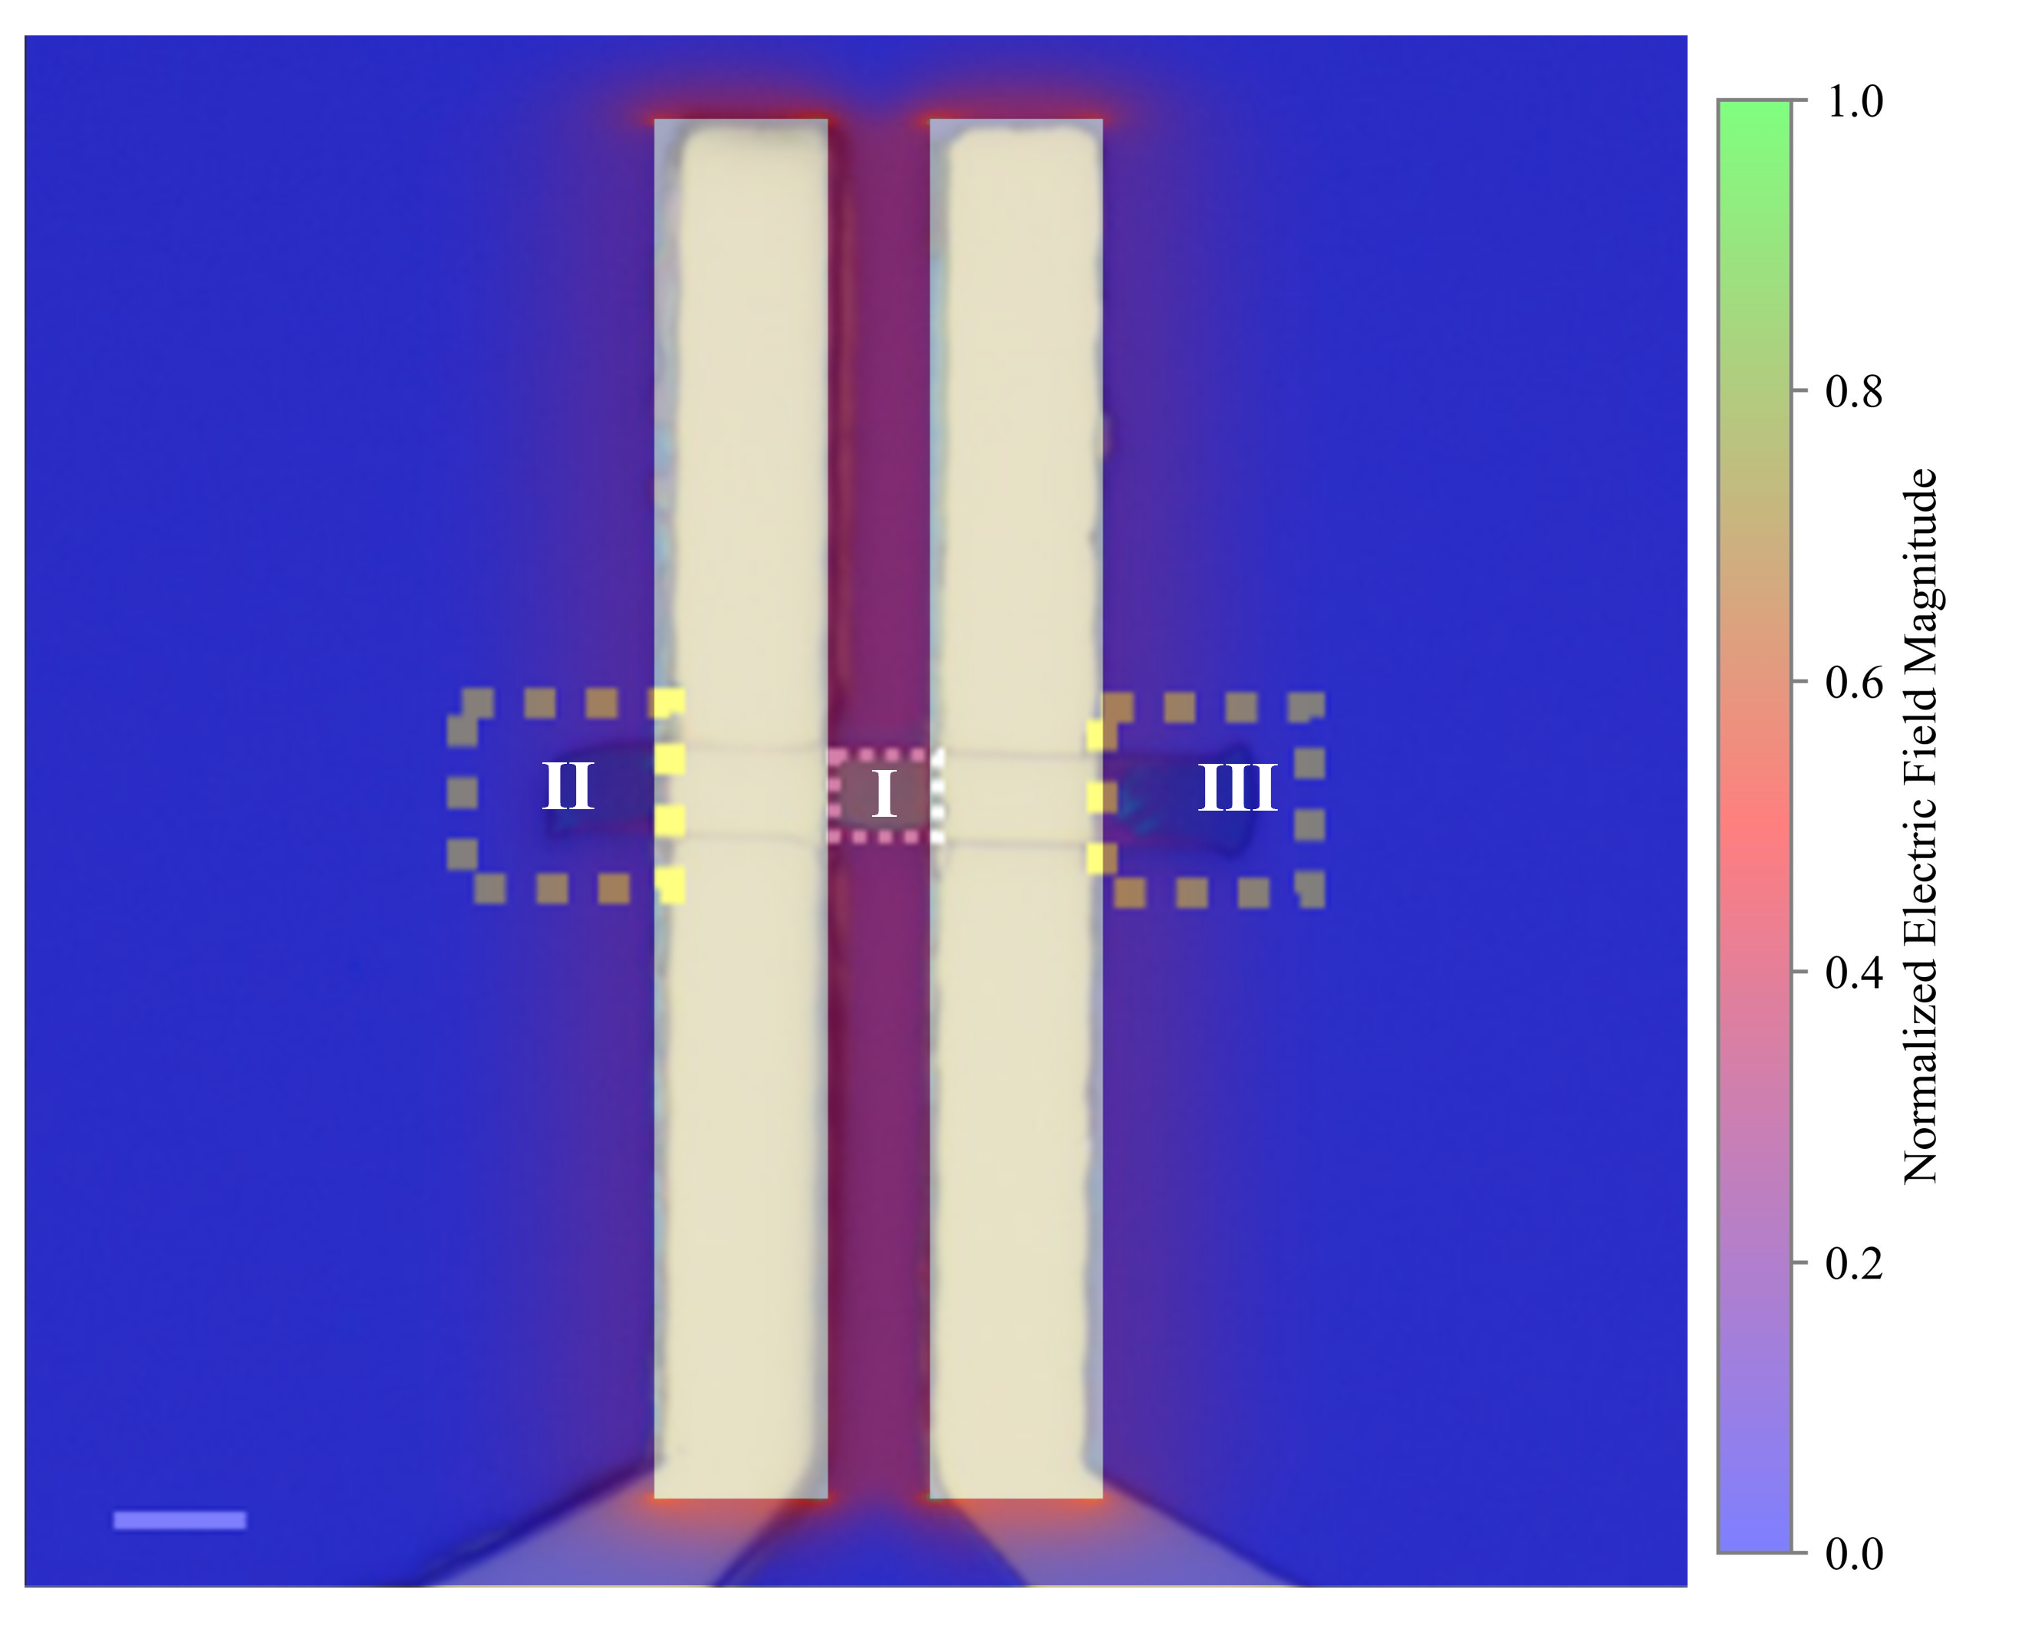
Supplementary Figure 11: Electric field simulation of parallel electrode geometry: The geometry replicates the experimental configuration, with electrode length and width set to 40 μm and 5 μm, respectively, and an inter-electrode gap of 3 μm. The FDM simulation shows that the electric field is nearly uniform within Region-I (between the electrodes), particularly near the center. In contrast, Regions-II and III, which lie outside the electrode gap, exhibit negligible electric field, with some fringing effects observed at the electrode edges. This confirms that Region-I is the dominant zone for drift-driven carrier collection.

Supplementary Note 10: Performance of α-MoO₃ based detector
The current response to sequential increases in photon flux at different photon energies demonstrates no saturation or degradation, even when detecting very high fluxes of ~10¹² photons/s. This shows the detector stability at elevated photon fluxes (Supplementary Figure 12(a))
Furthermore, we also measured the response speed of the EUV detector (Supplementary Figure 12(b)), defined as the time required for the detector to extract the generated carriers under EUV exposure to an external circuit as output current. This was calculated by measuring the change in output signal from $10\%$ to $90\%$ of the peak output value. Response time depends on material quality; polycrystalline materials often exhibit lower response times due to grain boundary-induced trap levels within the bandgap, which create potential barriers between adjacent grains.[Reference] The α-MoO₃-based EUV detector demonstrated average rise ($τ_{rise}$) and fall times ($τ_{fall}$) of $60 ms$ and $30 ms$, respectively, over photon energies from $90$ to $150 eV$. The high detector speed, on the order of milliseconds, and slow rise times compared to decay times, are due to the high crystalline quality, low defects, and high carrier mobilities, enabling effective carrier replenishment.

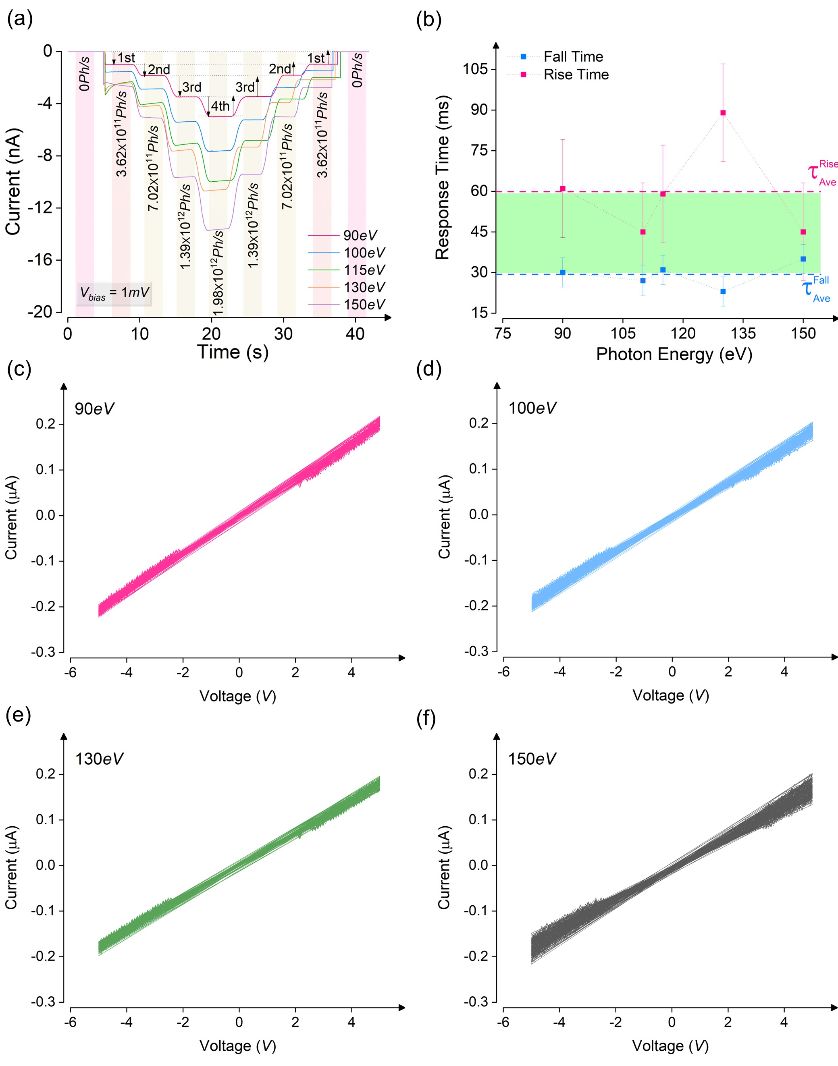
Supplementary Figure 12: Device Performance: (a) The current response to sequentially increase in photon flux at a different photon energy, indicating no saturation or degradation in detecting very high fluxes of ~ 10¹² Ph/s. Note: The indicated flux values are at 90eV. These values are higher at other photon energies. (b) The response speed of a detector indicating an average rise and fall time of ~ 60 ms and 30 ms, respectively. This millisecond-scale response time is consistent with long carrier lifetimes, which may contribute to the observed external quantum efficiency (EQE) exceeding 100%.^{[39]} (c-f) Recorded currents as a function of bias voltages ($-5 V$ to $5V$) for 100 consecutive repeated measurements under 90eV, 100eV, 130eV and 150eV were analyzed to test the device's stability. The output current remained consistent across repeated exposures, demonstrating the device's reliable stability under intense radiation conditions.

Supplementary Figure 13: Current as a function of photon energies at different bias voltages. Inset shows the slope of the current deviation with respect to bias.

Supplementary Note 11: Detectivity and EQE of α-MoO₃ based detector

Supplementary Figure 14: Figures of Merit for α-MoO₃ EUV Detector: (a, b) Operating at bias voltages of 1 mV and 5 V, the detector demonstrates a detectivity ranging from 6–8 × 10¹² Jones and 0.15–4 × 10¹² Jones in the EUV range, respectively. The peak responsivity at ~92 eV (or 13.5 nm) corresponds to a detectivity of 8 × 10¹² Jones at 1 mV, highlighting the device's suitability for detecting weak signals and effectively converting them into measurable values. (c, d) The external quantum efficiency (EQE) as a function of photon energies shows an almost linear trend at both 1 mV and 5 V bias voltages, with peak EQE values observed at higher photon energies. At 1 mV bias, the EQE achieves up to 10⁶ % for incident photon energy of 150 eV. For 92 eV (or 13.5 nm), the calculated EQE values exceed 10⁵ %, indicating a high conversion rate of absorbed EUV photons into generated carriers via the photoelectric effect.
Detectivity, which is used to distinguish a weak EUV signal from noise, is defined as $D={R\sqrt{S}}/{\sqrt{2eI_{d}}}$ , where $R$ is responsivity, $S$ is the active area, e is the electron charge, and $I_{d}$ is the dark current. For the device operating at biases of $1 mV$ and $5 V$, the detector demonstrates detectivity values ranging from $6-8 (×{10}^{12} Jones)$ and $0.15-4 (×{10}^{12} Jones)$, respectively, in the EUV range, as shown in Supplementary Figure 14(a) and (b). The effect of the large bandgap in α-MoO₃ is clearly observed in the high values of specific detectivity. Compared to $1 mV$, the relatively lower detectivity values at high bias are attributed to the relatively high dark currents, on the order of tens of nanoamperes, obtained in α-MoO₃ at $5 V$. These calculated detectivity values on the order of ${10}^{11}-{10}^{12} Jones$ for the α-MoO₃-based EUV detector surpass those of silicon or silicon-derived EUV detectors. In Figure 4-d, the peak responsivity at $\sim 95 eV$ (or $13.5 nm$) corresponds to a detectivity of $8×{10}^{12} Jones$ at $1 mV$, indicating the detector's suitability for detecting weak signals and converting these signals into measurable values. Increasing the bias, as shown in Supplementary Figure 14(b), results in comparatively lower detectivity values; however, the calculated values remain on the order of $0.3 (×{10}^{12} Jones)$, indicating the detector's overall performance.
We further calculated the external quantum efficiency (EQE) of the detector, defined as the number of charge carriers collected by the respective electrodes per incident photon at a given energy or wavelength. This photoconversion ability of the detector can be expressed as:
$EQE \left(\%\right)=\frac{hcR}{eλ}×100$where $h$ is Planck's constant, $c$ is the speed of light, $R$ is the responsivity of the detector, e is the electron charge, and $λ$ is the wavelength of the incident radiation. The EQE at bias voltages of both $1 mV$ and $5 V$, shown in Supplementary Figure 14(c) and (d), respectively, exhibits an almost linear trend, with peak EQE values calculated at higher photon energies. Compared to the device operating at a bias of $5 V$, the EQE at $1 mV$ reaches ${10}^{6}\%$ when the incident photon energy is $150 eV$. At $92 eV$(or $13.5 nm$), the calculated EQE values exceed ${10}^{5}\%$, indicating a high conversion rate from absorbed EUV photons to generated carriers via the photoelectric effect. These values gradually increase by an order of magnitude, with peak values exceeding $2×{10}^{6}\%$ at $150 eV$ when the device operates at $5 V$. Furthermore, layered 2D materials exhibit high photoresponsivity and extended carrier lifetimes due to their large surface-to-volume ratios, which promote efficient charge separation compared to bulk materials. Additionally, as demonstrated by Amani et al.,^{[40]} operating under relatively low excitation power densities (such as the 7.86 W/m² used in this work) can suppress defect-mediated nonradiative recombination. This effect may enhance quantum yield and carrier lifetime, potentially contributing to the high responsivity and EQE. The comparison of different parameters is shown in Supplementary Table 4.
Supplementary Table 4: Comparison of sensitivities in EUV region. Some data is not available and marked as NA. T = Thickness, R = Responsivity, D= Detectivity, RS = Response speed, and I_{d} = Dark Current. This comparative analysis underscores key performance parameters, including responsivity, detectivity, and response speed, highlighting significant advancements offered by our α-MoO₃ -based detector.
Material/  Active layer | T | λ | R (A/W) | Bias (V) | D (Jones) | EQE (%) | RS  $$τ_{Rise}/τ_{Fall}$$ | I_{d} | Ref
Pt/n-type GaN Schottky photodiode | 4.105 $μ$m | 13.5 nm | 0.01 | 0.8, 0V | 3.28×10¹¹ | 40 % | unknown | 2.7 nA | ^{[25]}
Si based Boron-doped  p⁺n diode | NA | 13.5 nm | 0.266 | NA | NA | NA | 100 ns pulsed response time | 50 pA at 10 V | ^{[27]}
PtSi-n-Si Schottky photodiode | 10 nm | 120 nm | 0.03 | NA | NA | NA | NA | NA | ^{[26]}
Si np (UVG-100) | NA | 120 nm | 0.04 | NA | NA | NA | NA | NA | ^{[41]}
Si with DLC, PtSi, Ti-SiN top layers | $\sim$200 $μ$m | 1-25 nm | 0.05-0.25 | NA | NA | NA | NA | NA | ^{[42]}
$β$- $Ga_{2}O_{3}$  vertical Schottky barrier photodetector | NA | 13.5 nm | 0.05531 | 0 V | NA | 508 % * | 185.8ns/1.3 $μ$s | 161 pA at 100 ⁰C | ^{[22]}
α-MoO₃ (ohmic) | 168 nm | 13.5 nm | $\sim$60 | 0.001 | $$6.1×{10}^{12}$$ | $\sim 5.5×{10}^{5 }$% | 60 ms/30 ms | NA | This work
α-MoO₃ (ohmic) | 168 nm | 10.8 nm | $\sim$145 | 5 | $$3.2×{10}^{11}$$ | $\sim 1.6×{10}^{6}$% | 60 ms/30 ms | NA | This work
*EQE exceeds 100% at 0 V, likely due to high-energy EUV photon absorption generating multiple electron–hole pairs. However, no direct evidence of a confirmed gain mechanism is provided.

Supplementary Note 12: Raman Spectra of ReS₂ device

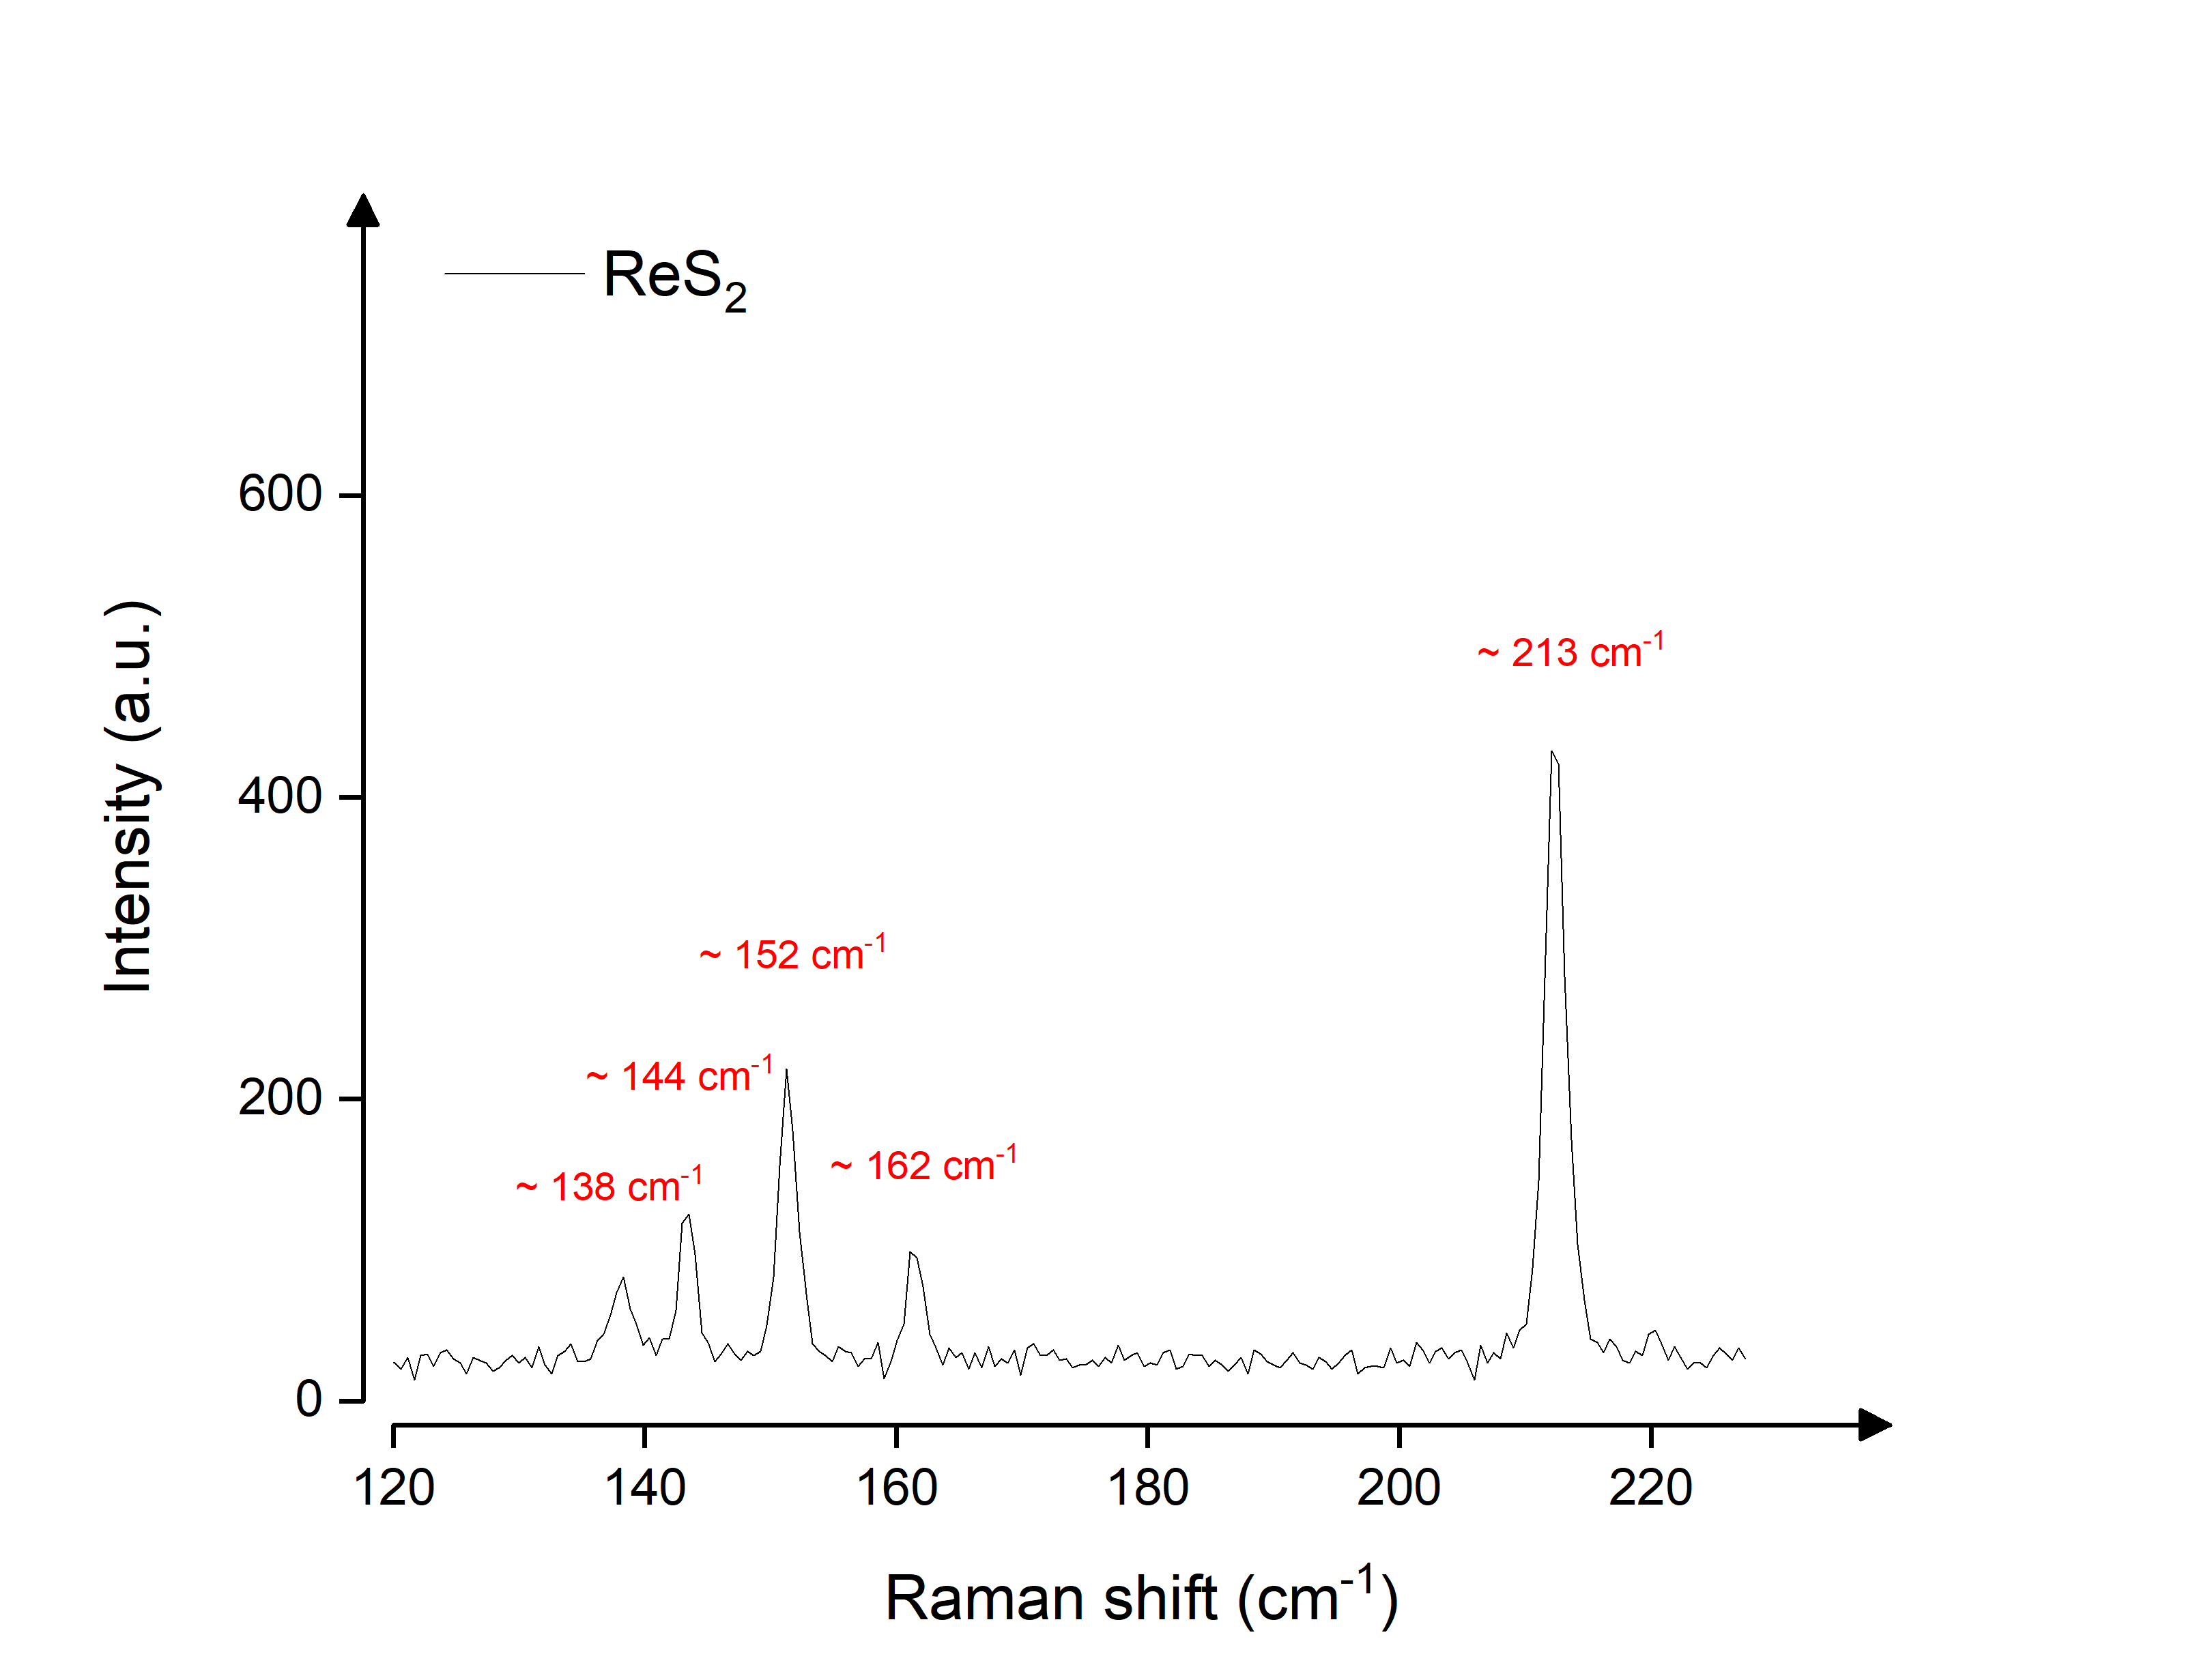
Supplementary Figure 15: The Raman spectrum of commercially sourced ReS₂ shows characteristic peaks, suggesting high crystallinity and structural quality.

Supplementary Note 13: Performance of ReS₂ detector
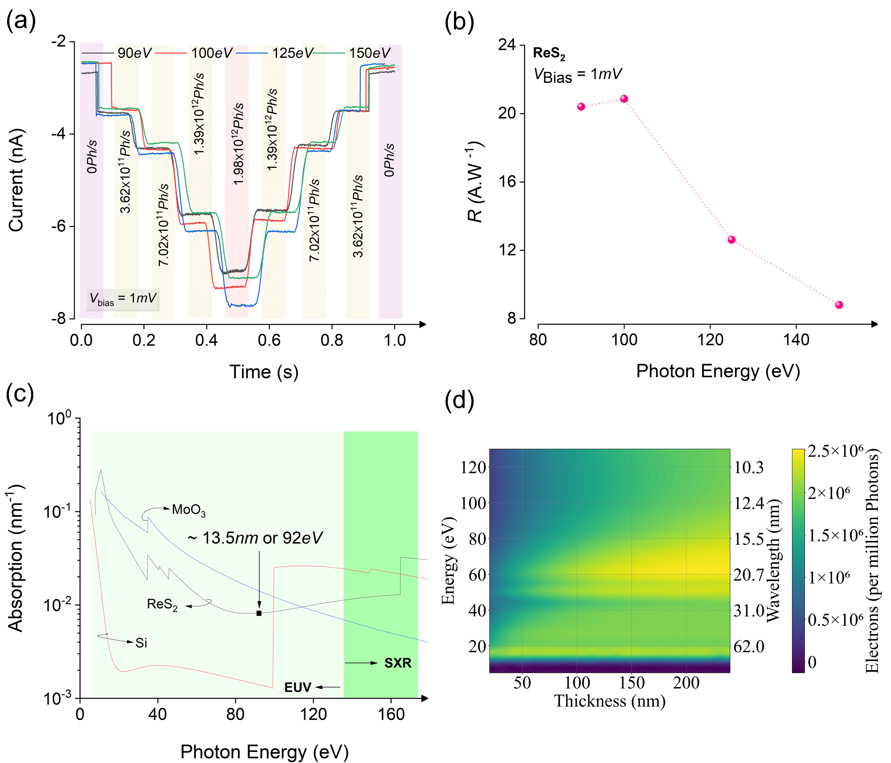
Supplementary Figure 16: Characterization of ReS₂: (a) The current response to sequentially increase in photon flux at a different photon energy, indicating no saturation or degradation in detecting very high fluxes of ~ 10¹² Ph/s. Note: The indicated flux values are at 90 eV. These values are higher at other photon energies. (b) At bias voltages of 1 mV, the device demonstrates a high responsivity of ~22 to 8 A/W, depending on the photon energy. The peak responsivity is approximately 22 A/W at 1 mV bias and EUV radiation of energy 103 eV. (c) Attenuation curves of ReS₂, α-MoO₃ and Silicon, indicating a significantly higher attenuation coefficient of ReS_{2,} and α-MoO₃ compared to Silicon at 13.5 nm radiations by an order of a magnitude, thus an attenuation result of Silicon can easily be achieved using a relatively much lower thickness of α-MoO₃ or ReS₂ and along with high resolution. (d) The Monte Carlo simulations depict electron generation in ReS₂ within the EUV region. Electron generation is presented as a function of EUV photon energy (or wavelength) and the thickness of the active layer. The results demonstrate that the ReS₂ active layer exhibits nearly uniform electron generation efficiency across the majority of the EUV region but less in magnitude as compared to α-MoO₃ and Si.
Supplementary References
[1] P. Chauhan, A. B. Patel, G. K. Solanki, K. D. Patel, V. M. Pathak, C. K. Sumesh, S. Narayan, P. K. Jha, Appl Surf Sci 2021, 536, DOI 10.1016/j.apsusc.2020.147739.
[2] M. A. Jabr, A. M. Ali, R. A. Ismail, Ceram Int 2023, 49, 11442.
[3] F. Yıldırım, S. Khalili, Z. Orhan, H. M. Chenari, Aydoğan, J Alloys Compd 2023, 935, DOI 10.1016/j.jallcom.2022.168054.
[4] Y. H. Lee, H. L. Lu, J. J. Tao, J. Jiang, S. N. Zhao, Y. Zhang, X. X. Li, X. Fang, P. Wang, W. Hu, D. W. Zhang, ACS Nano 2021, 15, 3241.
[5] T. Yang, S. Park, T. G. Kim, D. S. Shin, K. Suh, J. Park, Opt Express 2017, 25, 30843.
[6] A. B. Patel, P. Chauhan, K. Patel, C. K. Sumesh, S. Narayan, K. D. Patel, G. K. Solanki, V. M. Pathak, P. K. Jha, V. Patel, ACS Sustain Chem Eng 2020, 8, 4809.
[7] A. Sharma, A. K. Srivastava, T. D. Senguttuvan, S. Husale, Sci Rep 2017, 7, DOI 10.1038/s41598-017-18166-4.
[8] Y. Liu, G. Tai, C. Hou, Z. Wu, X. Liang, ACS Appl Mater Interfaces 2023, DOI 10.1021/acsami.2c23234.
[9] Z. Lu, Y. Xu, Y. Yu, K. Xu, J. Mao, G. Xu, Y. Ma, D. Wu, J. Jie, Adv Funct Mater 2020, 30, DOI 10.1002/adfm.201907951.
[10] Z. Yue, H. Shen, Y. Xu, Z. Wang, Y. Li, J. Zhang, H. Li, J. Zheng, J. Chen, H. Bai, J. Zeng, Surfaces and Interfaces 2023, 38, DOI 10.1016/j.surfin.2023.102854.
[11] S. Fu, R. Song, Y. F. Wang, Y. Han, C. Gao, J. Ma, H. Xu, B. Li, A. Shen, Y. Liu, Adv Mater Interfaces 2023, 10, DOI 10.1002/admi.202202488.
[12] S. Kapatel, C. K. Sumesh, Opt Mater (Amst) 2022, 129, DOI 10.1016/j.optmat.2022.112537.
[13] X. Li, S. Ruan, H. Zhu, Mater Sci Semicond Process 2022, 151, DOI 10.1016/j.mssp.2022.106991.
[14] Y. Hu, L. Zhang, T. Chen, Y. Ma, W. Tang, Z. Huang, B. T. Li, K. Xu, D. H. Mudiyanselage, H. Fu, X. Zhang, Z. Zeng, B. Zhang, Vacuum 2023, 213, DOI 10.1016/j.vacuum.2023.112130.
[15] A. K. Jehad, M. Fidan, Ö. Ünverdi, C. Çelebi, Sens Actuators A Phys 2023, 355, DOI 10.1016/j.sna.2023.114309.
[16] D. Hu, Y. Wang, Y. Wang, W. Huan, X. Dong, J. Yin, J. Zhu, Optik (Stuttg) 2021, 245, DOI 10.1016/j.ijleo.2021.167708.
[17] D. Xiang, C. Han, J. Zhang, W. Chen, Sci Rep 2015, 4, DOI 10.1038/srep04891.
[18] A. B. U. Rahman, S. Begum, N. M. S. Kaawash, M. Y. H. Thabit, D. I. Halge, P. M. Khanzode, V. N. Narwade, K. A. Bogle, in Mater Today Proc, Elsevier Ltd, 2023, pp. 775–778.
[19] V. Q. Dang, G. S. Han, T. Q. Trung, L. T. Duy, Y. U. Jin, B. U. Hwang, H. S. Jung, N. E. Lee, Carbon N Y 2016, 105, 353.
[20] S. S. Singh, B. Shougaijam, in Micro and Nanoelectronics Devices, Circuits and Systems (Eds.: T. R. Lenka, D. Misra, L. Fu), Springer, Singapore, 2022, pp. 131–140.
[21] P. Hu, L. Wang, M. Yoon, J. Zhang, W. Feng, X. Wang, Z. Wen, J. C. Idrobo, Y. Miyamoto, D. B. Geohegan, K. Xiao, Nano Lett 2013, 13, 1649.
[22] N. Zhang, Z. Wang, Z. Lin, S. Zhu, W. Cai, L. Zhang, X. Zhang, M. Rong, X. Zhang, D. Chen, H. Qi, W. Zheng, European Physical Journal: Special Topics 2025, DOI 10.1140/epjs/s11734-025-01487-1.
[23] H. Liu, T. P. Pasanen, T. H. Fung, J. Isometsä, A. Haarahiltunen, S. Hesse, L. Werner, V. Vähänissi, H. Savin, Light Sci Appl 2025, 14, DOI 10.1038/s41377-024-01670-4.
[24] B. R. Sutherland, A. K. Johnston, A. H. Ip, J. Xu, V. Adinolfi, P. Kanjanaboos, E. H. Sargent, ACS Photonics 2015, 2, 1117.
[25] S. Aslam, R. E. Vest, D. Franz, F. Yan, Y. Zhao, B. Mott, Nucl Instrum Methods Phys Res A 2005, 539, 84.
[26] K. Solt, H. Melchior, U. Kroth, P. Kuschnerus, V. Persch, H. Rabus, M. Richter, G. Ulm, Appl Phys Lett 1996, 69, 3662.
[27] L. Shi, F. Sarubbi, S. N. Nihtianov, L. K. Nanver, T. L. M. Scholtes, F. Scholze, in IECON Proceedings (Industrial Electronics Conference), 2009, pp. 1877–1882.
[28] W. B. Zhang, Q. Qu, K. Lai, ACS Appl Mater Interfaces 2017, 9, 1702.
[29] C. T. Chantler, J Phys Chem Ref Data 1995, 24, 71.
[30] C. T. Chantler, J Synchrotron Radiat 2001, 8, 1124.
[31] D. Xiang, C. Han, J. Zhang, W. Chen, Sci Rep 2015, 4, DOI 10.1038/srep04891.
[32] J. Chen, W. Ouyang, W. Yang, J. H. He, X. Fang, Adv Funct Mater 2020, 30, DOI 10.1002/adfm.201909909.
[33] C. Fan, B. Dai, H. Liang, X. Xu, Z. Qi, H. Jiang, H. Duan, Q. Zhang, Adv Funct Mater 2021, 31, DOI 10.1002/adfm.202010263.
[34] A. Jain, S. P. Ong, G. Hautier, W. Chen, W. D. Richards, S. Dacek, S. Cholia, D. Gunter, D. Skinner, G. Ceder, K. A. Persson, APL Mater 2013, 1, DOI 10.1063/1.4812323.
[35] A. K. Singh, L. Zhou, A. Shinde, S. K. Suram, J. H. Montoya, D. Winston, J. M. Gregoire, K. A. Persson, Chemistry of Materials 2017, 29, 10159.
[36] W. Ma, P. Alonso-González, S. Li, A. Y. Nikitin, J. Yuan, J. Martín-Sánchez, J. Taboada-Gutiérrez, I. Amenabar, P. Li, S. Vélez, C. Tollan, Z. Dai, Y. Zhang, S. Sriram, K. Kalantar-Zadeh, S. T. Lee, R. Hillenbrand, Q. Bao, Nature 2018, 562, 557.
[37] Y. Cao, K. Cai, P. Hu, L. Zhao, T. Yan, W. Luo, X. Zhang, X. Wu, K. Wang, H. Zheng, Sci Rep 2015, 5, DOI 10.1038/srep08130.
[38] P. Mai, J. Houel, N. Dreveton, B. Mahler, A. Gassenq, Photonics 2023, 10, DOI 10.3390/photonics10091043.
[39] V. Krishnamurthi, H. Khan, T. Ahmed, A. Zavabeti, S. A. Tawfik, S. K. Jain, M. J. S. Spencer, S. Balendhran, K. B. Crozier, Z. Li, L. Fu, M. Mohiuddin, M. X. Low, B. Shabbir, A. Boes, A. Mitchell, C. F. McConville, Y. Li, K. Kalantar-Zadeh, N. Mahmood, S. Walia, Advanced Materials 2020, 32, DOI 10.1002/adma.202004247.
[40] M. Amani, D.-H. Lien, D. Kiriya, J. Xiao, A. Azcatl, J. Noh, S. R. Madhvapathy, R. Addou, S. KC, M. Dubey, K. Cho, R. M. Wallace, S.-C. Lee, J.-H. He, J. W. Ager, X. Zhang, E. Yablonovitch, A. Javey, Science (1979) 2015, 350, 1065.
[41] P. Kuschnerus, H. Rabus, M. Richter, F. Scholze, L. Werner, G. Ulm, Characterization of Photodiodes as Transfer Detector Standards in the 120 Nm to 600 Nm Spectral Range, n.d.
[42] F. Scholze, R. Klein, T. Bock, Irradiation Stability of Silicon Photodiodes for Extreme-Ultraviolet Radiation, 2003.

-The End-

