Supplementary information

Mycobacterium bovis frd operon phase variation hijacks succinate signaling to drive immunometabolic rewiring and pathogenicity

Yuhui Dong¹, Xin Ge¹, Qingbin Guo¹, Xichao Ou², Chunfa Liu³, Yuanzhi Wang¹, Ziyi Liu¹, Ruichao Yue¹, Weixing Fan⁴, Yanlin Zhao²*, and Xiangmei Zhou¹*
¹National Key Laboratory of Veterinary Public Health and Safety, College of Veterinary Medicine, China Agricultural University, Beijing, China.
²National Key Laboratory of Intelligent Tracking and Forecasting for Infectious Diseases, National Center for Tuberculosis Control and Prevention, Chinese Center for Disease Control and Prevention, Beijing, China.
³College of Veterinary Medicine, Beijing University of Agriculture, Beijing, China.
⁴China Animal Health and Epidemiology Center, Qingdao, China.

Correspondence should be addressed to Yanlin Zhao; zhaoyl@chinacdc.cn and Xiangmei Zhou; zhouxm@cau.edu.cn.

Supplementary Figures

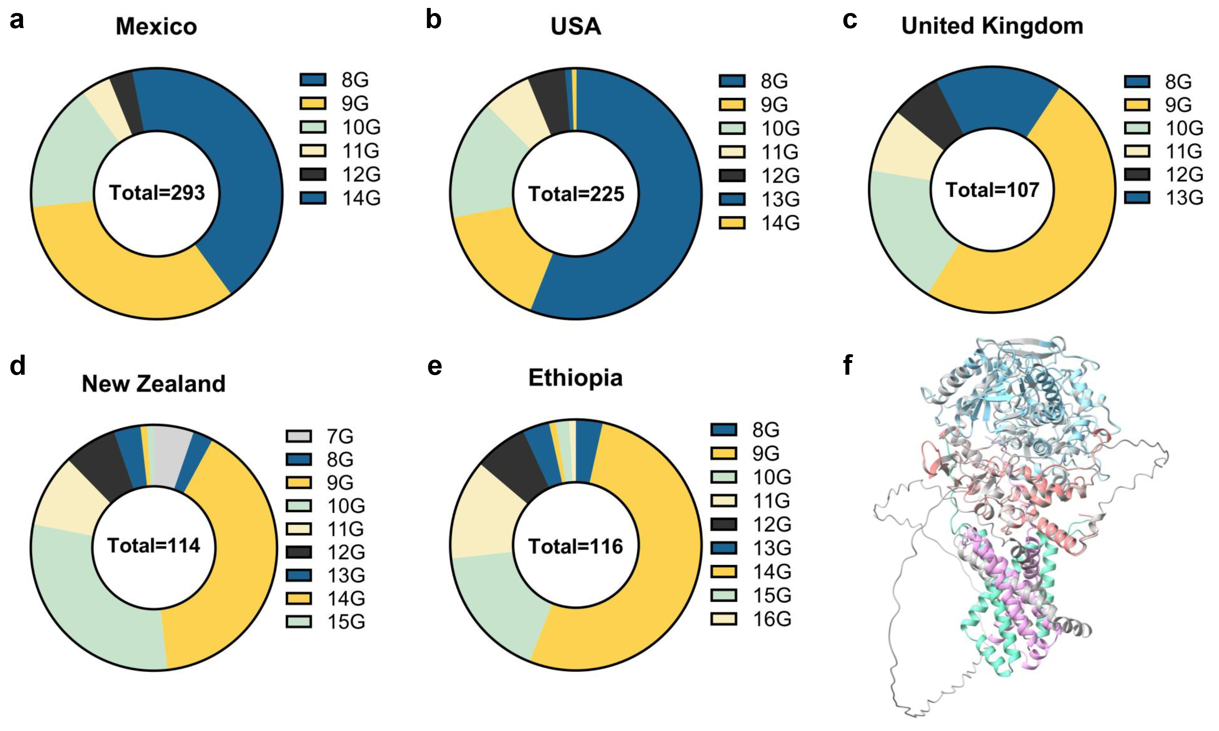
Supplementary Fig. 1 Insertion mutations in the frd 7G HT of M. bovis clinical isolates.
a–e Mutation frequency of M. bovis isolates from Mexico (a, n = 293), USA (b, n = 225), United Kingdom (c, n = 107), New Zealand (d, n = 114), and Ethiopia (e, n = 116). f 3D structural models of wild-type FRD (colored subunits: FrdA in blue, FrdB in red, FrdC in green, FrdD in purple) and the 9G HT mutant (gray). Source data are provided as a Source Data file.

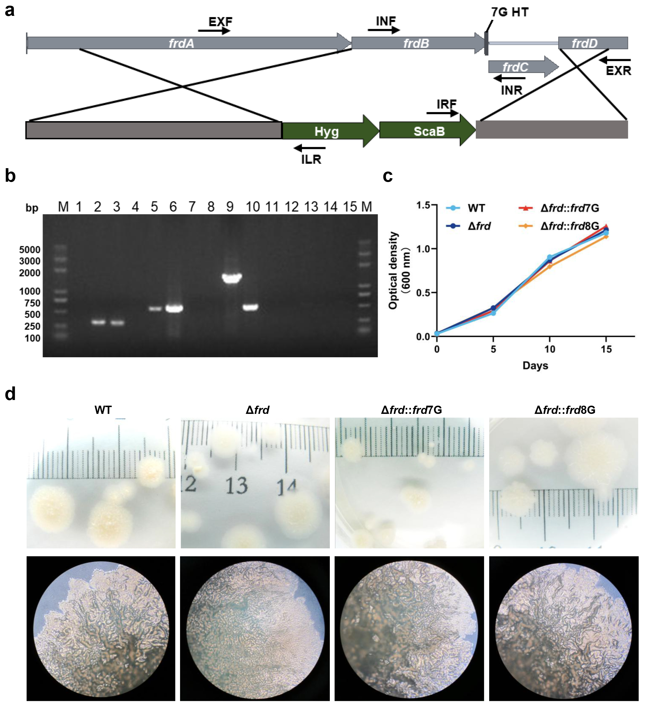
Supplementary Fig. 2 Construction and in vitro growth characterization of M. bovis Δfrd mutants.
a Schematic of PCR validation strategy for frd deletion mutants. Three primer pairs were designed: (1) Internal primers (INF/INR) flanking the frd deletion region, (2) External primers (EXF/EXR) targeting regions outside homologous arms, and (3) Vector-specific primers (ILR/IRF). b Agarose gel electrophoresis of PCR products from M. bovis Δfrd clones (lanes 1–5) versus wild-type (WT) strains (lanes 6–10). Lanes 1/6: INF/INR (Δfrd: no band; WT: target band). Lanes 2/7: EXF/ILR; lanes 3/8: EXR/IRF (Δfrd: target bands; WT: no bands). Lanes 4/9: EXF/EXR (Δfrd: no amplification; WT: target band). Lanes 5/10: 16S rRNA control (both amplified). Lanes 11–15: ddH₂O negative controls. c In vitro growth curves of M. bovis strains in Middlebrook 7H9 broth. d Colony morphology on Middlebrook 7H10 agar after 4-week incubation at 37°C. Source data are provided as a Source Data file.

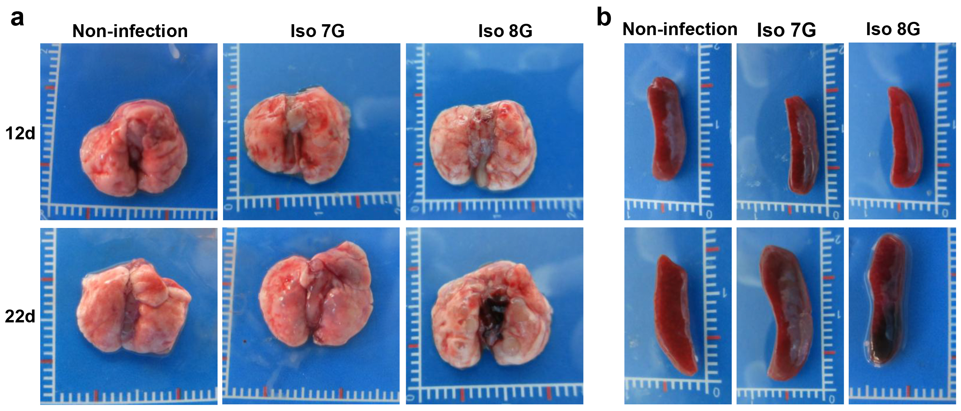
Supplementary Fig. 3 Gross pathology of murine lungs and spleens after clinical M. bovis infection.
C57BL/6 mice were intranasally challenged with 5,000 CFU of clinical M. bovis isolates (Iso 7G or Iso 8G). Representative gross lesions in (a) lungs and (b) spleens at 12 and 22 days post-infection.

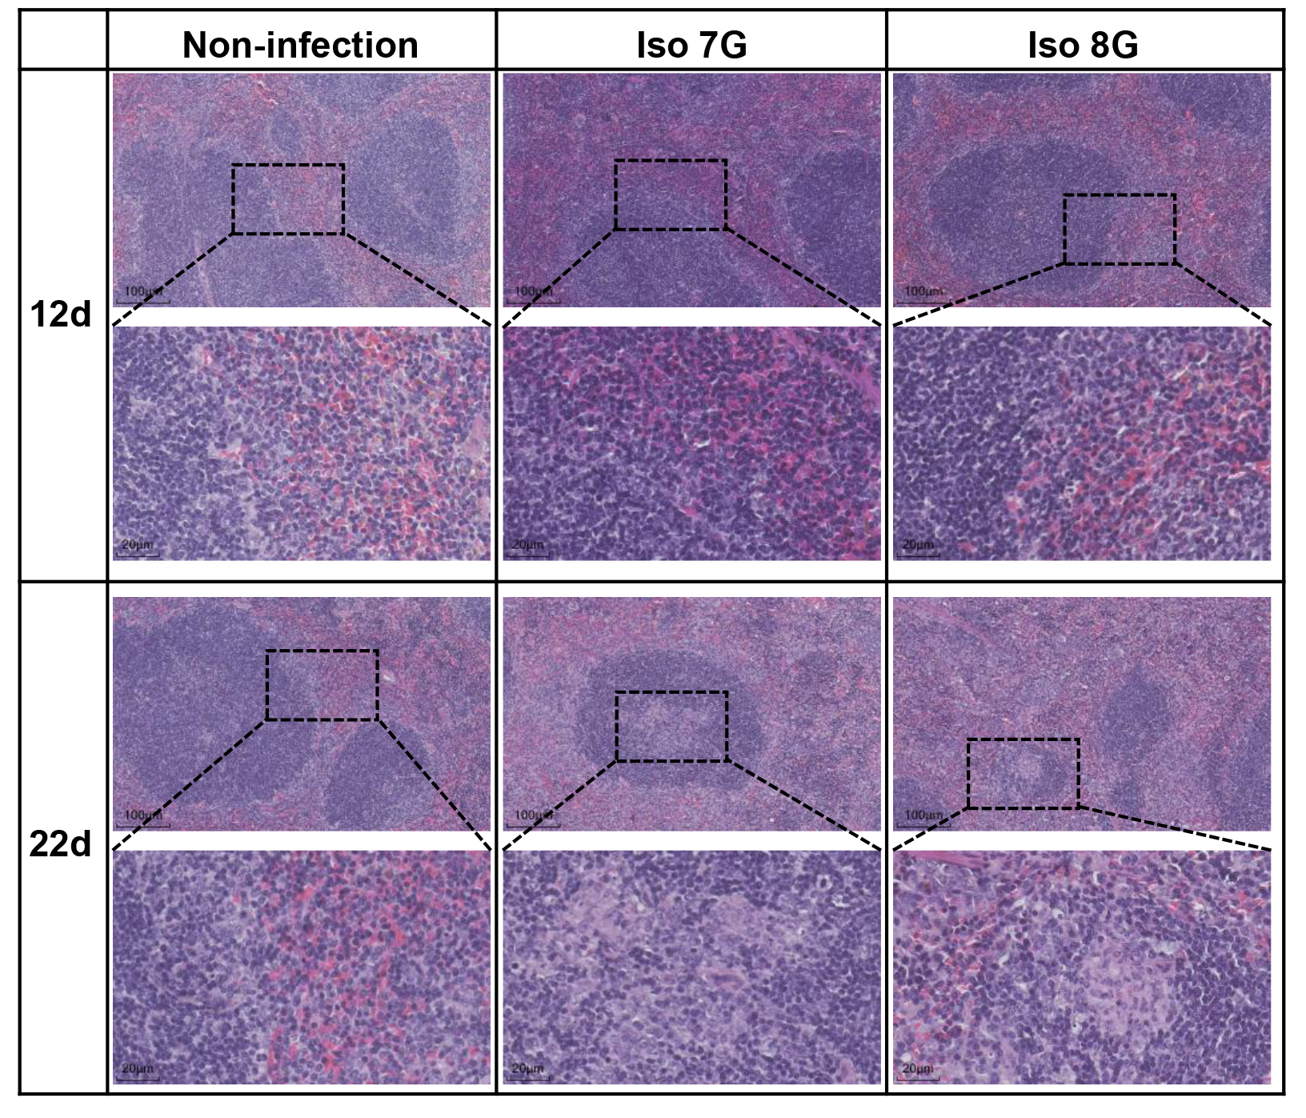
Supplementary Fig. 4 Histopathological analysis of murine spleens post-clinical M. bovis infection.
Hematoxylin and eosin (H&E)-stained splenic sections from mice infected with M. bovis Iso 7G or Iso 8G at 12 and 22 days post-infection. Scale bars, 100 μm (top) and 20 μm (bottom).

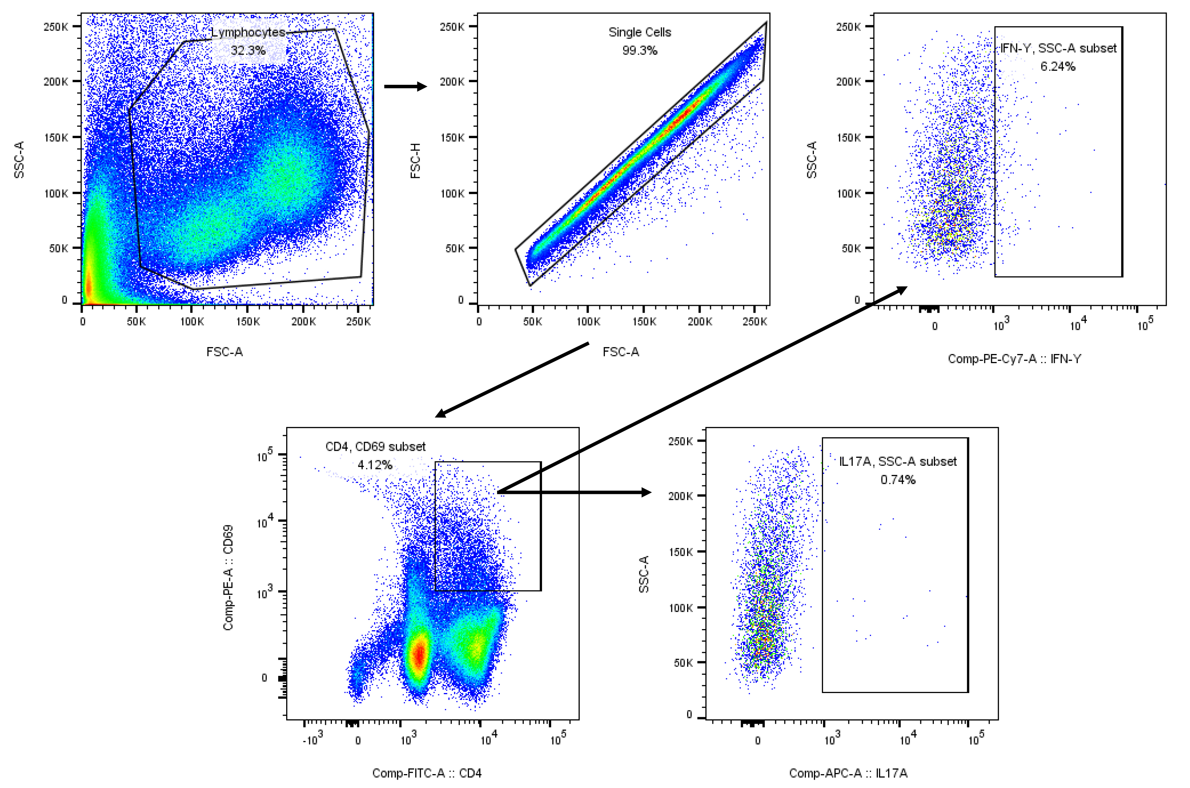
Supplementary Fig. 5 Gate strategy for flow cytometry analysis in animal experiments.

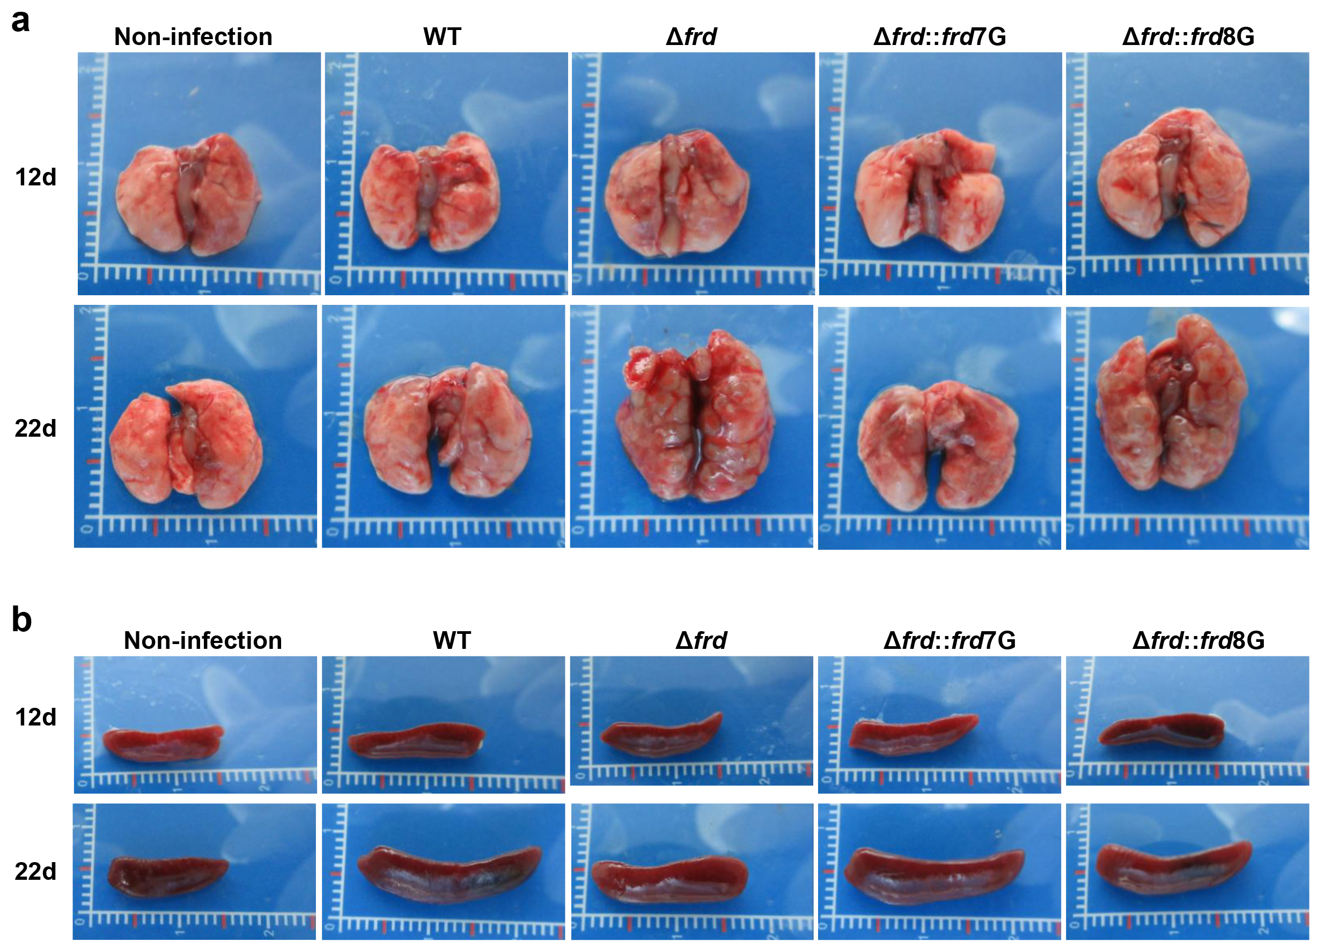
Supplementary Fig. 6 Gross pathology of murine lungs and spleens after infection with isogenic M. bovis derivatives.
C57BL/6 mice were intranasally challenged with 5,000 CFU of M. bovis strains: wild-type (WT), Δfrd, Δfrd::frd7G, or Δfrd::frd8G. Representative gross lesions in (a) lungs and (b) spleens at 12 and 22 days post-infection.

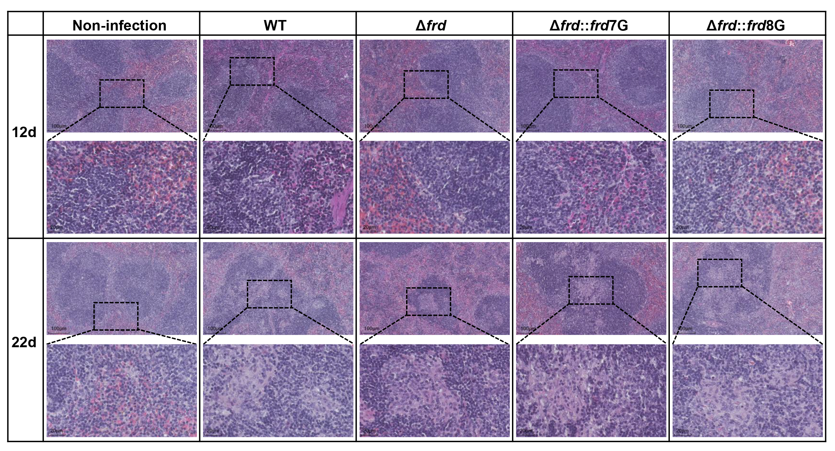
Supplementary Fig. 7 Splenic histopathology in mice infected with isogenic M. bovis strains.
C57BL/6 mice were intranasally challenged with 5,000 CFU of M. bovis strains: wild-type (WT), Δfrd, Δfrd::frd7G, or Δfrd::frd8G. Representative H&E-stained splenic sections at 12 and 22 days post-infection. Scale bars, 100 μm (top) and 20 μm (bottom).

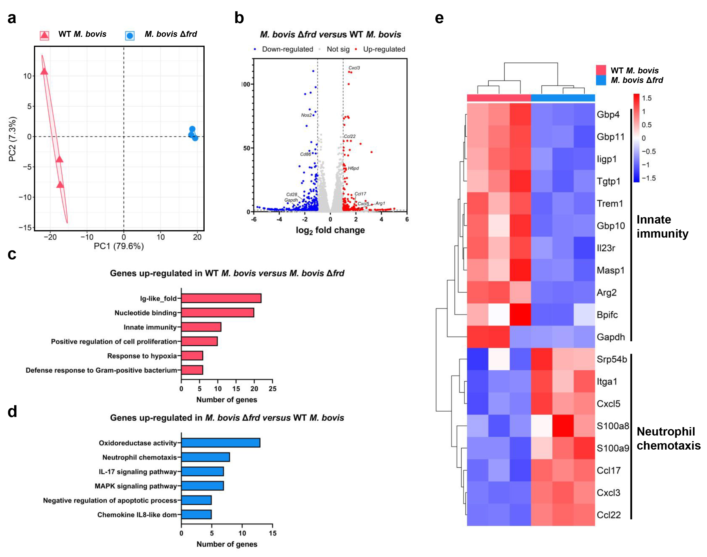
Supplementary Fig. 8 M. bovis Δfrd infection reprograms BMDM transcriptomic responses.
a Principal component analysis (PCA) of RNA-seq profiles from BMDMs 12 hours post-infection with wild-type (WT) M. bovis versus Δfrd mutant (n =3 biological replicates). b Volcano plot of differentially expressed genes (DEGs) (DESeq2; |log₂ fold change| >1, p < 0.05). c, d Significantly enriched biological processes and molecular functions were identified by the DAVID database functional annotation tool (minimal gene number = 5; EASE score threshold p < 0.05) among DEGs. e Hierarchical clustering of Z-score normalized RNA-seq expression values for DEGs (rows) across infection groups (columns). Source data are provided as a Source Data file.

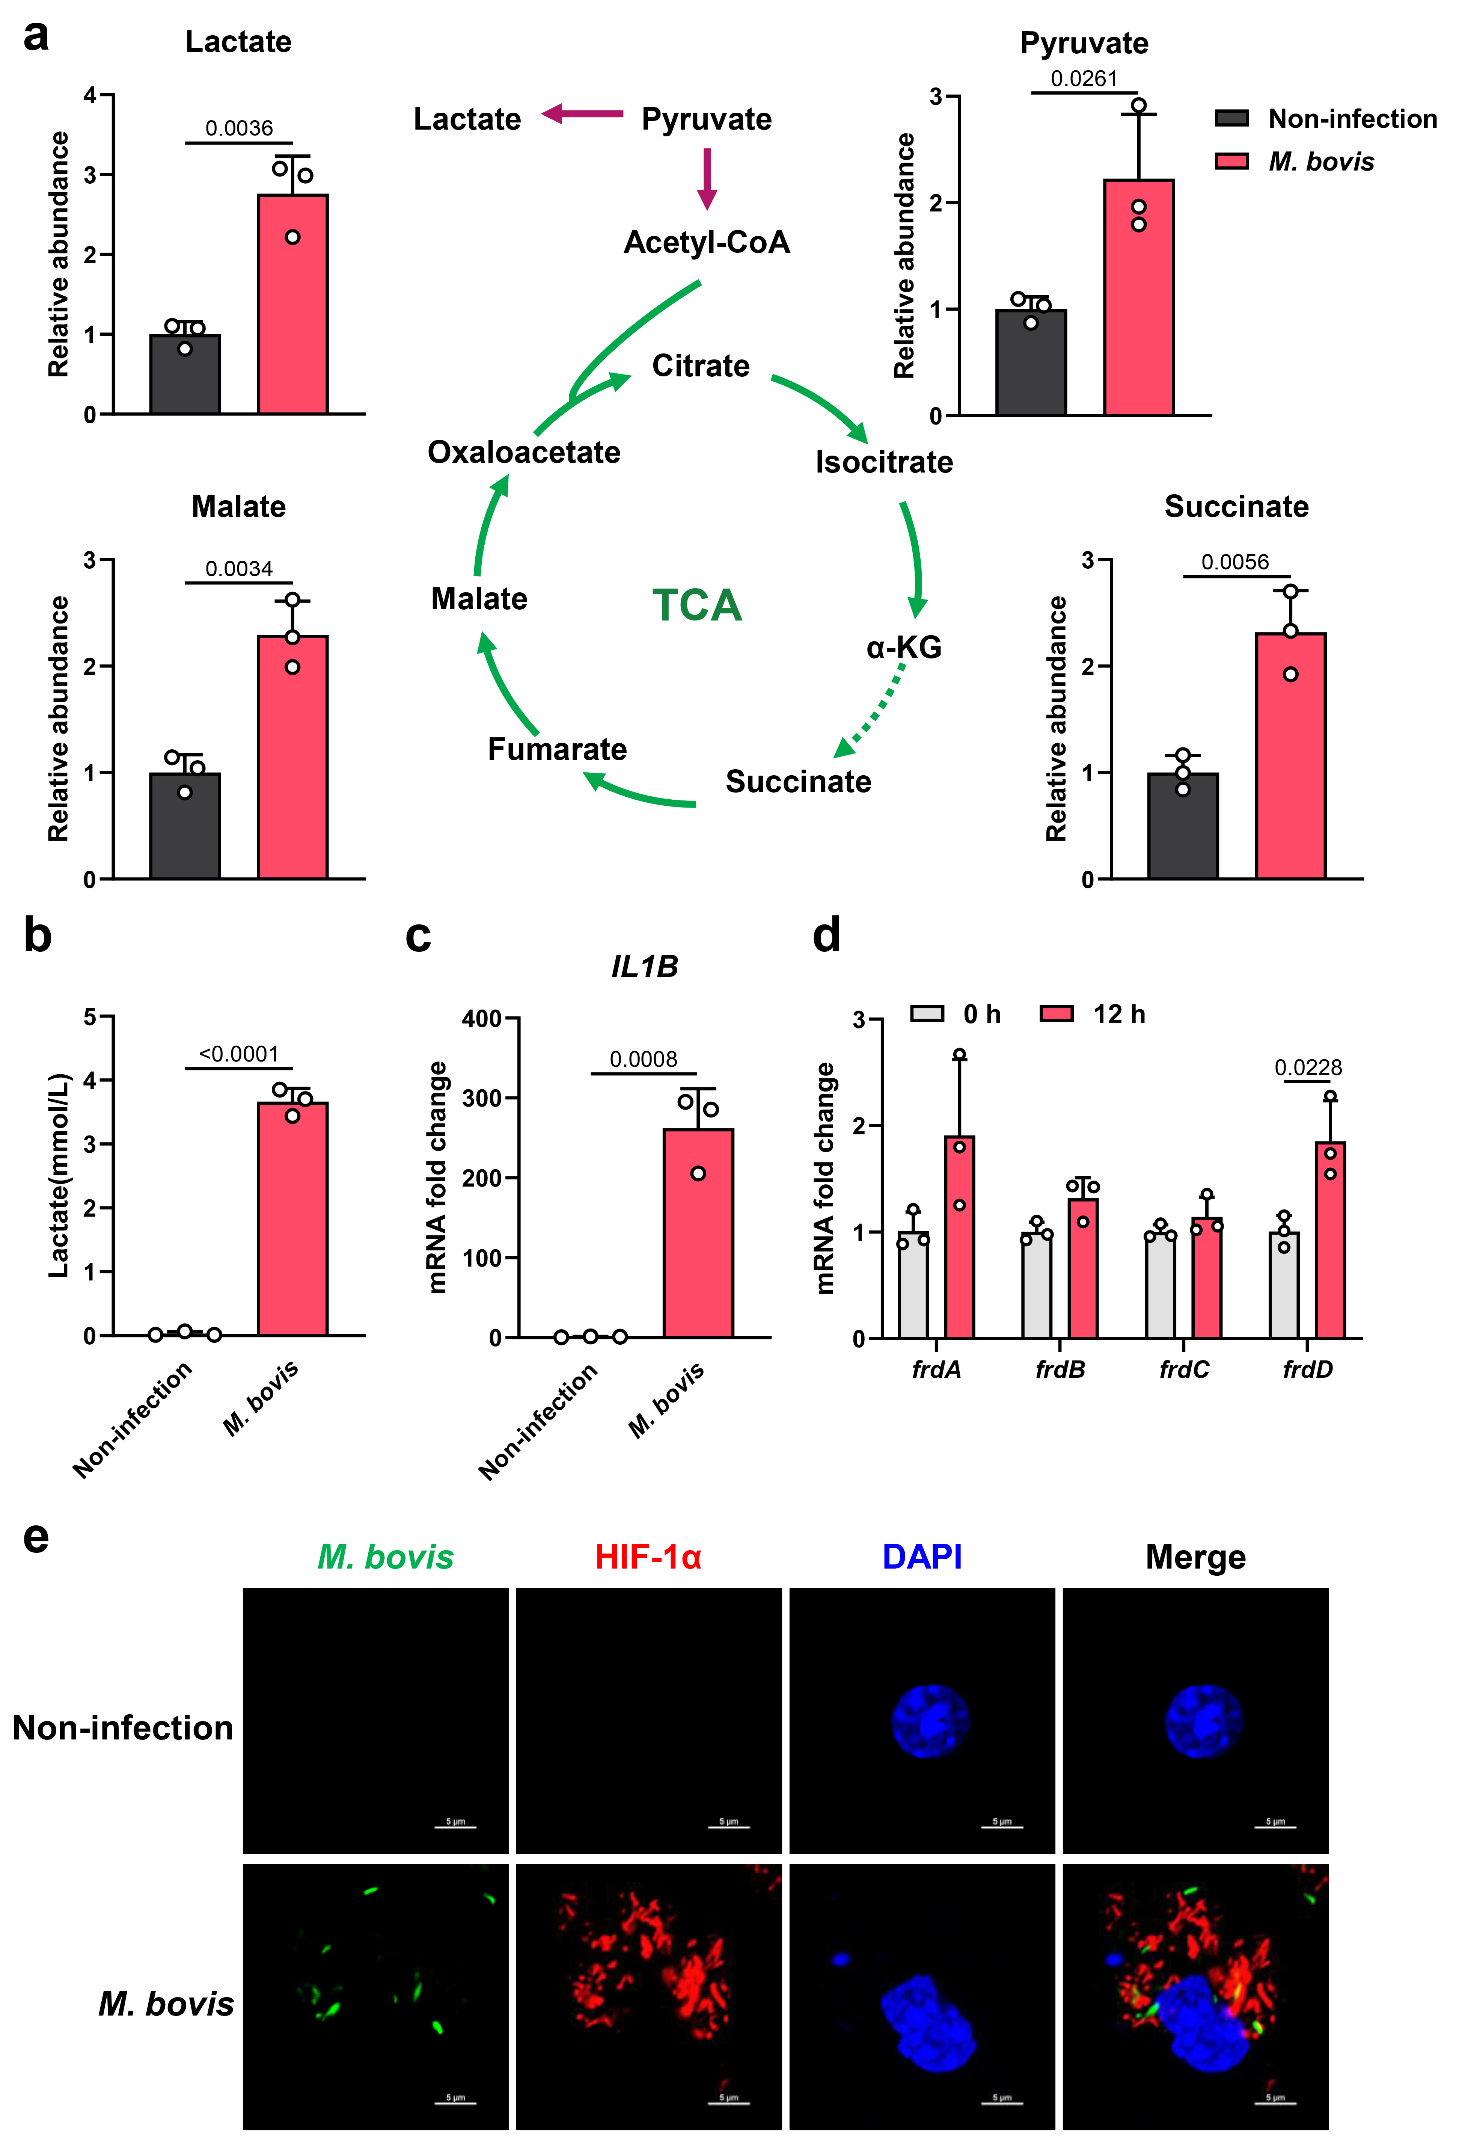
Supplementary Fig. 9 M. bovis remodels macrophage immunometabolism.
M. bovis infection of BMDMs 12 hours after infection; a Intracellular levels of central metabolites were measured by mass spectrometry (n = 3 biological replicates). b Lactate content in cell supernatant (n = 3 biological replicates). c Relative expression of IL1b (n = 3 biological replicates). d Expression of M. bovis frd operon genes in macrophages at 0 and 12 hours after infection (n = 3 biological replicates). e Infection of BMDMs with FITC-labeled M. bovis (green) to observe HIF-1α (red) expression; nuclei (blue) were stained with DAPI. Scale bar, 5 μm. Data are presented as mean values ± SD. p values depicted on the graphs were assessed using two-tailed unpaired Student’s t-test (a-d). Source data are provided as a Source Data file.
Supplementary Tables
Supplementary Table 1 Bacterial strains and plasmids used in this study
Name | Description | Reference
Strains
M. bovis C68004 | wild type M. bovis virulent strain | Laboratory stock
M. bovis Δfrd | frd operon knockout strain | This study
M. bovis Δfrd::frd7G | M. bovis Δfrd complementary strain with wild-type FRD (7G HT) | This study
M. bovis Δfrd::frd8G | M. bovis Δfrd complementary strain with FRD (8G HT) | This study
M. bovis Iso 7G | clinical M. bovis isolate harboring WT (7G HT) frd operon | Laboratory stock
M. bovis Iso 8G | clinical M. bovis isolate harboring WT (8G HT) frd operon | Laboratory stock
Vector Plasmid
pMV361-frd7G | For overexpression of wild-type FRD (7G HT) in M. bovis Δfrd | This study
pMV361-frd8G | For overexpression of FRD (8G HT) in M. bovis Δfrd | This study
p0004s-LR | For knockdown gene in M. bovis C68004 | This study
phAE159-p0004s-LR | For knockdown gene in M. bovis C68004 | This study

Supplementary Table 2 Primers used in this study
Name | 5’-3’ | purpose
frdLF | TTTTTTTTCCATAAATTGGGCTGGCTGCTCAACAAAGAC | gene knockout
frdLR | TTTTTTTTCCATTTCTTGGGGAGACCTCCATGACAATTCGA | gene knockout
frdRF | TTTTTTTTCCATAGATTGGGTGATCGTTGCCTGGATGGT | gene knockout
frdRR | TTTTTTTTCCATCTTTTGGTTGCACCGTGTCCTGGGT | gene knockout
INF | CCGATGCGAAACTTCCCGGTGA | knockout identification
INR | ACCAGGCCACGAAGATGCAAC | knockout identification
EXF | GCACACCAGCGAACCGACT | knockout identification
EXR | ACCAGGACCAGCACAACAAGC | knockout identification
IRF | GACACACCAACAGCATGGT | knockout identification
ILR | TCGACGACCCTAGAGTCC | knockout identification
16sRNAF | ACGGTGGGTACTAGGTGTGGGTTTC | knockout identification
16sRNAR | TCTGCGATTACTAGCGACTCCGACTTCA | knockout identification
frdF | GCGGATCCAGCTGCAGAATTCATGACCGCCCAACACAAC | pMV361-frd7G and pMV361-frd8G
frdR | TACGTCGACATCGATAAGCTTTTACATAGTGAGCAACATCCA | pMV361-frd7G and pMV361-frd8G
pMV361F | CGGAGGAATCACTTCGCAATGG | overexpression identification
pMV361R | GATGCCTGGCAGTCGATCGT | overexpression identification
β-actinF | GGCTGTATTCCCCTCCATCG | qRT-PCR
β-actinR | CCAGTTGGTAACAATGCCATGT | qRT-PCR
IL1bF | GAAATGCCACCTTTTGACAGTG | qRT-PCR
IL1bR | TGGATGCTCTCATCAGGACAG | qRT-PCR
LdhAF | TGTCTCCAGCAAAGACTACTGT | qRT-PCR
LdhAR | GACTGTACTTGACAATGTTGGGA | qRT-PCR
Nos2 F | GTTCTCAGCCCAACAATACAAGA | qRT-PCR
Nos2 R | GTGGACGGGTCGATGTCAC | qRT-PCR

