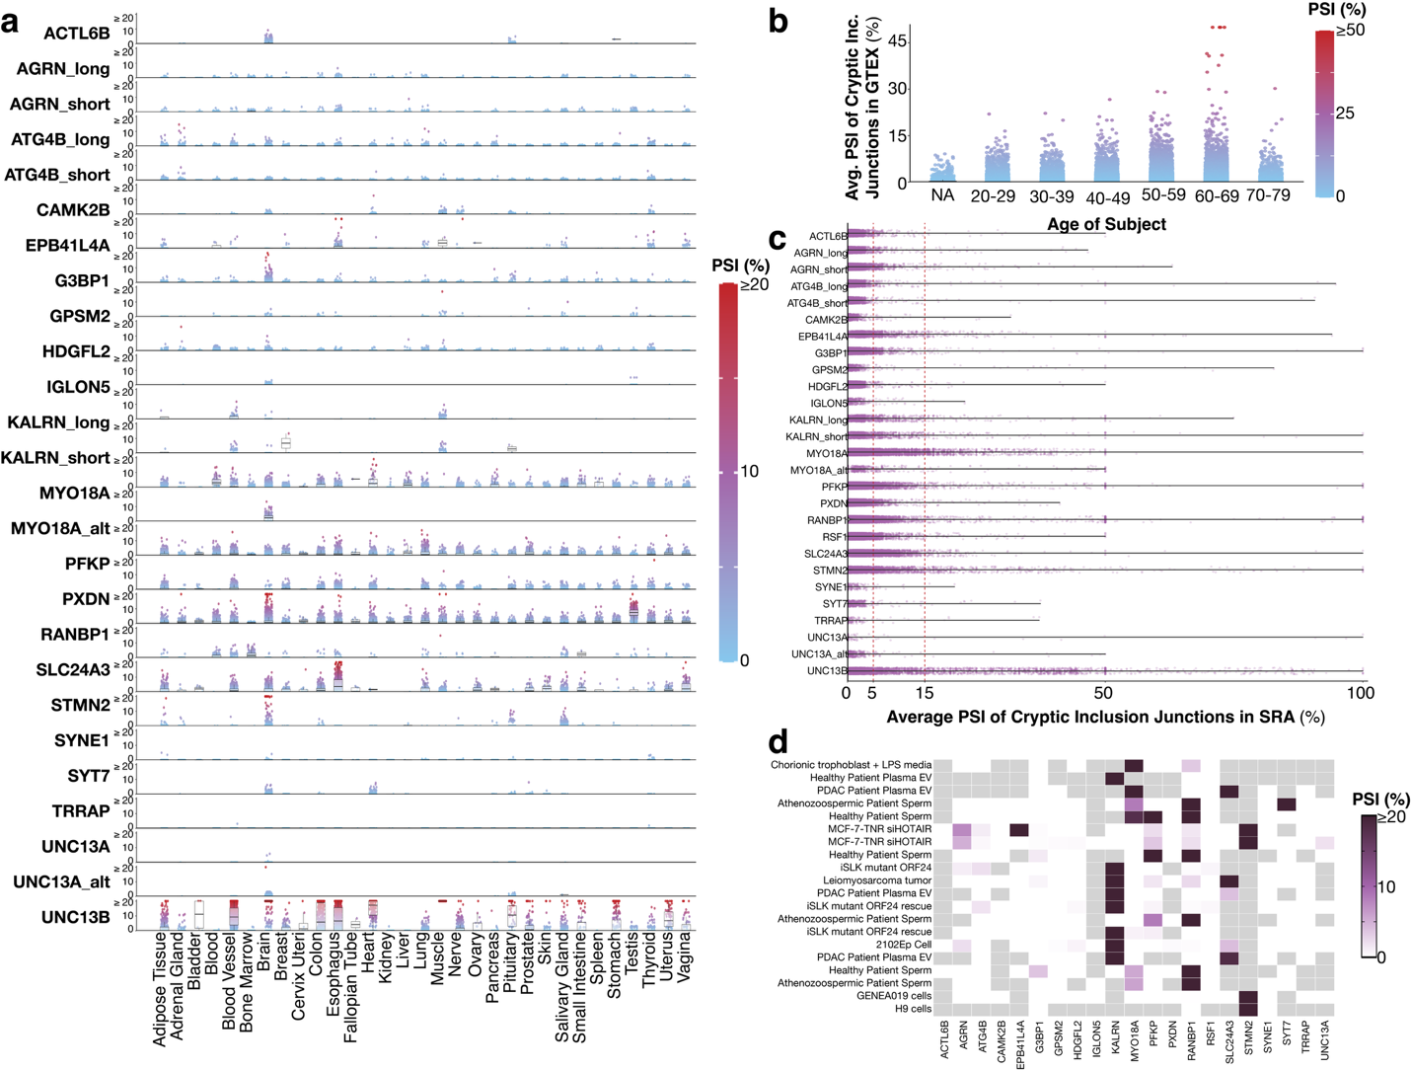Supplementary Figure 1: Using SnapMine to investigate GTEx and SRA data compilations can be mined for numerous additional cryptic exons. (a) Average percent spliced-in (PSI) values of human cryptic exons. Each point represents a sample in Genotype-Tissue Expression (GTEx) project dataset. Points are colored in a gradient from blue (PSI = 0%) to red (PSI ≥ 20%). The following tissues are sampled: adipose (n=28446), adrenal gland (n=6028), bladder (n=462), blood (n=23056), blood vessel (n=30756), bone marrow (n=4488), brain (n=64482), breast (n=10604), cervix uteri (n=418), colon (n=18084), esophagus (n=34694), fallopian tube (n=198), heart (n=20724), kidney (n=2156), liver (n=5522), lung (n=14410), muscle (n=19382), nerve (n=14498), ovary (n=4290, pancreas (n=7920), pituitary (n=6622), prostate (n=5786), salivary gland (n=3916), skin (n=42680), small intestine (n=4246), spleen (n=5610) stomach (n=8448), testis (n=9020), thyroid (n=15532), uterus (n=3498), vagina (n=3806). Data are presented as box plots with median and interquartile range, along with whiskers from minimum to maximum values. Each point represents a sample. (b) Visualization of overall average cryptic exon PSI values in human GTEx datasets by age. Each point represents a single sample. The following age ranges are included: 20-29 (n=32318), 30-39 (n=31218), 40-49 (n=65054), 50-59 (n=133474), 60-69 (n=139106), 70-79 (n=14168), and NA/unknown (n=4488). Points are colored in a gradient from blue (PSI = 0%) to red (PSI ≥ 50%). (c) Visualization PSI values of human-specific CEs can be extracted from and quantified in human SRA datasets using SnapMine. Data are presented as box plots with median and interquartile range, along with whiskers from minimum to maximum values. Each point represents a sample (n=259998). (d) Heatmap visualization of the top 20 human samples in SRA with high inclusion of all selected TDP-43-associated CEs without the words “TDP-43” or “ALS” in study title or sample names. A gradient from white (PSI = 0%) to deep purple (PSI ≥ 20%) is used to color the tiles. Gray tiles indicate the sum of the canonical and cryptic junction reads were less than 15 and, as such, the PSI cannot be calculated with certainty. Source data are provided as a Source Data file.

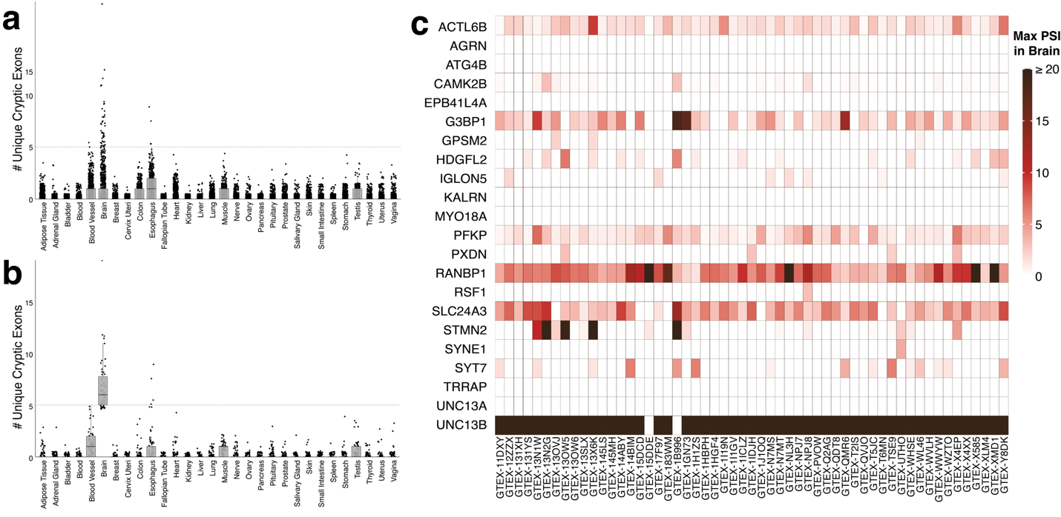
Supplementary Figure 2. Individuals excluded for potential undiagnosed TDP-43 pathology. (a-b) Tissue-specific expression of the number of unique cryptic exons in each tissue for individuals in Genotype-Tissue Expression (GTEx) project dataset. Tissue is positive for a cryptic exon if the average percent spliced-in (PSI) value was greater than or equal to 5%. Data are presented as box plots with median and interquartile range, along with whiskers from minimum to maximum values. Each point represents a unique individual. (a) Quantity of unique cryptic exons in each tissue of individuals with at least one cryptic exon-positive tissue (n=948). (b) Quantity of unique cryptic exons in each tissue type for individuals (n=62) identified with possible undiagnosed TDP-43 pathology. Each individual has at least five unique cryptic exons with greater than 5% PSI in their brain tissue samples. (c) Max average PSI of cryptic exon junctions measured in brain tissue samples for the individuals (n=62) with potential undiagnosed TDP-43 pathology. Individuals have relatively high rates of inclusion across the panel of cryptic exons. A gradient from white PSI = 0%) to deep red (PSI ≥ 20%) is used to color the tiles.

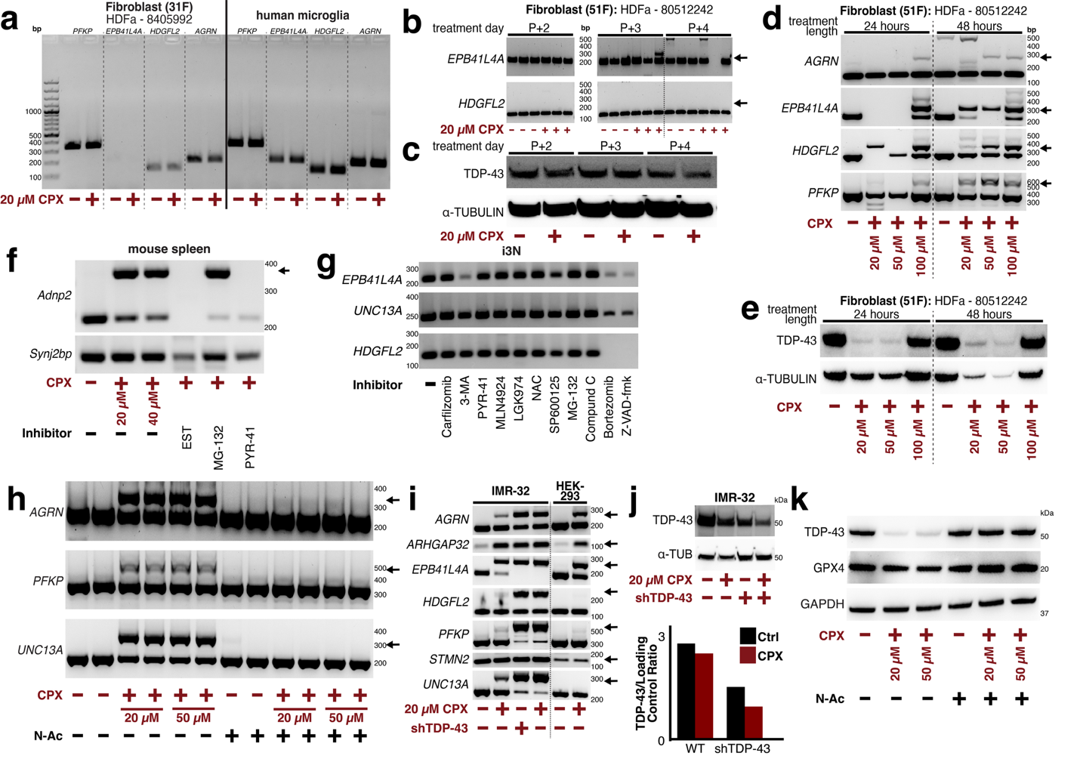
Supplementary Figure 3. Further confirmation of CPX treatment in various cell lines. (a-k) Representative quantification of targets of interest of samples treated with ciclopirox olamine (CPX). The black arrow points to the cryptic band in RT-PCR results. (a) Primary human dermal fibroblasts (HDF) (n=3) and induced pluripotent stem cell-derived microglia (hMg) (n=2) treated with 20 μM CPX for four hours do not incorporate CEs as measured by RT-PCR. (b-c) HDF treated with 20 µM CPX 2, 3, or 4 days after being plated do not have depleted TDP-43. (n=2). (b) CE inclusion tested using RT-PCR (c) TDP-43 protein levels measured through immunoblot (d-e) Human fibroblasts (n=2) treated with 20, 50, or 100 µM CPX for 24 or 48 hours. (d) CE inclusion tested using RT-PCR suggests longer treatment or higher dosages can induce CEs in HDF (e) TDP-43 protein levels measured through immunoblot suggests longer treatment or higher dosages can induce CEs in HDF (f) RT-PCR measurement of CEs of mouse spleen treated with various inhibitors in combination with CPX (n=2) (g) i³Neurons (i³N) treated with inhibitors only (no CPX) do not incorporate CE into RNA after 4.5 hour treatment as measured by RT-PCR (n=2). i³N treated with 3-MA, Z-VAD-fmk, and Bortezomib have reduced levels of RNA and viability. (h) IMR-32 treated with 20 or 50 µM CPX and/or 5mM N-Acetylcysteine (N-Ac) shows consistent suppression of TDP-43 associated cryptic events by N-Ac treatment as measured by RT-PCR (n=2). Duplicates are shown. (i) CE inclusion by RT-PCR is comparable to TARDBP knockdown in IMR-32 neuroblastoma and HEK293 cell lines after CPX treatment (n=2). IMR-32 has robust STMN2 and slight ARHGAP32 cryptic exon with no treatment. Not all CEs are expressed in all cell lines after CPX treatment. (j) Treatment of IMR-32 with CPX (n=3) leads to slight TDP-43 depletion on its own and worsens TDP-43 depletion in shTDP-43-treated cells as measured by immunoblot. (k) Treatment of IMR-32 cell-line with CPX (n=3) leads to TDP-43 depletion and slight GPX4 decrease as measured by immunoblot and N-Ac treatment leads to recovered levels of both. Source data are provided as a Source Data file.
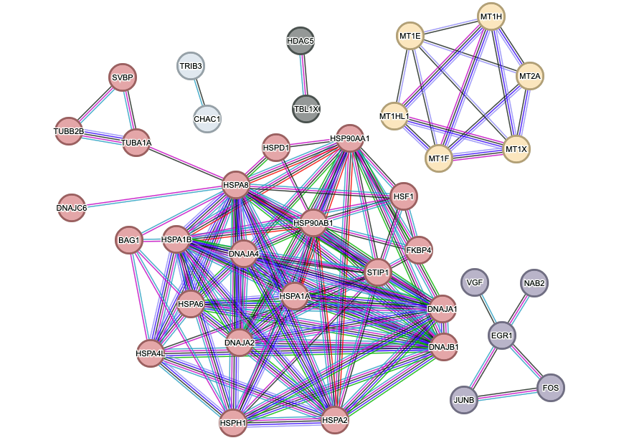
Supplementary Figure 4: Network Analysis of Gene Interactions in i3Neurons Treated with CPX via STRING Database. Protein-protein interaction networks from STRING show two main clusters among genes with log₂(fold change) > 2 following CPX treatment in i3Neurons: metallothionein genes (yellow) and heat-shock proteins (red), indicating responses to metal toxicity and cellular stress, respectively.

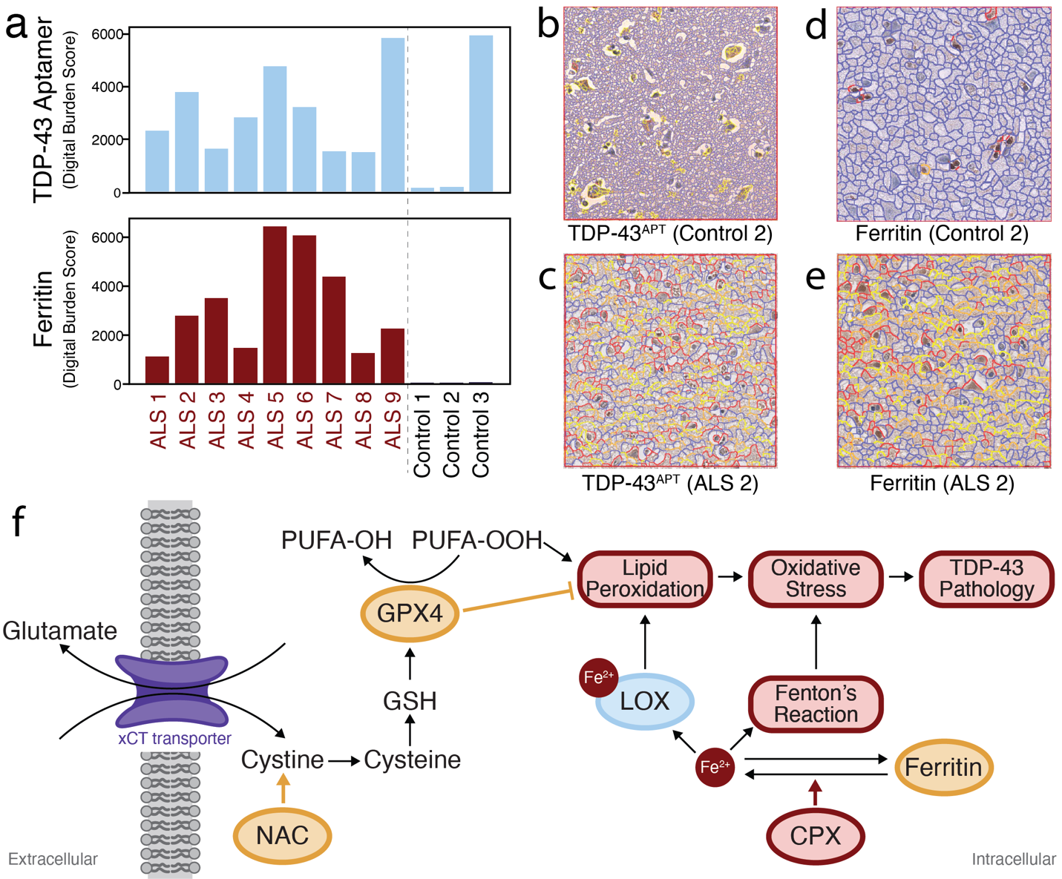
Supplementary Figure 5. Iron Dysregulation and Proposed Mechanism of CPX-Induced TDP-43 Pathology. (a) TDP-43 aptamer (TDP-43^{APT}) (light blue) and ferritin (red) staining in ALS cases (n=9) and controls (n=3), as measured using superpixel analysis of immunohistological staining. Ferritin staining is severely increased in ALS cases, indicating iron dysregulation. Due to the high levels of TDP-43 aptamer staining in control 3, it is possible that this patient is an undiagnosed or pre-symptomatic TDP-43 proteinopathy case. (b-e) Red box indicates a 200 µm x200µm section (b-c) Representative staining of TDP-43 in (b) Control 2, showing typical distribution without significant aggregation. (c) ALS 2, demonstrating abnormal aggregation and pathology associated with ALS. (d-e) Representative staining of ferritin in (d) Control 2, showing low levels indicative of normal iron regulation. (e) ALS 2, revealing high levels of ferritin, suggesting iron dysregulation and increased non-circulating iron burden. (f) Diagram of proposed mechanism of ciclopirox olamine (CPX)-induced TDP-43 pathology. CPX upregulates ferric permeases and reductases, converting iron from its 3+ to 2+ form. Fe²⁺ contributes to oxidative stress via cofactor activity with LOX, leading to lipid peroxidation and oxidative stress, which can induce TDP-43 pathology. Fe²⁺ also causes oxidative stress via Fenton's reaction. Ferritin is potentially upregulated in ALS due to iron-induced oxidative damage.

Gene | Inclusion Junction 1 Coordinates | Inclusion Junction 2 Coordinates | Exclusion Junction Coordinates
ACTL6B | chr7:100650136-100650574 | chr7:100650644-100655018 | chr7:100650136-100655018
AGRN_short | chr1:1044440-1044891 | chr1:1044988-1045160 | chr1:1044440-1045160
AGRN_long | chr1:1044440-1044891 | chr1:1045081-1045160 | chr1:1044440-1045160
ATG4B_long | chr2:241668686-241668781 | chr2:241668986-241670725 | chr2:241668686-241670725
ATG4B_short | chr2:241668686-241668874 | chr2:241668986-241670725 | chr2:241668686-241670725
EPB41L4A | chr5:112266331-112267209 | chr5:112267285-112275325 | chr5:112266331-112275325
G3BP1 | chr5:151786716-151787764 | chr5:151787795-151790322 | chr5:151786716-151790322
GPSM2 | chr1:108885579-108896316 | chr1:108896432-108896863 | chr1:108885579-108896863
HDGFL2 | chr19:4491836-4492014 | chr19:4492153-4493702 | chr19:4491836-4493702
PFKP | chr10:3099353-3099556 | chr10:3099820-3101364 | chr10:3099353-3101364
RANBP1 | chr22:20122422-20122579 | chr22:20122698-20125307 | chr22:20122422-20125307
STMN2 | chr8:79611215-79616821 | NA | chr8:79611215-79636801
UNC13A | chr19:17641557-17642413 | chr19:17642542-17642844 | chr19:17641557-17642844
UNC13A_alt | chr19:17641557-17642413 | chr19:17642592-17642844 | chr19:17641557-17642844
UNC13B | chr9:35313990-35364544 | chr9:35364568-35366946 | chr9:35313990-35366946
SLC24A3 | chr20:19681992-19683912 | chr20:19683961-19684175 | chr20:19681992-19684175
IGLON5 | chr19:51311927-51320385 | chr19:51320671-51322063 | chr19:51311927-51322063
KALRN_long | chr3:124700034-124700976 | chr3:124701256-124702037 | chr3:124700034-124702037
KALRN_short | chr3:124700034-124701092 | chr3:124701256-124702037 | chr3:124700034-124702037
MYO18A | chr17:29122254-29131382 | chr17:29131443-29165941 | chr17:29122254-29165941
MYO18A_alt | chr17:29124689-29131382 | chr17:29131443-29165941 | chr17:29124689-29165941
RSF1 | chr11:77764690-77813212 | chr11:77813784-77820527 | chr11:77764690-77820527
SYT7 | chr11:61547309-61547529 | chr11:61547621-61551383 | chr11:61547309-61551383
SYNE1 | chr6:152244657-152247822 | chr6:152247945-152249160 | chr6:152244657-152249160
CAMK2B | chr7:44254608-44258489 | chr7:44258611-44258871 | chr7:44254608-44258871
PXDN | chr2:1649676-1650799 | chr2:1650887-1653627 | chr2:1649676-1653627
TRRAP | chr7:98881251-98881694 | chr7:98881737-98881974 | chr7:98881251-98881974

Supplementary Table 1. Coordinates of queried human cryptic exon junctions using hg38 assembly.

Gene | Inclusion Junction 1 Coordinates | Inclusion Junction 2 Coordinates | Exclusion Junction Coordinates
Adnp2 | chr18:80137574-80138152 | chr18:80138305-80142648 | chr18:80137574-80142648
Bud23 | chr5:135061345-135063780 | NA | chr5:135061345-135063883
Crem | chr18:3276730-3278080 | chr18:3278225-3280948 | chr18:3276730-3280948
Fam135a | chr1:24022006-24022506 | NA | chr1:24022006-24024212
Hdac4 | chr1:92054973-92141519 | chr1:92141582-92148255 | chr1:92054973-92148255
Ift81 | chr5:122555543-122556905 | chr5:122556992-122559154 | chr5:122555543-122559154
Pnpla6 | chr8:3524330-3524947 | NA | chr8:3524330-3530961
Slc7a6 | chr8:106169257-106179101 | NA | chr8:106168955-106179101
Smg5 | chr3:88336498-88340648 | chr3:88340764-88341857 | chr3:88336498-88341857
Spata7 | chr12:98634320-98634590 | chr12:98634645-98637565 | chr12:98634320-98637565
Synj2bp | chr12:81510052-81510828 | NA | chr12:81504640-81510828
Tbc1d1 | chr5:64339732-64339816 | chr5:64339927-64345251 | chr5:64339732-64345251
Tecpr1 | chr5:144214420-144215737 | chr5:144215791-144216252 | chr5:144214420-144216252
Unc13a | chr8:71666671-71667328 | chr8:71667373-71671625 | chr8:71666671-71671625

Supplementary Table 2. Coordinates of queried mouse cryptic exon junctions using mm10 assembly.

Compound | Inhibits | Catalog Number | Solvent | Working Concentration
3-MA | Autophagy | Sigma-Aldrich  189490 | DMSO | 10  mM
Bortezomib | 20S proteasome | Sigma-Aldrich 5043140001 | DMSO | 100 nM
Carfilzomib | Proteasome | Selleck S2853 | DMSO | 35 nM
Compound  C (Dorsomorphin) | AMPK | Sigma-Aldrich 171261 | DMSO | 5 µM
LGK974 | Porcn Inhibitor (Wnt  pathway) | Sigma-Aldrich 5310910001 | DMSO | 1 µM
MG-132 | Proteasome | Sigma-Aldrich M7449 | DMSO | 10 µM
MLN4924 | Neddylation | Cell Signaling Tech 85923S | DMSO | 1 µM
N-acetylcysteine | ROS | Selleck S1623 | Water | 5 mM
PYR-41 | Ubiquitin E1 | Sigma-Aldrich 662105 | DMSO | 50 µM
SP600125 | JNK, Ser/Thr Kinase | Selleck S1460 | DMSO | 10 µM
Z-VAD-fmk | Pan caspase | Selleck S7023 | DMSO | 100 µM

Supplementary Table 3. Small molecule inhibitors tested.

Phase I | Step | Temperature | Time
1 | Denature | 98.0°C | 0:00:30
Phase II | Step | Temperature | Time
1 | Denature | 98.0°C | 0:00:10
2 | Anneal | 70.0°C * | 0:00:10
3 | Elongate | 72.0°C | 0:00:24
Repeat steps 1-3 (10 times)
*Every time steps 1-3 are repeated, the annealing temperature should be decreased by 1 °C/cycle
Phase III | Step | Temperature | Time
1 | Denature | 98.0°C | 0:00:10
2 | Anneal | 60.0°C | 0:00:10
3 | Elongate | 72.0°C | 0:00:24
Repeat steps 1-3 (20-30 times)
Phase IV | Step | Temperature | Time
1 | Elongate | 72.0°C | 0:05:00
2 | Halt | 4°C | Hold

Supplementary Table 4. Touchdown PCR protocol used to amplify cryptic exon bands for RT-PCR.

Species | Target | Forward Primer  (5’ 3’) | Reverse Primer  (5’ 3’) | Band size (bp)
Mouse | Adnp2 | CTTGACAACATCAGGAAGGTGC | TTGTCCGGTATCTCGCTTTCT | WT: 187  CE: 339
Mouse | Camk1g (42) | CTGGCCAAGATCACAGACTGG | CTGTGTAGACACCACGCTCT | WT: 423  CE: 509
Mouse | Ift81 | AAGTGCGAGGACTTCGTGAG | CAGCGATCTGTCTGCTTTGC | CE: 187
Mouse | Synj2bp | CTCCAACGACAGTGGCATCT | TCTTCCTGAGGACCTCCGTT | CE: 224
Mouse | Tbc1d1 | CCTGGTGCAGATGGAGAAGAC | TGTCACTGAGAGGCGAGGAC | WT: 128  CE: 238
Mouse | Tecpr1 | AGTCAGACTGGTACGTGGATGAG | GTGGCTGACATCCTCTCGG | WT: 329  CE: 382
Mouse | Unc13a | CAGACACTGAGAATCTCAAG | CAGGCGGTTGATCTCAAACATGA | CE: 166
Mouse | Usp15 | GGTCCCTCTACTCCTAAGTCCC | TGGCTGTTCATTGTTTCTTCCAG | WT: 192  CE: 356
Human | AGRN | GATGGGGTCACCTACAGCAC | GGCTGCGGTGATATTGTCCT | WT: 183,  short CE: 279,  long CE: 372
Human | AGRN  (Fig. S3A) | CAGCCCGGTGTGCGGCTCAGATG | GTTGCACTGGCAGGCACTGGG | WT: 247,  short CE: 340,  long CE: 436
Human | ARHGAP32 (123) | GAGGGTGTTTGGTTGTGACC | TTCAGGGAGATGGTTTCCAG | CE: 74
Human | EPB41L4A | TGTGACAGAAGCCATCAGACG | GCCCTGAAGGACATCTTGCT | WT: 195  CE: 270
Human | HDGFL2 | CAGCGACCAGGACTTCACAC | GAATCGGCCTTGGAGTCGGA | WT: 123  CE: 261
Human | PFKP | AAGTTCCTGGAGCACCTCTC | CACACACAGGTTGGTGATGC | WT: 330  CE: 593
Human | STMN2 (59) | GACTCAGTGCCTTATTCAGT | TTTCTCTCGAAGGTCTTCTG | CE: 142
Human | UNC13A (60) | CAACCTGGACAAGCGAACTG | GGGCTGTCTCATCGTAGTAAAC | WT: 227  CE: 355

Supplementary Table 5. Primers utilized to amplify cryptic exons. All primers were synthesized by Integrated DNA Technologies. Unless otherwise cited, all primers were designed for this publication.

Target | Host | Company | Catalog # | Concentration | Lot Number
Alpha Tubulin | Mouse | ProteinTech | HRP-66031 | 1:20000 | 21006026
TDP-43 | Rabbit | ProteinTech | 10782-2-AP | 1:2000 | 00128435
TDP-43 | Rabbit | ProteinTech | 81350-1-RR | 1:5000 | 23002373
Ferritin | Rabbit | abcam | ab287968 | 1:100 | unknown
GAPDH | Rabbit | ProteinTech | HRP-60004 | 1:5000 | 21010938
GPX4 | Mouse | ProteinTech | 67763-1-Ig | 1:1000 | 10027858

Supplementary Table 6. Antibodies utilized for immunoblots and staining.

