Shared Genetic Architecture Contributes to Risk of Major Cardiovascular Diseases
Jun Qiao^{1,2}, Lei Jiang^{3✉}, Liuyang Cai^{1,2}, Minjing Chang⁴, Can Wang⁵, Rong Zhao⁶, Shan Song⁷, Yuhui Zhao⁸, Miaoran Chen⁸, Shifang Ding^{9,10}, Ning Tan³, Pengcheng He³, Sakthivel Sadayappan¹¹, Jinguo Xu^{12✉}, Siim Pauklin^{13✉}, Zhengbing Liu^{9,14✉}, Yuliang Feng^{1,2✉}
¹ Department of Geriatrics, Shenzhen People's Hospital (The First Affiliated Hospital of Southern University of Science and Technology); Department of Pharmacology, SUSTech Homeostatic Medicine Institute, School of Medicine, Southern University of Science and Technology, Shenzhen, China.
² Joint Laboratory of Guangdong-Hong Kong Universities for Vascular Homeostasis and Diseases, Shenzhen, China.
³ Department of Cardiology, Guangdong Cardiovascular Institute, Guangdong Provincial People's Hospital (Guangdong Academy of Medical Sciences), Southern Medical University, Guangzhou, China.
⁴ School of Public Health and Emergency Management, Southern University of Science and Technology, Shenzhen, China.
⁵ Department of Health Statistics, School of Public Health, Shanxi Medical University, Taiyuan, China.
⁶ School of Medicine, South China University of Technology, Guangzhou, China.
⁷ Department of Rheumatology and Clinical Immunology, Peking University First Hospital, Beijing, China
⁸ Department of Rheumatology, The Second Hospital of Shanxi Medical University, Shanxi Key Laboratory of Rheumatism Immune Microecology, Shanxi Precision Medical Engineering Research Center for Rheumatology, Taiyuan, China.
⁹ The First School of Clinical Medicine, Southern Medical University, Guangzhou, China.
¹⁰ Department of Cardiology, General Hospital of Central Theater Command, Wuhan Clinical Medicine College of Southern Medical University, Wuhan, China.
¹¹ Heart, Lung and Vascular Institute, Department of Internal Medicine, Division of Cardiovascular Health and Disease, University of Cincinnati, Cincinnati, Ohio, USA.
¹² Department of Cardiovascular Surgery, First Affiliated Hospital of Anhui Medical University, Hefei, China.
¹³ Botnar Research Centre, Nuffield Department of Orthopaedics, Rheumatology and Musculoskeletal Sciences, University of Oxford, Headington, Oxford, UK.
¹⁴ Department of Cardiology, Jinling Hospital, Affiliated Hospital of Medical School, Nanjing University, Nanjing, China.
Supplementary Figures and Notes Page
Supplementary Fig. 1. Power plot illustrating percentage of variance explained by genome-wide significant SNPs (y-axis) at a given sample size (x-axis) for each of the cardiovascular diseases . 1
Supplementary Fig. 2. Supplemental MiXeR figures for each of the six cardiovascular diseases ............................................................................................................................................. 2
Supplementary Fig. 3. The forest plot for associations between pairs of cardiovascular diseases in bidirectional MR analysis ............................................................................................................ 6
Supplementary Fig. 4. Manhattan plots for the single-trait GWAS and MTAG results of each of the six cardiovascular diseases ......................................................................................................... 7
Supplementary Fig. 5. Quantile-quantile (Q-Q) plots for the single-trait GWAS results of each of the six cardiovascular diseases........................................................................................................ 10
Supplementary Fig. 6. Manhattan plots for the CPASSOC results of the six cardiovascular diseases ........................................................................................................................................... 13
Supplementary Fig. 7. Profile of cardiovascular disease associations for the other 10 pleiotropic loci .................................................................................................................................................. 14
Supplementary Fig. 8. Eleven pleiotropic loci with the same directional effects ....................... 17
Supplementary Fig. 9. The results of multiple-tissue analysis using gene expression data for six cardiovascular diseases .................................................................................................................. 19
Supplementary Fig. 10. The results of multiple-tissue analysis using chromatin data for six cardiovascular diseases .................................................................................................................. 21
Supplementary Fig. 11. The result of GARFIELD enrichment for MTAG_AF_EUR, MTAG_CAD_EUR, and MTAG_VTE_EUR in the genic regions: DHS (hotspots) regions, chromatin states, and histone-modified regions of different tissues .............................................. 24
Supplementary Fig. 12. Proteome-wide MR and Colocalization analysis of the six cardiovascular diseases ........................................................................................................................................... 27
Supplementary Note 1. Additional information on cardiovascular diseases for European populations...................................................................................................................................... 28
Supplementary Note 2. Additional information on negatively correlated loci identified by LAVA ............................................................................................................................................ 31
Supplementary Note 3: Additional information on shared genetic architecture between HF and PAD ............................................................................................................................................... 33
Supplementary Note 4. Additional information on MTAG-identified new loci ......................... 33
Supplementary Note 5. Additional information on prioritization of genes from the MTAG identified loci ................................................................................................................................. 40
Supplementary Note 6. Causal proteins identified by Proteome-wide MR and Colocalization analysis ........................................................................................................................................... 41
Supplementary Note 7. Causal inference between 24 metabolic traits/diseases and 6 major CVDs...........................................................................................................................................… 42
Supplementary Note 8. Shared genetic architecture contributes to risk of major cardiovascular diseases of East Asian ancestry...................................................................................................… 47
Supplementary References ..................................................................................................…… 53
(Source data are provided with this paper)
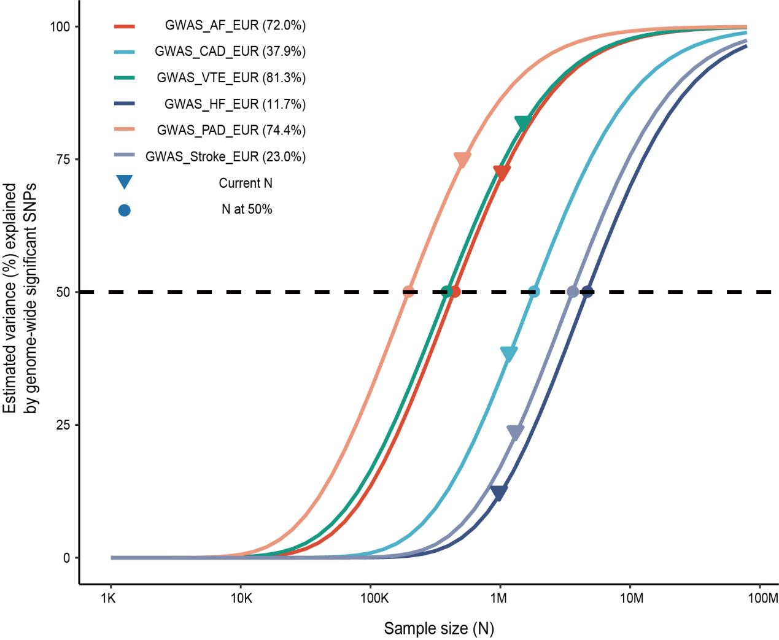
Supplementary Fig. 1. Power plot illustrating percentage of variance explained by genome-wide significant SNPs (y-axis) at a given sample size (x-axis) for each of the cardiovascular diseases.
The sample size required to discover 50% variance for each phenotype is represented by the dot. The current sample size for each phenotype is represented by a triangle, and the estimated variance (%) based on current sample size is listed in parentheses in the legend.
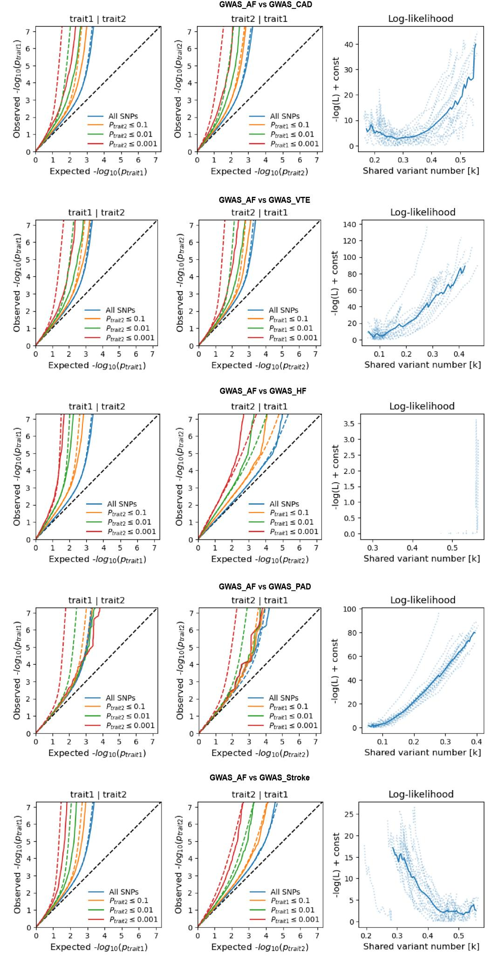
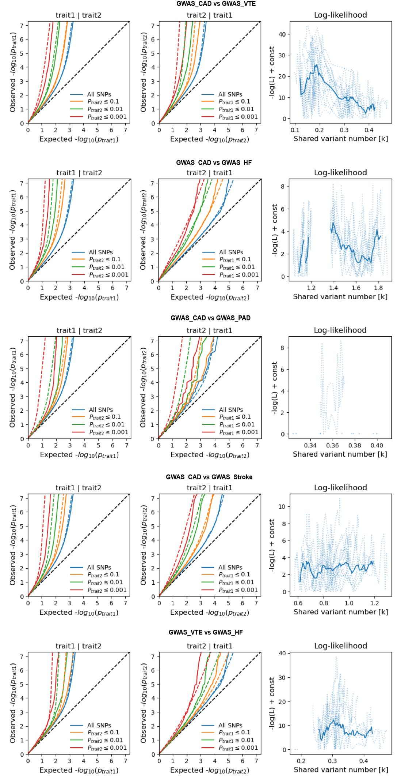
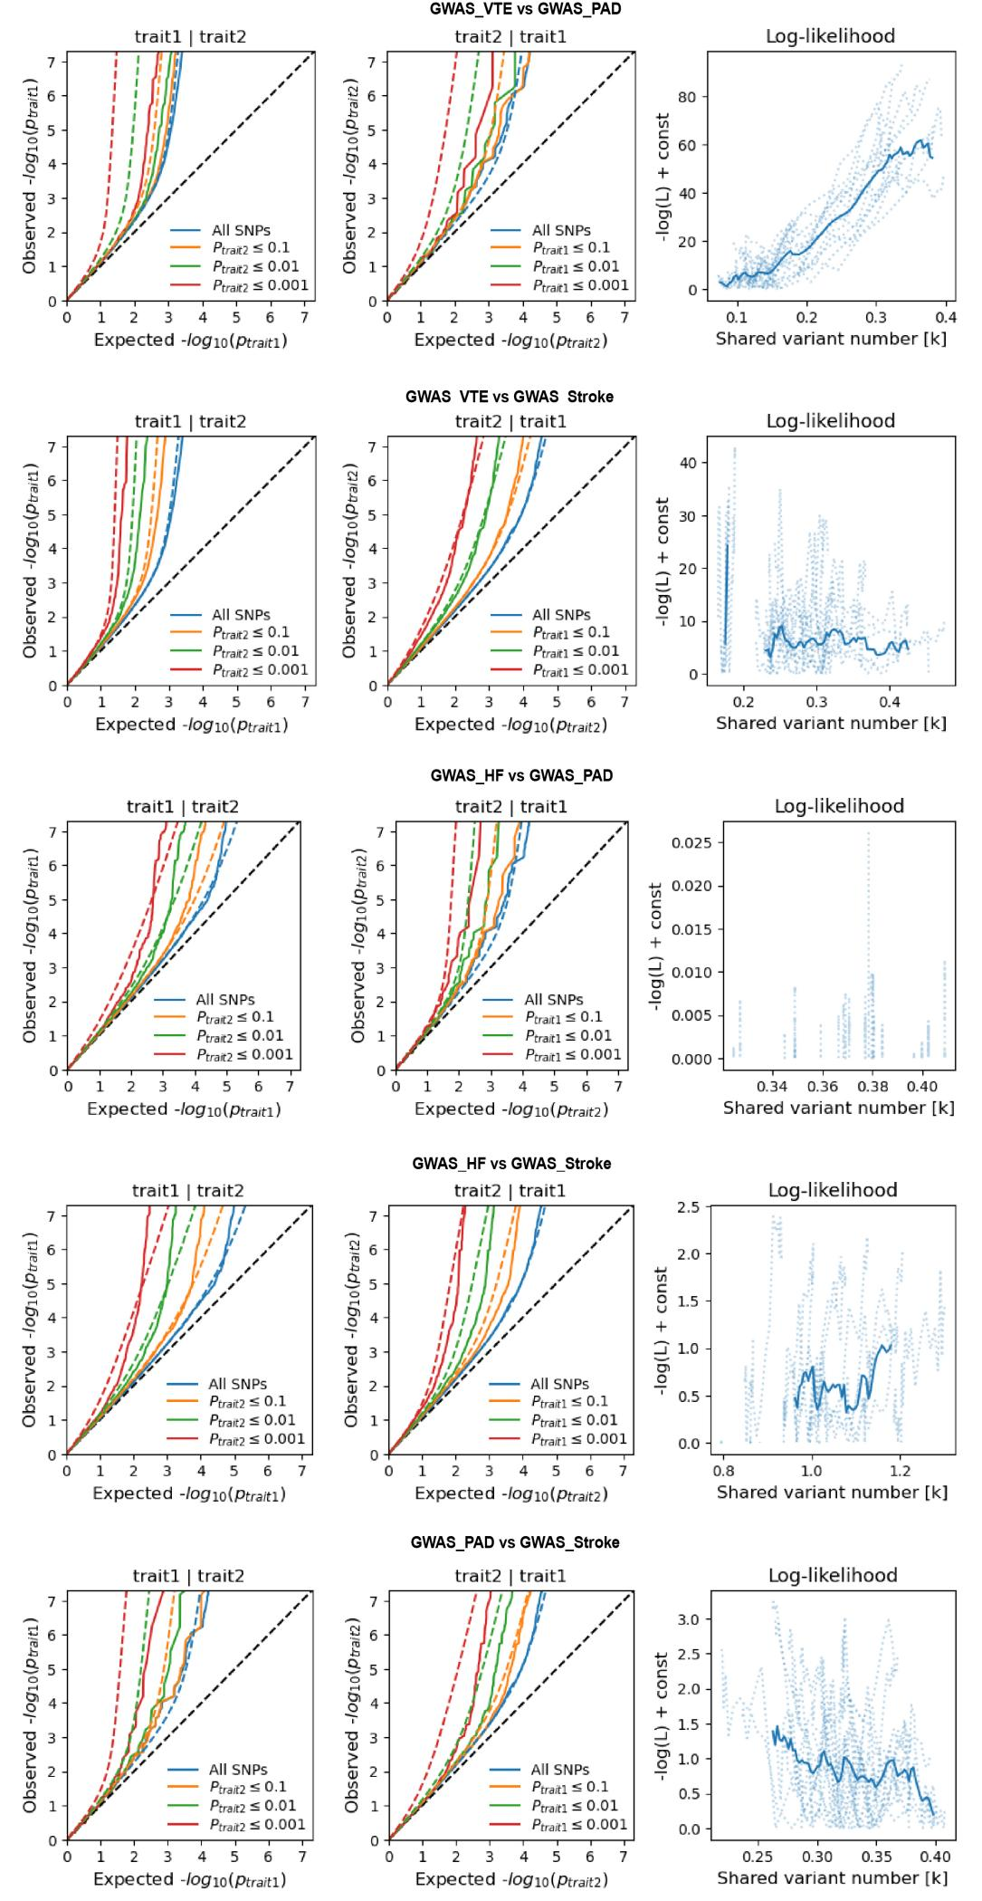
Supplementary Fig. 2. Supplemental MiXeR figures for each of the six cardiovascular diseases.
On the left, conditional QQ plots show for the observed versus expected -log10 P-values of the primary trait, based on the significance of its association with the secondary trait across all SNPs (blue lines)， P ≤ 0.1 (orange lines), P ≤ 0.01 (green lines), and P ≤ 0.001 (red lines). Dotted lines represent model predictions for each stratum. The black dotted line represents the expected Q-Q plot under the null hypothesis (no SNPs are associated with the phenotype). The points on the Q-Q plot were weighted according to LD structure, using 64 iterations of random pruning at an LD threshold r² = 0.1. On the right, log-likelihood curves illustrate the goodness of model fit by plotting the negative log-likelihood function (lower values correspond to better model fit) against the π₁₂ parameter (the number of influencing variants shared between two traits). The remaining parameters of the model were fixed at their estimated values. The π₁₂ range on the log-likelihood plots spans from the smallest possible value π₁₂ = r_{g}*sqrt(π_{1u}, π_{2u}) that was still compatible with the estimated genetic correlation, up to the largest possible value π₁₂ = min(π_{1u}, π_{2u}) that corresponded to the minimum total polygenicity among the two traits. The minimum point represents the best-fitting model estimate of the number of influencing variants shared between the two traits.

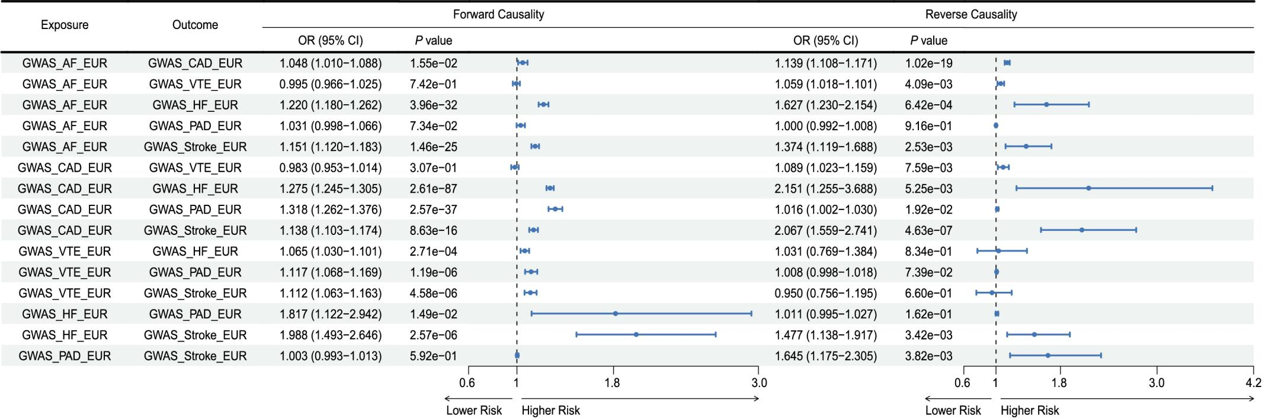
Supplementary Fig. 3. The forest plot for associations between pairs of cardiovascular diseases in bidirectional MR analysis.
The estimates presented in the forest plot were obtained using the MRlap method. A positive association is indicated by an odds ratio (OR > 1), while a negative association is indicated by OR < 1. The results of forward causality from the MRlap method are shown in the left panel, and the results of reverse causality from MRlap method are in the right panel.
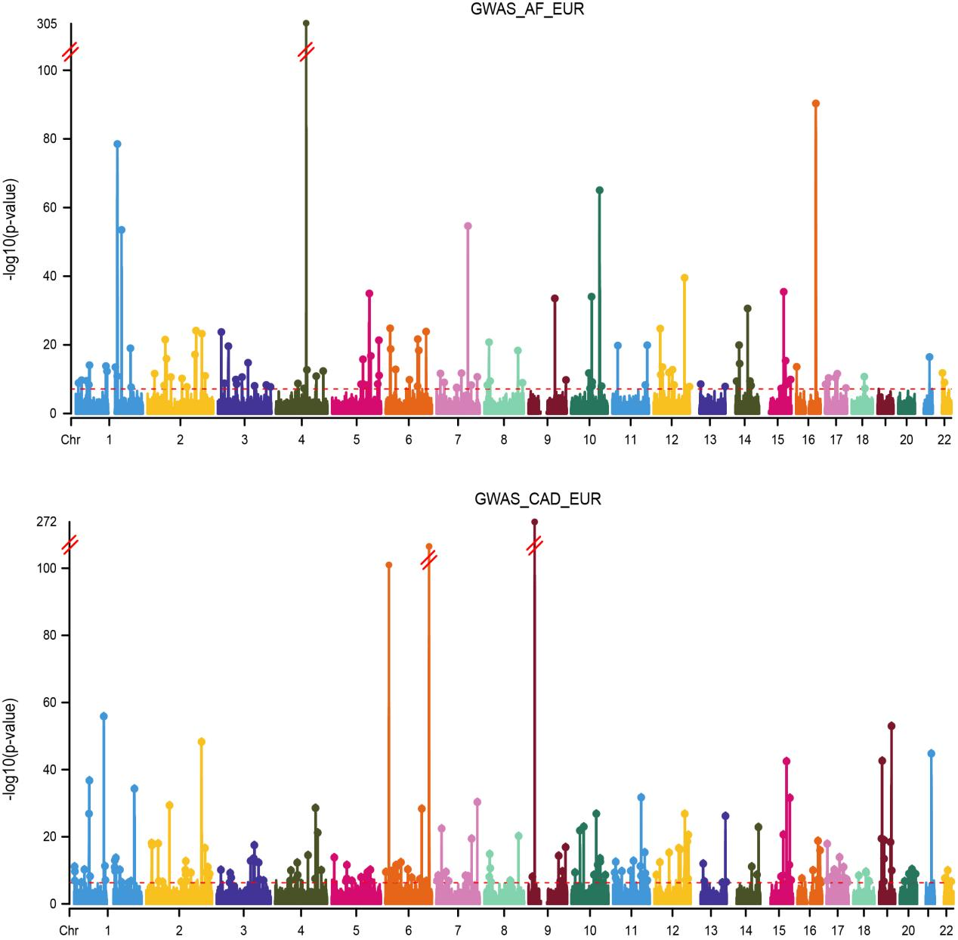
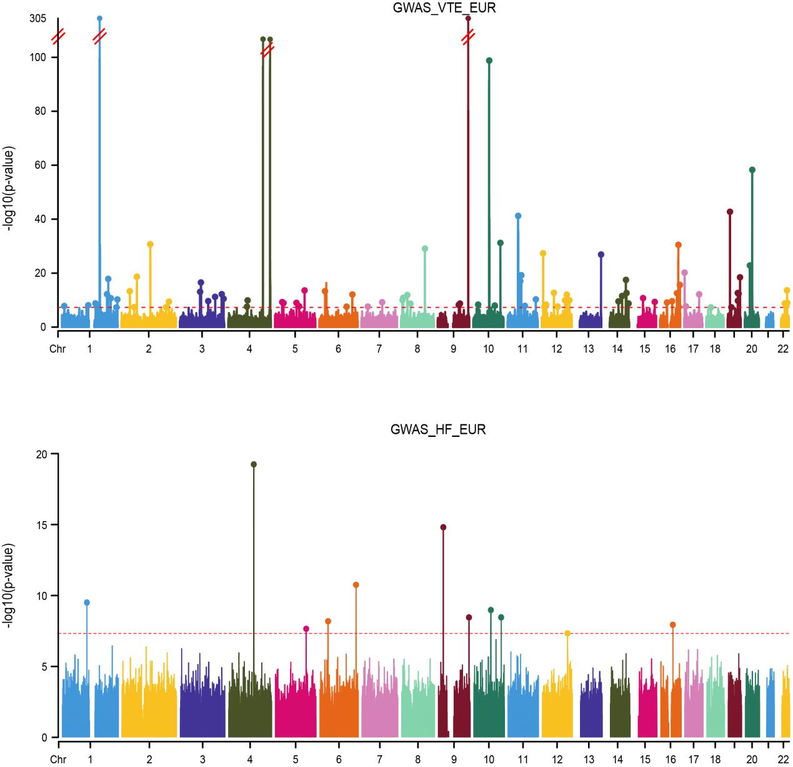
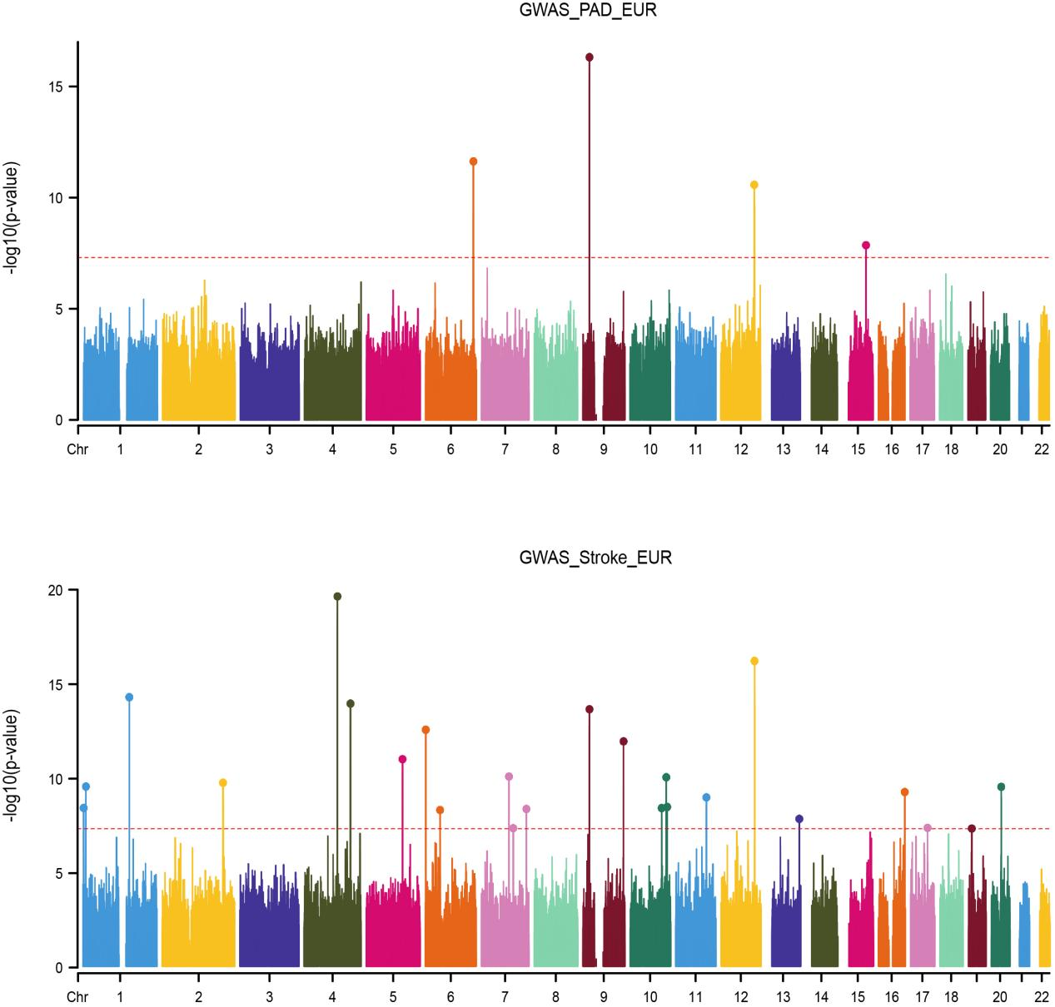
Supplementary Fig. 4. Manhattan plots for the single-trait GWAS results of each of the six cardiovascular diseases.
The upper and lower panels display the MTAG and GWAS results, respectively. The X-axis represents the chromosomal position, and the Y-axis represents negative log10 transformed P-values for each SNP. The cytoband annotations for the newly identified genomic loci are shown in gray. The red dotted lines indicate the genome-wide significant P-value of −log10 (5 × 10⁻⁸). Colorful dots indicate an independent genome-wide significant association with the smallest P-value (Top lead SNP). Only SNPs shared across all summary statistics were included.

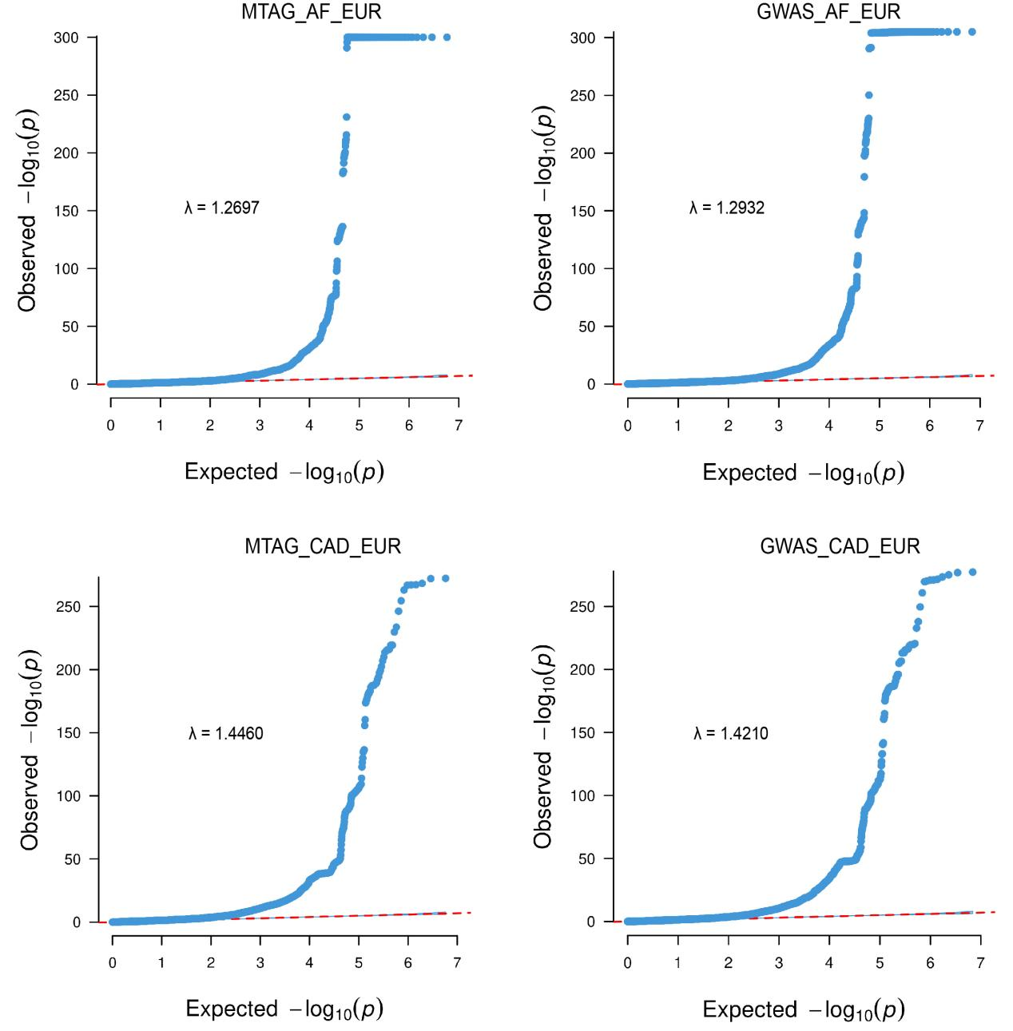
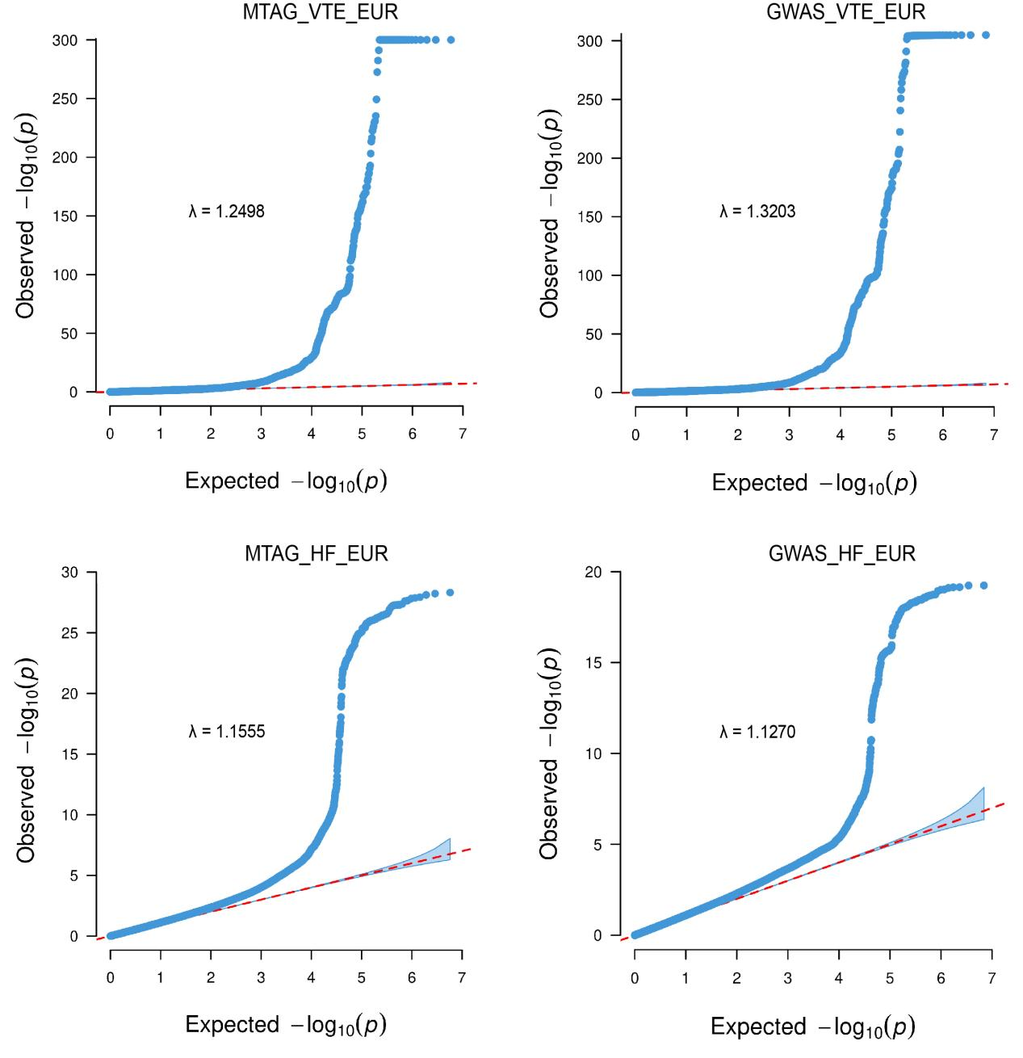
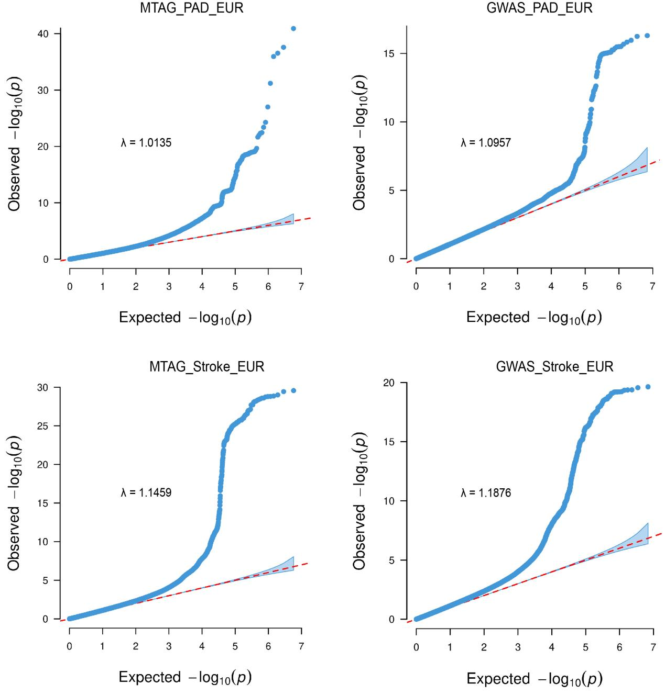
Supplementary Fig. 5. Quantile-quantile (Q-Q) plots for the single-trait GWAS and MTAG results of each of the six cardiovascular diseases.
The left and right panels display the MTAG and GWAS results, respectively.

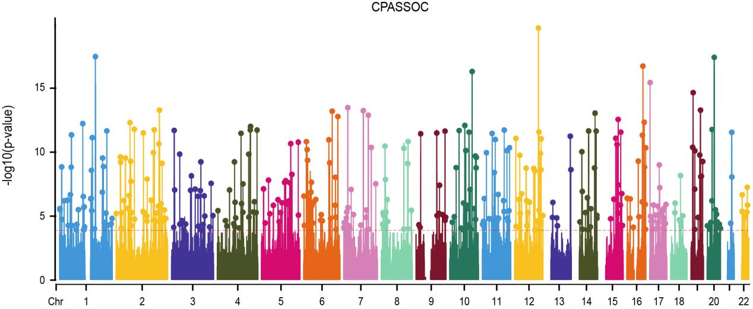
Supplementary Fig. 6. Manhattan plots for the CPASSOC results of the six cardiovascular diseases.
The X-axis represents the chromosomal position, and the Y-axis represents negative log10 transformed P-values for each SNP. The red dotted lines indicate the genome-wide significant P-value of -log10 (5 × 10⁻⁸). Colorful dots indicate an independent genome-wide significant association with the smallest P-value (Top lead SNP).

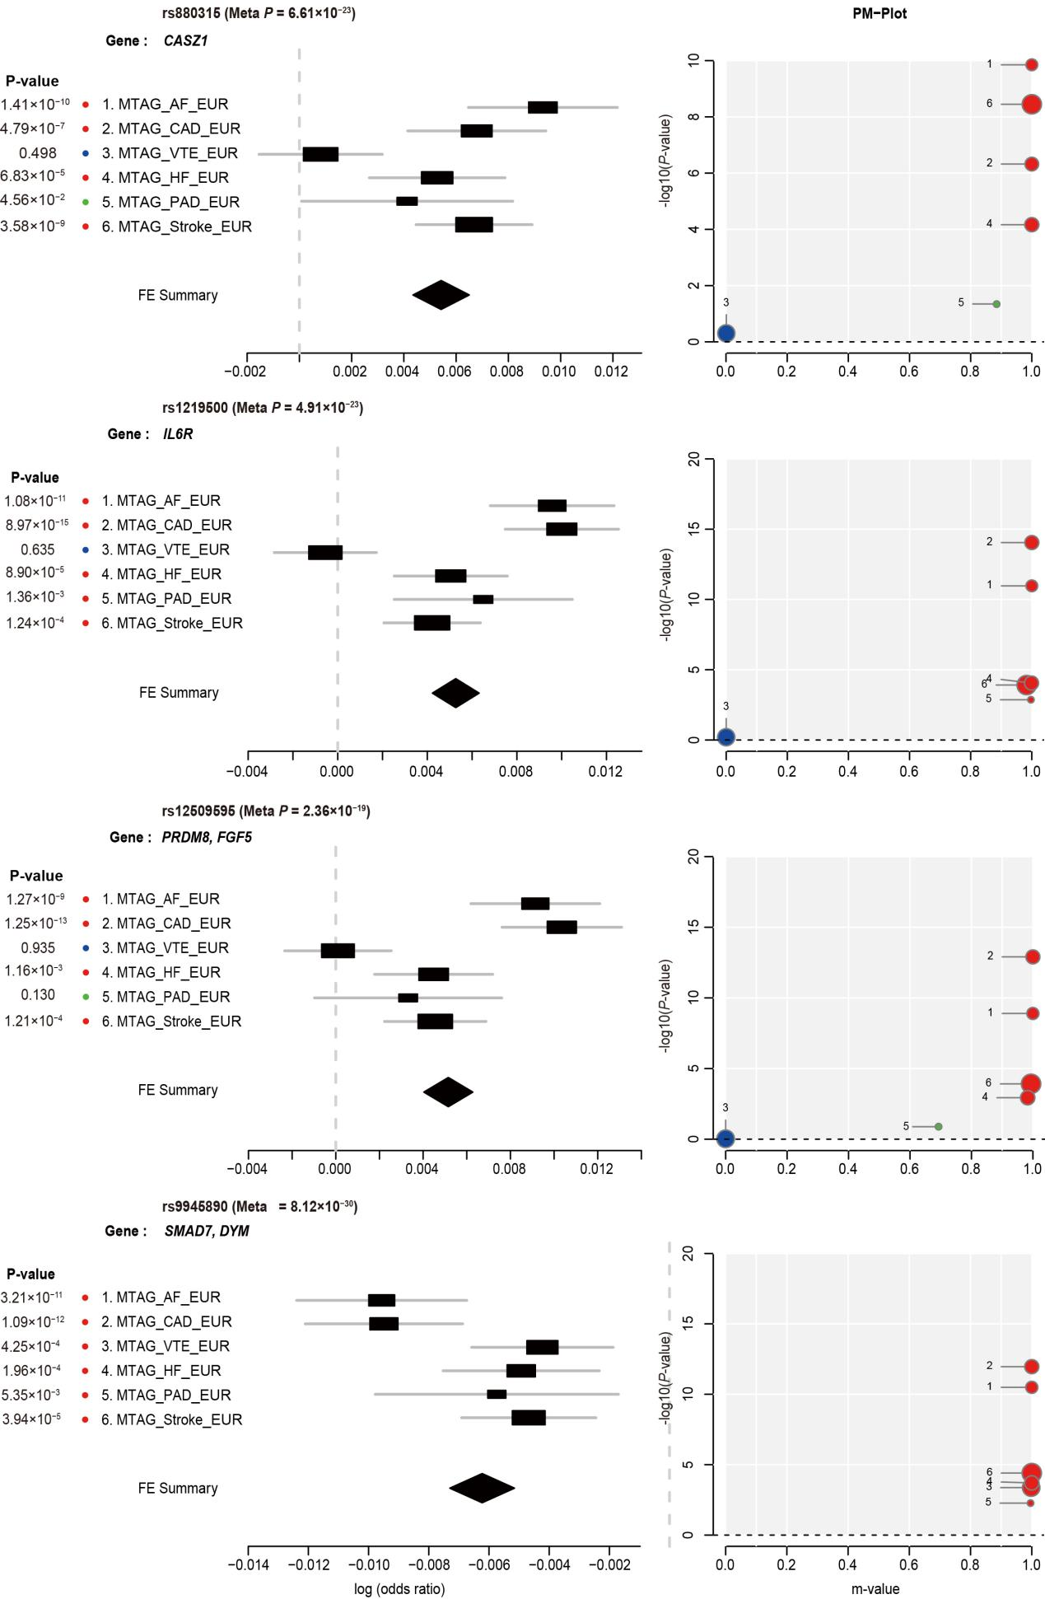

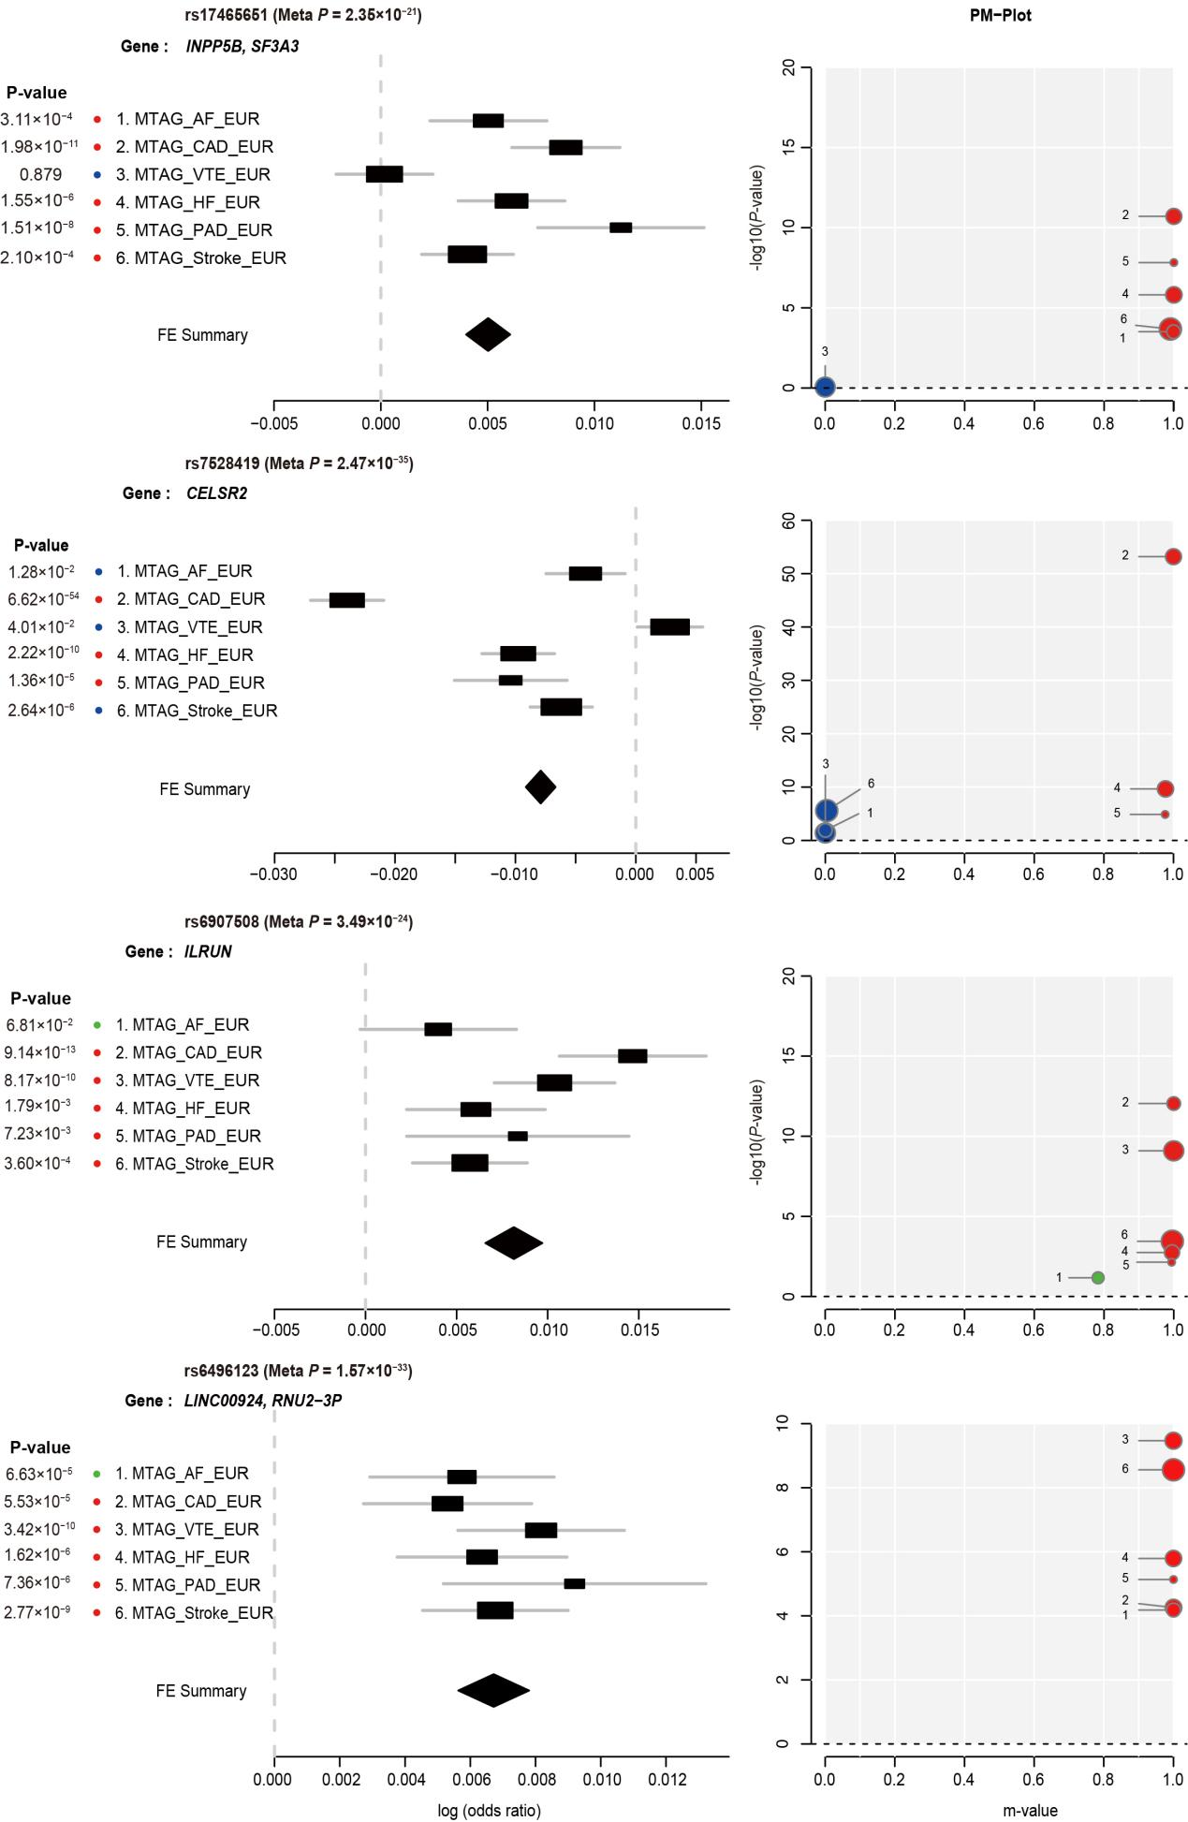

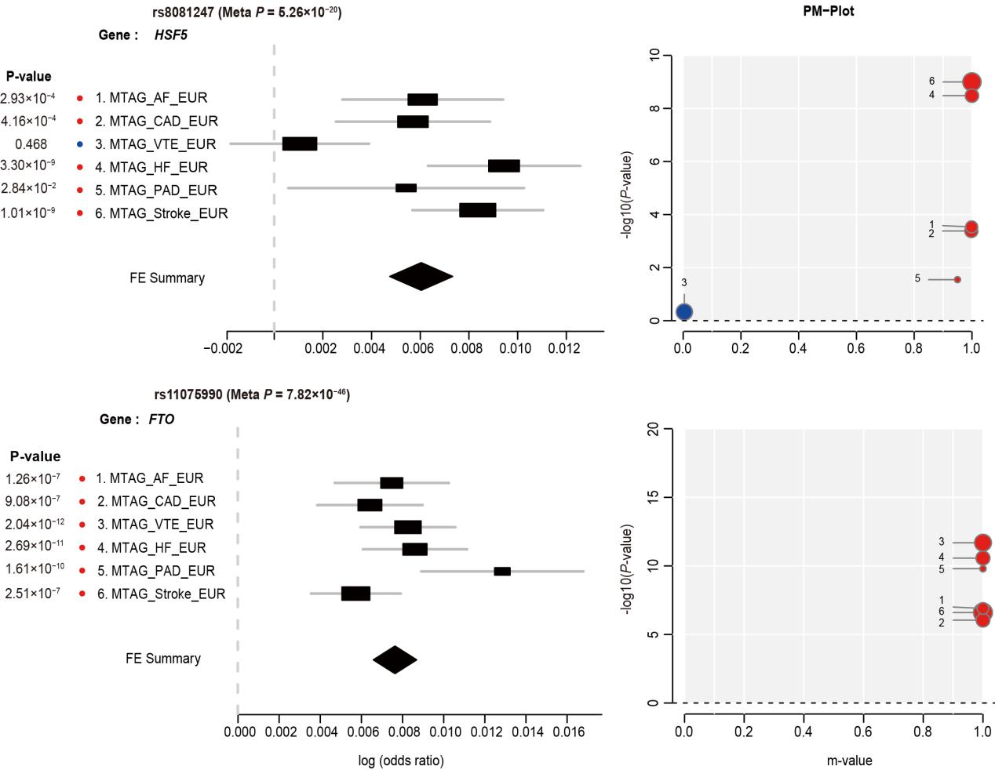
Supplementary Fig. 7. Profile of cardiovascular disease associations for the other 10 pleiotropic loci.
For each locus, cardiovascular disease-specific effects of the causal SNP are shown using ForestPMPlot. The first panel is the forest plot, displaying the disease-specific association P-value, log odds ratios (ORs), and standard errors of the SNP. The meta-analysis P-value and the corresponding summary statistic are displayed at the top and the bottom of the forest plot, respectively. The second panel is the PM-plot, in which X-axis represents the m-value, the posterior probability that the effect exists in each disease, and the Y-axis represents the disease-specific association P-value as -log10 (P-value). Diseases are depicted as dots whose size represents the sample size of individual GWAS. Diseases with estimated m-values of at least 0.9 are colored red suggesting that the SNP does have an effect on the disease, while those with m-values less than 0.1 are marked in blue suggesting that the SNP does not have an effect on the disease. Diseases with estimated m-values between 0.1 and 0.9 are marked in green, suggesting that the SNP has an uncertain effect on the disease.
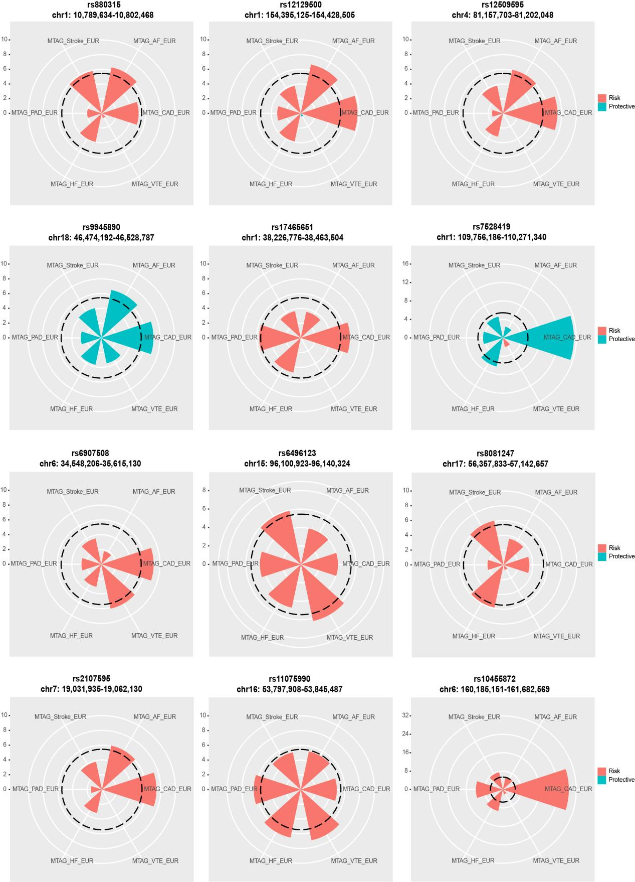

Supplementary Fig. 8. Twelve pleiotropic loci with the same directional effects.
Rose diagrams showing eleven loci with the same directional effects. The radius of each wedge corresponds to the absolute values of the Z-scores (log(Odds ratios [OR])/SE) obtained from association tests of the SNP for six cardiovascular diseases. The color indicates whether the examined SNP carries a risk (red) or protective effect (green) for each disease. The dotted line around the center indicates statistically significant SNP effects that account for the causal SNPs of pleiotropic loci.

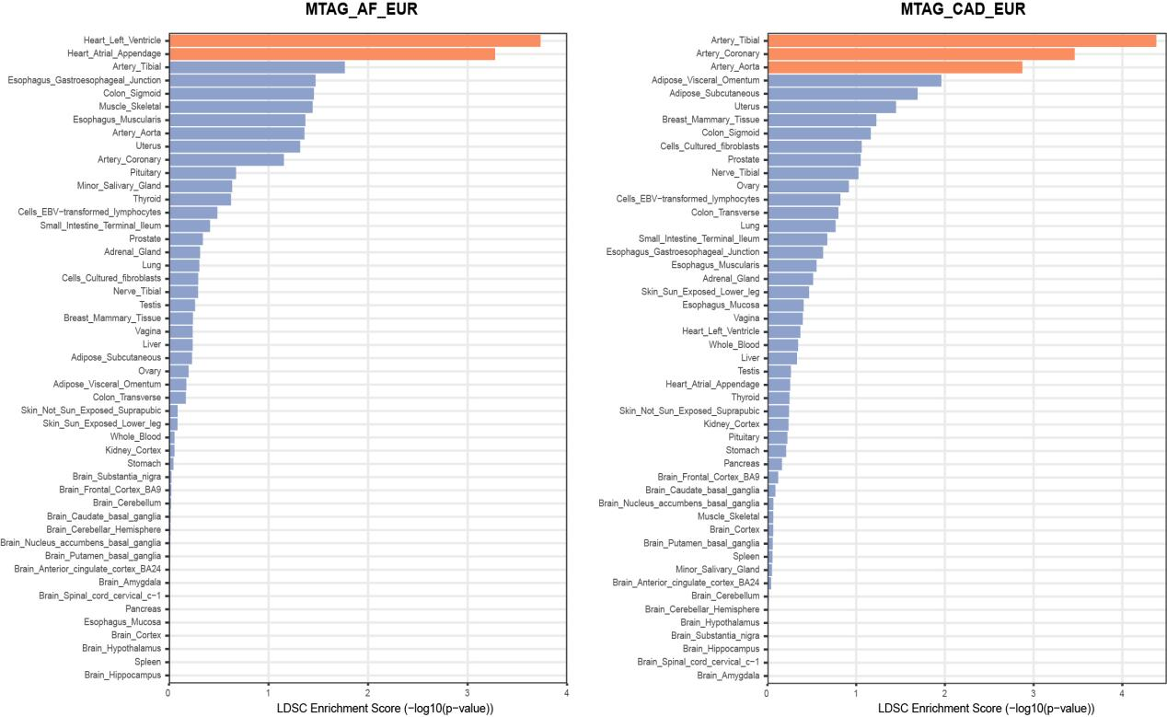
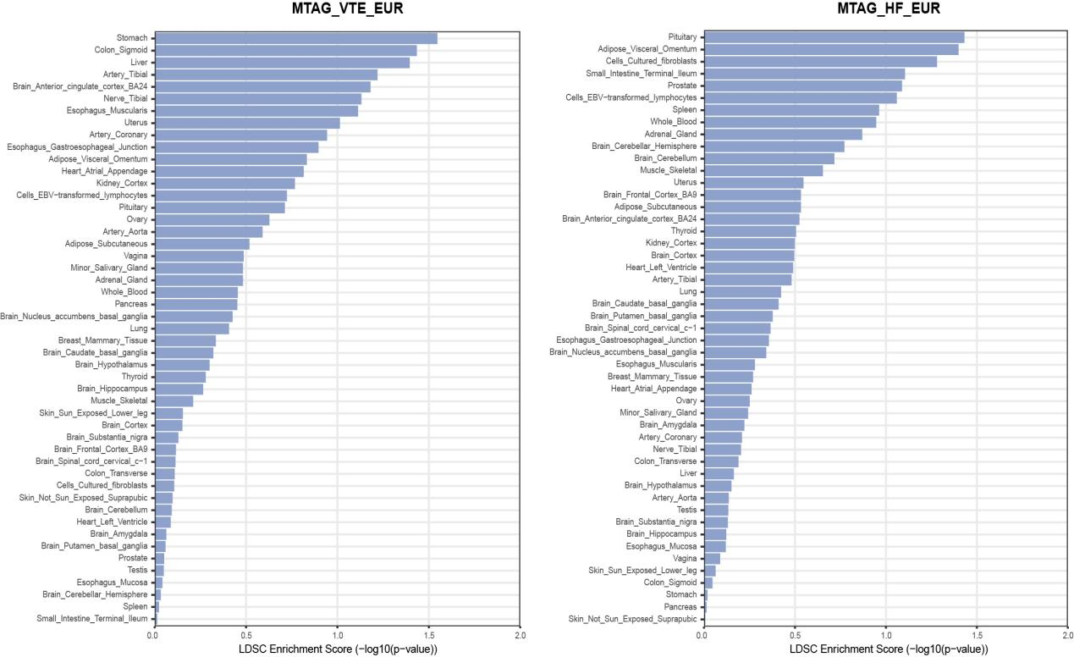
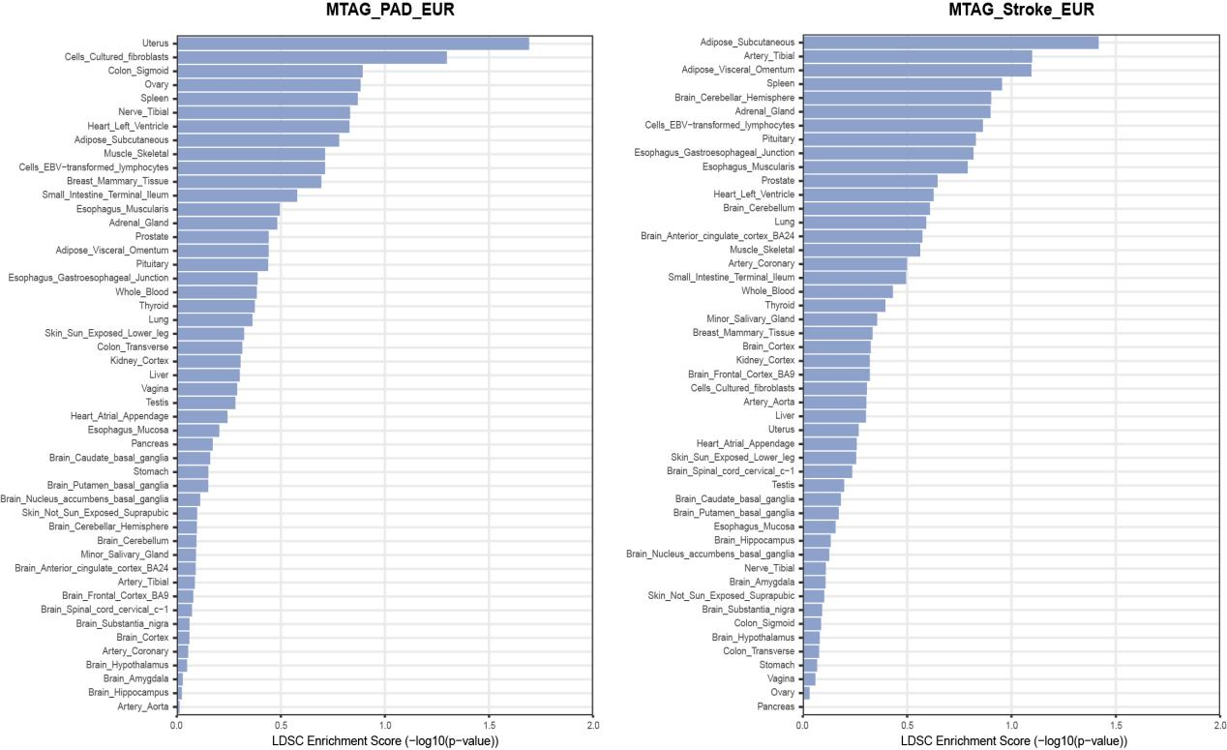
Supplementary Fig. 9. The results of multiple-tissue analysis using gene expression data for six cardiovascular diseases.
Each point represents a tissue type from the Genotype-Tissue Expression (GTEx) dataset. The orange color indicates a statistically significant P-value after performing Bonferroni correction for multiple testing, which is < 1.02 × 10⁻³ (0.05 / 49) at -log10 (P) = 2.99.
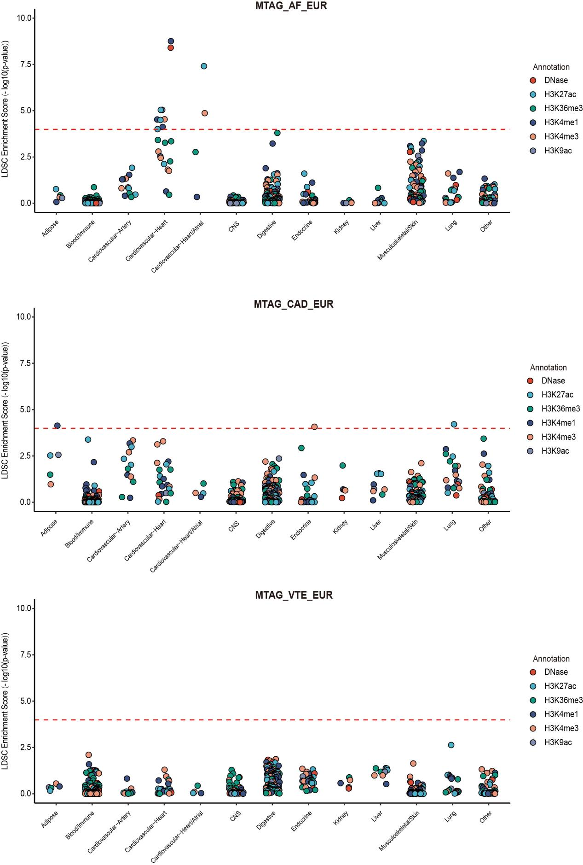
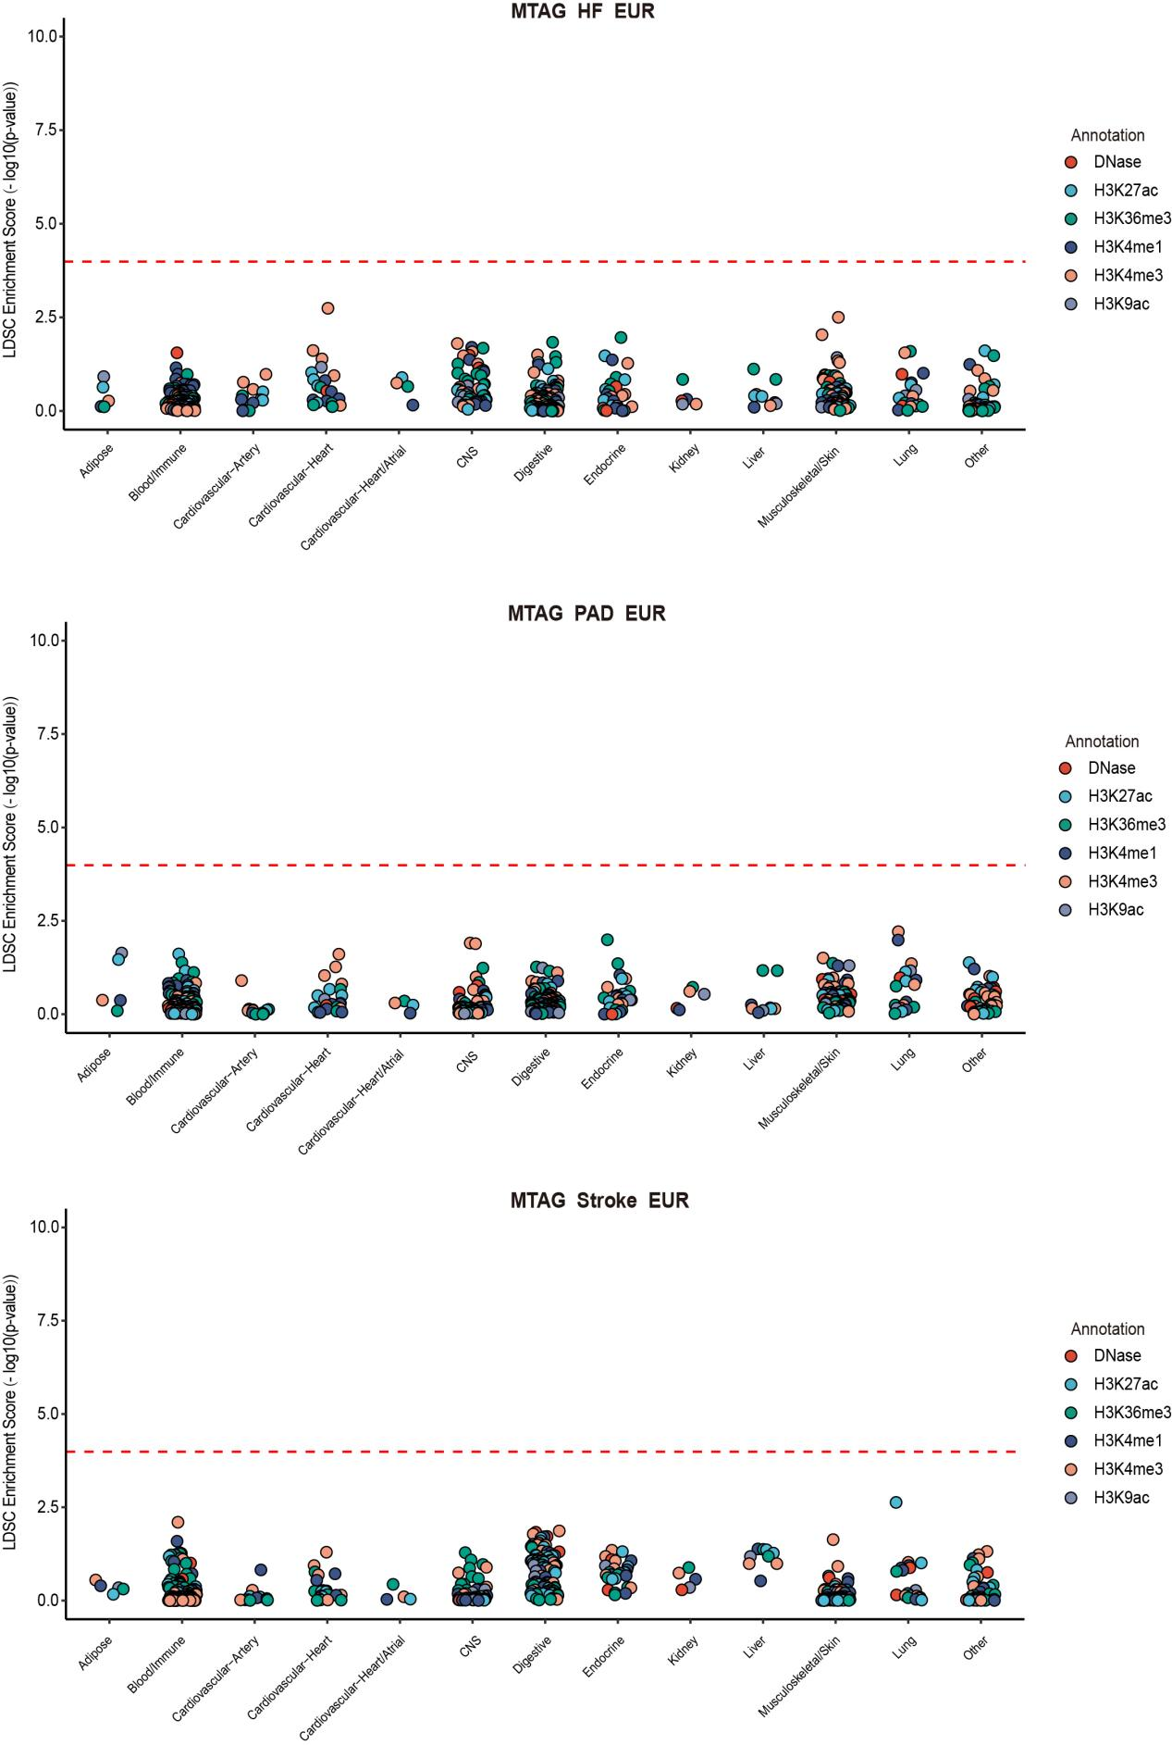
Supplementary Fig. 10. The results of multiple-tissue analysis using chromatin data for six cardiovascular diseases.
Each point represents a peak for a DNase I hypersensitivity site (DHS) or histone marks (including H3K27ac, H3K36me3, H3K4me1, aH3K4me3, and H3K9ac) in a tissue or cell type. Tissues or cell types were classified into 11 distinct categories, with the cardiovascular tissues further subdivided into 3 distinct categories: artery, heart, and both. The dashed red line indicates the significant P-value after performing Bonferroni correction for multiple testing, which is < 1.02 × 10⁻⁴ (0.05 / 489) at -log10 (P) = 4.00.
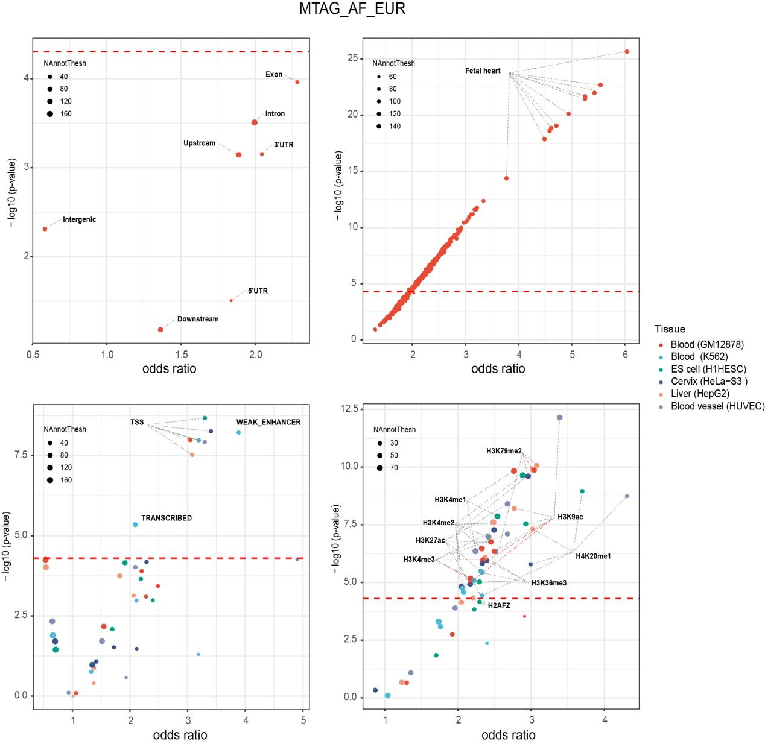
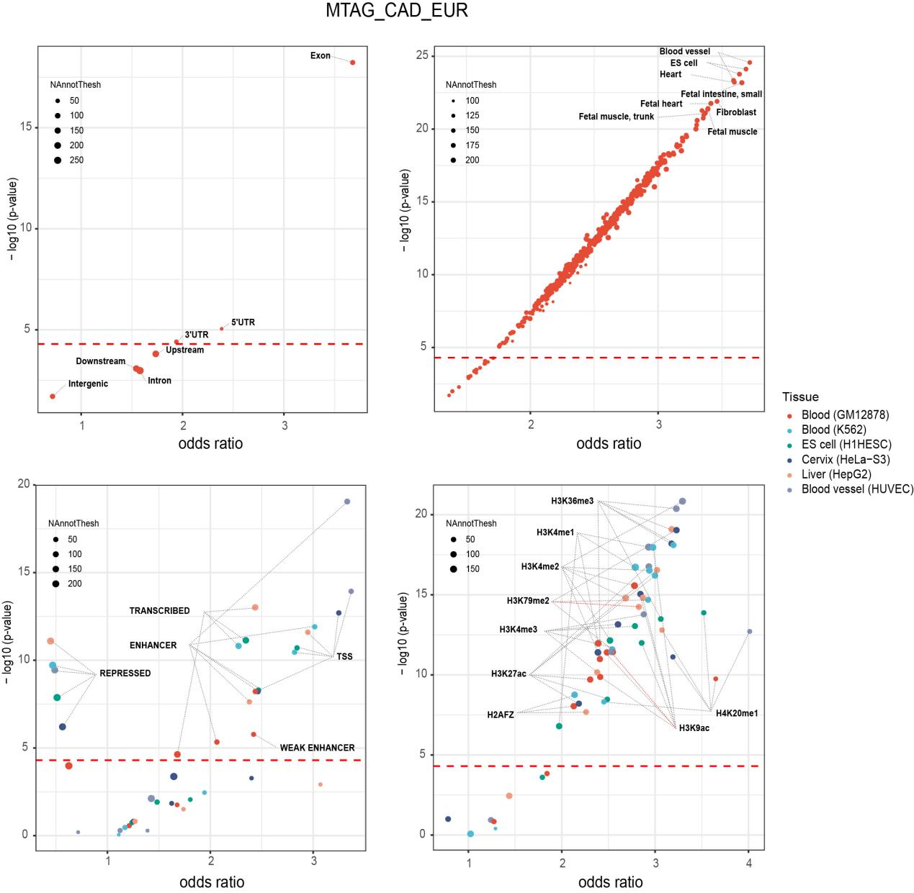
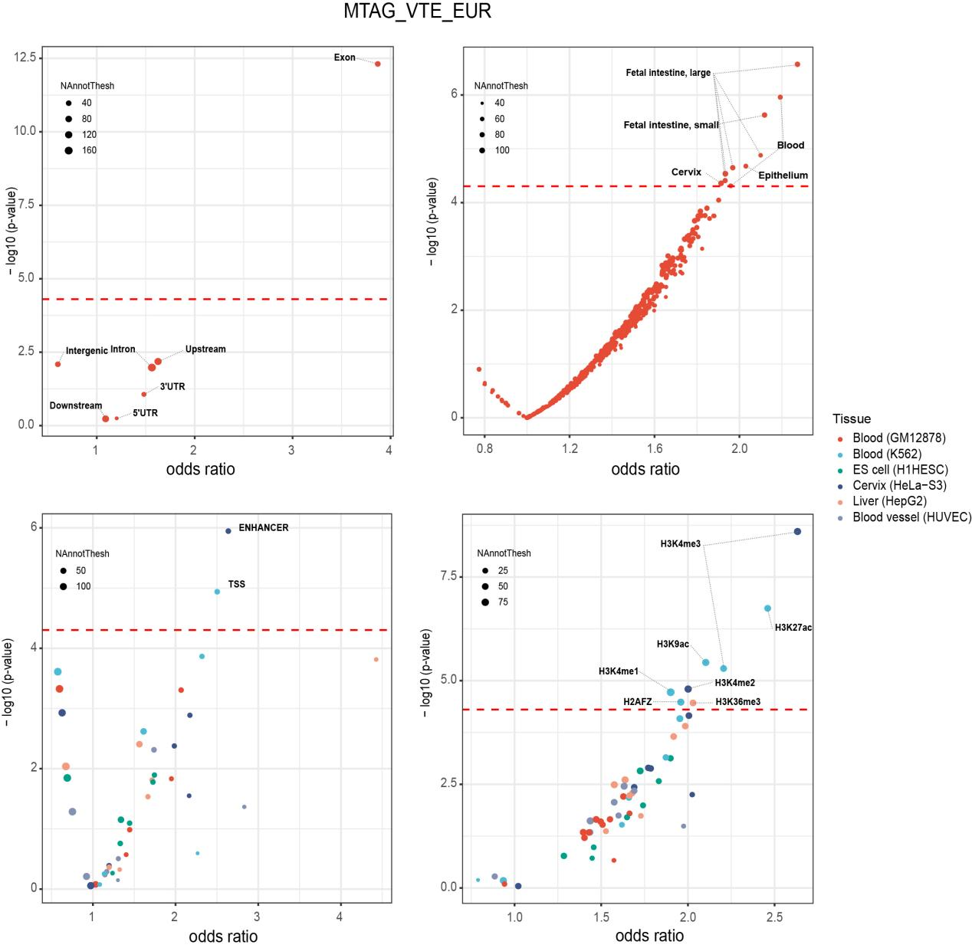
Supplementary Fig. 11. The result of GARFIELD enrichment for MTAG_AF_EUR, MTAG_CAD_EUR, and MTAG_VTE_EUR in the genic regions, DHS (hotspots) regions, chromatin states, and histone-modified regions of different tissues.
The horizontal axis represents the enrichment odds ratios (OR) for each annotation category derived from logistic regression, and the vertical axis shows the corresponding −log10 P-values. The dashed red line indicates the significant P-value after performing Bonferroni correction for multiple testing, which is < 4.98 × 10⁻⁵ (0.05 / 1005) at -log10 (P) = 4.30. The size of the dots represents the number of independent SNPs in each specific annotation. The color of the dots represents different tissue types.

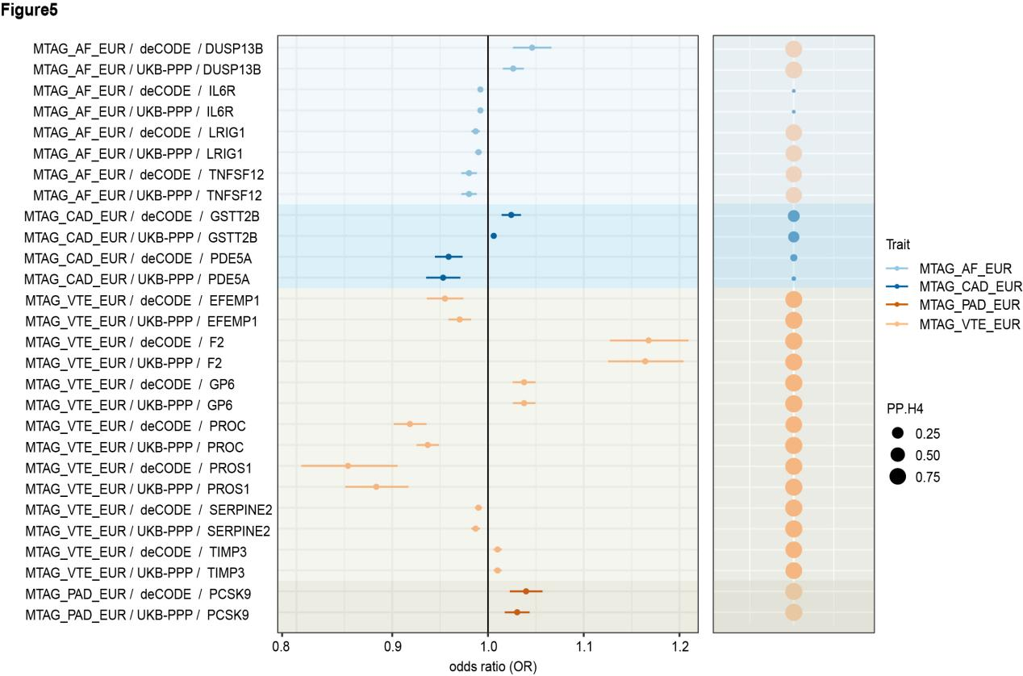
Supplementary Fig. 12. Proteome-wide MR and Colocalization analysis of the six cardiovascular diseases.
The estimates shown in the forest plot were obtained using the SMR method. A positive association is indicated by the odds ratio (OR > 1), while a negative association is indicated by OR < 1. The results of causality from the SMR analysis are shown in the left panel, and the results of colocalization analysis are in the right panel. AF: atrial fibrillation; CAD: coronary artery disease; VTE: venous thromboembolism; HF, heart failure; PAD, peripheral artery disease. Full name of proteins: LRIG1: leucine-rich repeats and immunoglobulin-like domains 1; DUSP13B: dual specificity phosphatase 13B; TNFSF12: TNF superfamily member 12; EFEMP1: EGF containing fibulin extracellular matrix protein 1; PROC: protein C: inactivator of coagulation factors Va and VIIIa; SERPINE2: serpin family E member 2; PROS1: protein S; GP6: glycoprotein VI platelet; TIMP3: TIMP metallopeptidase inhibitor 3; F2: coagulation factor II: thrombin; PCSK9: proprotein convertase subtilisin/kexin type 9; IL6R: interleukin 6 receptor; GSTT2B: glutathione S-transferase theta 2B; PDE5A: phosphodiesterase 5A.
Supplementary Note 1. Additional information on summary statistics
Note that all GWAS summary statistics included in our main study involve participants of European descent only.

Atrial fibrillation (AF)
The AF GWAS summary statistics by Nielsen et al. (2018)¹ were based on the analysis of individuals of European ancestry from six cohorts: the Nord-Trøndelag Health Study (HUNT), deCODE, Michigan Genomics Initiative (MGI), DiscovEHR, UK Biobank (UKB), and the AFGen Consortium. A clinical diagnosis of AF was made for all cases following ICD-9 code 427.3 and ICD-10 code I48 criteria. The combined European sample consisted of 60,620 cases and 970,216 controls.

Coronary artery disease (CAD)
The CAD GWAS summary statistics by Aragam et al. (2022)² were based on 12 cohorts consisting of individuals of European (> 95% of the samples) and East Asian ancestry: the deCODE, European Prospective Investigation into Cancer and Nutrition (EPIC)-CVD, GerMIFS V-VII, Greek Coronary Disease Cohort (GCC), Nord-Trøndelag Health Study (HUNT), Mass General Brigham Biobank, TIMI, and the UK Biobank (UKB) Consortium. A clinical diagnosis of CAD was defined as myocardial infarction, chronic ischemic heart disease, or angina using ICD9 (410-414), ICD10 (I20-I25) codes, or other diagnosis procedure codes. Here, we use the GWAS summary statistics based on the analysis of individuals of European ancestry only (181,522 cases and 984,168 controls).

Venous thromboembolism (VTE)
The VTE GWAS summary statistics by Ghouse et al. (2023)³ were based on the analysis of European ancestry from 6 cohorts: Copenhagen Hospital Biobank Cardiovascular Disease Cohort (CHB-CVDC) and The Danish Blood Donor Study (DBDS), deCODE, Intermountain Healthcare, UK Biobank (UKB), FinnGen, and the Million Veterans Program (MVP). Cases met the criteria for VTE as defined by ICD-9 or ICD-10 codes (except for the UK Biobank cohort, where case/control status was also determined through self-reported diagnosis history). The combined European sample consisted of 81,190 cases and 1,419,671 controls.

Heart failure (HF)
The HF GWAS summary statistics by Shah et al. (2020)⁴ were based on data from the Heart Failure Molecular Epidemiology for Therapeutic Targets (HERMES) Consortium, comprising 17 population-based studies and 9 case-control cohorts individuals of European ancestry. In these cohorts, cases were identified based on research-defined assessment criteria and clinical consensus diagnosis. More recently, Rasooly et al. (2023)⁵ conducted a meta-analysis of GWAS on HF from the MVP and HERMES Consortium, yielding a pooled N = 275,822 (90,653 cases and 1,188,957 controls). Due to data use restrictions, the summary statistics used in the current study are derived from the individuals included in Shah et al. (2020)⁴, i.e., the HERMES cohort only; N = 977,323 (47,309 cases and 930,014 controls).

Peripheral artery disease (PAD)
The PAD GWAS summary statistics by van Zuydam et al. (2021)⁶ were based on 11 cohorts of individuals of European ancestry: Corogene, Diabetes Control and Complications Trial (DCCT) / Epidemiology of Diabetes Interventions (EDIC), deCODE, Edinburgh artery study (EAS), Finnish Diabetic Nephropathy Study (FinnDiane), Genetics of Diabetes Audit and Research in Tayside Scotland (GoDARTS), MRC/BHF Heart Protection Study (HPS), Genetic Determinants of Peripheral Artery Disease (Mayo Clinic), Scannia Diabetes Registry (SDR), UK Biobank (UKB), and the Wisconsin Epidemiologic Study of Diabetic Retinopathy (WESDR) Consortium. In these cohorts, cases were defined by clinicians as atherosclerotic vascular disease affecting the lower limbs, and were ascertained using clinical assessments. The combined European sample consisted of 12,086 cases and 499,548 controls.

Stroke
The stroke GWAS summary statistics by Mishra et al. (2022)⁷ were derived from 54 cohorts comprising individuals of European (66.7% of stroke cases), African American, East Asian, Hispanic, and South Asian ancestry. Stroke diagnoses—including ischemic stroke and its subtypes (large-artery atherosclerotic stroke [LAS], cardioembolic stroke [CES], and small-vessel stroke [SVS]), intracerebral hemorrhage (ICH), and strokes of unknown or undetermined type—were defined according to research-based assessment criteria and clinical consensus diagnosis. Here, we use the GWAS summary statistics based on analysis of European ancestry individuals only (73,652 cases and 1,234,808 controls).

Supplementary Note 2: Additional information on negatively correlated loci identified by LAVA
Only one locus remained significant after Bonferroni correction among the 26 unique genomic regions identified as negatively genetically correlated. This locus, located in the PAD-Stroke trait pair, corresponds to LD block 804 (chr5:31,679,465–32,727,914). Further investigation of the GWAS-PW results in these negatively correlated regions revealed strong colocalization signals in the AF-VTE, AF-CAD, and CAD-VTE trait pairs. To support these findings, we conducted HyPrColoc analysis and identified strong colocalization evidence between CAD and VTE, particularly within LD block 96 (chr1:109,271,450–110,224,230). Notably, the shared causal SNP rs12740374, located in the 3′ untranslated region (3′UTR) of the CELSR2 gene on chromosome 1p13.3, contributed to the colocalization signal. Previously, using MTAG summary statistics, we performed multi-trait colocalization of cardiovascular and metabolic traits at overlapping loci and identified strong evidence that the shared causal variant rs12740374 showed high colocalization across multiple traits, including MTAG_CVD, MTAG_HF, and four lipidemic traits: low-density lipoprotein cholesterol (LDL-C), high-density lipoprotein cholesterol (HDL-C), triglycerides (TG), and total cholesterol (TC). We then repeated the multi-trait colocalization analysis using the original GWAS summary statistics for CAD, HF, VTE, and the four lipidemic traits, which again demonstrated strong colocalization (PPA > 0.9) with the shared causal SNP rs12740374. Interestingly, examination of Z-values (Beta/SE) for rs12740374 across the seven traits revealed negative Z-values for CAD, HF, LDL-C, TC, and TG, whereas VTE and HDL-C had positive Z-values. Notably, due to insufficient genetic signals in the HF region identified by LAVA, we could not calculate the local genetic correlation between CAD and HF. Therefore, we focused our discussion on the negative genetic correlation between CAD and VTE. Previous studies have demonstrated that elevated HDL-C levels are negatively associated with CAD risk, whereas elevated LDL-C levels are positively associated with CAD. Although the relationship between VTE and dyslipidemia has been studied in several clinical studies, the results have been inconsistent. To further explore the genetic relationships between CAD, VTE, and lipidemic traits, we calculated the local r_{g}s within this region. The results showed that CAD was negatively correlated with HDL-C but positively correlated with LDL-C, TC, and TG, consistent with previous epidemiological findings. In contrast, VTE showed the opposite pattern of association with these lipidemic traits, though the local rgs were not statistically significant except for the VTE-TC pair (P < 0.05). Overall, our findings provide new evidence supporting the involvement of lipidemic traits in both CAD and VTE, suggesting that lipids may have opposing roles in these two conditions. Further investigation is needed to elucidate the biological mechanisms underlying this negative correlation and to understand how this locus contributes to the divergent genetic architecture of CAD and VTE.

We compared the 38 pleiotropic loci identified using MTAG with the 15 unique loci from LAVA and GWAS-PW and found that four loci overlapped: Locus 20 (chr4: 155,106,847–155,678,217), Locus 32 (chr4: 111,283,206–112,163,297), Locus 34 (chr9: 21,683,805–22,138,762), and Locus 38 (chr9: 135,866,940–136,400,566). Notably, within Locus 34 (i.e., LD block 1,398), six trait pairs exhibited strong local r_{g} at the nominal significance level (P < 0.05). Four of these trait pairs—AF-CAD, CAD-HF, CAD-PAD, and CAD-Stroke—remained significant after Bonferroni correction and were validated by GWAS-PW. This locus harbors a shared causal SNP (rs4977574), located within an intron of the CDKN2B-AS1 gene on chromosome 9q21.3, which was further supported by colocalization analysis of the 38 pleiotropic loci based on MTAG results.

Supplementary Table 1. Bivariate LAVA results for CAD, VTE and four lipidemic traits in LD block 96 (chr1:109,271,450–110,224,230).
Trait1 | Trait2 | rho | rho.lower | rho.upper | p
GWAS_CAD_EUR | GWAS_HDL-C_EUR | -0.757 | -0.841 | -0.673 | 2.03 × 10⁻³⁶
GWAS_CAD_EUR | GWAS_LDL-C_EUR | 0.588 | 0.503 | 0.672 | 6.10 × 10⁻³²
GWAS_CAD_EUR | GWAS_TC_EUR | 0.652 | 0.573 | 0.732 | 1.09 × 10⁻³⁷
GWAS_CAD_EUR | GWAS_TG_EUR | 0.624 | 0.467 | 0.782 | 2.78 × 10⁻¹¹
GWAS_VTE_EUR | GWAS_HDL-C_EUR | 0.170 | -0.007 | 0.348 | 0.056
GWAS_VTE_EUR | GWAS_LDL-C_EUR | -0.133 | -0.298 | 0.022 | 0.102
GWAS_VTE_EUR | GWAS_TC_EUR | -0.213 | -0.373 | -0.053 | 8.49 × 10⁻³
GWAS_VTE_EUR | GWAS_TG_EUR | -0.155 | -0.409 | 0.096 | 0.216

Supplementary Note 3: Additional information on shared genetic architecture between HF and PAD
One seemingly contradictory finding in our analysis is the moderately high genome-wide genetic correlation between HF and PAD (r_{g} = 0.636, based on LDSC), contrasted with a relatively low Dice coefficient (π12 = 0.280) estimated by MiXeR. This apparent discrepancy arises from the fundamental differences in what these two methods capture. LDSC quantifies the average correlation of effect sizes across the genome, reflecting polygenic sharing at a broad level. In contrast, MiXeR models the proportion of shared causal variants between traits. Notably, all likely causal variants for PAD are fully contained within those for HF (i.e., PAD ⊆ HF), and the proportion of concordant shared variants is estimated to be 1. However, the absolute number of PAD-associated causal variants is relatively low, which suppresses the Dice coefficient, as it is normalized by the average number of causal variants in both traits. Thus, full containment of PAD variants within HF can still result in a low Dice coefficient due to this asymmetry in genetic architecture complexity. Further complexity is revealed by our regional genetic correlation analysis, which identified a heterogeneous pattern: ten genomic regions with positive local r_{g}s and one with negative local r_{g}s. These divergent regional signals suggest that genetic sharing between HF and PAD is not uniform across the genome. Some loci may be predominantly driven by HF-specific variants with little or even opposing effects in PAD, reflecting local architectural heterogeneity that can obscure interpretation of genome-wide correlation metrics. Taken together, these findings support a more nuanced model in which PAD may represent a genetically narrower subset of HF, with more consistent directionality of genetic effects. This implies that while some pathogenic mechanisms are shared, PAD is likely characterized by a more restricted set of pathways or loci contributing to HF risk. Additionally, comorbid cases—where individuals present with both HF and PAD—may blur phenotypic distinctions and contribute to elevated estimates of genetic sharing in methods like LDSC. Overall, these complexities underscore the importance of using complementary analytic approaches when interpreting cross-trait genetic architecture.

Supplementary Note 4. Additional information on MTAG-identified new loci
We performed multi-trait analyses of CVDs using MTAG, which identified novel variants located in loci previously unassociated with any form of CVD.

Atrial fibrillation (MTAG_AF_EUR)
Using FUMA, we identified 191 LD-independent lead SNPs from the MTAG analysis of AF, mapping to 108 independent genomic risk loci (Fig. 3a). Among them, 7 SNPs did not overlap with loci identified in the GWAS of AF, while 3 overlapped with loci reported in other GWAS studies on AF, not limited to those included in this study⁸⁻¹⁰. Four genomic risk loci (6q23.3, 9q21.3, 9q34.2, and 22q13.2) were considered novel, meaning there were no prior associations with AF. A newly identified association of an intronic variant, rs57130712, was located in SMG6 gene (SMG6 nonsense-mediated mRNA decay factor) on 17p13.3 (P_{MTAG_AF_EUR} = 1.53 × 10⁻⁸, P_{GWAS_AF_EUR} = 3.14 × 10⁻⁷), which was also identified by CPASSOC results (P_{CPASSOC} = 2.16 × 10⁻¹⁹, Supplementary Fig. 7 and 8, Supplementary Data 11 and 14). Among all the top SNPs, only one (0.93%) was located in exonic regions, while 66 (61.11%) were intronic, and 25 (23.15%) were intergenic. Notably, 96 (88.89%) of these SNPs were annotated as potentially having regulatory functions.

Coronary artery disease (MTAG_CAD_EUR)
Using FUMA, our MTAG analysis of CAD identified 295 LD-independent lead SNPs that mapped to 171 independent genomic risk loci (Fig. 3b). Seven SNPs did not overlap with loci identified in the GWAS of CAD, while four overlapped with loci reported in other GWAS of CAD^{2,11-15}. We identified three novel genomic risk loci (4q23, 11p11.2, and 19p13.11) that have not been previously associated with CAD. Among them, rs2625388 (located on 11p11.2, P_{MTAG_CAD_EUR} = 1.29 × 10⁻⁸, P_{GWAS_CAD_EUR} = 2.08 × 10⁻⁶) is an intergenic variant mapped to the nearest HSD17B12 gene (hydroxysteroid 17-beta dehydrogenase 12). This variant also acted as an eQTL associated with the 10 CVD-related tissues influencing HSD17B12 expression, with FDR values ranging from 4.93 × 10⁻⁶ in Cells EBV-transformed lymphocytes to 1.94 × 10⁻¹¹⁸ in Tibial Artery tissue, which was also identified by CPASSOC analysis (P_{CPASSOC} = 1.06 × 10⁻⁹, Supplementary Fig. 7 and 8, Supplementary Data 11 and 14). Among all the top SNPs, 11 (6.43%) were located in exonic regions, 87 (50.88%) in intronic regions, and 49 (28.65%) in intergenic regions. Notably, 138 (80.70%) of these SNPs were annotated as potentially having regulatory functions.

Venous thromboembolism (MTAG_VTE_EUR)
For VTE, we identified 176 LD-independent lead SNPs from the MTAG results, which were mapped to 72 independent genomic risk loci using FUMA (Fig. 3c). Among these, 7 loci (1p31.1, 4q25, 4q31.22, 6p21.31, 14q32.31, 16q22.2, and 17q21.31) were not found in the GWAS result of VTE, and none of them overlapped with previously reported loci in other GWAS studies of VTE. For example, rs3213422 (located on 16q22.2, P_{MTAG_VTE_EUR} = 7.98 × 10⁻⁹, P_{GWAS_VTE_EUR} = 2.45 × 10⁻⁸) is an exonic variant mapped to the dihydroorotate dehydrogenase (quinone) gene (DHODH). It was also an eQTL associated with 7 out of 10 CVD-related tissues influencing DHODH, excluding Liver, Cells EBV-transformed lymphocytes, and Whole Blood, with FDR values ranged from 7.12 × 10⁻⁷ in Heart Atrial Appendage to 1.51 × 10⁻⁶² in Artery Tibia), which was also identified by CPASSOC analysis (P_{CPASSOC} = 3.34 × 10⁻¹¹, Supplementary Fig. 7 and 8, Supplementary Data 11 and 14). Among all the top SNPs, 63 (87.50%) were annotated as potentially having regulatory functions. Specifically, 9 (12.50%) were located in exonic regions, 40 (55.56%) in intronic regions, and 12 (16.67%) in intergenic regions.

Heart failure (MTAG_HF_EUR)
Using FUMA, we identified 14 LD-independent lead SNPs from the MTAG results for HF, which were mapped to 13 independent genomic risk loci (Fig. 3d). Four loci did not overlap with those identified in the GWAS results for HF, although two of them overlapped with loci reported in other GWAS studies of HF¹⁶. Two genomic risk loci (17q22 and 19p13.2) were considered novel. A newly identified association involving the intronic variant rs8081247 (located on 17q22, P_{MTAG_HF_EUR} = 3.30 × 10⁻⁹, P_{GWAS_HF_EUR} = 6.73 × 10⁻⁷) was mapped to the heat shock transcription factor 5 gene (HSF5), which was also identified by CPASSOC analysis (P_{CPASSOC} = 3.91 × 10⁻¹⁰, Supplementary Fig. 7 and 8, Supplementary Data 11 and 14). Among all the top SNPs, none were located in exonic regions. Of these, 7 (53.85%) were intronic, 3 (23.08%) were intergenic, and 8 (61.54%) were annotated as potentially having regulatory functions.

Peripheral artery disease (MTAG_PAD_EUR)
Using FUMA, we identified 43 LD-independent lead SNPs from the MTAG results for PAD, which were mapped to 37 independent genomic risk loci (Fig. 3e). Of these, 33 loci did not overlap with those identified in the GWAS results for PAD, among which 3 overlapped with loci reported in other GWAS studies of PAD^{7,17}. We also identified 30 novel genomic risk loci, including one variant located downstream region of KLK13, two variants in the 3' untranslated regions (3' UTRs) of DPYD and KCNK, five intronic variants, eleven intergenic variants, and three ncRNA-intronic variants. For example, rs348662 (P_{MTAG_PAD_EUR} = 1.14 × 10⁻⁸, P_{GWAS_PAD_EUR} = 7.22 × 10⁻⁸), an intronic variant, was mapped to TAFA chemokine-like family member 2 gene (TAFA2) on 12q14.1, which was also identified by CPASSOC analysis (P_{CPASSOC} = 1.14 × 10⁻¹⁰, Supplementary Fig. 7 and 8, Supplementary Data 11 and 14). Among all the top SNPs, none were located in exonic regions. Of these, 11 (29.73%) were intronic, 15 (40.54%) were intergenic, and 30 (81.08%) were annotated as potentially having regulatory functions.

Stroke (MTAG_Stroke_EUR)
We identified 20 LD-independent lead SNPs from the MTAG analysis of stroke, which were mapped to 18 distinct genomic risk loci using FUMA (Fig. 3f). Among these, 7 did not overlap with loci identified in the GWAS of stroke, whereas 4 overlapped with loci reported in previous GWAS studies of stroke^{8,18,19}. Three genomic risk loci—6p21.2, 11p11.2, and 17p11.2—were considered novel. For example, rs7944241 (P_{MTAG_Stroke_EUR} = 5.57 × 10⁻⁹, P_{GWAS_Stroke_EUR} = 5.19 × 10⁻⁵), an intergenic variant located at the novel genomic locus 11p11.2, was mapped to the nearest gene, HSD17B12. It also functioned as an eQTL associated with HSD17B12 expression in 10 cardiovascular-related tissues, with FDR values ranging from 7.80 × 10⁻¹⁴ in liver to 2.00 × 10⁻¹²⁰ in whole blood, which was further confirmed by CPASSOC analysis (P_{CPASSOC} = 1.06 × 10⁻⁹, Supplementary Fig. 7 and 8, Supplementary Data 11, and Supplementary Data 14). Among all the top SNPs, only one (5.56%) was located in exonic regions, while 7 (38.89%) were intronic, 6 (33.33%) were intergenic, and 14 (77.78%) were annotated as potentially regulatory.

Supplementary Table 2. Novel genomic loci and corresponding top independent variants identified by FUMA.
Locus | Trait | Top LeadSNP | Genomic risk loci | Region | P_{GWAS} | P_{MTAG} | P_{CPASSOC} | Variant annotion | MappedGene
52 | MTAG_AF_EUR | rs4896104 | 6:135087658-135123836 | 6q23.3 | 7.51 × 10⁻⁸ | 7.61 × 10⁻⁹ | 5.34 × 10⁻⁶ | intergenic | FAM8A6P, MEMO1P2
65 | MTAG_AF_EUR | rs2891168 | 9:22065002-22125503 | 9p21.3 | 2.08 × 10⁻⁴ | 4.68 × 10⁻¹⁰ | NA | ncRNA_intronic | CDKN2B-AS1
67 | MTAG_AF_EUR | rs635634 | 9:136132908-136330428 | 9q34.2 | 2.74 × 10⁻⁵ | 3.81 × 10⁻²² | NA | intergenic | ABO, SURF6
98 | MTAG_AF_EUR | rs57130712 | 17:2015612-2205923 | 17p13.3 | 3.14 × 10⁻⁷ | 1.53 × 10⁻⁸ | 2.16 × 10⁻¹⁹ | intronic | SMG6
45 | MTAG_CAD_EUR | rs35864506 | 4:100293109-100321443 | 4q23 | 2.40 × 10⁻⁷ | 6.97 × 10⁻⁹ | 2.48 × 10⁻⁶ | intergenic | ADH1C, ADH7
109 | MTAG_CAD_EUR | rs2625388 | 11:43599791-43810235 | 11p11.2 | 2.08 × 10⁻⁶ | 1.29 × 10⁻⁸ | 1.06 × 10⁻⁹ | intergenic | MIR129-2, HSD17B12
157 | MTAG_CAD_EUR | rs3745318 | 19:16415993-16443718 | 19p13.11 | 6.54 × 10⁻⁸ | 1.58 × 10⁻⁸ | 4.74 × 10⁻⁶ | exonic | KLF2
1 | MTAG_VTE_EUR | rs34517439 | 1:77967507-78450517 | 1p31.1 | 7.22 × 10⁻⁸ | 1.14 × 10⁻⁸ | 4.11 × 10⁻⁸ | intronic | DNAJB4
18 | MTAG_VTE_EUR | rs2466455 | 4:111665783-111718067 | 4q25 | 9.42 × 10⁻¹ | 9.81 × 10⁻⁹ | NA | intergenic | PITX2, MIR297
19 | MTAG_VTE_EUR | rs4835410 | 4:148364908-148427893 | 4q31.22 | 4.18 × 10⁻⁷ | 6.03 × 10⁻¹⁰ | 4.35 × 10⁻¹⁴ | intronic | EDNRA
25 | MTAG_VTE_EUR | rs6907508 | 6:34548206-34831761 | 6p21.31 | 2.14 × 10⁻⁷ | 8.17 × 10⁻¹⁰ | 2.24 × 10⁻¹³ | intronic | ILRUN
50 | MTAG_VTE_EUR | rs7144340 | 14:103058769-103209153 | 14q32.31 | 8.11 × 10⁻⁸ | 1.22 × 10⁻⁸ | 2.92 × 10⁻¹⁰ | ncRNA_exonic | RPL23AP11
56 | MTAG_VTE_EUR | rs3213422 | 16:72030970-72051369 | 16q22.2 | 7.98 × 10⁻⁸ | 2.45 × 10⁻⁹ | 3.34 × 10⁻¹¹ | exonic | DHODH
61 | MTAG_VTE_EUR | rs199457 | 17:43795573-44865603 | 17q21.31 | 6.35 × 10⁻⁷ | 1.38 × 10⁻⁸ | 4.29 × 10⁻¹¹ | intronic | NSF
11 | MTAG_HF_EUR | rs8081247 | 17:56393633-57142657 | 17q22 | 6.73 × 10⁻⁷ | 3.30 × 10⁻⁹ | 3.91 × 10⁻¹⁰ | intronic | HSF5
13 | MTAG_HF_EUR | rs12151108 | 19:11186412-11210912 | 19p13.2 | 9.06 × 10⁻⁵ | 2.08 × 10⁻¹⁰ | NA | intergenic | SMARCA4, LDLR-AS1
1 | MTAG_PAD_EUR | rs17465651 | 1:38386727-38461821 | 1p34.3 | 8.40 × 10⁻⁴ | 1.51 × 10⁻⁸ | 1.64 × 10⁻¹² | intergenic | INPP5B, SF3A3
2 | MTAG_PAD_EUR | rs2455016 | 1:66555792-66593672 | 1p31.3 | 1.90 × 10⁻⁴ | 1.83 × 10⁻⁹ | 1.29 × 10⁻⁷ | intronic | PDE4B
3 | MTAG_PAD_EUR | rs1042482 | 1:97491891-97577502 | 1p21.3 | 8.60 × 10⁻⁵ | 6.59 × 10⁻⁹ | 2.73 × 10⁻⁶ | UTR3 | DPYD
4 | MTAG_PAD_EUR | rs1627854 | 2:26937669-26957737 | 2p23.3 | 1.90 × 10⁻⁴ | 1.65 × 10⁻¹¹ | 1.29 × 10⁻⁷ | UTR3 | KCNK3
5 | MTAG_PAD_EUR | rs6752766 | 2:72169353-72190463 | 2p13.2 | 2.20 × 10⁻⁵ | 1.96 × 10⁻⁹ | 1.14 × 10⁻¹⁰ | intergenic | DYSF, RPS20P10
6 | MTAG_PAD_EUR | rs58693850 | 2:130618119-130639545 | 2q21.1 | 3.60 × 10⁻⁶ | 3.89 × 10⁻¹⁰ | 1.14 × 10⁻¹⁰ | ncRNA_intronic | LINC02572
7 | MTAG_PAD_EUR | rs9859308 | 3:126140654-126140654 | 3q21.3 | 2.70 × 10⁻³ | 5.24 × 10⁻⁹ | 2.43 × 10⁻⁵ | intronic | CCDC37
8 | MTAG_PAD_EUR | rs4696937 | 4:19316688-19791040 | 4p15.31 | 7.20 × 10⁻⁶ | 1.24 × 10⁻⁸ | 1.29 × 10⁻⁷ | intergenic | RNA5SP157, RPL21P46
9 | MTAG_PAD_EUR | rs7689774 | 4:111665783-111718067 | 4q25 | 4.00 × 10⁻¹ | 4.27 × 10⁻¹⁵ | NA | intergenic | PITX2, MIR297
10 | MTAG_PAD_EUR | rs17226273 | 4:183028642-183036418 | 4q34.3 | 6.30 × 10⁻⁶ | 6.78 × 10⁻⁹ | 1.14 × 10⁻¹⁰ | intergenic | CCNHP1, TENM3-AS1
11 | MTAG_PAD_EUR | rs6898648 | 5:89254428-89406502 | 5q14.3 | 7.80 × 10⁻⁶ | 2.12 × 10⁻¹² | 1.14 × 10⁻¹⁰ | intergenic | MEF2C-AS1, MIR3660
12 | MTAG_PAD_EUR | rs27657 | 5:89806058-90021292 | 5q14.3 | 1.50 × 10⁻⁶ | 2.66 × 10⁻⁹ | 1.29 × 10⁻⁷ | intronic | GPR98
13 | MTAG_PAD_EUR | rs277871 | 5:100057207-100291657 | 5q21.1 | 3.50 × 10⁻⁴ | 7.25 × 10⁻⁹ | 1.29 × 10⁻⁷ | intergenic | RN7SKP62, ST8SIA4
14 | MTAG_PAD_EUR | rs2071303 | 6:26091336-26114702 | 6p22.2 | 1.20 × 10⁻⁴ | 1.58 × 10⁻⁹ | 1.17 × 10⁻⁷ | intronic | HFE
15 | MTAG_PAD_EUR | rs947138 | 6:119048567-119069825 | 6q22.31 | 4.30 × 10⁻⁴ | 9.42 × 10⁻¹⁰ | 1.29 × 10⁻⁷ | intergenic | CEP85L, SELENOKP3
17 | MTAG_PAD_EUR | rs11984041 | 7:19031935-19060333 | 7p21.1 | 7.20 × 10⁻⁷ | 8.28 × 10⁻¹¹ | 9.00 × 10⁻¹⁵ | intronic | HDAC9
18 | MTAG_PAD_EUR | rs320692 | 7:137039328-137081525 | 7q33 | 7.20 × 10⁻⁵ | 1.09 × 10⁻⁸ | 1.29 × 10⁻⁷ | intergenic | PTN, DGKI
19 | MTAG_PAD_EUR | rs922049 | 8:9156468-9221080 | 8p23.1 | 1.10 × 10⁻⁵ | 4.13× 10⁻¹⁰ | 1.14 × 10⁻¹⁰ | intergenic | LOC157273, RNU6-526P
20 | MTAG_PAD_EUR | rs2001337 | 8:10220412-10277982 | 8p23.1 | 2.20 × 10⁻⁴ | 1.34 × 10⁻⁸ | 1.29 × 10⁻⁷ | intronic | MSRA
23 | MTAG_PAD_EUR | rs6480406 | 10:71178215-71253277 | 10q22.1 | 2.00 × 10⁻⁵ | 8.84 × 10⁻⁹ | 2.48 × 10⁻¹³ | intergenic | TACR2, ATP5MC1P7
24 | MTAG_PAD_EUR | rs6592137 | 11:83343594-83422975 | 11q14.1 | 3.00 × 10⁻⁴ | 1.28 × 10⁻⁹ | 1.29 × 10⁻⁷ | intronic | DLG2
25 | MTAG_PAD_EUR | rs6581020 | 12:55466677-55705788 | 12q13.2 | 4.20 × 10⁻⁴ | 1.63 × 10⁻⁹ | 1.29 × 10⁻⁷ | intronic | OR9K2
26 | MTAG_PAD_EUR | rs348662 | 12:62423566-62464895 | 12q14.1 | 1.10 × 10⁻⁵ | 4.67 × 10⁻¹⁰ | 1.14 × 10⁻¹⁰ | intronic | TAFA2
28 | MTAG_PAD_EUR | rs12589496 | 14:49792385-49838381 | 14q21.3 | 1.70 × 10⁻⁵ | 8.31 × 10⁻¹⁰ | 1.14 × 10⁻¹⁰ | intergenic | RPL18P1, ATP5MC2P2
29 | MTAG_PAD_EUR | rs13329602 | 15:47365799-47486525 | 15q21.1 | 2.60 × 10⁻⁴ | 4.21 × 10⁻¹⁰ | 1.29 × 10⁻⁷ | intergenic | SEMA6D, RN7SKP101
31 | MTAG_PAD_EUR | rs11075990 | 16:53797908-53845487 | 16q12.2 | 2.20 × 10⁻³ | 1.61 × 10⁻¹⁰ | 2.99 × 10⁻¹⁸ | intronic | FTO
32 | MTAG_PAD_EUR | rs8057453 | 16:86769523-86773383 | 16q24.1 | 8.60 × 10⁻⁶ | 4.83 × 10⁻⁹ | 7.09 × 10⁻¹² | ncRNA_intronic | LINC02188
33 | MTAG_PAD_EUR | rs1788823 | 18:21074922-21165163 | 18q11.2 | 3.00 × 10⁻³ | 1.65 × 10⁻⁹ | 2.04 × 10⁻⁸ | intronic | NPC1
34 | MTAG_PAD_EUR | rs4522474 | 18:41158479-41214033 | 18q12.3 | 2.30 × 10⁻⁶ | 2.03 × 10⁻⁹ | 1.37 × 10⁻⁹ | intergenic | SYT4, RNU6-443P
36 | MTAG_PAD_EUR | rs17658754 | 19:51554821-51561413 | 19q13.33 | 1.20 × 10⁻⁴ | 2.15 × 10⁻⁹ | 1.29 × 10⁻⁷ | downstream | KLK13
5 | MTAG_Stroke_EUR | rs2395655 | 6:36616600-36648816 | 6p21.2 | 4.95 × 10⁻⁶ | 1.27 × 10⁻⁹ | 4.91 × 10⁻¹² | exonic | CDKN1A
11 | MTAG_Stroke_EUR | rs7944241 | 11:43599791-43878505 | 11p11.2 | 5.19 × 10⁻⁵ | 5.57 × 10⁻⁹ | 1.06 × 10⁻⁹ | intergenic | MIR129-2, HSD17B12
14 | MTAG_Stroke_EUR | rs4925118 | 17:17645951-17996780 | 17p11.2 | 6.29 × 10⁻⁷ | 4.53 × 10⁻⁹ | 2.75 × 10⁻⁸ | intronic | SREBF1
Genomic risk loci are identified by FUMA by merging LD blocks of independent significant SNPs that are located within 250 kb of each other; Chromosomal loci refer to the chromosomal regions that contain the genomic risk loci.; The top lead SNP is defined as the SNP with the lowest P value within each genomic locus.

Supplementary Table 3. Genomic loci and corresponding top independent variants identified by FUMA, which were reported in other GWAS of CVDs not included in this study.
Locus | Trait | Top LeadSNP | Genomic risk loci | Region | P_{GWAS} | P_{MTAG} | P_{CPASSOC} | Reference (PMID)
51 | MTAG_AF_EUR | rs117984853 | 6:149283505-149413519 | 6q23.3 | 1.34 × 10⁻²⁴ | 1.19 × 10⁻²³ | NA | 29892015, 35872910, 34594039, 30061737
53 | MTAG_AF_EUR | rs55734480 | 7:14365616-14386532 | 6q25.3 | 2.20 × 10⁻¹² | 2.86 × 10⁻¹¹ | 9.40 × 10⁻¹¹ | 29892015, 30061737, 35872910, 36653681, 34594039
108 | MTAG_AF_EUR | rs139558 | 22:41641984-42311097 | 22q13.2 | 1.16 × 10⁻⁷ | 1.30 × 10⁻⁸ | 9.70 × 10⁻¹¹ | 36653681
23 | MTAG_CAD_EUR | rs6744012 | 2:188003118-188381367 | 2q32.1 | 2.34 × 10⁻⁷ | 4.68 × 10⁻⁹ | 1.88 × 10⁻¹⁰ | 33532862, 29212778, 21378988
39 | MTAG_CAD_EUR | rs10938397 | 4:45165650-45187622 | 4p12 | 4.04 × 10⁻⁷ | 9.33 × 10⁻⁹ | 2.27 × 10⁻⁸ | 35915156, 36474045, 33910581
64 | MTAG_CAD_EUR | rs3829964 | 6:36616366-36648920 | 6p21.2 | 1.65 × 10⁻⁷ | 1.43 × 10⁻⁸ | 8.81 × 10⁻¹¹ | 29212778, 36474045
83 | MTAG_CAD_EUR | rs2286195 | 7:139717178-139761248 | 7q34 | 3.99 × 10⁻⁷ | 7.81 × 10⁻⁹ | 1.38 × 10⁻⁷ | 32469254, 33532862
8 | MTAG_HF_EUR | rs7944241 | 11:43599791-43878505 | 11p11.2 | 6.66 × 10⁻⁶ | 1.59 × 10⁻⁹ | 1.76 × 10⁻⁹ | 36376295
12 | MTAG_HF_EUR | rs1788785 | 18:21074255-21165163 | 18q11.2 | 1.76 × 10⁻⁵ | 7.01 × 10⁻⁹ | 4.55 × 10⁻¹² | 36376295
22 | MTAG_PAD_EUR | rs687289 | 9:136132908-136155000 | 9q34.2 | 1.70 × 10⁻⁶ | 2.29 × 10⁻¹⁸ | NA | 31285632, 34601942
35 | MTAG_PAD_EUR | rs12151108 | 19:11186412-11210912 | 19p13.2 | 5.10 × 10⁻⁴ | 4.36 × 10⁻¹⁰ | NA | 31285632, 34601942
37 | MTAG_PAD_EUR | rs28376 | 22:23890836-23903613 | 22q11.23 | 2.40 × 10⁻⁵ | 9.23 × 10⁻⁹ | 1.14 × 10⁻¹⁰ | 25009551
6 | MTAG_Stroke_EUR | rs10455872 | 6:160985526-161123451 | 6q25.3 | 1.77 × 10⁻³ | 1.20 × 10⁻¹⁴ | NA | 36180795, 24262325
7 | MTAG_Stroke_EUR | rs2107595 | 7:19034191-19052733 | 7p21.1 | 2.96 × 10⁻⁶ | 6.02 × 10⁻⁹ | NA | 34594039, 29531354, 32047268, 26708676, 23041239, 24262325, 36180795, 35285134
13 | MTAG_Stroke_EUR | rs6496123 | 15:96100923-96133934 | 15q26.2 | 1.64 × 10⁻⁷ | 2.77 × 10⁻⁹ | 2.19 × 10⁻¹³ | 29531354
15 | MTAG_Stroke_EUR | rs17608766 | 17:44967530-45244074 | 17q21.32 | 5.86 × 10⁻⁷ | 3.07 × 10⁻⁹ | 9.50 × 10⁻¹⁸ | 35872910, 36180795
Genomic risk loci are identified by FUMA by merging LD blocks of independent significant SNPs that are located within 250 kb of each other; Chromosomal loci refer to the chromosomal regions that contain the genomic risk loci.; The top lead SNP is defined as the SNP with the lowest P value within each genomic locus.

Supplementary Note 5. Prioritization of susceptibility genes and proteins from the MTAG-identified loci
To identify susceptibility genes associated with our MTAG findings, we utilized positional gene mapping results derived from both MAGMA and FUMA. Using FUMA, SNPs were mapped to 345 genes for AF, 567 for CAD, 375 for VTE, 47 for HF, 63 for PAD, and 66 for Stroke. Notably, several genes mapped by FUMA were not identified in the original GWAS results—34 for AF, 24 for CAD, 29 for VTE, 19 for HF, 42 for PAD, and 21 for stroke (Supplementary Data 12, 13, and 16). In parallel, MAGMA analysis mapped 241 genes for AF, 474 for CAD, 303 for VTE, 31 for HF, 17 for PAD, and 43 for Stroke. Among these, 9 genes for AF, 19 for CAD, 25 for VTE, 19 for HF, 13 for PAD, and 21 for stroke were not found in the original GWAS results (Supplementary Data 15).

To further investigate the biological relevance of these genes, we performed eQTL mapping using FUMA and conducted TWAS to identify tissue-specific gene associations. FUMA mapped SNPs to 900 genes for AF, 1,768 for CAD, 1,056 for VTE, 121 for HF, 151 for PAD, and 157 for stroke. Notably, this included 113 genes for AF, 179 for CAD, 177 for VTE, 79 for HF, 127 for PAD, and 55 for stroke that were not detected in the original GWAS results (Supplementary Data 12, 13, and 17). Furthermore, TWAS identified 322 genes for AF, 755 for CAD, 494 for VTE, 32 for HF, 33 for PAD, and 44 for stroke that were significantly associated with gene expression in at least one tissue, including adipose, artery, heart, liver, or whole blood. This included 15 genes for AF, 41 for CAD, 43 for VTE, 21 for HF, 24 for PAD, and 26 for stroke that were not detected in the original GWAS results (Supplementary Data 16).
Supplementary Note 6. Causal inference between 24 metabolic traits/diseases and 6 major CVDs
We employed the MRlap method to conduct bidirectional causal inference between 24 metabolic traits or diseases and six major CVDs. After Bonferroni correction (P = 0.05 / the number of combinations / the number of MR tests = 0.05 / 144 / 2 = 1.74 × 10⁻⁴), 51 out of the 144 trait pairs showed significant positive causal effects, suggesting that the majority of metabolic traits or diseases exert a causal influence on CVDs. Hypertension emerged as the most prominent causal risk factor for CVD, showing significant positive associations with HF (OR = 1.237; 95% CI, 1.192–1.284) and stroke (OR = 1.262; 95% CI, 1.217–1.308). Additionally, six trait pairs exhibited bidirectional causal relationships, with CAD demonstrating particularly strong reciprocal associations with six metabolic traits or diseases, most notably hypertension. Conversely, only one trait pair—CAD and CIMT—demonstrated an inverse causal relationship (Supplementary Data 24). Specifically, genetically predicted risk of CAD was associated with an increased risk of elevated CIMT. CIMT is a well-established subclinical marker of atherosclerosis, widely used to detect early vascular changes and to predict future cardiovascular events. This unexpected inverse causal direction may reflect complex underlying biological mechanisms, pleiotropy, or methodological limitations, and thus should be interpreted with caution.
Supplementary Note 7. Causal proteins identified by Proteome-wide MR and Colocalization analysis
We conducted an in-depth examination of the MR associations between 2,730 unique proteins with available index cis-acting variants (cis-pQTL) from two large-scale GWASs in the deCODE Health study and UK Biobank Pharma Proteomics Project (UKB-PPP) and the risk of CVD outcomes using the summary data-based Mendelian randomization (SMR) approach. Following the removal of associations that did not pass the HEIDI test, as well as employing sensitivity analysis using multi-SNPs-SMR and multiple testing corrections with Bonferroni correction (P = .05 / 2,730 / 3 = 6.11 × 10⁻⁶), genetically predicted levels of 81 proteins were significantly associated with the risk of CVDs. Among these, 11, 31, 30, 1, 4, and 4 proteins were significantly associated with MTAG_AF_EUR, MTAG_CAD_EUR, MTAG_VTE_EUR, MTAG_HF_EUR, MTAG_PAD_EUR, and MTAG_Stroke_EUR, respectively (Supplementary Data 25). Among the identified associations, 14 proteins were measured using both SomaScan and Olink profiling platforms and showed generally consistent associations with CVDs. We further investigated whether the circulating proteins identified in the analysis shared causal variants with CVDs. Strong evidence of colocalization was observed between 60 proteins and CVDs (PPH4 > 0.7). More specifically, for MTAG_AF_EUR, MTAG_CAD_EUR, and MTAG_VTE_EUR, we found that 8, 17, and 28 proteins, respectively, exhibited robust evidence of colocalization. Likewise, MTAG_HF_EUR, MTAG_PAD_EUR, and MTAG_Stroke_EUR demonstrated high support for colocalization with 1, 3, and 3 proteins, respectively, that is, cadherin EGF LAG seven-pass G-type receptor 2 (CELSR2) for MTAG_HF_EUR, proprotein convertase subtilisin/kexin type 9 (PCSK9), and alpha 1-3-N-acetylgalactosaminyltransferase and alpha 1-3-galactosyltransferase (ABO) for MTAG_PAD_EUR, and switching B cell complex subunit SWAP70 (SWAP70), G protein-coupled receptor kinase 5 (GRK5), and matrix metallopeptidase 12 (MMP12) for MTAG_Stroke_EUR. Among the 14 associations measured on both profiling platforms, 11 proteins showed strong colocalization support, which included leucine-rich repeats and immunoglobulin-like domains 1 (LRIG1), dual specificity phosphatase 13B (DUSP13B), TNF superfamily member 12 (TNFSF12), EGF containing fibulin extracellular matrix protein 1 (EFEMP1), protein C, inactivator of coagulation factors Va and VIIIa (PROC), serpin family E member 2 (SERPINE2), protein S (PROS1), glycoprotein VI platelet (GP6), TIMP metallopeptidase inhibitor 3 (TIMP3), coagulation factor II, thrombin (F2), and PCSK9 (Fig. 5). Notably, none of these proteins were found to be associated with more than one CVD.

To translate this genetic information into potential therapeutic targets for CVDs, we assessed the druggability of 11 causal proteins identified in the colocalization analysis. Our analysis identified 40 distinct drugs targeting four unique proteins, as detailed in Supplementary Data 26. A notable example is Dabigatran/Dabigatran etexilate, a direct thrombin inhibitor targeting coagulation factor II (F2). This drug has been approved for treating various CVDs, including VTE²⁰. Additionally, monoclonal antibodies Alirocumab and Evolocumab, both PCSK9 inhibitors, have been approved to reduce LDL cholesterol levels, thus protecting against various CVDs, including PAD²¹. Drugs originally designed for autoimmune conditions, targeting TNFSF12, also show promise as potential treatments for AF^{22,23}. Despite the lack of drug-related data for eight proteins in the OpenTargets database, six (75%) are promising candidates for future treatment, showing high druggability potential. Whether agents targeting these proteins could be repurposed for CVD prevention or treatment remains to be evaluated in clinical trials.

Overall, we explored the causal roles of circulating proteins in CVDs through proteome-wide MR and colocalization analyses. We identified 14 plasma proteins potentially causally associated with CVDs, measured on two different profiling platforms, with 11 strongly supporting colocalization (Supplementary Fig. 12). In this study, PCSK9 and F2 emerged as potential targets for PAD and VTE, respectively, with robust evidence at the proteomic level. Proprotein convertase subtilisin/kexin type 9 (PCSK9) is a serine protease that degrades the LDL receptor, preventing LDL-C clearance from the blood and serving as the target for monoclonal antibodies like Alirocumab and Evolocumab. Large randomized trials involving PAD patients have shown that additional LDL-C reduction, on top of high-intensity statin therapy, significantly reduces cardiovascular risk²⁴. The direct thrombin inhibitors Dabigatran/Dabigatran etexilate specifically inhibit the intrinsic activity of the F2 gene product, significantly reducing VTE risk. However, they also increase the risk of major bleeding events, including gastrointestinal bleeding, compared to placebo in VTE patients.²⁵.

Corresponding method description
To identify common causal drivers at the proteomic level, we performed the summary data-based Mendelian randomization (SMR) and Colocalization analyses based on available index cis-acting variants (cis-pQTL) from two large-scale GWASs in the deCODE Health study and UK Biobank Pharma Proteomics Project (UKB-PPP), using different proteomic measurement platforms (i.e., SomaScan and Olink). For the SomaScan platform, summary-level statistics of genetic associations with the levels of 4,907 plasma proteins were extracted from a large-scale pQTL study involving 35,559 Icelanders²⁶. For the Olink platform, summary-level statistics of genetic associations with the levels of 2,940 plasma proteins were extracted from a pQTL study involving 34,557 Europeans²⁷. Additional information on the GWAS is available in the original publication. For each protein, we included cis-acting SNPs (i.e., SNPs located within ±1 Mb of the transcription start site (TSS) of the target gene). In this study, only proteins with cis-pQTLs at the genome-wide significance level (P < 5 × 10⁻⁸) were included in the MR and colocalization analyses.

Summary data-based Mendelian randomization (SMR) is a method that uses summary-level data to test whether an exposure variable (e.g., gene expression) and an outcome (e.g., a trait) are associated due to a shared causal variant, utilizing genome-wide significant SNPs as instrumental variables²⁸. A significant SMR association could be explained by a causal effect (i.e., the causal variant influences disease risk through changes in gene expression), pleiotropy (i.e., the causal variant affects both gene expression and disease risk), or linkage (i.e., different causal variants exist for gene expression and disease). To distinguish causality or pleiotropy from linkage, we applied the heterogeneity in dependent instruments (HEIDI) method to each tested single nucleotide variant. Associations with a P-value in the HEIDI test < 0.01 were considered likely caused by pleiotropy and were thus removed from further analyses. We employed the SMR test using multiple SNPs (multi-SNPs-SMR) for each protein as a sensitivity analysis to avoid potential bias from analyzing a single SNP, providing significance levels (P_{smr-multi} < 0.05) to strengthen the primary analysis²⁹. We also applied multiple testing corrections to account for the number of unique proteins and independent CVDs (threshold: P = 0.05 / the number of proteins / the number of independent CVDs = 0.05 / 2,730 / 3 = 6.11 × 10⁻⁶). We calculated the odds ratios (ORs) and corresponding confidence intervals (CIs) for the associations between proteins and outcomes using the Wald ratio and delta method, respectively. SMR and HEIDI analysis were performed using the SMR software tool.

Colocalization analysis is a crucial complementary method used in MR studies to assess whether two or more traits share the same causal variant. We conducted colocalization analysis using the 'coloc' R package to determine whether the associations between causal proteins and each CVD were due to a shared causal variant or linkage disequilibrium³⁰. For each locus, Bayes factors were computed to evaluate the posterior probabilities (PPs) of five mutually exclusive hypotheses: (1) no SNP is associated with either trait (H0); (2) a SNP is associated only with trait 1, but not with trait 2 (H1); (3) a SNP is associated only with trait 2, but not with trait 1 (H2); (4) different SNPs are independently associated with each trait (H3); and (5) the same SNP is associated with both traits (H4). The posterior probabilities (PP0 to PP4) represent the level of support for each hypothesis. We set the prior probability of a SNP being associated with only trait 1 (p1) at 1 × 10⁻⁴, with only trait 2 (p2) at 1 × 10⁻⁴, and with both traits (p12) at 1 × 10⁻⁵. We considered two traits to have strong evidence of colocalization if the posterior probability supporting a shared causal variant (PPH4) exceeded 0.70.

To assess the potential druggability of the plasma proteins identified through colocalization analysis, we queried the publicly available OpenTargets database, which integrates target–disease associations from 22 reputable sources, including genetic associations, somatic mutations, approved drugs, differential expression, animal models, pathways, and systems biology³¹. We selected drugs that showed evidence of interaction with the proteins of interest and classified them according to their clinical trial phase, as reported on the ClinicalTrials website. Additionally, we cross-referenced our findings with a curated list of druggable genes to ensure consistency and replicability.
Supplementary Note 8. Shared genetic architecture contributes to risk of major cardiovascular diseases of East Asian ancestry
Comparing GWAS summary statistics across different ancestries provides a more comprehensive and diverse view of the genetic architecture. Although numerous genetic studies of CVDs have been conducted in non-European populations, these studies generally involved smaller sample sizes. In contrast, much larger-scale research efforts have predominantly focused on European populations. Moreover, most cross-ancestry or ancestry-specific GWAS meta-analyses have not released publicly available summary statistics stratified by individual ancestry. Fortunately, Ishigaki et al. reported a GWAS involving 42 common diseases in the BioBank Japan Project (BBJ), one of the largest non-European biobanks, with approximately 200,000 Japanese participants. This included data on four of the six major CVDs (i.e., CAD, HF, PAD, and stroke)³². Similarly, Low et al. conducted the largest GWAS of AF in the Japanese population, comprising 8,180 cases and 28,612 controls. For VTE, Zhang et al. conducted the first GWAS on VTE in Han Chinese, including 1,268 cases and 17,663 controls³³. Finally, we compiled the largest available GWAS datasets for five major CVDs—AF, CAD, HF, PAD, and stroke—in individuals of East Asian ancestry. However, the sample size for the AF GWAS remained below 50,000 participants. Detailed information about these diseases and their publication sources is available in Supplementary Data 27.

Nevertheless, we performed an integrative analysis of the available GWAS datasets covering five major CVDs in individuals of East Asian ancestry. Pre-analysis quality control procedures were carried out in a manner consistent with the main analysis described in the article. To ensure fair and interpretable comparisons across the five CVDs, we restricted the summary statistics to SNPs shared across all five traits, resulting in a final set of 4,872,181 SNPs.

Genome-wide genetic overlap beyond genetic correlation across the five CVDs of East Asian ancestry
We used linkage disequilibrium (LD) score regression (LDSC) to estimate SNP-based heritability (h²_{SNP}) and genome-wide genetic correlation (r_{g}). The statistical power of the GWASs and the magnitude of their genetic signals varied substantially across the five CVDs, with the median h²_{SNP} being 1.6% (ranging from 1.1% to 14.3%, Supplementary Data 28a). Estimated r_{g}s by LDSC were moderate to strong (median = 0.324, ranging from 0.070 to 0.573). Seven out of the ten trait pairs showed significant positive genetic correlations at the nominal threshold (P < 0.05), among which five remained significant after Bonferroni correction (P = 8.33 × 10⁻³; Supplementary Data 28b). Substantial r_{g}s were observed both between pairs of CVDs with low h²_{SNP} (for example, for HF and Stroke, h²_{SNP} is 1.1% and 1.6%; r_{g} = 0.467, SE = 0.139) as well as relatively high h²_{SNP} (for example, for AF and CAD, h²_{SNP} is 14.3% and 7.1%; r_{g} = 0.198, SE = 0.085). Based on GWAS results, MatSpD estimated that the five traits were equivalent to four independent components, leading to six independent trait pairs for multiple testing correction.

To further characterize the extent of polygenic overlap beyond genetic correlation, we applied MiXeR, a modeling framework that estimates the total number of trait-influencing ('causal') variants per phenotype (univariate analysis) and the numbers of shared and unique variants between phenotype pairs (bivariate analysis). For seven of the ten trait pairs, both AICs (best_vs_min_AIC and best_vs_max_AIC) were negative, indicating that the analyses lacked sufficient power to yield precise estimates of genetic overlap (Supplementary Data 29a). Three trait pairs (including CAD-HF, CAD-PAD, and CAD-Stroke) showed substantial genetic overlaps, with a median Dice coefficient of 0.679 (ranging from 0.468 to 0.786; Supplementary Data 29b), including both moderate (CAD-PAD) and minimal (CAD-Stroke) genome-wide genetic correlations. For example, the genetic overlap between CAD and Stroke was particularly striking, with 647 (SD = 47) shared variants, representing 89.1% of CAD-influencing variants and 54.0% of Stroke-influencing variants mirroring a robust positive genome-wide genetic correlation (r_{g} = 0.573, SE = 0.060) and genetic correlation of shared variants (r_{gs} = 0.687, SE = 0.034). Although genome-wide genetic correlation was weak, extensive genetic sharing was observed between CAD and Stroke, with 647 shared variants (sd = 47) and only 8 unique CAD variants, despite a low genome-wide genetic correlation (r_{g} = 0.182, SE = 0.103) and low genetic correlation of shared variants (r_{gs} = 0.215, SE = 0.030). This pattern of extensive overlap despite weak genetic correlation suggests mixed effect directions, supported by the MiXeR-estimated proportion of shared 'causal' variants with concordant effects (0.587, SE = 0.013).

To further explore the local genetic architecture underlying common CVDs, we applied LAVA to estimate pairwise local genetic correlations (local r_{g}) across 1,445 semi-independent genomic regions. This approach enables the identification of localized polygenic sharing and opposing effect directions, even in disease pairs with low genome-wide r_{g}. Among 747 significant genomic regions (P < 1 × 10⁻⁴), 352 (47.12%) showed univariate genetic associations with multiple CVDs, and 53 regions (7.10%) were associated with more than half of the CVDs (Supplementary Data 30).

Overall, 94 unique genomic regions showed significant bivariate associations (P-value < 0.05), and 26 of these were implicated in multiple CVD pairs, further supporting the presence of mixed effect directions across CVDs. This pattern was most pronounced between CAD and Stroke, with 5 positively and 6 negatively correlated regions identified. A similar mixture of directions was also observed between CAD and HF, despite their strong positive genome-wide r_{g} (7 positive and 1 negative regions). However, only 15 distinct genomic regions remained significant for local genetic correlations after Bonferroni correction (P = 0.05 / the number of bivariate tests = 0.05 / 460 = 1.09 × 10⁻⁴), and none were significant in more than one CVD pair (Supplementary Data 31).

To further investigate whether the genomic regions identified by LAVA contained variants associated with multiple CVDs, we applied GWAS-PW to estimate pleiotropy probabilities across the 1,445 LAVA-defined regions shared by both traits. In total, GWAS-PW identified 1,099 unique genomic regions associated with variants influencing pairs of CVDs (PPA_3 > 0.5 or PPA_4 > 0.5, Supplementary Data 32), indicating shared regions and causal variants. Notably, 19 unique genomic regions showed consistency for loci shared by more than two trait pairs. Meanwhile, 15 genomic regions were identified by both bivariate LAVA and GWAS-PW analyses, showing strong positive local genetic correlations between CAD and PAD after Bonferroni correction. Overall, due to limited statistical power, the shared genetic architecture of major cardiovascular diseases in East Asian ancestry was partially confirmed. We still observed an unexpected genetic overlap beyond what was expected from genetic correlation in some trait pairs (such as CAD-Stroke).

Causal association among the five CVDs (i.e., vertical pleiotropy) of East Asian ancestry
To test for causal relationships (i.e., vertical pleiotropy), we performed the Latent Causal Variable (LCV) model to assess the partial genetic causality between the two traits. Notably, only one trait pair (AF-HF, GCP = 0.575, P = 0.019) exhibited a trend towards partial genetic causality, suggesting that AF might have a partial influence on HF, although it did not withstand multiple testing corrections (P < 0.05 / number of combinations / MR tests = 0.05 / 6 / 2= 4.17 × 10⁻³, Supplementary Data 33). The MRlap method was subsequently used to confirm the positive causal associations between AF and HF. We found that the AF-HF pair showed bias due to reverse causality, which was consistent with results observed in individuals of European ancestry.

Exploration of shared biological mechanisms among the five CVDs (i.e. horizontal pleiotropy) of East Asian ancestry
We conducted cross-trait GWAS meta-analysis employing the MTAG methodology. As a result, we observed only a slight increase in the effective sample size for CAD (from 212,453 to 218,277), with a 'maxFDR' value less than 0.05. The 'maxFDR' values of the other four CVDs exceeded 0.05, indicating overall inflation due to violation of the homogeneous assumption. Considering the challenges of the MTAG results, we then conducted a comprehensive assessment of genetic overlap in the prior GWAS results of the five CVDs, covering genomic loci, SNPs, genes, and pathways.

Among the notable findings, five pleiotropic loci exhibited genetic associations with multiple CVDs, although none were associated with more than half of the CVDs analyzed (Supplementary Data 34 and 37). However, multitrait colocalization analysis using HyPrColoc revealed strong evidence of shared causal variants across all loci (PP > 0.70). Of these five loci, three (60%) were further supported by Metasoft analysis. For example, the locus 7p21.1, surrounding SNP rs57301765 and located in the intergenic region of the twist family bHLH transcription factor 1 gene (TWIST1) and histone deacetylase 9 (HDAC9), was strongly associated with GWAS_CAD_EAS and GWAS_PAD_EAS (P_{meta} = 3.30 × 10⁻¹³). This locus also colocalized with common vascular diseases in individuals of European ancestry, including GWAS_CAD_EUR, GWAS_PAD_EUR, and GWAS_VTE_EUR, where the index SNP rs2107595 (mapped gene: HDAC9 and TWIST1) was identified as a shared causal variant. Ma et al. reported that a detailed analysis of GWAS SNPs at the HDAC9-associated CAD risk locus identified rs2107595 as the lead SNP, although rs57301765 is in high LD with rs2107595 (r² = 0.96 in Europeans) and exhibits a comparable GWAS P-value. Subsequent experiments showed that the rs2107595 locus can regulate TWIST1 expression and suggested a functional role in vascular smooth muscle cells. We further assessed whether these pleiotropic loci colocalized with metabolic traits, including anthropometric, blood pressure, lipidemic, glycemic, kidney function, liver function traits, and others such as C-reactive protein (CRP)³⁴⁻³⁶. Multi-trait colocalization analysis using HyPrColoc further highlighted the pleiotropic locus 7p21.1, which was found to colocalize with a shared causal variant (i.e., rs57301765, mapped to HDAC9 and TWIST1), supporting the important role of blood pressure traits in CVD development.

Of the 119 lead SNPs and 201 susceptibility genes that reached genome-wide significance (GWS) for any of the six CVDs based on MAGMA analysis, only a small fraction were shared across multiple CVDs. Specifically, only 6 (5.04%) lead SNPs (P < 1.25 × 10⁻⁸; Supplementary Data 38) and 6 (2.99%) susceptibility genes (P < 7.09 × 10⁻⁷; Supplementary Data 36) achieved genome-wide significance in more than one CVD. Collectively, these results suggest that shared genetic signals across multiple CVDs—especially within common genomic regions supported by strong colocalization evidence—are further supported by comparative analyses at both the SNP and gene levels across the five CVDs.

Although shared genes and regions across CVDs are relatively few, the distinct genes implicated in each disease might be involved in common biological pathways or enriched in similar tissues or functional categories. To test this hypothesis, we performed gene set enrichment analysis based on MAGMA-identified susceptibility genes. After applying stringent multiple testing correction for 9,398 gene sets across the five CVDs (7,744 and 1,654 gene sets for GO BP and Reactome, respectively; P = 0.05 / 9,398 / 4 = 1.33 × 10⁻⁶; Supplementary Data 39), we found that significant gene set enrichment was predominantly observed in AF and CAD. Importantly, none of the gene sets showed significant enrichment in more than one CVD. The absence of East Asian-specific reference panels in several commonly used tools, including TWAS, SMR, and GARFIELD, limited our ability to identify tissue-specific genes, functional annotations, and candidate causal proteins. Overall, the limited overlap in lead SNPs, genomic regions, genes, and enriched gene sets across the five CVDs in East Asian populations poses challenges for interpreting these results as evidence of shared genetic liability to CVDs.

Supplementary References
1. Nielsen, J. B. et al. Biobank-driven genomic discovery yields new insight into atrial fibrillation biology. Nat. Genet. 50, 1234-1239 (2018).
2. Aragam, K. G. et al. Discovery and systematic characterization of risk variants and genes for coronary artery disease in over a million participants. Nat. Genet. 54, 1803-1815 (2022).
3. Ghouse, J. et al. Genome-wide meta-analysis identifies 93 risk loci and enables risk prediction equivalent to monogenic forms of venous thromboembolism. Nat. Genet. 55, 399-409 (2023).
4. Shah, S. et al. Genome-wide association and Mendelian randomisation analysis provide insights into the pathogenesis of heart failure. Nat. Commun. 11, 163 (2020).
5. Rasooly, D. et al. Genome-wide association analysis and Mendelian randomization proteomics identify drug targets for heart failure. Nat. Commun. 14, 3826 (2023).
6. van Zuydam, N. R. et al. Genome-Wide Association Study of Peripheral Artery Disease. Circ.-Genom. Precis. Med. 14, e2862 (2021).
7. Kullo, I. J. et al. The ATXN2-SH2B3 locus is associated with peripheral arterial disease: an electronic medical record-based genome-wide association study. Front. Genet. 5, 166 (2014).
8. Sakaue, S. et al. A cross-population atlas of genetic associations for 220 human phenotypes. Nat. Genet. 53, 1415-1424 (2021).
9. Carcel-Marquez, J. et al. A Polygenic Risk Score Based on a Cardioembolic Stroke Multitrait Analysis Improves a Clinical Prediction Model for This Stroke Subtype. Front. Cardiovasc. Med. 9, 940696 (2022).
10. Roselli, C. et al. Multi-ethnic genome-wide association study for atrial fibrillation. Nat. Genet. 50, 1225-1233 (2018).
11. Hartiala, J. A. et al. Genome-wide analysis identifies novel susceptibility loci for myocardial infarction. Eur. Heart J. 42, 919-933 (2021).
12. van der Harst, P. & Verweij, N. Identification of 64 Novel Genetic Loci Provides an Expanded View on the Genetic Architecture of Coronary Artery Disease. Circ. Res. 122, 433-443 (2018).
13. A genome-wide association study in Europeans and South Asians identifies five new loci for coronary artery disease. Nat. Genet. 43, 339-344 (2011).
14. Tcheandjieu, C. et al. Large-scale genome-wide association study of coronary artery disease in genetically diverse populations. Nat. Med. 28, 1679-1692 (2022).
15. Zhuang, Z., Yao, M., Wong, J., Liu, Z. & Huang, T. Shared genetic etiology and causality between body fat percentage and cardiovascular diseases: a large-scale genome-wide cross-trait analysis. Bmc Med. 19, 100 (2021).
16. Levin, M. G. et al. Genome-wide association and multi-trait analyses characterize the common genetic architecture of heart failure. Nat. Commun. 13, 6914 (2022).
17. Klarin, D. et al. Genome-wide association study of peripheral artery disease in the Million Veteran Program. Nat. Med. 25, 1274-1279 (2019).
18. Dichgans, M. et al. Shared genetic susceptibility to ischemic stroke and coronary artery disease: a genome-wide analysis of common variants. Stroke. 45, 24-36 (2014).
19. Mishra, A. et al. Stroke genetics informs drug discovery and risk prediction across ancestries. Nature. 611, 115-123 (2022).
20. Ruff, C. T. et al. Comparison of the efficacy and safety of new oral anticoagulants with warfarin in patients with atrial fibrillation: a meta-analysis of randomised trials. Lancet. 383, 955-962 (2014).
21. Natarajan, P. & Kathiresan, S. PCSK9 Inhibitors. Cell. 165, 1037 (2016).
22. Zarrin, A. A., Bao, K., Lupardus, P. & Vucic, D. Kinase inhibition in autoimmunity and inflammation. Nat. Rev. Drug Discov. 20, 39-63 (2021).
23. Croft, M. & Siegel, R. M. Beyond TNF: TNF superfamily cytokines as targets for the treatment of rheumatic diseases. Nat. Rev. Rheumatol. 13, 217-233 (2017).
24. Schwartz, G. G. et al. Peripheral Artery Disease and Venous Thromboembolic Events After Acute Coronary Syndrome: Role of Lipoprotein(a) and Modification by Alirocumab: Prespecified Analysis of the ODYSSEY OUTCOMES Randomized Clinical Trial. Circulation. 141, 1608-1617 (2020).
25. Bikdeli, B. et al. Efficacy and Safety Considerations With Dose-Reduced Direct Oral Anticoagulants: A Review. Jama Cardiol. 7, 747-759 (2022).
26. Ferkingstad, E. et al. Large-scale integration of the plasma proteome with genetics and disease. Nat. Genet. 53, 1712-1721 (2021).
27. Sun, B. B. et al. Plasma proteomic associations with genetics and health in the UK Biobank. Nature. 622, 329-338 (2023).
28. Zhu, Z. et al. Integration of summary data from GWAS and eQTL studies predicts complex trait gene targets. Nat. Genet. 48, 481-487 (2016).
29. Wu, Y. et al. Integrative analysis of omics summary data reveals putative mechanisms underlying complex traits. Nat. Commun. 9, 918 (2018).
30. Giambartolomei, C. et al. Bayesian test for colocalisation between pairs of genetic association studies using summary statistics. Plos Genet. 10, e1004383 (2014).
31. Finan, C. et al. The druggable genome and support for target identification and validation in drug development. Sci. Transl. Med. 9, (2017).
32. Ishigaki, K. et al. Large-scale genome-wide association study in a Japanese population identifies novel susceptibility loci across different diseases. Nat. Genet. 52, 669-679 (2020).
33. Zhang, Z. et al. Genome-wide association analyses identified novel susceptibility loci for pulmonary embolism among Han Chinese population. Bmc Med. 21, 153 (2023).
34. Akiyama, M. et al. Genome-wide association study identifies 112 new loci for body mass index in the Japanese population. Nat. Genet. 49, 1458-1467 (2017).
35. Wong, H. S. et al. Genome-wide association study identifies genetic risk loci for adiposity in a Taiwanese population. Plos Genet. 18, e1009952 (2022).
36. Kanai, M. et al. Genetic analysis of quantitative traits in the Japanese population links cell types to complex human diseases. Nat. Genet. 50, 390-400 (2018).

