Supplementary Information: Powder Diffraction Crystal Structure Determination Using Generative Models

Qi Li^{1,2‡}, Rui Jiao^{3,4‡}, Liming Wu^{5,6,7}, Tiannian Zhu^{1,2}, Wenbing Huang^{5,6,7*}, Shifeng Jin^{1,2*}, Yang Liu^{3,4}, Hongming Weng^{1,2}, Xiaolong Chen^{1,2}
1 The Beijing National Laboratory for Condensed Matter Physics, Institute of Physics, Chinese Academy of Sciences, Beijing 100190, China
2 School of Physical Sciences, University of Chinese Academy of Sciences, Beijing, 101408, China.
3 Dept. of Comp. Sci. & Tech., Institute for AI, Tsinghua University, China
4 Institute for AIR, Tsinghua University, China
5 Gaoling School of Artificial Intelligence, Renmin University of China
6 Beijing Key Laboratory of Big Data Management and Analysis Methods, Beijing, China
7 Engineering Research Center of Next-Generation Intelligent Search and Recommendation, MOE, China
‡ These authors contribute equally: Qi Li, Rui Jiao.
* Corresponding author:
Wenbing Huang (email: hwenbing@ruc.edu.cn)
Shifeng Jin (email: shifengjin@iphy.ac.cn).

Supplementary Figures

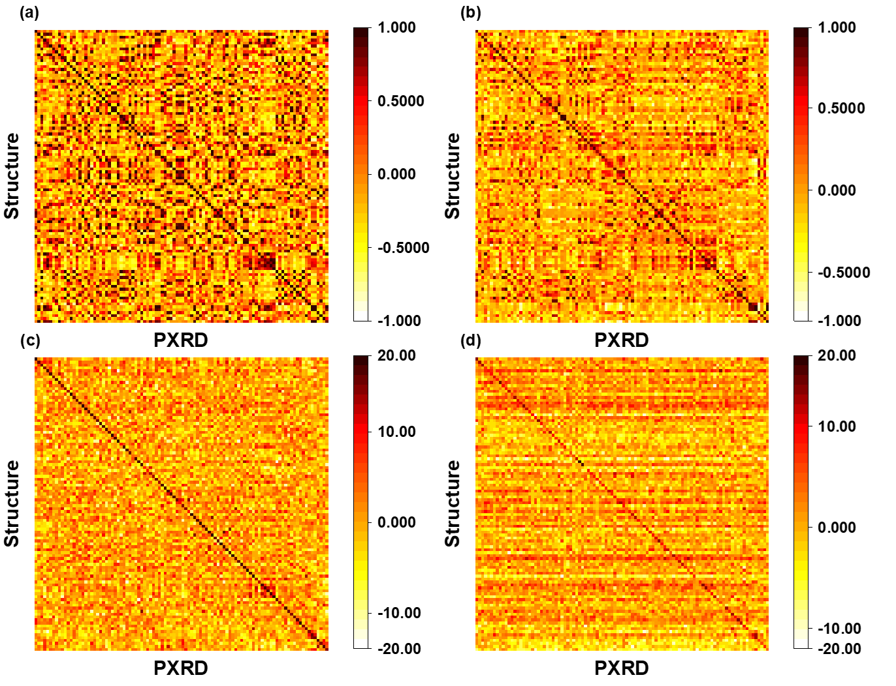
Supplementary Fig. 1. Visualization of the pre-trained contrastive learning module results. Panels (a)-(d) display the heatmap of similarity metrics for a random selection of 100 samples from the test dataset using XRDEncoder-T (t=1.0), XRDEncoder-CNN (t=1.0), XRDEncoder-T (t=0.05), and XRDEncoder-CNN (t=0.05) respectively. Darker colors indicate higher matches.

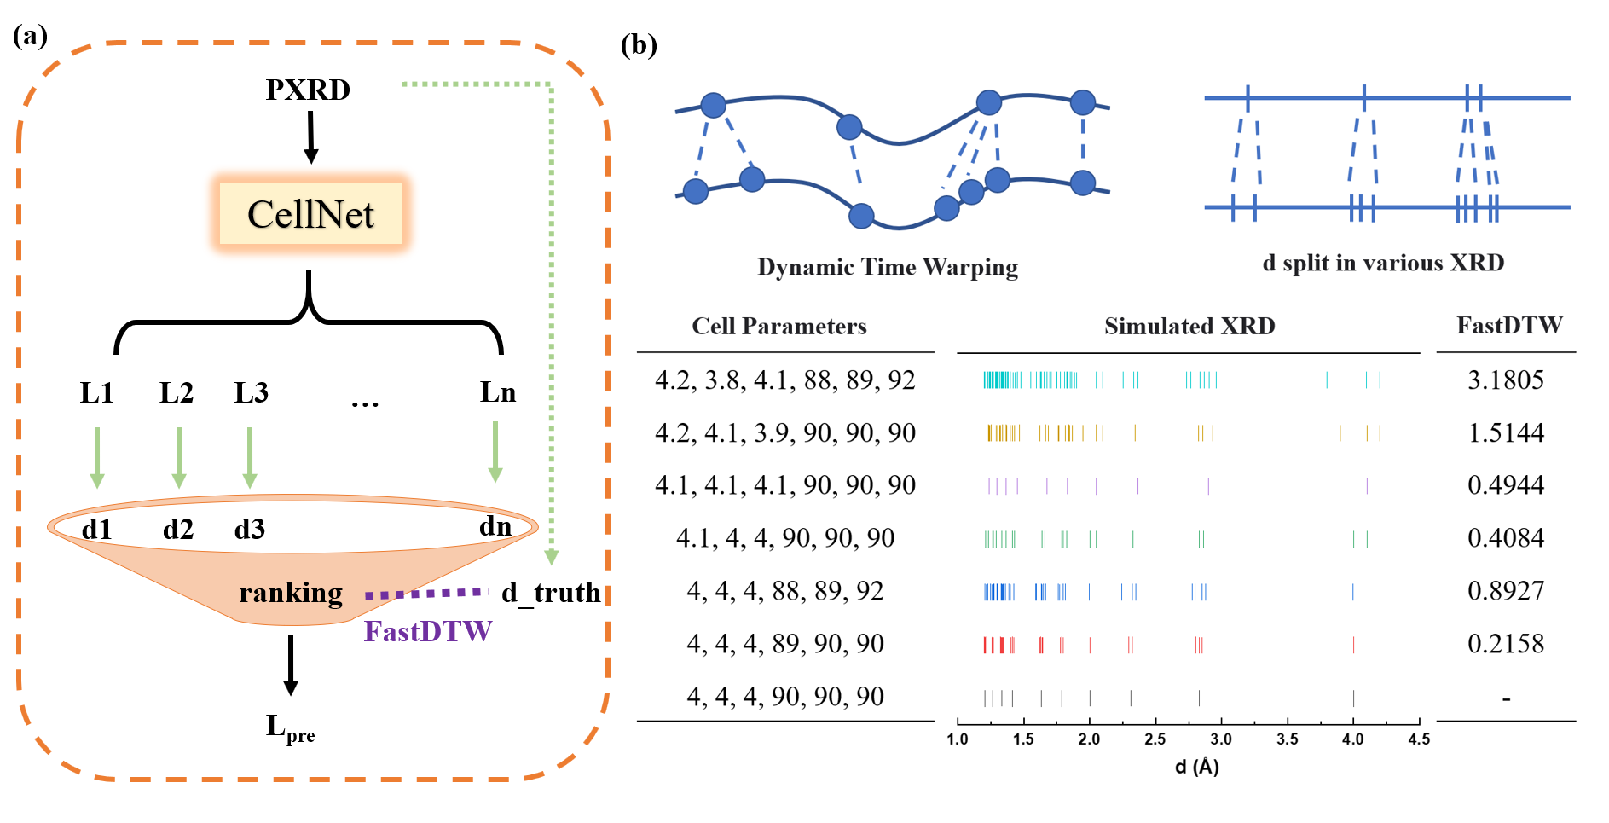
Supplementary Fig. 2. CellNet in PXRDGen. (a) Screen the best lattice parameters (L) from multiple L generated by CellNet. (b) The demonstration of FastDTW¹. Dynamic Time Warping is used to describe the similarity of different lengths of sequences. This scenario frequently occurs in XRD patterns when minor alterations in cell parameters result in variations in peak numbers, as illustrated by the provided examples. Therefore, utilizing FastDTW¹ to determine the optimal L from multiple options is a logical approach.

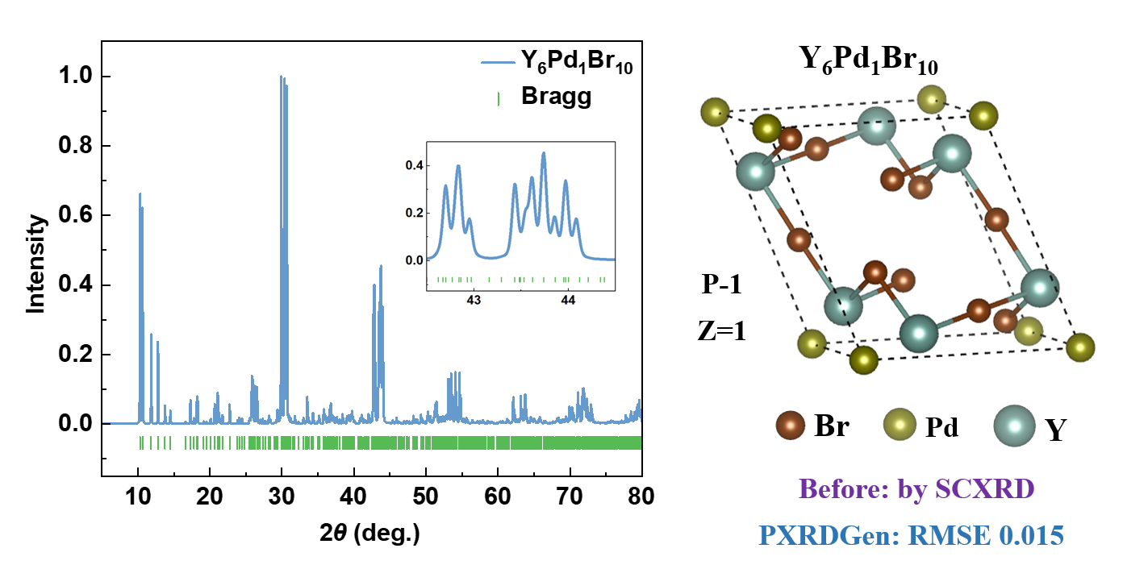
Supplementary Fig. 3. Examples of PXRDGen in Solving Challenging Structures. Demonstrating the application of PXRDGen in resolving peak overlap to determine the structure of Y₆Pd₁Br₁₀.

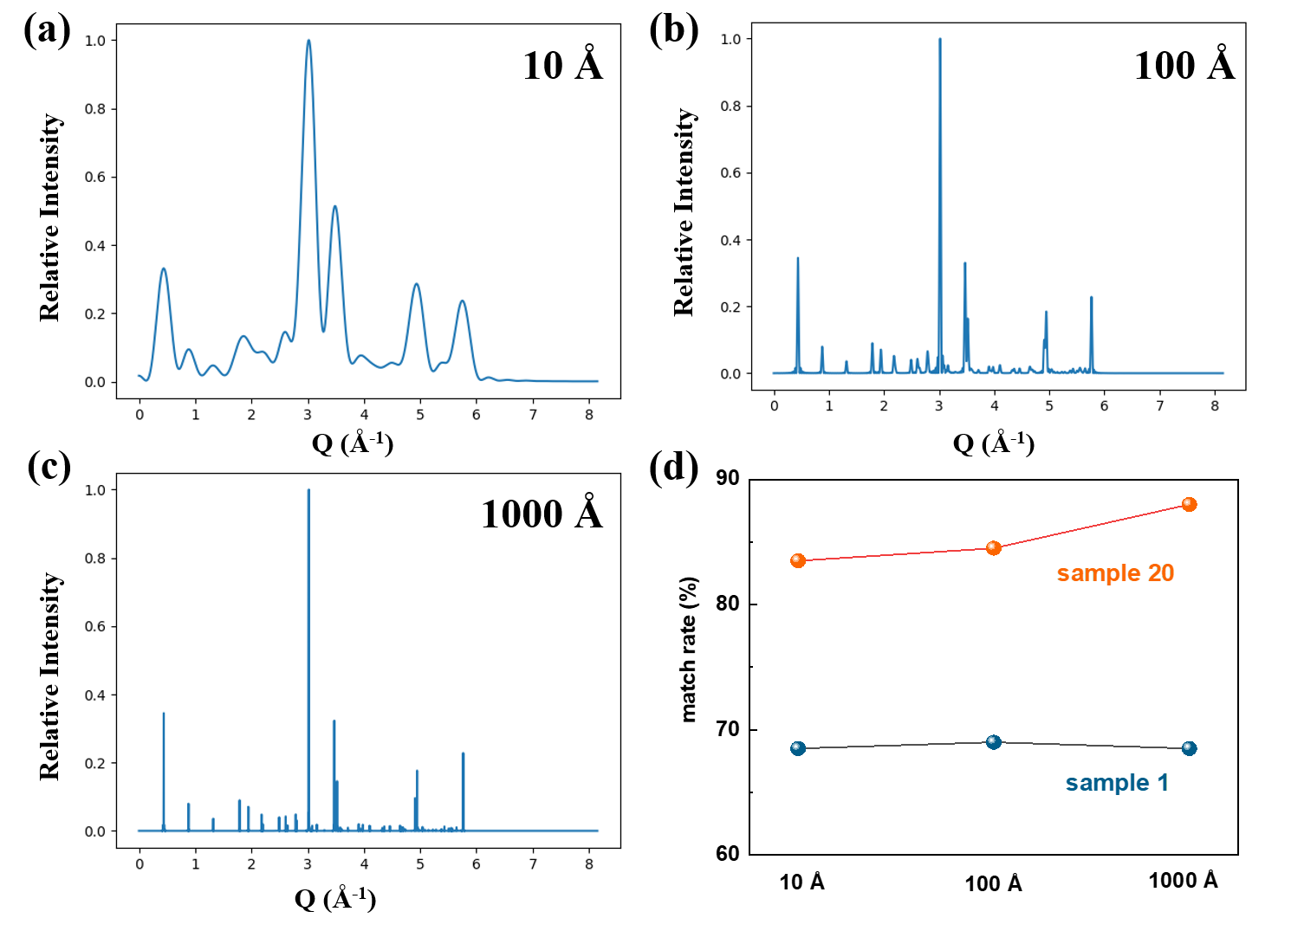
Supplementary Fig. 4. Impact of Grain Size on PXRDGen Performance. (a)-(c) Representative PXRD patterns of HfAl₃Ni₁₂ with varying nanocrystal sizes. (d) Evaluation of PXRDGen performance on 200 test dataset samples across different nanocrystal sizes.

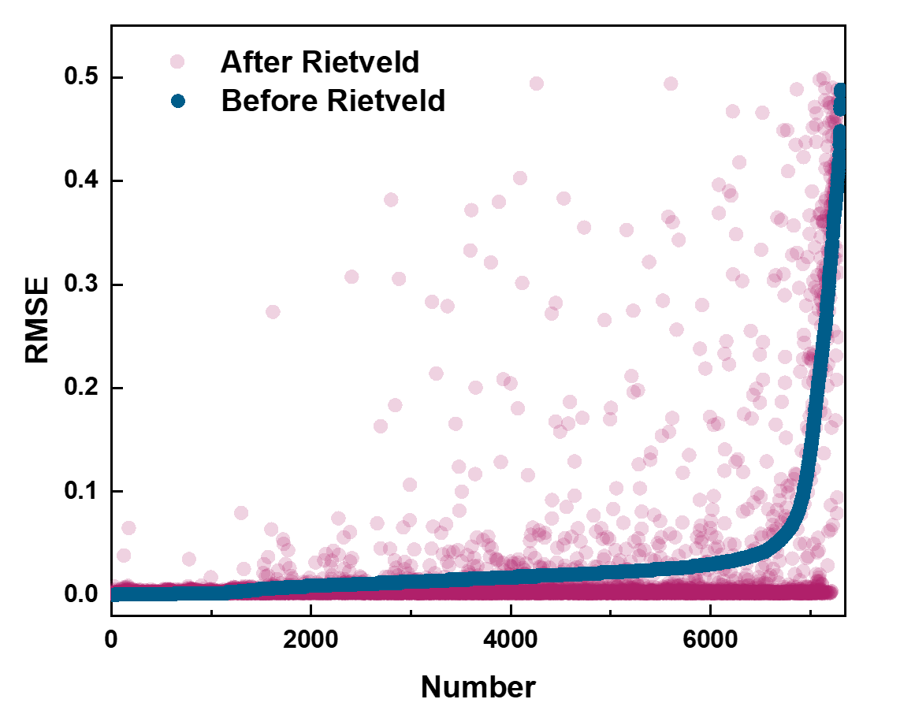
Supplementary Fig. 5. Comparison of RMSE values before and after Rietveld refinement using the flow-CNN-Ltruth module in the MP-20 dataset.

Supplementary Tables
Supplementary Table 1. Diffusion model combined with various pre-trained XRD encoders in MP-20 dataset.
Diffusion +  pretrained XRD encoder | fix | Sample 1 |  |  | Sample 20
Diffusion +  pretrained XRD encoder | fix | Match rate (%) | <RMSE> | n | Match rate (%) | <RMSE> | n
origin * | - | 52.42 | 0.0639 | 4742 | 77.69 | 0.0504 | 7028
origin +  ground truth | - | 67.74 | 0.0700 | 6128 | 87.68 | 0.0431 | 7931
XRDEncoder-T  w/o CL | - | 50.93 | 0.0605 | 4607 | 78.29 | 0.0505 | 7082
XRDEncoder-T (t=1.0) | yes | 52.43 | 0.0569 | 4743 | 78.92 | 0.0478 | 7139
XRDEncoder-T (t=1.0) | no | 50.45 | 0.0646 | 4564 | 78.33 | 0.0516 | 7086
XRDEncoder-T (t=0.05) | yes | 60.09 | 0.0620 | 5436 | 81.87 | 0.0457 | 7406
XRDEncoder-T (t=0.05) | no | 49.44 | 0.0618 | 4472 | 78.07 | 0.0540 | 7062
XRDEncoder-CNN w/o CL | - | 58.76 | 0.0555 | 5315 | 80.36 | 0.0422 | 7269
XRDEncoder-CNN (t=1.0) | yes | 55.59 | 0.0582 | 5029 | 78.80 | 0.0463 | 7128
XRDEncoder-CNN (t=1.0) | no | 66.01 | 0.0601 | 5971 | 84.04 | 0.0402 | 7602
XRDEncoder-CNN (t=0.05) | yes | 56.85 | 0.0634 | 5143 | 78.73 | 0.0502 | 7122
XRDEncoder-CNN (t=0.05) | no | 65.56 | 0.0617 | 5931 | 83.87 | 0.0422 | 7586
Note: * The origin result of DiffCSP² shows 51.49% match rate, 0.0631 RMSE in one sample, and 77.93% match rate, 0.0492 RMSE in 20 samples. Our test result is slightly better than the origin version. <RMSE> represents the averaged Root Mean Square Error, and n represent the number of results that are averaged.

Supplementary Table 2. Flow model combined with various pre-trained XRD encoders in MP-20 dataset.
Flow +  pretrained XRD encoder | fix | Sample 1 |  |  | Sample 20
Flow +  pretrained XRD encoder | fix | Match rate (%) | <RMSE> | n | Match rate (%) | <RMSE> | n
origin * | - | 58.25 | 0.0675 | 5269 | 80.23 | 0.0540 | 7257
origin  + ground truth | - | 76.33 | 0.0746 | 6905 | 87.97 | 0.0454 | 7958
XRDEncoder-T  w/o CL | - | 59.20 | 0.0674 | 5355 | 80.17 | 0.0534 | 7252
XRDEncoder-T (t=1.0) | yes | 60.78 | 0.0660 | 5498 | 80.85 | 0.0517 | 7314
XRDEncoder-T (t=1.0) | no | 59.99 | 0.0662 | 5427 | 79.88 | 0.0525 | 7226
XRDEncoder-T (t=0.05) | yes | 67.84 | 0.0724 | 6137 | 83.63 | 0.0473 | 7565
XRDEncoder-T (t=0.05) | no | 60.13 | 0.0732 | 5439 | 80.13 | 0.0538 | 7249
XRDEncoder-CNN w/o CL | - | 68.47 | 0.0724 | 6193 | 84.16 | 0.0476 | 7613
XRDEncoder-CNN (t=1.0) | yes | 60.32 | 0.0682 | 5456 | 81.27 | 0.0538 | 7352
XRDEncoder-CNN (t=1.0) | no | 68.07 | 0.0711 | 6158 | 85.02 | 0.0495 | 7691
XRDEncoder-CNN (t=0.05) | yes | 60.86 | 0.0761 | 5505 | 81.45 | 0.0570 | 7368
XRDEncoder-CNN (t=0.05) | no | 68.68 | 0.0707 | 6213 | 85.37 | 0.0489 | 7723

Note: * This version is inspired and adapted by FlowMM³, and the training epoch is set to 1000. When training in 2000 epochs, it shows 61.80% match rate, 0.0605 RMSE in one sample, and 79.18% match rate, 0.0472 RMSE in 20 samples. Although the performance in one sample increases, the ability in 20 samples dose not gain more. So the training epoch of flow is set to 1000 to save time and to keep align with diffusion model. <RMSE> represents the averaged Root Mean Square Error, and n represent the number of results that are averaged.
Supplementary Table 3. Comparison of match rate and mean RMSE for candidate structure (1 sample) generated by the flow-CNN and diffusion-CNN models at different generative steps.

model | Sample 1
model | Match rate (%) | <RMSE> | n
Flow step 10 | 45.56 | 0.1806 | 4121
Flow step 50 | 68.99 | 0.1077 | 6241
Flow step 100 | 69.01 | 0.081 | 6243
Flow step 200 | 68.68 | 0.0707 | 6213
Flow step 250 | 68.47 | 0.0712 | 6194
Flow step 500 | 68.56 | 0.0637 | 6202
Flow step 1000 | 68.53 | 0.0658 | 6199
Diffusion step 1000 | 65.56 | 0.0617 | 5931
Note: <RMSE> represents the averaged Root Mean Square Error, and n represent the number of results that are averaged.

Supplementary Table 4. Results of CellNet in lattice generation in MP-20 dataset.
Cell parameters | MAPE （Mean Absolute Percentage Error）/ %
Cell parameters | L₁ | L₂₀ | L₁₀₀ | L₂₀₀ | L₅₀₀ | L₁₀₀₀
a | 6.3792 | 3.4658 | 2.6598 | 2.4584 | 2.0846 | 1.8750
b | 4.8907 | 2.7106 | 2.1520 | 1.9053 | 1.6789 | 1.4781
c | 6.0874 | 2.7942 | 2.1202 | 1.8803 | 1.5651 | 1.3780
α | 7.4524 | 1.5136 | 0.7798 | 0.6213 | 0.4341 | 0.3424
β | 5.3369 | 1.2756 | 0.7475 | 0.5939 | 0.4158 | 0.3440
γ | 6.6226 | 1.4259 | 0.7547 | 0.5318 | 0.3810 | 0.2828
V | 12.8206 | 6.9605 | 5.3762 | 4.9635 | 4.1894 | 3.5727

Cell parameters | Root Mean Square Error
Cell parameters | L₁ | L₂₀ | L₁₀₀ | L₂₀₀ | L₅₀₀ | L₁₀₀₀
a | 0.6555 Å | 0.4276 Å | 0.3505 Å | 0.3398 Å | 0.2959 Å | 0.2729 Å
b | 0.6274 Å | 0.4265 Å | 0.3579 Å | 0.3203 Å | 0.2906 Å | 0.2615 Å
c | 2.5196 Å | 0.8553 Å | 0.7079 Å | 0.6652 Å | 0.5221 Å | 0.4625 Å
α | 14.5805° | 4.9690° | 3.2510° | 2.6570° | 2.2032° | 1.7897°
β | 10.9401° | 4.2835° | 3.1762° | 2.6958° | 2.0387° | 1.8461°
γ | 13.9864° | 5.1898° | 3.4696° | 2.6341° | 2.0887° | 1.5966°
V | 61.2992 Å³ | 42.7034 Å³ | 33.6405 Å³ | 34.0600 Å³ | 28.9132 Å³ | 26.5617 Å³
Note: L_{N} refers to screen out the best lattice from N predicted lattice from CellNet, and the screening method is to calculate the MAPE between the predicted cell and the target cell, which represents the upper capability of the CellNet.

Supplementary Table 5. Performance of flow-CNN module given the predicted L by CellNet.
Generate structures  given L | Screen Method | One sample  Match rate (%) | One sample  <RMSE> | One sample  n
flow-CNN | - | 68.68 | 0.0707 | 6213
flow-CNN + L_{truth} | - | 75.32 | 0.0726 | 6813
flow-CNN + L₁ | Compare with L_{truth} | 61.96 | 0.0694 | 5605
flow-CNN + L₂₀ | Compare with L_{truth} | 71.05 | 0.0735 | 6427
flow-CNN + L₁₀₀ | Compare with L_{truth} | 72.40 | 0.0743 | 6517
flow-CNN + L₂₀₀ | Compare with L_{truth} | 72.92 | 0.0746 | 6596
flow-CNN + L₅₀₀ | Compare with L_{truth} | 73.71 | 0.0752 | 6668
flow-CNN + L₁₀₀₀ | Compare with L_{truth} | 74.46 | 0.0744 | 6736
flow-CNN + L₂₀ | FastDTW | 67.80 | 0.0687 | 6133
flow-CNN + L₁₀₀ | FastDTW | 69.40 | 0.0680 | 6278
flow-CNN + L₂₀₀ | FastDTW | 69.57 | 0.0707 | 6293
flow-CNN + L₅₀₀ | FastDTW | 70.24 | 0.0693 | 6354
flow-CNN + L₁₀₀₀ | FastDTW | 70.39 | 0.0707 | 6367
Note: L_{N} represents to screen out the best lattice from N predicted lattice from CellNet. <RMSE> represents the averaged Root Mean Square Error, and n represent the number of results that are averaged.

Supplementary Table 6. The changes of mean RMSE before and after Rietveld Refinement.
Region | Before Rietveld |  | After Rietveld
Region | n | <RMSE> | n | <RMSE>
RMSE < 0.05 | 6854 | 0.0154 | 6660 | 0.0064
0.05 <= RMSE < 0.1 | 306 | 0.0684 | 271 | 0.0314
0.1 <= RMSE < 0.2 | 180 | 0.1442 | 141 | 0.0713
0.2 <= RMSE < 0.3 | 204 | 0.2512 | 112 | 0.1703
0.3 <= RMSE < 0.4 | 213 | 0.3484 | 85 | 0.3063
0.4 <= RMSE < 0.5 | 198 | 0.4448 | 35 | 0.3756
Note: <RMSE> represents the averaged Root Mean Square Error, and n represent the number of results that are averaged.

Supplementary Methods

Details of training neural networks. All the networks are implemented in Pytorch and Pytorch_Lightning framework, and trained on NVIDIA A100-PCIE-40GB GPUs. Nevertheless, the majority of models in PXRDGen can be easily implemented on more widely available 24 GB GPUs, such as the GeForce RTX 4090 or 3090.
In contrastive learning module, the batch size is set as 256, and the Adam optimizer is employed with a learning rate of 1e-3 for XRDEncoder-CNN and 1e-4 for XRDEncoder-T, with a CosineAnnealingLR scheduler. The training epoch is set as 400.
In crystal structure or lattice generation, the batch size is set as 256, and the Adam optimizer is employed with a learning rate of 1e-3, with a ReduceLROnPlateau scheduler. The training epoch is set as 1000 for both diffusion model and flow model. Diffusion model samples crystal structures or lattices in 1000 steps, while flow model can generate structures in less steps, here 200 steps are chosen.

Supplementary References
1. Salvador, S. et al. Toward accurate dynamic time warping in linear time and space. Intelligent Data Analysis 11, 561–580 (2007).
2. Jiao, R. et al. Crystal structure prediction by joint equivariant diffusion. Preprint at http://arxiv.org/abs/2309.04475 (2023).
3. Miller, B. K. et al. FlowMM: Generating Materials with Riemannian Flow Matching. Preprint at http://arxiv.org/abs/2406.04713 (2024).

