Supplementary Information
tRNA-dependent conformational dynamics and folding coordinate translational regulation by a full-length T-box riboswitch
Xiaolin Niu^{1, #}, Shanshan Cai^{2, #}, Junzheng Wang^{1, 3}, Chunlai Chen^{1, 3, *}, Xianyang Fang ^{2, 4, *}
¹School of Life Sciences, Tsinghua University, Beijing 100084, China
²Xinjiang Key Laboratory of Biological Resources and Genetic Engineering, College of Life Science and Technology, Xinjiang University, Urumqi 830046, China
³Beijing Frontier Research Center for Biological Structure, State Key Laboratory of Membrane Biology, Tsinghua University, Beijing 100084, China.
⁴Key Laboratory of RNA Science and Engineering, Institute of Biophysics, Chinese Academy of Sciences, Beijing, 100101, China
#These authors contributed equally: Xiaolin Niu, Shanshan Cai
⁎e-mail: chunlai@mail.tsinghua.edu.cn; fangxy@ibp.ac.cn

Table of Contents
Supplementary Figure 1 ...........................................................................................3
Supplementary Figure 2 ...........................................................................................4
Supplementary Figure 3 ...........................................................................................5
Supplementary Figure 4 ...........................................................................................6
Supplementary Figure 5 ...........................................................................................7
Supplementary Figure 6 ...........................................................................................8
Supplementary Figure 7 ...........................................................................................9
Supplementary Figure 8 ...........................................................................................10
Supplementary Table 1 .............................................................................................11
Supplementary Table 2 .............................................................................................12
Supplementary Table 3 .............................................................................................14
Supplementary Table 4 .............................................................................................15
Supplementary Table 5 .............................................................................................17

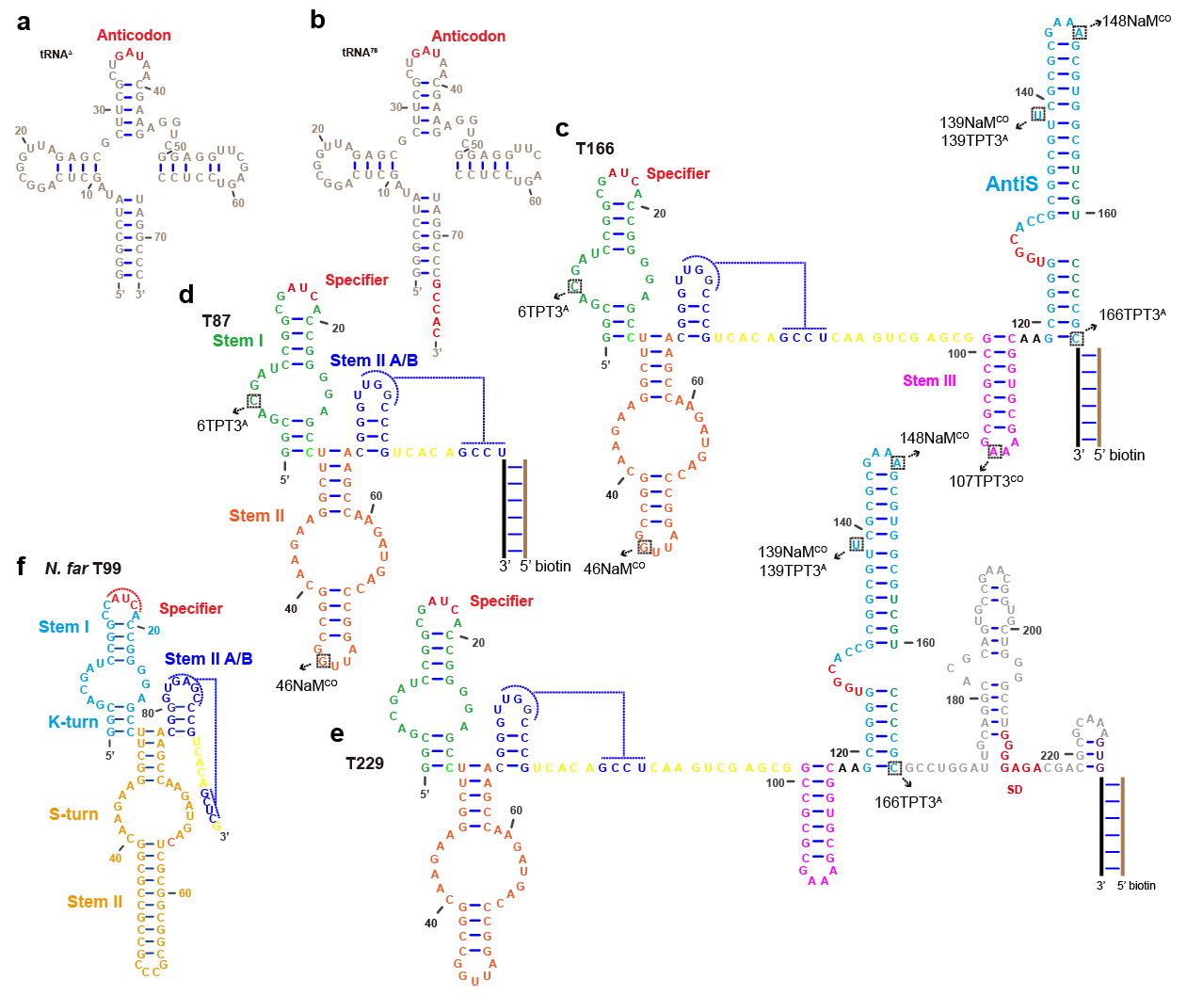

Supplementary Figure 1. The sequences and secondary structures of tRNA variants and ileS T-box riboswitch constructs used in the smFRET experiments. (a) tRNA^{Δ}, (b) tRNA⁷⁸, (c) T166, (d) T87 and (e) T229. (f) N.far T99 was used for comparison. The RNA extension at the 3’end of M.tub T-box constructs and the 5’-biotin labeled DNA oligonucleotides are represented with black and brown lines, respectively. The nucleotides selected for fluorophore labeling were indicated in the boxed regions, which were mutated to the unnatural nucleotides TPT3^{A}, TPT3^{CO} or NaM^{CO}, respectively.

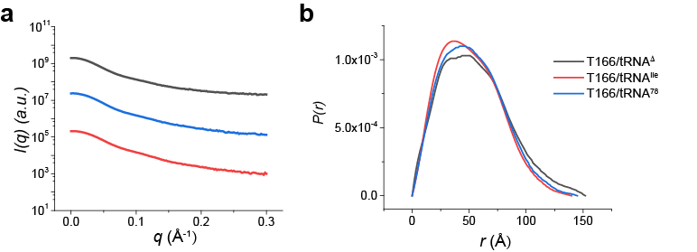
Supplementary Figure 2. SAXS analysis on the complexes formed between T166 and tRNA variants. The scattering curves (a) and normalized PDDFs (b) for T166 in the presence of different tRNA constructs (tRNA∆, tRNA^{Ile} and tRNA⁷⁸). The color codes are indicated on the upper right and are the same for a-b. Source data are provided as a Source Data file.

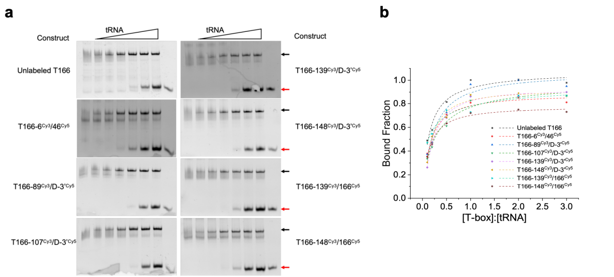
Supplementary Figure 3. UBP-based fluorophore labelings have a minor effect on the binding between T-box constructs and tRNA^{Ile}. (a) Electrophoretic mobility shift assays (EMSA) were performed for all of the fluorophore labeled T-box RNA constructs by varying the tRNA^{Ile} concentrations (the ratio for [tRNA^{Ile}]:[T-box] is 0:1, 0.1:1, 0.2:1, 0.5:1, 1:1, 2:1, 3:1, free tRNA^{Ile}). The red and black arrows represent the tRNA and T-box/tRNA complex, respectively. (b) Plots of the bound fractions as a function of [tRNA^{Ile}]:[T-box] molar ratios. All of the experiments were conducted on independent triplicates (n = 3). Source data are provided as a Source Data file.

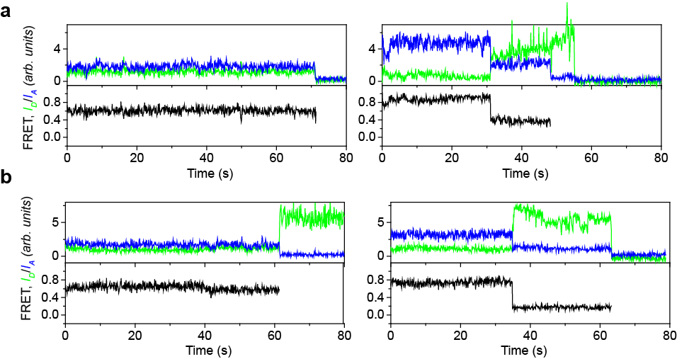
Supplementary Figure 4. Additional representative smFRET traces for T87-6/46 (a) and T166-6/46 (b) in the apo form. Green, blue and black lines represent the Cy3 intensity, Cy5 intensity and FRET efficiency, respectively. Source data are provided as a Source Data file.

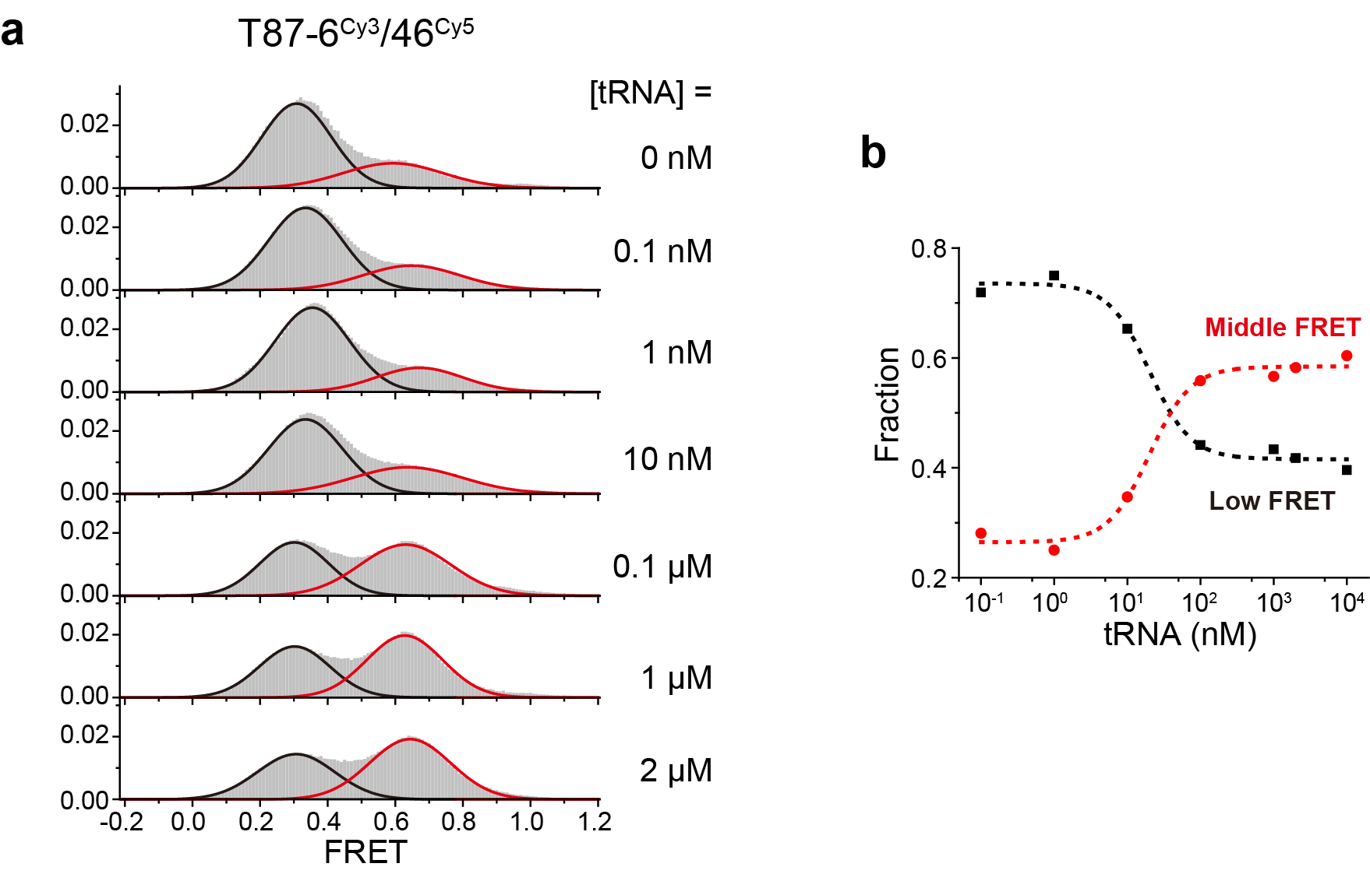
Supplementary Figure 5. Structural dynamics of decoding domain for T87 induced by uncharged tRNA binding. (a) FRET histograms for T87-6^{Cy3}/46^{Cy5} in the presence of various tRNA concentrations ranging from 0 nM to 2 uM. FRET histograms were well fitted with two Guassion peaks, shown in black and red for the low- and middle-FRET, respectively. (b) The low- and middle-FRET fractions were plotted as a function of tRNA concentrations. Source data are provided as a Source Data file.

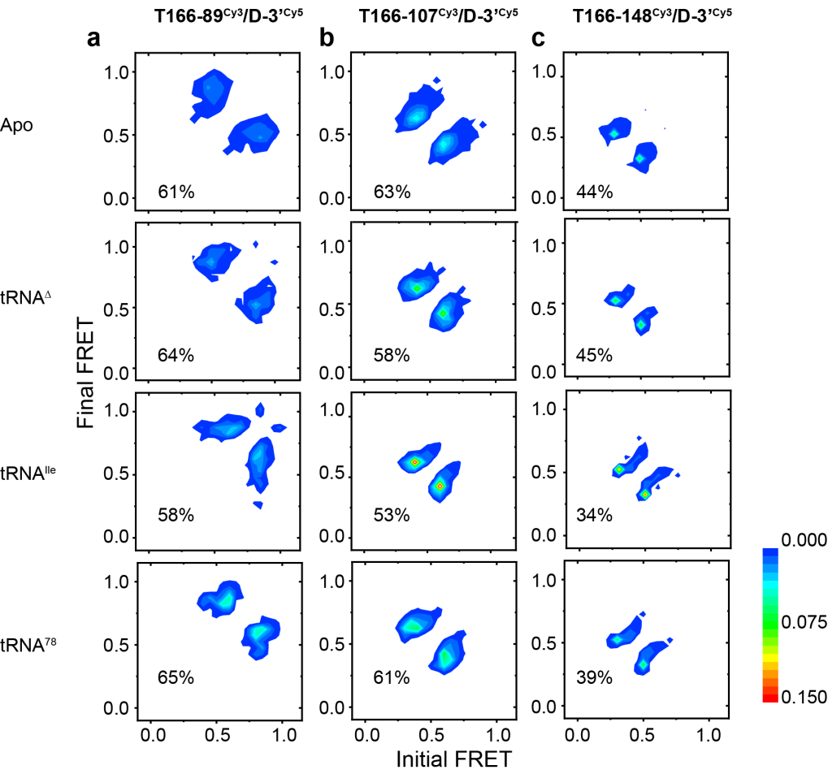
Supplementary Figure 6. Transition occupancy density plots for T166-89^{Cy3}/D-3’^{Cy5} (a), T166-107^{Cy3}/D-3’^{Cy5} (b) and T166-148^{Cy3}/D-3’^{Cy5} (c) under various experimental conditions, showing the relative populations of molecules undergoing specific FRET transition events (related to Figure 4). The fractions of dynamic traces among the total number of traces were listed in each panel. Source data are provided as a Source Data file.

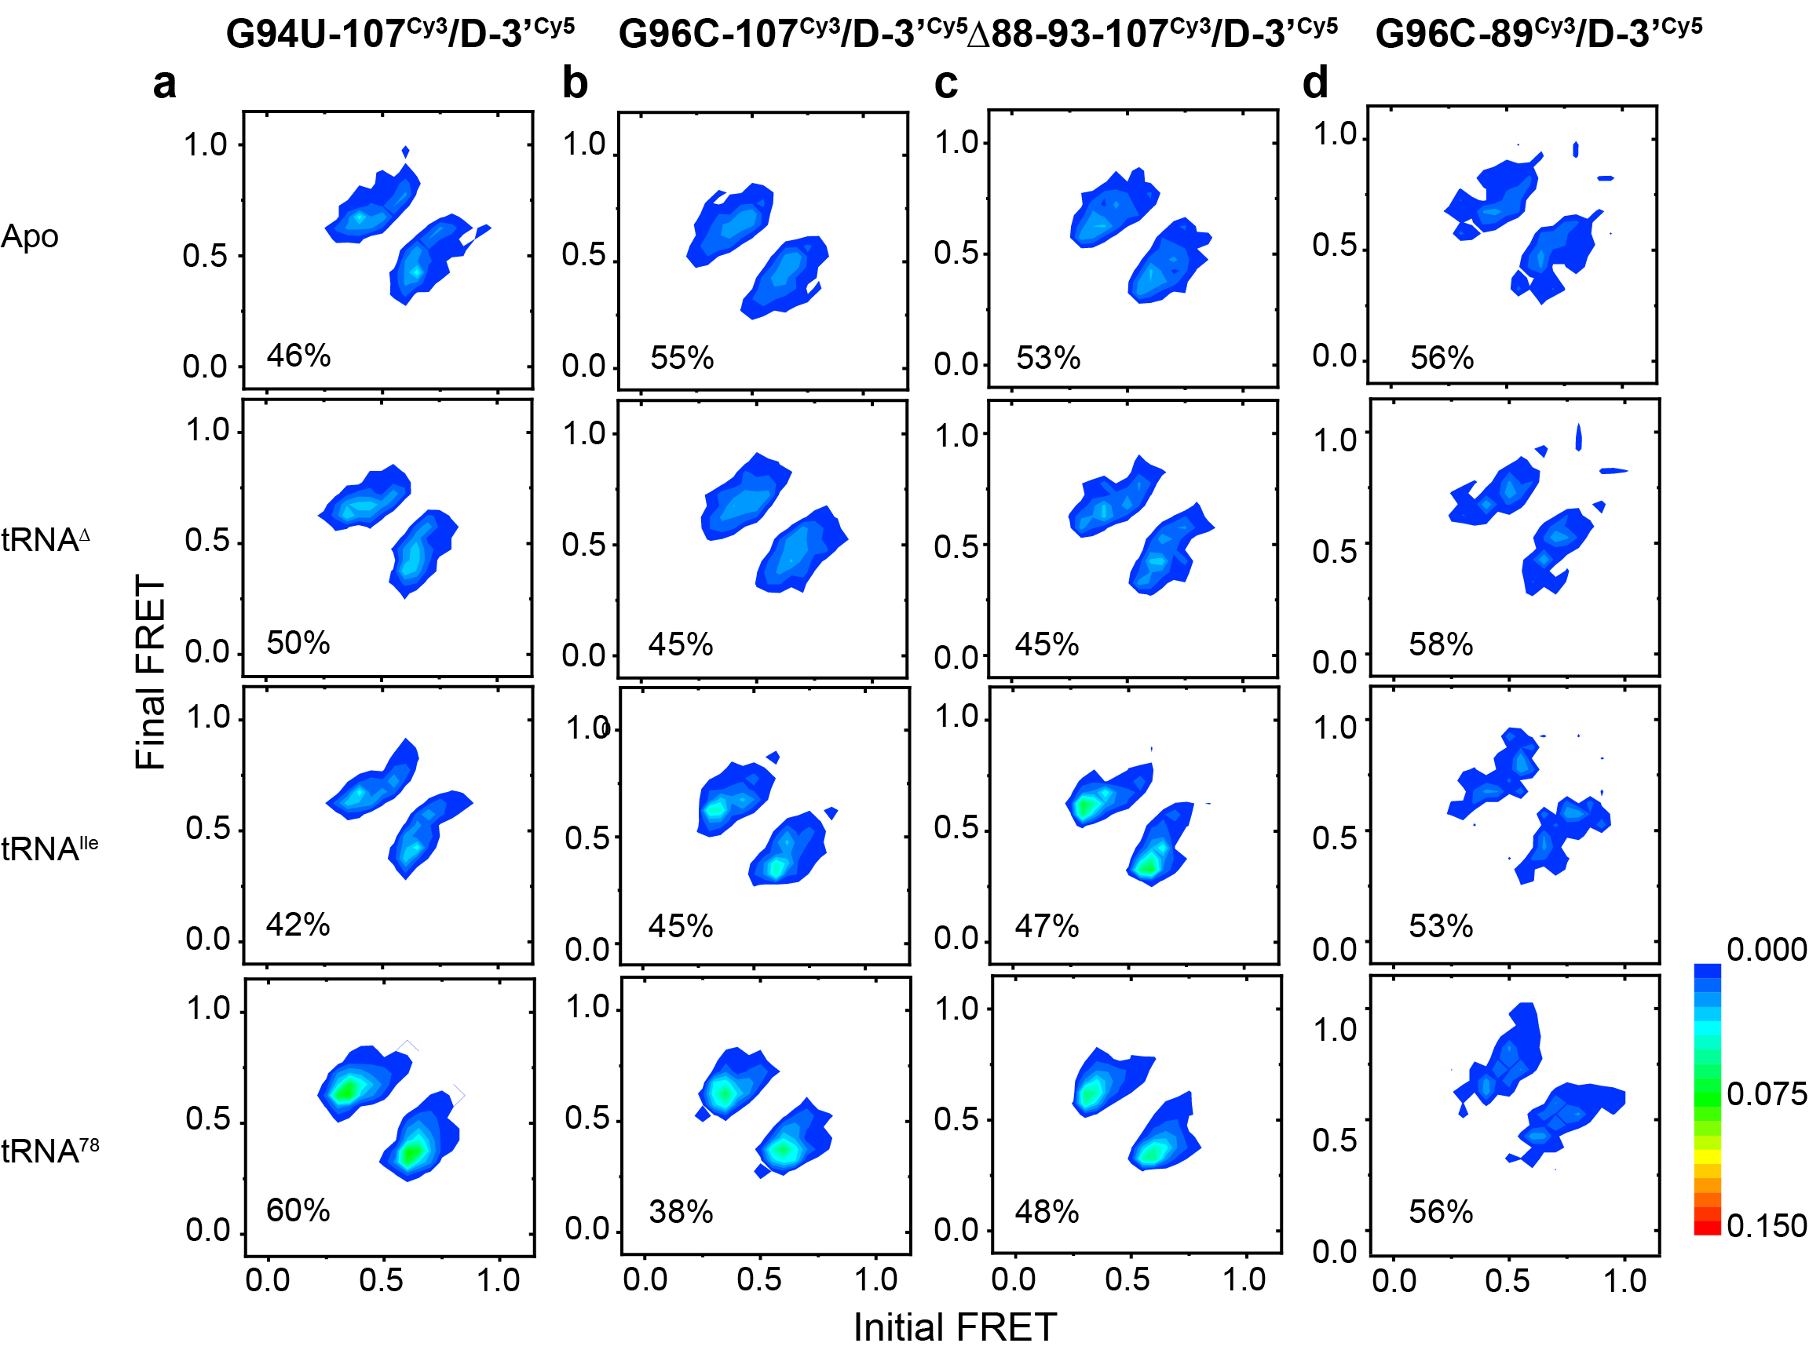
Supplementary Figure 7. Transition occupancy density plots for G94U-107^{Cy3}/D-3’^{Cy5} (a), G96C-107^{Cy3}/D-3’^{Cy5} (b), ∆88-93-107^{Cy3}/D-3’^{Cy5} (c) and G96C-89^{Cy3}/D-3’^{Cy5} (d) under various experimental conditions, showing the relative populations of molecules undergoing specific FRET transition events (related to Figure 6). The fractions of dynamic traces among the total number of traces were listed in each panel. Source data are provided as a Source Data file.

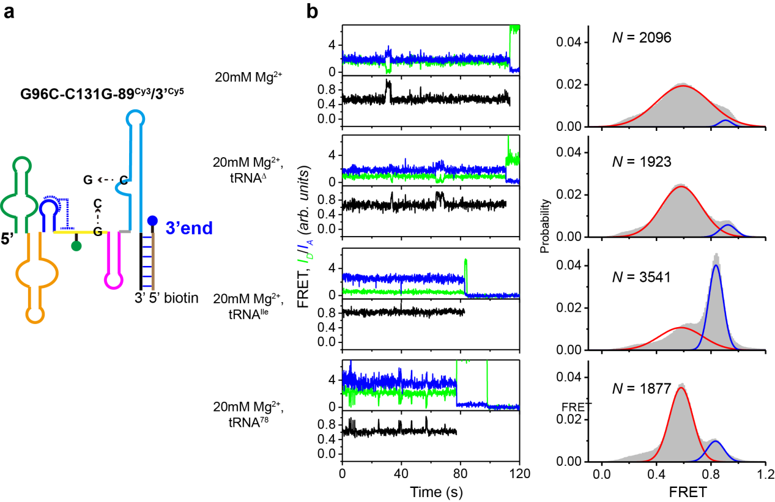

Supplementary Figure 8. C131G mutation restored the tRNA aminoacylation status discrimination ability of T-box. (a) Schematic representation for the secondary structure of labeling construct. The green and blue circles represent the Cy3 and Cy5 fluorophore, respectively. (b) Representative smFRET traces (left) and FRET histograms (right): in the absence of tRNA, in the presence of tRNA^{Δ}, tRNA^{Ile} and tRNA⁷⁸. Green, blue and black lines represent the Cy3 intensity, Cy5 intensity and FRET efficiency, respectively. FRET histograms were well fitted with Guassion peaks, shown in red and blue for the middle- and high-FRET, respectively. N denotes the total number of molecules used to generate the FRET histograms from three independent experiments (n = 3). Source data are provided as a Source Data file.

Supplementary Table 1. Basic structural parameters derived from SAXS data for the T-box riboswitches in comlex with different tRNA constructs .
RNAs | ªR_{g} (Å) | ^{b}D_{max} (Å) | ^{c}MW (kDa) | ^{d}MW (kDa)
T166/tRNA∆ | 42.5 ± 0.2 | 152 ± 2 | 78.9 | 65.2
T166/tRNA^{Ile} | 39.3 ± 0.2 | 140 ± 2 | 80.2 | 66.5
T166/tRNA⁷⁸ | 40.8 ± 0.2 | 145 ± 2 | 80.5 | 66.9

ªderived from Guinier fitting;
^{b}derived from GNOM analysis;
^{c}MW: molecular weight predicted from sequences;
^{d}MW: molecular weight calculated based on the power law of volume of correlation;
All the experiments were conducted in the buffer containing 20 mM Tris (pH 7.5), 100 mM KCl and 20 mM Mg²⁺.

Supplementary Table 2. The primary sequences of RNAs used in this study.
Construct | RNA sequences
T87 | 5΄-GGCGACGAUCCGGCGAUCACCGGGGAGCCUUCGGAAGAACGG  CCGGUUAGGCCCAGUAGAACCGAACGGGUUGGCCCGUCACAGCCU-3΄
T166 | 5΄- GGCGACGAUCCGGCGAUCACCGGGGAGCCUUCGGAAGAACGG  CCGGUUAGGCCCAGUAGAACCGAACGGGUUGGCCCGUCACAGCCUCAAGUCGAGCGGCCGCGCGAAAGCGUGGCAAGCGGGGUGGCACCGCGGCGUUCGCGCGAAAGCGUGGCGUCGUCCCCGC-3΄
T209 | 5΄-GGCGACGAUCCGGCGAUCACCGGGGAGCCUUCGGAAGAACGG  CCGGUUAGGCCCAGUAGAACCGAACGGGUUGGCCCGUCACAGCCUCAAGUCGAGCGGCCGCGCGAAAGCGUGGCAAGCGGGGUGGCACCGCGGCGUUCGCGCGAAAGCGUGGCGUCGUCCCCGCGCCUGGAUUGCAGGCACGCAGUGCCGAACGGUGCUGGGGCCUG-3΄
T215 | 5΄- GGCGACGAUCCGGCGAUCACCGGGGAGCCUUCGGAAGAACGG  CCGGUUAGGCCCAGUAGAACCGAACGGGUUGGCCCGUCACAGCCUCAAGUCGAGCGGCCGCGCGAAAGCGUGGCAAGCGGGGUGGCACCGCGGCGUUCGCGCGAAAGCGUGGCGUCGUCCCCGCGCCUGGAUUGCAGGCACGCAGUGCCGAACGGUGCUGGGGCCUGGGGAGA-3΄
T229 | 5΄-GGCGACGAUCCGGCGAUCACCGGGGAGCCUUCGGAAGAACGG  CCGGUUAGGCCCAGUAGAACCGAACGGGUUGGCCCGUCACAGCCUCAAGUCGAGCGGCCGCGCGAAAGCGUGGCAAGCGGGGUGGCACCGCGGCGUUCGCGCGAAAGCGUGGCGUCGUCCCCGCGCCUGGAUUGCAGGCACGCAGUGCCGAACGGUGCUGGGGCCUGGGGAGACGACGCGCAAAGUG-3΄΄
T166-G94U | 5΄- GGCGACGAUCCGGCGAUCACCGGGGAGCCUUCGGAAGAACGG  CCGGUUAGGCCCAGUAGAACCGAACGGGUUGGCCCGUCACAGCCUCAAGUCUAGCGGCCGCGCGAAAGCGUGGCAAGCGGGGUGGCACCGCGGCGUUCGCGCGAAAGCGUGGCGUCGUCCCCGC-3΄
T166-G96C | 5΄- GGCGACGAUCCGGCGAUCACCGGGGAGCCUUCGGAAGAACGG  CCGGUUAGGCCCAGUAGAACCGAACGGGUUGGCCCGUCACAGCCUCAAGUCGACCGGCCGCGCGAAAGCGUGGCAAGCGGGGUGGCACCGCGGCGUUCGCGCGAAAGCGUGGCGUCGUCCCCGC-3΄
T166-G96C/C131G | 5΄- GGCGACGAUCCGGCGAUCACCGGGGAGCCUUCGGAAGAACGG  CCGGUUAGGCCCAGUAGAACCGAACGGGUUGGCCCGUCACAGCCUCAAGUCGACCGGCCGCGCGAAAGCGUGGCAAGCGGGGUGGCACGGCGGCGUUCGCGCGAAAGCGUGGCGUCGUCCCCGC-3΄
T166-Δ88-93 | 5΄- GGCGACGAUCCGGCGAUCACCGGGGAGCCUUCGGAAGAACGG  CCGGUUAGGCCCAGUAGAACCGAACGGGUUGGCCCGUCACAGCCUGAGCGGCCGCGCGAAAGCGUGGCAAGCGGGGUGGCACCGCGGCGUUCGCGCGAAAGCGUGGCGUCGUCCCCGC-3΄
tRNA^{Ile} | 5΄-GGGCCUAUAGCUCAGGCGGUUAGAGCGCUUCGCUGAUAAC  GAAGAGGUCGGAGGUUCGAGUCCUCCUAGGCCCGCCA-3΄
tRNA^{Δ} | 5΄-GGGCCUAUAGCUCAGGCGGUUAGAGCGCUUCGCUGAUAAC  GAAGAGGUCGGAGGUUCGAGUCCUCCUAGGCCC-3΄
tRNA⁷⁸ | 5΄-GGGCCUAUAGCUCAGGCGGUUAGAGCGCUUCGCUGAUAAC  GAAGAGGUCGGAGGUUCGAGUCCUCCUAGGCCCGCCAC-3΄

(Note: the mutated residues are highlighted in bold and red.)

Supplementary Table 3. The natural and unnatural oligonucleotide primers used in this study.
Primer | Sequences
WT-F | 5΄-GGACAGGAAACAGCTATGACCATCGTCAGT-3΄
T87+linker-R | 5΄-CTGCGTGCCTGCAATCCAGGAGGCTGTGACGGGCC-3΄
T166+linker-R | 5΄-CTGCGTGCCTGCAATCCAGGCGCGGGGACGACGCCACGC-3΄
T209+linker-R | 5΄-CTGTCGTCCGCCATCGCCAGGCCCCAGCACCGTTCGGCACT  GC-3΄
T215+linker-R | 5΄- CTGTCGTCCGCCATCGCTCTCCCCAGGCCCCAGCACCGTTCG  GCACTGC-3΄
T229+linker-R | 5΄- CTGTCGTCCGCCATCGCCACTTTGCGCGTCGTCTCCCCAGGCC  CCAGCACCGTTCGGCACTGC-3΄
T200-R | 5΄-GCACCGTTCGGCACTGCGTGCCTGCAATCCAGGCGCGGGGAC  GACGCCACGC-3΄
6NaM-R | 5΄-CCGAAGGCTCCCCGGTGATCGCCGGATC(NaM)TCGCCTATAG  TGAGTCGTATTACCCC-3΄
46NaM-F | 5΄-GATCACCGGGGAGCCTTCGGAAGAACGGCCG(NaM)TTAGGC  CCAGTAGAACCGAACG-3΄
89TPT3-R | 5΄-CGCGCGGCCGCTCGACT(TPT3)GAGGCTGTGACGGGCCAACC  CGTTCGGTTCTACTGGG-3΄
107NaM-R | 5΄-CGAACGCCGCGGTGCCACCCCGCTTGCCACGCTT(NaM)CGCG  CGGCCGC-3΄
148TPT3-R | 5΄-GGGGACGACGCCACGC(TPT3)TTCGCGCGAACGCCGC-3΄
139TPT3-R | GGGACGACGCCACGCTTTCGCGCG(TPT3)ACGCCGCGGTGCCA
139NaM-R | GGGACGACGCCACGCTTTCGCGCG(NaM)ACGCCGCGGTGCCA
DNA-linker (T87/166) | 5΄biotin-CGCACCGGACCTCTCGT-3΄
DNA-linker (T87/166) | 5΄biotin-CGCACCGGACCTCTCGT-3΄Cy5
DNA-linker (T209/215/229) | 5΄biotin-CTGTCGTCCGCCATCGC-3΄

Supplementary Table 4. smFRET transition rates for different T-box constructs in different conditions.
Constructs | tRNAs | High-FRET dwell time (s) | Low-FRET dwell time (s) | High-FRET transition rate (s⁻¹) | Low-FRET transition rate (s⁻¹)
T166-139^{Cy5}/5’^{Cy3}-tRNA | tRNA∆ | 1.4 ± 0.3 | 0.96 ± 0.09 | 0.7 ± 0.2 | 1.0 ± 0.1
T166-139^{Cy5}/5’^{Cy3}-tRNA | tRNA^{Ile} | 3.7 ± 1.3 | 0.9 ± 0.2 | 0.27 ± 0.09 | 1.1 ± 0.2
T166-139^{Cy5}/5’^{Cy3}-tRNA | tRNA⁷⁸ | 1.22 ± 0.02 | 0.64 ± 0.05 | 0.82 ± 0.01 | 1.6 ± 0.1
G96C-139^{Cy5}/5’^{Cy3}-tRNA | tRNA∆ | 2 ± 1.1 | 1.2 ± 0.2 | 0.5 ± 0.3 | 0.8 ± 0.1
G96C-139^{Cy5}/5’^{Cy3}-tRNA | tRNA^{Ile} | 2.5 ± 0.6 | 0.77 ± 0.08 | 0.4 ± 0.1 | 1.3 ± 0.1
G96C-139^{Cy5}/5’^{Cy3}-tRNA | tRNA⁷⁸ | 2.5 ± 1.5 | 0.7 ± 0.1 | 0.4 ± 0.2 | 1.4 ± 0.2
G94U-139^{Cy5}/5’^{Cy3}-tRNA | tRNA∆ | 1.5 ± 0.9 | 1.2 ± 0.3 | 0.7 ± 0.4 | 0.8 ± 0.2
G94U-139^{Cy5}/5’^{Cy3}-tRNA | tRNA^{Ile} | 4.1 ± 0.4 | 0.38 ± 0.03 | 0.24 ± 0.02 | 2.6 ± 0.2
G94U-139^{Cy5}/5’^{Cy3}-tRNA | tRNA⁷⁸ | 1.6 ± 0.8 | 0.92 ± 0.06 | 0.6 ± 0.3 | 1.09 ± 0.07
∆88-93-139^{Cy5}/5’^{Cy3}-tRNA | tRNA∆ | 1.8 ± 0.3 | 1.2 ± 0.2 | 0.56 ± 0.09 | 0.8 ± 0.1
∆88-93-139^{Cy5}/5’^{Cy3}-tRNA | tRNA^{Ile} | 3 ± 0.2 | 0.32 ± 0.05 | 0.33 ± 0.02 | 3.1 ± 0.5
∆88-93-139^{Cy5}/5’^{Cy3}-tRNA | tRNA⁷⁸ | 1.8 ± 0.3 | 0.56 ± 0.08 | 0.56 ± 0.09 | 1.8 ± 0.3
T87-6^{Cy3}/46^{Cy5} | Apo | 1.02 ± 0.02 | 1.2 ± 0.3 | 0.98 ± 0.02 | 0.83 ± 0.01
T87-6^{Cy3}/46^{Cy5} | 10nM tRNA∆ | 1.5 ± 0.6 | 1.3 ± 0.4 | 0.7 ± 0.3 | 0.8 ± 0.2
T87-6^{Cy3}/46^{Cy5} | 10nM tRNA^{Ile} | 1.8 ± 0.4 | 1.4 ± 0.3 | 0.6 ± 0.1 | 0.72 ± 0.06
T87-6^{Cy3}/46^{Cy5} | 10nM tRNA⁷⁸ | 1.00 ± 0.02 | 1.6 ± 0.5 | 1.00 ± 0.02 | 0.63 ± 0.008
T87-6^{Cy3}/46^{Cy5} | 1uM tRNA∆ | 2.1 ± 0.7 | 1.1 ± 0.2 | 0.5 ± 0.2 | 0.9 ± 0.1
T87-6^{Cy3}/46^{Cy5} | 1uM tRNA^{Ile} | 2.2 ± 0.8 | 0.78 ± 0.09 | 0.5 ± 0.2 | 1.3 ± 0.1
T87-6^{Cy3}/46^{Cy5} | 1uM tRNA⁷⁸ | 1.25 ± 0.04 | 0.92 ± 0.09 | 0.80 ± 0.03 | 1.1 ± 0.1
T166-6^{Cy3}/46^{Cy5} | Apo | 2 ± 0.7 | 1.3 ± 0.2 | 0.5 ± 0.2 | 0.8 ± 0.1
T166-6^{Cy3}/46^{Cy5} | 10nM tRNA∆ | 1.9 ± 0.6 | 0.8 ± 0.2 | 0.5 ± 0.2 | 1.3 ± 0.3
T166-6^{Cy3}/46^{Cy5} | 10nM tRNA^{Ile} | 1.21 ± 0.03 | 0.8 ± 0.3 | 0.83 ± 0.02 | 1.3 ± 0.5
T166-6^{Cy3}/46^{Cy5} | 10nM tRNA⁷⁸ | 2.1 ± 0.9 | 0.9 ± 0.4 | 0.5 ± 0.2 | 1.1 ± 0.5
T166-6^{Cy3}/46^{Cy5} | 1uM tRNA∆ | 2.3 ± 0.4 | 0.25 ± 0.003 | 0.43 ± 0.07 | 4.00 ± 0.05
T166-6^{Cy3}/46^{Cy5} | 1uM tRNA^{Ile} | 1.35 ± 0.03 | 0.40 ± 0.04 | 0.74 ± 0.02 | 2.5 ± 0.3
T166-6^{Cy3}/46^{Cy5} | 1uM tRNA⁷⁸ | 1.30 ± 0.02 | 0.49 ± 0.09 | 0.77 ± 0.01 | 2.0 ± 0.4
T166-89^{Cy3}/D-3’^{Cy5} | Apo | 0.87 ± 0.01 | 0.9 ± 0.2 | 1.15 ± 0.01 | 1.1 ± 0.2
T166-89^{Cy3}/D-3’^{Cy5} | tRNA∆ | 0.85 ± 0.01 | 0.84 ± 0.09 | 1.18 ± 0.01 | 1.2 ± 0.1
T166-89^{Cy3}/D-3’^{Cy5} | tRNA^{Ile} | 2.4 ± 0.3 | 0.8 ± 0.2 | 0.42 ± 0.05 | 1.3 ± 0.3
T166-89^{Cy3}/D-3’^{Cy5} | tRNA⁷⁸ | 0.79 ± 0.01 | 1.4 ± 0.1 | 1.27 ± 0.01 | 0.71 ± 0.05
T166-107^{Cy3}/D-3’^{Cy5} | Apo | 1.34 ± 0.03 | 0.8 ± 0.1 | 0.75 ± 0.02 | 1.3 ± 0.2
T166-107^{Cy3}/D-3’^{Cy5} | tRNA∆ | 1.41 ± 0.03 | 0.57 ± 0.07 | 0.71 ± 0.02 | 1.8 ± 0.2
T166-107^{Cy3}/D-3’^{Cy5} | tRNA^{Ile} | 1.48 ± 0.03 | 0.5 ± 0.1 | 0.68 ± 0.01 | 2.0 ± 0.4
T166-107^{Cy3}/D-3’^{Cy5} | tRNA⁷⁸ | 1.13 ± 0.01 | 1.25 ± 0.07 | 0.88 ± 0.01 | 0.80 ± 0.04
T166-148^{Cy3}/D-3’^{Cy5} | Apo | 1.9 ± 0.5 | 0.8 ± 0.2 | 0.5 ± 0.1 | 1.3 ± 0.3
T166-148^{Cy3}/D-3’^{Cy5} | tRNA∆ | 1.45 ± 0.03 | 0.6 ± 0.2 | 0.69 ± 0.01 | 1.7 ± 0.6
T166-148^{Cy3}/D-3’^{Cy5} | tRNA^{Ile} | 2.7 ± 1.2 | 0.27 ± 0.03 | 0.4 ± 0.2 | 3.7 ± 0.4
T166-148^{Cy3}/D-3’^{Cy5} | tRNA⁷⁸ | 1.14 ± 0.02 | 0.74 ± 0.09 | 0.88 ± 0.02 | 1.4 ± 0.2
G94U-107^{Cy3}/D-3’^{Cy5} | Apo | 1.2 ± 0.2 | 0.9 ± 0.2 | 0.8 ± 0.1 | 1.1 ± 0.2
G94U-107^{Cy3}/D-3’^{Cy5} | tRNA∆ | 1.27 ± 0.03 | 0.8 ± 0.1 | 0.79 ± 0.02 | 1.3 ± 0.2
G94U-107^{Cy3}/D-3’^{Cy5} | tRNA^{Ile} | 1.21 ± 0.03 | 0.274 ± 0.003 | 0.83 ± 0.02 | 3.65 ± 0.04
G94U-107^{Cy3}/D-3’^{Cy5} | tRNA⁷⁸ | 1.35 ± 0.02 | 1.33 ± 0.05 | 0.74 ± 0.01 | 0.75 ± 0.03
G96C-107^{Cy3}/D-3’^{Cy5} | Apo | 1.23 ± 0.03 | 1.5 ± 0.2 | 0.81 ± 0.02 | 0.67 ± 0.09
G96C-107^{Cy3}/D-3’^{Cy5} | tRNA∆ | 1.26 ± 0.03 | 1.2 ± 0.1 | 0.79 ± 0.02 | 0.83 ± 0.07
G96C-107^{Cy3}/D-3’^{Cy5} | tRNA^{Ile} | 1.09 ± 0.02 | 1.7 ± 0.2 | 0.92 ± 0.02 | 0.59 ± 0.07
G96C-107^{Cy3}/D-3’^{Cy5} | tRNA⁷⁸ | 1.08 ± 0.02 | 1.8 ± 0.1 | 0.93 ± 0.02 | 0.56 ± 0.03
∆88-93-107^{Cy3}/D-3’^{Cy5} | Apo | 1.21 ± 0.03 | 0.9 ± 0.1 | 0.83 ± 0.02 | 1.1 ± 0.1
∆88-93-107^{Cy3}/D-3’^{Cy5} | tRNA∆ | 1.16 ± 0.02 | 0.81 ± 0.09 | 0.86 ± 0.01 | 1.2 ± 0.1
∆88-93-107^{Cy3}/D-3’^{Cy5} | tRNA^{Ile} | 1.29 ± 0.03 | 1.1 ± 0.2 | 0.77 ± 0.02 | 0.9 ± 0.2
∆88-93-107^{Cy3}/D-3’^{Cy5} | tRNA⁷⁸ | 1.2 ± 0.2 | 1.83 ± 0.07 | 0.8 ± 0.1 | 0.55 ± 0.02
G96C-89^{Cy3}/D-3’^{Cy5} | Apo | 2.1 ± 1.2 | 1.1 ± 0.1 | 0.5 ± 0.3 | 1.0 ± 0.1
G96C-89^{Cy3}/D-3’^{Cy5} | tRNA∆ | 2.1 ± 0.5 | 0.8 ± 0.1 | 0.5 ± 0.1 | 1.3 ± 0.2
G96C-89^{Cy3}/D-3’^{Cy5} | tRNA^{Ile} | 1.20 ± 0.02 | 1.2 ± 0.2 | 0.83 ± 0.01 | 0.8 ± 0.1
G96C-89^{Cy3}/D-3’^{Cy5} | tRNA⁷⁸ | 0.96 ± 0.01 | 1.1 ± 0.1 | 1.04 ± 0.01 | 0.91 ± 0.08

Supplementary Table 5. SAXS data collection parameters.
Data Collection Parameters
Facilities and parameters | Settings and values
Beam line | BL19U2 (SSRF)
Wavelength (Å) | 1.033
Detector | Pilatus 100K
q range (Å⁻¹) | 0.009-0.415
Exposure time (s) | 60
Concentration range ( mg/ml) | 0.75-3
Temperature (K) | 298

