Supplementary materials
Supplementary Figure 1: Average causal effect on personal disposable income among the non-retired population, adjusting for mortality. 2
Supplementary Table 1: Labor market attachment over time in the exposed and unexposed population, 2008 matched cohort. 3

Supplementary Figure 1: Average causal effect on personal disposable income among the non-retired population, adjusting for mortality.
Estimates are presented in absolute terms (top panel, 2023 EUR) and relative terms (bottom panel, as a percentage of control group income) over 10 years following diagnosis. For both groups, income is imputed as zero in all years following death, allowing for full comparability in cumulative income trajectories. Data are presented as mean values, with error bars indicating 95% confidence intervals based on two-sided t-tests. The analysis includes n = 30,802 individuals in the exposed group and n = 4,317,385 matched controls. The unit of analysis is the individual, and all replicates are biological. Control individuals were matched on age, sex, and baseline demographic, socio-economic and health characteristics. Source data are provided with the main paper.
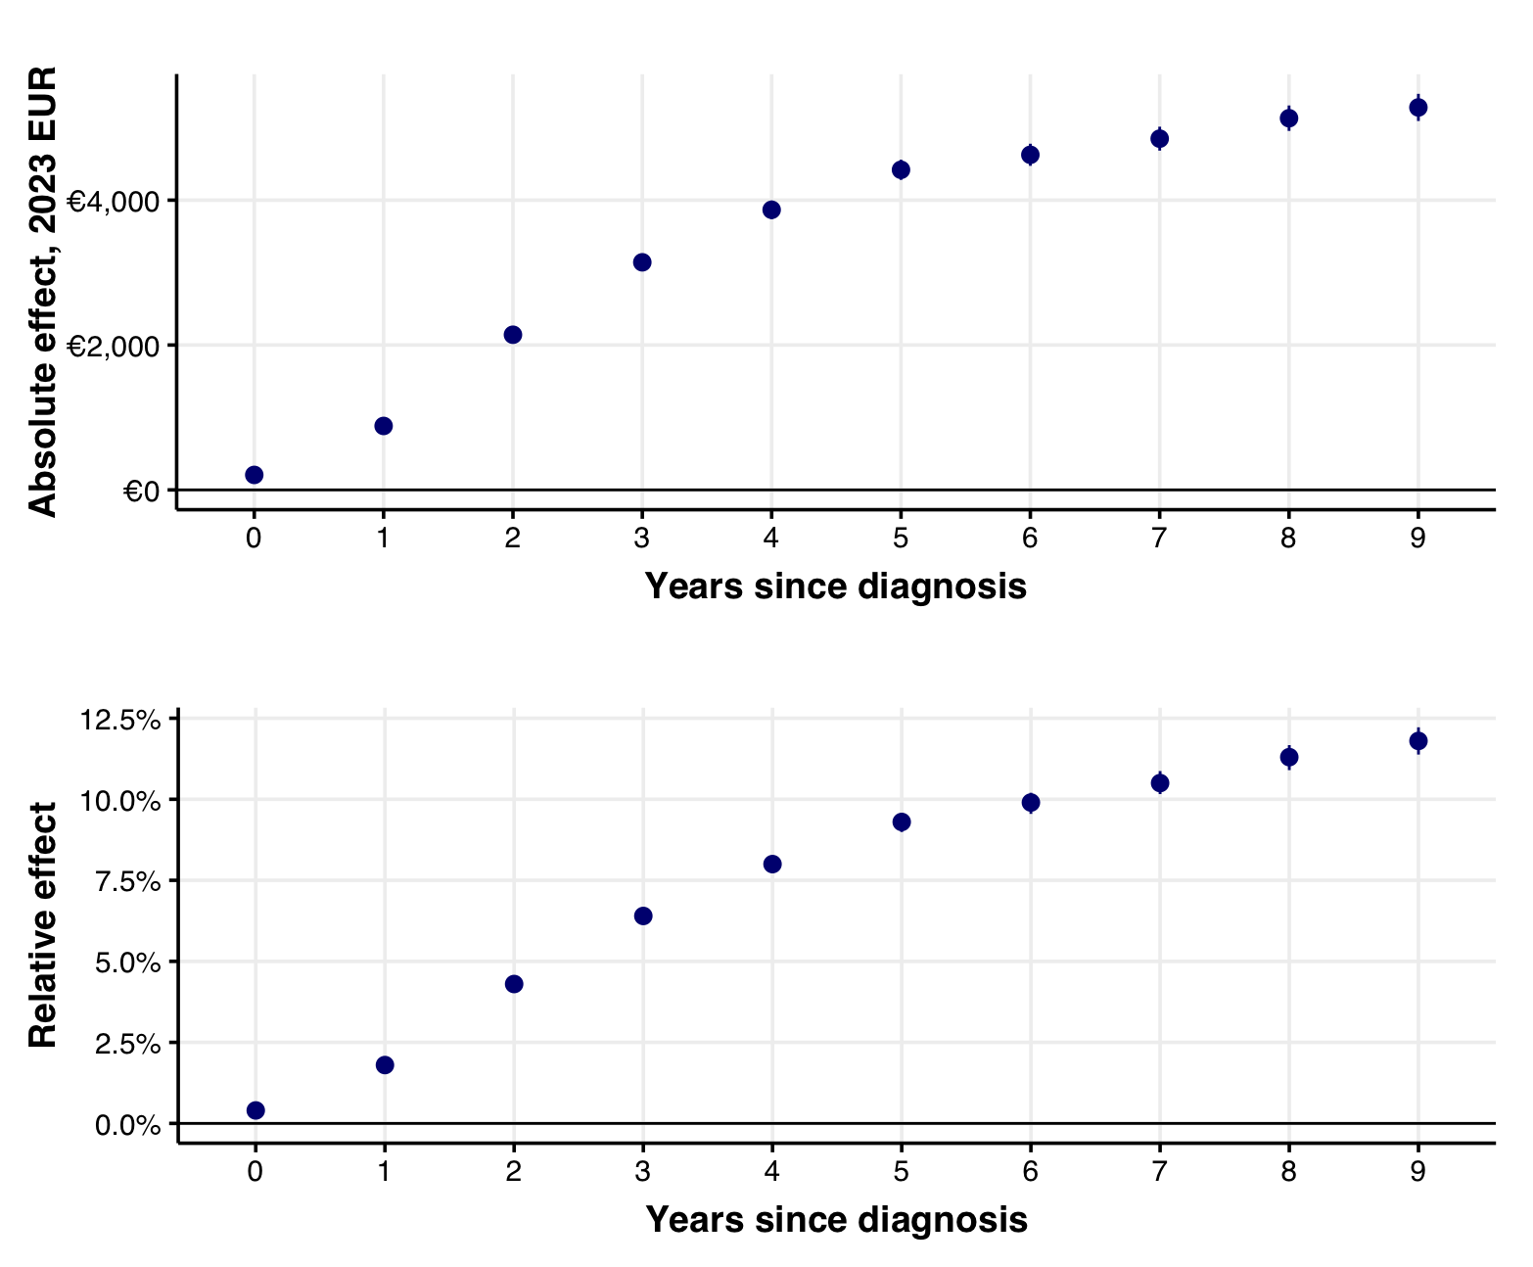

Supplementary Table 1: Labor market attachment over time in the exposed and unexposed population, 2008 matched cohort.
Proportions show the distribution along labor attachment at match year (2008), and in 2, 5, and 10 subsequent years (i.e. 2010, 2013, and 2018). Unexposed population is weighted at the match group level by the population size of the exposed population, to effectively standardize across all matching variables at baseline. Only individuals who are not retired (including early retirees) at baseline are shown in the table. Source data are provided with the paper.

Labor market attachment status | Control population (n = 322,171) |  |  |  | Breast cancer population (n = 2748)
Labor market attachment status | Match year | Years since diagnosis |  |  | Match year | Years since diagnosis
Labor market attachment status | Match year | 2 | 5 | 10 | Match year | 2 | 5 | 10
Wage earner | 76.7% | 66.9% | 53.5% | 36.4% | 76.7% | 62.5% | 46.7% | 29.6%
Retired | 0.0% | 4.9% | 17.0% | 41.6% | 0.0% | 5.2% | 17.0% | 39.8%
In school | 0.4% | 0.3% | 0.3% | 0.1% | 0.4% | 0.2% | 0.1% | 0.1%
Disability recipient | 13.8% | 12.1% | 9.4% | 5.2% | 13.8% | 12.4% | 11.0% | 6.6%
Social assistance recipient | 1.6% | 1.8% | 1.8% | 2.5% | 1.6% | 1.8% | 2.4% | 3.1%
Early retirement | 0.0% | 6.0% | 9.8% | 4.6% | 0.0% | 6.4% | 10.6% | 4.3%
Self employed | 2.9% | 2.6% | 2.2% | 2.0% | 2.9% | 2.3% | 1.8% | 1.5%
Sick and parental leave recipient | 1.2% | 1.1% | 0.9% | 0.4% | 1.2% | 4.9% | 1.8% | 0.4%
Unemployment recipient | 0.5% | 1.4% | 1.3% | 0.8% | 0.5% | 0.5% | 1.1% | 0.6%
Working for spouse | 0.4% | 0.3% | 0.2% | 0.1% | 0.4% | 0.3% | 0.4% | 0.2%
Other | 2.5% | 2.0% | 1.5% | 1.4% | 2.5% | 2.0% | 1.3% | 1.0%
Died | 0.0% | 0.6% | 2.2% | 4.9% | 0.0% | 1.5% | 5.7% | 12.6%

