Supplementary Figures
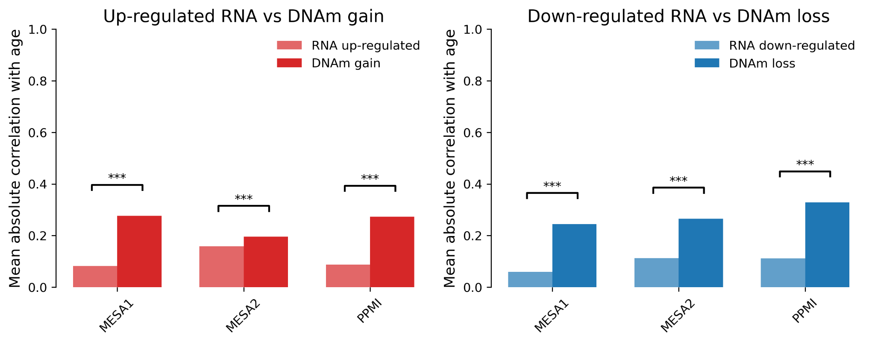 Supplementary Fig. 1. Replicability of age-associated DNAm versus transcriptomic data. Comparison of mean absolute correlation with age for DNAm and RNA data across three cohorts (MESA1, MESA2, PPMI). For DNAm the sample sizes were n=886 for MESA1, n=888 for MESA2 and n=510 for PPMI, and for RNA-seq the sample sizes were n=1,016 for MESA1, n=845 for MESA2 and n=1,111 for PPMI. Bars depict the mean absolute correlation across all CpG sites or transcripts, with individual data points overlaid as dots. Statistical significance was assessed using a two-sided Mann–Whitney U test; *** denotes p<0.001. The y-axis shows mean absolute correlation with age. The left panel compares up-regulated RNA vs. DNAm gain, while the right panel compares down-regulated RNA vs. DNAm loss. Asterisks (***) indicate statistically significant differences (p < 0.001), showing that age-associated DNAm data have significantly higher and more consistent correlations with age across datasets compared to aging transcripts.

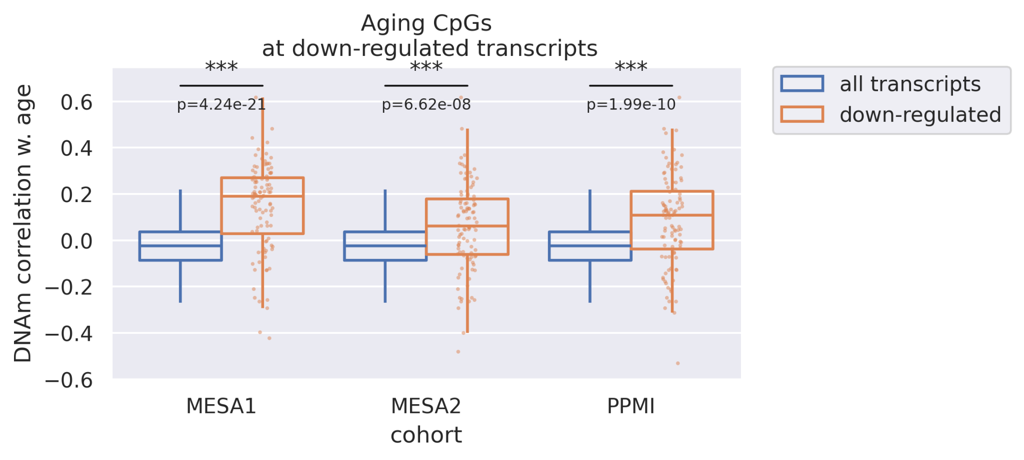 Supplementary Fig. 2. DNAm correlation with age for CpGs at down-regulated transcripts. Box plots showing DNAm correlation with age for CpGs associated with all transcripts versus CpGs associated with down-regulated transcripts across three cohorts (MESA1, MESA2, PPMI). Asterisks (***) indicate statistically significant differences (Wilcoxon rank-sum test), demonstrating that genes with the greatest decrease in expression with aging consistently feature significantly higher DNAm correlation with age. Sample sizes were n=886 (MESA1 DNAm), n=888 (MESA2 DNAm) and n=510 (PPMI DNAm). Box plots show the median (central line), first and third quartiles (boxes) and 1.5× interquartile range (whiskers); each dot represents one CpG site. P values for MESA1 (p=4.24×10⁻²¹), MESA2 (p=6.62×10⁻⁸) and PPMI (p=1.99×10⁻10) were calculated with a two-sided Wilcoxon rank-sum test; *** denotes p<0.001.

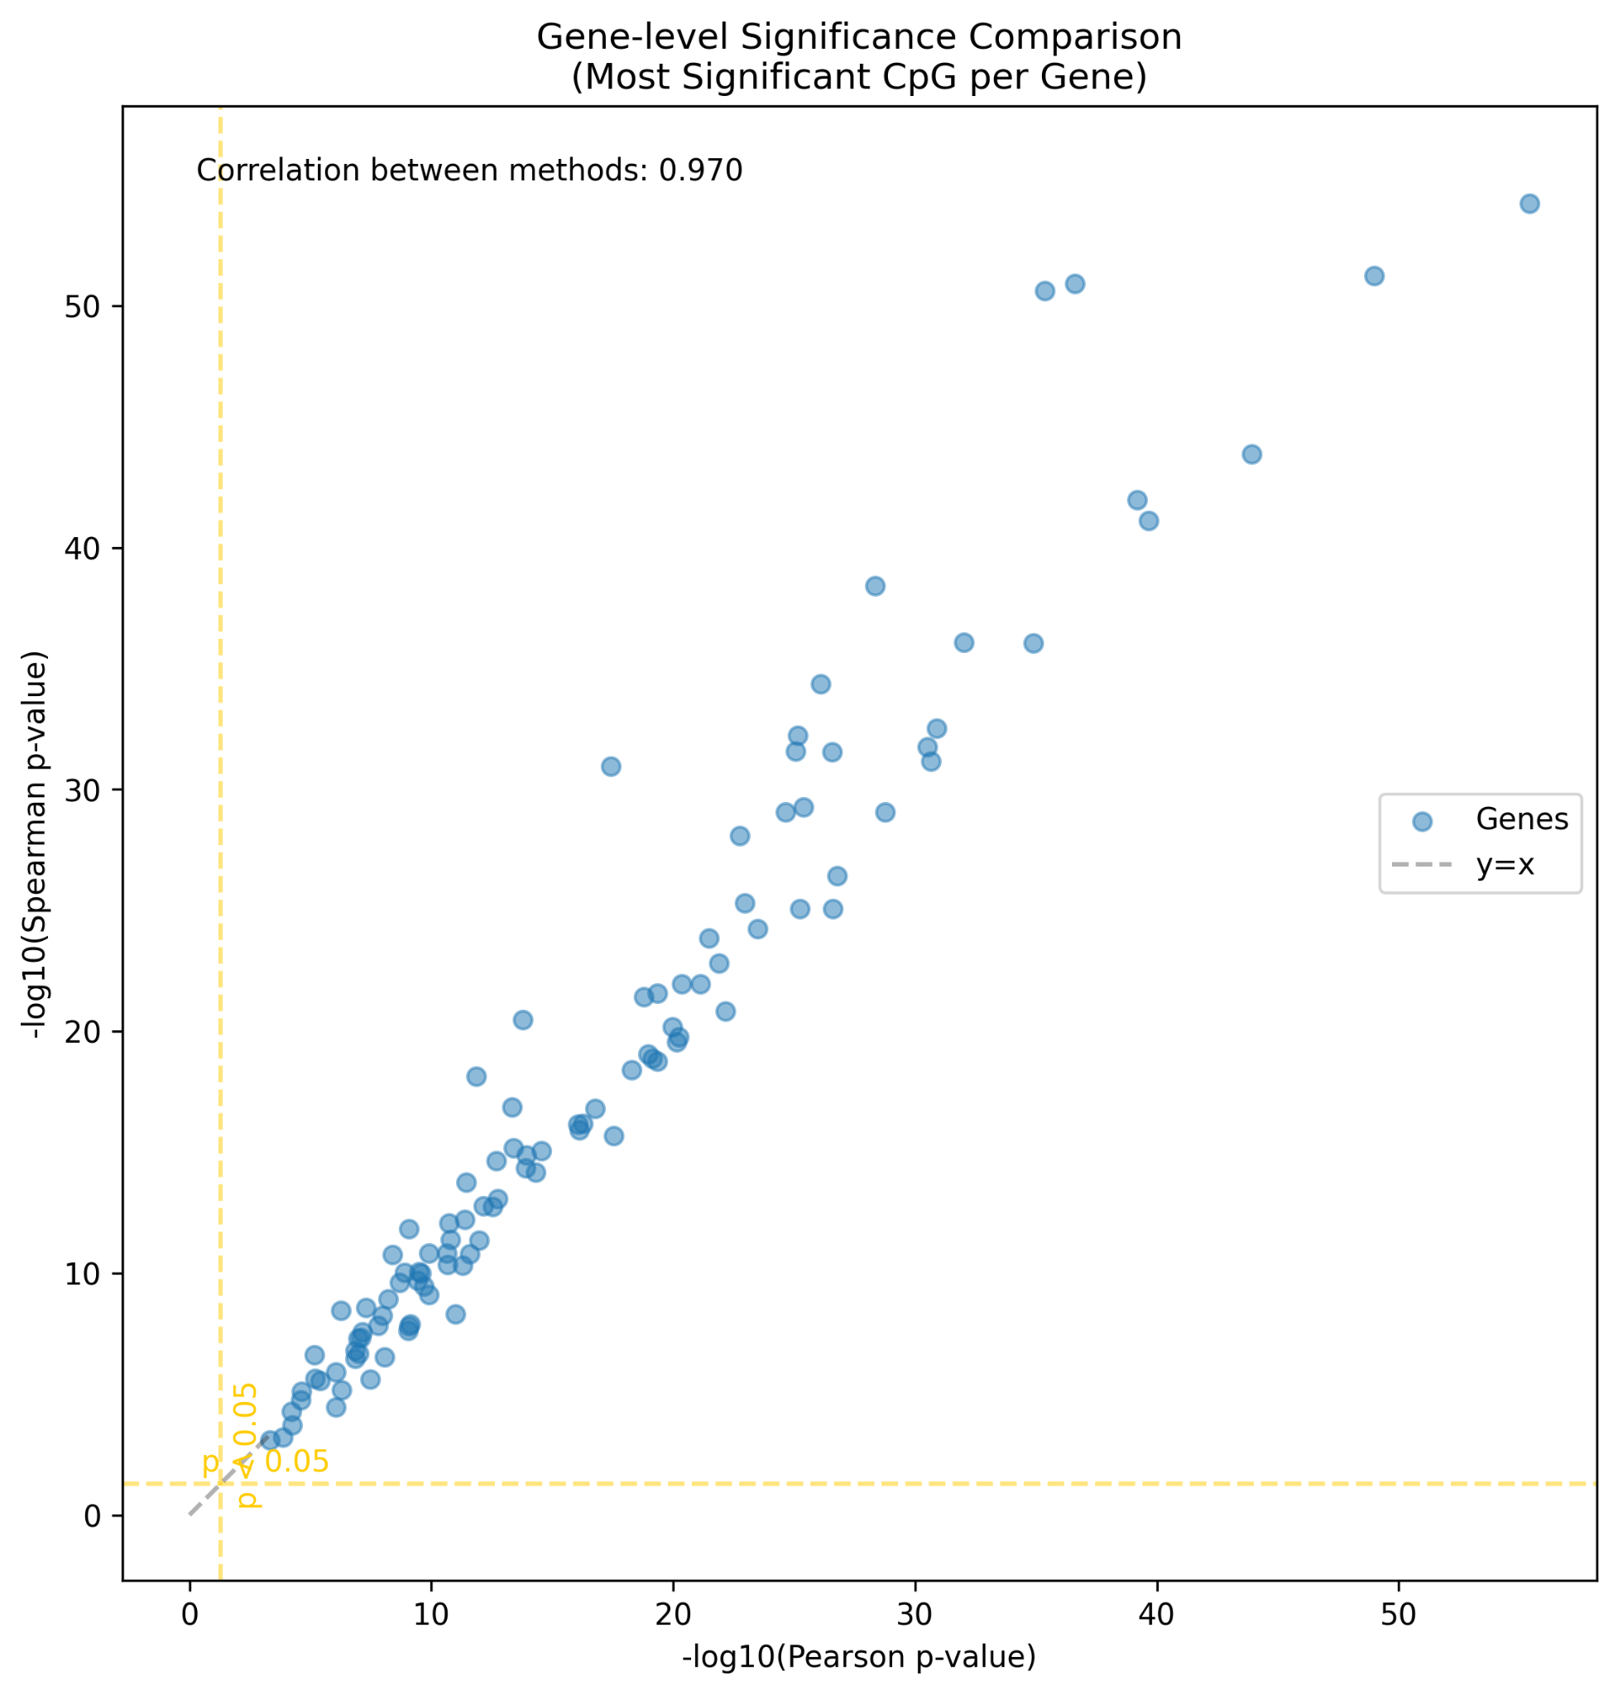 Supplementary Fig. 3. Comparison of Pearson and Spearman correlation p-values for age-CpG associations. Gene-level significance comparison (-log10 p-value) for the association between CpG methylation and age in the MGB500 cohort, calculated using Pearson correlation (x-axis) versus Spearman correlation (y-axis). Each dot represents the most significant CpG per gene. The high concordance (correlation = 0.970) demonstrates the robustness of findings regardless of the correlation method used. Dashed lines indicate p = 0.05.

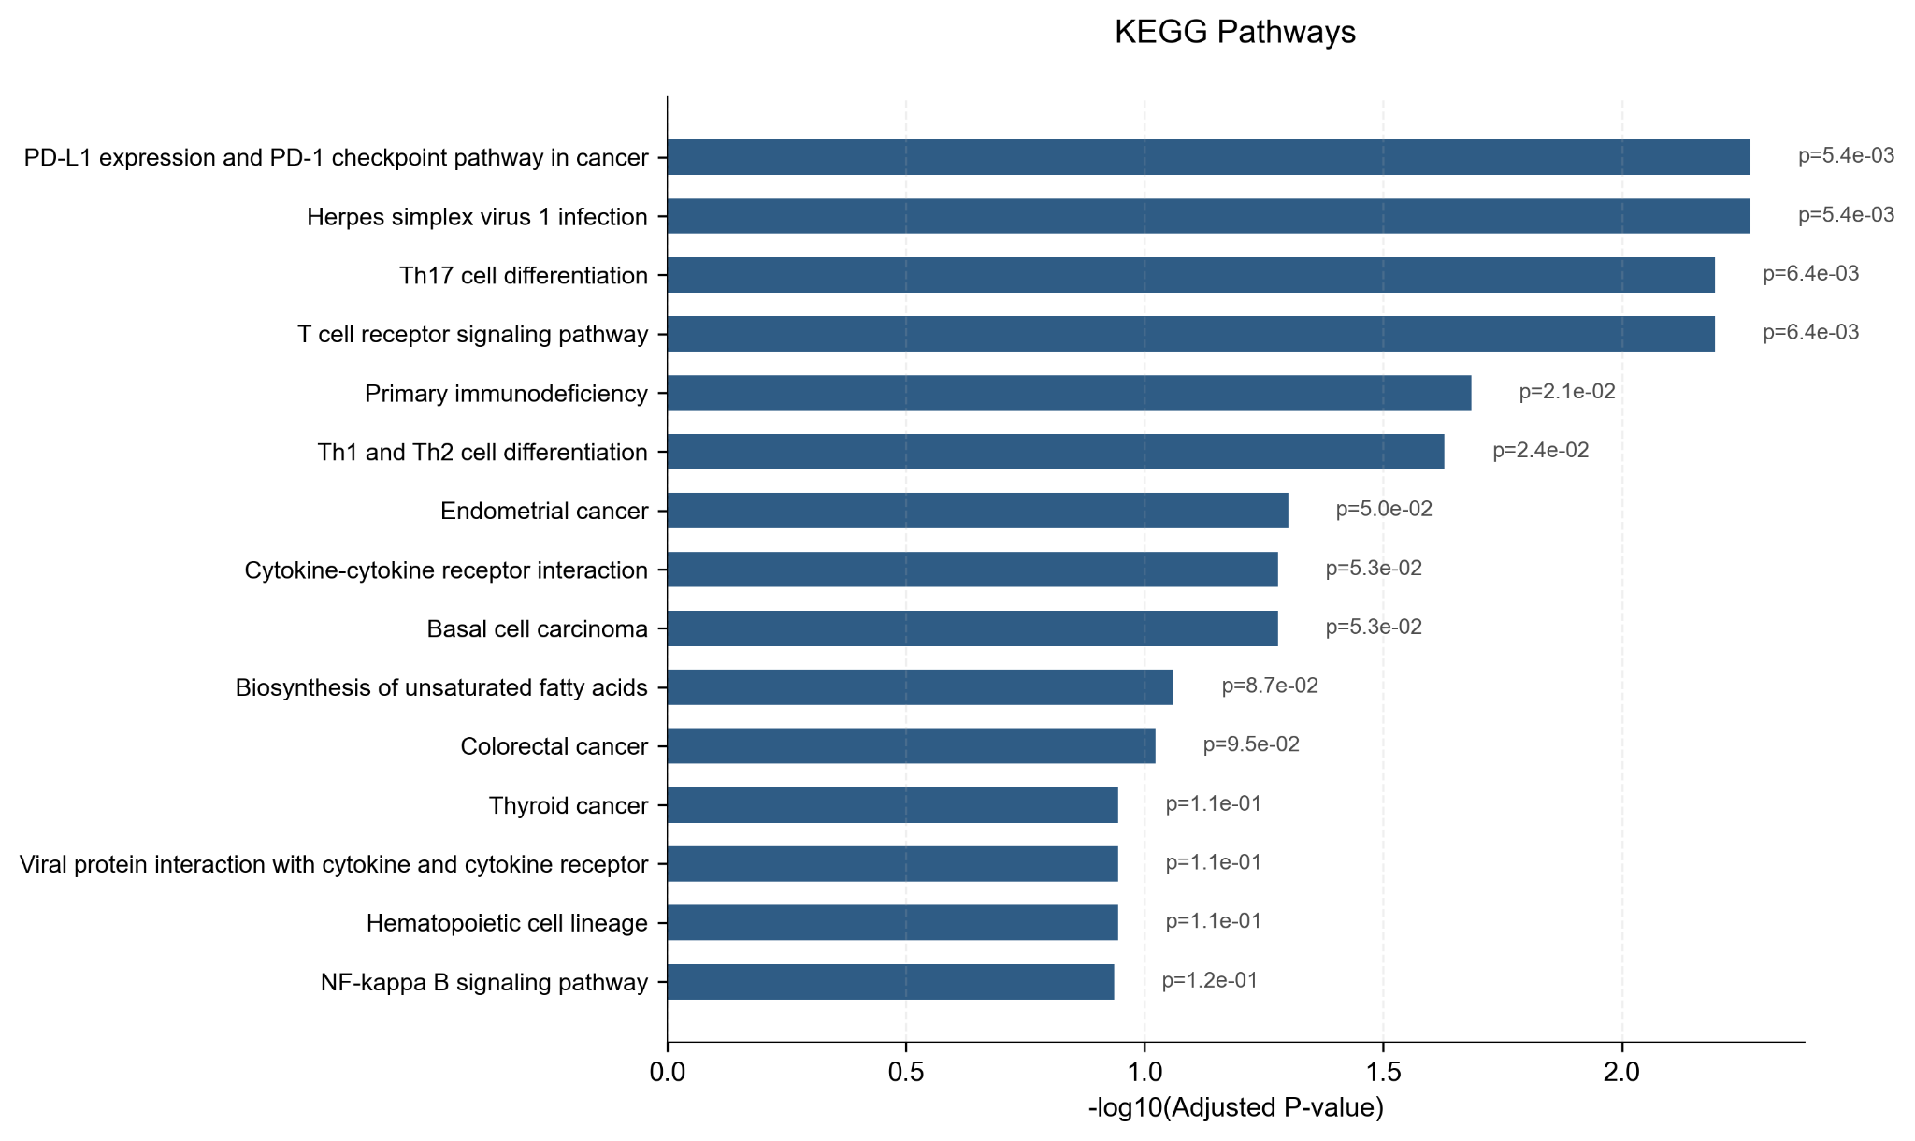 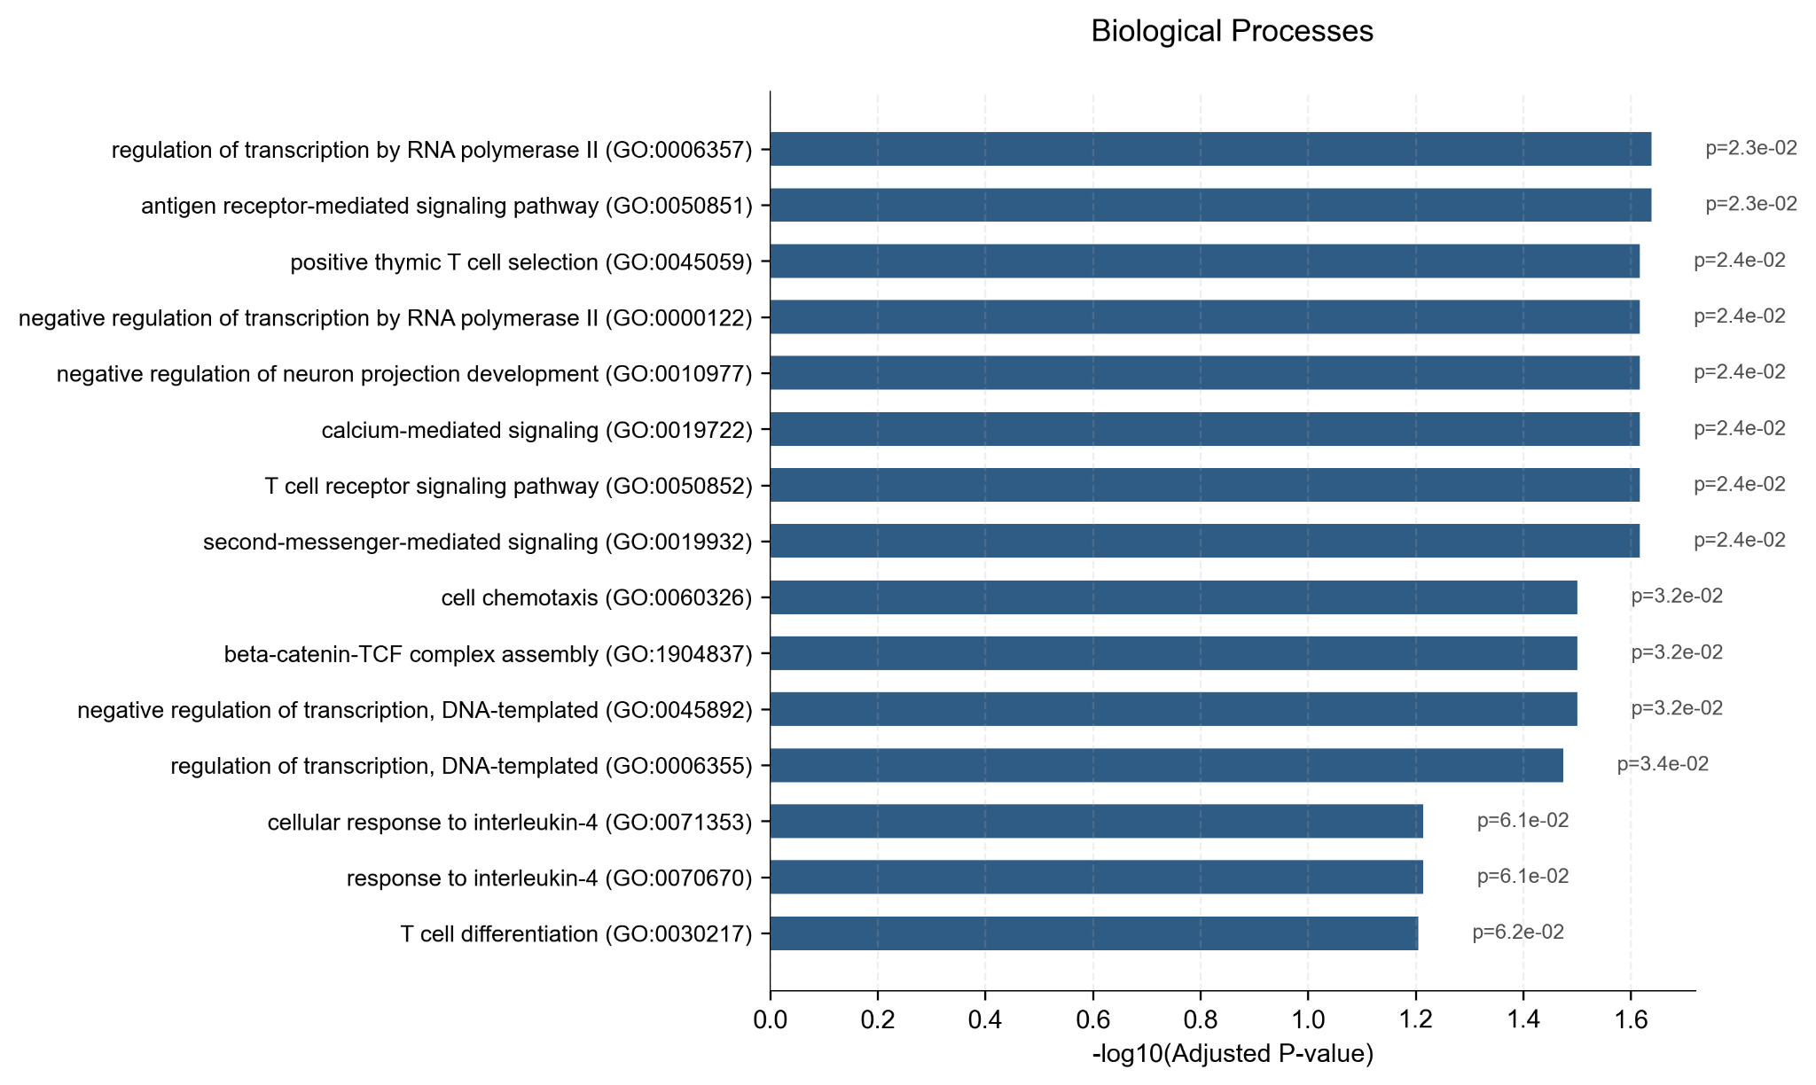 Supplementary Fig. 4. Enrichment analysis of multi-omic aging genes associated with PRC2. a. KEGG pathway enrichment analysis for multi-omic aging genes exhibiting PRC2 association. b. GO Biological Process enrichment analysis for the same set of PRC2-associated multi-omic aging genes. Bars represent -log10(Adjusted P-value). These findings highlight the involvement of PRC2-associated multi-omic aging genes in pathways related to immune function, cell differentiation, and developmental processes.

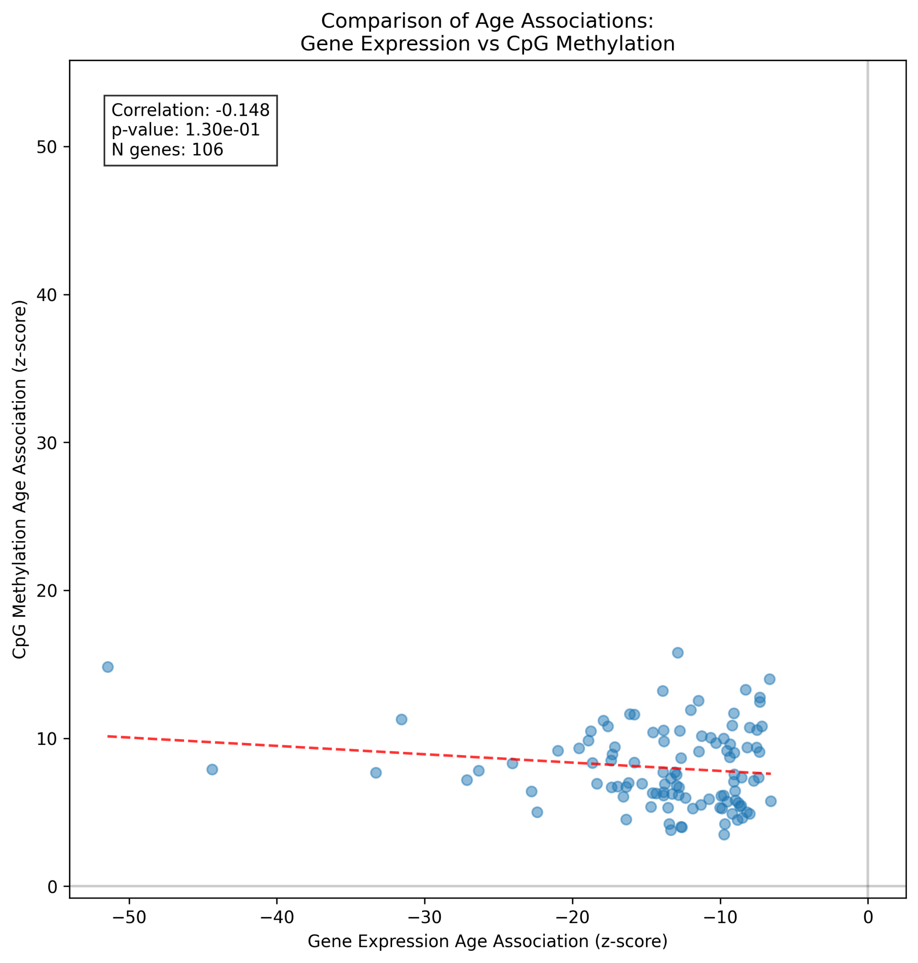 Supplementary Fig. 5. Relationship between age-gene expression and age-CpG methylation correlations for multi-omic aging genes. Scatter plot showing the correlation of gene expression with age (z-score, x-axis) against the correlation of associated CpG methylation with age (z-score, y-axis) for 106 multi-omic aging genes. No strong overall association (Correlation: -0.148, p-value: 1.30e-01) was observed between these two sets of correlations.

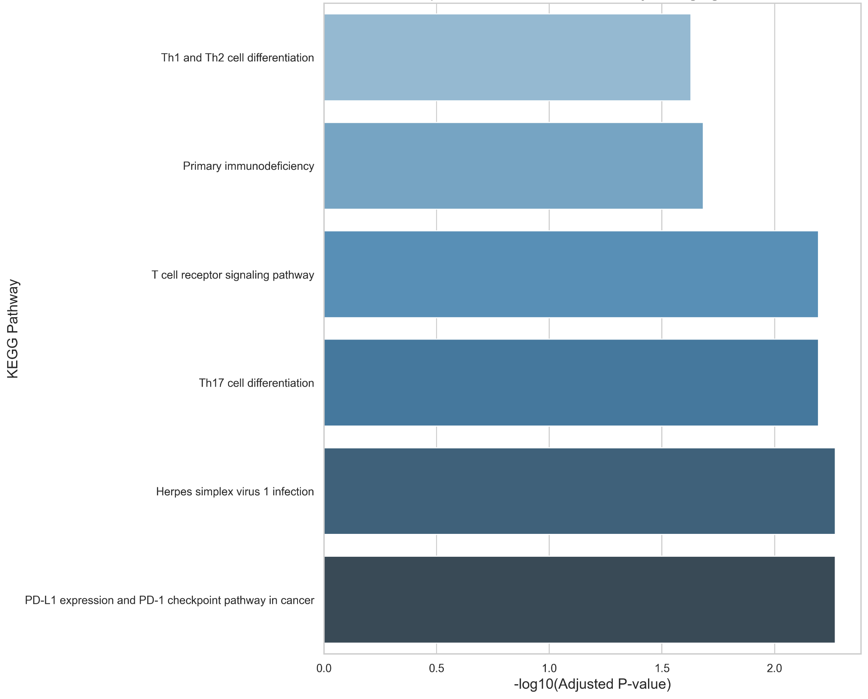 Supplementary Fig. 6. Enrichment of T-cell specific functions in multi-omic aging genes. KEGG pathway enrichment analysis demonstrating significant enrichment for T-cell specific functions among multi-omic aging genes. Bars represent -log10(Adjusted P-value). Enriched pathways include T cell receptor signaling pathway and T cell differentiation pathways.

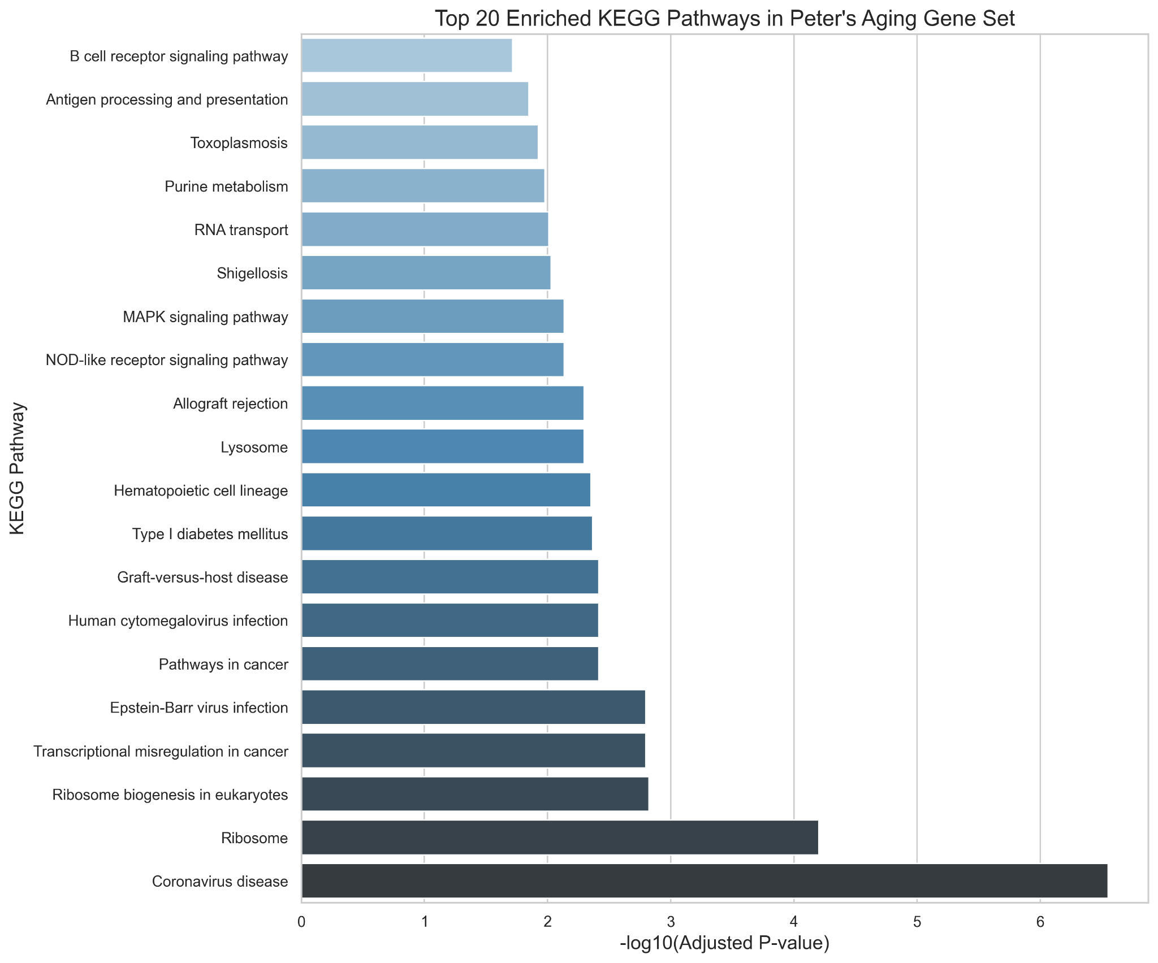 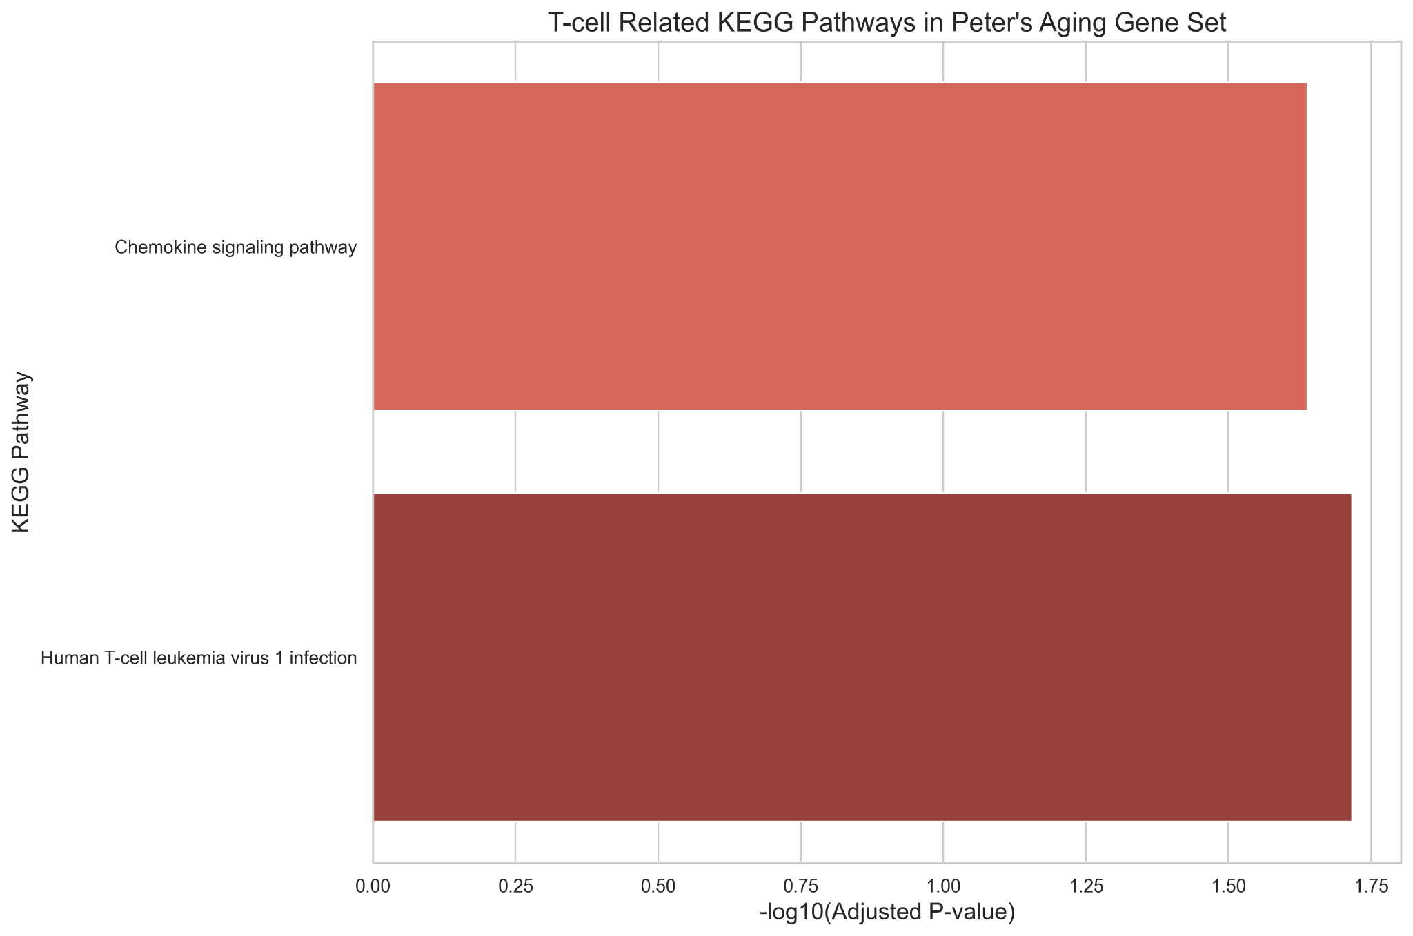 Supplementary Fig. 7. KEGG pathway enrichment analysis for Peters et al. (2015) aging gene set. KEGG pathway enrichment analysis for the 1,497 age-associated gene expression signatures identified by Peters et al. (2015). Bars represent -log10(Adjusted P-value). a. Top 20 enriched KEGG pathways. b. T-cell related KEGG pathways, for which this gene set is not particularly enriched.

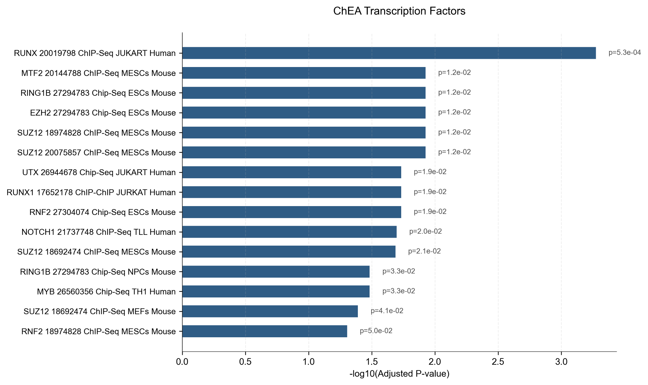 Supplementary Fig. 8. Transcription factor enrichment analysis for multi-omic aging genes. ChEA (ChIP-X Enrichment Analysis) transcription factor enrichment for the identified multi-omic aging genes. The plot shows -log10(Adjusted P-value) for significantly enriched transcription factors, identifying 15 significant associations (p < 0.05), including factors associated with the PRC2 complex (EZH2, SUZ12) and immune/haematopoietic cell development (RUNX).

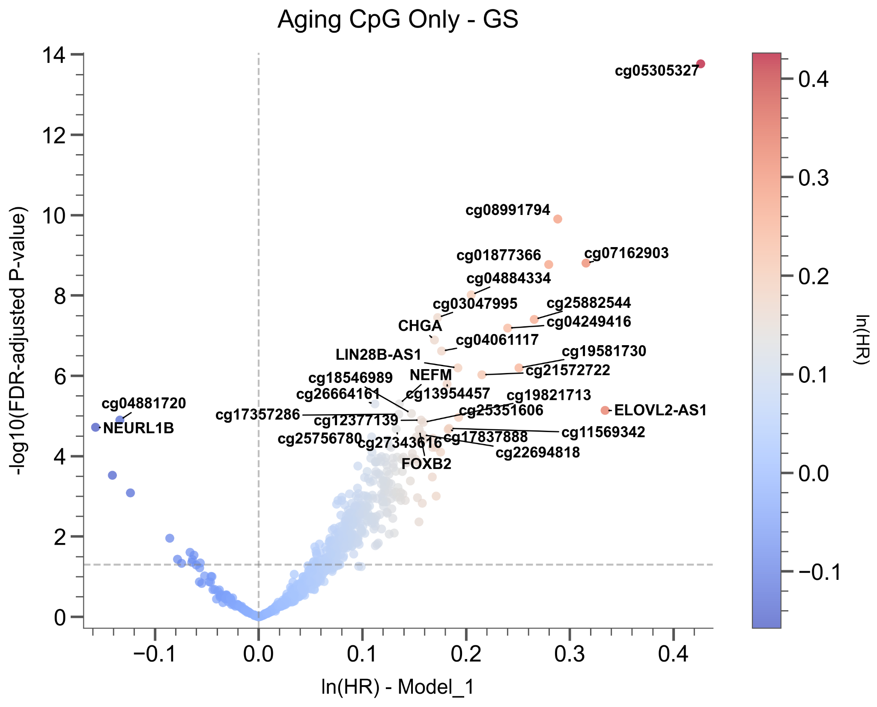 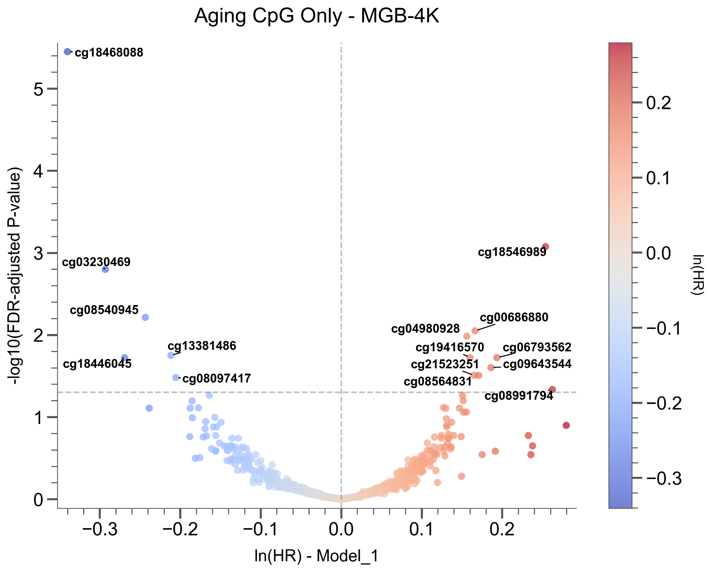 Supplementary Fig. 9. Volcano plots for mortality prediction using top age-correlated CpGs. Volcano plots showing association with mortality for the top 1,000 CpGs selected based on positive age correlation from the MGB500 cohort. Cox regression models were adjusted for age and 12 cell type compositions. a. Analysis in the Generation Scotland (GS) cohort. b. Analysis in the MGB-4K cohort.

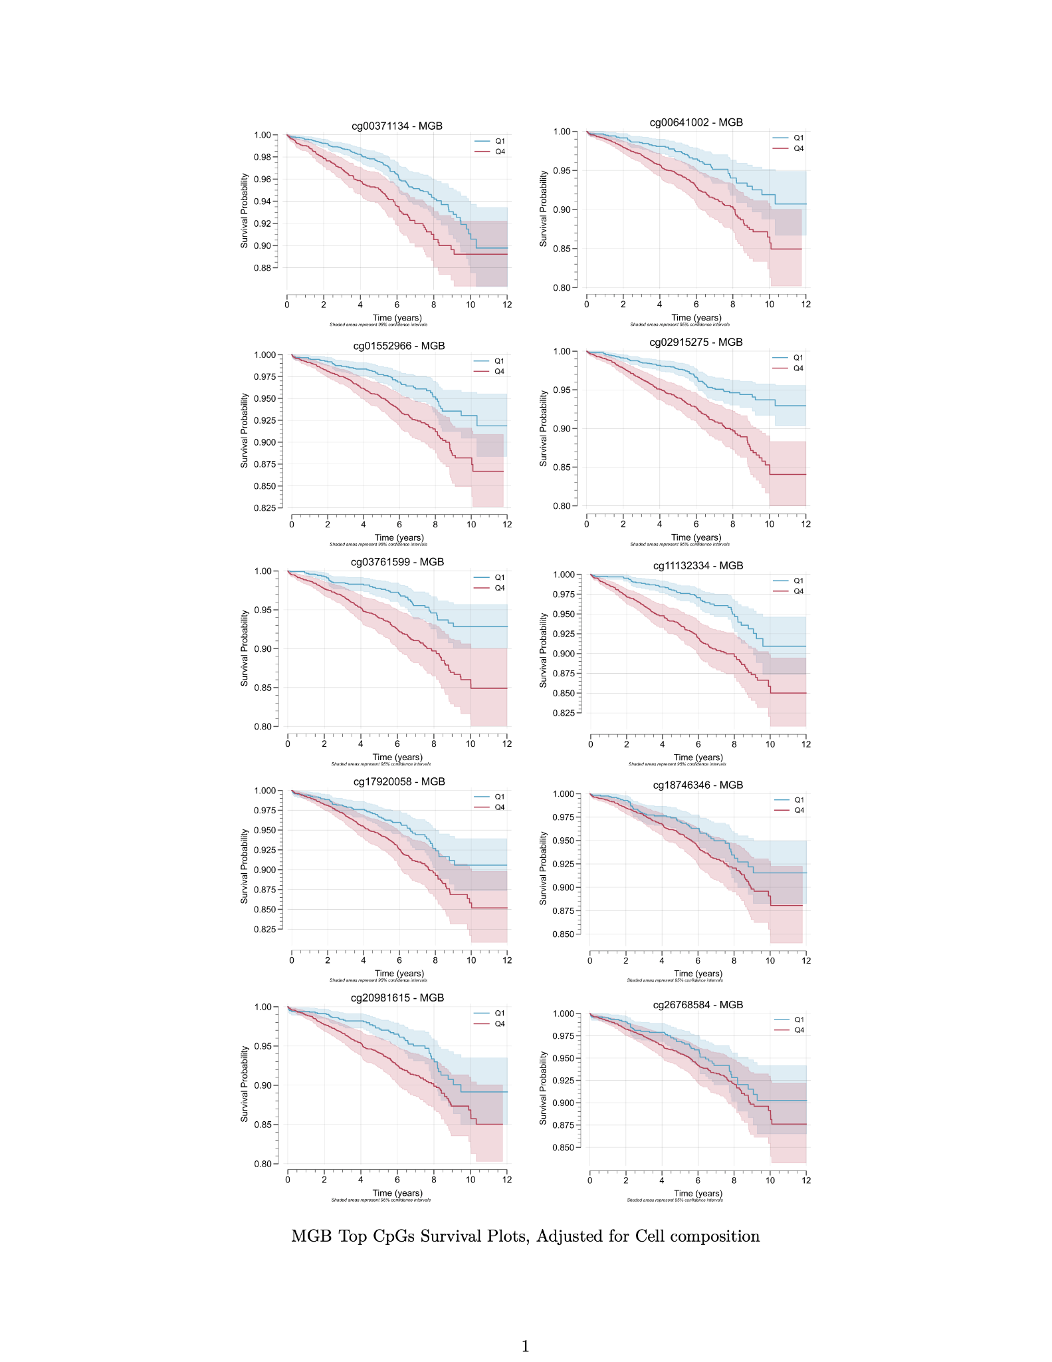 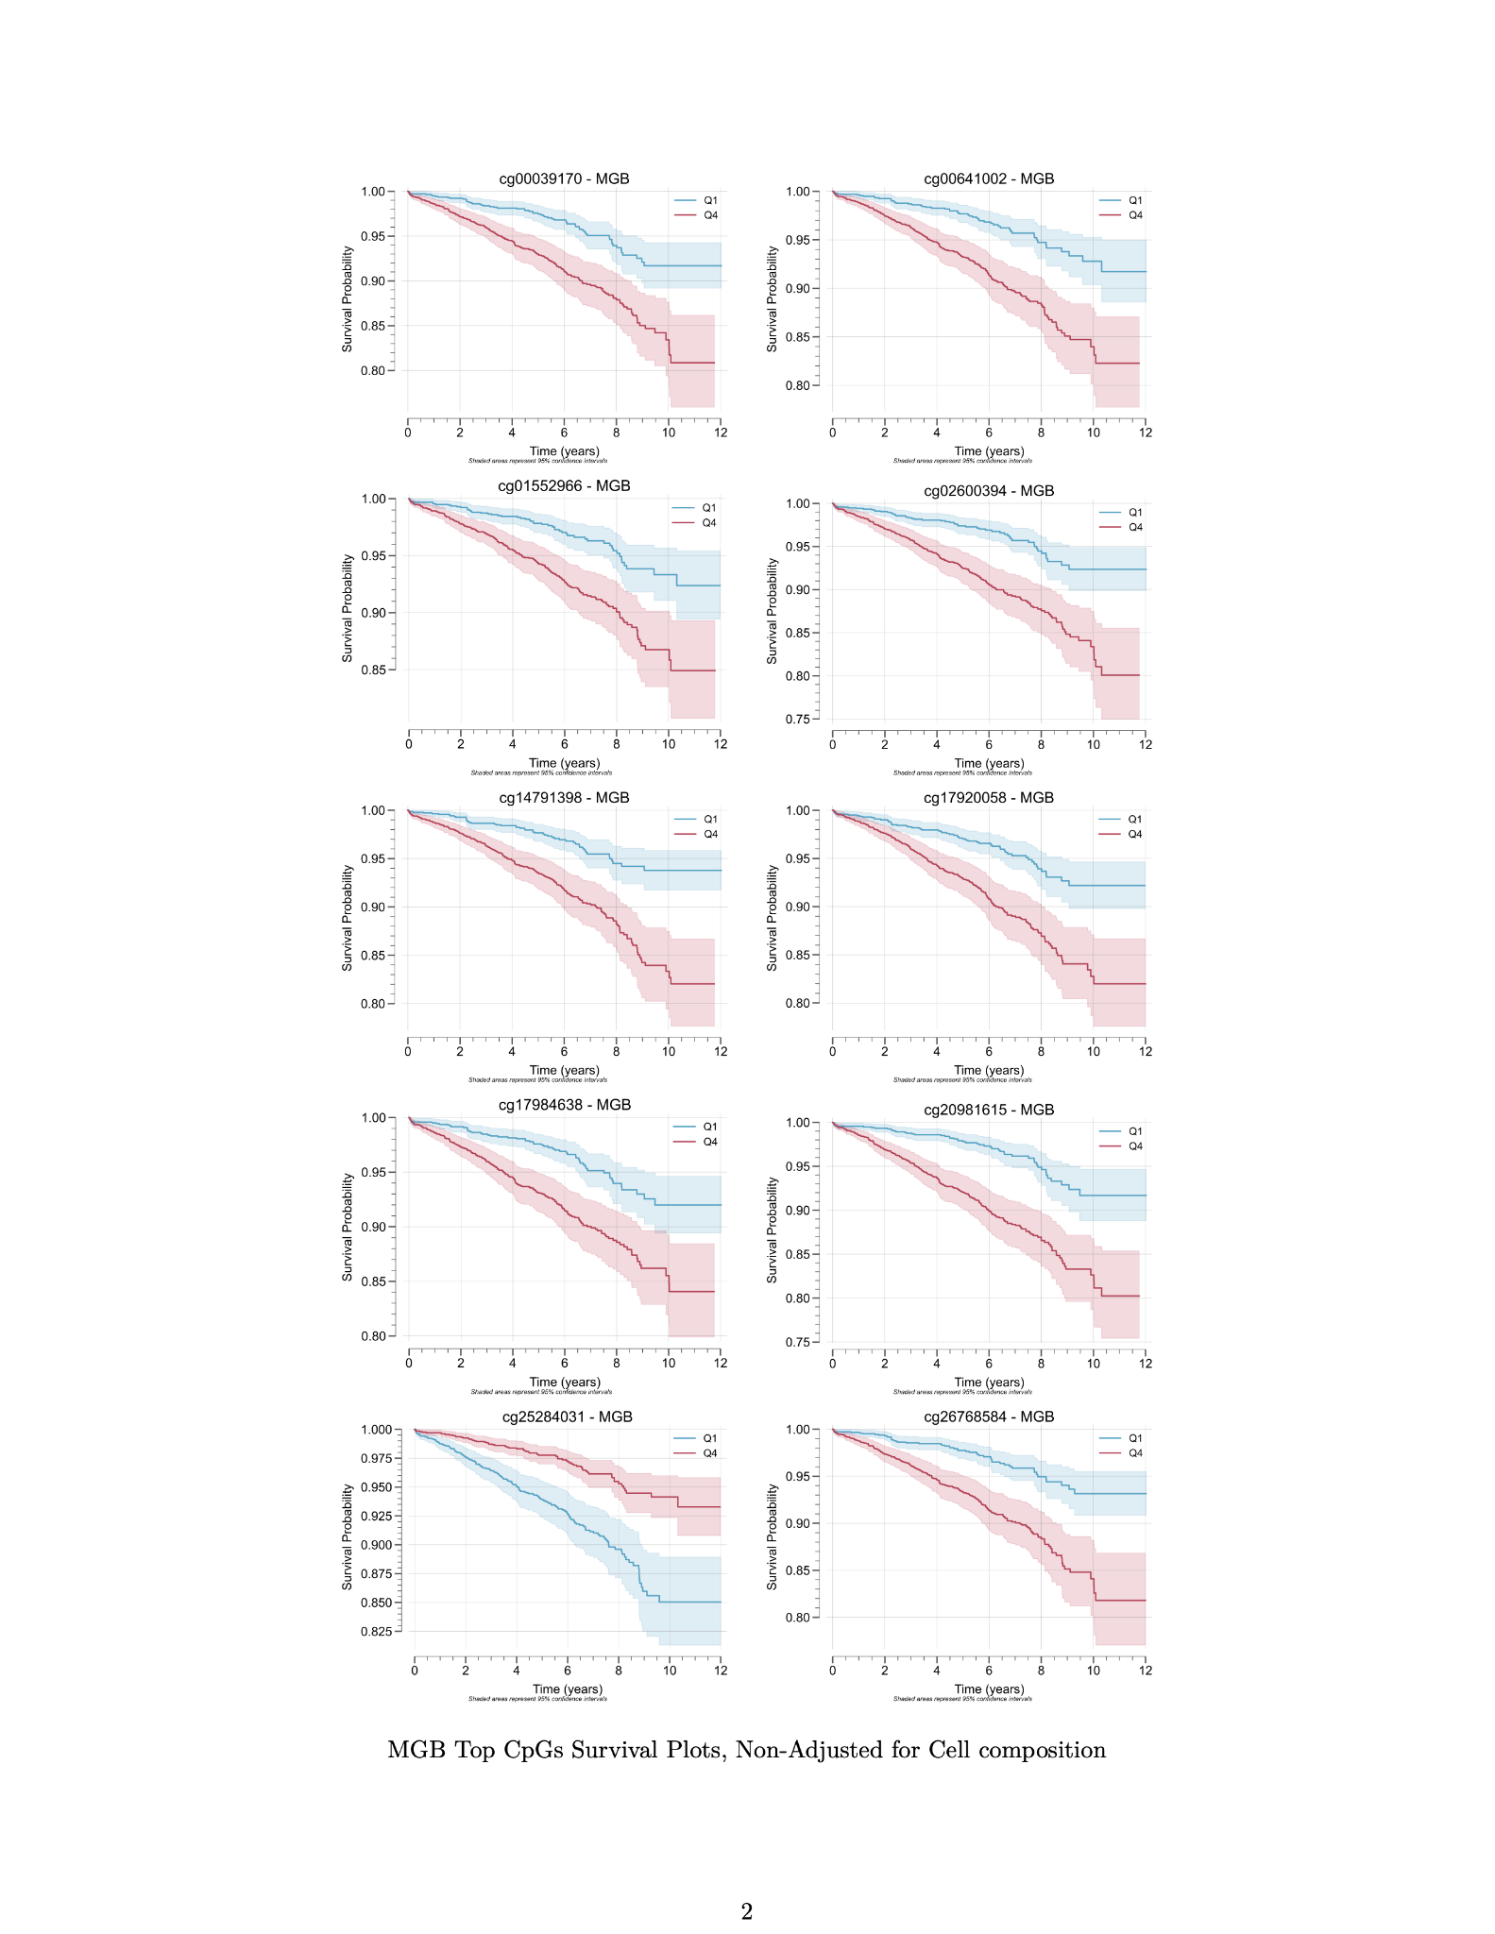 Supplementary Fig. 10. Kaplan-Meier survival plots for top mortality-associated CpGs in the MGB-4K cohort. Kaplan-Meier survival curves for top CpG sites associated with mortality risk in the MGB-4K cohort, stratified by quartiles (Q1 vs Q4) of CpG methylation levels. a. Survival plots adjusted for cell composition. b. Survival plots non-adjusted for cell composition.

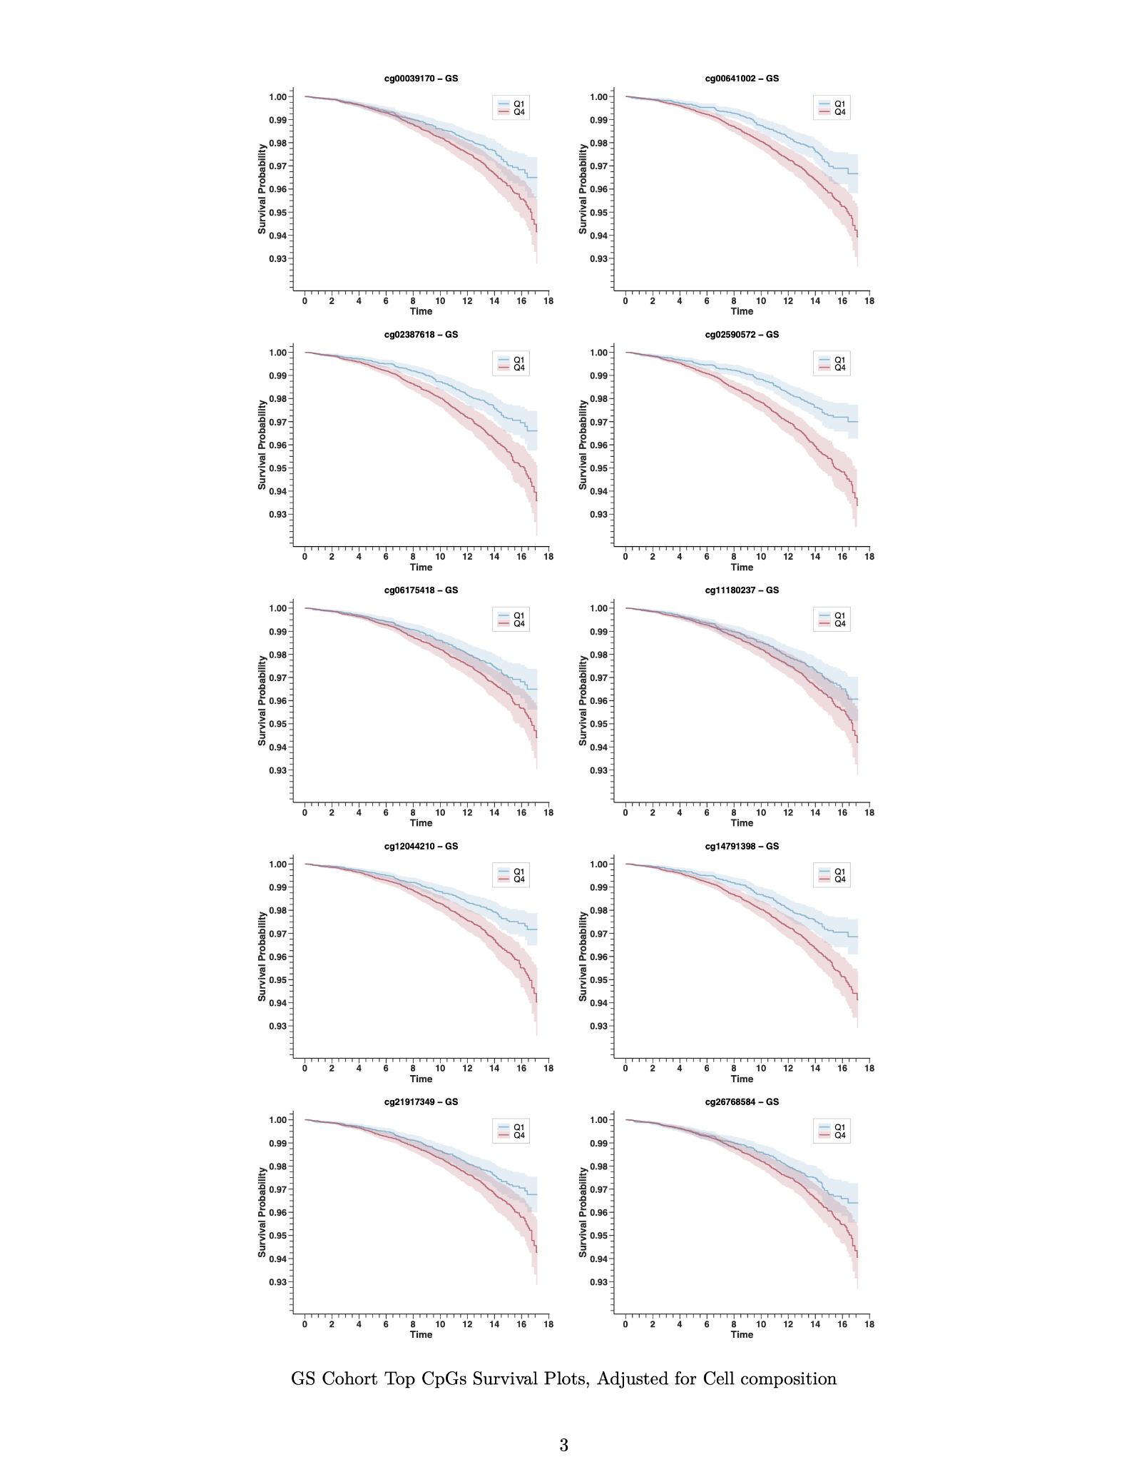 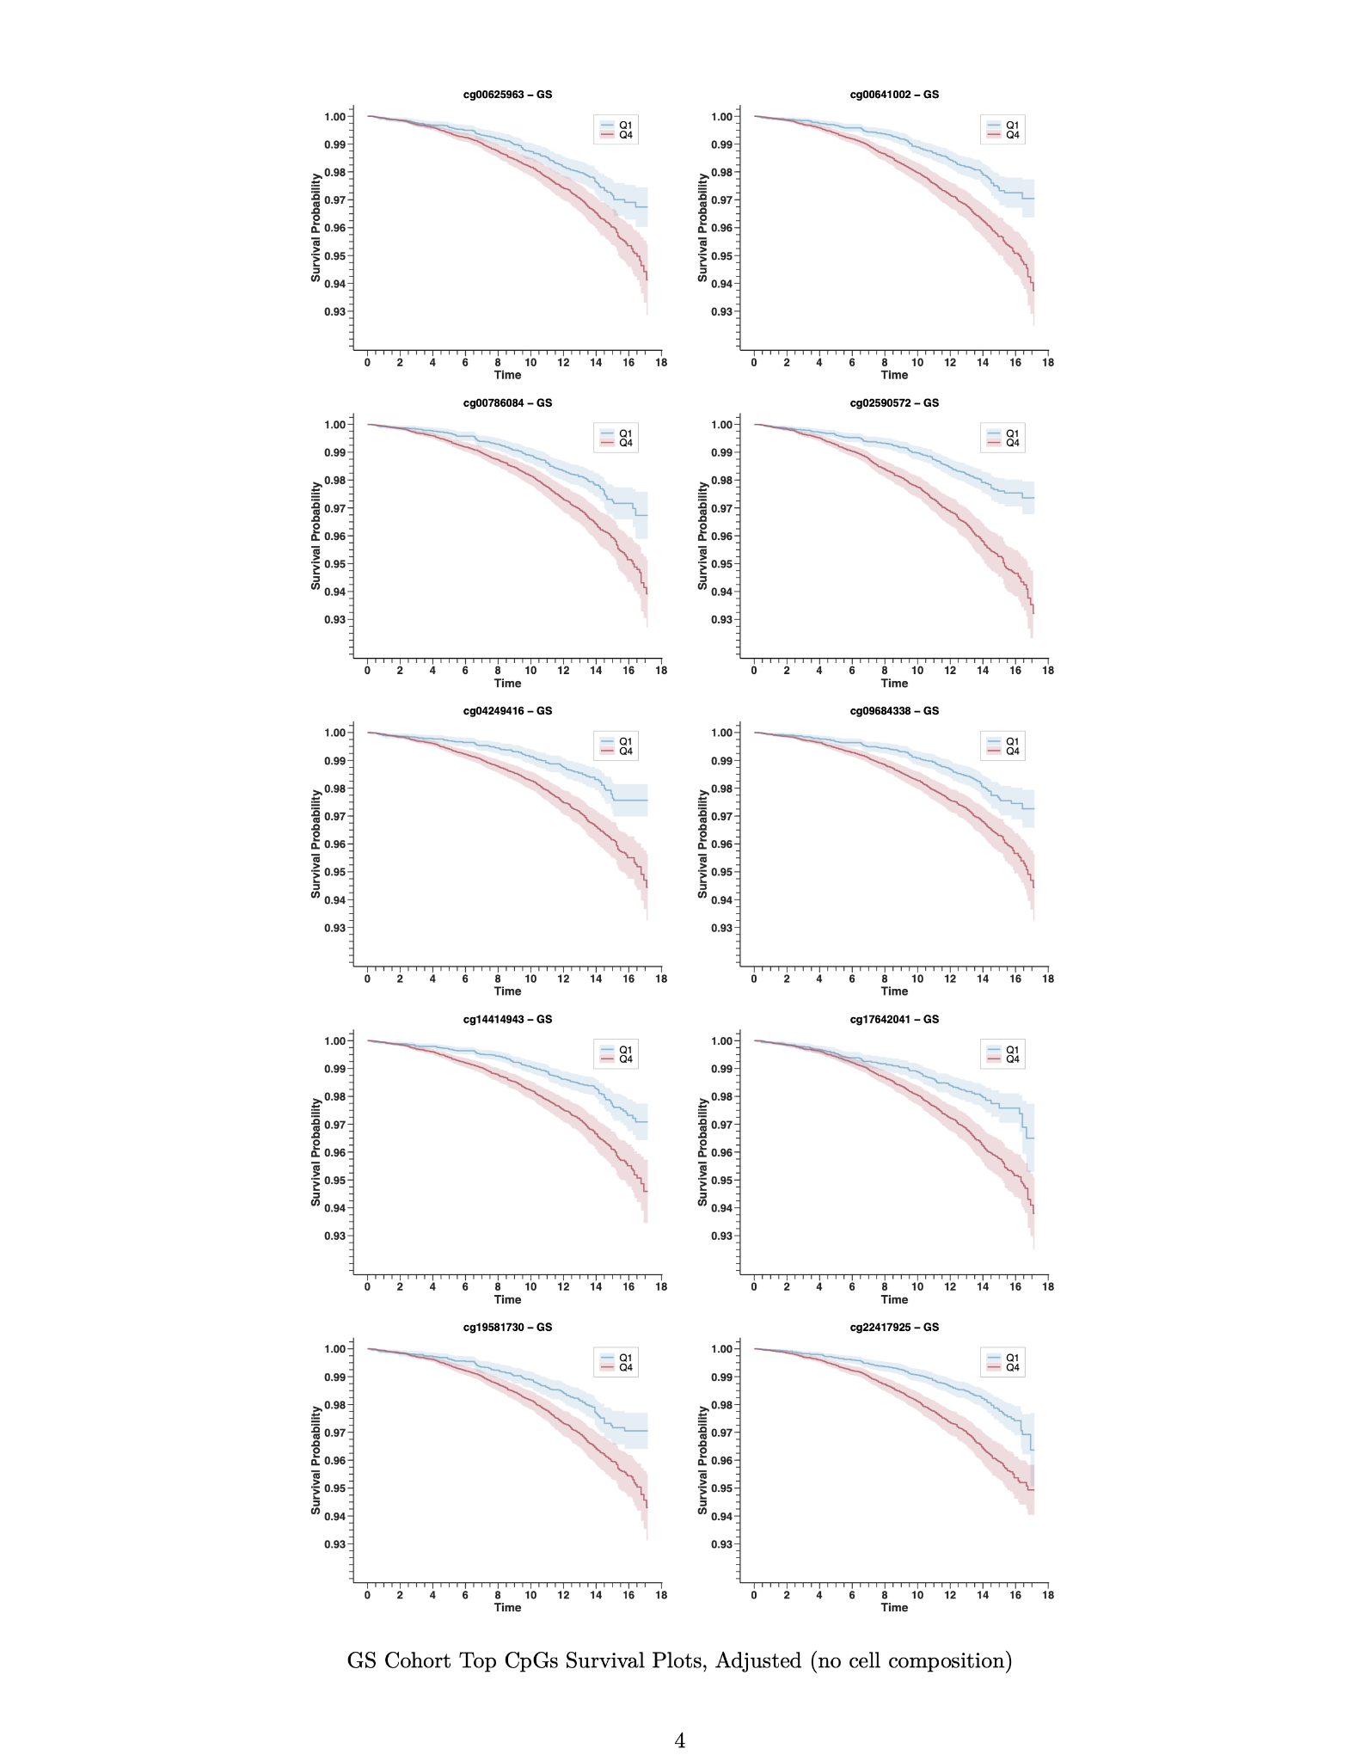 Supplementary Fig. 11. Kaplan-Meier survival plots for top mortality-associated CpGs in the GS cohort. Kaplan-Meier survival curves for top CpG sites associated with mortality risk in the Generation Scotland (GS) cohort, stratified by quartiles (Q1 vs Q4) of CpG methylation levels. a. Survival plots adjusted for cell composition. b. Survival plots without adjustment for cell composition.

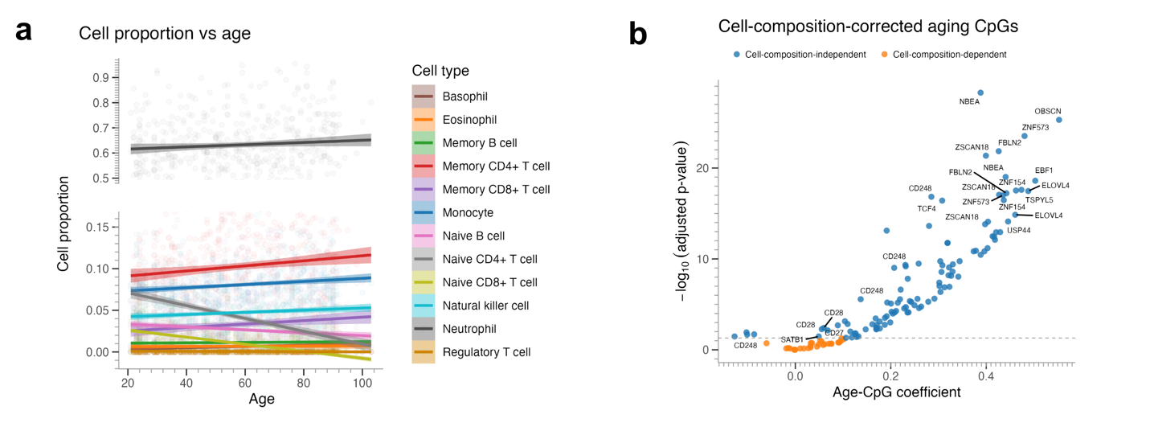
Supplementary Fig. 12. Analysis of cell type composition and its impact on age-CpG associations. a. Relationship between chronological age and estimated cell proportions for 12 different immune cell types. b. Scatter plot showing the association between age and CpG methylation after correction for 12 cell types. Significant associations remained after adjustment, indicating that age-related changes in these CpGs are largely independent of changes in cell composition. All the CpG sites around the TSS of the 104 aging genes we previously identified are included in this analysis.

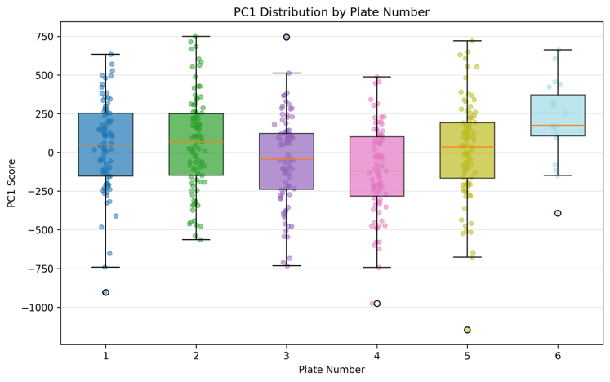
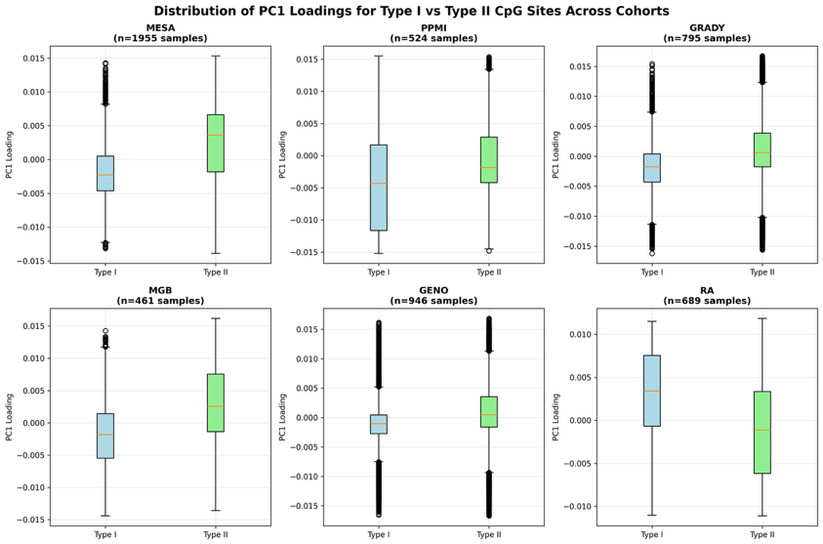
Supplementary Fig. 13. Distribution of PC1 loadings for Type I versus Type II CpG sites across cohorts. DNA methylation data from six cohorts were analyzed to investigate potential technical bias between Illumina Infinium probe design types. The EPIC array utilizes Type I probes (two separate probes for methylated/unmethylated states, n=142,137) and Type II probes (single probe design, n=720,790). Box plots show PC1 loadings distributions for each probe type across MESA (n=1,955), PPMI (n=524), Grady (n=795), MGB (n=461), GENOA (n=946), and RA (n=689) cohorts. No systematic bias between probe types was observed, confirming that technical factors did not drive the primary variance component in our methylation data.

