Insights into the structure and modulation of human TWIK-2
Qianqian Ma^{1†}, Ciria C. Hernandez^{1,2†}, Vikas Navratna^{1†}*, Arvind Kumar³, Jaimin K. Rana^{1,4}, Jiameng Zong^{1,5}, Abraham Lee⁶, Shyamal Mosalaganti^{1,4,5,7,8}*

†These authors contributed equally to this work
*Correspondence: navratna@umich.edu (V.N.), mosalaga@umich.edu (S.M.)

The PDF file includes:
Supplementary Figs. S1-S6
Supplementary Tables S1-S9

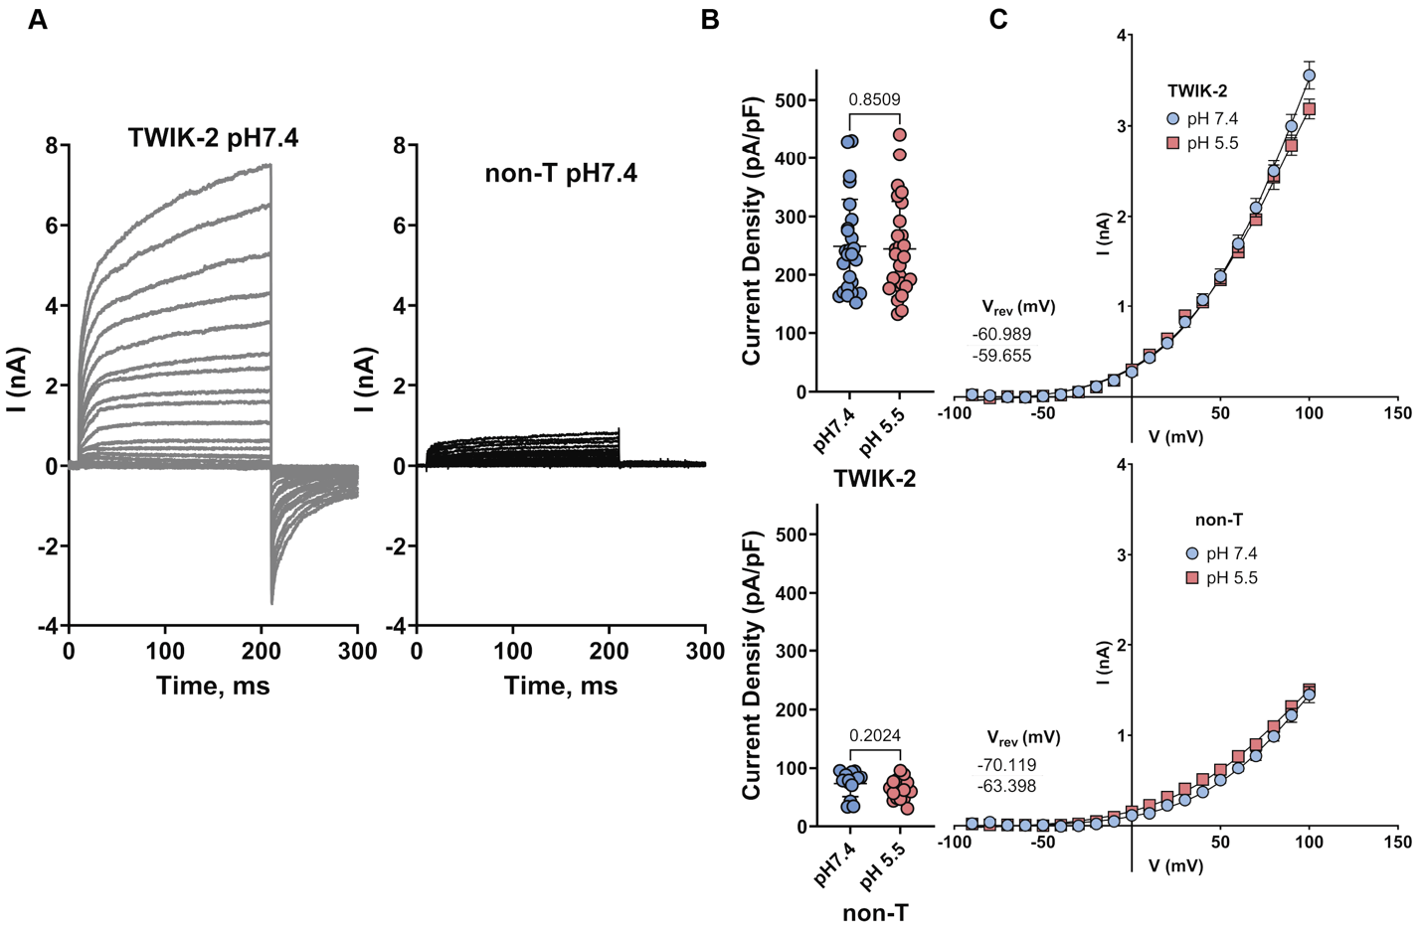
Supplementary Fig.1: Comparative Analysis of TWIK-2 Channel Function and Non-Transfected Cells in Whole-Cell Recordings at Different pH Levels. A. Representative whole-cell current traces were obtained from cells expressing TWIK-2 and from non-transfected (non-T) cells. These were recorded using voltage-clamp steps that ranged from -90 mV to +100 mV in 10 mV increments, with the pH set at 7.4. B. A comparison of peak current densities (pA/pF) at +100 mV was made between TWIK-2 (n = 25) and non-transfected (non-T) cells (n = 13) at pH 7.4, as well as between TWIK-2 (n = 26) and non-transfected cells (n = 18) at pH 5.5. C. The current–voltage (I-V) relationships recorded from both TWIK-2–transfected and non-transfected cells did not show significant differences across the voltage range of -90 to +100 mV, including the reversal potential (Vrev). The data presented in B and C are shown as mean ± SD, with some error bars being smaller than the data points themselves. A two-tailed unpaired t-test with Welch’s correction was used to evaluate statistical significance.

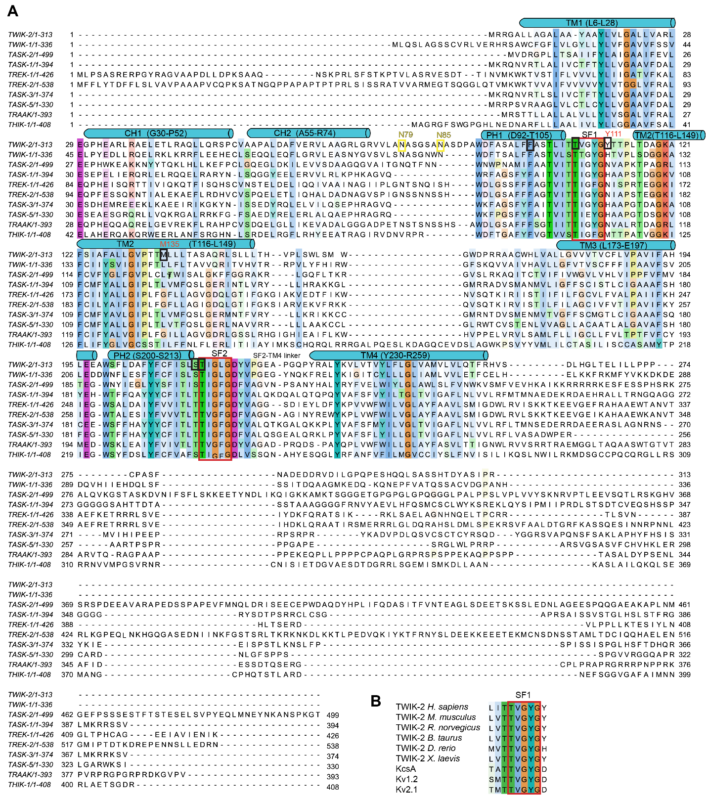
Supplementary Fig.2: Sequence alignment of TWIK-2 with indicated channels. A. Sequence alignment of TWIK-2 and other human K2P channels. Sequence alignments were colored by conservation in Jalview 2.11.4.1¹.TWIK-2 helical secondary structure elements are drawn above the sequences. Selectivity filters are highlighted in red boxes. The UniProt IDs for sequences from human K_{2P} channels are as follows: TWIK-2 (K_{2P}6.1), Q9Y257; TWIK-1 (K_{2P}1.1), O00180; TASK-2 (K_{2P} 5.1), O95279; TASK-1 (K_{2P} 3.1), O14649; TREK-1 (K_{2P} 2.1), O95069; TREK-2 (K_{2P} 10.1), P57789; TASK-3 (K_{2P} 9.1), Q9NPC2; TASK-5 (K_{2P} 15.1), O95279; TRAAK (K_{2P} 4.1), Q9NYG8; THIK-1 ( K_{2P} 13.1), Q9HB14. Glycosylation sites N79 and N85 are highlighted in yellow boxes. Sites of mutations are highlighted in black boxes. B. Sequence alignment of human TWIK-2 SF1 and other channels with the following UniProt IDs: TWIK-2 (M. musculus), Q3TBV4; TWIK-2 (R. norvegicus), G3V8R8; TWIK-2 (B. taurus), A0AAA9TYM7; TWIK-2 (D. rerio), A0A8M1N7B3; TWIK-2 (X. laevis), F6SQB1; KcsA, P0A333; K_{v} 1.2, P16389; K_{v} 2.1, P48050.

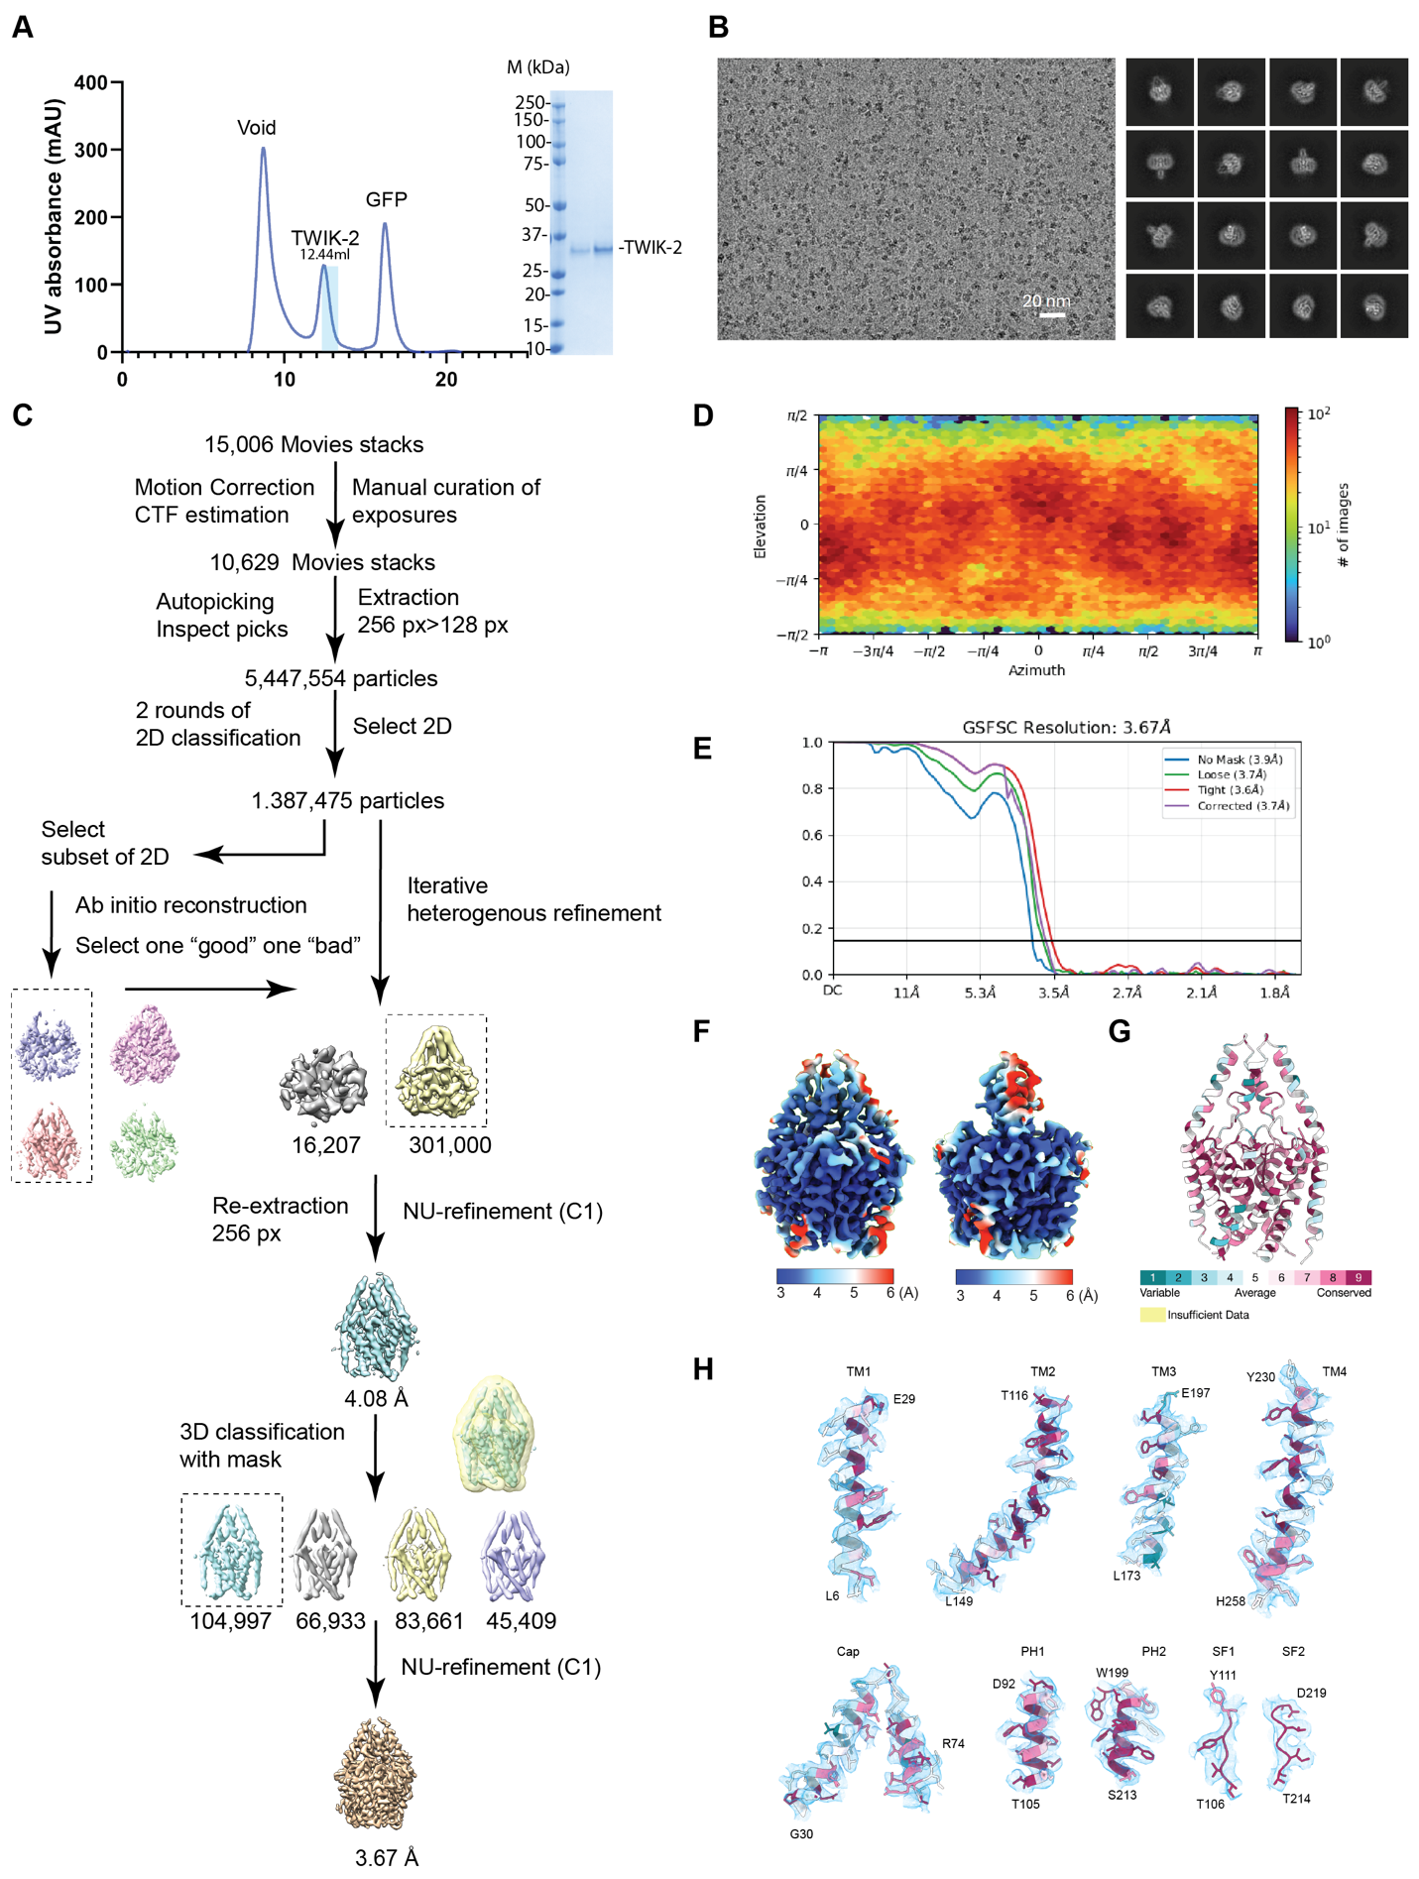
Supplementary Fig.3: Sample preparation and data processing of TWIK-2. A. Size-exclusion chromatogram of TWIK-2 purified in DMNG. Fractions from the peak eluting at 12.44 ml, corresponding to the dimer fraction of TWIK-2, are shown on the SDS-PAGE. B. Representative raw micrograph and sample 2D class averages of TWIK-2. C. Data processing pipeline for TWIK-2 in DMNG. Details can be found in Methods. D. Particle distribution plot. E. Fourier shell correlation (FSC) curves for TWIK-2. F. TWIK-2 map colored as per the estimated local resolution (3-6 Å). G. Consurf ²analysis of TWIK-2. H. Fit of the various secondary structural elements of TWIK-2 to the cryo-EM map. The cartoon is colored according to the evolutionary sequence conservation calculated by ConSurf². The cryo-EM density is shown in light blue (display level 0.18 in ChimeraX).

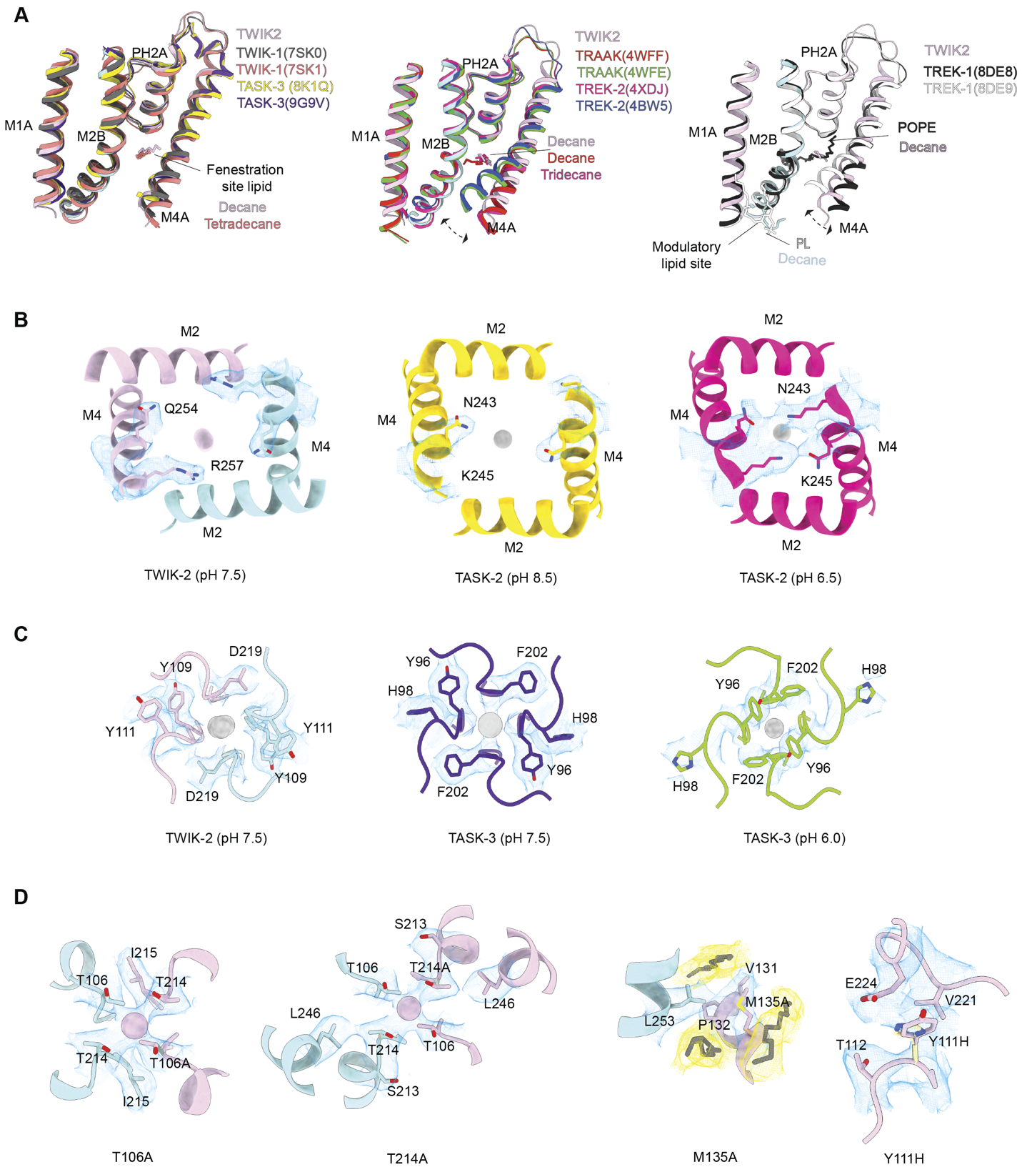
Supplementary Fig.4: Comparison of TWIK-2 structure with other K_{2P}s. A. Comparison of M4 helix ‘up’ and ‘down’ conformation of different pH-sensitive and lipid-regulated K_{2P} channels. Left panel, superposition of the M1A, M2B, PH2A, and M4A regions of TWIK-2 (chain A, magenta) and TWIK-1 at pH 7.4 (black, PDB: 7SK0), TWIK-1 at pH 5.5 (pink, PDB: 7SK1), TASK-3 at pH 6.0 (yellow, PDB: 8K1Q), TASK-3 at pH 7.5 (purple, PDB: 9G9V). The molecules modeled at the fenestration and modulatory lipid sites have been highlighted in the same color as their respective proteins. Middle panel, superposition of TWIK-2 and non-conductive TRAAK (red, PDB: 4WFF), conductive TRAAK (green, PDB: 4WFE), TREK-2 with M4 in down-state (pink, PDB: 4XDJ), and TREK-2 with M4 in up-state (blue, PDB: 4BW5). Dashed double-arrow lines depict M4 movement. Right panel, superposition of TWIK-2, TREK-1 in DDM/POPA mixed micelles (black, PDB: 8DE8), and TREK-1 in DDM/POPE mixed micelles (grey, PDB: 8DE9). B. Comparison of the entrance of the ion permeation pathway of TWIK-2 (left) with pH-regulated channel TASK-2 in pH 8.5 (yellow, PDB: 6MW0 and EMDB:10422) and in pH 6.5 (bright pink, PDB: 6WLV and EMDB:10423). The cryo-EM densities of critical residues of the hydrogen bond seal from the respective PDBs have been highlighted. C. Comparison of the top views of the exit of the ion permeation pathway of TWIK-2 with pH-sensitive TASK-3 at pH 7.5 (PDB: 9G9V and EMD-51158) and TASK-3 at pH 6.0 (PDB: 8K1Q and EMD-36799). D. Critical interactions and amino acid environment of the T106A, T214A, M135A, and Y11H mutations. The hydrocarbon tails in the hydrophobic cuff near M135A are highlighted in yellow.

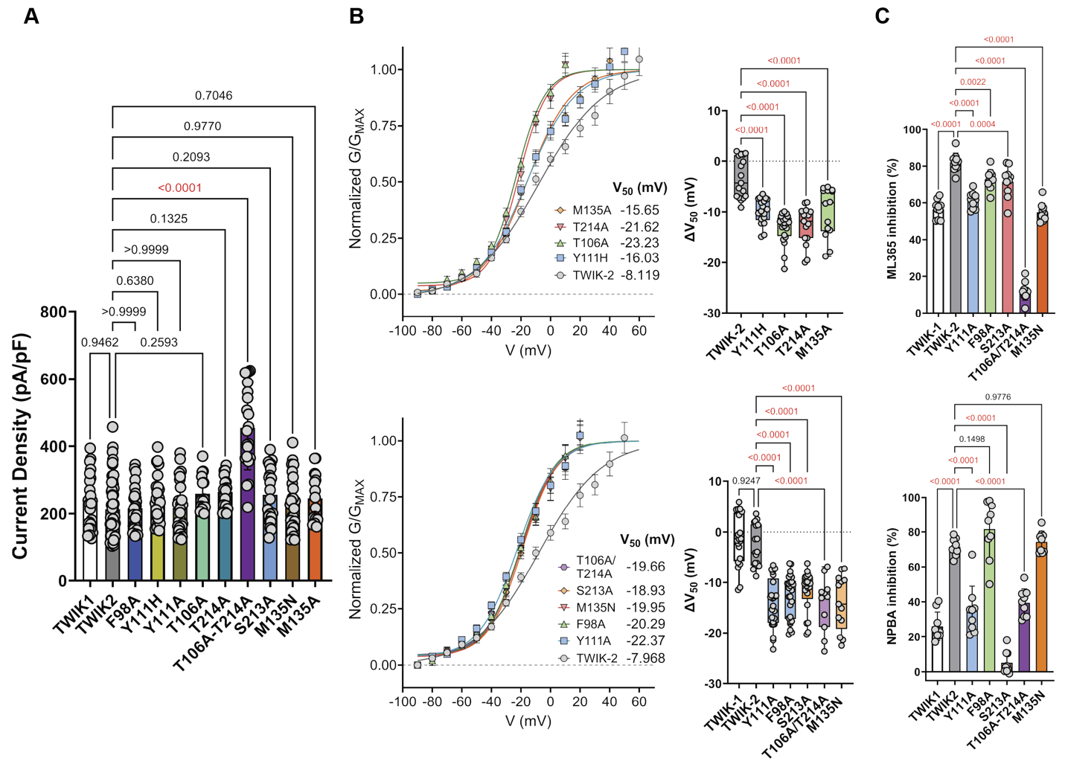
Supplementary Fig.5: Functional characterization of TWIK-2 channels. A. Current densities (pA/pF) at +100 mV for both wild-type and mutant TWIK channels are shown (TWIK-1, n= 25; TWIK-2, n = 56; Y111A, n = 28; F98A, n = 28; S213A, n = 22; T106A-T214A, n = 21; M135N, n = 28; Y111H, n = 29; T106A, n = 16; T214A, n = 17; M135A, n = 16). B. The G-V curves for wild-type and mutant TWIK channels are displayed, along with their respective ∆V₅₀ values (TWIK-1, n = 20; TWIK-2, n = 17-18; Y111A, n = 25; F98A, n = 26; S213A, n = 21; T106A-T214A, n = 11; M135N, n = 13; Y111H, n = 18; T106A, n = 21; T214A, n = 15; M135A, n = 14). C. Bar graphs show the effects of ML365 and NPBA at 50 µM on both wild-type and mutant channels (ML365: TWIK-1, n = 10; TWIK-2, n = 10; Y111A, n = 10; F98A, n = 10; S213A, n = 10; T106A-T214A, n = 10; M135N, n = 10; NPBA: TWIK-1, n = 9; TWIK-2, n = 9; Y111A, n = 9; F98A n = 9; S213A,, n= 9; T106A-T214A, n = 9; M135N, n = 9). Data in panels A, B, and C are expressed as mean ± SD. Statistical analysis was performed by comparing wild-type with each mutant, using one-way ANOVA, followed by Dunnett’s multiple comparisons test.

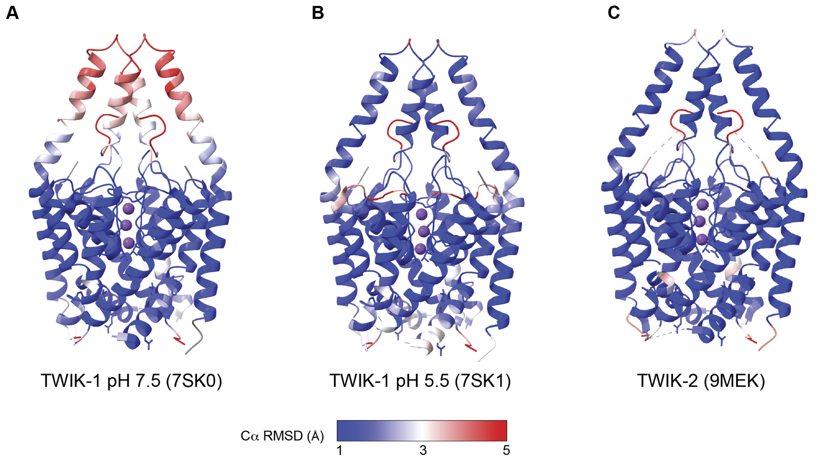
Supplementary Fig.6: Superposition of TWIK-2 and TWIK-1 structures. Cα RMSD calculated by superposing TWIK-2 (this study, 9E94) with TWIK-1 pH 7.5 (7SK0) in A, TWIK-1 pH 5.5 (7SK1) in B, or TWIK-2 structure determined by Khanra et al. (9MEK) in C. The color key denotes the range of Cα RMSD of the pairwise alignments, with blue for the lowest and red for the highest RMSDs.

Table S1- Summary data related to Figure 1B
TWIK-2 | Current density (pA/pF) |  | V_{rev} (mV)
 | pH 7.4 | pH 5.5 | pH 7.4 | pH 5.5
Number of values | 32 | 38 | 35 | 45
Mean | 202 | 204.3 | -67.67 | -63.08
Std. Deviation | 76.13 | 78.68 | 11.89 | 12.82
Std. Error of Mean | 13.46 | 12.76 | 2.011 | 1.911
Y111H | Current density (pA/pF) |  | V_{rev} (mV)
 | pH7.4 | pH 5.5 | pH 7.4 | pH 5.5
Number of values | 24 | 33 | 28 | 54
Mean | 222.5 | 210.2 | -56.06 | -60.56
Std. Deviation | 71.62 | 68.08 | 14.05 | 10.01
Std. Error of Mean | 14.62 | 11.85 | 2.656 | 1.362

Table S2- Summary data related to Figure S1B
 | TWIK-2 |  | non-T
 | Current density (pA/pF) |  | Current density (pA/pF)
 | pH7.4 | pH 5.5 | pH7.4 | pH 5.5
Number of values | 25 | 26 | 13 | 18
Mean | 248.3 | 244 | 72.97 | 63.29
Std. Deviation | 80.89 | 81.6 | 22.17 | 17.23
Std. Error of Mean | 16.18 | 16 | 6.148 | 4.062

Table S3. Cryo-EM data collection, refinement, and validation statistics
TWIK-2 (EMDB:47768) (PDB:9E94)
Data collection and processing
Magnification | 105,000 x
Voltage (kV) | 300
Electron exposure (e–/Å2) | 60
Defocus range (μm) | -0.8-2.5
pixel size (Å) | 0.83
Symmetry imposed | C1
Initial particle images (no.) | 5,447,554
Final particle images (no.) | 104,997
Map resolution (Å) | 3.67
FSC threshold | 0.143
Refinement
Model resolution (Å) | 3.67
FSC threshold | 0.143
Map sharpening B factor (Å2) | -135.9
Model composition
Nonhydrogen atoms | 3,381
Protein residues | 440
Potassium ion | 3
D10 | 7
B factors (Å2)
Protein (min/max/mean) | 1.07/102.63/26.79
ligands (min/max/mean） | 9.76/30.19/19.29
R.m.s. deviations
Bond lengths (Å) | 0.01
Bond angles (°) | 1.563
Validation
MolProbity score | 1.75
Clashscore | 6.18
Poor rotamers (%) | 0
Ramachandran plot
Favored (%) | 94%
Allowed (%) | 6%
Disallowed (%) | 0

Table S4- Summary data related to Figure 3C
Activation tau (s)
 | TWIK-1 | TWIK-2 | Y111A | F98A | S213A | T106A-T214A | M135N | Y111H | T106A | T214A | M135A
N | 15 | 28 | 15 | 12 | 15 | 15 | 15 | 32 | 14 | 18 | 18
Mean | 0.01175 | 0.02649 | 0.02017 | 0.02466 | 0.01402 | 0.01499 | 0.02854 | 0.03556 | 0.01682 | 0.01393 | 0.03112
S.D | 0.000912 | 0.006383 | 0.001735 | 0.002984 | 0.000756 | 0.001806 | 0.00497 | 0.01602 | 0.006373 | 0.00718 | 0.01655
S.E.M | 0.000235 | 0.001206 | 0.000448 | 0.000861 | 0.000195 | 0.000466 | 0.001283 | 0.002832 | 0.001703 | 0.001692 | 0.0039
Deactivation tau (s)
 | TWIK1 | TWIK2 | Y111A | F98A | S213A | T106A-T214A | M135N | M135A | T106A | T214A | Y111H
N | 15 | 15 | 15 | 13 | 15 | 15 | 15 | 11 | 24 | 12 | 33
Mean | 0.03783 | 0.04103 | 0.01448 | 0.09265 | 0.04327 | 0.04523 | 0.02925 | 0.02064 | 0.01894 | 0.0186 | 0.02251
S.D | 0.003168 | 0.005155 | 0.005058 | 0.05535 | 0.004489 | 0.006843 | 0.002533 | 0.005816 | 0.003883 | 0.00217 | 0.01062
S.E.M | 0.000818 | 0.001331 | 0.001306 | 0.01535 | 0.001159 | 0.001767 | 0.000654 | 0.001754 | 0.000793 | 0.000627 | 0.001849

Table S5- Summary data related to Figure S5A
Current density (pA/pF)
 | TWIK1 | TWIK2 | Y111A | F98A | S213A | T106A-T214A | M135N | Y111H | T106A | T214A | M135A
N | 25 | 56 | 28 | 28 | 22 | 21 | 28 | 29 | 16 | 17 | 16
Mean | 232.8 | 212.9 | 217.3 | 215.6 | 256.6 | 453.9 | 229.7 | 241.1 | 259.9 | 265.3 | 246
S.D | 79.25 | 83.23 | 74.64 | 62.32 | 80.61 | 123.7 | 79.58 | 65.53 | 51.6 | 47.75 | 71.99
S.E.M | 15.85 | 11.12 | 14.11 | 11.78 | 17.19 | 27 | 15.04 | 12.17 | 12.9 | 11.58 | 18

Table S6- Summary data related to Figure S5B
∆V₅₀ (mV) (upper panel)
 | TWIK-2 | Y111H | T106A | T214A | M135A
N | 17 | 18 | 21 | 15 | 14
Mean | -3.363 | -9.831 | -13.14 | -12.69 | -9.994
S.D | 3.963 | 2.518 | 2.92 | 3.795 | 4.884
S.E.M | 0.9611 | 0.5935 | 0.6372 | 0.9798 | 1.305
∆V₅₀ (mV) (lower panel)
 | TWIK-1 | TWIK-2 | Y111A | F98A | S213A | T106A/T214A | M135N
N | 20 | 18 | 25 | 26 | 21 | 11 | 13
Mean | -1.618 | -2.825 | -13.99 | -12.74 | -11.73 | -14.21 | -14.01
S.D | 5.125 | 4.095 | 4.84 | 4.333 | 4.025 | 5.378 | 5.472
S.E.M | 1.146 | 0.9652 | 0.968 | 0.8498 | 0.8784 | 1.621 | 1.518

Table S7- Summary data related to Figures 4D and 4E
ML365 (% inhibition)
 | TWIK-2 | M135A | T106A | T214A | Y111H
N | 9 | 9 | 9 | 9 | 9
Mean | 94.22 | 92.89 | 94.78 | 96.33 | 93.56
S.D | 4.353 | 5.134 | 3.073 | 2.646 | 3.678
S.E.M | 1.451 | 1.711 | 1.024 | 0.8819 | 1.226
NPBA (% inhibition)
 | TWIK-2 | M135A | T106A | T214A | Y111H
N | 10 | 10 | 10 | 10 | 10
Mean | 94.2 | 63.9 | 91.9 | 94 | 77.9
S.D | 5.308 | 4.909 | 8.762 | 4.372 | 5.915
S.E.M | 1.679 | 1.552 | 2.771 | 1.382 | 1.871

Table S8- Summary data related to Figure S5C
ML365 (% inhibition)
 | TWIK-1 | TWIK-2 | Y111A | F98A | S213A | T106A/T214A | M135N
N | 10 | 10 | 10 | 10 | 10 | 10 | 10
Mean | 56.5 | 82.15 | 61.34 | 72.91 | 71.58 | 11.96 | 54.91
S.D | 4.919 | 4.978 | 4.405 | 5.24 | 8.368 | 4.918 | 4.837
S.E.M | 1.556 | 1.574 | 1.393 | 1.657 | 2.646 | 1.555 | 1.53
NPBA (% inhibition)
 | TWIK1 | TWIK2 | Y111A | F98A | S213A | T106A-T214A | M135N
N | 9 | 9 | 9 | 9 | 9 | 9 | 9
Mean | 26.07 | 71.49 | 35.03 | 81.62 | 5.133 | 39.47 | 74.33
S.D | 8.093 | 4.815 | 13.91 | 16.44 | 6.443 | 7.932 | 6.111
S.E.M | 2.698 | 1.605 | 4.635 | 5.48 | 2.148 | 2.644 | 2.037

Table S9- Summary data related to Figure 5B
 | TWIK-1 |  | TWIK-2
 | Vrev (mV) |  | Vrev (mV)
 | pH 7.4 | pH 5.5 | pH 7.4 | pH 5.5
Number of values | 18 | 24 | 30 | 36
Mean | -86.1 | -63.4 | -66.12 | -62.05
Std. Deviation | 12.11 | 9.438 | 10.2 | 9.364
Std. Error of Mean | 2.854 | 1.927 | 1.862 | 1.561

References

1. Procter, J.B., Carstairs, G.M., Soares, B., Mourão, K., Ofoegbu, T.C., Barton, D., Lui, L., Menard, A., Sherstnev, N., Roldan-Martinez, D., et al. (2021). Alignment of biological sequences with Jalview. Methods Mol. Biol. 2231, 203–224.
2. Ashkenazy, H., Abadi, S., Martz, E., Chay, O., Mayrose, I., Pupko, T., and Ben-Tal, N. (2016). ConSurf 2016: an improved methodology to estimate and visualize evolutionary conservation in macromolecules. Nucleic Acids Res. 44, W344-50.

