Cross-species comparison of amniote single-cell transcriptomes reveals evolutionary conservation and divergence in the chicken immune system
Fei Wang^{1†}, Jilong Ren^{1†}, Yaqi Zhou^{1†}, Wuqiang Huo^{1†}, Huichao Liu^{2†}, Mumu Qin^{3†}, Yi Jing^{3†}, Zhongtao Yin⁴, Tao Shi¹, Huiquan Shan¹, Guanghui Tan¹, Haoping Wang¹, Xi Guo¹, Junpu Mei³, Zhen Yue³, Zhuocheng Hou⁴, Huaijun Zhou⁵, Jiuzhou Song⁶, Søren Egedal Degn⁷, Lin Lin⁷, Yonglun Luo⁷, Feilong Meng⁸, Xiaodong Fang^{3,9*}, Haihan Zhang^{2*}, Xi He^{2*}, Lingzhao Fang^{10*}, Yu Jiang^{1*}
Affiliations:
¹Key Laboratory of Animal Genetics, Breeding and Reproduction of Shaanxi Province, College of Animal Science and Technology, Northwest A&F University, Yangling, 712100, China
²College of Animal Science and Technology, Hunan Agricultural University, Changsha, 410128, China
³BGI Research, Sanya, 572025, China
⁴College of Animal Science and Technology, China Agricultural University, Beijing 100193, China.
⁵Department of Animal Science, University of California, Davis, 95616, USA
⁶Department of Animal and Avian Sciences, University of Maryland, College Park,20742, USA
⁷Department of Biomedicine, Aarhus University, Aarhus, 8000 Aarhus C, Denmark
⁸Key Laboratory of RNA Innovation, Science and Engineering, Shanghai Institute of Biochemistry and Cell Biology, Center for Excellence in Molecular Cell Science, Chinese Academy of Sciences, University of Chinese Academy of Sciences, Shanghai, 200031, China
⁹BGI Research, Shenzhen, 518083, China
¹⁰Center for Quantitative Genetics and Genomics, Aarhus University, Aarhus, 8000 Aarhus C, Denmark

These authors contributed equally: Fei Wang, Jilong Ren, Yaqi Zhou, Wuqiang Huo, Huichao Liu, Mumu Qin, Yi Jing
E-mail: yu.jiang@nwafu.edu.cn; lingzhao.fang@qgg.au.dk; hexi@hunau.edu.cn; zhhous@163.com; fangxd@bgi.com;

Supplementary Figures
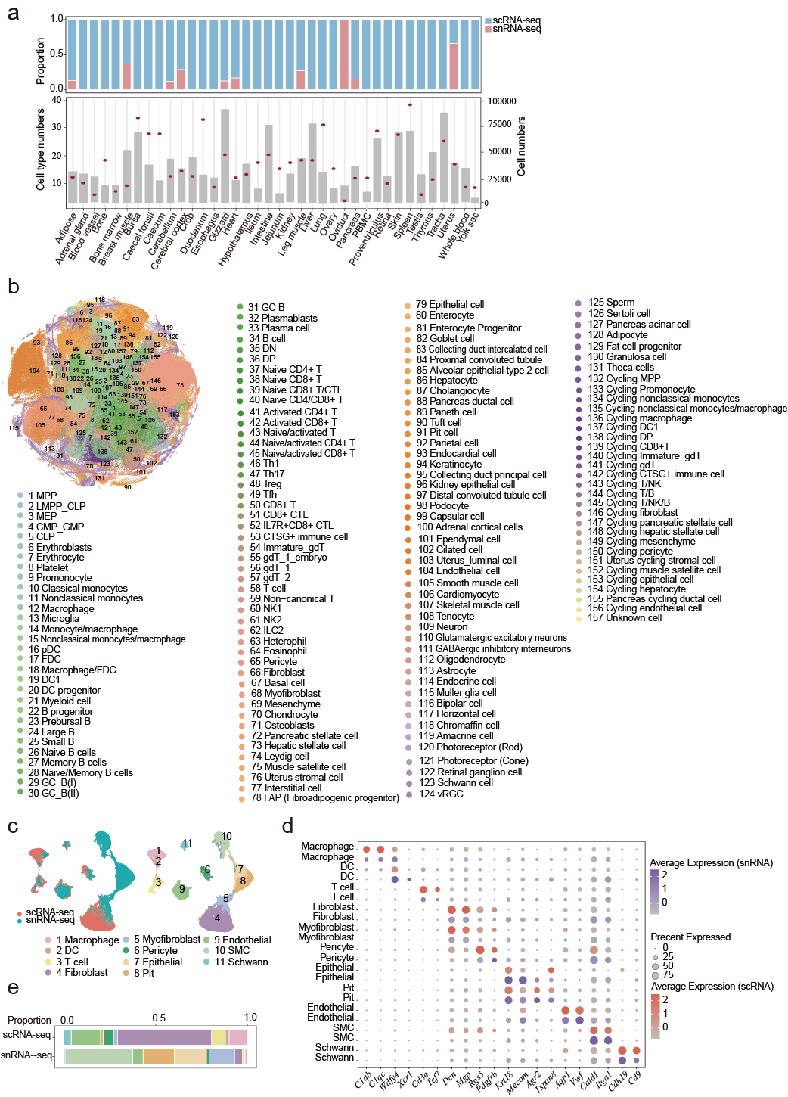
Supplementary Fig. 1. Overview of the chicken cell atlas. a Upper panel: The proportion of cell numbers dissociated by scRNA-seq and snRNA-seq across various tissues. Lower panel: The number of cell types identified in each tissue (red dot) and cell numbers after filtering in each tissue (grey bar frame). b T-SNE visualization of all clusters colored by major cell types. MPP, multipotent progenitor; LMPP_CLP, lymphoid-primed multipotent progenitor/common lymphoid progenitor; MEP, megakaryocyte-erythroid progenitor; CMP_GMP, common myeloid progenitor/granulocyte-macrophage progenitor; CLP, common lymphoid progenitor; FDC, follicular dendritic cell; pDC, plasmacytoid dendritic cell; DN, double negative T cells; DP, double positive T cells; vRGC, ventricular Radial Glial Cell. c Co-embedding of gizzard snRNA-seq and scRNA-seq datasets. d Dot plot showing the expression level of marker genes in each cell type of the gizzard comparing snRNA-seq and scRNA-seq methods. e Stacked bar plot representing the ratio of each cell type detected in the gizzard of a 14-week-old chicken using either snRNA-seq or scRNA-seq.

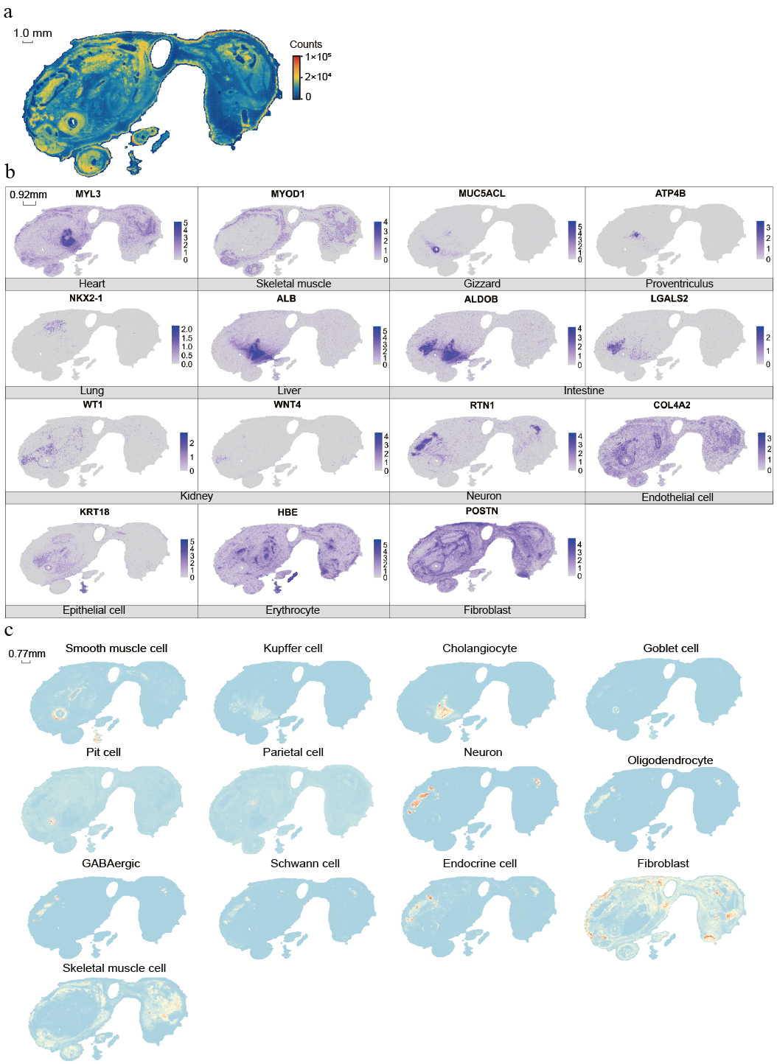
Supplementary Fig. 2. Overview of the chicken spatial transcriptomics. a Heatmap representation of the counts detected in the chicken embryo. b Spatial visualization of the indicated gene expression in the chicken embryo. c Spatial visualization of the indicated major cell types annotated using deconvolution in the chicken embryo.
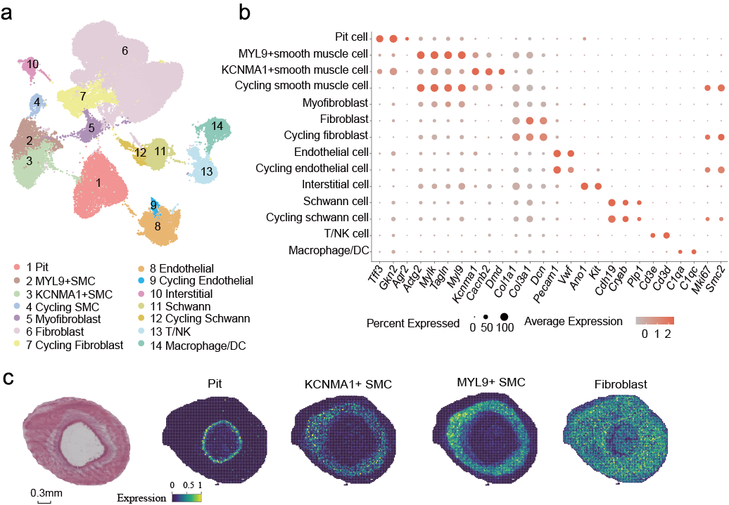Supplementary Fig. 3. ScRNA-seq profiling and spatial visualization of cell clusters in the gizzard of the chicken. a UMAP visualization of all clusters colored by major cell types. b Dot plot for expression of marker genes of the identified cell populations in chicken gizzard. c Spatial visualization of cells in gizzard of the chicken embryo.
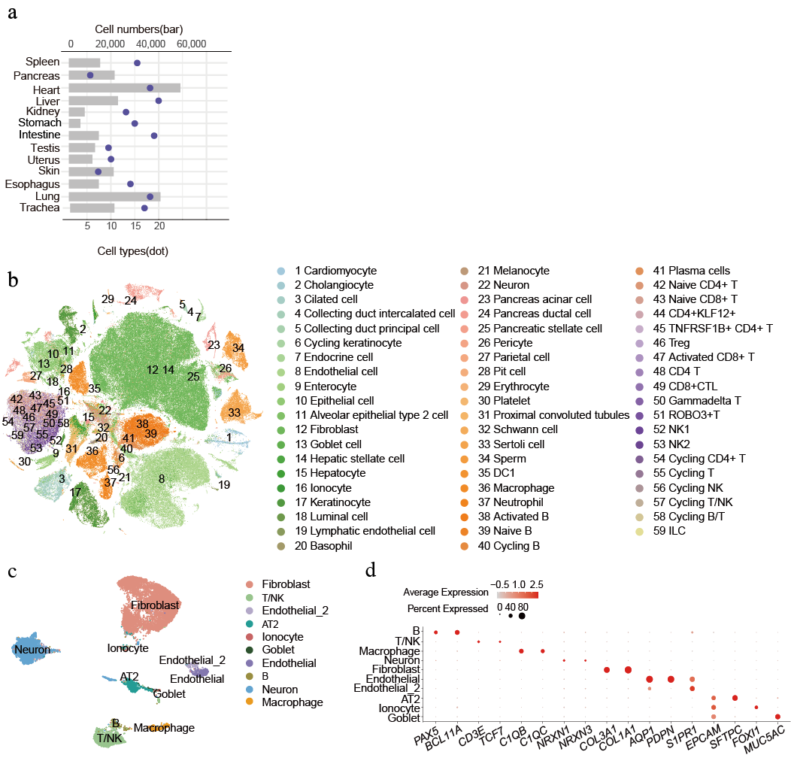Supplementary Fig. 4. Overview of the turtle cell atlas. a The number of cell types identified in each tissue (red dot) and cell numbers after filtering in each tissue (grey bar frame). b T-SNE visualization of all clusters colored by major cell types. c UMAP visualization of all clusters colored by major cell types in turtle lung. d Dot plot for expression of marker genes of the identified populations in turtle lung.
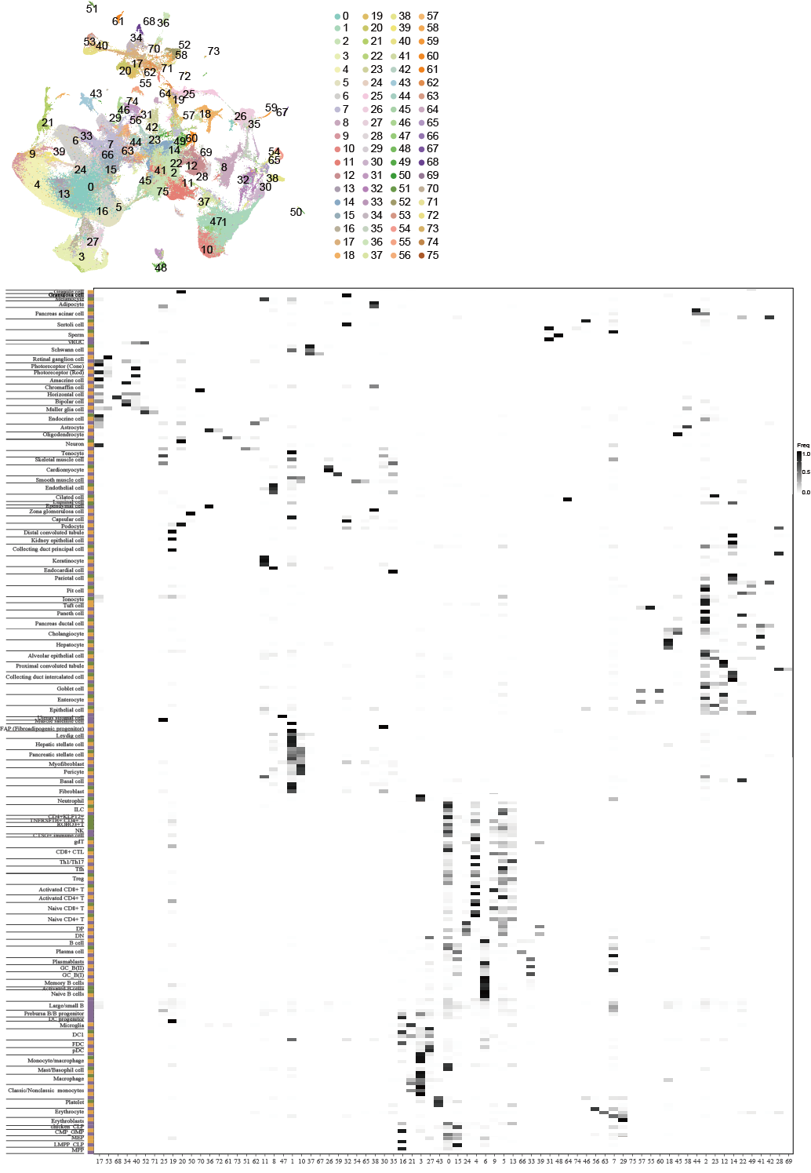Supplementary Fig. 5. Cross-species comparison of cell landscapes. Left: UMAP plot after integration of scRNA-seq data from the turtle, chicken and human. Right: percentage of cells from the original species-specific clusters (rows) in the integrated clusters (columns).
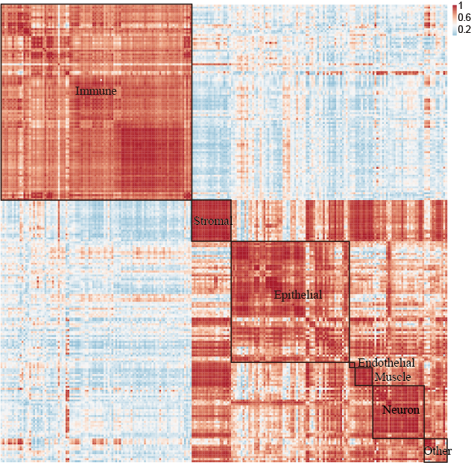
Supplementary Fig. 6. Correlation of orthologous gene expression between turtle, chicken and human cell types. AUROC scores were used to measure the similarity of cell types.
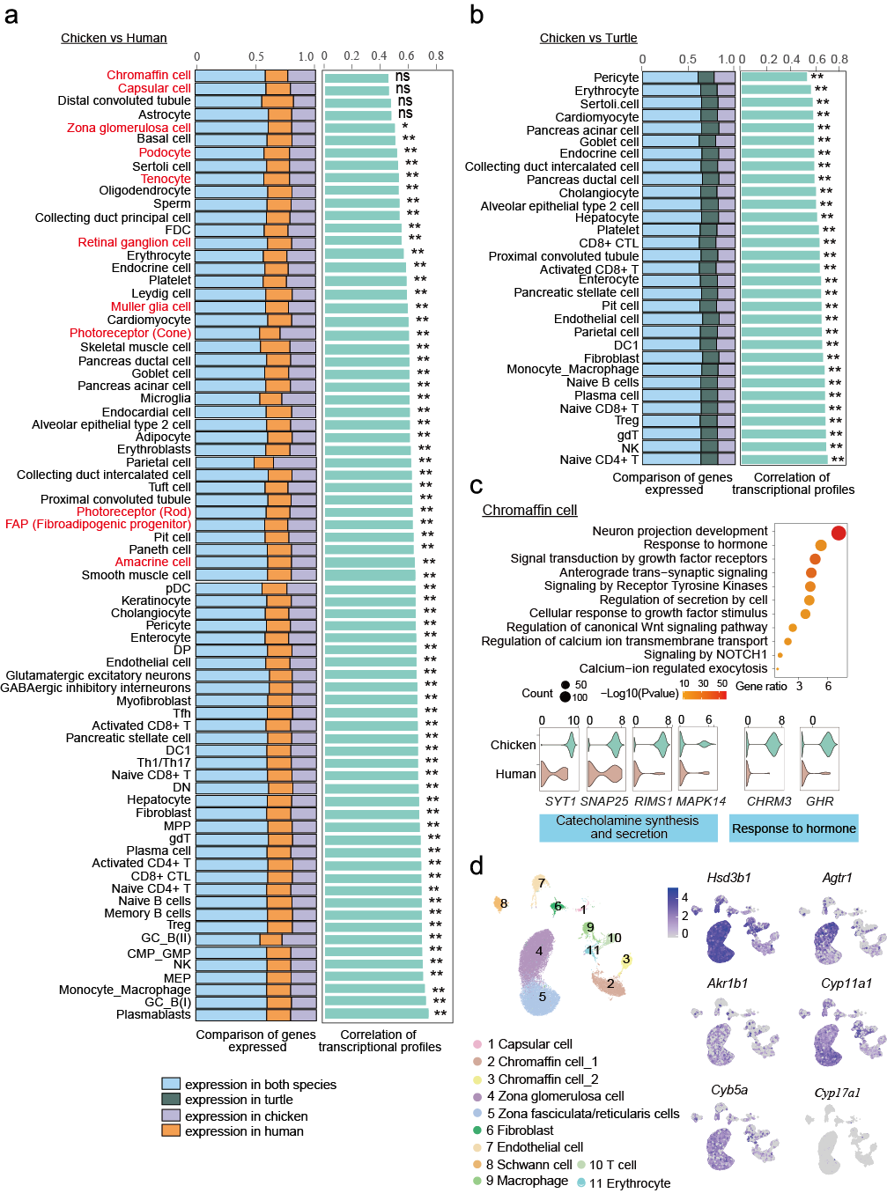Supplementary Fig. 7. Transcriptional similarity of cell types in chicken compared to human and turtle. a, b Left: The proportion of orthologous genes expressed in both species and a particular species. Right: Transcriptional similarity of the same cell type. Ns indicated no statistically significant correlations, and dots indicated statistically significant correlations. The cell types indicated in red were from the Xiangjia Black Phoenix chickens, while those labelled in black are from White Leghorn chickens. FDC, follicular dendritic cell; pDC, plasmacytoid dendritic cell; DP, double positive T cells; DN, double negative T cells; MPP, multipotent progenitor; MEP, megakaryocyte-erythroid progenitor; CMP_GMP, common myeloid progenitor/granulocyte-macrophage progenitor. c Gene ontology analysis of up-regulated genes in chicken chromaffin cells compared to those of humans. P-value was calculated using a one-sided hypergeometric test. Violin plot showing the expression of genes related to hormone secretion and lipid metabolism in chicken and human chromaffin cells. d Left: UMAP visualization of all clusters in the chicken adrenal gland, colored by major cell types. Right: Feature plot showing the expression of human adrenal cortex cell marker genes in chicken adrenal cell types. Source data are provided as a Source Data file.
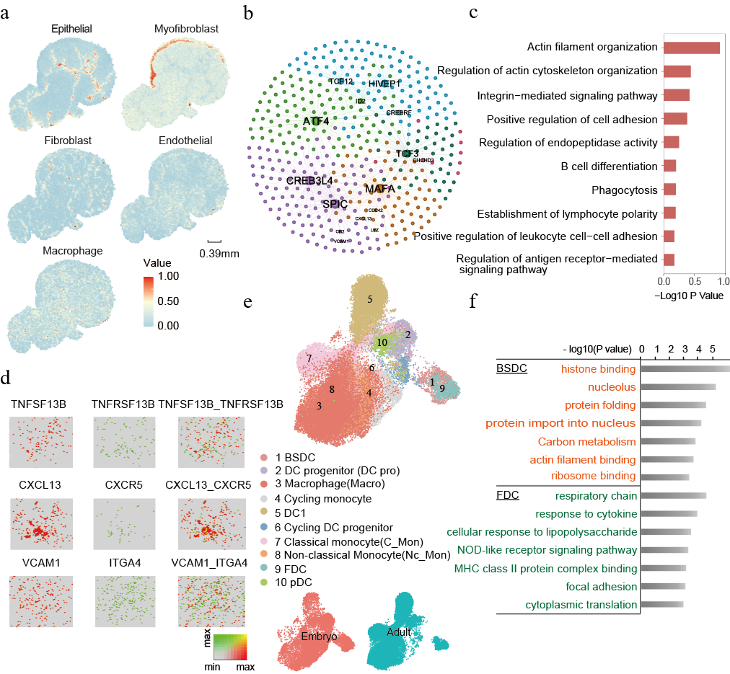Supplementary Fig. 8. Comparison of BSDC and FDCs in chicken embryo and adult. BSDC, bursa-specific secretory dendritic cell; FDC, follicular dendritic cell; pDC, plasmacytoid dendritic cell. a Spatial visualization of cell populations in the caecal tonsil of the adult chicken. b Transcriptional regulatory network of BSDC cells in chicken. c Gene ontology analysis of up-regulated genes in BSDC cells. P-value was calculated using a one-sided hypergeometric test. d Heatmap showing spatial proximity enrichment of cell-type pairs and cell-cell interactions in bursa of Fabricius in chicken embryo. e Left: UMAP visualization of all clusters coloured by major cell types. Right: Distribution of chicken mononuclear phagocyte from different ages. f Gene set enrichment analysis results for differentially expressed genes in embryonic BSDC and adult FDC. P-value was calculated using a one-sided hypergeometric test.
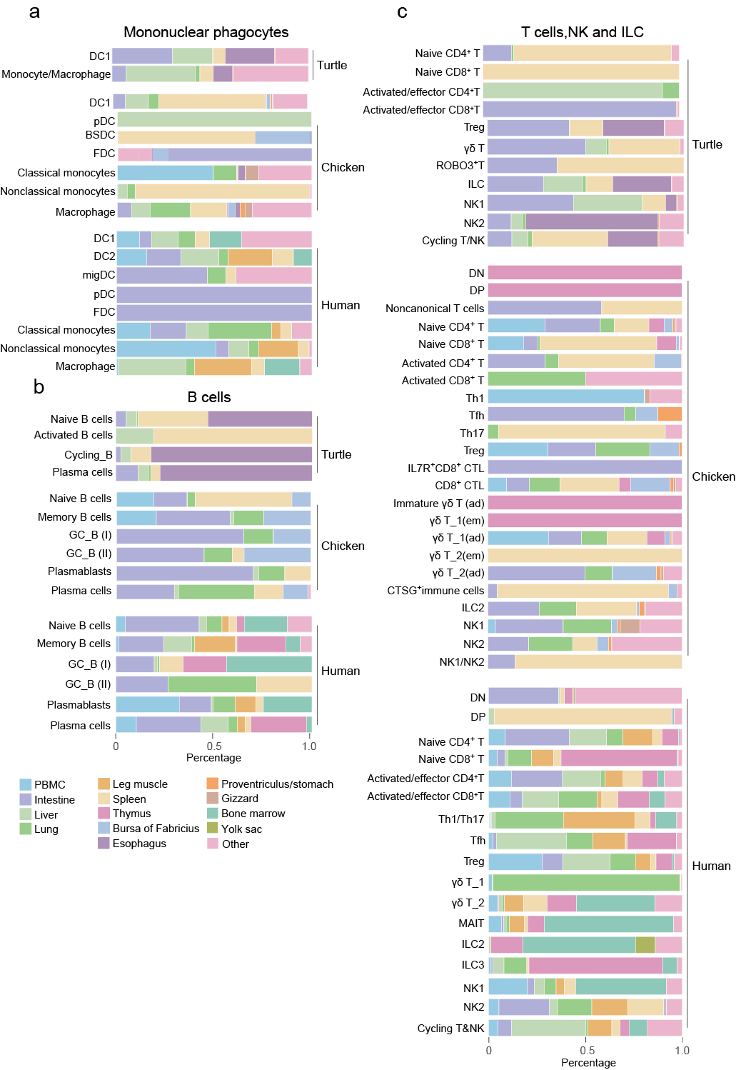Supplementary Fig. 9. Distribution of annotated mononuclear phagocyte populations and lymphoid populations across organs in turtle, chicken and human. a-c Proportional tissue distribution of mononuclear phagocytes(a), B cells(b), T cells and innate lymphoid cells (c) in three species. BSDC, bursa-specific secretory dendritic cell; FDC, follicular dendritic cell; pDC, plasmacytoid dendritic cell; DP, double positive T cells; DN, double negative T cells.
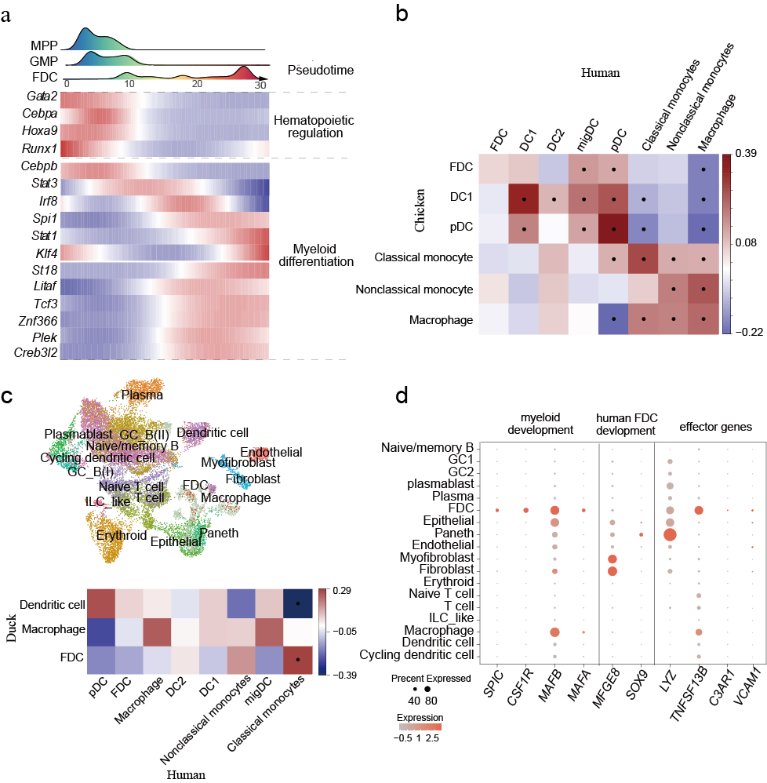Supplementary Fig. 10. Molecular architecture of FDCs in birds and mammals. a Top: Ridge plots showing the distribution of cell types along the pseudotime axis. MPP, multipotent progenitor; GMP, granulocyte-macrophage progenitor; FDC, follicular dendritic cell. The x-axis represents pseudo-temporal ordering, while the y-axis represents the density of cells at each pseudotime point. Bottom: Heatmaps of differentially expressed genes along the trajectories of the FDCs. Dot plot for expression of marker genes of the identified mononuclear phagocyte populations in turtle, chicken and human. b Pairwise correlations of mononuclear phagocytes in chicken and human, calculated from highly variable genes. FDC, follicular dendritic cell; pDC, plasmacytoid dendritic cell. c Top: UMAP visualization of cell types in duck spleen and bursa of Fabricius. Bottom: Pairwise correlations of mononuclear phagocytes in duck and human, calculated from highly variable genes. d Dot plot of crucial genes for chicken and human FDC cell in duck cell types.
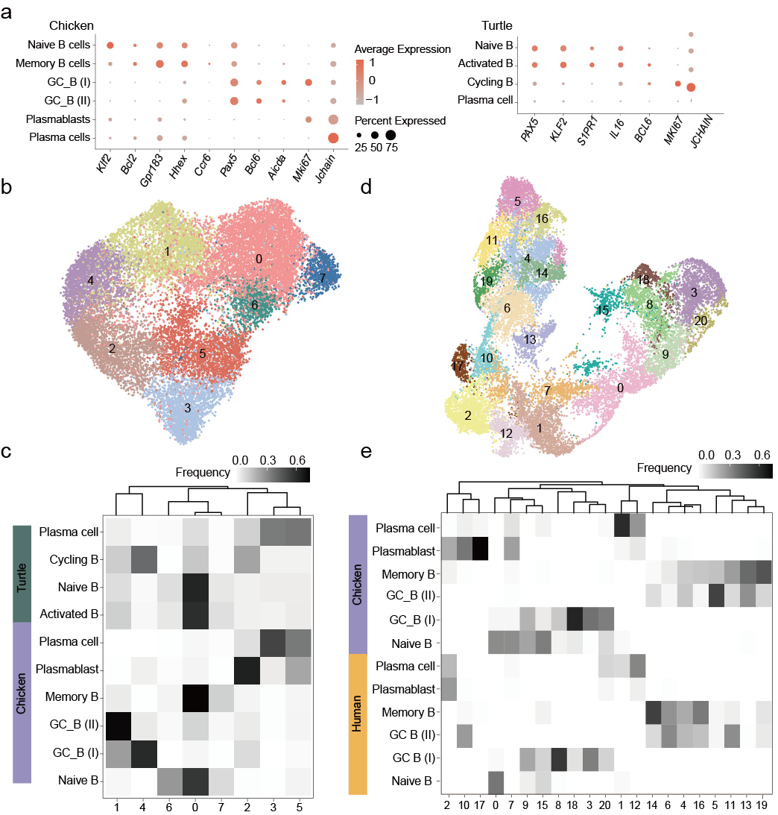Supplementary Fig. 11 Comparative analysis of B cells across amniotes. a Dot plot for expression of marker genes of the identified B cell populations in chicken(top) and turtle(bottom). b, d, UMAP plot after integration of scRNA-seq data from B cells of chicken with turtle(b) and human(d). c, e, percentage of cells from the original species-specific clusters (rows) in the integrated clusters (columns) of b and d.
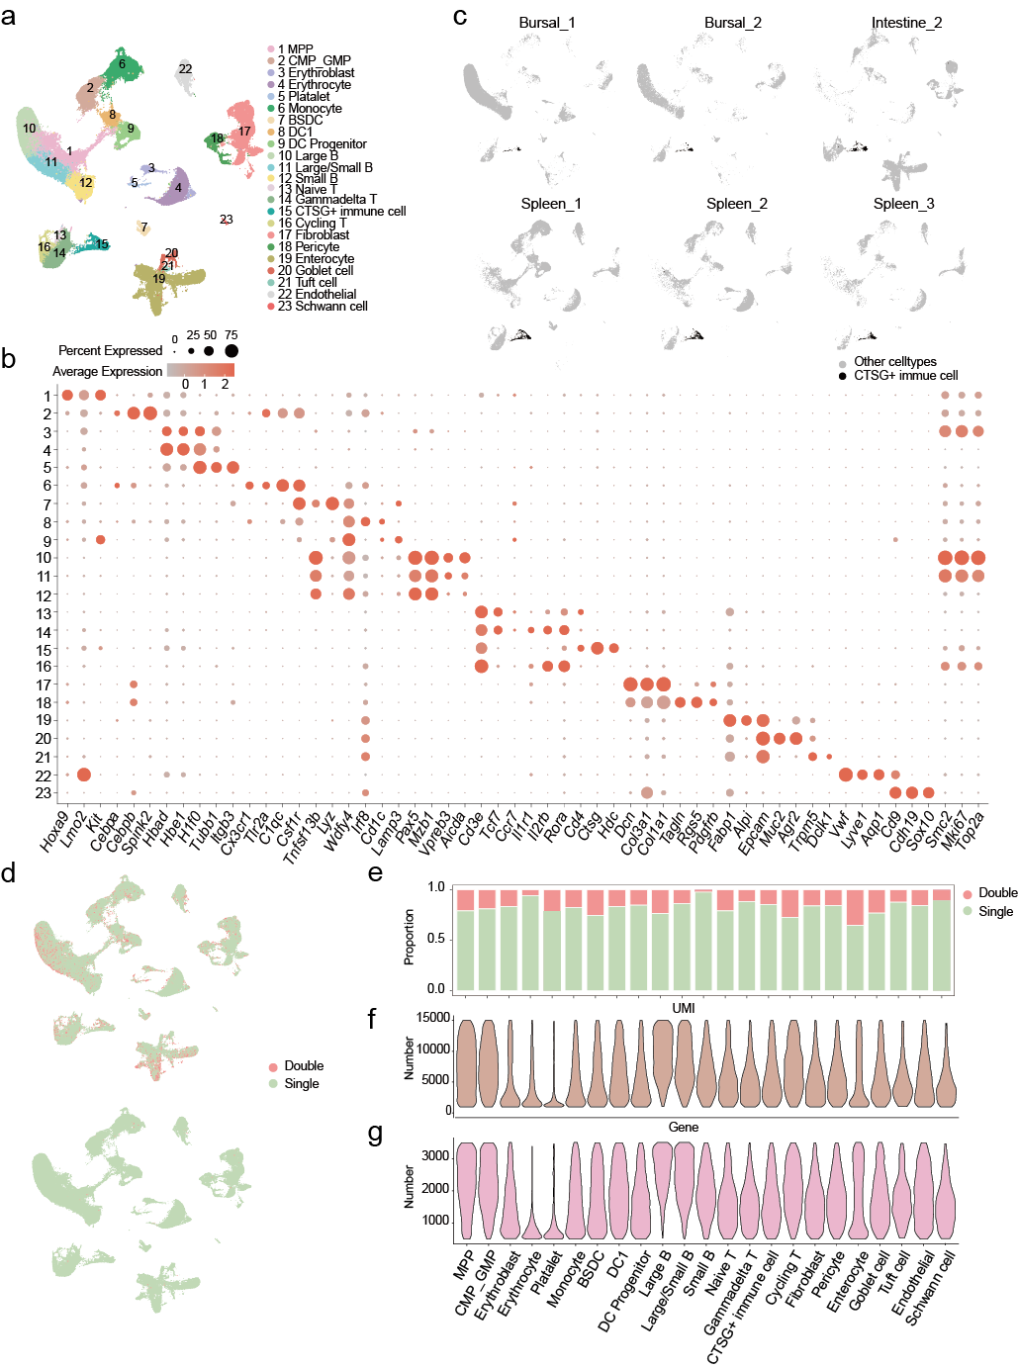Supplementary Fig. 12. Comparison of UMI and gene numbers between CTSG+ immune cells and other cells. a UMAP visualization of all annotated cell types from the bursa of Fabricius, intestine, and spleen samples containing CTSG+ immune cells. Cells are color-coded according to cell types. MPP, multipotent progenitor; CMP_GMP, common myeloid progenitor/granulocyte-macrophage progenitor; BSDC, bursa-specific secretory dendritic cell b Dot plot of marker genes of the identified cell types. c UMAP plots of the integrated dataset showing CTSG+ immune cells from each sample highlighted in black. d The distribution of doublets inferred by DoubletFinder and Scrublet. e The proportion of doublets in each cell type. f, g Violin plot indicating the number of UMI and genes detected in each cell type.
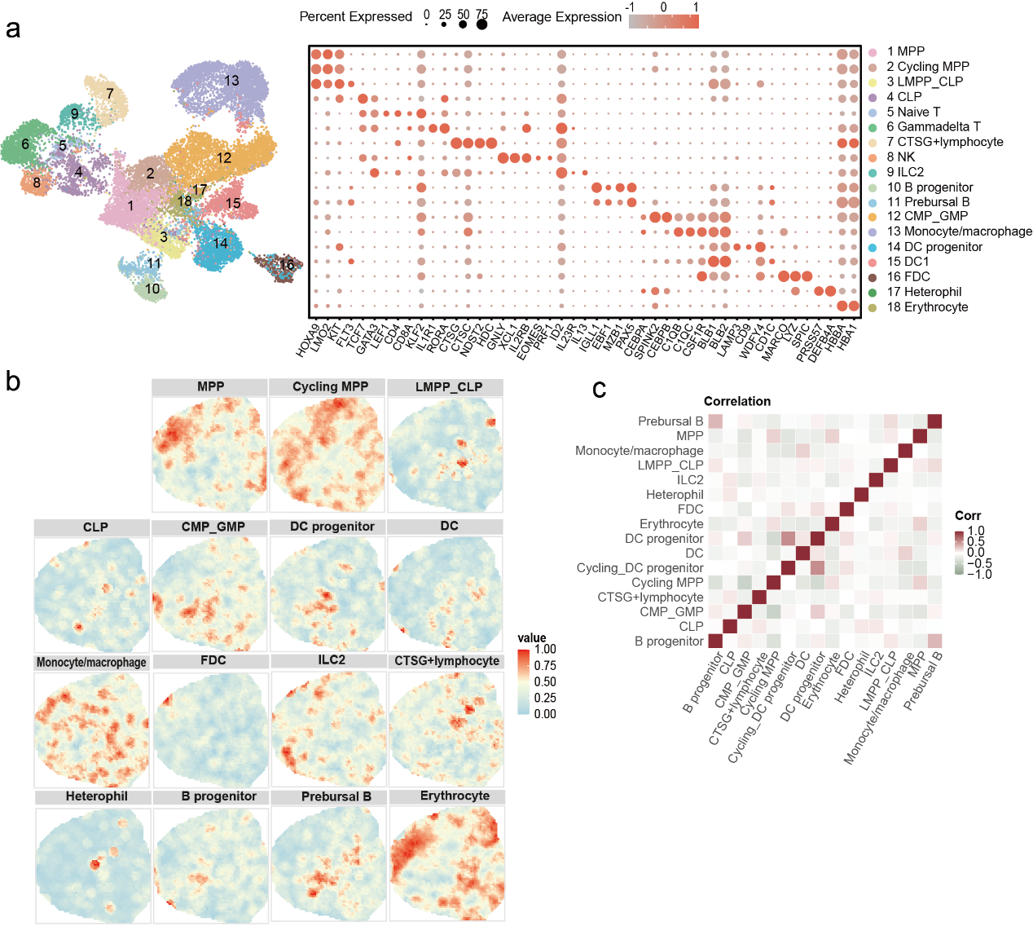Supplementary Fig. 13. ScRNA-seq profiling and spatial visualization of cell clusters in the spleen of the chicken embryo. MPP, multipotent progenitor; LMPP_CLP, lymphoid-primed multipotent progenitor/common lymphoid progenitor; CLP, common lymphoid progenitor; CMP_GMP, common myeloid progenitor/granulocyte-macrophage progenitor; FDC, follicular dendritic cell. a UMAP visualization of cell populations and dot plot for expression of marker genes of the these populations in the spleen. b Hematoxylin and Eosin (H&E) staining of the spleen, along with spatial visualization of the indicated cell types within the spleen. c Heatmap showing spatial proximity of cell-type pairs in the spleen.
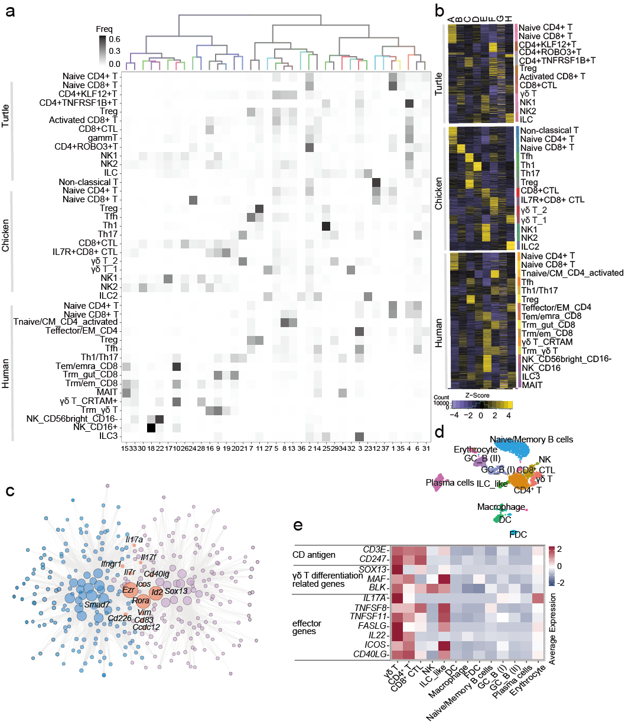Supplementary Fig. 14. Comparison of gene expression in T cells and innate lymphoid cells among amniotes. a Top: hierarchical clustering of the average expression profiles of integrated clusters; branches were colored by species mixture. Bottom: percentage of cells from the original species-specific clusters (rows) in the integrated clusters (columns). b Expression of module eigengenes of gene modules obtained from turtle, chicken and human T/NK/ILC cells with WGCNA. c Illustration of the union of chicken γδ T_2 and Th17 high expression gene networks. Nodes: genes; edges: high-ranking gene-gene correlations. d UMAP visualization of all clusters colored by cell types in adult duck intestine. e Heatmap showing the expression of effect genes in cell types in adult duck intestine.
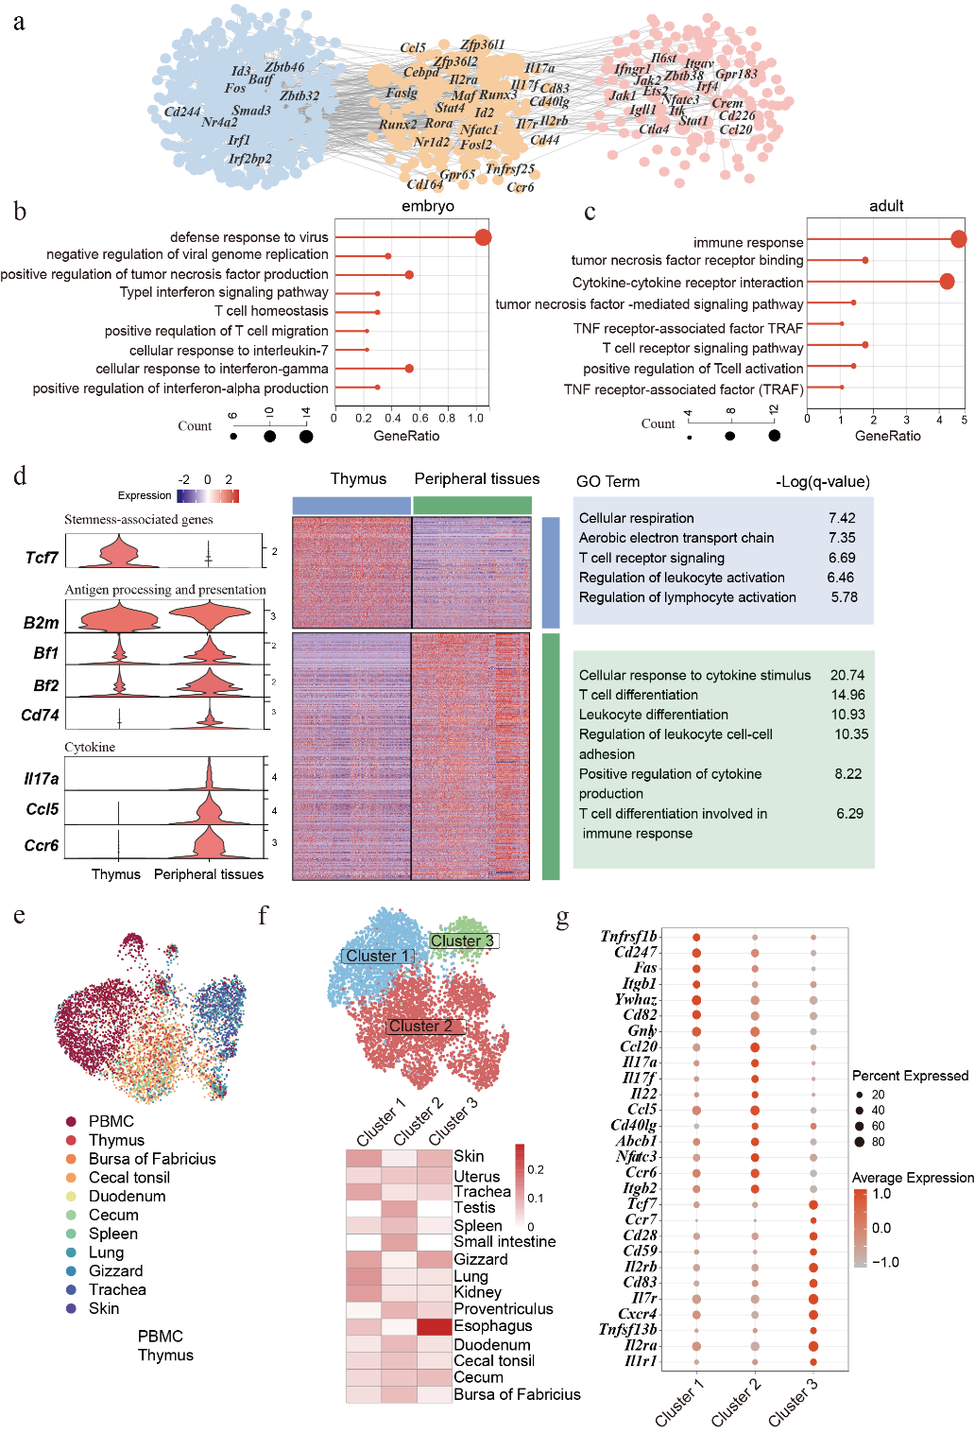
Supplementary Fig. 15. Heterogeneity of γδ across developmental stages and tissues. a Similarities and differences in gene regulatory networks of γδ T_2 across embryo and adult chicken. b,c Gene set enrichment analysis results for differentially expressed genes in embryonic and adult γδ T_2. d Genes highly expressed in γδ T cells in the peripheral tissues and thymus and their enriched signaling pathways. P-value was calculated using a one-sided hypergeometric test. Q-values were calculated via FDR correction following a one-sided hypergeometric test.e UMAP visualization of the adult γδ T_1 cells in chicken colored by tissues. f UMAP visualization of adult γδ T_2 subtypes in chicken(upper) and proportion of adult γδ T_2 subtypes in each tissue(lower). g Dot plot for differentially expressed genes of γδ T_2 subtypes in adult chicken.
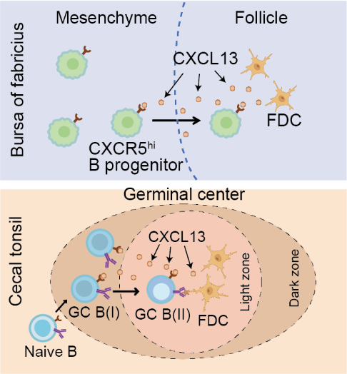
Supplementary Fig. 16. Diagram of the interaction mechanism between chicken FDCs and B cell progenitors and mature B cells. FDC, follicular dendritic cell. Created in BioRender. wang, F. (2026) https://BioRender.com/4p4dh9h

