Supplementary Information for
Modulating Ion Migration and Interface Chemistry via Covalent Organic Framework-Boosted Polymer Electrolytes toward Fast-Charging Sodium Solid-State Batteries
Yongbiao Mu‡,^{1,2} Chen Li‡,³ Jun Huang‡,³ Xiaoqian Xu‡,^{1,2} Yichun Wang,^{1,2} Quanyan Man,^{1,2} Zhiyu Zou,^{1,2} Meisheng Han,^{1,2} Qing Zhang,^{1,2} Guobin Zhang,*⁴ Lei Wei,*^{1,2} Baohua Li,*⁵ and Lin Zeng*^{1,2}
¹Shenzhen Key Laboratory of Advanced Energy Storage, Department of Mechanical and Energy Engineering, Southern University of Science and Technology, Shenzhen 518055, China
²SUSTech Energy Institute for Carbon Neutrality, Southern University of Science and Technology, Shenzhen 518055, China
³Department of Chemical and Biological Engineering, The Hong Kong University of Science and Technology, Hong Kong SAR, 999077 China
⁴College of New Materials and New Energies, Shenzhen Technology University, Shenzhen 518055, China
⁵Institute of Materials Research, Tsinghua Shenzhen International Graduate School, Tsinghua University Shenzhen 518055, China
‡These authors contributed equally.
E-mail: zhangguobin@sztu.edu.cn (Guobin Zhang); weil@sustech.edu.cn (Lei Wei); libh@sz.tsinghua.edu.cn (Baohua Li); zengl3@sustech.edu.cn (Lin Zeng)

Supplementary Figures

Figure S1. Synthesis process and molecular structures of the raw materials and products of TpPa-SO₃Na COF material.

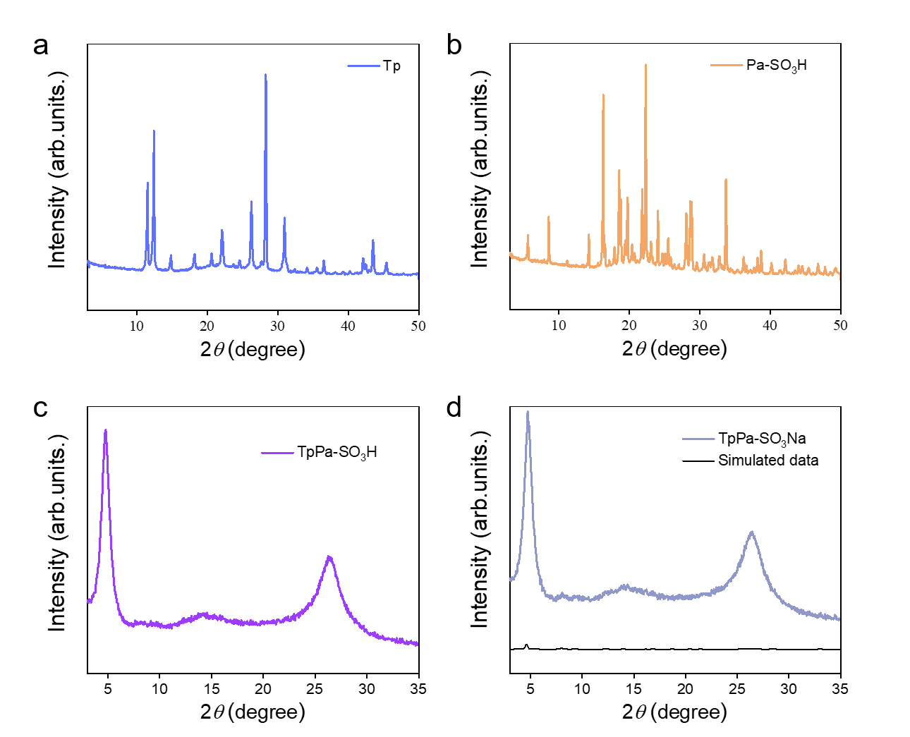
Figure S2. XRD of the raw materials used for COF synthesis and the final COF material. (a) Tp, (b) Pa-SO₃H, (c) TpPa-SO₃H, and (d) TpPa-SO₃-Na.

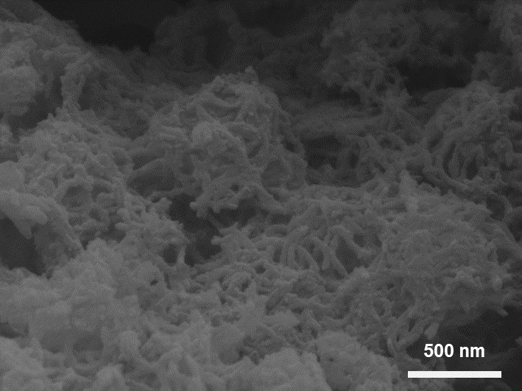
Figure S3. SEM image of TpPa-SO₃-Na COF.

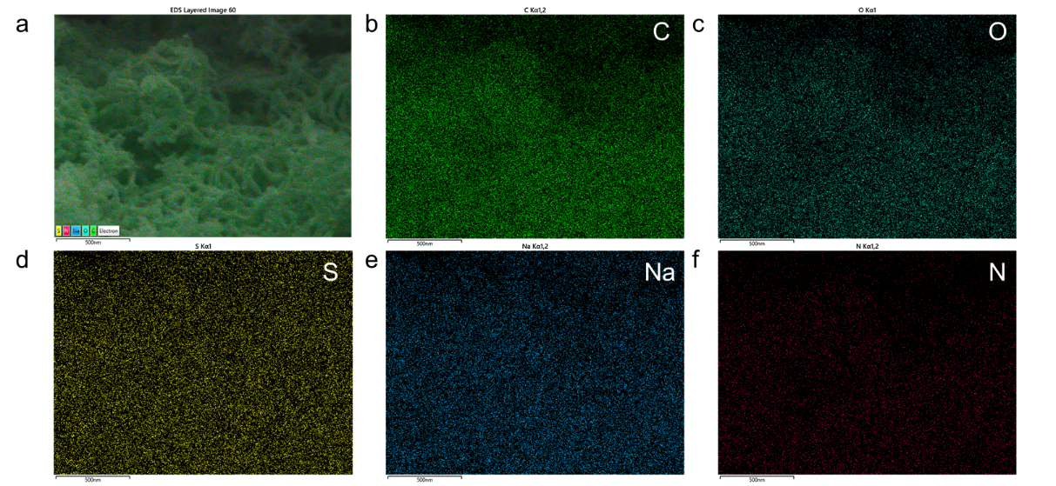
Figure S4. SEM mapping images of TpPa-SO₃-Na. a) Mixed mapping, b) C, c) O, d) S, e) Na, f) N elements.

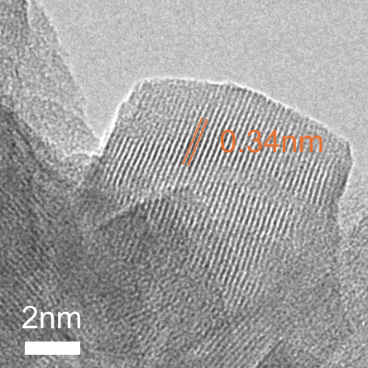
Figure S5. High-resolution TEM image of the TpPa-SO₃-Na.

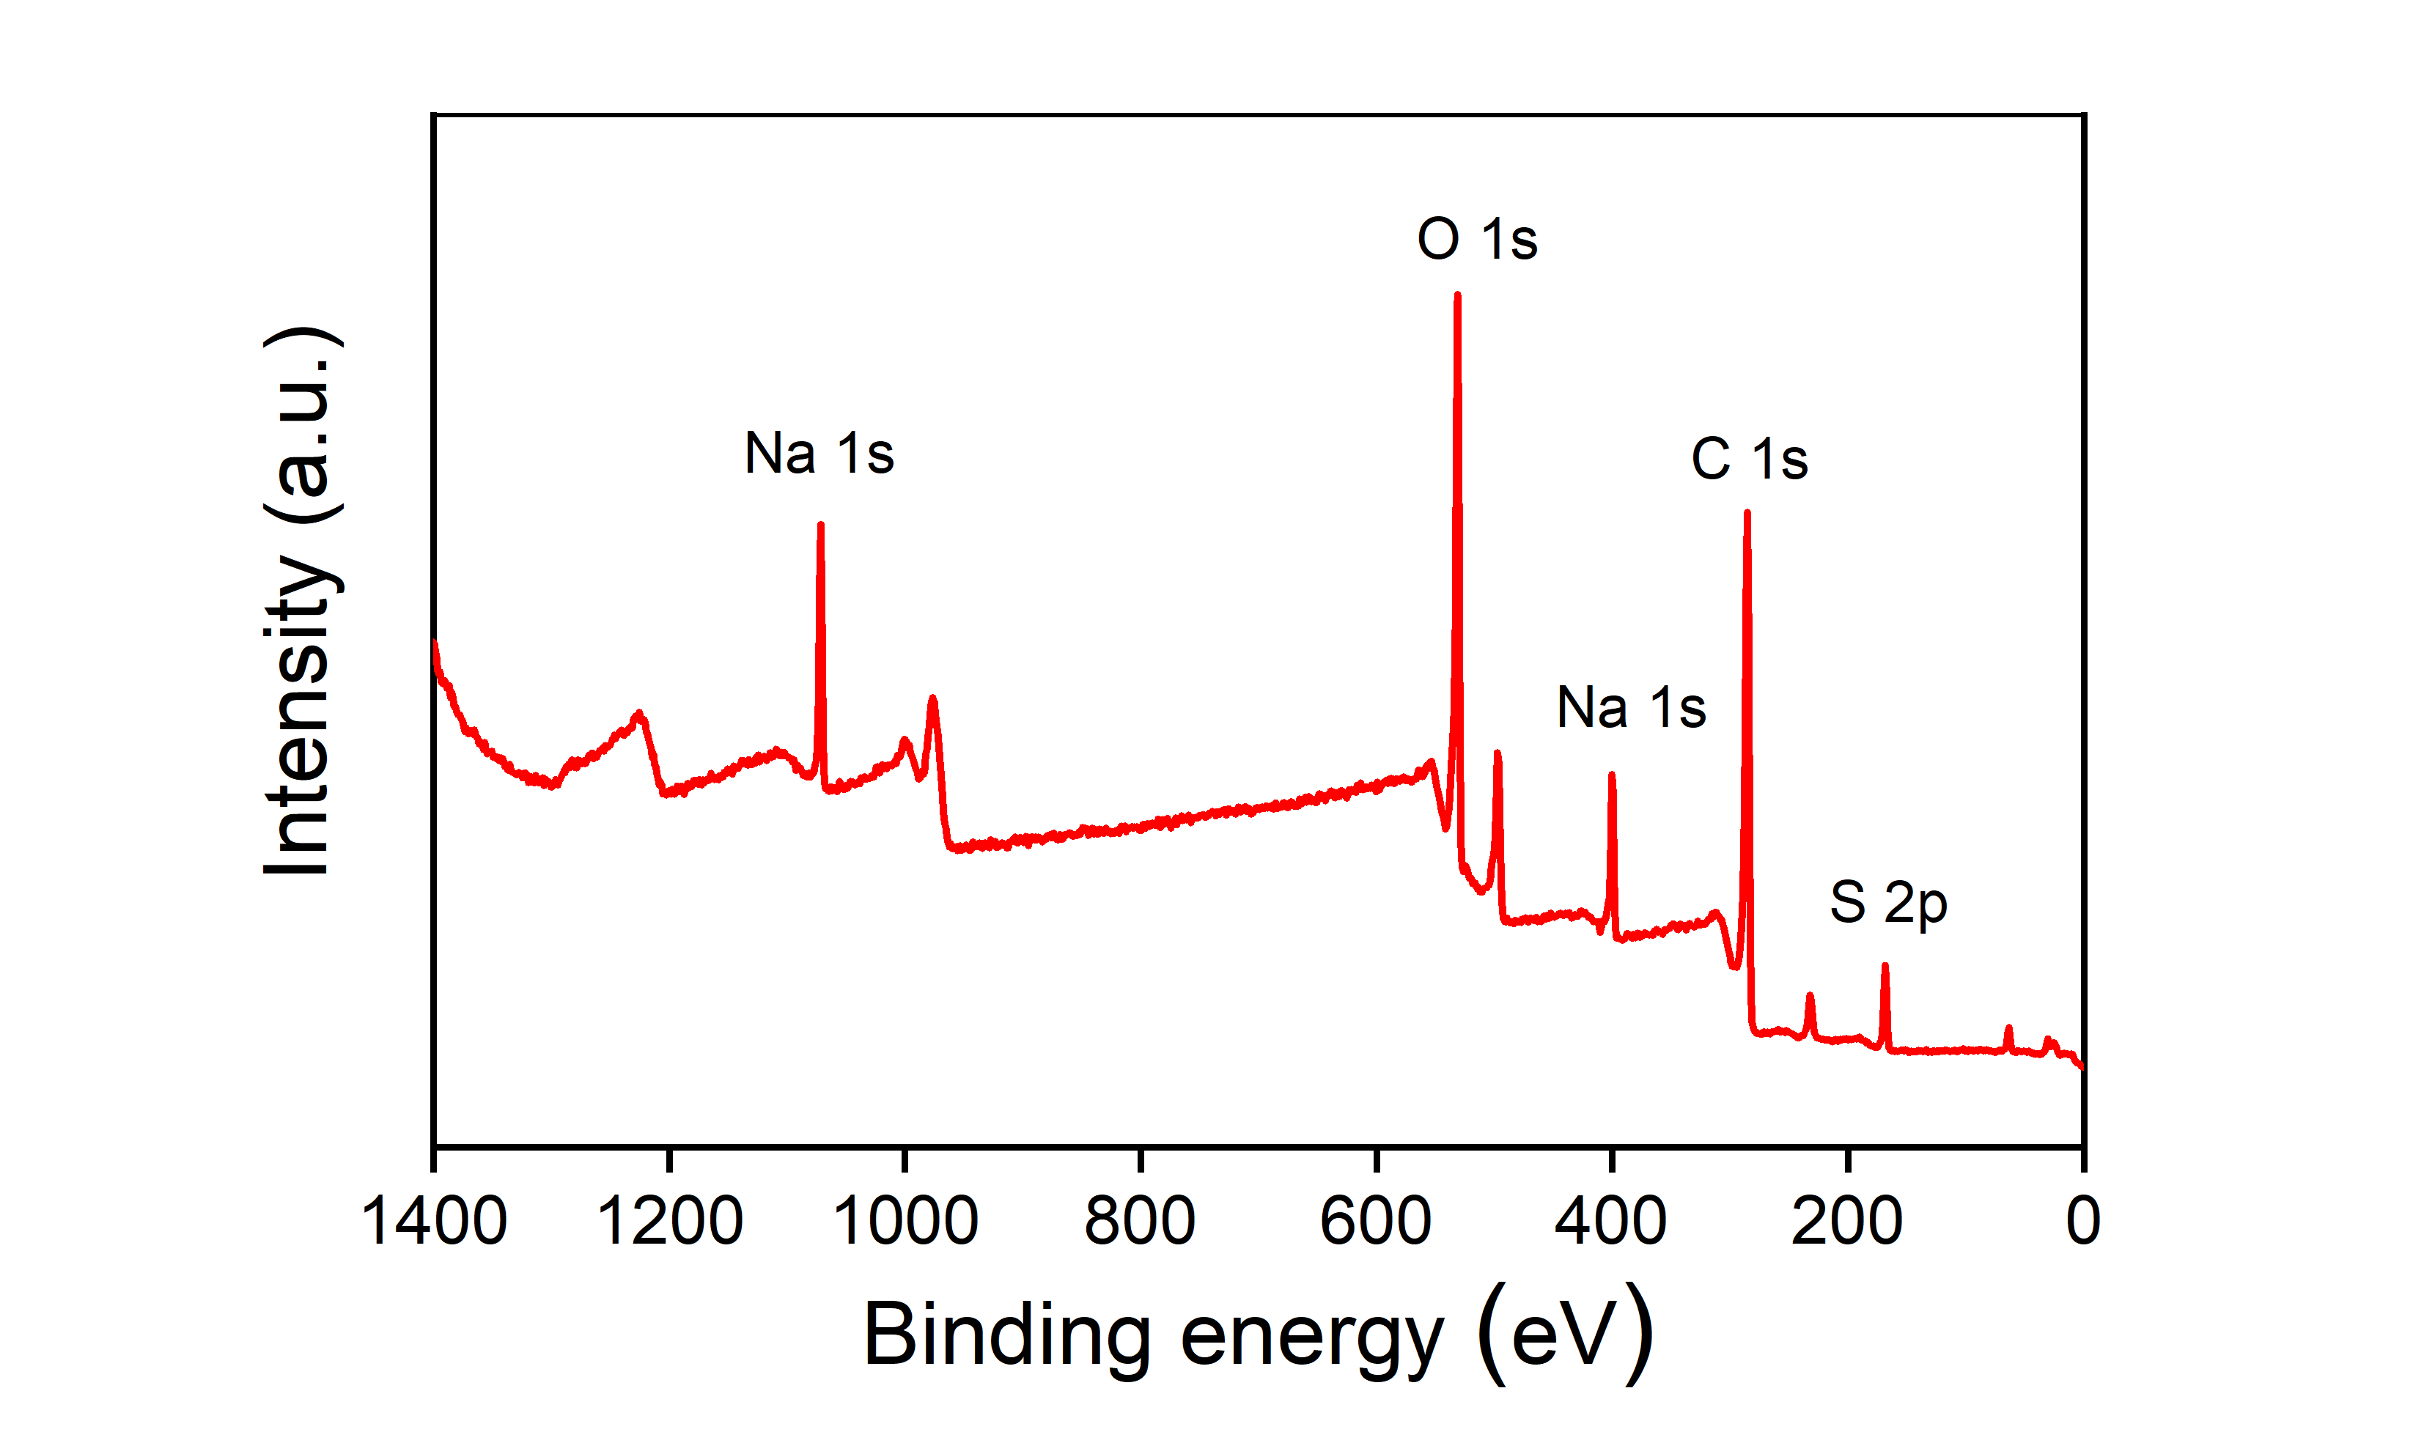
Figure S6. The XPS full spectrum of TpPa-SO₃-Na COF.

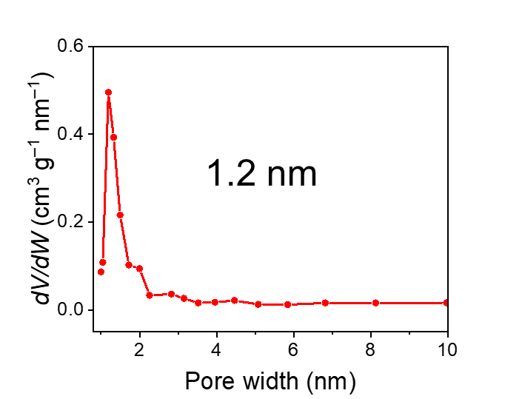
Figure S7. The pore size distribution of TpPa-SO₃-Na.

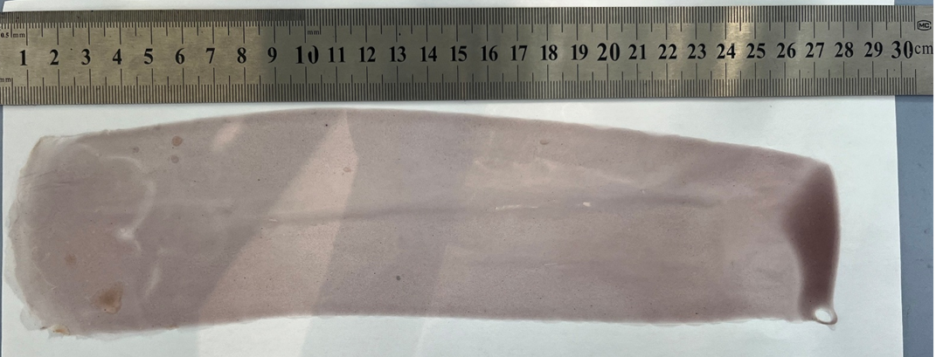
Figure S8. Optical image of large-area COF/PNSE electrolyte film.

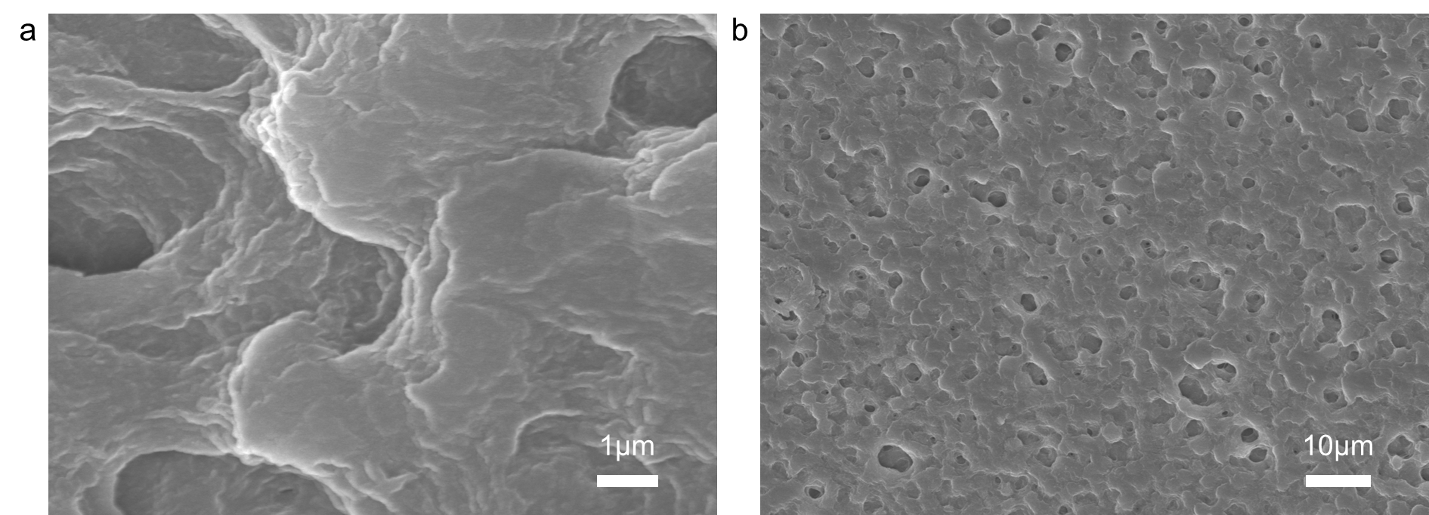
Figure S9. SEM images of COF/PNSE electrolyte. (a) High-magnification SEM, and (b) low-magnification SEM.

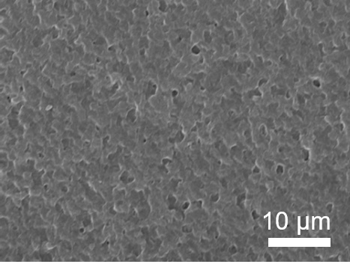
Figure S10. SEM image of the PNSE electrolyte film.

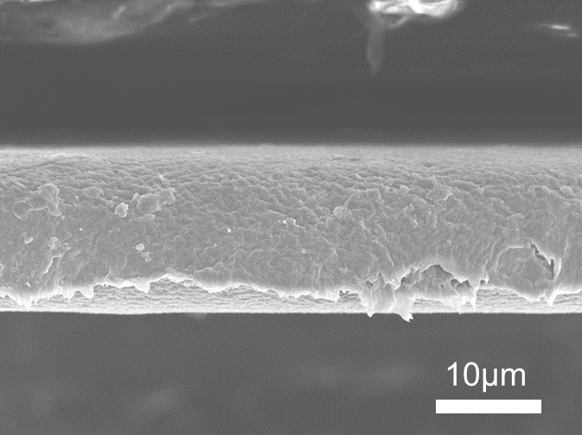
Figure S11. Cross-sectional SEM image of the PNSE electrolyte film.

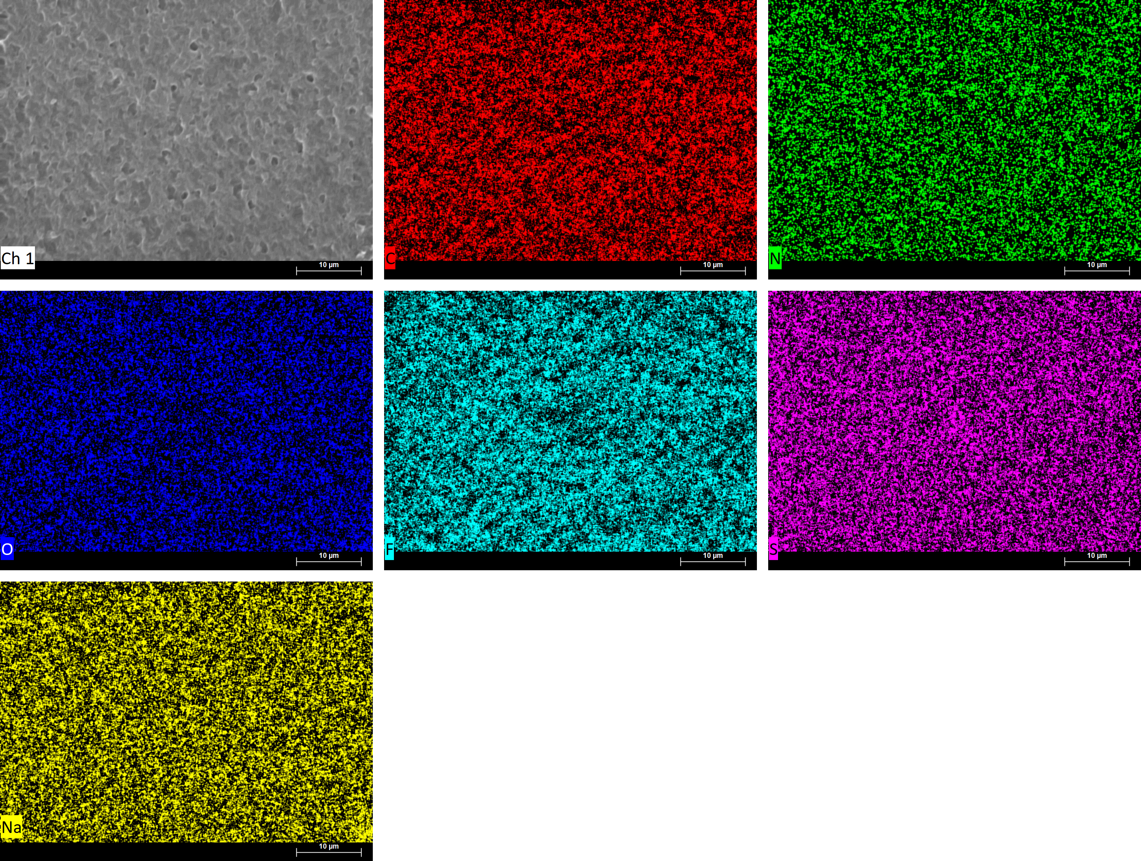
Figure S12. EDS mapping image (top-view) of the COF/PNSE electrolyte, including C, N, O, F, S, Na elements.

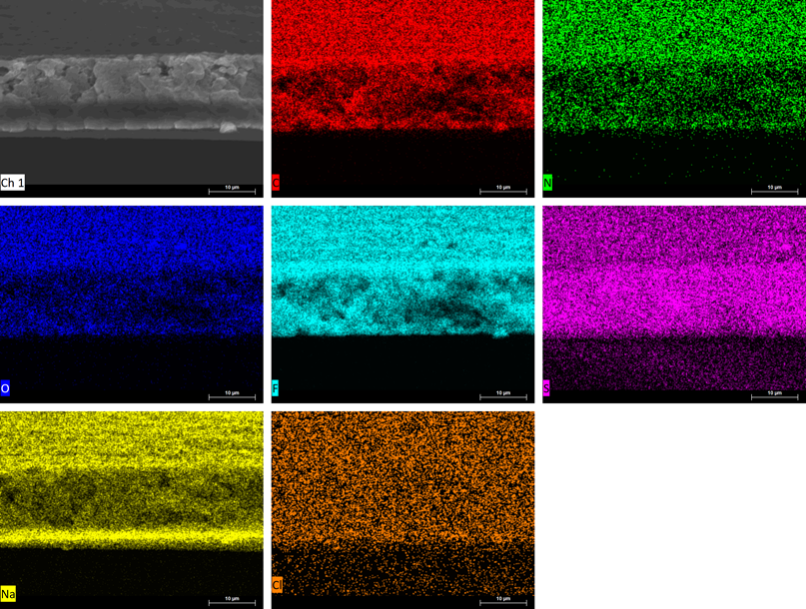
Figure S13. EDS mapping image (cross sectional-view) of the PNSE electrolyte, including C, N, O, F, S, Na, and Cl elements.

Figure S14. TGA curves of TpPa-SO₃-Na and COF/PNSE electrolyte films.

Figure S15. FTIR spectra of PNSE and COF/PNSE electrolytes.

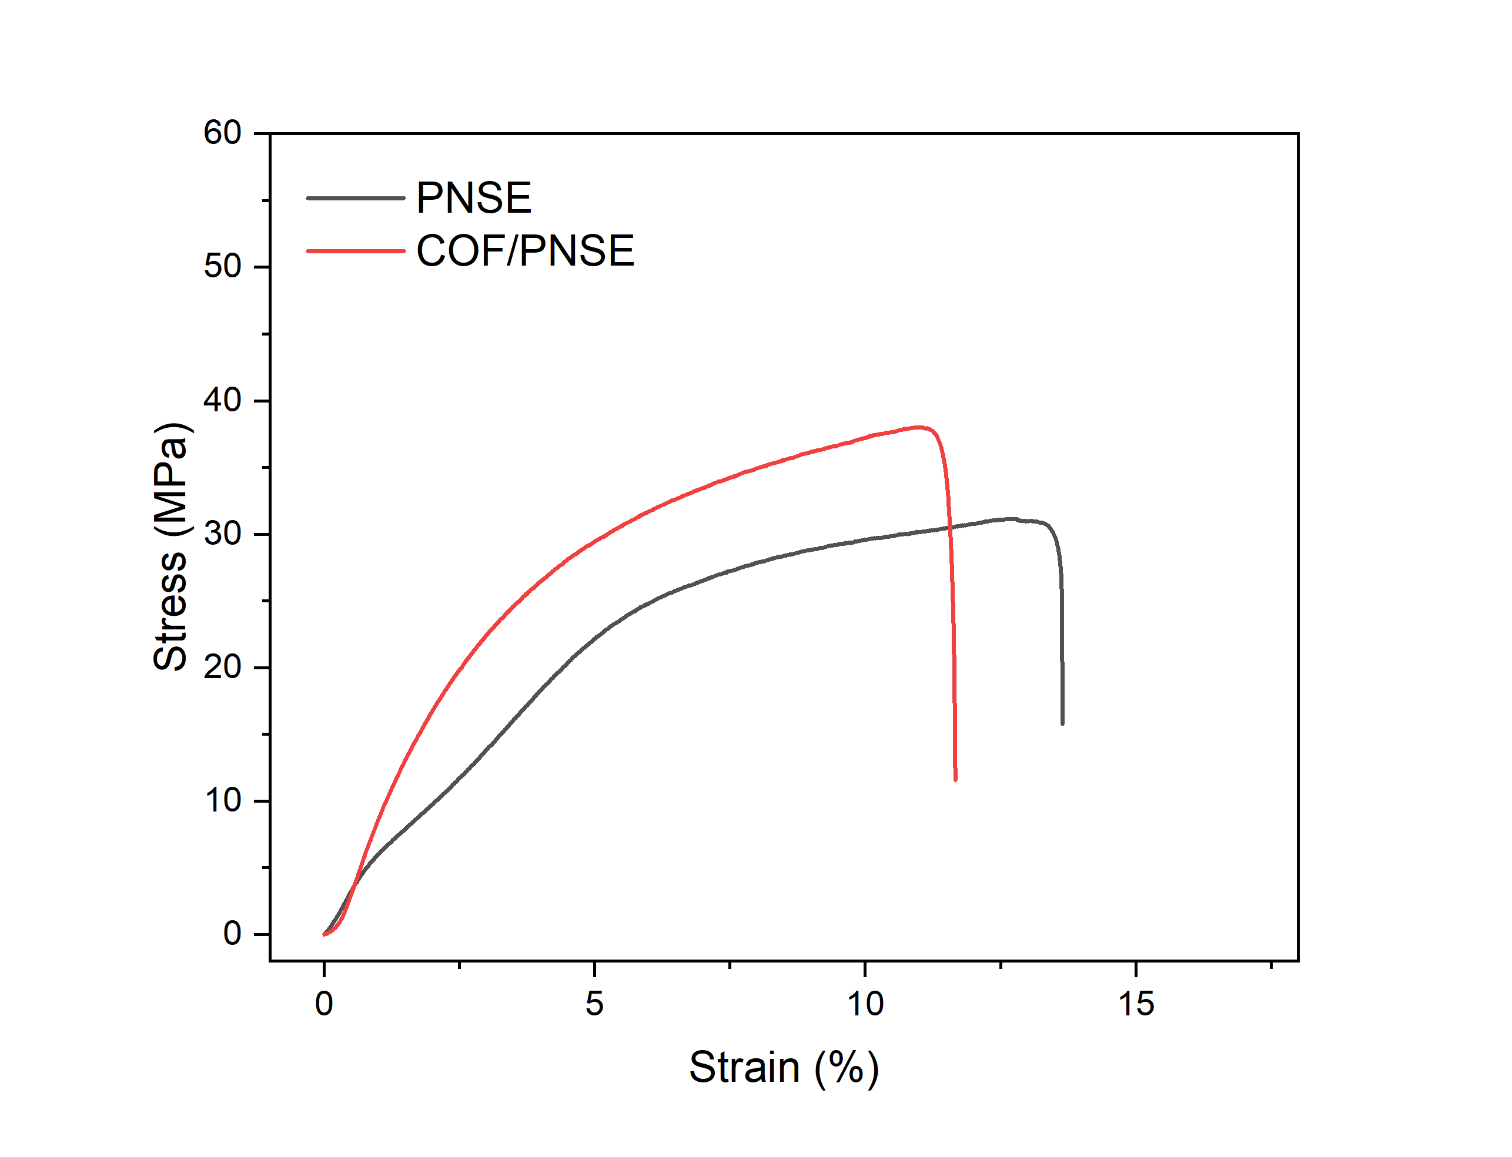
Figure S16. Stress-strain curves of PNSE and COF/PNSE electrolytes.

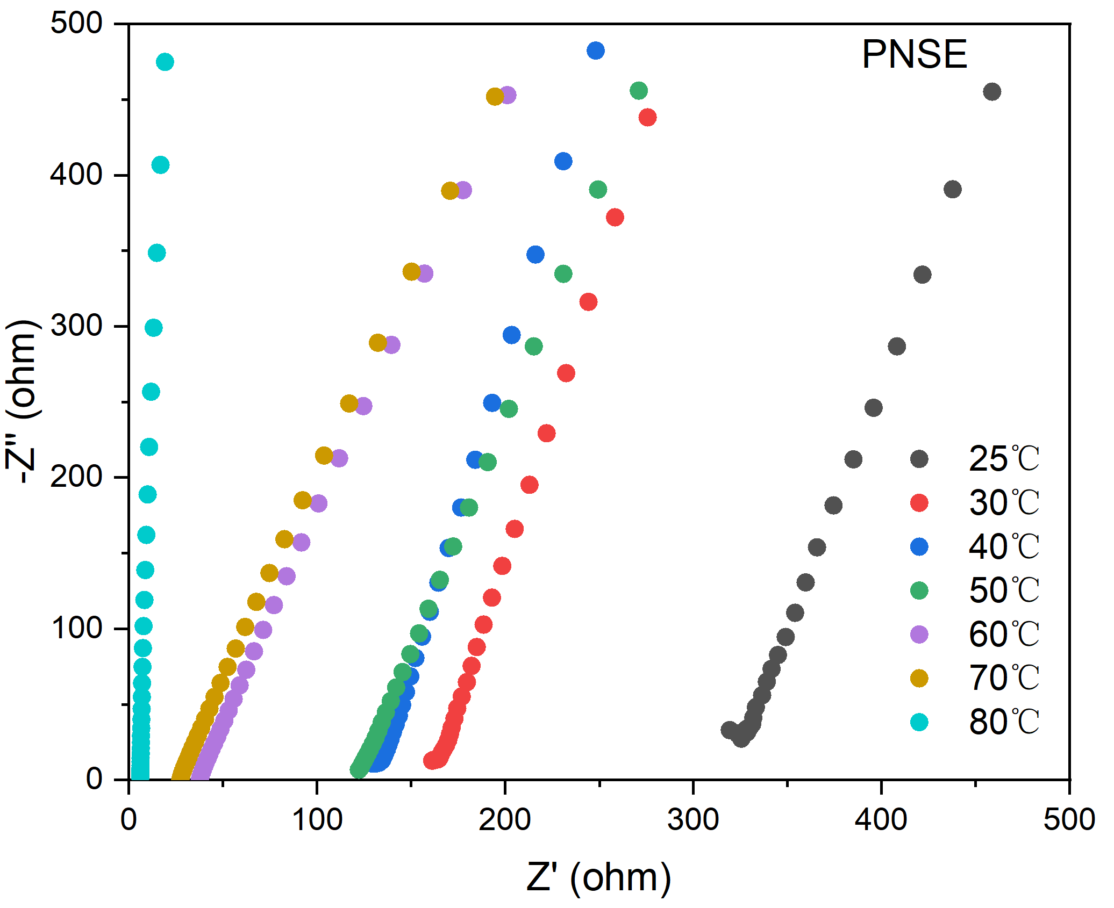
Figure S17. EIS spectra of PNSE electrolyte at different temperatures from 25 to 80 °C.

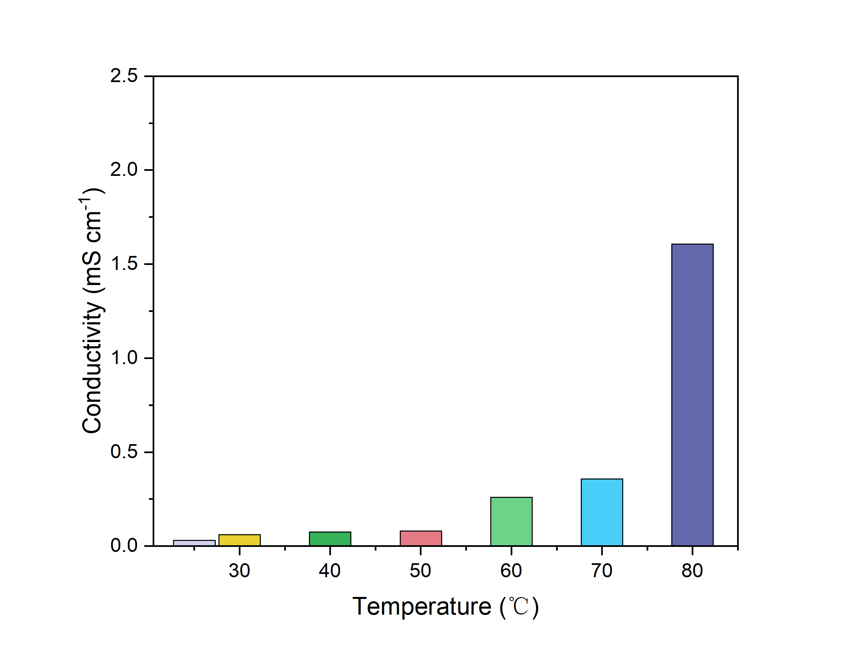
Figure S18. Ionic conductivity of PNSE electrolyte at different temperatures from 25 to 80 °C.

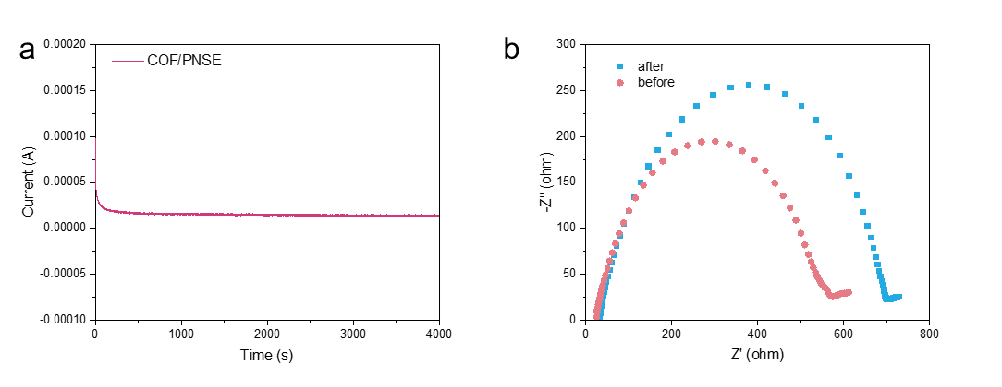
Figure S19. The (a) i-t curve and (b) EIS spectra before and after polarization of Na||Na cells using COF/PNSE electrolyte at room temperature.

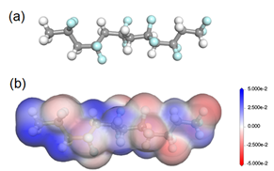
Figure S20. (a) The ball-and-stick model of PVDF and (b) the electrostatic potential of PVDF.

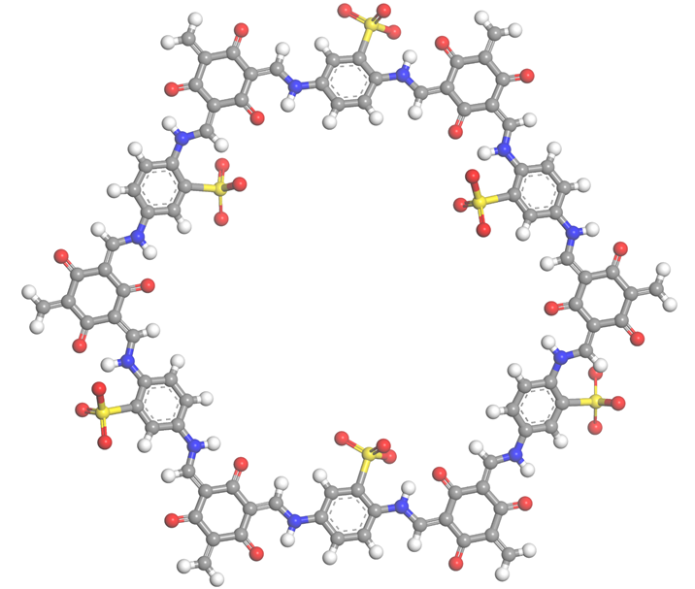
Figure S21. The ball-and-stick model of TpPa-SO₃-Na.
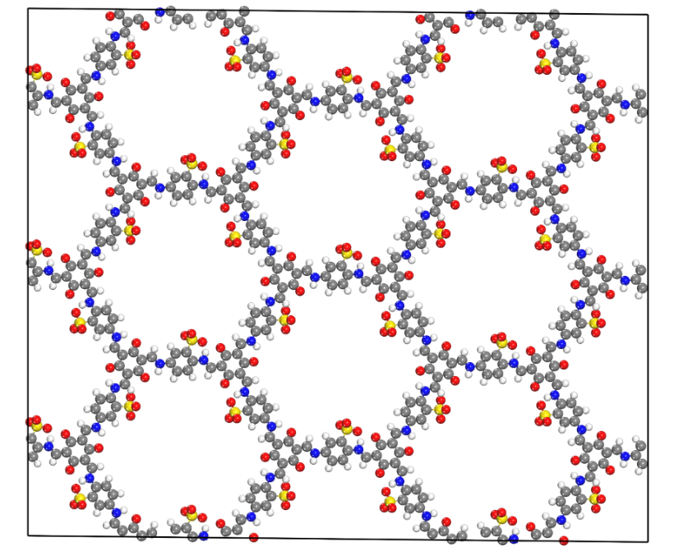
Figure S22. The structural diagram of TpPa-SO₃-Na in MD simulations.

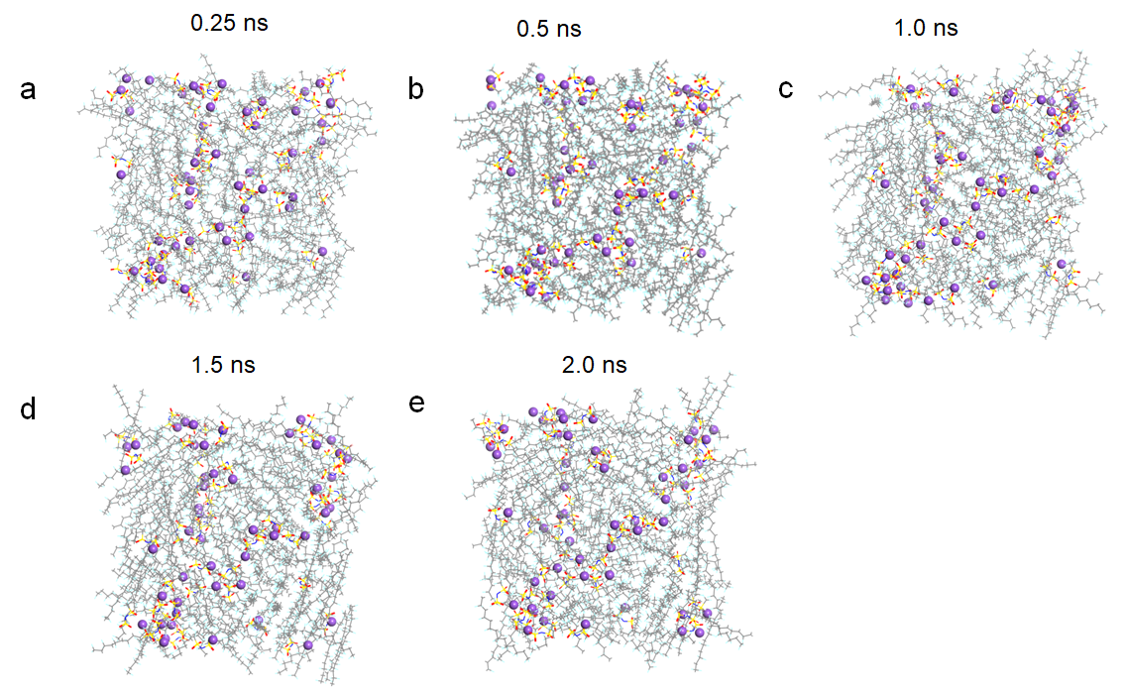
Figure S23. Simulation snapshots of the Na⁺ migration in the PNSE system at room temperature from 0.25 ns to 2 ns. (a) 0.25 ns, (b) 0.50 ns, (c) 1.0 ns, (d) 1.5 ns, (e) 2.0 ns.

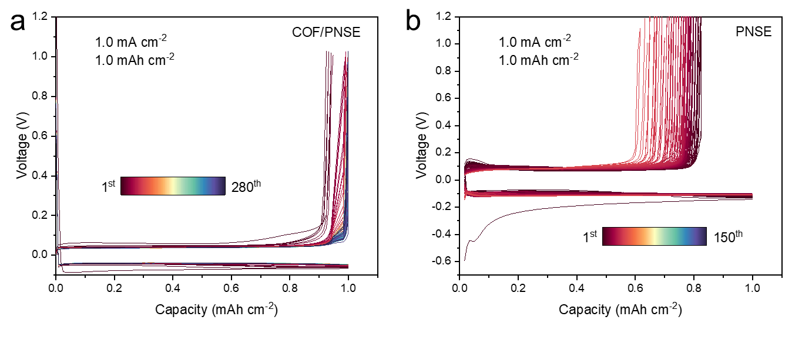
Figure S24. The deposition and stripping curve of Na||Cu battery with different electrolyte. (a) COF/PNSE and (b) PNSE electrolytes at 1 mA cm⁻² and 1 mAh cm⁻².

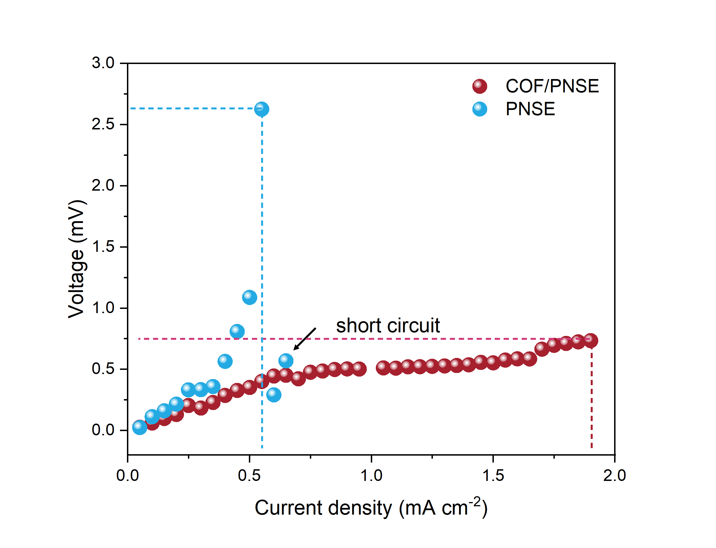
Figure S25. Comparison of polarization voltage at different current densities using two different electrolytes in CCD testing.

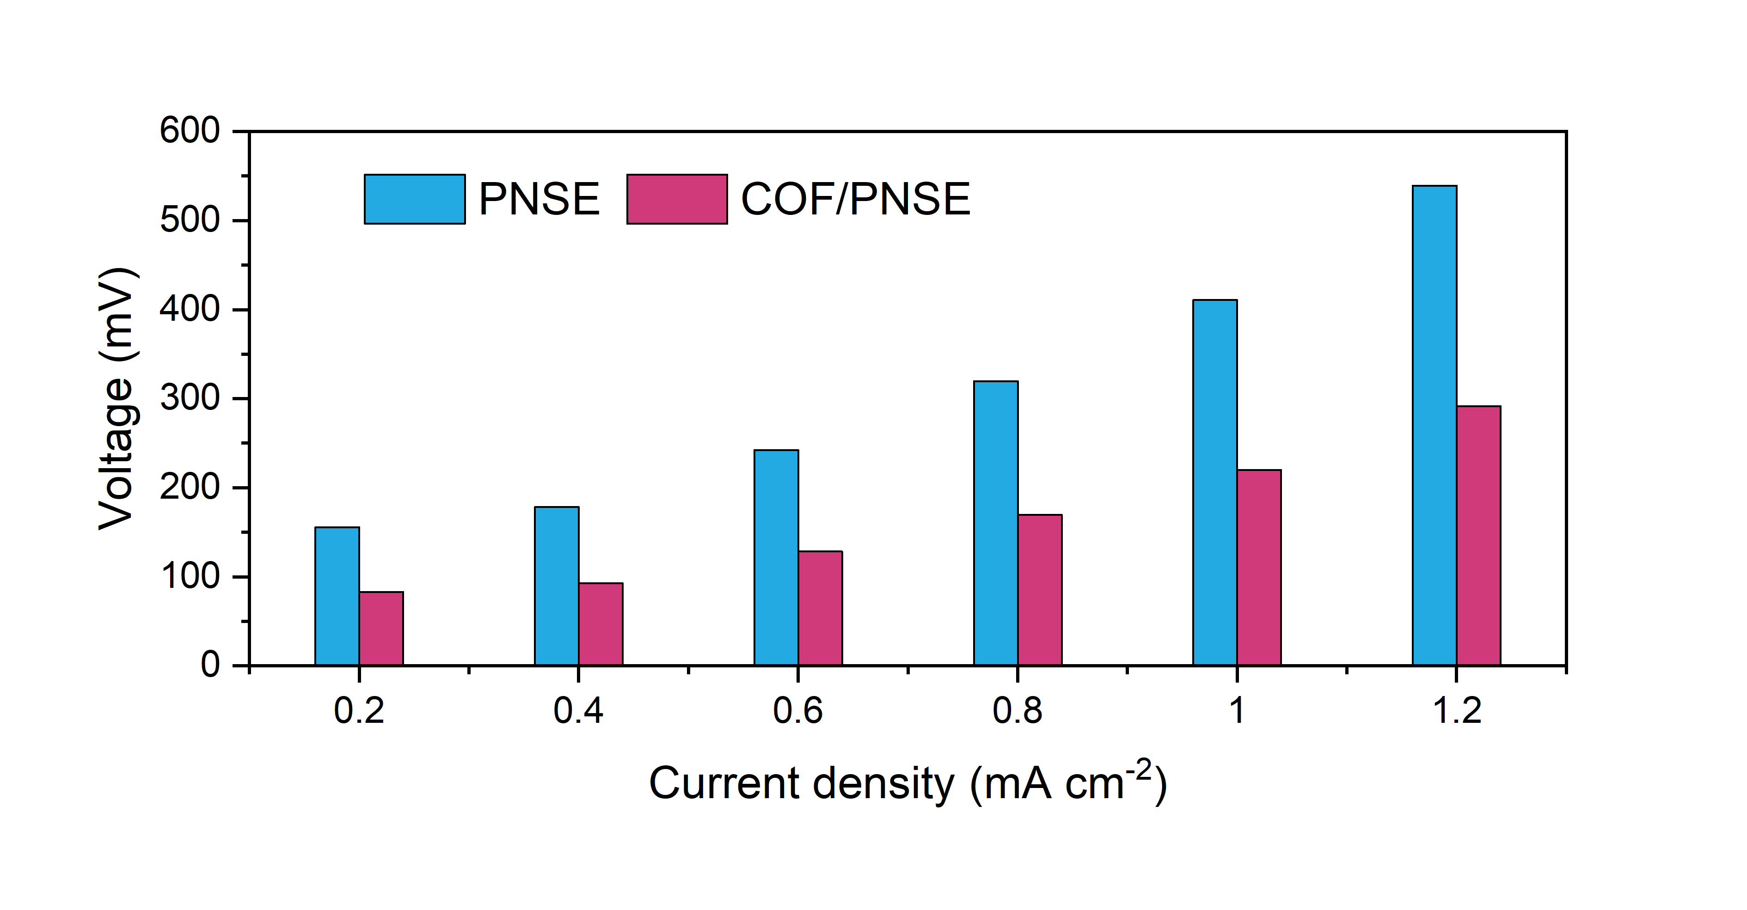
Figure S26. Comparison of polarization voltage at different current densities for Na||Na symmetric cell using PNSE and COF/PNSE electrolytes.

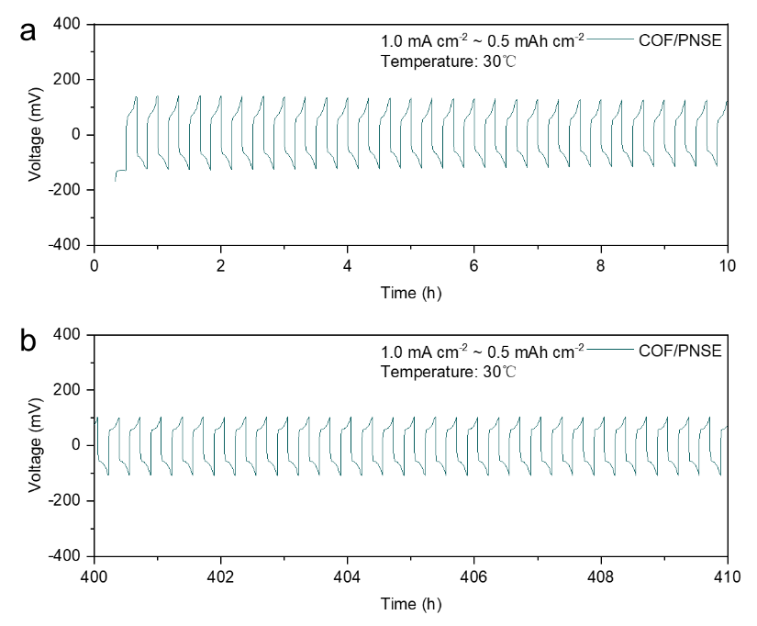
Figure S27. The deposition and stripping curve of Na||Na cells at different time. (a) 0~10 h and (b) 400~410 h at 1 mA cm⁻² and 0.5 mAh cm⁻².

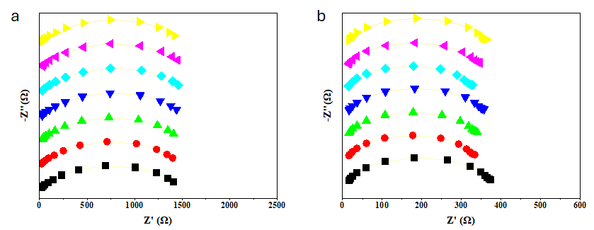
Figure S28. In-situ EIS spectra of Na||Na symmetric cell under different deposited Na using different electrolytes. (a) PNSE and (b) COF/PNSE electrolytes.

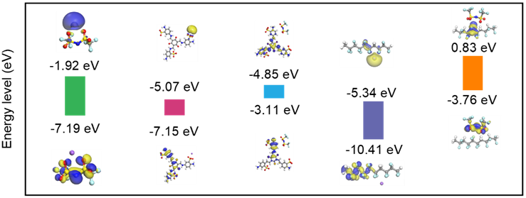
Figure S29. HOMO/LUMO energy levels and orbitals of each molecule of Na⁺-TFSI, Na⁺-COF, TFSI⁻-COF, Na⁺-PTC, and TFSI⁻-PTC, respectively.

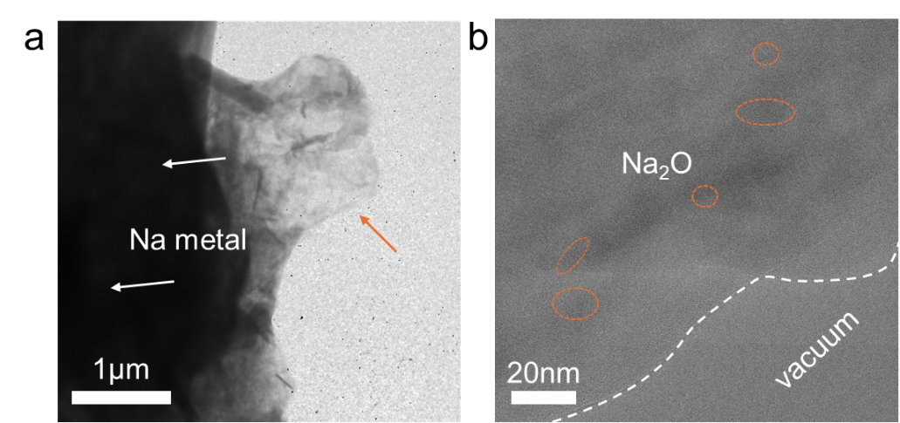
Figure S30. Cryo-TEM images of SEI on Na-anode surface formed by PNSE electrolyte at (a) low-magnification and (b) high-resolution.

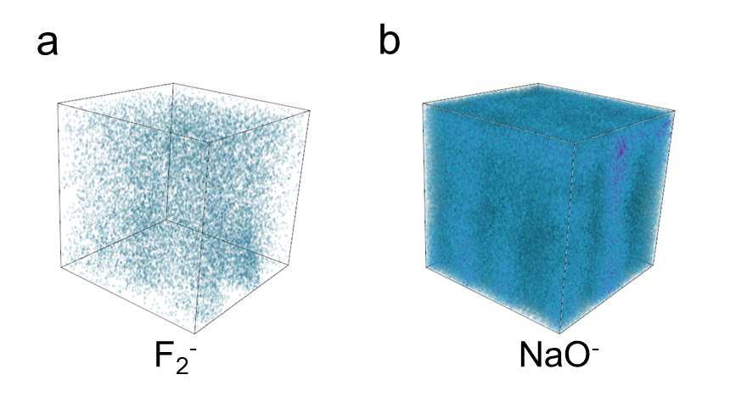
Figure S31. 3D image of TOF-SIMS of (a) F₂⁻ and (b) NaO⁻ using PNSE electrolyte.

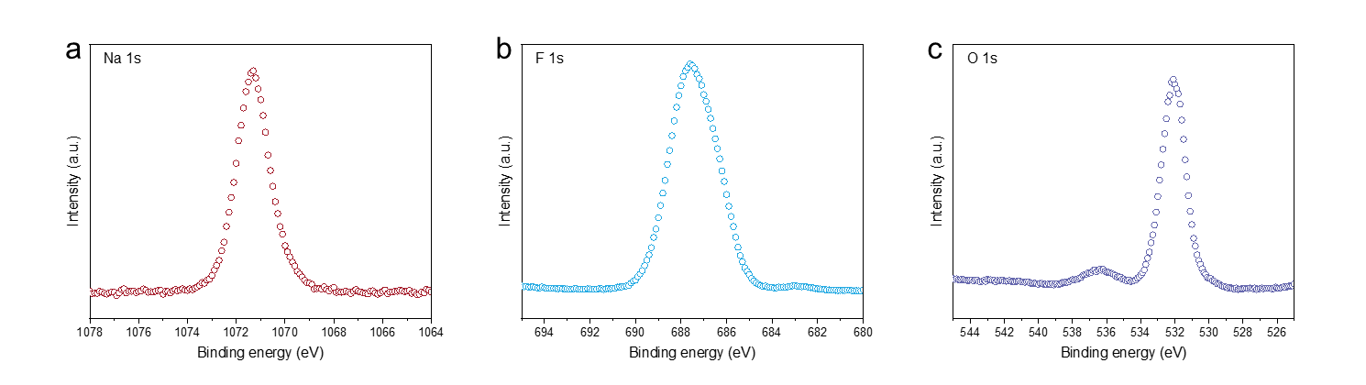
Figure S32. XPS profiles of Na-anode cycled in Na|PNSE|Na cells. (a) Na 1s, (b) F 1s, and (c) O 1s spectra.

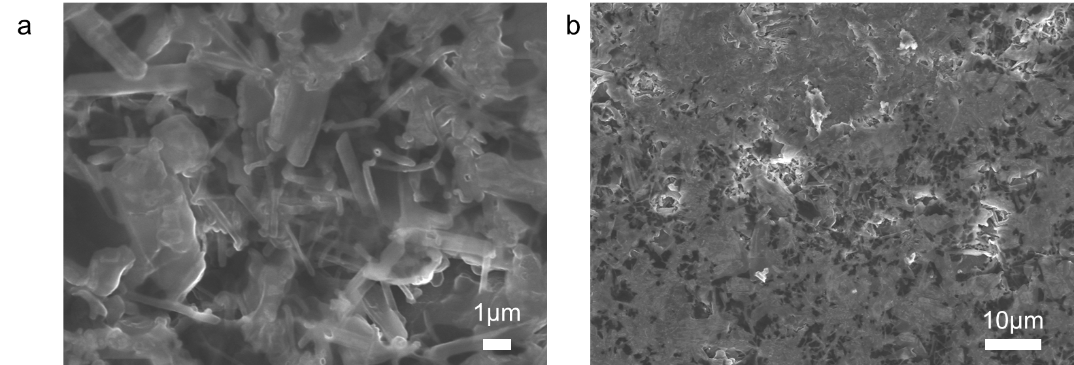
Figure S33. SEM images of cycled Na metal after 100 times repeated plating and stripping using PNSE electrolyte. (a) high-magnification and (b) low-resolution.

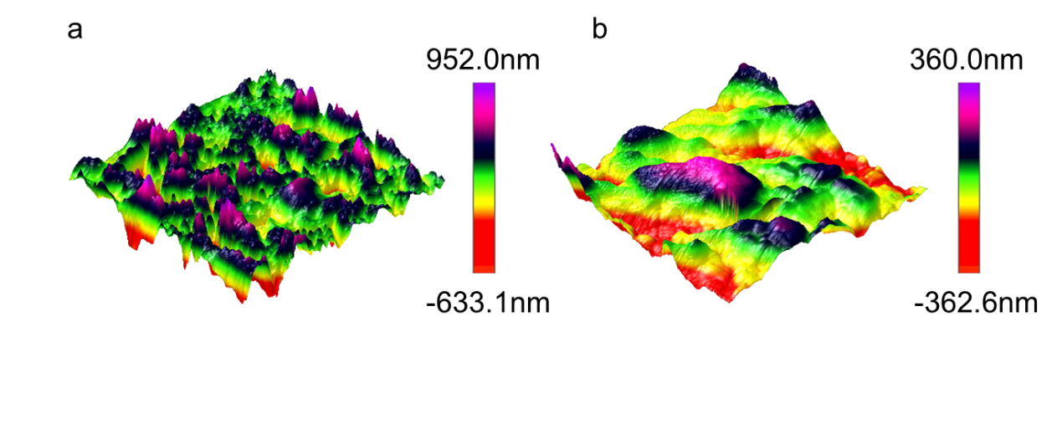
Figure S34. AFM 3D images of the sodium metal surface roughness after 500 hours of cycling: (a) using the PNSE electrolyte; (b) using the COF/PNSE electrolyte.

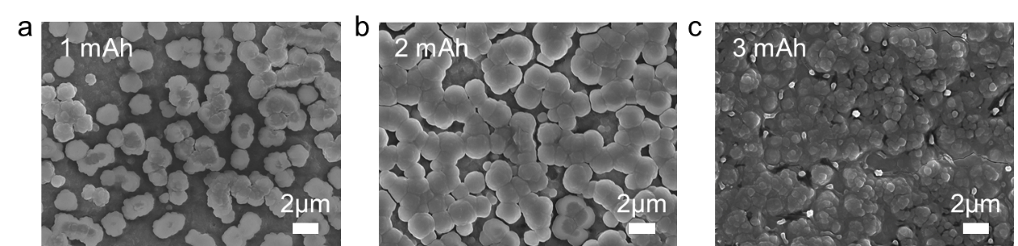
Figure S35. SEM images of deposited Na metal with the different capacity using COF/PNSE electrolyte. (a) 1 mAh, (b) 2 mAh, and (c) 3 mAh.

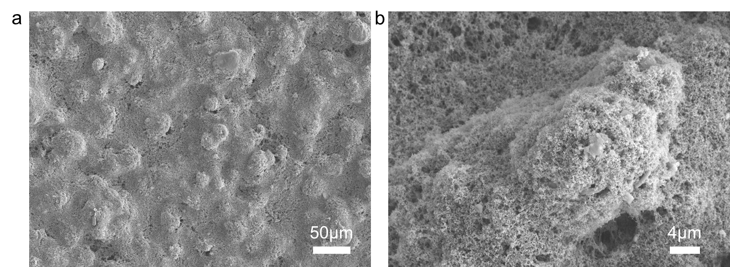
Figure S36. SEM images of NNM electrode:(a) low-magnification and (b) high-resolution.

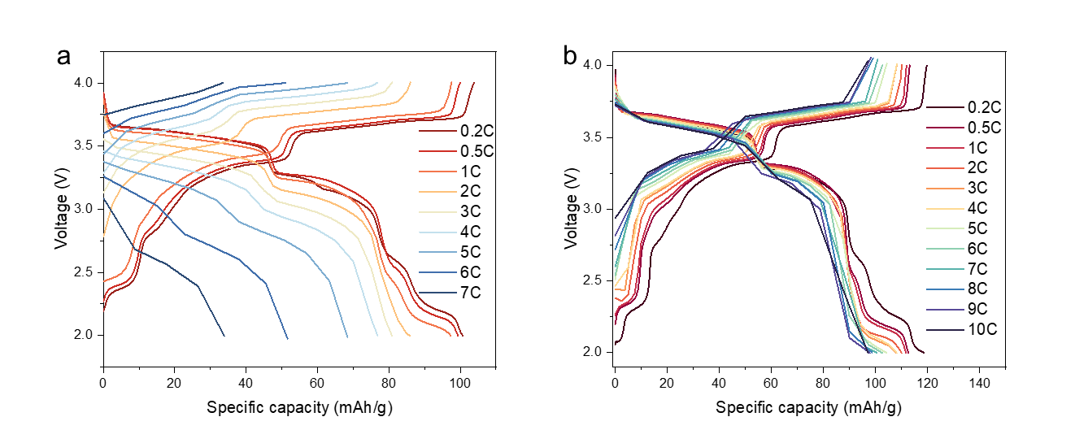
Figure S37. The charge-discharge curves of Na||SE||NNM batteries at different rates in the 2.0~4.0 V range using (a) PNSE and (b) COF/PNSE electrolytes.

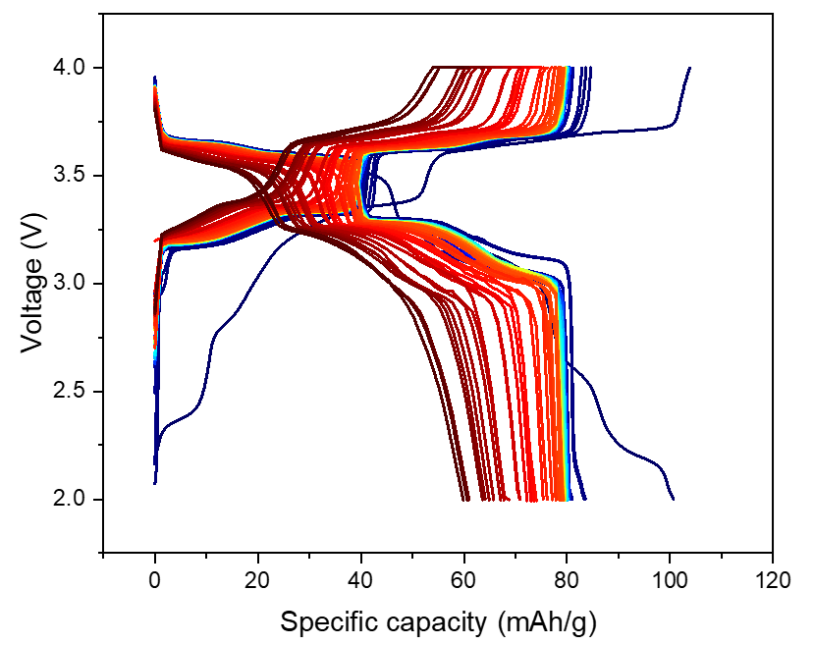
Figure S38. The charge-discharge curves of Na||COF/PNSE||NNM batteries in the 2.0~4.0 V range at 1C from 1st cycle to 1000th cycle.

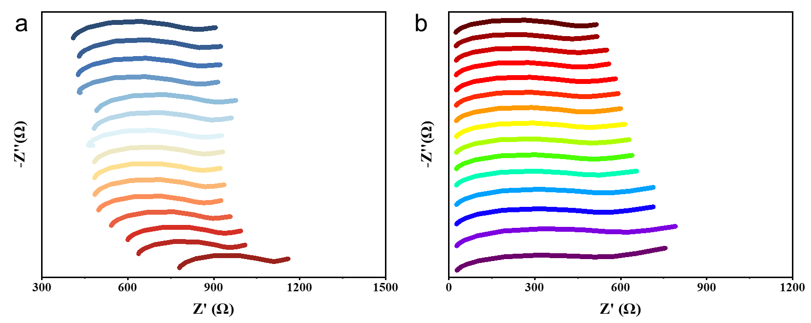
Figure S39. In-situ EIS spectra of Na||SE||NNM symmetric cell using (a) PNSE and (b) COF/PNSE electrolytes.

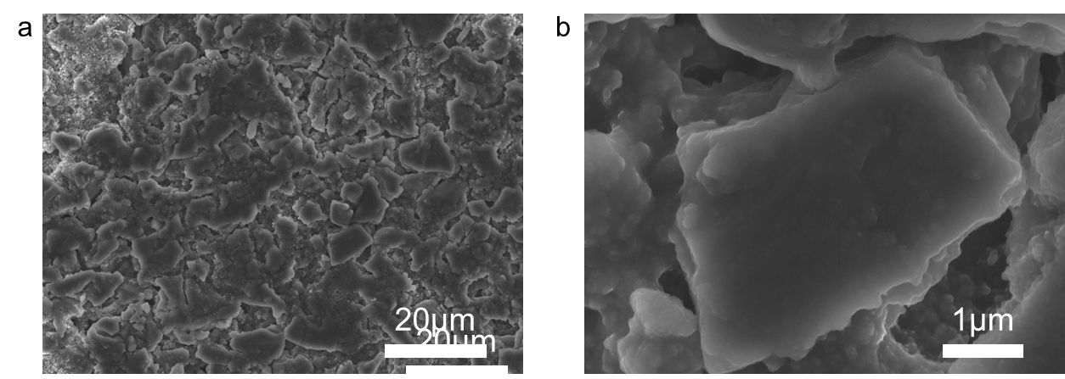
Figure S40. SEM images of cycled hard carbon electrode:(a) low-magnification and (b) high-resolution.

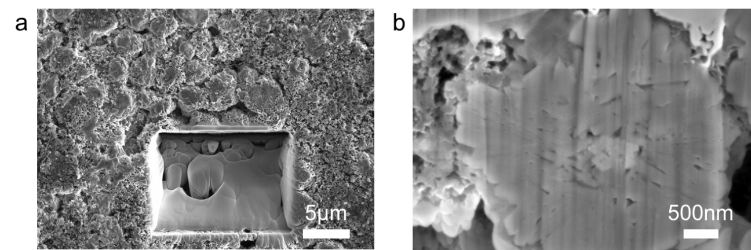

Figure S41. FIB-SEM images of cycled NNM electrode with COF/PNSE electrolyte. (a) low-magnification and (b) high-resolution.

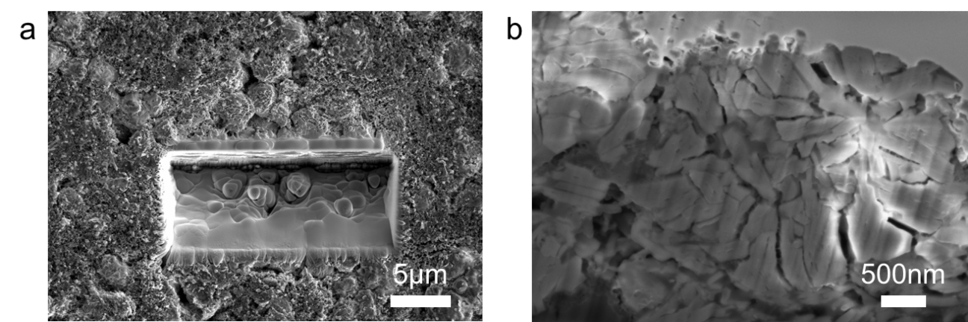
Figure S42. FIB-SEM images of cycled NNM electrode with PNSE electrolyte. (a) low-magnification and (b) high-resolution.

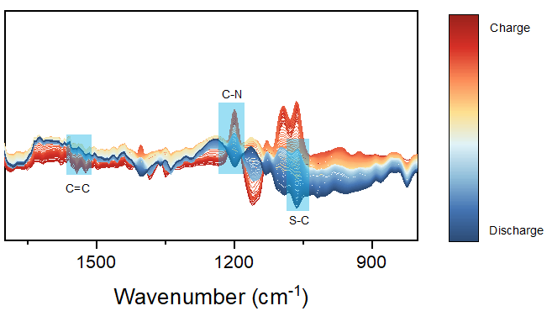
Fig. S43. Operando FT-IR measurements on Na||COF/PNSE||NNM batteries.

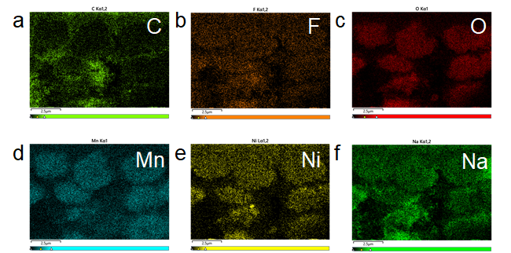
Figure S44. EDS images of cycled NNM electrode with COF/PNSE electrolyte. (a) C, (b) F, (c) O, (d) Mn, (e) Ni, and (f) Na elements.

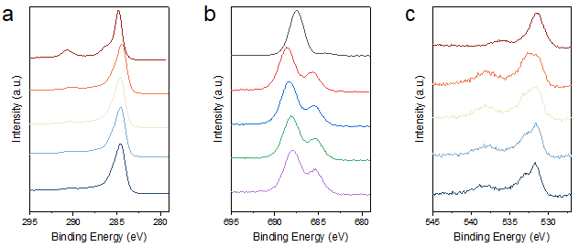
Figure S45. XPS depth-dependent elemental distribution at the cathode interface. (a) C 1s, (b) F 1s, and (c) O 1s

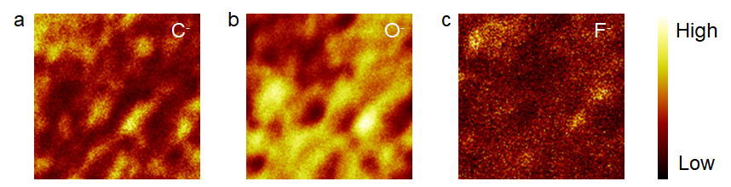
Figure S46. 2D TOF-SIMS images of (a) C⁻, (b) O⁻ , and (c) F⁻ at the cathode/electrolyte interface.

Table S1. The comparison of Na||Na symmetric cell electrochemical performance for solid-state/hydrogel electrolytes reported in the literature.
Electrolytes | Current density (mA cm⁻²) | Lifetime  (h) | Ref.
POSS-4PEG2K(NaE16) | 0.5 | 3550 | ¹
NaFSI/PolyIL | 0.5 | 100 | ²
PEGMEM-co-SSS@ZIF-8 | 0.5 | 220 | ³
PBAGPE | 0.2 | 980 | ⁴
NZSP/PVDF-HFP | 0.2 | 400 | ⁵
ETPTA–NaClO₄–QSSE | 0.1 | 1000 | ⁶
AMPSN | 0.4 | 400 | ⁷
PEO@LM&SO | 0.2 | 800 | ⁸
DSPE | 0.1 | 1000 | ⁹
PBMP | 0.5 | 1100 | ¹⁰
ATFPE | 0.1 | 600 | ¹¹
c-GPE | 0.1 | 800 | ¹²
FEC/SN-PCE | 0.5 | 1800 | ¹³
PSB60-GPE | 0.5 | 800 | ¹⁴
BSCPE | 0.5 | 200 | ¹⁵
PPNM | 0.23 | 500 | ¹⁶
sp² C-COF | 0.5 | 2000 | ¹⁷
QSSE-COF-SO₃Na | 0.2 | 830 | ¹⁸
NaOOC-COF | 0.05 | 700 | ¹⁹
TPDBD-CNa-QSSE | 0.01 | 900 | ²⁰
COF/PNSE | 0.1 | 6750 | This work
 | 1.0 | 418
Table S2. The comparison of electrochemical performance for Na||SE||NFM(NNM) batteries with solid-state/hydrogel electrolytes reported in the literature.
Samples | Rate (C) | Cycle | Retention (%) | Temperature (℃) | Ref.
PVC-CPE | 0.2C | 250 | 86.8 | 25 | ²¹
B-CPE | 0.2C | 320 | 80.1 | 40 | ²²
 | 3C | 700 | 80.4 | 10
B-PCPE | 0.1C | 120 | 80.1 | 25 | ²³
HP-GPE | 120 mA/g | 400 | 70 | 25 | ²⁴
PAPE SSEs | 0.2C | 100 | 91.1 | 25 | ²⁵
PAPE SSEs | 1.0C | 250 | ~70 | 25
COF/PNSE | 1.0C | 1000 | 77.2 | 30 | (This work)
COF/PNSE | 5.0C | 2000 | 80.2 | 30 | (This work)
COF/PNSE | 10.0C | 2000 | 83.5 | 30 | (This work)

Supplementary References
1. Zheng Y, Pan Q, Clites M, Byles BW, Pomerantseva E, Li CY. High-Capacity All-Solid-State Sodium Metal Battery with Hybrid Polymer Electrolytes. Advanced Energy Materials 8, 1801885 (2018).
2. Chen F, Wang X, Armand M, Forsyth M. Cationic polymer-in-salt electrolytes for fast metal ion conduction and solid-state battery applications. Nature Materials 21, 1175-1182 (2022).
3. Zhang J, et al. Confining Polymer Electrolyte in MOF for Safe and High-Performance All-Solid-State Sodium Metal Batteries. Angewandte Chemie International Edition 63, e202318822 (2024).
4. Zhang W, et al. In-situ Polymerized Gel Polymer Electrolytes with High Room-Temperature Ionic Conductivity and Regulated Na+ Solvation Structure for Sodium Metal Batteries. Advanced Functional Materials 32, 2201205 (2022).
5. Ling W, et al. A Flexible Solid Electrolyte with Multilayer Structure for Sodium Metal Batteries. Advanced Energy Materials 10, 1903966 (2020).
6. Wen P, et al. Photopolymerized Gel Electrolyte with Unprecedented Room-Temperature Ionic Conductivity for High-Energy-Density Solid-State Sodium Metal Batteries. Advanced Energy Materials 11, 2002930 (2021).
7. Dong X, Zhang Y, You Z, Chen Y, Wu X, Wen Z. Polyanion-Induced Single Na-Ion Polymer Electrolytes for Ultra-Stable Sodium Metal Batteries. Advanced Functional Materials 34, 2405931 (2024).
8. Suo J, et al. A Novel Super-Toughness and Self-Healing Solid Polymer Electrolyte for Solid Sodium Metal Batteries. Advanced Materials 36, 2409587 (2024).
9. Law HM, et al. A hybrid dual-salt polymer electrolyte for sodium metal batteries with stable room temperature cycling performance. Energy Storage Materials 46, 182-191 (2022).
10. Zhang Q, et al. Tertiary-Amine Based Network Polymer Electrolyte for Improving the Cyclic Stability of Na Metal Batteries with Large Capacity. Advanced Energy Materials 14, 2303791 (2024).
11. Guo J, et al. Achieving Ultra-Stable All-Solid-State Sodium Metal Batteries with Anion-Trapping 3D Fiber Network Enhanced Polymer Electrolyte. Small 19, 2206740 (2023).
12. Yuan Y, et al. Reconfiguring Polymer Chain for Regulating Na+ Solvation Structure in a Gel Polymer Electrolyte toward Sodium Metal Batteries. ACS Energy Letters 10, 2007-2016 (2025).
13. Zou P, Wang C, He Y, Xin HL. Making Plasticized Polymer Electrolytes Stable Against Sodium Metal for High-Energy Solid-State Sodium Batteries. Angewandte Chemie International Edition 63, e202319427 (2024).
14. Lai H, et al. In situ generated composite gel polymer electrolyte with crosslinking structure for dendrite-free and high-performance sodium metal batteries. Energy Storage Materials 54, 478-487 (2023).
15. Guo J, et al. Boosting Selective Na+ Migration Kinetics in Structuring Composite Polymer Electrolyte Realizes Ultrastable All-Solid-State Sodium Batteries. Advanced Functional Materials 34, 2313496 (2024).
16. Tian W, Lin G, Yuan S, Jin T, Wang Q, Jiao L. Competitive Coordination and Dual Interphase Regulation of MOF-Modified Solid-State Polymer Electrolytes for High-Performance Sodium Metal Batteries. Angewandte Chemie International Edition 64, e202423075 (2025).
17. Kang T, et al. Dendrite-Free Sodium Metal Anodes Via Solid Electrolyte Interphase Engineering With a Covalent Organic Framework Separator. Advanced Energy Materials 13, 2204083 (2023).
18. Kang T, et al. Ionic covalent organic frameworks-based electrolyte enables fast Na-ion diffusion towards quasi-solid-state sodium batteries. Energy Storage Materials 77, 104192 (2025).
19. Zhao G, et al. COFs-based electrolyte accelerates the Na+ diffusion and restrains dendrite growth in quasi-solid-state organic batteries. Nano Energy 92, 106756 (2022).
20. Yan Y, et al. Bioinspired design of Na-ion conduction channels in covalent organic frameworks for quasi-solid-state sodium batteries. Nature Communications 14, 3066 (2023).
21. Chen S, et al. Poly(vinylene carbonate)-Based Composite Polymer Electrolyte with Enhanced Interfacial Stability To Realize High-Performance Room-Temperature Solid-State Sodium Batteries. ACS Applied Materials & Interfaces 11, 43056-43065 (2019).
22. Chen S, Feng F, Che H, Yin Y, Ma Z-F. High performance solid-state sodium batteries enabled by boron contained 3D composite polymer electrolyte. Chemical Engineering Journal 406, 126736 (2021).
23. Chen S, Feng F, Yin Y, Lizo X, Ma Z. Plastic crystal polymer electrolytes containing boron based anion acceptors for room temperature all-solid-state sodium-ion batteries. Energy Storage Materials 22, 57-65 (2019).
24. Hu G, Xu Z, Wang Z. A fluorine-rich and flame-retardant gel polymer electrolyte enables thermal polymerization of fluorinated acrylates for stable quasi-solid-state Na-ion batteries. Chemical Communications 61, 4852-4855 (2025).
25. Liu C, et al. Scalable and Ultrathin Dual Entangled Network Polymer Electrolytes for Safe Solid-State Sodium Batteries. Angewandte Chemie International Edition 64, e202505938 (2025).

