Supplementary Data 1
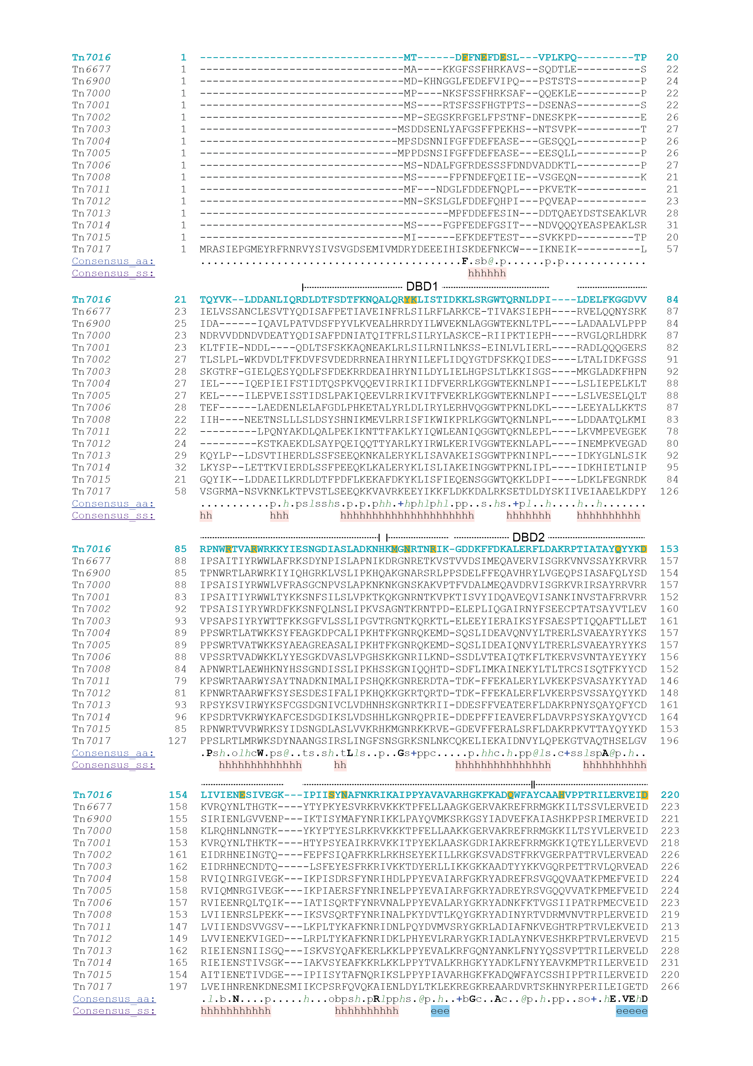

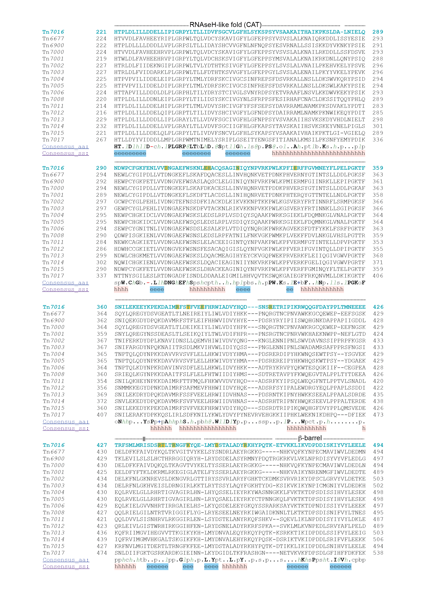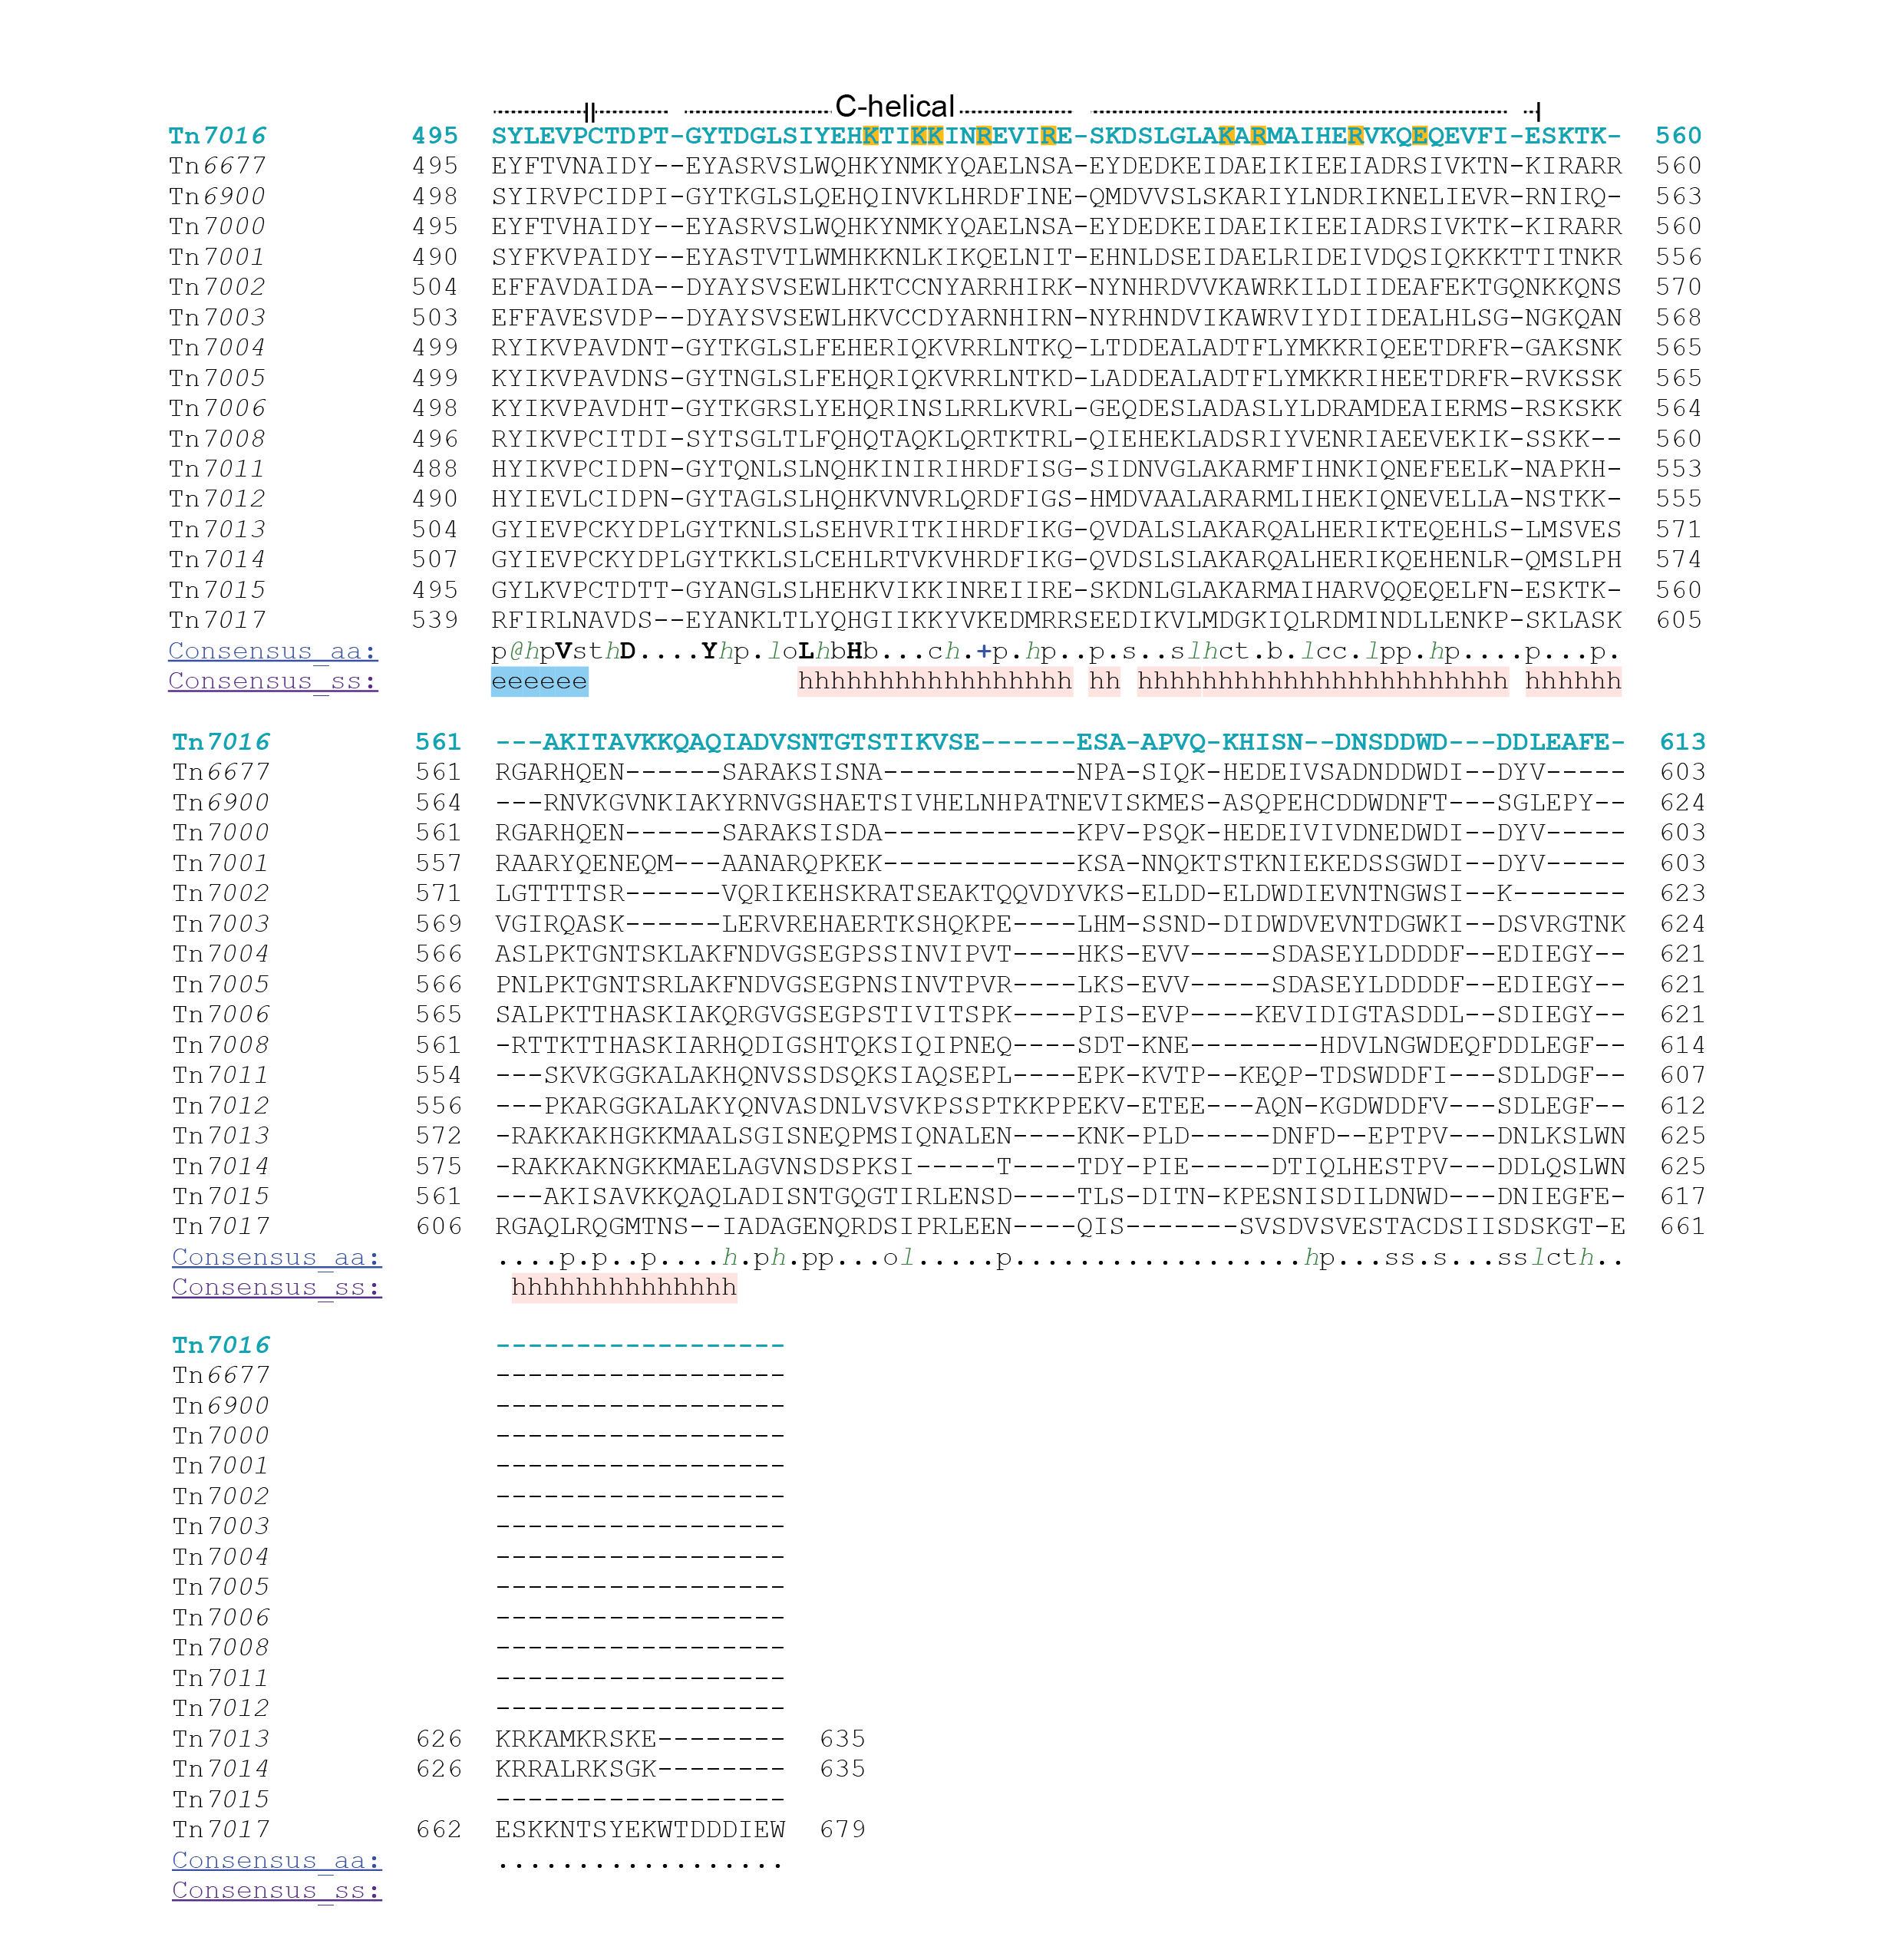

References
1 Pei, J., Kim, B. H. & Grishin, N. V. PROMALS3D: a tool for multiple protein sequence and structure alignments. Nucleic Acids Res 36, 2295-2300 (2008). https://doi.org:10.1093/nar/gkn072
2 Klompe, S. E., Jaber, N., Beh, L. Y., Mohabir, J. T., Bernheim, A. & Sternberg, S. H. Evolutionary and mechanistic diversity of Type I-F CRISPR-associated transposons. Mol Cell 82, 616-628.e615 (2022). https://doi.org:10.1016/j.molcel.2021.12.021

