Supplemental information

SATB1 lowers the T cell receptor signaling threshold for thymocytes positive selection via super-enhancer reprogramming
Wei Xue¹, Keyi Li¹, Junwei Luo², Delong Feng³, Ranran Dai⁴, Yongchang Zhu², Yiting Yang¹, Litao Qin⁵, Yan Zhang¹, Jiarui Zhang¹, Bo Lei^{6 *}, Bingtao Hao^{2, 6, 1 *}

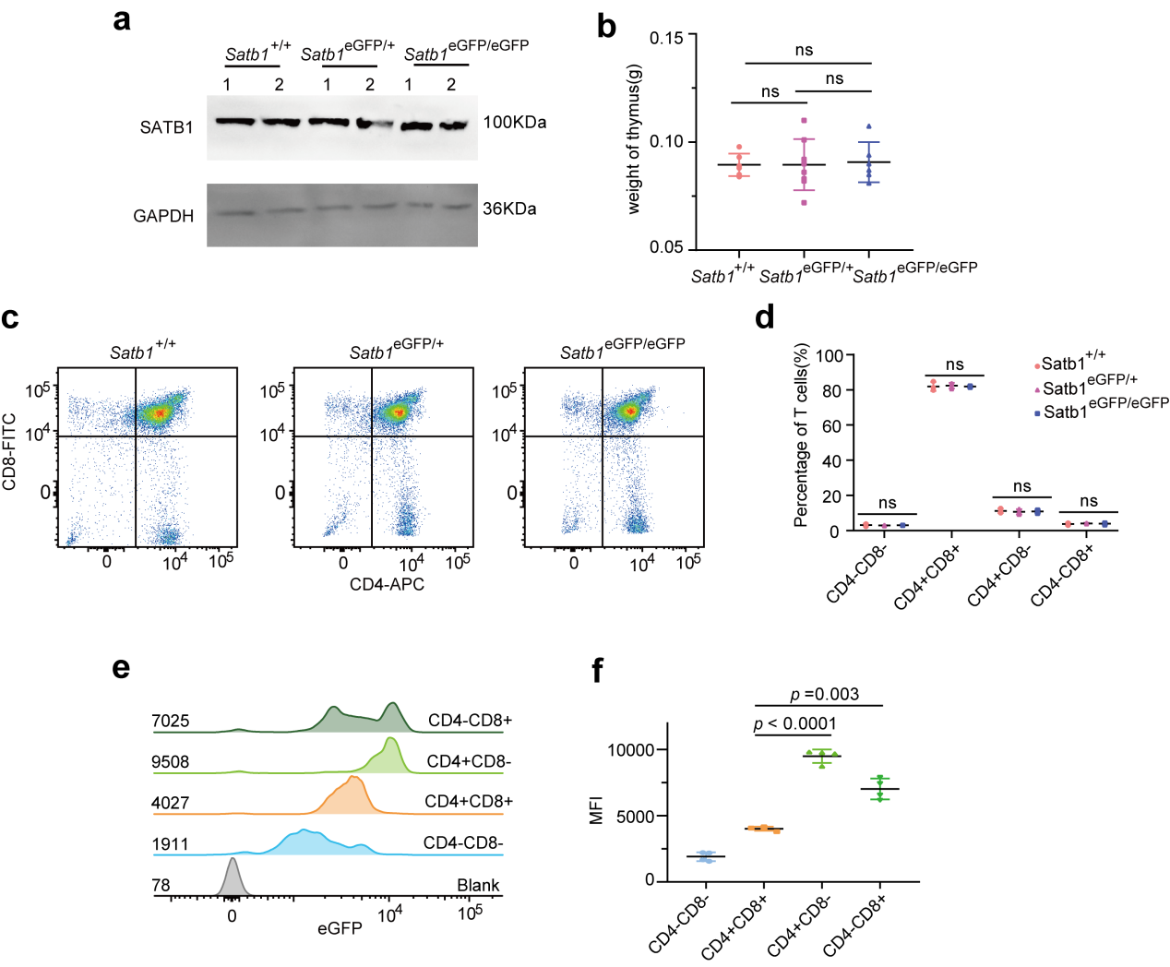Figure S1. Satb1-IRES-eGFP reporter mice display normal thymic development
(a) Immunoblot analysis of SATB1 protein expression in thymocytes from Satb1^{+/+}, Satb1^{eGFP/+}, and Satb1^{eGFP/eGFP} mice. GAPDH was used as a loading control.
(b) Thymus weight of Satb1^{+/+}, Satb1^{eGFP/+}, and Satb1^{eGFP/eGFP} mice. Each dot represents one mouse; data are shown as mean ± s.d. Statistical significance was assessed by two-sided Student’s t test.
(c) Representative flow cytometry plots showing CD4 and CD8 expression in thymocytes from Satb1^{+/+}, Satb1^{eGFP/+}, and Satb1^{eGFP/eGFP} mice.
(d) Quantification of the frequencies of CD4⁻ CD8⁻, CD4⁺ CD8⁺, CD4⁺ CD8⁻, and CD4⁻CD8⁺ thymocyte subsets from (c). Every data are three replications and shown as mean ± s.d. P value was assessed by two-sided Student’s t test.
(e) Representative histograms showing eGFP fluorescence intensity in thymocyte subsets from Satb1^{eGFP/+} mice.
(f) Quantification of mean fluorescence intensity (MFI) of eGFP in CD4⁻ CD8⁻, CD4⁺ CD8⁺, CD4⁺ CD8⁻, and CD4⁻CD8⁺ thymocyte subsets from Satb1^{eGFP/+} mice. Every data are four replications and shown as mean ± s.d. P value was assessed by two-sided Student’s t test.

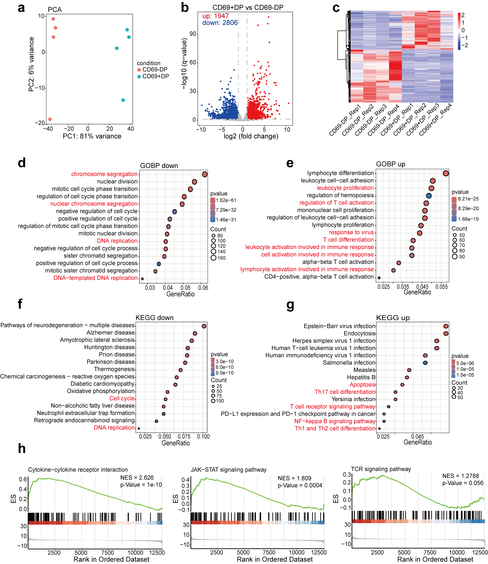Figure S2. Transcriptional reprogramming during thymocyte positive selection
(a) Principal component analysis (PCA) of Smart-seq2 transcriptomes from sorted wild-type CD69⁻ DP and CD69⁺ DP thymocytes. Each dot represents one biological replication.
(b) Volcano plot showing differentially expressed genes between wild-type CD69⁺ DP and CD69⁻ DP thymocytes. The x axis indicates log₂(fold change) and the y axis indicates -log₁₀(q value). Numbers of upregulated and downregulated genes are indicated.
(c) Heatmap showing hierarchical clustering of differentially expressed genes across all biological replicates of CD69⁻ DP and CD69⁺ DP thymocytes.
(d) Gene ontology (GO) enrichment analysis of biological processes associated with genes downregulated in CD69⁺ DP compared with CD69⁻ DP thymocytes.
(e) Gene ontology (GO) enrichment analysis of biological processes associated with genes upregulated in CD69⁺ DP compared with CD69⁻ DP thymocytes.
(f) KEGG pathway enrichment analysis of genes downregulated in CD69⁺ DP compared with CD69⁻ DP thymocytes.
(g) KEGG pathway enrichment analysis of genes upregulated in CD69⁺ DP compared with CD69⁻ DP thymocytes.
(h) GSEA showing enrichment of cytokine–cytokine receptor interaction, JAK-STAT signaling, and T cell receptor signaling pathways in CD69⁺ DP relative to CD69⁻ DP thymocytes.

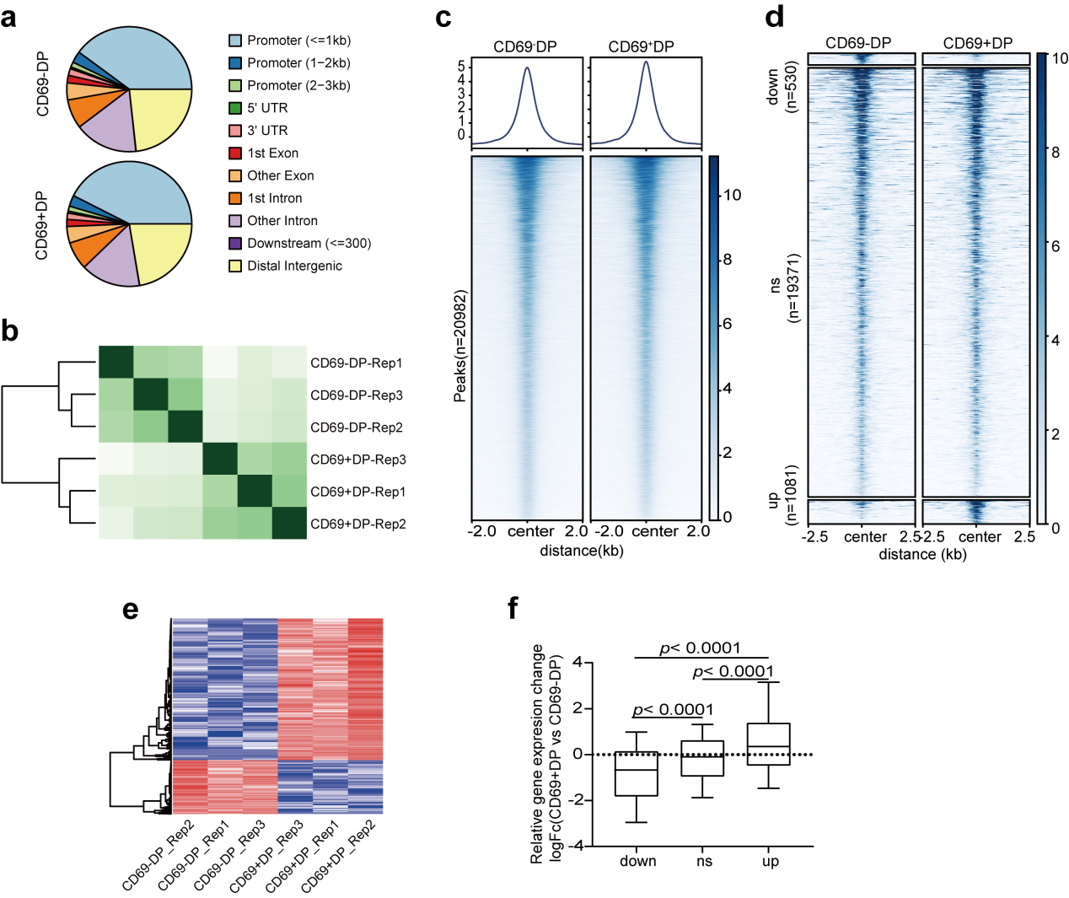Figure S3. Genomic distribution and transcriptional association of SATB1 binding during positive selection
(a) Pie charts showing the genomic distribution of SATB1 CUT&Tag peaks in wild-type CD69⁻ DP and CD69⁺ DP thymocytes, categorized by promoter, untranslated regions, exonic, intronic, downstream, and distal intergenic regions.
(b) Heatmap showing pairwise correlation of SATB1 CUT&Tag signal intensity across biological replicates of CD69⁻ DP and CD69⁺ DP thymocytes.
(c) Average profiles and heatmaps of SATB1 CUT&Tag signal centered on all SATB1 peaks in CD69⁻ DP (left) and CD69⁺ DP (right) thymocytes.
(d) Heatmaps showing SATB1 CUT&Tag signal at SATB1 peaks associated with genes that are downregulated, unchanged, or upregulated during the transition from CD69⁻ DP to CD69⁺ DP thymocytes.
(e) Heatmap showing expression of genes associated with SATB1 peaks across CD69⁻ DP and CD69⁺ DP thymocytes, with genes grouped based on differential expression patterns.
(f) Box plots showing relative expression changes of genes associated with SATB1 peaks that are downregulated, unchanged, or upregulated in CD69⁺ DP compared with CD69⁻ DP thymocytes. Box plots show median (center line), interquartile range (box), and 10th-90th percentiles (whiskers). Statistical significance was assessed by Kruskal-Wallis test followed by Dunn’s multiple comparisons test.

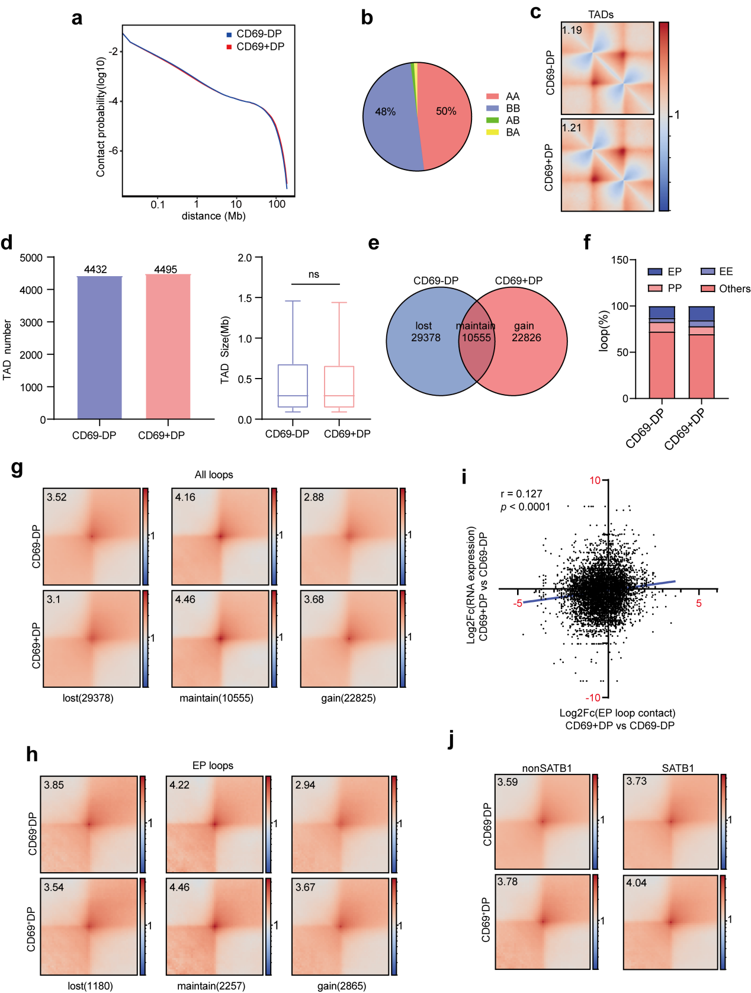Figure S4. Global 3D genome organization is largely preserved during thymocyte positive selection
(a) Chromatin contact probability decay curves derived from Hi-C data of wild-type CD69⁻ DP and CD69⁺ DP thymocytes, plotted as a function of genomic distance.
(b) Pie chart showing compartment status transitions between CD69⁻ DP and CD69⁺ DP thymocytes, including A-to-A, B-to-B (unchanged), A-to-B, and B-to-A compartments.
(c) Aggregate Hi-C contact maps illustrating topologically associating domains (TADs) in wild-type CD69⁻ DP (top) and CD69⁺ DP (bottom) thymocytes.
(d) Quantification of TAD number (left) and TAD size (right) in CD69⁻ DP and CD69⁺ DP thymocytes. Box plots show median (center line), interquartile range (box), and 10th-90th percentiles (whiskers). Statistical significance was assessed by one-sided Wilcoxon signed-rank test.
(e) Venn diagram showing chromatin loop dynamics between CD69⁻ DP and CD69⁺ DP thymocytes, including loops that are lost, maintained, or gained during positive selection.
(f) Proportion of chromatin loops classified as enhancer-promoter (EP), enhancer-enhancer (EE), promoter-promoter (PP), or other interactions in CD69⁻ DP and CD69⁺ DP thymocytes.
(g) Aggregate Hi-C contact maps of all chromatin loops classified as lost, maintained, or gained during the transition from CD69⁻ DP to CD69⁺ DP thymocytes.
(h) Aggregate Hi-C contact maps of EP loops classified as lost, maintained, or gained during positive selection.
(i) Correlation analysis between changes in EP loop contact strength and changes in expression of associated genes between CD69⁺ DP and CD69⁻ DP thymocytes. Two tailed pearson correlation coefficient and P value are indicated.
(j) Aggregate Hi-C contact maps of EP loops associated with SATB1-bound or non-SATB1-bound regions in CD69⁻ DP (top) and CD69⁺ DP (bottom) thymocytes.

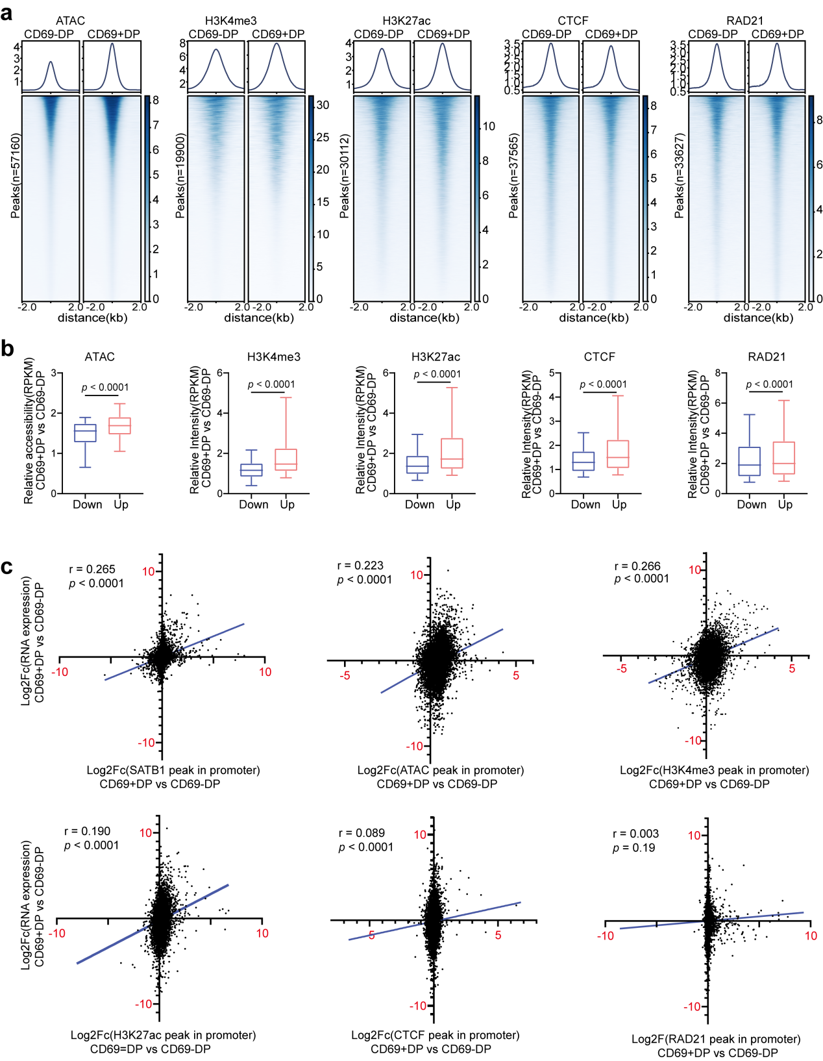Figure S5. Correlation between epigenetic features and transcriptional changes during positive selection
(a) Average signal profiles and heatmaps of ATAC-seq, H3K4me3, H3K27ac, CTCF, and RAD21 signals centered on promoter regions (±2 kb from transcription start sites) in wild-type CD69⁻ DP and CD69⁺ DP thymocytes.
(b) Box plots showing relative changes in chromatin accessibility (ATAC-seq) and CUT&Tag signal intensity (H3K4me3, H3K27ac, CTCF, and RAD21) at promoters of genes that are downregulated or upregulated in CD69⁺ DP compared with CD69⁻ DP thymocytes. Box plots show median (center line), interquartile range (box), and 10th-90th percentiles (whiskers). Statistical significance was assessed by Wilcoxon signed-rank test.
(c) Scatter plots showing two-sides correlations between changes in promoter-associated chromatin features and changes in gene expression during the CD69⁻ DP to CD69⁺ DP transition. Two tailed pearson correlation coefficients and P values are indicated for each comparison.

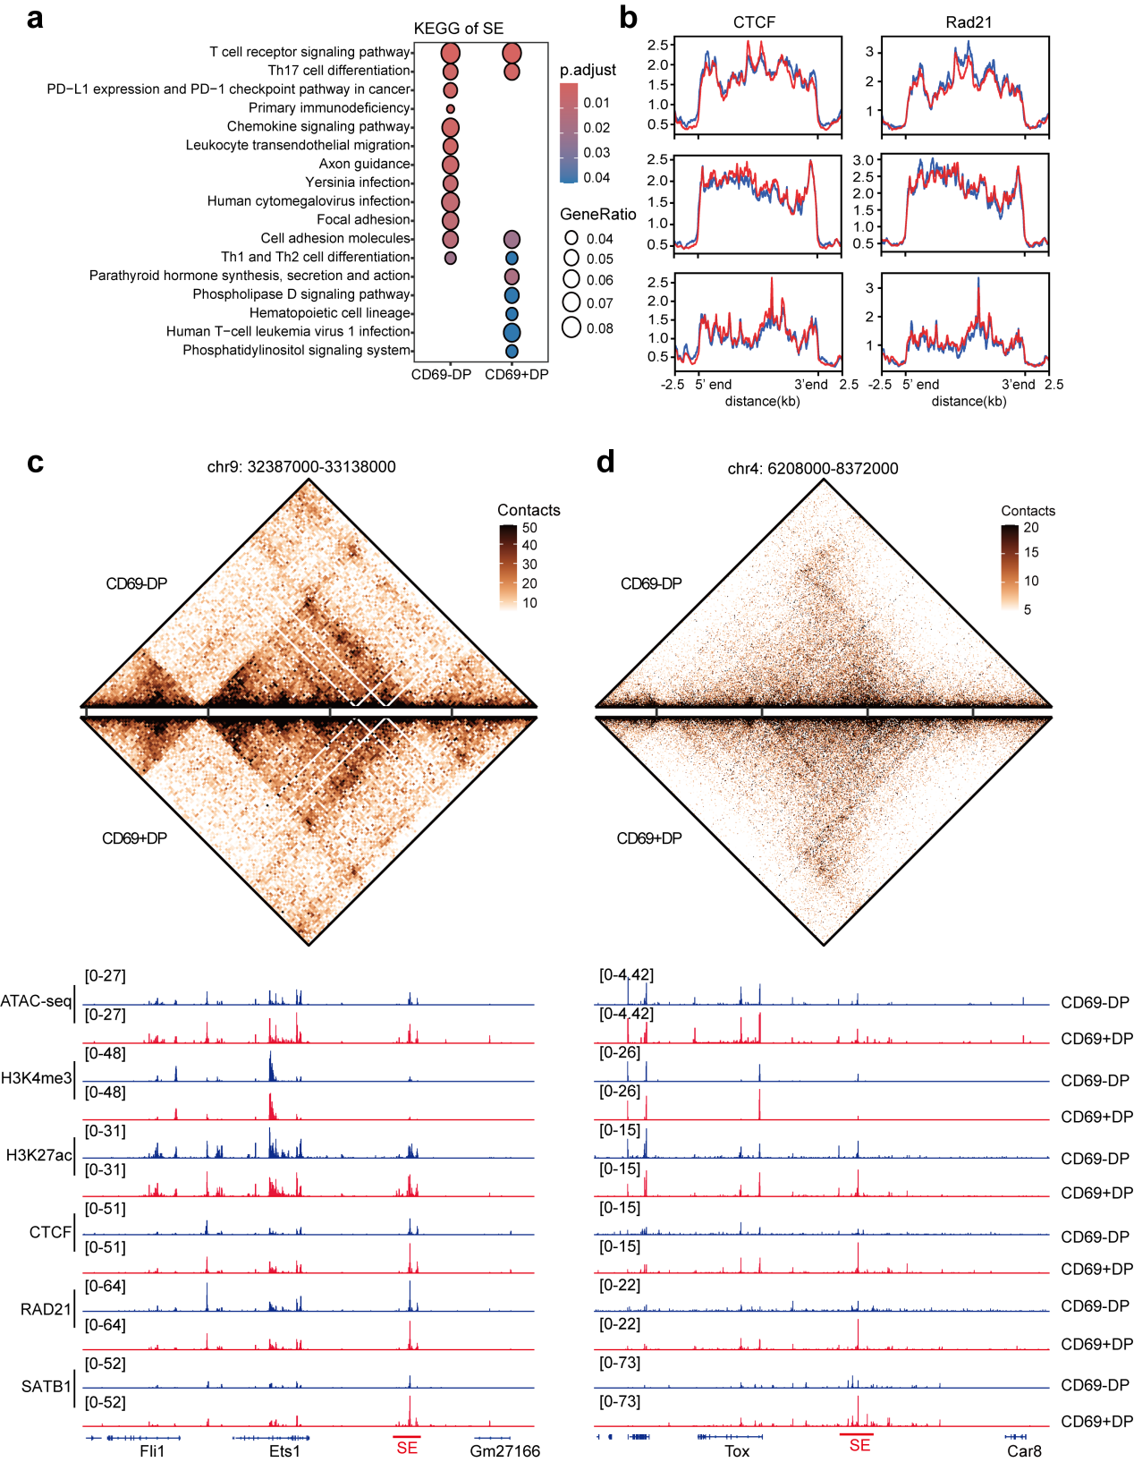Figure S6. Super-enhancers are associated with positive-selection-related gene expression programs
(a) KEGG pathway enrichment analysis of genes associated with SEs identified in wild-type CD69⁻ DP and CD69⁺ DP thymocytes. Dot size indicates gene ratio, and color denotes adjusted P value.
(b) Average signal profiles of CTCF and RAD21 across super-enhancer regions (±2.5 kb from SE boundaries) in wild-type CD69⁻ DP and CD69⁺ DP thymocytes.
(c) Hi-C contact maps showing chromatin interactions across the Fli1-Ets1 locus in CD69⁻ DP (top) and CD69⁺ DP (bottom) thymocytes. Genome browser tracks below display ATAC-seq, H3K4me3, H3K27ac, CTCF, RAD21, and SATB1 signals, highlighting a CD69⁺ DP–associated super-enhancer region.
(d) Hi-C contact maps showing chromatin interactions across the Tox–Car8 locus in CD69⁻ DP (top) and CD69⁺ DP (bottom) thymocytes. Genome browser tracks below display ATAC-seq, H3K4me3, H3K27ac, CTCF, RAD21, and SATB1 signals, highlighting a CD69⁺ DP–associated super-enhancer region.

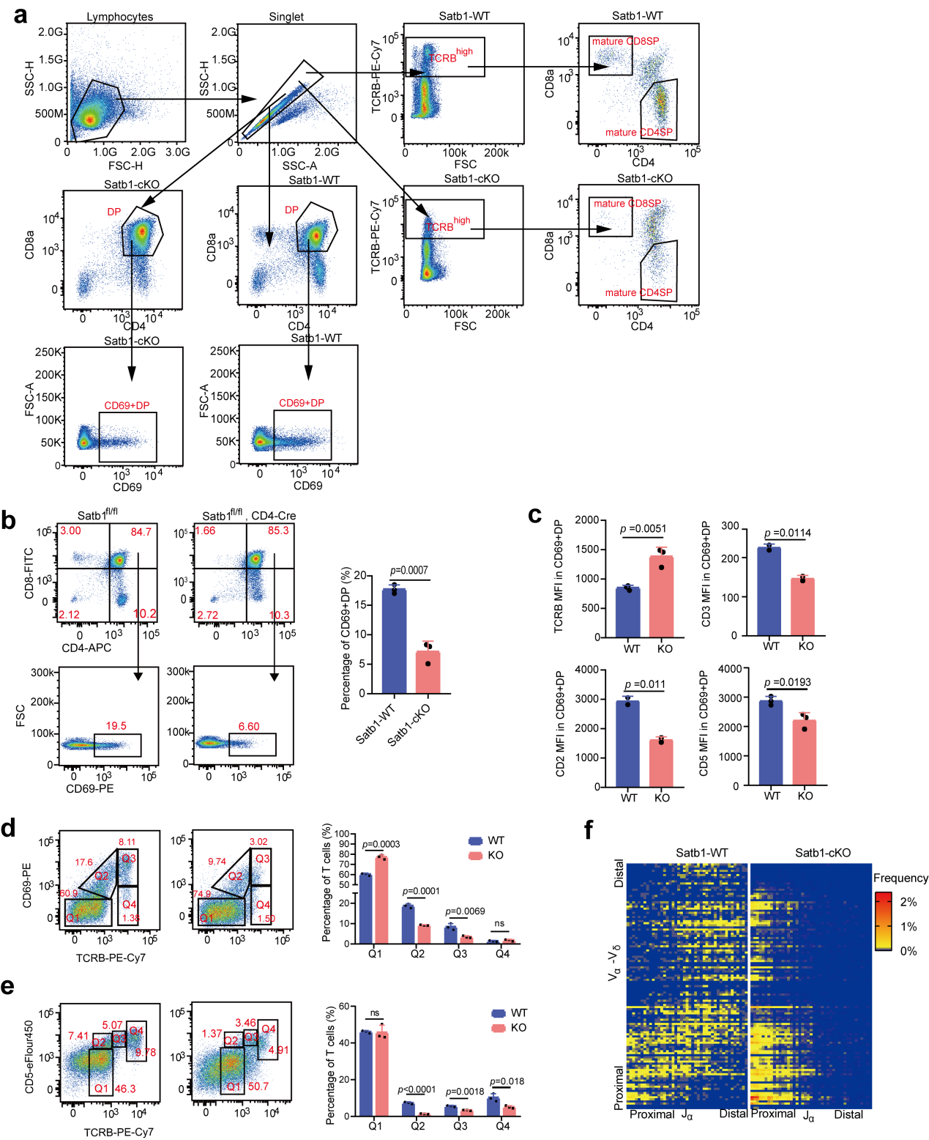Figure S7. Conditional deletion of Satb1 in DP thymocytes impairs positive selection
(a) Flow cytometry gate strategy of CD69⁺DP, mature CD4SP and CD8SP from Satb1^{fl/fl} (WT) and Satb1^{fl/fl}; Vav-Cre (cKO) mice.
(b) Flow cytometry analysis of thymocytes from Satb1^{fl/fl} (WT) and Satb1^{fl/fl}; CD4-Cre (cKO) mice. Representative plots show CD4 and CD8 expression (top) and CD69 expression within DP thymocytes (bottom). Right, quantification of the frequency of CD69⁺ DP cells. P values were determined by two-sided Student’s t test. Data are presented as mean ± s.d.; n = 3 biologically independent mice.
(c) Quantification of mean fluorescence intensity (MFI) of TCRβ, CD3, CD2, and CD5 on CD69⁺ DP thymocytes from WT and Satb1 cKO mice. P values were determined by two-sided Student’s t test. Data are presented as mean ± s.d.; n = 3 biologically independent mice.
(d) Flow cytometry analysis of thymocytes stratified by TCRβ and CD69 expression, defining four developmental stages (Q1-Q4) corresponding to sequential phases of positive selection. Representative plots (left) and quantification of population frequencies (right) are shown for WT and Satb1 cKO mice. Every data are 3 replications and shown as mean ± s.d. P values were determined by two-sided Student’s t test.
(e) Flow cytometry analysis of thymocytes stratified by TCRβ and CD5 expression, defining four developmental stages (Q1-Q4). Representative plots (left) and quantification of population frequencies (right) are shown for WT and Satb1 cKO mice. Every data are 3 replications and shown as mean ± s.d. P values were determined by two-sided Student’s t test.
(f) Heatmap of Va–Ja combination on CD69⁺ DP thymocytes from WT and Satb1 cKO mice.

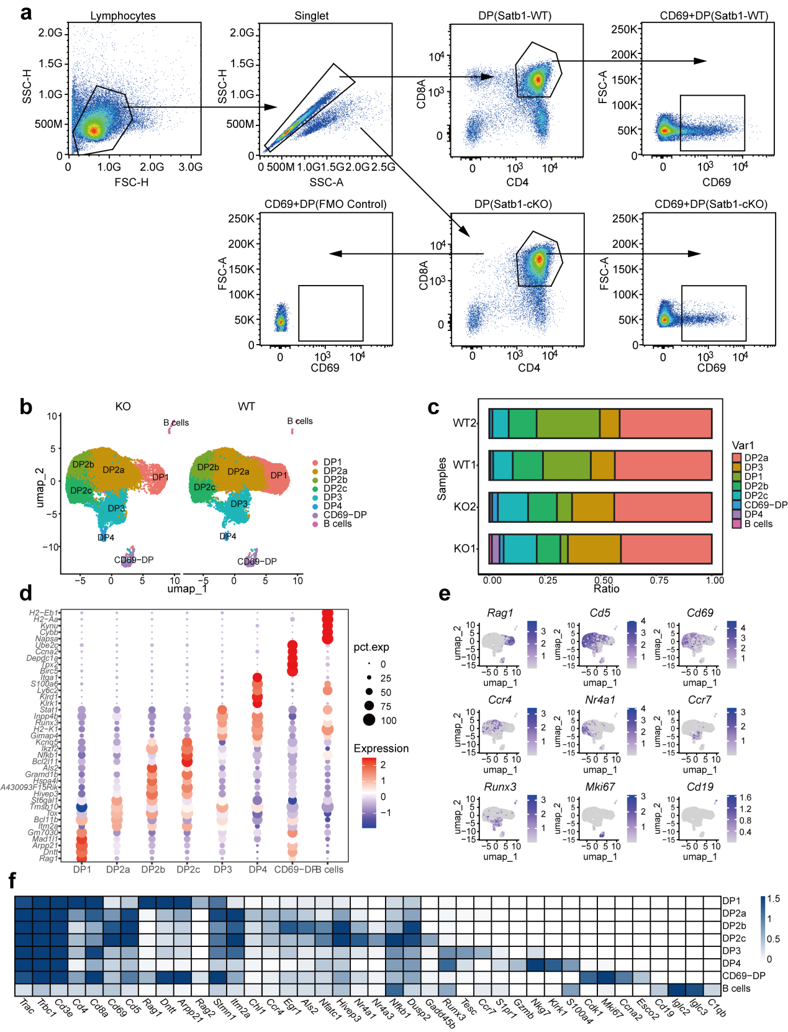Figure S8. Single-cell transcriptomic landscape of thymocyte populations during positive selection
(a) Flow cytometry gate strategy of CD69⁺ DP from Satb1^{fl/fl} (WT) and Satb1^{fl/fl}; Vav-Cre (cKO) mice.
(b) UMAP projection of single-cell RNA-seq profiles from WT and Satb1-deficient (KO) thymocytes. Cells are colored by transcriptionally defined clusters, including DP1, DP2a, DP2b, DP2c, DP3, DP4, CD69⁻ DP, and B cells.
(c) Stacked bar plots showing the relative proportions of each annotated cell population across individual WT and KO samples.
(d) Dot plot showing expression of representative marker genes used for cluster annotation. Dot size indicates the percentage of cells expressing each gene, and color intensity represents scaled average expression.
(e) Feature plots showing UMAP distribution of selected genes associated with thymocyte development, TCR signaling, and cell cycle progression, including Rag1, Cd5, Cd69, Ccr4, Nr4a1, Ccr7, Runx3, and Mki67.
(f) Heatmap showing scaled expression of representative genes across annotated thymocyte populations, highlighting transcriptional programs associated with early DP stages, positive selection, lineage commitment, and proliferative states.

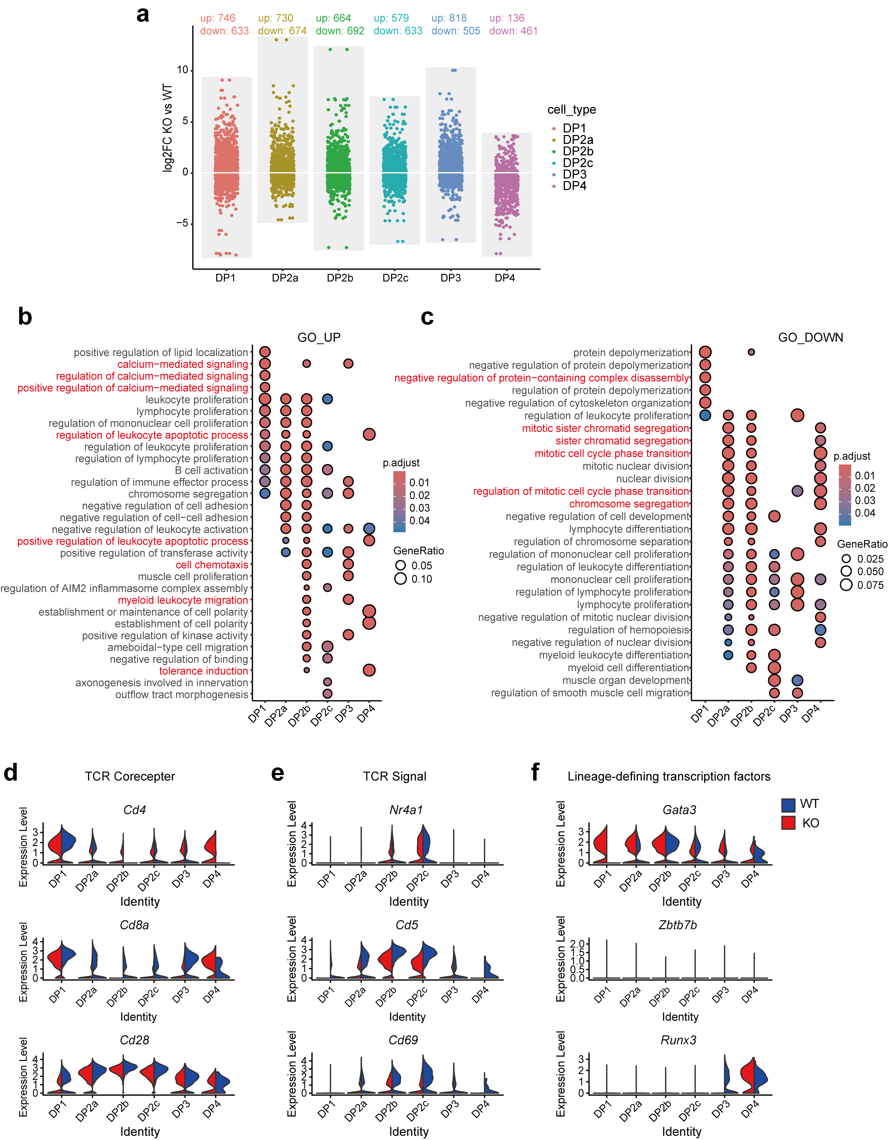Figure S9. Stage-specific transcriptional effects of Satb1 deletion across DP thymocyte subsets
(a) Dot plots showing differential gene expression (log₂ fold change, KO versus WT) across DP1, DP2a, DP2b, DP2c, DP3, and DP4 thymocyte subsets. Numbers of upregulated and downregulated genes in each subset are indicated.
(b) GO enrichment analysis of biological processes associated with genes upregulated in Satb1-deficient thymocytes across DP subsets.
(c) GO enrichment analysis of biological processes associated with genes downregulated in Satb1-deficient thymocytes across DP subsets.
(d) Violin plots showing expression of representative TCR coreceptor genes (Cd4, Cd8a, and Cd28) across DP subsets in WT and Satb1-deficient (KO) thymocytes.
(e) Violin plots showing expression of representative TCR signaling–responsive genes (Nr4a1, Cd5, and Cd69) across DP subsets in WT and KO thymocytes.
(f) Violin plots showing expression of lineage-associated transcription factors (Gata3, Zbtb7b, and Runx3) across DP subsets in WT and KO thymocytes.

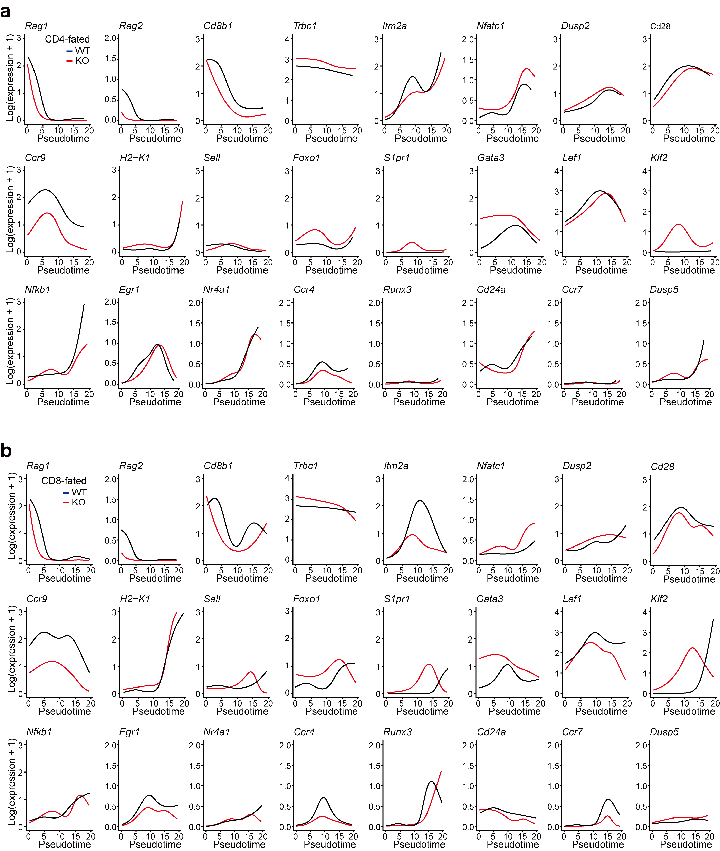

Figure S10. Expression of positive selection related genes in CD69⁺DP cells
(a) Smoothed expression profiles of positive selection related genes along pseudotime in CD4-fated trajectories from wild-type and Satb1-deficient thymocytes.
(b) Smoothed expression profiles of positive selection related genes along pseudotime in CD8-fated trajectories from wild-type and Satb1-deficient thymocytes.

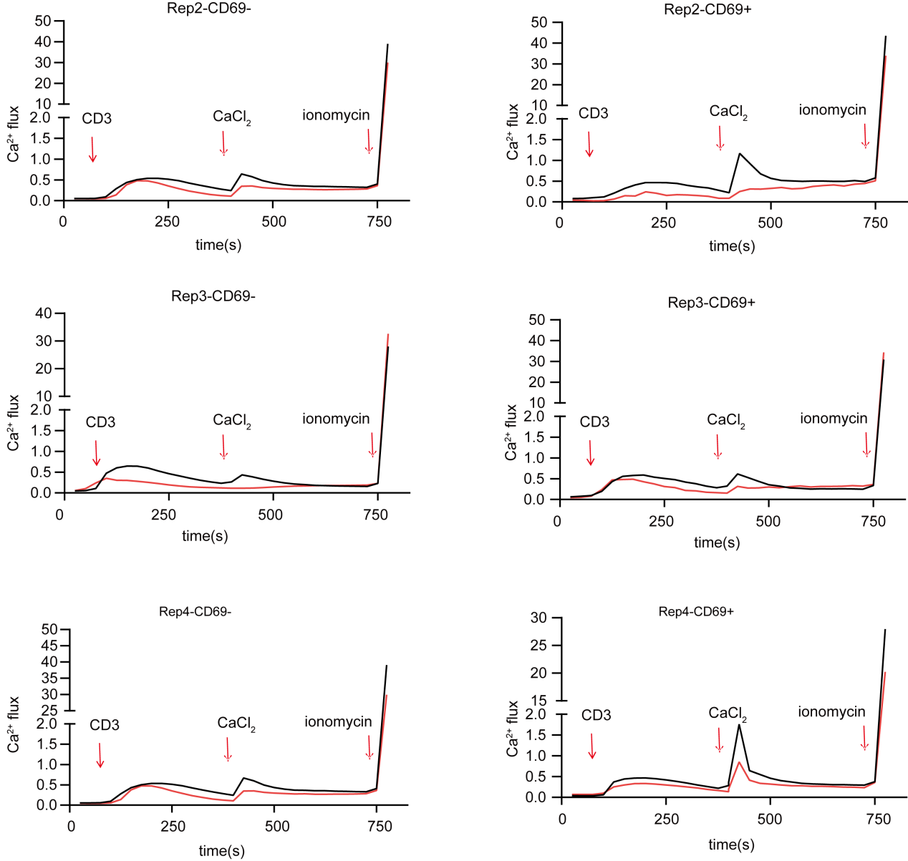

Figure S11. Satb1-deficient cells exhibited reduced Ca²⁺ flux
Ca²⁺ flux of CD69⁻ DP and CD69⁺ DP thymocytes stimulated with CD3 antibody from wild-type and Satb1-deficient mice for three replications.

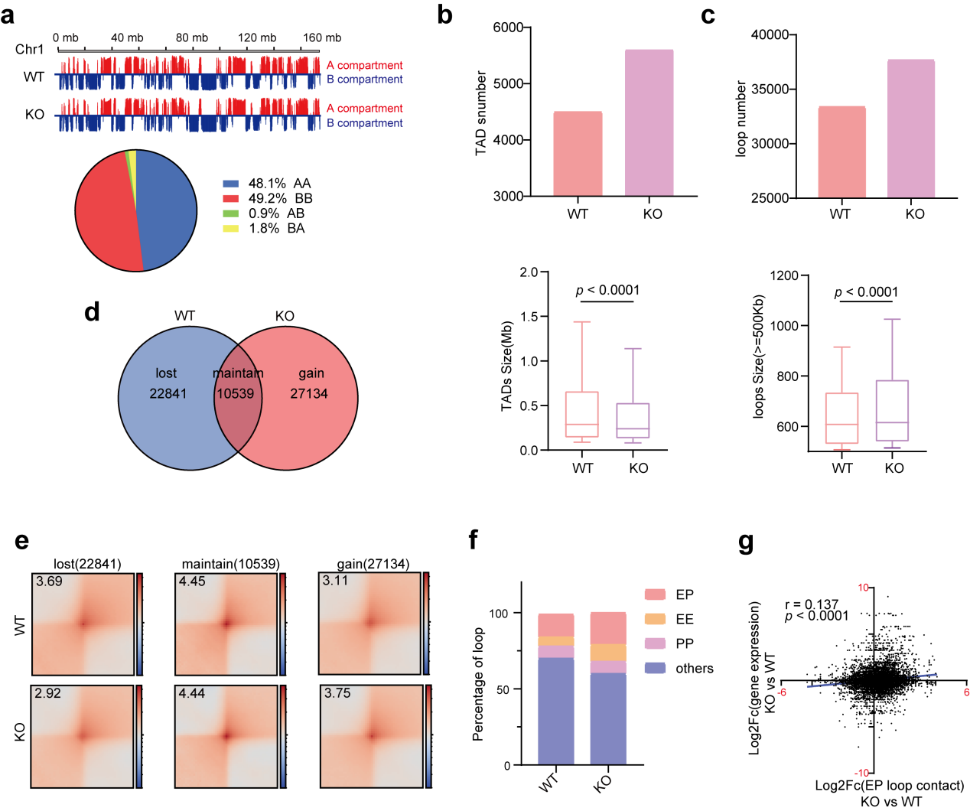Figure S12. Effects of Satb1 conditional deletion on global chromatin architecture
(a) Genome-wide compartment profiles along chromosome 1 in WT and Satb1 conditional knockout (KO) CD69⁺ DP thymocytes. Pie chart summarizes the proportions of A-A, B-B, A-B, and B-A compartment transitions between WT and KO cells.
(b) Quantification of the total number of TADs identified in WT and KO CD69⁺ DP thymocytes.Box plots show median (center line), interquartile range (box), and 10th-90th percentiles (whiskers). Statistical significance was determined by Kruskal-Wallis test followed by Dunn’s multiple comparisons test.
(c) Quantification of the total number and loop for size >=500kb of chromatin loops identified in WT and KO CD69⁺ DP thymocytes. Box plots show median (center line), interquartile range (box), and 10th-90th percentiles (whiskers). Statistical significance was determined by Kruskal-Wallis test followed by Dunn’s multiple comparisons test.
(d) Venn diagram showing chromatin loops that are lost, maintained, or gained upon Satb1 deletion in CD69⁺ DP thymocytes.
(e) Aggregate Hi-C contact maps of loops classified as lost, maintained, or gained in WT (top) and KO (bottom) CD69⁺ DP thymocytes. Average loop sizes are indicated.
(f) Proportions of loop classes, including enhancer-promoter (EP), enhancer-enhancer (EE), promoter-promoter (PP), and other interactions, in WT and KO CD69⁺ DP thymocytes.
(g) Scatter plot showing the correlation between changes in EP loop contact strength and changes in expression of associated genes in KO relative to WT CD69⁺ DP thymocytes. Two tailed pearson correlation coefficient and P value are indicated.

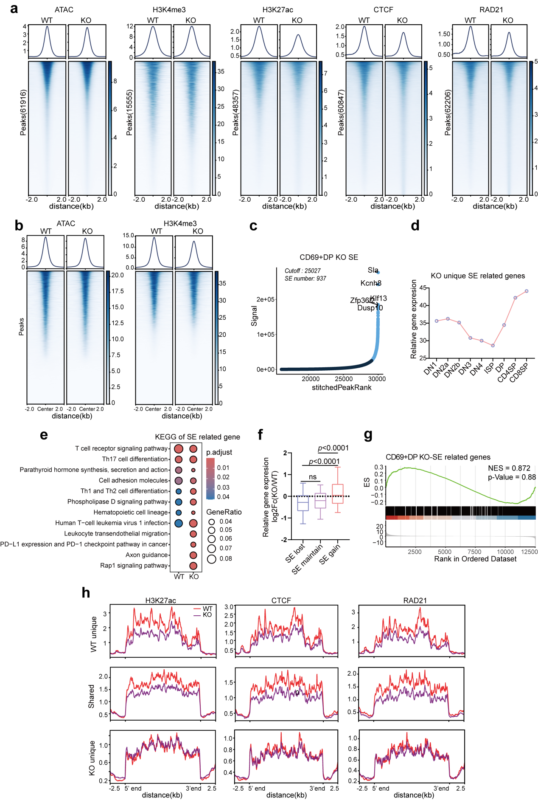Figure S13. Satb1 conditional deletion alters epigenetic features preferentially at super-enhancer–associated regions
(a) Average signal profiles and heatmaps of ATAC-seq, H3K4me3, H3K27ac, CTCF, and RAD21 signals centered on all peaks (±2.5 kb) in WT and Satb1 conditional knockout (KO) CD69⁺ DP thymocytes.
(b) Average signal profiles and heatmaps of ATAC-seq and H3K4me3 signals centered on peaks classified as WT-unique, shared, or KO-unique between WT and KO CD69⁺ DP thymocytes.
(c) Hockey-stick plot showing ranked stitched enhancers based on H3K27ac signal intensity in KO CD69⁺ DP thymocytes. SEs were defined using the ROSE algorithm, with the cutoff indicated.
(d) Relative expression of genes associated with KO-unique SEs across thymocyte developmental stages, including DN, ISP, DP, and SP populations(GSE109125).
(e) KEGG pathway enrichment analysis of genes associated with SEs identified in WT and KO CD69⁺ DP thymocytes. Dot size indicates gene ratio and color denotes adjusted P value.
(f) Box plots showing relative expression changes of genes associated with SEs that are lost, maintained, or gained upon Satb1 deletion in CD69⁺ DP thymocytes. Box plots show median (center line), interquartile range (box), and 10th-90th percentiles (whiskers). Statistical significance was assessed by Kruskal-Wallis test followed by Dunn’s multiple comparisons test.
(g) GSEA of KO-associated SE-related genes in CD69⁺ DP thymocytes. Normalized enrichment score (NES) and P value are indicated.
(h) Average signal profiles of H3K27ac, CTCF, and RAD21 across WT-unique, shared, and KO-unique SEs in WT and KO CD69⁺ DP thymocytes.

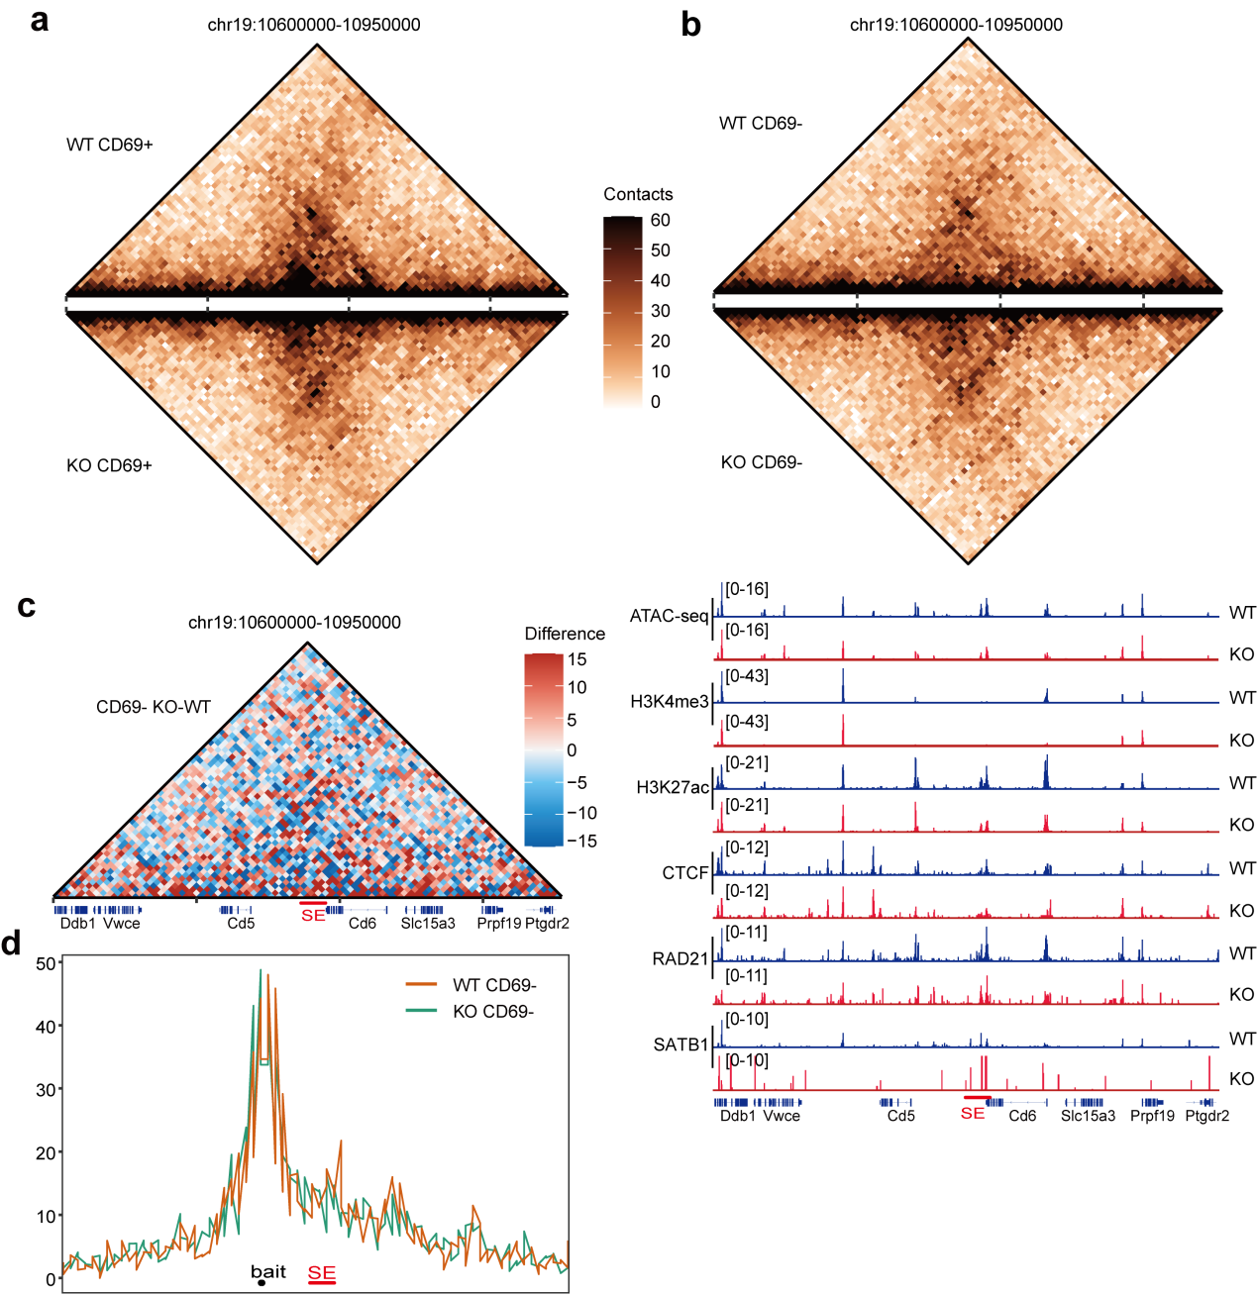Figure S14. Satb1-dependent chromatin alterations at the Cd5 locus are specific to CD69⁺ DP thymocytes
(a) Hi-C contact maps across the Cd5 genomic region (chr19:10600000-10950000) in WT and Satb1-deficient (KO) CD69⁺ DP thymocytes. Contact intensity is shown on a color scale.
(b) Hi-C contact maps across the same Cd5 genomic region in WT and KO CD69⁻ DP thymocytes.
(c) Subtraction Hi-C heatmap (KO - WT) for CD69⁻ DP thymocytes, illustrating differences in chromatin interaction frequencies across the Cd5 locus. Gene annotations and the associated SE region are indicated.
(d) Virtual 4C analysis using the Cd5 promoter as bait in WT and KO CD69⁻ DP thymocytes, showing interaction frequencies with the associated super-enhancer region.
(e) Genome browser tracks showing ATAC-seq, H3K4me3, H3K27ac, CTCF, RAD21, and SATB1 signals across the Cd5 locus in WT and KO CD69⁻ DP thymocytes.

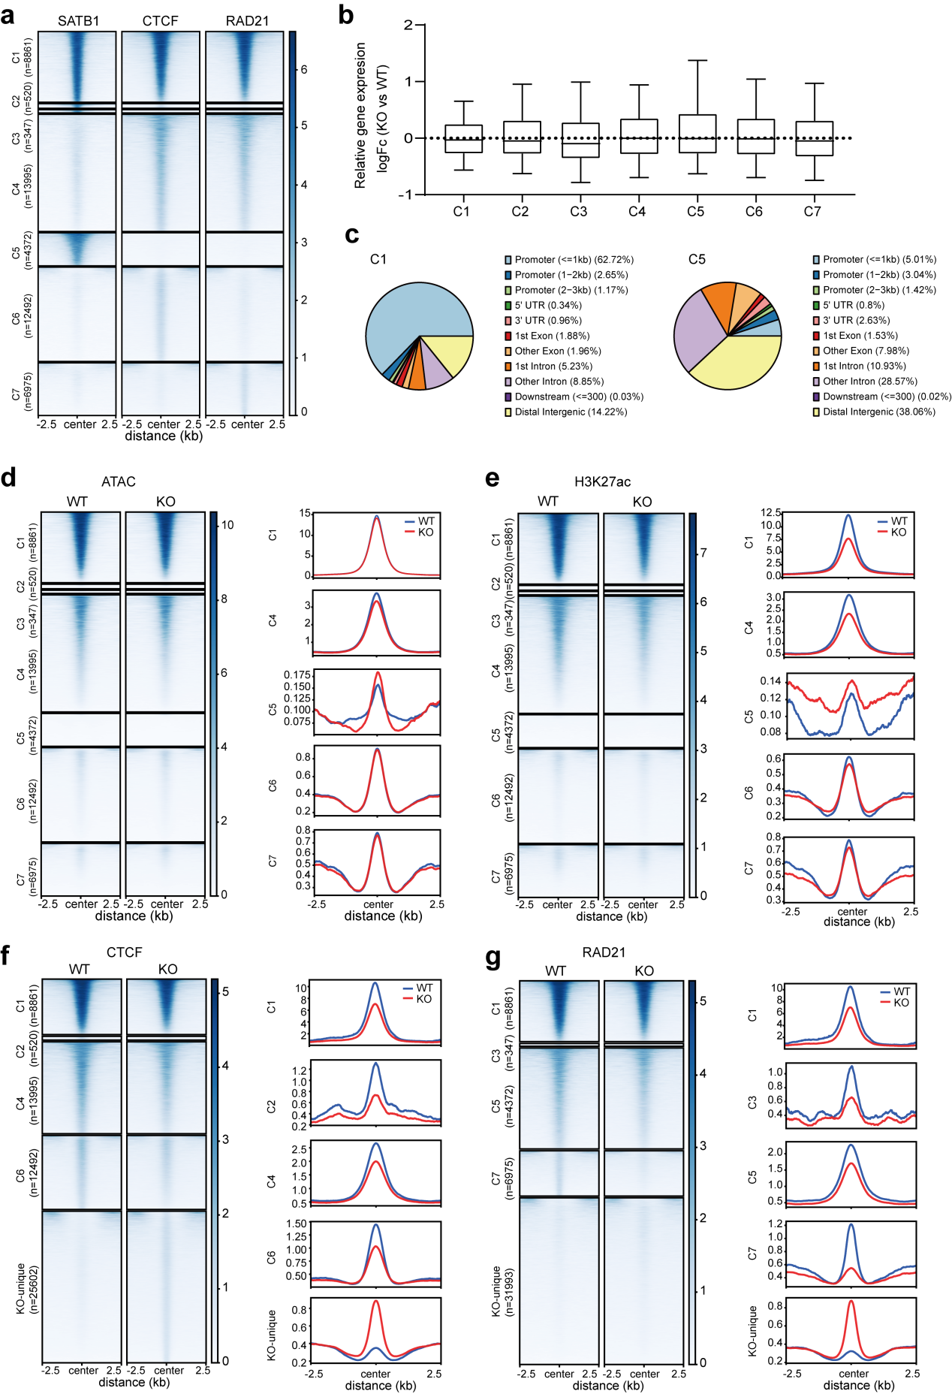Figure S15. SATB1-associated chromatin clusters are not defined by direct CTCF or RAD21 occupancy
(a) Heatmaps showing SATB1, CTCF, and RAD21 CUT&Tag signal intensities centered on SATB1 binding sites (±2.5 kb) in wild-type CD69⁺ DP thymocytes. SATB1 peaks were grouped into seven clusters (C1 to C7) based on SATB1 signal patterns.
(b) Box plots showing relative expression changes of genes associated with each SATB1 cluster (C1 to C7) in Satb1-deficient compared with wild-type CD69⁺ DP thymocytes. The dashed line indicates no change. Box plots show median (center line), interquartile range (box), and 10th-90th percentiles (whiskers).
(c) Pie charts showing the genomic distribution of SATB1 peaks in representative clusters (C1 and C5), categorized by promoter-proximal and distal regulatory regions.
(d) Heatmaps and average profiles of ATAC-seq signals centered on SATB1 peaks from clusters C1 to C7 in WT and Satb1-deficient (KO) CD69⁺ DP thymocytes.
(e) Heatmaps and average profiles of H3K27ac CUT&Tag signals centered on SATB1 peaks from clusters C1 to C7 in WT and KO CD69⁺ DP thymocytes.
(f) Heatmaps and average profiles of CTCF CUT&Tag signals centered on SATB1 peaks from clusters C1, C2, C4, C6 and KO-unique peaks in WT and KO CD69⁺ DP thymocytes.
(g) Heatmaps and average profiles of RAD21 CUT&Tag signals centered on SATB1 peaks from clusters C1, C3, C5, C7 and KO-unique peaks in WT and KO CD69⁺ DP thymocytes.

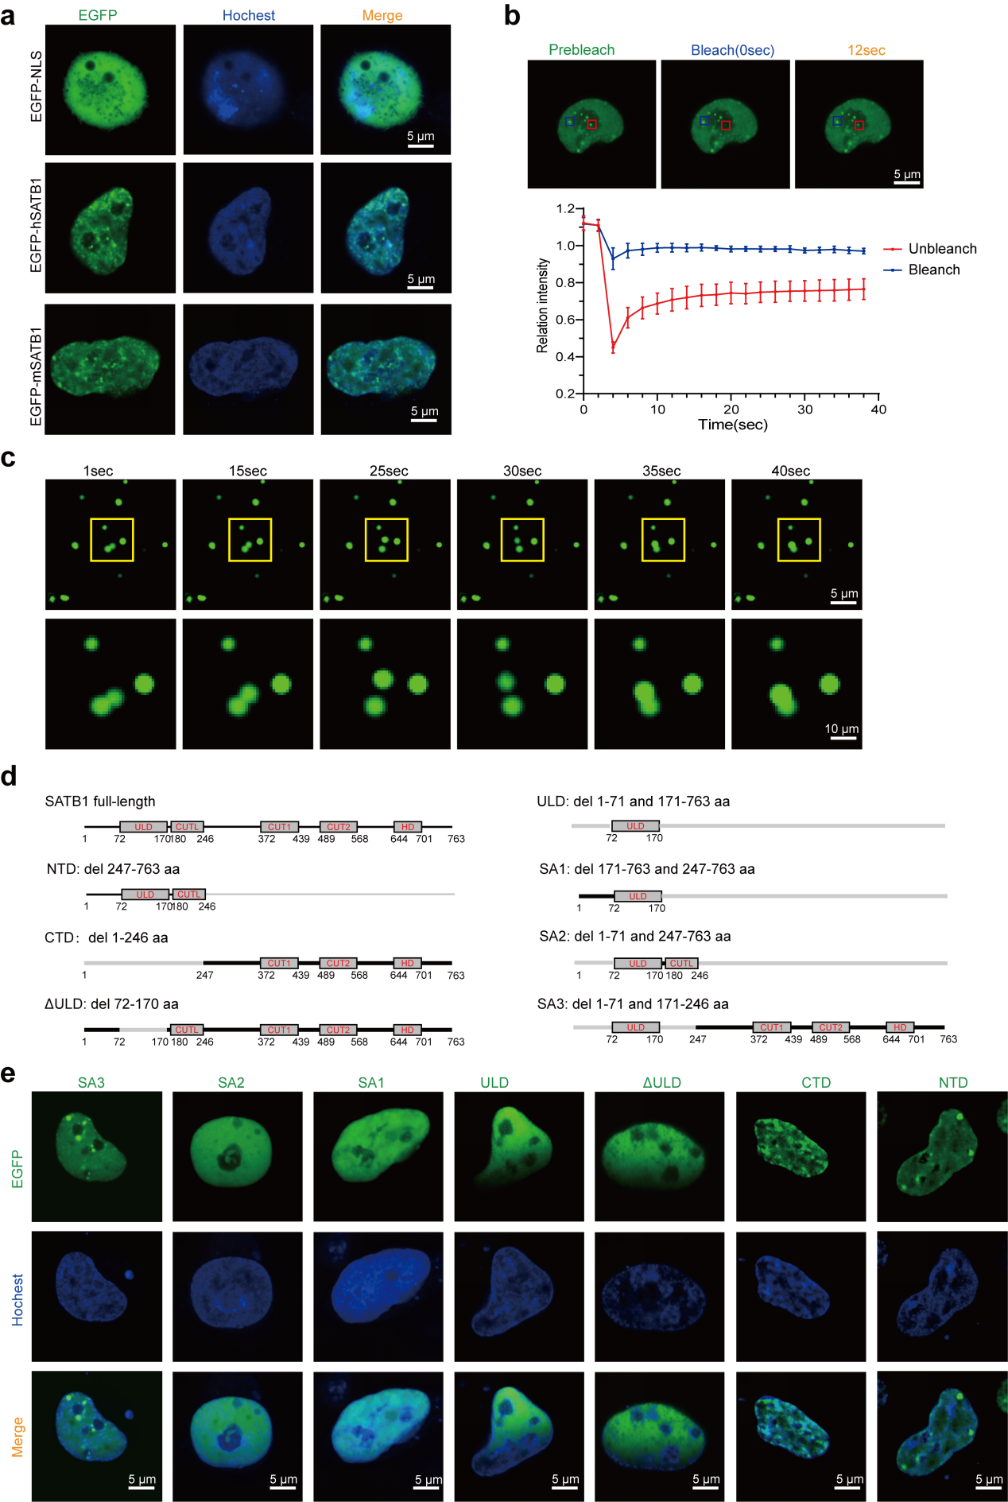Figure S16. SATB1 N-terminal region confers punctate nuclear organization and dynamic exchange properties
(a) Representative fluorescence microscopy images of cells expressing EGFP-NLS, EGFP-hSATB1, or EGFP-mSATB1. EGFP signals (green), Hoechst nuclear staining (blue), and merged images are shown. Every experiment with three independent experiments. Scale bars, 5 μm.
(b) Fluorescence recovery after photobleaching (FRAP) analysis of EGFP–SATB1 in the nucleus. Top, representative images before bleaching (Prebleach), immediately after bleaching (0 s), and during recovery (12 s). Bottom, quantification of fluorescence recovery over time in bleached (red) and unbleached (blue) regions. Data are three replications and shown as mean ± s.d.
(c) Time-lapse fluorescence microscopy images showing dynamic behavior of EGFP-SATB1 puncta in vitro at the indicated time points. Yellow boxes indicate regions shown at higher magnification below. Every experiment with three independent experiments. Scale bars, 5 μm (top) and 10 μm (bottom).
(d) Schematic diagrams of full-length SATB1 and truncation or deletion constructs used in this study, including N-terminal domain (NTD), C-terminal domain (CTD), ultra-low complexity domain (ULD), and serial deletion mutants (SA1-SA3 and ΔULD). Amino acid positions are indicated. Every experiment with three independent experiments. Scale bars, 5 μm.
(e) Representative fluorescence microscopy images of cells expressing EGFP-tagged SATB1 truncation or deletion constructs shown in (d). EGFP signals (green), Hoechst staining (blue), and merged images are shown. Every experiment with three independent experiments. Scale bars, 5 μm.

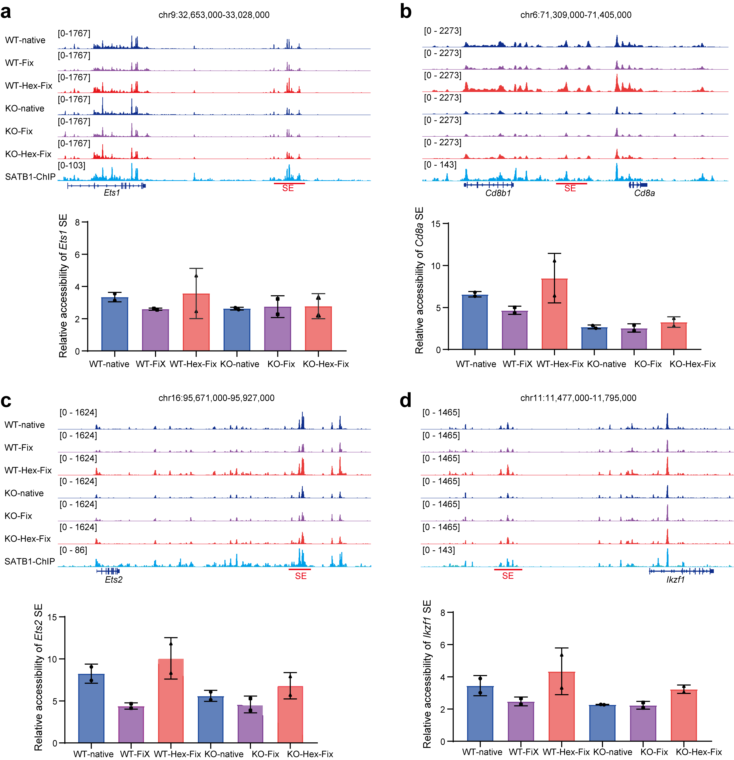

Figure S17. SATB1 condensate appears on the super enhancer of wild-type cells
(a-d) Genome browser tracks showing ACC-seq profiles across the Ets1,Cd8a, Ets2 and Ikzf1 super-enhancer under the indicated conditions in wild-type and Satb1-deficient CD69⁺ DP thymocytes. SATB1 ChIP-seq signal is shown below. Quantification of relative accessibility at the Ets1 super-enhancer is shown. Data are shown from two independent biological experiments (n = 2), with individual values and mean indicated.

TableS1 The primer for plasmid construction
pCAG EGFP F | TGGCAAAGAATTTGCTAGCATGGTGAGCAAGGGCGAGGAG
pCAG EGFP R | TCTTGGGACTAGTACCACCACCCTTGTACAGCTCGTCCATGC
pCAG EGFP-NLS R | ACTAGTACCACCACCCTTGTACAGCTCGTCCATGC
pCAG mSATB1 FL F | ACAAGGGTGGAGGTCGGACCATGGATCATTTGAACGAGGC
pCAG mSATB1 FL R | AGCTCTAGCCCGGGCGTCGACTCAGTCTTTCAAGTCGGCATTAAC
pCAG hSATB1 FL F | ACAAGGGTGGAGGTCGGACCATGGATCATTTGAACGAGGC
pCAG hSATB1 FL R | GCTCTAGCCCGGGCGTCGACTCAGTCTTTCAAATCAGTAT
pCAG hSATB1 FL-NLS R | ACTAGTACCACCACCGTCTTTCAAATCAGTAT
pCAG hSATB1 1-246 R | AGCTCTAGCCCGGGCGTCGACTCATGTCTTCTTGAAATGTT
pCAG hSATB1 247-763 F | ACAAGGGTGGAGGTCGGACCAAAGATATGATGGTTGAAATG
pCAG hSATB1 1-170 R | GCTCTAGCCCGGGCGTCGACTCATAACTGAATTTTCAATG
pCAG hSATB1 72-246 F | TACAAGGGTGGAGGTCGGACCACCATGCTGCCAGTTTTCTG
pCAG hSATB1 ULD-246-763 F | TCACATTGAAAATTCAGTTAAAAGATATGATGGTTGAAAT
pCAG hSATB1 ULD-246-763 R | ATTTCAACCATCATATCTTTTAACTGAATTTTCAATGTGA
pCAG hSATB1 ΔULD F | AAACCAACCTTAGGAAAGGACACAGTTGCCCCAAACTAGA
pCAG hSATB1 ΔULD R | TCTAGTTTGGGGCAACTGTGTCCTTTCCTAAGGTTGGTTT
NLS R | TCTAGCCCGGGCGTCGACTCACACCTTGCGCTTCTTCTTGGGACTAGTACCACCACC
PET28a EGFP F | AGCAAATGGGTCGCGGATCCATGGTGAGCAAGGGCGAGGA
PET28a EGFP R | TCGAGTGCGGCCGCAAGCTTCTTGTACAGCTCGTCCATGC
PET28a hSATB1 1-246 R | GCTCGAGTGCGGCCGCAAGCTTTGTCTTCTTGAAATGTTTGT

TableS2 The antibodies information for FACS
production | suppliers | catalogue numbers | clone | dilutions
anti-CD3e-EFLUOR 450 | eBioscience | 48-0032-80 | Clone 17A2 | 1:100
anti-CD2-Percp-Cy5.5 | Biolegend | 100115 | Clone RM2-5 | 1:100
anti-CD8a-FITC/PE | Biolegend | 100706 | Clone 53-6.7 | 1:100
anti-CD4-APC | Biolegend | 100516 | Clone RM4-5 | 1:100
anti-CD5-EFLUOR 450 | Thermo Scientific | 48-0051-82 | Clone 57-7.3 | 1:100
anti-CD69-PE | BioLegend | 104507 | Clone H1.2F3 | 1:100
nti-TCRB-PE-CY5 | BioLegend | 109222 | lone H57-597 | 1:100

TableS3 The antibodies information for Immunofluorescence and CUT&Tag
For Immunofluorescence
production | suppliers | catalogue numbers | clone | dilutions
anti-SATB1 | abcam | ab109122 | Rabbit monoclonal [EPR3951] | 1:200
anti-SATB1-AF647 | santa cruz | sc-376096 | Mouse monoclonal[C-6] | 1:100
anti-Rabbit-AF647 | Fdbio science | FD0144 | Mouse polyclonal | 1:200
For CUT&Tag
anti-SATB1 | abcam | ab109122 | Rabbit monoclonal [EPR3951] | 1:200
anti-H3K4me3 | Millipore | 04-745 | Rabbit monoclonal [MC315] | 1:100
anti-H3K27ac | abcam | ab4729 | Rabbit polyclonal | 1:100
anti-CTCF | Millipore | 07-729 | Rabbit polyclonal | 1:100
anti-RAD21 | abcam | ab217678 | Rabbit polyclonal [EPR22506-15] | 1:100

