Nonflammable Sulfamoyl–Carbonate Hybrid Electrolyte for High-Voltage Lithium Batteries via Preemptive Passivation

Hun Kim^{1,†}, Jae-Min Kim^{1,†}, Yo-Han Yang², Xiaosheng Song^{1,3}, Dong-Gun Koo¹, Kang Xu⁴, and Yang-Kook Sun^{1,2,*}
¹ Department of Energy Engineering, Hanyang University, Seoul 04763, Republic of Korea
² Department of Battery Engineering, Hanyang University, Seoul 04763, Republic of Korea
³ Key Laboratory for Special Functional Materials of Ministry of Education, School of Nanoscience and Materials Engineering, Henan University, Kaifeng 475004, P. R. China
⁴ SES AI Corp., Woburn, MA, USA
† These authors contributed equally

Corresponding author: yksun@hanyang.ac.kr (Y.-K.S)

This PDF file includes:
Supplementary Figures 1-37
Supplementary Note 1
Supplementary Table 1-3
Supplementary References

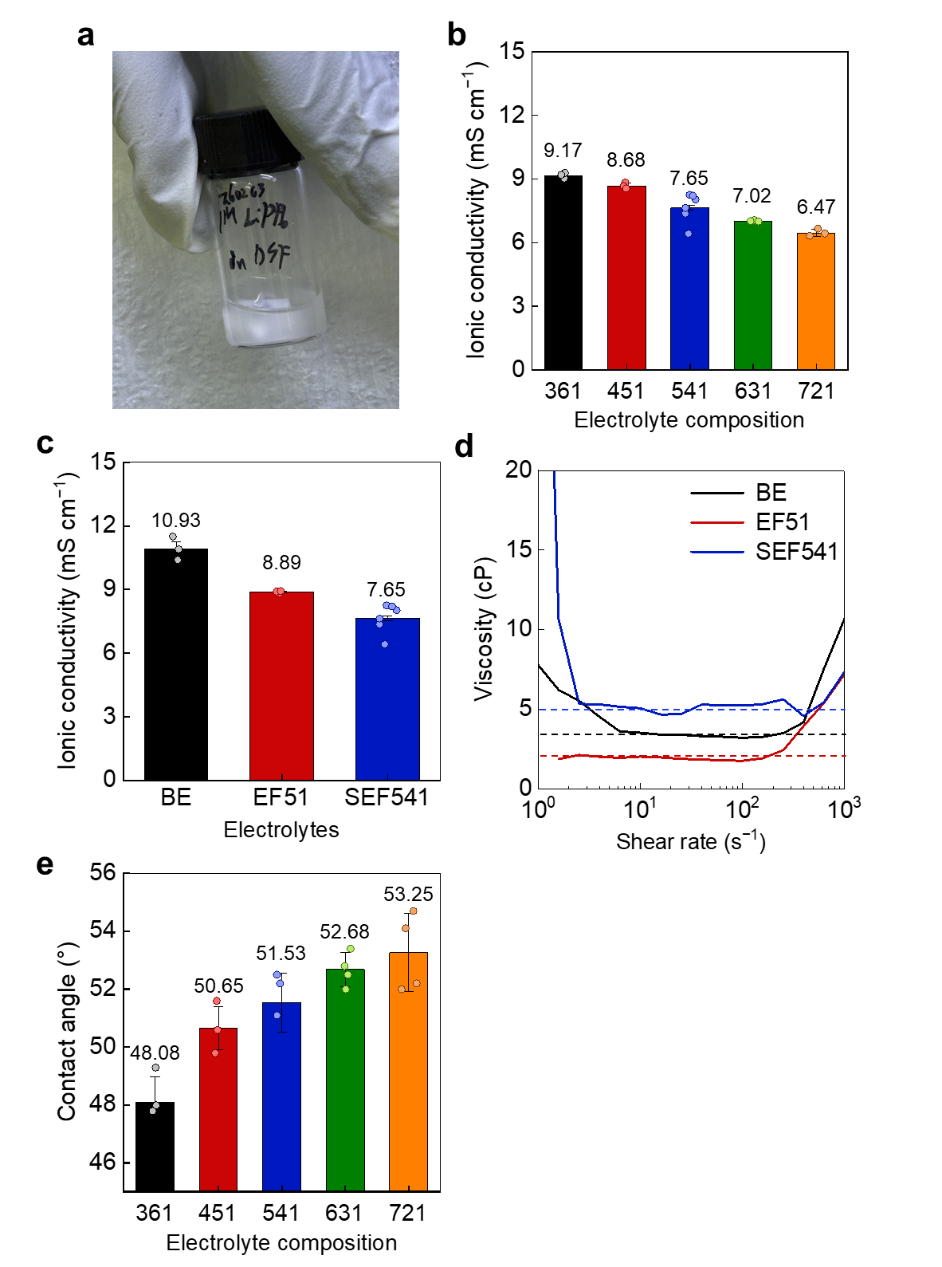
Supplementary Fig. 1 | Composition-dependent physicochemical properties of SEF electrolytes. a, Photograph showing the limited LiPF₆ solubility in DSF solvent (1 M LiPF₆ in DSF). b, Ionic conductivities of SEF electrolytes as a function of composition (1 M LiPF₆ in DSF:EMC:FEC = X:90-X:10, X = 30–70, v/v/v). c,d, Ionic conductivities (c) and viscosities (d) of different electrolytes measured at 30 ℃. e, Contact angle of SEF-based electrolyte depending on DSF content with 10 vol% FEC fixed. Bars and numerical annotations in panels b, c and e indicate mean values, and symbols represent individual measurements. Error bars represent standard deviations. In panels b and c, n = 3 for all electrolyte compositions except SEF541, for which n = 6. In panel e, n = 4 for each electrolyte composition. n denotes the number of independent electrolyte batches.
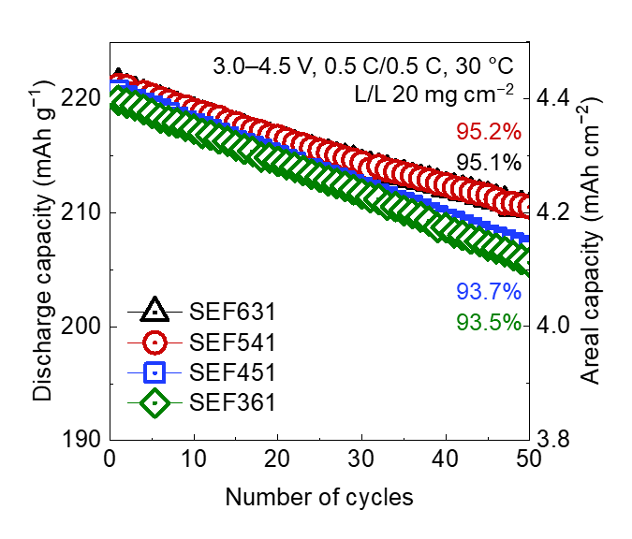
Supplementary Fig. 2 | Composition-dependent cycling performance of SEF electrolytes. Cycling performance depending on electrolyte compositions over a voltage range of 3.0–4.5 V at 0.5 C (90 mA g⁻¹)/0.5 C and 30 ℃.
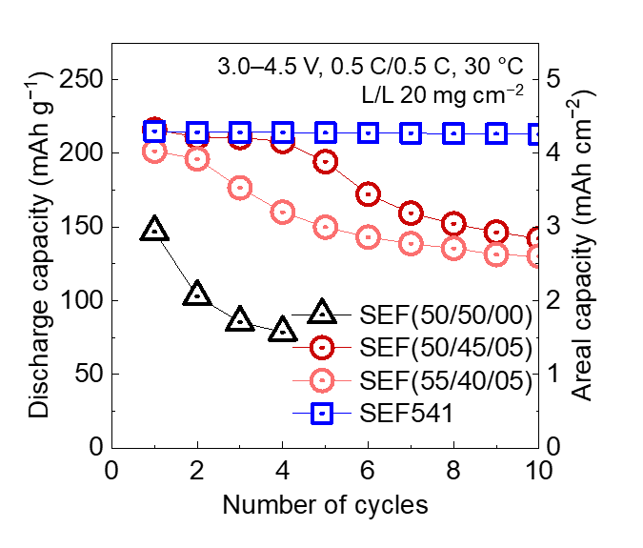
Supplementary Fig. 3 | Effect of FEC content on high-voltage cycling performance. Cycling performance depending on FEC content over a voltage range of 3.0–4.5 V at 0.5 C (90 mA g⁻¹)/0.5 C and 30 ℃.

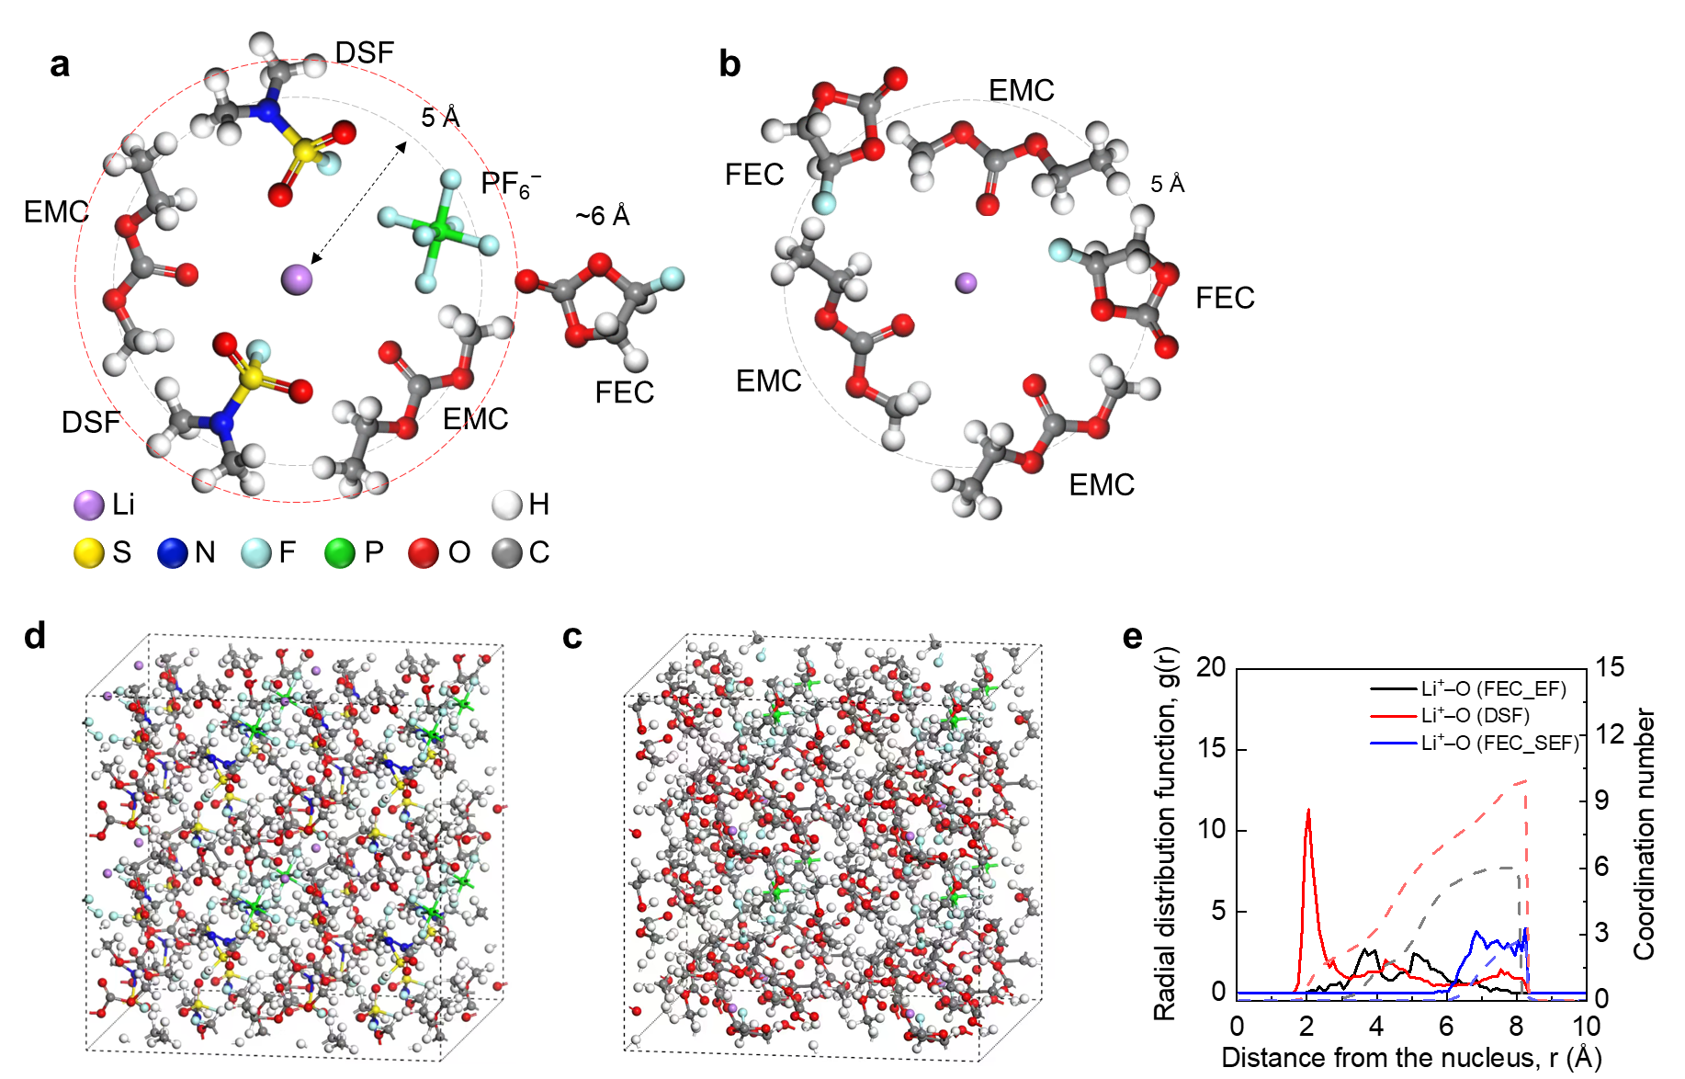
Supplementary Fig. 4 | Molecular-dynamics-derived solvation structures of EF51 and SEF541. Solvation structure of different electrolytes derived from MD simulation. a–d, Snapshots of SEF541 (a,d) and EF51 (b,c) electrolytes. e, RDFs and CNs of Li⁺–O interactions in different solvents.
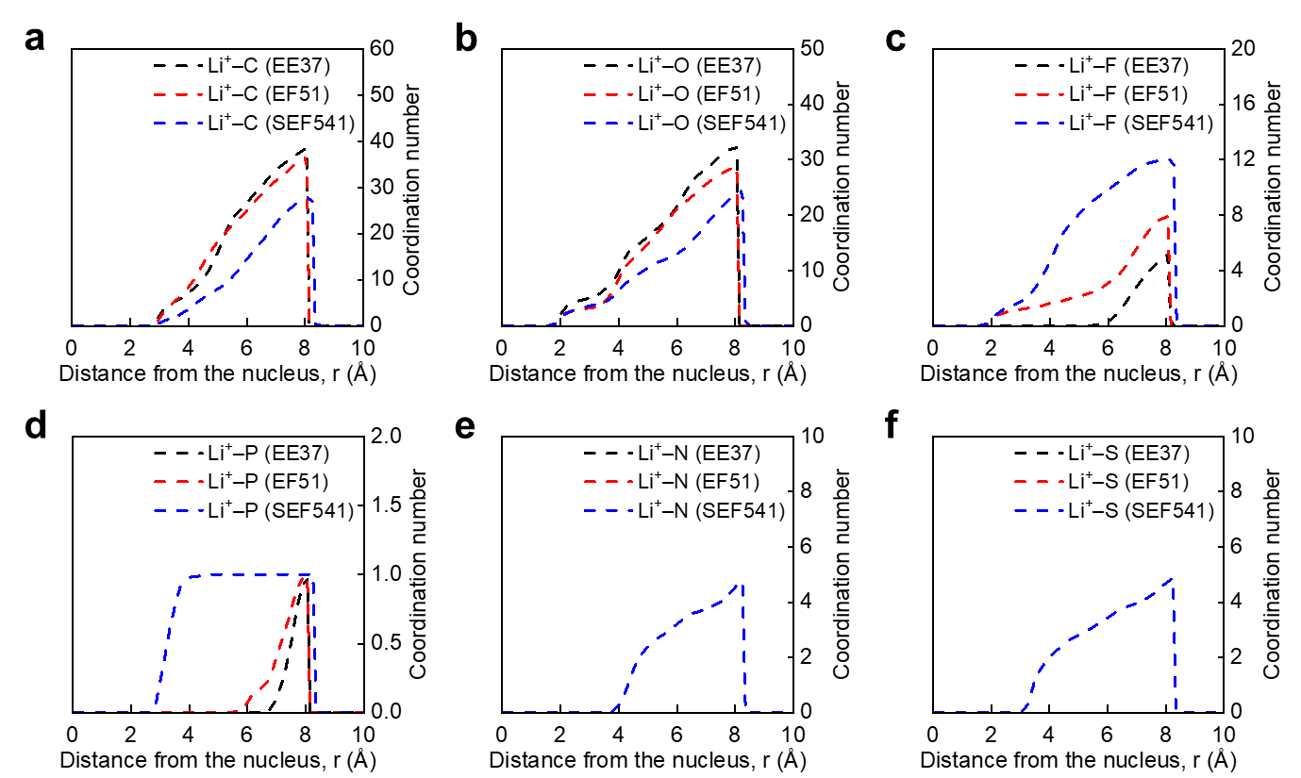
Supplementary Fig. 5 | Cumulative coordination numbers of electrolyte components around Li⁺. Cumulative coordination numbers (CNs) of Li⁺–X interactions in different electrolytes derived from MD simulations. a–f, Li⁺–C (a), Li⁺–O (b), Li⁺–F (c), Li⁺–P (d), Li⁺–N (e), and Li⁺–S (f).

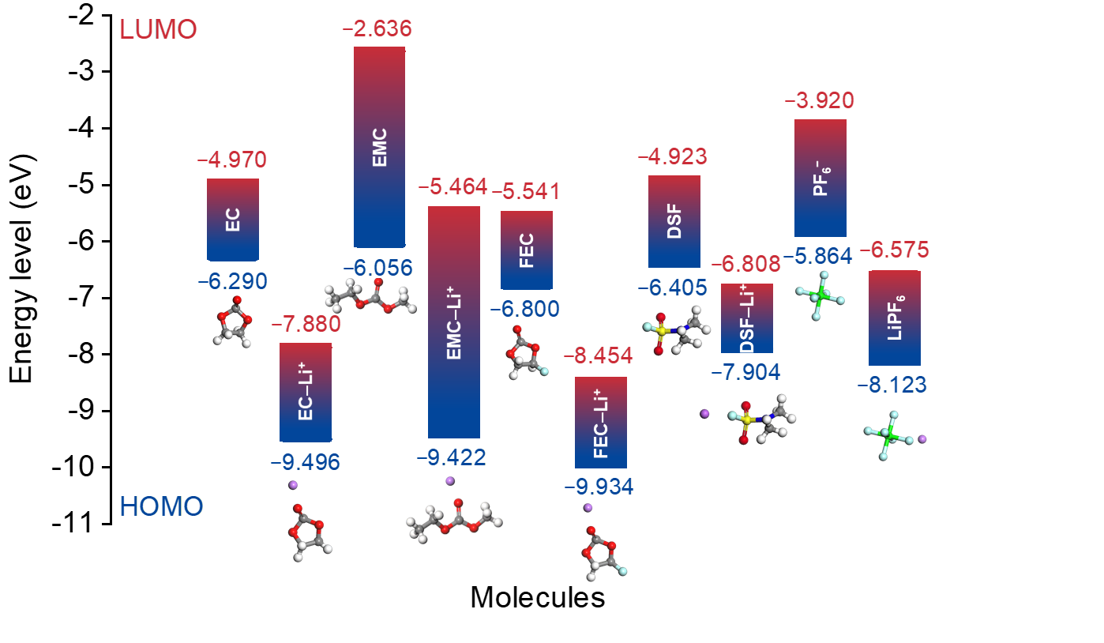
Supplementary Fig. 6 | Calculated orbital energies of electrolyte components through density functional theory (DFT). Calculated HOMO and LUMO energy levels of solvent molecules, Li salts, and Li⁺–coordinated solvent complexes.
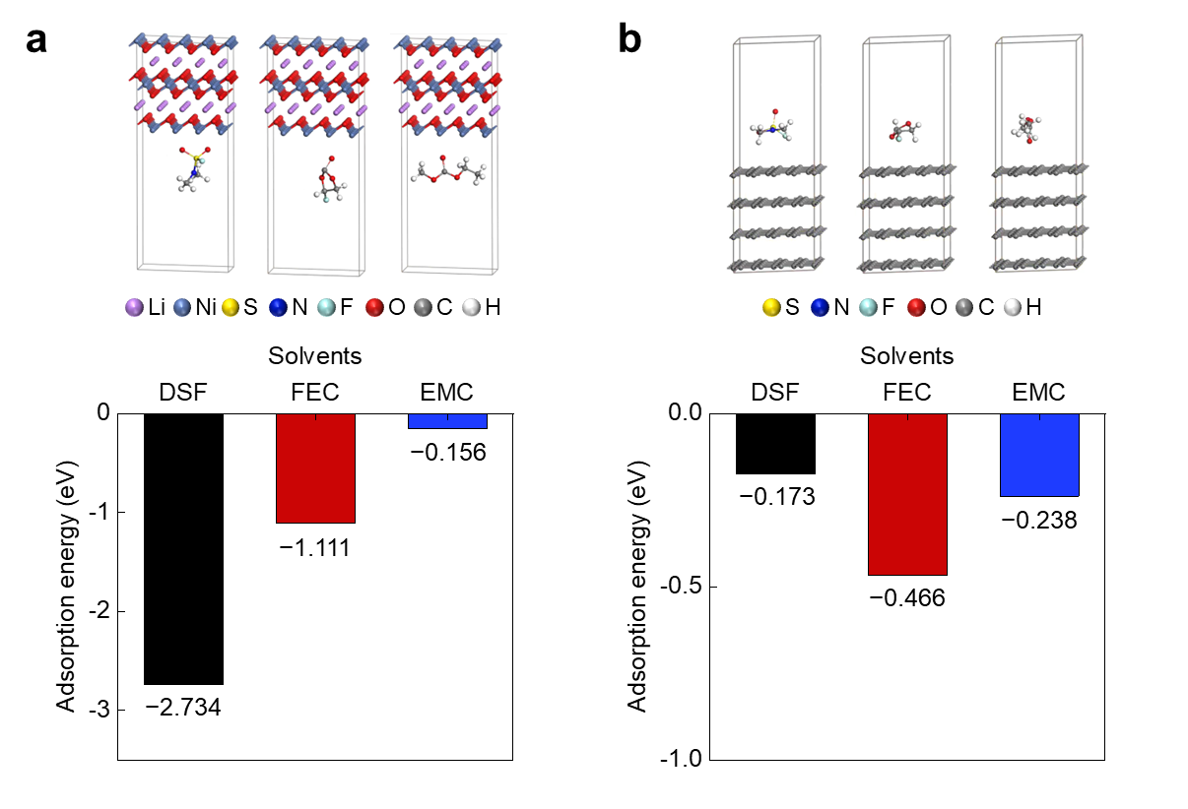

Supplementary Fig. 7 | Calculated adsorption configurations and energies of electrolyte solvents. a,b, Adsorption energy of solvent molecules with LiNiO₂ positive-electrode surface (a), graphite negative-electrode surface (b).

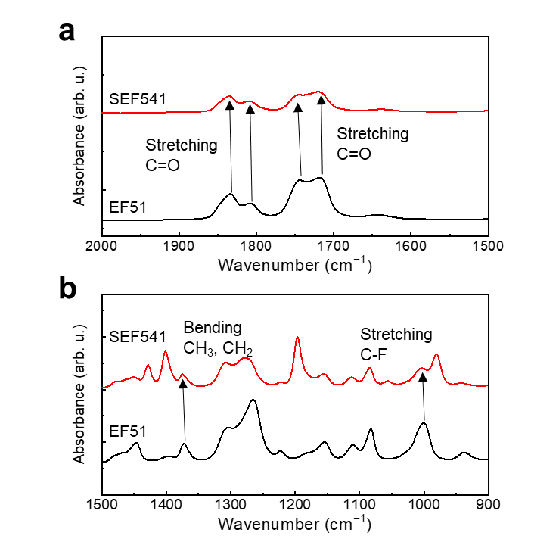
Supplementary Fig. 8 | Expanded FTIR spectra of EF51 and SEF541 electrolytes in selected regions. a, b, C=O stretching regions 1750–1700 cm⁻¹ (a) and 1850–1800 cm⁻¹ (b), showing blue shifts in SEF541.

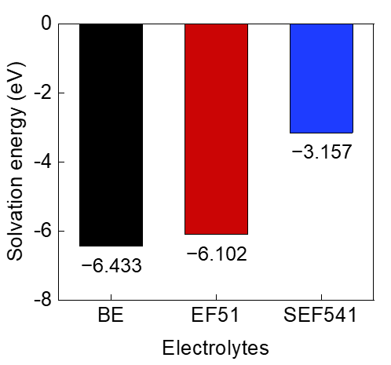
Supplementary Fig. 9 | Calculated Li⁺ solvation energies of different electrolytes. Li⁺ solvation energies of BE, EF51, SEF541 electrolytes.

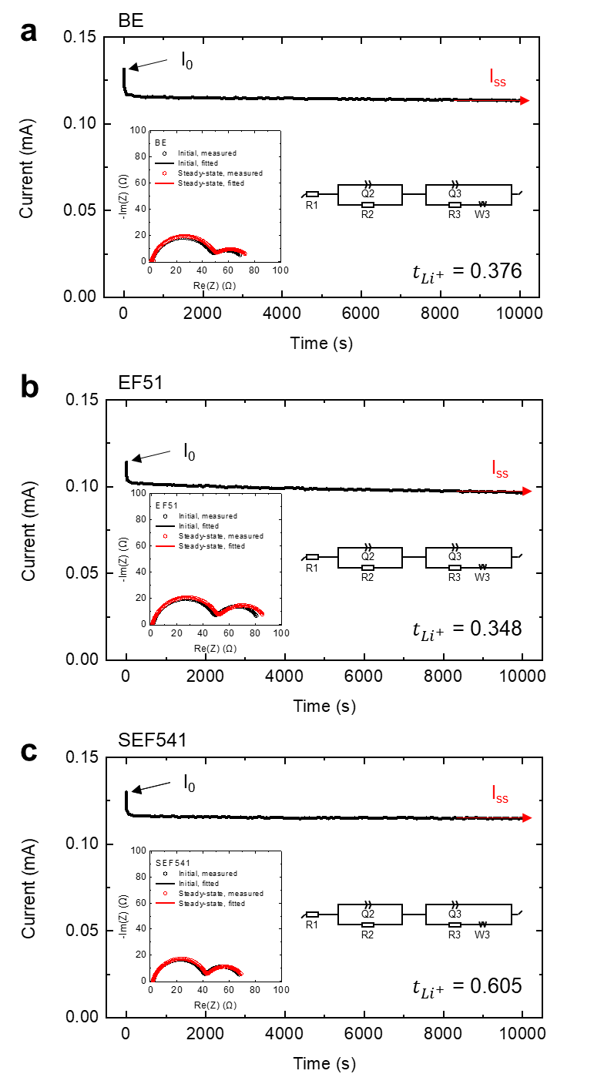
Supplementary Fig. 10 | Li⁺ transference number of different electrolytes at 30 ℃. a, BE, b, EF51, c, SEF541 electrolytes. Insets, corresponding Nyquist plots and equivalent circuits used for fitting. The parameters used for the Li⁺ transference number calculation and the corresponding EIS fitting errors are provided in Supplementary Table 2 and 3, respectively.
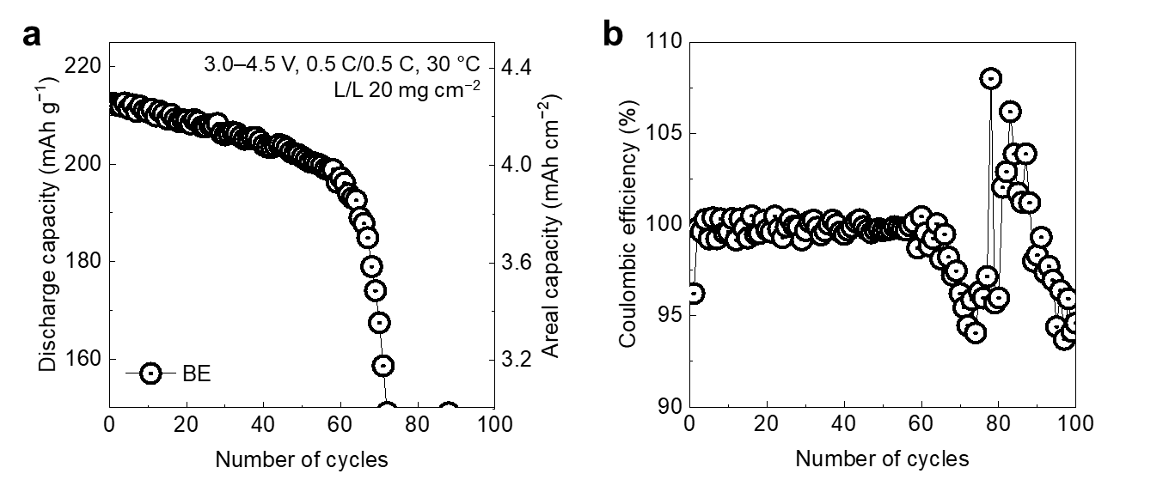
Supplementary Fig. 11 | Electrochemical performance of Li||FCG NCM78 cell. a, Cycling performance and areal capacity and b, corresponding Coulombic efficiency of the cells using BE electrolyte over a voltage range of 3.0–4.5 V at 0.5 C (90 mA g⁻¹)/0.5 C and 30 ℃.
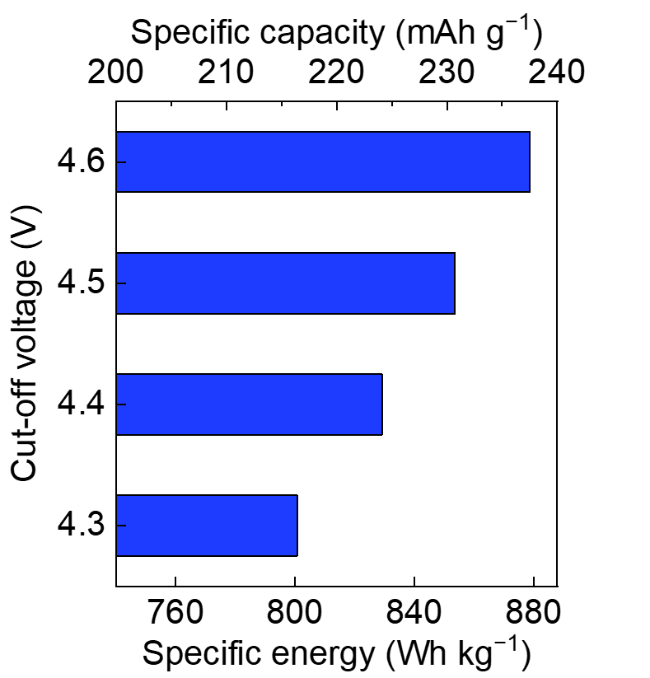
Supplementary Fig. 12 | Specific capacity and specific energy based on positive electrode active materials. Specific capacity and specific energy of Li||FCG NCM78 cells using SEF541 electrolyte at different upper cut-off voltages (4.3–4.6 V). The specific energy was calculated based on the mass of the positive-electrode active material using an average discharge voltage of 3.7 V.

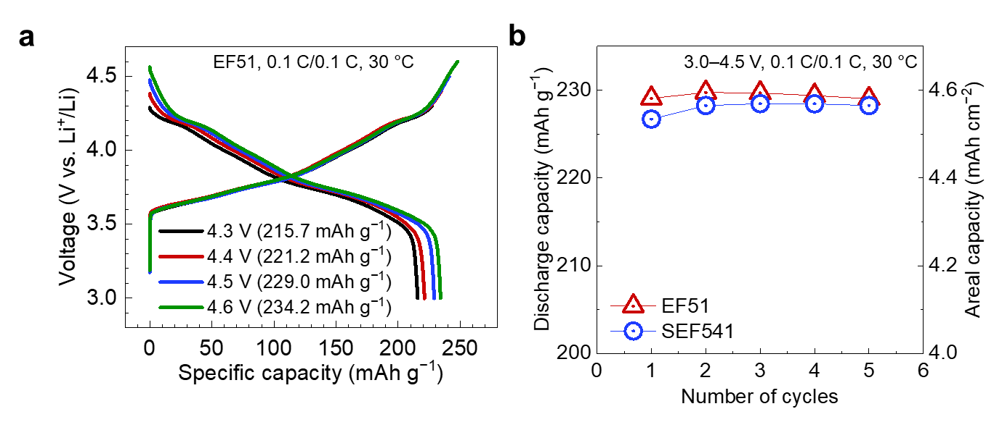
Supplementary Fig. 13 | Initial capacity evaluation of Li||FCG NCM78 cells. a, Charge–discharge voltage profiles of Li||FCG NCM78 cells using EF51 electrolyte at 0.1 C (18 mA g⁻¹) with different upper cut-off voltages ranging from 4.3 V to 4.6 V. b, Discharge capacities and areal capacities of Li||FCG NCM78 cells using EF51 and SEF541 electrolytes during formation cycles. Measurements were conducted at 0.1 C/0.1 C and 30 ℃.

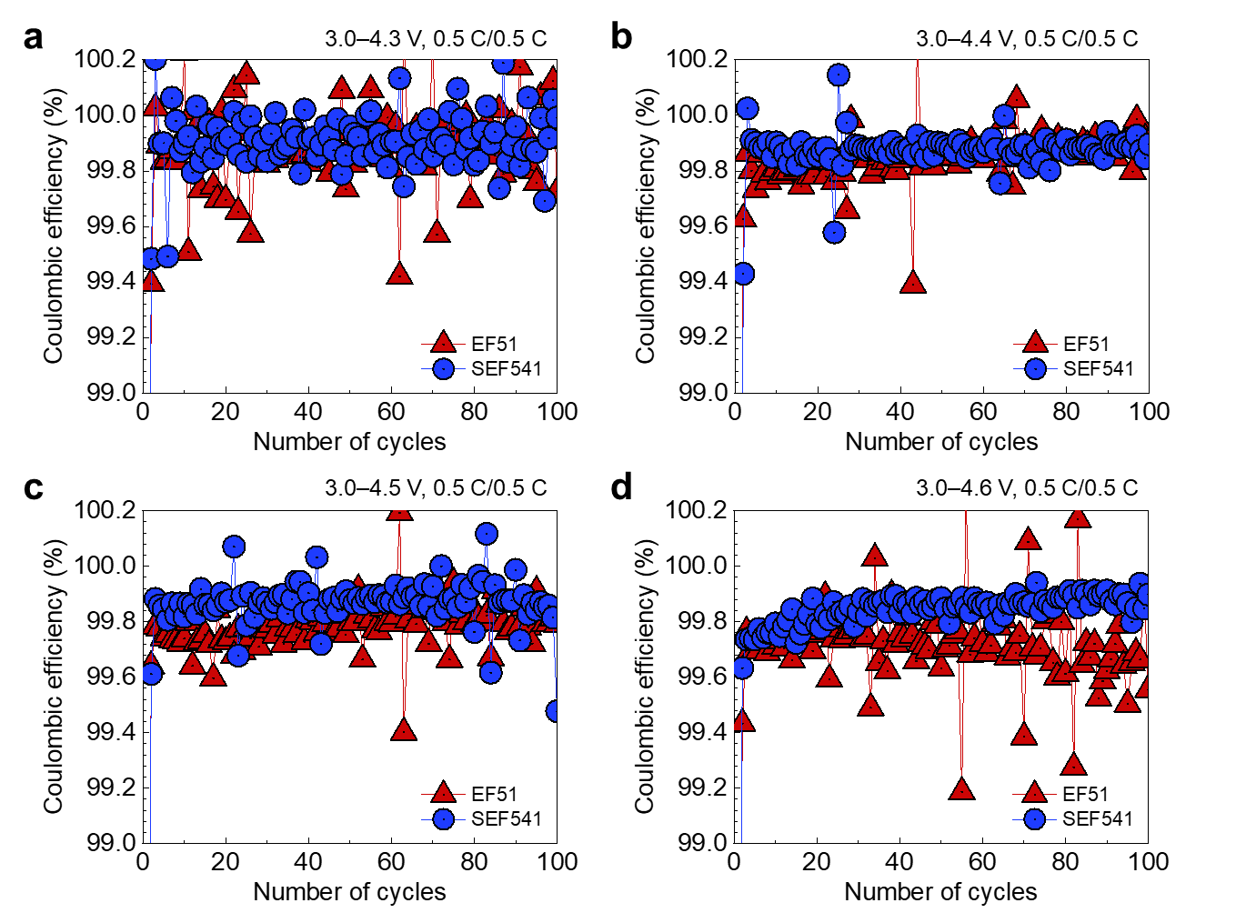
Supplementary Fig. 14 | Coulombic efficiencies of Li||FCG NCM78 cells at different upper cut-off potentials. a–d, Coulombic efficiencies of Li||FCG NCM78 cells using EF51 and SEF541 electrolytes over voltage ranges of 3.0–4.3 (a), 3.0–4.4 (b), 3.0–4.5 (c), and 3.0–4.6 V (d) at 0.5 C (90 mA g⁻¹)/0.5 C and 30 ℃.
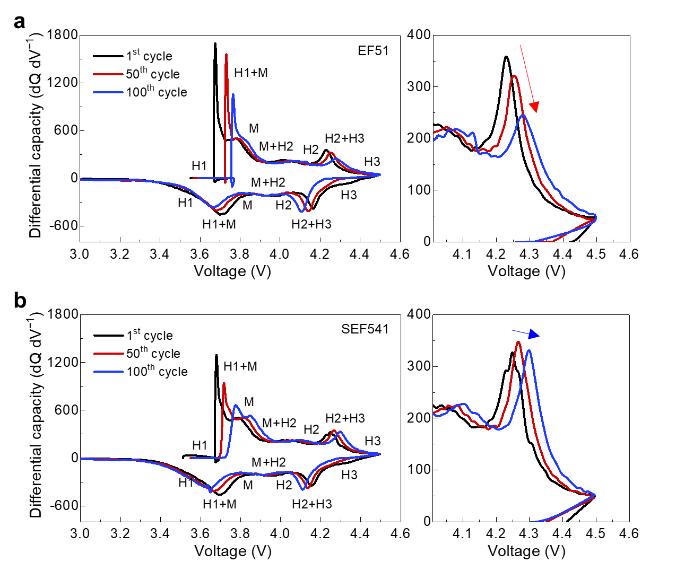
Supplementary Fig. 15 | Differential-capacity profiles of Li||FCG NCM78 cells during cycling. a,b, Differential capacity (dQ/dV) curves of Li||FCG NCM78 cells using EF51 (a) and SEF541 (b) electrolytes at the 1st, 50th, and 100th cycles.

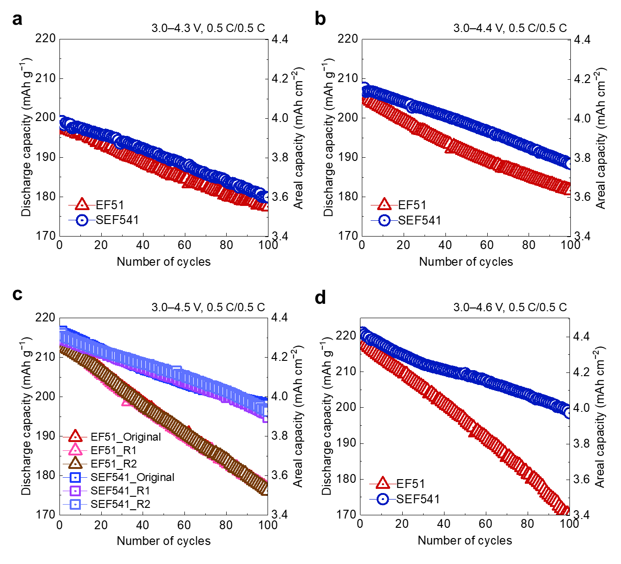
Supplementary Fig. 16 | High-voltage cycling performance and reproducibility of Li||FCG NCM78 cells. a–d, Electrochemical performance of Li||FCG NCM78 cells. Cycling performance and areal capacity of the cells using EF51 and SEF541 electrolytes over voltage ranges of 3.0–4.3 (a), 3.0–4.4 (b), 3.0–4.5 (c) and 3.0–4.6 V (d) at 0.5 C (90 mA g⁻¹)/0.5 C and 30 ℃. For the representative 3.0–4.5 V condition, the main-text cycling data are shown together with two independently reproduced cells for each electrolyte.

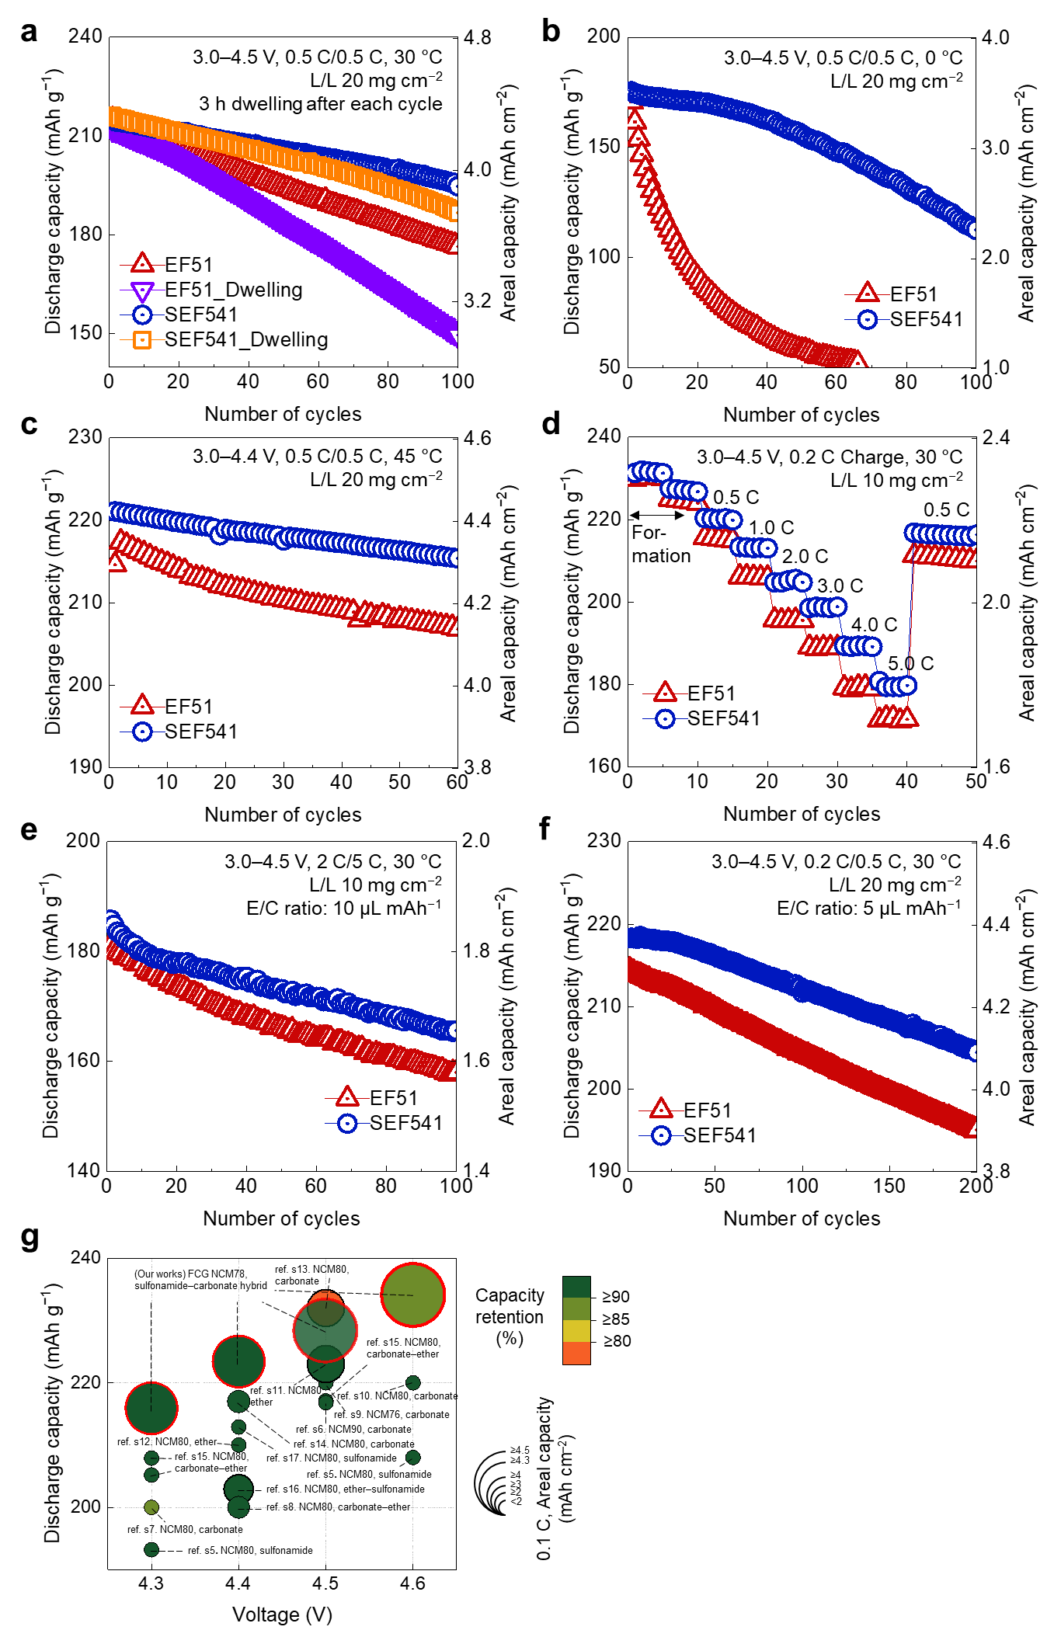
Supplementary Fig. 17 | Additional electrochemical performance data recorded under different dwell-time, temperature, and rate conditions. a–e, Dwell-time stability test (a), low-temperature cycling performance (b), high-temperature cycling performance (c), discharge rate capability test at different C-rates (d), and high-rate cycling performance (e) for the Li||FCG NCM78 cells prepared using EF and SEF electrolytes. f, Cycling performance of Li||FCG NCM78 cells prepared using lean EF51 and SEF541 electrolytes at E/C ratio of 5 µL mAh⁻¹. Unless otherwise specified, measurements were conducted at 30 °C, whereas panels b and c were measured at 0 and 45 ℃, respectively. Panel e and f were measured at 2 C (360 mA g⁻¹)/5 C (900 mA g⁻¹) and 0.2 C (36 mA g⁻¹)/0.5 C (90 mA g⁻¹), respectively. 1.0 C corresponds to a specific capacity of 180 mAh g⁻¹. The corresponding Coulombic efficiency data are provided in Supplementary Fig. 36. g, Comparison with previous studies using Ni-rich positive electrodes and high-voltage electrolytes. The sources of the literature data shown in this figure are provided in Supplementary Table 1.

Supplementary Note 1 | Electrochemical performance under demanding operating conditions. To verify the oxidative stability of the electrolyte under high-voltage conditions, a dwell-time test was conducted in which the voltage was held at 4.5 V for 3 h after each charge process (Supplementary Fig. 17a). The SEF541-based cell exhibited enhanced capacity retention compared to the EF51-based cell. Notably, while the EF51-based cell showed a significant decline in capacity retention compared with that observed under standard cycling conditions (10 min rest), the SEF541-based cell exhibited a marginal difference. This improvement indicates that the DSF-derived CEI layer effectively mitigated continuous electrolyte decomposition, even under prolonged exposure to high-voltages. Additionally, stable cycling behavior was maintained at an elevated temperature of 45 ℃ (Supplementary Fig. 17c), suggesting that the protective efficacy of the preemptive passivation layer remained robust, even at higher temperatures.
The SEF541 electrolyte also demonstrated improved rate capability compared with the EF51 electrolyte across a wide range of current densities from 0.2 (36 mA g⁻¹) to 5.0 C (900 mA g⁻¹) (Supplementary Fig. 17d). This improvement, despite the relatively lower ionic conductivity of SEF541, suggests that the high-rate behavior is not governed solely by bulk ion conduction. Rather, it is consistent with the combined effects of the CIP-dominant weakly solvating structure and reduced interfacial resistance (Supplementary Fig. 37), which support more favorable transport and interfacial kinetics in the SEF541-based cells^{1,2}. Furthermore, high rate cycling results showed the improved cycling stability of SEF541 electrolyte compared with the EF51 electrolyte. (Supplementary Fig. 17e)
The CIP-rich weakly solvating structure of SEF541 can promote Li⁺ desolvation at the electrode interface, while its higher Li⁺ transference number indicates a larger Li⁺ contribution to ionic conduction. Together with the reduced interfacial resistance growth observed during cycling (Supplementary Fig. 37), these transport and interfacial characteristics support the improved high-rate behavior of the SEF541-based cells.
Furthermore, the SEF541 electrolyte showed stable cycling performance at a low temperature of 0 ℃, a condition where ionic conductivity typically decreases and interfacial resistance increases (Supplementary Fig. 17b and Supplementary Fig. 37). The improved kinetics at low temperatures are likely driven by the synergistic effect of the weakly solvating structure^{3,4}, which supports facile desolvation, and by the LiF-rich CEI, which reduces interfacial resistance.
The applicability of the SEF541 electrolyte was further validated under lean electrolyte conditions (E/C ratio = 5 μL mAh⁻¹) (Supplementary Fig. 17f). The cell exhibited stable capacity retention, confirming that the formed interphase effectively suppressed continuous electrolyte consumption. As summarized in Supplementary Fig. 17g and Supplementary Table 1, compared with selected recent reports on Ni-rich positive electrode and high-voltage electrolytes, the SEF541-based cell delivers relatively high specific capacities while maintaining high capacity retention within the upper cut-off voltage range of 4.3–4.6 V, even under high areal capacity conditions.

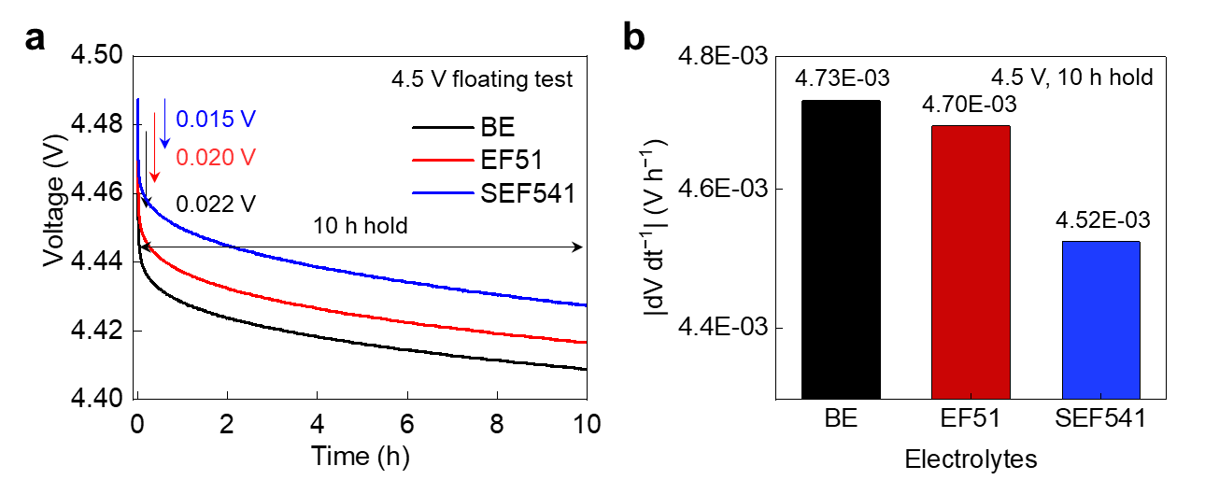
Supplementary Fig. 18 | High-voltage floating behavior of Li||FCG NCM78 cells. a, b, Floating test profiles (a) and voltage decay over 10 h (b) of Li||FCG NCM78 cells using different electrolytes held at 4.5 V. All cells were evaluated in the charged state.

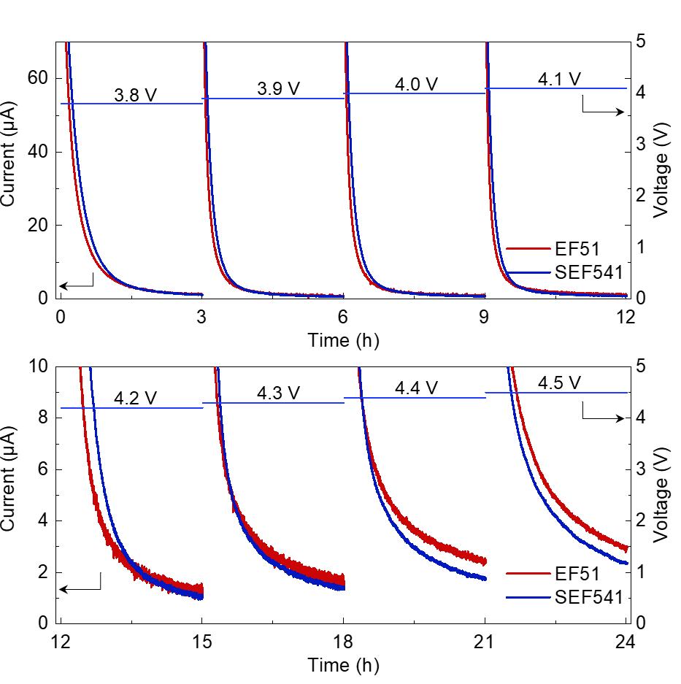
Supplementary Fig. 19 | Voltage-dependent leakage-current response of Li||FCG NCM78 cells. Leakage current profiles of Li||FCG NCM78 cells using EF51 and SEF541 electrolytes during stepwise voltage holds from 3.8 to 4.5 V at 0.1 V interval, with each voltage held for 3 h.

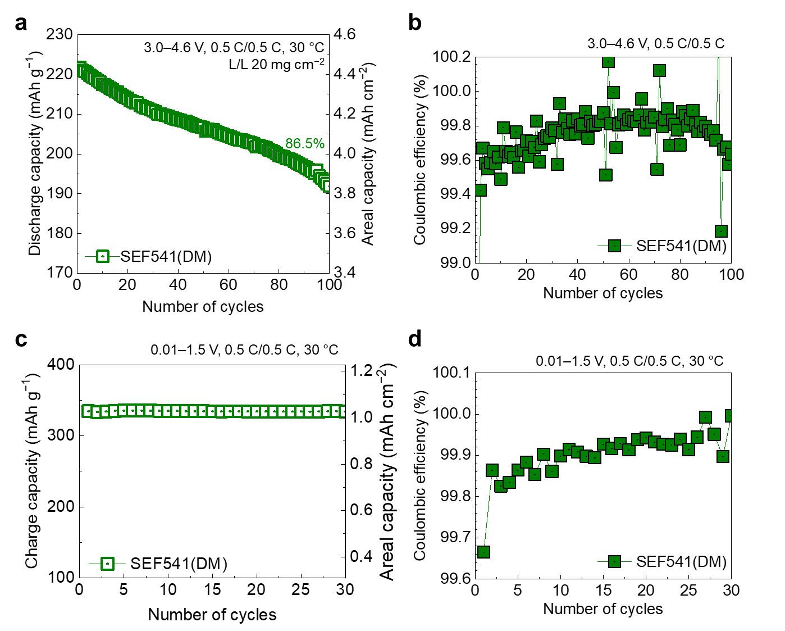
Supplementary Fig. 20 | Electrochemical performance of a DM-based sulfamoyl–carbonate hybrid electrolyte. The electrolyte (SEF541 (DM)) consisted of 1 M LiPF₆ dissolved in N,N-dimethyl trifluoromethanesulfonamide (DM), EMC, and fluoroethylene carbonate (FEC) (5:4:1, v/v/v). a,b, Cycling performance (a) and corresponding Coulombic efficiency (b) of the Li|| FCG NCM78 cell using SEF541 (DM) electrolytes over voltage ranges of 3.0–4.6 V at 0.5 C (90 mA g⁻¹)/0.5 C and 30 ℃. c,d, Cycling performance (c) and corresponding Coulombic efficiency (d) of the Li||graphite cell using SEF541 (DM) electrolytes over a voltage range of 0.01–1.5 V at 0.5 C (180 mA g⁻¹)/0.5 C and 30 ℃.

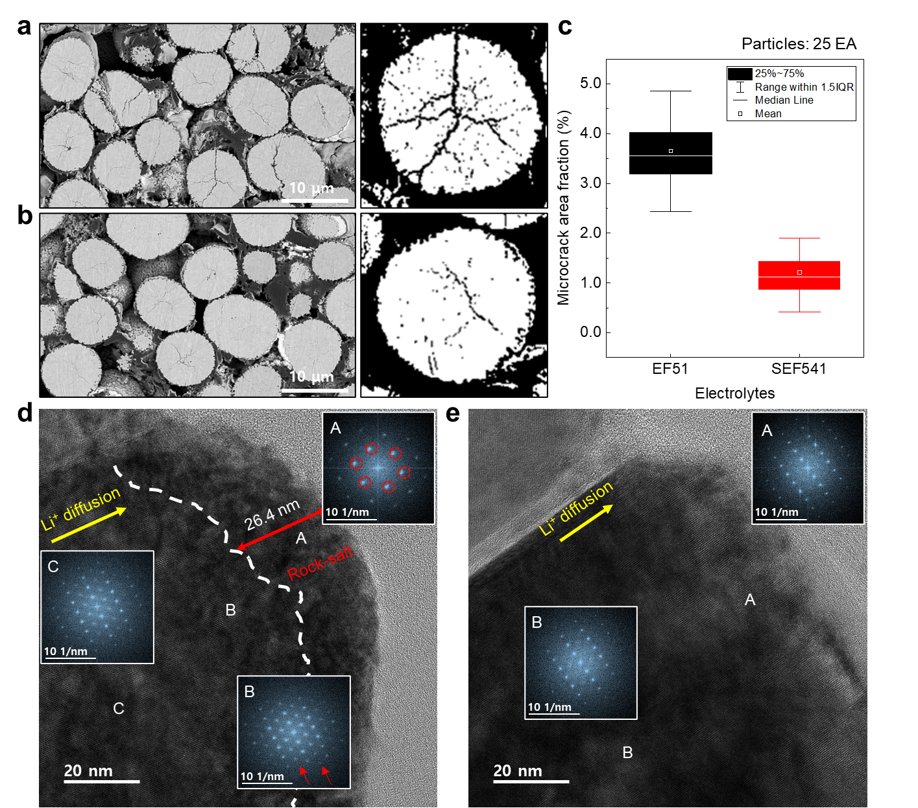
Supplementary Fig. 21 | Postmortem analysis of the NCM morphology. a, b, Cross-sectional SEM images of the FCG NCM78 positive electrodes after 100 cycles in EF51 (a) and SEF541 (b) electrolytes over a voltage range of 3.0–4.5 V. c, Box-and-whisker plots of the microcrack area fractions in NCM particles shown in (a) and (b). The center line indicates the median, box limits indicate the 25th and 75th percentiles, whiskers indicate 1.5× the interquartile range, and squares denote mean values. n = 25 particles for each electrolyte. d, e, HR-TEM images of the FCG NCM78 positive electrodes after 100 cycles in EF51 (d) and SEF541 (e) electrolytes under identical conditions. Insets, corresponding Fourier-transformed patterns of selected regions.

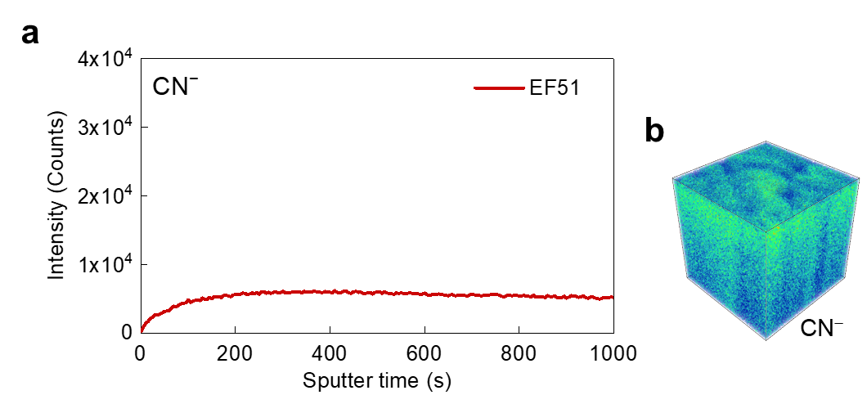
Supplementary Fig. 22 | ToF-SIMS analysis of CN⁻ fragments on cycled FCG NCM78 positive electrodes. a,b, ToF-SIMS depth profiles of selected secondary ion fragments (a) and corresponding 3D spatial distribution images of the CN⁻ species (b). All analyses were performed using charged FCG NCM78 cathodes after 100 cycles over a voltage range of 3.0–4.5 V.

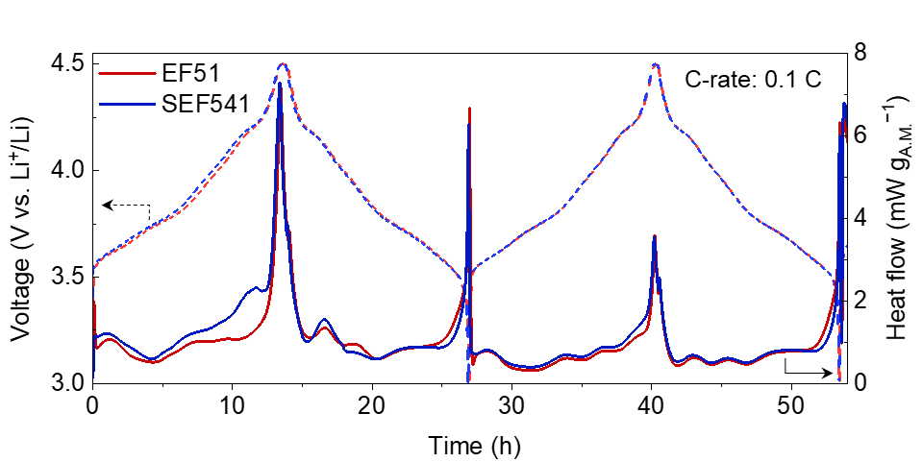
Supplementary Fig. 23 | Isothermal microcalorimetry of Li||FCG NCM78 cells during the initial cycles. IMC analysis for Li||FCG NCM78 cells using EF51 and SEF541 during the initial two cycles at 0.1 C (18 mA g⁻¹).

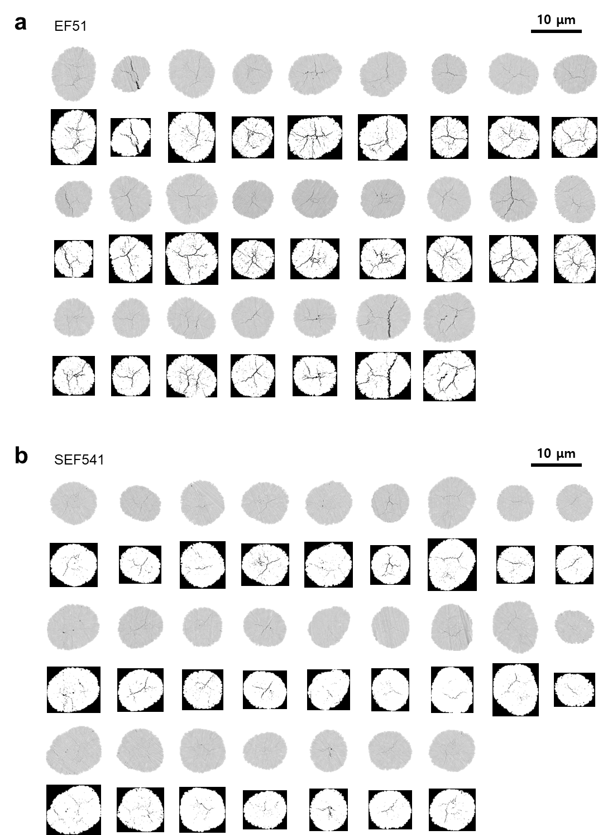
Supplementary Fig. 24 | Cross-sectional SEM analysis of cycled FCG NCM78 positive electrodes. a,b, Cross-sectional SEM images (top) and corresponding inverted grayscale images generated by ImageJ (bottom) of the FCG NCM78 cathodes after 100 cycles with EF51 (a) and SEF541 (b) electrolytes.

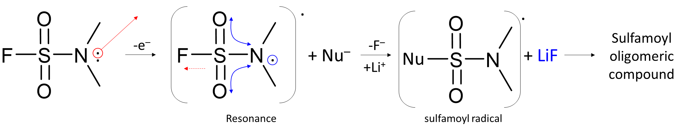
Supplementary Fig. 25 | Proposed electrochemical oxidation mechanism of DSF. The mechanism illustrates the formation of a sulfamoyl radical cation via resonance stabilization and the subsequent release of F⁻ to form LiF and sulfamoyl oligomeric compounds.

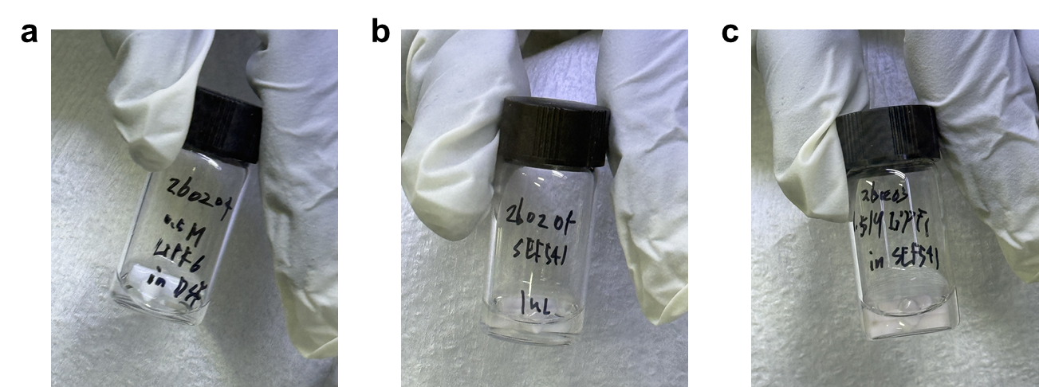
Supplementary Fig. 26 | LiPF₆ solubility in DSF and SEF541 formulations. a–c, Comparison of the photographs dissolving Li-salt depending on electrolyte compositions. 0.5 M LiPF₆ in DSF (a), SEF541 (b), 1.5 M LiPF₆ in SEF541 (c).

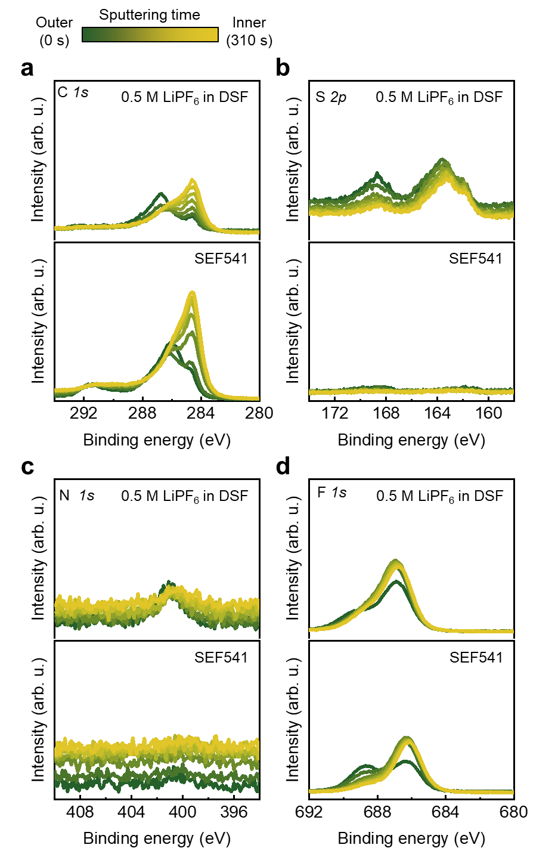
Supplementary Fig. 27 | XPS depth profiles of graphite negative electrodes after the initial formation cycle. a–d, XPS spectra of the graphite negative electrode retrieved from Li||graphite cells using 0.5 M LiPF₆ in DSF and SEF541 electrolytes after the first formation cycle. C 1s (a), S 2p (b), N 1s (c), and F 1s (d) depth profiles.
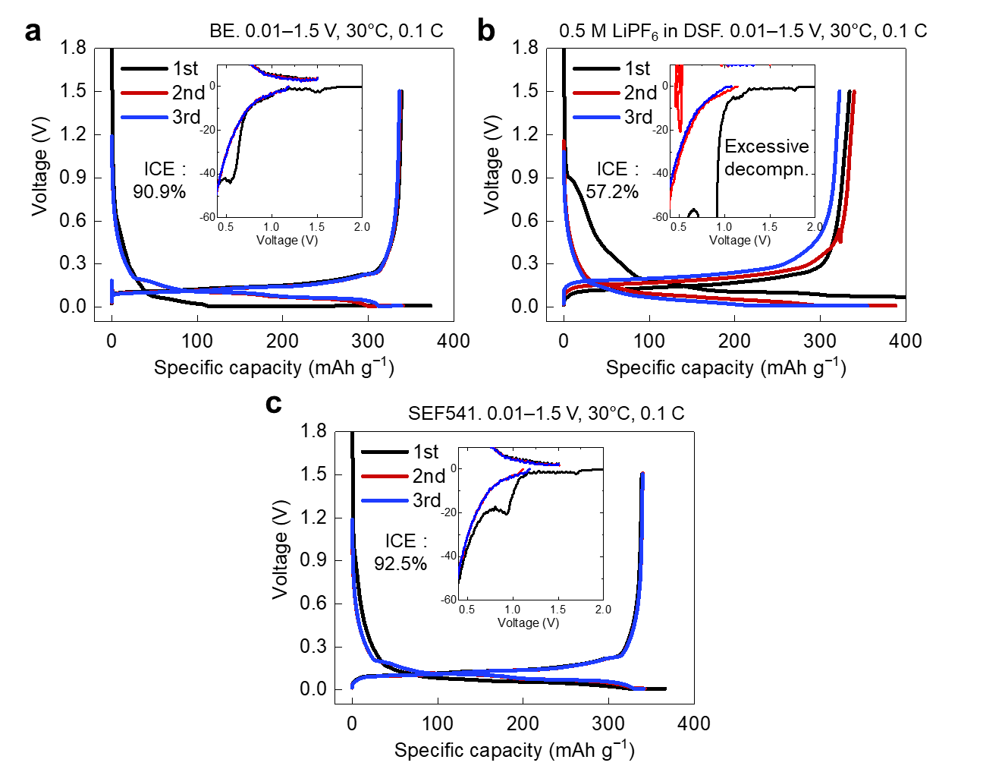
Supplementary Fig. 28 | Initial voltage and differential-capacity profiles of Li||graphite cells. a–c, Voltage profiles of Li||graphite half-cells using BE (a), 0.5 M LiPF₆ in DSF (b), and SEF541 (c) electrolytes during the formation cycles at 0.1 C (36 mA g⁻¹)/0.1 C and 30 ℃. Insets, the magnified views of the corresponding dQ/dV for initial solvent decomposition region.

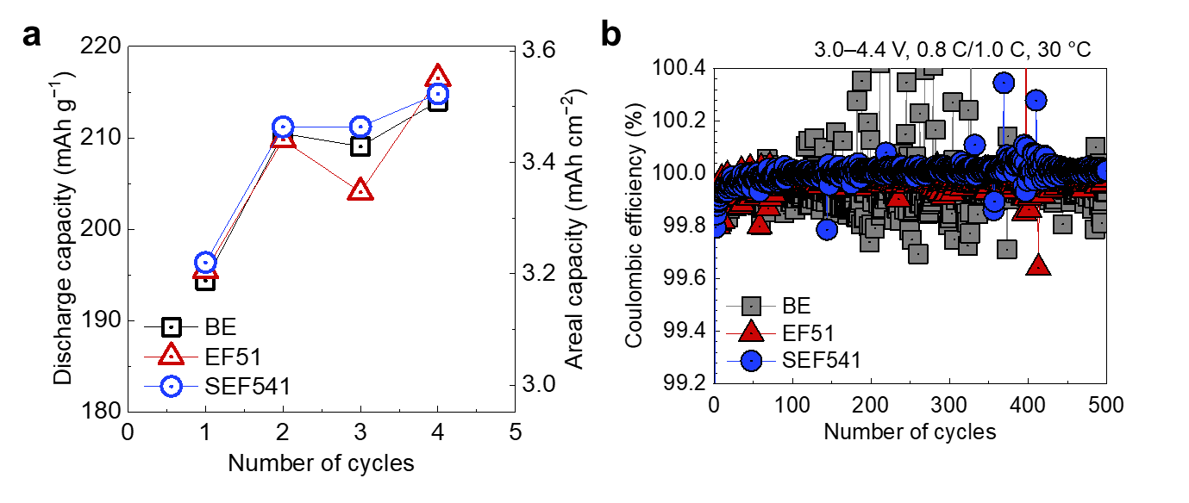
Supplementary Fig. 29 | Formation cycle capacities and Coulombic efficiencies of graphite||FCG NCM78 pouch-type full cells. a, Discharge capacities and areal capacities of graphite||FCG NCM78 pouch-type full cells using BE, EF51 and SEF541 electrolyte during formation cycles. b, Coulombic efficiency of corresponding cells during cycling over a voltage range of 3.0–4.4 V at 0.8 C (144 mA g⁻¹)/1.0 C (180 mA g⁻¹) and 30 ℃.

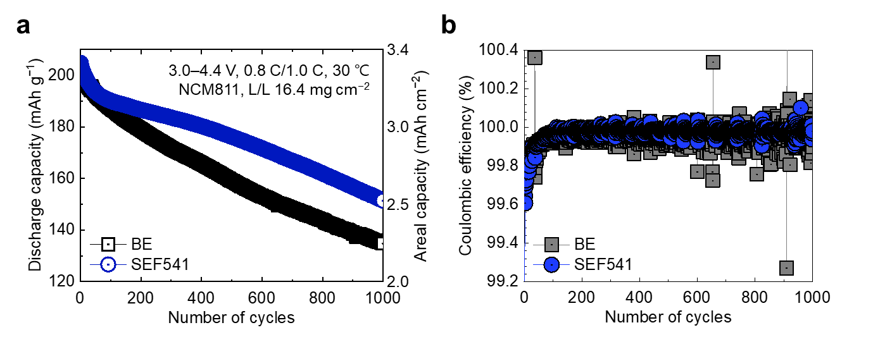
Supplementary Fig. 30 | Electrochemical performance of graphite||NCM811 pouch-type full cells. Electrochemical performance of graphite||NCM811 pouch-type full cells. a,b, Cycling performance and areal capacity (a) and corresponding Coulombic efficiency (b) of the cells using BE and SEF541 electrolytes at 0.8 C (144 mA g⁻¹)/1.0 C (180 mA g⁻¹) and 30 ℃.

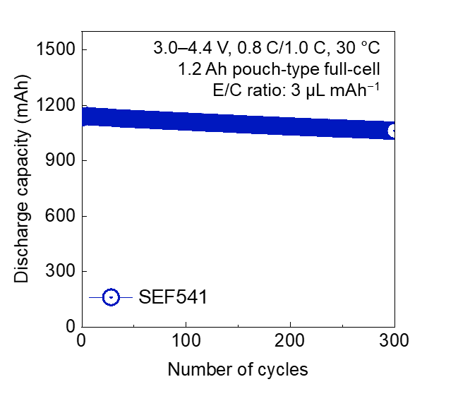
Supplementary Fig. 31 | Cycling performance of a 1.2 Ah graphite||NCM811 pouch-type full cell. Electrochemical performance of 1.2 Ah graphite||NCM811 pouch-type full cell prepared using SEF541 electrolyte over a voltage range of 3.0–4.4 V at 0.8 C (144 mA g⁻¹)/1.0 C (180 mA g⁻¹) and 30 ℃.

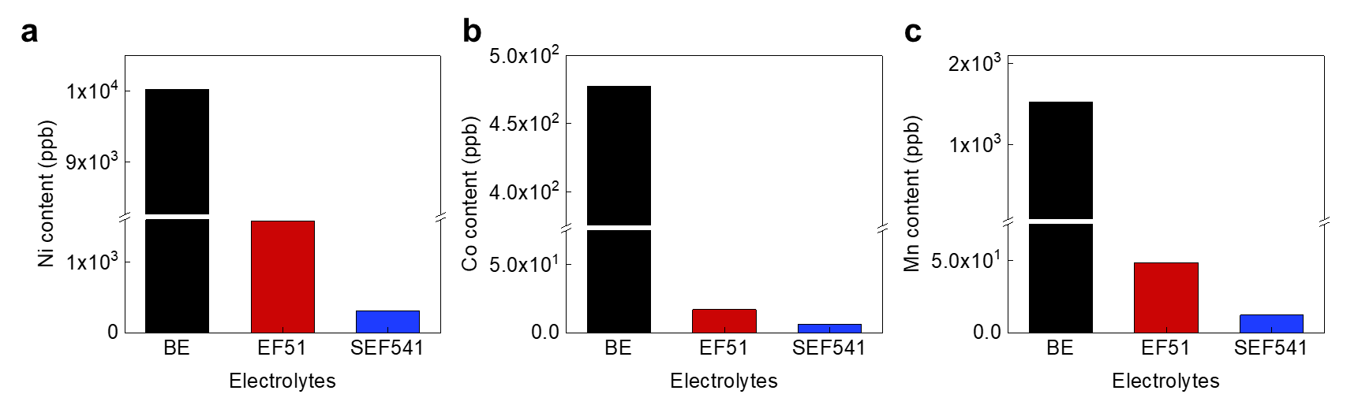
Supplementary Fig. 32 | Transition-metal deposition on cycled graphite negative electrodes quantified by ICP-MS. a–c, Amount of TM deposited on the graphite negative electrode after 500 cycles in pouch-type full cells with different electrolytes, determined by ICP-MS analysis. Ni (a), Co (b), Mn (c).

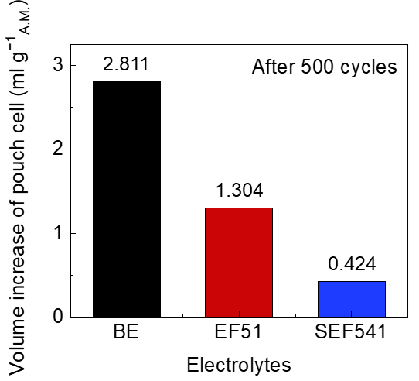
Supplementary Fig. 33 | Pouch-cell swelling after high-voltage cycling. Gas evolution of pouch-type full cell using different electrolytes during cycling.

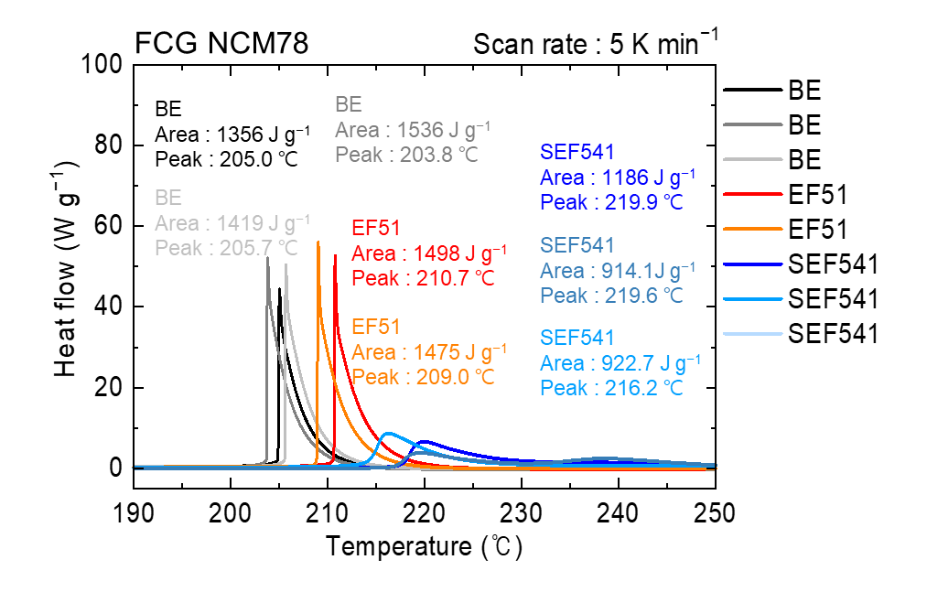
Supplementary Fig. 34 | Differential scanning calorimetry of charged FCG NCM78 positive electrodes with different electrolytes. DSC thermograms of delithiated FCG NCM78 positive electrode charged to 4.5 V in the presence of BE, EF51, and SEF541 electrolytes. The inset values indicate the total heat generation and peak temperatures.

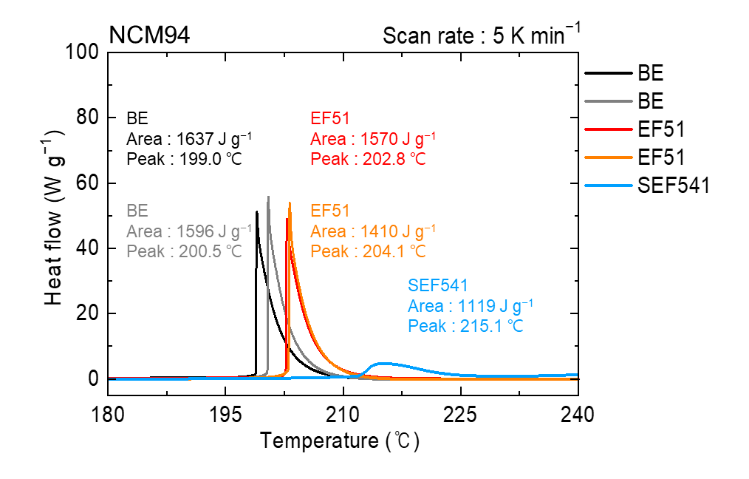
Supplementary Fig. 35 | Differential scanning calorimetry of charged NCM94 positive electrodes with different electrolytes. DSC thermograms of delithiated NCM94 cathodes charged to 4.3 V in the presence of BE, EF51, and SEF541 electrolyte.

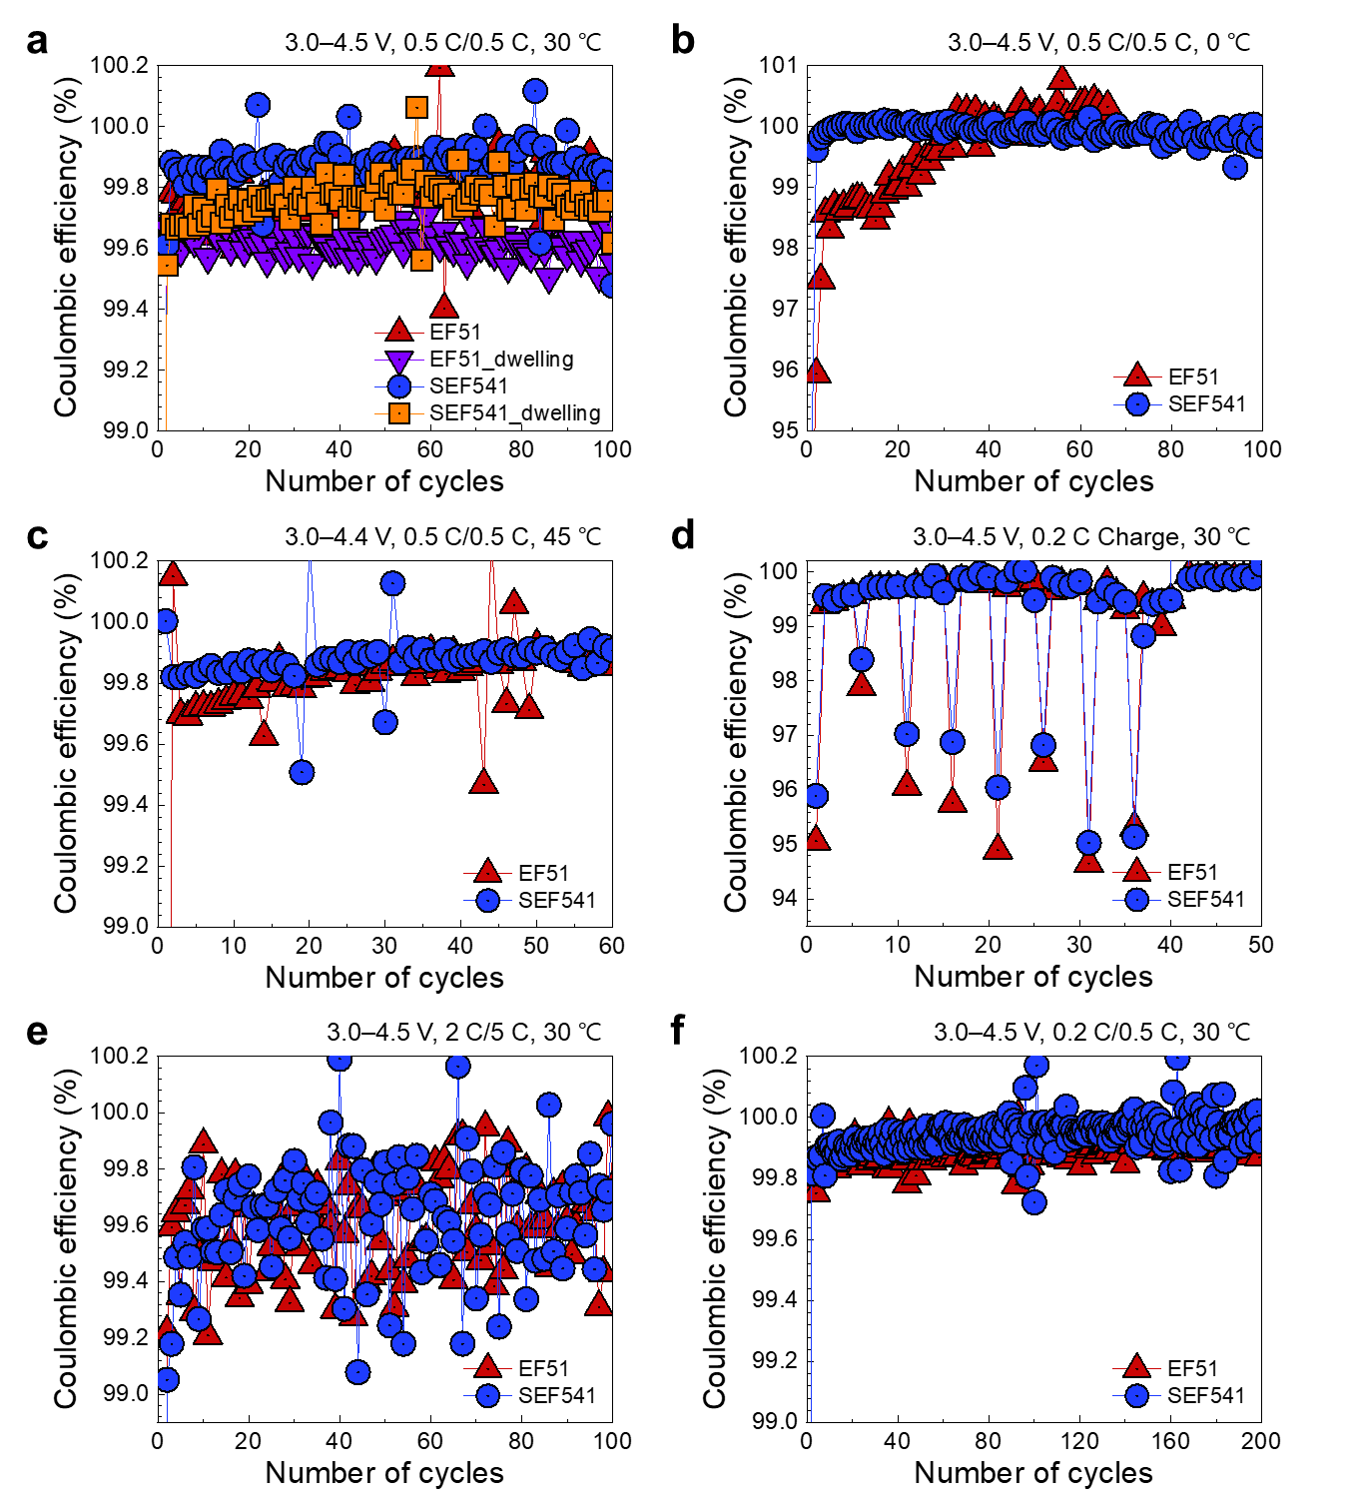
Supplementary Fig. 36 | Coulombic efficiencies of Li||FCG NCM78 cells under demanding operating conditions. a–f, Coulombic efficiencies of Li||FCG NCM78 cells using EF51 and SEF541 electrolyte under different dwell-time, temperature, and rate conditions. Dwell-time stability test (a), low-temperature cycling performance (b), high-temperature cycling performance (c), discharge rate capability test at different C-rates (d), high-rate cycling performance (e), and lean electrolyte test (f). Unless otherwise specified, measurements were conducted at 30 °C, whereas panels b and c were measured at 0 and 45 ℃, respectively. Panel e and f were measured at 2 C (360 mA g⁻¹)/5 C (900 mA g⁻¹) and 0.2 C (36 mA g⁻¹)/0.5 C (90 mA g⁻¹), respectively. 1.0 C corresponds to a specific capacity of 180 mAh g⁻¹.

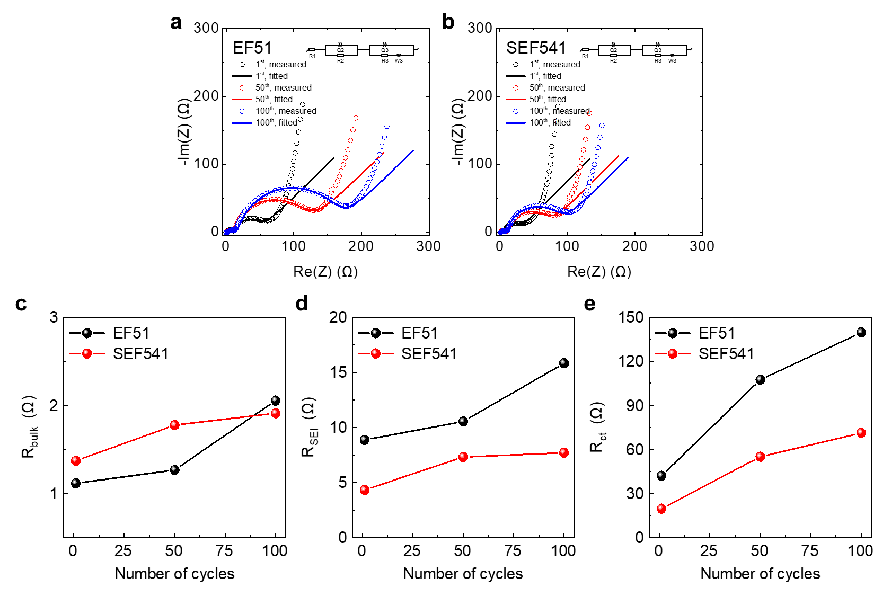
Supplementary Fig. 37 | Electrochemical impedance spectroscopy of Li||FCG NCM78 cells during cycling. a–e, Electrochemical impedance spectroscopy measurements of Li||FCG NCM78 cells with EF51 and SEF541 electrolyte during cycling at 30 ℃. Nyquist plots (a, b), Bulk resistance (R_{bulk}) (c), SEI resistance (R_{SEI}) (d), charge-transfer resistance (R_{ct}) (e) for different electrolytes. Insets, equivalent circuits used for fitting. The corresponding EIS fitting errors are provided in Supplementary Table 3.
Supplementary Table 1 | Comparison of this work with selected recent studies using Ni-rich positive electrodes and high-voltage electrolytes. Specific and areal capacities are reported at 0.1 C. Positive electrode materials and electrolyte compositions are presented at material columns. Reported test condition of used voltage range and C-rate and cycle retentions are also provided.
No. | Positive electrode material |  |  | Electrolyte |  | Test condition |  |  | Results |  | Ref. No.
No. | Mater. | Specific Capa.  (0.1 C,  mAh g^{–1}) | Areal Capa.  (mAh cm^{–2}) | Mater.  (full) | Voltage range  (V) |  | Char.  C-rate  (C) | Dischar.  C-rate  (C) | Cycle # |  | Ref. No.
Our works | FCG NCM78 | 215.9 | 4.32 (@0.1 C) | 1 M LiPF₆ in  DSF:EMC:FEC  (5:4:1, v/v/v) | 3.0–4.3 |  | 0.5 | 0.5 | 100  (90.3%)
Our works | FCG NCM78 | 223.4 | 4.47 (@0.1 C) | 1 M LiPF₆ in  DSF:EMC:FEC  (5:4:1, v/v/v) | 3.0–4.4 |  | 0.5 | 0.5 | 206  (81.5%) | 100  (90.7%)
Our works | FCG NCM78 | 228.3 | 4.57 (@0.1 C) | 1 M LiPF₆ in  DSF:EMC:FEC  (5:4:1, v/v/v) | 3.0–4.5 |  | 0.5 | 0.5 | 175  (82.8%) | 100  (90.6%)
Our works | FCG NCM78 | 234.1 | 4.68 (@0.1 C) | 1 M LiPF₆ in  DSF:EMC:FEC  (5:4:1, v/v/v) | 3.0–4.6 |  | 0.5 | 0.5 | 121  (84.8%) | 100  (89.8%)
1 | NCM80 | 193.2 | 1.80 (@0.1 C) | 1.6 M LiFSI in AzTFSA | 2.8–4.3 |  | 0.5 | 0.5 | 150  (80.0%) | 100  (92.1%) | 5
1 | NCM80 | 208.0 | 1.94 (@0.1 C) | 1.6 M LiFSI in AzTFSA | 2.8–4.6 |  | 0.5 | 0.5 | 100  (92.0%) |  | 5
2 | NCM90 | 216.8 | 0.98 (@0.1 C) | 1 M LiPF₆ in EC:DEC (3:7, w/w) +2 wt.% FBSN | 3.0–4.5 |  | 1.0 | 1.0 | 200  (83.1%) | 100  (93.3%) | 6
3 | NCM80 | 200.0 | 0.70 (@0.1 C) | 1 M LiPF₆ in BMEC  + 3 vol.% FEC | 2.7–4.3 |  | 0.5 | 0.5 | 197  (78.7%) | 100  (88.0%) | 7
4 | NCM80 | 200.0 | 2.00 (@0.1 C) | 1M LiFPF₆ in FEC:FEMC:HFE (2:6:2, w/w/w) | 3.0–4.4 |  | 0.5 | 0.5 | 450  (90.0%) | 100  (103.4%) | 8
5 | NCM76 | 220.0 | 0.88 (@0.1 C) | 0.6 M LiTFSI + 0.4 M LiBOB + 0.05 M LiPF₆ in EC:EMC  (4:6, w/w) | 3.0–4.5 |  | 2.0 | 2.0 | 1000  (86.2%) | 100  (95.3%) | 9
6 | NCM80 | 220.0 | 0.53 (@0.1 C) | 3.1 M LiPF₆ in EC:EMC  (3:7, w/w) | 3.0–4.6 |  | 1.0 | 1.0 | 500  (77.0%) | 100  (92.2%) | 10
7 | NCM80 | 223.0 | 4.20 (@0.1 C) | LiFSI-1.2DME-3TTE  (in molar ratio) | 3.0–4.5 |  | 0.33 | 0.33 | 250  (82.0%) | 100  (94.4%) | 11
8 | NCM80 | 210.0 | 1.50 (@0.1 C) | 1 M LiFSI in DME/TFEO  (1:9, w/w) | 3.0–4.4 |  | 0.33 | 0.33 | 300  (80.0%) | 100  (99.9%) | 12
9 | NCM80 | 232.0 | 4.00 (@0.1 C) | 1 M LiPF₆ in FEC:EMC  (3:7, v/v)  + 3 wt.% LiNO₃  + 1 wt.% TPFPB | 3.0–4.5 |  | 0.2 | 0.33 | 100  (75.4%) |  | 13
10 | NCM80 | 217.0 | 2.39 (@0.1 C) | 1 M LiPF₆ in ETFEC:PFPN:FEC (3.8:3.8:0.4, mol.%) | 3.0–4.4 |  | 0.3 | 0.5 | 200  (85%) | 100  (95.2%) | 14
11 | NCM80 | 205.2 | 0.41 (@0.1 C) | 1.0 M LiFSI in FEC:FEMC:DME (3:3:2 v/v/v)  + 0.5 wt.% LiNO₃ | 3.0–4.3 |  | 1.0 | 1.0 | 500  (80.0%) | 100  (95.1%) | 15
11 | NCM80 | 207.9 | 1.46  (@0.1 C) |  |  |  |  |  | 189  (83.5%) | 100  (90.3%) | 15
11 | NCM80 | 217.1 | 0.43 (@0.1 C) | 1.0 M LiFSI in FEC:FEMC:DME (3:3:2 v/v/v)  + 0.5 wt.% LiNO₃ | 3.0–4.5 |  | 1.0 | 1.0 | 300  (79.2%) | 100  (91.0%) | 15
12 | NCM80 | 202.9 | 3.40 (@0.1 C) | 1 M LiFSI in DME:NFS  (1:3, mol.%) | 2.8–4.4 |  | 0.2 | 0.5 | 200  (90.0%) | 100  (97.2%) | 16
13 | NCM80 | 212.9 | 2.50 (@0.1 C) | 1 M LiFSI in TFSPY | 2.8–4.4 |  | 0.2 | 0.5 | 300  (95.0%) | 100  (99.7%) | 17

Supplementary Table 2 | Parameters used to calculate the Li⁺ transference number of different electrolytes at 30 °C using the Bruce–Vincent method. ΔV denotes the applied polarization voltage, while I₀ and I_{ss} are the initial and steady-state currents, respectively. R₀ and R_{ss} refer to the total fitted resistances obtained from EIS measurements before and after 8000 s of polarization, respectively, and t_{Li+} is the calculated Li⁺ transference number.
Electrolytes | ΔV  (mV) | I₀  (mA) | I_{ss}  (mA) | R₀  (Ω) | R_{ss}  (Ω) | $$t_{{Li}^{+}}$$
BE | 10 | 0.13157 | 0.11383 | 71.724 | 76.454 | 0.376
EF51 | 10 | 0.11411 | 0.09771 | 83.560 | 90.637 | 0.348
SEF541 | 10 | 0.12998 | 0.11501 | 66.992 | 70.510 | 0.605

Supplementary Table 3 | Fitted resistance parameters and EIS fitting errors. Values are reported as the fitted value ± standard error. R_{bulk}, R_{SEI} and R_{ct} denote the bulk, interphase and charge-transfer resistances, respectively.
Figure | Measurement | Electrolyte | State  /cycle | R_{bulk}  ± standard error  (Ω) | R_{SEI}  ± standard error  (Ω) | R_{ct}  ± standard error  (Ω)
Supplementary Fig. 10 | Li⁺  transference number | BE | Initial | 1.134±0.05 | 45.64±3.40 | 24.95±2.65
Supplementary Fig. 10 | Li⁺  transference number | BE | Steady-state | 1.284±0.04 | 47.21±1.14 | 27.96±2.00
Supplementary Fig. 10 | Li⁺  transference number | EF51 | Initial | 1.3±0.03 | 48.74±0.30 | 33.52±0.17
Supplementary Fig. 10 | Li⁺  transference number | EF51 | Steady-state | 1.377±0.03 | 49.56±0.31 | 39.7±0.85
Supplementary Fig. 10 | Li⁺  transference number | SEF541 | Initial | 1.432±0.11 | 39.99±0.38 | 25.57±0.47
Supplementary Fig. 10 | Li⁺  transference number | SEF541 | Steady-state | 1.48±0.13 | 41.69±2.12 | 27.34±1.99
Supplementary Fig. 37 | Cycling EIS | EF51 | 1st | 1.114±0.19 | 8.852±0.76 | 41.97±1.20
Supplementary Fig. 37 | Cycling EIS | EF51 | 50th | 1.266±0.38 | 10.53±1.15 | 107.4±1.26
Supplementary Fig. 37 | Cycling EIS | EF51 | 100th | 2.053±0.46 | 15.81±1.71 | 139.6±1.41
Supplementary Fig. 37 | Cycling EIS | SEF541 | 1st | 1.37±1.00 | 4.308±6.10 | 19.64±5.79
Supplementary Fig. 37 | Cycling EIS | SEF541 | 50th | 1.775±0.10 | 7.303±0.45 | 54.99±0.57
Supplementary Fig. 37 | Cycling EIS | SEF541 | 100th | 1.91±0.23 | 7.686±0.77 | 71.16±0.69

References
1. Zhang, X. et al. Li⁺(ionophore) nanoclusters engineered aqueous/non-aqueous biphasic electrolyte solutions for high-potential lithium-based batteries. Nat. Nanotechnol. 20, 798–806 (2025).
2. Yao, Y. X. et al. Regulating Interfacial Chemistry in Lithium-Ion Batteries by a Weakly Solvating Electrolyte. Angew. Chem. Int. Ed. 60, 4090–4097 (2021).
3. Yang, Y. et al. Synergy of Weakly-Solvated Electrolyte and Optimized Interphase Enables Graphite Anode Charge at Low Temperature. Angew. Chem. Int. Ed. 61, e20228345 (2022).
4. Piao, N. et al. Designing Temperature-Insensitive Solvated Electrolytes for Low-Temperature Lithium Metal Batteries. J. Am. Chem. Soc. 146, 18281–18291 (2024).
5. Pompizii, L. et. al. Solvation Structure Engineering of Weakly Coordinating Sulfonamide Electrolytes for 4.6 V Lithium Metal Batteries. ACS Energy Lett. 10, 246–253 (2025).
6. Zou, Y. et. al. Self-repaired cathode electrolyte interphase to stabilize the high-nickel cathode interface by a sustained-release multifunctional electrolyte additive. Chem. Eng. J. 488, 151153 (2024).
7. Lee, J. et. al. Molecularly engineered linear organic carbonates as practically viable nonflammable electrolytes for safe Li-ion batteries. Energy Environ. Sci. 16, 2924–2933 (2023).
8. Fan, X. et. al. Non-flammable electrolyte enables Li-metal batteries with aggressive cathode chemistries. Nat. Nanotechnol. 13, 715–722 (2018).
9. Zhao, W. et. al. High Voltage Operation of Ni-Rich NMC Cathodes Enabled by Stable Electrode/Electrolyte Interphases. Adv. Energy Mater. 8, 1800297 (2018).
10. Tatara, R. et. al. Enhanced Cycling Performance of Ni-Rich Positive Electrodes (NMC) in Li-Ion Batteries by Reducing Electrolyte Free-Solvent Activity. ACS Appl. Mater. Interfaces 11, 34973–34988 (2019).
11. Ren, X. et. al. Enabling High-Voltage Lithium-Metal Batteries under Practical Conditions. Joule 3, 1662–1676 (2019).
12. Cao, X. et. al. Monolithic solid–electrolyte interphases formed in fluorinated orthoformate-based electrolytes minimize Li depletion and pulverization. Nat. Energy 4, 796–805 (2019).
13. Li, S. et. al. Synergistic Dual-Additive Electrolyte Enables Practical Lithium-Metal Batteries. Angew. Chem. Int. Ed. 59, 14935–14941 (2020).
14. Zou, Y. et. al. Intermolecular Interactions Mediated Nonflammable Electrolyte for High-Voltage Lithium Metal Batteries in Wide Temperature. Adv. Energy Mater. 13, 2300443 (2023).
15. Rao, Y. et. al. Fluorinated electrolyte formulations design enabling high-voltage and long-life lithium metal batteries. Nano Energy 123, 109362 (2024).
16. Zhang, G. et. al. A Nonflammable Electrolyte for High-Voltage Lithium Metal Batteries. ACS Energy Lett. 8, 2868–2877 (2023).
17. Sun, C. et. al. Reduction-Tolerance Electrolyte Design for High-Energy Lithium Batteries. Angew. Chem. Int. Ed. 63, e202400761 (2024).

