Supplementary information

The GSK3β-β-catenin-TCF1 pathway improves naïve T cell activation in old adults by upregulating miR-181a
Zhongde Ye, Timothy M. Gould, Huimin Zhang, Jun Jin, Cornelia M. Weyand, Jörg J. Goronzy

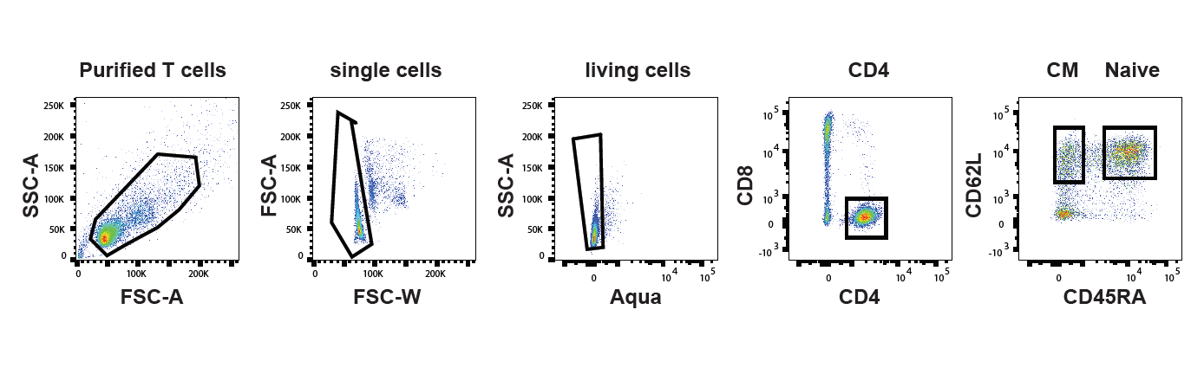

Supplementary Figure 1. Flow cytometry gating strategy.
Gating strategy for flow cytometry studies of naïve CD4 T cells, related to experiments in Fig. 2c on TCF1 expression and sorting of naïve or central memory CD4 T cells in supplementary Figures 2 and 3.

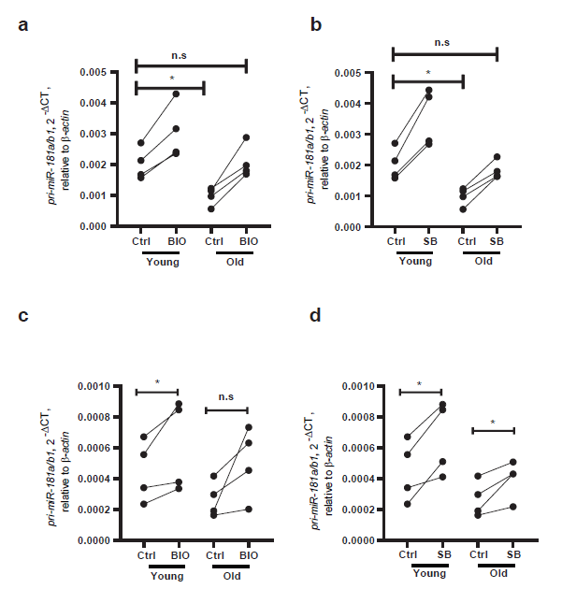

Supplementary Figure 2. Upregulation of miR-181a expression in CD4 T cells by inhibition of GSK3ß
(a, b) Naïve CD4 T cells (CD4⁺CD45RA⁺CD62L⁺) or (c, d) central memory CD4 T cells (CD4⁺CD45RA⁻CD62L⁺) from four young and four old individuals were purified by cell sorting cultured with DMSO solvent control or BIO (a, c, 1 µM) or SB216763 (b, d, 5 µM) for 48hrs. Pri-miR-181a/b1 transcripts were quantified by qPCR. Comparisons were done by two-tailed unpaired t test in a, b and paired t test in c, d. Significance levels are indicated as *P < 0.05, **P < 0.005, ***P < 0.0001.

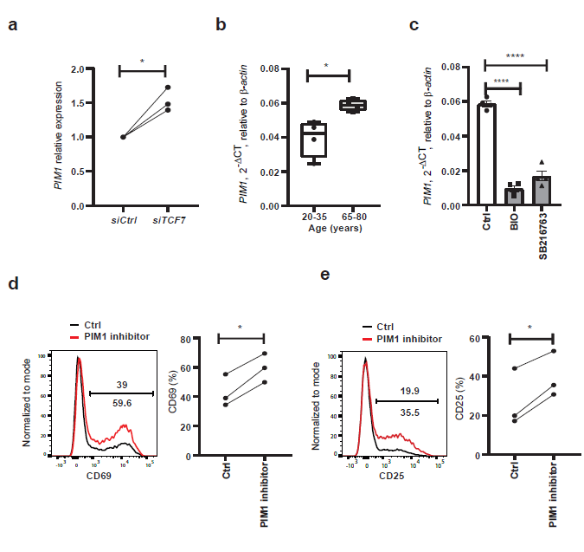

Supplementary Figure 3. TCF1 silencing regulates TCR signaling through upregulating PIM1. (a) Silencing of TCF7 upregulates PIM1 transcripts in naïve CD4 T cells (n=3). (b) Comparison of naïve CD4 T cells from young and old adults for PIM1 expression. (c) GSK3ß inhibition downregulates PIM1 expression in naïve CD4 T cells from old adults (n=4). (d) Inhibition of PIM1 increases CD3/CD28-activated expression of CD69 in naïve CD4 T cells from old adults. Representative histograms (left) and frequencies of CD69-positive cells are shown as mean ± SEM (n=3, right). (e) Inhibition of PIM1 increases CD3/CD28-activated expression of CD25 expression in naïve CD4 T cells from old adults. Representative histograms (left) and frequencies of CD25-expressing cells are shown as mean ± SEM (n=3, right). Comparisons were done by two-tailed unpaired (a, b) or paired (d, e) t tests; or by one-way ANOVA with post-hoc Tukey test in c. Significance levels are indicated as *P < 0.05, **P < 0.005, ****P < 0.00001.

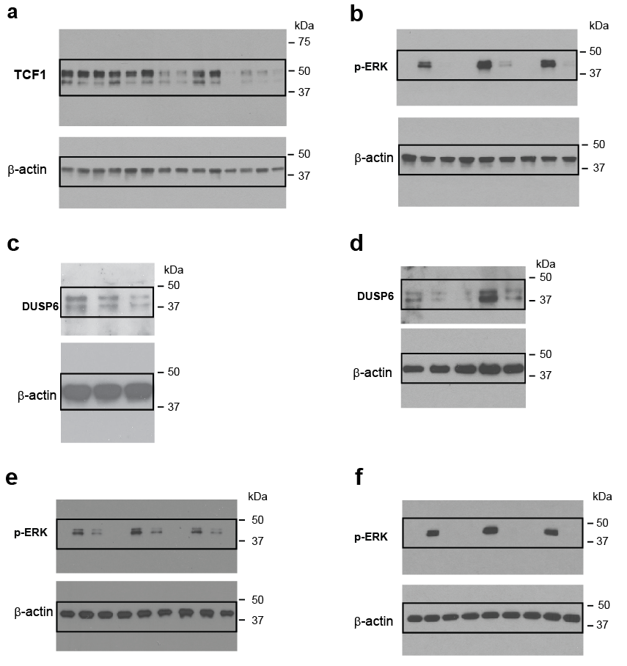

Supplementary Figure 4. Original immunoblot corresponding to Fig. 2b (a), Fig. 3a (b), and Fig. 4a-d (c-f).

