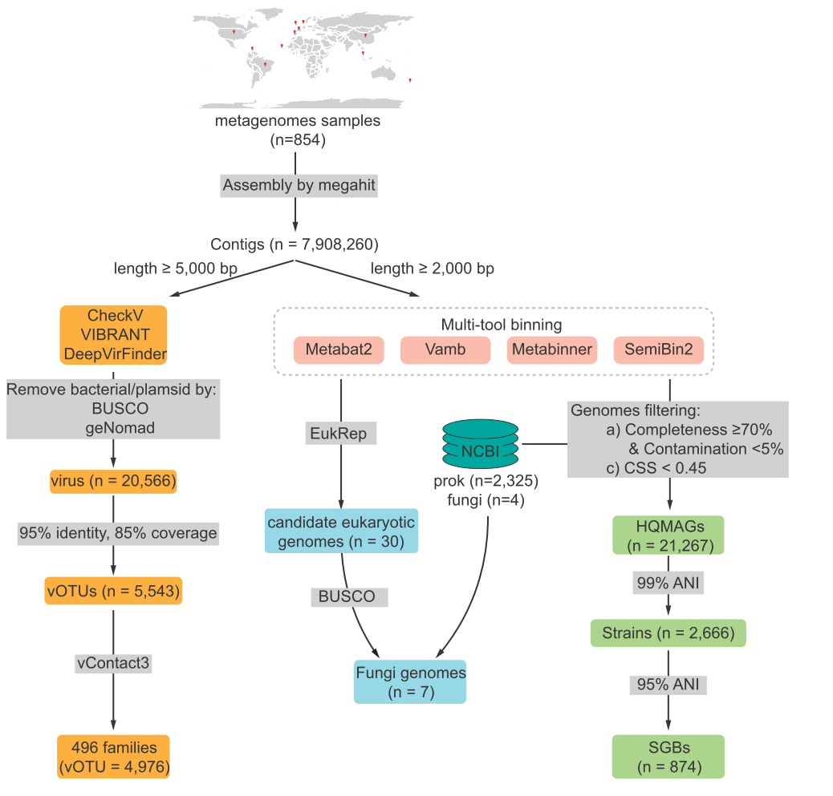
Supplementary Fig. 1. Overview of the bioinformatics workflow for multi-kingdom gut microbiome analysis. The diagram illustrates the complete pipeline from raw metagenomic samples (n = 854) to final viral operational taxonomic units (vOTUs), prokaryotic SGBs, and eukaryotic genomes. Viral sequence identification was performed using a multi-tool consensus approach integrating DeepVirFinder, VIBRANT, and CheckV.

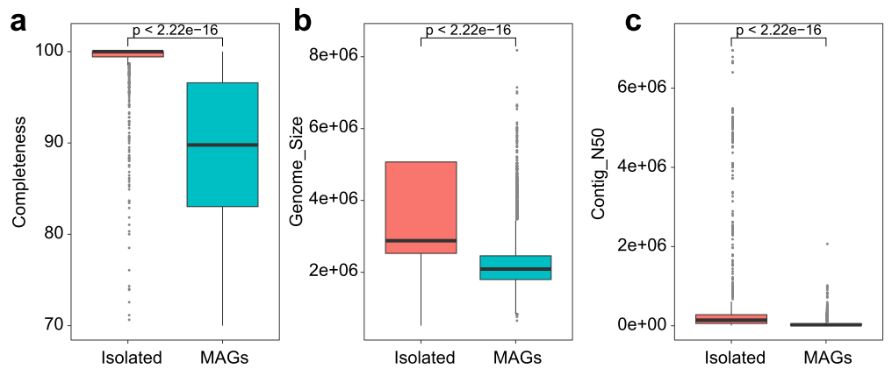
Supplementary Fig. 2. Assembly quality comparison between cultured isolates and metagenome-assembled genomes (MAGs). Boxplots showing (a) genome completeness (%), (b) genome size (bp), and (c) contig N50 (bp) for cultured isolates and MAGs. Differences between groups are statistically significant (p < 2.22e-16, Wilcoxon rank-sum test).

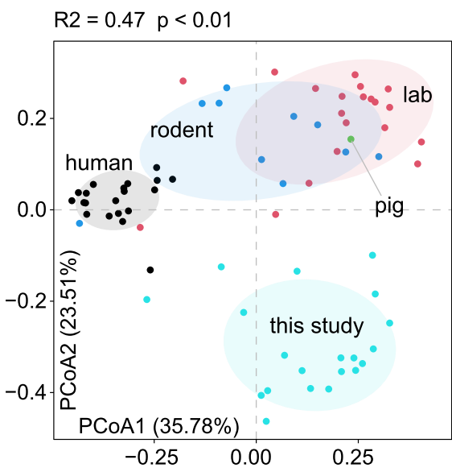
Supplementary Fig. 3. Complementary PCoA analyses based on quantitative abundance profiles of SGB0149. Bray-Curtis PCoA based on the abundance of 71 MAGs of SGB0149 across 649 metagenomic samples from five host species. Each point represents one genome and is colored by host species. PERMANOVA results are shown in the panels.

