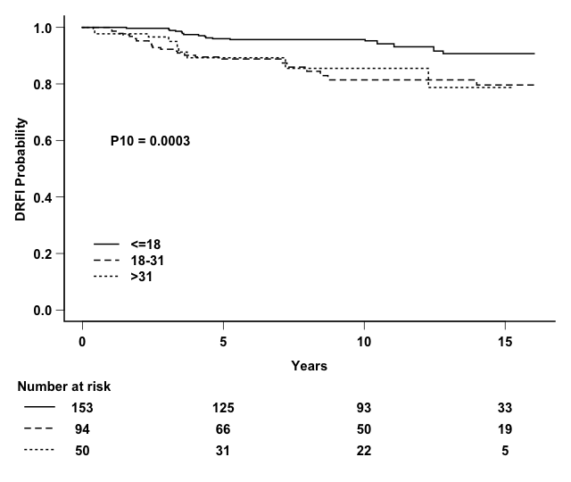

Supplemental Figure 1A. Distant relapse free interval (DRFI) by Oncotype Recurrence Score using classical definitions of low, intermediate, and high Recurrence Score (<18, 18-30, >30) in HR+/HER2- disease (P10: p-value computed truncating follow-up at 10 years).

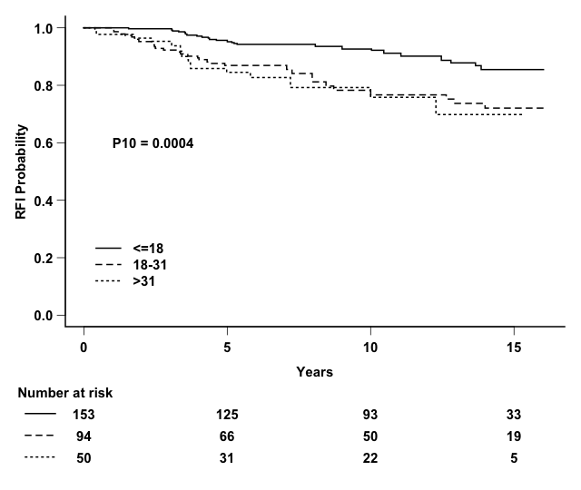

Supplemental Figure 1B. Relapse free interval (RFI) by Oncotype Recurrence Score using classical definitions of low, intermediate, and high Recurrence Score (<18, 18-30, >30) in HR+/HER2- disease (P10: p-value computed truncating follow-up at 10 years).

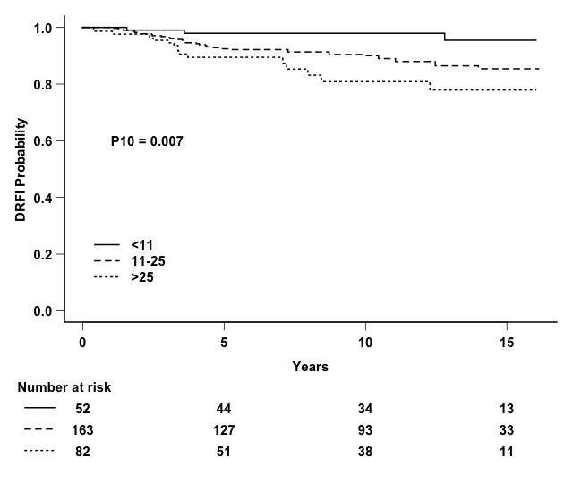Supplemental Figure 1C. Distant relapse free interval (DRFI) by Oncotype Recurrence Score using TAILORx definitions of low, intermediate, and high Recurrence Score (<11, 11-25, >25) in HR+/HER2- disease (P10: p-value computed truncating follow-up at 10 years).

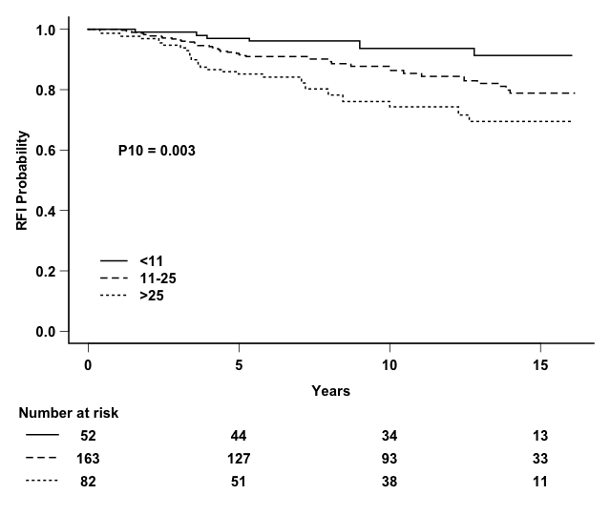
Supplemental Figure 1D. Relapse free interval (RFI) by Oncotype Recurrence Score using TAILORx definitions of low, intermediate, and high Recurrence Score (<11, 11-25, >25) in HR+/HER2- disease (P10: p-value computed truncating follow-up at 10 years).

