Supplementary Data
Supplementary Table 1. Unadjusted and adjusted results for ROR score continuous (10-point) on time to recurrence (TR) according to treatment group, divided according to follow-up time and HER2 status.
 |  |  | All |  |  |  | HER2-negative |  |  |  | HER2-positive
 |  |  | HR | (95% CI) | P_{interaction} |  | HR | (95% CI) |  |  | HR | (95% CI) | P_{interaction}
Unadjusted analysis
 |  |  |  |  | 0.001
 | CMF |  | 1.24 | 1.16;1.32
 | CEF |  | 1.07 | 1.00;1.14
≤ 2.5 yrs |  |  |  |  | 0.009 |  |  |  |  |  |  |  | 0.009
 | CMF |  | 1.40 | 1.30;1.52 |  |  | 1.41 | 1.27;1.56 |  |  | 1.24 | 1.09;1.42
 | CEF |  | 1.21 | 1.11;1.31 |  |  | 1.25 | 1.13;1.39 |  |  | 0.99 | 0.85;1.16
> 2.5 yrs
 | CMF |  | 1.00 | 0.91;1.11 |  |  | 0.95 | 0.85;1.05 |  |  | 1.07 | 0.86;1.33
 | CEF |  | 0.91 | 0.83;1.01 |  |  | 0.88 | 0.79;0.97 |  |  | 0.91 | 0.69;1.20
Adjusted analysis
 |  |  |  |  | 0.0007
 | CMF |  | 1.16 | 1.08;1.25
 | CEF |  | 1.00 | 0.93;.1.08
≤ 2.5 yrs |  |  |  |  | 0.004 |  |  |  |  |  |  |  | 0.005
 | CMF |  | 1.28 | 1.17;1.39 |  |  | 1.34 | 1.21;1.49 |  |  | 1.16 | 1.02;1.33
 | CEF |  | 1.10 | 1.00;1.20 |  |  | 1.19 | 1.07;1.33 |  |  | 0.95 | 0.83;1.09
> 2.5 yrs
 | CMF |  | 0.98 | 0.88;1.11 |  |  | 0.97 | 0.85;1.10 |  |  | 1.04 | 0.81;1.32
 | CEF |  | 0.87 | 0.78;0.98 |  |  | 0.87 | 0.77;0.98 |  |  | 0.86 | 0.64;1.14
CMF cyclophosphamide, methotrexate and fluorouracil; CEF cyclophosphamide, epirubicin and fluorouracil; ROR, risk of recurrence; DR, distant recurrence; HR, hazard ratio; 95% CI, 95% confidence interval; P_{interaction}, P derived from a Wald test for heterogeneity.

Supplementary Table 2. Unadjusted and adjusted results for ROR score continuous (10-point) on overall survival (OS) according to treatment group, divided according to follow-up time and HER2 status.
 |  |  | All |  |  |  | HER2-negative |  |  |  | HER2-positive
 |  |  | HR | (95% CI) | P_{interaction} |  | HR | (95% CI) |  |  | HR | (95% CI) | P_{interaction}
Unadjusted analysis
 |  |  |  |  | 0.02
 | CMF |  | 1.29 | 1.20;1.38
 | CEF |  | 1.15 | 1.07;1.24
≤ 5 yrs |  |  |  |  | 0.03 |  |  |  |  |  |  |  | 0.04
 | CMF |  | 1.36 | 1.25;1.48 |  |  | 1.37 | 1.23;1.51 |  |  | 1.18 | 1.03;1.34
 | CEF |  | 1.30 | 1.18;1.42 |  |  | 1.37 | 1.23;1.52 |  |  | 1.04 | 0.90;1.22
> 5 yrs
 | CMF |  | 1.10 | 0.96;1.26 |  |  | 1.04 | 0.90;1.22 |  |  | 1.07 | 0.84;1.36
 | CEF |  | 0.89 | 0.79;1.01 |  |  | 0.85 | 0.75;0.96 |  |  | 0.91 | 0.71;1.16
Adjusted analysis
 |  |  |  |  | 0.07
 | CMF |  | 1.14 | 1.05;1.23
 | CEF |  | 1.04 | 0.96;1.13
≤ 5 yrs |  |  |  |  | 0.05 |  |  |  |  |  |  |  | 0.052
 | CMF |  | 1.18 | 1.08;1.28 |  |  | 1.22 | 1.10;1.36 |  |  | 1.07 | 0.94;1.23
 | CEF |  | 1.14 | 1.04;1.26 |  |  | 1.28 | 1.13;1.45 |  |  | 0.96 | 0.84;1.11
> 5 yrs
 | CMF |  | 1.02 | 0.89;1.17 |  |  | 1.03 | 0.88;1.20 |  |  | 1.05 | 0.80;1.39
 | CEF |  | 0.84 | 0.74;0.96 |  |  | 0.84 | 0.73;0.97 |  |  | 0.90 | 0.68;1.18
CMF cyclophosphamide, methotrexate and fluorouracil; CEF cyclophosphamide, epirubicin and fluorouracil; ROR, risk of recurrence; DR, distant recurrence; HR, hazard ratio; 95% CI, 95% confidence interval; P_{interaction}, P derived from a Wald test for heterogeneity.

Supplementary Figure 1
Forest plot illustrating subdistributional hazard models for time to recurrence (TR) according to immunohistochemistry (IHC) HER2 and ER status (- negative, + positive, ? unknown), Risk of reccurence (ROR) score and intrinsic subtype. Hazard ratios (HR) refer to adjusted estimates obtained in multivariable analysis. Boxes represent the weight of data for each subgroup relative to the total data. P_{interaction} derived from a Wald test for heterogeneity; for IHC: HER2 negative versus HER2 positive.
Supplementary Figure 2
Forest plot illustrating proportional hazard models for overall survival (OS) according to immunohistochemistry (IHC) HER2 and ER status (- negative, + positive, ? unknown), Risk of reccurence (ROR) score and intrinsic subtype. Hazard ratios (HR) refer to adjusted estimates obtained in multivariable analysis. Boxes represent the weight of data for each subgroup relative to the total data. P_{interaction} derived from a Wald test for heterogeneity; for IHC: HER2 negative versus HER2 positive.
Supplementary Figure 3
Forest plot illustrating subdistributional hazard models for distant recurrence (DR) according to immunohistochemistry (IHC) HER2 and ER status (- negative, + positive, ? unknown), Risk of reccurence (ROR) score and intrinsic subtype. Hazard ratios (HR) refer to unadjusted estimates obtained in univariable analysis. Boxes represent the weight of data for each subgroup relative to the total data. P_{interaction} derived from a Wald test for heterogeneity; for IHC: HER2 negative versus HER2 positive.
Supplementary Figure 4
Forest plot illustrating subdistributional hazard models for time to recurrence (TR) according to immunohistochemistry (IHC) HER2 and ER status (- negative, + positive, ? unknown), Risk of reccurence (ROR) score and intrinsic subtype. Hazard ratios (HR) refer to unadjusted estimates obtained in univariable analysis. Boxes represent the weight of data for each subgroup relative to the total data. P_{interaction} derived from a Wald test for heterogeneity; for IHC: HER2 negative versus HER2 positive.

Supplementary Figure 5
Forest plot illustrating proportional hazard models for overall survival (OS) according to immunohistochemistry (IHC) HER2 and ER status (- negative, + positive, ? unknown), Risk of reccurence (ROR) score and intrinsic subtype. Hazard ratios (HR) refer to unadjusted estimates obtained in univariable analysis. Boxes represent the weight of data for each subgroup relative to the total data. P_{interaction} derived from a Wald test for heterogeneity; for IHC: HER2 negative versus HER2 positive.
Supplementary Figure 6
Estimates of distant recurrence rate according to chemotherapy regimen and intrinsic subtype for patients with with Basal-like (A), HER2-enriched (B), Luminal A (C) and Luminal B (D) Prosigna breast cancer subtypes. 10-year estimates with 95% CI are included.
Supplementary Figure 7
Estimates of distant recurrence rate in patients in subgroups according to treatment arm, HER2 status and HER2-enriched vs non-HER2-enriched subtype; HER2-negative Non-HER2-enriched (A) HER2-positive Non-HER2-enriched (B), HER2-negative HER2-enriched (C) and HER2-positive HER2-enriched (D). 10-year estimates with 95% CI are included.

Supplementary Figure 1
Forest plot illustrating subdistributional hazard models for time to recurrence (TR) according to immunohistochemistry (IHC) HER2 and ER status (- negative, + positive, ? unknown), Risk of reccurence (ROR) score and intrinsic subtype. Hazard ratios (HR) refer to adjusted estimates obtained in multivariable analysis. Boxes represent the weight of data for each subgroup relative to the total data. P_{interaction} derived from a Wald test for heterogeneity; for IHC: HER2 negative versus HER2 positive.
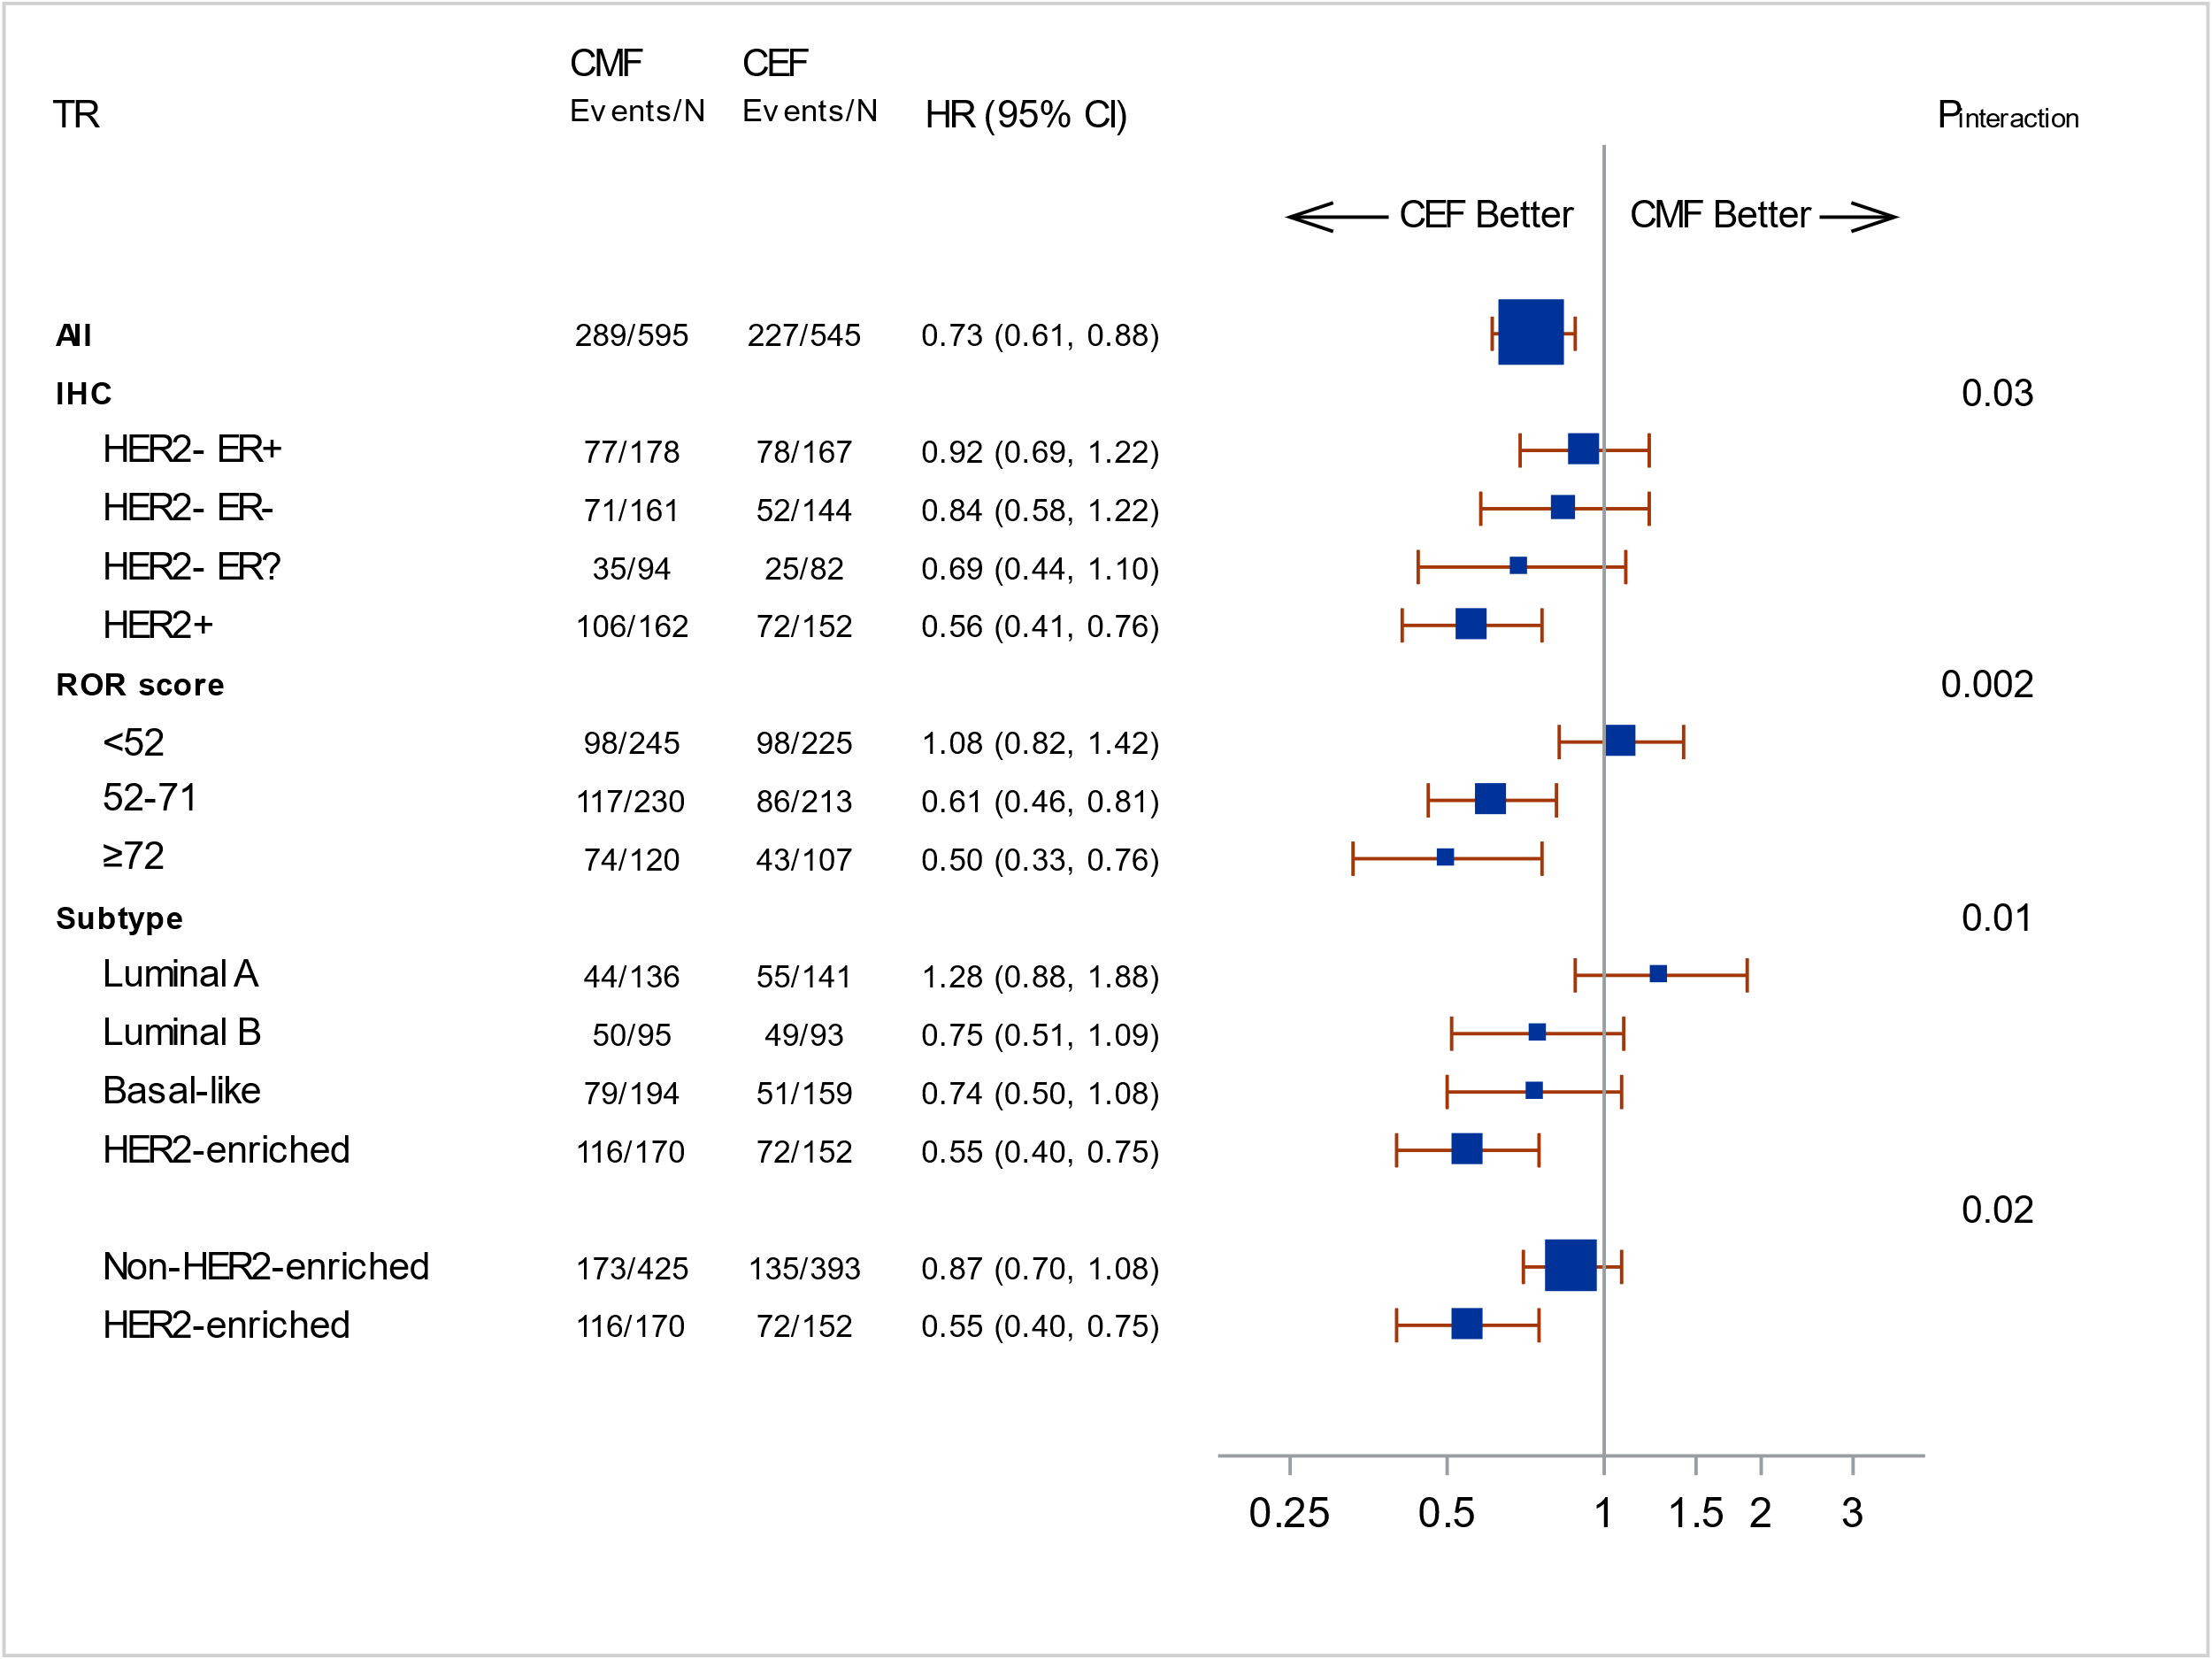

Supplementary Figure 2
Forest plot illustrating proportional hazard models for overall survival (OS) according to immunohistochemistry (IHC) HER2 and ER status(- negative, + positive, ? unknown), Risk of reccurence (ROR) score and intrinsic subtype. Hazard ratios (HR) refer to adjusted estimates obtained in multivariable analysis. Boxes represent the weight of data for each subgroup relative to the total data. P_{interaction} derived from a Wald test for heterogeneity; for IHC: HER2 negative versus HER2 positive.
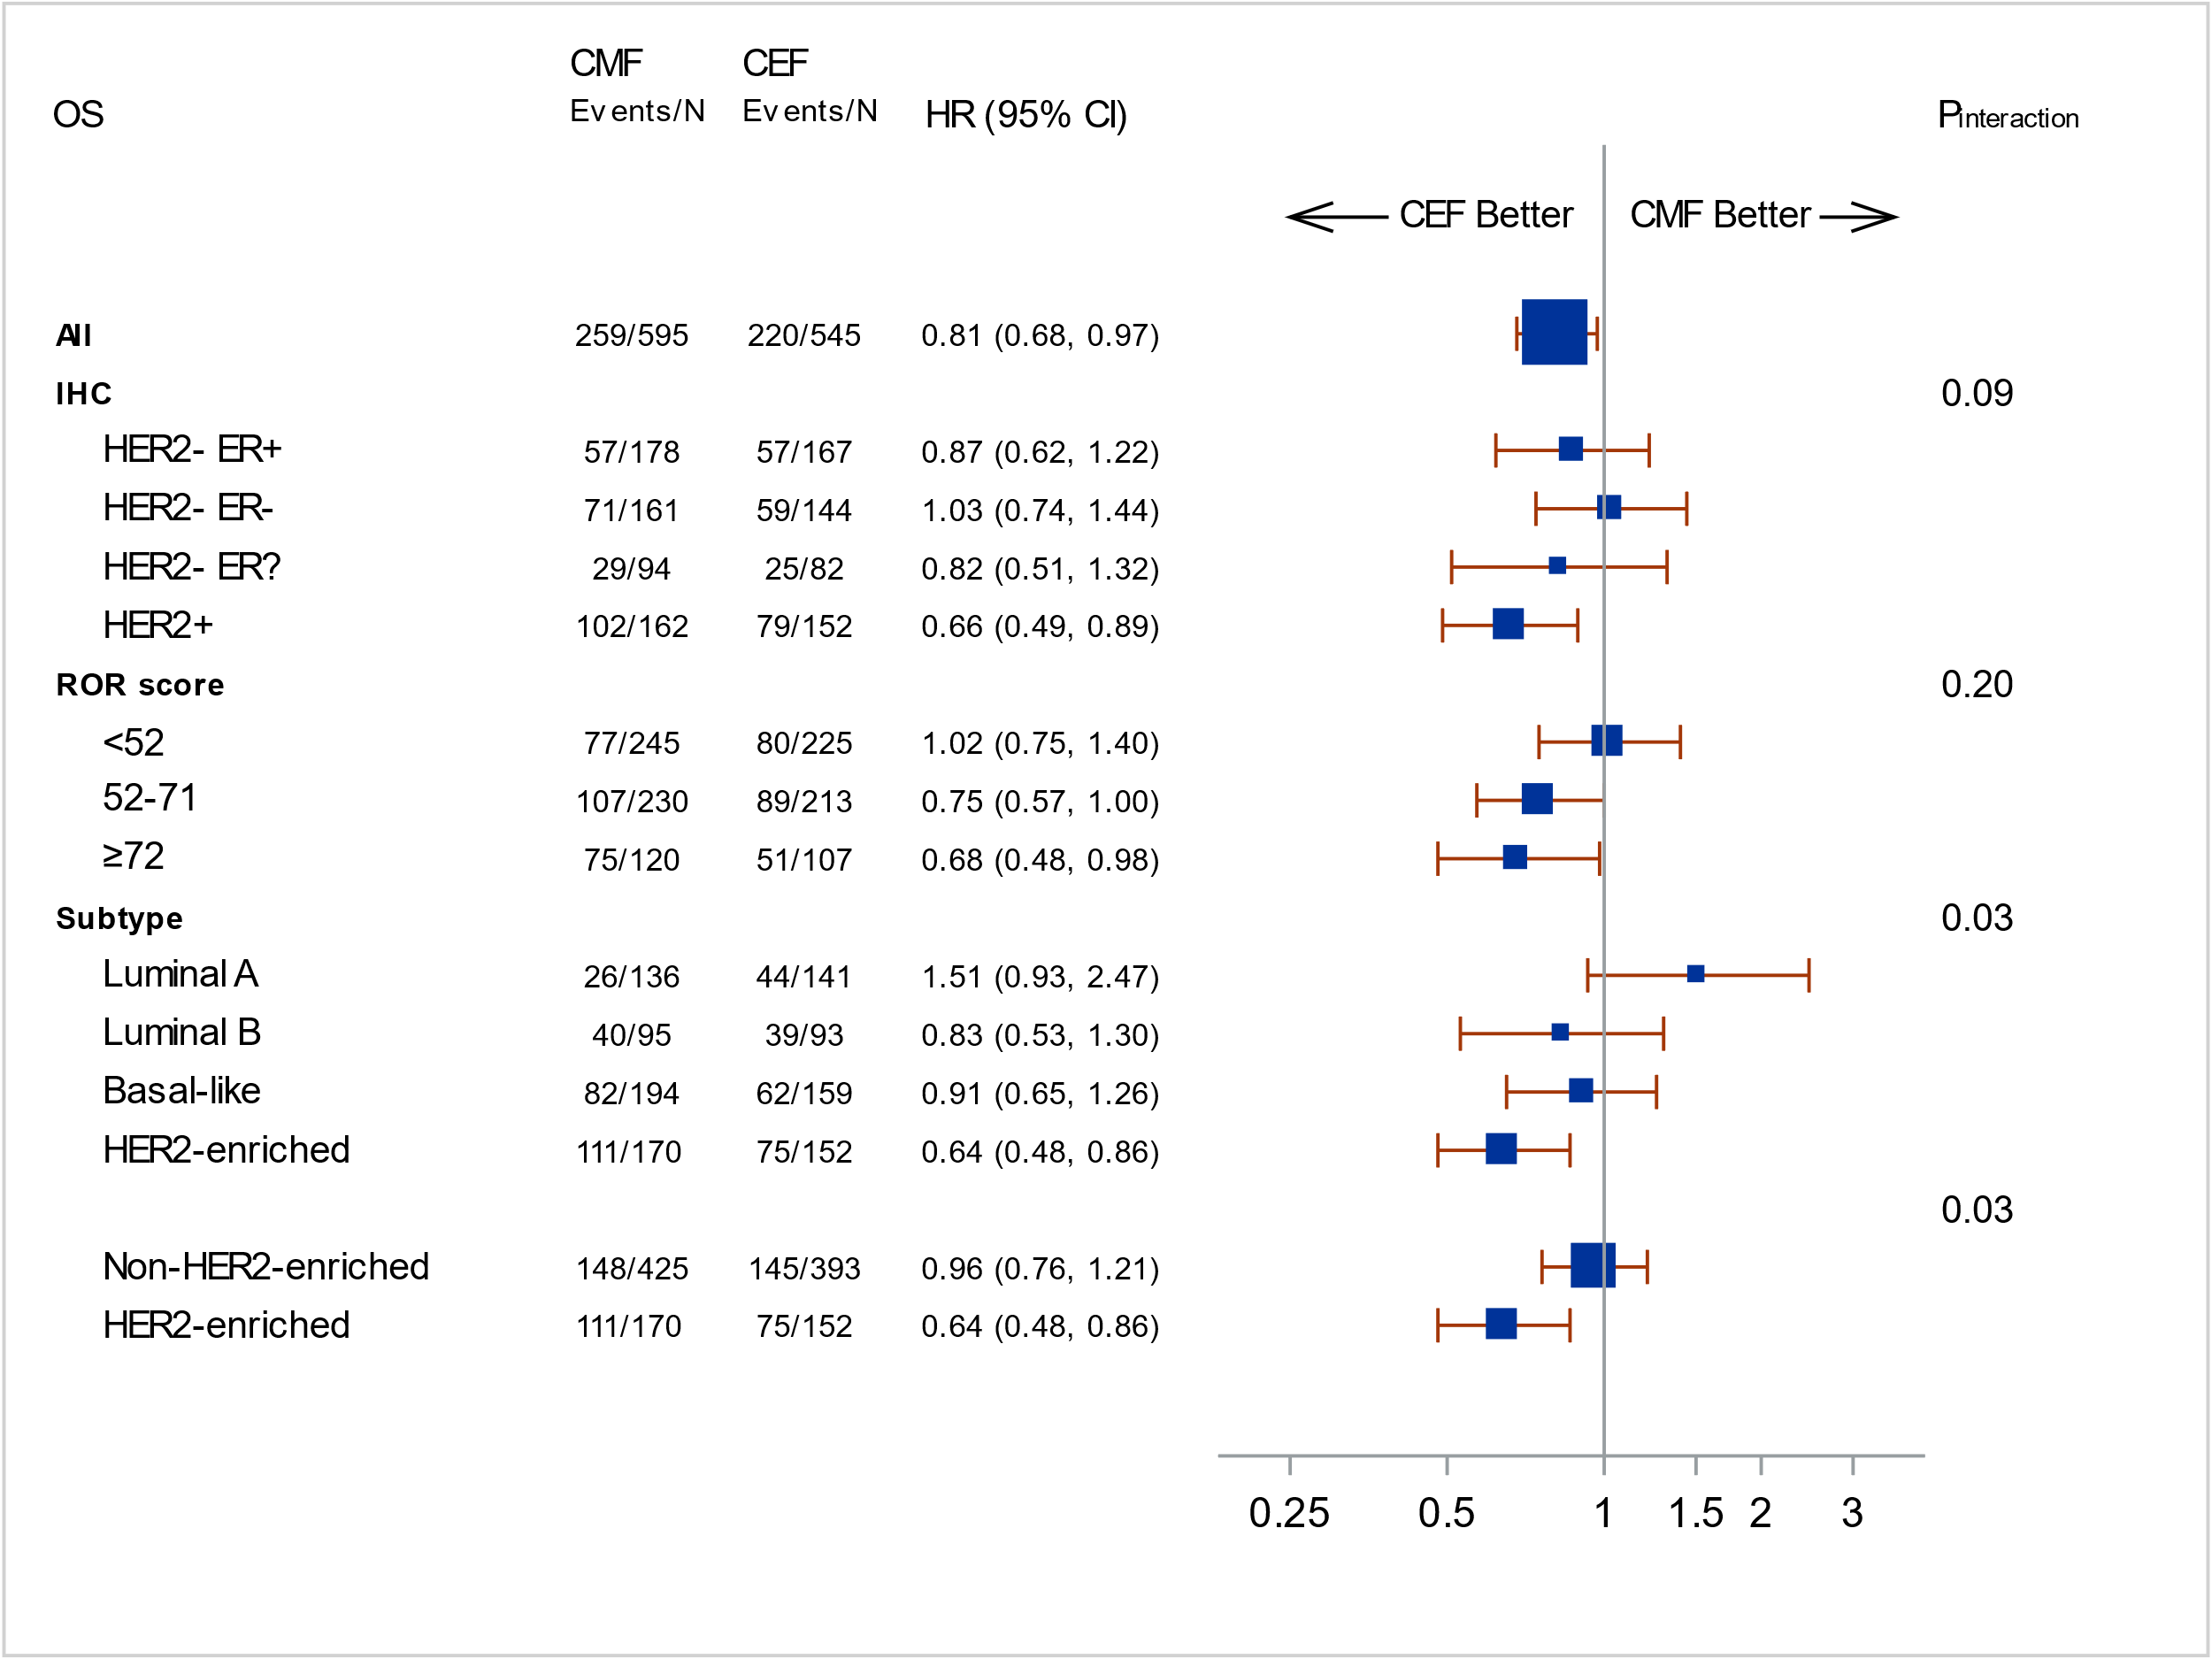

Supplementary Figure 3
Forest plot illustrating subdistributional hazard models for distant recurrence (DR) according to immunohistochemistry (IHC) HER2 and ER status(- negative, + positive, ? unknown), Risk of reccurence (ROR) score and intrinsic subtype. Hazard ratios (HR) refer to unadjusted estimates obtained in univariable analysis. Boxes represent the weight of data for each subgroup relative to the total data. P_{interaction} derived from a Wald test for heterogeneity; for IHC: HER2 negative versus HER2 positive.
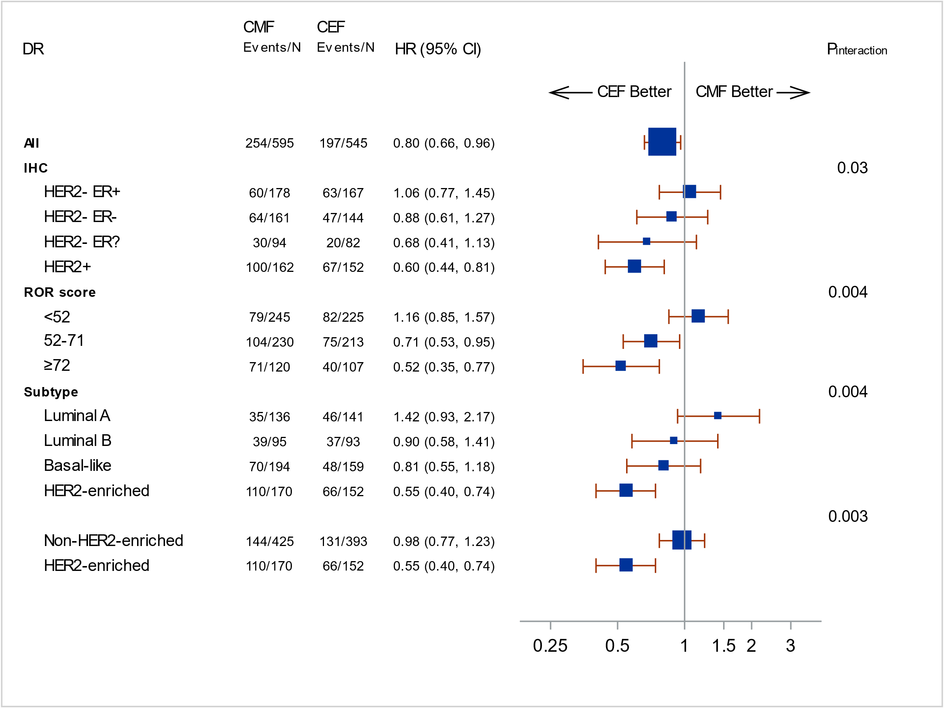

Supplementary Figure 4
Forest plot illustrating subdistributional hazard models for time to recurrence (TR) according to immunohistochemistry (IHC) HER2 and ER status (- negative, + positive, ? unknown), Risk of reccurence (ROR) score and intrinsic subtype. Hazard ratios (HR) refer to unadjusted estimates obtained in univariable analysis. Boxes represent the weight of data for each subgroup relative to the total data. P_{interaction} derived from a Wald test for heterogeneity; for IHC: HER2 negative versus HER2 positive.
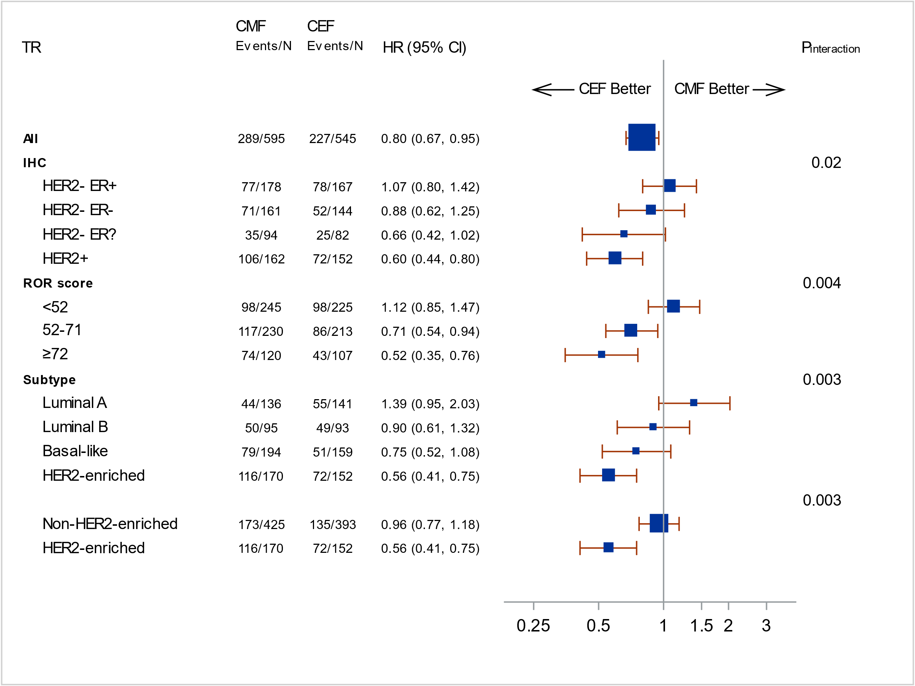

Supplementary Figure 5
Forest plot illustrating proportional hazard models for overall survival (OS) according to immunohistochemistry (IHC) HER2 and ER status(- negative, + positive, ? unknown), Risk of reccurence (ROR) score and intrinsic subtype. Hazard ratios (HR) refer to unadjusted estimates obtained in univariable analysis. Boxes represent the weight of data for each subgroup relative to the total data. P_{interaction} derived from a Wald test for heterogeneity; for IHC: HER2 negative versus HER2 positive.
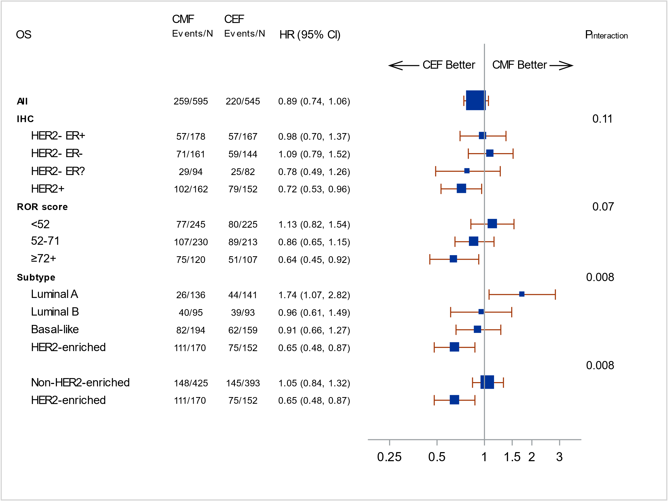

Supplementary Figure 6
Estimates of distant recurrence rate according to chemotherapy regimen and intrinsic subtype for patients with Basal-like (A), HER2-enriched (B), Luminal A (C) and Luminal B (D) Prosigna breast cancer subtypes. 10-year estimates with 95% CI are included.

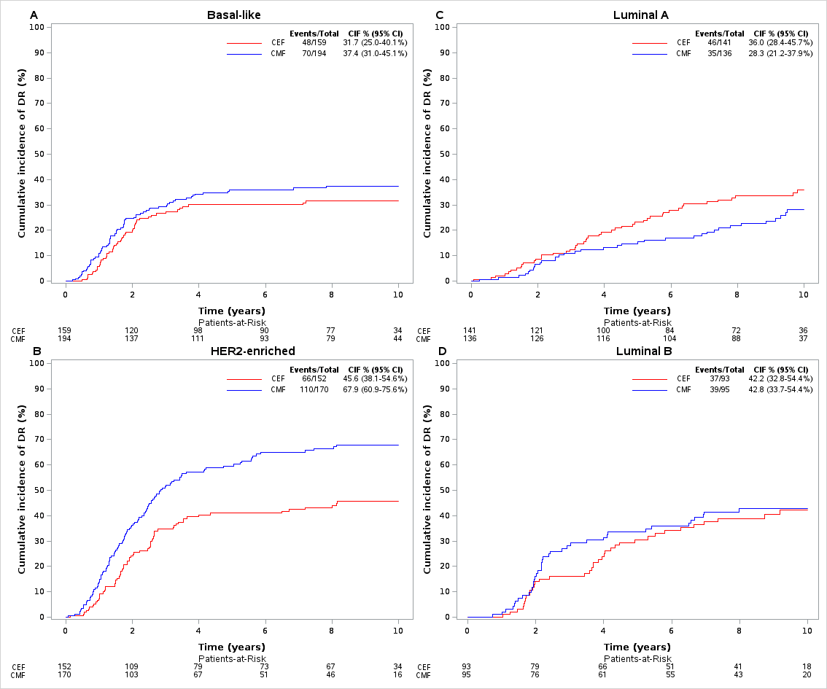

Supplementary Figure 7
Estimates of distant recurrence rate in patients in subgroups according to treatment arm, HER2 status and HER2-enriched vs non-HER2-enriched subtype; HER2-negative Non-HER2-enriched (A) HER2-positive Non-HER2-enriched (B), HER2-negative HER2-enriched (C) and HER2-positive HER2-enriched (D). 10-year estimates with 95% CI are included.

