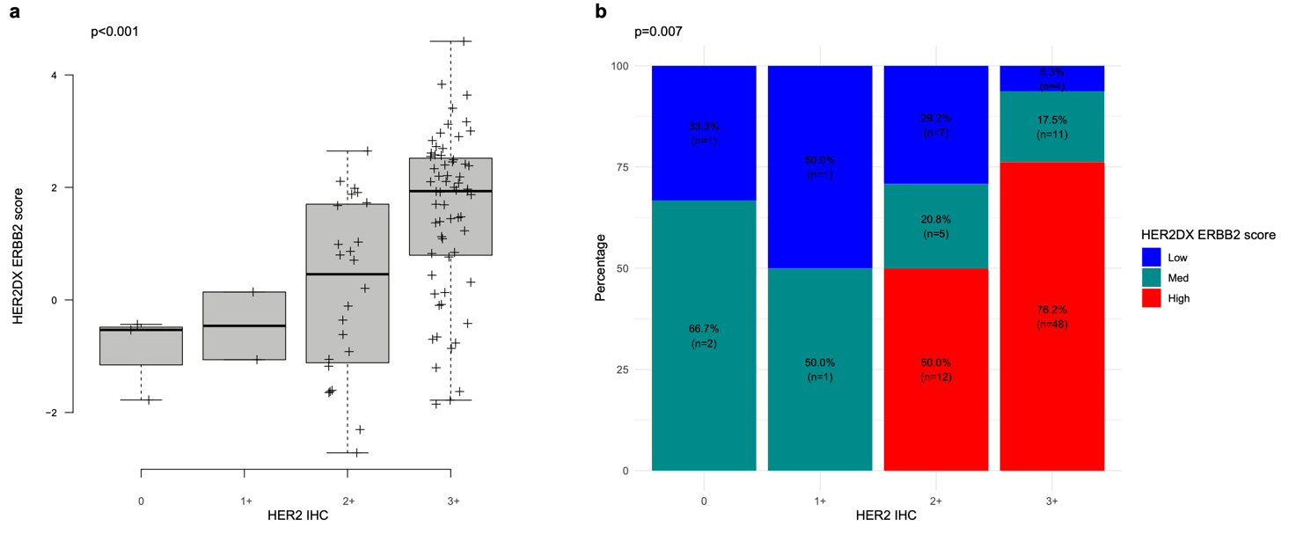

Supplementary Figure 1. Association of HER2DX ERBB2 score and HER2 IHC. (A) Correlation of HER2DX ERBB2 mRNA score as continuous variable and HER2 IHC categories (0, 1+, 2+, 3+). (B) Distribution of HER2DX ERBB2 mRNA score high, medium and low groups and HER2 IHC categories (0, 1+, 2+, 3+).

