Supplementary Material
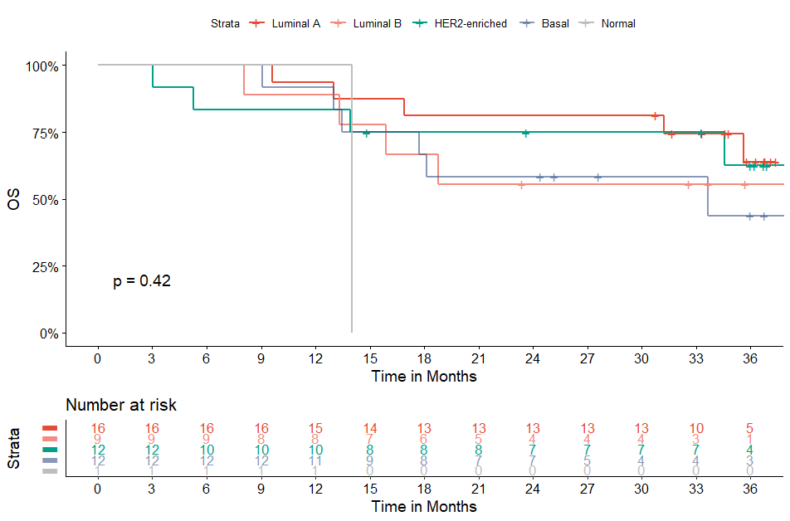
Figure S1. Overall survival (OS) by PAM50 intrinsic subtype of patients with inflammatory breast cancer.
HER 2, human-epidermal growth factor receptor 2.

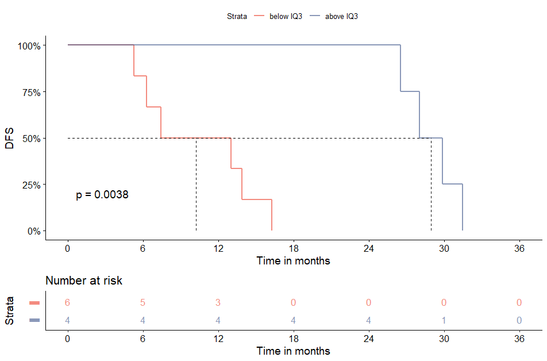
A
B 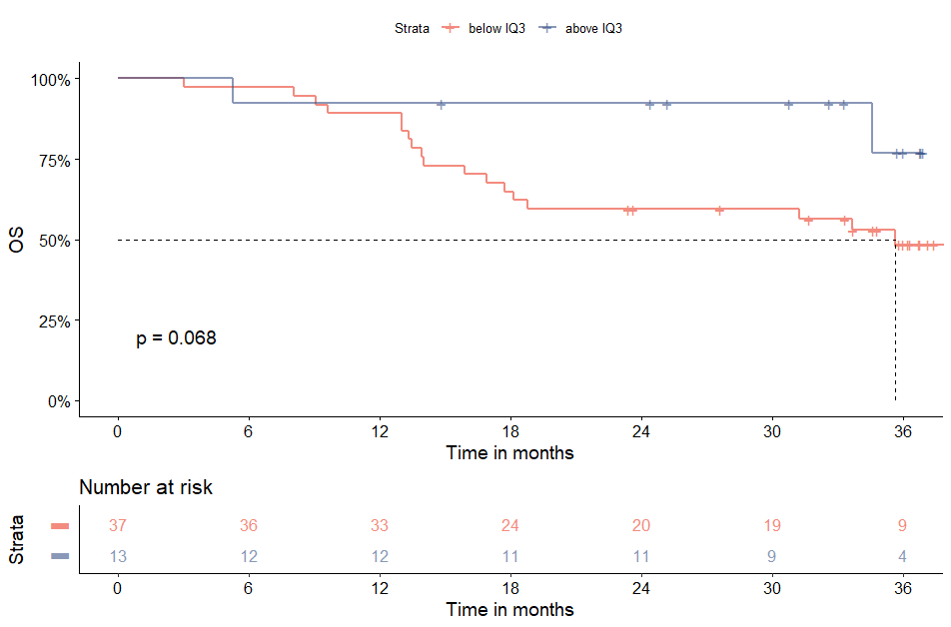
Figure S2. Disease-free survival (A) and overall survival (B) by mRNA tumor infiltrating lymphocyte (TIL) signature in patients with inflammatory breast cancer.

A
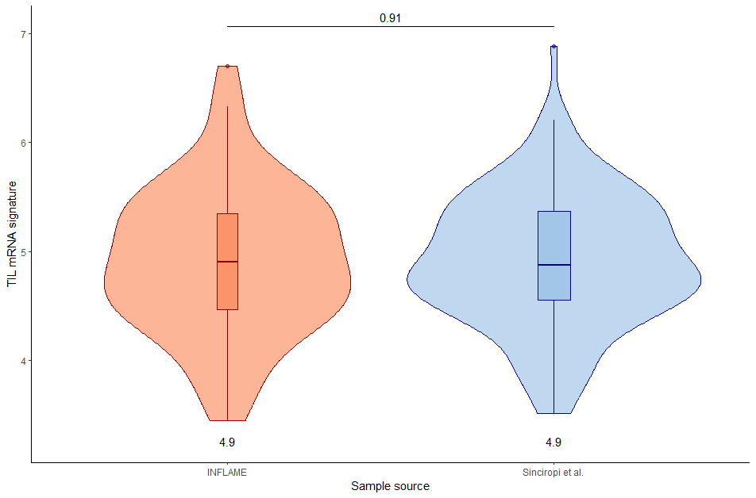
B 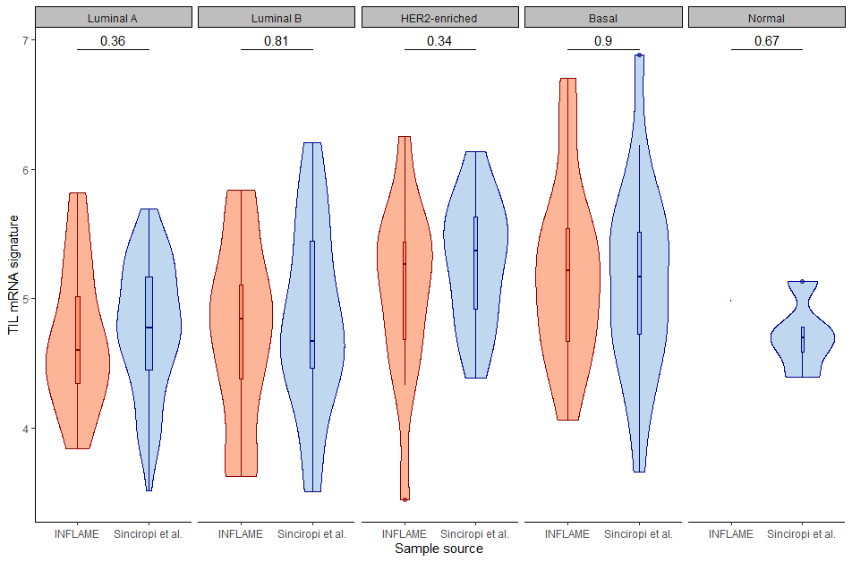
Figure S3. Differences in mRNA tumor infiltrating lymphocyte (TIL) signature between IBC and non-IBC cohort (A) by PAM50 subtype (B).

Table S1. PAM50 intrinsic subtypes of two samples in same patient
PAM 50 intrinsic subtype biopsy | Luminal A  (n = 4) | Luminal B  (n = 1) | HER2  (n = 1) | Basal  (n = 2)
PAM 50 intrinsic subtype primary material, No. (%)  Luminal A  Luminal B  HER2-enriched  Basal | 2  0  1  1 | 0  1  0  0 | 0  0  1  0 | 0  1  1  0

Table S2. PAM50 intrinsic subtypes of two samples in same patient
Patient | Material | Intrinsic subtype | Secondary material | Intrinsic subtype
7 | Biopsy breast (right) | HER2-enriched | Biopsy breast (left) | Luminal A
30 | Biopsy breast | Luminal A | Biopsy breast | Luminal A
49 | Biopsy breast | Luminal A | Biopsy breast (lower) | Luminal A
53 | Biopsy breast | HER2-enriched | Biopsy breast | HER2-enriched
57 | Resection breast | Luminal B | Biopsy breast | Luminal B
67 | Biopsy breast (left) | Luminal B | Biopsy breast (right) | Basal
80 | Resection breast | Luminal A | Biopsy breast | Basal
97 | Biopsy breast (middle) | HER2-enriched | Biopsy breast  (lateral) | Basal

Table S3. Probabilities of discordant PAM50 intrinsic subtypes of two samples in one patient
Patient | Material | Basal | HER2 | LumA | LumB | Normal | x | Conclusion
7 | Biopsy breast (right)  Biopsy breast (left) | 0.00  0.00 | 0.70  0.00 | 0.30  0.62 | 0.00  0.00 | 0.00  0.38 | HER2  LumA | 30% LumA (next highest call)
30 | Biopsy breast  Biopsy breast | 0.00  0.00 | 0.00  0.00 | 0.94  0.48 | 0.02  0.00 | 0.04  0.52 | LumA  Normal | 48% LumA (next highest call)
67 | Biopsy breast (left)  Biopsy breast (right) | 0.00  0.93 | 0.00  0.06 | 0.27  0.00 | 0.73  0.00 | 0.00  0.00 | LumB  Basal | Completely discordant
80 | Resection breast  Biopsy breast | 0.44  0.00 | 0.47  0.00 | 0.00  0.65 | 0.10  0.00 | 0.00  0.35 | HER2  LumA | Completely discordant

Table S4. Patients that did not receive surgery
Reason no surgery | Number of patients
M0  Death  Progressive disease  Irresectable  Other/unknown | N = 10  3  2  1  4
M1  Death  Progressive disease  Irresectable  Considered no indication due to M1 disease  Other/unknown | N = 24  1  3  1  13  6

Table S5. PAM50 intrinsic subtypes by IHC subtyping
PAM 50 intrinsic subtype biopsy | Luminal A  (n = 32) | Luminal B  (n = 33) | HER2  (n = 24) | Basal  (n = 30)
IHC subtyping, No. (%)  ER-positive, HER2-negative  HER2-positive  Triple-negative | 31  0  1 | 16  17  0 | 0  24  0 | 0  0  30

