Supplementary Materials:

Supplementary Figure S1: Supplementary to Figure 1: Breast cell line proliferation and biomarker expression data.
Supplementary Figure S2: Supplementary to Figure 1: T-47D engineered cell line data.
Supplementary Figure S3: Supplementary to Figure 1: In vivo study information
Supplementary Figure S4: BLU-222+ribociclib synergy and biomarker analysis in breast cancer cell lines.
Supplementary Figure S5: BLU-222+ribociclib synergy and biomarker expression in cancer cell lines.
Supplementary Figure S6: CCNE1 and CDKN2A overexpression engineered T-47D CDX models in vivo.
Supplementary Figure S7: MCF-7 palbociclib-resistant isogenic CDX model system PK/PD and body weight.
Supplementary Figure S8: Expression of known markers of resistance in CDK4/6i-resistant HR+ breast cell cancer lines.
Supplementary Figure S9: BLU-222+ribociclib synergy analysis in T-47D and MCF-7 cells resistant to CDK4/6i.
Supplementary Figure S10: Modulation of CDK-RB-E2F pathway protein expression by BLU-222 +/- ribociclib in T-47D and MCF-7 parental and CDK4/6i-resistant cell lines.
Supplementary Figure S11: Body weight measurements in PDX model studies. Supplementary Figure S12: ER+ breast PDX panel efficacy studies.
Supplementary Figure S13: TNBC breast PDX panel efficacy studies.
Supplementary Figure S14: Correlation between mRNA and percent positive IHC in PDX models.
Supplementary Figure S15: ST2056 and ST941 PDX model efficacy study body weight and plasma PK.

Uncropped Western Blots:
Figure 2C
Figure 3D
Supplementary Figure S1C
Supplementary Figure S2A,D
Supplementary Figure S3A
Supplementary Figure S5B-F
Supplementary Figure S6C,D
Supplementary Figure S7D-F
Supplementary Figure S7G-I
Supplementary Figure S8A
Supplementary Figure S10A

Supplementary Data S1: Cell line information, compound GI50s, synergy scores.
Supplementary Data S2: CDK2 inhibitor information
Supplementary Data S3: In vivo studies: Observed and predicted this for breast cancer PDX models
Supplementary Data S4: Single biomarker efficacy prediction accuracy.
Supplementary Data S5: KIYA-PREDICT assay: XenoSTART breast XPDX tumor models, disease subtype, receptor status, and patient treatment history.
Supplementary Data S6: In vivo studies: XenoSTART breast XPDX tumor models, disease subtype, receptor status, and patient CDK4/6i and/or ET treatment history.
Supplementary Data S7: In vivo studies: MDACC TRACTION PDX models, receptor status, and patient CDK4/6i and/or ET treatment history.
Supplementary Data S8: MDACC PDX models and characteristics.

Figure S1

Figure S1: Supplementary to Figure 1: Breast cell line proliferation and biomarker expression data. A) CDK2 inhibitor and palbociclib proliferative IC₅₀ as determined by 5d CyQuant Direct Proliferation Assay in breast cancer cell lines (as in Figure 1). Cell lines categorized by receptor subtype, as determined by PAM50. B) BLU-222 and palbociclib antiproliferative GI₅₀ values in breast cell lines measured by CyQuant, 5d treatment. Alternative view of data in Figure 1A. C) Western blot for proteins of interest in breast cancer cell lines. D-E) Proliferative IC₅₀ as determined in A. Overexpression of C) CCND1 and D) CCNE1 defined as top 75th percentile mRNA expression of cell lines in CCLE. Statistical significance evaluated using Wilcoxon rank sum test. F) Anti-proliferative response to CDK2 inhibitors in breast cancer cell lines as in Figure 1A. Cell lines were categorized by Rb protein expression from Western blotting (S1C) (+: intact, > 10th percentile Rb1 immunoblot signal), CDKN2A (p16) expression (+: > 75th percentile of mRNA expression, -: ≤ 25th percentile of mRNA expression), and CCNE1 (cyclin E1) expression (overexpression defined as above the 75th percentile of mRNA expression). CCNE1 copy number status is noted by symbol color. Statistical significance evaluated using Wilcoxon rank sum test.

Figure S2

Figure S2: Supplementary to Figure 1: T-47D engineered cell line data. A) Protein expression measured by Western blot in T-47D engineered cell lines. B) CyQuant, 5d treatment, in T-47D engineered cell lines treated with ribociclib. C) Cell cycle distribution in T-47D engineered cell lines, measured by Click-iT EdU Cell Proliferation Kit. Cells were untreated, or treated with DSMO (0.1%), palbociclib (250 nM), or BLU-222 (100 nM). Percent cells was calculated relative to total viable cell population. D) FACS cell cycle scatter plots for (C) with cell cycle phase gating shown. E) siRB1 knockdown (25 nM siRNA) in T-47D engineered cell lines as measured by Western blot. F) FACS cell cycle scatter plots for Figure 1M with cell cycle phase gating shown.

Figure S3
Figure S3: Supplementary to Figure 1: In vivo study information. A) Pharmacodynamic markers of interest were tested by Western blot in BCX.022 tumors treated for two days with BLU-222 (60 mg/kg BID), ribociclib (50 mg/kg QD), or the combination. Tumors were harvested 2 hours post-final dose. B-C) HCC1569 were inoculated into flanks of female NOD-SCID mice. BLU-222 was dosed on either a BID or QD schedule for 28 days and then tumor volume was monitored during a dosing-free period for an additional 32 days. Mean tumor volume and SEM is plotted, n=8 per group. E) BLU-222 plasma exposure (mean concentration ± SEM) after 3 days of treatment, n=4 per group F) pRbS807, pRbT821/826, and total Rb as measured by Western blot in HCC1569 tumors collected 2 hours post-final dose. Western blot signal was normalized to β-actin and graphed as percent inhibition from Western blot signal in vehicle tumors (mean ± SEM, n=4 per time point).

Figure S4

Figure S4: BLU-222+ribociclib synergy and biomarker analysis in breast cancer cell lines.
A-D) As in Figure 2, CyQUANT Direct Proliferation assay was used to assess CDK2i+ribociclib synergy. HSA MSA scores were estimated using day 5 percent inhibition by SynergyFinder. Pearson correlation between MSA and A) CCNE1 mRNA expression Z-score or B) CCND1 mRNA expression Z-score was evaluated for all breast cancer cell lines. Restricting to only RB1+/CDKN2A- breast cancer cell lines, difference in HSA between overexpressed and non-overexpressed populations for C) CCNE1 mRNA or D) CCND1 mRNA was evaluated using Wilcoxon rank sum test.

Figure S5

Figure S5: BLU-222+ribociclib synergy and biomarker expression in cancer cell lines. A) BLU-222+ribociclib BLISS MSA scores graphed relative to Rb and p16 status in colorectal (n = 38), NSCLC (n = 24), prostate (n = 7), soft-tissue sarcoma (n = 12), and osteosarcoma (n = 16). Each dot represents an individual cell line. B–F) Western blot for biomarkers of interest in cell lines included in (A).

Figure S6

Figure S6: CCNE1 and CDKN2A overexpression engineered T-47D CDX models in vivo. A–B) The PK/PD arm was dosed for 3 days in BALB/c nude female mice and samples were taken at indicated timepoints. Plasma exposure is graphed as concentration (ng/mL) on the right Y-axis, mean ± SEM (n=3 per timepoint). Tumor pRbS807 as measured by Western blot is graphed as percent of vehicle on the left-axis, mean ± SEM (n=3 per timepoint). C–D) Example Western blots in BLU-222 (100 mg/kg BID)+ribociclib (75 mg/kg QD) groups. E–F) Body weight change relative to day 0 over duration of efficacy study, mean ± SEM (n=8 per group).

Figure S7

Figure S7: MCF-7 palbociclib-resistant isogenic CDX model system PK/PD and body weight. A) Heatmap of differential gene expression for known markers of CDK4/6i resistance in MCF-7 parental and MCF-7 Palbociclib^{R} baseline tumors, n = 3 for each. Significance (adjusted P-value) is annotated based on global differential expression analysis using DeSeq2. Type of CDK4/6 Resistance is annotated under Resistance. Expected direction of resistance effect is annotated under Direction (e.g. Up means upregulation has been previously observed to be a resistance mechanism). B–C) MCF-7 parental and MCF-7 Palbociclib^{R} tumor bearing mice were treated for 3 days with compounds and samples were taken at indicated time points. Compound plasma concentration is graphed on the right y-axis, mean ± SEM (n=3 per timepoint). pRbS807/811 normalized to β-actin signal was determined by Western blot and graphed as percent of signal in vehicle tumors, mean ± SEM (n=3 per timepoint). D–I) pRbS807/811 and Rb Western blots from the PK/PD parental tumors (D-F) and Palbociclib^{R} tumors (G–I). Tumors sampled at indicated time points. J) BLU-222 dose response in the MCF-7 Palbociclib^{R} model. Mean tumor volume ± SEM is plotted (n=9 per group). Statistical deviation from vehicle was assessed by 2-way ANOVA, ***P < 0.001, ****P < 0.0001. K–L) Serum TK1 activity correlated to tumor volume in MCF-7 parental and palbociclib^{R} efficacy study tumors. Each dot represents a single on-study mouse/tumor. M–N) Body weight of MCF-7 parental (M) and MCF-7 Palbociclib^{R} (N) tumor bearing mice throughout efficacy study period. Body weight change is represented as percentage change from day 0.

Figure S8

Figure S8: Expression of known markers of resistance in CDK4/6i-resistant HR+ breast cell cancer lines. A) Protein expression measured by Western blot for indicated proteins. B) Quantification of signal was normalized to β-actin and then expression in resistant cell line was expressed as fold over expression in the parental cell line.

Figure S9

Figure S9: BLU-222+ribociclib synergy analysis in T-47D and MCF-7 cells resistant to CDK4/6i. CyQUANT 5d proliferation IC₅₀ values for A) abemaciclib, B) atirmociclib, and C) palbociclib in the CDK4/6i-resistant cell lines. D–E) INX-315 antiproliferative effect measured CyQUANT 5d in T-47D (D) and MCF-7 (E) CDK4/6i-resistant cell lines. F–G) Antiproliferative effect of BLU-222 and ribociclib, alone or in combination at indicated doses, measured by CyQUANT after 5d dosing in T-47D (F) and MCF-7 (G) CDK4/6i-resistant cell lines. Mean ± SEM for n=2 is plotted for A-G.

Figure S10

Figure S10: Modulation of CDK-RB-E2F pathway protein expression by BLU-222 +/- ribociclib in T-47D and MCF-7 parental and CDK4/6i-resistant cell lines. A) Western blot images for proteins of interest. Cells were treated with 250 nM BLU-222, 500 nM ribociclib, or the combination for 24 hours. B) Quantifications of Western blot signals.

Figure S11

Figure S11: Body weight measurements in PDX model studies. A) HR+/ER- breast cancer models. B) TNBC models. Unless otherwise noted, BLU-222 was dosed at 60 mg/kg BID, ribociclib at 50 mg/kg QD, and fulvestrant at 2.5 mg Q7D. Mean body weight change from day 0 ± SEM is plotted. Studies were performed with n=6, n=7, n=8, or n=10 mice per group.

Figure S12

Figure S12: ER+ breast PDX panel efficacy studies. A) Summary of tumor growth normalized to vehicle for each study arm in every ER+ PDX model tested. BLU-222 was dosed at 60 mg/kg BID, ribociclib at 50 mg/kg QD, and fulvestrant at 2.5 mg Q7D. PR1, PR3, and PR4 TGI data from (Keyomarsi, submitted 2024). B) Individual ER+ breast efficacy studies. Mean tumor volume ± SEM is plotted. Studies were performed with n=6, n=7, n=8, or n=10 mice per group.
Figure S13

Figure S13: TNBC breast PDX panel efficacy studies. A) Summary of tumor growth normalized to vehicle for each study arm in each TNBC PDX model tested. BCX.017, BCX.070 and XC5172013 TGI data from (Keyomarsi, submitted 2024). B) Individual TNBC efficacy studies. BCX.017, BCX.095, PDX.003.430, PDX.003.138, and BCX.070 are CCNE1-amplified (CN ≥4) models. Mean tumor volume ± SEM is plotted. Studies performed with n=6, n=7, n=8, or n=10 mice per group.

Figure S14

Figure S14: Correlation between mRNA and percent positive IHC in PDX models. A) Kendall’s tau correlation between Z-score of mRNA expression and percent positive IHC (%IHC) for a single biomarker of interest in HR+/HER2- and TNBC breast cancer PDX models.

Figure S15

Figure S15: ST2056 and ST941 PDX model efficacy study body weight and plasma PK. A) ST2056 tumor-bearing mice body weight measurements over study period, normalized to day 0. Mean ± SEM is plotted, n=8 per group. B) BLU-222 plasma PK (mean plasma concentration ± SEM, n=3) at indicated time points postfinal dose (day 60). C) Ribociclib plasma PK (mean plasma concentration ± SEM, n=3) at indicated time points postfinal dose (day 60). D) ST941 tumor-bearing mice body weight measurements over study period, normalized to day 0. Mice were on treatment for 31 days and then observed in a dosing-free period to day 60. Mean ± SEM is plotted, n=8 per group. E) BLU-222 plasma PK (mean plasma concentration ± SEM, n=3) at indicated time points postfinal dose (day 31). F) Ribociclib plasma PK (mean plasma concentration ± SEM, n=3) at indicated time points postfinal dose (day 31).

Uncropped Western Blots

Figure 2C

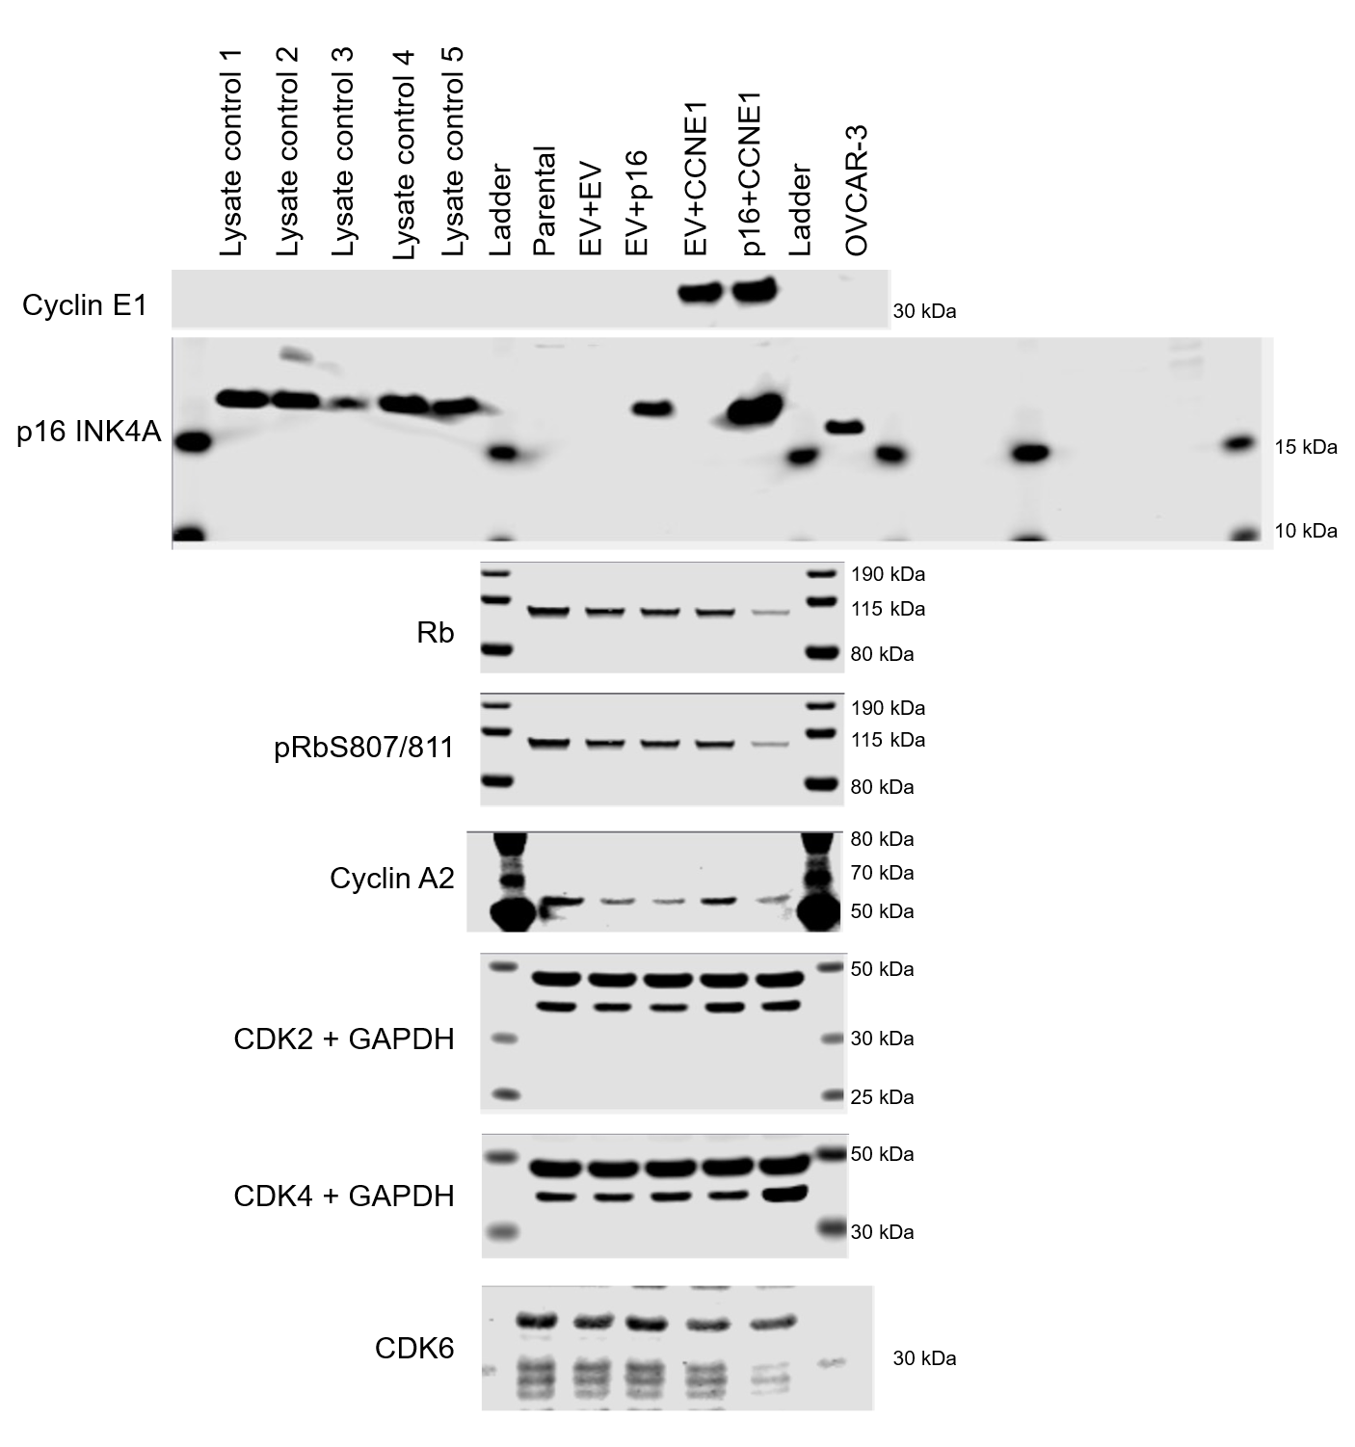
Figure 3D
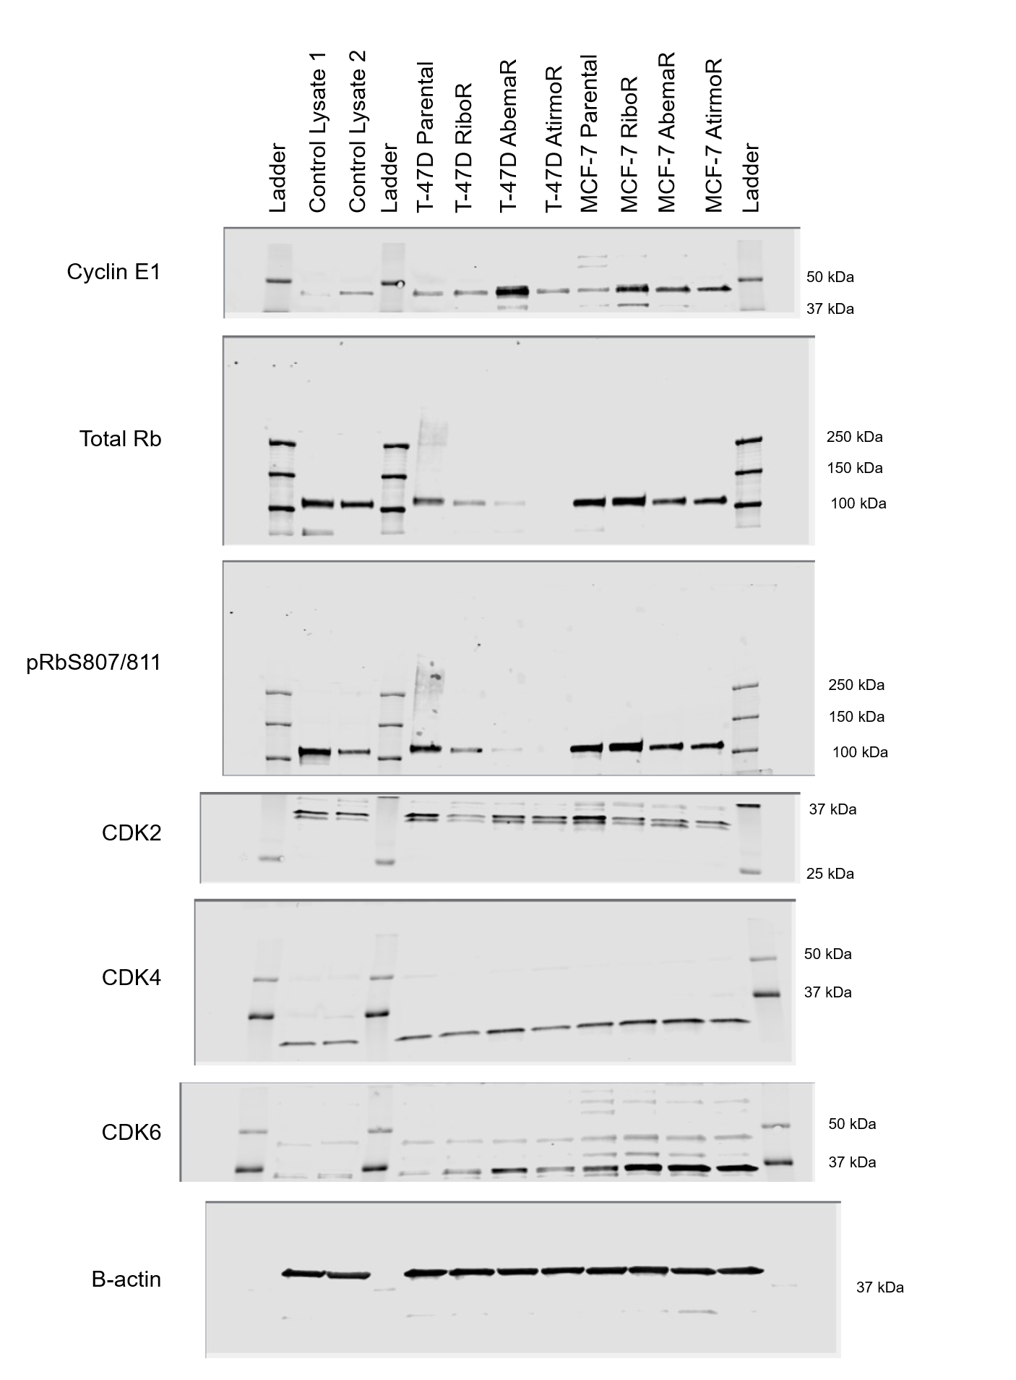

Supplementary Figure S1C
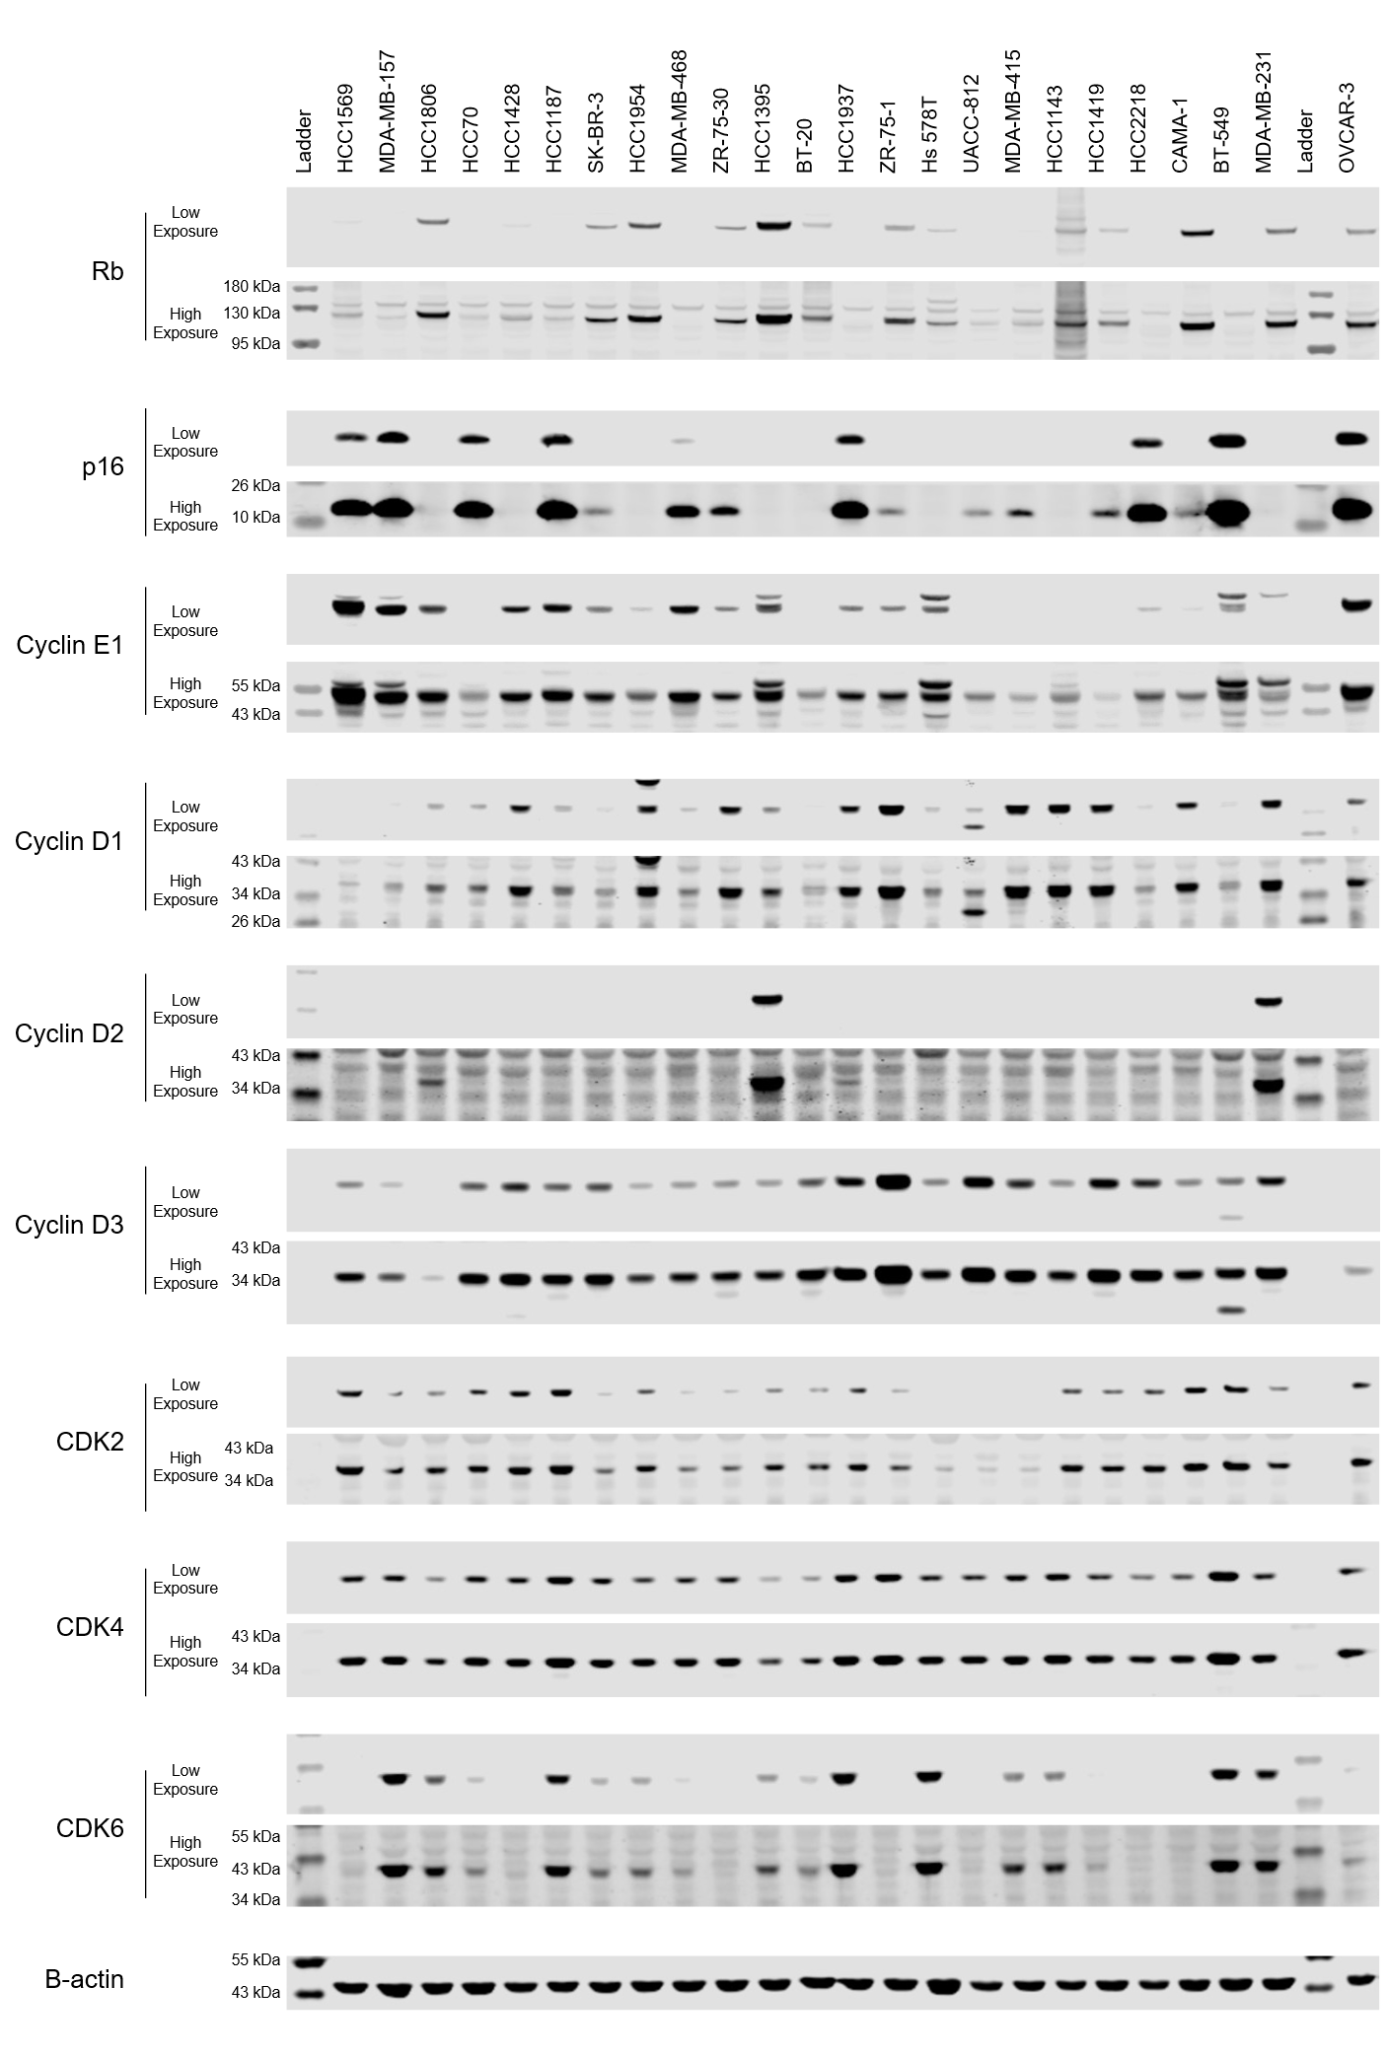

Supplementary Figure S1C, cont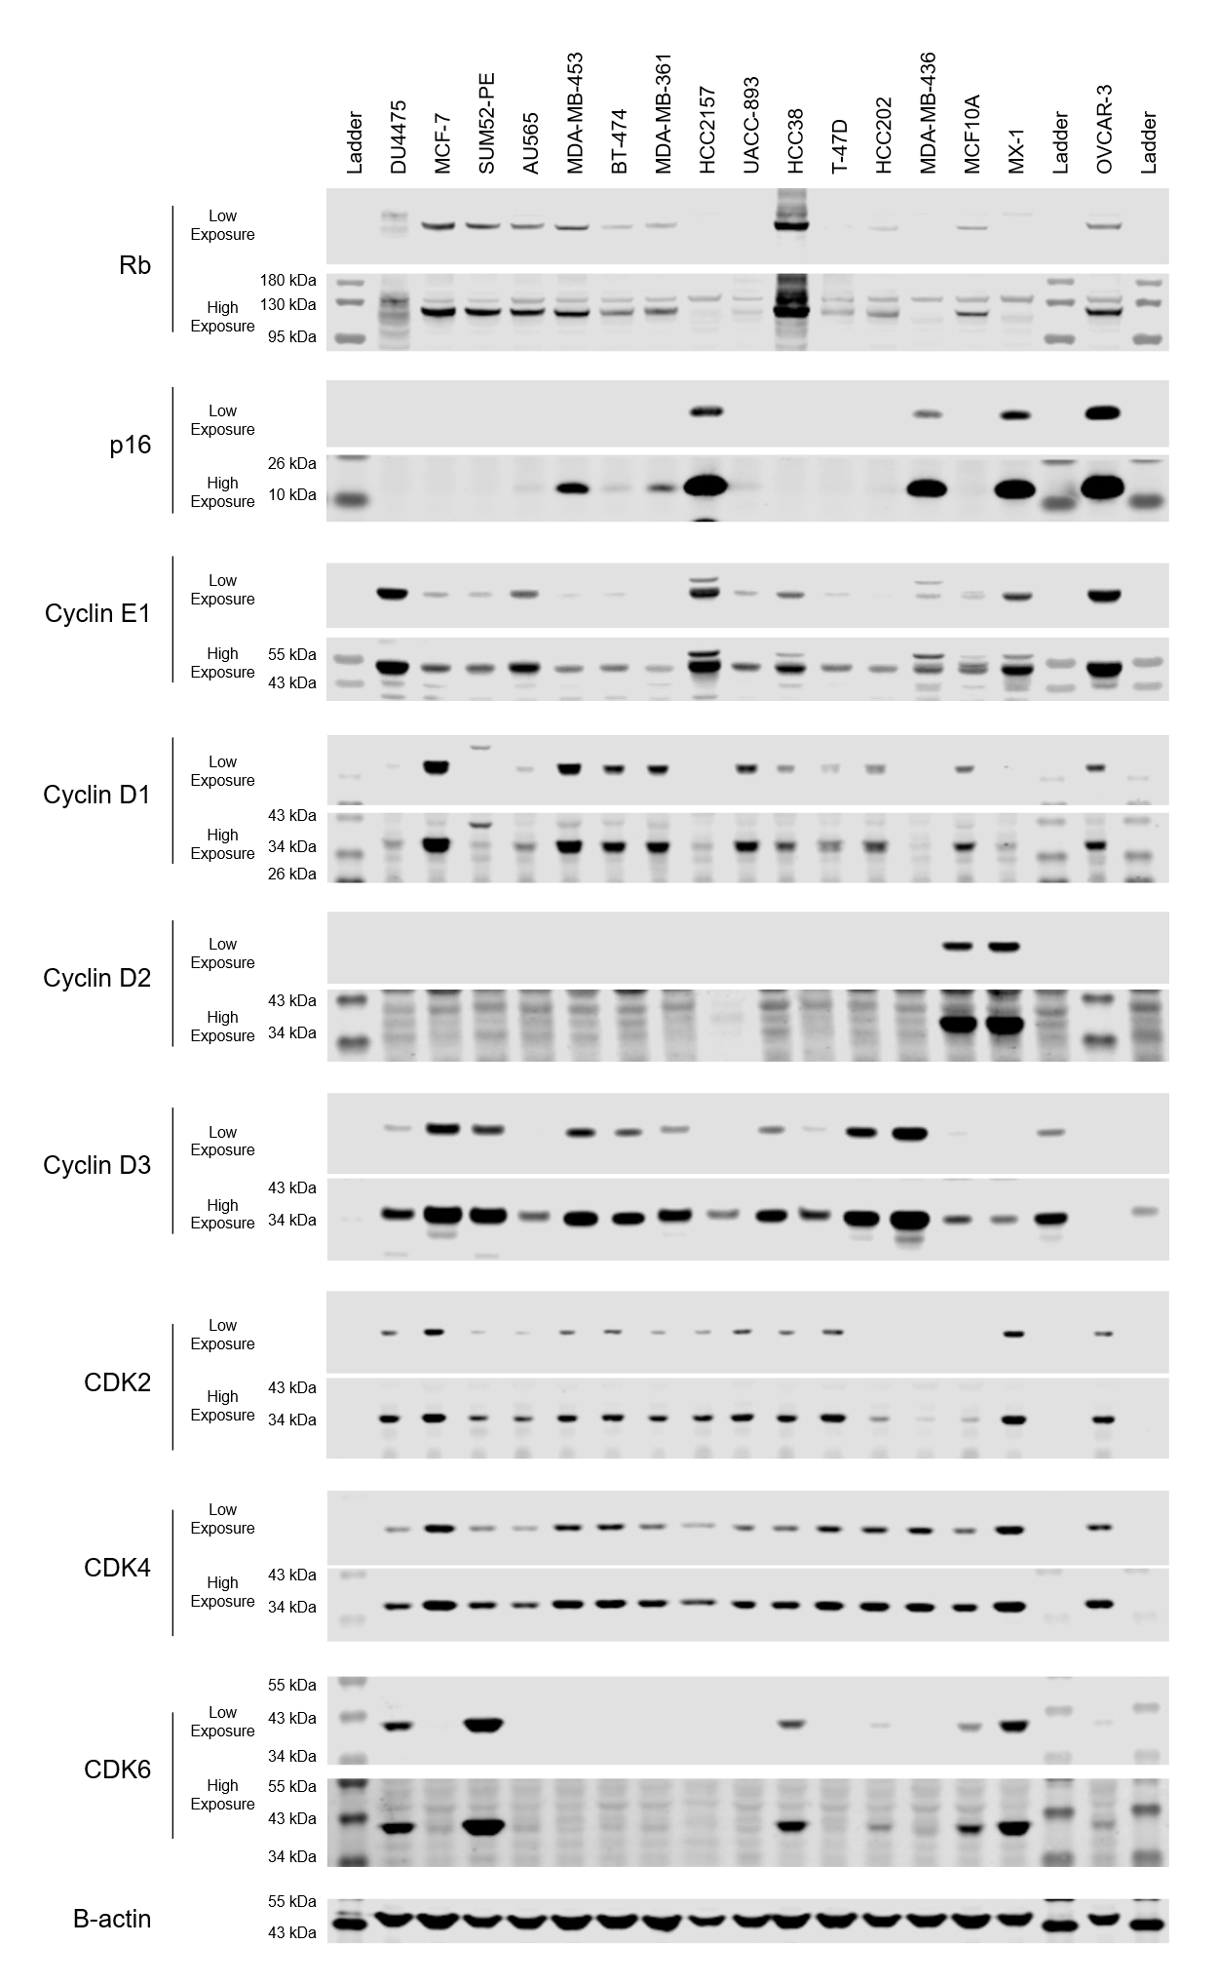
Supplementary Figure S2A,D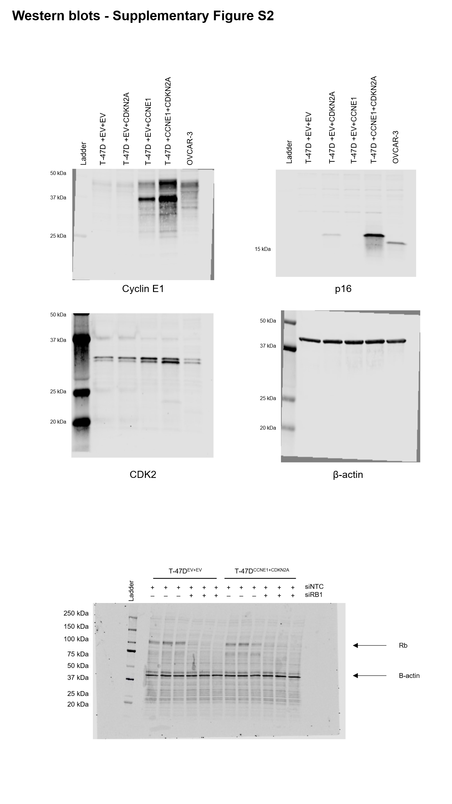
Supplementary Figure S3A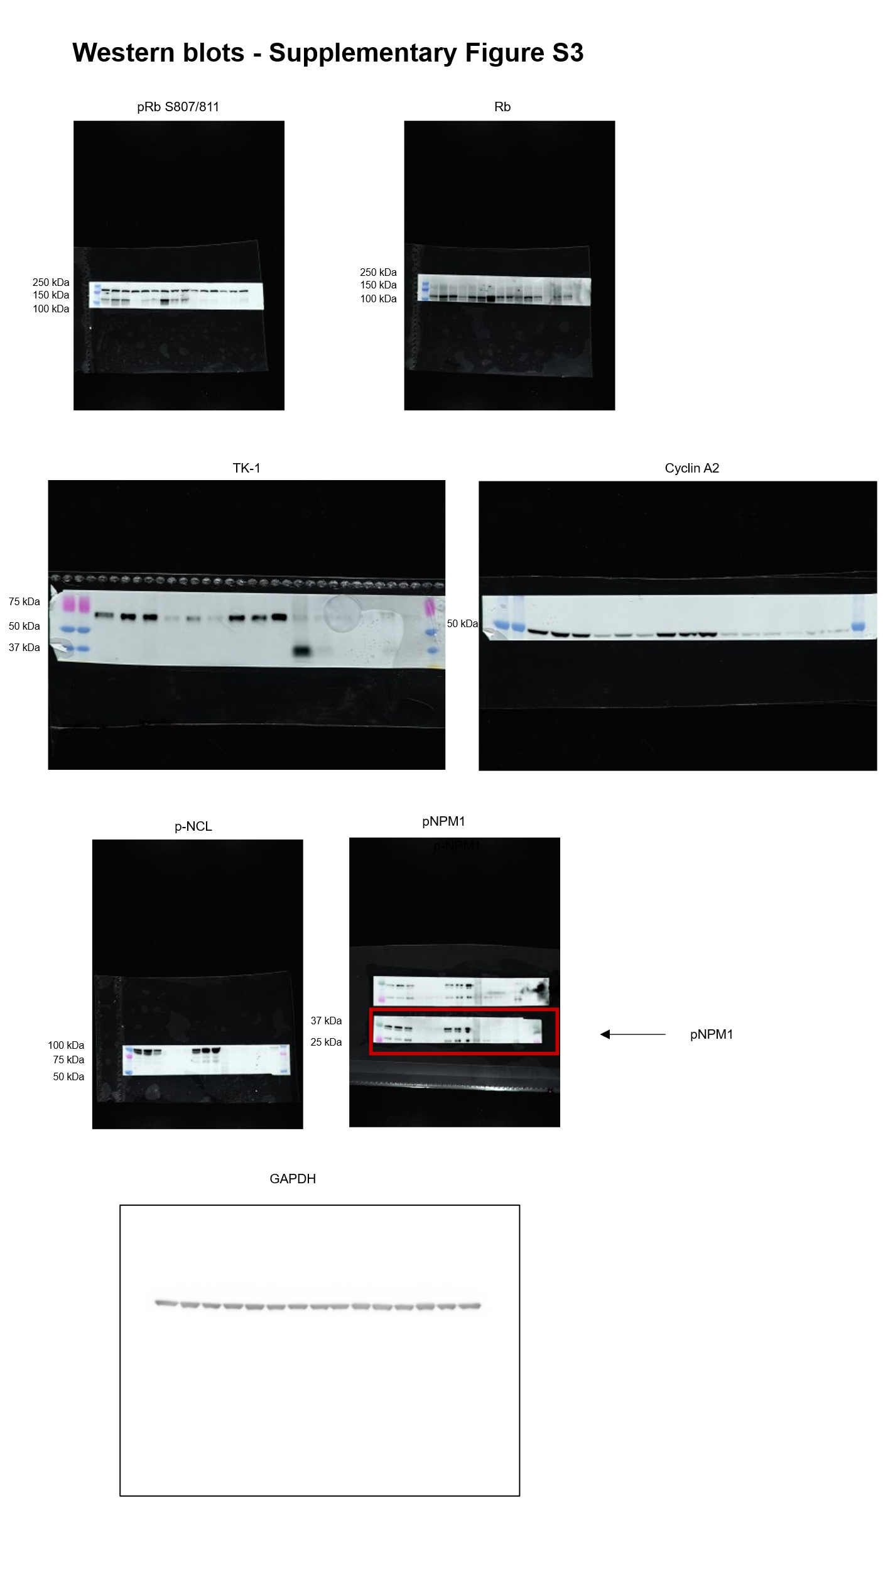

Supplementary Figure S5B
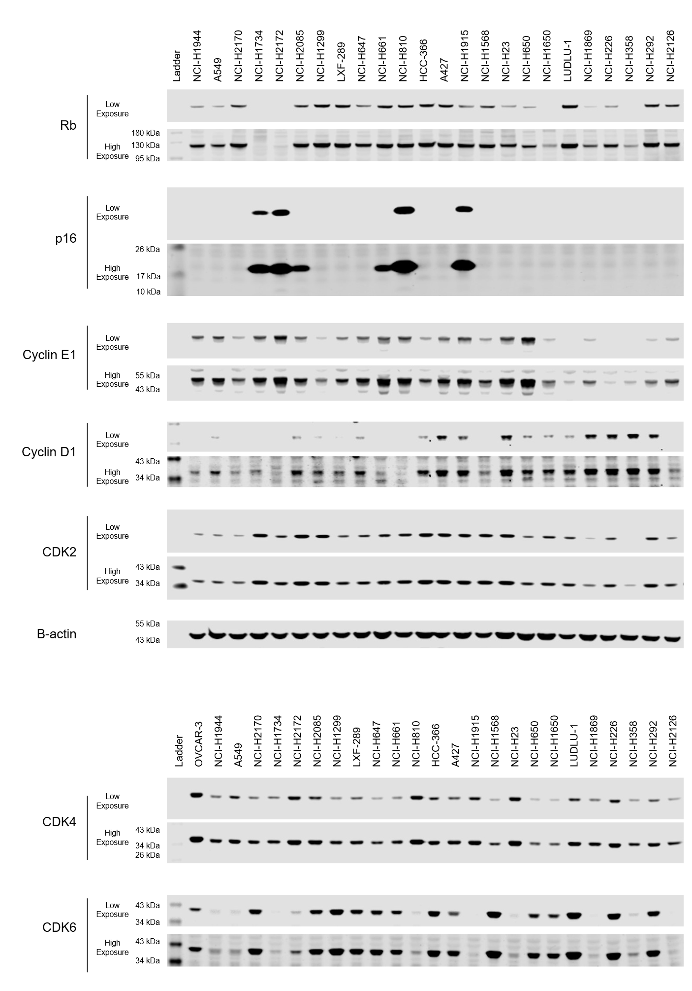

Supplementary Figure S5C
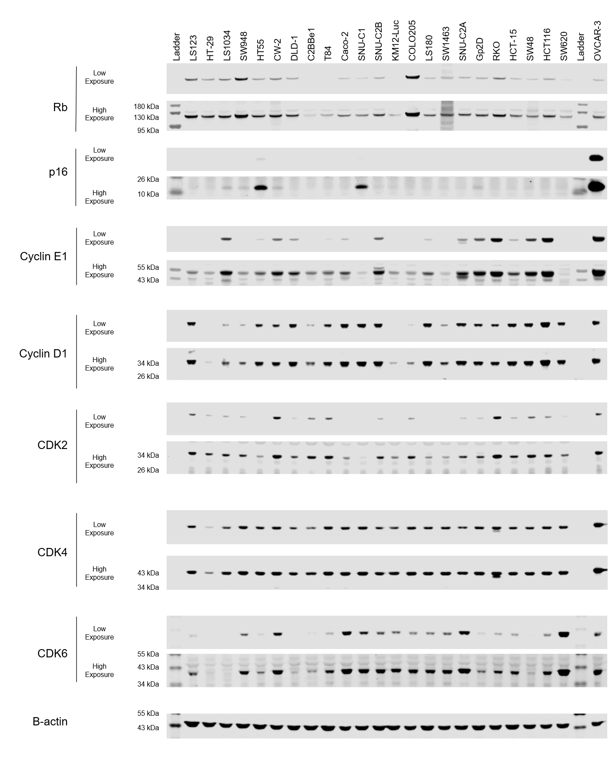

Supplementary Figure S5C, con’t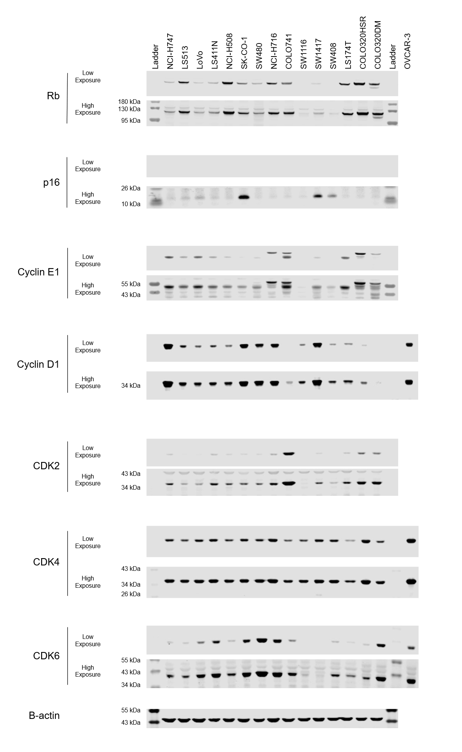
Supplementary Figure S5D
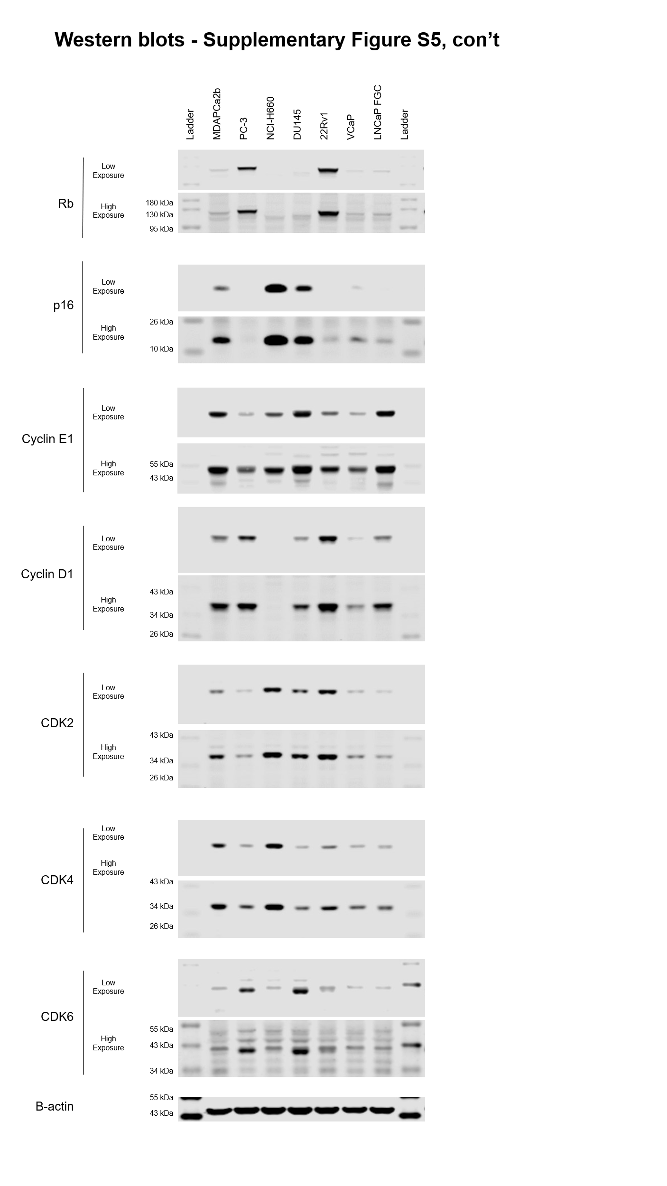

Supplementary Figure S5E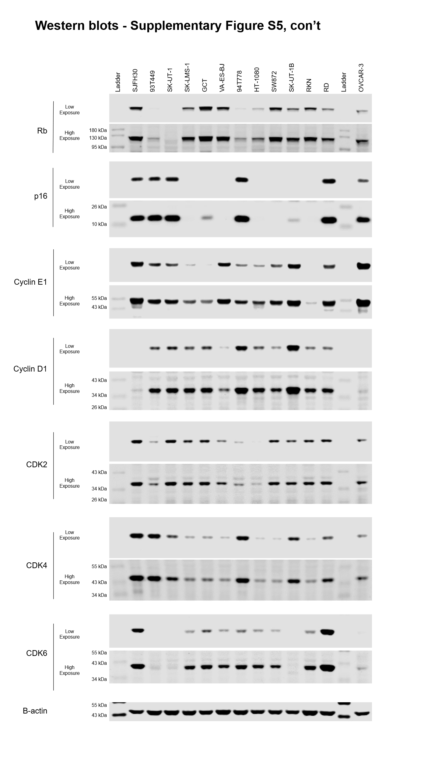

Supplementary Figure S5F
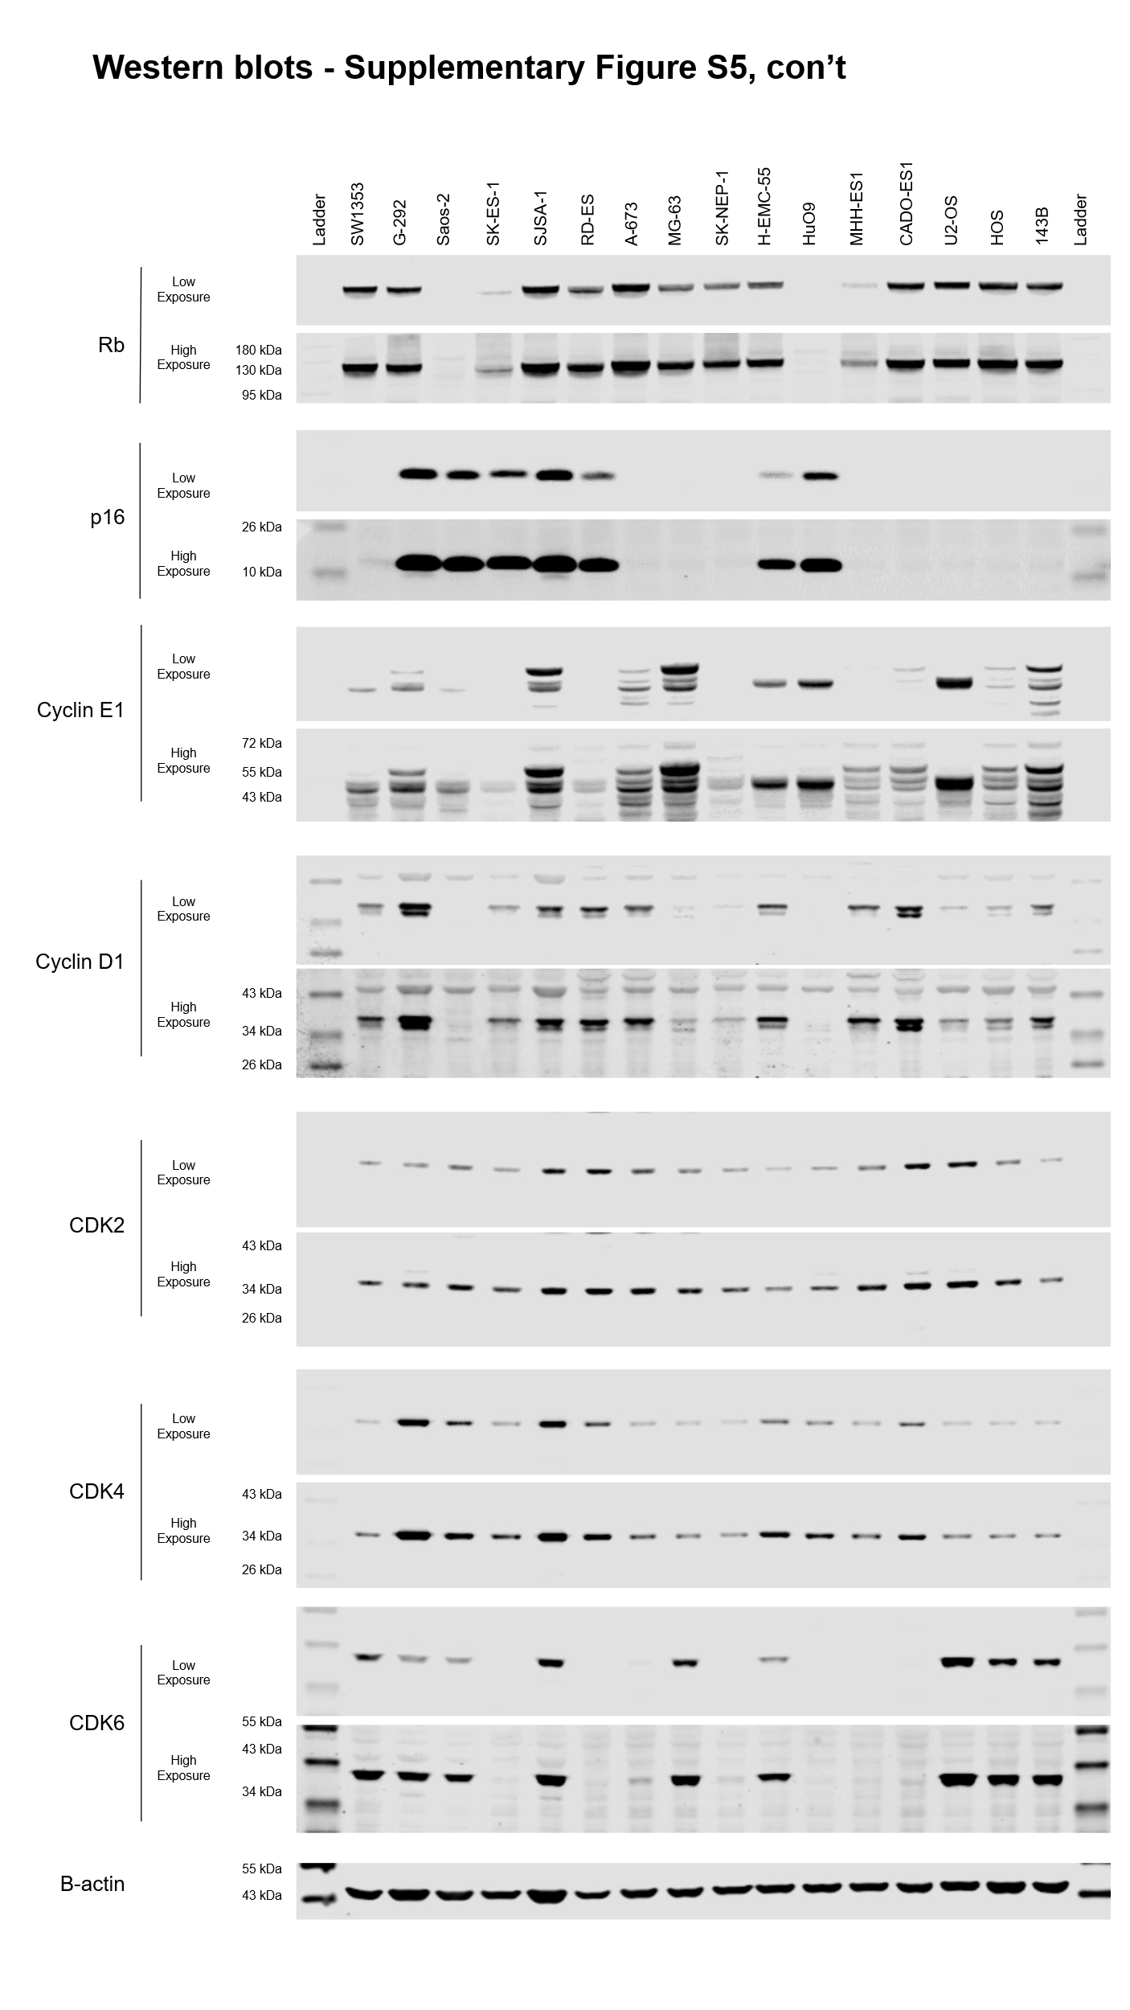

Supplementary Figure S6C,D
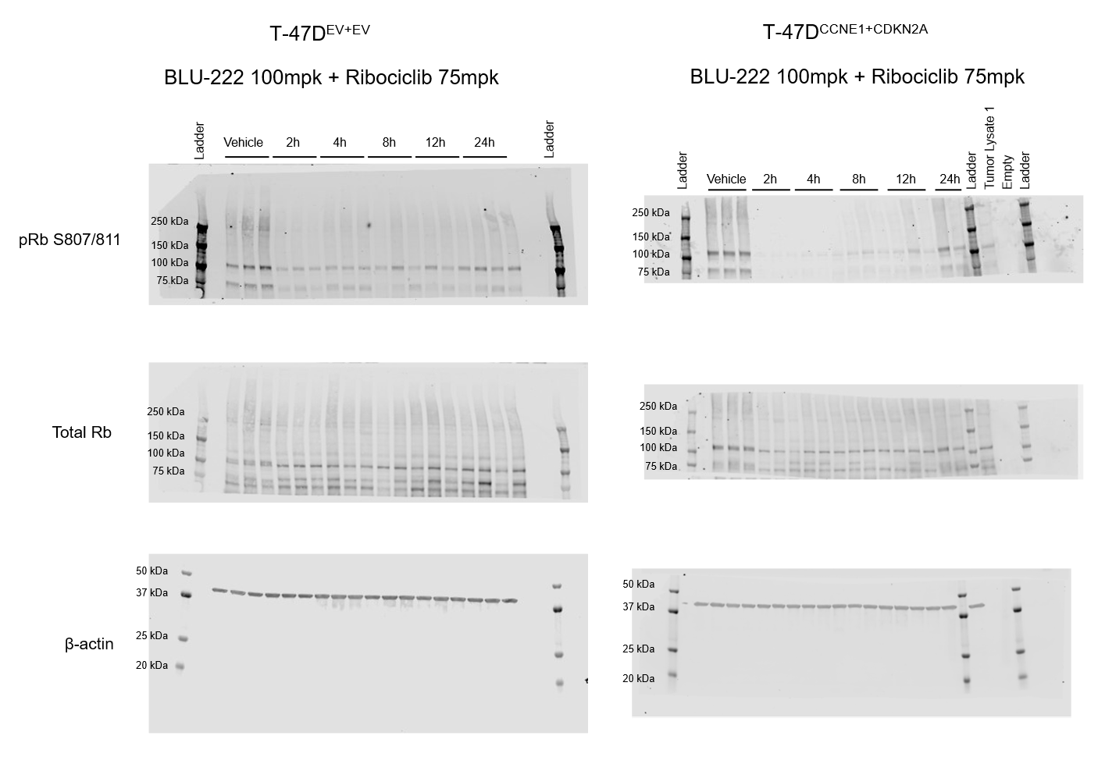

Supplementary Figure S7D-F

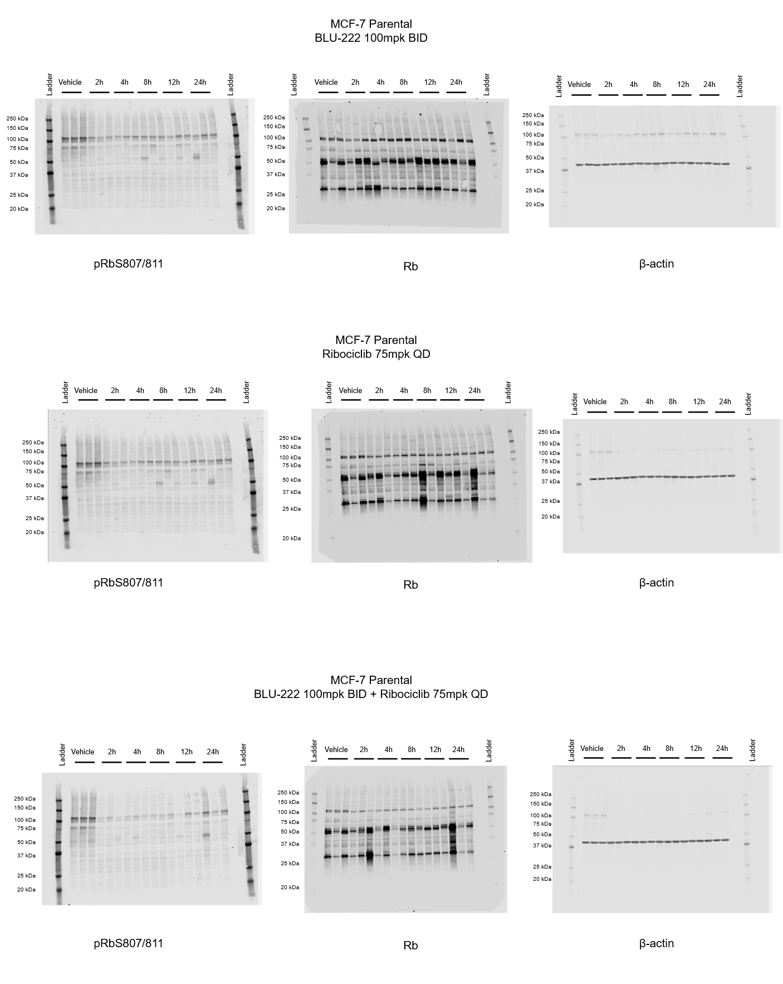

Supplementary Figure S7G-I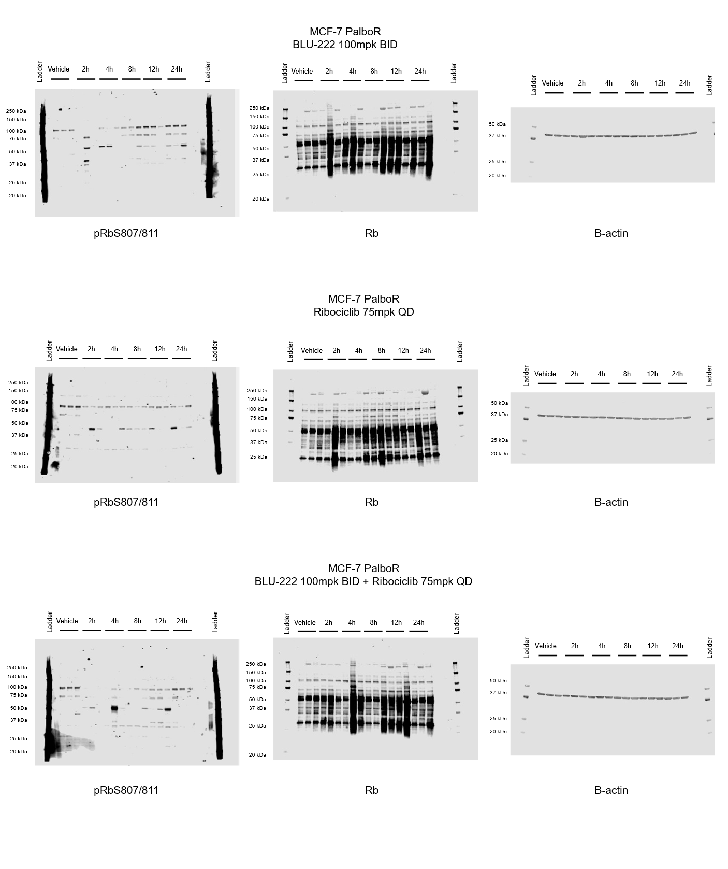

Supplementary Figure S8A (Supplement to Figure 3D)

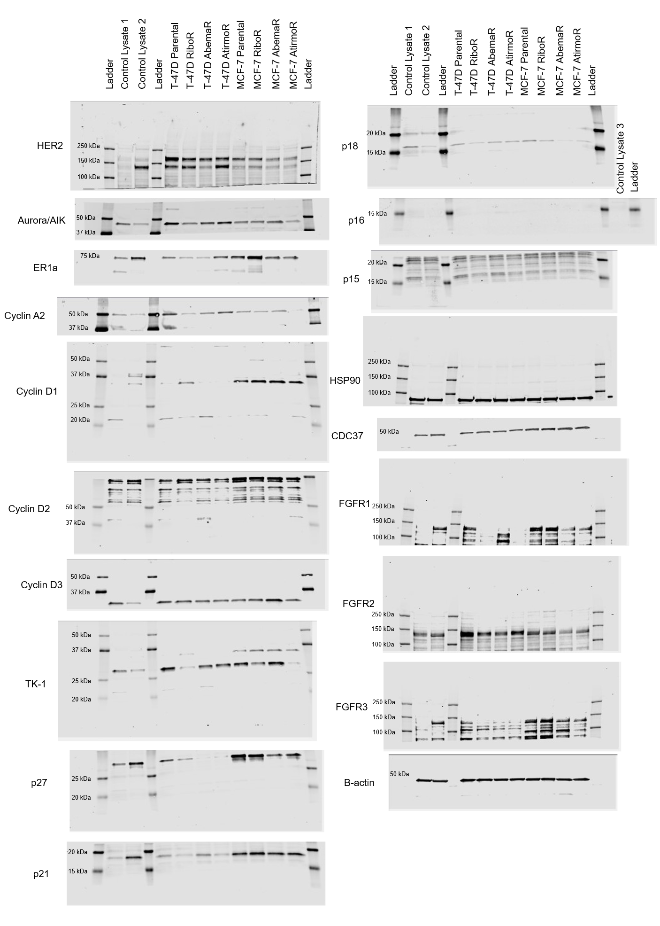

Supplementary Figure S10A

