Supplementary material

Supplementary Table 1 HER2 expression (20-gene signature) and tumor-infiltrating immune cell (TIIC) populations (CIBERSORTx)

TIICs | Discovery cohort | Confirmatory cohort | External independent (ABiM) cohort
TIICs | ρ (95% CI) | ρ (95% CI) | ρ (95% CI)
B cells naïve |  | -0.15 (-0.36;0.08) | -0.07 (-0.18;0.04)
B cells memory | -0.04 (-0.24;0.17) | p= 0.654
Plasma cells | 0.13 (-0.07;0.32) | -0.19 (-0.41;0.04) | -0.26 (-0.36;-0.15)
T cells CD8 | -0.01 (-0.23;0.21) | -0.34 (-0.52;-0.13) | -0.30 (-0.40;-0.19)
T cells CD4 naïve | p= 0.513 | p= 0.733
T cell CD4 memory | p= 0.062 | p= 0.076 | -0.21 (-0.32;-0.1)
T cells CD4 memory activated |  | p= 0.001
T cells follicular helper | -0.01 (-0.21;0.18) |  | -0.24 (-0.34;-0.13)
T cells regulatory | 0.16 (-0.05;0.35) | 0.15 (-0.07;0.37) | -0.17 (-0.28;-0.06)
T cells γδ |  | p= 0.027 | p=0.002
NK cells resting |  | p= 0.699
NK cells activated | 0.01 (-0.18;0.21) | 0.15 (-0.07;0.38) | -0.22 (-0.33;-0.11)
Monocytes | -0.18 (-0.37;0.03) | p= 0.513 | -0.01 (-0.12;0.10)
Macrophages M0 | -0.11 (-0.30;0.09) | 0.02 (-0.21;0.23) | -0.26 (-0.36;-0.16)
Macrophages M1 | -0.32 (-0.49;-0.12) | -0.62 (-0.75;-0.46) | -0.33 (-0.43;-0.22)
Macrophages M2 | -0.07 (-0.26;0.12) | 0.26 (0.03; 0.47) | 0.08 (-0.04;0.19)
DC resting |  | p= 0.617 | p= 0.588
Mast cells resting | -0.04 (-0.23;0.15) | 0.06 (-0.15;0.27) | 0.17 (0.05;0.28)
Mast cells activated | p= 0.080
Neutrophils | p=0.783 |  | p=0.027

Bold values, significant findings; Spearman’s rank correlation coefficients (ρ)>0.30; 95% confidence intervals (95%CI) are reported for continuous TIICs; p-values from Wilcoxon tests for dichotomous TIICs; blank cells, TIICs not estimated as reported in the Methods; NK, natural killer; DC, dendric cells.

Supplementary Table 2 HER2 expression (20-gene signature) and tumor-infiltrating immune cell (TIIC) populations (CIBERSORTx) by hormone-receptor (HR) status

TIICs | HR-positive  (n=255) | HR-negative  (n=63)
B cells Naïve | -0.15 (-0.28;-0.03) | -0.19 (-0.43;0.07)
Plasma cells | -0.27 (-0.38;-0.15) | -0.10 (-0.33;0.16)
T cells CD8 | -0.25 (-0.37;-0.12) | -0.27 (-0.50;-0.001)
T cells CD4 memory | -0.18 (-0.30;-0.04) | -0.16 (-0.40;0.10)
T cells follicular helper | -0.04 (-0.16;0.08) | -0.37 (-0.56;-0.13)
T cells regulatory | -0.07 (-0.20;0.06) | -0.05 (-0.29;0.18)
NK cells activated | -0.19 (-0.31;-0.05) | -0.11 (-0.35;0.14)
Monocytes | -0.03 (-0.16;0.09) | -0.08 (-0.31;0.14)
Macrophages M0 | -0.11 (-0.23;-0.001) | -0.10 (-0.36;0.17)
Macrophages M1 | -0.19 (-0.30;-0.06) | -0.39 (-0.59;-0.15)
Macrophages M2 | 0.07 (-0.06;0.20) | 0.04 (-0.22;0.28)
Mast cells resting | -0.16 (-0.28;-0.03) | 0.24 (-0.001;0.44)
Neutrophils | p= 0.008 | p= 0.003
DC resting | p= 0.129 | p= 0.382
T cells γδ | p= 0.017 | p= 0.531

Spearman’s rank correlation coefficients (ρ); 95% confidence intervals (95%CI) are reported for continuous TIICs; p-values of Wilcoxon tests for dichotomous TIICs; NK, natural killer; DC, dendric cells. Data refer to the ABiM cohort.

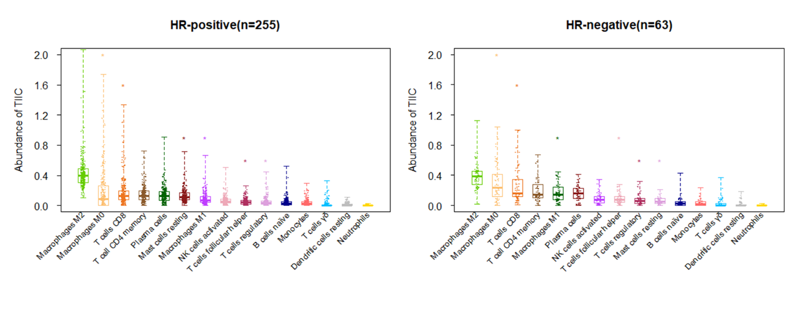
Supplementary Fig. 1: Tumor-infiltrating immune cell (TIIC) abundance by hormone receptor (HR) status
Supplementary Fig. 1 legend
A total of 15 TIICs were estimated in the ABiM cohort (n= 318). T cells γδ, dendric cells resting and neutrophils were considered as continuous variables. Stars indicate statistically significant differences in TIIC abundance between hormone receptor (HR)-positive and negative (HR-negative) tumors (Bonferroni adjusted p< 0.05).

