Supplementary Material

Supplementary Table 1. Distribution of clinicopathological features according to PAM50 intrinsic subtype.

 |  | Luminal A  n (%) | Luminal B  n (%) | HER2-Enriched  n (%) | Basal like  n (%) | p-value  (chi-squared)
Ki67, median (range) |  | 15 (2-40) | 25 (10-54) | 20 (14-25) | 35 (2-70) | <0.001
Estrogen receptor,  median (range) |  | 95 (50-100) | 95 (50-100) | 90 (60-95) | 90 (25-100) | 0.439
Progesterone receptor, median (range) |  | 80 (0-100) | 80 (0-100) | 20 (0-90) | 60 (0-100) | 0.089
Grade |  |  |  |  |  | 0.016
 | 1-2 | 23 (69.7) | 17 (40.5) | 1 (20) | 6 (33.3) | 0.016
 | 3 | 10 (30.3) | 25 (59.5) | 4 (80) | 12 (67.7) | 0.016
Stage |  |  |  |  |  | 0.478
 | IIA | 21 (58.3) | 28 (58.3) | 2 (40) | 8 (40) | 0.478
 | IIB | 14 (38.9) | 14 (29.2) | 2 (40) | 9 (45) | 0.478
 | IIIA | 1 (2.8) | 6 (12.5) | 1 (20) | 3 (15) | 0.478
Menopausal status |  |  |  |  |  | 0.082
 | Premenopausal | 11 (30.6) | 24 (50) | 0 (0) | 8 (40) | 0.082
 | Postmenopausal | 25 (69.4) | 24 (50) | 5 (100) | 12 (60) | 0.082

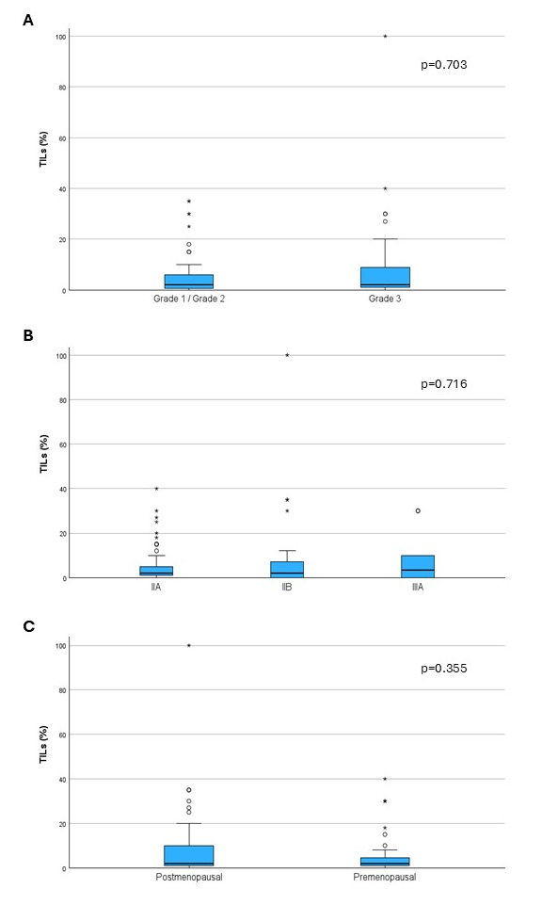
Supplementary Figure 1. Distribution of TIL levels according to histological grade (A), tumor stage (B), and menopausal status (C)
Supplementary Figure 2. Association between continuous TILs and PAM50 signatures

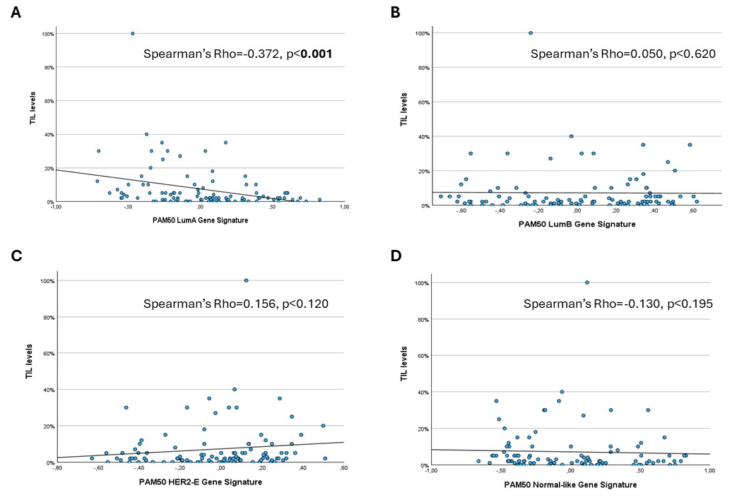

Supplementary Table 2. Associations between PAM50 signatures (as a continuous variable) and immune signatures expression.

 |  | CD8 signatures | Cytotoxic signature | IFN-gamma signature | GeparNuevo signature
Luminal A
 | Spearman coefficient | -0,277 | -0,213 | -0,406 | -0,178
 | p-value | 0,003 | 0,026 | <0,001 | 0,064
Luminal B
 | Spearman coefficient | -0,204 | -0,325 | -0,025 | -0,275
 | p-value | 0,034 | <0,001 | 0,799 | 0,004
HER2-enriched
 | Spearman coefficient | 0,130 | -0,004 | 0,270 | -0,001
 | p-value | 0,179 | 0,963 | 0,004 | 0,994
Basal like
 | Spearman coefficient | 0,420 | 0,486 | 0,409 | 0,399
 | p-value | <0,001 | <0,001 | <0,001 | <0,001
Normal like
 | Spearman coefficient | 0,085 | 0,196 | -0,089 | 0,144
 | p-value | 0,379 | 0,041 | 0,355 | 0,135

Supplementary Table 3. Associations between PAM50 signatures (as a continuous variable) and significant immune gene mRNA expression.

 |  | PDCD1 | CD274 | PDCD1LG2
Luminal A
 | Spearman coefficient | -0,320 | -0,423 | -0,463
 | p-value | 0,036 | 0,005 | 0,002
Luminal B
 | Spearman coefficient | -0,329 | -0,494 | -0,309
 | p-value | 0,031 | <0,001 | 0,044
HER2-enriched
 | Spearman coefficient | 0,030 | -0,064 | 0,067
 | p-value | 0,849 | 0,685 | 0,670
Basal like
 | Spearman coefficient | 0,473 | 0,648 | 0,513
 | p-value | 0,001 | <0,001 | <0,001
Normal like
 | Spearman coefficient | 0,226 | 0,368 | 0,192
 | p-value | 0,146 | 0,015 | 0,217

Supplementary Figure 3. Density of CD3+PD-1+ cells in the tumor area according to PAM50 subtyping
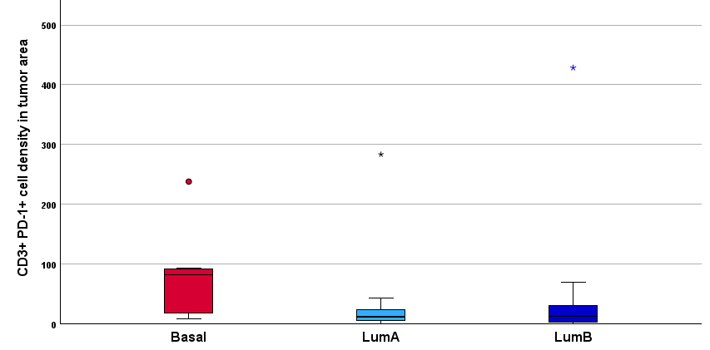
p=0.010 (Basal vs others)

Supplementary Figure 4. Density of PD-L1+ cells in the tumor area according to PAM50 subtyping
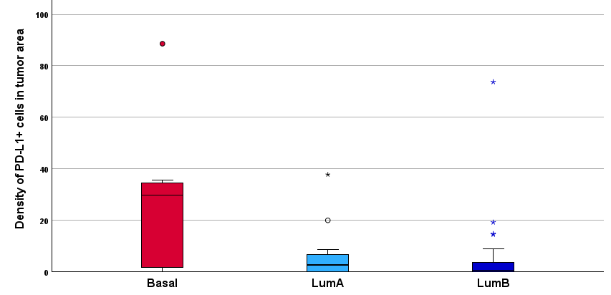
p=0.043 (Basal vs others)

Supplementary Figure 5. Density of PD-L1+ macrophagic cells (CD68+) cells in the tumor area according to PAM50 subtyping
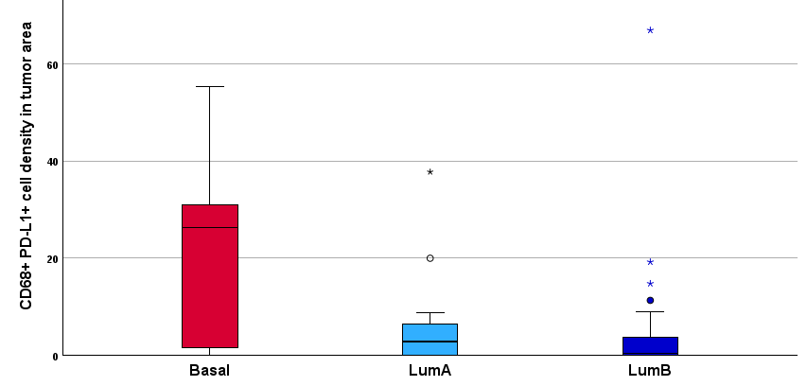
p=0.043 (Basal vs others)

Supplementary Figure 6. Density of PD-L1+ tumor cells in the tumor area according to PAM50 subtyping
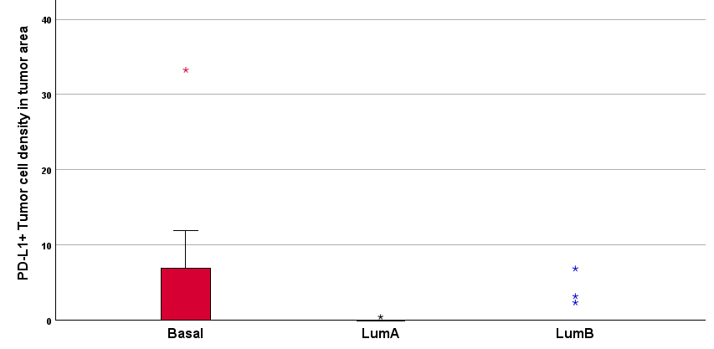
p=0.222 (Basal vs others)

Supplementary Table 4. Associations between PAM50 signatures (as a continuous variable) and density of PD-1+ and PD-L1+ cells in the tumor area as assessed by mutliplex immunofluorescence.

 |  | CD3+PD-1+ cells density | PD-L1+  cells density | CD68+ PD-L1+ cells density | PD-L1+ tumor  cells density
Luminal A
 | Spearman coefficient | -0.433 | -0.371 | -0.385 | -0.187
 | p-value | 0.004 | 0.014 | 0.011 | 0.230
Luminal B
 | Spearman coefficient | -0.280 | -0.252 | -0.298 | -0.048
 | p-value | 0.069 | 0.103 | 0.052 | 0.759
HER2-enriched
 | Spearman coefficient | 0.086 | 0.005 | -0.021 | 0.014
 | p-value | 0.583 | 0.976 | 0.893 | 0.930
Basal like
 | Spearman coefficient | 0.566 | 0.461 | 0.494 | 0.126
 | p-value | <0.001 | 0.002 | <0.001 | 0.419
Normal like
 | Spearman coefficient | 0.164 | 0.106 | 0.137 | 0.106
 | p-value | 0.294 | 0.498 | 0.383 | 0.498

