SUPPLEMENTARY INFORMATION

Deep Learning Analysis of Defect and Phase Evolution During Electron Beam Induced Transformations in WS₂

Artem Maksov^{1,2,3}, Ondrej Dyck^{1,2}, Kai Wang¹, Kai Xiao¹, David B. Geohegan¹, Bobby G. Sumpter^{1,4}, Rama K. Vasudevan^{1,2}, Stephen Jesse^{1,2}, Sergei V. Kalinin^{1,2,*}, Maxim Ziatdinov^{1,2,*}

¹Center for Nanophase Materials Sciences, Oak Ridge National Laboratory, Oak Ridge TN 37831
²Institute for Functional Imaging of Materials, Oak Ridge National Laboratory, Oak Ridge TN 37831
³Bredesen Center for Interdisciplinary Research, University of Tennessee, Knoxville, Tennessee 37996
⁴Computational Sciences & Engineering Division, Oak Ridge National Laboratory, Oak Ridge TN 37831

CONTENTS:
Supplementary Figures 1-3.
Jupyter Notebooks.
STEM “movies” (original, decoded)

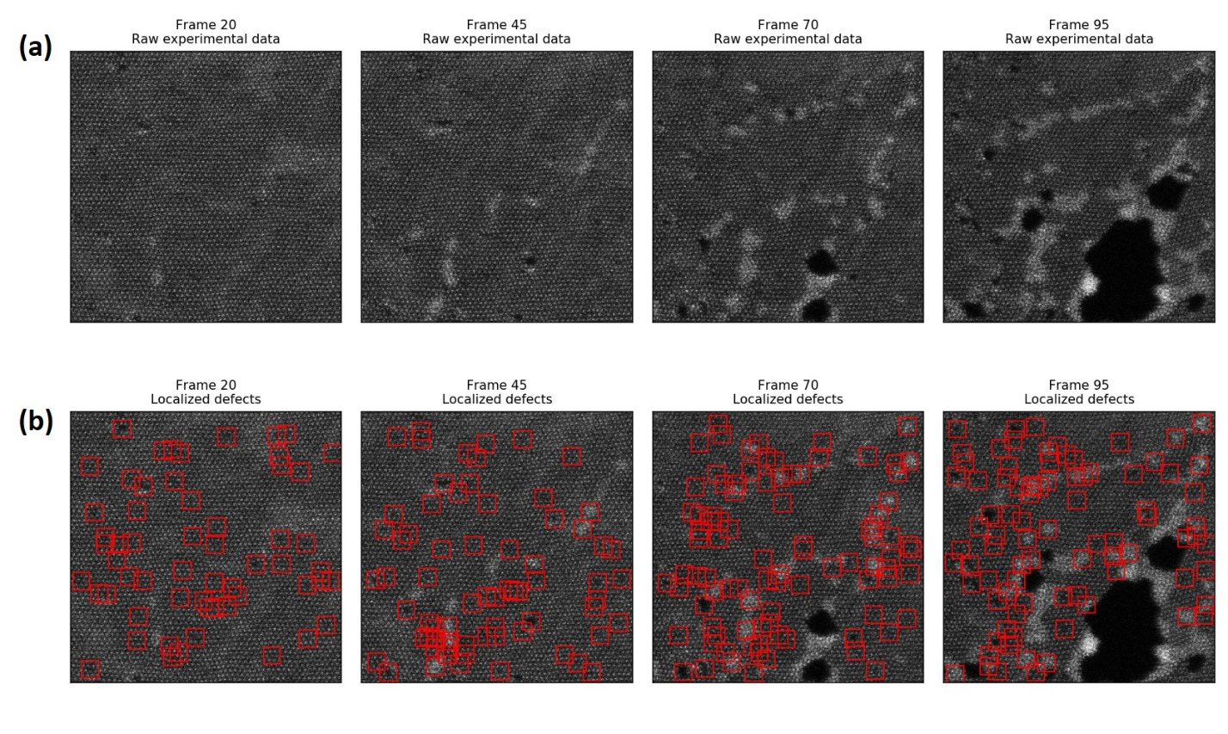
SUPPLEMENTARY FIGURE 1. (a) Raw experimental data (selected frames). (b) Same data with point-like defects localized. Note that here we do not consider extended defects. See full movie with localized defects in the supplementary video file.

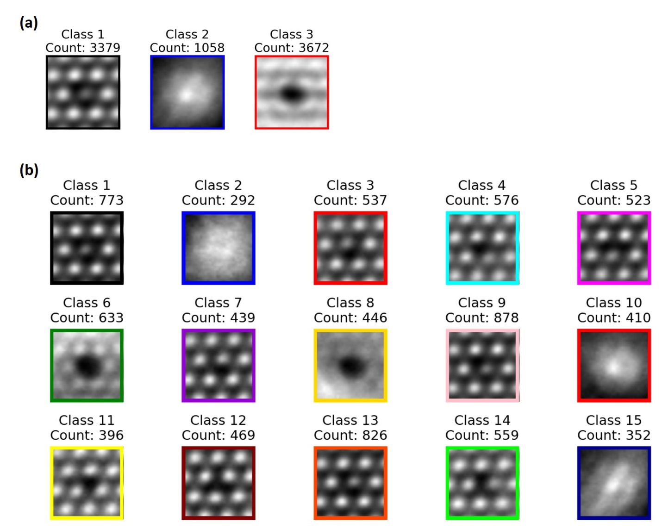
SUPPLEMENTARY FIGURE 2. (a) GMM splitting into 3 clusters. The class 3 structure is clearly distorted due to insufficient number of components (b) GMM splitting into 15 clusters.

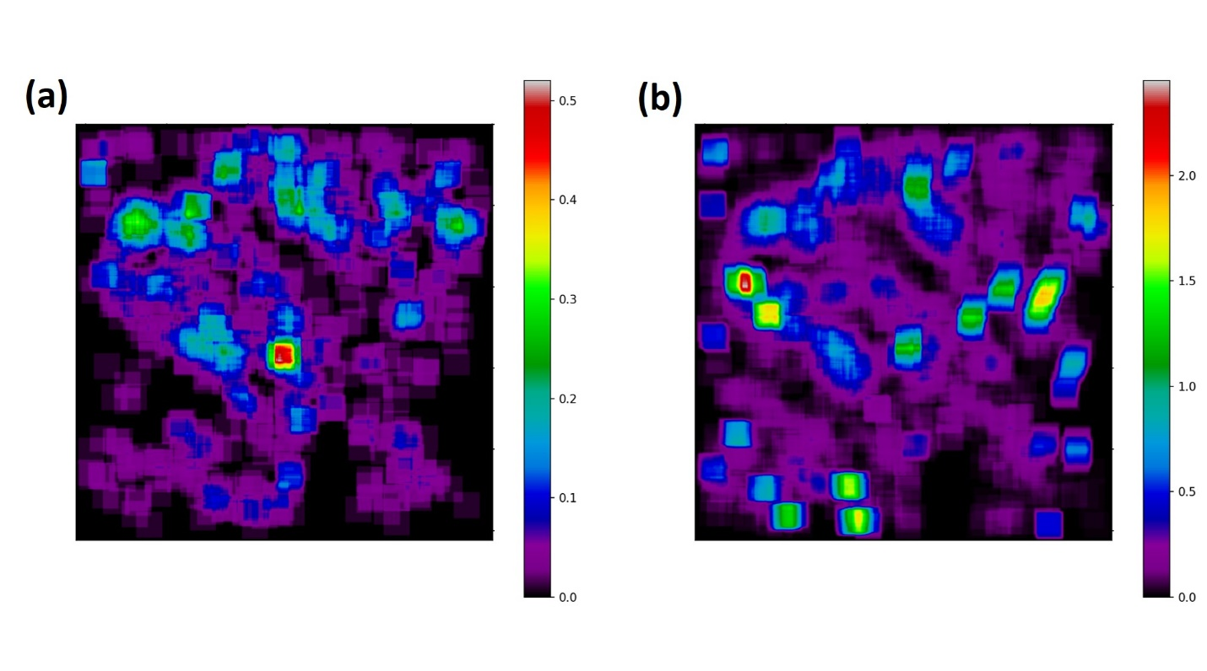
SUPPLEMENTARY FIGURE 3. (a) Projection of sub-windows associated with S vacancy (class 5). (b) Projection of sub-windows associated with Mo defects (class 1 and class 3)

