Supporting Information
Nanoscale Self-Healing Mechanisms in Shape Memory Ceramics
Ning Zhang and Mohsen Asle Zaeem*
Department of Mechanical Engineering, Colorado School of Mines, Golden, CO 80401, USA

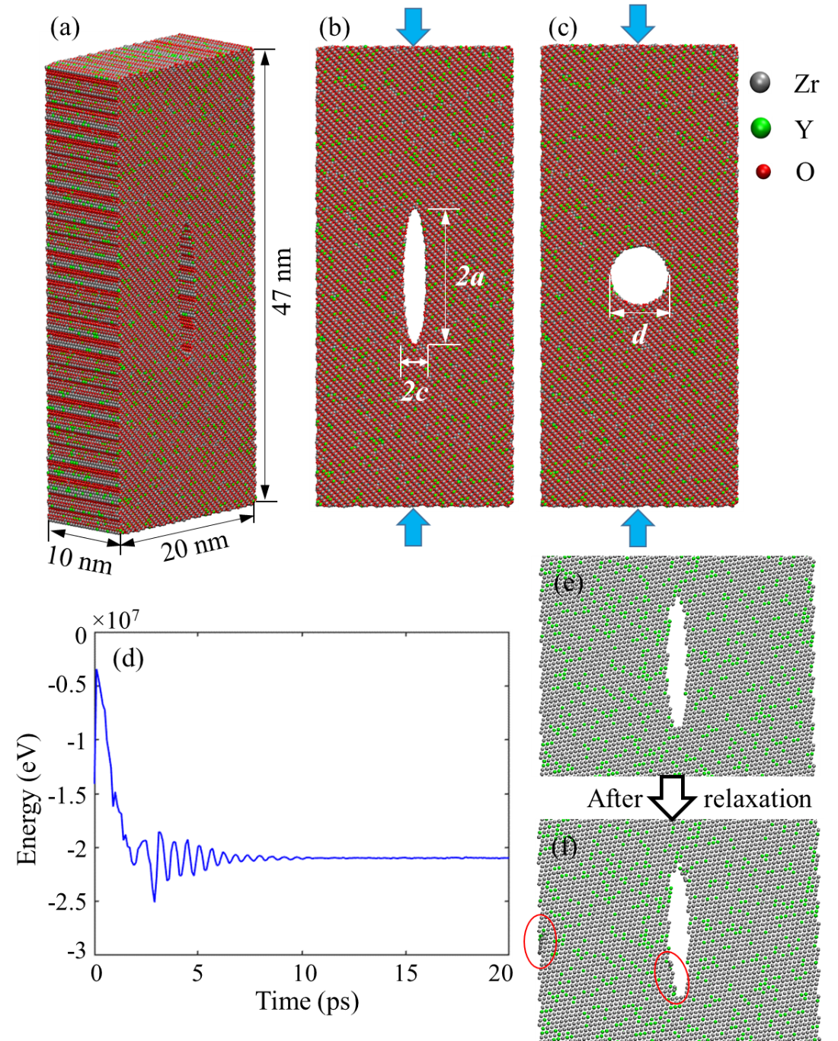
Figure S1. (a) 3-dimensional view and (b-c) side view of YSTZ nanopillars with pre-existing crack and void. 2a, 2c and d in (b), (c) denote the length and width of crack, and the diameter of void, respectively. (d) Energy-time response during relaxation of a YSTZ nanopillar with a pre-existing crack. (e) and (f) compare the microstructure around the pre-existing crack before and after relaxation. The red ellipses in (f) highlight the local disordered atoms after relaxation.

To investigate the specimen size effect on the nanostructure evolution around the crack, we set up three YSTZ nanopillars with different width (L) of 30.0 nm, 40.0 nm, and 50.0 nm, which have total number of atoms of 1,160,000, 1,560,000 and 2,000,000, respectively. The pre-existing crack has a same size of 2a = 18.2 nm and 2c = 2.6 nm in all these nanopillars. Fig. S2 presents the snapshots regarding specimen size effect on the evolution of crack closure.

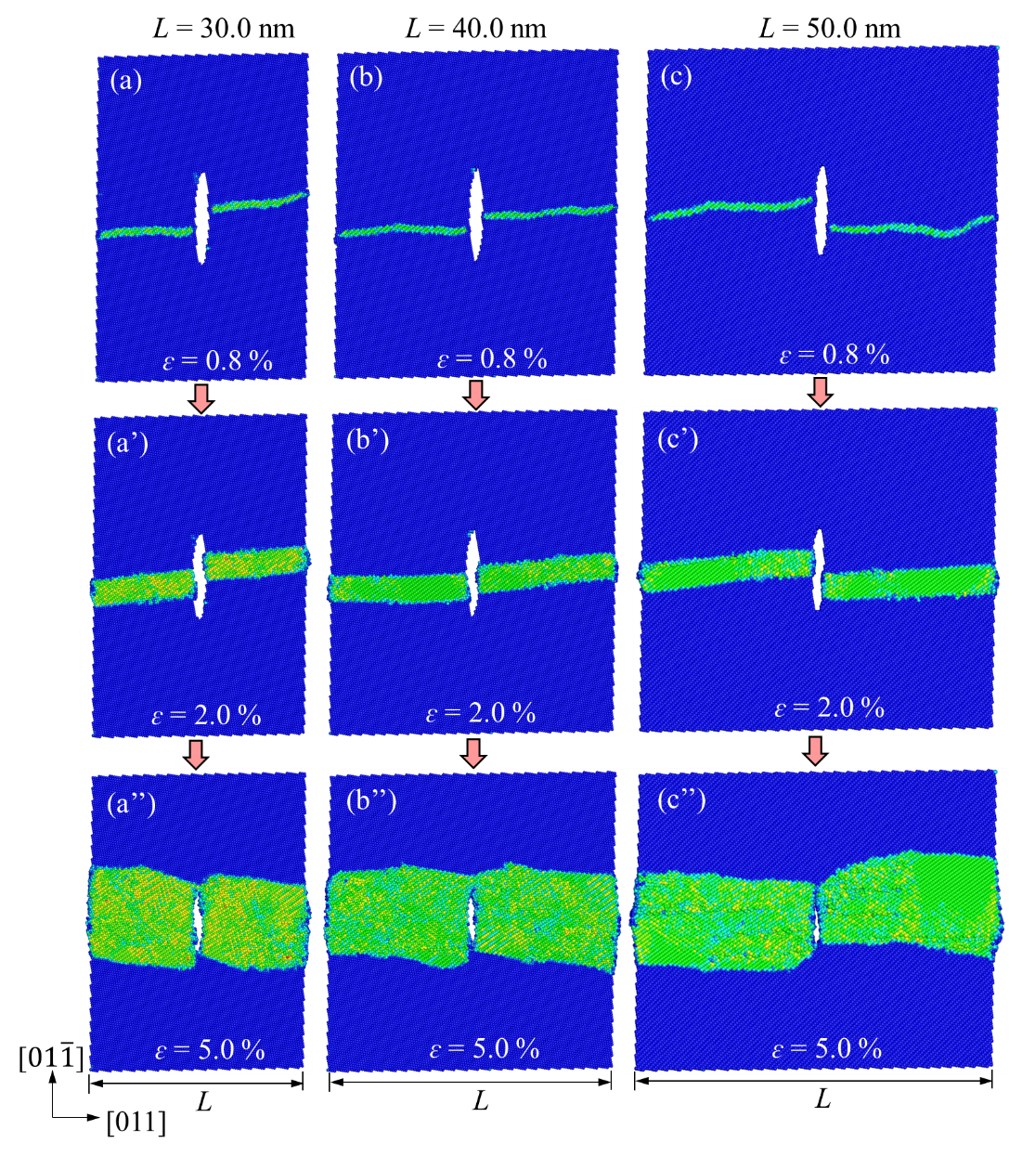
Figure S2. Atomic configurations for $\left[01\overline{1}\right]$-oriented YSTZ nanopillars with different specimen sizes under compressive strains of (a-c) 0.8%, (a’-c’) 2.0% and (a’’-c’’) 5.0%. The pre-existing cracks in different models have a same size of 2a = 18.2 nm and 2c = 2.6 nm. The atoms are colored by coordination number, where blue and green colors denote atoms with tetragonal and monoclinic crystal structures.

Figure S3b presents the obtained stress-strain relations of [001]-oriented YSTZ nanopillars with different pre-existing void sizes. The strain-strain curves for nanopillars with different pre-existing voids show a similar deformation trend, i.e., an initial linear elastic region, followed by sudden stress drop due to the onset of plasticity around the void, and then stress fluctuates with continuous loading.

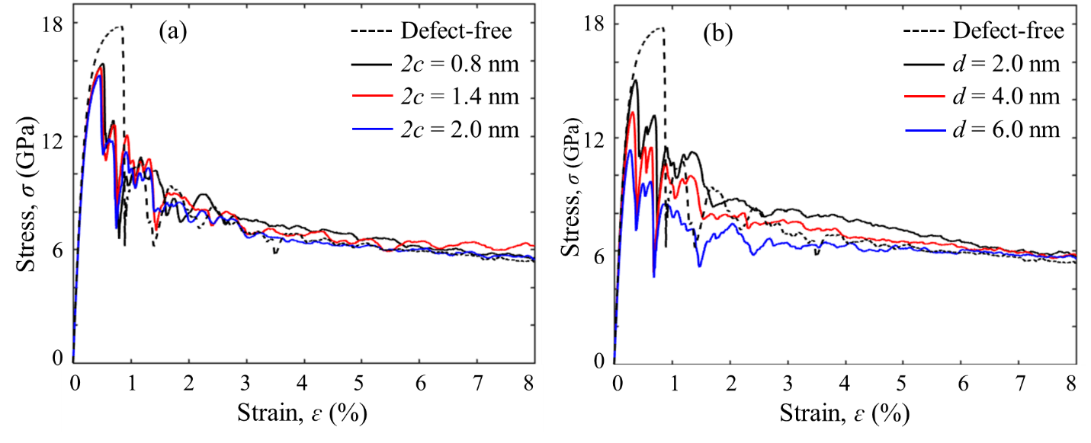
Figure S3. Stress-strain (σ - ɛ) relations of [001]-oriented YSTZ nanopillars (a) with and without cracks, and (b) with and without voids. The length/width ratio of cracks are controlled at 7.0. The crack widths are 0.8 nm, 1.4 nm and 2.0 nm. The voids have diameters (d) of 2.0 nm, 4.0 nm, and 6.0 nm, respectively.

To reveal the interaction between dislocation and void, we present the atomic trajectories at various strains of [001]-oriented YSTZ nanopillars with difference void sizes in Fig. S4. CN and SV are adopted to identify the dislocation migration behavior.
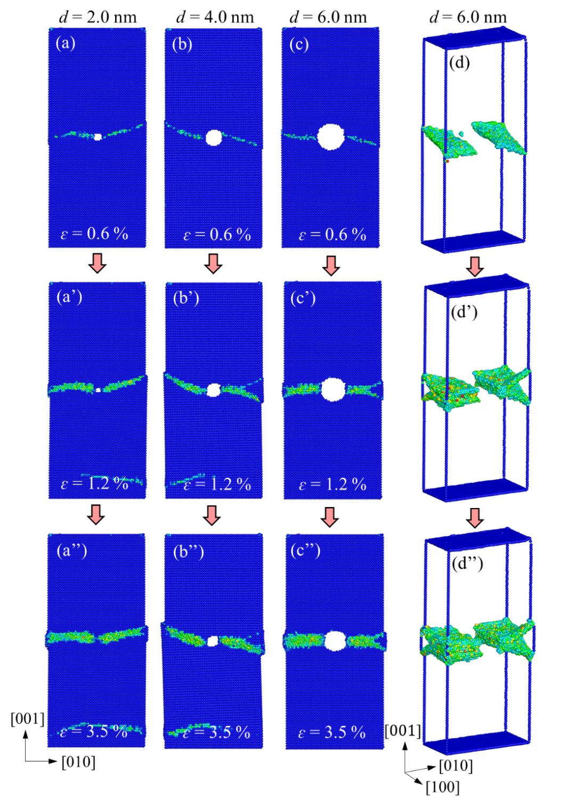
Figure S4. Atomic configurations of [001]-oriented YSTZ nanopillars with different void sizes under compression. The diameters (d) of pre-existing voids in (a-a’’), (b-b’’), (c-c’’) are 2.0 nm, 4.0 nm and 6.0 nm, respectively. And the atoms are colored by coordination number (CN), where blue atoms have the tetragonal crystal structure and other colors denotes the dislocated atoms. Slip vector (SV) is employed to identify the slip planes in (d-d’’).
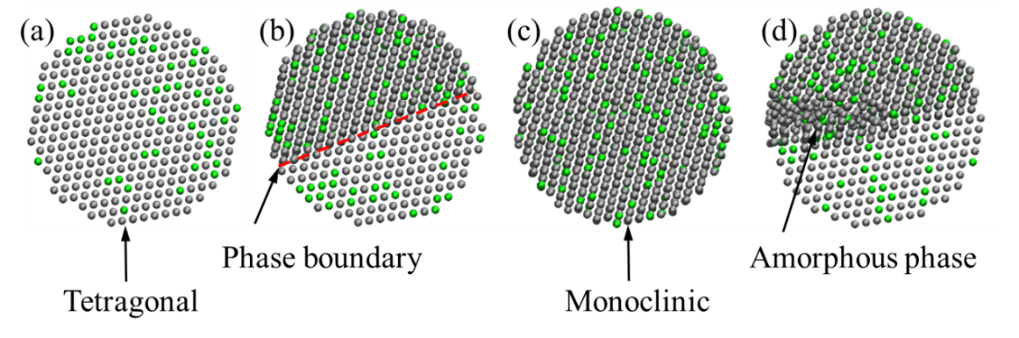
Figure S5. Crystal structures of (a) original phase (tetragonal), (b) phase boundary region (between tetragonal and monoclinic phases), (c) transformed new phase (monoclinic), and (d) amorphous phase around the interface in YSTZ. Gary and green atoms are zirconium and yttrium, respectively; the oxygen atoms are not shown for visibility.

Movie S1. Evolution of dislocation migration and shear in a small model.

* Corresponding author. Email address: zaeem@mines.edu

