Supplementary Information for:
Machine learning-based discovery of vibrationally stable materials

Sherif Abdulkader Tawfik^{1,2,*} Mahad Rashid, ³ Sunil Gupta,³ Salvy P. Russo,^{2,4} Tiffany R. Walsh¹, and Svetha Venkatesh^{3*}
¹Institute for Frontier Materials, Deakin University, Geelong, VIC 3216, Australia
²ARC Centre of Excellence in Exciton Science, Deakin University, Geelong, VIC 3216, Australia
³Applied Artificial Intelligence Institute (A²I²), Deakin University, Geelong, VIC 3216, Australia
⁴Chemical and Quantum Physics, School of Science, RMIT University, Melbourne VIC 3001, Australia

Supplementary Tables
Supplementary Table 1: Explanation of the descriptors used in the work.
Descriptor | Description
Pristine_SDFT_BelowFermi_n (n: 1 to 50) | The energy eigenvalues below the Fermi level in the pristine crystal
Pristine_SDFT_AboveFermi_n (1: 51 to 100) | The energy eigenvalues above the Fermi level
Pristine_SDFT_ef | The Fermi level
Pristine_SDFT_e_band | Total energy of the electronic bands
Pristine_SDFT_e_coulomb | Total Coulomb energy
Pristine_SDFT_e_entropy | Total entropy
Pristine_SDFT_e_external | Total electron-nuclear energy
Pristine_SDFT_e_kinetic | Total kinetic energy
Pristine_SDFT_e_xc | Total exchange-correlation energy
Pristine_SDFT_e_total_free | Total free energy
Defective_SDFT_BelowFermi_n (n: 1 to 50) | The energy eigenvalues below the Fermi level in the defective crystal
Defective_SDFT_AboveFermi_n (1: 51 to 100) | The energy eigenvalues above the Fermi level
Defective_SDFT_ef | The Fermi level
Defective_SDFT_e_band | Total energy of the electronic bands
Defective_SDFT_e_coulomb | Total Coulomb energy
Defective_SDFT_e_entropy | Total entropy
Defective_SDFT_e_external | Total electron-nuclear energy
Defective_SDFT_e_kinetic | Total kinetic energy
Defective_SDFT_e_xc | Total exchange-correlation energy
Defective_SDFT_e_total_free | Total free energy
mean_atomic_numbers | Statistics of the atomic numbers
max_atomic_numbers | Statistics of the atomic numbers
min_atomic_numbers | Statistics of the atomic numbers
std_atomic_numbers | Statistics of the atomic numbers
volume_per_atom | Total volume/Number of atoms in the crystal
empty_volume | Volume – total volume occupied by the atoms. The volume occupied by an atom is represented as a sphere with a radius of the average ionic radius.
metals_fraction | Number of metal elements/Number of atoms in the crystal
mean_distance_matrix | Statistics of the distance matrix
max_distance_matrix | Statistics of the distance matrix
min_distance_matrix | Statistics of the distance matrix
std_distance_matrix | Statistics of the distance matrix
mean_van_der_waals_radius | Statistics of the van der Waals radius
max_van_der_waals_radius | Statistics of the van der Waals radius
min_van_der_waals_radius | Statistics of the van der Waals radius
std_van_der_waals_radius | Statistics of the van der Waals radius
mean_electrical_resistivity | Statistics of the electrical resistivity
max_electrical_resistivity | Statistics of the electrical resistivity
min_electrical_resistivity | Statistics of the electrical resistivity
std_electrical_resistivity | Statistics of the electrical resistivity
mean_velocity_of_sound | Statistics of the velocity of sound
max_velocity_of_sound | Statistics of the velocity of sound
min_velocity_of_sound | Statistics of the velocity of sound
std_velocity_of_sound | Statistics of the velocity of sound
mean_reflectivity | Statistics of the reflectivity of the elements
max_reflectivity | Statistics of the reflectivity of the elements
min_reflectivity | Statistics of the reflectivity of the elements
std_reflectivity | Statistics of the reflectivity of the elements
mean_poissons_ratio | Statistics of the Poisson ratio
max_poissons_ratio | Statistics of the Poisson ratio
min_poissons_ratio | Statistics of the Poisson ratio
std_poissons_ratio | Statistics of the Poisson ratio
mean_molar_volume | Statistics of the molar volume
max_molar_volume | Statistics of the molar volume
min_molar_volume | Statistics of the molar volume
std_molar_volume | Statistics of the molar volume
mean_thermal_conductivity | Statistics of the thermal conductivity
max_thermal_conductivity | Statistics of the thermal conductivity
min_thermal_conductivity | Statistics of the thermal conductivity
std_thermal_conductivity | Statistics of the thermal conductivity
mean_melting_point | Statistics of the melting point
max_melting_point | Statistics of the melting point
min_melting_point | Statistics of the melting point
std_melting_point | Statistics of the melting point
mean_critical_temperature | Statistics of the critical temperature
max_critical_temperature | Statistics of the critical temperature
min_critical_temperature | Statistics of the critical temperature
std_critical_temperature | Statistics of the critical temperature
mean_superconduction_temperature | Statistics of the superconducting temperature
max_superconduction_temperature | Statistics of the superconducting temperature
min_superconduction_temperature | Statistics of the superconducting temperature
std_superconduction_temperature | Statistics of the superconducting temperature
mean_liquid_range | Statistics of the liquid range
max_liquid_range | Statistics of the liquid range
min_liquid_range | Statistics of the liquid range
std_liquid_range | Statistics of the liquid range
mean_bulk_modulus | Statistics of the bulk modulus
max_bulk_modulus | Statistics of the bulk modulus
min_bulk_modulus | Statistics of the bulk modulus
std_bulk_modulus | Statistics of the bulk modulus
mean_youngs_modulus | Statistics of the Young’s modulus
max_youngs_modulus | Statistics of the Young’s modulus
min_youngs_modulus | Statistics of the Young’s modulus
std_youngs_modulus | Statistics of the Young’s modulus
mean_brinell_hardness | Statistics of the Brinell hardness
max_brinell_hardness | Statistics of the Brinell hardness
min_brinell_hardness | Statistics of the Brinell hardness
std_brinell_hardness | Statistics of the Brinell hardness
mean_rigidity_modulus | Statistics of the rigidity modulus
max_rigidity_modulus | Statistics of the rigidity modulus
min_rigidity_modulus | Statistics of the rigidity modulus
std_rigidity_modulus | Statistics of the rigidity modulus
mean_vickers_hardness | Statistics of the Vickers hardness
max_vickers_hardness | Statistics of the Vickers hardness
min_vickers_hardness | Statistics of the Vickers hardness
std_vickers_hardness | Statistics of the Vickers hardness
mean_density_of_solid | Statistics of the density of solid
max_density_of_solid | Statistics of the density of solid
min_density_of_solid | Statistics of the density of solid
std_density_of_solid | Statistics of the density of solid
mean_coefficient_of_linear_thermal_expansion | Statistics of the coefficient of linear thermal expansion
max_coefficient_of_linear_thermal_expansion | Statistics of the coefficient of linear thermal expansion
min_coefficient_of_linear_thermal_expansion | Statistics of the coefficient of linear thermal expansion
std_coefficient_of_linear_thermal_expansion | Statistics of the coefficient of linear thermal expansion
mean_average_ionic_radius | Statistics of the average ionic radius
max_average_ionic_radius | Statistics of the average ionic radius
min_average_ionic_radius | Statistics of the average ionic radius
std_average_ionic_radius | Statistics of the average ionic radius
mean_average_cationic_radius | Statistics of the average cationic radius
max_average_cationic_radius | Statistics of the average cationic radius
min_average_cationic_radius | Statistics of the average cationic radius
std_average_cationic_radius | Statistics of the average cationic radius
mean_average_anionic_radius | Statistics of the average anionic radius
max_average_anionic_radius | Statistics of the average anionic radius
min_average_anionic_radius | Statistics of the average anionic radius
std_average_anionic_radius | Statistics of the average anionic radius
SG_n (n: 1 to 230) | The hot-coding of the crystal’s symmetry group into 230 boolean descriptors.
G1_n (n: 1 to 120) | The G₁ symmetry functions for the crystal:  $$G_{1}^{i}=\sum_{j}{e^{-ρ{(R_{ij}-R_{s})}^{2}}f_{c}(R_{ij})}$$  where  $$f_{c}(x)=\left\{\begin{aligned}1, &x<R_{c} \\ 0, &x≥R_{c}\end{aligned}\right.$$  and the value is calculated for different values of $ρ$, $R_{s}$and $R_{c}$. Refer to Ref. ¹ for more details.
G2_n (n: 1 to 480) | The G₂ symmetry functions for the crystal:  $$G_{2}^{i}=\sum_{j}{e^{-ρ{(R_{ij}-R_{s})}^{2}}e^{-γ\left|Z_{i}-Z_{j}\right|}f_{c}(R_{ij})}$$  where  $$f_{c}(x)=\left\{\begin{aligned}1, &x<R_{c} \\ 0, &x≥R_{c}\end{aligned}\right.$$  and the value is calculated for different values of $ρ$, $R_{s}$, $γ$ and $R_{c}$. Refer to Ref. ¹ for more details.

Supplementary Table 2: Summary of the Classification metrics at different confidence thresholds
 | Precision
 | Class 0 |  |  |  | Class 1
 | 50 % | 55 % | 60 % | 65% | 50 % | 55 % | 60 % | 65%
Average | 0.60 | 0.63 | 0.65 | 0.70 | 0.84 | 0.85 | 0.87 | 0.89
Maximum | 0.63 | 0.68 | 0.71 | 0.77 | 0.86 | 0.87 | 0.89 | 0.90

 | Recall
 | Class 0 |  |  |  | Class 1
 | 50 % | 55 % | 60 % | 65% | 50 % | 55 % | 60 % | 65%
Average | 0.68 | 0.68 | 0.70 | 0.71 | 0.79 | 0.82 | 0.85 | 0.88
Maximum | 0.73 | 0.71 | 0.74 | 0.75 | 0.82 | 0.85 | 0.88 | 0.92

 | F1 - Score
 | Class 0 |  |  |  | Class 1
 | 50 % | 55 % | 60 % | 65% | 50 % | 55 % | 60 % | 65%
Average | 0.63 | 0.65 | 0.67 | 0.70 | 0.81 | 0.84 | 0.86 | 0.88
Maximum | 0.67 | 0.69 | 0.71 | 0.74 | 0.83 | 0.86 | 0.87 | 0.91

Supplementary Table 3: Comparison of the Random Forest Model using all features and using top 30 features on same test folds.
Average Results Across 5-Folds Using all Features
 | Class | 50% Confidence | 55% Confidence | 60% Confidence | 65% Confidence
Recall | Class 0 | 0.66 | 0.68 | 0.70 | 0.73
Recall | Class 1 | 0.78 | 0.81 | 0.84 | 0.87
Precision | Class 0 | 0.58 | 0.62 | 0.66 | 0.68
Precision | Class 1 | 0.83 | 0.85 | 0.86 | 0.89
F1 Score | Class 0 | 0.62 | 0.64 | 0.68 | 0.70
F1 Score | Class 1 | 0.80 | 0.83 | 0.85 | 0.88
Total Remaining Points |  | 623 || 100% | 548.2 || 88.13% | 468.2 || 75.27% | 390.4 || 62.76%

Average Results Across 5-Folds Using Top 30 Features
 | Class | 50% Confidence | 55% Confidence | 60% Confidence | 65% Confidence
Recall | Class 0 | 0.69 | 0.70 | 0.73 | 0.74
Recall | Class 1 | 0.81 | 0.84 | 0.87 | 0.88
Precision | Class 0 | 0.63 | 0.66 | 0.70 | 0.71
Precision | Class 1 | 0.85 | 0.86 | 0.89 | 0.90
F1 Score | Class 0 | 0.66 | 0.68 | 0.72 | 0.73
F1 Score | Class 1 | 0.83 | 0.85 | 0.88 | 0.89
Total Remaining Points |  | 623 || 100% | 564.4 || 90.59% | 496.8 || 79.74% | 435 || 69.82%

Supplementary Figures
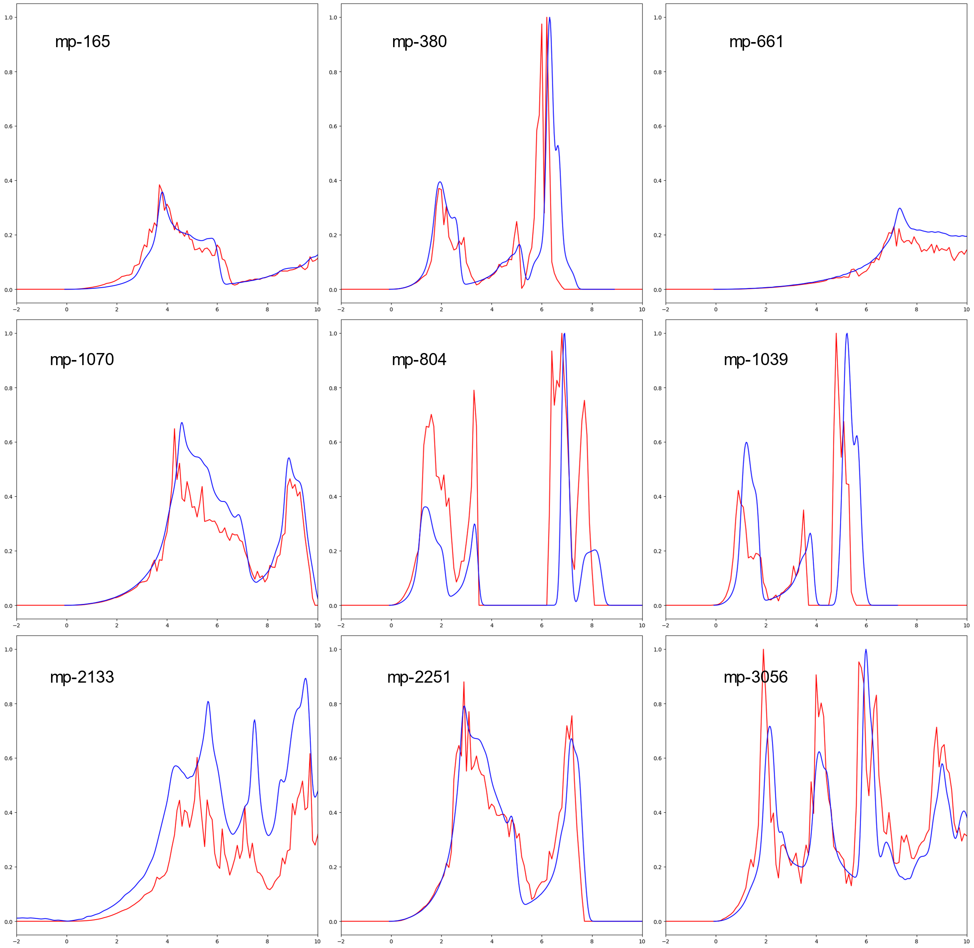
Supplementary Figure 1: Comparison between the vibrational density of states that were calculated in the present work, and those calculated in Ref. ².

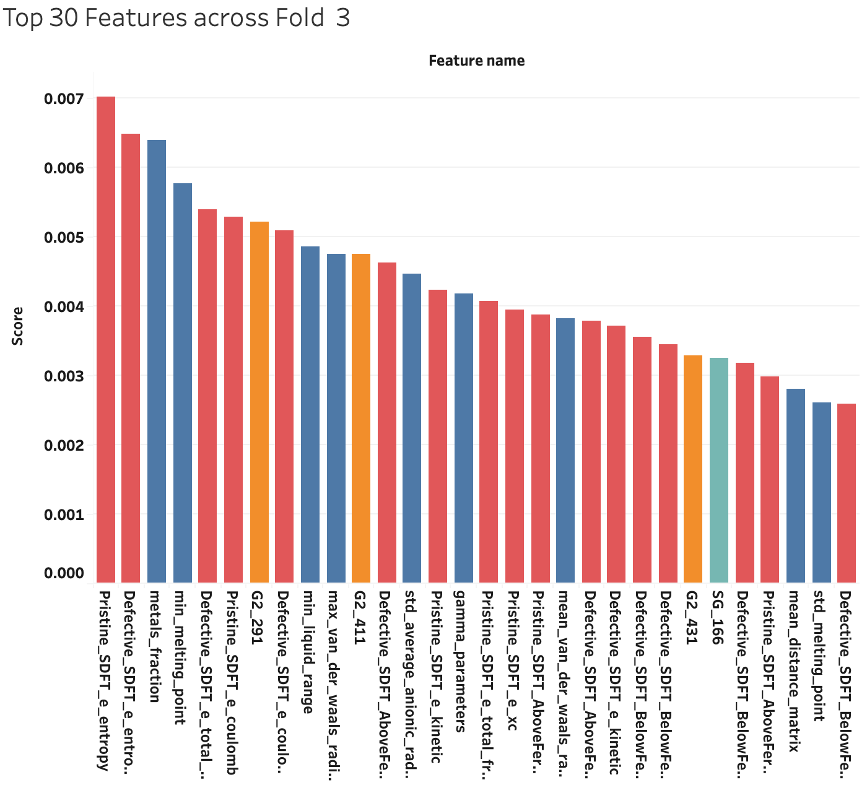
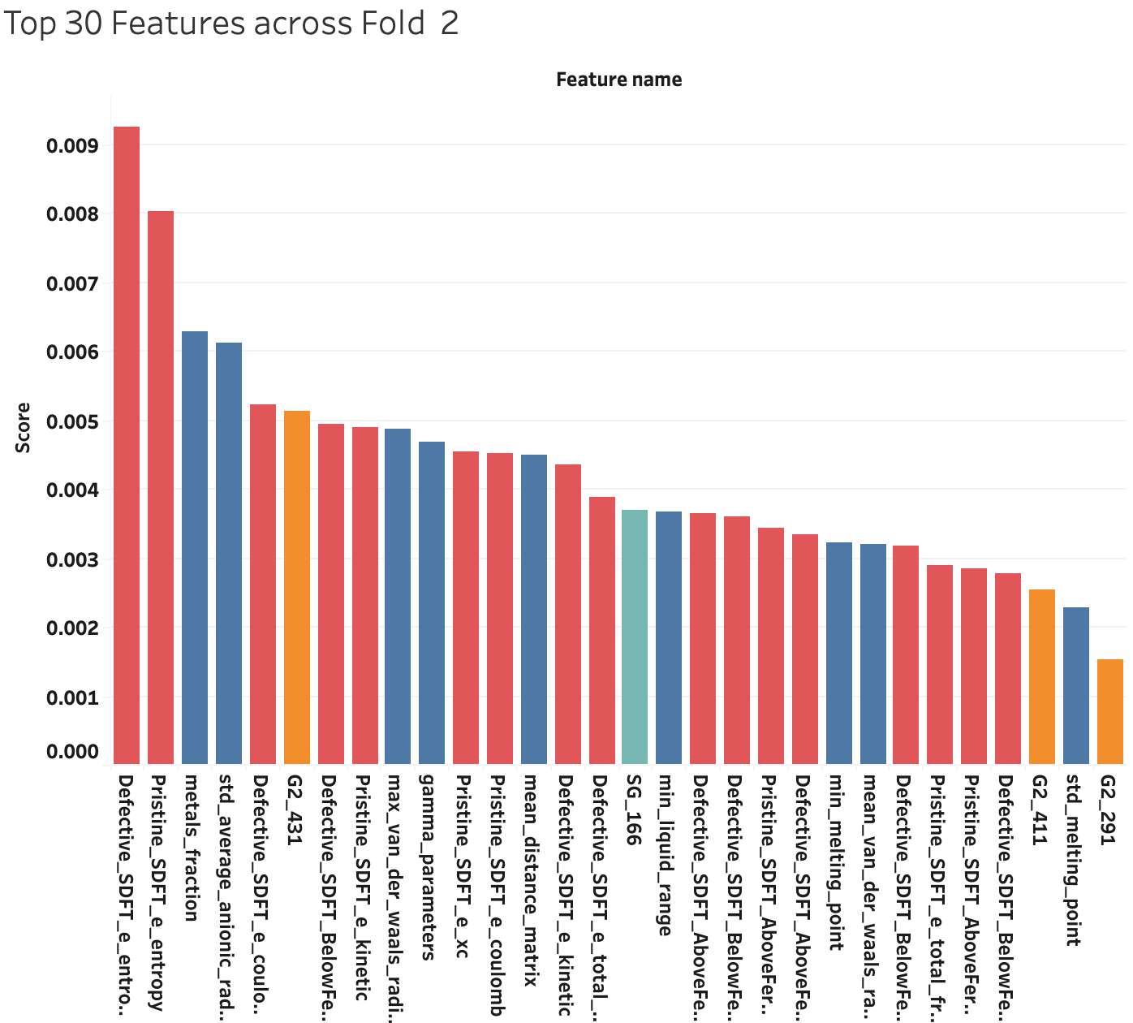
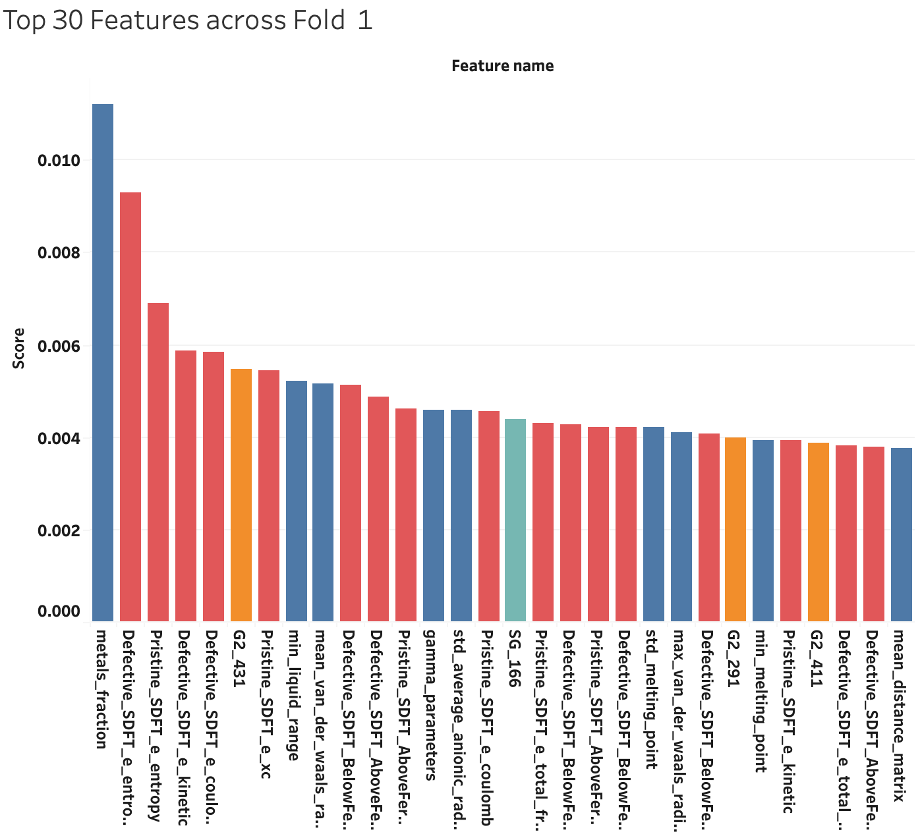
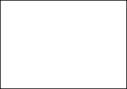

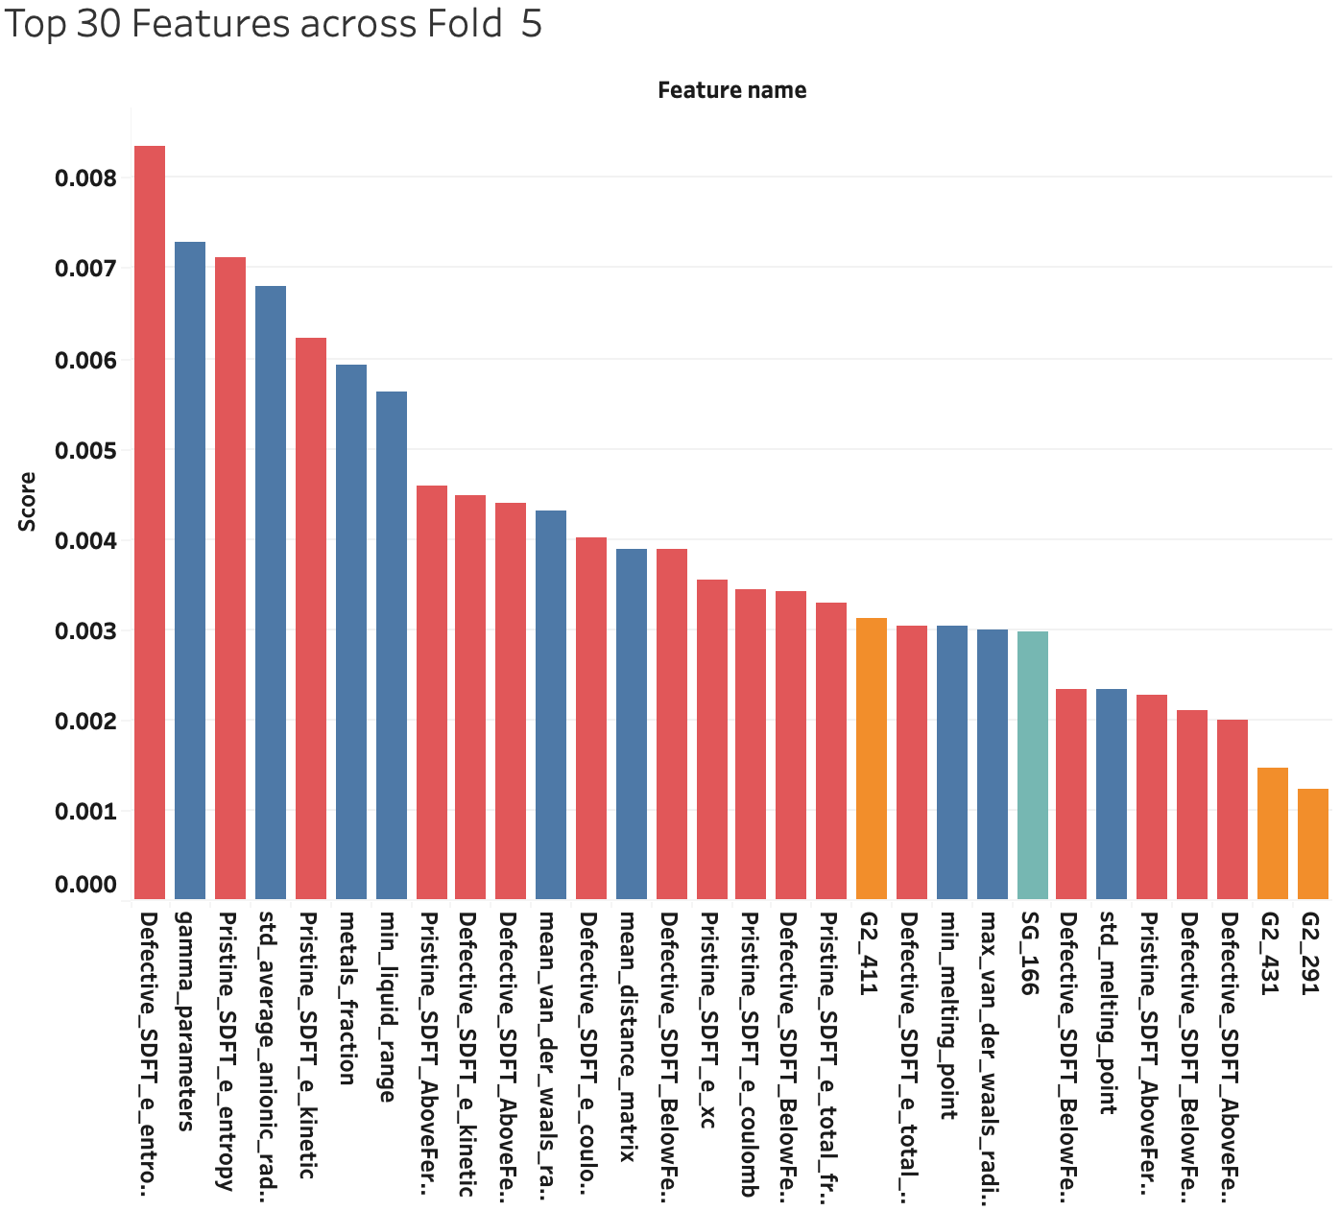
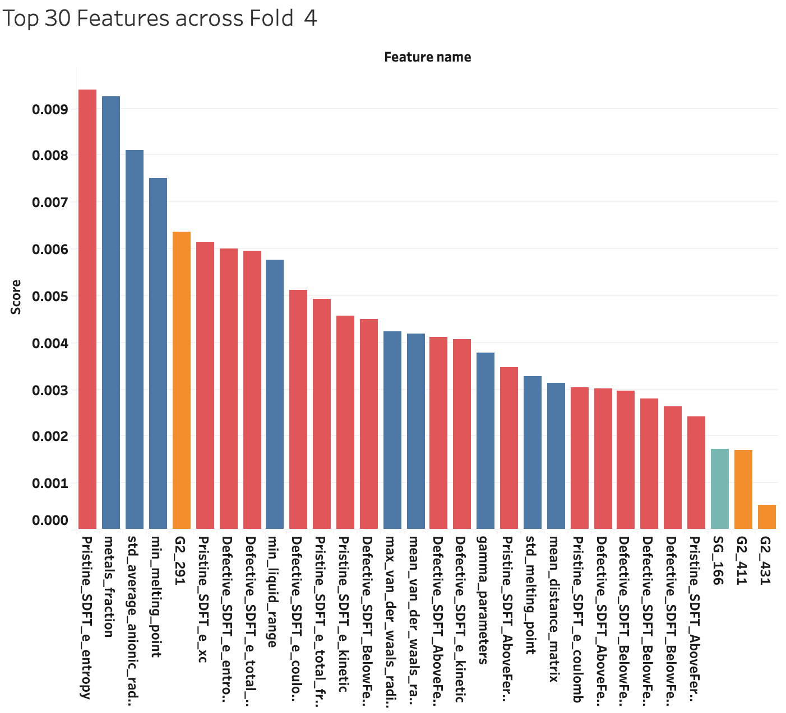

Supplementary Figure 2: Top 30 features across 5 folds. (Atomic in blue, ROSA in Red, SG in Green and Geometric in Orange)

Supplementary Methods
Steps for calculating the classification metrics at various confidence levels:
- Calculate the prediction probability score for each of the 623 test data points.
- We choose the following confidence thresholds: 0.55, 0.60, 0.65.
- From the 623 test data points, only data points where the model confidence is higher than or equal to the threshold value are considered. For example, if the threshold was set as 0.65 then only those data points from the stable and unstable classes were chosen where the model confidence was at least 0.65 for stable and unstable classes.
- The classification metrics were calculated based on the selected data points that fulfilled the threshold criteria.
References
1. Tawfik, S. A. & Russo, S. P. Naturally-meaningful and efficient descriptors: machine learning of material properties based on robust one-shot ab initio descriptors. J Cheminform 14, 78 (2022).
2. Petretto, G. et al. High-throughput density-functional perturbation theory phonons for inorganic materials. Sci Data 5, 1–12 (2018).

