Supplementary Information
Fanglei Huª, Stephen Niezgoda^{b}, Tianju Xue^{c*}, Jian Cao^{a*}
ª Department of Mechanical Engineering, Northwestern University, Evanston, IL 60208, USA
^{b} Department of Materials Science and Engineering, The Ohio State University, Columbus, OH 43210, USA
^{c} Department of Civil and Environmental Engineering, The Hong Kong University of Science and Technology, Hong Kong, China

Supplementary Note 1. Notation
As a general scheme of notation, vectors are written as boldface lowercase letters (e.g. a, b), a second-order tensors as boldface capital letters (e.g. A, B), and fourth-order tensors as blackboard-bold capital letters (e.g. $C$). For vectors and tensors, Cartesian components are denoted as, a_{i}, A_{j}, and $C_{ijkl}$. We define the following: $a∙b=a_{i}b_{i}$, ${\left(A∙a\right)}_{i}= A_{il}a_{l}$, ${\left(AB\right)}_{il}= A_{ip}B_{pl}$, $A:B= A_{il}B_{il}$, $C:A= C_{ijkl}A_{kl}$, and $a⨂b=a_{i}b_{j}$. The transpose, $A^{T}$, a tensor is denoted by a superscript “T”, and the inverse, $A^{-1}$, by a superscript “-1”. represents the norm of a function or a vector.

For the notations used in the chain rule, including Eqs. (25) ~ (28), they should include the interactions between derivatives of scalar, vector, and tensor fields. The terms in the chain rule thus have different dimensions, which makes it hard to use the inner product to represent the calculation. To demonstrate the dimension consistency, several examples are given to show the calculation rules:
Case I.1: For $A(B(c))$, where $A{: R}^{dim×dim}$ and $B{: R}^{dim×dim}$ are second-order tensors, and $c$ is a scalar, the form of chain rule should be as follows
(1.1)
$\frac{∂A}{∂c}=\frac{∂A }{∂B}\frac{∂B}{∂c}$.
We define the operation in Eq. (1.1) as follows
(1.2)
${(\frac{∂A}{∂c})}_{ij}={(\frac{∂A }{∂B})}_{ijkl}{(\frac{∂B}{∂c})}_{kl}$,
where $\frac{∂A }{∂B}∈R^{(dim×dim)×(dim×dim)}$ and $\frac{∂B}{∂c}∈R^{(dim×dim)}$. For the left-hand side, $\frac{∂A}{∂c}∈R^{(dim×dim)}$.

Case I.2: For $A(B(C(D)))$, where $A{: R}^{dim×dim}$, $B{: R}^{dim×dim}$, $C{: R}^{dim×dim}$, and $D{: R}^{dim×dim}$are second-order tensors, the form of chain rule should be as follows
$\frac{∂A}{∂D}=\frac{∂A }{∂B}\frac{∂B}{∂C}\frac{∂C}{∂D}$.
We define the operation in Eq. (1.3) as follows
(1.3)
(1.4)
${(\frac{∂A}{∂D})}_{ijmn}={(\frac{∂A }{∂B})}_{ijkl}{(\frac{∂B}{∂C})}_{klpq}{(\frac{∂C}{∂D})}_{pqmn}$,
where $\frac{∂A }{∂B}∈R^{(dim×dim)×(dim×dim)}$, $\frac{∂B}{∂C}∈R^{(dim×dim)×(dim×dim)}$ and $\frac{∂C}{∂D}∈R^{(dim×dim)×(dim×dim)}$. For the left-hand side, $\frac{∂A}{∂D}∈R^{(dim×dim)×(dim×dim)}$. Similar treatments are used in Eq. (26.2), Eq. (27) and Eq. (28).

Case I.3: For $A(b(c(D)))$, where $A{: R}^{dim×dim}$and $D{: R}^{dim×dim}$ are second-order tensors, b and c are scalars, the form of chain rule should be as follows
(1.5)
$\frac{∂A}{∂D}=\frac{∂A }{∂b}\frac{∂b}{∂c}\frac{∂c}{∂D}$.
We define the operation in Eq. (1.5) as follows
${(\frac{∂A}{∂D})}_{ijpq}={(\frac{∂A }{∂b})}_{ij}(\frac{∂b}{∂c}){(\frac{∂c}{∂D})}_{pq}$,
where $\frac{∂A }{∂b}∈R^{(dim×dim)}$, $\frac{∂b}{∂c}∈R^{1×1}$, and $\frac{∂c}{∂D}∈R^{(dim×dim)}$. For the left-hand side, $\frac{∂A}{∂D}∈R^{(dim×dim)×(dim×dim)}$. Similar treatments are used in Eq. (25) and (26.2).
(1.6)

Supplementary Note 2. Basic Material Parameters used in Three Cases
For all three cases, we considered phenological-based CP, and used Kalidindi et al. [2] self and latent hardening laws for describing hardening performance.

Supplementary Table 1. Material Parameters used for three cases
 | Unit | Case 1  Tantalum [1] | Case 2  Copper [2] | Case 3  304 Steel [1]
Crystal Structure | - | BCC | FCC | FCC
Initial flow stress g_{ini} | MPa | 67.4641 | 60.8 | 90.0
Coefficient for hardening a | - | 200.0 | 2.5 | 8.0
Hardening constants h₀ | MPa | 1959.1320 | 541.5 | 392.9772
Saturated slip strength g_{sat} | MPa | 7295.1754 | 109.8 | 7295.1754
Rate sensitivity exponent n | - | 1.0/45.2726 | 0.1 | 1.0/120.0
Latent hardening coefficient r | - | 1.0 | 1.0 | 1.0
Reference strain rate $\dot{γ_{0}}$ | s⁻¹ | 0.001 | 0.001 | 0.001
Elasticity modulus C₁₁ | MPa | 267,000 | 168,400 | 262,200
Elasticity modulus C₁₂ | MPa | 161,000 | 121,400 | 112,000
Elasticity modulus C₄₄ | MPa | 82,500 | 75,400 | 74,600

Supplementary Note 3. Platform Report
Here, we report the platforms for those numerical experiments. JAX-CPFEM (GPU) runs on 2.3 GHz Intel(R) Xeon(R) W-2195 CPU (18 cores) with NVIDIA Quadro RTX 8000 GPU (48 GB Graphics memory) on Ubuntu 20.04.5 LTS. Both JAX-CPFEM (CPU) and MOOSE CPU with MPI runs on 2.2 GHz AMD Ryzen Threadripper PRO 3975WX (32 Cores).

Supplementary Note 4. Chain Rules for Derivative
To derive the total derivative of $\hat{O}\left(θ\right)$, mentioned in Eq. (31), with respect to parameters $θ$, we need to use chain rules as follows
$\frac{d\hat{O}}{dθ}=\frac{∂O}{∂U}\frac{dU}{dθ}+\frac{∂O}{∂θ}$,
(4.1)
where $\frac{dU}{dθ}$ is justified by the implicit function theorem under certain mild conditions. Based on the constrain condition with respect to parameters $θ$,
(4.2)
$\frac{dR}{dθ}=\frac{∂R}{∂U}\frac{dU}{dθ}+\frac{∂R}{∂θ}=0$,
we can get the formulation of $\frac{dU}{dθ}$ as follows
(4.3)
$\frac{dU}{dθ}=-{(\frac{∂R}{∂U})}^{-1}\frac{∂R}{∂θ}$.
Thus, we can reformulate the total derivative of $\hat{O}\left(θ\right)$ as follows
(4.4)
$\frac{d\hat{O}}{dθ}=-\frac{∂O}{∂U}{(\frac{∂R}{∂U})}^{-1}\frac{∂R}{∂θ}+\frac{∂O}{∂θ}$,
where the first term can be evaluated either by solving the adjoint PDE first (from left to right) or solving the tangent linear PDE first (from right to left). For the adjoint method, the adjoint PDE is formulated as follows
(4.5)
$\frac{∂R^{*}}{∂U}λ=\frac{∂O^{*}}{∂U}$,
where $λ∈R^{N}$ represents the adjoint variable. This is a linear PDE to solve, which requires the solution vector $U$ to get the Jacobian matrix $\frac{∂R}{∂U}$. Then we can obtain total derivative as follows
(4.6)
$\frac{d\hat{O}}{dθ}=-λ^{*}\frac{∂R}{∂θ}+\frac{∂O}{∂θ}$.
Compared to AD to compute these derivatives, the above expressions of derivatives are hard to be derived by hands, especially when consider the non-linearity of CPFEM.

Supplementary Note 5. Comparison of Local Microstructure Information between MOOSE and JAX-CPFEM
Visualization of local microstructure information provides valuable insights into the behavior of materials at the microscale, helping to better understand local fields within the microstructure. Here, for Case study 3, we compared the results of JAX-CPFEM (GPU mode) and MOOSE (CPU MPI) using the same levels of mesh resolution (16³ mesh). By utilizing ParaView [3], an open-source post-processing software, we mapped the components of the Cauchy stress fields, including ${\left.σ_{xx}\right|}_{ϵ=1\%}$, ${\left.σ_{yy}\right|}_{ϵ=1\%}$,and ${\left.σ_{zz}\right|}_{ϵ=1\%}$onto the deformed sample. The comparison of visualizations, summarized in Supplementary Figure 1, further validates the accuracy of our software.

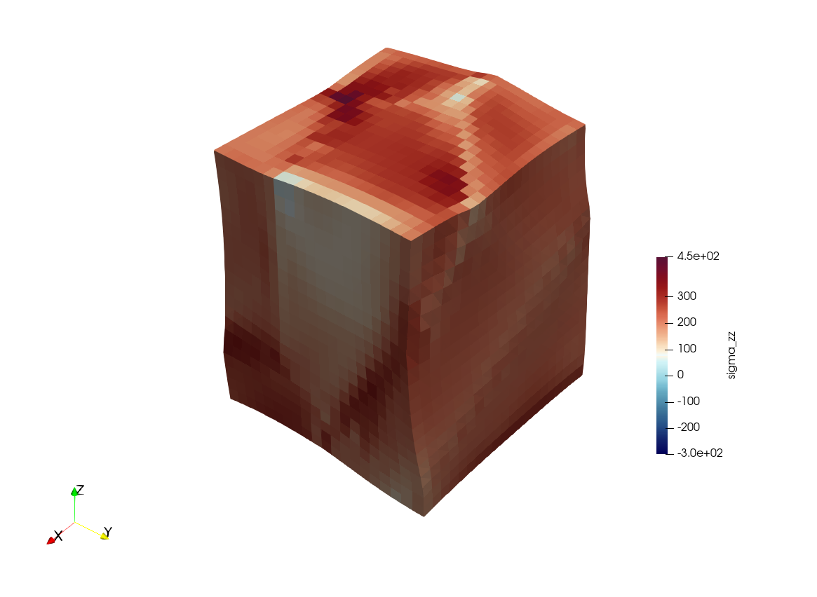
(a)
(b)
(c)
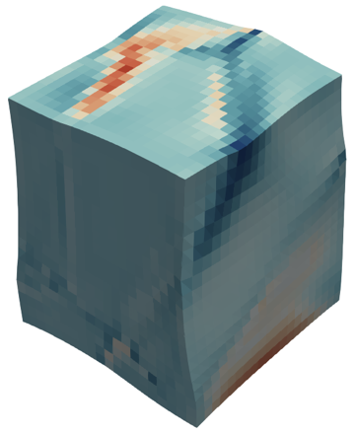
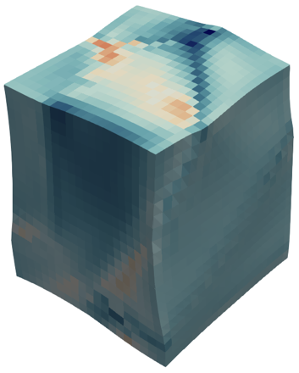
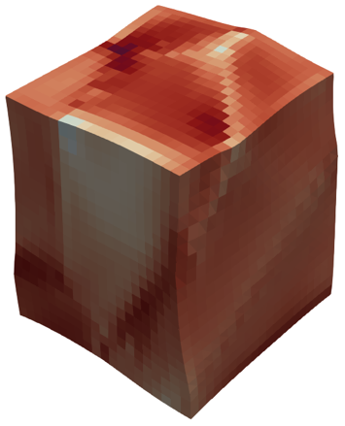
(d)
(e)
(f)
Supplementary Figure 1. Local microstructure information of polycrystal 304 steel (Case Study 3) mapped onto the deformed sample (scale factor: 15) obtained from (a)~(c) MOOSE and (d)~(f) JAX-CPFEM. The comparison of the components of Cauchy stress fields - (a), (d) ${\left.σ_{xx}\right|}_{ϵ=1\%}$; (b), (e) ${\left.σ_{yy}\right|}_{ϵ=1\%}$; and (c), (f) ${\left.σ_{zz}\right|}_{ϵ=1\%}$ between the two software validates the accuracy of JAX-CPFEM.

Supplementary Note 6. Performance Test of Bi-crystal with Two Different Microstructures
To further demonstrate the computational performance of JAX-CPFEM (GPU mode), we did a case study of bi-crystal with two different microstructures, considering a single crystal tantalum (BCC) and a single crystal copper (FCC) connected to each other artificially. The domain dimensions of both parts are 1 mm × 1 mm × 1 mm with quasi-static compressive loadings from 0 to -0.01 mm applied in 20 steps to the right surface along the z-axis within 1.0 s. In this scenario, the left, bottom, and back surfaces were constrained, as detailed in Supplementary Figure 2a.

For performance benchmarking, this case was solved at various levels of mesh resolution (2×2³, 2×5³, 2×10³, 2×16³, 2×20³, and 2×25³ mesh) using JAX-CPFEM (GPU mode) and MOOSE (CPU MPI). Wall time measurements relative to the number of degrees of freedom (DOF) are shown in Supplementary Figure 2b. JAX-CPFEM running on GPU demonstrated an advantage for moderate to larger-size problems. For instance, for a problem with 103,428 DOF (2×25³ mesh), JAX-CPFEM on GPU took 9,054 s, while MOOSE on CPU with MPI (8 cores) took 11,487 s. JAX-CPFEM achieved 1.26× (GPU mode) acceleration compared to MOOSE with MPI.
(a)
(b)
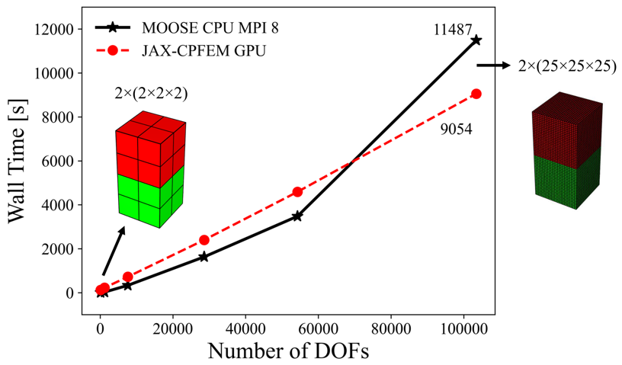
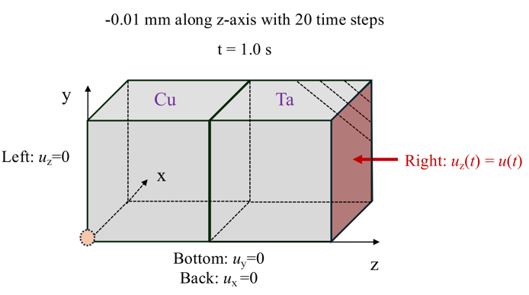
Supplementary Figure 2. Case study of bi-crystal with single crystal copper (FCC) and tantalum (BCC) under (a) compressive loading boundary condition. The compressive experiment fixes the bottom, left, and back sides and compresses the right surface with a prescribed displacement condition. (b) shows performance test with different levels of mesh resolution (2×2³, 2×5³, 2×10³, 2×16³, 2×20³, and 2×25³).

Supplementary References
[1] A. Tran, H. Lim, An asynchronous parallel high-throughput model calibration framework for crystal plasticity finite element constitutive models, Comput. Mech. (2023) 1-14.
[2] S.R. Kalidindi, C.A. Bronkhorst, L. Anand, Crystallographic texture evolution in bulk deformation processing of FCC metals, J. Mech. Phys. Solids 40(3) (1992) 537-569.
[3] A. Henderson, J. Ahrens, C. Law, The ParaView Guide, Kitware Clifton Park2004.

