Supplementary Information
Deep-learning real-time phase retrieval of imperfect diffraction patterns from X-ray free-electron lasers
Sung Yun Lee^{1,2,3}, Do Hyung Cho^{1,2}, Chulho Jung^{1,2}, Daeho Sung^{1,2}, Daewoong Nam^{2,4}, Sangsoo Kim⁴, Changyong Song^{1,2,3,*}
¹Department of Physics, POSTECH, Pohang 37673, Republic of Korea, ²Photon Science Center, POSTECH, Pohang 37673, Republic of Korea, ³Center for Ultrafast Science on Quantum Matter, Max Planck POSTECH/Korea Research Initiative, Pohang 37673, Republic of Korea, ⁴XFEL Beamline Division, Pohang Accelerator Laboratory, POSTECH, Pohang 37673, Republic of Korea
* Corresponding author; email: cysong@postech.ac.kr

Layer no. | Structure | Output shape  (C × H × W)
0 |  | 1 × 512 × 512
1 | WPC(7, 1, 3) + BN + ReLU | 64 × 512 × 512
3 | WPC(3, 2, 1) + BN + ReLU | 128 × 256 × 256
4 | WPC(3, 2, 1) + BN + ReLU | 256 × 128 × 128
5 | WPC(3, 2, 1) + BN + ReLU | 512 × 64 × 64
6 | DSC(3, 1, 1) + BN + ReLU + Split | (256 + 256) × 64 × 64
7–12 | FFC residual blocks × 3 | (256 + 256) × 64 × 64
  $\left(x_{0},x_{0}^{'}\right)$ → FFC(3, 1, 1) + BN + ReLU → $\left(x_{1},x_{1}^{'}\right)$
  $\left(x_{1},x_{1}^{'}\right)$ → FFC(3, 1, 1) + BN + ReLU → $\left(x_{2},x_{2}^{'}\right)$
  → $\left(x_{0}+x_{2},x_{0}^{'}+x_{2}^{'}\right)$
13 | FFC(3, 1, 1) + BN + ReLU | (128 + 128) × 64 × 64
14 | FFC(3, 1, 1) + BN + ReLU | (64 + 64) × 64 × 64
15 | FFC(3, 1, 1) + BN + ReLU | (32 + 32) × 64 × 64
16 | Concatenate + DSC(3, 1, 1) + Sigmoid | 1 × 64 × 64
17 | $x_{0}$ → Fourier projection → $x_{1}$  $\left(x_{0},x_{1}\right)$ → Concatenate → $x_{2}$ | 2 × 64 × 64
18 | DSC(3, 1, 1) + BN + ReLU + Split | (32 + 32) × 64 × 64
19–30 | FFC residual blocks × 6 | (32 + 32) × 64 × 64
31 | Concatenate + DSC(3, 1, 1) + Sigmoid | 1 × 64 × 64
Total trainable parameters: 1.52 × 10⁷
Supplementary Table 1. Detailed structure of DPR. Full list of components and output shapes for each layer of the DPR architecture. The layers in encoder, base decoder, and diffraction-compensated decoder are colored in green, orange, and blue, respectively. All convolution operations operate without bias, and their parameters, kernel size, stride, and padding, are noted in parentheses in order. Batch normalization (BN) and rectified linear unit (ReLU) are used in all convolution layers except for the last layers of the decoders, which use sigmoid functions without BN. Split and concatenation are conducted on the channel dimension. The Fourier projection replace the Fourier magnitude of the inputs with square roots of initial diffraction patterns. Final outputs are scaled by initial diffraction patterns.
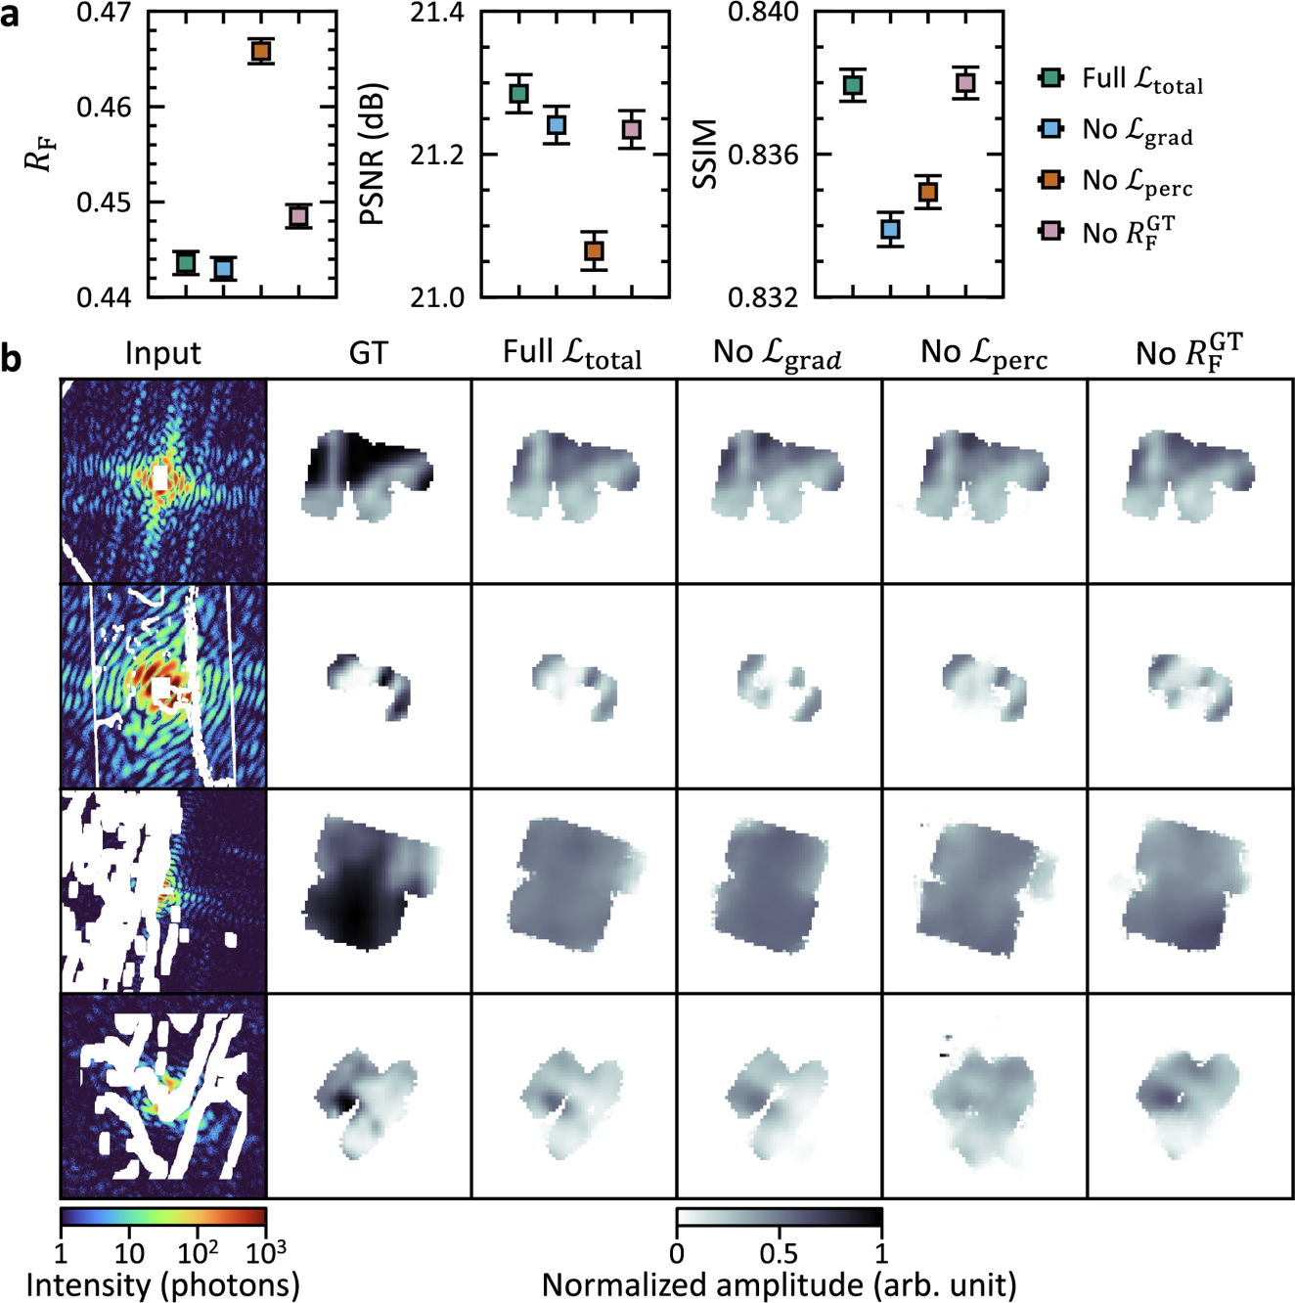
Supplementary Fig. 1. Ablation study on loss function. a,b, Comparisons of evaluation metrics (a) and example reconstruction results (b) between the full loss function and loss functions excluding each component. The boxes and whiskers indicate average and standard error of each metric, respectively. The full loss function offers the best overall performance.
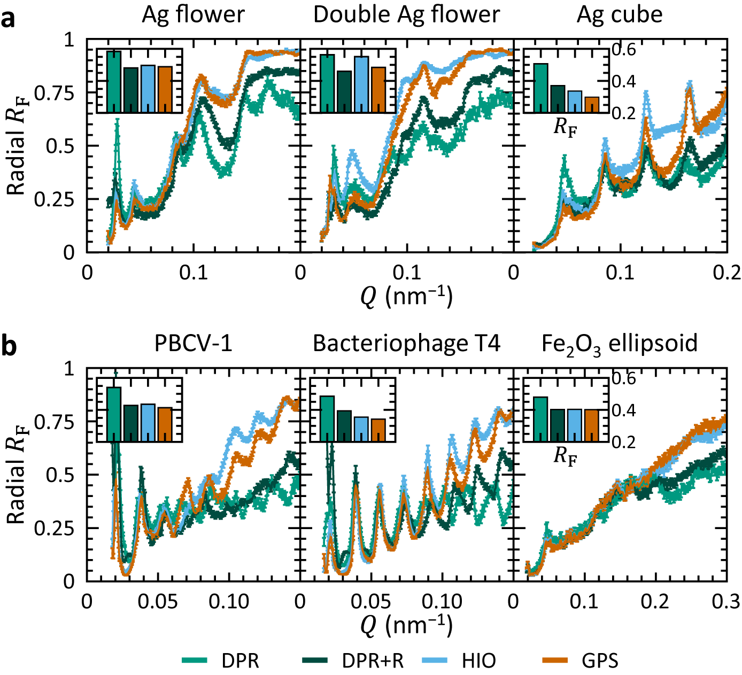
Supplementary Fig. 2. Local $R_{F}$ for experimental data. a,b, Radial distributions of local $R_{F}$, derived from the reconstructed images of experimental data measured at PAL-XFEL (a) and publicly available data deployed at the CXIDB (b). Original $R_{F}$ values are also provided for each method in the inset figures. The boxes and whiskers represent the average and standard errors of each metric, respectively. DPR and DPR with refinement offer a significantly lower level of local $R_{F}$ for larger momentum transfer $Q$.
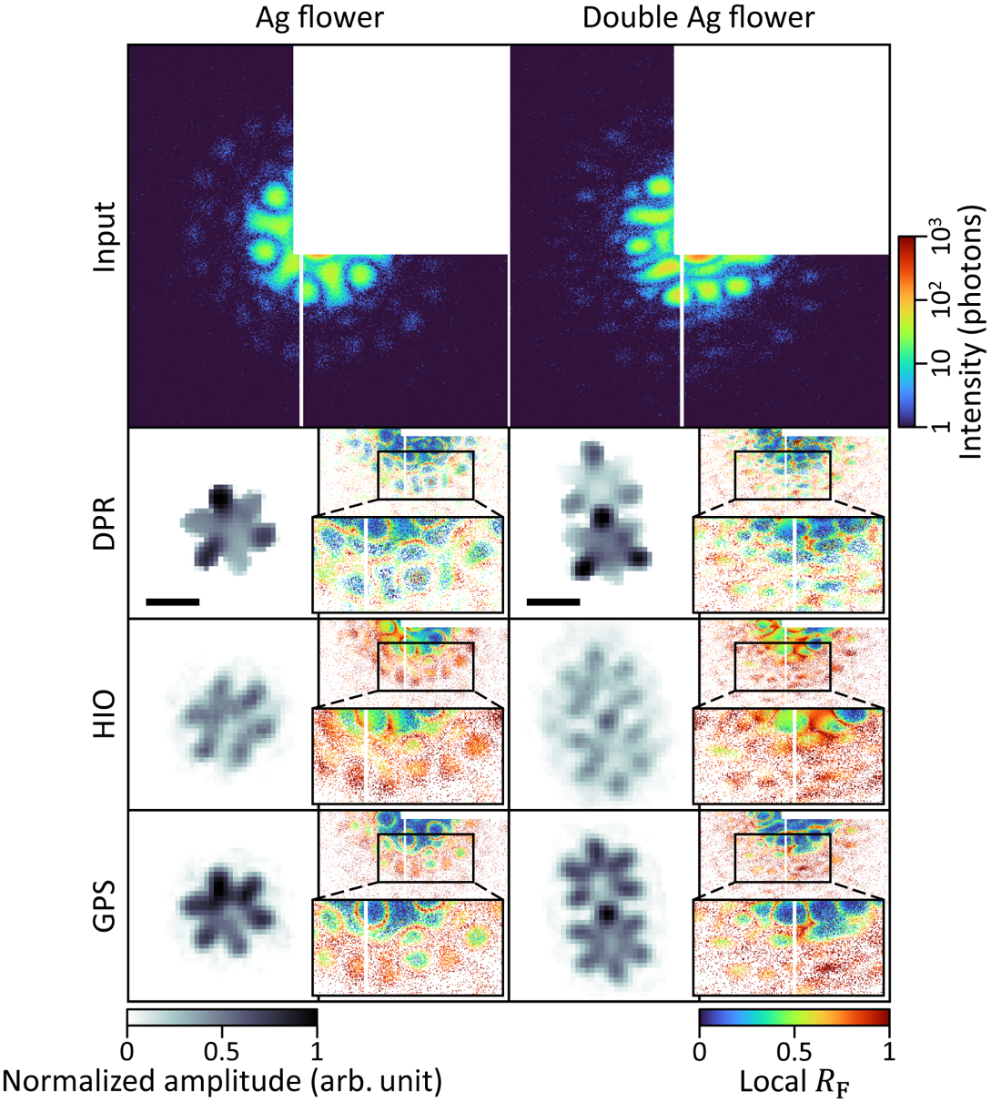
Supplementary Fig. 3. DPR on experimental data without centrosymmetric filling. Comparisons of reconstruction results from diffraction patterns of Ag flower and double Ag flower nanoparticles measured at PAL-XFEL. A quadrant of each diffraction pattern was occluded by the beam stop, and centrosymmetric filling was not applied before the phase retrieval. Scale bars represent 150 nm.
Supplementary Note 1. Ewald sphere curvature effect
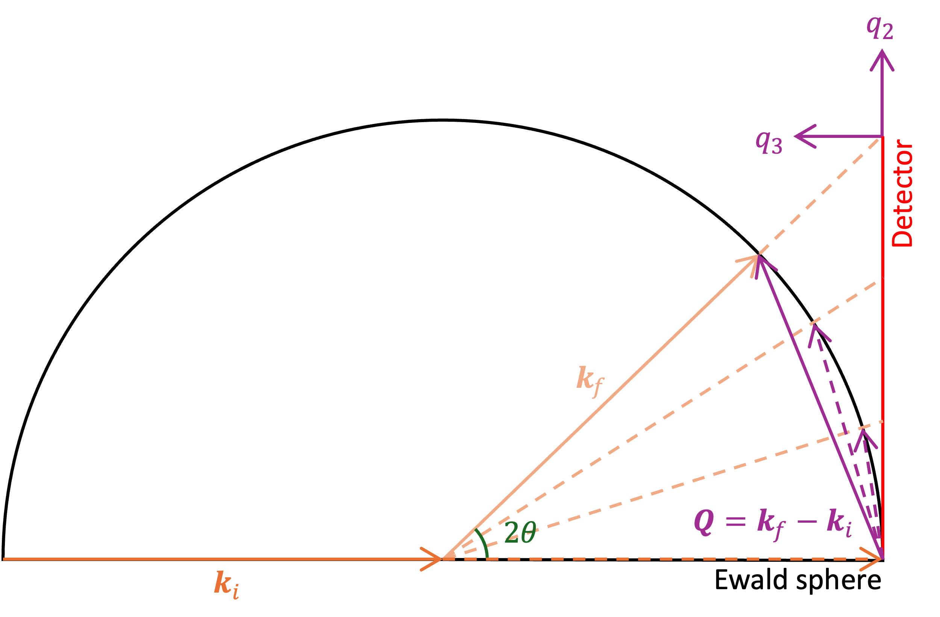
Due to the curvature of Ewald sphere, momentum transfers, defined as $Q=k_{f}-k_{i}$ with incoming and outgoing wavevector $k_{i}$ and $k_{f}$, respectively, are not linearly increasing across the detector plane and contain out-of-plane components. Such effects should be considered for proper phase retrievals. From the experimental parameters of the data from PAL-XFEL and CXIDB, ${2θ}_{max}$ were calculated as 0.458° and 1.55°, giving $Q_{max}$ of 0.203${\hat{q}}_{2}$ + 8.11 × 10⁻⁴${\hat{q}}_{3}$ nm⁻¹ and 0.158${\hat{q}}_{2}$ + 2.06 × 10⁻³${\hat{q}}_{3}$ nm⁻¹, respectively. They gave errors up to 3.20 × 10⁻³% and 3.38 × 10⁻²% for the in-plane components of $Q$, when the $Q$ is linearly mapped to each detector pixel. For the out-of-plane components of $Q$, the values correspond to 7750 nm and 3050 nm in real space (full period), respectively, which are much larger than the size of the samples. Thus, Ewald sphere curvature effect is negligible with the experimental data used in the main text.

