Supplementary Materials: Generative Deep Learning for Predicting Ultrahigh Lattice Thermal Conductivity Materials
Liben Guo,^{1,†} Yuanbin Liu,^{2,†} Zekun Chen,³ Hongao Yang,¹ Davide Donadio,^{3,*} Bingyang Cao^{1,*}
¹Key Laboratory for Thermal Science and Power Engineering of Ministry of Education, Department of Engineering Mechanics, Tsinghua University, Beijing 100084, China
²Inorganic Chemistry Laboratory, Department of Chemistry, University of Oxford, Oxford OX1 3QR, UK
³Department of Chemistry, University of California, Davis, Davis, California 95616, USA
†These authors contributed equally
*e-mail: ddonadio@ucdavis.edu and caoby@tsinghua.edu.cn

- Details of pre-trained Allegro potential
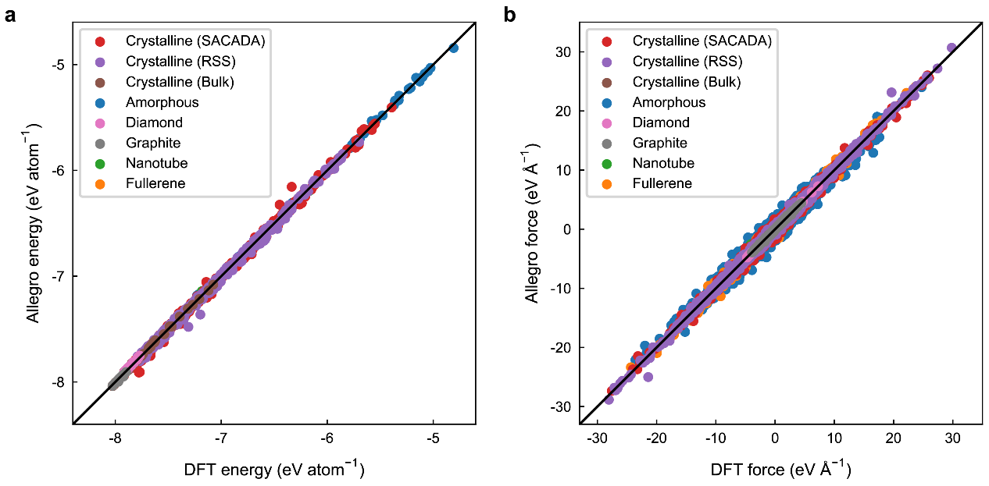
Fig. S1 Comparison of DFT reference result and pre-trained Allegro potential prediction on: a energy per atom b force components.

Table S1. Accuracy of the pre-trained Allegro potential on various configuration types.
Configuration types | Size of testing set | MAE of energy  (meV atom⁻¹) | RMSE of force  (meV Å⁻¹)
Crystalline (SACADA) | 523 | 25.5 | 205.9
Crystalline (RSS) | 365 | 26.2 | 162.7
Crystalline (Bulk) | 60 | 9.3 | 19.3
Amorphous | 60 | 19.2 | 582.3
Diamond | 30 | 11.8 | 23.8
Graphite | 30 | 11.3 | 31.2
Nanotube | 10 | 19.7 | 224.4
Fullerene | 10 | 12.3 | 384.3
Total | 1088 | 24.3 | 273.0

- High 𝜅_{L} materials screening with structural similarity metrics
Table S2. 𝜅_{L} of 10-nearest neighbors of diamond and BCO-C16.
Benchmark | 𝜅_{L} of 10-nearest neighbors of benchmark (W m⁻¹ K⁻¹)
Benchmark | #1 | #2 | #3 | #4 | #5 | #6 | #7 | #8 | #9 | #10
Diamond | 2572 | 1953 | 1785 | 1784 | 1729 | 1677 | 1677 | 1130 | 1010 | 770
BCO-C16 | 553 | 462 | 372 | 304 | 300 | 249 | 198 | 145 | 68 | 17

- Energy convex hull
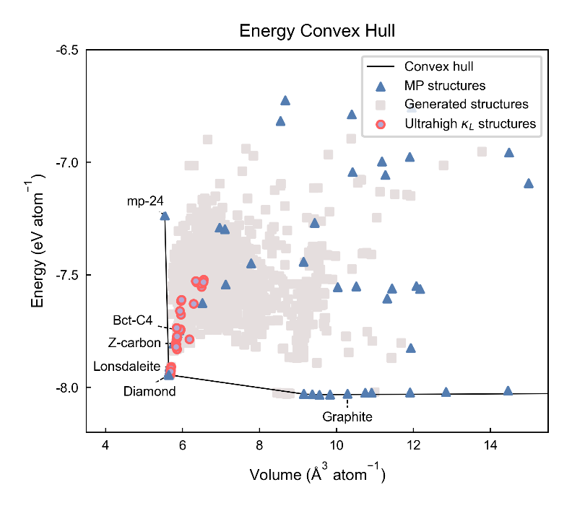
Fig. S2 Energy convex hull of carbon allotropes by the active-learned Allegro potential. The baselines of data are derived from Material Project (MP).¹ The positions of materials with ultrahigh 𝜅_{L} predicted in this work are close to diamond within a hull energy of 0.5 eV.

- Detailed structural information carbon allotropes with ultrahigh 𝜅_{L}
The link https://github.com/Dio2k/Ultrahigh_kappa_Carbon_Supplementary provides the POSCAR files of all 34 high 𝜅_{L} structures. Detailed information of six representative carbon allotropes is presented in Table S3.
Table S3. Detailed structural information of six representative carbon allotropes
Structure (space group) | a (Å) | b (Å) | c (Å) | Atomic positions
C₁₈-cfe-15 (R$\overline{3}$m) | 2.512 | 2.512 | 18.750 | 6c (0.0000, 0.0000, 0.2645)  6c (0.0000, 0.0000, 0.1806)  6c (0.0000, 0.0000, 0.0411)
C₁₀-hccch-C13 (P$\overline{3}$m1) | 2.516 | 2.516 | 10.376 | 2c (0.0000, 0.0000, 0.4255)  2d (0.3333, 0.6667, 0.2268)  2d (0.3333, 0.6667, 0.3757)  2d (0.3333, 0.6667, 0.9747)  2d (0.3333, 0.6667, 0.8233)
C₈-cfc-659 (P6₃/mmc) | 2.514 | 2.514 | 8.311 | 4e (0.0000, 0.0000, 0.0928)  4f (0.3333, 0.6667, 0.1554)
C₁₆-cag-172 (Cmca) | 4.333 | 5.023 | 4.352 | 16g (0.1809, 0.1349, 0.5898)
C₁₆-pcl-9191 (Cmcm) | 4.779 | 4.905 | 4.371 | 16h (0.1653, 0.3573, 0.5728)
C₈-sra-208 (Imma) | 2.543 | 4.829 | 4.180 | 8h (0.0000, 0.0854, 0.6463)

- Phonon properties of six representative predicted carbon allotropes with ultrahigh 𝜅_{L}
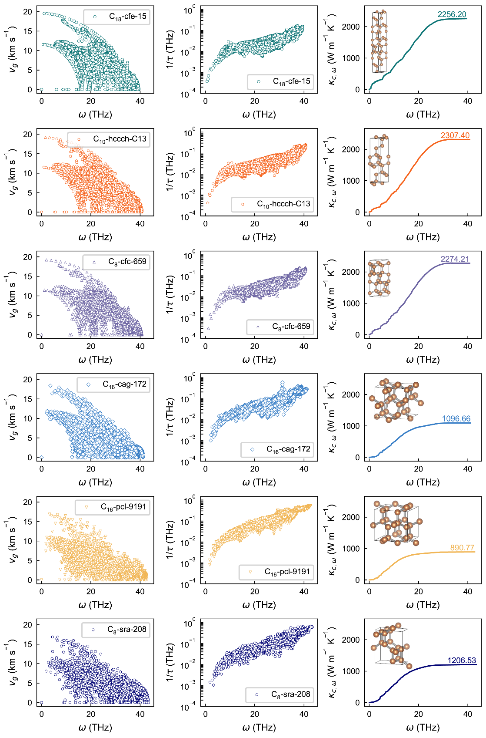
Fig. S3 Group velocity, phonon scattering rate and cumulative 𝜅_{L} results of six representative structures from DFT.

- Bandgaps distribution of predicted carbon allotropes with ultrahigh 𝜅_{L}
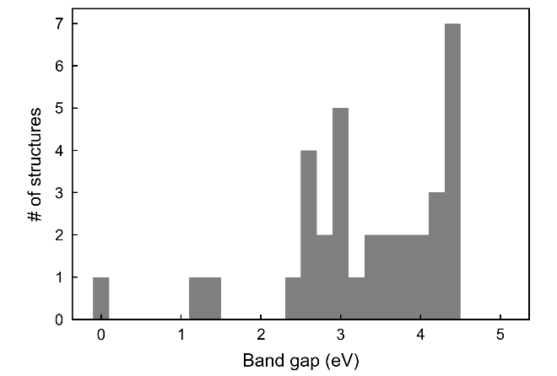
Fig. S4 Bandgaps distribution of predicted carbon allotropes with ultrahigh 𝜅_{L}. Only one structure out of 34 materials displays metallic properties, which is beyond the scope of our study on lattice thermal conductivity.

- Comparison between RTA and full converged solution
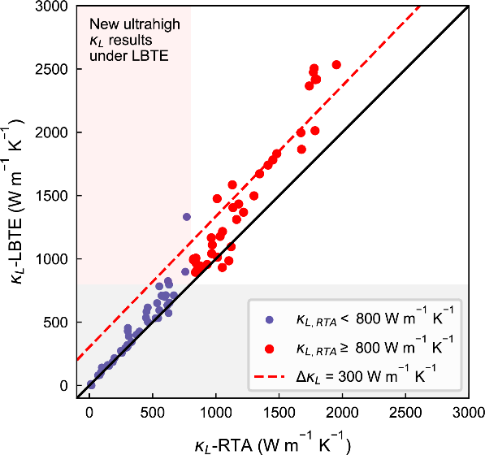
Fig. S5 Comparing of the 𝜅_{L} predictions on KNN structures between RTA method and full converged solution method (LBTE). RTA tends to underestimate 𝜅_{L} of carbon-based materials. Most of these discrepancies fall within the 300 W m⁻¹ K⁻¹ range, and the excepted 8 structures with differences beyond this value are all confirmed to be diamond polytypes. By correcting 𝜅_{L} with full converged solution, the number of ultrahigh 𝜅_{L} materials increases from 34 to 37, which has a minimal impact on our overall outcomes.

- Converging test for 𝜅_{L} calculation
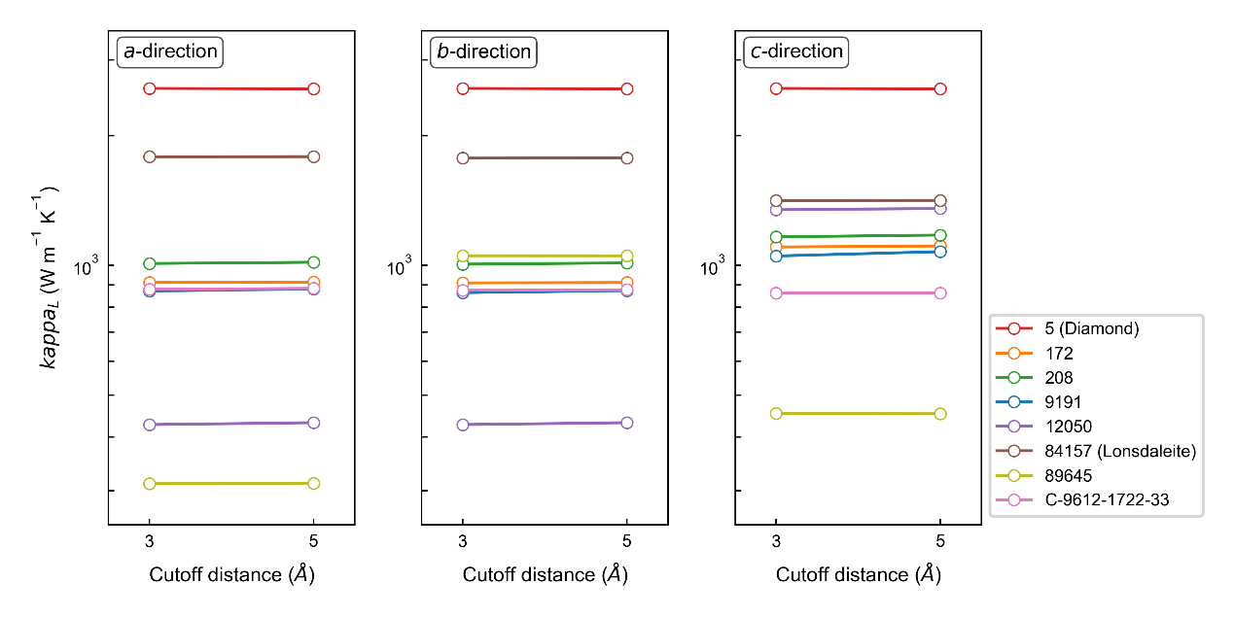
Fig. S6 Cutoff radius converging verification of 𝜅_{L} prediction. The 𝜅_{L} results using a cutoff radius distance of 3 Å in this work for calculation force constants are very close to results with a larger radius (5 Å). This indicates that using the setting of cutoff radius of 3 Å has already shown good convergence.

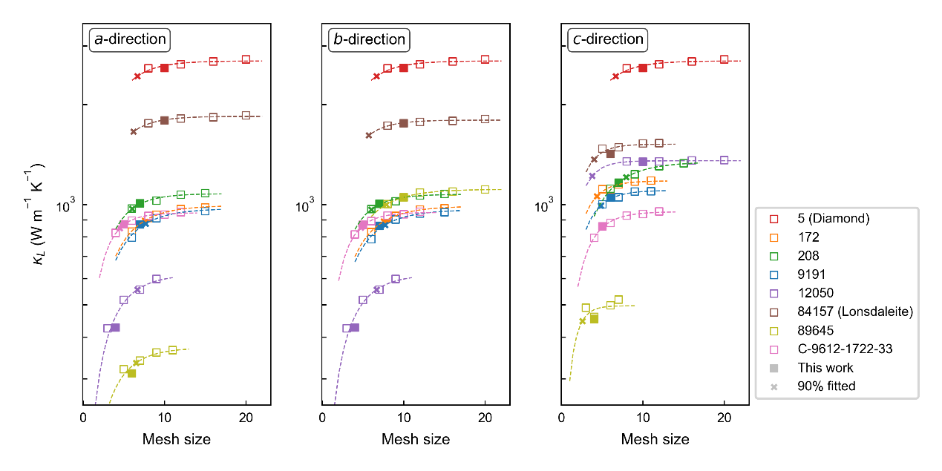
Fig. S7 Mesh converging verification of 𝜅_{L} prediction. Here convergence is reached if 𝜅_{L} reaches 90% of the converged value of fitted curve $κ_{L}=κ_{∞}[1-\exp{(-N_{mesh}/A)}]$.² The setting that mesh numbers multiply the respective lattice lengths exceeding 25 promises convergence for most cases.

References
- Jain, A. et al. Commentary: The Materials Project: A materials genome approach to accelerating materials innovation. APL Mater. 1, 011002 (2013).
- Li, W., Carrete, J., A. Katcho, N. & Mingo, N. ShengBTE: A solver of the Boltzmann transport equation for phonons. Comput. Phys. Comm. 185, 1747–1758 (2014).

