Supplementary Information for

Accelerated discovery of extreme lattice thermal conductivity by crystal graph attention networks and chemical bonding
Mohammed Al-Fahdi,¹ Riccardo Rurali,² Jianjun Hu,³ Christopher Wolverton,⁴ and Ming Hu^{1,}*
¹Department of Mechanical Engineering, University of South Carolina, Columbia, South Carolina 29208, USA
²Institut de Ciència de Materials de Barcelona, ICMAB–CSIC, Campus UAB, 08193 Bellaterra, Spain
³Department of Computer Science and Engineering, University of South Carolina, Columbia, South Carolina 29208, USA
⁴Department of Materials Science and Engineering, Northwestern University, Evanston, IL 60201, USA

Additional notes on normalization for -ICOHP and ICOBI

As seen from Eqs. (2) – (5) in the main text, the ICOHP and ICOBI are computed from the projected orbitals on all sites to quantify their bonding and antibonding interactions to grasp bonding strength between the atoms in a material. It can be simply deduced that the more atoms exist in the primitive cell of a material, the more projected orbitals there are, and the higher -ICOHP and ICOBI values are. An appropriate way to normalize such value is to divide the number of projected orbitals from all the sites in the primitive cell to properly and accurately quantify the bond strength. It is worth reiterating that LOBSTER calculations are done on the primitive cells of the materials, not the conventional cells as executed by pymatgen. If -ICOHP and ICOBI are good bonding strength descriptors without normalization then CsZrAgTe₃, RbHfCuSe₃, and MgCdSO should have higher LTC than BAs, BN, BSb, and AlN since they have higher -ICOHP and ICOBI as shown in Table S1. However, the normalized -ICOHP and normalized ICOBI are higher in materials with high LTC such as BAs, BN, BSb, and AlN than materials with low LTC such as BaO, BaLiSb, CsZrAgTe₃, RbHfCuSe₃, and MgCdSO. Furthermore, the importance of normalization is not just seen between materials with high and low LTC, but it is also seen in the materials with the same reduced formula but with different primitive cell formula. For example, BAs with two different phases (i.e., cubic phase with space group number of 216 and hexagonal phase with space group number of 186) have the following primitive cell formula: BAs in the cubic phase and B₂As₂ in the hexagonal phase. The projected orbitals of B atom are 2s and 2p, and the projected orbitals of As atom are 4s, and 4p. Since the hexagonal phase has twice more atoms and therefore twice more projected orbitals than the cubic phase, it is not surprising that the hexagonal phase of BAs has higher -ICOHP and ICOBI (-ICOHP and ICOBI are approximately twice as high in the hexagonal phase than the cubic one). However, upon looking at the normalized -ICOHP and normalized ICOBI, the values are approximately the same (i.e., the normalized -ICOHP values are 3.032 eV and 3.020 eV for hexagonal and cubic phases, respectively, and the normalized -ICOBI values are 0.493 and 0.495 for hexagonal and cubic phases, respectively). The difference in normalized -ICOHP and normalized ICOBI can be attributed to the difference in the different number of nearest neighbors, bond lengths, local environment in each site due to the change in phase which caused the difference in the bonding interactions in both phases. The same observation of -ICOHP and ICOBI being roughly a multiple in phases where the primitive cell number of atoms is a multiple of the reduced formula is also observed in other materials with high and low LTC such as AlN, BaO, BaLiSb, BN, and BSb as seen from Table S1. After realizing all the above statements, we claim our descriptors are properly normalized and can be used universally for a wide range of materials classes as can be seen from Table S1, Figures S1-S2, and Figures 2 – 3 in the main text.

In Figure S1 a), lots of the red dots (i.e., materials with high LTC) exist around the middle or middle to high part of the plot where -ICOHP is average or average-to-high. A vast number of materials with average LTC represented by the green color have higher -ICOHP than most of the materials with high LTC that are represented by the red color. However, when the normalized -ICOHP is compared with average mass and LTC in Figure 2 a) in the main text, materials with high LTC in red tend to have high normalized -ICOHP and low average mass. Moreover, the -ICOHP decrease does not in general clearly and necessarily mean that LTC decreases at the same average mass in Figure S1 a). Generally speaking, if the bond strength is high in materials, the materials could have high LTC because bond strength is directly proportional to phonon group velocity and LTC is directly proportional to phonon group velocity from Eq. (1) in the main text. The fact that many materials in green with medium LTC in Figure S1 a) have higher -ICOHP than many materials in red with high LTC proves that -ICOHP by itself is not a sufficiently good general bonding strength descriptor for LTC. On the other hand, the trend of high LTC having high normalized -ICOHP (i.e., the bond strength descriptor) and LTC decreasing as normalized -ICOHP decreases for the same mean atomic mass is clearly seen from Figure 2 a) in the main text. It can also be observed from Figure S1 b) that several materials with medium and medium-to-high average MSD in green, yellow, and orange have higher -ICOHP than many materials with low average MSD in dark and light blue across a wide range of average atomic masses. Moreover, materials with medium average MSD exist in the area under the low average MSD materials where -ICOHP are lower than the blue dots. However, if the bonding strength (-ICOHP) is a universally sufficient general descriptor for all the materials to capture bonding strength, then the materials with low average MSD in blue should have higher -ICOHP than the green ones with medium average MSD. As it is known, atoms with strong bonding strength should have deeper potential, and those atoms should not be displaced much from their equilibrium positions during thermal motion. The fact that many materials with medium average MSD in green above the low average MSD materials in blue demonstrates that -ICOHP descriptor is not sufficiently good universal descriptor to represent the general trend. Figure 2 b) in the main text shows a much better trend for the average MSD since it clearly shows that generally speaking the materials with high (low) average MSD have low (high) normalized -ICOHP. Furthermore, the colors change gradually from red to blue according to the color bar colors based on their average MSD values from high normalized -ICOHP to low normalized -ICOHP. Moreover, Figure S1 visually analyzes ICOBI vs. mean atomic mass with c) LTC and d) average MSD. As mentioned in the main text, ICOBI is a measure of bonds covalency. It is also known that covalent bonds are stronger than ionic bonds [1]. In Figure S1 c), a tremendously large number of materials with medium LTC in green and some blue dots that represent materials with low LTC have higher ICOBI than red dots with high LTC. That demonstrates that the ICOBI descriptor is not a sufficiently good bonding strength descriptor since bond strength is directly proportional to phonon group velocity which is also directly related to LTC. Therefore, the materials with higher bond strength would have higher LTC in general. Upon looking at Figure 2 c) the normalized ICOBI is a better descriptor for chemical bonding strength. In Figure S1 d), materials with medium average MSD represented by green from the color bar have higher ICOBI than many materials with low average MSD in light and dark blue colors. If ICOBI is a sufficiently good bonding strength descriptor for all materials classes, then not many materials with average MSD in green dots will appear above the blue dots that represent the materials with low average MSD. Low average MSD materials should have higher bonding strength since the interatomic potential in such materials should be deeper. When Figure S1d) is compared with Figure 2 d), it can clearly be seen that the average MSD trend makes more sense physically in Figure 2 d) because the average MSD gradually decreases based on the color bar from low to high bonding strength descriptor which is the normalized ICOBI.

In summary, according to Table S1, Figure S1, and Figures 2-3, normalized -ICOHP and normalized ICOBI are better chemical bonding strength descriptors compared to the direct values (unnormalized) of -ICOHP and ICOBI.

In Figure S2, the training/validation/testing sets fractional split, which is 75%/15%/10%, looks similar among most of the elements. That ensures that the elements-based training/validation/testing fractional splits are properly balanced. Figure S3 shows the element count for materials in the entire dataset.

In Figure S4, the phonon dispersion plots of DFT and our newly trained CHGNet model from scratch are compared with each other. It can be observed that the phonon dispersion plots from both DFT and our newly trained CHGNet model are approximately the same except that a systematic underestimation of frequencies from our trained CHGNet model clearly exists. However, our CHGNet model is still good enough to screen positive/ imaginary phonon frequencies and thus accelerate the discovery of dynamically stable materials.

Here we normalize the number of atoms to demonstrate that the normalization definitions in Eqs. (6a) and (6b) are not unique in showing good trends with LTC and average MSD. Eqs. (S1a) and (S1b) show those two new normalization definitions:

$normalized -ICOHP (\# of atoms)=\frac{\sum_{μ}{\sum_{ν}{{ICOHP}_{μν}}}}{\# ofatoms}$ (S1a)

$normalized ICOBI (\# of atoms)=\frac{\sum_{μ}{\sum_{ν}{{ICOBI}_{μν}}}}{\# of atoms}$ (S1b)

Those two normalization definitions are analyzed with LTC and average MSD as shown in Figure S5. The plots show similar trends as Figures 2-3 in the main text.

Table S1: selected materials with OQMD ID, primitive cell formula, reduced formula, and space group (SG), their chemical bonding information (i.e., -ICOHP, normalized -ICOHP, ICOBI, and normalized ICOBI), and materials properties (i.e., LTC and the average MSD).

OQMD ID | Reduced formula | Space group number | -ICOHP (eV) | Normalized -ICOHP (eV) | ICOBI | Normalized ICOBI | LTC (W/mk) | Avg. MSD (Å²)
1440386 | AlN | 186 | 50.188 | 3.137 | 6.300 | 0.394 | 319.5 | 0.0231
1218324 | AlN | 216 | 26.780 | 3.347 | 3.402 | 0.425 | 275.0 | 0.0242
1105129 | BaO | 225 | 9.376 | 1.042 | 1.203 | 0.134 | 3.5 | 0.0945
22045 | BaO | 194 | 16.493 | 0.916 | 2.047 | 0.114 | 3.8 | 0.0902
1277969 | BAs | 186 | 48.505 | 3.032 | 7.891 | 0.493 | 1908.9 | 0.0263
8235 | BAs | 216 | 24.160 | 3.020 | 3.961 | 0.495 | 2370.4 | 0.0267
1489473 | BaLiSb | 62 | 24.875 | 0.565 | 6.688 | 0.152 | 2.8 | 0.1407
1455903 | BaLiSb | 189 | 17.192 | 0.521 | 4.986 | 0.151 | 1.1 | 0.1728
1455061 | BaLiSb | 194 | 12.601 | 0.573 | 3.707 | 0.169 | 5.6 | 0.1359
1236324 | BN | 216 | 38.296 | 4.787 | 3.729 | 0.466 | 844.3 | 0.0116
7497 | BN | 186 | 75.340 | 4.709 | 7.254 | 0.453 | 748.1 | 0.0115
1277988 | BSb | 186 | 41.083 | 2.568 | 7.858 | 0.491 | 375.1 | 0.0349
1218583 | BSb | 216 | 20.558 | 2.570 | 3.966 | 0.496 | 423.9 | 0.0358
1049981 | MgCdSO | 61 | 158.844 | 0.946 | 27.290 | 0.162 | 1.8 | 0.0965
1357607 | CsZrAgTe₃ | 62 | 143.826 | 0.999 | 32.140 | 0.223 | 0.5 | 0.1655
1357736 | RbHfCuSe₃ | 62 | 114.641 | 0.819 | 25.071 | 0.179 | 1.2 | 0.1172

Table S2: 81 selected stable materials with low LTC and high MSD and our developed chemical bonding strength descriptors: normalized -ICOHP and normalized ICOBI. The lattice thermal conductivities (LTCs) reported here are averaged over three crystallographic directions.

Database | Id | Reduced formula | Space group # | LTC (W/mk) | Avg. MSD ($Å^{2}$) | Normalized -ICOHP (eV) | Normalized ICOBI
OQMD | 1554232 | Na₂Mg₂BiP | 99 | 0.75 | 0.2374 | 0.4914 | 0.1440
OQMD | 11976 | Na₆MnS₄ | 186 | 0.78 | 0.1823 | 0.5737 | 0.1348
OQMD | 1376579 | BaNaAs | 189 | 0.82 | 0.1254 | 0.4660 | 0.1309
ICSD | 20020 | KI | 194 | 0.82 | 0.3203 | 0.3675 | 0.0679
ICSD | 422273 | K₂SrCdSb₂ | 26 | 0.83 | 0.1672 | 0.6457 | 0.1663
OQMD | 1369362 | K₂NaSb | 194 | 0.84 | 0.2569 | 0.3798 | 0.1255
ICSD | 41322 | CsNaSe | 129 | 0.92 | 0.1951 | 0.5341 | 0.1053
OQMD | 1338889 | Sr₇Ge₃ | 186 | 0.93 | 0.1850 | 0.2229 | 0.0833
OQMD | 1474283 | K₂Te | 123 | 0.99 | 0.2980 | 0.3691 | 0.0950
ICSD | 35458 | BaBrCl | 62 | 0.99 | 0.2552 | 0.3645 | 0.0542
ICSD | 67276 | KNaTe | 62 | 1.03 | 0.2047 | 0.4077 | 0.1054
OQMD | 24724 | Na₃Sr₃GaP₄ | 186 | 1.04 | 0.1228 | 0.6765 | 0.1630
ICSD | 107569 | CsNaTe | 129 | 1.08 | 0.2262 | 0.4530 | 0.1058
ICSD | 92771 | Na₂S | 62 | 1.09 | 0.1714 | 0.4914 | 0.1116
OQMD | 1561683 | Ba₂TlCuSb₂ | 156 | 1.10 | 0.1352 | 0.5757 | 0.1570
OQMD | 1505450 | Ca₂ZnSbP | 36 | 1.11 | 0.0987 | 0.7883 | 0.1852
OQMD | 1554236 | Na₂Mg₂BiAs | 99 | 1.11 | 0.1864 | 0.4797 | 0.1440
OQMD | 1482262 | BaNaAs | 62 | 1.13 | 0.1294 | 0.4772 | 0.1327
OQMD | 1505419 | Ca2CdBiAs | 36 | 1.18 | 0.1292 | 0.7106 | 0.1810
OQMD | 1552765 | KNa(MgBi)₂ | 99 | 1.29 | 0.1972 | 0.4233 | 0.1370
ICSD | 67278 | KNaSe | 62 | 1.40 | 0.1713 | 0.4565 | 0.1016
OQMD | 1371419 | K2NaGaBi₂ | 72 | 1.46 | 0.2370 | 0.5980 | 0.1704
OQMD | 1371775 | Rb₂NaTlAs₂ | 72 | 1.46 | 0.1910 | 0.6699 | 0.1706
OQMD | 1554237 | Na₂Mg₂SbAs | 99 | 1.49 | 0.1695 | 0.4979 | 0.1460
OQMD | 1554435 | RbNa(MgSb)₂ | 99 | 1.50 | 0.1861 | 0.4522 | 0.1377
ICSD | 409178 | RbCaSb | 129 | 1.51 | 0.1998 | 0.3848 | 0.1238
OQMD | 1552767 | RbNa(MgBi)₂ | 99 | 1.52 | 0.2082 | 0.4197 | 0.1352
OQMD | 1366391 | Na₂MgGe | 194 | 1.56 | 0.1703 | 0.3506 | 0.1263
OQMD | 1284285 | BaSrSi | 62 | 1.58 | 0.1632 | 0.4171 | 0.1292
OQMD | 1553617 | Rb₂CaMgP₂ | 115 | 1.58 | 0.1493 | 0.5138 | 0.1273
ICSD | 62658 | KNaS | 62 | 1.59 | 0.1525 | 0.4904 | 0.1000
OQMD | 1374584 | K₂NaTlAs₂ | 72 | 1.60 | 0.1954 | 0.6589 | 0.1709
OQMD | 1553454 | K₂CaCdAs₂ | 115 | 1.61 | 0.1451 | 0.6788 | 0.1677
OQMD | 24717 | BaNaP | 189 | 1.64 | 0.1185 | 0.4909 | 0.1325
OQMD | 1371513 | NaCaSb | 62 | 1.65 | 0.1216 | 0.3979 | 0.1324
OQMD | 1366462 | Cs₂NaGaSb₂ | 72 | 1.71 | 0.2046 | 0.6600 | 0.1759
OQMD | 1372533 | Rb₂NaGaBi₂ | 72 | 1.74 | 0.2313 | 0.6054 | 0.1708
OQMD | 1753875 | K₂NaTlP₂ | 72 | 1.80 | 0.1801 | 0.6987 | 0.1730
OQMD | 1374152 | K₂LiInSb₂ | 72 | 1.83 | 0.1834 | 0.6896 | 0.1866
ICSD | 52681 | BaCaGe | 62 | 1.84 | 0.1233 | 0.2978 | 0.0981
OQMD | 1554374 | RbNa(MgAs)₂ | 99 | 1.85 | 0.1535 | 0.5097 | 0.1377
OQMD | 1553966 | K₂CaMgP₂ | 115 | 1.87 | 0.1471 | 0.4826 | 0.1276
OQMD | 1385208 | NaCaAs | 189 | 1.92 | 0.1022 | 0.4411 | 0.1330
OQMD | 1554235 | Na₂Mg₂BiSb | 99 | 1.93 | 0.1797 | 0.4584 | 0.1452
OQMD | 1553665 | KNa(MgP)₂ | 99 | 1.94 | 0.1400 | 0.5341 | 0.1386
OQMD | 1377160 | NaMgBi | 129 | 1.98 | 0.1894 | 0.4434 | 0.1441
ICSD | 172006 | SrCaGe | 62 | 1.99 | 0.1091 | 0.2891 | 0.1016
OQMD | 1554384 | CsNa(MgAs)₂ | 99 | 2.00 | 0.1652 | 0.5446 | 0.1395
OQMD | 1554378 | KNa(MgAs)₂ | 99 | 2.04 | 0.1501 | 0.5056 | 0.1378
OQMD | 1742597 | KMgAs | 194 | 2.07 | 0.1688 | 0.5010 | 0.1530
OQMD | 1505601 | Ca₂CdAsP | 36 | 2.10 | 0.0934 | 0.7896 | 0.1834
OQMD | 1552758 | K₂Mg₂BiAs | 99 | 2.12 | 0.1442 | 0.4538 | 0.1300
OQMD | 1017904 | NaLi₂Bi | 139 | 2.18 | 0.1823 | 0.6740 | 0.1896
OQMD | 26328 | NaSrP | 189 | 2.21 | 0.0975 | 0.4805 | 0.1345
OQMD | 1473988 | K₂Te | 225 | 2.22 | 0.2426 | 0.3902 | 0.1009
ICSD | 42455 | Ca₂Ge | 62 | 2.22 | 0.1138 | 0.2848 | 0.1000
OQMD | 24739 | NaSrAs | 189 | 2.22 | 0.1057 | 0.4543 | 0.1324
OQMD | 1501614 | Ba₃Ca₃(As₂P)₂ | 189 | 2.28 | 0.0860 | 0.5871 | 0.1435
ICSD | 166534 | Ca₂AsI | 166 | 2.33 | 0.1257 | 0.4051 | 0.1025
OQMD | 1381978 | Na₂LiSb | 194 | 2.33 | 0.1809 | 0.5291 | 0.1714
ICSD | 172007 | SrCaSn | 62 | 2.36 | 0.1151 | 0.2658 | 0.0993
OQMD | 1370558 | Rb₂NaGaSb₂ | 72 | 2.38 | 0.1996 | 0.6457 | 0.1749
OQMD | 7598 | NaMgSb | 129 | 2.46 | 0.1690 | 0.4754 | 0.1464
OQMD | 1745662 | NaCaP | 189 | 2.47 | 0.0932 | 0.4589 | 0.1339
OQMD | 1369685 | Ca₂MgAs₂ | 36 | 2.56 | 0.0926 | 0.4664 | 0.1285
ICSD | 172602 | Sr₂IN | 166 | 2.50 | 0.0955 | 0.5273 | 0.1144
OQMD | 1554373 | KRb(MgAs)₂ | 99 | 2.68 | 0.1241 | 0.5148 | 0.1311
OQMD | 1552760 | K₂Mg₂SbAs | 99 | 2.86 | 0.1340 | 0.4754 | 0.1328
ICSD | 6068 | Ca₂PI | 166 | 2.93 | 0.1120 | 0.4144 | 0.1039
OQMD | 1553662 | KRb(MgP)₂ | 99 | 2.97 | 0.1129 | 0.5504 | 0.1329
OQMD | 1553664 | CsK(MgP)₂ | 99 | 3.15 | 0.1297 | 0.5753 | 0.1339
OQMD | 1374151 | K₂LiGaSb₂ | 72 | 3.40 | 0.1734 | 0.7228 | 0.1889
ICSD | 172600 | Sr₂BrN | 166 | 3.46 | 0.0910 | 0.5602 | 0.1095
ICSD | 42458 | SrMgGe | 62 | 3.57 | 0.0879 | 0.3263 | 0.1043
ICSD | 65216 | Ca₂IN | 194 | 3.66 | 0.0735 | 0.5090 | 0.1175
OQMD | 1376631 | CsMgP | 129 | 3.76 | 0.1418 | 0.6164 | 0.1363
OQMD | 30639 | KMgP | 129 | 4.26 | 0.1080 | 0.5364 | 0.1319
OQMD | 28055 | KMgAs | 129 | 4.34 | 0.1193 | 0.5064 | 0.1316
ICSD | 41959 | CaTe | 194 | 4.87 | 0.0962 | 0.4273 | 0.1058
ICSD | 153105 | Ca₂BrN | 166 | 4.97 | 0.0731 | 0.5327 | 0.1084
OQMD | 1743569 | Ca₃Mg₂(CuP₂)₂ | 164 | 5.18 | 0.0671 | 0.5087 | 0.1308

Table S3: POTCAR symbol and title along with the implemented LOBSTER basis for each element. The elements are ordered alphabetically.

Element | POTCAR Symbol | POTCAR Title | LOBSTER Basis
Ag | Ag | PAW_PBE Ag 02Apr2005 | 4d 5p 5s
Al | Al | PAW_PBE Al 04Jan2001 | 3p 3s
As | As | PAW_PBE As 22Sep2009 | 4p 4s
Au | Au | PAW_PBE Au 04Oct2007 | 5d 6p 6s
B | B | PAW_PBE B 06Sep2000 | 2p 2s
Ba | Ba_sv | PAW_PBE Ba_sv 06Sep2000 | 5p 5s 6s
Be | Be_sv | PAW_PBE Be_sv 06Sep2000 | 1s 2p 2s
Bi | Bi | PAW_PBE Bi 08Apr2002 | 6p 6s
Br | Br | PAW_PBE Br 06Sep2000 | 4p 4s
C | C | PAW_PBE C 08Apr2002 | 2p 2s
Ca | Ca_sv | PAW_PBE Ca_sv 06Sep2000 | 3p 3s 4s
Cd | Cd | PAW_PBE Cd 06Sep2000 | 4d 5p 5s
Cl | Cl | PAW_PBE Cl 06Sep2000 | 3p 3s
Co | Co | PAW_PBE Co 02Aug2007 | 3d 4p 4s
Cr | Cr_pv | PAW_PBE Cr_pv 02Aug2007 | 3d 3p 4s
Cs | Cs_sv | PAW_PBE Cs_sv 08Apr2002 | 5p 5s 6s
Cu | Cu_pv | PAW_PBE Cu_pv 06Sep2000 | 3d 3p 4s
F | F | PAW_PBE F 08Apr2002 | 2p 2s
Fe | Fe_pv | PAW_PBE Fe_pv 02Aug2007 | 3d 3p 4s
Ga | Ga_d | PAW_PBE Ga_d 06Jul2010 | 3d 4p 4s
Ge | Ge_d | PAW_PBE Ge_d 03Jul2007 | 3d 4p 4s
H | H | PAW_PBE H 15Jun2001 | 1s
Hf | Hf_pv | PAW_PBE Hf_pv 06Sep2000 | 5d 5p 6s
Hg | Hg | PAW_PBE Hg 06Sep2000 | 5d 6p 6s
I | I | PAW_PBE I 08Apr2002 | 5p 5s
In | In_d | PAW_PBE In_d 06Sep2000 | 4d 5p 5s
Ir | Ir | PAW_PBE Ir 06Sep2000 | 5d 6p 6s
K | K_sv | PAW_PBE K_sv 06Sep2000 | 3p 3s 4s
Li | Li_sv | PAW_PBE Li_sv 10Sep2004 | 1s 2s 2p
Mg | Mg_pv | PAW_PBE Mg_pv 13Apr2007 | 2p 3s
Mn | Mn_pv | PAW_PBE Mn_pv 02Aug2007 | 3d 3p 4s
Mo | Mo_pv | PAW_PBE Mo_pv 04Feb2005 | 4d 4p 5s
N | N | PAW_PBE N 08Apr2002 | 2p 2s
Na | Na_pv | PAW_PBE Na_pv 19Sep2006 | 2p 3s
Nb | Nb_pv | PAW_PBE Nb_pv 08Apr2002 | 4d 4p 5s
Ni | Ni_pv | PAW_PBE Ni_pv 06Sep2000 | 3d 3p 4s
O | O | PAW_PBE O 08Apr2002 | 2p 2s
Os | Os_pv | PAW_PBE Os_pv 20Jan2003 | 5d 5p 6s
P | P | PAW_PBE P 06Sep2000 | 3p 3s
Pb | Pb_d | PAW_PBE Pb_d 06Sep2000 | 5d 6p 6s
Pd | Pd | PAW_PBE Pd 04Jan2005 | 4d 5p 5s
Pt | Pt | PAW_PBE Pt 04Feb2005 | 5d 6p 6s
Rb | Rb_sv | PAW_PBE Rb_sv 06Sep2000 | 4p 4s 5s
Re | Re_pv | PAW_PBE Re_pv 06Sep2000 | 5d 5p 6s
Rh | Rh_pv | PAW_PBE Rh_pv 25Jan2005 | 4d 4p 5s
Ru | Ru_pv | PAW_PBE Ru_pv 28Jan2005 | 4d 4p 5s
S | S | PAW_PBE S 06Sep2000 | 3p 3s
Sb | Sb | PAW_PBE Sb 06Sep2000 | 5p 5s
Sc | Sc_sv | PAW_PBE Sc_sv 07Sep2000 | 3d 3p 3s 4s
Se | Se | PAW_PBE Se 06Sep2000 | 4p 4s
Si | Si | PAW_PBE Si 05Jan2001 | 3p 3s
Sn | Sn_d | PAW_PBE Sn_d 06Sep2000 | 4d 5p 5s
Sr | Sr_sv | PAW_PBE Sr_sv 07Sep2000 | 4p 4s 5s
Ta | Ta_pv | PAW_PBE Ta_pv 07Sep2000 | 5d 5p 6s
Te | Te | PAW_PBE Te 08Apr2002 | 5p 5s
Ti | Ti_pv | PAW_PBE Ti_pv 07Sep2000 | 3d 3p 4s
Tl | Tl_d | PAW_PBE Tl_d 06Sep2000 | 5d 6p 6s
V | V_pv | PAW_PBE V_pv 07Sep2000 | 3d 3p 4s
W | W_sv | PAW_PBE W_sv 04Sep2015 | 5d 5p 5s 6s
Y | Y_sv | PAW_PBE Y_sv 25May2007 | 4d 4p 4s 5s
Zn | Zn | PAW_PBE Zn 06Sep2000 | 3d 4p 4s
Zr | Zr_sv | PAW_PBE Zr_sv 04Jan2005 | 4d 4p 4s 5s

Figure S1: -ICOHP vs. average mass color mapped with (a) log₁₀(LTC) and (b) log₁₀(Avg. MSD). ICOBI vs. average mass color mapped with (c) log₁₀(LTC) and (d) log₁₀(Avg. MSD).

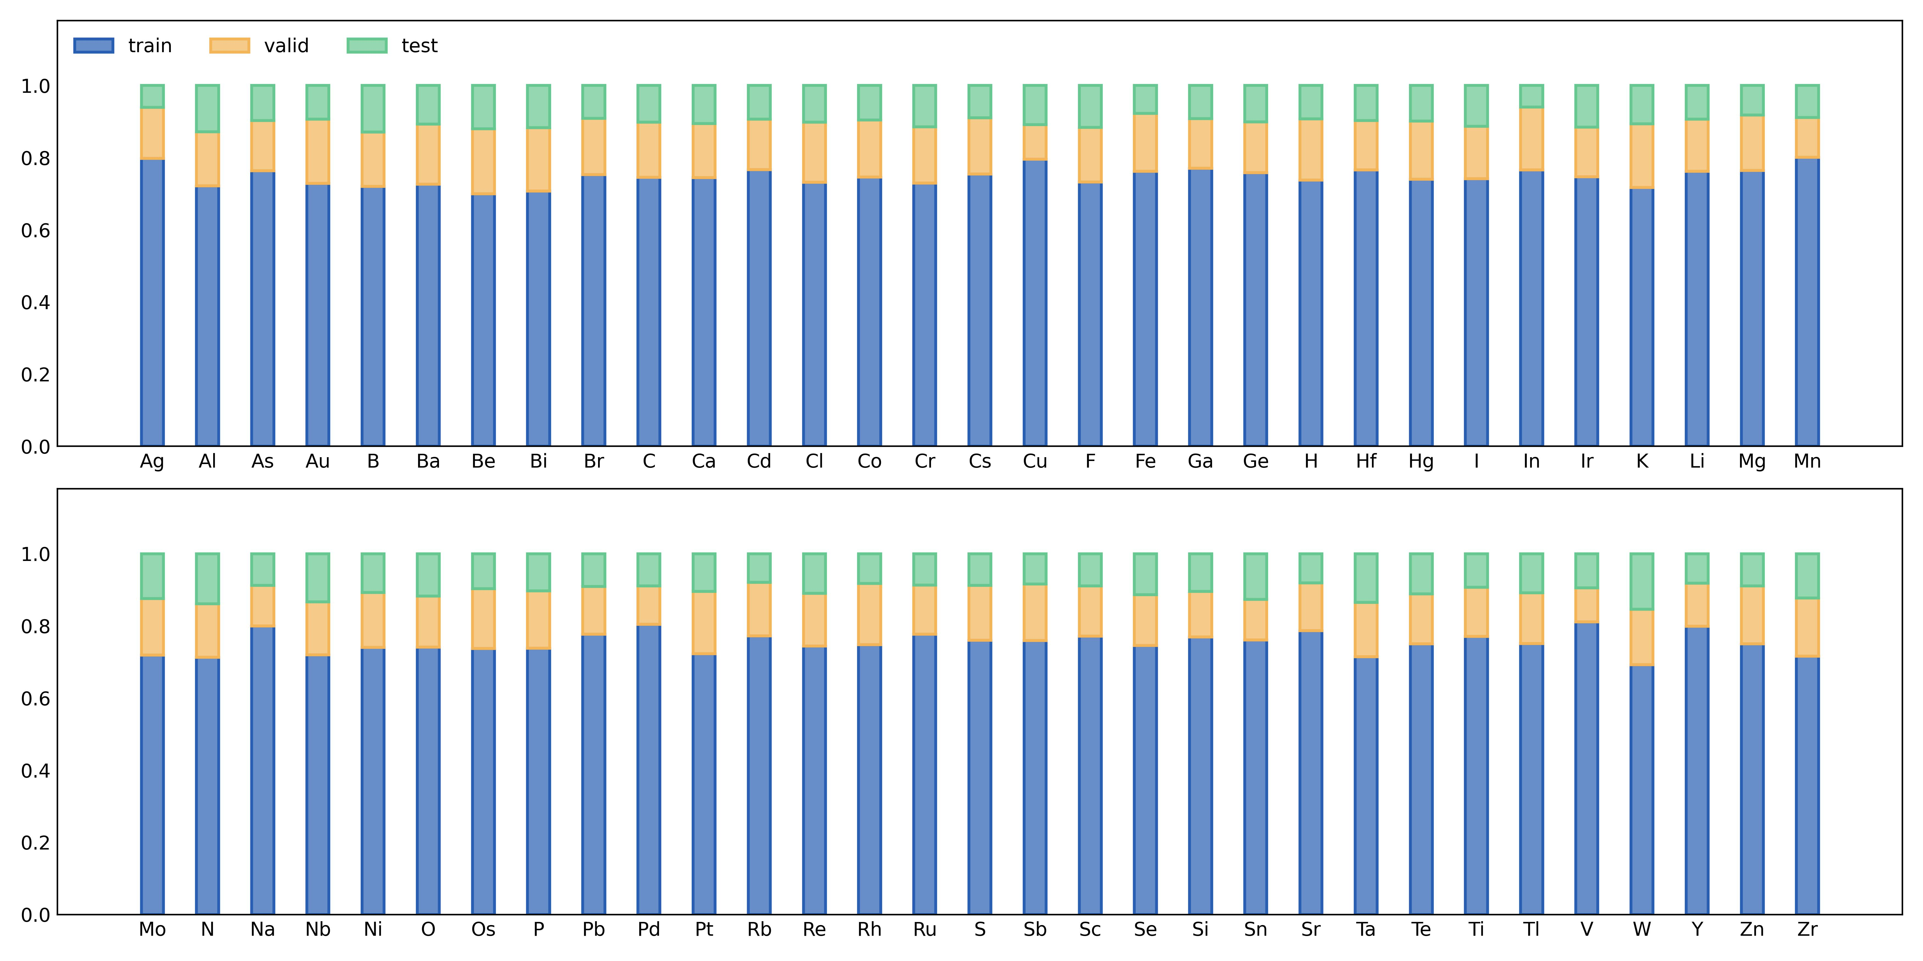
Figure S2: The training/validation/testing fraction split for the total number of materials that contain specific elements. Even element distribution across the training/validation/testing datasets indicates that all datasets are well-balanced.

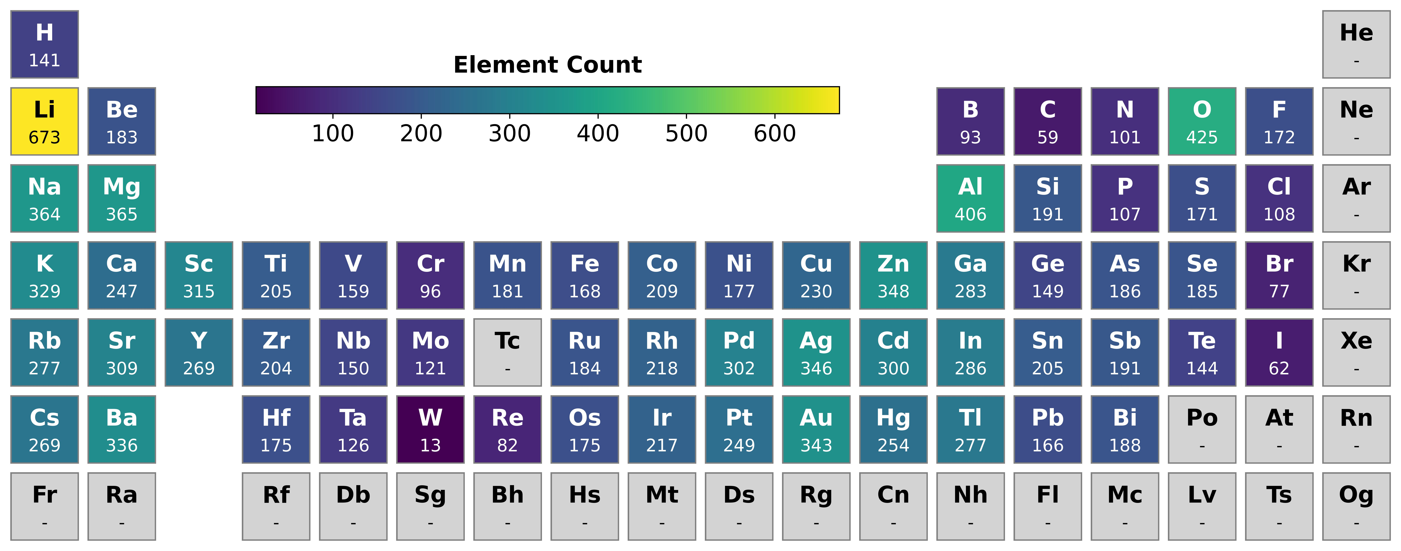
Figure S3: Number of materials that contain specific elements in periodic table format.

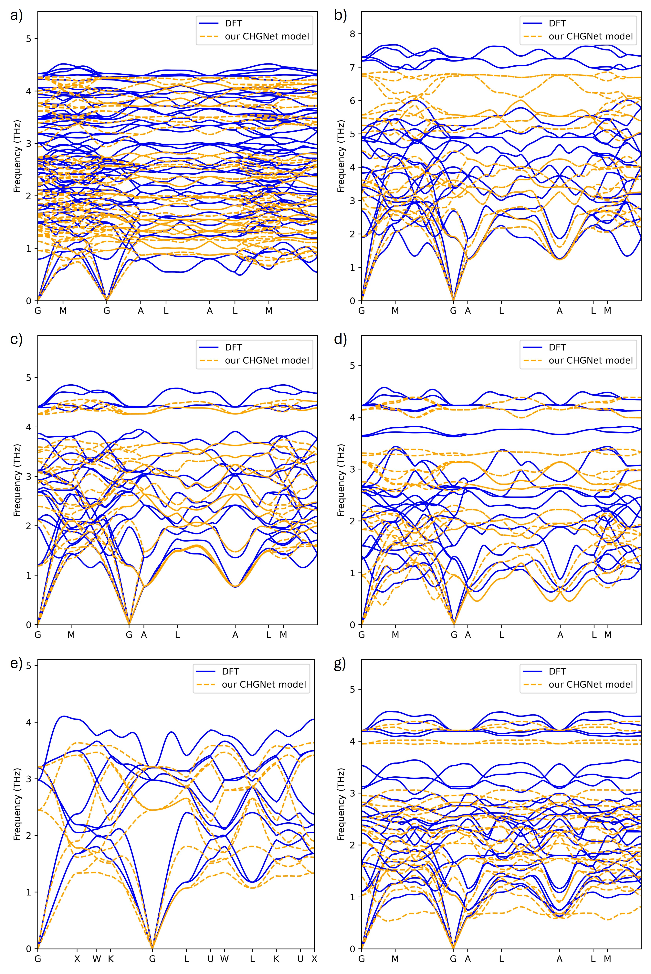

Figure S4: Phonon dispersion plots comparison between DFT and our CHGNet model for the following OQMD ID with corresponding chemical formula: (a) 1338889, Sr₇Ge₃, (b) 1366391, Na₂MgGe, (c) 1369362, K₂NaSb, (d) 1372624, Rb₂NaAs, (e) 1473988, K₂Te, (f) 1610487, KRbNaSb.
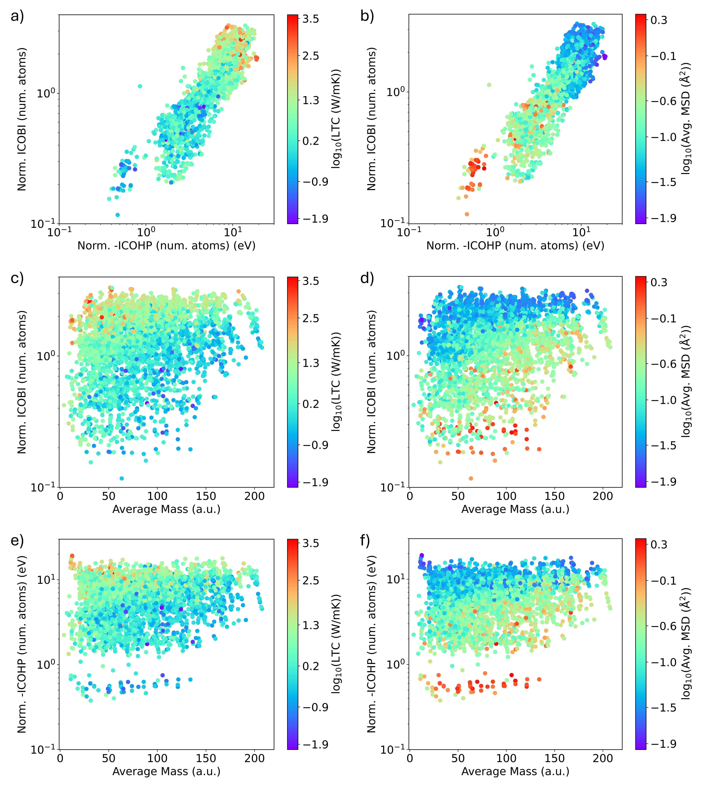

Figure S5: Plots for normalized -ICOHP (number of atoms) and normalized ICOBI (number of atoms) to analyze for LTC and average MSD. The plots show a) normalized ICOBI (number of atoms) and normalized -ICOHP (number of atoms) color-mapped with LTC, b) normalized ICOBI (number of atoms) and normalized -ICOHP (number of atoms) color-mapped with the average MSD. c) normalized ICOBI (number of atoms) and average mass color-mapped with LTC. d) normalized ICOBI (number of atoms) and average mass color-mapped with the average MSD. e) normalized -ICOHP (number of atoms) and average mass color-mapped with LTC. f) normalized -ICOHP (number of atoms) and average mass color-mapped with the average MSD.
Reference

[1] Vedernikov, M. V. The Thermoelectric Powers of Transition Metals at High Temperature. Advances in Physics 1969, 18 (74), 337–370.

* Author to whom all correspondence should be addressed. E-Mail: hu@sc.edu (M.H.)

