Supplementary Information

Operating advanced scientific instruments with AI agents that learn on the job

Aikaterini Vriza^{1,*}, Michael H. Prince², Tao Zhou¹, Henry Chan¹, Mathew J. Cherukara^{2,}*

¹ Center for Nanoscale Materials, Argonne National Laboratory, IL, USA
² Advanced Photon Source, Argonne National Laboratory, IL, USA

email: kvriza@gmail.com, mcherukara@anl.gov

Table of Contents

1. Workflow description 2
1.1. Hard X-ray Nanoprobe 3
1.2. Robotic platform for thin film fabrication (N9 robot) 10
2. Multi-agent system 12
3. Memory creation and teachability 13
4. Performance evaluation 16
4.1 Evaluation metrics on the Hard X-ray Nanoprobe 16
4.1.1 Task 1 16
4.1.2 Task 2 19
4.1.3 Task 3 21
4.2 Evaluation metrics of the N9 platform 25
4.2.1 Task 1 25
4.1.2 Task 2 26
4.1.3 Task 3 28
5. User interface 33

- Workflow description
  - Hard X-ray Nanoprobe
# Enables command line scripting for HXN microscope operation
# start this with /APSshare/anaconda/x86_64/bin/ipython -i S26_commandline.py
# When you create a code script for execution always import the libraries and define the motors to be used
import sys
import epics
import epics.devices
import time
import datetime
import numpy as np
import os
import math

# Define motors
fomx = epics.Motor('26idcnpi:m10.') # motor for moving focusing optics in the x direction, a positive value moves the motor in the outboard direction
fomy = epics.Motor('26idcnpi:m11.') # motor for moving focusing optics in the y direction, a positive value moves the motor up in the lab frame
fomz = epics.Motor('26idcnpi:m12.') # motor for moving focusing optics in the z direction, a positive value moves the motor further downstream
samy = epics.Motor('26idcnpi:m17.') # motor for moving the sample in the y direction, a positive value moves the sample up in the lab frame
samth = epics.Motor('atto2:PIC867:1:m1.')
osax = epics.Motor('26idcnpi:m13.')
osay = epics.Motor('26idcnpi:m14.')
osaz = epics.Motor('26idcnpi:m15.')
condx = epics.Motor('26idcnpi:m5.')
objx = epics.Motor('26idcnpi:m1.')
xrfx = epics.Motor('26idcDET:m7.') # motor for moving the XRF detector in

DCMenergy = epics.Motor("26idbDCM:sm8")
zpx = epics.Device('26idcnpi:X_HYBRID_SP.', attrs=('VAL','DESC')) # motor for moving the x-ray beam in the x direction. A positive value moves the beam outboard. The range is from -50 um to 50 um.
zpx.add_pv('26idcnpi:m34.RBV', attr='RBV')
zpy = epics.Device('26idcnpi:Y_HYBRID_SP.', attrs=('VAL','DESC')) # motor for moving the x-ray beam in the y direction. A positive value moves the beam up in the lab frame. The range is from -50 um to 50 um.
zpy.add_pv('26idcnpi:m35.RBV', attr='RBV')
twotheta = epics.Motor('26idcSOFT:sm3.')
not_epics_motors = [zpx.NAME, zpy.NAME, twotheta.NAME]
Supplementary Fig. 1. Python script for initializing motor control and library imports for the Hard X-ray Nanoprobe (HXN). This script serves as the foundation for command-line scripting of microscope operations. It imports the necessary Python libraries (including epics for EPICS-based device communication), defines the key motors used in positioning optics and samples, and annotates their function with descriptive comments. The script facilitates automation of beamline tasks by providing context and low-level access for agent-based or user-defined routines. Motors defined include those for focusing optics (fomx, fomy, fomz), sample positioning (samy, samth), beam steering (zpx, zpy).

def mov(motor,position):
# move motor to absolute position defined by the 2nd argument.
if motor in [fomx, fomy, samy]:
epics.caput('26idcnpi:m34.STOP',1)
epics.caput('26idcnpi:m35.STOP',1)
epics.caput('26idcSOFT:userCalc1.SCAN',0)
epics.caput('26idcSOFT:userCalc3.SCAN',0)
if motor.NAME in not_epics_motors:
motor.VAL = position
time.sleep(1)
print(motor.DESC+"---> "+str(motor.RBV))
else:
result = motor.move(position, wait=True)
if result==0:
time.sleep(0.5)
print(motor.DESC+" ---> "+str(motor.RBV))
fp = open(logbook,"a")
fp.write(motor.DESC+" ---> "+str(motor.RBV)+"\n")
fp.close()
epics.caput('26idcSOFT:userCalc1.SCAN',6)
epics.caput('26idcSOFT:userCalc3.SCAN',6)
else:
print("Motion failed")

def movr(motor,tweakvalue):
"""
Tweak motor relatively by value defined by the 2nd argument, tweakvalue is in um"""

# move motor by tweakvalue

if motor in [fomx, fomy, samy]:
epics.caput('26idcnpi:m34.STOP',1)
epics.caput('26idcnpi:m35.STOP',1)
if ( (motor in [zpx, zpy]) and ( (abs(zpx.RBV-zpx.VAL)>100) or (abs(zpy.RBV-zpy.VAL)>100) ) ):
print("Please use lock_hybrid() to lock piezos at current position first...")
return
if motor.NAME in not_epics_motors:
motor.VAL = motor.VAL+tweakvalue
time.sleep(1)
print(motor.DESC+"---> "+str(motor.RBV))
else:
result = motor.move(tweakvalue, relative=True, wait=True)
if result==0:
time.sleep(0.5)
print(motor.DESC+" ---> "+str(motor.RBV))
fp = open(logbook,"a")
fp.write(motor.DESC+" ---> "+str(motor.RBV)+"\n")
fp.close()
else:
print("Motion failed")

def scan1d(motor,startpos,endpos,numpts,dettime, absolute=False):
# scan 1 motor from start position (startpos) to end position (endpos), with number of points (numpts) and count time (dettime)

if motor in [fomx, fomy, samy]:
epics.caput('26idcnpi:m34.STOP',1)
epics.caput('26idcnpi:m35.STOP',1)
if ( (motor in [zpx, zpy]) and ( (abs(zpx.RBV-zpx.VAL)>100) or (abs(zpy.RBV-zpy.VAL)>100) ) ):
print("Please use lock_hybrid() to lock piezos at current position first...")
return
sc1.P1PV = motor.NAME+'.VAL'
if absolute:
sc1.P1AR=0
else:
sc1.P1AR=1
sc1.P1SP = startpos
sc1.P1EP = endpos
sc1.NPTS = numpts
count_time(dettime)
fp = open(logbook,"a")
fp.write(' ----- \n')
fp.write('SCAN #: '+epics.caget(scanrecord+':saveData_scanNumber',as_string=True)+' ---- '+str(datetime.datetime.now())+'\n')
if absolute:
fp.write('Scanning '+motor.DESC+' from '+str(startpos)+' ---> '+str(endpos)+' in '+str(numpts)+' points at '+str(dettime)+' seconds acquisition\n')
else:
fp.write('Scanning '+motor.DESC+' from '+str(startpos+motor.VAL)+' ---> '+str(endpos+motor.VAL))
fp.write(' in '+str(numpts)+' points at '+str(dettime)+' seconds acquisition\n')
fp.write(' ----- \n')
fp.close()
time.sleep(1)
stopnow = prescan();
if (stopnow):
return
sc1.execute=1
print("Scanning...")
time.sleep(1)
while(sc1.BUSY == 1):
time.sleep(1)
postscan()

def fly2d(motor1,startpos1,endpos1,numpts1,motor2,startpos2,endpos2,numpts2,dettime, absolute=False):
# scan two motors for a mesh scan
# the unit of the scan is in um
# motor1 is the outer loop motor, and is scanned in step mode. The step size or resolution in this case is defined as the difference between endpos1 and startpos1, divided by (numpts1-1)
# notor2 is the inner loop motor, and is scanned continuously in fly mode. The step size or resolution in this case is defined as the difference between endpos2 and startpos2, divided by numpts2

if (motor1 in [fomx, fomy, samy]) or (motor2 in [fomx, fomy, samy]):
epics.caput('26idcnpi:m34.STOP',1)
epics.caput('26idcnpi:m35.STOP',1)
if ( ( (motor1 in [zpx, zpy]) or (motor2 in [zpx,zpy]) ) and ( (abs(zpx.RBV-zpx.VAL)>100) or (abs(zpy.RBV-zpy.VAL)>100) ) ):
print("Please use lock_hybrid() to lock piezos at current position first...")
return
sc2.P1PV = motor1.NAME+'.VAL'
sc1.P1PV = motor2.NAME+'.VAL'
if absolute:
sc1.P1AR=0
sc2.P1AR=0
else:
sc1.P1AR=1
sc2.P1AR=1
sc2.P1SP = startpos1
sc1.P1SP = startpos2
sc2.P1EP = endpos1
sc1.P1EP = endpos2
sc2.NPTS = numpts1
sc1.NPTS = numpts2
count_time(dettime)
fp = open(logbook,"a")
fp.write(' ----- \n')
fp.write('SCAN #: '+epics.caget(scanrecord+':saveData_scanNumber',as_string=True)+' ---- '+str(datetime.datetime.now())+'\n')
if absolute:
fp.write('2D Scan:\n')
fp.write('Inner loop: '+motor2.DESC+' from '+str(startpos2)+' ---> '+str(endpos2))
fp.write(' in '+str(numpts2)+' points at '+str(dettime)+' seconds acquisition\n')
fp.write('Outer loop: '+motor1.DESC+' from '+str(startpos1)+' ---> '+str(endpos1))
fp.write(' in '+str(numpts1)+' points at '+str(dettime)+' seconds acquisition\n')
else:
fp.write('2D Scan:\n')
fp.write('Outer loop: '+motor1.DESC+' from '+str(startpos1+motor1.VAL)+' ---> '+str(endpos1+motor1.VAL))
fp.write(' in '+str(numpts1)+' points at '+str(dettime)+' seconds acquisition\n')
fp.write('Inner loop: '+motor2.DESC+' from '+str(startpos2+motor2.VAL)+' ---> '+str(endpos2+motor2.VAL))
fp.write(' in '+str(numpts2)+' points at '+str(dettime)+' seconds acquisition\n')
fp.write(' ----- \n')
fp.close()
time.sleep(1)
stopnow = prescan();
if (stopnow):
return
sc2.execute=1
print("Scanning...")
time.sleep(1)
while(sc2.BUSY == 1):
time.sleep(1)
postscan()

Supplementary Fig. 2. Detailed description of some of the functions extensively used to operate the X-ray Nanoprobe.

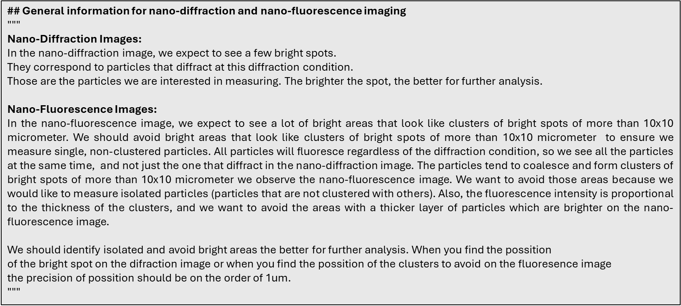
Supplementary Fig. 3. User provided context describing the process of getting visual insights from nano-diffraction and nano-fluorescence images.

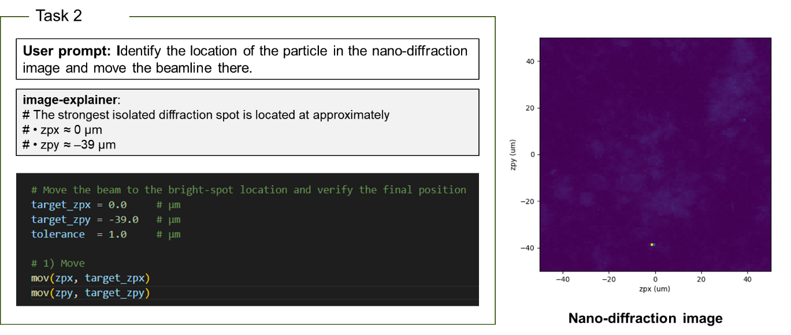
Supplementary Fig. 4. The agentic output for task 2 using GPT-4o (left). The nano-diffraction 2D scan used for task 2.

# In the nano-diffraction image, the bright spots indicating strong diffraction are located at:

# 1. Approximately (-40, 40) µm
# 2. Approximately (20, 20) µm
# 3. Approximately (0, -20) µm

# In the nano-fluorescence image, we need to avoid areas with clusters larger than 10x10 µm. The isolated bright spot that corresponds to a strong diffraction and is not in a clustered area is:

# - Approximately (20, 20) µm

# This location is suitable for further analysis. Move the beam to (20, 20) µm.

# Move the beam to the coordinates (20, 20) µm
mov(zpx, 20) # Move zpx motor to 20 µm
mov(zpy, 20) # Move zpy motor to 20 µm
Supplementary Fig. 5. The agentic output for task 3 using GPT-4o. The model fails to retrieve the coordinates of the bright spots with high accuracy.

  - Robotic platform for thin film fabrication (N9 robot)

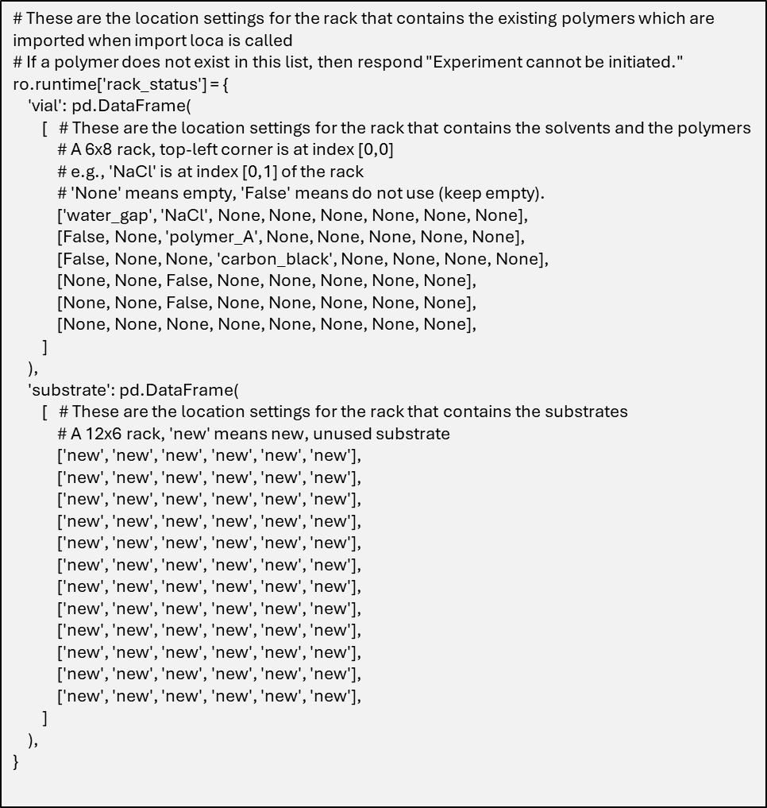
Supplementary Fig. 6. Example of the N9 station layout information provided as context to the LLM agents.

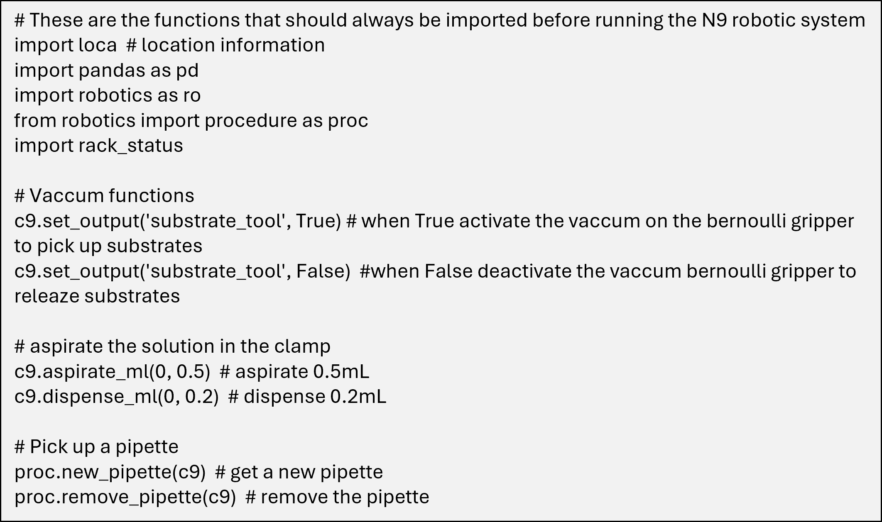
Supplementary Fig. 7. Example of the operating functions that interface with the underlying control system of the N9 robot. The main instructions and commands are provided to the LLM agents as context to create the operating environment, accompanied by a brief description of each function as text.

- Multi-agent system
Below we present the agents used to operate the N9 robotic station.
Administrator agent: The administrator agent is designed to function as an administrative interface between users and the other agents. Its primary responsibilities include task delegation to other agents, receiving human input before a further action is taken and code execution in the specified working directory.
Literature Scraping Agent: The literature scraping agent is responsible for extracting key information from scientific literature and transferring this knowledge to other agents. It has access to an external tool that converts PDFs into textual format, enabling efficient data extraction.
System Message:
• ”You are a PDF scraper and can extract information from any provided PDF using the available tools.”
• ”After reading the text, you can provide specific answers based on the PDF’s context.”
• ”Return ’TERMINATE’ when the scraping process is complete.”
Code writer agent: This agent is responsible for providing the execution code as a python script. We provide the operating functions with a short description about the utility of each function in the system message. An example is shown in Figure 4.
Code reviewer agent: This agent is designed to evaluate the code created by the code writer and provide feedback.
System Message:
• ”Your task is to review the code provided by the code writer agent and provide feedback on necessary corrections.”
• ”Ensure that all required libraries are imported and that only the existing approved operation functions are used.”
Manager: This agent is creating a group with all the existing agents and is responsible for selecting the next relevant agent in the workflow.

The agent-to-agent communication is achieved via a dynamic group chat pattern, in which participating agents share the same context and converse with the others in a dynamic manner instead of following a pre-defined order.

- Memory creation and teachability
To enhance agent reliability and long-term adaptability, we integrated AutoGen’s teachability mechanism with a persistent memory backend. The system appends new instructions to the agent system message and interfaces with a background teachability agent that determines whether information provided by the human user is sufficiently generalizable to be stored. When relevant guidance for experimental execution is identified, it is extracted, generalized, and stored as input–output pairs in a local ChromaDB vector database (Supplementary Figs. 8 and 9).
Stored memories are embedded as text representations, enabling semantic similarity search during task execution. For each new user task, the agent queries the memory database and retrieves the most relevant prior teachings, which are then incorporated into the reasoning process. To prevent memory redundancy, we introduced an additional similarity check prior to storage: new entries are compared against existing memories using ChromaDB’s similarity search, and are only stored if their distance exceeds a predefined threshold.
This memory mechanism enables training and memory creation using more capable but computationally expensive language models, while allowing subsequent task execution to be performed using smaller or open-source models without loss of accumulated procedural knowledge.
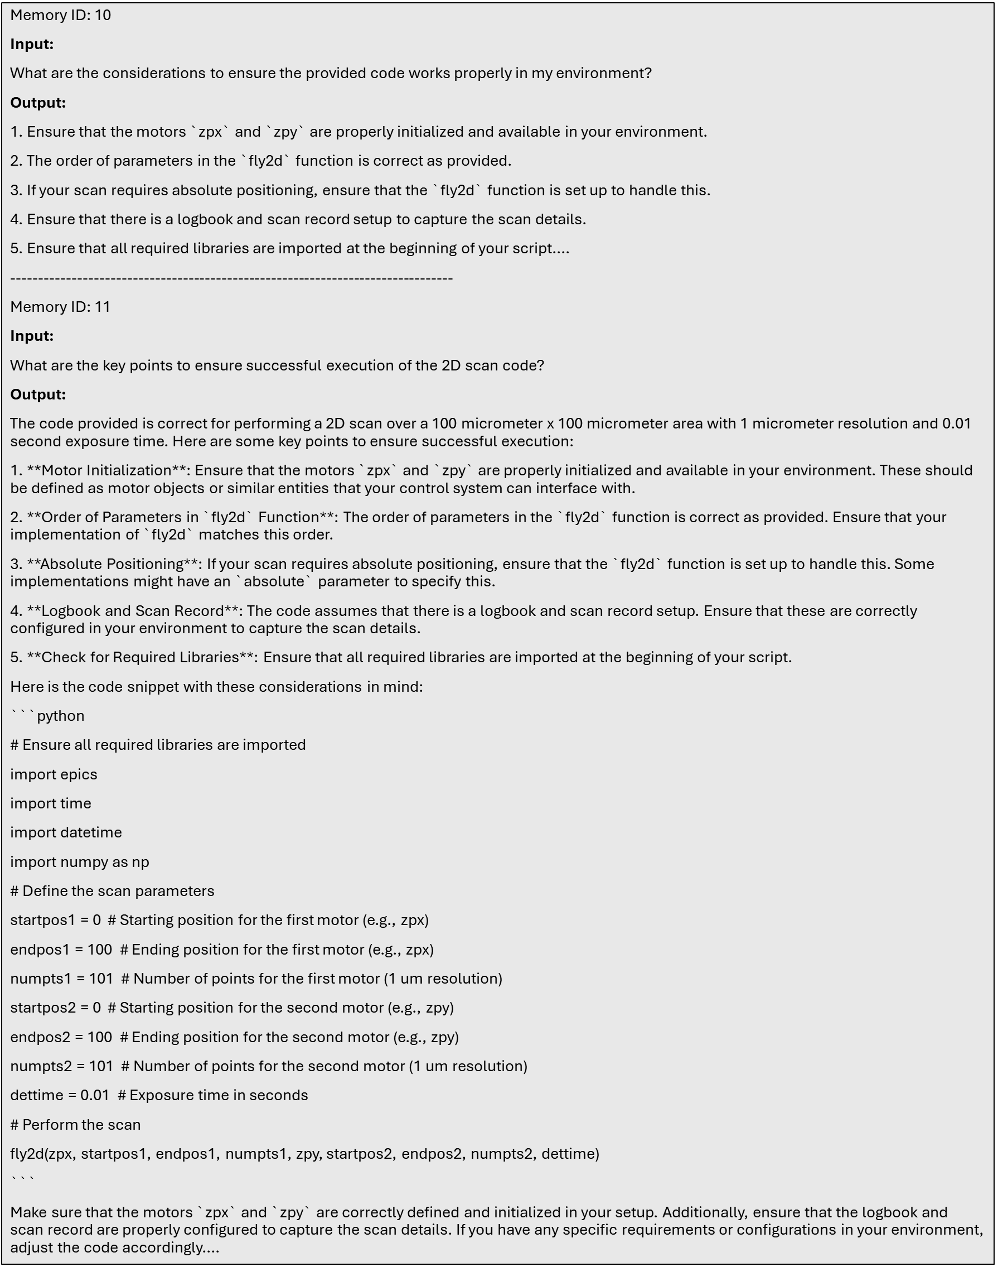
Supplementary Fig. 8. Example of memories created from gpt-4o on the operation of the beamline.

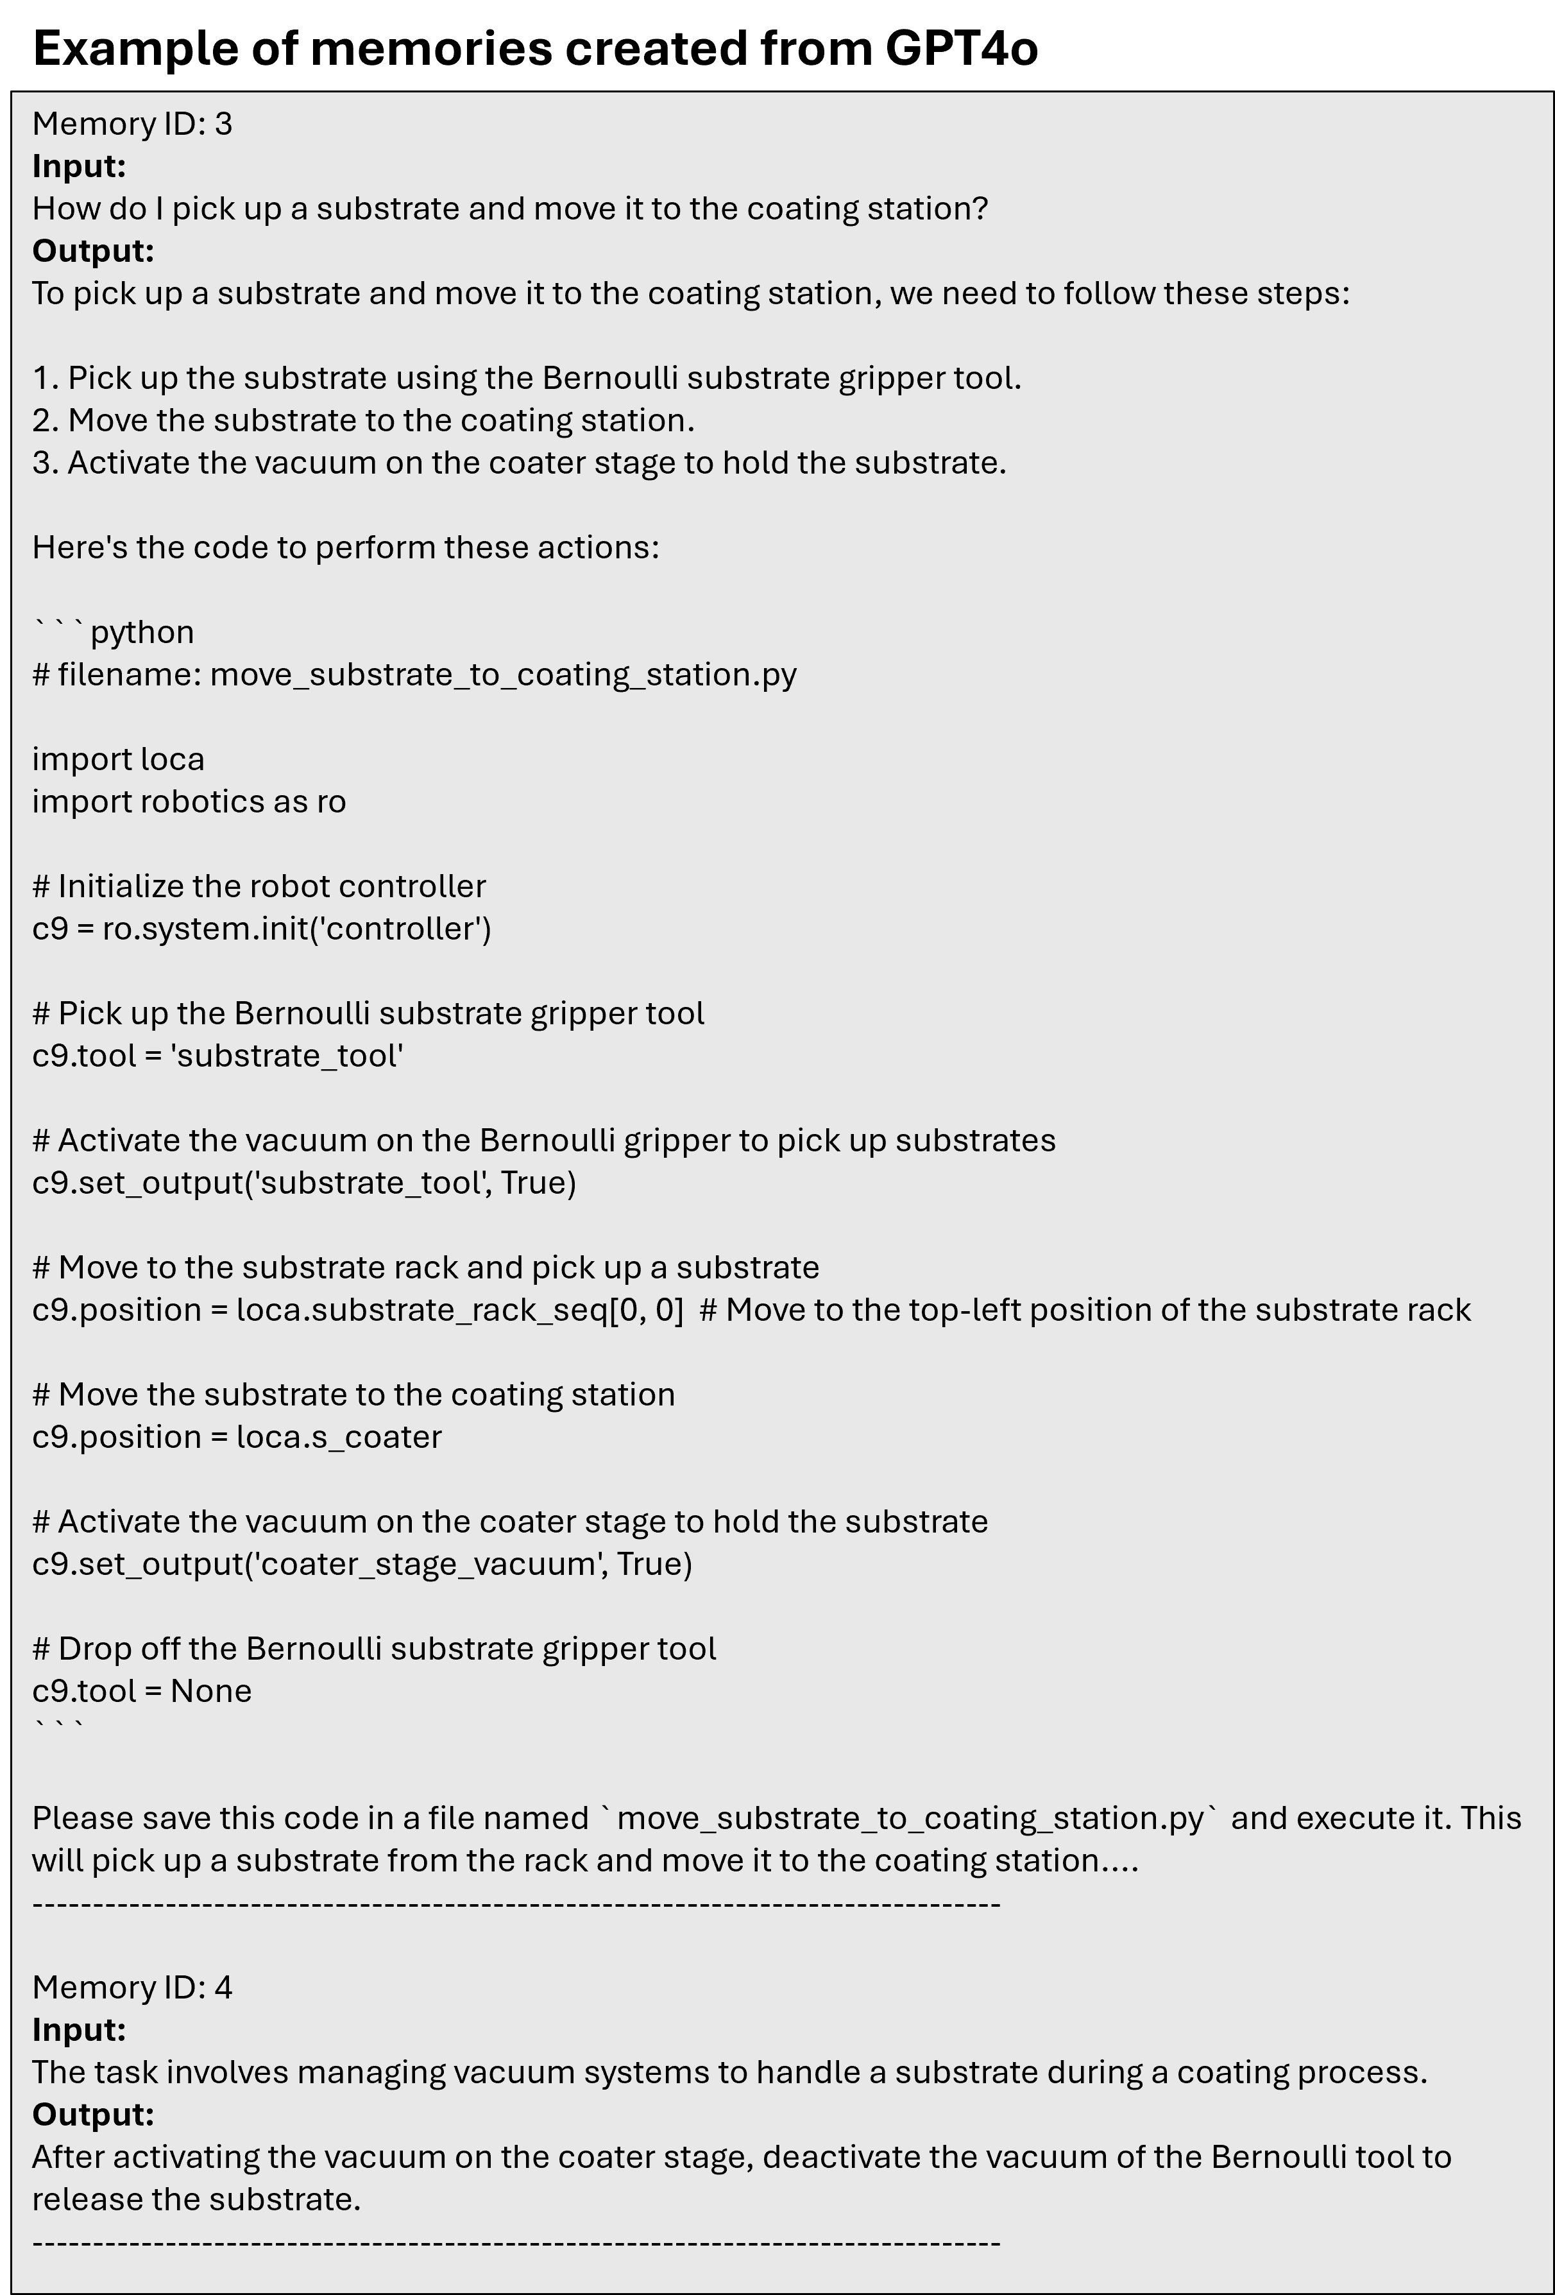
Supplementary Fig. 9. Example of memories created from gpt-4o on the operation on the N9 robotic station.
- Performance evaluation
For the evaluation of the agents performance we Focused on five tasks:
1. Code quality check: Checking if the code reviewer was initiated to check the initial code written by the code writer. That is basically focusing checking if the correct functions have been imported and that the code is operational.
2. Correctness: Checking if the final code is correct and calls the correct functions sequentially. Evaluating the functionality of the generated code and checking whether the sequential steps are performed in the correct order. The score is counting how many steps of the required ones have been identified from the agents. The best score is 8, 10, 25 for the first, second and third task accordingly.
3. Code execution: How many of the steps can the code run without doing something wrong. This differs from the code correctness, as all the steps might have been identified correct but placed in a wrong sequence and as such the operation of the robot will break. The score is counting how many steps of the required ones have been identified from the agents. The best score is 8, 10, 25 for the first, second and third task accordingly.
4. Code repeatability: Evaluating whether the same code is generating after running the same prompt task for two times. The temperature of the models is set to 0 in all cases.
5. Reproducibility: Assess the consistency of the generated code when provided with altered
prompts for the same task. This is particularly crucial in user facilities, where different users may describe identical tasks using various expressions.

  - Evaluation metrics on the Hard X-ray Nanoprobe

4.1.1 Task 1
prompt_1 = """I need to scan a 100 um x 100 um area, with 1 um resolution, 0.01 sec exposure time."""
prompt_1a = """Scan a 100 micrometer x 100 micrometer area, with 1 micrometer resolution and 0.01 sec exposure time."""
Expected output: Define the correct parameters for a 100x100 um area and resolution 0.01 sec, identify the correct motors, identify the correct function. For a 100% score all these three steps should be correct.

Supplementary Table 1. Evaluation table for task 1 in the S26 beamline experiments without human intervention for teachability. The first three trials are performed using the same exact prompt, whereas the fourth trial is using a slightly different prompt (referred a prompt 1a) but with the same meaning.
Trial | model | Code quality check | Code correctness (%) | Code execution (correct order of functions) (%) | Comments
1 | gpt-4o-mini | V | 33.33 | 33.33 | Correct function but selected wrong motors and wrong parameters (1/3)
2 | gpt-4o-mini | V | 33.33 | 33.33 | Correct function but selected wrong motors and wrong parameters(1/3)
3 | gpt-4o-mini | V | 33.33 | 33.33 | Correct function but selected wrong motors and wrong parameters (1/3)
4 | gpt-4o-mini | X | 33.33 | 33.33 | Correct function but selected wrong motors and wrong parameters (1/3)
1 | gpt-4o | V | 66.66 | 66.66 | Correct function, correct motors but not correct numpts1&2 (2/3)
2 | gpt-4o | V | 66.66 | 66.66 | Correct function, correct motors but not correct numpts1&2 (2/3)
3 | gpt-4o | V | 66.66 | 66.66 | Correct function, correct motors but not correct numpts1&2 (2/3)
4 | gpt-4o | V | 66.66 | 66.66 | Correct function, correct motors but not correct numpts1&2 (2/3)
1 | claude-3.5 | V | 33.33 | 33.33 | Correct function and parameters but picked up wrong motors
2 | claude-3.5 | V | 33.33 | 33.33 | Correct function and parameters but picked up wrong motors
3 | claude-3.5 | V | 33.33 | 33.33 | Correct function and parameters but picked up wrong motors
4 | claude-3.5 | V | 66.66 | 66.66 | Correct function and correct motors but added several unnecessary steps and calls
1 | o3 | V | 100 | 100 | Correct function, correct motors and correct parameters (3/3)
2 | o3 | V | 100 | 100 | Correct function, correct motors and correct parameters (3/3)
3 | o3 | V | 100 | 100 | Correct function, correct motors and correct parameters (3/3)
4 | o3 | V | 100 | 100 | Correct function, correct motors and correct parameters (3/3)

Supplementary Table 2. Evaluation table for task 1 in the S26 beamline experiments with human intervention for teachability. The first three trials are performed using the same exact prompt, whereas the fourth trial is using a slightly different prompt (referred a prompt 1a) but with the same meaning.
Trial | model | Code quality check | Code correctness (%) | Code execution (correct order of functions) (%) | Comments
1 | gpt-4o-mini | V | 100 | 100 | Correct function, correct motors and correct parameters (3/3)
2 | gpt-4o-mini | V | 100 | 100 | Correct function, correct motors and correct parameters (3/3)
3 | gpt-4o-mini | V | 100 | 100 | Correct function, correct motors and correct parameters (3/3)
4 | gpt-4o-mini | V | 100 | 100 | Correct function, correct motors and correct parameters (3/3)
1 | gpt-4o | V | 100 | 100 | Correct function, correct motors and correct parameters (3/3)
2 | gpt-4o | V | 100 | 100 | Correct function, correct motors and correct parameters (3/3)
3 | gpt-4o | V | 100 | 100 | Correct function, correct motors and correct parameters (3/3)
4 | gpt-4o | V | 100 | 100 | Correct function, correct motors and correct parameters (3/3)
1 | claude-3.5 | V | 100 | 100 | Correct function, correct motors and correct parameters (3/3)
2 | claude-3.5 | V | 100 | 100 | Correct function, correct motors and correct parameters (3/3)
3 | claude-3.5 | V | 66.66 | 66.66 | Correct function and parameters but picked up wrong motors
4 | claude-3.5 | V | 66.66 | 66.66 | Correct function and parameters but picked up wrong motors
1 | o3 | V | 100 | 100 | No human intervention is required since the model performs 100%
2 | o3 | V | 100 | 100 | No human intervention is required since the model performs 100%
3 | o3 | V | 100 | 100 | No human intervention is required since the model performs 100%
4 | o3 | V | 100 | 100 | No human intervention is required since the model performs 100%

4.1.2 Task 2
prompt_2 = f"""In the result of the previous scan <img {image_path}> we see a bright dot. Find out the location of the particle and move the beam there."""
prompt_2a = f"""Check the scan <img {image_path}> , find out the location of the particle and move the beam towards this location."""
Expected output: Identify the approximate location of the bright spot in the 2D heatmap (0, -40), use these coordinates to call the correct function to move the beam there.

Supplementary Table 3. Evaluation table for task 2 in the S26 beamline experiments without any human intervention. The first three trials are performed using the same exact prompt, whereas the fourth trial is using a slightly different prompt (referred a prompt 2a) but with the same meaning.
Trial | model | Code quality check | Code correctness (%) | Code execution (correct order of functions) (%) | Comments
1 | gpt-4o-mini | X | 50 | 50 | Correct location but made up the function
2 | gpt-4o-mini | X | 50 | 50 | Correct location but made up the function
3 | gpt-4o-mini | X | 50 | 50 | Correct location but made up the function
4 | gpt-4o-mini | V | 100 | 100 | Correct location and function
1 | gpt-4o | X | 100 | 100 | Correct location and function
2 | gpt-4o | X | 100 | 100 | Correct location and function
3 | gpt-4o | X | 100 | 100 | Correct location and function
4 | gpt-4o | X | 100 | 100 | Correct location and function
1 | claude-3.5 | X | 100 | 50 | Correct location and correct function. But it performed a scan without being asked for. The instructions were to move to the location not to take a scan.
2 | claude-3.5 | X | 100 | 50 | Correct location and correct function. But it performed a scan without being asked for. The instructions were to move to the location not to take a scan.
3 | claude-3.5 | X | 100 | 50 | Correct location and correct function. But it performed a scan without being asked for. The instructions were to move to the location not to take a scan.
4 | claude-3.5 | X | 100 | 50 | Correct location and correct function. But it performed a scan without being asked for. The instructions were to move to the location not to take a scan.
1 | o3 | V | 100 | 100 | Correct location and correct function
2 | o3 | V | 100 | 100 | Correct location and correct function
3 | o3 | V | 100 | 100 | Correct location and correct function
4 | o3 | V | 100 | 100 | Correct location and correct function

Observations: when code-reviewer wasn’t called the model was making up functions. In 4o the reviewer wasn;t called but functions were correct.

Supplementary Table 4. Evaluation table for task 2 in the S26 beamline experiments with teachability through human intervention. The first three trials are performed using the same exact prompt, whereas the fourth trial is using a slightly different prompt (referred a prompt 2a) but with the same meaning.
Trial | model | Code quality check | Code correctness (%) | Code execution (correct order of functions) (%) | Comments
1 | gpt-4o-mini | V | 100 | 100 | Correct location and function
2 | gpt-4o-mini | V | 100 | 100 | Correct location and function
3 | gpt-4o-mini | V | 50 | 50 | Correct location but made up the function
4 | gpt-4o-mini | V | 100 | 100 | Correct location and function
1 | gpt-4o | V | 100 | 100 | Correct location and function
2 | gpt-4o | V | 100 | 100 | Correct location and function
3 | gpt-4o | V | 100 | 100 | Correct location and function
4 | gpt-4o | V | 100 | 100 | Correct location and function
1 | claude-3.5 | V | 100 | 100 | Correct location and function
2 | claude-3.5 | X | 50 | 50 | Correct location but called several functions without being asked to
3 | claude-3.5 | X | 100 | 50 | Correct location and mov function but again called several functions without being asked to
4 | claude-3.5 | X | 50 | 50 | Correct location but called several functions without being asked to
1 | o3 | V | 100 | 100 | No human intervention is required since the model performs 100%
2 | o3 | V | 100 | 100 | No human intervention is required since the model performs 100%
3 | o3 | V | 100 | 100 | No human intervention is required since the model performs 100%
4 | o3 | V | 100 | 100 | No human intervention is required since the model performs 100%

4.1.3 Task 3
prompt_3 = f"""The nano-diffraction image from the previous scan is shown in <img {image_path}>, and the corresponding nano-fluorescence image is shown in <img {image_path_fluo}>. Provide the coordinates of the particle that diffracts strongly and is also isolated. And move the beam towards this location."""
prompt_3a = f"""The nano-diffraction image from the previous scan is shown in <img {image_path}>, and the assosciated nano-fluorescence image is shown in <img {image_path_fluo}>. Find the coordinates of the particle that diffracts best and is also isolated. Then move the beam to this location."""
Expected output: Identify the location of the brightest spot in the 2D heatmap of the nano-diffraction image and also simultaneously check the corresponding nano-fluorescence image to make sure that the previously identified area is isolated (away from bright spots). Then use these coordinates to call the correct function to move the beam there.

Supplementary Table 5. Evaluation table for task 3 in the S26 beamline experiments. The first three trials are performed using the same exact prompt, whereas the fourth trial is using a slightly different prompt (referred a prompt 3a) but with the same meaning.
Trial | model | Code quality check | Code correctness (%) | Code execution (correct order of functions) (%) | Comments
1 | gpt-4o-mini | X | 0 | 0 | Cannot identify the correct points, makes up a wrong function
2 | gpt-4o-mini | X | 0 | 0 | Cannot identify the correct points, makes up a wrong function
3 | gpt-4o-mini | X | 0 | 0 | Cannot identify the correct points, makes up a wrong function
4 | gpt-4o-mini | X | 0 | 0 | Cannot identify the correct points, makes up a wrong function
1 | gpt-4o | V | 50 | 50 | Identified all the three spots with low accuracy and select the wrong location for scanning (20, 20). Correct function.
2 | gpt-4o | V | 50 | 50 | Identified all the three spots with low accuracy and select the wrong location for scanning (20, 20). Correct function.
3 | gpt-4o | V | 50 | 50 | Identified all the three spots with low accuracy and select the wrong location for scanning (20, 20). Correct function.
4 | gpt-4o | V | 50 | 50 | Identified all the three spots with low accuracy and select the wrong location for scanning (0, -20). Correct function.
1 | claude-3.5 | X | 50 | 50 | Identified the correct spot (-40, 45) but called the wrong function: movr instead of mov.
2 | claude-3.5 | X | 0 | 0 | Identified all the three spots with low accuracy and select the wrong location for scanning (20, 20). Wrong function.
3 | claude-3.5 | X | 0 | 0 | Identified all the three spots with low accuracy and select the wrong location for scanning (20, 20). Wrong function.
4 | claude-3.5 | X | 50 | 50 | Identified the correct spot (-40, 45) but called the wrong function: movr instead of mov.
1 | o3 | V | 100 | 100 | Correct cross-modal location and correct function
2 | o3 | V | 100 | 100 | Correct cross-modal location and correct function
3 | o3 | V | 100 | 100 | Correct cross-modal location and correct function
4 | o3 | V | 100 | 100 | Correct cross-modal location and correct function

Supplementary Table 6. Evaluation table for task 3 in the S26 beamline experiments with teachability through human intervention. The first three trials are performed using the same exact prompt, whereas the fourth trial is using a slightly different prompt (referred a prompt 3a) but with the same meaning.
Trial | model | Code quality check | Code correctness (%) | Code execution (correct order of functions) (%) | Comments
1 | gpt-4o-mini | X | 50 | 50 | Cannot identify the correct points, found the correct function
2 | gpt-4o-mini | X | 50 | 50 | Cannot identify the correct points, found the correct function
3 | gpt-4o-mini | X | 50 | 50 | Cannot identify the correct points, found the correct function
4 | gpt-4o-mini | X | 50 | 50 | Cannot identify the correct points, found the correct function
1 | gpt-4o | V | 50 | 50 | Identified all the three spots with low accuracy and select the wrong location for scanning (20, 20). Correct function.
2 | gpt-4o | V | 100 | 100 | Identified all the three spots with selected the correct one. Correct function.
3 | gpt-4o | V | 100 | 100 | Identified all the three spots with selected the correct one. Correct function.
4 | gpt-4o | V | 50 | 50 | Identified all the three spots with low accuracy and select the wrong location for scanning (0, -20). Correct function.
1 | claude-3.5 | X | 50 | 50 | Identified the correct spot (-40, 45) but called the wrong function: movr instead of mov.
2 | claude-3.5 | X | 0 | 0 | Identified all the three spots with low accuracy and select the wrong location for scanning (20, 20). Wrong function.
3 | claude-3.5 | X | 0 | 0 | Identified all the three spots with low accuracy and select the wrong location for scanning (20, 20). Wrong function.
4 | claude-3.5 | X | 50 | 50 | Identified the correct spot (-40, 45) but called the wrong function: movr instead of mov.
1 | o3 | V | 100 | 100 | No human intervention is required since the model performs 100%
2 | o3 | V | 100 | 100 | No human intervention is required since the model performs 100%
3 | o3 | V | 100 | 100 | No human intervention is required since the model performs 100%
4 | o3 | V | 100 | 100 | No human intervention is required since the model performs 100%

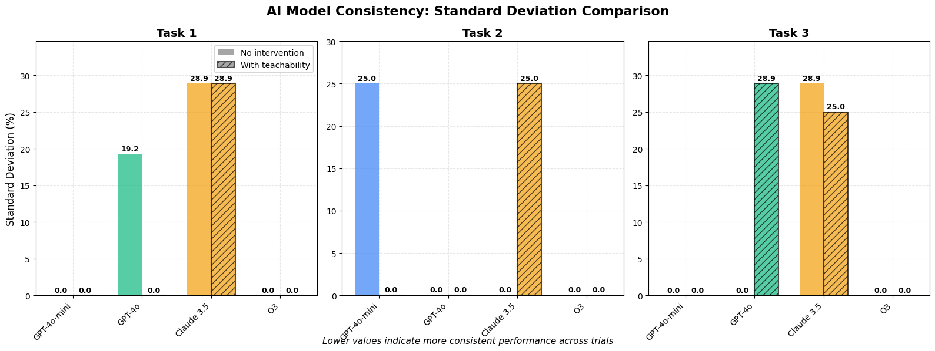
Supplementary Fig. 10. LLM model consistency on the operation of the X-ray nanoprobe system calculated by comparing the standard deviation of each task. Claube 3.5 showed the highest inconsistency among the tasks as the output of the model was varying across the different trials.

 | without intervention
 | gpt-4o-mini | gpt-4o | claude-3.5 | gpt-o3
task1 | 0.33 | 0.87 | 0.62 | 1
task2 | 0.52 | 1 | 0.75 | 1
task3 | 0 | 0.5 | 0.25 | 1
 | with teachability
 | gpt-4o-mini | gpt-4o | claude-3.5 | gpt-o3
task1 | 1 | 1 | 0.87 | 1
task2 | 0.87 | 1 | 0.68 | 1
task3 | 0.5 | 0.75 | 0.25 | 1
Supplementary Fig. 11. Summary table with the comparison of all the LLMs used in this work across all the X-ray nanoprobe system tasks.

To set up the 100 µm × 100 µm raster you’ve requested we still need a couple of details that are not defined in the current session:

1. Which motors should we use for X and Y?
• The most common choice is the fast-fly piezos zpx (X) and zpy (Y).
• If you want to move the sample instead, we can use samx/samy or another pair.

2. Integration time (dettime) per point – e.g. 0.05 s, 0.1 s, … ?

3. Should the scan be:
• Relative to the current position (typical)
• Absolute, with explicit start/end coordinates?

Let me know these items and I’ll generate the ready-to-run scan command.
Supplementary Fig. 12. Example of the response of o3 model after the user provided an incomplete question without specifying the exposure time: “Scan a 100 micrometer x 100 micrometer area, with 1 micrometer resolution."

  - Evaluation metrics of the N9 platform

4.2.1 Task 1
prompt_1 = """Write the execution code to move the vial with PEDOT:PSS defined as polymer A to the clamp holder."""
prompt_1a = """Write the code to move the vial with polymer A to the clamp."""
Expected output: The eight (8) sequential tasks are organized as follows:
- Import the correct libraries
- Initialize the required system components
- Identify the location of the vial
- Move gripper to the vial position
- Close the gripper to pick up the vial
- Move the gripper with the vial to the clamp holder
- Close the clamp holder to hold the vial
- Release the gripper
We give one point for each correct step

Supplementary Table 7. Evaluation table for task 1 on the N9 robotic station without human intervention for teachability. The first three trials are performed using the same exact prompt, whereas the fourth trial is using a slightly different prompt (referred a prompt 1a) but with the same meaning.
Trial | model | Code quality check | Code correctness (%) | Code execution (correct order of functions) (%) | Comments
1 | gpt-4o-mini | V | 87.5 | 75 | 7/8 of the steps were identified. It didn’t close the clamp to hold the gripper. For code execution it will stop in step 6 the rest is not correct and will break the process so 6/8.
2 | gpt-4o-mini | V | 87.5 | 75
3 | gpt-4o-mini | V | 87.5 | 75
4 | gpt-4o-mini | V | 87.5 | 75
1 | gpt-4o | V | 100 | 100 | 8/8 of the steps were identified and in the correct order.
2 | gpt-4o | V | 100 | 100 | 8/8 of the steps were identified and in the correct order.
3 | gpt-4o | V | 100 | 100 | 8/8 of the steps were identified and in the correct order.
4 | gpt-4o | V | 100 | 100 | 8/8 of the steps were identified and in the correct order.
1 | claude-3.5 | V | 75 | 50 | 8/8 of the steps were identified. But the two final steps were not in the correct order: it first release the gripper and then closed the clamp. Also added extra step for vertical movement which will break the code (-2 points). Code execution Will stop in step 4 the rest is not correct and will break the process
2 | claude-3.5 | V | 75 | 50
3 | claude-3.5 | V | 75 | 50
4 | claude-3.5 | V | 75 | 50
1 | o3 | V | 0 | 0 | Hallucinated not existing functions
2 | o3 | V | 0 | 0 | Hallucinated not existing functions
3 | o3 | V | 0 | 0 | Hallucinated not existing functions
4 | o3 | V | 0 | 0 | Hallucinated not existing functions

Supplementary Table 8. Evaluation table for task 1 on the N9 robotic station with human intervention for teachability. The first three trials are performed using the same exact prompt, whereas the fourth trial is using a slightly different prompt (referred a prompt 1a) but with the same meaning.
Trial | model | Code quality check | Code correctness (%) | Code execution (correct order of functions) (%) | Comments
1 | gpt-4o-mini | V | 100 | 100 | 8/8 of the steps were identified and in the correct order.
2 | gpt-4o-mini | V | 100 | 100 | 8/8 of the steps were identified and in the correct order.
3 | gpt-4o-mini | V | 100 | 100 | 8/8 of the steps were identified and in the correct order.
4 | gpt-4o-mini | V | 100 | 100 | 8/8 of the steps were identified and in the correct order.
1 | gpt-4o | V | 100 | 100 | 8/8 of the steps were identified and in the correct order.
2 | gpt-4o | V | 100 | 100 | 8/8 of the steps were identified and in the correct order.
3 | gpt-4o | V | 100 | 100 | 8/8 of the steps were identified and in the correct order.
4 | gpt-4o | V | 100 | 100 | 8/8 of the steps were identified and in the correct order.
1 | claude-3.5 | V | 100 | 100 | 8/8 of the steps were identified and in the correct order.
2 | claude-3.5 | V | 100 | 100 | 8/8 of the steps were identified and in the correct order.
3 | claude-3.5 | V | 100 | 100 | 8/8 of the steps were identified and in the correct order.
4 | claude-3.5 | V | 100 | 100 | 8/8 of the steps were identified and in the correct order.
1 | o3 | V | 100 | 100 | 8/8 of the steps were identified and in the correct order.
2 | o3 | V | 100 | 100 | 8/8 of the steps were identified and in the correct order.
3 | o3 | V | 100 | 100 | 8/8 of the steps were identified and in the correct order.
4 | o3 | V | 100 | 100 | 8/8 of the steps were identified and in the correct order.

4.1.2 Task 2
prompt_2 = """Write the execution code to pick up a substrate from the substrate rack and move it to the coating station."""
prompt_2a = """Write the code to pick up a substrate and move it to the coating stage."""
Expected output: The ten (10) sequential tasks are organized as follows:
- Import the correct libraries
- Initialize the required system components
- Pick up the Bernoulli tool
- Identify the location of the substrate
- Move the Bernoulli tool to the location of the substrate
- Activate the vacuum to pick up the substrate
- Move the substrate to the blade coating station
- Activate the vacuum of the coating station to hold the substrate
- Deactivate the vacuum of the Bernoulli tool to release the substrate
- Return the Bernoulli tool to its location
We give one point for each correct step
Supplementary Table 9. Evaluation table for task 2 N9 robotic station experiments without any human intervention. The first three trials are performed using the same exact prompt, whereas the fourth trial is using a slightly different prompt (referred a prompt 2a) but with the same meaning.
Trial | model | Code quality check | Code correctness (%) | Code execution (correct order of functions) (%) | Comments
1 | gpt-4o-mini | V | 60 | 50 | For the code correctness: 8/10 of the steps were identified. It didn’t activate the vacuum of the coating station, and it didn’t return the Bernoulli tool back. Also -1 point as it a made up a function (c9.wait_until_reached()) (total: 7/10). For the code execution, it will stop in step 5 the rest is not correct and will break the process
2 | gpt-4o-mini | V | 60 | 50
3 | gpt-4o-mini | V | 60 | 50
4 | gpt-4o-mini | V | 80 | 80 | 8/10 steps correct and no made up function
1 | gpt-4o | V | 90 | 70 | Code correctness: 9/10 of the steps were identified. It didn’t activate the vacuum on the coating station. Code execution: 7/10 sequential steps correct
2 | gpt-4o | V | 90 | 70
3 | gpt-4o | V | 90 | 70
4 | gpt-4o | V | 100 | 100 | Using the prompt 2a it worked well and activated the coating stage vacuum in correct order
1 | claude-3.5 | V | 60 | 60 | 10/10 of the steps were identified. But added extra steps for vertical movement which will break the code and hallucinated commands (-4 points). Will stop in step 6 the rest is not correct and will break the process
2 | claude-3.5 | V | 60 | 60
3 | claude-3.5 | V | 60 | 60
4 | claude-3.5 | V | 100 | 100 | 10/10 steps were identified in correct order
1 | o3 | V | 100 | 100 | 10/10 steps are correct
2 | o3 | V | 100 | 100 | 10/10 steps are correct
3 | o3 | V | 100 | 100 | 10/10 steps are correct
4 | o3 | V | 100 | 100 | 10/10 steps are correct

Supplementary Table 10. Evaluation table for task 2 N9 robotic station experiments with teachability through human intervention. The first three trials are performed using the same exact prompt, whereas the fourth trial is using a slightly different prompt (referred a prompt 2a) but with the same meaning.
Trial | model | Code quality check | Code correctness (%) | Code execution (correct order of functions) (%) | Comments
1 | gpt-4o-mini | V | 100 | 100 | 10/10 steps are correct
2 | gpt-4o-mini | V | 100 | 100 | 10/10 steps are correct
3 | gpt-4o-mini | V | 100 | 100 | 10/10 steps are correct
4 | gpt-4o-mini | V | 100 | 100 | 10/10 steps are correct
1 | gpt-4o | V | 100 | 100 | 10/10 steps are correct
2 | gpt-4o | V | 100 | 100 | 10/10 steps are correct
3 | gpt-4o | V | 100 | 100 | 10/10 steps are correct
4 | gpt-4o | V | 100 | 100 | 10/10 steps are correct
1 | claude-3.5 | V | 100 | 100 | 10/10 steps are correct
2 | claude-3.5 | V | 100 | 100 | 10/10 steps are correct
3 | claude-3.5 | V | 100 | 100 | 10/10 steps are correct
4 | claude-3.5 | V | 100 | 100 | 10/10 steps are correct
1 | o3 | V | 100 | 100 | 10/10 steps are correct
2 | o3 | V | 100 | 100 | 10/10 steps are correct
3 | o3 | V | 100 | 100 | 10/10 steps are correct
4 | o3 | V | 100 | 100 | 10/10 steps are correct

4.1.3 Task 3
prompt_3 = """Write the execution code to create a polymer film using only PEDOT:PSS defined as polymer A. Extract the best range of the film processing conditions from the paper PEDOT_PSS_manuscript.pdf."""
prompt_3a = """ Write the code to create a polymer film with only PEDOT:PSS defined as polymer A. Identify the best processing conditions from the paper PEDOT_PSS_manuscript.pdf."""
Expected output: The twenty-five (25) sequential tasks are organized as follows:
- Read the paper and extract the correct experimental parameters
- Import the correct libraries
- Initialize the required hardware modules
- Pick up the Bernoulli tool
- Identify the location of the substrate
- Move the Bernoulli tool to the location of the substrate
- Activate the vacuum to pick up the substrate
- Move the substrate to the blade coating station
- Activate the vacuum of the coating station to hold the substrate
- Deactivate the vacuum of the Bernoulli tool to release the substrate
- Return the Bernoulli tool to its location
- Identify the location of the vial
- Move gripper to the vial position
- Close the gripper to pick up the vial
- Move the gripper with the vial to the clamp holder
- Close the clamp holder to hold the vial
- Uncap the vial
- Pick up a pipette from the pipette rack
- Go to the clamp holder to aspirate the polymer
- Go to the coating station to dropcast the polymer solution to the substrate
- Drop the pipette
- Cap the vial
- Set the temperature and speed of the coating station (identified from literature)
- Blade-coat the polymer
- Return the substrate to initial rack location``
We give one point for each correct step

Supplementary Table 11. Evaluation table for task 3 N9 robotic station experiments without any human feedback. The first three trials are performed using the same exact prompt, whereas the fourth trial is using a slightly different prompt (referred as prompt 3a) but with the same meaning.
Trial | model | Code quality check | Code correctness (%) | Code execution (correct order of functions) (%) | Comments
1 | gpt-4o-mini | V | 44 | 24 | 11/25 of the steps were identified. Missed many steps and incorrect order. The process stops in step 6 as the rest is not correct and will break the process.
2 | gpt-4o-mini | V | 44 | 24
3 | gpt-4o-mini | V | 44 | 24
4 | gpt-4o-mini | V | 44 | 24
1 | gpt-4o | V | 48 | 36 | 12/25 of the steps were identified. It didn’t get a pipette and substrate. The process will stop after 9 steps.
2 | gpt-4o | V | 48 | 36
3 | gpt-4o | V | 48 | 36
4 | gpt-4o | V | 48 | 24 | The process stops after 6 steps.
1 | claude-3.5 | V | 64 | 32 | 16/25 of the steps were identified. But the two final steps were not in the correct order: it first release the gripper and then closed the clamp. Will stop after 8 steps the rest is not correct and will break the process.
2 | claude-3.5 |  | 80 | 60 | 20/25 steps were identified. Picks up random temperature instead of retrieving the correct from the paper. The process will break after 15 steps as it is not holding the vial when tries to uncap.
3 | claude-3.5 |  | 64 | 32 | 16/25 of the steps were identified. But the two final steps were not in the correct order: it first release the gripper and then closed the clamp. Will stop after 8 steps the rest is not correct and will break the process.
4 | claude-3.5 |  | 64 | 16 | 16/25 steps were correct but not in correct order. The execution breaks after 4 steps. It tries to incorrectly identify a vial with additive ethylenoglycole (EG) which is referred in the paper, even though in the prompt it is clear that we ask to use only PEDOT:PSS
1 | o3 | V | 100 | 64 | 25/25 steps were identified but the process will break in 16 steps as it was not holding the vial when uncapping.
2 | o3 | V | 100 | 64 | 25/25 steps were identified but the process will break in 16 steps as it was not holding the vial when uncapping.
3 | o3 | V | 100 | 64 | 25/25 steps were identified but the process will break in 16 steps as it was not holding the vial when uncapping.
4 | o3 | V | 100 | 80 | 20/25 steps were executed correctly

Supplementary Table 12. Evaluation table for task 3 N9 robotic station experiments with teachability through human intervention. The first three trials are performed using the same exact prompt, whereas the fourth trial is using a slightly different prompt (referred a prompt 3a) but with the same meaning.
Trial | model | Code quality check | Code correctness (%) | Code execution (correct order of functions) (%) | Comments
1 | gpt-4o-mini | V | 84 | 64 | 16/25 steps were executed in correct order
2 | gpt-4o-mini | V | 84 | 64 | 16/25 steps were executed in correct order
3 | gpt-4o-mini | V | 84 | 64 | 16/25 steps were executed in correct order
4 | gpt-4o-mini | V | 84 | 64 | 16/25 steps were executed in correct order
1 | gpt-4o | V | 100 | 100 | 25/25 steps were identified correctly
2 | gpt-4o | V | 100 | 100 | 25/25 steps were identified correctly
3 | gpt-4o | V | 100 | 100 | 25/25 steps were identified correctly
4 | gpt-4o | V | 100 | 100 | 25/25 steps were identified correctly
1 | claude-3.5 | V | 100 | 100 | 25/25 steps were identified correctly
2 | claude-3.5 | V | 100 | 100 | 25/25 steps were identified correctly
3 | claude-3.5 | V | 100 | 100 | 25/25 steps were identified correctly
4 | claude-3.5 | V | 100 | 100 | 25/25 steps were identified correctly
1 | o3 | V | 100 | 100 | 25/25 steps were identified correctly
2 | o3 | V | 100 | 100 | 25/25 steps were identified correctly
3 | o3 | V | 100 | 100 | 25/25 steps were identified correctly
4 | o3 | V | 100 | 100 | 25/25 steps were identified correctly

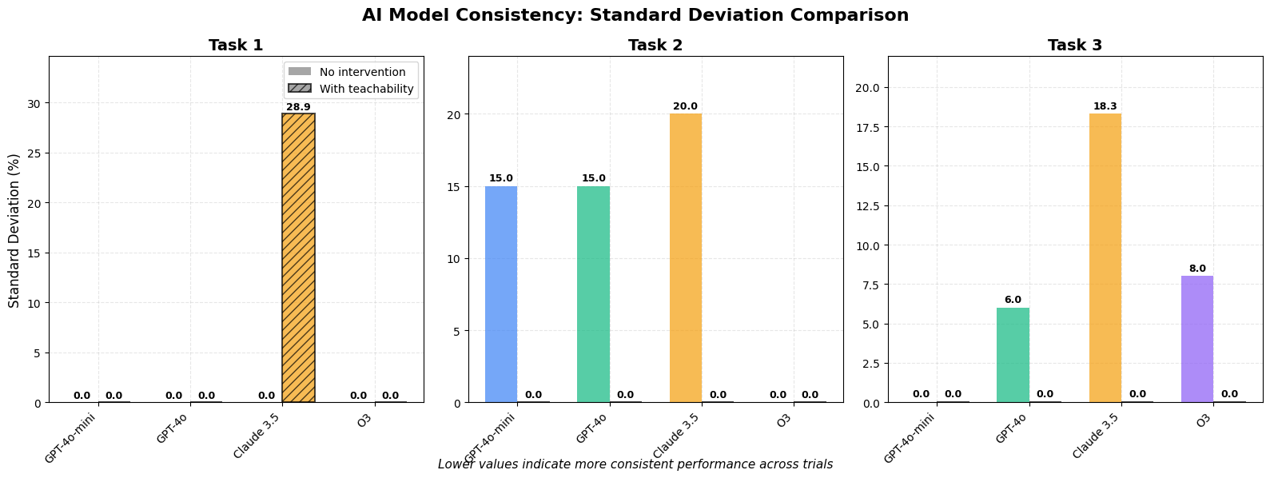
Supplementary Fig. 13. LLM model consistency on the operation of the N9 robotic system calculated by comparing the standard deviation of each task. Claube 3.5 showed the highest inconsistency among the tasks as the output of the model was varying across the different trials.

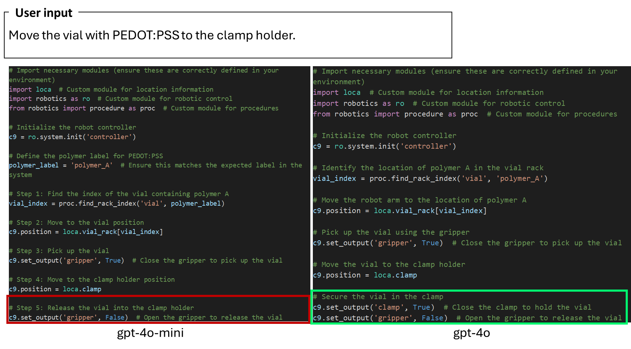
Supplementary Fig. 14. Comparison of the agentic output for gpt-4o-mini (left) and gpt-4o (right) for the simplest task in the N9 robotic station. The major error of gpt-4o-mini is highlighted in the red box, where it releases the vial by opening the gripper without first closing the clamp to securely hold it.

# filename: move_polymer_A_to_clamp.py
# --------------------------------------------------------------
# Collision-safe transfer of the vial labelled polymer_A
# (PEDOT:PSS) from the vial rack to the clamp holder.
# Uses ONLY the objects / motion primitives exposed by the
# PolyBot bundle that is pre-loaded in the runtime.
# --------------------------------------------------------------

from polybot import ro, loca, proc, c9 # <- single sanctioned import

def move_polymer_A_to_clamp():
label = "polymer_A" # PEDOT:PSS vial label

# ── 1 Availability check ────────────────────────────────────────────
if label not in ro.runtime["rack_status"]["vial"].values:
print("Experiment cannot be initiated.") # mandatory wording
return

# ── 2 Rack indices & predefined safe poses ──────────────────────────
row, col = proc.find_rack_index("vial", label) # (row, col)

# These pose maps are defined in the starter PolyBot file
above_vial = loca.vial_rack_approach[row][col] # safe overhead point
pick_vial = loca.vial_rack_pick[row][col] # pick height
above_clamp = loca.clamp_approach # safe overhead point
insert_clamp = loca.clamp_insert # insert height

# ── 3 Motion parameters (units = mm s⁻¹) ────────────────────────────
vel_xy = 150 # horizontal moves
vel_z = 150 # vertical moves

# ── 4 Pick the vial ─────────────────────────────────────────────────
c9.set_output("gripper", False) # open gripper
c9.move_linear(above_vial, vel=vel_xy) # approach rack well
c9.move_linear(pick_vial, vel=vel_xy) # descend to pick height
c9.set_output("gripper", True) # grip vial
c9.move_linear(above_vial, vel=vel_z) # lift back to overhead

# ── 5 Place the vial into the clamp ─────────────────────────────────
c9.move_linear(above_clamp, vel=vel_xy) # approach clamp
c9.set_output("clamp", False) # open clamp
c9.move_linear(insert_clamp, vel=vel_xy) # descend to insert height
c9.set_output("clamp", True) # secure vial
c9.set_output("gripper", False) # release gripper
c9.move_linear(above_clamp, vel=vel_z) # retract to overhead

# ── 6 Completion message ────────────────────────────────────────────
print("polymer_A vial successfully transferred to the clamp holder.")

# ------------------------------------------------------------------------
# Execute once
# ------------------------------------------------------------------------
move_polymer_A_to_clamp()

Supplementary Fig. 15. Example output of the O3 reasoning model for Task 1 in the N9 robotic workflow. The example illustrates a recurring failure model observed for O3 where unnecessary complexity and incorrect tool usage reduced reliability, despite strong performance in more complex, higher-level reasoning tasks.

- User interface
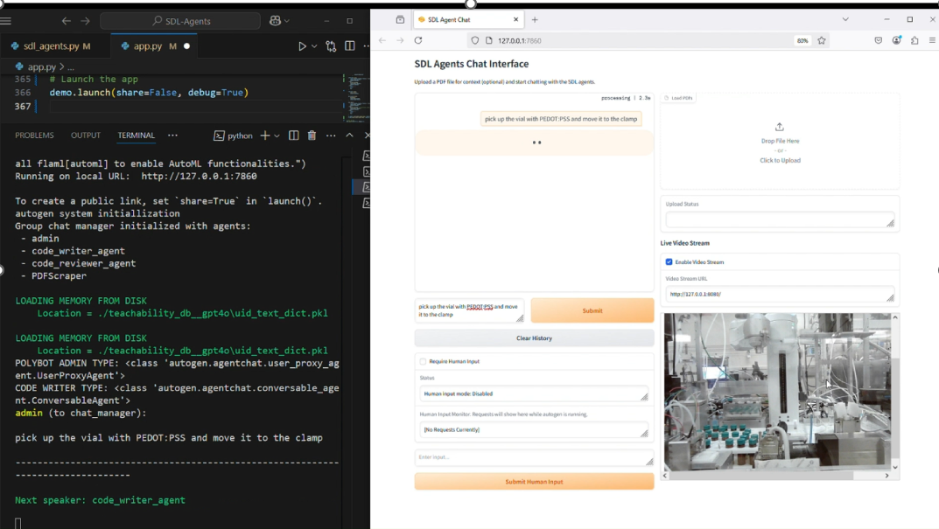
Supplementary Fig. 16. User interface for enabling real time in-lab operations of the agentic system.

