SUPPLEMENTARY INFORMATION

High-Entropy Solid Electrolytes Discovery: A Dual-Stage Machine Learning Framework Bridging Atomic Configurations and Ionic Transport Properties

Xiao Fu ^{a,b}, Jing Xu ^{a,c}, Qifan Yang ^{a,b}, Xuhe Gong ^{a,d}, Jingchen Lian ^{a,c}, Liqi Wang ^{a,c}, Zibin Wang^{a,c}, Ruijuan Xiao ^{a,b}*, Hong Li ^{a,b}*
ª Institute of Physics, Chinese Academy of Sciences, Beijing 100190, China
^{b} Center of Materials Science and Optoelectronics Engineering, University of Chinese Academy of Sciences, Beijing 100049, China
^{c} School of physical sciences, University of Chinese Academy of Sciences, Beijing 100049, China
^{d} School of Materials Science and Engineering, Key Laboratory of Aerospace Materials and Performance (Ministry of Education), Beihang University, Beijing 100191, China
Corresponding Author
*E-mail: rjxiao@iphy.ac.cn, hli@iphy.ac.cn

Supplementary text 1
1.1 DFT calculations
Initial structure of pristine LZSP was adopted from ref¹, and the supercell was built by a transformation matrix of [1, 1,$\overline{\text{1}}$;$\overline{\text{1}}$, 1, 1; 1,$\overline{\text{1}}$, 1] acting on the primitive cell. To fine-tune CHGNet for structural relaxation and MD successively, all computational accuracy and setups were consistent in primitive cells and supercells, and MD dataset was generated by single point calculations (NSW=1) of selected images. All DFT calculations with spin on were performed with Γ-centered k-mesh density of one point per 0.1 Å⁻³ using the Vienna Ab initio Simulation Program (VASP)² within the projector augmented-wave (PAW)³ approach. The generalized gradient approximation (GGA) ⁴was used with the Perdew-Burke-Ernzerhof (PBE)⁵ and both ions and cells were relaxed in the optimization with the energy and force convergence criteria of 10⁻⁵ eV and 0.01 eV/Å. For elements that might contain magnetic properties, all parameter settings were the same as the Pymatgen MPRelaxSet which was used in the Materials Project DFT calculations^{6,7}.
1.2 MD simulations
All NVT-Berendsen-MD simulations with fixed lattice were performed using the Atomic simulation environment (ASE) software package⁸, the time step was set to 1 fs, and all simulations were set at 1000 K with the exception of the final MD simulation that was used to fit the Arrhenius curve. The simulations performing to compare AIMD and CHGNet MDs lasted 50 ps, while the MD simulations performing to generate the dataset for the SF-MSD model lasted 100 ps. Li MSD was determined as the average of the squared displacement of Li ions at each time step, and to ensure sufficiently reasonable statistics, all the MSD values in the dataset were obtained by taking an average of 20~80 ps over the MSD-Δt curve lasting for 100 ps, which are close to the MSD values obtained at the time interval of 50 ps. By obtaining equivalent values in regions with better linearity during longer simulation times, this method aims to minimize statistical errors in the general slope fitting process as much as possible.
1.3 Details for CHGNet fine-tuning
Based on pretrained CHGNet, the model for structural relaxation and MD were both trained with energy, force, stress and magnetic moment under the mean squared error (MSE) loss criterion and a learning rate of 10⁻³ with the RAdam optimizer. The setting for train-validation-test ratio was 6:2:2 with batch size of 50 in structural relaxation model and 10 in MD model, respectively. The model checkpoint of best validation mean absolute error (MAE) was collected for test set predictions, while the final model of 500 epochs was used as a calculator.
To get more information about elemental interactions and transition states for Li migration from limited DFT data, the following approaches are taken to construct the structural relaxation and MD dataset and complete the CHGNet fine-tuning:
- Elements are selected by referring research [9] and [10], and the pristine LZSP structure is adopted from reference [1]
- For structural relaxation dataset, 50 images for each composition consist of the first 10 consecutive high-energy images and follow-by 40 random images from the DFT relaxation ionic steps. This approach produces a dataset with controlled size that better accommodates the large structural changes during the relaxation calculations.
- For MD dataset, it is important to find the structure of Li in the transition state from a range of structures, and this information is valuable for subsequent simulations of the ionic migration process. In order to find the desired structures, the closest distance from each Li atom for all dynamic images to Li sites in the initial static structure is calculated, and when the distance is greater than 2.5 Å, this Li is considered to be in the transition state, and the structures are sorted according to the number of Li in the transition state, and the top 10 structures containing the most Li atoms in the transition state are added to the MD dataset.
- It is important to check whether high-energy images are abnormal structures in both of two datasets. If structures of excessively high energies are entered, this can lead to poor model performance or unstable iterations while fine-tuning CHGNet.
1.4 Training the SF-MSD model
To construct the structural feature dataset, vasppy and pymatgen software packages⁷ were used to calculate the RDF and CSM of the relaxed structures, respectively. Because the RDF was read from only one structure, the curve was smeared with a gaussian kernel of sigma = 0.5. In SISSO model training the following settings were maintained: feature construction operators in '(+)(-)(*)(/)(exp)(exp-)(^-1)(^2)(log)(sin)', 10 of features in each of the SIS-selected subspace, and others as default in SISSO guide input, while the effects of the settings of dimension of the descriptor (desc_dim), maximal feature complexity (fcomplexity) and the metric for model selection in regression on the prediction results were mainly tested as detailed in Table S1, and the final model compared with GB and RF model in Fig. 4 is model 9. At the same time, GB and RF model constructions were executed in scikit-learn procedure package¹¹. The Shapley Additive Explanations (SHAP)¹² python package, based on the game theoretic approach, was adopted to dissect the relationship between structural features and ionic transport properties from GB and RF model.

Table S1 Detailed information for the parameters and training results of SISSO model.
model | desc_dim | metric | fcomplexity | nsf | nsample | RMSE | MaxAE
1 | 5 | RMSE | 5 | 21 | 146 | 19.46 | 63.89
2 | 5 | MaxAE | 5 | 21 | 146 | 19.94 | 46.37
3 | 6 | MaxAE | 5 | 21 | 146 | 20.48 | 59.03
4 | 6 | MaxAE | 4 | 21 | 146 | 20.21 | 42.67
5 | 7 | MaxAE | 4 | 21 | 146 | 19.06 | 38.46
6 | 7 | MaxAE | 4 | 21 | 145 | 18.90 | 35.77
7 | 7 | MaxAE | 4 | 17 | 145 | 16.61 | 30.99
8 | 7 | RMSE | 4 | 17 | 145 | 15.10 | 43.00
9 | 7 | MaxAE | 4 | 17 | 124 | 18.04 | 36.07
10 | 7 | RMSE | 4 | 17 | 124 | 15.41 | 39.53

Supplementary text 2
Discussion of high-error structures in fine-tuned CHGNet relaxation test
Table 1 shows that the fine-tuned CHGNet demonstrates structural relaxation reproducibility comparable to DFT calculations for most configurations. However, notable exception exists in Li₄Fe_{0.5}Al_{0.5}Ge_{0.5}Zr_{0.5}Si₂PO₁₂ as shown in Table 1. We observe volume deviations up to 5.49% and root sum squared distance error up to 4.680 Å. Though, in terms of the accuracy of the CHGNet model, the force errors obtained from the validation on the relaxation path, MAE_f =0.058 eV/Å and RMSE_f = 0.078 eV/Å, are slightly higher than those on its testing set, and such force errors are still tolerable on structures that do not appear in the training dataset. Furthermore, based on these two different structures, CHGNet MD simulations were performed, and the MSD values are obtained by the same method as samples in SF-MSD model dataset. Besides, the SF-MSD model predictions on these two structures were listed in Table S1 together with simulated MSD values. Regardless of the relaxation calculators used to obtain these two structures, the MSD values obtained by the same method are very close. This indicates that the difference between the relaxation of the fine-tuned CHGNet and DFT is not significant enough to affect the subsequent estimation of ionic transport properties. Therefore, it can be considered that this error would not alter the main characteristics of the SF-MSD model.

Table S2 MSD values obtained by different methods based on two configurations of Li₄Fe_{0.5}Al_{0.5}Ge_{0.5}Zr_{0.5}Si₂PO₁₂ relaxed by DFT and fine-tuned CHGNet methods.
Relaxation calculator | Fine-tuned CHGNet MD calculation(Å²) | Multinary SF-MSD (RF) prediction(Å²) | Multinary SF-MSD (GB) prediction(Å²)
DFT | 107.32 | 61.99 | 71.93
Fine-tuned CHGNet | 108.25 | 62.37 | 65.09

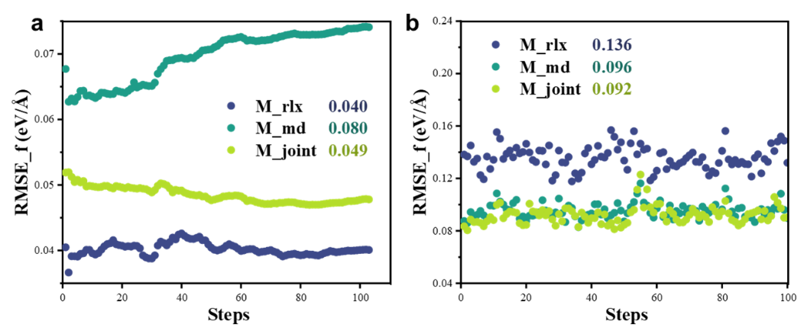
Fig. S1 | Model Performance across Diverse Tasks. Force RMSE comparison of stepwise models (M_rlx and M_md) with the joint optimized model (M_joint) for configurations in (a) DFT structural relaxation pathway and (b) AIMD trajectories
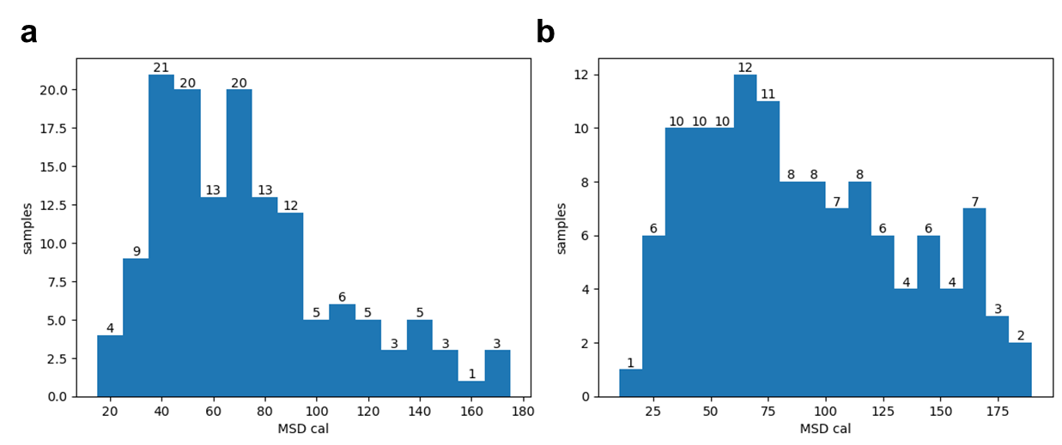
Fig. S2 | The MSD distribution profiles. (a) The randomly chosen samples and (b) data-cleaned samples for quaternary SF-MSD model.
Table S3 Number of sites and S_{config} of different proportion types of compositions in multinary dataset. Here ${\text{S}}_{\text{config}}\text{=-R}\left(\sum_{\text{i}\text{=1}}^{\text{N}}{{\text{x}}_{\text{i}}\text{ln}{{\text{x}}_{\text{i}}}}\right)$, in which N is the number of elemental species, ${\text{x}}_{\text{i}}$ is the mole fraction of component i, and R is the universal gas constant (R = 8.314 J K⁻¹ mol⁻¹), and compositions with S_{config} ≥1.5 R are considered HE, whereas those with 1.5 R > S_{config} ≥ 1 R and S_{config} < 1 R are considered to be medium- and low-entropy systems, respectively. ^{[13]}
type | Number of sites (Zr) |  |  |  |  |  |  |  | S_{config}/R
type | ele0=Zr | ele1 | ele2 | ele3 | ele4 | ele5 | ele6 | ele7 | S_{config}/R
3-1 | 6 | 5 | 5 |  |  |  |  |  | 1.095
3-2 | 6 | 6 | 4 |  |  |  |  |  | 1.082
3-3 | 7 | 5 | 4 |  |  |  |  |  | 1.072
4-1 | 4 | 4 | 4 | 4 |  |  |  |  | 1.386
4-2 | 5 | 4 | 4 | 3 |  |  |  |  | 1.371
4-3 | 5 | 5 | 3 | 3 |  |  |  |  | 1.355
5-1 | 4 | 3 | 3 | 3 | 3 |  |  |  | 1.602
5-2 | 4 | 4 | 3 | 3 | 2 |  |  |  | 1.581
5-3 | 5 | 3 | 3 | 3 | 2 |  |  |  | 1.565
6-1 | 3 | 3 | 3 | 3 | 2 | 2 |  |  | 1.775
6-2 | 4 | 2 | 2 | 2 | 3 | 3 |  |  | 1.754
6-3 | 4 | 4 | 2 | 2 | 2 | 2 |  |  | 1.733
7-1 | 3 | 3 | 2 | 2 | 2 | 2 | 2 |  | 1.927
7-2 | 4 | 2 | 2 | 2 | 2 | 2 | 2 |  | 1.906
7-3 | 4 | 3 | 2 | 2 | 2 | 2 | 1 |  | 1.873
8-1 | 2 | 2 | 2 | 2 | 2 | 2 | 2 | 2 | 2.079
8-2 | 3 | 2 | 2 | 2 | 2 | 2 | 2 | 1 | 2.047
8-3 | 3 | 3 | 2 | 2 | 2 | 2 | 1 | 1 | 2.014

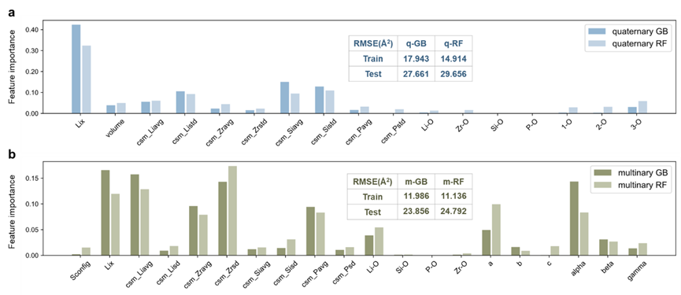
Fig. S3 | Comparative analysis of feature importance. The feature importance distributions (the sum of all importance scores is 1) among (a) quaternary model and (b) multinary model.
Supplementary text 3
Cross-validation on the combined dataset
In this work, we expect to achieve a more accurate and faster assessment of the ion transport properties of HE SEs with as little computational effort as possible. To demonstrate that the multinary model in this paper meets the requirements, the following cross-validation was performed with an extended training set. To get a dataset which is the largest in this study for the cross-validation experiment, the quaternary dataset of 172 structures and the multinary dataset of 270 structures are combined, and the testing set is 30 structures in 5-1 type structures as mentioned in Fig. 6 of the main text. Then, the parameters are optimized by randomized search with 100 iterations to obtain models with better predictive performance. It comes out that in the testing set the RMSE of the best GB model is 28.730 Å² and the best RF model is 26.131 Å², which is not a significant improvement over the previous model. Therefore, it can be assumed that the models trained using the 188 structures already contain sufficient relationships between structural features and transport properties.
In addition, to compare the robustness of GB and RF models, 1000 different disordered arrangements are tested as input perturbations on the best models in cross-validation. As shown in Fig. S4, the prediction distributions of the GB models are more concentrated than those of the RF models. Furthermore, the best RF model is shifted due to more noise in the combined dataset, while the best GB model is still robust around the same distribution center. Since then, it can be concluded that the GB model has a better robustness than the RF model and can do a better job in SF-MSD prediction work.
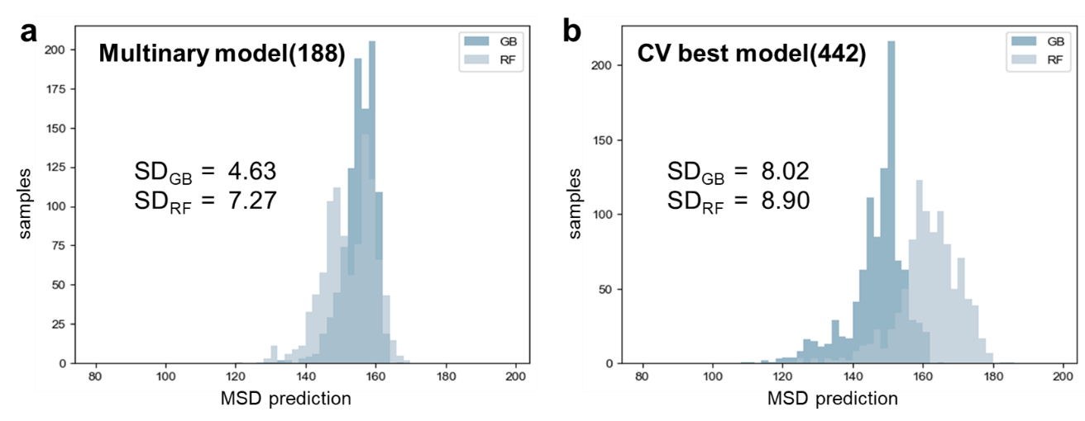
Fig. S4 | Model robustness analysis under varied training data. The MSD prediction distributions for (a)the multinary models in the main text and (b)the best models in cross-validation of 1000 random structures in formula Li_{2.5}Zr_{0.5}Ta_{0.5}Hf_{0.5}Ti_{0.5}Si₂PO₁₂.
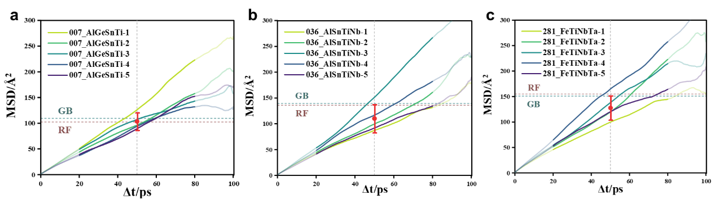
Fig. S5 | Variances of MSD-Δt curves different samples. Here samples of which prediction is out of corresponding acceptable region in Fig. 6(a). For each composition, 500-ps MD simulations at 1000 K are divided into five segments of 100 ps and the error bars are calculated following the same rule as target MSD values in SF-MSD models.
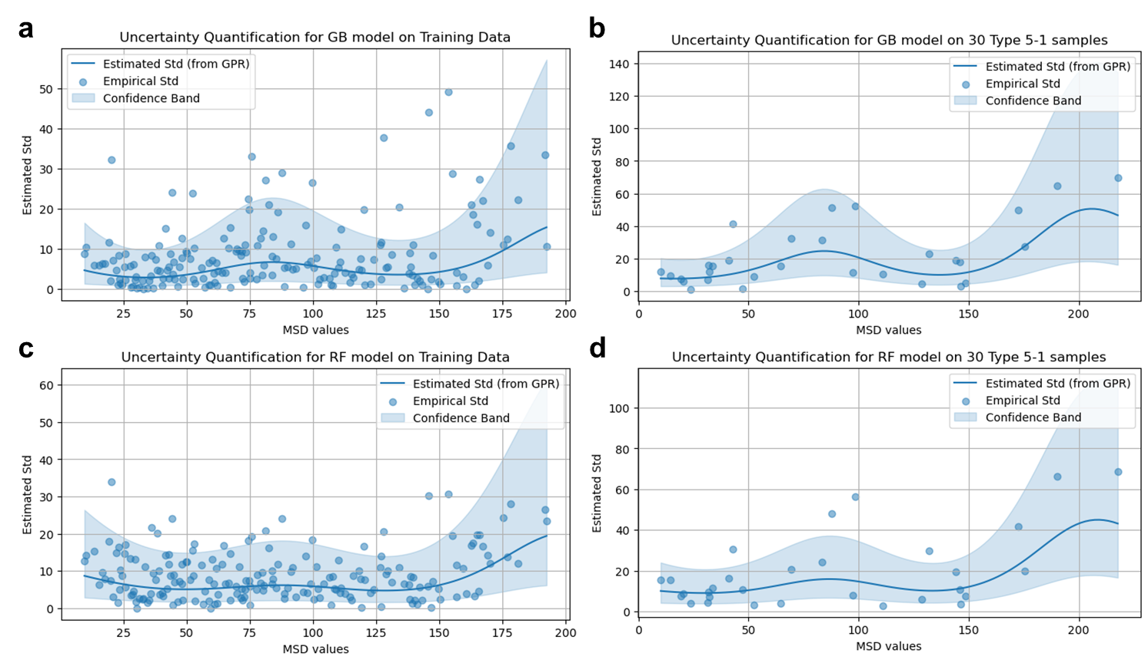
Fig. S6 | Uncertainty quantification analysis using Gaussian Process Regression (GPR) for standard deviation estimation. The plots compare the estimated uncertainty (blue line) with empirical standard deviations (blue dots) across MSD target values. Shaded areas represent confidence intervals around the GPR-fitted uncertainty estimates.
Supplementary text 4
AIMD simulation results for pristine LZSP
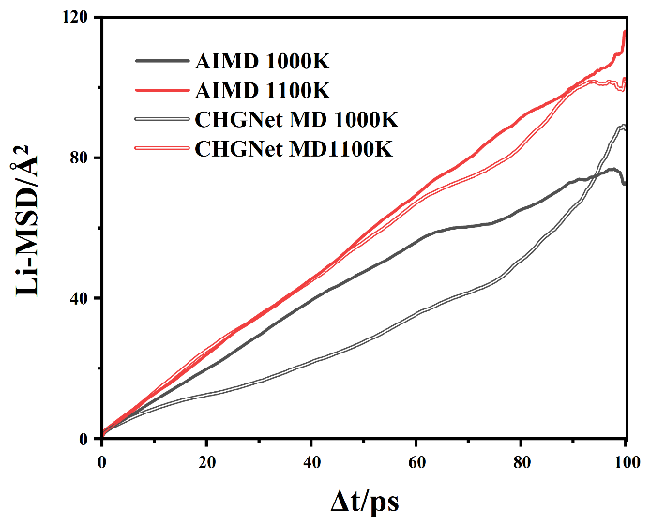
We additionally compared the CHGNet MD results with AIMD on pristine LZSP even though DFT calculations are expensive for this supercell, to make sure the rationality of CHGNet MD simulations. To ensure sufficient migration events statistics, the simulation duration was lasted to 100 ps, with the temperature elevated to enhance ionic mobility, thereby achieving a sufficient large MSD of ~100 Å². This approach thereby ensured a good overlap between the two sets of curves, confirming the validity of the CHGNet MD data.
Fig. S7 | Comparasion of AIMD and CHGNet MD. MSD curves of pristine LZSP calculated from AIMD and CHGNet MD simulations at 1000 K and 1100 K.

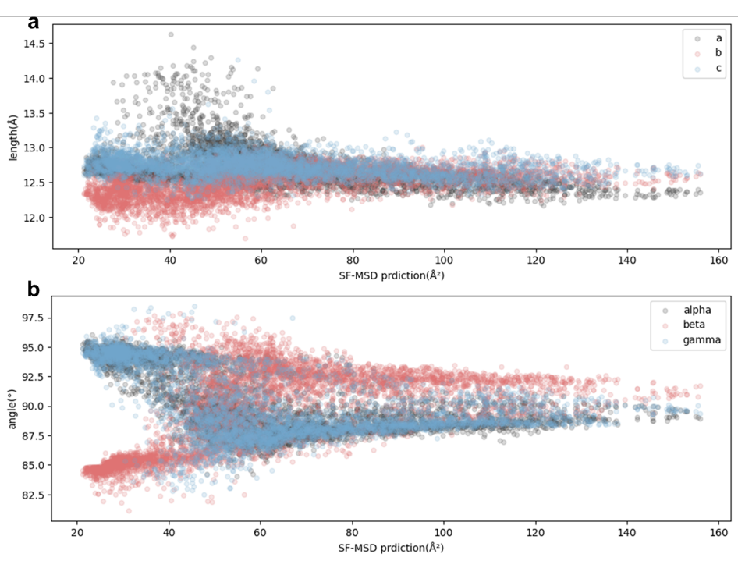
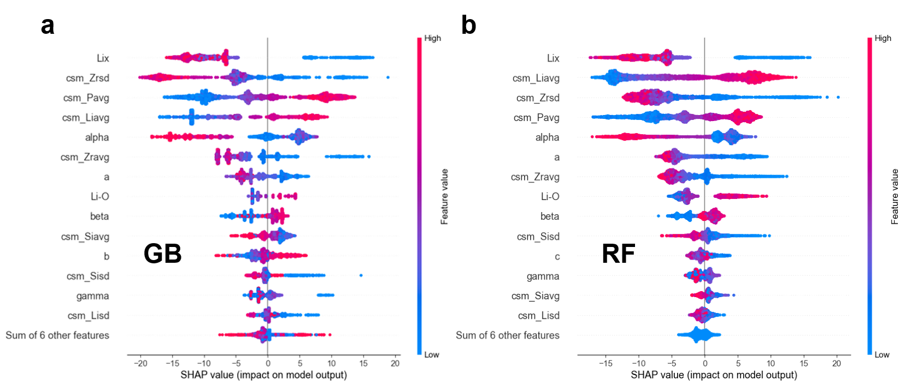
Fig. S9 | Analysis of cell paramaters of 5-1 type HE-LZSP. Scatter plots showing the relationship between SF-MSD predictions and cell parameters.
Fig. S8 | SHAP analysis of SF-MSD models. SHAP value for each feature in multinary (a) GB and (b) RF models, and points represent 4575 samples of 5-1 type in Table S2

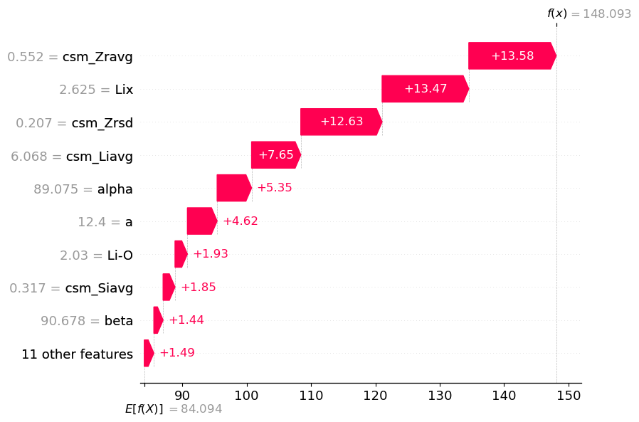
Fig. S10 | Single sample SHAP analysis. Waterfall plot for structure features of LZHSTNSP as predicted by multinary GB model.
Reference:
1. Zhu, L. et al. Enhancing ionic conductivity in solid electrolyte by relocating diffusion ions to under-coordination sites. Sci. Adv. 8, eabj7698 (2022).
2. Kresse, G. & Furthmüller, J. Efficient iterative schemes for ab initio total-energy calculations using a plane-wave basis set. Phys. Rev. B 54, 11169–11186 (1996).
3. Blöchl, P. E. Projector augmented-wave method. Phys. Rev. B 50, 17953–17979 (1994).
4. Perdew, J. P., Burke, K. & Ernzerhof, M. Generalized Gradient Approximation Made Simple. Phys. Rev. Lett. 77, 3865–3868 (1996).
5. Perdew, J. P., Ernzerhof, M. & Burke, K. Rationale for mixing exact exchange with density functional approximations. J. Chem. Phys. 105, 9982–9985 (1996).
6. Jain, A. et al. Commentary: The Materials Project: A materials genome approach to accelerating materials innovation. APL Mater. 1, 011002 (2013).
7. Ong, S. P. et al. Python Materials Genomics (pymatgen): A robust, open-source python library for materials analysis. Comput. Mater. Sci. 68, 314–319 (2013).
8. Larsen, A. H. et al. The atomic simulation environment—a Python library for working with atoms. J. Phys.: Condens. Matter 29, 273002 (2017).
9. Zeng, Y. et al. High-entropy mechanism to boost ionic conductivity. Science 378, 1320–1324 (2022).
10. Rao, Y. B., Bharathi, K. K. & Patro, L. N. Review on the synthesis and doping strategies in enhancing the Na ion conductivity of Na₃Zr₂Si₂PO₁₂ (NASICON) based solid electrolytes. Solid State Ionics 366–367, 115671 (2021).
11. Pedregosa, F. et al. Scikit-learn: Machine learning in python. J. Mach. Learn. Res. 12, 2825–2830 (2011).
12. Lundberg, S. M. & Lee, S.-I. A Unified Approach to Interpreting Model Predictions. in Advances in Neural Information Processing Systems 30 vol. 30 4765–4774 (Curran Associates, Inc., 2017).
13. Zheng, W. et al. The promise of high-entropy materials for high-performance rechargeable Li-ion and Na-ion batteries. Joule 7, 2732–2748 (2023).

