Supplementary material for
A general purposed machine learning interatomic potential for Mg-Al-Si-O system suitable for Earth materials

Xin Zhong¹, Yifan Li², Timm John¹

¹Institut für Geologische Wissenschaften, Freie Universität Berlin, Germany
²Department of Chemistry, Princeton University, U.S.A.

Training data
The final training data includes 20 minerals and melts. The list is given in Table S1. The final training data is generated from randomly perturbing the reference configuration or from molecular dynamics simulations using the training force field from previous iteration. In total, 3 iterations are done. In the list, each mineral contains 1000 to 3000 configurations depending on the complexity, e.g. for crystal phase we only choose 1000 configurations, while for melt phase we typically choose >2000 configurations for each element combination including Mg-Al-Si-O, Mg-O, Mg-Si-O, Si-O. In total, ca. 50,000 configurations are used for training the final machine learning interatomic potential.
The raw training data and the trained potential can be found in open access database: https://osf.io/784bv/
Phonon dispersion of quartz
Phonon dispersion of quartz is also calculated using the trained machine learning interatomic potential. Phonopy software is used to perform phonon calculation with finite displacement method to obtain the force constant (Togo, 2023; Togo & Tanaka, 2015). The results are compared with experimental data from Dorner et al. (1980).
Umbrella sampling
A strong requirement of umbrella sampling is sufficient overlap of the collective variables in different windows constrained by a harmonic potential (Benoît, 1995). An example of the frequency plot of the collective variables is shown in Fig. S2. The overlap is shown to be sufficient to perform a weighted histogram analysis method following the method in Benoît (1995).
To accelerate the convergence speed, we increase the temperature by 300K from the melting point. This provides a faster convergence speed, but the calculated free energy surface needs to be corrected to obtain the interface free energy. The equation for correction is in the main text.

Table S1. Mineral and melt training data list. Reference means that trained configuration is generated by randomly perturbing the reference configuration, MD means the configuration is directly from molecular dynamics simulation. Slab means that the configuration contains free surface to capture the surface effect. For each one, the number of configurations being used for training is between 1000 to 3000.
Phase name | Type
Akimotoite | Reference
Clinoenstatite | Reference
Forsterite | Reference
Quartz | Quartz high
Stishovite | MD
Wadsleyite | Reference
Coesite | MD
Cristobalite | MD
Periclase | Reference
Quartz | MD
Stishovite | Reference
Coesite | Reference
Cristobalite | Reference
Protoenstatite | Reference
Quartz | Reference
Tridymite | MD
Bridgmanite | Reference
Enstatite | Reference
Majorite | Reference
Ringwoodite | Reference
Tridymite | Reference
Pyrope | Reference
Akimotoite | MD
Bridgmanite | MD
Clinoenstatite | MD
Enstatite | MD
Forsterite | MD
Ringwoodite | MD
Pyrope | MD
Forsterite | Slab
Clinoenstatite | Slab
Enstatite | Slab
Periclase | Slab
Melt MSO | MD
Melt SO | MD
Melt MASO | MD
Melt MO | MD

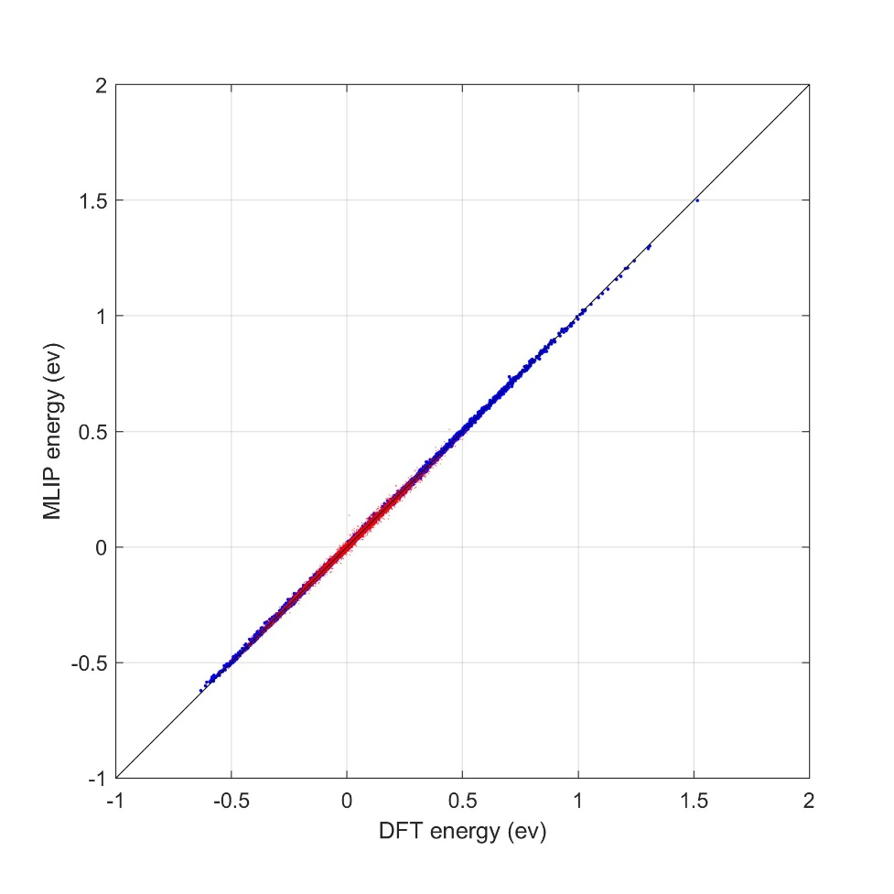
Fig. S1. Parity plot for the trained MLIP. The blue dots are for all solid phases (RMSE=0.003 ev/atom) and red dots are for the melt (RMSE=0.01 ev/atom). The energy is shifted for each mineral phase for demonstration purpose.

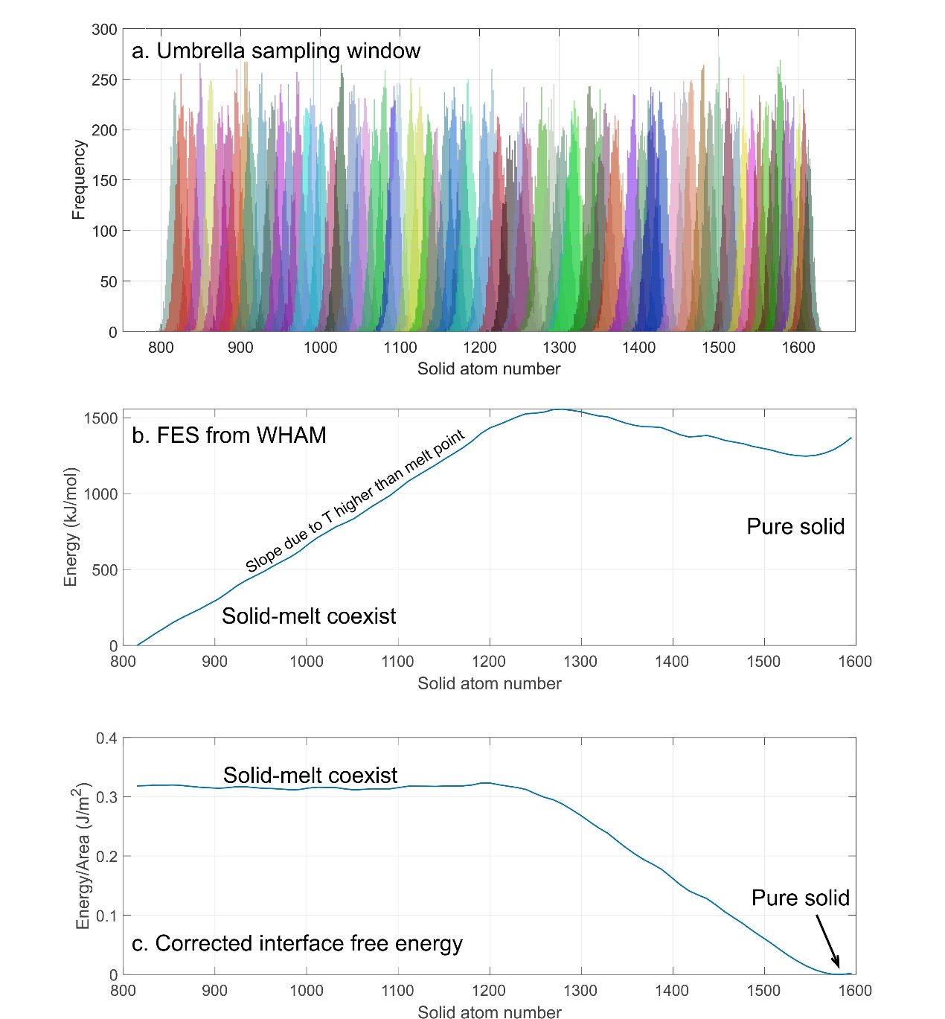
Fig. S2. a shows the collective variable frequency plot in different windows shown by different color for forsterite. b is the reconstructed free energy surface as a function of the collective variable with weighted histogram analysis method (WHAM). The temperature is set at 2400K. The slope from 800 to 1200 is due to the $\left(N-n_{s}\right)Δμ$ term not being equal to zero. This additional term is fitted within CV of 800~1200 and subtracted from the free energy surface to get c, which is the corrected free energy surface that allows direct extraction of interface free energy $γ$.

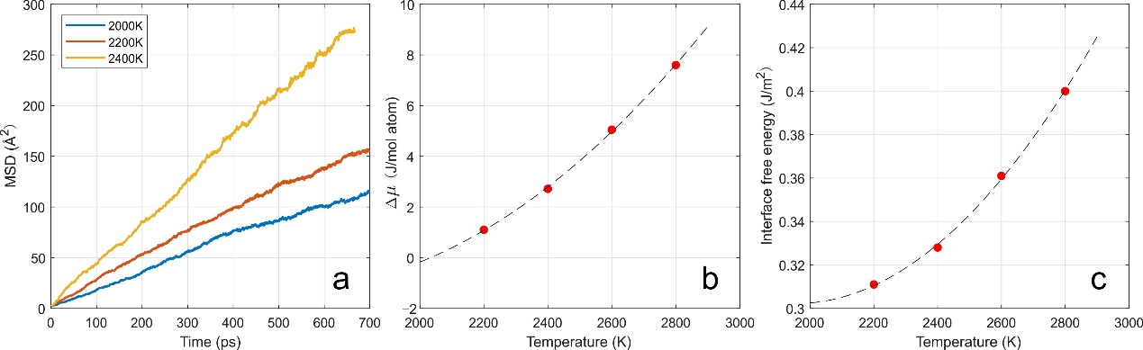
Fig. S3. a shows the mean square displacement of half solid, half melt model at different temperature during the umbrella sampling simulation. The linear trend comes from the melt atoms and the structure is not stuck. b and c show the chemical potential difference between solid and melt atoms at raised temperature, and the interfacial free energy calculated at different temperatures. A temperature dependence on the interface free energy is found.

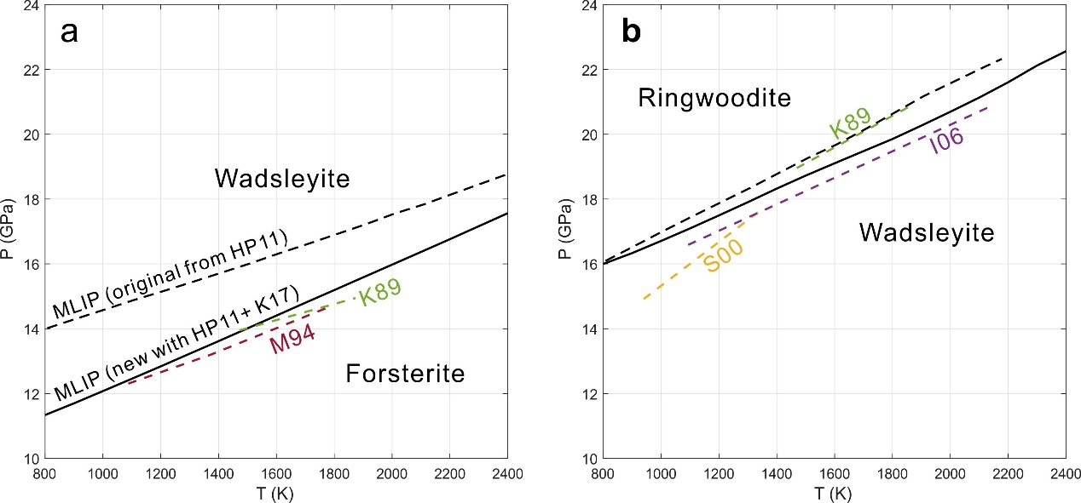
Fig. S4. a shows the transition between forsterite and wadsleyite, b shows the transition between ringwoodite and wadsleyite. The two transitions are separated into two subplots for illustrative purposes. The solid black lines are the newly corrected MLIP using the formation enthalpy from Kojitani et al. (2017) for forsterite, ringwoodite and wadsleyite. See main text for the procedures. The black dashed lines are the MLIP using correction from HP11 (the same with Fig. 3c in main text). The color dashed lines are experimental constraints: I06 (Inoue et al., 2006); K89 (Katsura & Ito, 1989); M94 (Morishima et al., 1994); S00 (Suzuki et al., 2000).

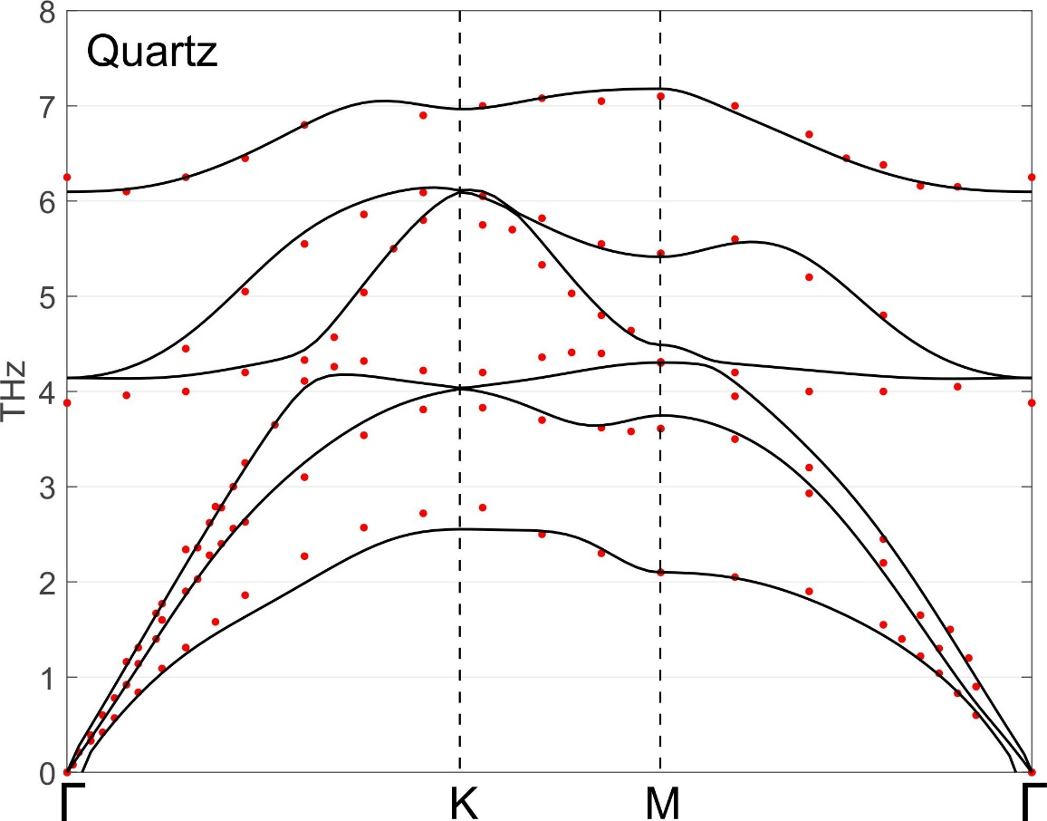
Figure. S5. Comparison of phonon dispersion from calculation and experiments for quartz crystal. The match is in general very good. The experimental data is from Dorner et al. (1980).

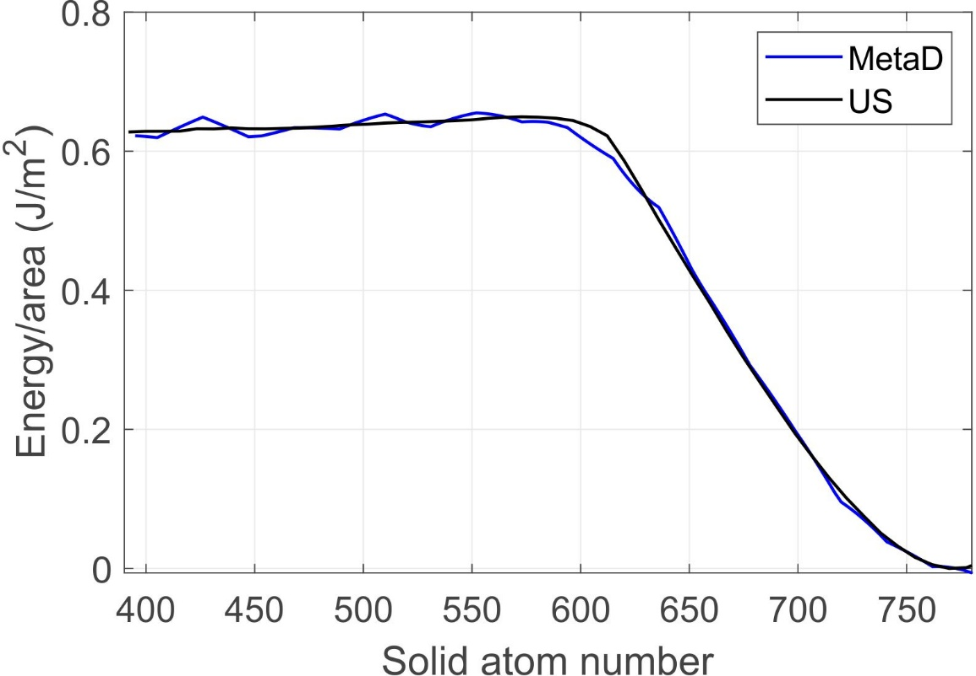
Fig. S6. Internal benchmark for the interface free energy of MgO periclase using metadynamics (MetaD in blue) and umbrella sampling (US in black) methods. The same model geometry is applied, and the only difference is the method used. The two independent methods yield consistent results. The energy difference is less than 2%.

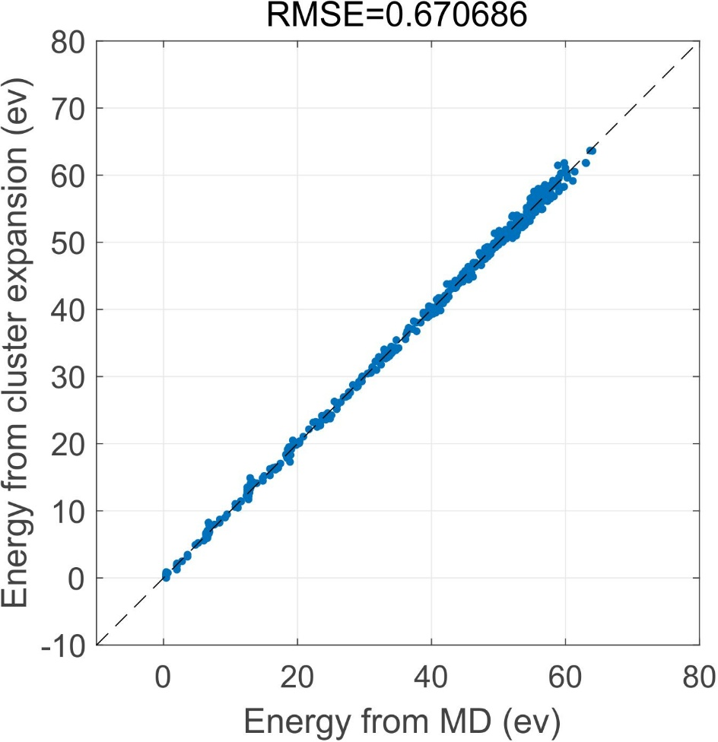
Fig. S7. Parity plot of cluster expansion for sillimanite. The Al and Si atoms along the c-chain are randomly shuffled that yield different energies. The x-axis shows the energy from MD simulation with the training machine learning interatomic potential, and y-axis shows the energy directly calculated from cluster expansion. A 2-by-2-by-3 supercell is used for the calculation. The fitted parameters for the cluster expansion can be found in the main text.

References
Benoît, R. (1995). The calculation of the potential of mean force using computer simulations. Computer Physics Communications, 91(1995), 275–282.
Dorner, B., Grimm, H., & Rzany, H. (1980). Phonon dispersion branches in α quartz. Journal of Physics C: Solid State Physics, 13(36), 6607–6613. https://doi.org/10.1088/0022-3719/13/36/014
Inoue, T., Irifune, T., Higo, Y., Sanehira, T., Sueda, Y., Yamada, A., Shinmei, T., Yamazaki, D., Ando, J., Funakoshi, K., & Utsumi, W. (2006). The phase boundary between wadsleyite and ringwoodite in Mg₂SiO₄ determined by in situ X-ray diffraction. Physics and Chemistry of Minerals, 33(2), 106–114. https://doi.org/10.1007/s00269-005-0053-y
Katsura, T., & Ito, E. (1989). The System Mg₂SiO₄-Fe₂SiO₄ at High Pressures and Temperatures’ Precise Determination of Stabilities of Olivine, Modified Spinel, and Spinel. Journal of Geophysical Research, 94, 15663–15670.
Kojitani, H., Terata, S., Ohsawa, M., Mori, D., Inaguma, Y., & Akaogi, M. (2017). Experimental and thermodynamic investigations on the stability of Mg 14 Si 5 O 24 anhydrous phase B with relevance to Mg 2 SiO 4 forsterite , wadsleyite , and ringwoodite. American Mineralogist, 102, 2032–2044.
Morishima, H., Kato, T., Suto, M., Ohtani, E., Urakawa, S., Utsumi, W., Shimomura, O., & Kikegawa, T. (1994). The Phase Boundary Between alpha and beta-Mg₂SiO₄ Determined by in Situ X-ray Observation. Science, 265, 1202–1203.
Suzuki, A., Ohtani, E., Morishima, H., Kubo, T., Kanbe, Y., Kondo, T., Okada, T., Terasaki, H., Kato, T., & Kikegawa, T. (2000). In situ determination of the phase boundary between wadsleyite and ringwoodite in Mg2SiO4. Geophysical Research Letters, 27(6), 803–806. https://doi.org/10.1029/1999GL008425
Togo, A. (2023). First-principles Phonon Calculations with Phonopy and Phono3py. Journal of the Physical Society of Japan, 92(1). https://doi.org/10.7566/JPSJ.92.012001
Togo, A., & Tanaka, I. (2015). First principles phonon calculations in materials science. Scripta Materialia, 108, 1–5. https://doi.org/10.1016/j.scriptamat.2015.07.021

